The Importance of communicating during children’s transition periods.

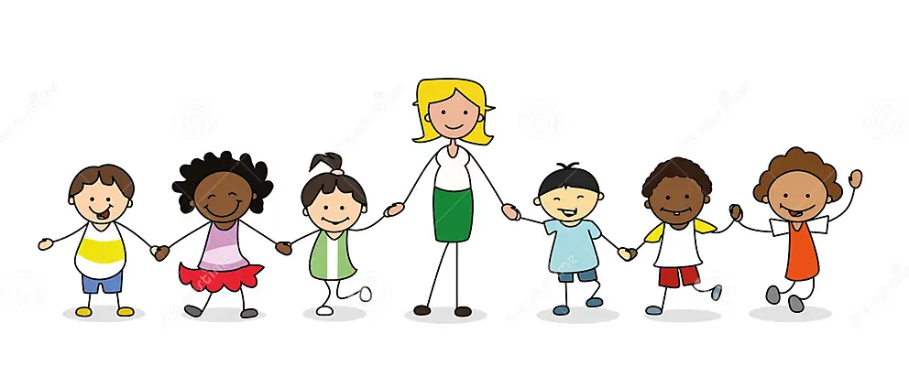



Introduction

In this handbook you can find effective ways to communicate when processing transitions for young children’s learning and development, this leads to the importance of promoting the understanding for all early year’s practitioners to provide children with the best support and encouragement when transitioning. Many don’t see the importance of positive and effective Transitions when it comes to children, when this should be one of the focus points to prioritize when it comes to children in Early years. Having a positive or negative transition can determine a child’s future in Education and in general life.
Transitions are important to children of all age ranges. Transitions are opportunities for professionals in early years to make key connections with the children, as well as professionals it is also important for parents in home life. Birth to 5 matters believes that it is the duty of all early year’s practitioners to make sure that children feel comfortable, to gain a sense of closeness and are aided to be made to feel settled and happy.
When being involved in a child’s transition it is important to get all valuable information and gather everyone who is involved in the child’s life. It is important to have all relevant information about a child to be able to give that child the most suitable strategies for transitions, without the personal level there is no way to know if the strategies you are putting into place will be relevant to that child.
Transitions are going to be completely different for every child depending on what has happened previously in their lives ad also their age, there are certain techniques and approaches that can be used for varied age ranges, then there are some techniques and approaches that will only work for certain age ranges this is why it is key to establish the age range of the child that you are working with. There are two types of transitions in one being Horizontal, this is transitions that occur every day, such as a child going from their family home to their grandparent’s house these are transitions that are normally very simple for a child and should not cause any upset to a child. The other type of transition is called a Vertical transition, this transition is a key change/moving upwards. This could be moving from primary school to secondary school these changes are huge to children and can cause upset, anxiety and lose of self-confidence.

Transitions for children in Early years.

Transitions for children aged 4-5 can be the first key transition a child may go through. Many children will not have left their parents up until this point, this may be a child’s first time separating from their home comforts and all they have ever known. It is detrimental to handle this transition with great delicacy.
It has been researched that transitions play a key role in a child’s development. Piaget was a psychologist from the 1900’s, Piaget believed that learning was associated to play and that play had a great role in a child’s development. During the 20th century Piaget’s early writing was popularised meaning it had become highly talked about leading to debates surrounding the concept of children being ready for learning in school or in general. This leads to believing that as children were at readiness to learn at ages 4-5 there was key work to be done ready for children to transition to school, this led to more theorist making new theories. (Vogler, P., Crivello, G. and Woodhead, M. 2008, p. 6-8.)

What is the role of Adults in Transitions?

Vygotsky’s theory suggests by engaging children in relevant activities it can encourage a child’s cognitive development. It is crucial that Transitions go well so children can go on to learn in their new surroundings, if transitions do not go well a child is not going to feel comfortable in their new setting leading to the child not wanting to participate in learning this will then lead to development problems.
Adults play a key role when it comes to children’s transitions in many ways, before a transition has started to the ending of a transition. These adults can be many different people and they can play many different roles. Parents have a key role to play when it comes to the before stages of transitions, parents need to make sure they are involved and are engaging. There are lots of different ways as parents they can get involved when it comes to starting their child’s transitions, for example parents could be contacting school to see what support is in place within the school/ nursery for transitions, if parents are having any support from outside agencies they can be contacted for help and guidance. As well as getting involved before the transition has started it is important for parents to stay involved through the whole transition, whist the transition is happening it is key for parents to encourage their children through the whole process, parents are children’s comforts and children trust their parents so when parents are giving that encouragement it is going to spur the child on, making the transition as smooth as possible. In an article written by Tobin et al (2022) Suggest that parents want to be involved in their child’s transition to school, research found that parental involvement and support can help encourage the relationship between school and parents, they believe that this will lead to greater development in a child’s education. As Tobin et al state they found parents wanted to be involved in their children’s transition, a way to do this could be stay and plays, this is where the parents come into the school/ nursery setting with their child for a few hours a day before their child goes alone, this will have a positive impact on the child and parent. It is important that as well as the child feeling safe and comfortable in their new setting that the parents have experienced being in the setting also, this will make parents feel comfortable knowing where their child is going to be staying Mereoiu, Abercrombie and Murray(2016).

What needs are to be met for children going through Transitions?

All children have many different needs that need to be met, it is important to take this into consideration when approaching a transition. Children have attachment to Parents/careers Bowlby believed that to make sure we are meeting the specific needs to each individual child we must get to know each child that is coming into our new setting, a great way to do this would be to end home a pack to parents for the child to fill in, with help of parents. The pack could include a form ‘all about me’ the parents can fill this out with help from the child and send it back to the setting that they’ll be attending for the staff to get an idea of what needs the child has and what needs, need to be met. This is a great exercise to do before the child enters the new setting as staff can have time to put things into position ready for the transition.

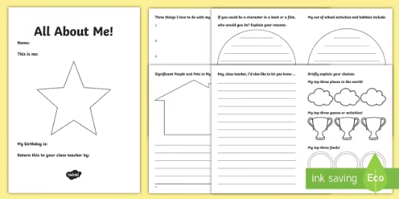

Twinkl (2023)

Children have many rights, one important right when going through transitions is Leisure, Play and Culture this right is stated by United Nations Convention on the Rights of the Child (UNCRC) (no date) they believe that ‘every child has a right to relax, play and take part in a wide range of cultural and artistic activities. This is a key right when going through transitions as it states every child has a right to feel relaxed and comfortable, this Is the main goal overall when going through an early year’s transition.

Interventions

When attending school/ nursery there can be many different transitions faced, for example being dropped off somewhere strange, new activities and new people. This is why it is extremely important for Early years practitioners to get transitions right Brooker (2008).There can be a multitude of different strategies that can be put into place when starting a transition, a great way to start could be sending home a pack for child with things such as photo cards with names on of the staff in the new setting they will be attending, in the pack could also be pictures of the new setting, explain to a child where these pictures are and what is going to be happening there this is a great way for a child to see and start to understand who these new people are and start to get familiar with the look of the new setting, this strategy is a great way for both parents and early years practitioners to get involved. By sending photos of the setting this could encourage the child to want to go to this new place, by seeing the toys this could make the child exited with something to look forward to. Visiting children in their own home can also be a great way to start a transition, by doing this you are going somewhere that is familiar to them, when a child is in their own environment, they are more likely to participate in getting involved and getting to know someone Nursery story (2021).
There are also some disadvantages of home visits one being that home visits are very time consuming for the Early years staff, trying to get around to every child that is about to have a transition to school/nursery. Home visits can also cause embarrassment onto parents, everyone has different lives and live in different environments, this could lead to making parents uneasy and potentially causing more harm on future communication between parents and early years staff Aspiring Youths (2023).
Another intervention to help make a transition a positive and successful is allow a transitional object that makes the child feel comfortable, this could be a teddy bear, comforter, or a photo of someone familiar. This is a great way to make a child feel comfortable in a new setting. HealthyChildren.org (2023) suggests that transitional objects will grow with a child and will not only be used for transitions to school/ nursey but for many different times in life such as when a child is tired this object can comfort them to sleep. As comforting as transitional objects can be there is also some disadvantages of them, children may become extremely attached and not be able to part with this object this can lead to attachment issues and the children becoming distressed without their object (Lee and Hood, 2021).

The importance in play

Play has a massive role when going through transitions, there are many theorists who point out the importance in play and how it can have positive impact on children. Play can have a positive impact on a child’s cognitive, physical, social, and emotional wellbeing. Through play children can learn a lot about themselves and learn a lot of valuable skills including, confidence, self-esteem, social skills, and independence. All these skills are valuable for life. Nidirect government services (2023). Iaccas a theorist believed that children’s play is a form of expression, this is the first stage of children learning to be interactive and have their own personality, this is important as children can learn ways to express their emotions and many other things. Mickelburgh (2018).
Play should be in place when planning a transition for early years, play is a key aspect and will help all children feel more comfortable in the early years setting. There are many ways you can use play in your transitions, using play to encourage children to interact with new staff and new friends in groups is an excellent exercise, not only are they playing they are interacting with others meaning their social skills are developing. This can be where friendships start and new relationships with staff members, this is extremely important for children not just for transitions but for throughout life, the skills children learn will then be carried with them and used in numerous aspects of life. As well as relationships between the children and early years staff it is important for the parents and early years staff to have a genuine relationship, this can affect the way a child transitions. If parents don’t have a good relationship with staff, it can affect the child’s transition, by there being no communication neither party know how the transition Is going and if the child is happy in their new setting Teach Early Years (2023).
Play can have great physical benefits on a child including strength, fine motor skills, coordination, Brain development and many more. As children play their brain develops their muscles grow strong and they develop good social skills such as learning to share and take turns The Sector (2022).

Holistic approach

Holistic development in Early years Is an approach to children’s learning that highlights the significance of an impact that physical, emotional and phycological well-being can have on children during a transition and in day to day life. It can help children in a different way than any other approach can, it can make a positive impact on a child. This can be used for transitions in early years as it is important for a child to explore and evaluate play at their own pace with no pressure from parents or Early years staff, this will then hopefully help the child feel more independent and enjoy the transition as the child feels they are in control of the situation and the way they feel Paxman (2020).
Making sure a child can feel its own emotions and deal with them how they choose Is important for development, and important for their emotional well-being. How can we make sure children are in control of their own emotions and feel parents/ Early years staff are understanding? This can be done by both parents and staff, an example of this is listening to a child when they are dealing with a lot of emotions, this is important because children need to feel they are being listened and understood otherwise this could lead to behavioural issues from the child. As well as behavioural issues not listening to children could result in children not wanting to open about their emotions and feelings. Children being able to open and discus what is on their mind to someone they feel comfortable with is essential for children, bottling emotion is not great when going through a transition as there is a lot of different emotions due to the transition, so being a safe space for a child is key. The National Society for the Prevention of Cruelty to Children [NSPCC] (2023) backs this opinion up, on their website they state that children need and should be allocated a safe environment free from distraction so that they have your undivided attention, you should remind children clearly and often that they are in a safe space and can feel free to talk openly no matter how tough the conversation may be, this can be used in transitions making sure that you form a bond with the child during a transition so they can feel safe to talk about anything that may be happening at home or in any outside environment, as they may not feel they have this freedom to talk in their outside environment.

Partnership in transitions

There are many different partnerships you may want to think about and consider when a child is going through a transition, the main partnership being between the parent of the child and the school/Nursery staff this partnership is extremely important to make sure the transition is as seamless as possible, to do this there should be communication from both sides. The school should send home information packs on how the transition should go and any tips and tricks they may have on making the transition successful, furthermore when the transition is taking place there are many other effective ways to communicate between both parties, Notice boards, Parents Evenings, Newsletters and being accessible to talk to at pick ups and drop offs so parents are kept UpToDate properly, this works in both ways parents should communicate effectively also, therefore parents should be open and honest with their thoughts on how they think the transition is going, with doing this both sides have a clear and concise idea of what is happening with the individual child Aspiring Youths (2023) back this up in their blog.

How do we know Transitions have been successful?
A transition is a process; therefore, the process needs to be completed before you can know if it has been successful, there will be many pointer throughout the process to know how the transition Is going and if it is having a positive effect. One way of seeing if a transition has been successful is if the child can now make good relationships, with other children and staff, this shows that a child feels comfortable enough in their setting to mingle with other and create friednships. Children work well in clear routines, once you’ve established these routines the children will know what’s coming and know what to expect, leaving them free to express emotions and enjoyment O’Donoghue(2020).
When a child has positively taken to a transition it should be clear that the child is comfortable in their new setting, children will show this by going into the setting without getting upset, wanting to engage in activities with others. NurseryWorld(2023). A child showing they are meeting their developmental stages is another way to show a positive transition, if a child is meeting all developmental key stages it is clear they are enjoying their environment and are able to be free to enjoy learning.

References

Dreamstime(2023) Available at: https://www.dreamstime.com/kids-kindergarten-group-children-female-teacher-holding-hands-image136450416 (Accessed:27 November 2023)
Tobin, E., Sloan, s., Symonds, J. and Devine, D. (2022) ‘Family -School connectivity during transition to primary school, Educational Research, 64(3), pp. 277-294. Available at: https://www.tandfonline.com/action/showCitFormats?doi=10.1080%2F00131881.2022.2054451
Twinkl (2023) Available at: https://www.twinkl.co.uk/resource/t2-t-16803-lks2-all-about-me-transition-booklet (Accessed: 1st December 2023)
Nursery story (2021) Supporting Children and Parents with Transitions. Available at: https://nurserystory.co.uk/ (Accessed: 1st December 2023).
Birth to 5 Matters (2023) Transitions. Available at: https://birthto5matters.org.uk/
(Accessed: 29 November 2023).
Vogler, P., Crivello, G. and Woodhead, M. (2008) Early Childhood Transitions and Research: A Review of Concepts, Theory, and practice. The Netherlands: Bernard Van Leer Foundation.
Nidirect government services (2023) How play helps children’s development. Available at: https://www.nidirect.gov.uk/articles/how-play-helps-childrens-development (Accessed: 2 December 2023).
Mickelburgh., J. (2018) Educational Pioneers: Susan Isaacs’, Teaching and Learning, pp.1885-1948. Available at: https://eyfs.info/articles.html/teaching-and-learning/educational-pioneers-susan-isaacs-1885-1948-r40/#:~:text=Isaacs%20used%20her%20psychoanalytical%20knowledge,with%20a%20range%20of%20emotions. (Accessed: 2 December 2023).
United Nations Convention on the Rights of the Child (UNCRC) (NO DATE) A summary of the un convention on the rights of the child. Available at: https://www.unicef.org.uk/donate/childrens-emergency-fund/?gad_source=1&gclid=Cj0KCQiAyKurBhD5ARIsALamXaGVil8Cz1kKrE5JLgQ2aFGMXfnt5w8YeLeyUJ21bh7OruyNEEp0md4aAoUhEALw_wcB
(Accessed: 2 December 2023).
Teach Early Years (2023) Transitions in early years- Ideas for supporting children and families. Available at: https://www.teachearlyyears.com/a-unique-child/view/supporting-transitions-in-the-early-years (Accessed: 2 December 2023).
Paxman. (2020) Five Benefits of Holistic Development in Early years. Available at: https://www.twinkl.co.uk/blog/five-benefits-of-holistic-development-in-early-years (Accessed: 1 December 2023).
Aspiring Youths (2023) What are the advantages and disadvantages of home visits by teachers. Available at: https://aspiringyouths.com/advantages-disadvantages/home-visits-by-teachers/ (Accessed: 1 December 2023).
Lee, A. and Hood, B. (2021) ‘The origins and development of attachment object behaviour’, 39, pp. 72-75. Available at: https://www.sciencedirect.com/science/article/abs/pii/S2352250X20301354 (Accessed: 1 December 2023).
The National Society for the Prevention of Cruelty to Children [NSPCC] (2023) ‘Every childhood is worth fighting for’, Practical tips for starting a conversation about life online’ Available at: https://www.nspcc.org.uk/keeping-children-safe/online-safety/online-safety-blog/want-to-talk-about-it-making-space-for-conversations-about-life-online/ (Accessed:2 December 2023).
The Sector [Early Education news, Jobs and more] (2022) The Benefits of Physical Play in Early Childhood. Available at: https://thesector.com.au/2022/11/15/the-benefits-of-physical-play-in-early-childhood/ (Accessed: 2 November 2023).
Brooker, L. (2008) Supporting transitions in the early years. Maidenhead: Open University Press.
Mereoiu, M., Abercrombie, S. and Murray, M. (2016) ‘One Step Closer: Connecting parents and teachers for improved student outcomes’. Cogent Education, 3(1). Available at: https://www.tandfonline.com/action/showCitFormats?doi=10.1080%2F2331186X.2016.1243079 (Accessed: 2 December 2023)
O’Donoghue, A. (2020) ‘How to Transition Children Successfully in the Early years’ Available at: https://blog.easypeasyapp.com/blog/how-to-transition-children-successfully-in-the-early-years#:~:text=A%20strong%20predictor%20of%20a,routines%20and%20set%20clear%20expectations. (Accessed: 3 December 2023).
NurseryWorld (2023) ‘Transitions between settings’. Available at: https://www.nurseryworld.co.uk/news/article/transition-between-settings ( Accessed: 3 December 2023).

