Price Elasticity of Demand: Impact on Revenue.

1. Missing words

Firms will use price elasticity of demand to determine their _____________ and also work out their total revenue.

What is the formula for total revenue? ______________ x ______________

2. Calculating Revenue Using the following information calculate the total revenue for each price level.
Price (£s) | Quantity | Total revenue
10 | 0
9 | 1
8 | 2
7 | 3
6 | 4
5 | 5
4 | 6
3 | 7
2 | 8
1 | 9
0 | 10

2.1 On the graph paper below (the demand curve has been drawn for you) plot the total revenue at each level of output.
2.2 What does this suggest happens when elasticity is equal to 1 (unitary elasticity)? ________________________

______________________________________________________________________________________
2.3 What does this suggest a firm could do to price, in order to maximise revenue, if it found that it was operating on the elastic part of the demand curve?
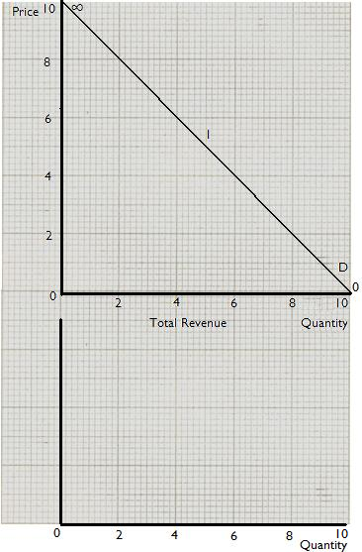
_______________________________________________________

_____________________________________________

_____________________________________________

2.4 What would a firm do to price if it was on the inelastic
part of the demand curve and wished to increase total
revenue?

_____________________________________________
3. Elasticity and total revenue.
A hotel has 75 rooms, it finds that when it charges £130 per
night it fills 50 rooms. It calculates that the price elasticity of
demand is – 1.5. What will be the change in total revenue if
it lowers the price for each room by 20 per cent?
- £6760
- - £10
- + £10
d) £260

e) £5200

ANSWERS. Price Elasticity of Demand.
1. prices … Price x Quantity
2.
Price | Quantity | Total revenue
10 | 0 | 0
9 | 1 | 9
8 | 2 | 16
7 | 3 | 21
6 | 4 | 24
5 | 5 | 25
4 | 6 | 24
3 | 7 | 21
2 | 8 | 16
1 | 9 | 9
0 | 10 | 0

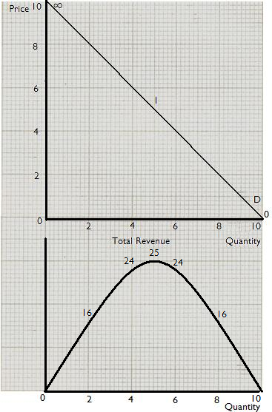
2.2 Suggests that when the elasticity is 1 the total revenue is maximised.

2.3 This means that if the firm reduces the price of a good when it is on the elastic part of the demand curve (between -1 and -∞) then it can increase total revenue.

2.4 If the firm is selling a price inelastic good (between -1 and 0) then it can raise price and therefore increase revenue.

3. Answer D

If the PED is -1.5 then QD must increase by 30% when price falls by 20%

+ 30% = -1.5
- 20%

Original total revenue

£130 x 50 rooms = £6500

New total revenue

£104 (£130 – 20%) x 65 (50 rooms + 30%) = £6760

Therefore the change in total revenue is +£260

