Name: Md Oliur Rahman
Business Plan for: The Newcastle Cultural Haven Hotel
Lecturer: | Charlotte Joyner
Date: | 30/05/2024
Team members: | Md Oliur Rahman (2207462)
Business plan contents
1 Executive summary 4
2 Business details 5
3 Key personnel 6
Vision 9
4 The business idea 9
5 Business goals 10
6 What the business does 10
7 What makes the business different (Value Proposition) 11
8 Legal requirements (including regulations and licences particular to business) 11
Marketing 13
9 Market research 13
10 Profiling customers 13
11 Profiling competitors 14
12 Managing market risks 15
13 Pricing 16
14 Promotion and advertising 17
Running the business 18
15 Staff 18
16 Premises 18
17 Suppliers 18
18 Equipment 19
19 Managing operational risks 20
Finance 21
20 Start-up costs 21
21 Profit and loss forecast 21
22 Sourcing finance 23
23 Managing financial risks 23
24 Cash flow forecast 24
26 Reference list 26
27. Appendix- Presentation 30

1 Executive summary
The business plan is based on a hospitality business. A Hotel that offers a cultural immersive experience to the guests will be established. The business will target those customers who have an interest in local culture and like to experience unique hospitality services. The market analysis and customer analysis show that the hotel has huge potential in the UK market. The investors and management of the business will undertake comprehensive marketing, and risk management initiatives to successfully implement the business plan.

2 Business details
Company name:
The Newcastle Cultural Haven Hotel
Address:
Warwickshire, England (specific address to be determined)
Primary contact method
www.newcastleculturalhavenhotel.com
The business will:
The business will offer cultural immersive hospitality services such as accommodation, dining, and events. It will also address environmental issues in the hotel operations.

3 Key personnel
Details of owner(s):
Name: Mohammed Ali Hayder

Position/main responsibilities: Management Head
Experience and knowledge of our industry: 2 years of experience working in the UK hospitality industry and having knowledge of hotel management, leadership, customer service.
Previous employment: Front Staff at The Grand Hotel in London and receptionist at The Cotswold Manor Resort in Oxfordshire, OWNER CHENNAI CENTRAL.
Key skills brought to the business: Strong leadership abilities, strategic vision, and a passion for ensuring exceptional customer experiences, and immense knowledge about hotel management
Business experience and any training undertaken: Advanced training program in hospitality management, participated workshops and seminars related to the hospitality management
Academic/professional qualifications: DIPLOMA IN HOTEL MANAGEMENT.
Salary expectations £45,000 per year

Name: Md jaglu uddin
Position/main responsibilities: Operations Manager
Experience and knowledge of our industry: Specialisation in operations management and customer service, owner ujala take away.
Previous employment: Operations Manager at The Lakeside Resort in Windermere and as the Front Office Manager at The Edinburgh Grand Hotel, owner of Ujala take away
Key skills brought to the business: Organisational skills, process optimisation, team leadership, attention to detail, and a commitment to provide better service.
Business experience and any training undertaken: Extensive training on hotel operations and leadership
Academic/professional qualifications: BA (hons) diploma in hotel management
Salary expectations: £45,000

Name: Mourana YANSANE
Position/main responsibilities: Culinary Director and Associate Manager
Experience and knowledge of our industry: Possesses knowledge of modern British cuisine and regional delicacies.
Previous employment: Manager of Y4 Hotel
Key skills brought to the business: Creativity, innovative ideas, and a profound understanding of local cuisine and flavours.
Business experience and any training undertaken: Received formal training in culinary, training for the new manager.
Academic/professional qualifications: BA in Hotel Management
Salary expectations: 45,000
Name: Md Oliur Rahman
Position/main responsibilities: Marketing Manager
Experience and knowledge of our industry: Marketing management knowledge in the UK hospitality industry
Previous employment: Owner bayleafs takeaway.
Key skills brought to the business: Strategic Planning abilities, creative thinking, and organisational skills
Business experience and any training undertaken: Attended training programs in marketing strategy, digital marketing, and brand management
Academic/professional qualifications: BA (hons) diploma in hotel management.
Salary expectations: £45,000

Vision

4 The business idea
The business idea can be summarised by the business model canvas because the BMC framework focuses on 9 key components of the business (Grande and Camprubi, 2022). The business idea is to establish a hotel which will be named after Newcastle Cultural Haven Hotel. The hotel will increase its market presence by establishing partnerships with local businesses. The local suppliers will provide fresh ingredients that will help the business deliver the local culture to the guests. The hotel will identify the nearest cultural attractions and the partnerships with the local businesses will ensure that the guests can have easy access to those cultural attractions. The hotel's key activities are to offer accommodation services, organise cultural events and programmes, and promote local cultures. Its unique selling point is its exceptional rooms and services. The hotel creates value by integrating regional cultures into its hotel operations. From the decoration of the rooms to cultural programmes, every aspect of the hotel will highlight the various cultural heritage of the areas. Its exceptional dining experience that provides the opportunity to have regional culinary taste and guest stay will ensure that the hotel has differentiated value propositions. The events and programmes organised in the hotel will bring diversified cultures into a single place. The hotel will establish a clear and effective medium for communication with the guests. The guests can use mobile apps and the company website to provide their feedback and recommendations. They can also engage with the hotel operations by participating in the loyalty programme. Hence, the business can maintain a good relationship with the customers. The hotel will serve tourists, business travellers, and local communities as the key customer segments because these segments will be profitable for the business. The Newcastle Cultural Haven Hotel will establish its hotel buildings, recruit the most experienced and capable employees, purchase amenities that highlight the cultural heritage, and identify locations at the heart of cultural heritage sights. These aspects will be the key resources and provide a competitive advantage to the business. For communication with the guests, it will utilise its various channels such as websites, social media sites, and face-to-face interactions. The hotel will incur costs from its hotel operations such as employee compensations, operating costs, and administrative costs. However, it might invest a substantial amount of funds as capital costs to develop the hotel establishments. The hotel aims to generate revenues from diversified sources that include room rentals, restaurant services, and cultural events and programmes.

5 Business goals
- What do you want to achieve in your first year of business?
In the first year of the business, Newcastle Cultural Haven Hotel will focus on creating brand awareness as it will be the foundation for the future expansion of the business. The brand awareness activities will be conducted by the strategic marketing campaigns and it will achieve a 25% market share among the cultural tourists in the target market. The business will get its financial stability within 12 months of its operations by securing the break-even point (Bjerke and Renger, 2017).
- Where do you see your business in 3-5 years’ time?
In 5 years of business operations, the hotel will expand to 3 key markets in the UK and increase the number of properties by 100%. By introducing two ground-breaking hospitality innovations within the room services, and clean energy usage, the hotel will present itself as a leading innovator in the hospitality industry and contribute to the rapid expansion in the key markets.

6 What the business does
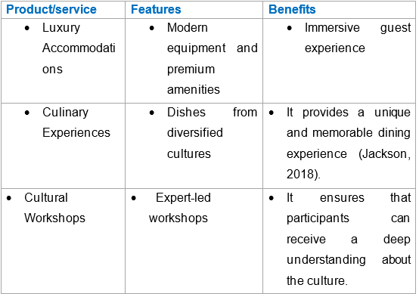
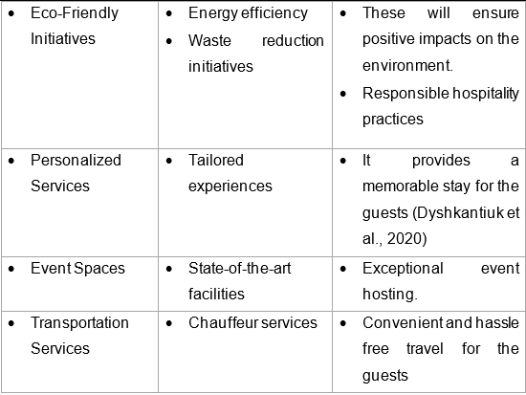

7 What makes the business different (Value Proposition)
Newcastle Cultural Haven Hotel's value propositions are differentiated from other hotel businesses because the hotel makes sure that the guests can have local cultural heritage in their hospitality experiences such as accommodation, dining, and events (Baines, Fill and Rosengren, 2018).

8 Legal requirements (including regulations and licences particular to business)
The following legal requirements must be complied with for the hotel:
Register as a limited company in companies house
The hotel needs licensing for alcohol and entertainment sold under the Licensing Act 2003 (UK Government, 2019).
Health and Safety at Work Act 1974 needs to be complied with.
Food Safety Act 1990 and Food Hygiene Regulations 2006.
Data Protection Act 2018 and GDRP (GOV.UK, 2018).
Employment Rights Act 1996.
The Equality Act 2010 to ensure accessibility to all.
Insurance Requirements: Employer’s liability, public liability, property, product liability, and professional indemnity insurances should be covered by the company to overcome all the risks associated with the hotel operations (Direct Line, 2024).
The legal requirements should be met in the following ways:
The hotel should be registered with a company house as a limited company.
The hotel will receive licences from the local council for selling alcohol and entertainment (UK Government, 2019).
Regular assessment must be conducted to determine the health and safety of the employees (Health and Safety at Work Act, 1974).
The hotel should be registered with the local environmental health department because it will serve food to the guests. Moreover, the staff must be well-trained and certified to maintain hygiene and safety (Brent, 2023).
The hotel should use a strong firewall to protect customer data and restrict third party access.
The company has to implement HR policies that will maximise the well-being of the staff.
The hotel will keep the necessary initiatives to ensure access to all guests including the disabled ones.

Marketing

9 Market research
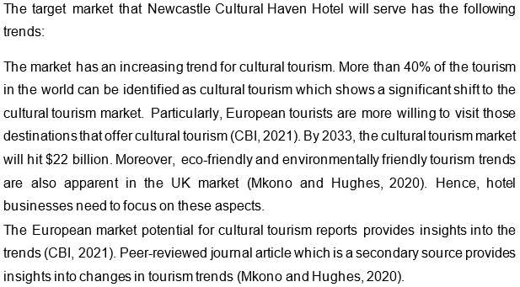

10 Profiling customers

The customer groups you will be selling to are: (4 x Customer profiles minimum)
- Cultural Enthusiast: The customer segment may be aged between 25 to 52 and they have a high level of interest in cultural aspects. They have high education and earnings.
- Business Travellers: They are aged 35 to 55 and have high income levels (Kim et al., 2020).
- Family Vacationers: The customer segment consists of children and parents and usually they have a middle income level.
- Event Attendees: They are aged 20 to 40 years old. They have a high interest in cultural events and programmes.

Your customer research has shown what your customers want is:
Cultural enthusiasts want attractions of the local culture, cultural events, and immersive experiences from the hospitality services.
Business travellers want business amenities such as office space, high-speed internet, and comfortable stay (Kim et al., 2020).
Family Vacationers want adjoining rooms and dining services.
Event attendees want group discounts and convenient transportation.

How you know this:
Al-Ababneh (2019) found in their research what the cultural enthusiast’s customer segments want. Wang et al. (2020) provide evidence of other customer segment preferences in the hotel businesses like Newcastle Cultural Haven Hotel.

Number of customers you expect to win in each group and what they might pay:
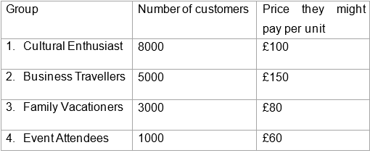
According to Statista (2023), business travellers are willing to spend more on the hotel. Statista (2022) explains that event attendees and family vacationers are likely to pay less due to the COVID-19 pandemic and economic downturns in the UK.

11 Profiling competitors

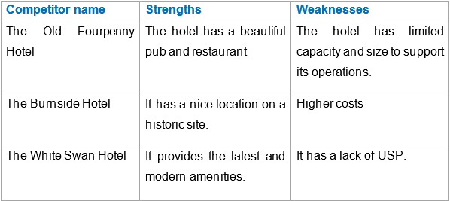
Enz (2015) explains that when hotels are offering the same services to the same markets, they become direct competitors to one another. Hence, these three hotels are direct competitors to the Newcastle Cultural Haven Hotel because they all serve the same region and market with similar hospitality offerings.

How you can improve on their offer and/or price(s) unique offerings:
- The hotel should highlight the cultural themes by developing rooms and suites reflecting various cultural aspects. It will offer customised services to the guests to meet their unique needs and preferences. The use of AI and big data analytics might be useful in this regard. By partnering with other local businesses, it can ensure that the guests can have immersive cultural experience such as workshops and different cultural themed dining experiences (Mary George et al., 2014; Samara, Magnisalis and Peristeras, 2020).

12 Managing market risks

Write down the risks you have identified:
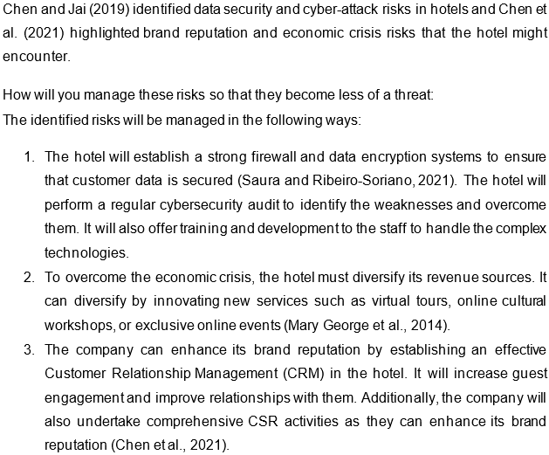

13 Pricing

How you can calculate your prices:
- The hotel will use a cost-based pricing strategy because it is simple to apply and it overcomes the risks of underpricing for various hospitality services (Barringer and Ireland, 2019).

How your prices compare with the competition:
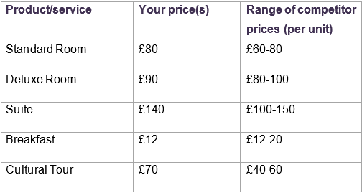

Reasons for the difference between your price(s) and your competitors’ price(s):
- The hotel charges comparatively higher prices than the competitors due to its cost structure and value perception. The hotel offers greater value than the competitors. It has installed the latest and modern amenities and so the prices become comparatively higher (Burns, 2022).

14 Promotion and advertising

How and where will you promote your product/service?
The marketing and promotion plan for the hotel is given below:
Digital Marketing:
- SEO: The hotel will utilise SEO to increase the visibility of the business online. SEO will ensure that the guest can have easy access to the website (Baines, Fill and Rosengren, 2018).
- Targeted Online Advertising: Google Ads and social media platforms will be used to make targeted ads based on demographics and other factors.
- Social Media Marketing: The hotel will use Facebook, Twitter, and Instagram to increase customer engagement and showcase the hotel's amenities and offers.
Email Marketing: To make loyal customers, the hotel will send personalised emails to the guests (Jan et al., 2023).
Partnerships: The hotel will establish partnership with the local businesses to gain their existing customer base (Baines, Fill and Rosengren, 2018).

Running the business

15 Staff

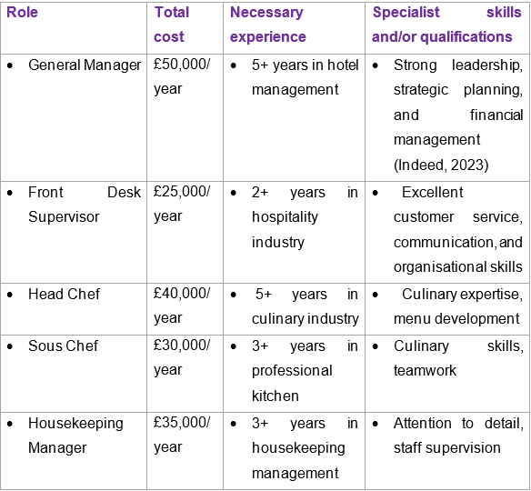

16 Premises

 | Cost £
Premises required at start-up: | £120,000
Premises required in the future (if different): | £50,000

17 Suppliers

Your key suppliers and their credit terms
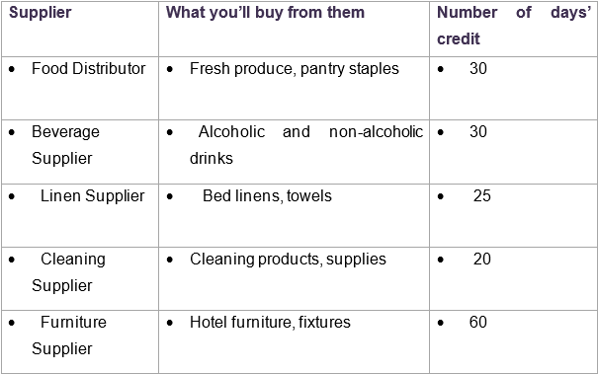

18 Equipment
Kitchway (2024) provides the prices and requirements for the equipment for the hotel.
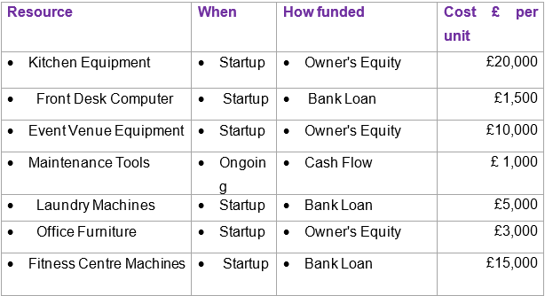

19 Managing operational risks

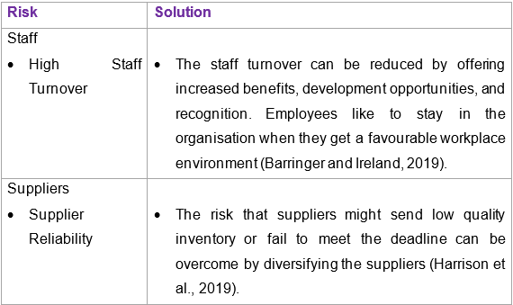

Finance

20 Start-up costs

Calculate how much money you need before you start trading

21 Profit and loss forecast

22 Sourcing finance

Total borrowing requirement for the business

23 Managing financial risks

The risks that you have identified for your financial forecast are:
El Haddad (2015) identified revenue shortages as a financial risk in the hotel business. Annamalaisami and Kuppuswamy (2019) identified cost overrun as a financial risk and Wieczorek-Kosmala (2021) identified liquidity shortage as a financial risk for hotel businesses. These risks are relevant to the business.

How you will minimise their impact:
El Haddad (2015) emphasises an effective revenue management system to address revenue shortage issues which sets relevant pricing strategies based on the accurate forecast. Annamalaisami and Kuppuswamy (2019) explain that the cost estimation must be realistic considering the changing market factors to overcome the risk of cost overrun. Wieczorek-Kosmala (2021) suggests finding different liquidity sources such as banks.

24 Cash flow forecast (Click on the tabs within the Microsoft Excel sheet to view the second 6 months and summary)

25 Conclusion
Newcastle Cultural Haven Hotel is a profitable business. Investors can benefit from its high potential to grow in the market. However, adequate funding is necessary to support the venture implementation.

26 Reference list
Al-Ababneh, M.M. (2019). Creative Cultural Tourism as a New Model for Cultural Tourism. [online] papers.ssrn.com. Available at: https://ssrn.com/abstract=3633645 [Accessed 23 May 2024].
Annamalaisami, C.D. and Kuppuswamy, A. (2019). Reckoning Construction Cost Overruns in Building Projects through Methodological Consequences. International Journal of Construction Management, pp.1–11. doi:https://doi.org/10.1080/15623599.2019.1683689.
Baines, P., Fill, C. and Rosengren, S. (2018). Marketing. Oxford University Press.
Barringer, B.R. and Ireland, R.D. (2019). Entrepreneurship Successfully Launching New Ventures. 6th ed. Harlow London New York, Ny Boston [U.A.] Pearson.
Bjerke, M.B. and Renger, R. (2017). Being Smart about Writing SMART Objectives. Evaluation and Program Planning, [online] 61(1), pp.125–127. doi:https://doi.org/10.1016/j.evalprogplan.2016.12.009.
Brent (2023). Food Safety Regulations | Brent Council. [online] Brent Council. Available at: https://www.brent.gov.uk/business/food-safety-and-hygiene/food-safety-regulations#:~:text=Under%20the%20Food%20Safety%20Act [Accessed 23 May 2024].
Burns, P. (2022). Entrepreneurship and Small Business : start-up, Growth and Maturity. London: Red Globe Press an Imprint of Macmillan Education Limited.
CBI (2021). The European Market Potential for Cultural Tourism | CBI. [online] www.cbi.eu. Available at: https://www.cbi.eu/market-information/tourism/cultural-tourism/market-potential#:~:text=The%20European%20market%20for%20cultural%20tourism%20is%20significant. [Accessed 23 May 2024].
Chen, C.-C., Khan, A., Hongsuchon, T., Ruangkanjanases, A., Chen, Y.-T., Sivarak, O. and Chen, S.-C. (2021). The Role of Corporate Social Responsibility and Corporate Image in Times of Crisis: the Mediating Role of Customer Trust. International Journal of Environmental Research and Public Health, [online] 18(16), pp.1–20. doi:https://doi.org/10.3390/ijerph18168275.
Chen, H.S. and Jai, T.-M. (Catherine) (2019). Cyber alarm: Determining the Impacts of Hotel’s Data Breach Messages. International Journal of Hospitality Management, 82, pp.326–334. doi:https://doi.org/10.1016/j.ijhm.2018.10.002.
Direct Line (2024). Hotel Insurance - Get Started with a Personalised Quote Today. [online] Direct Line for Business. Available at: https://www.directlineforbusiness.co.uk/small-business-insurance/hotel-insurance [Accessed 23 May 2024].
Dyshkantiuk, O., Salamatina, S., Polishchuk, L., Komarnytskyi, I., Tserklevych, V. and Nedobiichuk, T. (2020). Modern Hotel Business Management Tools. [online] papers.ssrn.com. Available at: https://ssrn.com/abstract=3645056.
El Haddad, R. (2015). Exploration of Revenue Management Practices – Case of an Upscale Budget Hotel Chain. International Journal of Contemporary Hospitality Management, 27(8), pp.1791–1813. doi:https://doi.org/10.1108/ijchm-08-2013-0390.
Enz, C.A. (2015). Competing Successfully with Other Hotels: the Role of Strategy. The Cornell School of Hotel Administration on Hospitality, [online] pp.207–226. doi:https://doi.org/10.1002/9781119200901.ch15.
GOV.UK (2018). Data Protection. [online] Gov.UK. Available at: https://www.gov.uk/data-protection#:~:text=The%20Data%20Protection%20Act%202018%20is%20the%20UK [Accessed 23 May 2024].
Grande, K. and Camprubi, R. (2022). Analysing the Business Model Canvas of the Camping Industry Using Cluster Analysis. Tourism and Hospitality Research, p.146735842211413. doi:https://doi.org/10.1177/14673584221141301.
Harrison, B., Foley, C., Edwards, D. and Donaghy, G. (2019). Outcomes and Challenges of an International Convention centre’s Local Procurement Strategy. Tourism Management, 75, pp.328–339. doi:https://doi.org/10.1016/j.tourman.2019.05.004.
Health and Safety at Work Act (1974). Health and Safety at Work etc. Act 1974. [online] Legislation.gov.uk. Available at: https://www.legislation.gov.uk/ukpga/1974/37/contents [Accessed 23 May 2024].
Indeed (2023). 39 Types of Hotel Jobs You Can Pursue. [online] Indeed Career Guide. Available at: https://www.indeed.com/career-advice/finding-a-job/what-are-the-different-jobs-in-a-hotel [Accessed 19 Feb. 2024].
Jackson, E. (2018). Hotel Management. New York, Ny: Larsen & Keller.
Jan, A., Khan, M., Ajmal, M.M. and Ataul Karim Patwary (2023). From Traditional Advertising to Digital marketing: Exploring Electronic Word of Mouth through a Theoretical Lens in the Hospitality and Tourism Industry. Global knowledge, Memory and Communication. doi:https://doi.org/10.1108/gkmc-08-2022-0199.
Kim, D., Hong, S., Park, B.-J. and Kim, I. (2020). Understanding Heterogeneous Preferences of Hotel Choice attributes: Do Customer Segments matter? Journal of Hospitality and Tourism Management, 45, pp.330–337. doi:https://doi.org/10.1016/j.jhtm.2020.08.014.
Kitchway (2024). Hotel Kitchen Equipment | Commercial Hospitality Equipment. [online] Kitchway. Available at: https://kitchway.co.uk/pages/hotel-kitchen-equipment-commercial-hospitality-equipment [Accessed 23 May 2024].
Mary George, N., Parida, V., Lahti, T. and Wincent, J. (2014). A Systematic Literature Review of Entrepreneurial Opportunity recognition: Insights on Influencing Factors. International Entrepreneurship and Management Journal, [online] 12(2), pp.309–350. doi:https://doi.org/10.1007/s11365-014-0347-y.
Mkono, M. and Hughes, K. (2020). Eco-guilt and eco-shame in Tourism Consumption contexts: Understanding the Triggers and Responses. Journal of Sustainable Tourism, 28(8), pp.1223–1244. doi:https://doi.org/10.1080/09669582.2020.1730388.
Samara, D., Magnisalis, I. and Peristeras, V. (2020). Artificial Intelligence and Big Data in tourism: a Systematic Literature Review. Journal of Hospitality and Tourism Technology, 11(2), pp.343–367. doi:https://doi.org/10.1108/jhtt-12-2018-0118.
Saura, J.R., Ribeiro-Soriano, D. and Palacios-Marqués, D. (2021). From user-generated Data to data-driven innovation: a Research Agenda to Understand User Privacy in Digital Markets. International Journal of Information Management, [online] 60, p.102331. doi:https://doi.org/10.1016/j.ijinfomgt.2021.102331.
Statista (2022). UK consumer spending on restaurants and hotels 2020. [online] Statista. Available at: https://www.statista.com/statistics/476625/restaurant-and-hotels-consumer-spending-uk/ [Accessed 23 May 2024].
Statista (2023). Topic: Business Travel in the United Kingdom. [online] Statista. Available at: https://www.statista.com/topics/9789/business-travel-in-the-united-kingdom/#topicOverview [Accessed 23 May 2024].
UK Government (2019). Licensing Act 2003. [online] Legislation.gov.uk. Available at: https://www.legislation.gov.uk/ukpga/2003/17/contents [Accessed 23 May 2024].
Wang, L., Wang, X., Peng, J. and Wang, J. (2020). The Differences in Hotel Selection among Various Types of travellers: a Comparative Analysis with a Useful Bounded Rationality Behavioural Decision Support Model. Tourism Management, 76, p.103961. doi:https://doi.org/10.1016/j.tourman.2019.103961.
Wieczorek-Kosmala, M. (2021). COVID-19 Impact on the Hospitality industry: Exploratory Study of financial-slack-driven Risk Preparedness. International Journal of Hospitality Management, 94, p.102799. doi:https://doi.org/10.1016/j.ijhm.2020.102799.

27. Appendix- Presentation
Slide 1
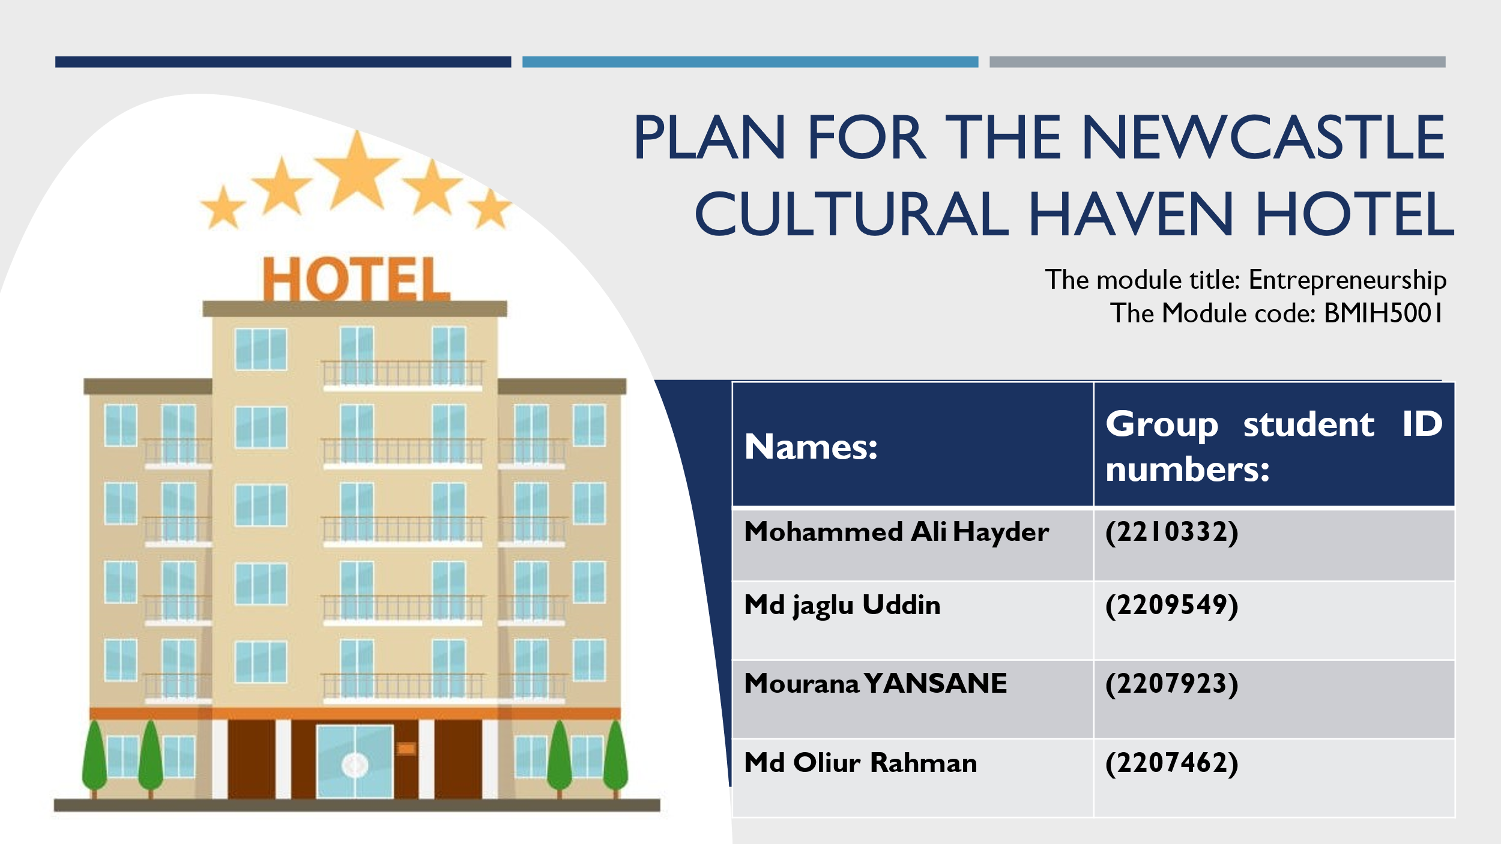
Slide 2
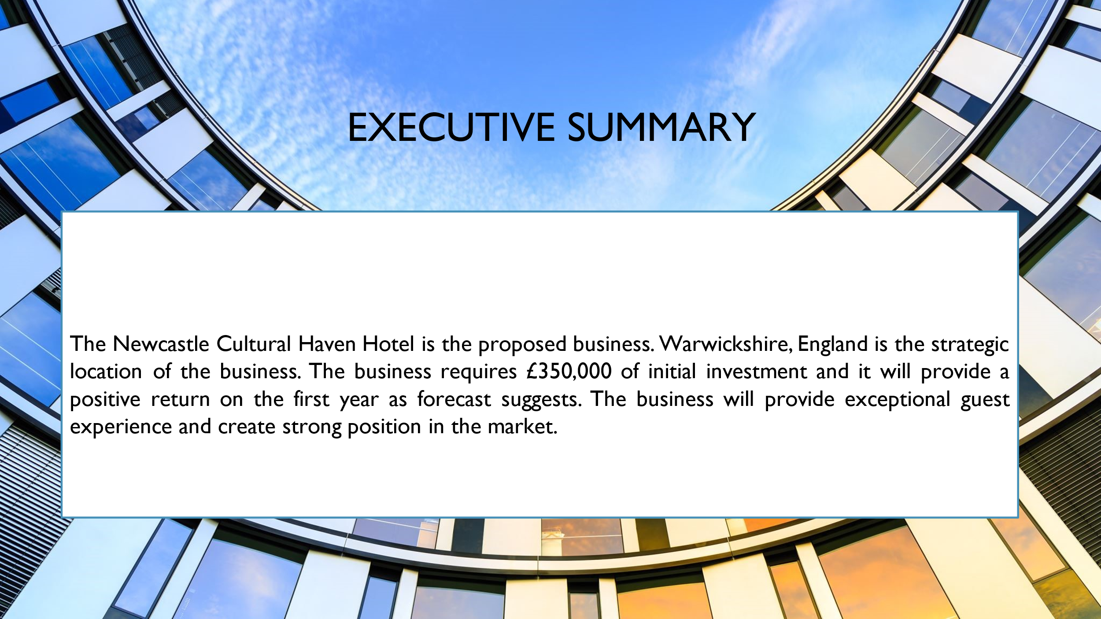
Slide 3
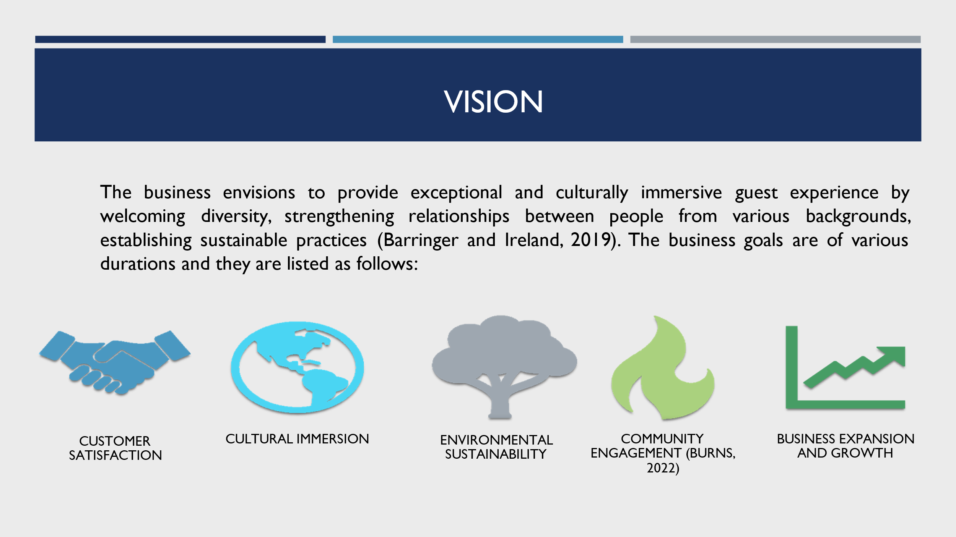
Slide 4
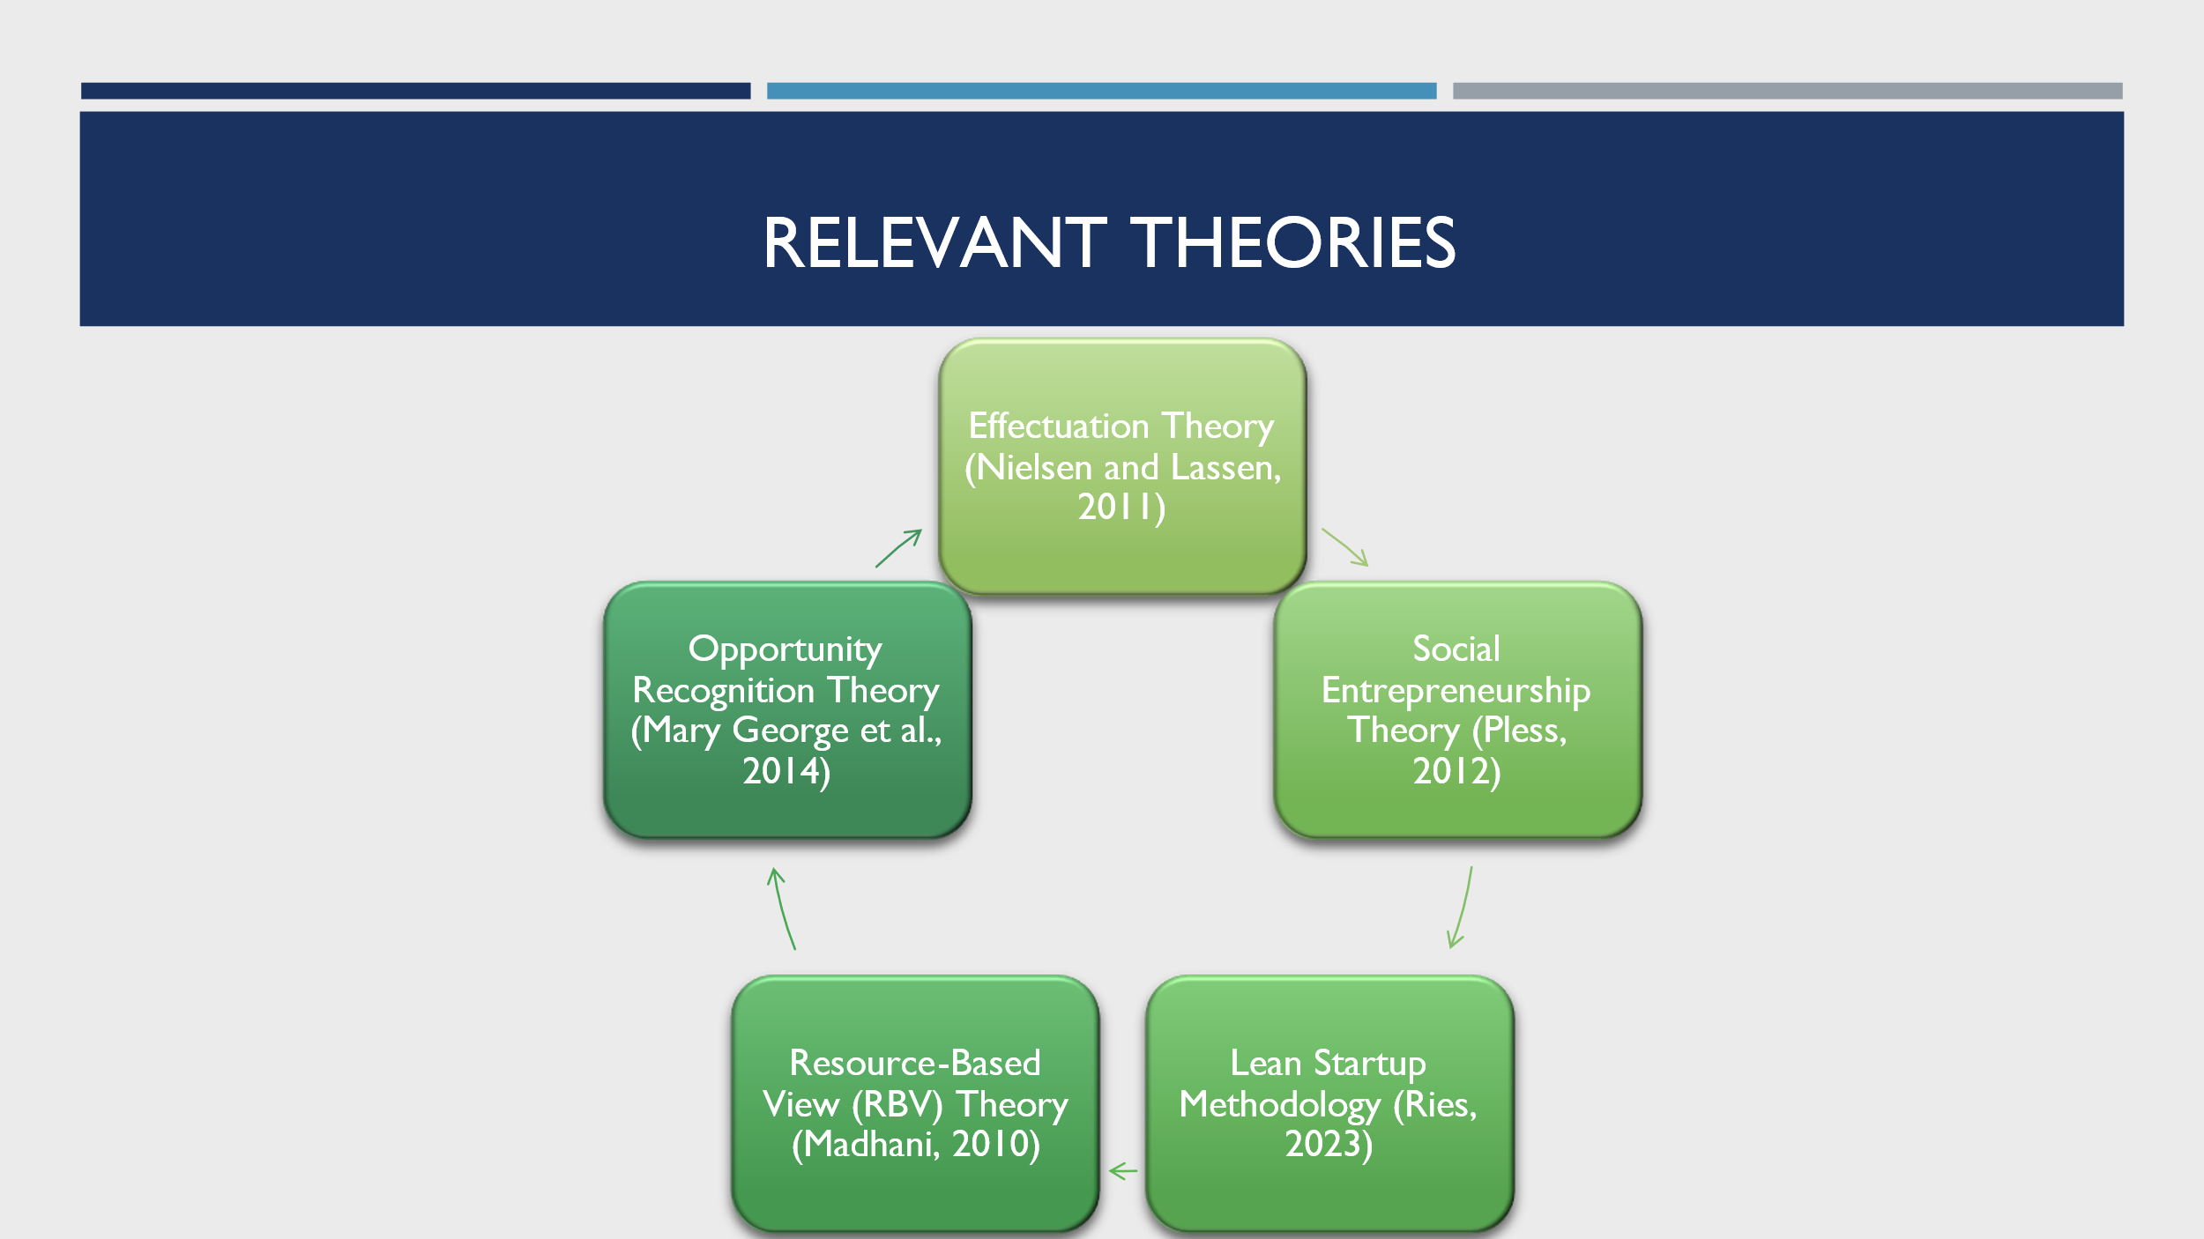
Slide 5
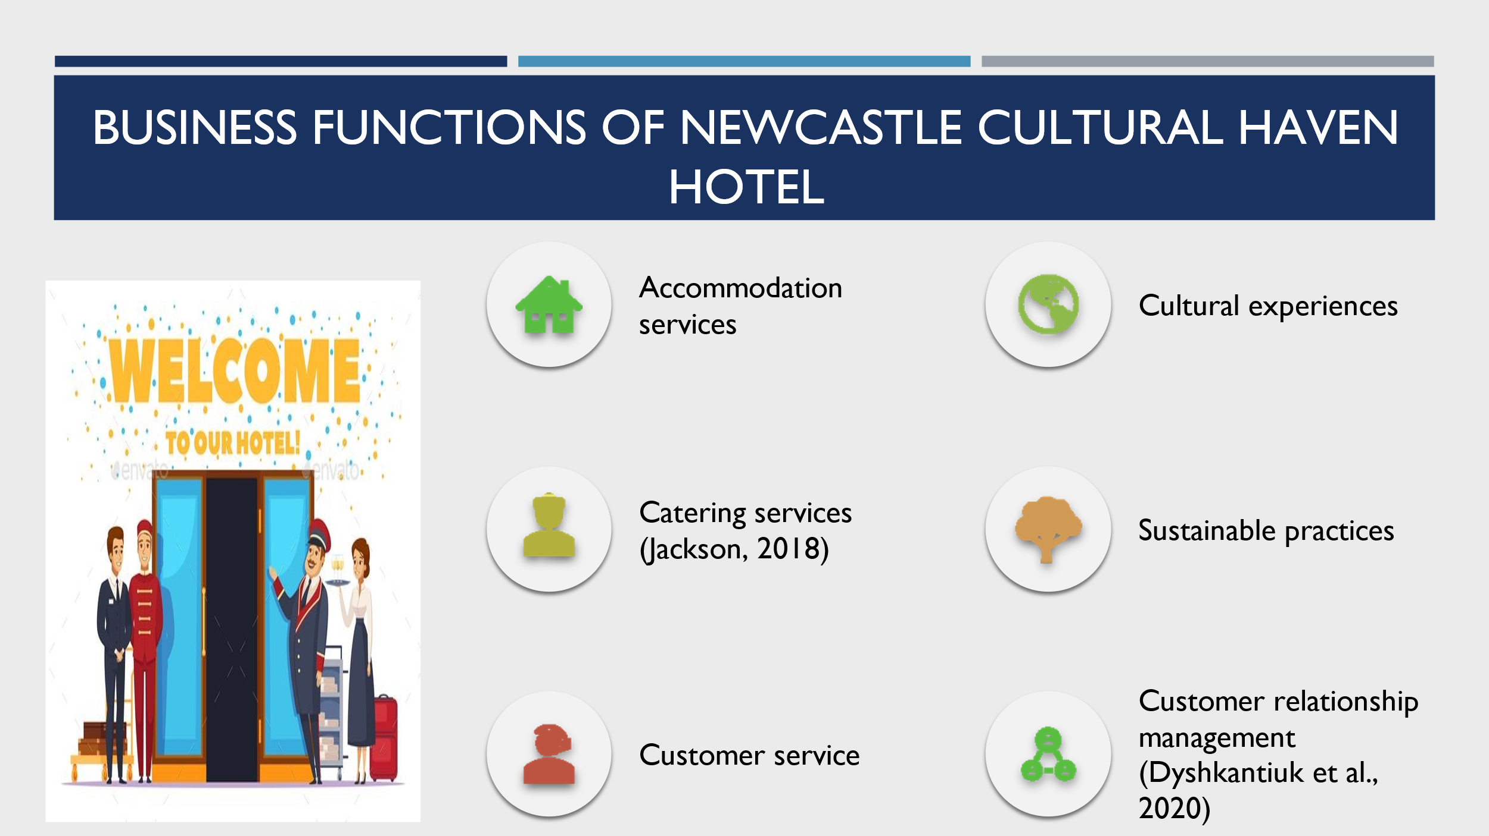
Slide 6
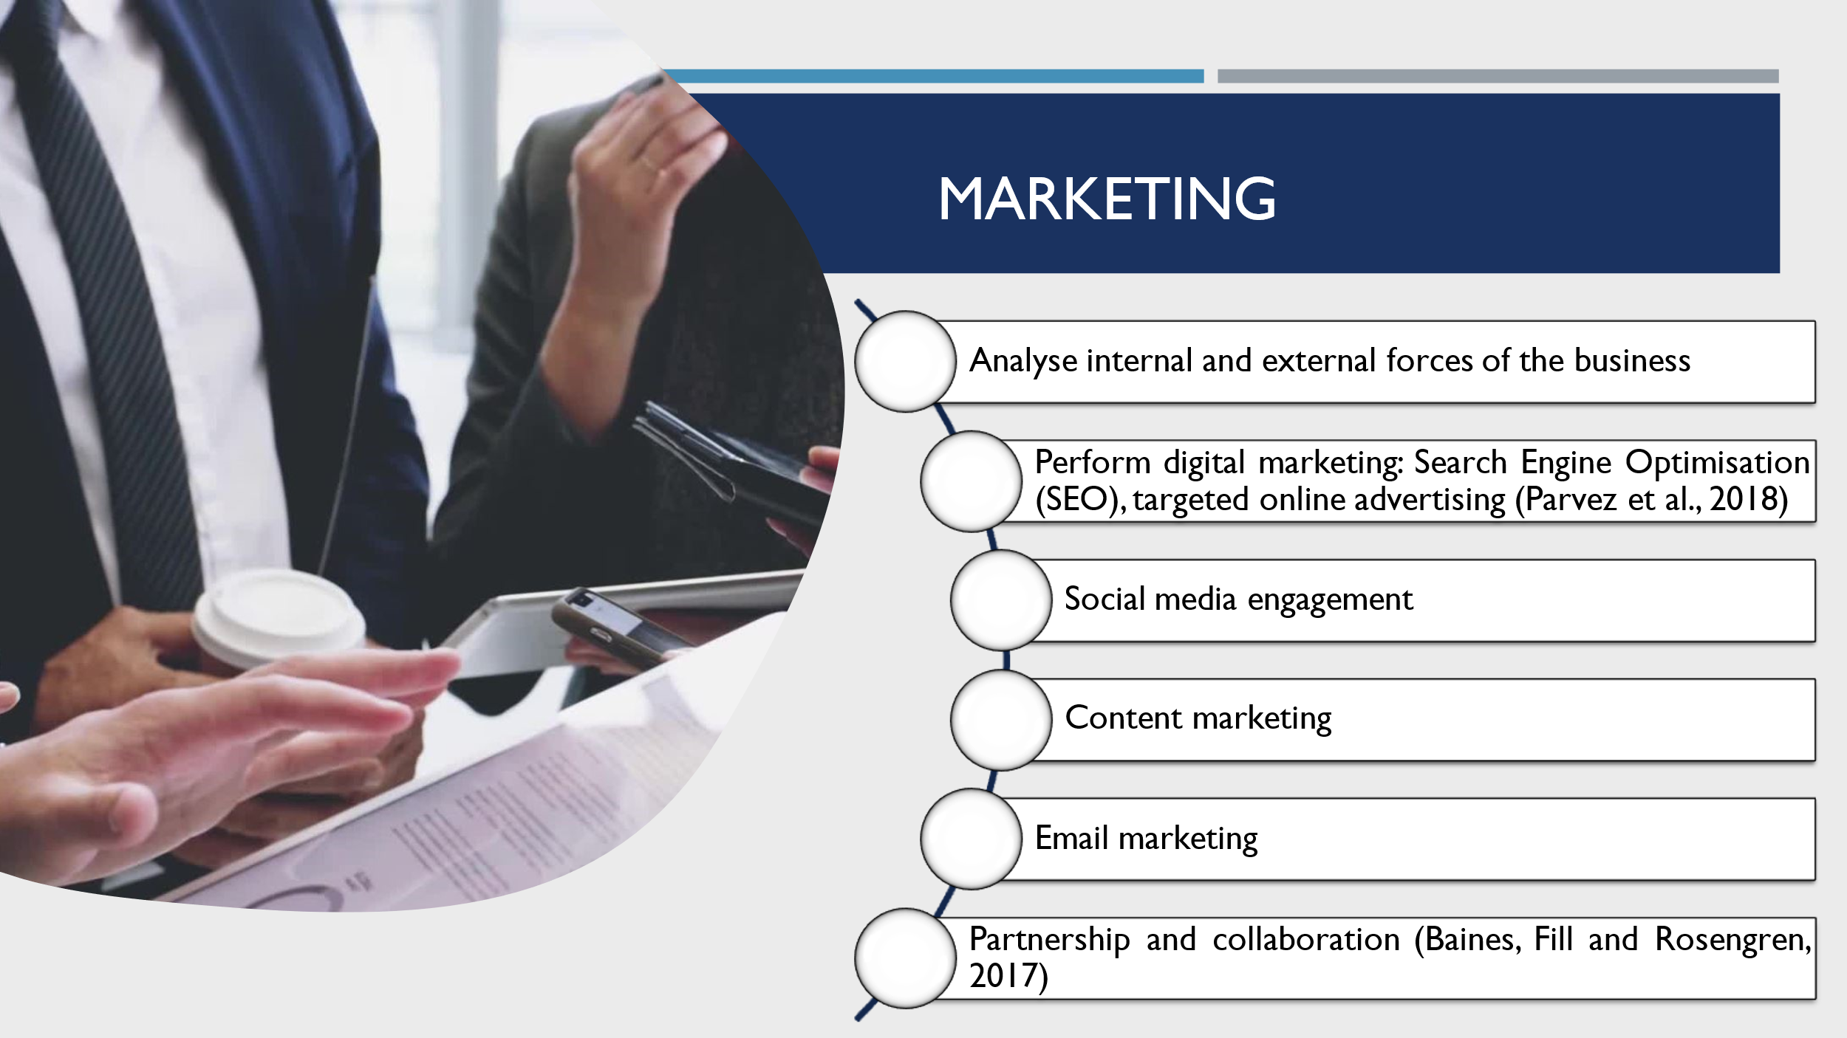
Slide 7
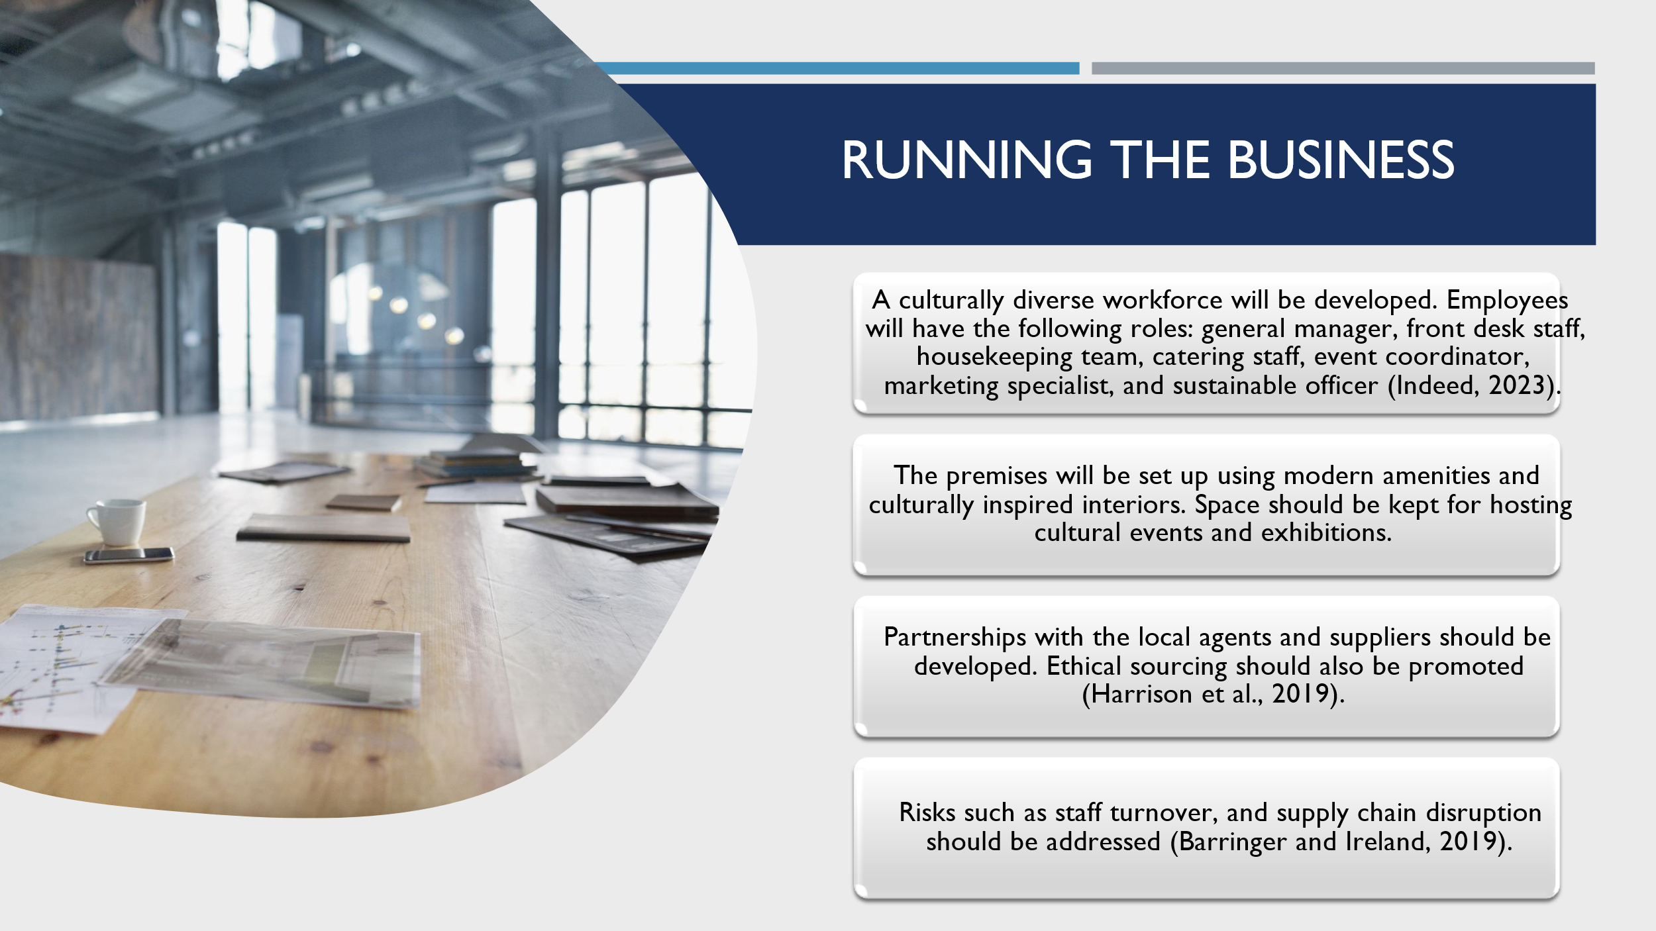
Slide 8
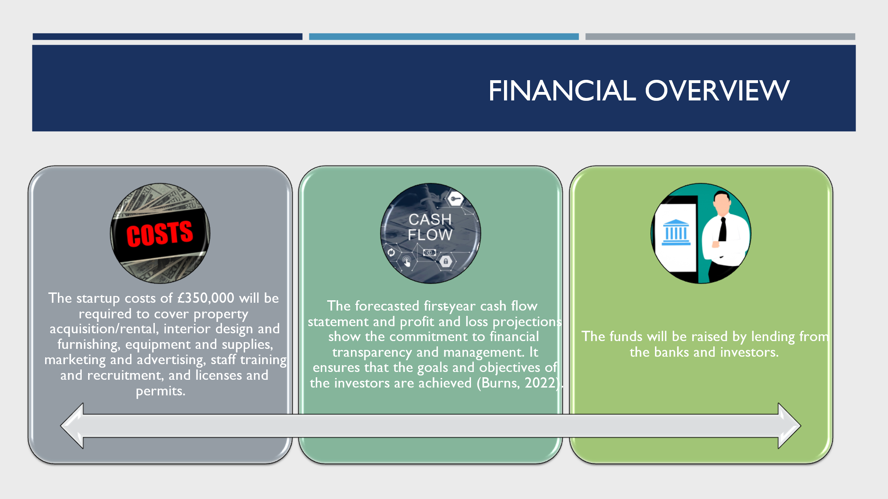
Slide 9
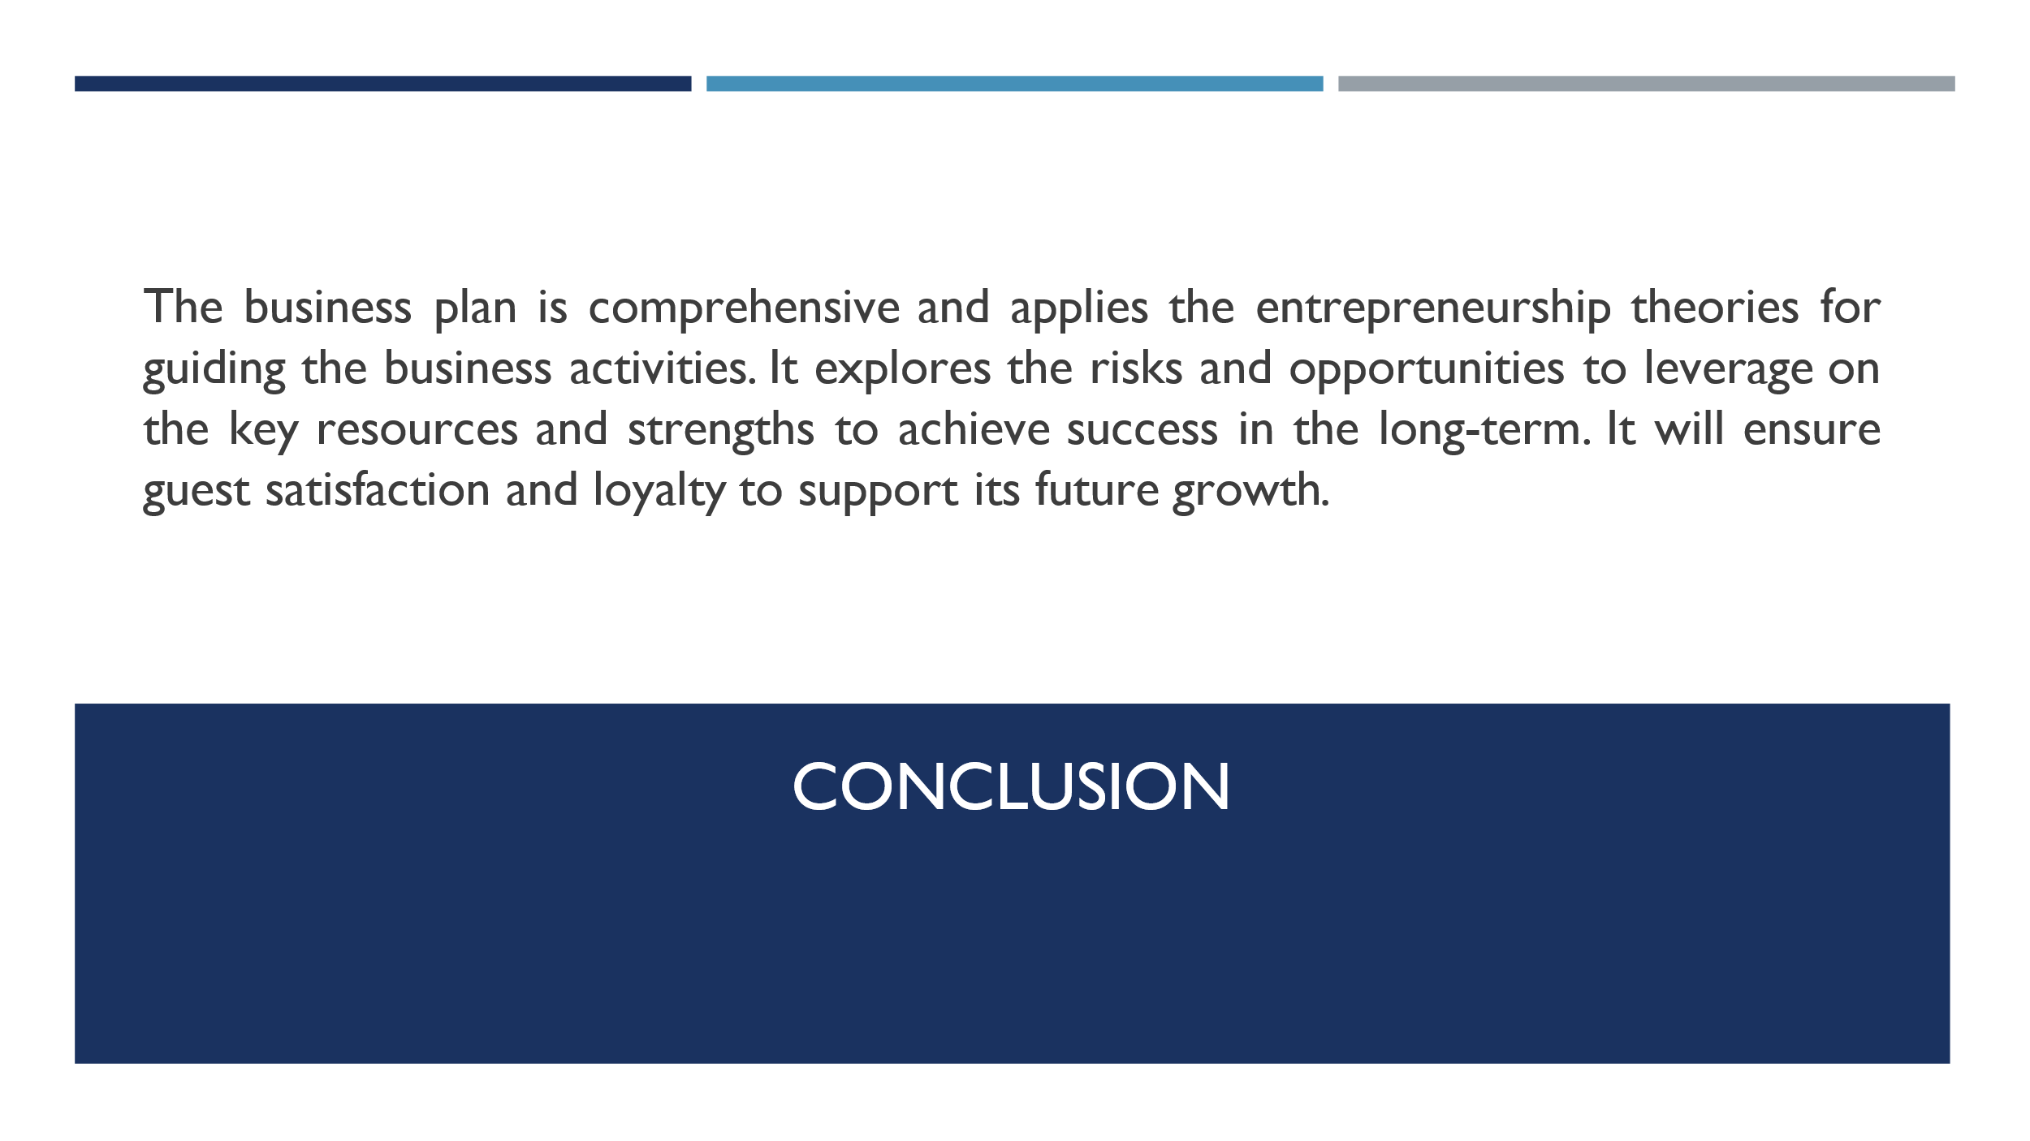
Slide 10


