
managing projects in the organisation (bmsw5104_card
RIPARA BEGUM 1709528

December 20, 2019
University of Wales Trinity Saint David

Table of Contents
Introduction 2
Conclusion 11
Appendix 15

Introduction

Project management what it means, it involves planning tasks or activities in phases to achieve the goals and aims of a project in a timeframe. In order to have a successful outcome and goals by organising, using resources in the project. Therefore to have a successful project need to go through a project life cycle. The project life cycle has five phases in the life cycle which are, initiation, planning, Executing, Monitoring and controlling, closing (PMI, 2019, Lucid Chart, 2017).
The team selected to do the project for was MEND organisation, MEND is a community-funded organisation trying to establish Islamophobia awareness in the community and how to tackle it through Muslim engagement, development (Mend.Org, 2019). Also to develop knowledge and understanding of project management using different tools and techniques Quad chart, stakeholder analysis (Chegg Study, 2019, Product Plan, 2019).

Main findings
Starting in the beginning of the project there must be a project manager. Reflecting on selecting a project manager for the project this was done using Belbin team roles. Also looking at individuals’ expertise possessed, everyone possessed different expertise according to Belbin theory model to make a successful team for the project. According to the model each of the team associates have abilities and knowledge that relate to the Belbin's team roles. A plants role is to be keen on resolving situations and overcome obstacles, also has an awareness and always open to new concepts to take on board. The implementer Is practical, resourceful and dependable. Likes to work according to plan but can also be flexible if needed. The coordinator role exists as a good listener, calm, good-natured, like to take up responsibility, delegate tasks very effectively to get the job done on time. The completer finisher Likes to finalise things and make sure every detail is achieved. Also appreciates doing the IT side of things. The Team Worker according to Belbin's theory he believes that helping team members gain their goals and achievement. It Also, improves team performance, Belbin's roles tie strongly with every team member skill possessed (Business Coaching, 2019).

The team members decided on selecting the strongest individual who also possessed skills of strong leadership skills and the role of the plant from the Belbin’s team role. Having a strong leadership skill are important to lead a project along with good communication, sharing a vision, team management, delegation, creativity and honest to be a project leader according to Upwork, 2017. Project Managers help project to have a vision, direction of the project. Enables leadership, motivation for all members in the project and a person to delegate the project matters also to have someone to be accountable for the project (The Digital Project Manager, 2017).
Tool the Quad Chart (initiation phase)
In the project the initiation phase was to choose MEND, organisation every member expressed that by arranging a workshop and fundraising. The quad chart tool used in the project the initiation phase to work with MEND, decided to organise an workshop which would include a food sale and a presentation for awareness of islamophobia as well as this, also arranged to fundraise by collecting donations from class associates, friends and family. The quad chart tool has four segments which are.
purpose – therefore the project is being done and the effect of the project having on the outcomes result of the project.
Customers – this would be who the project is for, such as the stake holders and who is involved in the project and whether it will benefit the stake holders.
Desired end result- this is the goal that we reach at the end of the project and the achievement of what makes a successful project.
Measures of success – this is final segment which results in how we measured success and what was measured in time frame of the project.
Values - the values that an organisation trust in to ensure that those values are met and supposed by others in order to make an effective organisation. (Chegg Study, 2019, MEND, 2019).
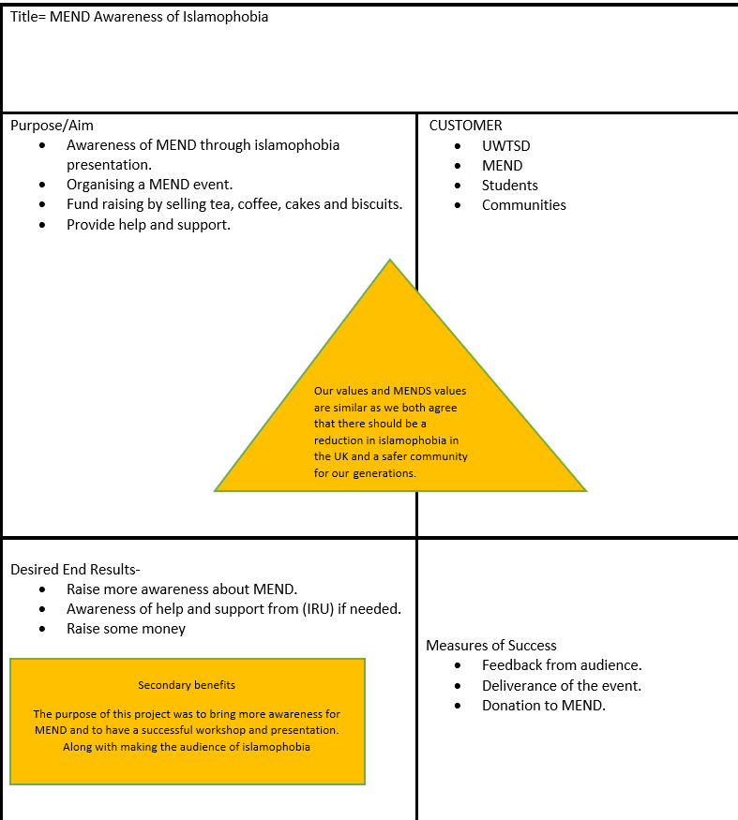

A Tool called Work Breakdown Structure (WBS)
In the planning stage used a tool called the work breakdown structure it identifies breaking down tasks or activities into manageable pieces for the team. The WBS outlines what needs to be accomplished, tasks organised in small pieces, it’s easy to understand chart, manageable elements. The WBS was used by the bottom-up approach this was the appropriate method for the project involving unapproved methods and approaches that wasn’t used before. The team brainstormed to generate all activities needed to be done for the project and grouped them into categories and breakdown in small pieces. This is a WBS for the project that was done for MEND project also, all activates were colour coded for everyone to follow which activates with their name, colour to make it easy to follow (WBS, 2019, Markgraf, B., 2019).
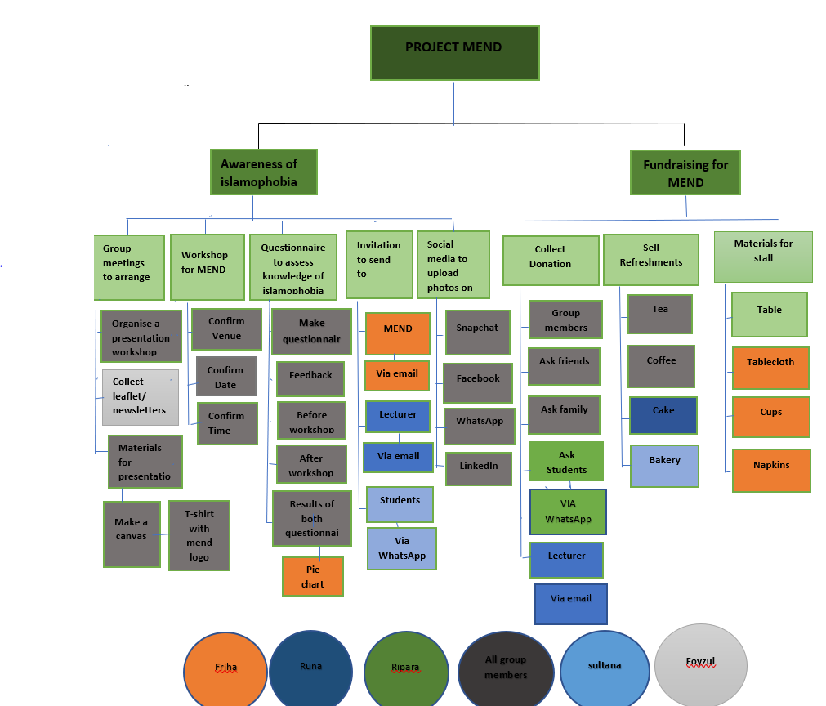

TOOL STAKEHOLDERS ANALYSIS
After a successful planning and initiation stage, the team started the execution process of the project life cycle. This was where the deliverables result, and the project come together the processes to obtain achievement of the goals planned. Stakeholders are individuals who focusses on the projects. Stakeholders are the individuals who capitalises in the project, who will be affected by the project at any time and their contribution can directly affect the result of the project.
It is therefore vital to continually communicate with the Stakeholders in order to co-operate on the project. However those stakeholders who have the impact and ability to dictate whether a project is a success or not, they make or break the project, they are the people or assemblies whose objectives must be satisfied according to Product Plan, (2019). Execution phase used a tool to risk analysis grid this is the stakeholder analysis of Mend organisation.
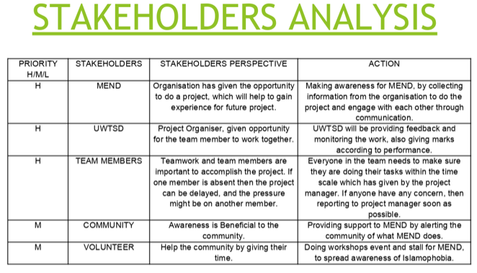
To prioritise Stakeholders of MEND, there are three stakeholders who have the main importance they are: MEND – The organisation itself, has given the opportunity to do the project, which will help to gain knowledge for doing forthcoming projects. The Achievement will be making awareness for MEND, by assembling info from the organisation to do the project and engaging with each other through communication. UWTSD – The main project organiser, giving the chance to work together as a team. The Action will be monitoring the work, providing feedback and results of outcome given according to performance.
Team Members – Team members and teamwork are very significant to accomplish the project, if one member is missing, then the pressure might be on another member. The Action will be every member needs to make sure doing their tasks within the time scale if any problems arise, then reporting to the project manager soon as it arises.
Stakeholders who are prioritise in Medium position are: Community – Awareness is Valuable to the public and action will be providing backing to MEND.
Volunteer – Helping the public by giving their time. Action will be doing workshop events, stalls for MEND to spread awareness of Islamophobia. We communicated with our Stakeholders through, emails, WhatsApp chat, and verbally.
According to SWOT Analysis of MEND, their weakness is not everyone is aware about the organisation and their awareness to respond to Islamophobia. MEND seeks to allow British Muslims to be more actively involved in media and politics, but British Muslims have remained demoted in public sector, their contribution extremely low according to MEND, (2019). Therefore, undertaking this MEND Alertness Workshop, the organisation will be known by the public (Reference for Business, 2019).
The monitoring and evaluation phase
In the monitoring phase is a vital stage were team members reflect on all tasks period which include team performance any issues in the project. Monitoring all tasks development, progress and acting on any issues faced to take actions for the aims to be meet in the timeframe. Therefore a Gannt chart tool was used to monitor the tasks that were needed to be achieved in a certain timeframe which had a start date, finishing date and number of weeks it took to complete. The Gannt chart is an informal way to show team members in a project visually the progress of tasks planned layout and expected date to be completed. The only change that was made to the Gannt chart was the workshop date, which was a week later than planned due to students not being in (knowledge Hut, 2017, Carroll, J. 2011, Training Zone, 2019).
This was the completed Gannt chart used in the project.

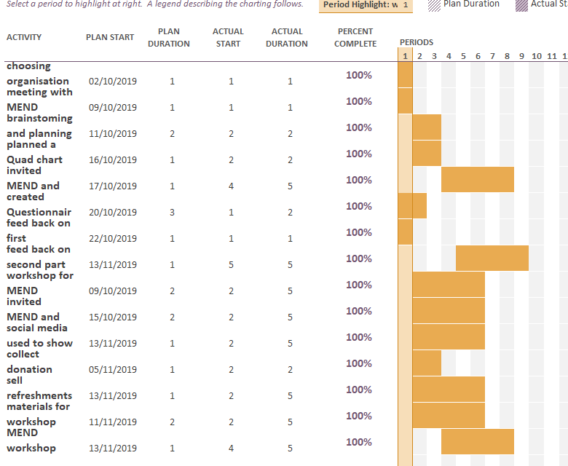
Also used a questionnaire before the workshop to monitor the audience awareness of the organisation and Islamophobia. The questionnaire was the soft outcome of the project and the hard outcome was the results of the questionnaire which was in a pie chart. Also having a good teamwork and effective communication with all members though out the project staying focused on the SMART objectives from start to finish of the project (Reference, 2019, Network for Europe, 2003). This is the hard outcome results of pie chart from the questionnaire.
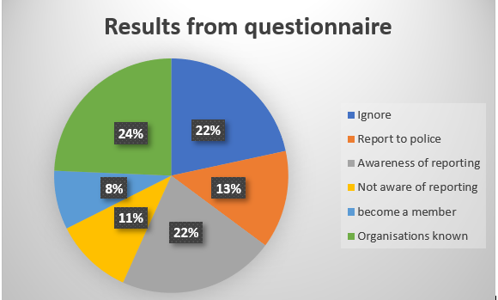
A PESTAL analyst tool to monitor the external factors that have an impact directly to the organisation when implementing strategies and decision making at MEND organisation. Using the PESTAL tool helps organisations monitor the external marketing environmental that influence the performance (CIPD, 2018).
To monitor the risks the team used a tool called the iron triangle. These three elements need to be managed in project delivery; each point is connected to the triangle moving one point affects the other two points.

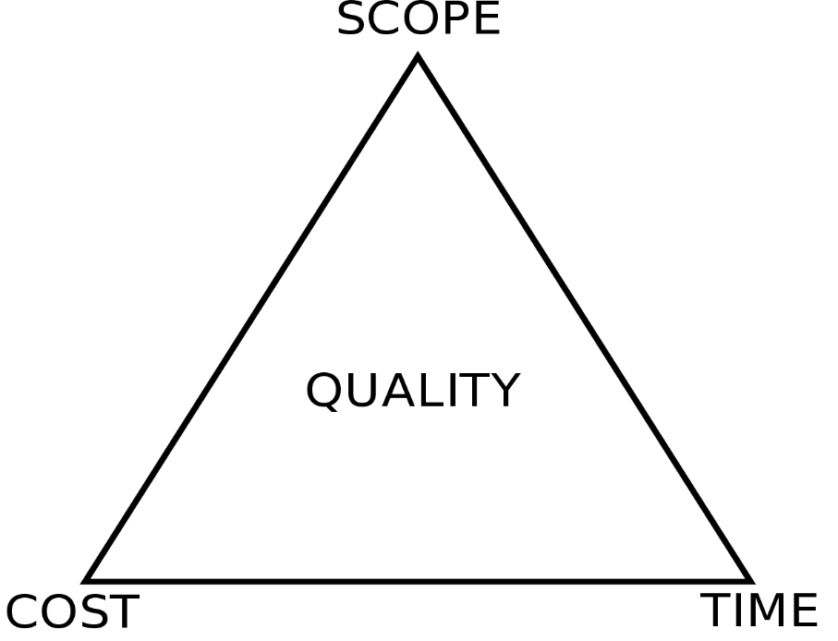

There are three elements in the iron triangle:
Cost – there were no funding available which was limited to only team members contributing and limited supplies available from organisation.
Time – this is mainly due to lack of communication and response from organisation.
Product – preparing the workshop for MEND to raise awareness for organisation. Included a presentation, arranging a food sale in the workshop (Copper Team, 2017, stakeholder Map. Com, 2008).
Risk management is recognising the possible risks that may transpire. Measuring their potential effect they could have on the project. Risk management help minimising the undesirable effects and reviewing them throughout the project. The two types of risks, external and internal. External risks are things outside of the projects control such as weather problems and internal which can occur during the project but can usually be resolved.
Also 3 types of constraint risks which are product risk – this is a risk which prevents from achieving the project.
Schedule risk – this is a risk which prevents the project element from its deadline and the resource risk – this is a risk which averts having enough or the correct resources to completing the project. A risk analysis its illustrations the understanding of the tool and shows that the impact and likelihood are the main priorities, if the risk analysis tool is not used this is a risk within the project and things may not go to plan.
To minimise risks and prevent things from going wrong we created a risk analysis, in the risk analysis as a group we listed the potential risks and the impacts they would have on the project (Lavanya, N. Malarvizhi, 2008).

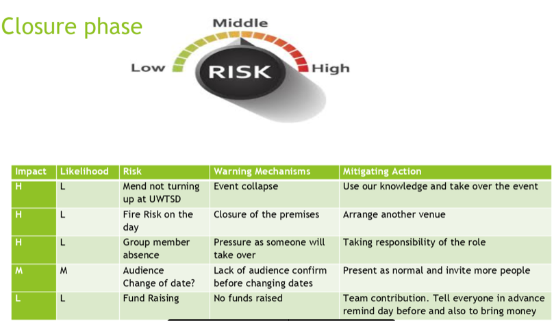

Reflecting on the project using Gibb’s reflecting cycle (1988) of the experiences what has been learned, what could have done differently in the project. In the different phases in the project cycle, planning, monitoring and Evaluation and the project manager’s role in the project. There are key chractistics of a project with a goal, specific outcome, start date initiated, a project manager to run the project on achieving a successful outcome (The University Edinburgh, 2019).
The evaluation phase although the workshop was a successful outcome, few points to evaluate for next time is having more time to prepare for a bigger venue to host the fundraising with more people and wider audience for the presentation on awareness of Islamophobia and the organisation. Although communication was a barrier at sometimes from the organisation not responding on time, this made the project not running as smoothly as the project manager desired and individual felt confused (Nut Cache, 2019). However the project was a success, fundraising went well than expected (Lucid Chart, 2017, MEND,2019).

Conclusion
Therefore to conclude numerous tools, techniques like, Quad chart, Iron triangle, stakeholder analysis can be used to manage projects to effectively at different phases of the project life cycle (Lucid Chart, 2019, Chegg Study, 2019, Copper Team, 2017, Product Plan,2019). In order to overcome risks and manage the project smoothly. Also having effective communication with organisation and team members are vital for the achievement of the project throughout (Nut Cache, 2019).

Recommendation
The recommendation would be to have better communication between the project manage and organisation for the project to run smoother and overcome issues. Given more time the workshop could hosted in a bigger venue and more audience for awareness and fundraising (Nut Cache, 2019, Lucid Chart, 2017, MEND, 2019).

Reference
Carroll, J. (2011), Effective Project Management (2nd Edition) United Kingdom: Easy Steps [accessed on 20/11/2019].
Chegg Study, (2019), ‘what is a Quad Chart’ [online]. Available at: https://www.chegg.com [accessed on 20/11/2019].
CIPD, (2018), ‘PESTLE Analysis’ [online]. Available at: https://www.cipd.co.uk/knowledge [accessed on 22/11/2019].
Copper Team, (2017), ‘What are the Iron Triangle Constraints of Project Management’ [online]. Available at: https://www.copperproject.com [accessed on 20/11/2019].
Knowledge Hut, (2019), ‘How Important is Project Monitoring and How Do We Implement It Through’ [online]. Available at: https://www.knowledgehut.com [accessed on 20/11/2019].
Lavanya, N. & Malarvizhi, (2008), ‘Risk Analysis and Management’ [online]. Available at: https://www.pmi.org [accessed 22/11/2019].
Lucid Chart, (2017), ‘The 4 Phases of the Project Management Life Cycle’ [online]. Available at: https://www.lucidchart.com [accessed on 21/11/2019].
Markgraf, B. (2019), ‘The Importance of a Work Breakdown Structure|Chorn.com’,[online]. Available at: https://www.smallbusiness.chorn [accessed on 21/11/2019].
MEND, (2019), ‘Islamophobia awareness’ [online]. Available at: https://www.mend.org.uk [accessed on 21/11/2019].
MEND, (2019), ‘Islamophobia Awareness’ [online]. Available at: https://www.mend.org.uk [accessed 21/11/2019].
MEND, (2019), ‘MEND’ [online]. Available at: https://www.mend.org.uk [accessed 19/11/2019].
Network for Europe, (2003), ‘A Practical Guide to Measuring soft outcomes’ [online].available at: https://www.networkforeurope.eu [accessed on 22/11/2019].
Nut Cache, (2019), ‘Five Reasons That Justify the Important of Communication in Project Management’ [online]. Available at: https://www.nutcache.com [accessed on 06/12/2019].
Product Plan, (2019), ‘What is Stakeholder Analysis?’ [Online] Available at: https://www.productplan.com [Accessed 23rd November 2019].
Project Manager, (2019), ‘What is a Gantt Chart’ [online]. Available at: https://www.projectmanager.com [accessed on 20/11/2019].
Reference for Business, (2019), ‘SWOT Analysis – Strategy, Organization, levels’ [online]. Available at: https://www.referenceforbusiness.com [accessed on 18/11/2019].
Reference, (2019), ‘Why Should You Use Questionnaire As a Method’ [online].available at: https://www.reference.com/world-view/should-use-questionnaires-research-method-1a6a5567acb545a4 [accessed on 21/11/2019].
Stakeholder map. Com, (2008), ‘Project-Triangle’ [online]. Available at: https://www.stakeholdermap.com/ [accessed on 10/12/2019].
The Digital Project Manager, (2017), ‘Why is Project Management Important’ [online]. Available at: https://www.thedigitalprojectmanager.com [accessed on 04/12/2019].
The University of Edinburgh, (2019), ‘Gibbs Reflective Cycle’ [online]. Available at: https://www.ed.ac.uk/reflection [accessed on 04/12/2019].
Training Zone, (2019), ’11 Key Indicators of good Team Performance’ [online]. Available at: https://wwwtrainingzone.co.uk [accessed on 21/11/2019].
University of Cambridge, (2019), ‘Belbin Team Theories’ [online]. Available at: https://www.ifm.cam.ac.uk [accessed on 05/12/2019].
Upwork, (2017), ‘7 Leadership Qualities Every Project Manager Should Possess’ [online]. Available at: https://www.upwork.com/hiring [accessed on 04/12/2019].
WBS, (2019), ‘What is a Work Breakdown Structure (WBS)’ [online]. Available at: https://www.workbreakdownstructure.com [accessed on 18/11/2019].

Appendix

