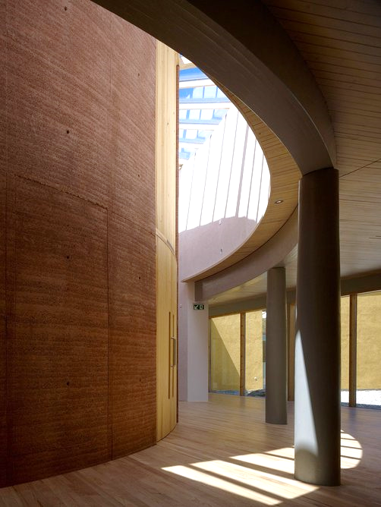

THE WALES INSTITUTE FOR SUSTAINABLE EDUCATION

-DREW DENNEHY

The WISE Building

What is CAT?
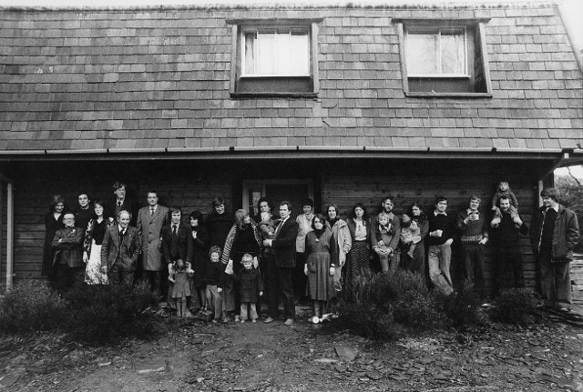
Located in Machynlleth, Powys the Centre of Alternative Technology (CAT) is Europe’s leading eco-centre (Welsh Government, 2012). CAT began on the site of a disused quarry in 1973, as a community reacting to the 1970s oil crisis and set out to experiment with alternative technologies to live off-grid (Hilling, 2018, p. 257). Today, the centre has become a thriving hub for sustainable education, offering post-graduate courses and educational workshops that receive over 65,000 annual visitors (DCFW, n.d).

Figure 1, photo of CAT staff in 1978 (CAT, 2020)

Pat Borer and David Lea designed the Wales Institute for Sustainable Education (WISE) as their 3rd collaboration with the centre (Jones, 2011). Situated in the North-Eastern corner of the site, the WISE building is an exemplar of CAT’s ecological principles, utilising natural materials and renewable technologies to produce an efficient, low-carbon design: not only when in use but throughout its construction. Commencing in June 2006, the project stretched over 4 years to construct, finishing in June 2010 at a cost of £4.5 million (roughly £2,200 per m²) (Woodman, 2010).
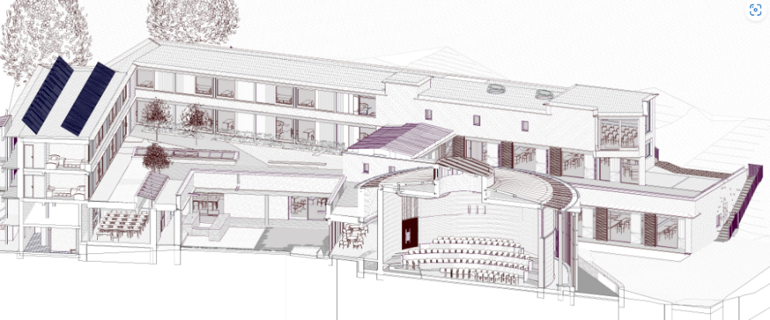

Figure 2, cutaway axonometric projection (Jones, 2022)

The main entrance to the WISE building is an extension of the old factory cafeteria that directs you to the reception and toward the heart of the building. To the South sits the 200-seat Sheppard Theatre, named after Graham Sheppard: a benefactor who donated £650,000 towards the project (BBC, 2010). The idea of a round auditorium came from the client that took inspiration from buildings in Denmark, though it is also pantheon-like with its circular form and oculus roof light (Jones, 2022). Wrapping around the lecture hall is a fully glazed corridor that floods the interior spaces with natural daylight and blurs the boundary between exterior and interior. Exploring the Western exterior places you in the courtyard, which adopts Japanese influence throughout and offers a sense of calm to the user. There are slate-lined ponds, gargoyles, and a diverse range of shrubbery that create a visual space for contemplation (Architectural Review, 2010). “We wanted all the spaces to relate to the landscape, and for the spaces to unfold as you move through it and come upon surprising views of nature” – Lea (Jones, 2022).
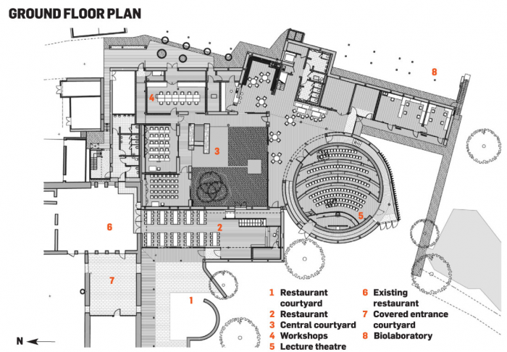

Figure 3, ground floor plan of the WISE building (Woodman, 2010)

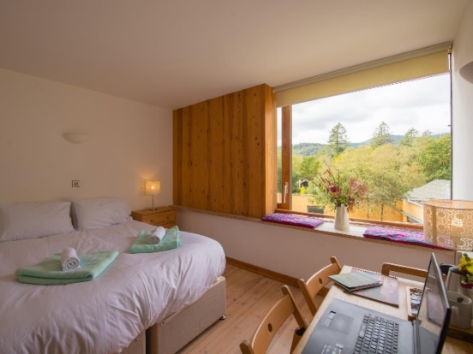
In addition to lecture space, the project included a research lab, restaurant, bar and overnight accommodation (E-architect, 2012). The accommodation came as 24 ensuite twin bedrooms which the students or the public can pay to stay in, costing between £60-£80 per night (see figure 4) (CAT, 2019). The space is also available to hire as an event or wedding space.

(Figure 4, one of the 24 ensuite bedrooms built within WISE (CAT, 2019)

Materiality
Embodied energy is the total amount of energy used to create a product: the closer and less power-intensive it is, the lower its embodied energy (Yuksel, 2018). This was one of CAT’s primary considerations when deciding the material palette for the WISE building. The online journal, Architectural Review, refers to the building as “an example that energy saving requires no architectural compromise, ugliness or loss of quality” (Architectural Review, 2010).
Standing at 7.2m, this project contains the highest rammed earth wall in the UK (Woodman, 2010). With advice sought from consultants Rowland Keable and Andy Simmonds, the earth was sourced from Llynclys Quarry (Shropshire), where a waste product was selected with a grading of 6mm particles or less (Satriya, 2013). This was then positioned in layers of 100mm and pneumatically rammed, taking multiple trial and error attempts. The wall amounted to 320 tonnes of earth and is structurally sound (Jones, 2011). Additionally, due to its thermal mass the wall performs well acoustically and thermally, as do the other internal walls which are made from earth blocks (TEDx Talks, 2018).
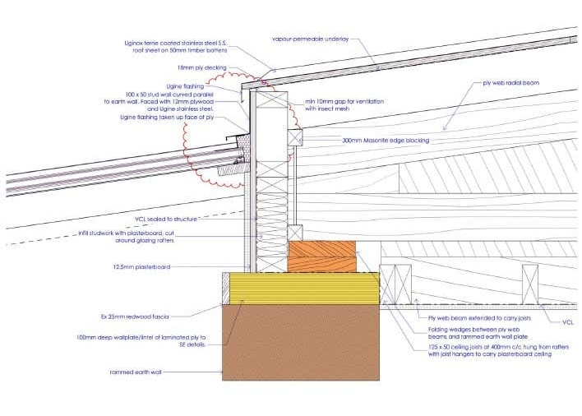
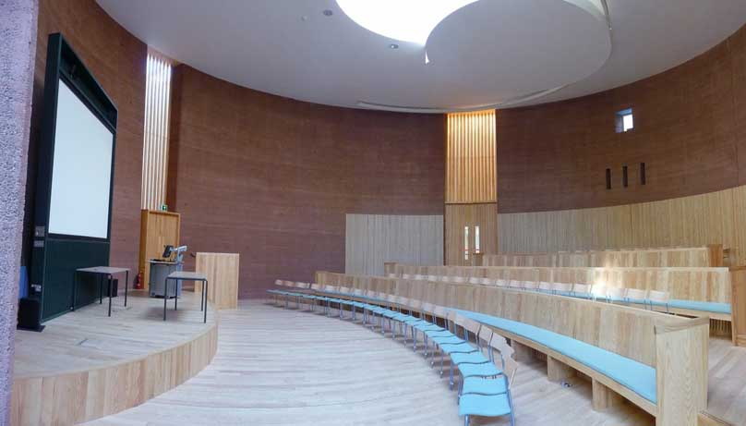

(Figure 6, detail of the earth wall to roof joint (Satriya, 2013)
(Figure 5, the Sheppard Theatre (E-architect, 2012)

The design team made every effort to locally source the materials, however, due to its size and complexity, the timber frame came from Denmark (Jones, 2022). The walls were constructed using FSC-certified (Forest Stewardship Council) European Whitewood glulam timbers, linked together by steel flitch plates (Buro Happold, n.d.). The toxic chemical Formaldehyde is used in the production of glulam beams, however, CAT reports that it is very minimal and much less energy intensive than steel. The roof is made up of FSC-rated timber I-beams which are clad with recycled, ultra-thin stainless steel and insulated with 450mm of cellulose (U-value 0.09W/m²K) (CAT, 2019). It is worth mentioning that the timbers used to support the roof were left untreated from toxins to be recycled easily at the end of their use. To support the main frame, it was placed on plinth walls made from sand-lime bricks which are steam pressurised, as opposed to clay bricks fired in an oven, reducing their embodied energy (Borer et al, 2009). These bricks expand and contract from moisture, so movement joints were designed-in to accommodate this (CAT, 2019).
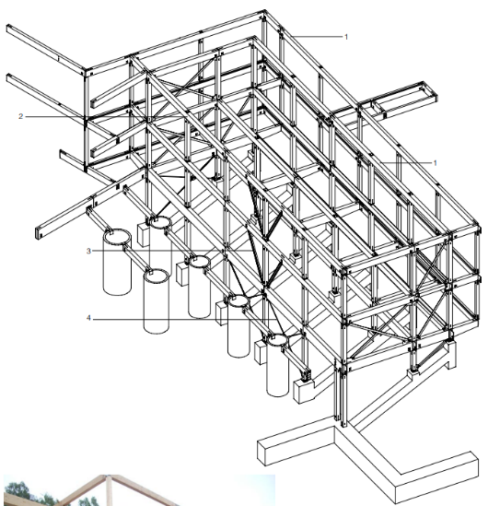

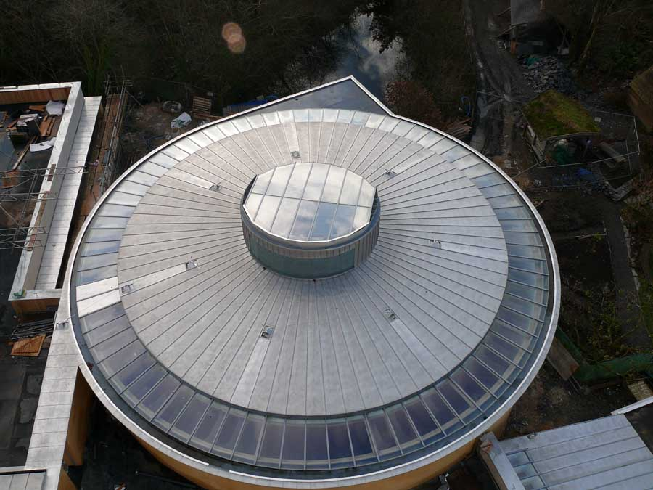

Key
1 - 350 x 150mm glulam beam, connected with steel flitch plates to 150 x 150mm Douglas fir posts
2 - 350 x 200mm glulam beam, connected with steel flitch plates to 200 x 200mm Douglas fir posts
3 - frame braced with small 125 x 65mm Parallel flange channels (PFCs)
4 - frame braced with galvanised steel flats

Figure 8, part of glulam frame in WISE (TRADA, 2012
Figure 7, Sheppard Theatre roof (E-architect, 2012)

Hemp is a sustainable resource used in thousands of products that, when mixed with a concrete binder, create a high-performance construction material: hempcrete. Once erected, hempcrete was sprayed and cast into the timber frame onto Heraklith (wood wool) board to achieve a thickness of 500mm: containing a binder of 15% concrete to achieve a U-value of 0.14W/m²K (TRADA, 2012). This type of construction creates a wall that is non-fibrous, breathable, regulates the humidity and doesn’t require a vapour barrier (Lupu, et al., 2022). Brick cavity walls are also used within the design, insulated with perlite and capped off with limecrete (Borer et al, 2009).
The foundation was made by levelling the ground with low-grade slate sourced directly from the site and laying a steel-reinforced strip foundation. Despite their efforts to minimise the use of concrete, it was necessary to achieve a sufficient level of strength and stiffness, though replacing half the portland cement with ground-granulated blast-furnace slag (GGBS) significantly reduced the embodied energy. CAT continued to express their principles in material choice throughout every element of the building by using triple glazed, low E-coated glass (U-value 1.1-1.4w/m²k), clay piping where ever possible (as opposed to PVC) and using cork insulation to prevent thermal bridging through the foundations (Borer et al, 2009).
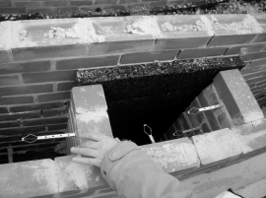

(Figure 9, cork being used to prevent thermal bridging (Satriya, 2013)

RENEWABLE TECHNOLOGIES
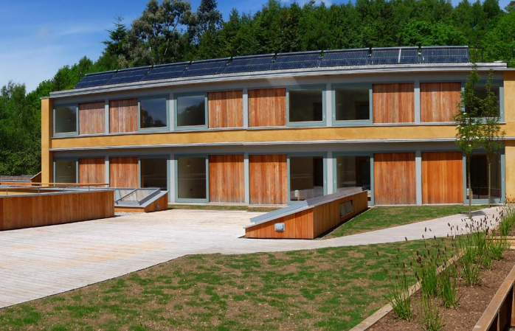
Borer and Lea were just as selective and considerate when it came to optimising the performance of the WISE building and reducing its energy demand. The project uses passive design features and fully maximises the suns potential for energy generation and natural daylight. 70m² of evacuated solar thermal collectors are fixed to the roof of the accommodation; donated to CAT by NG Bailey Ltd, an engineering and services business (Welsh Government, 2012). These collectors provide approximately 66% of the annual hot water demand and are backed by the site’s wood-fuelled district system (Welsh Government, 2012). A biomass combined heat and power unit (CHP) supplies heat to the interior spaces with a gas backup. The carbon emissions associated with burning woodchips are negligible due to the local supply and the amount of carbon absorbed throughout photosynthesis.

Figure 10, solar collectors above accommodation roof (TRADA, 2012)
Vents were strategically placed at high and low levels at both ends of the rooms to create an updraught of warm air and promote regular air changes (CAT, 2019). A heat exchanger was integrated into the mechanical ventilation inside the lecture hall to replace stale air with fresh, warm air (Welsh Government, 2012). Also, the oculus roof light has a retractable cover which can be positioned as necessary at any given time to aid in heating or cooling the room (Jones, 2011). High-performance glazing encompasses the theatre, enhancing natural light and minimising unwanted solar gain.
Like the rest of the site, the WISE building was fitted with low-flush toilets that drain out to a reed bed filtration system, and surface water is drained back into the earth via soakaways (Borer et al, 2009).

PERFORMANCE
After its completion in 2010, the WISE building was closely monitored to compare its actual performance against its theoretical performance. The project achieved an emission rate of 19kg CO/m²/annum: over 70% less than the target rate of 75.4kg CO/m²/annum (Welsh Government, 2012). The building performed just as well regarding its energy consumption figures, heat energy demand was 41% lower than predicted and electricity (54Mwh/annum) was half what it was estimated to be (Welsh Government, 2012). Ecotect environmental analysis software was used from the early stages of the project and helped to achieve these statistics and ensure a minimum daylight factor of at least 3 (Jones, 2022).

This project received various awards, namely the Dewi-Prys Thomas prize: a prestigious award that recognises the importance of good design to the quality of life, identity and regeneration of Wales (BBC, 2012). Since it was founded in the 1900s, CAT has been very experimental in its pursuit of a greener future, and its WISE building is no exception. There is a full range of local, natural materials and a diverse range of technologies to raise the bar for sustainable architecture around the world.
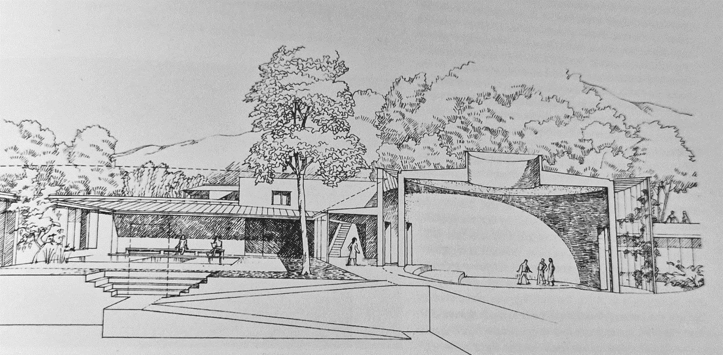
Figure 11, early drawing of the WISE building by David Lea (Hilling, 2018, p. 257)

References
Architectural Review (2010) Wales Institute for Sustainable Education by David Lea and Pat Borer, Machynlleth, Wales, UK. Retrieved from Architectural Review: https://www.architectural-review.com/today/wales-institute-for-sustainable-education-by-david-lea-and-pat-borer-machynlleth-wales-uk (Accessed: 10th December 2022).
BBC (2010) State-of-the-art eco-centre opens near Machynlleth. Retrieved from BBC News: https://www.bbc.co.uk/news/10282109 (Accessed: 10th December 2022).
BBC (2012) Dewi-Prys Thomas Trust: Machynlleth WISE building's prize. Retrieved from BBC: https://www.bbc.co.uk/news/uk-wales-mid-wales-20560406 (Accessed: 10th December 2022).
Buro Happold (n.d.) A WISE building with sustainable principles. Retrieved from Buro Happold: https://www.burohappold.com/projects/wales-institute-of-sustainable-education/# (Accessed: 10th December 2022).
CAT (2019) Stay. Retrieved 12 06, 2022, from Centre for Alternative Technology: https://cat.org.uk/come-to-cat/stay/ (Accessed: 10th December 2022).
CAT (2019) The WISE Building. Retrieved from Center for Alternative Technology: https://cat.org.uk/info-resources/free-information-service/building/the-wise-building/ (Accessed: 10th December 2022).
CAT (2020) History. Retrieved December 06, 2022, from Centre for Alternative Technology: https://cat.org.uk/history-2/ (Accessed: 10th December 2022).
DCFW (n.d) Wales Institute for Sustainable Education Centre for Alternative Technology. Retrieved from Design Commission For Wales: http://dcfw.org/wales-institute-for-sustainable-education-centre-for-alternative-technology/ (Accessed: 10th December 2022).
E-architect (2012, December 6) Machynlleth Building: Education Centre Development Wales. Retrieved from E-architect: https://www.e-architect.com/wales/machynileth-wise-building (Accessed: 10th December 2022).
Hilling, J. B. (2018) Recent developments 1986-2017. In J. B. Hilling, The Architecture of Wales (p. 257). Cardiff: RIBA. (Retrieved December 09, 2022).
Jones, P. B (2011) Wales Institute for Sustainable Education. Retrieved from ProQuest: https://www.proquest.com/docview/847024979?accountid=130472&parentSessionId=VMm0CapZ7l3EFreKH930j%2F7FzNkTq2NaUeucNeeOd5E%3D&pq-origsite=primo (Accessed: 10th December 2022).
Jones, P. B (2022) 'From the archive: WISE building at the Centre for Alternative Technology by David Lea and Pat Borer', Architects' Journal. Retrieved from: From the archive: WISE building at the Centre for Alternative Technology by David Lea and Pat Borer (architectsjournal.co.uk) (Accessed on: 10th December 2022).
Lupu, M. L., Isopescu, D. N., Baciu, I.-R., Maxineasa, S. G., Pruna, L., & Gheorghiu, R (2022) 'Hempcrete - modern solutions for green buildings, Materials science and engineering (pp. 2-8). Bristol: IOP conference series. Retrieved from: Hempcrete - modern solutions for green buildings - ProQuest (Accessed on: 10th December 2022).
Pat Borer, R. H. et al. (2009) 'THE WALES INSTITUTE FOR SUSTAINABLE EDUCATION'. Non-conventional Materials and Technologies. Bath: NOCMAT. Retrieved from: Microsoft Word - Paper 174.doc (solaripedia.com) (Accessed on: 10th December 2022).
Satriya, A (2013) Rammed earth wall at WISE, case study, retrieved from Academia: https://www.academia.edu/25655697/Rammed_Earth_Wall_at_WISE (Accessed on: 10th December 2022).
TEDx Talks (2018). Building with rammed earth | earthLAB Ásgeir Sigurjónsson, David Martínez, Shea Hagy | TEDxGöteborg [video] Retrieved from: Building with rammed earth | earthLAB Ásgeir Sigurjónsson, David Martínez, Shea Hagy | TEDxGöteborg - YouTube (Accessed on: 10th December 2022).
TRADA (2012) Wales Institute for Sustainable Education, Powys, Wales, case study, retrieved from index.php (timberdevelopment. UK) (Accessed on: 10th December 2022).
Welsh Government (2012) Centre for Alternative Technology and Wales Institute for Sustainable Education (CAT WISE), case study, case-study-15-centre-for-alternative-technology-and-wales-institute-for-sustainable-education-cat-wise.pdf (gov.wales) (Accessed on: 10th December 2022).
Woodman, E. (2010). Wales Institue educates sustainably. Retrieved from Solaripedia: https://www.solaripedia.com/13/264/2839/wales_institute_main_courtyard.html (Accessed on: 10th December 2022).
Yuksel, I. (2018). Waste and Supplementary Cementitious Materials in Concrete. Bursa: Woodhead Publishing. Retrieved from: Waste and Supplementary Cementitious Materials in Concrete | ScienceDirect (Accessed on: 10th December 2022).

