Capturing Music’s Emotions
In this essay I plan to research and discuss different ways in which emotion can be portrayed through cinematography. I will be looking into lighting and colouring and how it can influence the mood of a film. I want to hone in on cinematographers who have made music videos, because that is the field of work in which I plan to venture into. Ultimately, I want to reach a better understanding of how I can portray the emotions from a song, into a music video. I believe that music videos fill in the gap for songs, showing what can’t be said. Music videos really help to manifest and visualise the song and emotions held within them. I want to be able to display the feelings and words of myself and other people through the camera lens. This leads me to the question of;
How do you speak your mind through the camera?
In order to answer this question, I need to look at different aspects of portraying emotion through camera and focus in on a category that is specific to me and my aspirations. The first thing I’m going to investigate is lighting and colour, and how lighting and colour resonate with the emotion being portrayed.
‘Lighting defines and supports the genre of the film. Lighting is the tool that conveys mood most clearly.’ (MasterClass, 2021) In the article, Film 101: Understanding Film and Lighting, they discuss a range of lighting techniques, and how they are used to create a certain mood or genre of film. Lighting being one of the main tools to portray a certain mood is something to be widely considered when making any film. They discuss how lighting can be specific to a certain mood or genre, using the example of film noir. I looked at how it is used in practice through films such as, The Batman (2022) and music videos such as Lana Del Rey’s West Coast (2014). The harsh contrasts between light and dark used in these pieces can create an older feel and display the emotion of pessimism and disruption.
There is a variety of ways lighting can reflect the mood of a piece, ‘When controlled differently, each point of light can create different kinds of moods to both the looks and the story.’ (Jameses Tech, 2020). Jameses talks about how through the position of different lighting, you can create a dramatic, suspenseful and suspicious feel, or a light, happy and peaceful mood. These different types of lighting can be seen between the contrast of films such as Fight Club(1999) and Her(2014). Fight Club uses harsh, overhead lighting, spotlighting a character to create suspense and unease. In the film Her, they use soft and distance key lights, brightening up the image to present the sense of hope and friendliness of the characters. After looking at these different lighting styles I now want to practice how I would use them within music videos and explore the emotion of lighting to match the song I’m creating for.
Colour is just as important as lighting when it comes to representing emotion and mood on screen. ‘color can manipulate the emotions of an audience on many different conscience and subconscious levels.’ (Logan Baker, 2016) Colour plays a huge role in how the audience perceives a piece, whether it’s subtly or drastic. Every colour displays an emotion, and within that colour, through uses of lighting, it can mean different things. Red often symbolises anger, evil and violence and can be seen in films such as Ex Machina (2014). It can also symbolise love and passion and even in certain cultures such as Chinese film, it resembles health and happiness, which can be seen in the film Raise the Red Lantern (1991). Depending on the genre of film and the context within it, colour can say a great deal in terms of how we read the scene and character’s emotions. I had not realised just how different the meaning behind colours can be between different cultures, but I find it fascinating and I want to make sure I take it into consideration for further projects that will be aimed at a variety of audiences.
I took it upon myself to try out different lighting setups and colour schemes for a dance performance video I have planned. Due to the fact that they dance to metal music, and use fire, I wanted to create the sense of drama, anger and menace. (quote) I also took inspiration from a variety of music videos, such as TroyBoii -Do You? (2019) and BTS-Black Swan (2020), which have both the colour scheme and dramatic lighting I was looking to emulate. Do You music video has the exact colours I was looking to use, as they give an intense, dramatic and angry setting for the dancers.
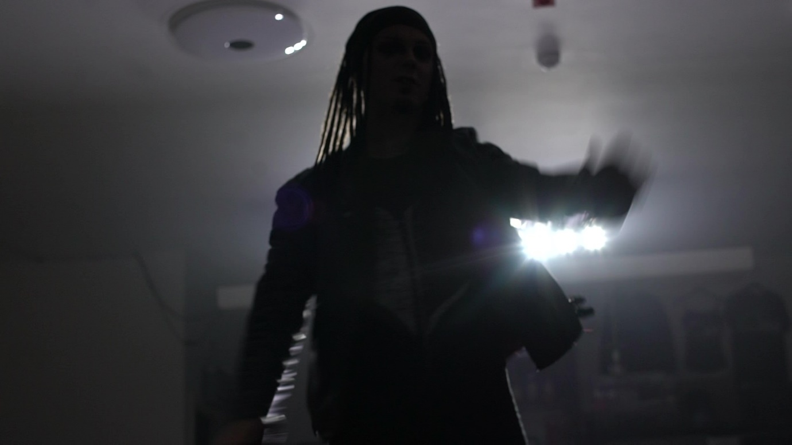
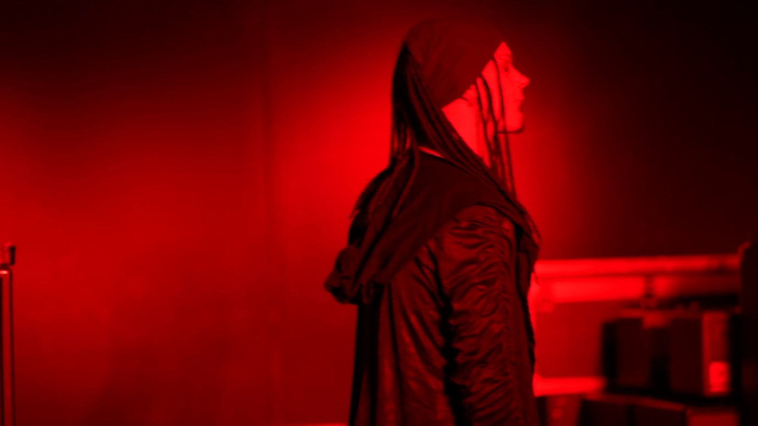
I have learnt that you must make sure you not only consider the colours in which you plan to use, but how you light up the subject with the space and equipment available to generate the desired effect. Here are some stills from the test footage I have gathered, in preparation for the final video.
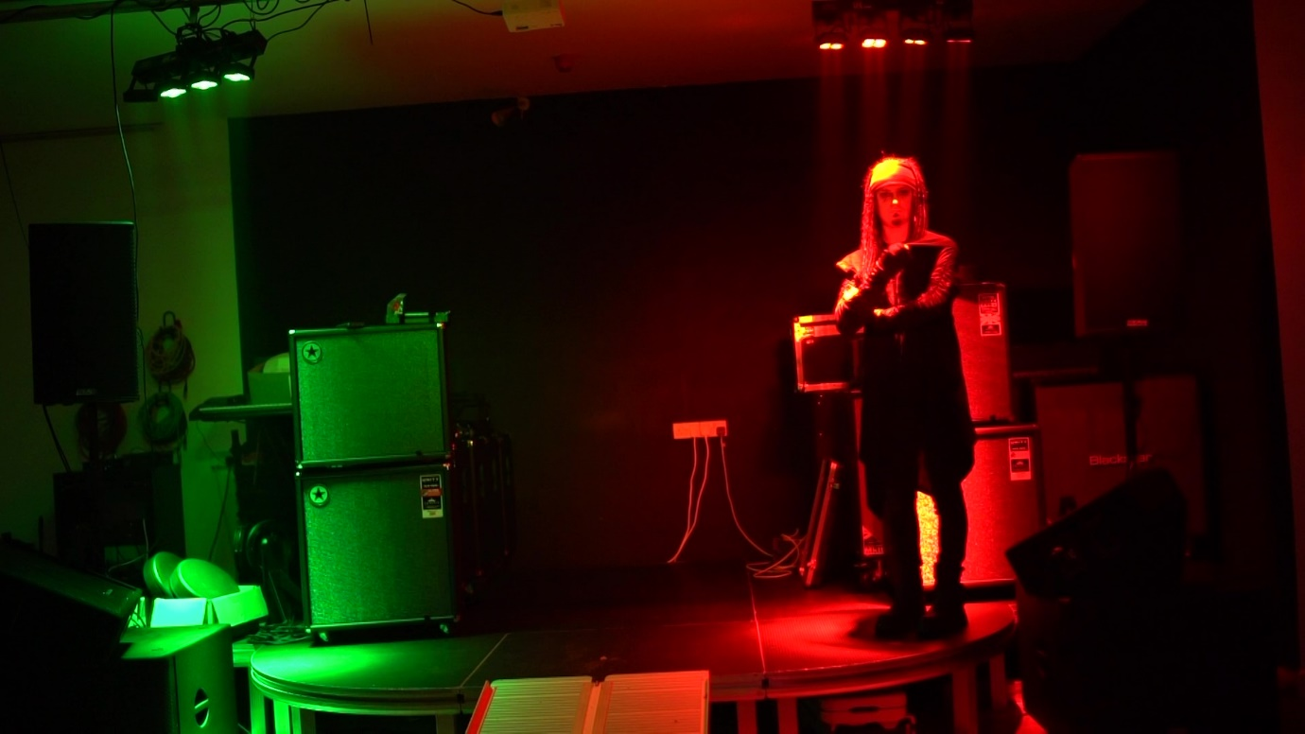

An aspect of creating videos for music that I want to look at is how different cinematographers go about creating mood for a music video. The use of visual aids such as lighting and colour are mere tools to help the cinematographer generate a mood and genre for the music video they’re creating. An important thing for me is to hear the music and be able to resonate the feeling through the camera. ‘So for me, creating, the mood is essential.’ (Sigismondi, 2020). The cinematographer Floria Sigismondi has a unique way in which she involves herself within a music video. In an interview Floria says, ‘There’s a lot of things we have to do that won’t allow us to completely go and daydream into different worlds’ (2016), in reference to how she approaches music videos. She explains that music videos should be able to put people in a trance and take them out of their reality for the duration. She explains that for her work with Rihanna, she wanted to create a mystical/powerful character for her which translates to how ‘people have such a big power that they don’t use.’ (Sigismondi, 2016). I find this extremely interesting as she really immerses herself within the music and conjures up the mood, genre and emotion for the music video from there. She creates these pieces because she resonates with the music and story behind it and wants to display her emotions. She spends time with the artist beforehand, trying to get into their head space, and goes over lyrics to understand the emotion behind the song, and goes off what she feels would suit. ‘Details are super important to me.’ (Sigismondi, 2020) In contrast you have cinematographers such as Joseph Labisi, who seem to have more of a commercial approach to creating videos. Both are very technically skilled and invested in their work, but Joseph focuses more on the overall look of the video, rather than its story and deeper meaning. Joseph says in an interview in regards to his Busta Rhymes video, ‘I want this to look like an old 30’s movie’, and ‘it’s a funny thing, the whole thing is kinda silly and you know campy the way a Busta Rhymes video should be.’(2020) Joseph looks at the music video from purely just a visual point of view. I take inspiration from how he approaches a shoot, the way he comes up with a visual concept and rolls with it. The biggest difference between these cinematographers is that one focuses on the story and concept of the music, looking into its deeper meaning and how that can be shown, and the other focuses on the overall genre of the music and how that should come across on screen.
I feel that I have a stronger connection to how Floria thinks and approaches videos, but I want to try and find a balance between solely filming based off my emotions alone and just shooting in the way that is the particular standard for the artist. Both are very important when it comes to creating music videos and it can be heavily affected by the mood in which you wish to portray. ‘You could, of course, just film beautiful abstract visuals and edit them to the music track. Or you might like to develop a story that adds to the soundtrack or music lyrics’ (Julian Langham, 2022). This quote resembles how I’m conflicted when it comes to approaching music videos. On one hand I think logically and need to strategize my work so that it is understood perfectly and easily accessible to all audiences, but on the other hand I have a strong desire to spill my emotions and thoughts onto the screen and want to use music as a tool to help me. Daniel Pearl, ASC, makes a good point about how music videos rely very heavily on the visuals, the track is already done, you don’t have to worry about the scripts and performance, it solely relies on the imagery, (2020). I am a strong believer in how music videos show things the songs didn’t say, you can express such complex, layered emotions without having to say a word. Music has always been a massive part of my life and getting to be a part of what makes it so complex and meaningful is my desire. I plan on using my research into lighting and colour to display the internal emotions of the artist. I am going to take what different cinematographers have said on how they approach music videos and implement it into my own development. I believe it should be a balance between the artist and the cinematographer to come up with a visual that exhibits the disposition and emotion from who is trying to speak.

Reference list
Baker, L., (2016). Manipulating the Audience’s Emotions With Color. [online] Available at: https://www.premiumbeat.com/blog/manipulate-emotions-with-color-in-film/
(Accessed: 21st April 2022)

Youtube.com. (2020). BTS (방탄소년단) 'Black Swan' Official MV [online] Available at:
https://www.youtube.com/watch?v=0lapF4DQPKQ&ab_channel=HYBELABELS
(Accessed:19th April 2022)

MasterClass. (2021) Film 101: Understanding Film Lighting - 2021 - MasterClass. [online] Available at: https://www.masterclass.com/articles/film-101-understanding-film-lighting#what-is-cinematic-lighting
(Accessed: 18th April 2022)

Fight Club. (1999). [film] Directed by D. Fincher. 20th Century Studios.
(Accessed: 19th April 2022)

Ex Machina. (2015). [film] Directed by A. Garland. A24, Universal Pictures, Film4 Productions, DNA Films.
(Accessed: 20th April 2022)

Her. (2014). [film] Directed by S. Jonze. Warner Bros. Pictures, Annapurna Pictures.
(Accessed: 20th April 2022)

Labisi, J. (2020). Cinematography for Music Videos - Part 1. Available at:
https://vimeo.com/447665633?embedded=true&source=vimeo_logo&owner=50567664
(Accessed: 15th April 2022)

Youtube.com. (2022). Lana Del Rey- West Coast. [online] Available at:
https://www.youtube.com/watch?v=oKxuiw3iMBE&ab_channel=LanaDelReyVEVO
(Accessed: 17th April 2022)

Langham, J., (2022). How To Make A Music Video. [online] Julianlangham.co.uk. Available at:
https://julianlangham.co.uk/how-to-make-a-music-video/
(Accessed: 15th April 2022)

Pearl, D. (2020). Cinematography for Music Videos - Part 1. Available at
https://vimeo.com/447665633?embedded=true&source=vimeo_logo&owner=50567664
(Accessed: 20th April 2022)

The Batman. (2022). [film] Directed by M. Reeves. Warner Bros. Pictures
(Accessed: 21st April 2022)

Sigismondi, F., (2016). Activating The Vehicle Of Ascension: An Interview Of Filmmaker and Artist Floria Sigismondi Autre Magazine. [online] Autre Magazine. Available at:
https://autre.love/interviewsmain/2016/7/18/activating-the-vehicle-of-ascension-an-interview-of-filmmaker-and-artist-floria-sigismond
(Accessed: 18th April 2022)

Sigismondi, F., (2020). Exclusive: Floria Sigismondi Unabridged Q&A on The Turning | Interview. [online] Red River Horror. Available at:
https://www.redriverhorror.com/2020/01/18/exclusive-floria-sigismondi-unabridged-qa-on-the-turning-interview/
(Accessed: 19th April 2022)

Sigismondi, F., (2020). Interview: Filmmaker Floria Sigismondi Discusses the Challenges of Making THE TURNING and More - Daily Dead. [online] Daily Dead. Available at:
https://dailydead.com/interview-filmmaker-floria-sigismondi-discusses-the-challenges-of-making-the-turning-and-more/
(Accessed: 18th April 2022)

Tech, J., (2020). How lighting affects the mood of films. [online] Medium. Available at: https://medium.com/age-of-awareness/how-lighting-affects-the-mood-of-films-8509e8eb1e18
(Accessed: 19th April 2022)

Youtube.com. (2019). TroyBoi - Do You?. [online] Available at:
https://www.youtube.com/watch?v=ku3JbhWUwsg&ab_channel=OWSLA
(Accessed: 20th April 2022)

Raise the Red Lantern. (1991). [film] Directed by Y. Zhang. China Film Group Corporation, Orion Classics.
(Accessed: 17th April 2022)

