Group Project
Reflective Project Report
Improving mill performance
Thrust Monitoring Project

James Thomas – 2010180

Contents
Introduction 3
Project Plan 4
Research 4
Thrusting 5
Understanding Bearing Housing 7
Concepts of the topic researched – Thrust monitoring Design. 8
The Design 10
Thrust Monitoring Project Analysis 10
Project effectiveness 11
Design Analysis 12
Improvements for mill performance 15
Conclusion 16
Works Cited 17
Appendix 18
Appendix No.1 18
Appendix No.2 18
Appendix No.3 18

Introduction

Throughout this report there will be a focus on a past project which has been designed to improve mill performance and stability, by implementing an effective thrust monitoring solution. Extensive research will be carried out into the operation of hot strip rolling mills and how productivity is paramount to the operation. Focusing on how the design and implantation of this project has improved or not improved current performance, and to analyze the effectiveness it has had.

This engineering concept is a bespoke design that was created specifically to reduce unplanned maintenance in the event of thrust bearing failure. Its purpose was to detect early indications of excessive axial load (known as thrusting) when rolling steel slab. An unplanned failure can result in in hours of delay impacting our weekly targets, in turn effecting downstream products and customer needs. Also, the cost implications run into the hundreds of thousands based on spares alone. See App.1. for cost implications.

This analysis will include an insight into chock and roll assembly building, focusing on components and spares that are involved such as the thrust bearing assembly. Typically thrust bearings are designed for axial load so it is important that you understand its purpose when in service and the excessive axial load we are trying to combat and why. Following this report, you should have understood the basic principles of the hot mill process and why thrust bearing failure occurs. The concept of the design will be clearly outlined, and effectiveness, whether effective or not can be visible from the results.

This report will focus on the shear bolt and stud concept to detect excessive axial load, which was a thrust monitoring project introduced by a Tata Steel colleague to finishing work roll chocks and finishing Back up chocks. The report findings will draw me to factors which have not worked and how these can be improved. Leading to discussions to what can be done differently or what can be done to increase the effectiveness. There will be statistical data available to use, where illustration of these results pre and post implementation can be seen from Score cards and delay reports. Measuring effectiveness of mill performance from implementation stage. Discussions regarding the sustainability of the process following implementation, and the possible effects by having no detectable measures in place, could potentially lead to an unsustainable operation and catastrophic failures.

Project Plan

To achieve goals, throughout the project I will be referring to Gannt chart and project plan. This is to ensure that all targets are met within the timescales set out. The success of this given project will come down to well-executed time management and completion of tasks.

The use of this Gannt chart will allow me to view specific detailed tasks and follow the concise timeline. It would also be a good tool to delegate tasks in a larger group project. It is important to remember that timelines can change and the Gannt chart will be revised through this project. See App.2. for Gannt Chart on reflective project report. Here you will see in detail, the tasks, and dates for each task. Progress of tasks can be updated on completion.

Research

Metal rolling, in this case using a Hot strip mill, can be regarded as one of the most important manufacturing processes in the world today. This is because a greater volume of material is worked using the process of rolling, than any other process or technique [1]. At Tata steel Port Talbot, this process is used to create strip steel, where steel slab is hot rolled and then formed into coil for transport to customers. The strip product can be used in many applications. One of our main customers that we supply to is the automotive industry, such as jaguar/Land Rover, BMW, Honda, and Renault. As well as other engineering industries, Mauser, JCD and Caterpillar to name a few.

Many steel manufacturers throughout the world are continuously trying to improve productivity to maximize efficiency and quality of their product. Many different methods are used. From automation design and AI intelligence, to re design of mill equipment and implementation, to gain an accurate rolling force which will improve productivity and quality [2]. Ultimately, a stable operation to prevent unplanned breakdowns will allow us to reach weekly targets and tonnage rolled.

It is important to consider that in the metal rolling process there are necessary parts to the operation. A roll assembly does not function without a driving force provided by motors and bearing housings. These are what we call Chocks. Within the chock there is several mechanical components that support the operation including bearings (radial/thrust), sleeves, bushes, thrust plates, locking arrangements and so on. Also, all Rolling mills are not alike, there can be different arrangements of Roll assemblies for example, two high, four high, cluster mills and many others.

At Tata steel port talbot we use a four high rolling mill. Work rolls are supported by much larger back up rolls. The backup rolls are preventing the smaller work rolls from deflecting during the rolling process. Another point to consider is the number of stands we have in our finishing mill. 7 stands in total, F5-F11. This process for rolling is called a tandem mill where the strip material passes through more than 1 stand. Each pass reducing the gauge of the material each time and the reduction from F5 to F11 is a significant amount (1.5mm – 20mm).

See fig.1. which illustrates the rolling process at Tata Steel Port Talbot, even though the focus here is based on finishing mill assemblies and chocks, you can see where the material begins the process as slab and the product at which point it is formed into strip coil.
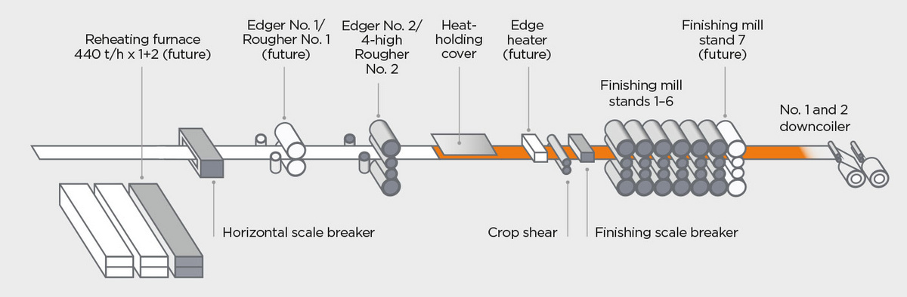
Figure 1 [3]
Through each stage of the process, it is possible for a multitude of failures to occur which do not relate to thrust bearing failures. However, there are detection modes in place for these common failures. The introduction of these detection modes will allow us to make small adjustments when a possible failure may occur.

Thrusting

Regarding excessive thrusting on the finishing pass there are no detections systems in place for excessive axial loads on stands F5 to F9. As, discussed earlier, there are finishing mill stands F5-F11.

Stands F10-11 have already implemented detection systems (Mill side shift and load cells) that will indicate excessive thrusting. This will allow us to shim each chock accordingly to counteract the thrusting which occurs. Thrusting can be better explained using illustrations. See fig.2. for plan and side view of 4 high mill at Port Talbot Hot Strip Mill. This is how a perfectly aligned mill should look during the production process.
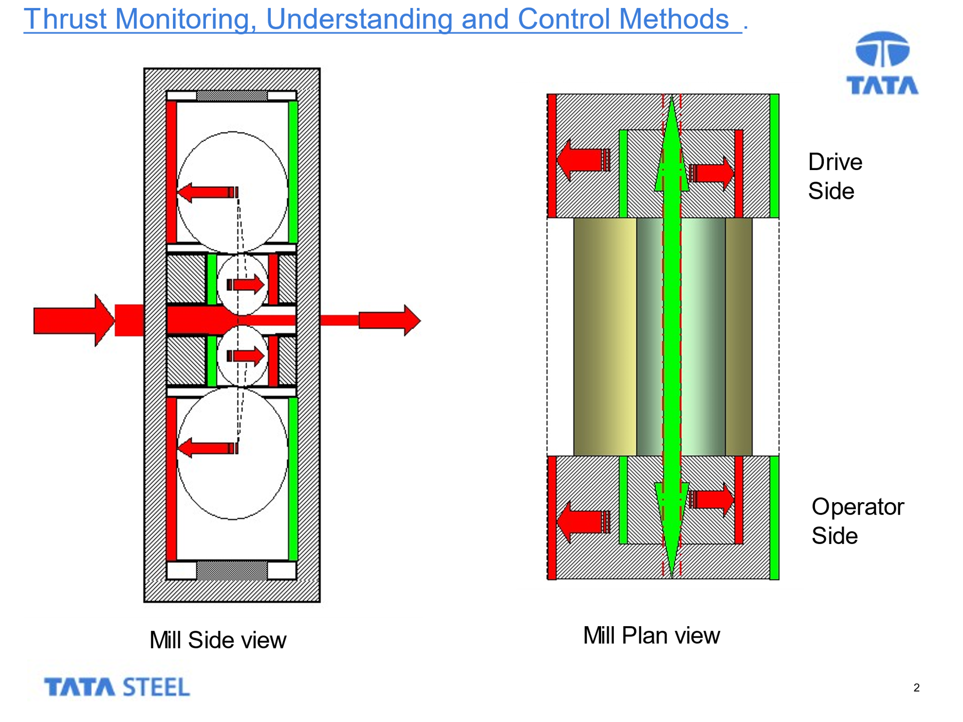
Figure 2 [4]

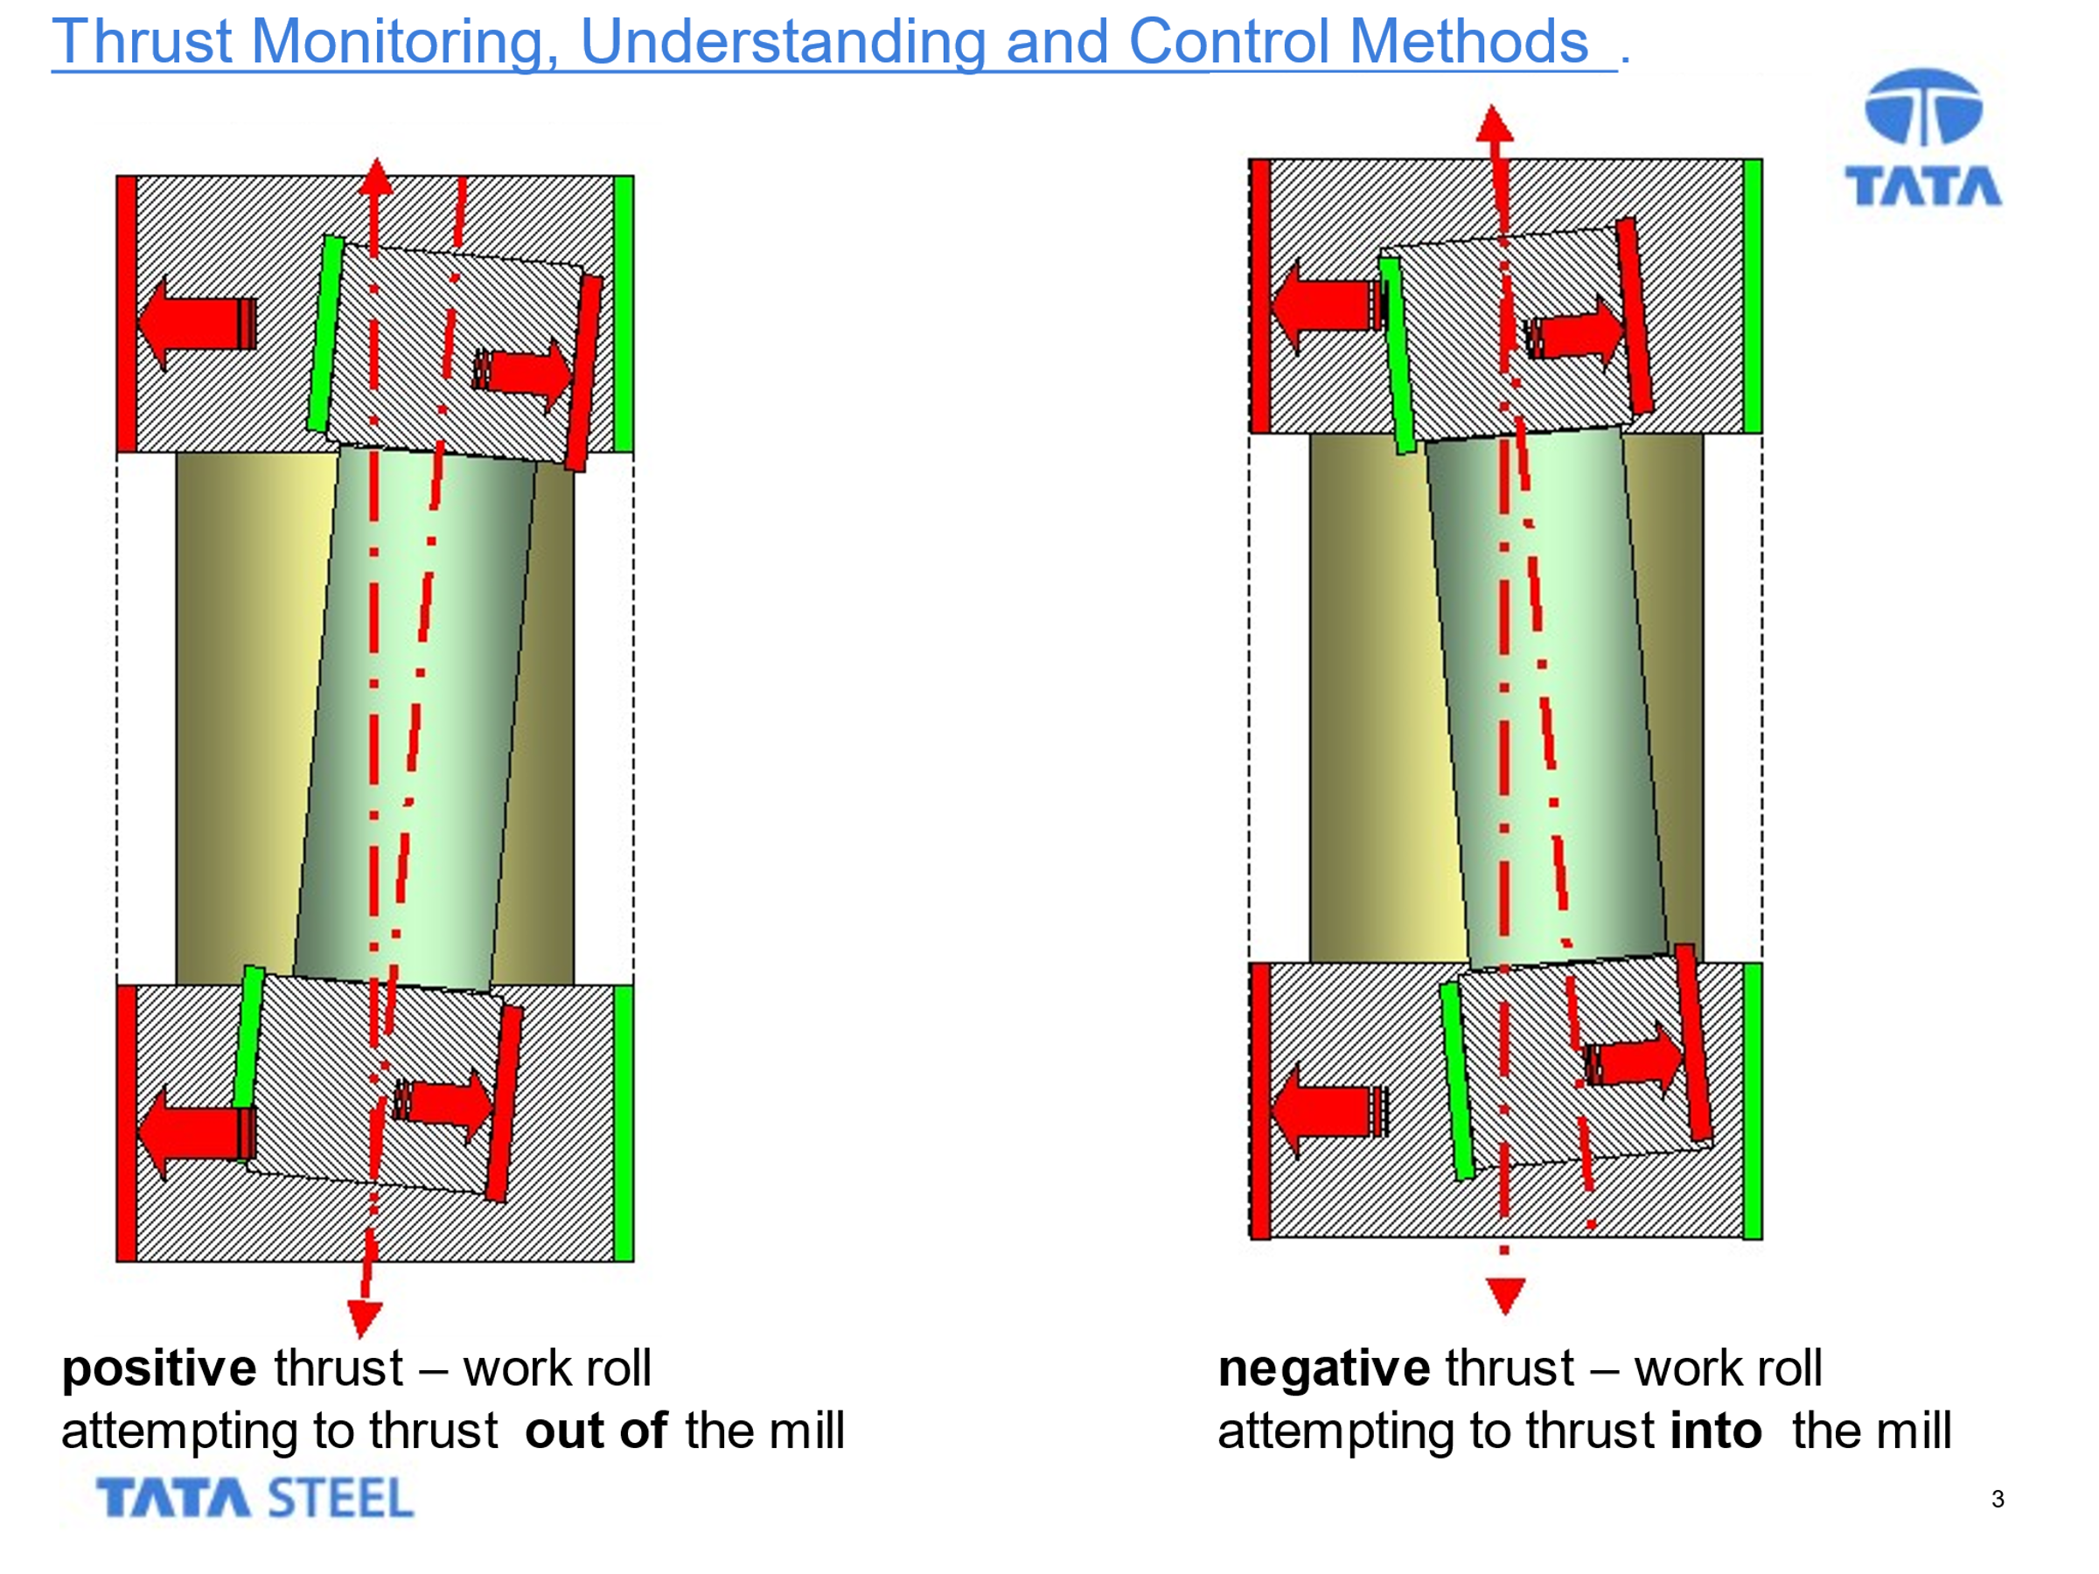
Figure 3 [4]

Fig.3. empathizes the effects of work roll thrusting, which is primary contributor to thrust bearing failure along with lack of lubrication through Morgoil fittings. Morgoil is a heavy-duty oil designed for use in back up bearings, both thrust and radial due to its resistance to emulsify.

Using FMEA analysis the potential failure mode has been highlighted, and the risks associated with the failure can be found through delay reports, where mill delays, and costs implication can be seen. It is through this process the organization found there were no detection or mitigating control in place to reduce the risk of potential thrust bearing failure, because of axial load.

Understanding Bearing Housing

A “naked” chock is the main body of the bearing. With no components it is pretty much of no use to the production process. A white metal bush is inserted into the chock which houses a keyed tapered sleeve. This bush is locked into position and the tapered sleeve is designed to rotate freely in the bush on an unbroken film of oil. This sleeve sits on the neck of a roll used as a journal. Further to this is where you would find a thrust bearing arrangement on the end board side of the chock.

This thrust bearing is designed to carry only axial load for either direction and has an inner and outer race, which carries positive and negative thrusting. Sitting inside a thrust cartridge and held into position by a thrust cover. A thrust assembly sits on top of the sleeve and thrust plate which allows its effective use in the rolling mill.

As discussed earlier, the chock is held onto the roll journal/neck using a locking arrangement of a half ring and nut. Locking keys, clamps and segments are used in this process to complete the build of a chock onto a roll neck. A Morgoil bearing is typically used in high performance rolling mills due to its higher loading capacities and its longer in service life expectancy compared to other bearings [5].

An operator side chock for both Finishing, and Back up work rolls has a thrust bearing to deal with axial load. These thrust bearings sit behind a main cover which is bolted into position on the main body of the chock. These main covers are there to retain bearings (radial/thrust), sleeves, bushes, thrust plates, cartridges and so on.

Concepts of the topic researched – Thrust monitoring Design.

To understand the concept of the thrust monitoring project, you should consider that excessive axial load is responsible for the failing of many main cover retaining bolts prior to complete thrust bearing failure. Or at least this is a common occurrence on chock investigation following thrust bearing failure. The theory for this project was to detect early signs of thrusting and prevent mill delays and breakdown maintenance. There for improving mill performance and substantiality in the operation.

Negative thrusting can be detected when the Back Up roll is thrusting out of the mill (into the operator side chock). A Weakened shear bolt Is used to retain the main cover in each chock assembly, and will give the indication to early thrusting, the detection will be picked up before critical failure of thrust bearing. Alternatively, Positive thrusting is detected when the Finishing mill Work roll thrusting out of the mill (into the operator side chock). In this same instance, a weakened shear stud will fail giving the early indication to positive thrusting [6].

The theory is then to shim work roll chocks 1mm at a time to reduce positive or negative thrusting. Referring to fig.2. you can see how a perfectly aligned mill should look. This is how shim adjustment should, in theory aligning the mill creating a more stable operation and improve productivity. Also, fig.3. you can see the emphasis on thrusting, and what monitoring project was designed to detect. Only operator WR chocks are shimmed to counteract excessive axial load on thrust bearings.

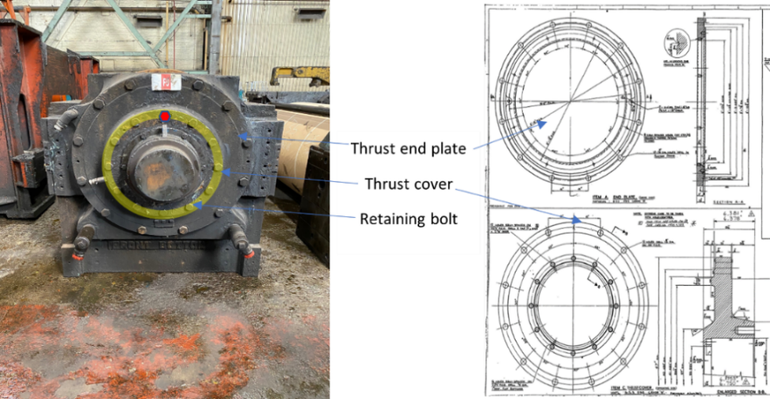
Figure 4: Own Author/Tata technical drawings

See Fig.4 (Finishing Mill Back Up Chock, technical drawing of main cover including bolt assembly and thrust plate) for an understanding of the position on the shear bolt concept. Also, see Fig.5 for the position of Work Roll chock shear stud concept.

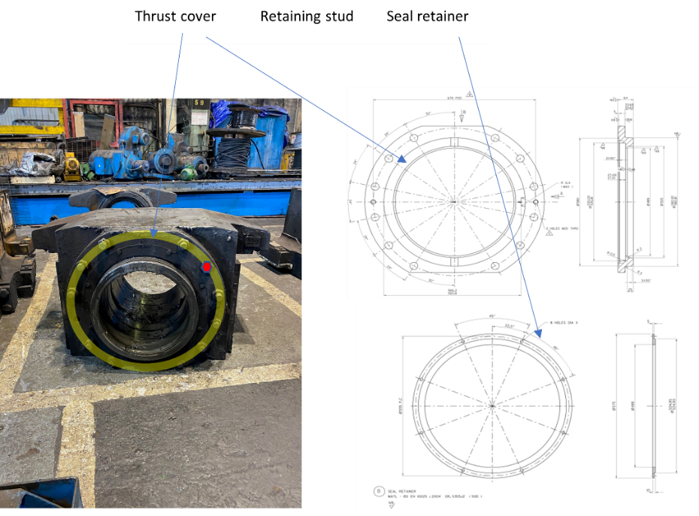
Figure 5: Own Author/Tata technical drawings

Both bolt arrangements consist of 12 bolts equally spaced (PCD) around the main cover which hold complement into place. These bolts are induced to stresses that cause them to fail under excessive axial load. See fig.6 for a side view of an FMB chock assembly. Here you can see the roll journal sitting with in the sleeve. To the rear of the chock (known as the outboard side the thrust bearing arrangement can be seen marked.

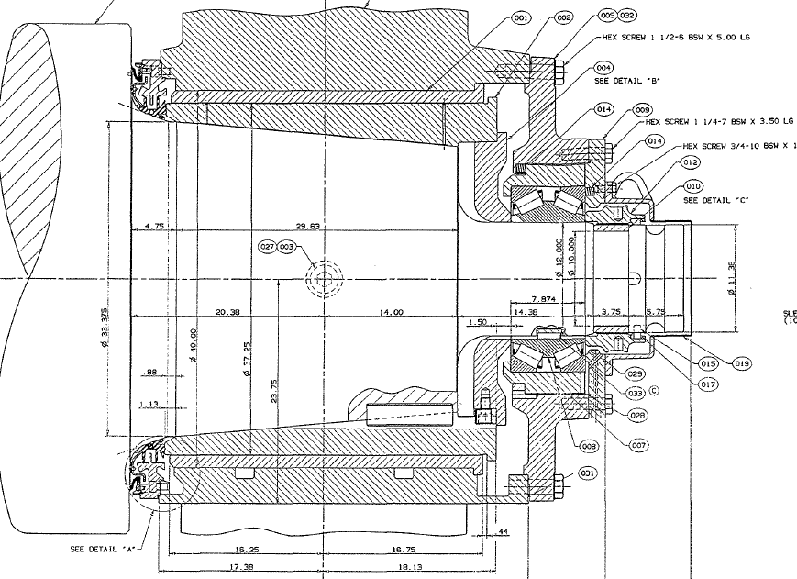
Figure 6

The Design

For the shear bolt concept to work, it was designed to fail under tensile load. This was done by reducing cross sectional area of the existing bolts and therefor reducing tensile strength of each shear bolt and stud. This would then yield first and fail before any other bolt and used to monitor thrust. Existing bolts for finishing mill back up main covers were 1 ¼ BSW bolt grade 8.8. Many of the fasteners used in the hot strip mill are imperial as well as metric. Finishing mill work roll chock studs are M30 8.8 grade. Both these studs were modified in a way to weaken their tensile strength. Reduction of cross-sectional area was machined into the bolts and a necking was induced for greater effect. This would allow the bolt to shear above the surface of the main cover making it easy to extract. See fig.7 for modified bolts drawings.

Figure 7 [6]

Thrust Monitoring Project Analysis

Reviewing this project has led me to research from delay reports at predesign stage and it is quite clear, through FMEA (Failure Modes and effects analysis) there were no detectable measures in place. Use of the DMAIC approach for problem solving and making improvements can have massive ethical benefits to the production process [7].

The DMAIC approach consist of five stages; Define, Measure, Analyze, Improve and Control. At this stage, opportunities for improvement were identified, failure modes were measured, and data collected from previous failures. Analyzing the project using FMEA to identify possible problems occurring without a thrust monitoring project in place. The design and implementation of engineering concept must be tested to gather data on how performance can be improved. Finally, control measures must be put in place to ensure long term effectiveness. This can be done through Management of change process and new work standards being followed.

FMEA analysis used for quality improvement, is a well know method which detect failures and measure their effect. The criticality is measured with a priority risk number known as an RPN, occurrence x severity x the chance of being undetected [8]. Method of risk analysis was used when reviewing the potential failures from excessive axial load. No detectable measures where in place and the severity of critical failure was detrimental to the performance of the rolling mill.

Project effectiveness

From historic data gathered, it is clear to see that the thrust monitoring project has reduced thrust bearing failure since implementation. It has proven to be an effective means of monitoring excessive thrusting and reducing unplanned breakdowns, which can implicate weekly targets and downstream products. Using the evidence from delay reports and score cards over the last ten years, results are shown by the reduction in thrust bearing failure that contribute to total mill delays. These results can be seen in Fig.8. where thrust bearing failure can be seen as a percentage of total mill delays.
Figure 8: Own Author

Here you can also see percentage of mill delays caused by thrust bearing failures. The project has been successful in reducing thrust bearing failure. However, they still occur, and have not been eliminated. This would indicate that the project is not entirely effective. There have been thrust bearing failures with no broken shear bolts found. If this was the case, the thrusting cannot be monitored and is ineffective. See reports as recent as April 2021 conducted by myself App.3. A thrust bearing failure occurred with no signs of excessive axial load and sheared bolts. See Fig.9. for recent mill delays against Roll shop scorecard. 310 minutes in total, 167 of those minutes from thrust bearing failure (captured in delay report App.3.).

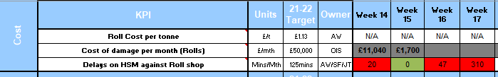
Figure 9: Alan Witts

Costing the business approximately £37,000 for each hour of mill downtime having a significant impact to productivity, effecting downstream operations and stakeholder agreements. This is not a sustainable approach to allow thrust bearing failure to still occur. However, the average thrust bearing failure per annum from 2015-present is now 1. Compared to pre implementation stage 2010-2015 an average of 4 per annum.

An approximate estimation of cost saving over the last 6 years:
3 x 125-minute delay PA costing £231,240 in downtime alone. Projected cost saving over the last 6 years equates to £1,387,440 not inclusive of FMB damage and spares which can be seen in App.1 for a breakdown of spares.

Design Analysis

The reliability of the design is questionable. I believe that improvements could have been made using the DMAIC approach. This was not followed to full effect. For example, the DMAIC approach of Define, Measure, Analyze, Improve and Control is to ensure that in this final stage, controls are to create to ensure the process has successfully improved productivity. In this case that was correct. A new standard work procedure was designed when building Finishing mill back up chock assemblies. All bolts were to be torqued to the correct setting so taking equal mounts of axial load when in service. However, to ensure long term effectiveness, the design concept should have undergone statistical process control to monitor effectiveness and any problems found with the design. In this case, thrust bearing failure with no shear bolts present should have raised questions about the design. At this stage, the design could have been reviewed for possible solutions to improve its effectiveness. Ultimately, the DMAIC process could have been used again when detecting new issues that did not work. This process along with PDCA can be used again and again for continuous improvement [9].

Further research into the tensile strength of the bolts posed the question, was the reduction suffice to indicate early signs of excessive axial loads? Once again, referring to F10-11 stands, we have thrust monitoring systems in place see Fig.10.

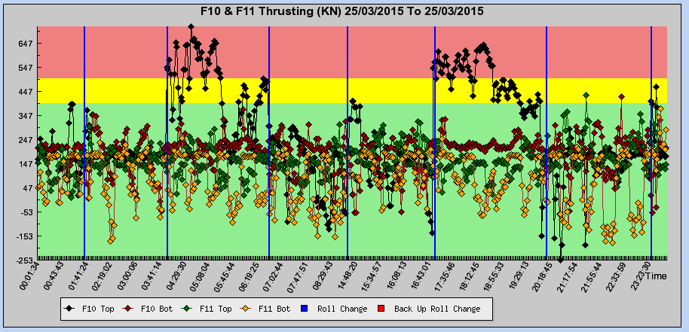
Figure 10: Tata Thrust Monitoring Screen - HRP Intranet Page

The traffic light system (red, amber, green) is an indication to what is regarded as excessive thrusting. From load cells in finishing mill stands F10-11, where side shift has been implemented you can see that 500KN of force is regarded as excessive thrusting. Anything above this is likely to overcome the viscosity of the morgoil lubricating each bearing and lead to catastrophic failure of the thrust bearing which can be seen in App.3. Delay report F7 Back up failure. A standard 1 ¼ “grade 8.8 bolt UTS (ultimate tensile strength) is 518KN see Fig.11.
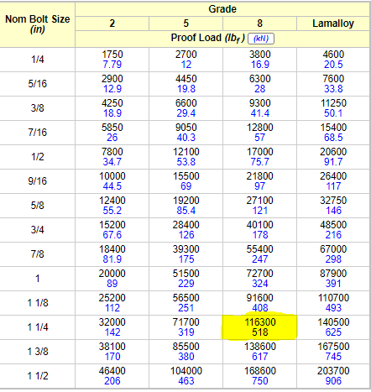
Figure 11 [10]
The reduction in cross sectional area of the Finishing mill back up bolt was to reduce tensile strength. From Fig.7. (the design) you can see that the Cross-sectional area was its lowest at 22mm in diameter. This would have been the weakest point where bolt necking was introduced. The UTS of grade 8.8 M22 bolt is 182KN, see Fig.12.

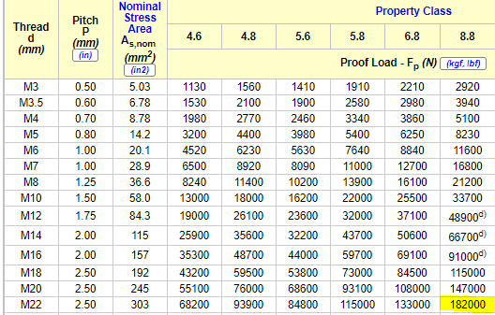
Figure 12 [10]
This would suggest that the reduction was suffice. However, we must remember that there are 12 bolts PCD equally spaced around the thrust cover. This is an assumption and would require stress analysis to illustrate the distribution of load, but I believe the excessive axial load is distributed unequally between all bolts. At any one time of excessive axial load, it could be possible for the thrust bearing to fail without overloading one shear bolt due to equal distribution of axial load. I would suggest stress analysis needs to be conducted and the design reviewed for possible improvement using the DMAIC process.
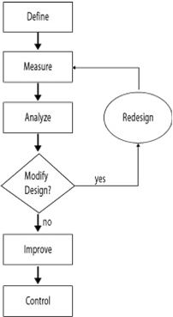
Figure 13 [11]

To my Knowledge there are no recordable results for stress analysis conducted on the shear bolts concept. Further to this, load cells and strain gauges have never been used to monitor the thrust effect of FMB back up chocks. Therefor, it is hard to determine the axial force generated and how its distribution would be spread over bolt configuration.

It may be beneficial to carry out trial tests on improvements to the standards. One theory is to apply more torque to the shear bolt so that it is pre-loaded, therefor would shear before any other. However, this may have a negative impact if the tensile strength cannot withstand normal axial load generated through this process. This could lead to incorrect shimming of work roll chocks.

Factors that affect tensile strength can be molecular structure, temperature or material composition. It should be considered that using a different grade or material may be more effective for its application. Material selection can be reviewed at the design stage following the DMAIC process.

Improvements for mill performance

When considering mill performance and productivity there are far more advanced technology that can be used to detect axial load. These technologies are used in F10-11 where mil side shift has been introduced to reduce the wear on work rolls and improve strip shape control when producing steel coil. Load cells have been introduced to detect axial load in these given stands, the solution is still the same and chock housings are to be shimmed 1mm increments until thrusting is reduced and under control.

With the demand for steel continuously growing, the performance of the rolling mill is critical to a sustainable and competitive operations. With that in mind, some of the leading rolling mill suppliers have introduced new technologies since the installation of machinery in the Port Talbot Hot Strip Mill. Primetals Technologies have introduced a mill stabilizing device to their mills, which can prevent Work roll skew between back up and work roll, improving mill stability and reducing unplanned failures [3]. Cylinders are mounted on non-movable chocks within the mill housing window. They exert their forces on each end of the bearing chocks at each end of the roll. During Shifting, the rolls move relative to the mounted cylinders. Unless compensated for by shimming there is a significant amount of axial load on chock housing, which leads to early thrust bearing failures. The load cell will allow monitoring of excessive axial load and can be shimmed to counteract these forces [12].

Further to this a new technology of work roll crossing has been designed to further improve productivity and sustainability of rolling mills through out the world. Also, considered to reduce rolling force which contributes to thrusting. This is a combination of work roll shifting and work roll crossing. Work roll crossing angles have been shown to significantly reduce the flow of material, and the distribution of rolling pressures on the strip steel has minimized the rolling force, whilst improving strip quality [13].
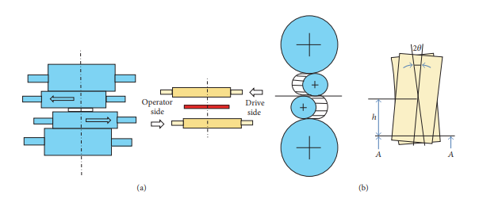
Figure 14 [13]

Conclusion

The project under review was a design to improve mill performance and prevent delays, creating a more sustainable operation and increase productivity. After reflecting on the design concept, it can be regarded as an ease of manufacture to highlight the current issues around thrust bearing failure caused by axial load and rolling forces. As simplistic as it is, it has proven to significantly reduce the occurrence of thrust bearing failure having detrimental impact to productivity and performance. The effectiveness can be seen from graphs and cost savings analysis from data gathered over the last 10 years. However, design analysis has raised concerns about the reliability of this project. These failures still occur and effect the performance of the mill.

To sustain market competitiveness, the focus should be on continuous improvements and to consider new technology to improve productivity. The design should be review following the DMAIC process to see where improvement can be made. The design concept has worked, but investments are required to stay competitive and improve performance of the rolling mill.

Recommendations

Stress analysis to be carried out on the existing design to determine effects of axial load on shear bolts. This will show if the load has been equally distributed or not and would explain how some failure still occur with no sheared bolts found.

Further research is required into Work Roll Crossing combined with Work Roll Shifting to reduce rolling forces and improve the quality of the product. this in turn reducing vibration caused by rolling forces and improving mill stability.

Works Cited

[1] | S. Spuzic, K. N. Strafford, C. Subramanian and G. Savage, "Wear of hot rolling mill rolls," Wear, vol. Volume 176, no. Issue 2, pp. Pages 261-271, 1994.
[2] | J. Son, D. Lee, I. Kim and S. Choi, "A study on on-line learning neural network for prediction for rolling force in hot-rolling mill," Journal of Materials Processing Technology, vol. Volumes 164–165, no. 0924-0136, pp. Pages 1612-1617, 2005.
[3] | "primetals technoligies," 05 october 2020. [Online]. Available: https://www.primetals.com/press-media/metals-magazine/issue-01-2016/superior-mill-performance. [Accessed 25 march 2021].
[4] | I. M. Williams, Thrusting Presentation, Swnasea: TATA Steel Port Talbot, 2015.
[5] | F. P. Dhalstrom, "The Morgoil Roll Neck Bearing," Transactions Of The American Society Of Mechanical Engineers, vol. 55, no. 2, 1932.
[6] | A. Witts, "Thrusting Presentation," Tata Steel Port Talbot , Swansea, 2015.
[7] | R. McAdam and B. Lafferty, "A multilevel case study critique of Six Sigma: statistical control or strategic change," International Journal of Operations and Production Management, vol. 24, no. 5, pp. 530 - 549, 2004.
[8] | L. Liu, N. Liu and H. C. Liu, "Risk Evaluation Approaches In Failure Mode And Effects Analysis," Expert Systems With Applications , vol. 40, no. 17, pp. 828-838, 2013.
[9] | A. B. Sin, Z. S. M. Iranmanesh and T. Ramayah, "Structural equation modelling on knowledge creation in Six Sigma DMAIC project and its impact on organizational performance," International Journal of Production Economics, vol. Volume 168, no. 0925-5273, pp. 105-117, 2015.
[10] | "The Engineering Tool Box," 01 January 2018. [Online]. Available: https://www.engineeringtoolbox.com/us-bolts-tensile-proof-load-d_2066.html. [Accessed 29 April 2021].
[11] | "ASQ (American Society Of Quality)," 01 January 2021. [Online]. Available: https://asq.org/quality-resources/dmaic. [Accessed 04 May 2021].
[12] | V. B. Ginzburg and P. F. Ronald Vidil, "Roll Shifting Systems For Rolling Mills". United States Of America Patent 4,898,017, 06 Febuary 1990.
[13] | H. Tibar and Z. Jiang, "Improving Thisn Strip Profile Using Work Roll Cross And Work Roll Shifting Methods," International Jounral Of Metals, vol. 1, no. 1, pp. 1-10, 2017.

Appendix

Appendix No.1

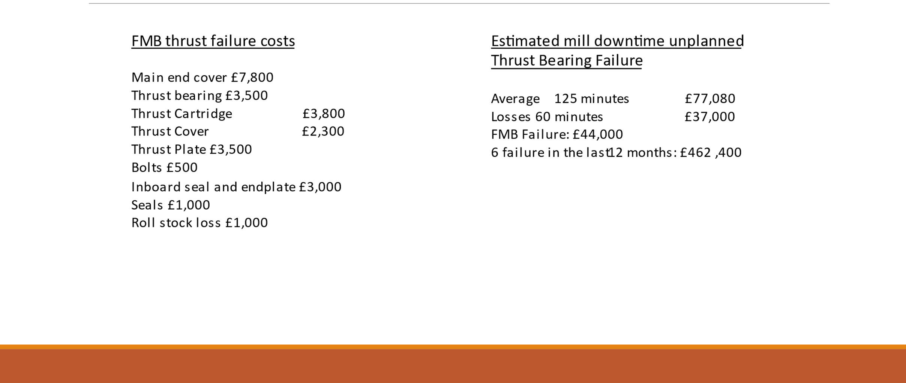

Appendix No.2

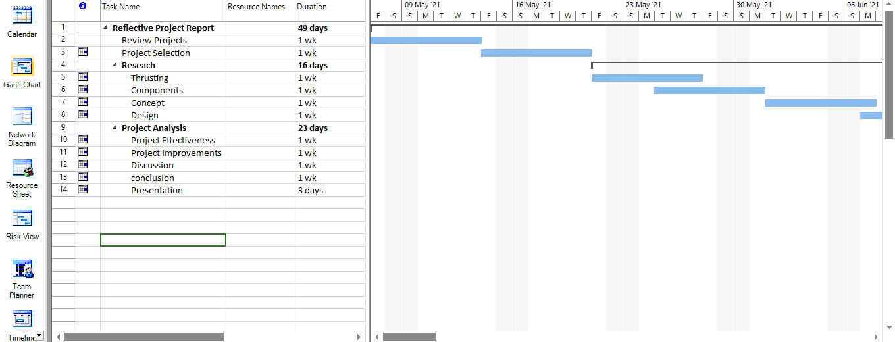

Appendix No.3

By: James Thomas Report No: RS15/2021

Date: 29/04/2021

Delay:

F7 Top Back Up Changed – Over heating Op side chock 67 (Thrust bearing Failure)

Details:

Rolling issues -
F7 top back up leaking morgoil from front thrust bearing plate - Called shift mech down to check found back up was on
verge of failing so had to change - Re datum mill after change and had to take 3.5mm out as excessive tilt on drive
side.

Chock numbers:
TOP OP: 67
TOP DR: 50

Roll number:
750

Roll history data etc…
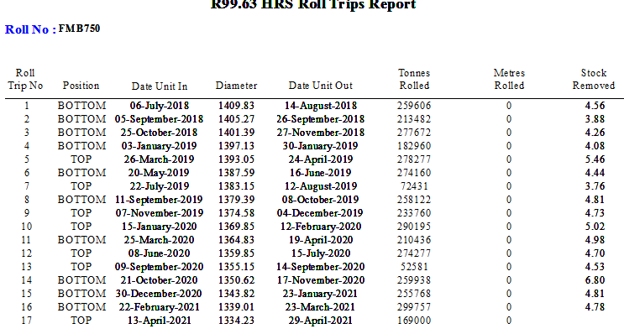

CHOCK DATA:

Top Op chock 67 had recently gone through a stage 2 service in the HRS on the 30.03.2021 before entering the mill on the 13.04.2021. Rolling 169KT tonnes before signs of failure had occurred. This would have had full thrust bearing service as well as inspections on the chock bush and sleeve.

Sequence of events:

Morgoil leaking from thrust bearing cover. On inspection chock was overheating and the decision was made to change the back up for the standby assembly (FMB:743 CH;63+98).

Investigation:

On removal of top hat cover there were significant signs of damage caused by overheating and the nut was found to be extremely tight. The use of crane was needed to unwind see app.1. There was also lift in the nut, later inspection found that this was due to movement in the half ring app.2. Also, roll Journal has been damaged.

Chock was difficult to remove from roll. Once free from roll a thorough inspection of possible failures could be carried out. Firstly, the outer race of the thrust bearing had experienced catastrophic failure see app.3. the chock was laid over and main cover removed to reveal the extent of the damage. Thrust plate had been worn and heat generated by the failure can be seen app.4,5. This was caused by the back up roll thrusting out of the mill. On removal of thrust cover the bearing cartridge locating key had completely sheared off, and the ore ring for the Morgoil was out of position and perished App.6.

Once Cartridge had been removed from the main cover, there was significant wear to the inner face on of the flange where the cartridge would sit App.7. When removing thrust bearing from cartridge it was clear that the inner race sustained no damage. The rollers and bottom cup were in good condition. However, the outer race had been completely destroyed App.8,9. This is suggestive to excessive axial load, contributing to negative thrusting.

Further investigation to the latches found that these had been worn below acceptable tolerances. This damage was new and also suggest the Back Up roll assembly was thrusting out of the mill App.10.

Following failure and investigation, it was brought to the attention that there had been some recent issues with B system which included F7 alcove filters and F11 top drain hose. Unsure if this had any effect, however lube tank level on B system started to drop 28/04/2021 (20:41 HRS) App.11. Prior to the detection of F7 Top Back Up Failure.
Conclusion:

No sheared bolts were found on the main cover or thrust cover. However, all evidence suggests that this failure was caused by excessive thrusting (negative). Damage, to ONLY the outer race of the thrust bearing was caused by the back up roll thrusting out of the mill (negative thrusting). This chock was serviced prior to this trip in the mill and any defects would have been detected and thrust bearing replaced. Also, wear to latches is a clear indication thrusting has been present during the failure. Thrust plate wear also shows that the back up roll was forced out of the mill. The ore ring was found to be out of position but this is more than likely following the catastrophic failure of thrust bearing so does not suggest that lack of lubrication came from this finding. There was no damage present on drive side chock.

Date: 29.04.2021 – F7 Top Bu failure - Report No: RS15 / 2021

Summary & Next Steps

Enter detail here.

Action Required – Next Steps | Who | When | Date completed
Collect data and produce draft report | James Thomas | 29/04/2021 | 29/04/2021
Strip Back up chock and investigate failure | JT/HRS | 30/04/2021 | 30/04/2021
Discuss report with initiator – feedback.

Appendices:

Appendix No.1:
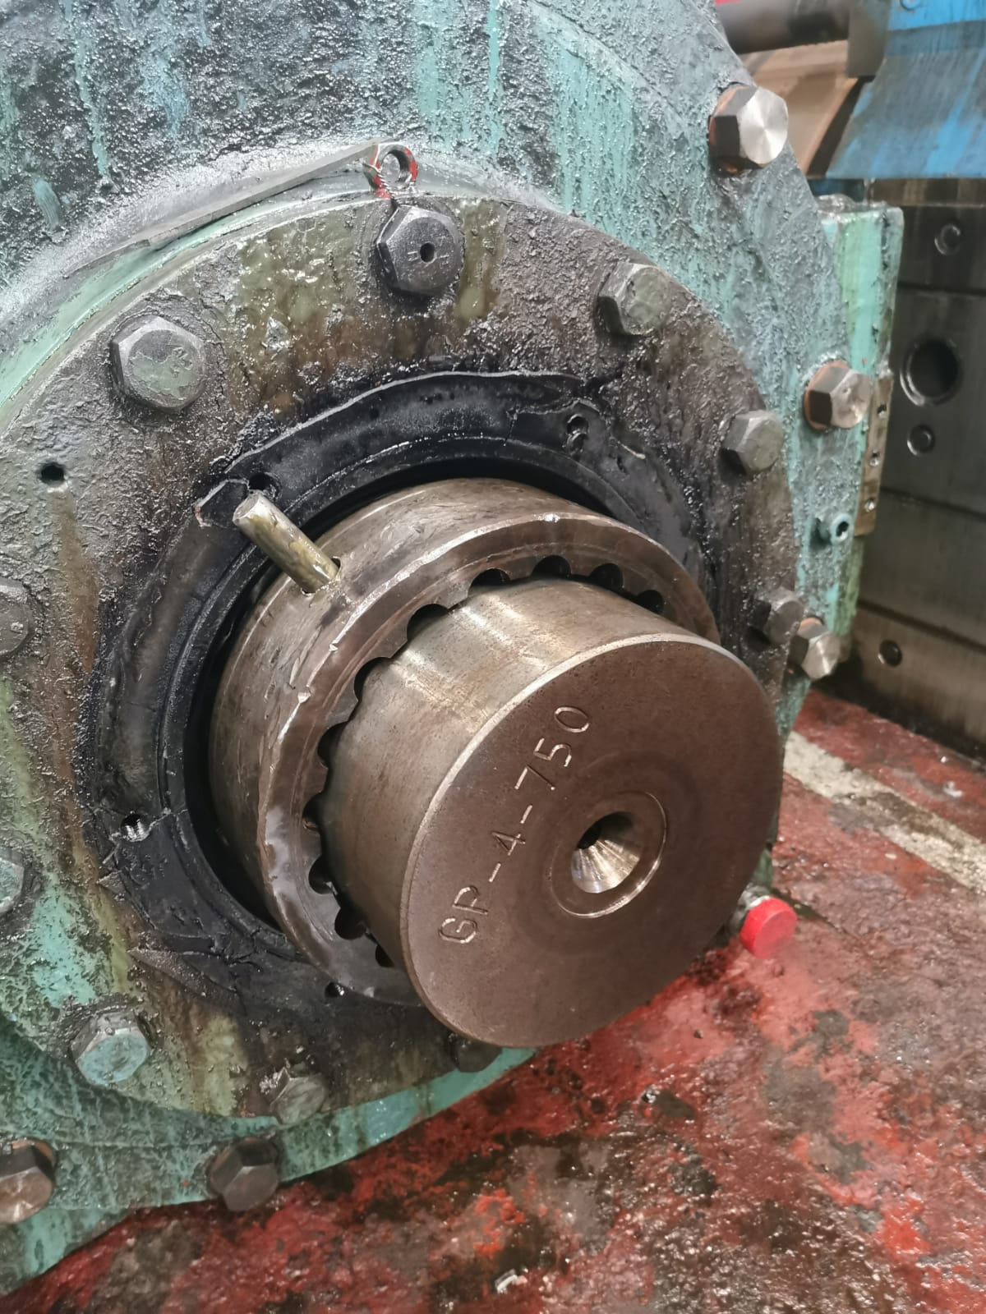

Appendix No.2
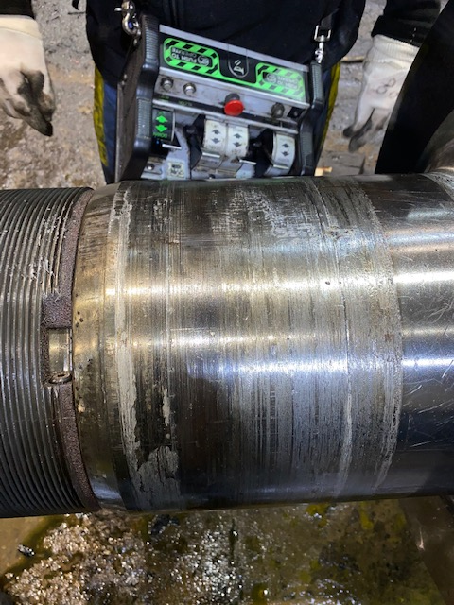
Appendix No.3
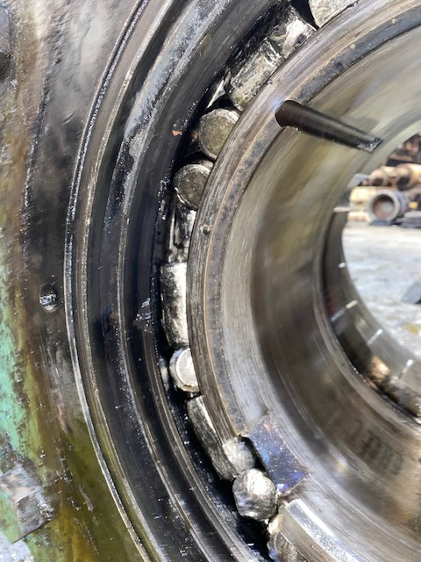
Appendix No.4:
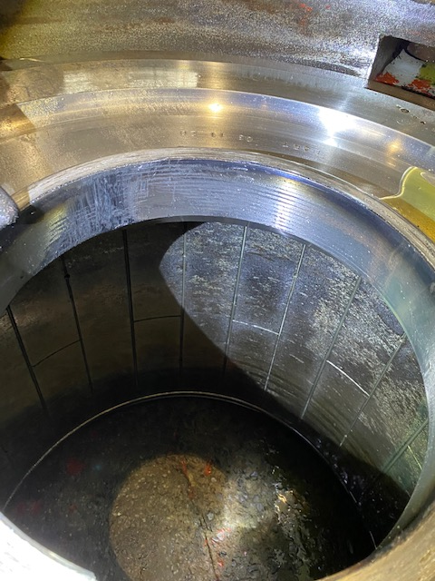

Appendix No.5:

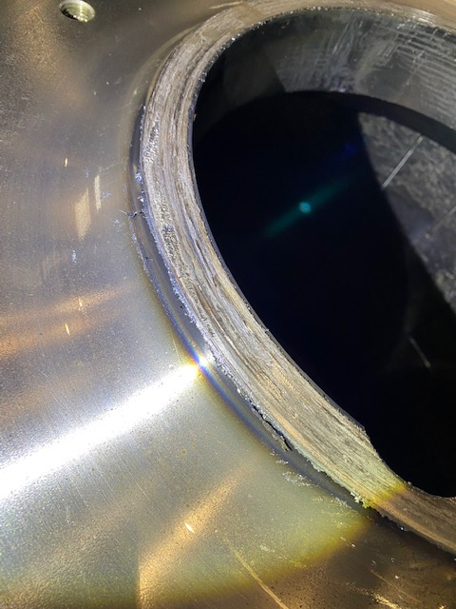

APPENDIX No.6

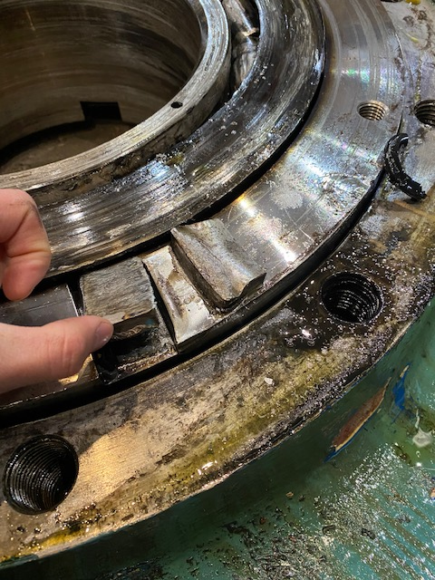

Appendix No.7

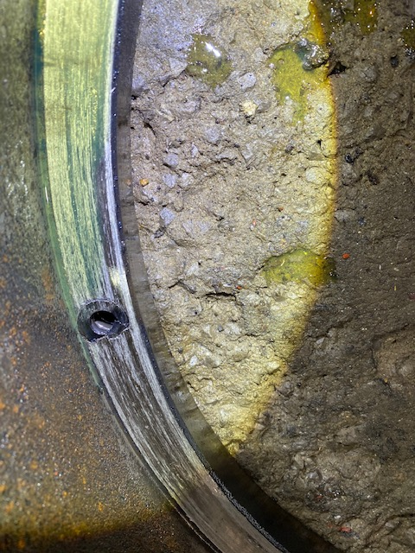

Appendix No.8

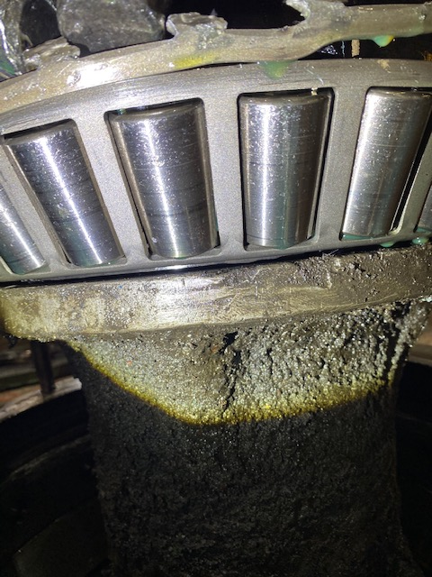

Appendix No.9

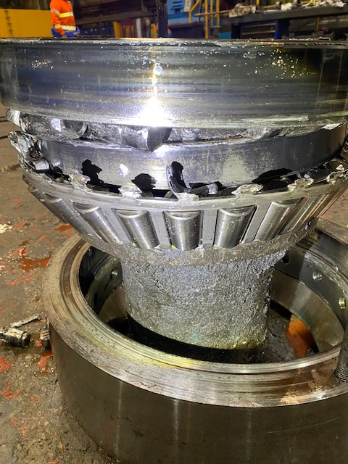

Appendix No.10

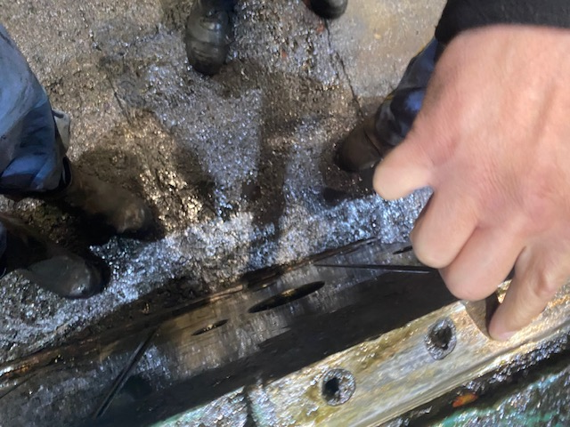

Appendix No.11



