Artistic Responses to Conflict:
Trauma.

Student No. P147080

BA Fine Art

Word Count: 5,699

Tutor: Dr Catrin Webster

Introduction.

Given the enormity of the consequences of war, conflict and subjugation, it is perhaps inevitable that artists through the years have consistently felt compelled to explore, interpret and consider its human costs. Whether it is Pablo Picasso (1881-1973) in his meditation on the atrocities at Guernica (1937), Wilfred Owen (1893-1918) with his poetic narrative on the desperation experienced in the trenches of the First World War (1914 -18), or even Hollywood’s gaze on the American dream to nightmare trajectory of the Vietnam War (1955-75), the impact on the human psyche has been a theme that artists regularly return to. Analysis reveals that the artistic account of trauma frequently focuses on the lives of ‘ordinary’ people and is often expressed in existential terms, presented variously as reportage, polemic and as a vehicle for catharsis. In its ancient Greek reading, catharsis is interpreted as a purification or purging of the emotions. Indeed, Rapp (2015, p.439) reminds us that Aristotle considered it as an essential component of dramatic tragedy and one that arouses emotions of pity and fear, with the effect of purging or cleansing the psyche.
Set against this reading, it is perhaps artists who have a legitimate capacity to examine these powerful emotions and in doing so, they may facilitate an emotional purging of our collective psyches, which may elicit a sense of hope or renewal. Reflecting on this notion of conflict and hope, Alex Danchev describes the artist as a moralist, or moral witness who offers hope:
Hope that there is, or will be, an audience of sentient spectators, viewers, readers, absorbed in the work: a community, a moral community for whom it stands up and who will stand up for it. Art is the highest form of hope… armed with art, in other words, we are more alert and less deceived. (2009, p.3).
As already implied, the artistic response to such profound events is vast and is reflected in virtually all forms of creative art. However, for the purposes of this discussion, I will concentrate on the artistic interpretation of trauma as portrayed in three discrete cinema films. The ability of film to reach a potentially diverse audience was a significant factor in identifying it for discussion. Moreover, the cross over between fine art practice and film is long established, as demonstrated by the work of Turner Prize artists, Steve McQueen and Sam Taylor Wood, who have both shifted from the creation of gallery based work to mainstream cinema films. In addition, it is interesting to note that all four of the shortlisted artists for the Turner Prize 2018 used film as a medium.
My research will consider three films. They are El Espíritu de la Colmena (1973), Persepolis (2007) and La vita è bella (1997). My discussion will provide an analysis of these artistically important works, through an assessment of their form, their narrative approach and the devices each film maker uses that may offer deeper meaning. In addition, as an integral part of the research, reference will be made to significant thinkers and relevant theoretical critiques.
In Chapter One, I will assess Victor Erice’s Spanish language film, El Espíritu de la Colmena (1973). Translated as the spirit of the beehive, Erice’s film is presented as a homage to an isolated community in fascist dominated Spain during the civil war. Although the film has come to be regarded as a Spanish masterpiece and has a reach which extends globally, the film speaks loudest to the Spanish audience of the early 1970s, who were still experiencing the final years of a dictatorship that had lasted for five decades. Indeed, it this cultural context, whereby many rural communities had become silently compliant to authority, that gives the film its subtle essence. Thus, it is a film rich in symbolism and motif, not least the idea of the labyrinthine interior of a beehive, presented here as an implicit symbol of the secret complexity of a community that has been diminished by civil war. My discussion will assess how Erice brings together cinematography and storytelling to present his audience with the viewpoint of a child, in a narrative that pays respect to the endurance of the human spirit in difficult times.
Chapter Two will look at a French/Iranian animated film by the graphic novelist Marjane Satrapi. In her work, Persepolis (2007), Satrapi also considers the effects of conflict through the eyes of a child, who in this instance faces formative challenges in post-revolutionary Iran. We see the young Marji forced to wear a veil and culturally diminished because of her gender. A story that is partly autobiographical, Persepolis is considered highly subversive by the Iranian government and has had only limited screenings in Satrapi’s homeland, with all sexual scenes edited out. Nevertheless, its audience extends throughout the Islamic world and beyond. As an animated film, it has an appeal to a younger audience, who may already have experience of the graphic novel format. Indeed, its many adolescent themes are universal and adolescent girls identify with Marji’s challenges (Ebert 2008).
In Chapter Three, my discussion will turn to a comparatively mainstream production, La vita è bella (1997). Translated as life is beautiful, Roberto Benigni’s film uses comedy as a device to elicit meaning, in a story that often challenges our collective Holocaust sensibilities. It is a narrative that is positioned in magical reality and tells the story of an Italian Jewish bookshop owner and his young son surviving against the odds in a Nazi concentration camp during World War Two (1939-45). Although the film includes the familiar ‘popular movie’ device of sentimentality, it also importantly portrays the dominance of the human spirit in a situation of complete catastrophe. Made fifty years after these events, Benigni speaks to a global audience who are arguably conversant with the Nazi concentration camp narrative, but he does so with a new and challenging approach.
In a concluding section these three works and important perspectives will be merged in an analysis that takes stock of these filmmakers. It will assess their themes and approach and will consider the role of the auteur filmmaker in accounts of trauma.

Chapter One

Beneath the Surface:
El Espíritu de la Colmena (1973).

In his film El Espíritu de la Colmena (1973), the director Victor Erice offers a multiplicity of readings of a community suppressed by totalitarianism. It is at once
a dramatic critique of 1940s rural Spain under the dictatorship of General Franco, a meditation on a society imbued in secrecy and an elegiac evocation of a landscape from which we witness a young girl develop from innocence to enlightenment (Wilson, 2008).
The film was made and released during the final years of Franco’s five-decade dictatorship of Spain and consistent with the difficulties of free expression at that time, Erice provides a portrait that is at first sight subtle and slow paced (Hagopian, 2009). Indeed, it is the languid pace of the narrative that allows deeper meaning to emerge and as the story develops important questions concerning secrecy, lies and compliance are raised. By intricately weaving together these themes, Erice presents a timely moment of catharsis to a Spanish population that was seeking to come to terms with its past.
Ana, the young protagonist is portrayed as a symbol of naïve innocence. She is very young and looks on bewildered, at a world where everything seems confusing. Through a series of vignettes, we see the young girl begin to question her world and to test the legitimacy of those around her and as if to underscore Ana’s questioning innocence, the film is abundant in visual metaphor, whereby we see her family and community go about their everyday tasks as if in retreat from their own realities. Each vignette, whether it is her parents writing secret letters, Ana seeing the reflection of a monster in a pool of water, or children jumping over the flames of a bonfire, becomes a symbol for deeper meaning.
Perhaps the most enduring symbol is the relationship with her older sister Isabel. We initially see them at a screening of James Whale’s film Frankenstein (1931) at the village hall. It is interesting to note that Erice is presenting us with the idea of a film within a film and although we briefly see cutaway shots of the Frankenstein movie, the predominant focus is on Ana’s face (Fig. 1.) as we witness her astonishment.
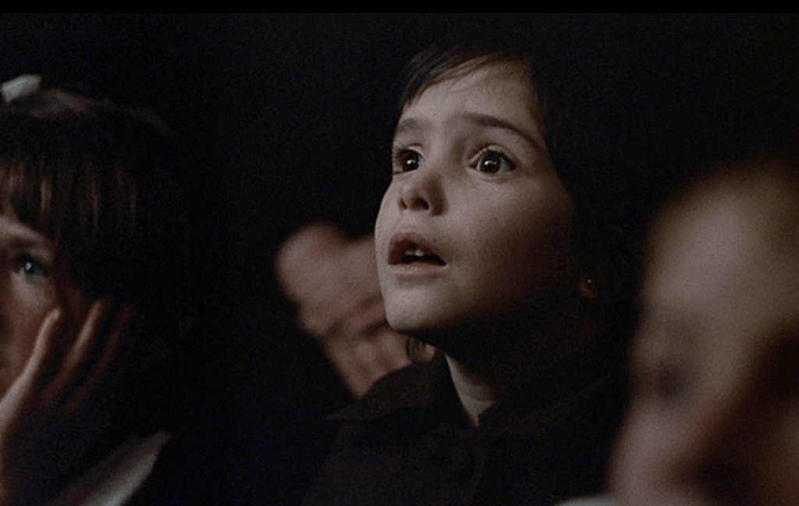
Figure 1. The Spirit of the Beehive (1973)

It seems that Erice presents this as a pivotal moment, whereby the Frankenstein movie has triggered her to interpret her own world:
The light of the screen shines in her eyes. Put neutrally; we see what Frankenstein shows and Ana's reaction to it. Put more expressively - and with greater fidelity to the moment of Ana's reaction… we don't see what she sees, but her seeing it. We watch Ana's face itself becoming a screen upon which the external signs of an internal epiphany are being played out, a revelation the child will carry into the world beyond the cinema (Darke, 2010, p. 153).

In an interview in 2006 the director himself identifies this scene as a moment of epiphany describing it as, “the best… the most important… and most essential moment” he had captured on film (Erice, 2006). Developing the idea of epiphany, Darke also comments that this is the moment when Ana realises her distinctiveness from others around her, “The figure of Frankenstein becomes Ana's placeholder of an otherness" (2010, p. 157).
It seems to me that what follows is a journey where Ana seeks answers and explanation. Her parents are portrayed as secretive and overwhelmed by their own subdued worlds and thus Ana can only turn to her elder sister, Isabel for answers. It is clear, that Erice uses the motif of sibling rivalry to extend the idea of secrecy, when we see Isabel in the position of power denying her innocent sister access to truth and answers (Fig. 2.). Isabel merely teases her young sibling to invoke the spirit of the monster and tells her to repeat the mantra, ‘Soy Ana’ (I am Ana). It is interesting to speculate whether Isabel in her determination to exercise her power has unwittingly started Ana on a path to self-discovery. Louis Arata agrees that, “Isabel has become a guide in Ana’s journey of discovery. Yet… is not aware of the deep significance” (1983, p. 31). It is certainly the case that Ana begins to realise she cannot even trust her sister and by rejecting her dependency, she begins to think for herself in a moment of pre-adolescent crisis:
The crisis which Ana undergoes is a crisis of identity. She is responding to a deeply felt need to assert herself and establish her independence from the rest of the family (Riley, 1984, p. 491).

The parallel between the relationship of the two sisters and the Spanish Civil War is clear. Presented as an allegory, the older sister Isabel is portrayed as the controlling Francosit who tells lies, whilst Ana is depicted as the innocent republican peasant who looks for truth and answers.
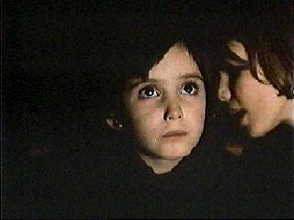
Figure 2 The Spirit of the Beehive (1973)

The image of the monster that has triggered Ana’s journey becomes an important motif that is repeated throughout the narrative. It feels as though the monster is all pervasive and is symbolically evoked by the thunderous roar of a steam train, by the dismembered body parts of an anatomy chart in the schoolroom and even by the footprints that lead to a deserted barn. It is interesting to consider whether Ana perhaps identifies with the monster’s exclusion from society and the quest for truth:
El Espiritu de la Colmena is a film about the struggle of a young girl to assert her independence… to break the constraints of the beehive. Ana is not a passive victim of a monster either real or imagined, but ultimately its arbiter or proxy, embodying its spirit of outcast and rebel (Stiles, 2016).

The monster theme is perhaps fully realised when Ana befriends a fugitive at the barn and gives him an apple (Fig 3). It is of course a moving moment that evokes the flower scene from the James Whale film. However, one wonders whether the giving of an apple extends beyond the need for simple nourishment, but becomes instead a philosophical and religious symbol for the loss of innocence and the attainment of knowledge.
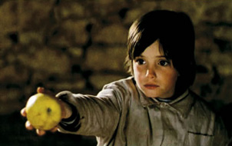
Figure 3. The Spirit of the Beehive (1973)

The critic Roger Ebert supports the idea that the film can be read as a coded allegory about Franco’s fascist dictatorship, but also affirms its aesthetic quality, “I relate to it more strongly as a poetic work about the imagination of children, and how it can lead them into mischief and sometimes rescue them from its consequences.” (2012)
Indeed, Erice privileges the sense of atmosphere as much as the plot and thus the look and ‘texture’ of the film becomes an integral component of how the movie functions as a commentary of the events it seeks to portray. Muted tones fill the screen with honey yellow, gold and brown as the predominant colours (Fig 4).
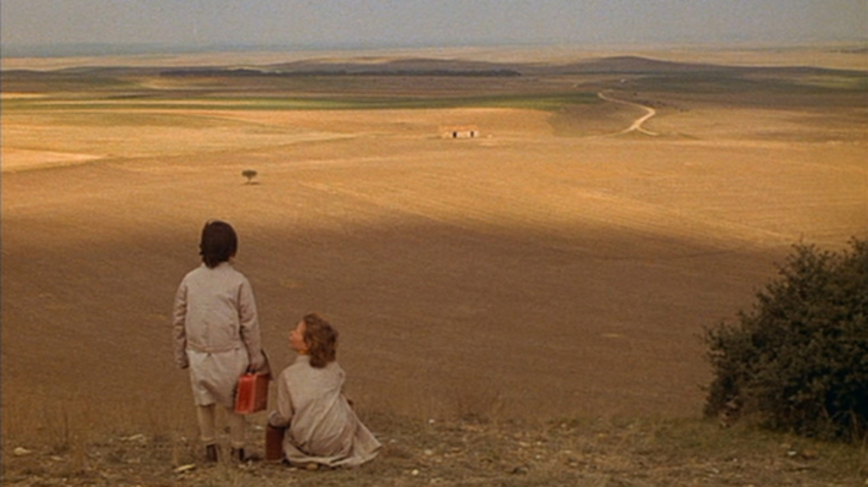
Figure. 4 The Spirit of the Beehive (1973)

Shadow and light compel you to look further and deeper, as if you may discover the secret of a beehive and the perfect symmetry of honeycomb witnessed in the pattern of glass (Fig. 5). It is a story which is infused with concealment and dishonesty. Further investigation reveals that even the simple folk song we hear children singing in the middle of the story translates as, ‘Let’s tell lies’.
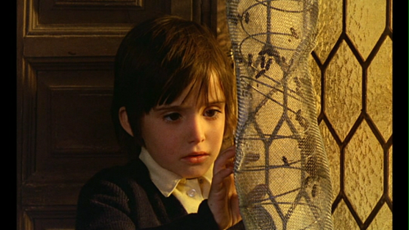
Figure 5. The Spirit of the Beehive (1973)

In, El Espíritu de la Colmena (1973). Victor Erice has created a narrative that seeks to see through the pain and silence of the oppressed, offering the motif of a beehive as a, “symbol of social order which, while superficially unified, is nevertheless marked by a radical isolation of each of its members from one another” (D’Lugo 2009). Erice’s film seeks to present a palpable release of repressed emotion as felt by a traumatised community, but expressed here through the vehicle of a little girl’s coming of age experience. It is a cathartic and liberating piece in Erice’s notable oeuvre, that pays respect to the quest for truth and identity, which is accentuated by Ana’s final words as she looks directly at the camera, “I am Ana”.
In, El Espíritu de la Colmena (1973), the narrative is often hidden and the dialogue is thus suitably spare. Moreover, much of what Erice seeks to present is coded in allegory and metaphor, which creates an immersive experience for the viewer who is required to unpick a delicate tapestry. In Chapter Two an entirely different approach to the traumatic effects of conflict is considered. In Marjane Satrapi and Vincent Parranaud’s film Persepolis (2007), the story is arguably less hidden than in Victor Erice’s film and is told in a linear form through a dynamic use of monochrome animation.

Chapter Two.

An End of Idealism:
Persepolis (2007)

Marjane Satrapi first came to fame as a critically acclaimed graphic novelist. Her autobiographical graphic novel, Persepolis (2004) charts her life as a child and young adult during and after the Islamic Revolution in Iran. In 2007, the novel was made into a film, written and directed by Satrapi herself and in partnership with French filmmaker Vincent Parronaud.
Persepolis (2007) like El Espíritu de la Colmena (1973) is a coming of age story. It is a film in three distinct movements that tells the story of a little girl called Marji who is raised in a privileged, secular and well-educated family. At intervals, we see the effect of the revolution on Marji, we observe her life in Vienna, where her parents send her for respite and we witness her return to Iran as a student.
As a prelude, the film starts with Marji as an adult sitting at an airport as she muses back on her childhood in pre-revolutionary Tehran. Marji’s parents are portrayed as idealists, who live a cosmopolitan life and typically hold dinner parties with other liberal minded friends where they smoke, drink alcohol and campaign against the Shah of Iran (Fig 6.).
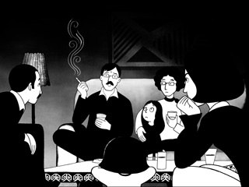
Figure 6. Persepolis (2007)

But change is in the air and a fundamentalist Islamic revolution takes place in Iran. At first her parents welcome the revolution, believing it to be a transitory phase on the road to a more progressive society, until it becomes apparent that the religious zealots who have overthrown the Shah are here to stay.
Satrapi cleverly imbues the screen with an atmosphere of tyranny, as we see young Marji witness the idealistic world of her parents in severe decline. A culture of fear, hate and restriction takes hold, opposition is firmly controlled, liberal values are denounced and hard won womens rights are reversed. It is in Satrapi’s depiction of such events, that her animated approach provides a strength that ‘real life’ characters often lack. Rather than ordering history in a recreated sense, Satrapi’s animation emphasises that her story is a history of the memory and one that is more able to destroy myths and stereotypes of orientalism.
This strategy frees the filmmakers from generic constraints and allows creating narratives that represent an alternative to the dominant media discourse about the middle east and war in general… The narrative illustrates the ridiculousness of stereotypes… thus holding a mirror to the west (Dzmuranova, 2011, p. 3).

Moreover, what we are witnessing here is no childlike animation, instead it is a serious attempt to portray a society in conflict and Satrapi’s innovative approach shines a light on injustice as seen in the eyes of a narrator who is trapped by childhood. It is interesting to note that Marji is portrayed as a feisty girl who loves western trash culture and as someone who questions authority. It is an important characterisation that sets her apart from authority.
She has something of Lisa Simpson and a little more of Peanuts' Lucy van Pelt, but with a seriousness and a single-mindedness that is all her own. She is close to her mother, closer still to her wise and worldly grandmother, whose wit and shrewdness she imbibes. Hers is a funny and deeply involving story but its sharp stabs against the women-hatred of the Iranian governing classes are enough to trigger rage (Bradshaw, 2008).

The portrayal of injustices to women in a time of traumatic oppression gives the narrative its beating heart and Marji, a young girl facing puberty, is the ideal conduit to express the visceral emotions caused by such prejudice. Women are forced by the government to wear veils and their place in society becomes increasingly marginalised. In a particularly upsetting scene we witness Marji’s mother being ordered to adjust her headscarf by a smug group of young policemen. Her protestations are met with unbridled anger as one policeman screams at her, “I fuck whores like you and throw them in the trash.” (Fig. 7)
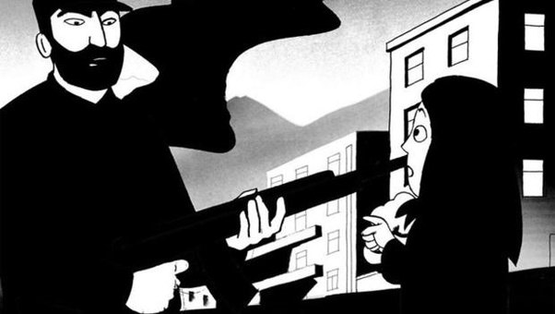
Figure 7. Persepolis (2007)

With such confrontational scenes, it is perhaps surprising to discover that the film is also rich in humour. To see Marji variously portrayed aping her western heroes, like martial arts actor Bruce Lee, or playing air guitar to Iron Maiden songs, once again confronts western stereotypes. Moreover, it is the juxtaposition between the humour of the naive pubescent and the reality of the world around her, that gives the narrative a gravitational pull, which in turn immerses the viewer into Marji’s confusing world. As with the character of Ana in Chapter One, Marji is a resolute girl and seeks to push back against the conspiracy of silence, but ultimately it is her resolve to be different that causes her parents to send her to Vienna, where they believe she will be safe to express herself freely.
In Vienna, life is very different for Marji, but her experiences there are far from idyllic. Already suffering from the trauma of seeing her homeland in conflict and its culture undergoing existential change, in Vienna she faces the challenges of adolescence as a misplaced person in an unfamiliar culture. Living with Roman Catholic nuns, her free spirit is at odds with their restrictive lifestyle. Moreover, under their guardianship she experiences racial prejudice and is eventually thrown out for insulting a nun. What follows is a descending spiral of failure and lost opportunity.
Satrapi cleverly evokes the classic dramatic trope of the traumatised refugee, whereby day to day existence becomes nomadic. Ultimately, Marji’s life in the west is presented as an endless stream of disappointment. Relationships are difficult to forge, attempts at love are spurned and even false accusations of criminality eventually force Marji into destitution and homelessness. Sam Leith describes this integral and important theme as, “the loneliness of the exile” (2004) and Satrapi’s almost flat animation during these scenes create a sense of blankness and melancholy (Fig 8).
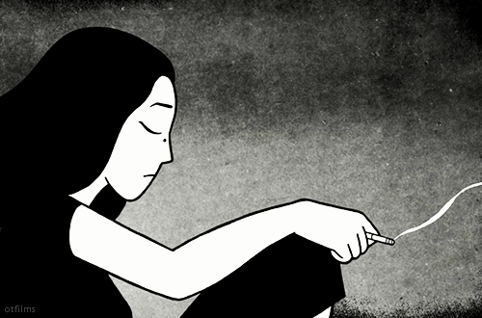
Figure 8. Persepolis (2007)

Marji’s despair is palpable and eventually we witness her attempting to take her own life, but it is the consequences of her suicide attempt that at last offers hope. Drenched in a drug induced dream, she sees images of God and Karl Marx swirling and merging. However, Marji is comforted by the dream and like Ana with Frankenstein, this is a moment of epiphany, whereby her emotional perspective at last begins to repair.
In analysis, Marji’s experiences of the west had promised so much, not least a liberation from the trauma and a chance to transition to adulthood in safety. Instead, she has experienced bigotry, danger and misogyny. Europe is clearly drawn as a metaphor for empty promises and as a society that is self-regarding, unkind and ultimately covetous.
In the final part of the narrative, Marji returns to Iran to study at university. Her relationship with her grandmother is emphasised and becomes an important symbol of continuity in this final part of the story. It seems to me that Satrapi is keen to portray her grandmother as her moral compass and as a metaphor that connects her to her past. Back in Iran, Marji still encounters hurdles and make mistakes, but it is her grandmother who restores her equilibrium.
The end of Marji’s time in Iran is inevitable. The authorities increasingly clamp down on political dissidents and Marji understands she must leave following a critical speech she makes at university, whereby she attacks the institutionalised sexism of the university authorities. Her decision to leave is clearly a moment of self-determination and like Ana she has affirmed her identity and gained insight. Her sense of distinctiveness is underlined in the concluding moments, when a Parisian taxi driver asks her where is she from. Almost surprised by her own candour she replies, “Iran”.
In, Persepolis (2007), Satrapi has given us a story that speaks movingly of the traumatic effects of violent revolution on ordinary people. Whilst the symbolism is less hidden than in the Spirit of the Beehive (1973), its effect on the human cost of conflict is evoked with passion and honesty. The two-dimensional nature of the animation and the largely monochrome palette, remains true to the original graphic novel. Moreover, its visual texture is as important as it narrative storyline.
Satrapi and Paronnaud’s animation is clean, unfussy and marked by fluid lines, and is so richly drawn and sharply edited that the filmmakers prove adept at capturing sentiments and atmosphere through purely visual means (Shager, 2007).

There is nothing ersatz, or sentimental about Satrapi’s story and its success rests entirely on this innate integrity. Indeed, whilst many coming of age films involve manufactured dilemmas, Ebert reminds us that, “here is one about a woman who indeed does come of age, and magnificently” (2008).
In Chapter Three, the trauma of the vanquished in the most awful of circumstances will be considered by an analysis of Roberto Benigni’s film La Vita è Bella (1997), whereby the use humour in a story about the holocaust confronts our collective sensibilities.

Chapter Three

Hope Amidst Atrocity:
La Vita è Bella (1997)
A film that focusses on the persecution of Jews and the concentration camps where so many European Jews lost their lives would seem an unlikely subject for comedy. Indeed, one may consider such a treatment as tasteless and abhorrent to our collective sensibilities. However, Roberto Benigni presents a narrative that straddles the boundaries of tragedy and comedy in his film La Vita è Bella (1997). Translated as life is beautiful, Benigni directs the movie and stars as its central protagonist, an Italian Jew, Guido Orefice. The story is based partly on the experiences of Benigni’s father who spent several years in a German concentration camp and by the then unpublished memoirs of Rubino Romeo Salmoni (1920-2011).
La Vita è Bella (1997) is regarded as a mainstream film, rather than art house and gained critical and financial success at the Cannes Film Festival and the Academy Awards in Hollywood. Given this context of success in the mainstream entertainment industry, it is perhaps pertinent to question the film’s artistic intentions. Indeed, although celebrated by many, the film has stern critics:
While comedy here does capture something of the absurdity of the death camps, ultimately Benigni's sentimental fantasy diminishes the suffering of Holocaust victims, with the self-consciously 'beautiful' shot of a mound of corpses the most glaring of several directorial misjudgements (Dawson, 2002).

Notwithstanding such criticism, Benigni’s film may still be regarded as a heartfelt eulogy to his father and others who suffered so badly under the evil of the Nazi’s. Benigni himself remembers how his father always recounted his days in a Nazi labour camp with comedy, so as not to scare the young Benigni (Ben-Ghiat, 2014, p.298). It is perhaps this and the director’s extensive experience of comedy that determines this unusual approach for a subject, which is usually reserved for only the most solemn of consideration.
Perhaps serving as an allusion to Benigni’s own relationship with his father, the story itself rests on the relationship between Guido and his young son, Giosuè (Fig. 9), albeit in far more tragic circumstances. Guido is a young Jewish man living in Italy who has a tendency towards clowning and a talent for improvisation in often testing situations. Variously we see how Guido protects his son from the reality of a politically unstable Italy. Persecution and prejudice are everywhere, but Guido is portrayed as resolute in his determination to shield his son and treats every difficult situation as if it were game. Guido and Giosuè are eventually seized and sent to a German labour camp. Even at the camp, Guido convinces his son that the experience is nothing more than an elaborate game. It is of course an absurd notion and one that often extends into a sense of magical realism, but is nonetheless poignant in his attempts to mask the truth:
It's stunningly inappropriate, yet by turning the death camp into an improvised child's game Benigni articulates at least a partial truth. Auschwitz was in the deepest, most awful sense an absurd place - a monstrous institutionalised irrationality. When told by his child that the camp's other kids have warned him that they are all going to be turned into soap and buttons… Benigni replies that such ideas are absurd, a trick to get him out of the game: "You fell for that? Buttons and soap out of people. That will be the day" (Hoberman, 1999, p. 21).

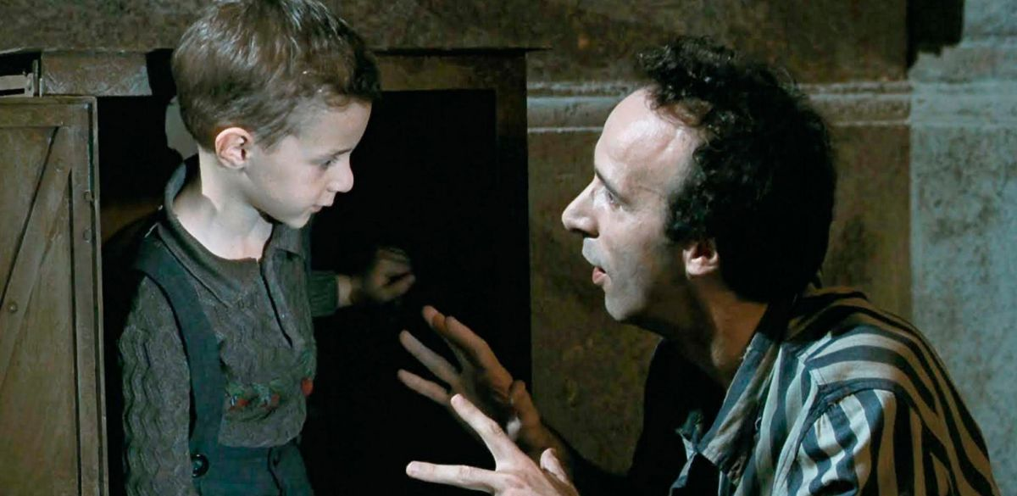
Figure 9. La Vita e Bella (1997)

It seems to me that the innate tension between tragedy and comedy produces a startling and dangerous juxtaposition in Benigni’s film. It at once confronts our received and collective preconceptions about this time in history and dares us to laugh at man’s gross inhumanity to man. As a performance, it is often registered in the sentimental, but importantly we are also reminded of the potential of the human spirit and how it may have the imagination to seize upon even the faintest glimmer of hope. Conscious of the emotional juxtaposition it presents us, Benigni uses imagery and symbolism rather than humour to evoke incalculable human suffering. Typical of this approach is the scene where Guido with his son in his arms, sees a pile of corpses through a fog as he walks across the yard (Fig. 10). It is an image as brutal and disturbing as any from medieval depictions of hell (Fig. 11). But in this instance, the cinematography abandons the comic register and evokes the most terrifying notions of the sublime (Fijman, 2011). Whilst Casper David Friedrich’s (1774 -1840) swirling mists reveal the elemental forces of nature (Fig. 12), here the mist reveals a perverse scene of sorrow and pain. In using a painterly approach, Benigni’s image of the corpses produces an almost hallucinatory or dream effect and with Guido’s son embraced close to him, so as not to see this obscenity, a moment of profound pity is forged. For that moment, Guido must carry the burden as a sole witness to the abyss of hell.
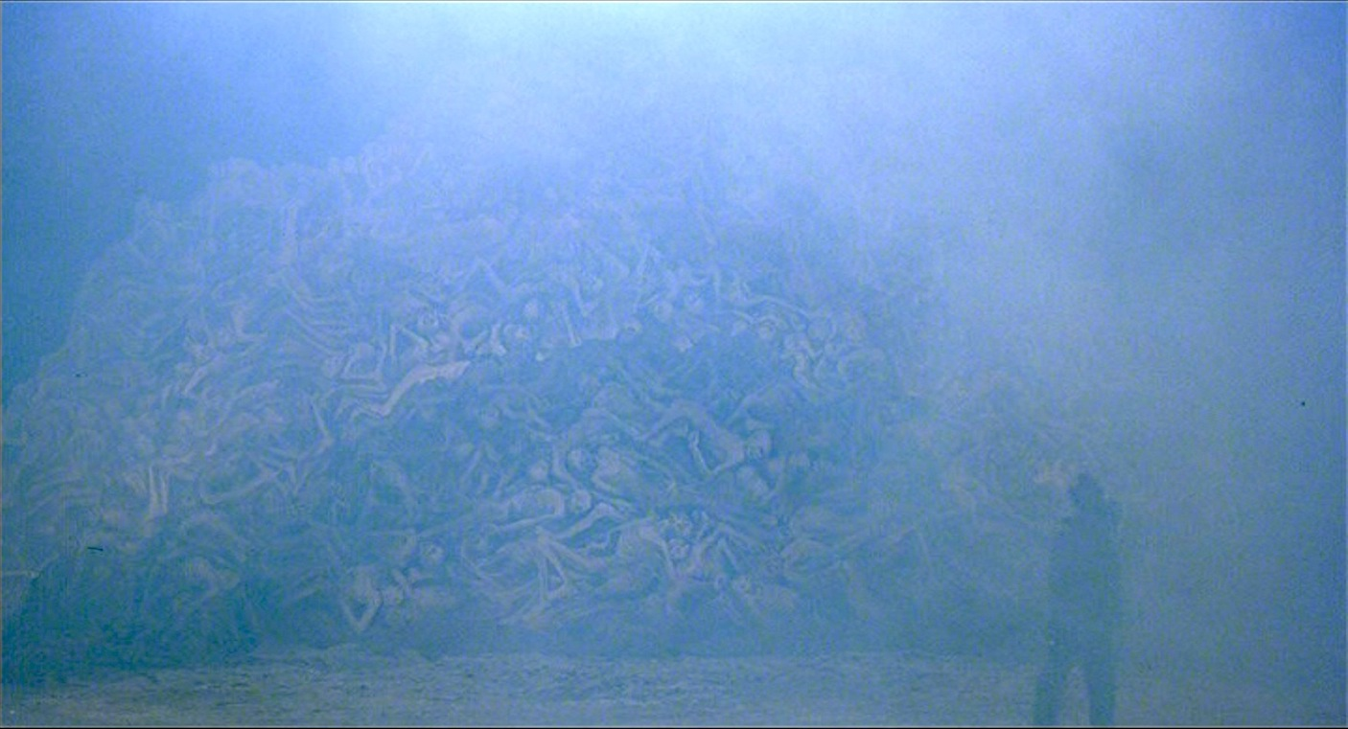
Figure 10. La Vita e Bella (1997)

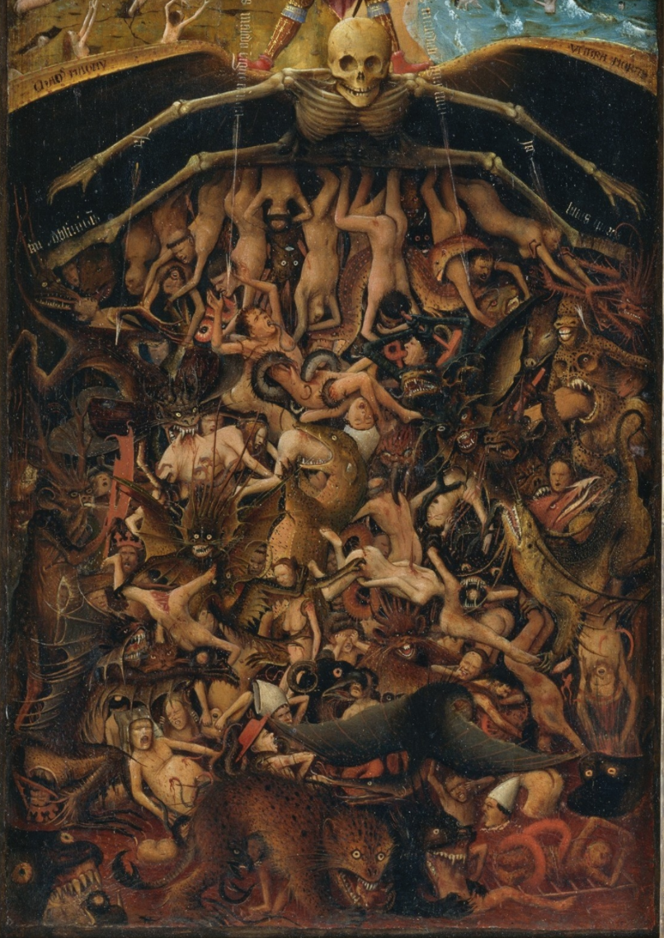

Figure 11. Hell. Detail from The Last Judgement by Jan Van Eyck (Circa. 1430-40)

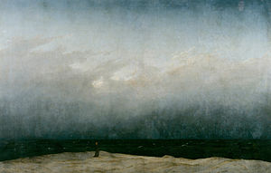
Figure 12. The Monk by the Sea by Caspar David Friedrich (1808-10)

Given the enormity of the wider events the film seeks to portray, the question remains whether comedy can be justifiably used in a meditation on the holocaust. Are we being merely invited to smile through the tears, or maybe the director is seeking to make a profounder point? Ultimately, it is surely an integral and unavoidable part of the human condition that we use what meagre resources we may have, no matter how appalling the situation.
The film finds the right notes to negotiate its delicate subject matter. And Benigni isn't really making comedy out of the Holocaust, anyway. He is showing how Guido uses the only gift at his command to protect his son. If he had a gun, he would shoot at the Fascists. If he had an army, he would destroy them. He is a clown, and comedy is his weapon (Ebert, 1998).

Moreover, as an account on the effects of trauma, Benigni presents comedy as a courageous choice. In its presentation of history, it is both serious and mischievous, but it importantly never lapses into self-righteousness. Maslin comments that, “piety has no place here, nor do tears until the final reel. 'Life is Beautiful’ plays by its own rules” (1998).
It is perhaps self-evident that La Vita è Bella (1997) could never be described as high art or even as a historical account of the holocaust atrocities and given the audience it potentially seeks, it may be regarded as mass art. Nevertheless, in its constellation of difficult themes, it serves to provide a challenge to a mass audience who may be “expecting a fairly, innocent night at the movies” (Haskins, 2001, p. 373). La Vita è Bella (1997) is at heart an unpretentious account with a predominant focus given to the dignity of the human spirit. It is about rescuing some measure of hope from the wreckage of our dreams and is a moving declaration that things could and should be better for our children (Ebert,1998).

Conclusion.

My research has considered three very different films, that offer three distinct meditations on how trauma is engendered by war or conflict. The common thread of storytelling is self-evident. Moreover, each film in their own contrasting ways uses storytelling as an artistic device that may enable our understanding and does so to potentially different audiences.
El Espíritu de la Colmena (1973), speaks to a primarily Spanish audience and is presented with subtlety. This delicate approach is as a result and indeed as a reflection of the cultural context in which the film is placed, whereby much of the audience may have been familiar with the social subtext. It is a nuanced piece, where visual metaphor and symbolism drive the narrative with lyrical effect. Persepolis (2007) also shares a sense of the subversive, given it attacks a sitting regime, but does so more overtly. In addition, with its adaptation of the graphic novel format, it reaches to a younger global audience who may not usually be politically cognisant. Moreover, it speaks to the culturally misplaced and to the trauma of the adolescent too. Naturally, both films also have a wider audience, due to the universal issues they examine and to their critical success. However, in the case of La Vita è Bella (1997) we witness a film that may be regarded as more mainstream. Indeed, the film has a traditional feel and given the director’s prior fame in the wider show business world, we may mistakenly dismiss it as cliché. Yet whilst the production may appear to some critics as overly sentimental, such a view is arguably limited, given the film presents a range of challenging ideas to a wide audience who may be used to more conventional interpretations.
It is also interesting to note that a common theme in each production is childhood. Variously the narrative is either seen, or influenced by the perspective of a child. Ana and Marji are presented as trapped observers, whose perspectives are initially limited by their age and their place in society. In the space of their stories, Ana and Marji begin to understand reality and eventually gain a sense of clarity and authenticity. However, Giosuè remains trapped as an observer because of his father’s resolve to shield him from the awful truth. In Benigni’s narrative, Giosuè’s worldview must remain inauthentic and ambiguous, at least for the time being. A message perhaps, that although truth is overwhelmingly crucial, it comes with its inevitable costs.
From a wider perspective, films, visual art, literature and other forms of creative expression contribute to our collective understanding of the traumatic effects of conflict. They serve not only to inform, but also to provide a cathartic release that may help us to memorialise and even to forgive. In this sense, our collective need to deal with catastrophe is rightfully mirrored in art. At its best and most thoughtful it may increase our understanding, explain our pain and satisfy the human need for renewal.

Reference List

Arata, L.O. (1983) ‘I am Ana: The Play of the Imagination in the Spirit of the Beehive’, Quarterly Review of Film Studies, 8(2), p.31.

Ben-Ghiat, R. (2014) ‘Life is beautiful’, The American Historical Review,
104(1), pp. 298-299.

Bradshaw, P. (2008) Persepolis. Available at: https://www.theguardian.com/film/2008/apr/25/animation.drama (Accessed 2nd December 2018).

Danchev, A. (2009) On art and war and terror. Edinburgh: Edinburgh University Press.

Darke, C. (2010) ‘Les enfants et les cinéphiles’: The moment of epiphany in the spirit of the beehive’, Cinema Journal, 49(2), pp. 152-158.

Dawson, T. (2002) La Vita e Bela. Available at: http://www.bbc.co.uk/films/2002/06/06/la_vita_e_bella_1997_review.shtml (Accessed 5th December 2018).

D’Lugo, M. (2009) in Hagopian, K. The Spirit of the Beehive. Available at: https://www.albany.edu/writers-inst/webpages4/filmnotes/beehive.html (Accessed 25 November 2018).

Dzmuranova, K. (2011) Persepolis and Waltz with Bashir, an Alternative Perspective on the Middle East, a Mirror for the West. Unpublished MA thesis. Florida Atlantic University.

Ebert, R. (1998) Life is Beautiful. Available at:
https://www.rogerebert.com/reviews/life-is-beautiful-1998
(Accessed 6th December 1998).

Ebert, R. (2008) Persepolis. Available at:
https://www.rogerebert.com/reviews/persepolis-2008
(Accessed 30th November 2018).

Ebert, Roger, (2012) The Spirit of the Beehive. Available at:
https://www.rogerebert.com/reviews/great-movie-spirit-of-the-beehive-1973
(Accessed 25th November 2018).

Erice, V. (2006) The Footprints of a Spirit Les huellas de un espíritu. Directed by Carlos F. Heredero [DVD] London: Criterion Collection.

Fijman, L. (2011) Life is Beautiful. Is Death Sublime? Available at:
https://holocaustvisualarchive.wordpress.com/2012/01/30/life-is-beautiful-is-death-sublime/ (Accessed 7th December 2018).

Hagopian, K. (2009) The Spirit of the Beehive. Available at:
https://www.albany.edu/writers-inst/webpages4/filmnotes/beehive.html (Accessed 25 November 2018).

Haskins, C. (2001) ‘Art, Morality, and the Holocaust: The Aesthetic Riddle of Benigni's Life Is Beautiful’, The Journal of Aesthetics and Art Criticism, 59(4), pp. 373-384.

Hoberman, J. (1999) ‘Dreaming the Unthinkable’, Sight and Sound, 9(2), pp. 20-23.
Leith, S. (2004) A Writers Life: Marjane Satrapi. Available at: https://www.telegraph.co.uk/culture/books/3633695/A-writers-life-Marjane-Satrapi.html (Accessed 6th December 2018).

Maslin, J. (1998) Giving a humorous face to rearing a boy under fascism. Available at:
https://www.nytimes.com/1998/10/23/movies/film-review-giving-a-human-and-humorous-face-to-rearing-a-boy-under-fascism.html (Accessed 2nd December 2018).

Rapp, C. (2015) ‘Tragic Emotions’, in Destrée, P, & Murray, P, (eds.), A Companion to Ancient Aesthetics, Chichester: John Wiley & Sons.

Riley, E.C. (1984) ‘The Story of Ana in El espíritu de la colmena’, Bulletin of Hispanic Studies, 61(4), p. 491.

Shager, N. (2007) Persepolis. Available at: https://www.slantmagazine.com/film/review/persepolis (Accessed at 1st December 2018).

Stiles, O.A. (2016) The Monster and the Other. Available at:
http://www.anothergaze.com/the-monster-and-the-other-reading-gender-in-victor-erice-the-spirit-of-the-beehive/ (Accessed 8th December 2018).

Waxman, S. (1998) Embracing Life in Death Camps. Available at:
https://www.washingtonpost.com/archive/lifestyle/style/1998/11/01/embracing-life-in-death-camps/668c73c3-4480-4045-9f87-5d4438d9d1e6/ (Accessed 8th December 2018).

Wilson, K. (2008) The Spirit of the Beehive. Available at:
http://thirtyframesasecond.blogspot.com/2008/08/spirit-of-beehive-1973-spain-victor.html
(Accessed 2nd November 2018).

Illustrations.

Figure 1. Still from The Spirit of the Beehive (1973) Directed by Victor Erice.

Figure 2. Still from The Spirit of the Beehive (1973) Directed by Victor Erice.

Figure 3. Still from The Spirit of the Beehive (1973) Directed by Victor Erice.

Figure 4. Still from The Spirit of the Beehive (1973) Directed by Victor Erice.

Figure 5. Still from The Spirit of the Beehive (1973) Directed by Victor Erice.

Figure 6. Still from Persepolis (2007) Directed by Marjane Satrapi & Vincent Parannoud.

Figure 7. Still from Persepolis (2007) Directed by Marjane Satrapi & Vincent Parannoud.

Figure 8. Still from Persepolis (2007) Directed by Marjane Satrapi & Vincent Parannoud.

Figure 9. Still from La Vita e Bella (1997) Directed by Roberto Benigni.

Figure 10. Still from La Vita e Bella (1997) Directed by Roberto Benigni.

Figure 11. Van Eyck, Jan (circa. 1430-40) Hell. Detail from the Last Judgement [Oil on canvas, transferred from wood]. Available at: https://www.metmuseum.org/art/collection/search/436282 (accessed 10th December 2018).

Figure 12. Friedrich, Caspar David (1808-10) The Monk by the Sea [Oil on canvas]. Available at: https://www.tate.org.uk/context-comment/articles/whispering-zeitgeist (accessed 8th December 2018).

