

Student name: Samantha Essono Manana
Student ID:2441601

Module name: Introduction to Physiology
Module code: (BMHP5023_LON)
Lecturer name: Shaila Hussain.
Contents
Introduction 2
1a. Asthma 3
1b. The main risk factors for developing asthma. 3
1c. Education and self-management 4
2. Respiratory system and Mechanical respiration. 5
2a.The structure and Function of the Respiratory Tract 5
2b. The Process of Inhalation 6
2c. The process of exhalation. 6
3. Gas Exchange and Respiratory Irritants 7
3a. How Gas Exchange Takes Place in the Alveoli 7
3b. How Oxygen Enters the Bloodstream 8
3c. How Carbon Dioxide Leaves the Body 8
4. Effects of Respiratory Irritants on the Airways 8
4a. How Irritants Trigger Airway Inflammation 9
4b. How Airway Inflammation Affects Breathing 9
4c. Reducing Exposure to Respiratory Irritants 10
5. Peak Flow Monitoring 10
5a. Using a Peak Flow Meter 10
5b. The Importance of Peak Flow Monitoring 11
6. Promoting Healthy Lifestyles in Asthma Management 12
6b. How Healthcare Professionals Can Support People with Asthma 13
7. Conclusion 14
Reference list 14

Introduction
Asthma is one of the most common chronic respiratory disorders affecting children and adolescents in the United Kingdom. Although many young people are diagnosed during their childhood, puberty is frequently associated with changes in lifestyle, behaviour, and independence that can make asthma more difficult to treat. As young people take more responsibility for their own health, they may be exposed to additional risk factors such as smoking, vaping, air pollution, failing to comply with prescribed medication, and respiratory infections, all of which may increase the likelihood of asthma exacerbations and hospitalisations (NICE, 2024). 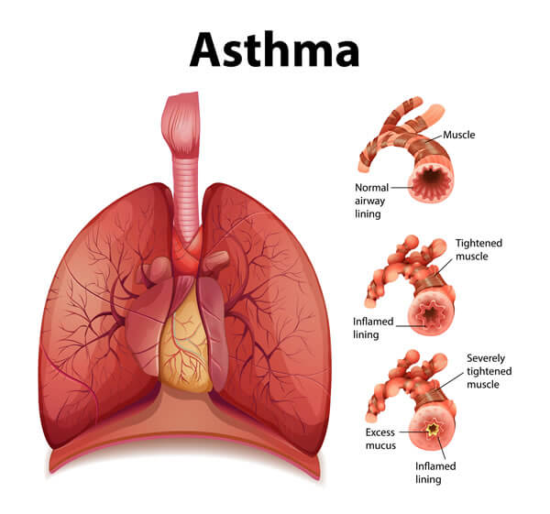

1a. Asthma
Although there is no cure for asthma, it can usually be treated effectively with a combination of prescription medicine, avoidance of identified triggers, regular monitoring, and patient education. Reliever inhalers provide immediate comfort by relaxing the muscles that surround the airways, while preventer inhalers contain corticosteroids, which lower airway inflammation and help prevent future exacerbations. (Global Initiative for Asthma [GINA], 2024).
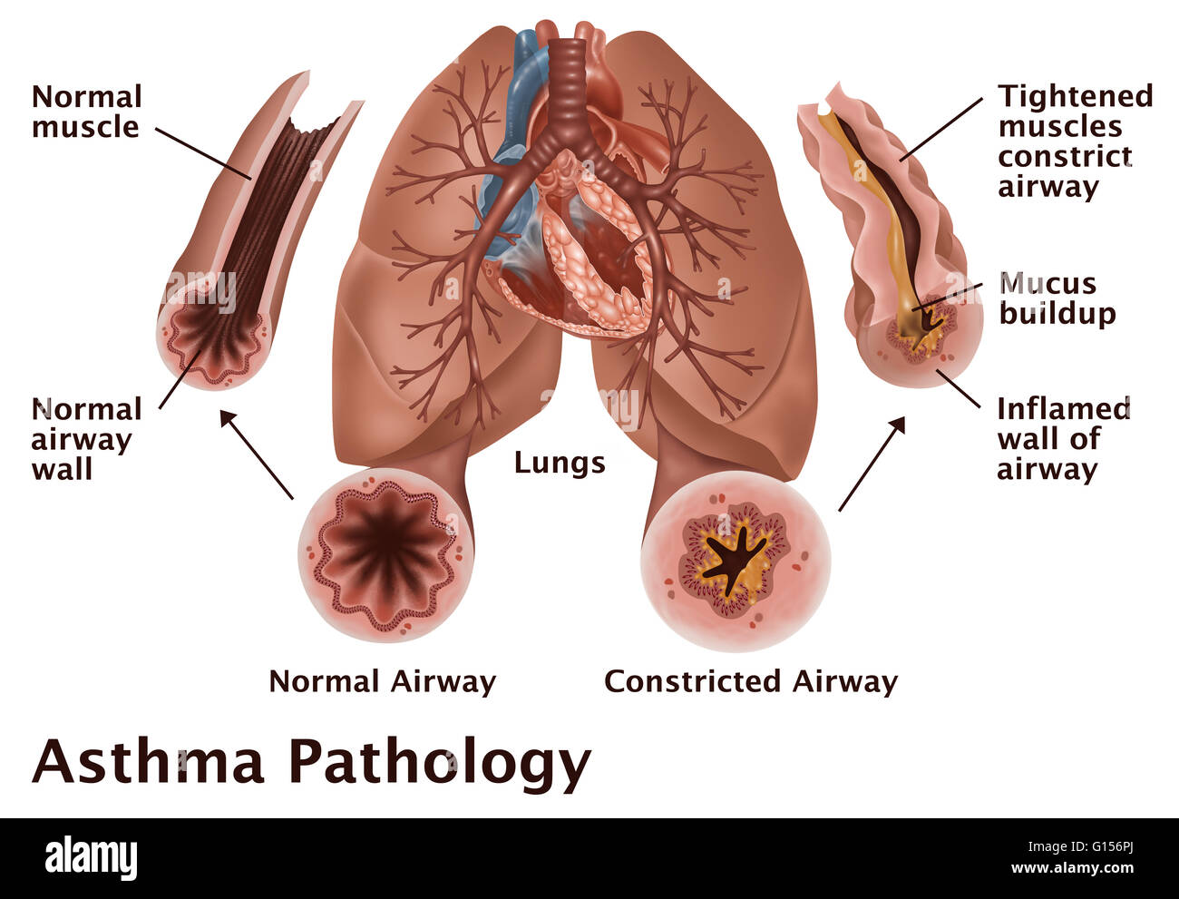

1b. The main risk factors for developing asthma.
Asthma develops through a combination of genetic and environmental factors. People with a family history of asthma, eczema, or allergic rhinitis have a higher risk of developing asthma. Genetic factors increase susceptibility to airway inflammation and hypersensitivity (GINA, 2024). Allergens such as pollen, house dust mites, mould and animal dander can trigger asthma symptoms in susceptible individuals. In addition, air pollution, such as traffic emissions and industrial pollutants, can irritate the airways and cause chronic inflammation. Respiratory infections, particularly during childhood, can increase the risk of asthma and trigger exacerbations (NICE, 2024). Personal choices are another significant risk factor, especially during adolescence. Cigarettes and electronic cigarettes (vaping) expose the lungs to harmful chemicals that damage the airways, cause inflammation, and impair lung function. Smoking and vaping increase the risk of poor asthma control and asthma exacerbations. Passive smoking increases the risk of asthma and worse symptoms (Asthma + Lung UK, 2024). 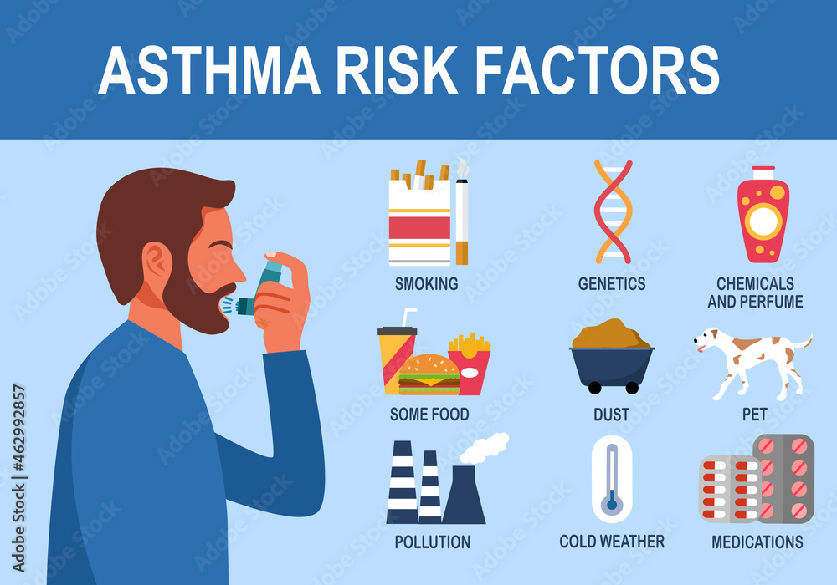

1c. Education and self-management
Healthcare professionals teach adolescents how to use inhalers correctly, monitor symptoms and understand the difference between reliever and preventer medication. Correct inhaler technique is especially important because poor technique can lower the amount of medication reaching the lungs, making treatment less effective and raising the likelihood of uncontrolled asthma (GINA, 2024). Following a tailored asthma action plan allows people to identify changes in their symptoms, respond effectively to worsening asthma, and know when to seek medical guidance or emergency care. Regular asthma reviews, peak flow monitoring when necessary, and adherence to prescribed medication can improve symptom control and prevent hospital admissions. Education should also include information on living a healthy lifestyle, avoiding smoking and vaping, engaging in safe physical exercise, and minimising exposure to environmental triggers (Asthma + Lung UK, 2024).
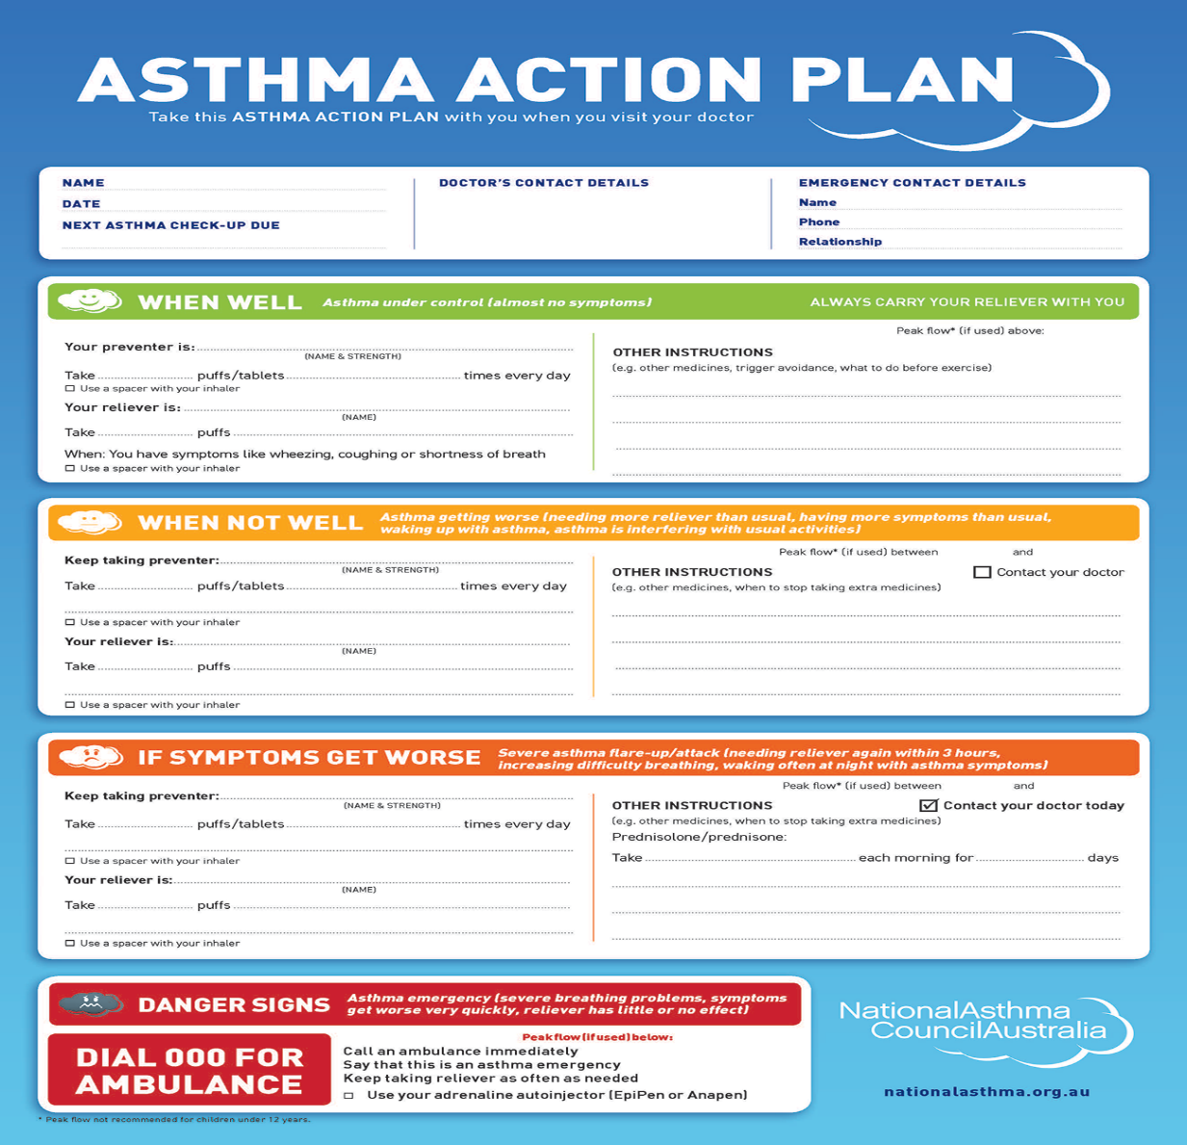

2. Respiratory system and Mechanical respiration.

The respiratory system is a complex network of organs and tissues that supply oxygen to the body and remove carbon dioxide generated during cellular metabolism. Each structure of the respiratory tract serves a particular purpose in filtering, warming, humidifying, and delivering air to the lungs, where gas exchange happens. Mechanical respiration, also known as pulmonary ventilation, is the process by which air enters and exits the lungs via the coordinated motion of the diaphragm and intercostal muscles

2a.
The respiratory system comprises various specialised structures that work together to transport air into the lungs, allowing oxygen to enter the circulation and carbon dioxide to leave the body. During inhalation, air travels along a precise path through the respiratory tract before reaching the alveoli, where gas exchange occurs (Tortora & Derrickson,2021). Air first enters the body via the nose or mouth. The nose is the primary route because it filters, warms, and humidifies the air before it reaches the lungs, but the mouth serves as an alternate conduit when more airflow is required, such as during exercise. The air then passes through the nasal cavity, where cilia and mucus trap airborne particles. The air then passes via the pharynx, or throat. The larynx, often known as the voice box, includes the vocal cords and epiglottis. During swallowing, the epiglottis closes over the airway, stopping food or fluids from entering the lungs. The air then flows through the trachea, also known as the windpipe, which is a tube supported by C-shaped cartilage rings that keep the airway open. The bronchi branch into smaller bronchioles, which regulate airflow.
Finally, air reaches the alveoli, defined as little air sacs surrounded by capillaries. The alveoli have thin walls that allow oxygen to enter the bloodstream while carbon dioxide diffuses from the blood into the lungs and is expelled. (NHS, 2024).
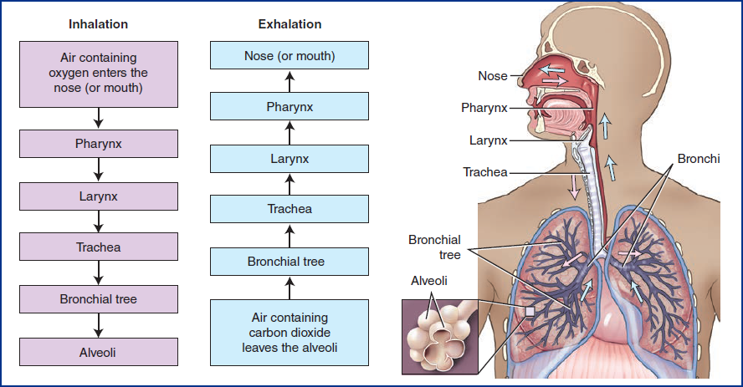

2b. The Process of Inhalation

During inhalation, the diaphragm contracts and moves downward, while the external intercostal muscles elevate the rib cage. This movement increases the capacity of the chest cavity, reducing the pressure inside the lungs. Because the pressure within the lungs falls below the pressure outside the body, air flows into the lungs and into the alveoli, where oxygen is available for gas exchange (NHS, 2024; Tortora & Derrickson, 2021).

2c. The process of exhalation.

Exhalation occurs when the diaphragm relaxes and moves upward, while the external intercostal muscles relax, allowing the rib cage to move downward and inward. These movements restrict the chest cavity, raising pressure inside the lungs. As the pressure rises above the pressure outside the body, carbon dioxide-rich air flows out through the airways. This mechanism aids in the elimination of waste gases produced during regular body metabolism (NHS, 2024; Tortora & Derrickson, 2021).

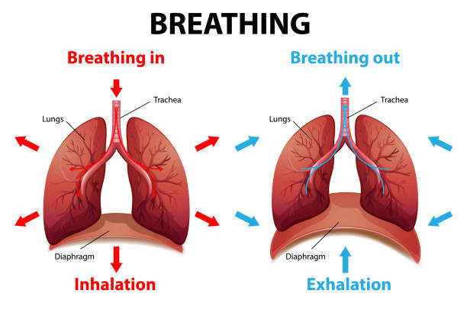

3. Gas Exchange and Respiratory Irritants

Gas exchange is a vital process that occurs in the lungs, allowing oxygen into the bloodstream while eliminating carbon dioxide from the body. Healthy lungs are essential for this process to function properly. However, respiratory irritants such as smoking, vaping, and air pollution can harm the airways and compromise lung function, increasing the risk of asthma symptoms and exacerbations (NHS, 2024; WHO, 2024).

3a. How Gas Exchange Takes Place in the Alveoli

Gas exchange takes place in the alveoli, which are small air sacs surrounded by capillaries. Because the oxygen content in the alveoli is higher than that in the circulatory system, oxygen diffuses from them into the bloodstream. At the same time, carbon dioxide flows from the blood into the alveoli and is expelled during exhalation. This continual process delivers oxygen to the tissues of humans and removes waste gases, helping the body to function correctly (NHS, 2024; Tortora & Derrickson, 2021).

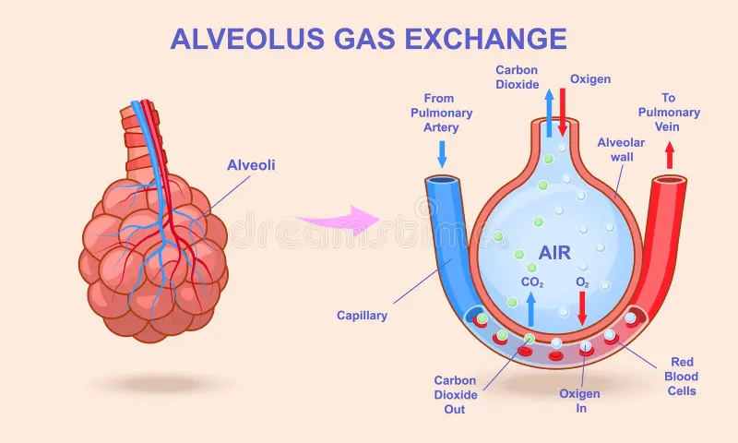

3b. How Oxygen Enters the Bloodstream

Oxygen circulates from the alveoli into the circulation. Because oxygen is more concentrated in the alveoli than in the circulation, it passes through the thin alveolar and capillary walls into the circulatory system. Oxygen then bonds to haemoglobin in red blood cells, delivering it to the body's tissues where it is necessary for energy production (NHS, 2024; Tortora & Derrickson, 2021).

3c. How Carbon Dioxide Leaves the Body

Carbon dioxide is produced by body cells as a waste product and delivered to the lungs via the bloodstream. It diffuses from the blood to the alveoli because its concentration is higher in the blood than in the alveoli. Exhalation eliminates carbon dioxide from the lungs. In asthmatic patients, constricted and inflamed airways may restrict airflow, making gas exchange less efficient (NHS, 2024; Tortora & Derrickson, 2021).

4. Effects of Respiratory Irritants on the Airways
Cigarette smoke, vaping aerosols, air pollution, and respiratory infections are all respiratory irritants that can damage the airways and aggravate asthma symptoms. These irritants cause increased airway inflammation, mucus development, and bronchoconstriction, which reduces airflow and makes breathing harder. Avoiding these triggers is an important aspect of asthma management (GINA, 2024; Asthma + Lung UK, 2024).
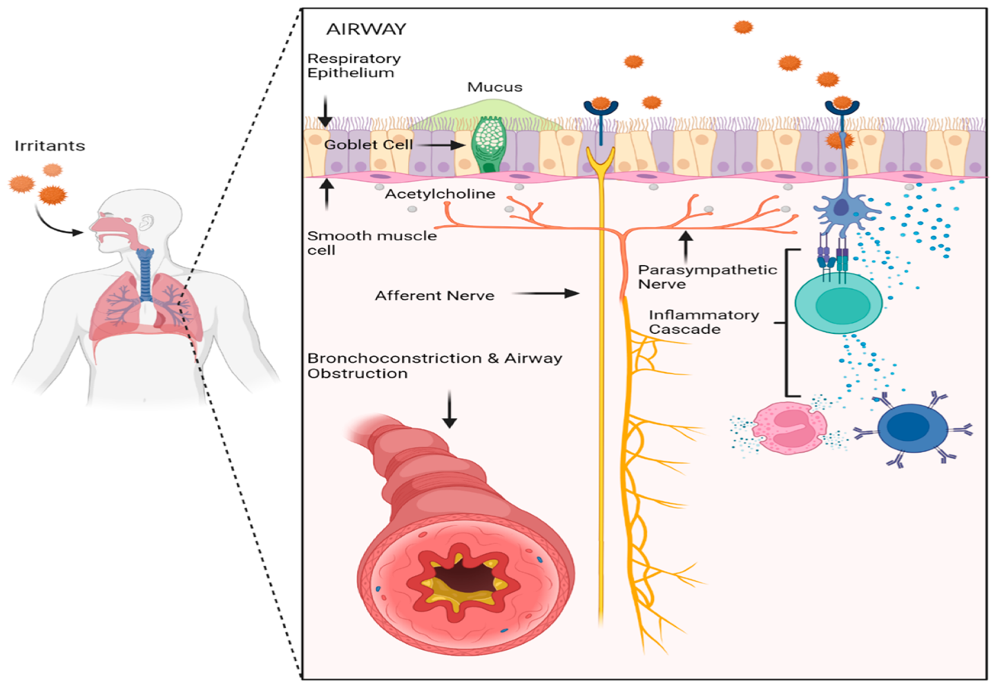

4a. How Irritants Trigger Airway Inflammation

Cigarette smoke, vaping aerosols, and other irritants can harm the lining of the airways and induce an immune system response. This causes inflammation, increased mucus production, and airway muscular contraction (bronchospasm). As a result, the airways narrow, making breathing difficult and increasing the likelihood of asthma symptoms and exacerbations (GINA, 2024; Asthma + Lung UK, 2024).

4b. How Airway Inflammation Affects Breathing

Inflamed airways expand and create extra mucus, reducing the available area for airflow. This makes it more difficult for oxygen to pass through the lungs, resulting in symptoms including asthma, coughing, chest tightness, and shortness of breath. Severe inflammation in asthmatic patients can result in an asthma attack if not treated promptly (Asthma + Lung UK, 2024; NHS, 2024).
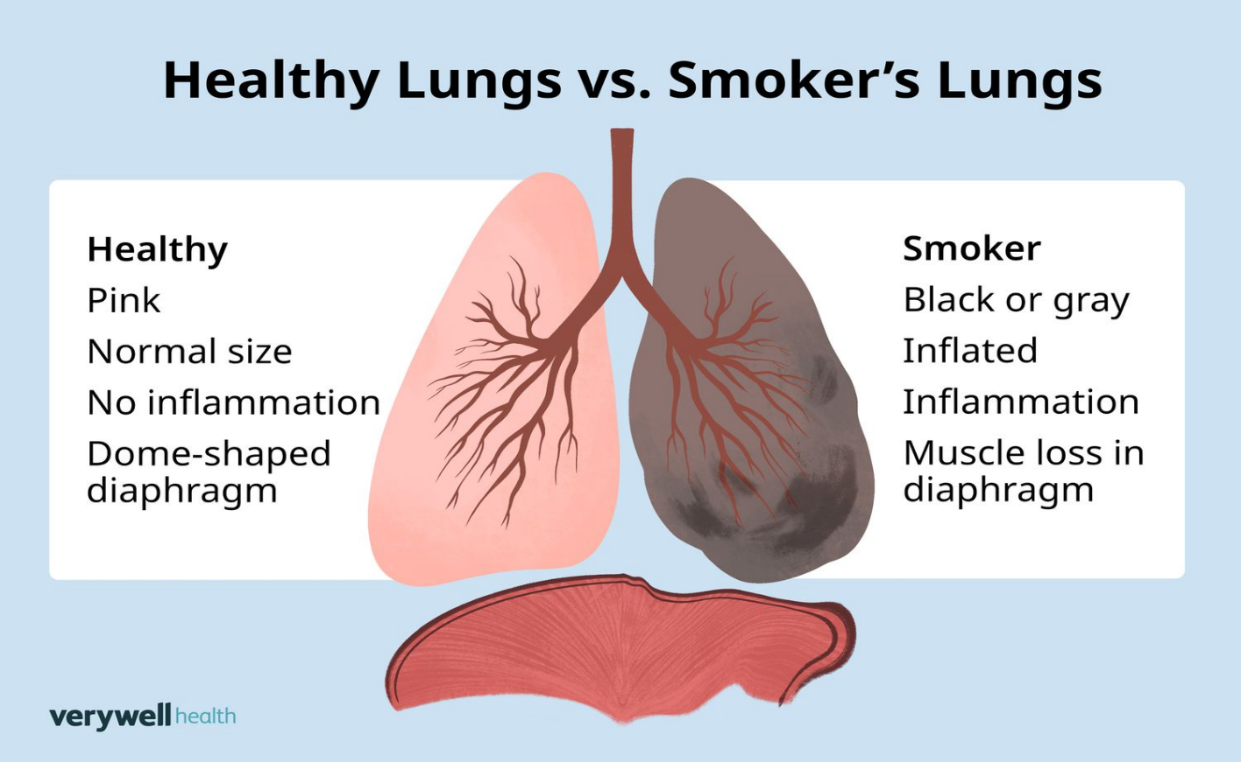

4c. Reducing Exposure to Respiratory Irritants

People with asthma should minimise their exposure to respiratory irritants by quitting smoking and vaping, minimising their exposure to air pollution, and avoiding allergens like dust, pollen, and pet dander as much as possible. Keeping interior environments clean and ventilated can also help alleviate symptoms. These treatments enhance asthma control and lower the likelihood of exacerbations (NICE, 2024; NHS,2024).

5. Peak Flow Monitoring

Peak flow monitoring is a simple way of measuring how quickly air is expelled from the lungs. It assists asthma patients and healthcare professionals in identifying changes in lung function, monitoring asthma management, and detecting early signals of increasing symptoms. Regular monitoring can assist to ensure timely treatment and lower the risk of severe asthma attacks (NICE, 2024; Asthma + Lung UK, 2024).

5a. Using a Peak Flow Meter

A peak flow meter is a handheld device that measures how quickly a person can blow air out of their lungs. It aids in tracking lung function and detecting early indicators of elevated asthma before symptoms become severe. To use the device correctly, the person using it should take a deep breath and exhale as hard and quickly as possible. The highest of three readings is usually recorded and compared with the person's normal peak flow value (NHS, 2024; BTS, 2024).
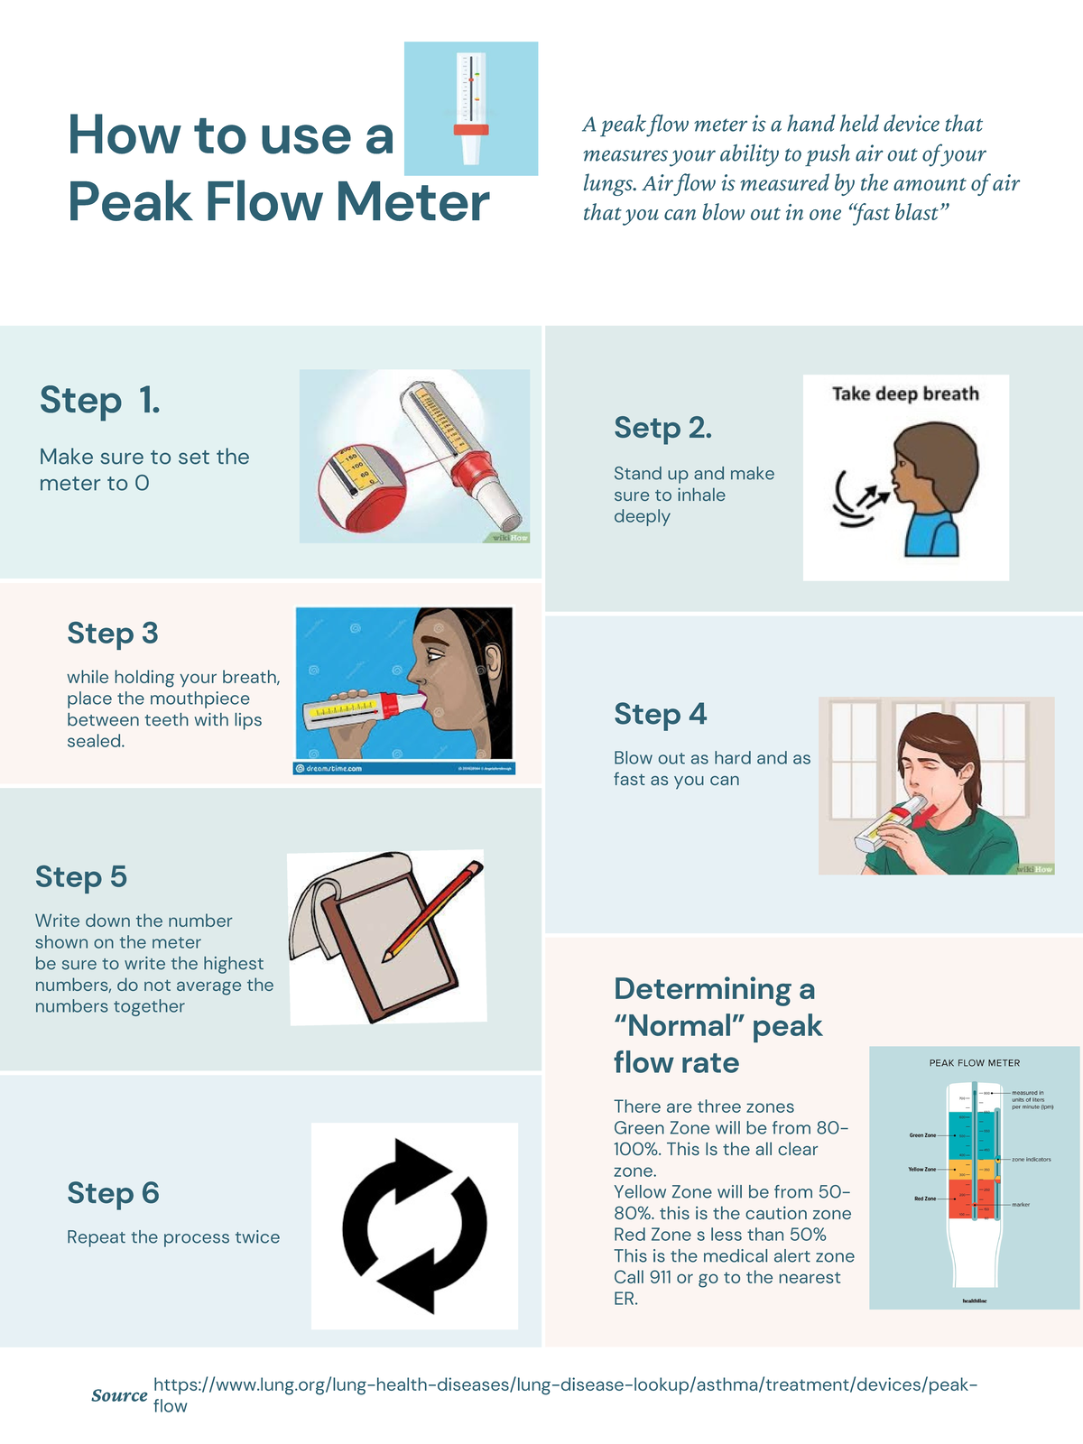

5b. The Importance of Peak Flow Monitoring
Regular peak flow monitoring helps identify changes in lung function before asthma symptoms worsen. Peak flow assessments allow patients and healthcare providers to detect early indicators of deteriorating asthma and modify treatment as needed. This improves asthma control, lowers the risk of severe exacerbations, and aids in deciding when to seek medical treatment (NICE, 2024; Asthma + Lung UK, 2024).
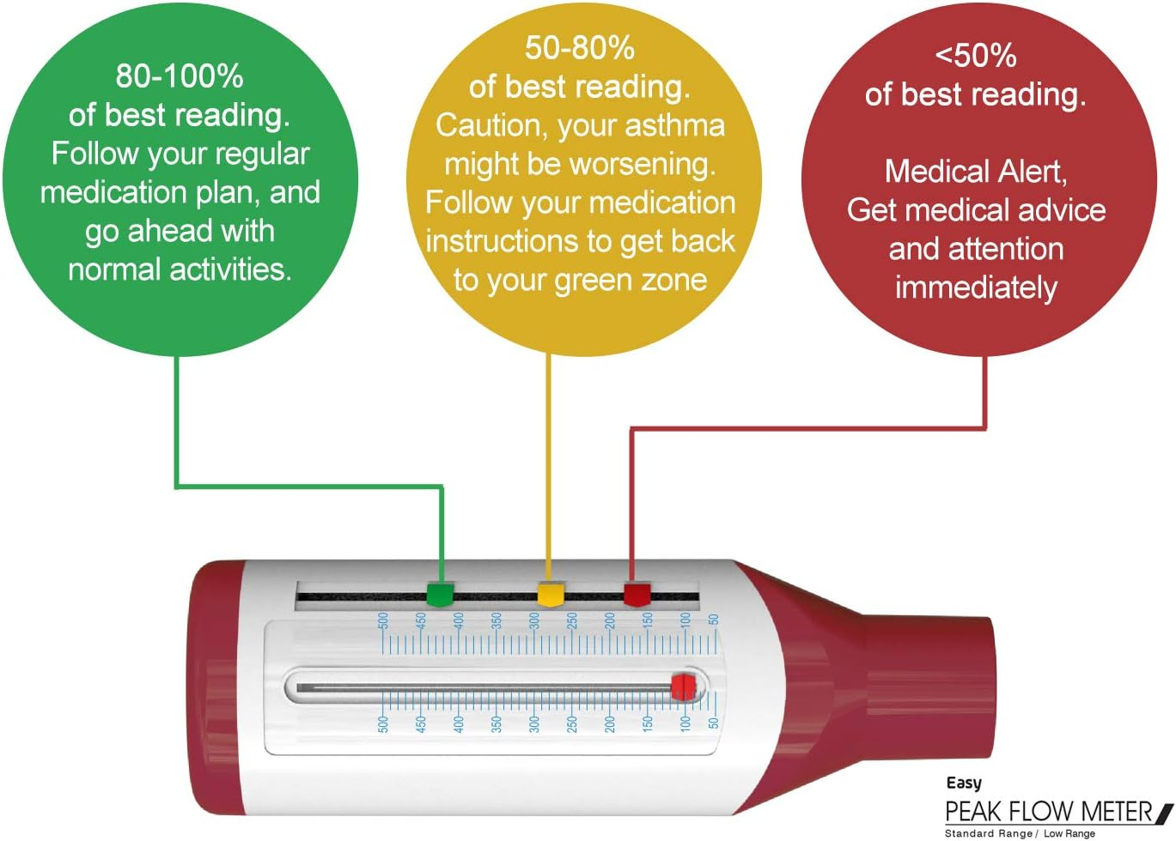

6. Promoting Healthy Lifestyles in Asthma Management
Healthy lifestyle choices are vital for managing asthma and reducing the likelihood of exacerbations. Regular physical exercise, a nutritious diet, quitting smoking and vaping, and following the specified treatment plan can all help to improve lung function and general well-being. Healthcare workers should encourage asthma patients to adopt healthy habits to support long-term asthma control (NICE, 2024; GINA, 2024).

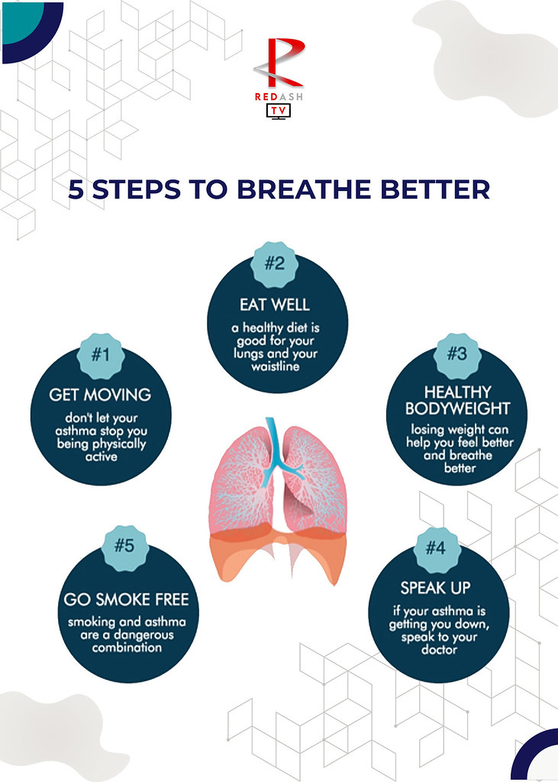

6a. Benefits of a Healthy Lifestyle for People with Asthma

A healthy lifestyle may improve asthma control and reduce the number of exacerbations. Regular physical activity strengthens the lungs, whilst a well-balanced diet helps the immune system and overall health. Avoiding smoking and vaping decreases airway inflammation and increases the success rate of asthma medications. These good habits can improve people's quality of life and help them better control their asthma (NICE, 2024; NHS,2024).

6b. How Healthcare Professionals Can Support People with Asthma

Healthcare professionals play a vital role in assisting patients with asthma. They educate patients about proper inhaler technique, identify asthma triggers, create personalised asthma action plans, and urge regular reviews. They also promote healthy lifestyle choices and make sure that treatment is modified as symptoms change. This support improves asthma treatment and reduces the likelihood of severe asthma attacks (NICE, 2024; British Thoracic Society, 2024)
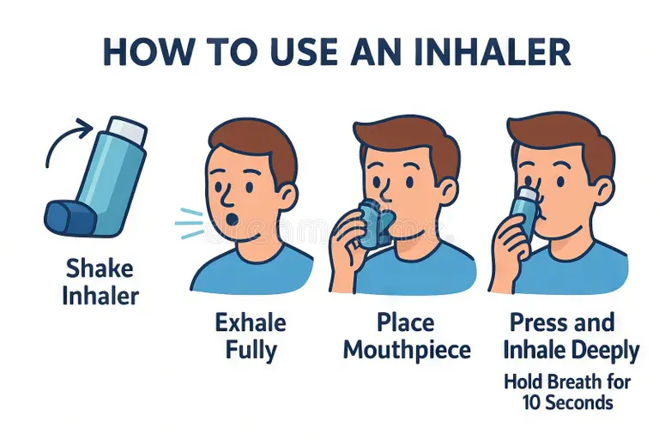

7. Conclusion

Asthma is a long-term respiratory condition that affects the airways and can reduce normal breathing. Understanding the respiratory system, mechanical ventilation, gas exchange, and the effects of airway inflammation is essential for effective asthma management. Regular peak flow monitoring, correct inhaler use, and following an asthma action plan can help identify worsening symptoms early and improve asthma control. Healthy lifestyle choices, including avoiding smoking, vaping, and other respiratory irritants, can reduce exacerbations and improve quality of life. With the right treatment, education, and self-management, people with asthma can control their symptoms and live healthy, active lives

Reference list

Asthma + Lung UK (2024) Asthma. Available at: https://www.asthmaandlung.org.uk (Accessed: 2 August 2026).

British Thoracic Society (2024) British guideline for the management of asthma. Available at: https://www.brit-thoracic.org.uk (Accessed: 2 August 2026).

Centres for Disease Control and Prevention (CDC) (2024) Asthma. Available at: https://www.cdc.gov/asthma (Accessed: 2 August 2026).

Global Initiative for Asthma (GINA) (2024) Global Strategy for Asthma Management and Prevention. Available at: https://ginasthma.org (Accessed: 2 August 2026).

National Heart, Lung, and Blood Institute (NHLBI) (2024) Asthma. Available at: https://www.nhlbi.nih.gov/health/asthma (Accessed: 2 August 2026).

National Health Service (NHS) (2024) Asthma. Available at: https://www.nhs.uk/conditions/asthma/ (Accessed: 2 August 2026).

National Health Service (NHS) (2024) Quit smoking. Available at: https://www.nhs.uk/better-health/quit-smoking/ (Accessed: 2 August 2026).

National Institute for Health and Care Excellence (NICE) (2024) Asthma: diagnosis, monitoring and chronic asthma management (NG80). Available at: https://www.nice.org.uk/guidance/ng80 (Accessed: 2 August 2026).

Tortora, G.J. and Derrickson, B.H. (2021) Principles of Anatomy and Physiology. 16th edn. Hoboken, NJ: John Wiley & Sons.

World Health Organization (WHO) (2024) Asthma. Available at: https://www.who.int/news-room/fact-sheets/detail/asthma (Accessed: 2 August 2026).

