MSc Data and Artificial Intelligence
Master’s Project
Student Name: Mihai – Sergiu Varzare
Student ID: 2217294
Module: ACFA7003 Master’s Project
Submission date: 28 August 2026

Contents
CHAPTER 1 — INTRODUCTION 3
1.1 Context and Background 3
1.2 Research Problem 4
1.3 Research Aim and Objectives 5
1.4 Significance of the Research 5
1.5 Research Questions 6
1.6 Project Scope 6
1.7 Methodology Overview 7
1.8 Dissertation Structure 7
CHAPTER 2 — LITERATURE REVIEW 8
2.1 Artificial Intelligence and Conversational Assistants 8
2.2 Conversational AI and Natural-Language Interaction 8
2.3 Speech Recognition and Voice-Based Interaction 9
2.4 Large Language Models and Generative AI 9
2.5 Embodied Conversational Agents and Virtual Humans 10
2.6 Text-to-Speech and Non-Verbal Behaviour 11
2.7 AI Assistants and Smart-Environment Interaction 11
2.8 External Information Services and Context-Aware Interaction 12
2.9 Evaluation of Conversational and Embodied AI Systems 13
2.10 Critical Synthesis and Research Positioning 13
CHAPTER 3 — METHODOLOGY 14
3.1 Research Approach 14
3.2 Development Methodology 15
3.3 Requirements Gathering 16
Functional requirements 18
Non-functional requirements 18
3.4 Technology Selection 18
3.5 System Development Process 19
3.6 Integration Strategy 20
3.7 Testing Methodology 21
3.8 Evaluation Approach 21
3.9 Ethical, Privacy and Security Considerations 22
3.10 Methodological Limitations 23
CHAPTER 4 — SYSTEM DESIGN AND ARCHITECTURE 24
4.1 System Overview 24
4.2 System Architecture 24
4.3 Voice Interaction Pipeline 25
4.4 Command Processing Architecture 26
4.5 Generative AI Integration 27
4.6 Weather/API Architecture 28
4.7 Smart Environment Architecture 28
4.8 TTS and Embodied Response 29
4.9 Data Flow 30
4.10 Security and Error Handling 31
4.11 Design Rationale 32
CHAPTER 5 — IMPLEMENTATION 33
5.1 Implementation Overview 33
5.2 Unity Environment and Component Structure 34
5.3 Speech Recognition Implementation 34
5.4 VoiceCommandManager Implementation 34
5.5 Generative AI Implementation 35
5.6 AI Request and Response Processing 36
5.7 Virtual Smart-Home Control 37
5.8 Conversational Response and User Feedback 37
5.9 Text-to-Speech and Animation Integration 38
5.10 Error Handling 38
5.11 API and External-Service Integration 39
5.12 Implementation Integration 40
5.13 Implementation Summary 41
CHAPTER 6 — TESTING AND EVALUATION 42
6.1 Testing Strategy 42
6.2 Functional Testing 42
Table 6.1 — Functional Test Cases 43
6.3 Voice Command Testing 43
Table 6.2 — Voice Command Variation Testing 44
6.4 Smart Environment Testing 44
Table 6.3 — Smart Environment Test Results 44
6.5 Weather Testing 45
Table 6.4 — Weather Test Results 45
6.6 Generative AI Testing 46
Table 6.5 — Generative AI Test 46
6.7 End-to-End Testing 46
Table 6.6 — End-to-End Test Results 47
6.8 Error and Boundary Testing 47
6.9 Overall Test Results 48
Table 6.7 — Overall Test Results 49
6.10 Evaluation Against the Research Questions 49
RQ1 — Voice, AI and TTS integration 49
RQ2 — Natural-language environmental control 49
RQ3 — External information services 49
RQ4 — Limitations and challenges 49
6.11 Chapter Summary 50
CHAPTER 7 — DISCUSSION 50
7.1 Discussion of Findings 50
7.2 Achievement of Project Objectives 51
Objective 1 — Develop a 3D conversational assistant capable of voice-based interaction 51
Objective 2 — Integrate artificial intelligence for conversational interaction 52
Objective 3 — Implement voice-controlled interaction with a simulated smart environment 52
Objective 4 — Integrate external information retrieval 52
Objective 5 — Provide an embodied response 52
Objective 6 — Integrate the components into a functional prototype 52
7.3 Significance of the Findings 52
7.4 Comparison with Existing Approaches 53
7.5 Strengths of the Proposed System 54
Modular architecture 54
Hybrid interaction model 54
Unified embodied interface 54
Multi-functional interaction 54
Specialised external services 54
Defensive behaviour 54
Successful integration 55
7.6 Limitations 55
7.7 Practical and Research Implications 55
7.8 Chapter Summary 56
CHAPTER 8 — CONCLUSION 57
8.1 Conclusion 57
8.2 Achievement of the Research Aim and Objectives 57
8.3 Key Contributions 58
8.4 Limitations and Future Work 58
8.5 Final Conclusion 59
REFERENCES 60
APPENDICES 61
[APPENDIX A — PROTOTYPE DEMONSTRATION VIDEO] 61
Prototype Demonstration Video 61

CHAPTER 1 — INTRODUCTION

1.1 Context and Background
Artificial Intelligence (AI) has increasingly influenced human-computer interaction (HCI), particularly through conversational interfaces and voice-based virtual assistants. Traditional interaction with digital systems has largely relied on graphical interfaces, keyboards, mice and touch-based controls, whereas contemporary AI systems increasingly allow users to communicate using natural language. This development creates opportunities for more accessible and intuitive forms of interaction in which users can communicate with computational systems using conversational language.
Many conventional virtual assistants remain primarily voice-based and lack a persistent embodied presence. Embodied Conversational Agents (ECAs) provide an alternative approach by incorporating a virtual or physical representation into conversational interaction. An embodied agent can combine verbal communication with non-verbal elements such as facial behaviour, gestures, movement and animation, creating opportunities for a more engaging and socially meaningful interaction. This project therefore investigates the combination of conversational artificial intelligence and a 3D embodied character as an alternative interface for interacting with intelligent systems.
The project builds upon an existing 3D AI-driven assistant prototype originally developed during the author's undergraduate studies. The original system established a foundation for real-time interaction with a 3D avatar but had limited capabilities, particularly in voice-command interaction, non-verbal behaviour and interaction with an external environment. The present project extends this foundation at Master's level by introducing enhanced voice interaction, conversational AI, simulated smart-environment functionality and external information retrieval.
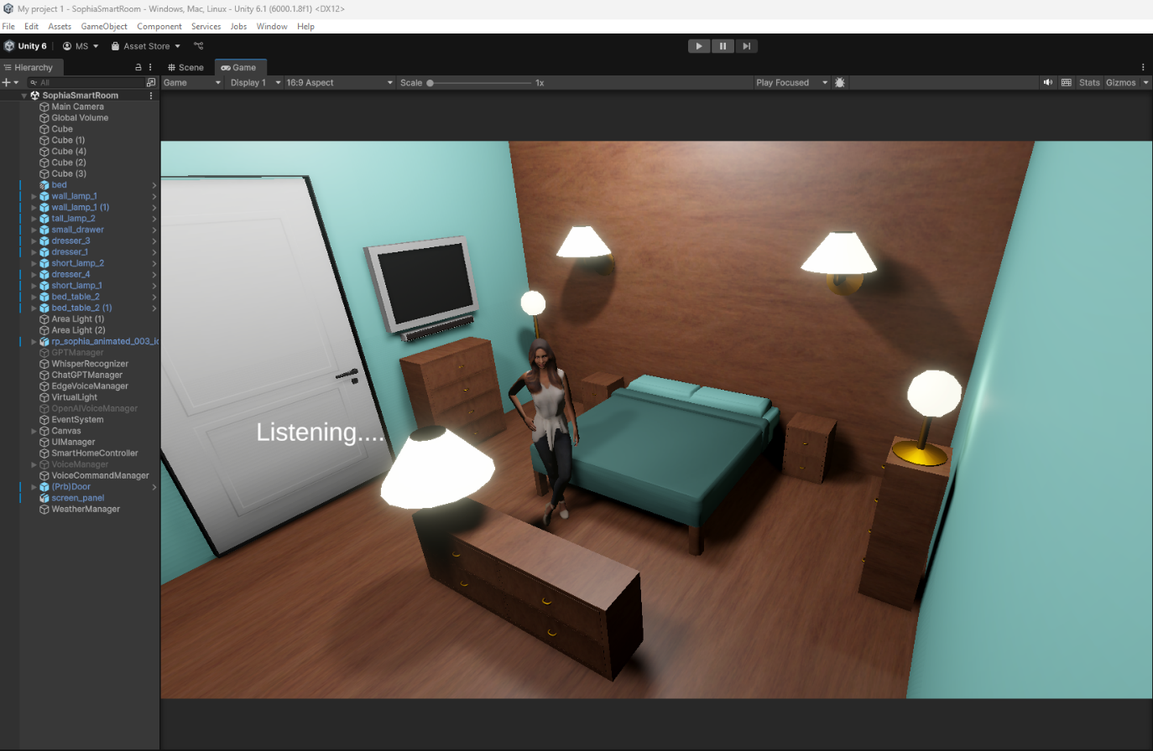

The resulting prototype, named Sophia, operates within a Unity-based 3D environment. Users can issue spoken requests that may result in simulated environmental actions, retrieval of external information or general conversational responses. The system integrates speech recognition, command processing, generative AI, text-to-speech and character animation within a single interactive environment. The project is therefore concerned not only with demonstrating individual technologies, but with investigating how they can be integrated into a coherent interactive system and evaluating the effectiveness and limitations of that integration.

1.2 Research Problem
The increasing availability of conversational artificial intelligence has enabled users to interact with computational systems through increasingly natural forms of language. However, many conversational systems remain centred on text or voice and provide limited physical or visual embodiment. ECAs offer an alternative by combining conversational interaction with a visual representation capable of producing speech, animation and other non-verbal behaviour.
Integrating these technologies into a single real-time embodied system introduces several challenges. Speech recognition must interpret user input, natural-language requests must be mapped to appropriate actions, generative AI must operate without interfering with predefined environmental controls, external information services must be handled reliably, and resulting responses must be communicated coherently and in a timely manner.
A further challenge concerns the balance between fixed command-based interaction and flexible natural-language interaction. Exact predefined commands can provide predictable functionality but may reduce interaction naturalness, while completely open-ended conversational systems may not reliably determine when a request should trigger a specific environmental action.
The project therefore addresses the problem of integrating conversational AI, voice interaction, 3D embodiment, external information retrieval and environmental control into a coherent assistant. The research investigates whether these technologies can operate together within a real-time Unity environment while providing useful and sufficiently natural interaction.

1.3 Research Aim and Objectives
1.3.1 Research Aim
The aim of this project is to design, develop and evaluate a 3D AI-driven virtual assistant capable of real-time voice interaction, conversational responses and control of simulated smart-home devices within an interactive Unity environment.
1.3.2 Research Objectives
The project addresses this aim through six objectives:
O1. To critically investigate existing research and technologies relating to conversational artificial intelligence, speech recognition, text-to-speech, virtual assistants, virtual humans and smart-home interaction.
O2. To identify and define the functional and non-functional requirements for a 3D AI-driven assistant capable of interacting with users and controlling simulated smart-home devices.
O3. To design an integrated architecture combining speech recognition, natural-language command processing, generative AI, text-to-speech and simulated smart-device control within a real-time 3D environment.
O4. To implement the proposed assistant as an interactive Unity-based prototype incorporating voice interaction, conversational AI, simulated smart-home control and real-time weather information.
O5. To evaluate the functionality, responsiveness and reliability of the developed assistant through systematic functional and voice-interaction testing.
O6. To critically assess the limitations of the developed system and propose recommendations for improving natural-language interaction, reliability, scalability and integration with real-world smart-home technologies.

1.4 Significance of the Research
The significance of this research lies in investigating how multiple artificial intelligence and HCI technologies can be integrated into an embodied 3D virtual assistant. Although conversational AI, speech recognition and smart-environment technologies can provide useful functionality independently, their integration introduces additional challenges relating to interaction, responsiveness, reliability and usability.
Academically, the project contributes a practical development artefact through which the relationship between conversational intelligence and visual embodiment can be examined. Technically, it demonstrates the integration of speech recognition, generative AI, text-to-speech, simulated environmental controls, external weather information and a real-time 3D environment.
From an HCI perspective, Sophia provides an alternative interaction model in which users communicate with an identifiable embodied agent rather than exclusively through conventional graphical controls or a disembodied voice. The project therefore provides an opportunity to investigate the potential role of embodiment in supporting interaction with an intelligent environment.
The significance of the research also lies in its critical evaluation of practical limitations, including natural-language variability, speech recognition, external-service dependency and scalability.

1.5 Research Questions
The research is guided by four questions derived from the research problem and project objectives:
RQ1: How can speech recognition, conversational AI and text-to-speech technologies be integrated into a 3D virtual assistant to support real-time human-computer interaction?
RQ2: How effectively can a 3D AI-driven assistant interpret natural-language requests and control simulated smart-home devices within a real-time Unity environment?
RQ3: To what extent can external real-time information services, such as weather APIs, enhance the usefulness and contextual responsiveness of a virtual AI assistant?
RQ4: What are the principal limitations and challenges of using an AI-driven 3D virtual assistant for smart-environment interaction, and how could these be addressed in future implementations?
These questions are investigated through the system's design, implementation, functional testing, natural-language testing and critical evaluation.

1.6 Project Scope
The project focuses on the design, development and evaluation of Sophia, a 3D AI-driven virtual assistant operating within a real-time Unity environment. The system combines voice interaction, conversational AI, 3D embodiment, simulated smart-environment functionality and external information retrieval.
The implemented smart environment is limited to simulated lighting, television and door components within Unity. This provides a controlled environment for investigating natural-language interaction without requiring physical IoT hardware. The system also incorporates an external weather service to provide current weather information and precipitation data.
Conversational interaction is supported through generative AI, while predefined environmental requests are handled through deterministic command processing. The evaluation considers functional operation, natural-language variations, external information retrieval and conversational responses.
The project does not include development of a proprietary large language model, a physical IoT ecosystem, unrestricted autonomous household control, large-scale user studies or commercial deployment. These areas are treated as potential directions for future development.

1.7 Methodology Overview
The project adopts a development-oriented research approach in which the design, implementation and evaluation of a functional software artefact form the central activities of the investigation. An existing 3D AI assistant prototype was extended through an iterative development process incorporating speech recognition, conversational AI, text-to-speech, character animation, simulated environmental controls and external weather information.
Evaluation was conducted through functional and voice-interaction testing to determine whether the implemented features operated correctly, whether natural-language variations could be processed, whether external information could be retrieved and whether general conversational requests could be handled. The methodology also considers limitations associated with speech recognition, external-service dependency and the distinction between simulated and physical smart-device interaction. Detailed methodology and evaluation procedures are presented in Chapter 3.

1.8 Dissertation Structure
This dissertation is organised into eight chapters. Chapter 1 introduces the research context, problem, aim, objectives, research questions, scope and methodology. Chapter 2 critically reviews relevant literature concerning conversational AI, speech recognition, natural-language interaction, ECAs, virtual humans and smart environments. Chapter 3 presents and justifies the research and development methodology. Chapter 4 defines the system requirements and presents the proposed architecture and design. Chapter 5 documents the implementation and development of the Sophia prototype. Chapter 6 presents the testing procedures and results. Chapter 7 critically discusses the findings, strengths, limitations and implications of the project. Chapter 8 concludes the dissertation, evaluates achievement of the aim and objectives, identifies contributions and presents recommendations for future development. References and supporting appendices provide supplementary material and evidence where appropriate.

CHAPTER 2 — LITERATURE REVIEW

2.1 Artificial Intelligence and Conversational Assistants
Artificial Intelligence (AI) has increasingly influenced interactive computing, particularly through conversational systems that allow users to communicate with software using natural language. Earlier conversational agents were generally based on predefined rules and scripted responses, which provided predictable behaviour within restricted domains but struggled with requests outside anticipated patterns. The development of statistical natural-language processing and neural language models substantially increased the flexibility of conversational systems. [1]
Contemporary conversational AI can process more varied language and generate responses dynamically. However, technical capability alone does not determine the quality of an interaction. Research in conversational-agent and HCI contexts highlights factors including communication, engagement, trust, privacy and the relationship between the user and the system. This suggests that conversational AI should be evaluated as part of a wider interactive system rather than solely according to whether it produces technically valid responses. [1], [2] [3]
Large language models have further increased the linguistic capabilities of conversational systems, but their human-like communication can encourage users to attribute human characteristics or understanding that the underlying system does not possess. This issue is particularly relevant when generative AI is combined with a human-like embodied character. [4], [6]
For the present project, generative AI is therefore considered one component of a wider system rather than the complete assistant. Sophia combines conversational AI with speech recognition, deterministic command processing, external information retrieval, text-to-speech and a 3D embodied interface. The literature consequently supports evaluating the complete interaction system at both technical and human-interaction levels.

2.2 Conversational AI and Natural-Language Interaction
Conversational AI allows users to communicate through natural language rather than relying exclusively on predefined interface controls. Traditional rule-based systems provided predictable behaviour but depended heavily on users expressing requests in patterns anticipated by developers. Neural approaches and large language models have increased the ability of conversational systems to accommodate linguistic variation and generate responses dynamically. [4]
However, linguistic flexibility does not necessarily provide reliable action selection. A system capable of generating an appropriate response to a request such as turning on a television must also determine whether the request represents an actionable intention and identify the appropriate device and operation. This distinction becomes particularly important when conversational systems are connected to environmental controls.
The literature therefore supports a distinction between conversational generation and deterministic action control. Sophia applies this principle through a hybrid architecture. Requests associated with predefined environmental functions are handled by a command-management layer and dedicated Unity functions, while general conversational requests can be passed to the generative AI component. Weather-related requests are similarly routed to a dedicated external-information component.
Natural-language variability remains an important challenge. Users may express the same intention using different words, sentence structures or levels of politeness. Sophia's testing demonstrates that the implemented command-processing approach can accommodate a degree of variation, but it remains dependent on defined patterns and intent-detection rules rather than unrestricted semantic understanding. [1], [4]
The resulting design represents a balance between usability and predictability. More flexible interaction can reduce the need to memorise exact commands, while deterministic handling of environmental actions provides greater control over system behaviour. This balance forms an important basis for evaluating the project's hybrid architecture.

2.3 Speech Recognition and Voice-Based Interaction
Automatic speech recognition (ASR) converts spoken language into a machine-readable representation that can subsequently be processed by a software system. Within conversational interfaces, ASR provides the bridge between spoken human communication and computational language processing. [5]
The effectiveness of a voice-driven assistant is influenced by speech-recognition accuracy. Spoken language contains characteristics such as pronunciation differences, accents, speaking speed, pauses, background noise and microphone variation that can affect transcription. Errors introduced during transcription may subsequently influence command interpretation and therefore the final system behaviour. [5]
Speech-recognition accuracy should therefore be distinguished from overall assistant performance. Accurate transcription does not guarantee correct interpretation, while an effective language-processing component cannot compensate for severely incorrect transcription. ASR is consequently best understood as one stage within a wider interaction pipeline.
Within Sophia, speech recognition provides the initial textual input for the command-management system. The resulting text is then used to determine whether the request relates to environmental control, external information or general conversation. This separation allows transcription and subsequent interpretation to remain distinct responsibilities.
Speech recognition also affects perceived responsiveness because delays may occur during audio capture, transcription, network communication, AI processing and speech synthesis. The effectiveness of the complete voice interaction therefore depends on the combined performance of the pipeline rather than ASR alone. These considerations justify evaluating Sophia through end-to-end interaction rather than assessing speech recognition as an isolated technology.

2.4 Large Language Models and Generative AI
Large Language Models (LLMs) represent a significant development in natural-language processing because they can generate responses dynamically rather than relying exclusively on manually constructed response patterns. Their flexibility allows conversational assistants to handle a broader range of questions and formulations and reduces the need to define a response for every possible user request. [4]
For an embodied assistant, this capability allows general conversational questions to be handled outside predefined environmental functions. However, generative AI introduces important reliability concerns. LLMs can produce fluent and convincing responses containing factual inaccuracies or fabricated information, commonly referred to as hallucinations. Consequently, greater linguistic flexibility does not automatically provide reliable information or action selection. [6], [15]
This distinction is particularly important when generative AI is combined with environmental control. Allowing a language model unrestricted control over devices could introduce uncertainty about which action should be performed. Sophia therefore separates conversational generation from environmental control. Dedicated Unity functions handle predefined device actions, while the generative AI component handles general conversation.
External information retrieval is similarly separated from generative AI. Current weather information is obtained from an external service rather than being generated from the model's internal knowledge, after which the retrieved data can be presented through conversational language. This creates a distinction between obtaining information and communicating that information.
The combination of LLMs with a human-like 3D character also introduces anthropomorphic considerations. Human-like language combined with visual embodiment may encourage users to attribute greater intelligence, agency or social capability to the system than it actually possesses.
The literature therefore supports using generative AI as one component within a broader architecture rather than treating it as an unrestricted controller. Sophia applies this principle by combining the flexibility of generative AI with deterministic environmental control and dedicated external information services.

2.5 Embodied Conversational Agents and Virtual Humans
Embodied Conversational Agents (ECAs) combine conversational capabilities with a visual or physical representation. Unlike text-only systems, ECAs can communicate through spoken language alongside facial expressions, gestures, body movement and other non-verbal behaviours. Embodiment therefore provides additional communicative information and creates an identifiable agent with which the user can interact. [1]
Research into embodiment suggests that visual representation can provide contextual cues unavailable through purely textual interfaces. Gaze, posture, gestures and animation can accompany spoken communication and potentially improve the perceived naturalness of interaction. However, embodiment does not automatically improve an interaction. Human-like representations may cause users to attribute greater intelligence or social capability to the system than its underlying technology supports. [1], [2]
This creates an important design consideration for ECAs: the visual behaviour should support communication without creating expectations that exceed the system's actual capabilities. Consistency between verbal and non-verbal behaviour is also important. Poorly timed or inappropriate animation may reduce the perceived coherence of the interaction.
Sophia applies these principles through a persistent 3D character implemented within Unity. Spoken responses are accompanied by character animation, providing both auditory and visual feedback. The character also shares the virtual environment with the simulated devices, establishing a common spatial context between the assistant and the environment it controls.
The use of simulation provides a controlled means of investigating embodied smart-environment interaction without the additional complexity of physical IoT hardware. However, physical environments would introduce additional considerations including network reliability, device compatibility, security and the consequences of incorrect commands.
The literature therefore supports embodiment as a potentially useful component of conversational interaction while also demonstrating the need to evaluate it critically rather than assuming that a human-like character automatically improves user experience.

2.6 Text-to-Speech and Non-Verbal Behaviour
Text-to-speech (TTS) converts machine-generated text into spoken language and therefore provides the output mechanism required for voice-based conversational interaction. In an embodied assistant, spoken output can be combined with visual behaviour to create a more coherent interaction.
The perceived quality of synthetic speech can be affected by pronunciation, speech rate, intonation, pauses and voice characteristics. TTS therefore contributes to the overall interaction rather than functioning merely as a technical output mechanism.
The combination of TTS and animation also introduces synchronisation requirements. Speech and visual behaviour should occur at appropriate times so that the character's actions remain consistent with its spoken response. Poor synchronisation may make the interaction appear unnatural.
Within Sophia, TTS provides a common output mechanism for responses originating from environmental commands, weather information and generative AI. Character animation provides corresponding visual feedback. This creates an architectural separation in which components determine what the assistant should communicate while the TTS system determines how the response is spoken.
Network-based TTS can nevertheless introduce latency and synthetic speech cannot reproduce every characteristic of human communication. These limitations are therefore considered as part of the overall evaluation of the embodied interaction.

2.7 AI Assistants and Smart-Environment Interaction
The Internet of Things (IoT) enables connected objects and devices to communicate with software systems. Within smart homes, this can include lighting, entertainment systems, security equipment and environmental controls. Conversational assistants provide a potential unified interface through which users can interact with multiple devices.
However, environmental control introduces requirements beyond ordinary conversational interaction. The system must correctly identify the user's intended action and execute the appropriate operation. Incorrect interpretation can therefore have greater consequences than an incorrect informational response.
Natural-language smart-environment control presents a particular architectural challenge because flexible human language must ultimately be translated into a specific machine action. The hybrid approach provides a way of combining flexible language interpretation with deterministic device-control functions.
Sophia investigates this approach through simulated lighting, television and door components within Unity. Simulation allows the interaction architecture to be evaluated without requiring physical hardware, manufacturer-specific protocols or additional networking infrastructure. It also provides a controlled environment in which device states and command outcomes can be observed directly.
However, simulation represents an abstraction of physical IoT deployment. Real-world systems would introduce network connectivity, interoperability, authentication, security, privacy, hardware failure and physical-safety considerations. The present prototype should therefore be understood as an evaluation of the interaction architecture rather than a production smart-home implementation.
The shared virtual environment also provides an opportunity to investigate the role of an embodied assistant as an intermediary between users and an intelligent environment. Sophia provides visible and audible feedback while the resulting environmental state can be observed directly within the virtual environment.

2.8 External Information Services and Context-Aware Interaction
Conversational assistants may require access to information that changes over time, including weather conditions, transport information, schedules and other real-time data. External application programming interfaces (APIs) provide a mechanism for retrieving such information and can therefore complement the knowledge available within a conversational AI model.
Weather provides a clear example because current conditions cannot reliably be determined from static model knowledge. Sophia integrates an external weather service to retrieve current temperature, apparent temperature, weather conditions, wind speed and precipitation probability. The retrieved information is then processed and communicated through natural-language speech.
This architecture separates information retrieval from language generation. The external service provides the current data while the assistant provides the conversational presentation. The approach can also transform raw information into a more useful interaction, such as using precipitation probability to respond to a question about whether an umbrella may be required.
External services nevertheless introduce additional dependencies. Network connectivity, API availability, response latency and changes to service behaviour can affect the assistant even when the remainder of the application is functioning correctly.
The weather integration should also not be interpreted as unrestricted context awareness. The prototype provides a limited form of environmental context based on configured location and retrieved information. This distinction prevents the system from being described as possessing capabilities beyond those implemented.

2.9 Evaluation of Conversational and Embodied AI Systems
Successful implementation alone does not establish whether a conversational or embodied AI system is effective. Evaluation should consider technical functionality as well as the resulting interaction. This is particularly important for integrated systems because failure at any stage of the interaction pipeline can affect the final user experience.
Relevant evaluation dimensions include interpretation accuracy, response relevance, response time, reliability and the ability to accommodate linguistic variation. For embodied systems, evaluation may additionally consider the coherence of speech, animation and other visual behaviours.
Testing a single fixed command formulation provides limited evidence of natural-language capability because users may express the same intention in different ways. Testing alternative formulations can provide stronger evidence of whether a system accommodates linguistic variation.
The present project therefore combines functional testing with natural-language voice testing. Functional tests examine simulated device control, weather retrieval and conversational responses, while natural-language tests use alternative formulations of supported commands.
The evaluation also recognises the distinction between technical functionality and broad user acceptance. A larger user study could investigate perceived usefulness, engagement, trust and usability, but such an evaluation is outside the scope of the current prototype. The present testing therefore focuses on whether the implemented system performs its intended functions and on identifying the conditions and limitations under which it succeeds or fails.

2.10 Critical Synthesis and Research Positioning
The literature demonstrates that conversational AI has progressed from constrained rule-based systems towards technologies capable of processing increasingly flexible natural-language input. Speech recognition provides spoken input, LLMs provide broader conversational generation, and TTS enables spoken output. However, these technologies do not independently constitute a complete embodied assistant.
Embodied Conversational Agents provide a visual representation through which conversational interaction can be extended with non-verbal behaviour. However, embodiment also introduces issues relating to anthropomorphism, user expectations and behavioural consistency. Similarly, smart-environment interaction introduces requirements for predictable action selection that differ from ordinary conversational response generation.
A central tension therefore exists between the flexibility of generative AI and the predictability required for environmental control. A purely rule-based system can provide reliable behaviour but restrict natural-language interaction, while unrestricted generative control can introduce uncertainty regarding actions. External information services provide another capability by allowing assistants to access dynamic information, but they simultaneously introduce dependencies on network connectivity and service availability. [4], [6]
Across these areas, the literature indicates that the usefulness of an intelligent assistant depends not only on the capabilities of individual technologies but on the effectiveness of their integration. Conversational quality, speech recognition, embodiment, information retrieval and environmental control each introduce separate challenges, meaning that an integrated system must balance flexibility, predictability, responsiveness and reliability.
The literature also highlights the distinction between technical capability and human-centred interaction quality. A system may successfully recognise speech, generate language or execute commands while still producing an unsatisfactory interaction if responses are delayed, inappropriate or inconsistent. Evaluation should therefore consider the behaviour of the complete interaction pipeline rather than focusing exclusively on individual components.
Based on this synthesis, the present project positions a 3D embodied assistant as a framework for investigating the integration of conversational AI with environmental interaction. Rather than developing a new language model or attempting to reproduce a complete commercial smart-home ecosystem, the project integrates established technologies within a controlled real-time 3D environment.
The research gap is therefore positioned at the integration and evaluation level. Existing technologies provide capabilities for speech recognition, language generation, speech synthesis and connected-device interaction, but their combination within an embodied assistant introduces architectural and interaction considerations that require evaluation as a complete system. In particular, the project investigates how deterministic environmental control, generative conversation and real-time external information can be combined while maintaining a coherent embodied interaction.
Sophia addresses this research position through a development-oriented prototype integrating speech recognition, command processing, generative AI, text-to-speech, character animation, simulated smart-home controls and real-time weather information. The contribution is therefore not the creation of a new AI model or smart-home protocol, but the design, implementation and evaluation of an integrated embodied AI assistant that demonstrates how existing technologies can operate together within a real-time 3D environment.

CHAPTER 3 — METHODOLOGY

3.1 Research Approach
This project adopts a development-oriented research approach focused on the design, implementation and evaluation of a functional software artefact. The central artefact is Sophia, a 3D AI-driven virtual assistant developed to investigate the integration of conversational artificial intelligence, voice interaction, embodied character behaviour and simulated smart-environment control within a real-time Unity environment.
The research approach is informed by the principles of Design Science Research (DSR), where the development and evaluation of an artefact provide a means of addressing an identified problem. This approach is appropriate because the project centres on creating and evaluating a practical system rather than conducting a purely theoretical investigation. [7], [8]
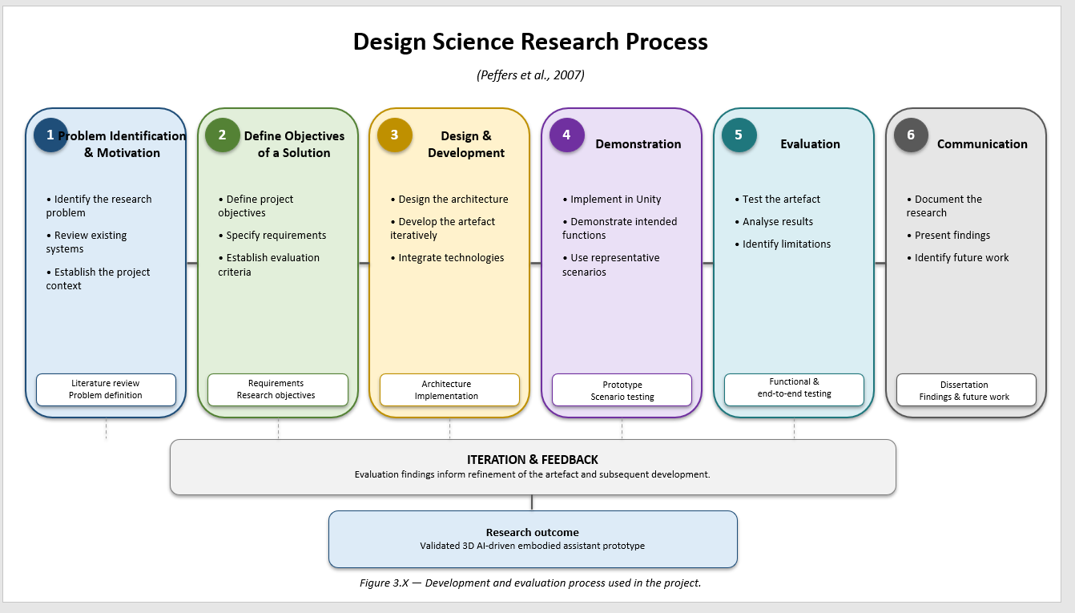

Sophia integrates several existing technologies, including speech recognition, generative AI, text-to-speech, character animation, simulated environmental controls and an external weather service. The research therefore focuses on the design and integration of these technologies, rather than developing new underlying AI models.
Development began from an existing prototype and progressively extended its capabilities. Individual components were implemented and tested before the complete interaction pipeline was evaluated. The research consequently follows an iterative cycle of problem identification, design, implementation, integration and evaluation.
The approach also recognises that successful prototype operation does not establish suitability for unrestricted real-world deployment. Limitations involving natural-language variability, speech recognition, external services, simulated devices and scalability are therefore treated as part of the research evaluation.

3.2 Development Methodology
Sophia was developed using an iterative and incremental approach. Rather than implementing the complete assistant simultaneously, individual capabilities were developed, compiled and tested before being integrated into the wider system. This approach was appropriate because the project combines several technically independent components whose behaviour can affect the complete interaction pipeline.
The existing Unity prototype provided the initial virtual environment, character and basic interaction functionality. Development therefore concentrated on extending this foundation rather than recreating the complete system.
The principal development areas were:
- speech-based interaction;
- natural-language command processing;
- simulated environmental control;
- generative AI;
- external weather information;
- text-to-speech; and
- character animation.
Each component was assigned a defined role within the architecture. Speech recognition provided spoken input, command processing determined the appropriate pathway, environmental controllers executed predefined actions, external services supplied dynamic information, and TTS communicated responses through the embodied character.
Testing was performed throughout development. Modifications were compiled and the relevant functionality tested before additional capabilities were introduced. This allowed integration problems, compilation errors, API issues and interaction problems to be identified progressively rather than being carried into the final evaluation.
Natural-language handling was also refined during development. Testing used alternative formulations of supported requests rather than relying exclusively on one fixed phrase. The completed system was subsequently evaluated as an integrated pipeline from spoken input through processing and response to character output.

3.3 Requirements Gathering
System requirements were established from the research aim and objectives, the capabilities and limitations of the existing prototype, and the functionality required for the enhanced Master's-level system. Requirements were divided into functional and non-functional categories.
Table 1 :
Requirement ID | Requirement | Implementation component | Evaluation / test evidence
FR1 | Accept spoken user input and convert it to text. | Whisper / speech-recognition component | Voice-command and E2E testing
FR2 | Process recognised input and identify supported requests. | VoiceCommandManager | VC01–VC05 / E2E tests
FR3 | Control simulated lighting using voice commands. | SmartHomeController / VoiceCommandManager | FT01–FT02, SE01–SE02
FR4 | Control the simulated television using voice commands. | SmartHomeController / VoiceCommandManager | FT03, SE03
FR5 | Open and close the simulated door using voice commands. | SmartHomeController / VoiceCommandManager | FT04–FT05, SE04–SE05
FR6 | Retrieve and communicate current weather information. | WeatherController / Open-Meteo | WT01, E2E05
FR7 | Provide precipitation information for weather-related requests. | WeatherController | WT02, E2E06
FR8 | Provide generative responses to general questions. | ChatGPTManager / GPT-4.1 | AI01, E2E07
FR9 | Convert textual responses into spoken output. | EdgeTTS | E2E07
FR10 | Provide appropriate visual character behaviour. | CharacterAnimatorController | E2E testing / prototype demonstration
FR11 | Combine input, processing, environmental actions, information retrieval and output into one interaction pipeline. | Integrated Sophia architecture | E2E01–E2E07
NFR1 | Provide suitable responsiveness for real-time interaction. | Modular runtime architecture / asynchronous service calls | Functional and E2E observation
NFR2 | Execute supported commands reliably under test conditions. | VoiceCommandManager / SmartHomeController | FT01–FT08, SE01–SE05
NFR3 | Support natural-language variations rather than requiring one exact phrase. | VoiceCommandManager / command processing | VC01–VC05
NFR4 | Maintain modularity and maintainability. | Separate Unity components and controllers | Architecture / implementation evidence
NFR5 | Handle recognition, service and invalid-input failures without terminating the application. | Error handling in recognition, API and AI components | Error/boundary testing
NFR6 | Provide a foundation for future extensions. | Modular architecture / component-based design | Chapter 7 discussion and future work

Functional requirements
The principal functional requirements were:
ID | Requirement
FR1 | Accept spoken user input and convert it to text.
FR2 | Process recognised input and identify supported requests.
FR3 | Control simulated lighting using voice commands.
FR4 | Control the simulated television using voice commands.
FR5 | Open and close the simulated door using voice commands.
FR6 | Retrieve and communicate current weather information.
FR7 | Provide precipitation information for weather-related requests.
FR8 | Provide generative responses to general questions.
FR9 | Convert textual responses into spoken output.
FR10 | Provide appropriate visual character behaviour.
FR11 | Combine input, processing, environmental actions, information retrieval and output into one interaction pipeline.

Non-functional requirements
ID | Requirement
NFR1 | Provide suitable responsiveness for real-time interaction.
NFR2 | Execute supported commands reliably under test conditions.
NFR3 | Support natural-language variations rather than requiring one exact phrase.
NFR4 | Maintain modularity and maintainability.
NFR5 | Handle recognition, service and invalid-input failures without terminating the application.
NFR6 | Provide a foundation for future extensions.
These requirements established a direct connection between development and evaluation. Functional requirements could be associated with implementation components and subsequently tested, while the non-functional requirements provided broader criteria for considering system quality and limitations. The requirements were also refined where practical development and integration considerations identified changes that were necessary to maintain realistic project boundaries.

3.4 Technology Selection
Technology selection was based on the project requirements, the existing prototype and the need to integrate multiple technologies within a real-time 3D environment.
Unity was selected as the primary development environment because it provides the 3D framework required for the virtual character, animations, environmental objects and interactive behaviour. Its component-based structure also supports modular development.
C# was used as the principal programming language because it is supported by Unity and provides the functionality required for interaction logic, environmental control and external-service integration.
Whisper-based speech recognition was selected to provide speech-to-text functionality, converting spoken requests into textual input for subsequent processing.
OpenAI's generative AI service was incorporated to provide open-ended conversational capability. It complements rather than replaces the deterministic command-processing architecture.
Edge TTS was selected to convert system responses into spoken output, allowing Sophia to communicate audibly.
An external weather API was selected because weather information is dynamic and therefore requires current data rather than reliance on static conversational knowledge.
The smart environment was implemented using simulated Unity components rather than physical IoT hardware. This provided a controlled development environment without the additional complexity of hardware, networking and manufacturer-specific interfaces.
Finally, the 3D character and animation system were selected to support the project's investigation of embodied interaction.
The technologies therefore operate as complementary components: speech recognition provides input, command processing provides deterministic action selection, generative AI provides open-ended conversation, external APIs provide dynamic information, TTS provides spoken output, and Unity provides the environment in which they operate.

3.5 System Development Process
Development began by establishing the existing Unity prototype as the foundation. The virtual character and existing environment were retained where appropriate, allowing development effort to focus on extending functionality.
The first major development stage established the voice-interaction pipeline. Spoken input was converted into text and passed to the command-management layer.
Environmental interaction was then implemented through dedicated functionality for the simulated lighting, television and door. Recognised environmental requests were mapped to predefined Unity actions, providing deterministic behaviour.
Generative AI was subsequently introduced alongside the deterministic command system. Requests that did not correspond to supported environmental functions could be processed conversationally.
The weather component was then introduced as a dedicated pathway for current external information. Weather requests were routed to the weather controller, which retrieved current information and converted it into a response suitable for Sophia.
Finally, TTS and character animation were integrated so that responses from environmental controls, weather services and generative AI could be communicated through the embodied character.
Compilation and testing occurred throughout these stages. Natural-language variations were also tested to determine whether the command-processing system could accommodate different formulations of supported requests.
Once the components had been integrated, the complete interaction pipeline was tested, including environmental controls, weather requests and general conversation.

3.6 Integration Strategy
The integration strategy used a modular architecture in which individual technologies were assigned defined responsibilities. Speech recognition, request processing, environmental control, external information retrieval, generative AI, speech synthesis and character behaviour were therefore separated rather than managed by a single component.
The overall interaction can be represented as:
User speech → Speech recognition → Command processing → Appropriate function → Textual response → Text-to-speech → Character response
Three principal processing pathways were established:
- Environmental request → Simulated Unity device
- Weather request → External weather service
- General conversational request → Generative AI
This separation provides a boundary between deterministic environmental actions and generative conversation. Environmental commands are mapped to explicitly defined application functions, while general conversational requests benefit from generative flexibility.
Error handling was also considered at component boundaries. Speech recognition and external services can fail because of connectivity or service problems, so unsuccessful operations should be handled without terminating the complete application.
The modular architecture also provides a basis for future extension. Additional devices or information services could be added through dedicated components, while alternative AI, speech-recognition or TTS technologies could potentially replace existing services without requiring complete redesign.

3.7 Testing Methodology
Testing was incorporated throughout development and subsequently expanded into structured evaluation of the completed prototype. The purpose was to determine whether the defined requirements were satisfied and to provide evidence for answering the research questions.
Four complementary testing categories were used:
- Functional testing
- Natural-language variation testing
- Integration testing
- External-service testing
Functional testing examined whether individual capabilities performed their intended operations, including simulated devices, weather functionality and conversational interaction.
Natural-language testing examined whether supported commands could be expressed using different formulations rather than one fixed phrase.
Integration testing examined the complete sequence from spoken input through speech recognition, command processing, environmental or external-service processing, response generation, TTS and character behaviour.
External-service testing focused particularly on the weather functionality and considered whether current information could be retrieved and communicated successfully. The external dependencies associated with generative AI and TTS were also considered.
Tests were conducted using the completed Unity application. Each test used a defined user request and compared the observed behaviour with the expected outcome. Test cases followed a consistent structure containing the test identifier, functionality, user input, expected outcome, observed outcome and pass/fail result. This created traceability between the requirements and the results presented later.
Failure conditions were also considered, including unsuccessful external-service communication and inputs that could not be processed correctly.
The evaluation remained focused on the functional prototype rather than a large participant study. Consequently, the methodology does not claim to establish statistically generalisable measures of user satisfaction or usability.

3.8 Evaluation Approach
Evaluation was based on evidence obtained through functional, natural-language, integration and external-service testing. Expected behaviour defined by the requirements was compared with observed system behaviour.
The evaluation considered:
- functional effectiveness;
- natural-language capability;
- integration effectiveness;
- external-service functionality;
- deterministic environmental behaviour;
- generative conversational behaviour;
- responsiveness; and
- reliability.
Environmental commands were evaluated according to whether they produced predictable predefined actions, while general conversation was considered separately according to the output of the generative AI component. This distinction reflects the hybrid architecture used by Sophia.
Responsiveness and reliability were considered qualitatively because precise latency measurements and large-scale performance benchmarking were outside the project scope.
The evidence was then mapped to the research questions. RQ1 was considered through the integrated speech, AI, TTS and embodiment pipeline; RQ2 through natural-language and environmental-control testing; RQ3 through weather-service integration; and RQ4 through observed limitations, dependencies and challenges.
The evaluation therefore combines evidence of successful functionality with critical consideration of the conditions and limitations under which that functionality was demonstrated.

3.9 Ethical, Privacy and Security Considerations
Ethical, privacy and security considerations were incorporated into the design because Sophia accepts spoken input and communicates with external AI and information services.
Voice interaction may involve personal information, while external services may process transmitted requests. The prototype was designed for controlled testing rather than continuous monitoring and does not create a persistent personal profile. Nevertheless, privacy implications would require greater consideration if the system were deployed as a persistent personal assistant.
Generative AI introduces additional considerations because conversational requests may be transmitted to an external service. Sensitive personal information should therefore not deliberately be included during normal prototype use.
Security is particularly relevant to environmental control. In the current implementation, all devices are simulated, meaning incorrect commands do not directly affect physical equipment. A physical deployment would require appropriate authentication, authorisation, secure communication and access controls.
The separation between generative AI and deterministic device control also limits the scope of actions that can be initiated through the conversational AI pathway.
The human-like appearance of Sophia introduces a further transparency consideration. Users should understand that the character represents an AI-driven software system rather than a human. Future participant-based studies would additionally require consideration of informed consent, data handling and ethical approval where applicable.
These considerations contributed to the decision to restrict the current project to simulated environmental controls and a controlled research prototype.

3.10 Methodological Limitations
Several methodological limitations must be considered when interpreting the findings.
First, the system operates within a controlled Unity environment rather than a physical smart home. The simulated devices demonstrate conversational environmental control but cannot establish performance with physical IoT equipment, where network reliability, hardware compatibility, authentication and safety would introduce additional challenges.
Second, natural-language testing covered a limited range of formulations. Successful handling of the tested variations therefore cannot be interpreted as evidence that Sophia can understand arbitrary natural-language commands.
Third, several system components depend on external services. Speech recognition, generative AI, TTS and weather information may be affected by connectivity, service availability, latency or API changes.
Fourth, generative AI introduces uncertainty concerning factual accuracy. Its role is therefore treated primarily as conversational rather than as an authoritative source of factual information.
Fifth, the project does not include a large-scale human-participant evaluation. The results can demonstrate functional behaviour but cannot provide statistically generalisable conclusions regarding usability, trust, satisfaction or long-term engagement.
The project also does not provide a comprehensive quantitative benchmark against commercial assistants or alternative architectures. Its purpose is to investigate the design and integration of the Sophia prototype rather than establish that the selected technologies outperform all alternatives.
Finally, project timeframe and computational constraints limited opportunities for extensive optimisation, large-scale deployment and physical-device integration.
These limitations define the boundaries within which the findings should be interpreted rather than preventing the project from addressing its research questions. They also provide clear directions for future work, including broader natural-language testing, participant studies, quantitative performance measurements, physical IoT integration and more extensive security evaluation.

CHAPTER 4 — SYSTEM DESIGN AND ARCHITECTURE

4.1 System Overview
Sophia was designed as a modular, real-time 3D conversational assistant combining voice interaction, artificial intelligence, external information retrieval, simulated environmental control and embodied character behaviour within a Unity environment. The system provides a unified interface through which users communicate with the assistant using spoken natural language.
The architecture separates the major responsibilities of the system into speech recognition, request processing, environmental control, external information retrieval, generative conversational processing, text-to-speech and character animation. This separation allows individual components to be developed and tested independently while operating together as an integrated assistant.
The interaction begins with spoken input. Speech is converted into text and passed to the command-management layer, which determines whether the request represents an environmental operation, an external-information request or general conversation.
Environmental requests are routed to dedicated Unity functions controlling simulated lighting, television and door components. Weather requests are handled through the WeatherController, which retrieves current information from an external weather service. General conversational requests are passed to the generative AI component.
All processing pathways ultimately converge on a common response mechanism. Textual responses can be converted into speech through Edge TTS, while the character animation system provides corresponding visual behaviour.
A central design principle is therefore the separation between deterministic processing and generative processing. Environmental functions use explicitly defined operations where predictable behaviour is required, while generative AI provides flexibility for open-ended conversation. The modular architecture also allows individual technologies to be replaced or extended in future development.

4.2 System Architecture
Sophia follows a five-layer logical architecture:
- Input layer
- Processing and routing layer
- Service and control layer
- Response layer
- Embodiment layer
The input layer captures spoken user requests and uses speech recognition to convert audio into text.
The processing and routing layer is centred on the VoiceCommandManager. It evaluates recognised text and determines the appropriate processing pathway.
The service and control layer contains the components responsible for executing requests. Simulated environmental devices are controlled through dedicated Unity functions, weather requests are processed by WeatherController, and general conversational requests are passed to the generative AI component.
The response layer provides a common textual response representation regardless of the processing pathway that produced it. This allows environmental, weather and conversational responses to use the same output mechanism.
The embodiment layer provides Sophia's visible and audible representation. Edge TTS converts textual responses into spoken output while the animation system provides corresponding visual behaviour within the Unity environment.
The conceptual architecture is:
User → Speech Recognition → VoiceCommandManager → Processing Pathway → Response → TTS → Sophia
with three principal branches:
Environmental request → SmartHomeController
Weather request → WeatherController → External Weather API
General question → Generative AI
This architecture deliberately prevents the generative model from having unrestricted control over environmental objects. It also provides error-handling boundaries around components and external services, reducing the likelihood that a failure in one component will terminate the complete application.

4.3 Voice Interaction Pipeline
Voice interaction forms Sophia's primary input mechanism. The pipeline allows users to communicate through spoken natural language rather than relying on typed commands or conventional graphical controls.
The process begins with microphone input. Whisper converts the captured speech into a textual transcription, which is then passed to the VoiceCommandManager.
The pipeline can therefore be represented as:
User speech → Microphone → Whisper → Text transcription → VoiceCommandManager
The command manager then determines the appropriate processing pathway. Environmental requests are routed to device-control functionality, weather requests to the weather component, and general questions to generative AI.
An important design consideration was natural-language variation. Users are unlikely to consistently use identical wording, so supported functions were designed to accommodate alternative formulations expressing the same underlying intention.
The speech-recognition stage also represents an external dependency. Microphone quality, background noise, network connectivity and service availability can influence performance. Consequently, speech recognition is treated as one component of the complete interaction pipeline rather than as an isolated measure of system effectiveness.
Converting audio into a common textual representation also simplifies integration because downstream components do not need to process raw audio directly.

4.4 Command Processing Architecture
The VoiceCommandManager provides the central routing layer between recognised speech and Sophia's functionality. Its purpose is to transform the textual representation produced by speech recognition into an appropriate application action or processing pathway.
The architecture follows:
Recognised speech → VoiceCommandManager → Intent/pathway selection
The principal pathways are:
- Lighting intent → Lighting control
- Television intent → Television control
- Door intent → Door control
- Weather intent → WeatherController → External weather service
- General conversational intent → Generative AI
Environmental commands are mapped to predefined operations, providing deterministic behaviour. The system nevertheless supports some linguistic variation so that users are not required to reproduce one exact phrase.
Weather requests are deliberately routed separately because current weather information should be obtained from an external data source rather than generated solely by the language model.
Requests outside the predefined environmental and weather pathways can be passed to generative AI, providing open-ended conversational capability.
This creates an important architectural boundary: generative AI provides conversational flexibility, while predefined functions provide predictable environmental behaviour.
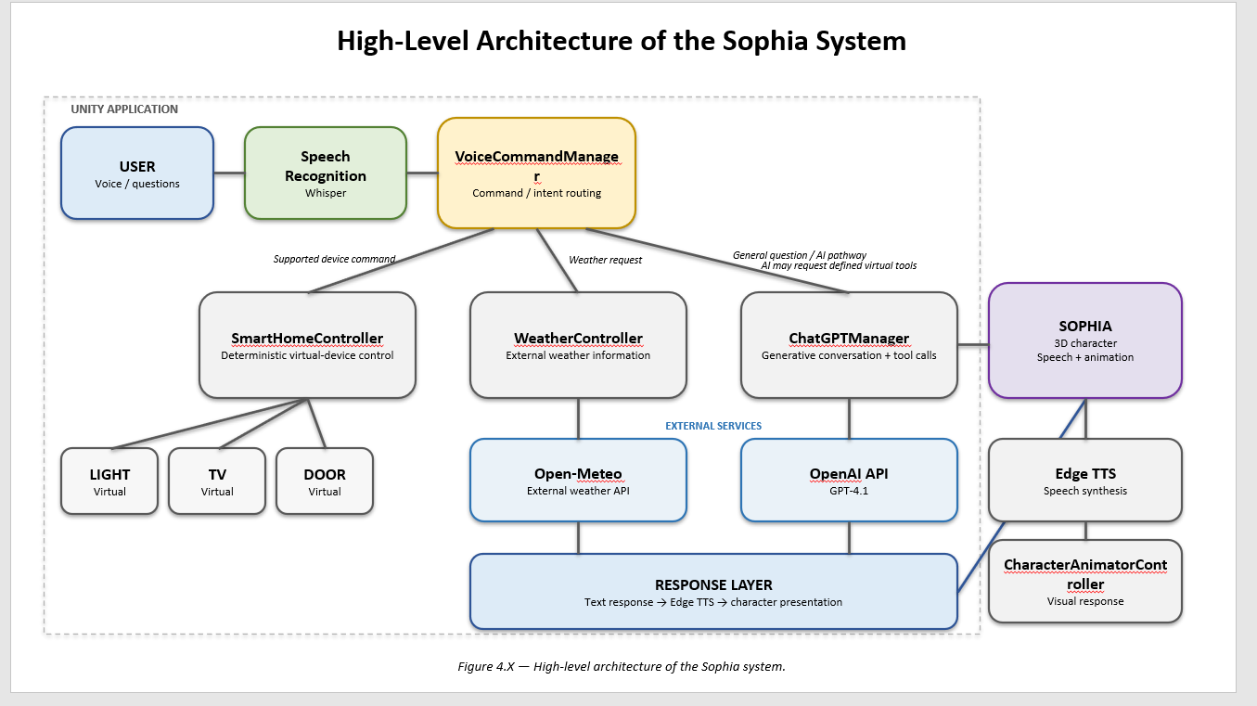
The approach also establishes the limits of the prototype. Supporting several alternative formulations does not constitute unrestricted natural-language understanding; the recognised command patterns still define the boundaries of environmental interaction.

4.5 Generative AI Integration
Generative AI provides Sophia with open-ended conversational capability. It is integrated as one processing pathway rather than being used as the sole controller of the assistant.
When the VoiceCommandManager determines that a request does not correspond to a supported environmental or weather function, the textual request can be passed to the external generative AI service. The resulting text response is returned to Unity and presented through Sophia.
The pathway is:
User speech → Whisper → VoiceCommandManager → Generative AI → Text response → TTS → Sophia
This allows questions that have no predefined application function to be answered without manually programming an individual response for every possible conversational request.
Environmental operations remain separate from this pathway. Commands affecting the virtual environment are executed through predefined Unity functions rather than allowing generated language to directly determine environmental behaviour. This improves predictability and reduces the potential impact of unexpected generative output.
The same principle applies to current weather information: dynamic weather data is retrieved through the dedicated weather service rather than relying on the language model to provide current conditions.
The main limitation is that the generative AI component depends on an external service and may introduce latency, availability issues and uncertainty regarding factual accuracy.

4.6 Weather/API Architecture
Weather functionality is implemented as a dedicated external-information pathway through the WeatherController. [12]
When a weather request is recognised, the VoiceCommandManager routes it to WeatherController. The controller sends a request to the external weather service using configured geographical coordinates and receives structured JSON data.
The pathway is:
User speech → Whisper → VoiceCommandManager → WeatherController → Weather API → JSON → Data processing → Text response → TTS → Sophia
The implementation retrieves parameters including:
- current temperature;
- apparent temperature;
- weather condition;
- wind speed;
- precipitation probability; and
- precipitation amount.
Weather condition codes are converted into human-readable descriptions, while numerical values are formatted into conversational responses.
The system can also use precipitation probability to answer practical questions such as whether an umbrella may be required. This demonstrates a distinction between retrieving factual information and communicating that information conversationally.
The WeatherController also validates returned data and provides an error response when the external request fails. This prevents unavailable data from being processed as though it were valid.
Because the functionality depends on network connectivity and an external service, availability, latency, API changes and unexpected responses remain limitations.
The dedicated controller also supports modularity because the weather provider can potentially be replaced without redesigning the remainder of Sophia's architecture.

4.7 Smart Environment Architecture
The simulated smart environment contains three device types:
- lighting;
- television; and
- door.
Environmental interaction follows a deterministic pathway:
User speech → Whisper → VoiceCommandManager → Smart-home control → Unity device state
After speech has been converted into text, the VoiceCommandManager identifies the intended environmental operation and passes it to the relevant control function.
Lighting supports switching on and off, television supports switching on and off, and the door supports opening and closing. Each operation is explicitly defined within the application, ensuring predictable state changes.
Natural-language variations can be recognised at the command-processing level while the resulting action remains deterministic.
The virtual environment also provides visual feedback because the user can directly observe the state change within Unity. This creates an additional feedback channel alongside Sophia's spoken response.
Physical IoT hardware was deliberately excluded from the current implementation. Simulation provides a controlled environment without introducing hardware compatibility, manufacturer-specific APIs, networking and physical-safety requirements. However, the architecture provides a potential foundation for future physical integration. [9]

4.8 TTS and Embodied Response
The final stage of the interaction presents responses through spoken audio and visual character behaviour.
Text generated by the environmental, weather or generative AI pathway is passed to Edge TTS and converted into spoken audio. Character animation then provides corresponding visual behaviour. [13]
The pathway is:
Processing result → Text response → Edge TTS → Audio output
Using a common response mechanism means that the source of the response does not affect how it is presented. A weather response and a generative AI response can both be converted into speech and accompanied by animation.
Sophia therefore acts as a consistent visible interaction layer over the different underlying technologies. This is important to the project's investigation of embodied interaction because the user encounters one persistent virtual character rather than several separate technical interfaces.
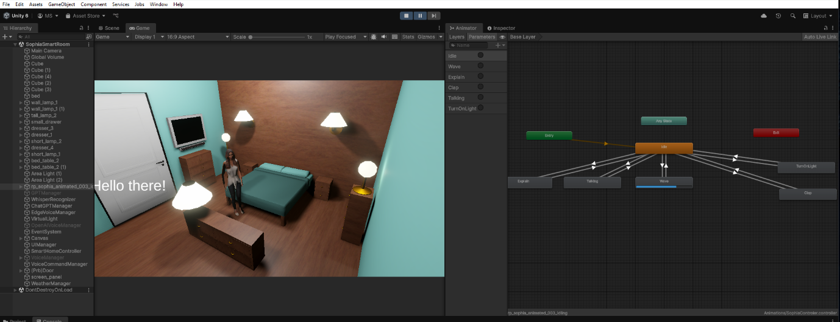
However, the current project does not quantitatively establish that embodiment improves usability, trust or user satisfaction. Such conclusions would require participant-based evaluation beyond the current scope.
The external TTS service also introduces another dependency affecting reliability and response time.

4.9 Data Flow
Sophia processes several forms of data during interaction, including audio input, textual transcription, command information, structured external data, generated responses and audio output. 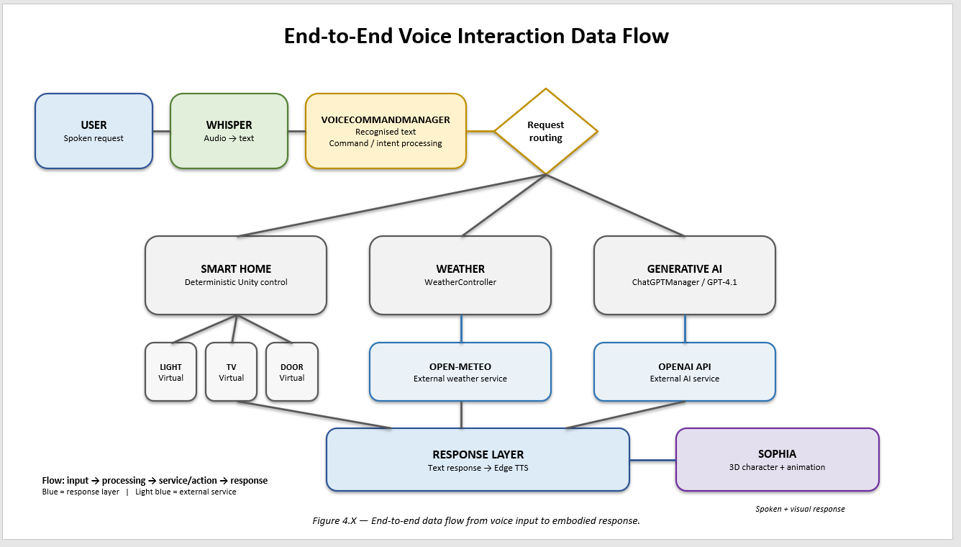

The general flow is:
Audio input → Text transcription → Command processing → Function/service → Text response → Audio output → Embodied response
The three principal branches are:
Environmental control
Audio → Text → Command → Unity device state
Weather
Audio → Text → WeatherController → HTTP request → JSON data → Text response
General conversation
Audio → Text → Generative AI → Text response
These pathways converge at:
Text response → Edge TTS → Audio → Sophia
The separation of representations supports modularity. For example, WeatherController does not need to process audio, while TTS does not need to understand the original user request.
The data flow also distinguishes local processing from external processing. Simulated environmental state changes occur within Unity, whereas weather, speech recognition, generative AI and TTS may require network communication. This distinction is relevant to system performance, reliability, privacy and security.
External communication introduces potential delays and failure points, so appropriate error handling is required at these boundaries.

4.10 Security and Error Handling
Security and error handling were incorporated into the architecture because Sophia processes user-generated input and relies on external services.
A primary security measure is the separation between generative AI and environmental actions. The generative model does not receive unrestricted control over the environment. Instead, environmental operations are predefined within Unity and accessed through the command-processing layer.
External services represent additional security boundaries. Speech recognition, generative AI, TTS and weather functionality may involve transmission outside the local application. API credentials should therefore be protected and should not be unnecessarily exposed in distributed application code.
The current prototype does not provide production-level security, physical-device authentication or a comprehensive security gateway because all environmental devices are simulated. These measures would become necessary for physical deployment.
Error handling is implemented at relevant component boundaries. For example, the weather controller checks whether external requests succeed and validates returned data before processing it. Similar principles apply to speech-recognition and other external-service failures.
The architecture also distinguishes between technical failures and unsupported requests. A network failure is different from a request that simply falls outside the currently implemented command set, and these situations require different responses.
The overall approach prioritises continued operation of the prototype when individual capabilities become unavailable while recognising that a production smart-home implementation would require stronger security controls, authentication, encrypted communication and formal security testing.

4.11 Design Rationale
The design of Sophia was guided by the requirement to combine conversational interaction, AI, environmental control, external information retrieval and embodied character behaviour within one real-time 3D application.
The primary design decision was the hybrid processing architecture. Generative AI was selected for open-ended conversation, while deterministic functions were selected for environmental control. This reflects the different requirements of the two interaction types: conversation benefits from linguistic flexibility, whereas environmental actions require predictable outcomes.
A second decision was the use of modular components. Speech recognition, command processing, environmental control, weather retrieval, generative AI, TTS and animation are separated into distinct functional areas. This supports maintenance and allows individual components to be modified or replaced.
The decision to use simulated environmental devices was based on project scope and practical feasibility. Simulation provides a controlled environment for evaluating the relationship between natural-language commands and environmental actions without introducing physical hardware, networking or safety concerns.
The inclusion of the external weather service was motivated by the time-sensitive nature of weather information. Current information is therefore retrieved externally rather than relying exclusively on generative AI.
The 3D embodied character provides a consistent interaction representation for all underlying technologies. Speech, AI, environmental actions and external information are presented through the same virtual character.
Separating speech recognition from command processing also ensures that determining what the user said remains distinct from determining what the application should do. Similarly, separating response generation from response presentation allows responses from different processing pathways to share the same TTS and animation mechanisms.
Finally, the architecture was designed with future extensibility in mind. Additional devices, information services and alternative technologies could potentially be introduced without redesigning the complete application.
Overall, the design balances AI flexibility, environmental predictability, modularity and practical feasibility, while deliberately positioning Sophia as a research prototype rather than a production-ready smart-home platform.

CHAPTER 5 — IMPLEMENTATION

5.1 Implementation Overview
The implementation of Sophia was carried out within the Unity development environment using C# as the primary programming language. The system was implemented as a collection of interconnected components, with each component responsible for a specific aspect of the overall interaction process.
The implementation followed the architecture established in Chapter 4. Speech recognition provides textual input, the VoiceCommandManager processes and routes recognised requests, dedicated functionality controls the simulated environment and external services provide generative AI, weather information and text-to-speech capabilities.
The implementation was developed incrementally so that individual components could be tested before being integrated into the complete interaction pipeline. This approach reduced the likelihood that errors within one component would obscure problems elsewhere in the system.
The principal implementation components include:
- speech recognition;
- VoiceCommandManager;
- smart-environment controls;
- ChatGPTManager;
- WeatherController;
- Edge TTS;
- CharacterAnimatorController; and
- Unity user-interface components.
Together these components form the operational implementation of the architecture described in Chapter 4.

5.2 Unity Environment and Component Structure
Unity provides the runtime environment in which Sophia, the simulated smart-home objects and the supporting software components operate. [10]
The implementation uses Unity GameObjects and C# scripts to separate functionality into manageable components. This structure allows individual systems to communicate while retaining distinct responsibilities.
Sophia's character is represented as a 3D humanoid model with associated animation behaviour. The virtual environment contains the simulated devices that can be manipulated through voice commands.
The component-based structure also provides a practical mechanism for connecting the different technologies. For example, the ChatGPTManager maintains references to the output interface, TTS system, animation controller and VoiceCommandManager. This allows generated responses and tool requests to be passed to the appropriate Unity components.
The implementation therefore follows the modular principles established during system design rather than combining all functionality into a single script.

5.3 Speech Recognition Implementation
Speech recognition provides the initial conversion between the user's spoken interaction and the textual representation required by the remainder of the application.
The implementation uses Whisper to perform speech-to-text processing. Once speech has been captured and transcribed, the resulting text is passed to the command-processing layer. [5]
This separation is important because subsequent components do not need to process the original audio. Instead, they receive a consistent textual representation that can be analysed and routed according to its intended purpose.
The speech-recognition implementation was tested repeatedly during development because changes to the surrounding interaction pipeline could affect the complete voice interaction process.
Speech recognition remains dependent on microphone quality, network connectivity and the availability of the external recognition service. These dependencies are therefore considered when evaluating the final system.

5.4 VoiceCommandManager Implementation
The VoiceCommandManager acts as the central coordination component for recognised requests.
Its principal responsibility is to determine which functionality should process a recognised request. Environmental requests are directed towards the appropriate virtual-device functionality, weather requests are passed to WeatherController and general conversational requests can be passed to the AI component.
This implementation creates a clear separation between recognising an intention and executing the resulting operation.
For environmental interaction, the command-processing system ultimately invokes predefined Unity functions. This means that a recognised request results in a controlled application operation rather than unrestricted execution based on generated language.
The implementation also supports alternative natural-language formulations of supported commands. This allows the interaction to be more conversational while retaining defined boundaries around the available environmental operations.

5.5 Generative AI Implementation
The generative AI functionality is implemented through the ChatGPTManager component. The component communicates with the external AI service using an HTTP request from Unity.
The implementation constructs a request containing the selected model, system instructions and the user's textual request. The system instructions define Sophia as a friendly 3D AI assistant operating within a simulated Unity environment and explicitly state that the available tools control only simulated devices.
The implementation currently uses the gpt-4.1 model in the request payload. [14]
A significant implementation feature is the use of function/tool calling. The AI is provided with explicitly defined virtual functions, including:
- turn_on_light
- turn_off_light
The function descriptions explain when each operation should be selected by the AI.
This provides an important bridge between conversational AI and deterministic Unity functionality.
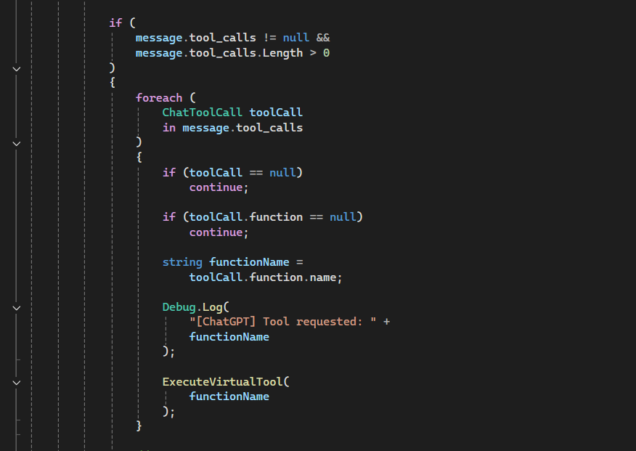
Rather than allowing the AI to directly manipulate Unity objects, the AI produces a recognised tool request. The Unity application then interprets the requested function and executes the corresponding predefined operation.

5.6 AI Request and Response Processing
The ChatGPTManager uses a coroutine to submit the request and wait for the external service response. The implementation sets an isProcessing flag while a request is active, preventing another request from being processed simultaneously. [11]
The request is sent using UnityWebRequest with JSON data and the required HTTP headers. The response is then retrieved and deserialised using Newtonsoft.Json.
The response-processing stage distinguishes between a normal conversational response and a tool request.
When a tool call is returned, the requested function name is extracted and passed to the virtual-tool execution method.
When no tool call is present, the textual response is extracted and displayed through Sophia.
This distinction provides the implementation-level mechanism for the hybrid architecture described previously.

5.7 Virtual Smart-Home Control
Virtual environmental control is implemented using predefined Unity functions.
The ExecuteVirtualTool() method receives the requested function name and uses a switch statement to determine the appropriate Unity operation.
For example, the turn_on_light request invokes:
voiceCommandManager.ToggleLight(true)
while turn_off_light invokes:
voiceCommandManager.ToggleLight(false).
This approach creates a controlled boundary between AI-generated tool selection and actual application behaviour.
The AI therefore does not receive arbitrary access to Unity objects. Instead, only explicitly implemented operations can be executed.
This is particularly important for the research prototype because it demonstrates how natural-language interaction can be combined with deterministic environmental behaviour.
The implementation also includes handling for unknown virtual-tool names. An unsupported function generates a warning rather than being silently executed.

5.8 Conversational Response and User Feedback
After a virtual tool has been executed, the implementation generates a predefined natural-language confirmation.
For example, successful activation of the virtual light results in a confirmation that the light has been turned on. Similar handling is provided for switching the light off.
This response is then displayed through the Unity interface and can also be passed to the TTS and animation systems.
The implementation therefore provides multiple forms of feedback:
- visual state change within the environment;
- textual response through the Unity interface;
- spoken response through TTS; and
- character animation.
The ShowSophiaText() method updates the user interface with the response and invokes the response event used by other components.

5.9 Text-to-Speech and Animation Integration
The TTS and animation systems provide the final presentation stage of the implementation.
Once a textual response has been obtained, it can be passed to Edge TTS to generate spoken audio. At the same time, the character animation controller can trigger an appropriate animation.
The implementation therefore connects response processing with the embodied character rather than presenting the output exclusively as text.
For normal conversational responses, the implementation triggers the "Explain" animation before starting the TTS coroutine and subsequently returns Sophia to an idle state.
The same response mechanism is used for virtual-device confirmations.
This creates a consistent implementation pathway regardless of whether the response originates from generative AI or an environmental operation.

5.10 Error Handling
Error handling was implemented at important points within the interaction pipeline.
The ChatGPTManager checks the result of the HTTP request and logs an error if communication with the AI service fails. It also provides a user-facing failure message instead of terminating the interaction.
The implementation also handles unsuccessful JSON deserialisation and validates that the returned response contains an appropriate message before attempting to process it.
These checks prevent malformed or unavailable responses from being processed as valid conversational output.
The virtual-tool implementation also verifies that the VoiceCommandManager is available before attempting to execute a requested operation.
Together, these mechanisms provide basic defensive behaviour across the implementation.

5.11 API and External-Service Integration
Sophia depends on several external services, including speech recognition, generative AI, weather information and TTS.
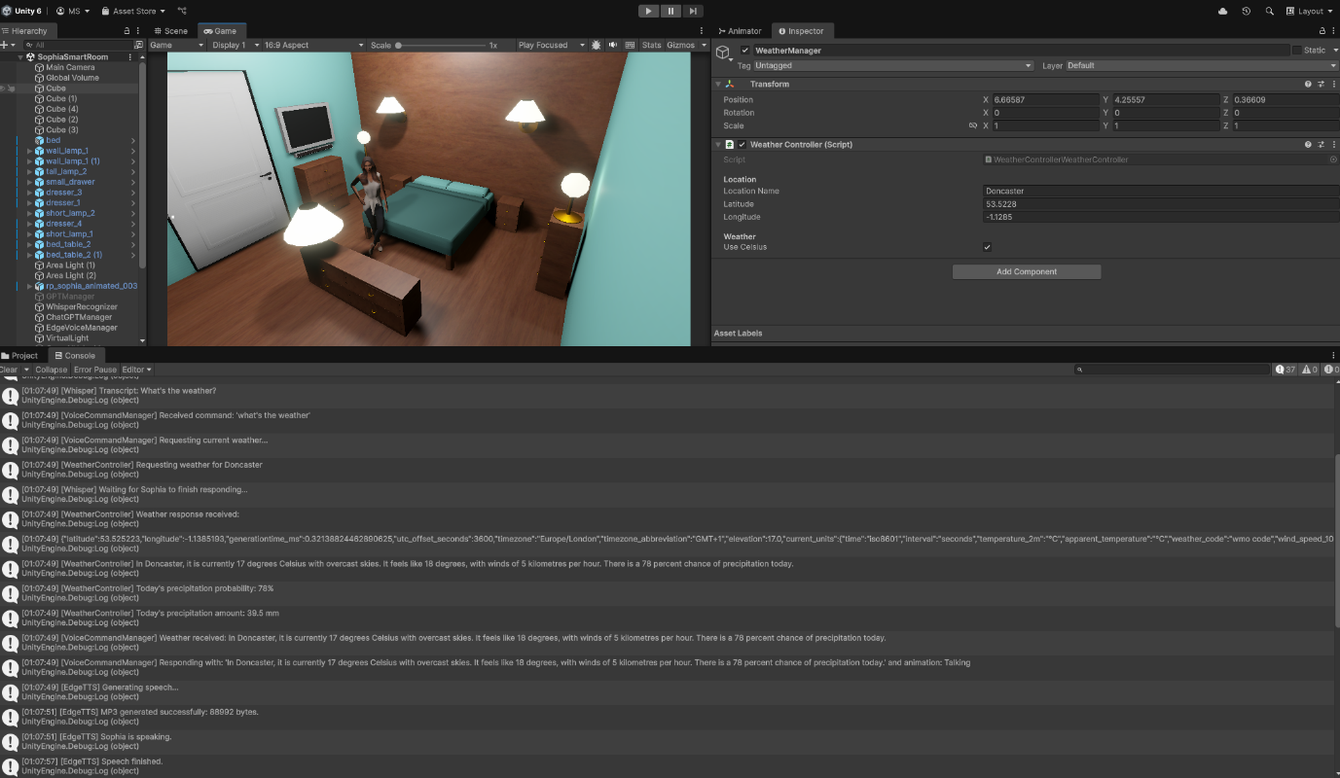
External communication was implemented using appropriate request and response mechanisms within Unity. The generative AI implementation uses an HTTP POST request and JSON payload, while returned information is deserialised into C# response structures. [11]
The implementation therefore establishes clear boundaries between Unity's local processing and externally provided services.
These boundaries are important because external services introduce dependencies that are outside the direct control of the application. Connectivity problems, service availability, API changes and response latency can therefore affect the complete interaction.
The architecture was designed so that these failures can be handled without unnecessarily terminating the Unity application.

5.12 Implementation Integration
The completed implementation integrates the individual components into a continuous interaction cycle:
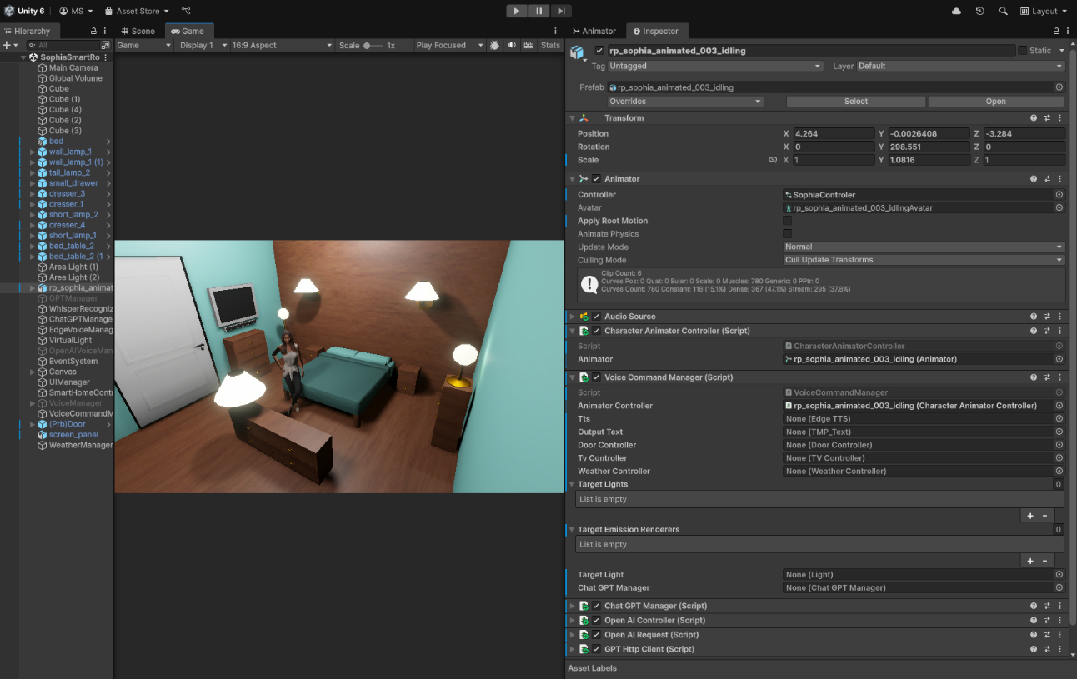

User speech
↓
Whisper speech recognition
↓
VoiceCommandManager
↓
Environmental control / WeatherController / Generative AI
↓
Text response
↓
Edge TTS
↓
Sophia animation and spoken response
This integration represents the practical implementation of the architecture described in Chapter 4.
The use of shared textual response data allows different processing pathways to converge before presentation. Environmental confirmations, weather information and generative responses can therefore all be presented through the same TTS and animation mechanisms.
The result is a unified embodied assistant rather than a collection of disconnected technical demonstrations.

5.13 Implementation Summary
The implementation demonstrates the integration of speech recognition, natural-language processing, generative AI, simulated environmental control, external information retrieval, TTS and 3D character animation within Unity.
The most significant implementation decision was maintaining a boundary between AI-generated language and executable environmental functions. Function/tool calling provides a controlled mechanism through which conversational requests can result in predefined Unity actions.
The modular implementation also supports future extension. Additional virtual devices, external services or alternative AI and speech technologies could potentially be incorporated without requiring the complete system to be rewritten.
However, the implementation remains a research prototype rather than a production smart-home system. The use of simulated devices, external services and a limited set of predefined environmental operations defines the scope within which its functionality should be evaluated.

CHAPTER 6 — TESTING AND EVALUATION

6.1 Testing Strategy
Testing was conducted to determine whether the completed Sophia prototype operated according to the functional and non-functional requirements established during development. The evaluation focused on the principal interaction pathways, including speech recognition, voice-command processing, environmental control, weather retrieval, generative AI, text-to-speech and embodied character behaviour.
Testing combined functional testing, natural-language variation testing and end-to-end integration testing. Functional testing assessed whether individual capabilities produced their intended outcomes, while integration testing examined whether multiple components could operate together as a continuous interaction pipeline.
Representative spoken requests were provided to Sophia and the observed behaviour was compared with the expected outcome. Environmental requests were evaluated through the resulting state of the virtual devices, weather requests through retrieval and communication of current information, and general conversational requests through successful routing to the generative AI component.
Natural-language variations were also tested rather than relying exclusively on fixed command phrases. This allowed the command-processing system to be assessed against alternative formulations expressing the same underlying intention.
Testing was conducted incrementally throughout development. Following modifications to the C# implementation, the project was compiled before runtime testing. Once compilation succeeded, the relevant functionality was executed within Unity and the resulting behaviour was observed.
The final evaluation focused on the completed prototype and included lighting, television, door, weather, precipitation-related and general conversational interactions.
The evaluation was primarily functional and qualitative rather than statistically representative. Consequently, a successful test demonstrates that the selected scenario operated correctly under the tested conditions; it does not establish universal reliability or unrestricted natural-language understanding. External-service dependencies, linguistic variation and the defined scope of the command set were therefore considered when interpreting the results.

6.2 Functional Testing
Functional testing examined whether the principal capabilities of Sophia produced their intended outcomes. The tests covered simulated environmental control, weather information retrieval, precipitation-related interaction and generative AI.
Environmental testing used spoken requests rather than direct manipulation of Unity objects, allowing the complete voice-command pathway to be evaluated. Lighting was tested through activation and deactivation requests, television through a state-change request, and the door through opening and closing requests.
Weather functionality was tested through a general weather request and a precipitation-related request. The latter examined whether retrieved precipitation information could be transformed into a practical response concerning umbrella use.
The generative AI pathway was tested using a general knowledge question that did not correspond to a predefined environmental or weather operation.
The eight functional scenarios all produced their expected outcomes:

Table 6.1 — Functional Test Cases
Test | Function | Input | Expected outcome | Result
FT01 | Lighting | "Would you please turn the lights on?" | Lights activate | PASS
FT02 | Lighting | "Turn the lights off." | Lights deactivate | PASS
FT03 | Television | "Could you switch the TV off?" | TV switches off | PASS
FT04 | Door | "Can you open the door?" | Door opens | PASS
FT05 | Door | "Close the door." | Door closes | PASS
FT06 | Weather | "How's the weather outside?" | Weather information returned | PASS
FT07 | Precipitation | "Do I need an umbrella today?" | Appropriate response returned | PASS
FT08 | Generative AI | "What is the meaning of artificial intelligence?" | AI response returned | PASS
All eight tests passed, giving a 100% pass rate for the defined functional test set. The results provide evidence that the principal implemented capabilities operated correctly for the selected scenarios.
However, the result must be interpreted according to the size and design of the test set. Eight successful scenarios do not demonstrate that every possible linguistic formulation or environmental condition would produce the same result. The functional tests therefore provide evidence of successful prototype operation rather than statistically generalisable reliability.

6.3 Voice Command Testing
Voice-command testing examined whether supported environmental requests could be expressed using different natural-language formulations.
The tests deliberately used conversational expressions rather than requiring users to reproduce a fixed command. Examples included:
- "Would you please turn the lights on?"
- "Could you switch the TV off?"
- "Can you open the door?"
The corresponding opposite operations were also tested for the lights and door.

Table 6.2 — Voice Command Variation Testing
Test | Intended function | Expected action | Observed action | Result
VC01 | Lights ON | Activate lights | Lights activated | PASS
VC02 | Lights OFF | Deactivate lights | Lights deactivated | PASS
VC03 | TV OFF | Switch TV off | TV switched off | PASS
VC04 | Door OPEN | Open door | Door opened | PASS
VC05 | Door CLOSE | Close door | Door closed | PASS
All five voice-command variation tests passed. The results provide evidence that the command-processing implementation could accommodate the tested conversational formulations rather than requiring one rigid sentence structure.
However, these results do not establish unrestricted natural-language understanding. Natural language permits a very large number of alternative expressions, while the present system operates within the boundaries of its implemented command-processing rules.
The testing nevertheless demonstrates that speech recognition and command execution can remain separate stages: once spoken input has been converted into text, the command-processing layer can determine the intended operation and invoke the relevant environmental function.

6.4 Smart Environment Testing
Smart-environment testing evaluated whether spoken commands produced the intended state changes within the Unity environment.
The three simulated devices were:
- lighting;
- television; and
- door.

Table 6.3 — Smart Environment Test Results
Test | Device | Operation | Expected state | Observed state | Result
SE01 | Lights | ON | Activated | Activated | PASS
SE02 | Lights | OFF | Deactivated | Deactivated | PASS
SE03 | TV | OFF | Switched off | Switched off | PASS
SE04 | Door | OPEN | Opened | Opened | PASS
SE05 | Door | CLOSE | Closed | Closed | PASS
All five tests passed. The results demonstrate that recognised voice commands could be connected successfully to the corresponding Unity objects and that different environmental state types could be controlled.
The deterministic nature of these functions also makes them particularly suitable for functional evaluation because the expected state can be directly compared with the observed state.
The result remains limited to the simulated environment. Successful control of virtual devices does not demonstrate reliable operation with physical smart-home hardware, where communication protocols, hardware compatibility, authentication, network reliability and safety would introduce additional variables.

6.5 Weather Testing
Weather testing evaluated the integration between Sophia, WeatherController and the external Open-Meteo weather service.
Two scenarios were evaluated:
- "How's the weather outside?"
- "Do I need an umbrella today?"
The first request was routed through speech recognition and command processing to WeatherController. The controller constructed the external weather request using the configured geographical coordinates and retrieved current temperature, apparent temperature, weather condition, wind speed and precipitation information. The returned JSON data was successfully processed and converted into a conversational response. [12]
The second test focused on precipitation probability. Rather than simply presenting a numerical value, Sophia used the retrieved information to provide a practical response concerning whether an umbrella might be appropriate.

Table 6.4 — Weather Test Results
Test | Request | Expected outcome | Result
WT01 | "How's the weather outside?" | Current weather retrieved and communicated | PASS
WT02 | "Do I need an umbrella today?" | Precipitation information used in practical response | PASS
Both weather tests passed, producing a 100% pass rate for the defined weather test set.
The results demonstrate two important aspects of the architecture: external structured information can be retrieved successfully, and that information can subsequently be transformed into a conversational response.
The results do not imply permanent accuracy because weather information changes continuously. They also remain dependent on network connectivity and external-service availability.

6.6 Generative AI Testing
Generative AI testing evaluated whether Sophia could process a general conversational request outside the predefined environmental and weather pathways.
The test used:
"What is the meaning of artificial intelligence?"
The spoken request was transcribed, passed to the VoiceCommandManager and identified as a general conversational request. It was subsequently routed to the generative AI component, which returned a textual response. The response was passed through the common output pathway and converted into speech using Edge TTS.
The complete tested pathway was:
Spoken question → Whisper → Text → VoiceCommandManager → Generative AI → Text response → Edge TTS → Sophia

Table 6.5 — Generative AI Test
Test | Input | Expected outcome | Result
AI01 | "What is the meaning of artificial intelligence?" | AI response generated and communicated | PASS
The test passed and therefore provides evidence that the generative AI component was successfully integrated with the wider Sophia interaction pipeline.
However, the test evaluated functional integration, not factual accuracy. A generated response may be linguistically appropriate while containing inaccurate or incomplete information. Furthermore, one conversational test is insufficient to establish general consistency or reliability.

6.7 End-to-End Testing
End-to-end testing evaluated Sophia as an integrated system rather than as a collection of independent components.
A successful interaction required the sequence from spoken input through speech recognition, command processing, the appropriate service or environmental function, response generation, TTS and final character output to operate correctly.
Seven representative interactions were evaluated.

Table 6.6 — End-to-End Test Results
Test | Interaction | Main pathway | Result
E2E01 | Lights ON | Speech → Command → Smart Home | PASS
E2E02 | TV OFF | Speech → Command → Smart Home | PASS
E2E03 | Door OPEN | Speech → Command → Smart Home | PASS
E2E04 | Door CLOSE | Speech → Command → Smart Home | PASS
E2E05 | Weather | Speech → Command → Weather API | PASS
E2E06 | Umbrella | Speech → Weather → Response | PASS
E2E07 | General AI | Speech → Command → AI → TTS | PASS
All seven end-to-end scenarios passed under the tested conditions.
This is particularly significant because the tests required multiple components to operate consecutively rather than simply demonstrating isolated functionality. Environmental interactions required speech recognition, command routing and Unity state changes, while weather and AI interactions additionally required successful communication with external services.
The results therefore provide evidence that the modular architecture could operate as a continuous interaction system.
However, the seven scenarios remain a limited sample and cannot establish production-level reliability or successful processing of arbitrary user requests.

6.8 Error and Boundary Testing
Testing also considered situations in which Sophia may be unable to complete an interaction or where its functionality is intentionally constrained.
The first important boundary is the defined command set. Sophia supports a specified range of environmental operations, while other requests are directed towards the weather or generative AI pathways. A request for an unsupported environmental operation therefore represents a functional limitation rather than necessarily a programming failure.
External services represent another boundary. Speech recognition, generative AI, weather retrieval and TTS depend to varying degrees on network communication and external availability. An unavailable service could prevent the relevant interaction from completing.
The WeatherController includes checks for unsuccessful requests and incomplete response data. The implementation also checks that relevant weather objects and precipitation arrays contain usable data before processing them.

Speech recognition introduces a further dependency because background noise, microphone quality, pronunciation and unclear speech can affect transcription. An incorrect transcription may subsequently lead to an incorrect command interpretation.
Generative AI represents a different boundary because its responses cannot automatically be considered factually authoritative. The AI test therefore evaluates successful integration rather than comprehensive factual accuracy.
TTS introduces another dependency because successful processing of the preceding stages does not guarantee that spoken output will be produced if audio generation fails.
This distinction between functional boundaries and operational failures is important. An unsupported request reflects the defined scope of the prototype, whereas an unavailable external service represents a failure condition. Both affect system behaviour but require different approaches to future improvement.

6.9 Overall Test Results
The overall results can be summarised as follows:
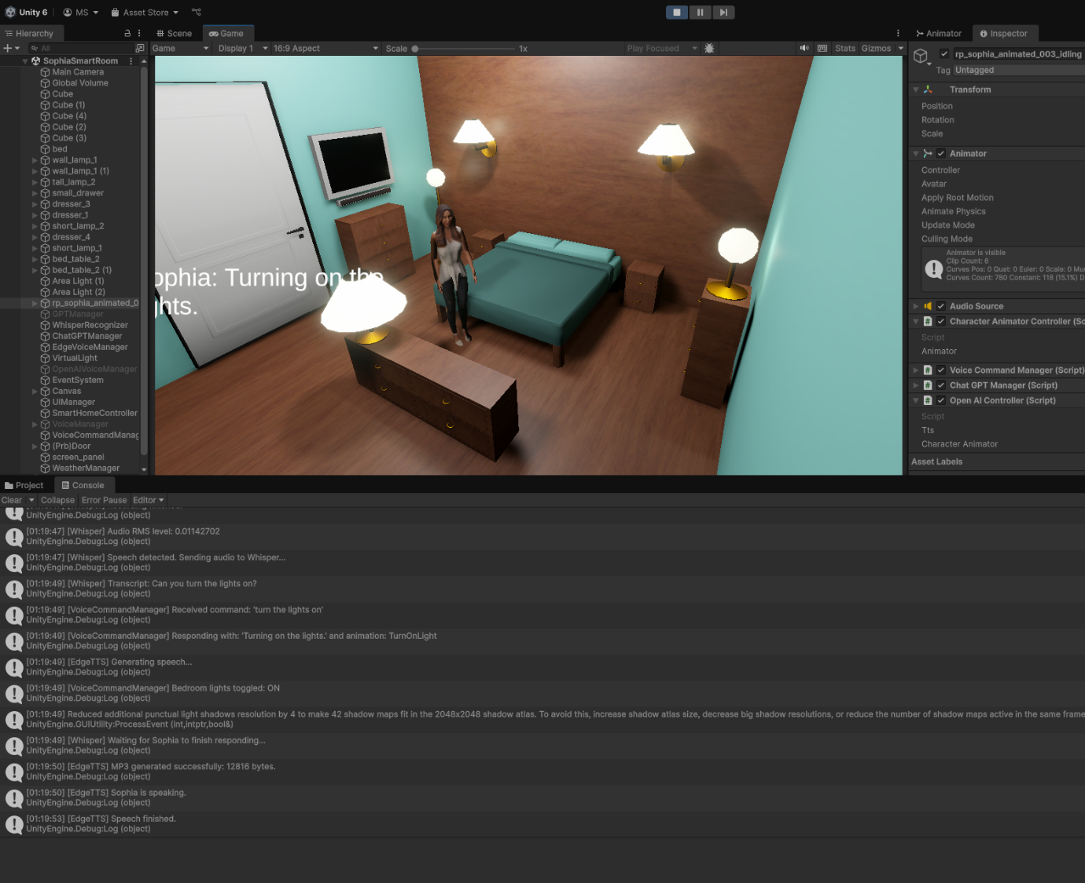

Table 6.7 — Overall Test Results
Test category | Tests | Passed | Failed | Pass rate
Functional Testing | 8 | 8 | 0 | 100%
Smart Environment | 5 | 5 | 0 | 100%
Weather | 2 | 2 | 0 | 100%
Generative AI | 1 | 1 | 0 | 100%
End-to-End | 7 | 7 | 0 | 100%
All defined scenarios passed under the tested conditions.
The results provide evidence that:
- deterministic environmental controls operated successfully;
- weather information could be retrieved and communicated;
- generative AI could provide a conversational response;
- the different processing pathways could be integrated;
- complete voice-to-response interactions could operate successfully.
However, the 100% pass rates must not be interpreted as universal reliability. They apply only to the defined test cases. The evaluation was not statistically representative and did not test every possible language formulation, environmental condition or external-service failure.

6.10 Evaluation Against the Research Questions
The testing provides evidence relevant to all four research questions.

RQ1 — Voice, AI and TTS integration
The successful speech-recognition, command-processing, generative AI and TTS pathways demonstrate that Sophia can receive spoken requests and return responses through an embodied interface. The tested conversational variations further demonstrate that supported interaction is not restricted entirely to one fixed phrase.

RQ2 — Natural-language environmental control
The smart-environment and voice-command tests demonstrate that selected natural-language requests could be converted into deterministic state changes for the simulated lighting, television and door.

RQ3 — External information services
The weather tests demonstrate successful retrieval of dynamic information from the external weather service and integration of that information into Sophia's conversational response. The umbrella test additionally demonstrates how structured data can be transformed into a practical user-oriented response.

RQ4 — Limitations and challenges
The evaluation identified several limitations, including the simulated rather than physical environment, limited natural-language testing, generative-AI uncertainty and dependence on external services.
The testing therefore supports the conclusion that the proposed architecture is technically feasible within the defined prototype scope, while also establishing clear boundaries around what the results can demonstrate.

6.11 Chapter Summary
The evaluation demonstrated successful operation across the defined functional, voice-command, smart-environment, weather, generative AI and end-to-end scenarios.
The strongest evidence comes from the successful end-to-end tests, because these required multiple components to operate sequentially as one interaction pipeline. The environmental tests demonstrated deterministic virtual-device control, while the weather and generative AI tests demonstrated integration with external information and conversational services.
At the same time, the evaluation identified important boundaries. The system was tested within a simulated environment, natural-language testing covered a limited set of formulations, several capabilities depend on external services, and the generative AI evaluation did not establish factual accuracy.
The results therefore demonstrate successful prototype functionality under the evaluated conditions, rather than production-level reliability or unrestricted natural-language understanding. Overall, the testing provides evidence that the core technical objectives of Sophia were achieved within the defined scope.

CHAPTER 7 — DISCUSSION

7.1 Discussion of Findings
The development and evaluation of Sophia demonstrate the technical feasibility of combining voice interaction, artificial intelligence, external information retrieval, simulated environmental control and an embodied 3D character within a single Unity-based application. The findings indicate that these technologies can operate together through a modular architecture while retaining distinct responsibilities.
The most significant finding is the effectiveness of the hybrid interaction model. Deterministic functions were used for environmental control, while generative AI was used for open-ended conversation. Testing demonstrated that this separation allowed Sophia to perform predictable environmental operations while retaining flexibility for general conversational interaction. This supports the architectural decision not to rely on generative AI for direct control of environmental states.
The successful voice-command tests provide further evidence that natural-language speech can be used as an interaction mechanism for the simulated environment. Conversational formulations such as requests to activate the lights, switch off the television and open the door were successfully processed. However, these findings demonstrate flexibility only within the tested command scope and should not be interpreted as evidence of unrestricted natural-language understanding.
The weather functionality demonstrates the value of combining conversational interaction with specialised external services. Rather than relying on generative AI to produce current weather information, Sophia retrieves structured data from an external weather service and converts it into a natural-language response. The successful weather and umbrella tests demonstrate how numerical external information can be transformed into information that is more directly useful to the user.
The generative AI component provides a complementary capability. It allows general questions outside the predefined environmental and weather functions to be handled conversationally. However, successful response generation does not establish factual accuracy. The results therefore support the use of generative AI as a conversational component rather than treating its responses as inherently authoritative.
Embodiment represents another important finding. Sophia presents the different capabilities through a persistent 3D character using spoken output and animation. This provides a common representation for otherwise independent technologies and demonstrates the technical feasibility of using an embodied character as an interface layer.
The end-to-end tests are particularly significant because they demonstrate integration rather than isolated functionality. Speech recognition, command processing, environmental control, external information retrieval, generative AI, TTS and animation were able to operate together as a complete interaction pipeline.
Nevertheless, the relatively small and primarily functional test set limits the conclusions that can be drawn. The results demonstrate successful operation for the selected scenarios rather than statistically generalisable reliability. Similarly, because the environmental devices are simulated, the findings cannot automatically be extended to physical smart-home environments.
Overall, the findings support the central proposition of the project: a 3D conversational assistant can technically integrate multiple intelligent and interactive technologies within a single Unity environment, provided that deterministic and generative functionality are appropriately separated and external dependencies are managed.

7.2 Achievement of Project Objectives
The implementation and testing evidence indicate that the principal project objectives were achieved within the defined prototype scope.

Objective 1 — Develop a 3D conversational assistant capable of voice-based interaction
This objective was achieved through the integration of speech recognition, command processing, TTS and the Sophia 3D character. Successful voice-command and end-to-end testing demonstrated that spoken requests could be received, converted into text, processed and communicated through the embodied character.

Objective 2 — Integrate artificial intelligence for conversational interaction
This objective was achieved through the generative AI component. The AI test demonstrated that a general question could be routed through the conversational pathway and returned through Sophia. Importantly, the architecture maintained a distinction between generative conversation and deterministic environmental control.

Objective 3 — Implement voice-controlled interaction with a simulated smart environment
This objective was achieved through simulated lighting, television and door functionality. Testing demonstrated successful state changes for all evaluated operations.

Objective 4 — Integrate external information retrieval
The WeatherController successfully retrieved and processed weather information and communicated the results through natural language. The umbrella interaction additionally demonstrated how precipitation information could be converted into a practical user-oriented response.

Objective 5 — Provide an embodied response
This objective was achieved through TTS and character animation. Responses from the different processing pathways could be presented through Sophia's voice and visual behaviour.

Objective 6 — Integrate the components into a functional prototype
The end-to-end evaluation demonstrated successful integration of speech recognition, command processing, smart-environment control, weather retrieval, generative AI, TTS and animation.
The objectives should nevertheless be understood within the project's boundaries. The environment remains simulated, natural-language testing was limited, and generative AI was evaluated primarily for functional integration rather than factual accuracy. The project therefore demonstrates technical feasibility rather than production readiness.

7.3 Significance of the Findings
The significance of Sophia lies primarily in the integration of established technologies rather than the invention of a new individual AI, speech-recognition or smart-home technology.
The project demonstrates that voice interaction, generative AI, external information retrieval, deterministic environmental control and embodiment can be combined behind one interface. The hybrid architecture is particularly significant because it assigns different technologies to tasks for which they are appropriate: generative AI provides conversational flexibility, while deterministic functions provide predictable environmental behaviour.
The weather functionality further demonstrates how specialised services can complement conversational AI. Structured information can be retrieved from an external source and transformed into a user-oriented response rather than requiring the conversational model to provide every type of information.
The embodied character provides another layer of integration. Although the underlying services perform different technical functions, they are presented through one persistent character, giving the user a consistent interaction representation.
From a software-engineering perspective, the results also support modular architecture. Successful end-to-end integration demonstrates that independently implemented components can operate together while retaining separation of responsibilities. This makes individual components easier to modify or replace.
The significance remains bounded by the prototype's evaluation scope. The project does not provide statistically generalisable evidence about usability, user preference or long-term reliability, nor does successful virtual-device control establish safe physical smart-home operation.

7.4 Comparison with Existing Approaches
Sophia incorporates characteristics associated with several established approaches to conversational interaction.
A conventional voice assistant provides spoken interaction and access to predefined functionality. Sophia adopts this principle through speech recognition but extends it by representing the assistant through a persistent 3D character.
The system also reflects the principles of an embodied conversational agent, using a humanoid character, speech and animation to provide a consistent visual representation.
Unlike a system based exclusively on generative AI, Sophia uses a hybrid architecture. General conversation is handled through generative AI, while environmental state changes are controlled through deterministic application logic. This provides greater predictability for environmental operations.
Sophia also differs from a purely rule-based conversational system. Deterministic rules remain useful for environmental control, but generative AI allows general questions to be handled dynamically without requiring an individual predefined response for every possible question.
The weather implementation reflects a service-oriented approach. A specialised external service supplies current weather information, while Sophia acts as the conversational interface through which the information is communicated.
The overall relationship can therefore be summarised as:

Existing approach | Sophia implementation
Voice assistant | Spoken interaction
Embodied conversational agent | 3D character + animation
Generative AI assistant | Open-ended conversation
Rule-based system | Deterministic environmental control
Service-oriented application | External weather service
The principal contribution is therefore not the invention of these individual technologies, but their practical integration into a single coherent Unity-based environment.
Importantly, no direct user study or benchmark against commercial assistants was conducted. Therefore, the comparison demonstrates architectural relationships rather than claiming that Sophia is superior to established systems.

7.5 Strengths of the Proposed System
Several strengths emerge from the implementation and evaluation.

Modular architecture
Speech recognition, command processing, environmental control, weather retrieval, generative AI, TTS and animation are separated into dedicated components. This improves maintainability and allows individual services to potentially be replaced without redesigning the complete system.

Hybrid interaction model
The separation between deterministic environmental operations and generative conversation provides a balance between predictability and flexibility.

Unified embodied interface
Multiple technologies are presented through one persistent character. The user therefore interacts with one conversational entity rather than separate technical interfaces.

Multi-functional interaction
Sophia combines environmental control, weather retrieval and general conversation through a common voice interface.

Specialised external services
Using specialised services for speech recognition, weather, generative AI and TTS allowed the project to focus on integration rather than recreating every underlying technology.

Defensive behaviour
External requests and returned information are checked before processing, reducing the likelihood of uncontrolled behaviour when external data is unavailable or invalid.

Successful integration
The end-to-end tests demonstrate that the separate components could operate together as one interaction pipeline.

7.6 Limitations
The main limitations are directly related to the scope and evaluation design.
First, the smart environment is simulated. The successful tests demonstrate virtual control but do not establish reliable operation with physical devices. Real-world deployment would introduce compatibility, communication, authentication, reliability and safety requirements.
Second, the test set is relatively small and primarily functional. Although all defined scenarios passed, the evaluation cannot provide statistically representative measurements of reliability.
Third, natural-language evaluation was limited. Several conversational formulations were successfully tested, but this does not establish unrestricted language understanding.
Fourth, speech-recognition performance may be affected by background noise, microphone quality, pronunciation and unclear speech. A dedicated acoustic evaluation was outside the project's scope.
Fifth, generative AI responses are not guaranteed to be factually correct. The project evaluated functional integration rather than factual accuracy, consistency or hallucination frequency.
Sixth, several capabilities depend on external services. Network interruption, service availability, latency and API changes may therefore affect system behaviour. The prototype contains basic error handling but does not provide comprehensive offline functionality or advanced service recovery.
Seventh, no large-scale user study was conducted. Consequently, conclusions concerning satisfaction, usability, accessibility or long-term user behaviour cannot be established empirically.
Finally, Sophia remains a research and demonstration prototype rather than a production-ready assistant. Large-scale deployment, comprehensive security testing, physical-device safety, advanced authentication, privacy architecture and continuous service monitoring were beyond the project scope.
These limitations do not invalidate the successful tests; instead, they establish the boundaries within which the results should be interpreted.

7.7 Practical and Research Implications
The project has implications for both practical development and future research.
From a practical perspective, the modular architecture demonstrates that multiple AI and software services can be integrated behind a single embodied interface. Additional environmental devices could potentially be introduced through the existing control architecture, while alternative AI, speech-recognition and TTS services could be substituted through their respective components.
The most significant practical extension would be connecting the architecture to physical smart-home devices. The current prototype demonstrates the interaction concept within a controlled environment, while a real deployment would require appropriate communication protocols, authentication, reliability controls and safety mechanisms.
The architecture could also be extended through additional specialised information services, such as transport information, calendars or other real-time sources, provided appropriate APIs and security mechanisms were available.
From a research perspective, Sophia provides a platform for investigating whether embodiment affects interaction with conversational AI. However, the present project does not establish whether users prefer an embodied assistant over conventional voice or text interfaces. A controlled user study could measure usability, engagement, trust and satisfaction.
Natural-language processing could also be evaluated using a substantially larger dataset covering different linguistic structures, accents, speaking styles and environmental conditions. This would allow quantitative recognition and command-execution measures to be obtained.
Future research could additionally examine generative-AI accuracy, consistency, response latency and reliability, alongside contextual memory and personalisation while retaining the separation between conversational generation and environmental control.
Finally, service resilience could be investigated through caching, local fallback models, service redundancy and adaptive behaviour during external-service failures.

7.8 Chapter Summary
The discussion demonstrates that Sophia successfully integrated voice interaction, generative AI, external information retrieval, simulated environmental control and embodied character behaviour within a single Unity-based system.
The findings particularly support the hybrid architecture: deterministic logic provides predictable environmental behaviour, while generative AI provides conversational flexibility. Weather integration demonstrates how specialised external information can be transformed into conversational responses, while the 3D character provides a consistent interface across the different capabilities.
The principal contribution of the project is therefore the practical integration of established technologies into a coherent embodied conversational prototype rather than the creation of a new underlying AI technology.
The project also demonstrates clear strengths in modularity, hybrid processing, embodiment, specialised service integration and successful end-to-end operation. At the same time, the findings remain limited by the simulated environment, small testing scope, natural-language coverage, external dependencies, generative-AI uncertainty and absence of a large-scale user study.
Overall, the evidence supports the conclusion that the principal technical objectives were achieved within the defined prototype scope and provides a foundation for future work involving physical smart-home devices, broader language evaluation, user-centred research and improved system resilience.

CHAPTER 8 — CONCLUSION

8.1 Conclusion
This project developed and evaluated Sophia, a 3D AI-driven conversational assistant that integrates voice interaction, generative artificial intelligence, external information retrieval, simulated smart-environment control and embodied character behaviour within Unity. The implementation demonstrates that these capabilities can operate as a unified interaction pipeline while retaining distinct responsibilities between conversational generation and deterministic environmental control.
The hybrid architecture was central to the project. Predefined environmental operations were handled through deterministic Unity functions, while general conversational requests were routed to generative AI. Weather information was obtained from an external service rather than generated from model knowledge. This separation improved predictability for environmental actions while retaining flexibility for open-ended interaction.
Evaluation demonstrated successful operation across the defined functional, voice-command, smart-environment, weather, generative-AI and end-to-end test scenarios. The results provide evidence of technical feasibility within the defined prototype scope, but the limited test set does not establish production-level reliability or unrestricted natural-language understanding.

8.2 Achievement of the Research Aim and Objectives
The research aim was achieved within the prototype scope. The system accepted spoken input, processed supported requests, generated conversational responses, controlled simulated devices, retrieved weather information and presented responses through speech and character animation. The objective outcomes are summarised in Table 8.1.

Table 8.1 — Achievement of Project Objectives
Objective | Outcome
Voice-based 3D conversational assistant | Achieved
Generative AI conversation | Achieved
Voice-controlled simulated environment | Achieved
External information retrieval | Achieved
Embodied character response | Achieved
Integration into functional prototype | Achieved
The evidence supporting these outcomes is distributed across the implementation and evaluation chapters. In particular, the end-to-end tests demonstrate that the principal components can operate consecutively as one interaction pipeline.

8.3 Key Contributions
The primary contribution is the practical integration of established technologies into a coherent embodied conversational system. Three aspects are particularly significant: first, the separation of generative conversation from deterministic environmental control; second, the use of a persistent 3D character as a common interaction representation; and third, the integration of specialised external information services alongside conversational AI.

8.4 Limitations and Future Work
The most important limitation is that the smart environment is simulated rather than connected to physical IoT devices. Real deployment would introduce additional requirements involving compatibility, communication protocols, authentication, security, privacy, reliability and safety. The natural-language evaluation was also limited in scale, while speech recognition may be affected by pronunciation, background noise and microphone conditions.
Generative AI introduces additional uncertainty because fluent output is not equivalent to factual accuracy [6], [15]. The project evaluated functional integration rather than hallucination frequency or comprehensive factual correctness. Several components also depend on external services, so network interruption, service availability and API changes may affect the interaction pipeline.
Future work should therefore investigate physical smart-home integration, larger natural-language evaluation datasets, controlled user studies, quantitative evaluation of response accuracy and latency, and improved resilience through caching, fallback services and redundancy. These extensions would provide stronger evidence for usability, reliability and real-world deployment.

8.5 Final Conclusion
Overall, Sophia demonstrates that voice interaction, generative AI, external information retrieval, simulated environmental control, text-to-speech and 3D embodiment can be integrated within a single Unity-based assistant. The project achieved its principal technical objectives within the defined scope and provides a practical foundation for further research into embodied conversational interaction. The findings should nevertheless be interpreted as evidence of prototype feasibility rather than production readiness.

REFERENCES
[1] J. Cassell, Ed., Embodied Conversational Agents. Cambridge, MA, USA: MIT Press, 2000.
[2] J. Cassell, T. Bickmore, L. Campbell, H. Vilhjálmsson, and H. Yan, “More than just a pretty face: Conversational protocols and the affordances of embodiment,” Knowledge-Based Systems, vol. 14, nos. 1–2, pp. 55–64, 2001, doi: 10.1016/S0950-7051(00)00102-7.
[3] T. W. Bickmore and J. Cassell, “Relational agents: A model and implementation of building user trust,” in Proc. CHI 2001, Seattle, WA, USA, 2001, pp. 396–403, doi: 10.1145/365024.365304.
[4] A. Vaswani, N. Shazeer, N. Parmar, J. Uszkoreit, L. Jones, A. N. Gomez, L. Kaiser, and I. Polosukhin, “Attention is all you need,” in Advances in Neural Information Processing Systems, vol. 30, 2017.
[5] A. Radford, J. W. Kim, T. Xu, G. Brockman, C. McLeavey, and I. Sutskever, “Robust speech recognition via large-scale weak supervision,” arXiv:2212.04356, 2022.
[6] Z. Ji, N. Lee, R. Frieske, T. Yu, D. Su, Y. Xu, E. Ishii, Y. J. Bang, A. Madotto, and P. Fung, “Survey of hallucination in natural language generation,” ACM Computing Surveys, vol. 55, no. 12, pp. 1–38, 2023, doi: 10.1145/3571730.
[7] A. R. Hevner, S. T. March, J. Park, and S. Ram, “Design science in information systems research,” MIS Quarterly, vol. 28, no. 1, pp. 75–105, 2004.
[8] K. Peffers, T. Tuunanen, M. A. Rothenberger, and S. Chatterjee, “A design science research methodology for information systems research,” Journal of Management Information Systems, vol. 24, no. 3, pp. 45–77, 2007, doi: 10.2753/MIS0742-1222240302.
[9] A. Aldahmani, B. Ouni, T. Lestable, and M. Debbah, “Cyber-security of embedded IoTs in smart homes: Challenges, requirements, countermeasures, and trends,” IEEE Open Journal of Vehicular Technology, vol. 4, pp. 281–292, 2023, doi: 10.1109/OJVT.2023.3234069.
[10] Unity Technologies, “Unity 6.1 User Manual,” Unity Documentation, 2025. [Online]. Available: https://docs.unity3d.com/6000.1/Documentation/Manual/UnityManual.html. [Accessed: Aug. 28, 2026].
[11] OpenAI, “Developer quickstart: OpenAI API,” OpenAI Documentation. [Online]. Available: https://platform.openai.com/docs/quickstart/make-your-first-api-request. [Accessed: Aug. 28, 2026].
[12] Open-Meteo, “Weather Forecast API documentation.” [Online]. Available: https://open-meteo.com/en/docs. [Accessed: Aug. 28, 2026].
[13] rany2, “edge-tts: Use Microsoft Edge’s online text-to-speech service from Python,” GitHub repository. [Online]. Available: https://github.com/rany2/edge-tts. [Accessed: Aug. 28, 2026].
[14] OpenAI, “Models: GPT-4.1,” OpenAI API Documentation. [Online]. Available: https://platform.openai.com/docs/models/gpt-4.1. [Accessed: Aug. 28, 2026].
[15] Z. Y. Ho, S. Liang, and D. Tao, “Understanding hallucinations in large visual and language models,” ACM Computing Surveys, vol. 58, no. 13, pp. 1–36, 2026, doi: 10.1145/3811409.

APPENDICES

[APPENDIX A — PROTOTYPE DEMONSTRATION VIDEO]

Prototype Demonstration Video

