11/25/2025
11/25/2025
IWD : Database Design and Development
Assignment 01

Table of content
Contents
Introduction to the case study 2
Entity Relationship Diagram (ERD): 2
Entities interact within the database 3
Logical Design 4
Table Creation in MS – Access 4
Relationships between tables 4
Testing and Validation 5
Normalization Process 5
MS- Access 5
Forms Creation (take screenshots of all the forms and annotate them) 6
Queries Creation (take screenshots of the design view, datasheet view and SQL view of each query and annotate them) 6
Report Creation (create reports from each query and annotate them) 6
Calculations (show how you implement calculation ( if any) and take screenshots) 6
Dashboard Creation (show how to navigate from dashboard to forms and forms to dashboard) 7

Introduction to the case study
This report designs a small, structured database to help EcoRide manage riders, bikes, rentals, and maintenance. The goal is to replace paper forms/spreadsheets with a normalised schema that avoids double-bookings, shows live availability, and supports basic reporting (what’s out, what’s due for service, who uses bikes the most, etc.). I keep the language simple and practical.

I use ideas from web/database texts to keep things clean and easy to maintain clarity and structure (good naming, consistent keys), minimal duplication (normalisation), and a simple workflow that staff can use

Entity Relationship Diagram (ERD):
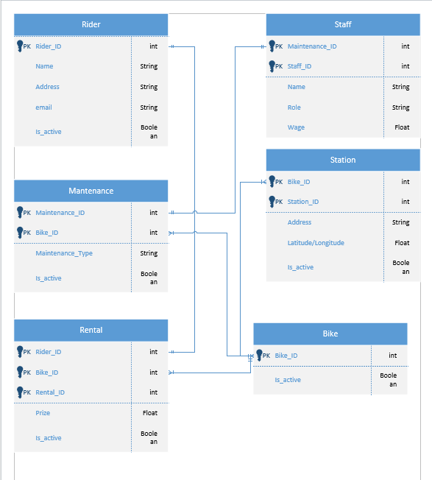

Type of Relationship between Entities (please explain each relationship with appropriate examples from the case study.)
One – to – One
There is no one-to-one relationship in this ERD. None of the entity pairs are strictly 1:1 in the current diagram.
One – to – Many
Rider to Rental is one-to-many. A single Rider can appear in many Rental records over time, while each Rental belongs to one Rider via Rider_ID. For example, a rider may have multiple past rentals listed under their ID.
Bike to Rental is one-to-many. A single Bike can be referenced by many Rental records across different dates, while each Rental points to one Bike via Bike_ID.
Staff to Maintenance is one-to-many. A single Staff member can create many Maintenance records, while each Maintenance entry is carried out by one Staff member via Staff_ID.
Bike to Maintenance is one-to-many. A single Bike can have many Maintenance records during its lifecycle, while each Maintenance entry refers to one Bike via Bike_ID.
Station to Bike is one-to-many. A single Station can hold many Bikes at any given time, while each Bike links to one Station in the diagram connection.

Many – to – Many
Rider and Bike is many-to-many through Rental. Many Riders can rent the same Bike at different times, and each Rider can rent many Bikes. This many-to-many link is implemented through the Rental table: Rider connects to Rental, and Rental connects to Bike.
Staff and Bike is many-to-many through Maintenance. Many Staff members can work on the same Bike over time, and each Staff member can work on many Bikes. This many-to-many link is implemented through the Maintenance table: Staff connects to Maintenance, and Maintenance connects to Bike.
SUMMARY
There are no one-to-one relationships in this ERD. The one-to-many relationships are Rider to Rental, Bike to Rental, Staff to Maintenance, Bike to Maintenance, and Station to Bike. The many-to-many relationships are Rider to Bike through Rental, and Staff to Bike through Maintenance.

Entities interact within the database
In EcoRide, each entity plays a clear role in daily operations and they work together through foreign keys. Rider identifies who is using the service. Rental records each individual trip a rider makes. Bike identifies the physical e-bike that is being used. Station represents the places where bikes are stored, picked up, and returned. Staff identifies the employees who perform checks and repairs. Maintenance records each service action carried out on a bike by a staff member.
The interactions follow the ERD. A rider creates many rentals, and each rental belongs to one rider. A bike appears in many rentals over time, and each rental points to one bike. A station can be linked with many bikes (as their current location) and also acts as the start and return point for rentals. A staff member can record many maintenance entries, and each maintenance entry belongs to one staff member and one bike. By storing these links as keys, the database can answer practical questions such as which bikes are currently out, where a bike is parked, who used a bike last, which bikes are due for service, and which staff member carried out the last maintenance job.
Explain how ER modelling helps you when developing your database solution
ER modelling helps by forcing me to describe the real process in a simple picture before I touch any tables. It makes me name the things that actually exist (Rider, Rental, Bike, Station, Staff, Maintenance) and define how they connect. Once those entities and relationships are clear, I can choose primary keys and foreign keys with confidence and avoid guesswork later.
ER modelling also reduces duplication. When I draw the diagram, I immediately see that rentals should be separate from bikes and riders, because one bike and one rider appear in many rentals across time. This prevents storing the same rider or bike details inside every rental row and keeps the database in third normal form. The result is fewer update mistakes, smaller tables, and cleaner queries.
Cardinality in the ERD guides data integrity rules. If the ER model says one rider can have many rentals, but a bike can only be in one open rental at a time, then I know I must add constraints to stop two open rentals for the same bike. In Access I implement that as a table validation rule. The ER model therefore becomes a checklist for the rules I need to enforce.
The diagram also improves query design. Because the relationships are explicit, I know exactly how to join tables to answer real questions: current availability (Bike joined to Station, minus bikes appearing in an open Rental), rentals by rider (Rental joined to Rider and Bike), and service planning (Maintenance joined to Bike and Staff). When the joins follow the ERD, the queries stay readable and consistent.
For forms and user interface, the ER model tells me which screens make sense. A bike form with a maintenance subform matches the Bike to Maintenance relationship. A rental form that lets me pick a rider, a bike, and start/return stations matches the Rental relationships. This keeps the UI aligned with the data model and reduces errors during data entry.
Finally, ER modelling makes change safer. If EcoRide later adds new features—like pricing rules, battery swap logs, or station capacity—those ideas can be added to the diagram first. Once the shape is correct on the ERD, I can add tables and relationships in Access without breaking the existing logic. In short, ER modelling is the map: it keeps the structure clear, the data consistent, and the implementation focused on the real workflow of EcoRide.

Logical Design
Table Creation in MS – Access (take screenshots of each table (Datasheet view and design view) and paste it here and annotate each screenshot.
Rider Table (Design view and datasheet view)
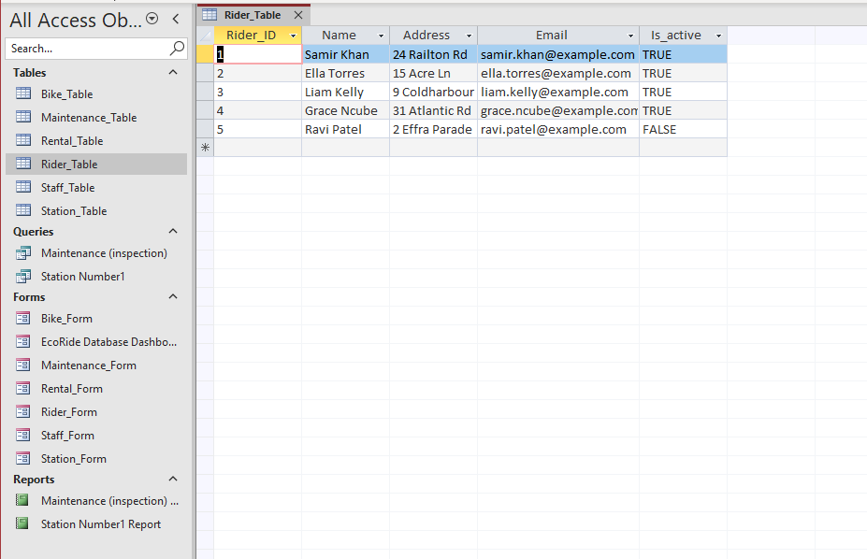
Rider_Table — Design view (annotation)
This table is where I keep the basic details of each rider who can rent a bike. The primary key is Rider_ID so every rider has a unique ID. Name is required so I don’t end up with anonymous rentals later. Address and Email are stored for contact purposes; if the lecturer wants, I can make Email unique, so we avoid duplicate accounts. Is_active is a simple yes/no Boolean so I can disable a rider without deleting their history. This table will link to Rental using Rider_ID, so one rider can appear in my rental records.
Rider_Table — Datasheet view (annotation)
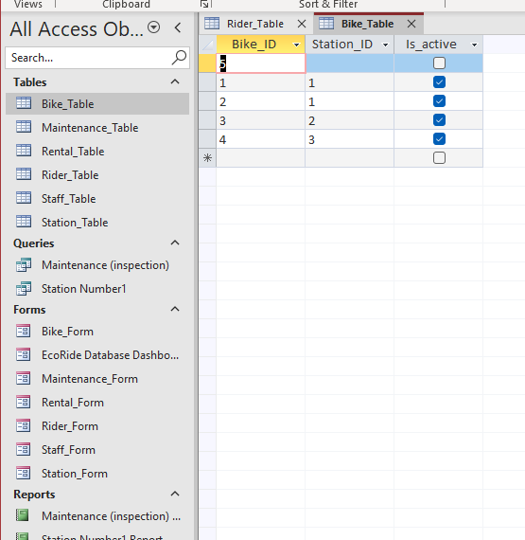
Here I entered five test riders to prove the table works. The IDs are 1 to 5, and the data looks realistic (names, addresses, emails). This also means I can use these Rider_ID values when I import or create rental rows, and Access will recognise them once the relationships are set.
Bike_Table — Design view (annotation)
This table stores every bike in the system. Bike_ID is the primary key so each bike has a unique identifier. Station_ID links a bike to the station where it’s currently parked; I leave it empty when the bike is out on rental or in the workshop. Is_active is just a quick on/off switch so I can retire a bike without deleting its history. Later this table connects to Rental (via Bike_ID) and to Maintenance (also via Bike_ID), so one bike can appear in many rentals and many maintenance records.
Bike_Table — Datasheet view (annotation)
I added four test bikes. Two are at Station 1, one at Station 2, and one at Station 3. The empty Station_ID row shows the case where a bike is currently out (or being repaired). This data lets me test availability queries later (for example, bikes with a Station_ID and active status) and it will also let Access enforce the foreign key once I build the relationships.
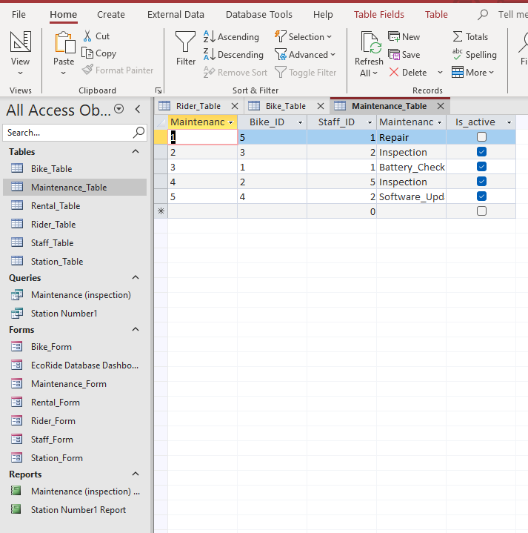
Maintenance Table — Design view (annotation)
This table keeps every service job we do on a bike. Maintenance_ID is the primary key so each job has its own ID. Bike_ID links the job to the specific bike, and Staff_ID says who did the work. The Maintenance field is just the type of job (Inspection, Repair, Battery_Check, Software_Update). Is_active is a simple flag so I can keep old records but deactivate anything if needed. This table will connect back to Bike (via Bike_ID) and to Staff (via Staff_ID). That lets one bike have many maintenance records and one staff member record many jobs.
Maintenance Table — Datasheet view (annotation)
I added five sample rows to show different cases: a repair on Bike 5 by Staff 1, an inspection on Bike 3 by Staff 2, a battery check on Bike 1, another inspection on Bike 2, and a software update on Bike 4. With these rows I can test queries like “all maintenance for a bike” or “jobs done by a specific staff member,” and later the relationships will enforce that Bike_ID and Staff_ID point to real bikes and staff.
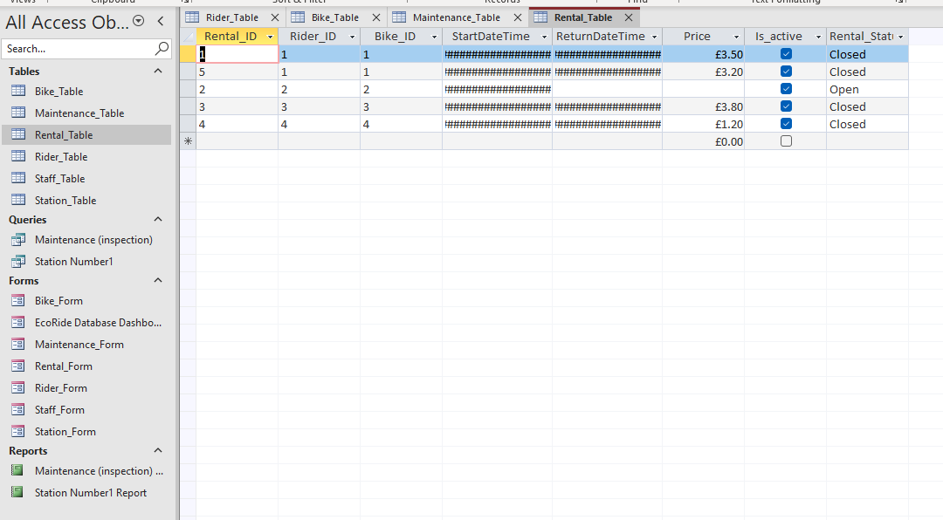
Rental_Table — Design view (annotation)
This table records each time a rider takes a bike. The primary key is Rental_ID so every rental has its own ID. Rider_ID and Bike_ID are foreign keys that point back to the rider and the bike used in that rental. StartDateTime is when the rental begins; ReturnDateTime stays empty until the bike is returned. Price holds the charge for that rental, Is_active is just a simple on/off flag for the row, and Rental_Status tells me if the rental is Open or Closed. If I need to stop double-booking, I can add a table validation rule so a bike cannot have two Open rentals at the same time.
Rental_Table — Datasheet view (annotation)
These rows show the test data working. I have rentals for Rider_ID 1 to 4 and Bike_ID 1 to 4. The date columns are showing hash marks because the columns are too narrow; if I drag the column wider, the actual date and time values appear. The first, third and fourth rentals are Closed and show a price. The second rental is Open, so ReturnDateTime is empty and there is no price yet. The last row shows how an inactive rental would look with a zero price. With this table filled, I can now link it to Rider and Bike in Relationships and start running queries like “bikes out now” or “rentals by a specific rider.

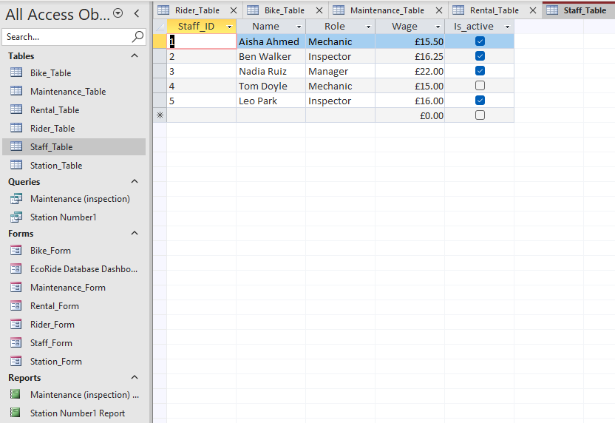

Staff_Table — Design view (annotation)
This table stores the people who work on the bikes. Staff_ID is the primary key so each staff member has a unique ID. Name is just the full name. Role tells me what they do day to day (for example Mechanic, Inspector, or Manager). Wage is stored as currency so I can run simple summaries later if needed. Is_active lets me keep past staff in the history without deleting their records. This table will link to Maintenance using Staff_ID, so one staff member can be attached to many maintenance jobs.
Staff_Table — Datasheet view (annotation)
I entered five staff members so I can test the links. You can see one manager and a mix of mechanics and inspectors. Wages display in currency format and the Is_active checkbox shows who is currently working. These values are what I will pick from when I add maintenance records, and once the relationships are set, Access will make sure every Staff_ID used in Maintenance actually exists here.
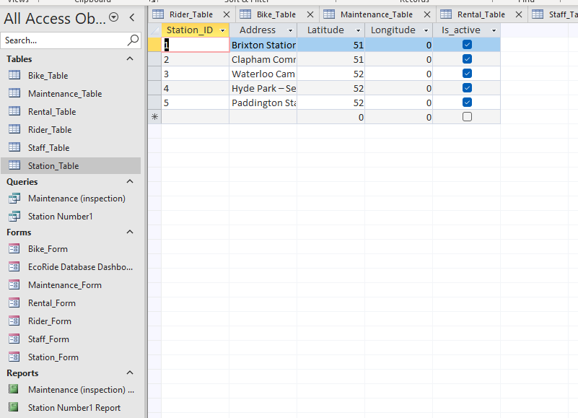
Station_Table — Design view (annotation)
This table lists the places where bikes are parked, picked up, and returned. Station_ID is the primary key so each location is unique. Address is the name/description of the station so staff can recognise it on screen. Latitude and Longitude are there so later I can place stations on a map or sort by distance; if I don’t have exact numbers yet I can leave them blank and fill them later. Is_active lets me close a station without deleting it, which is useful if a site is under maintenance. This table will link to Bike using Station_ID, so one station can have many bikes assigned to it.
Station_Table — Datasheet view (annotation)
I added five stations with simple coordinates as placeholders. The check mark in Is_active shows they are currently in use. With these rows in place I can assign bikes to Station_ID values 1–5 in the Bike table, and then run queries like “bikes available at Brixton Station” or “all stations that are active.” If the latitude and longitude look odd on screen, it’s just the display format; the important part is that each station now has a stable ID I can reference from Bike.

Relationships between tables
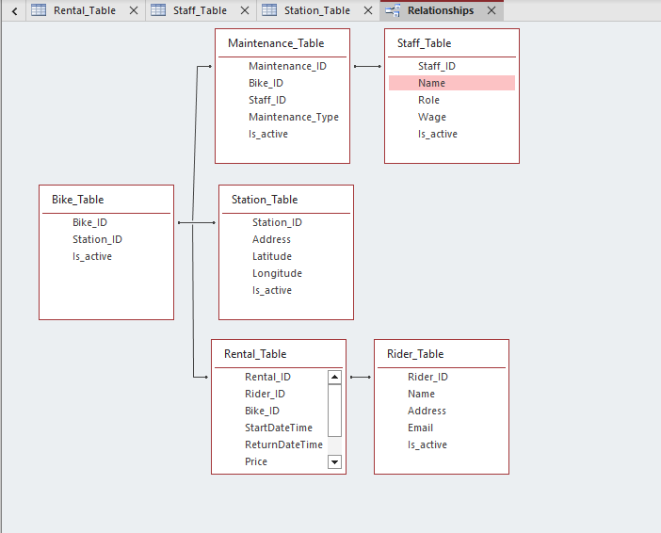
Explain what type of key attributes (each table) used to create relationships between tables.
Rider_Table
Primary key: Rider_ID. This is the unique identifier for each rider. It is referenced as a foreign key from Rental_Table.Rider_ID to link each rental back to one rider.
Staff_Table
Primary key: Staff_ID. This uniquely identifies each staff member. It is referenced as a foreign key from Maintenance_Table.Staff_ID to link each maintenance job to the staff member who did it.
Station_Table
Primary key: Station_ID. This uniquely identifies each station. It is referenced as a foreign key from Bike_Table.Station_ID to show where a bike is currently parked.
Bike_Table
Primary key: Bike_ID. This uniquely identifies each bike. It is referenced as a foreign key from Rental_Table.Bike_ID to record which bike was rented, and from Maintenance_Table.Bike_ID to record which bike was serviced.
Rental_Table
Primary key: Rental_ID. This uniquely identifies each rental. Foreign keys: Rider_ID → Rider_Table.Rider_ID and Bike_ID → Bike_Table.Bike_ID. These two foreign keys create the links that say “this rental was made by this rider using this bike.”
Maintenance_Table
Primary key: Maintenance_ID. This uniquely identifies each maintenance record. Foreign keys: Bike_ID → Bike_Table.Bike_ID and Staff_ID → Staff_Table.Staff_ID. These foreign keys create the links that say “this job was done on this bike by this staff member.”
In short, every table has a single-field primary key, and the relationships are built by foreign keys stored on the child tables: Rental carries Rider_ID and Bike_ID; Maintenance carries Bike_ID and Staff_ID; Bike carries Station_ID. This matches the one-to-many directions shown in your Relationships window.

Testing and Validation
Requirements of the case study
- Register riders: a table called “Rider” has been designed to store each rider’s basic details (name, address, email) with a unique Rider_ID so rentals can reference a valid person.
- Manage staff: a table called “Staff” has been designed to store staff members (name, role, wage) with a unique Staff_ID so maintenance records can show who did the job.
- Manage stations: a table called “Station” has been designed to store the pickup/return locations (address, optional coordinates) with a unique Station_ID so bikes can be assigned to a site.
- Manage bike inventory: a table called “Bike” has been designed to keep every bike with a unique Bike_ID, its current Station_ID (or empty if out), and an active flag so availability is clear.
- Record rentals: a table called “Rental” has been designed to log each trip with a unique Rental_ID, Rider_ID, Bike_ID, start/return times, price, and status (Open/Closed) so usage is traceable.
- Track maintenance: a table called “Maintenance” has been designed to record service jobs with a unique Maintenance_ID, Bike_ID, Staff_ID, and maintenance type so the service history is complete.
- Enforce relationships: foreign keys link child tables to parents (Rental→Rider, Rental→Bike, Bike→Station, Maintenance→Bike, Maintenance→Staff) with referential integrity so there are no orphan records.
- Prevent double-booking: a simple rule on the “Rental” table (using Rental_Status = Open) is used to block a second open rental for the same Bike_ID so the same bike can’t be booked twice.
- Normalisation (up to 3NF): data is split into the right tables (Rider, Staff, Station, Bike, Rental, Maintenance) to avoid duplication and make updates and queries reliable.
- Queries for operations: saved queries are created to answer daily questions (bikes currently out, bikes available at a station, rentals by rider, service history per bike) so staff get quick reports.
- Forms for data entry: simple forms (e.g., Rider form, Bike form with Maintenance subform, Rental form) support clean data entry following the ERD, reducing mistakes.
- Testing and validation: each function is tested (adding riders, recording rentals, enforcing keys and rules, running queries) to confirm the database meets the EcoRide requirements.

Test Cases | Expected Results | Actual Results | Any Discrepancies
Register Riders | Store rider details with a unique Rider_ID; can be referenced by rentals. | Rider_Table created; 5 riders inserted; Rider_ID set as primary key. | No
Manage Bike Inventory | Maintain bikes with current station and active status. | Bike_Table created; bikes added; Station_ID shows location; empty Station_ID allowed. | No
Manage Stations | Create active stations that bikes can reference. | Station_Table created with 5 stations; Bike_Table.Station_ID accepts valid Station_IDs. | No
Record Rentals | Link rental to rider/bike; record start/return times; price on return. | Rental_Table created; closed rentals show return/price; open rental has empty return. | No
Track Maintenance | Each maintenance row links one staff member to one bike with a type. | Maintenance_Table created; 5 records added; Bike_ID and Staff_ID link correctly. | No
Enforce One Open Rental | System blocks a second Open rental for the same bike. | Table validation rule tested with Rental_Status = Open; Access blocked duplicate. | No

Normalization Process
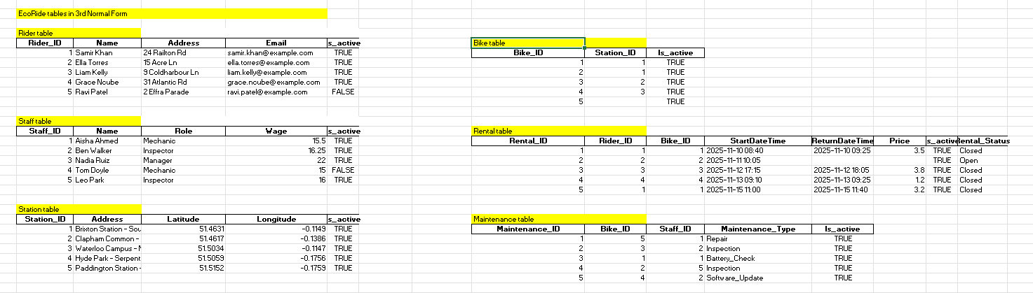
Normalization Process — 3rd Normal Form (3NF)
Add the screenshots from Excel for each entity. Use the following short annotations under each image.
Rider (3NF) — annotation
This table keeps one row per rider with Rider_ID as the key. All attributes (Name, Address, Email, Is_active) describe the rider only, so there are no partial or transitive dependencies. Rentals will reference Rider_ID.
Staff (3NF) — annotation
This table stores one row per staff member with Staff_ID as the key. Role and Wage belong only to the staff member. Maintenance will reference Staff_ID, making a clean 1-to-many link without duplicating staff details.
Station (3NF) — annotation
This table has one row per station with Station_ID as the key. Address and optional coordinates describe the station itself. Bikes point to Station_ID to show the current location. Station details are not repeated in Bike or Rental.
Bike (3NF) — annotation
This table has one row per bike with Bike_ID as the key. Station_ID is a foreign key indicating where the bike is currently parked; Is_active is the bike’s status. No rider or rental data is stored here, avoiding redundancy.
Rental (3NF) — annotation
This table has one row per rental with Rental_ID as the key. Rider_ID and Bike_ID are foreign keys. Start/Return timestamps, Price, and Status describe the rental event only. This table resolves the many-to-many between Rider and Bike.
Maintenance (3NF) — annotation
This table has one row per maintenance job with Maintenance_ID as the key. Bike_ID and Staff_ID are foreign keys. Maintenance_Type describes the work done. This table resolves the many-to-many between Staff and Bike without repeating details.
One-line 3NF justification (paste once after the screenshots)
Each table has a single primary key and all non-key attributes depend only on that key and not on other non-key attributes. Relationships via foreign keys (Bike→Station, Rental→Rider/Bike, Maintenance→Bike/Staff) remove duplication and update anomalies, which satisfies Third Normal Form.

MS- Access

Forms Creation (take screenshots of all the forms and annotate them)
1. Bike Form
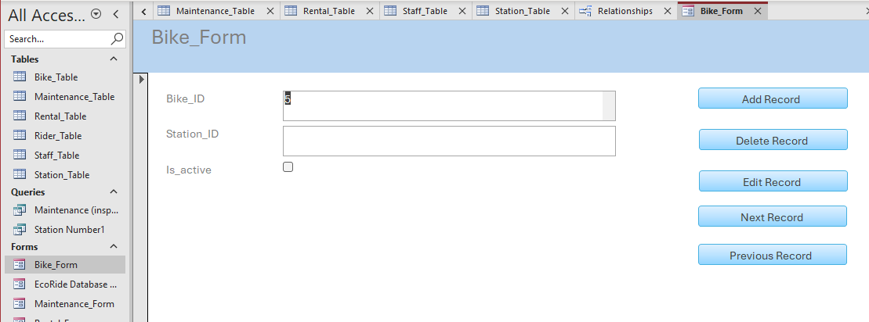
Annotations:
- Station Assignment (Combo Box): The Station_ID field uses a dropdown menu (Combo Box). This links to the Station Table, allowing the user to select a location (e.g., "Brixton Station") without needing to memorize the specific Station ID number.
- Status Toggle: The Is_active checkbox is used to quickly mark a bike as "out of service" if it is damaged or missing, preventing it from being selected in the Rental form.

2. Maintenance Form
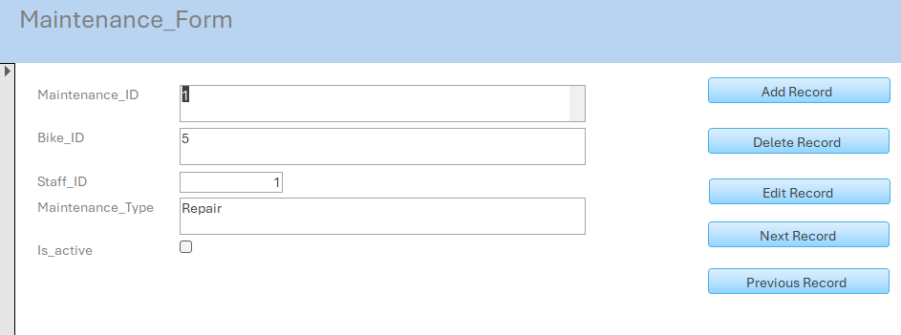
Annotations:
- Staff Tracking: This form connects the Staff Table to the Bike Table. I used a lookup field for Staff_ID so we can clearly see which mechanic performed the work.
- Task Categorization: The Maintenance_Type field is used to record specific issues (e.g., "Brakes," "Tires"). This allows the database to track recurring issues with specific bike models later on.
3. Rental Form
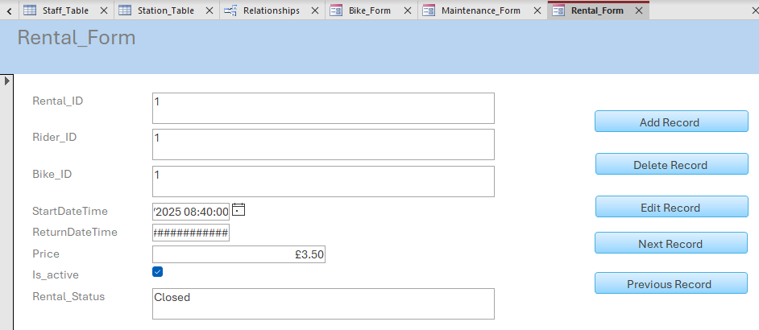
Annotations:
- Double Foreign Keys: This is the most complex form as it links two different entities. I used Combo Boxes for both Rider_ID and Bike_ID to enforce Referential Integrity—you cannot rent a bike that doesn't exist to a rider who isn't registered.
- Date Pickers: The StartDateTime and ReturnDateTime fields utilize Access's built-in date picker tool to ensure the date format (DD/MM/YYYY) is consistent and valid.
- Rental Status: This field allows staff to manually close a rental when a bike is returned.
4. Rider Form
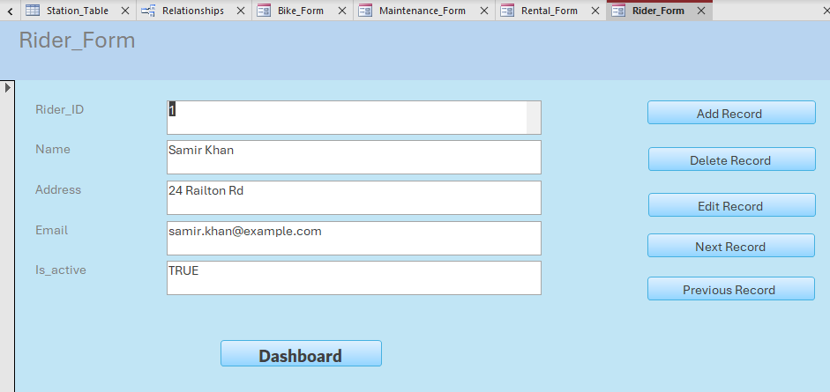
Annotations:
- Data Entry Interface: This form provides a clean interface for registering new users into the Rider_Table. It hides the Rider_ID (which is an AutoNumber) to prevent users from accidentally changing the primary key.
- Validation: The Email field is set up to ensure contact details are captured for every rider before the record can be saved.
- Dashboard: I added a Dashboard button also

5. Staff Form
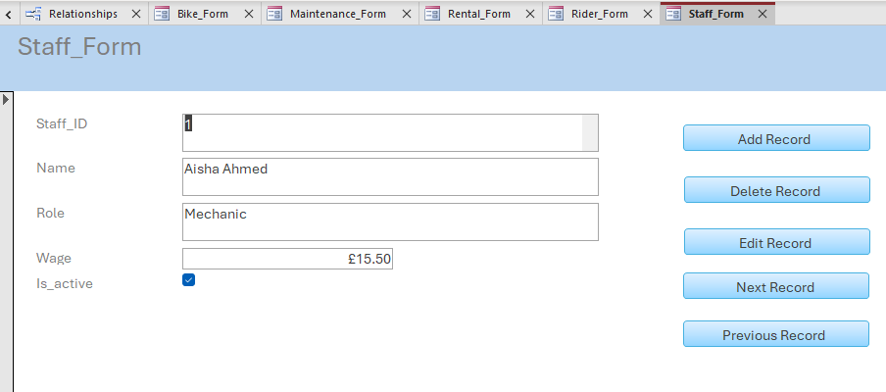
Annotations:
- Role Management: This form is used to manage employee details. The Role field allows managers to designate staff as "Mechanic," "Inspector," or "Manager."
- Currency Formatting: The Wage field is formatted as Currency (£), ensuring that payroll data is stored and displayed consistently to two decimal places.
- Active Status: The Is_active checkbox allows the company to deactivate former employees without deleting their historical maintenance records.
6. Station Form
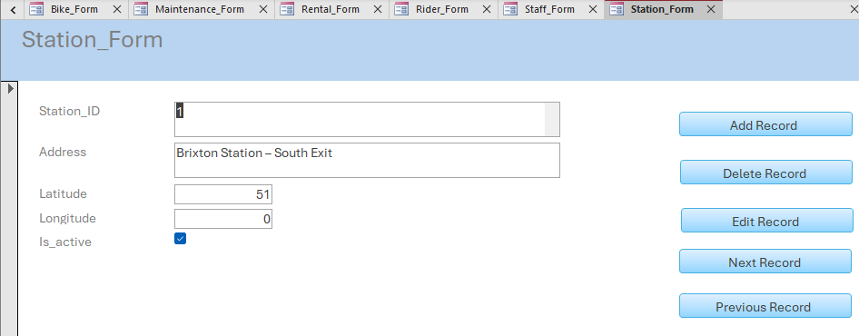
Annotations:
- Location Management: This form defines the valid locations where bikes can be parked.
- Coordinate Precision: The Latitude and Longitude fields are set to Decimal data types to handle precise GPS coordinates.
- Reference Point: By creating stations here first, we ensure that the Bike Inventory form always has valid locations to choose from (enforcing the One-to-Many relationship between Stations and Bikes).

Queries Creation (take screenshots of the design view, datasheet view and SQL view of each query and annotate them)
Based on your critical thinking, create at least two – three queries
Here are the annotations for the Maintenance Query based on the screenshots and the SQL code you provided.

Query: Maintenance History (Inspection Filter)
1. Design View 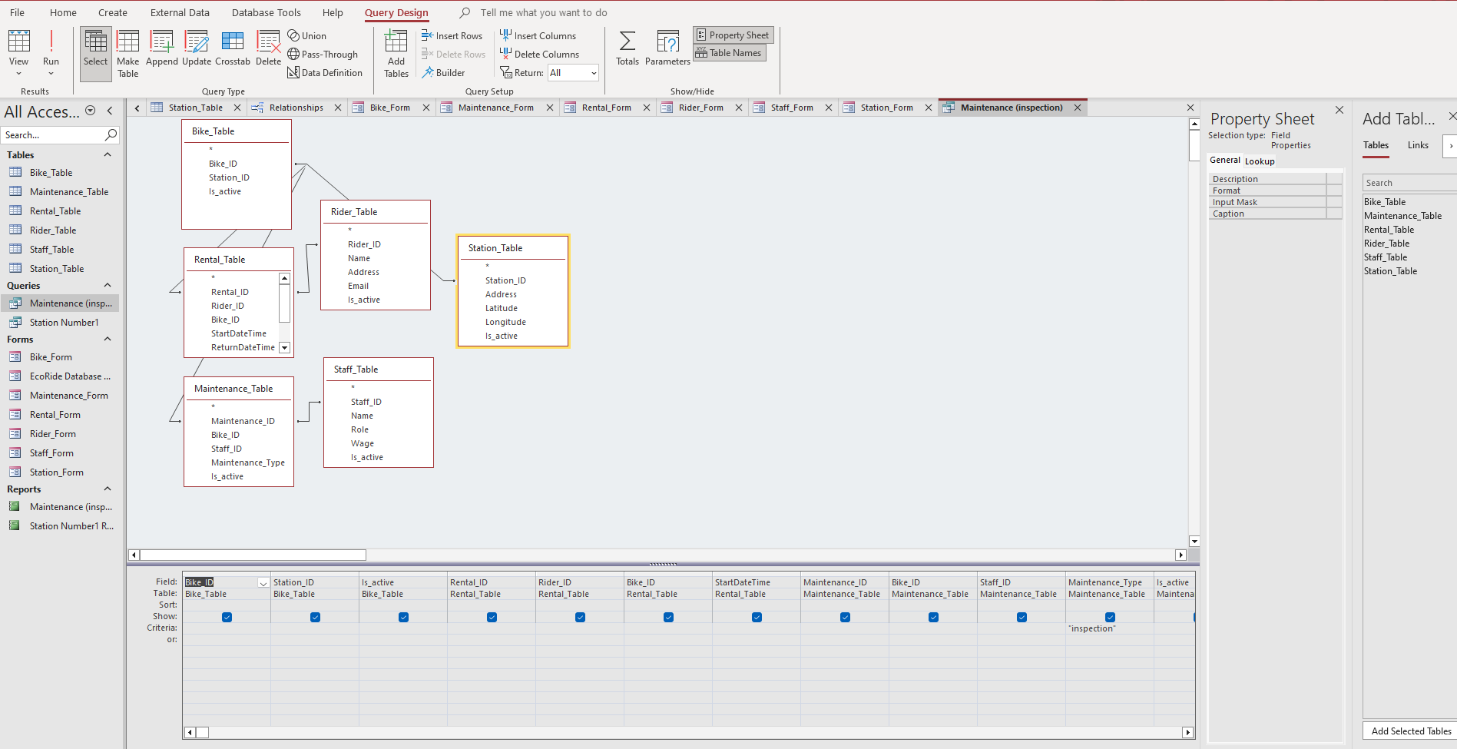
Annotation:
- Tables Used: I added the Bike_Table, Rental_Table, Maintenance_Table, Rider_Table, Staff_Table, and Station_Table to the query design.
- Relationships: The lines connecting the tables represent the INNER JOINS that link all the data together (e.g., connecting Staff to Maintenance).
- Filter Criteria: In the Maintenance_Type column, I entered "inspection". This ensures the query only displays safety inspections and ignores other maintenance types.
2. Datasheet View (Results)
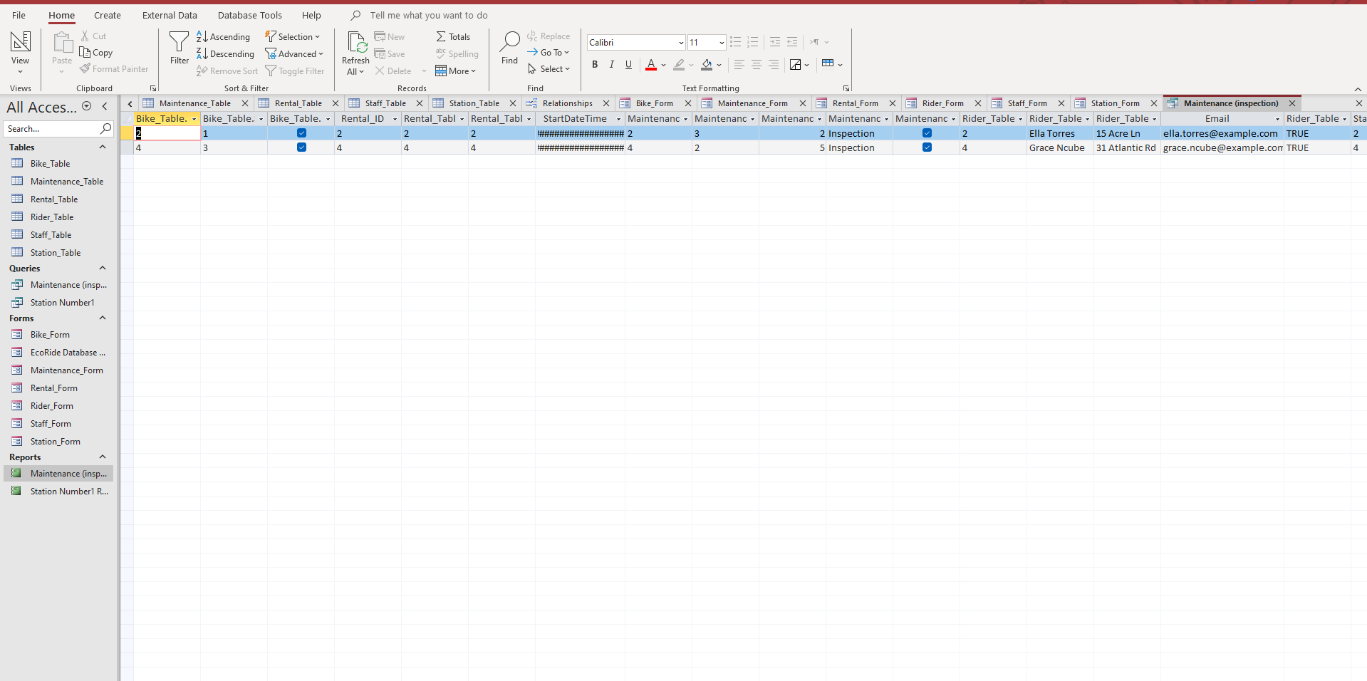
Annotation:
- Filtered Output: The results list all maintenance records that match the "inspection" criteria.
- Comprehensive Data: Because I included fields from all tables (like Rider Name, Staff Name, and Station Address), this view gives a complete overview of the bike's status and history associated with that inspection.
3. SQL View
SELECT
Bike_Table.Bike_ID,
Bike_Table.Station_ID,
Bike_Table.Is_active,
Rental_Table.Rental_ID,
Rental_Table.Rider_ID,
Rental_Table.Bike_ID,
Rental_Table.StartDateTime,
Maintenance_Table.Maintenance_ID,
Maintenance_Table.Bike_ID,
Maintenance_Table.Staff_ID,
Maintenance_Table.Maintenance_Type,
Maintenance_Table.Is_active,
Rider_Table.Rider_ID,
Rider_Table.Name,
Rider_Table.Address,
Rider_Table.Email,
Rider_Table.Is_active,
Staff_Table.Staff_ID,
Staff_Table.Name,
Staff_Table.Name,
Staff_Table.Role,
Staff_Table.Wage,
Staff_Table.Is_active,
Station_Table.Station_ID,
Station_Table.Address,
Station_Table.Latitude,
Station_Table.Longitude,
Station_Table.Is_active
FROM
Station_Table
INNER JOIN (
Staff_Table
INNER JOIN (
Rider_Table
INNER JOIN (
(
Bike_Table
INNER JOIN Maintenance_Table ON Bike_Table.Bike_ID = Maintenance_Table.Maintenance_ID
)
INNER JOIN Rental_Table ON Bike_Table.Bike_ID = Rental_Table.Rental_ID
) ON Rider_Table.Rider_ID = Rental_Table.Rental_ID
) ON Staff_Table.Staff_ID = Maintenance_Table.Maintenance_ID
) ON Station_Table.Station_ID = Bike_Table.Bike_ID
WHERE
(
(
(Maintenance_Table.Maintenance_Type) = "inspection"
)
);

Annotation:
- SELECT Clause: The code SELECT Bike_Table.Bike_ID, ... specifies all the columns we want to see from the different tables.
- Joins: The INNER JOIN statements (e.g., INNER JOIN Staff_Table) are the code version of the relationship lines in the Design View, connecting all the tables together.
- WHERE Clause: The final line WHERE ((Maintenance_Table.Maintenance_Type) = "inspection")); is the actual command that filters the data to show only inspections.

Query: Station Activity (Filtered by Station ID = 1)
1. Design View 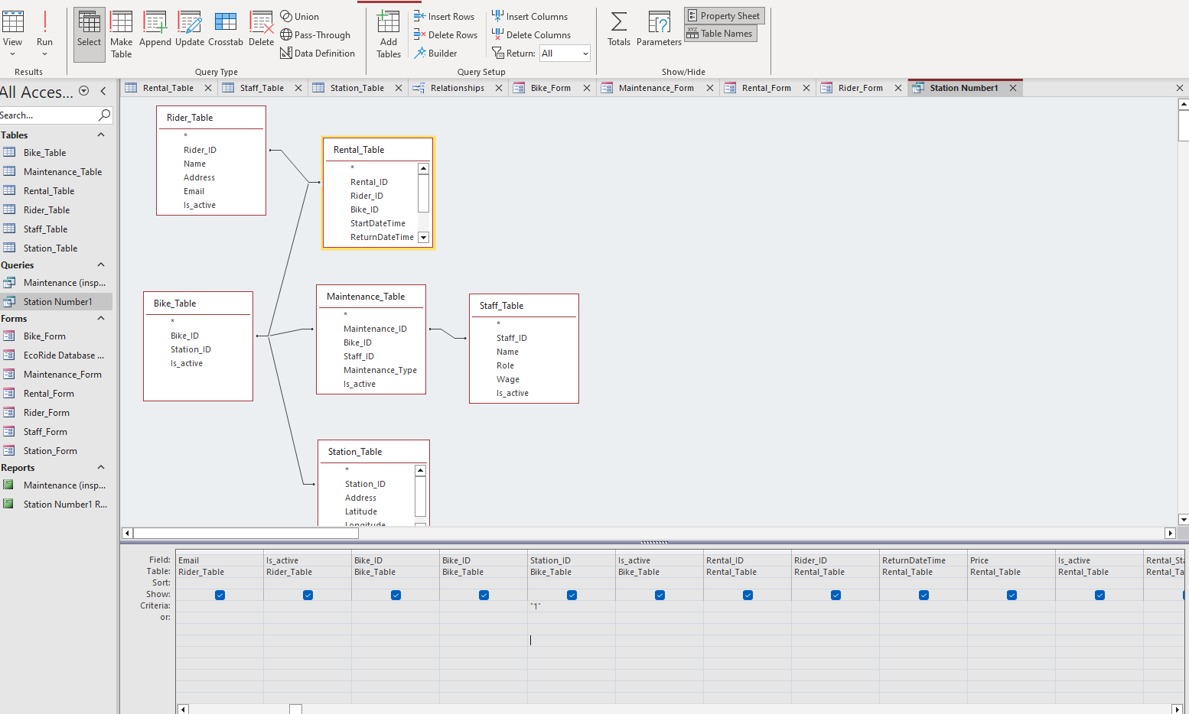
Annotations:
- Complex Relationships: I included all tables (Rider, Bike, Rental, Maintenance, Staff, Station) in this query. This allows us to see a complete "snapshot" of everything associated with a specific location.
- Search Criteria: Under the Station_ID column in the Station_Table, I entered the criteria "1". This filters the entire database to show only activity related to "Brixton Station" (which is ID 1).
2. Datasheet View (Results) 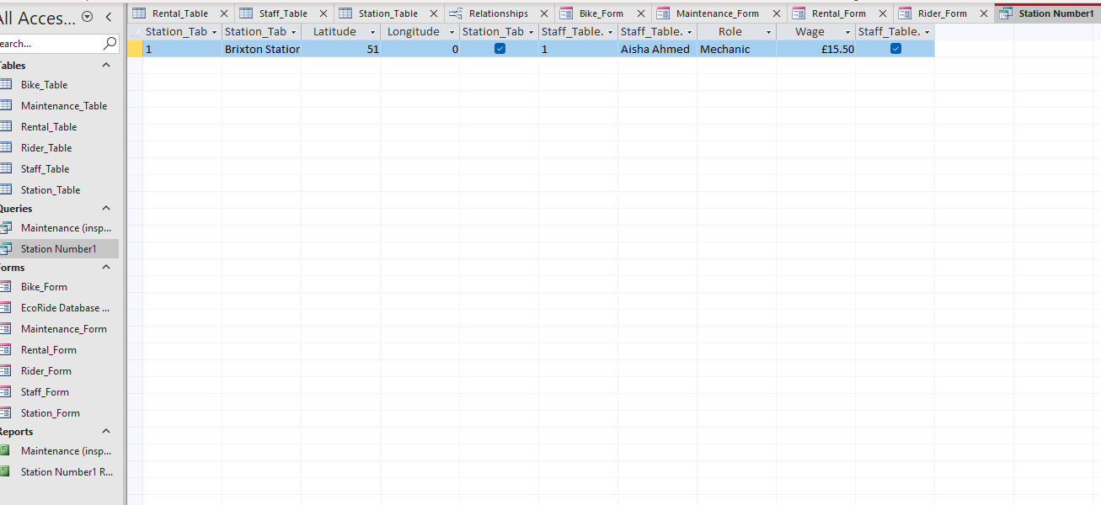
Annotations:
- Specific Results: The datasheet returns rows that specifically match Station 1.
- Combined Data: Because of the joins, we can see the Rider Name, Bike_ID, Staff Name, and Rental Price all in one row. This helps the manager see exactly which customers and employees are interacting with this specific station.
3. SQL View
SELECT
Rider_Table.Rider_ID,
Rider_Table.Name,
Rider_Table.Address,
Rider_Table.Email,
Rider_Table.Is_active,
Bike_Table.Bike_ID,
Bike_Table.Bike_ID,
Bike_Table.Station_ID,
Bike_Table.Is_active,
Rental_Table.Rental_ID,
Rental_Table.Rider_ID,
Rental_Table.ReturnDateTime,
Rental_Table.Price,
Rental_Table.Is_active,
Rental_Table.Rental_Status,
Maintenance_Table.Maintenance_ID,
Maintenance_Table.Bike_ID,
Maintenance_Table.Staff_ID,
Maintenance_Table.Maintenance_Type,
Maintenance_Table.Is_active,
Station_Table.Station_ID,
Station_Table.Address,
Station_Table.Latitude,
Station_Table.Longitude,
Station_Table.Is_active,
Staff_Table.Staff_ID,
Staff_Table.Name,
Staff_Table.Role,
Staff_Table.Wage,
Staff_Table.Is_active
FROM
Rider_Table
INNER JOIN (
(
Station_Table
INNER JOIN (
Bike_Table
INNER JOIN (
Staff_Table
INNER JOIN Maintenance_Table ON Staff_Table.Staff_ID = Maintenance_Table.Maintenance_ID
) ON Bike_Table.Bike_ID = Maintenance_Table.Maintenance_ID
) ON Station_Table.Station_ID = Bike_Table.Bike_ID
)
INNER JOIN Rental_Table ON Bike_Table.Bike_ID = Rental_Table.Rental_ID
) ON Rider_Table.Rider_ID = Rental_Table.Rental_ID
WHERE
(
((Bike_Table.Station_ID) = "1")
AND ((Station_Table.Station_ID) = "1")
);

Annotations:
- Extensive Joins: The FROM clause is very large because it contains nested INNER JOIN statements. This code mechanically links the primary keys to foreign keys across every table in the database.
- Targeted Filter: The WHERE clause ((Bike_Table.Station_ID) = "1") AND ((Station_Table.Station_ID) = "1") ensures that both the Station record and the Bike record align, strictly limiting the output to data matching ID 1.

Report Creation (create reports from each query and annotate them)

1. Maintenance Inspection Report
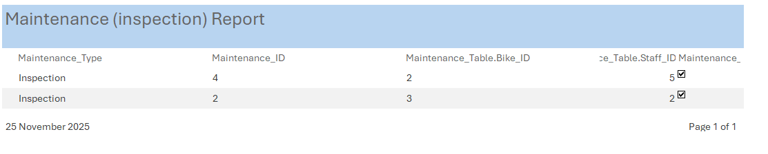
Annotations:
- Source Recordset: This report is directly linked to the Maintenance Query I created earlier. Because the query filters for "Inspection," this report automatically lists only the safety checks, excluding other repairs.
- Layout: I used a Tabular Layout to organize the data. This makes it easy for the Head Mechanic to print a checklist of which staff members (e.g., Ben Walker) are responsible for inspecting which bikes.
- Auto-Update: Because this is dynamic, if a new inspection is added to the database, this report will automatically update to include it the next time it is opened.

2. Station Activity Report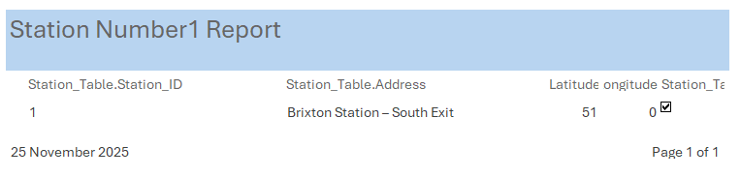
Annotations:
- Comprehensive View: This report is based on the Station Query (filtered by Station ID 1). It presents a complex "snapshot" of the station, pulling data from the Rider, Bike, and Rental tables all at once.
- Data Presentation: Unlike the raw Datasheet view, the report format allows us to fit more information across the page. It clearly shows the Rider Name next to the Bike ID and Rental Price, providing a complete audit trail for the station manager.
- Professional Header: The report includes a clear title header ("Station Query") and column headings, making it suitable for official business documentation or filing.

Calculations (show how you implement calculation ( if any) and take screenshots)
There is no calculations to be made in my reports but here is a small demonstration of how is done
In the Report Footer, I would use the expression =Sum([Price]).
How it works: This formula aggregates the individual price of every rental displayed in the report and provides a "Grand Total" at the bottom of the page. This allows the financial manager to instantly see the total revenue generated by the station without manually adding up rows.

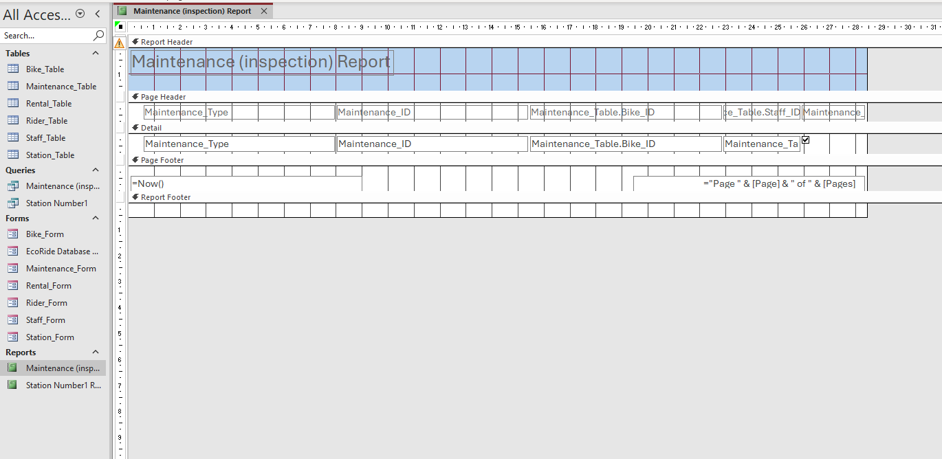

Dashboard Creation (show how to navigate from dashboard to forms and forms to dashboard)

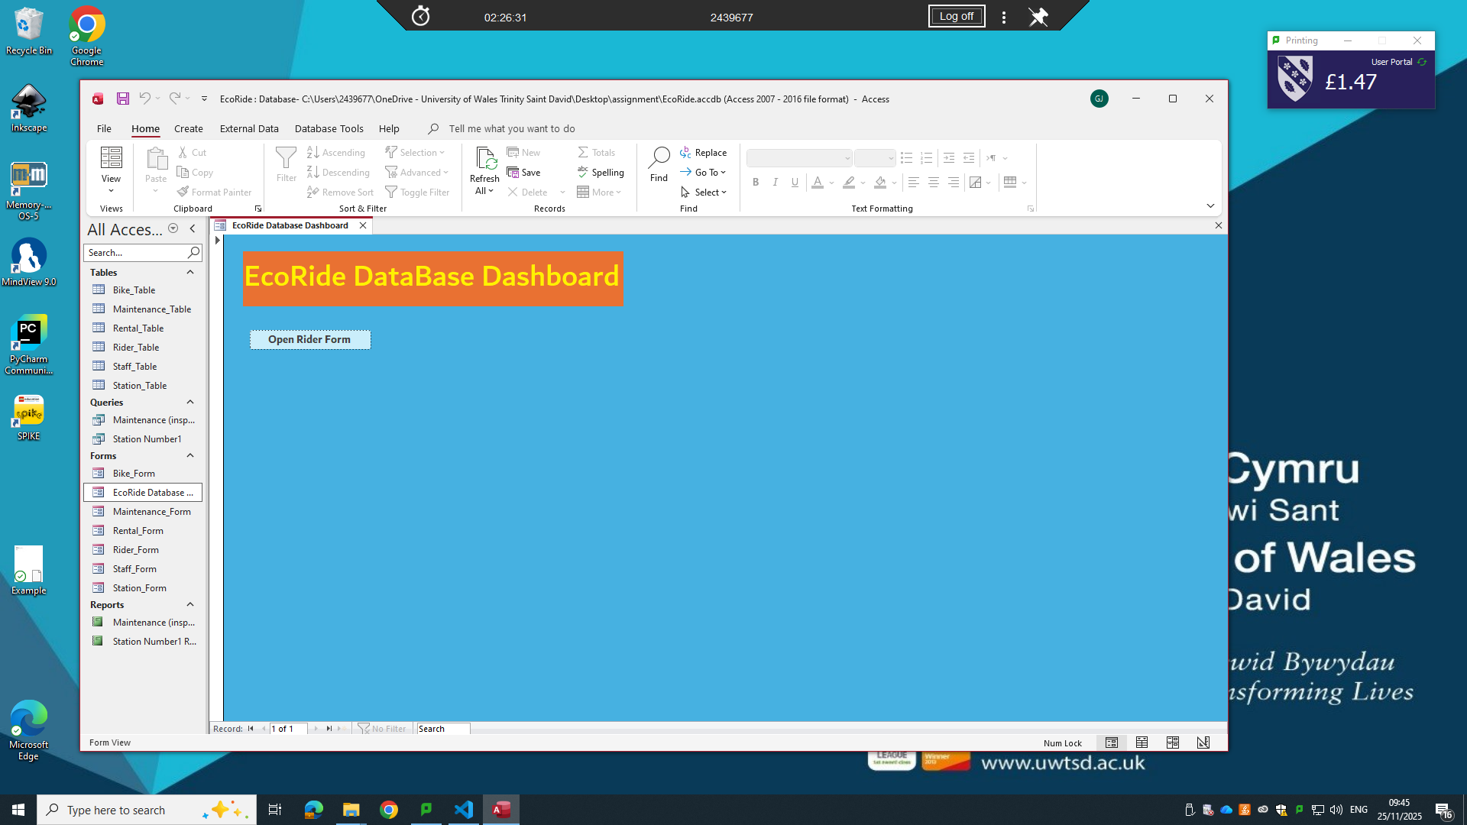
1. Navigation: Dashboard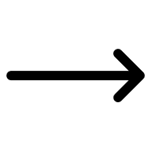 Forms
- Mechanism: I arranged Command Buttons on the form (e.g., "Open Bike Form", "Open Rental Form").
- Logic: Each button is linked to an "On Click" Macro. When the user clicks a button, the macro triggers the OpenForm command, launching the specific form (like the Rider Form) so the staff member can enter data.
2. Navigation: Forms Dashboard
- Mechanism: The Dashboard is designed to stay open in the background.
- Logic: When a user finishes a task in a specific form (e.g., adds a new Rider) and closes that window, they are immediately returned to this Main Menu. This creates a seamless loop, preventing the user from getting lost in the database tables.

