University of Wales Trinity Saint David Cardiff
Baragau Claudia Elena -1905817
Digital Sills and Research Methods
7/7/2022
Specific Market Research and I Bee Website


Table of Contents
1. Log in detail for ,, I Bee’’ Website 1
2.Primary and market research: 1
3.Questionnaire analysis 1
4. I Bee - Webpage 4
5. SEO importance 5
6 References 5

Log in detail for ,, I Bee’’ Website
Email: 1905817sn@gmail.com
Password: honeybusiness

2.Primary and market research:
21st Century is the century where Technology is part of everyone’s life , technology where we stock and collect data for market research. According to (Dawson, 2009) market research can by primary and secondary research. Primary research refers to the first hand data collected from a specific target market in order to analyse their needs and preferences and secondary research refers to information already collected by other people on the same subject.
Market research is important in any business because they offer the managers all the information needed to be able to take decisions for their business and at the same time it’s a tool used for monitoring their marketing activities efficiency (Birn, 2004).
For my Honeybee Business idea, named ,,I Bee’’, I have conducted a primary research through a Questionnaire in order to find out the needs and preferences of my targeted market.
In the future I Bee will also conduct a Brand awareness research, as it is the best way of knowing if the marketing strategies are effective enough , and to know if people manage to recognise our brand and products.

3.Questionnaire analysis
I Bee is a new Honeybee Business that is focusing on providing the best quality honey products on the market. In order to find out what the preferences and needs of the specific targeted market are, Primary research was needed , to obtain all the raw information straight from the source (customers). For my primary research I have created and shared with 19 people my Honey Questionnaire and the followings are some of the questions and answers that aimed in shaping my business plan.

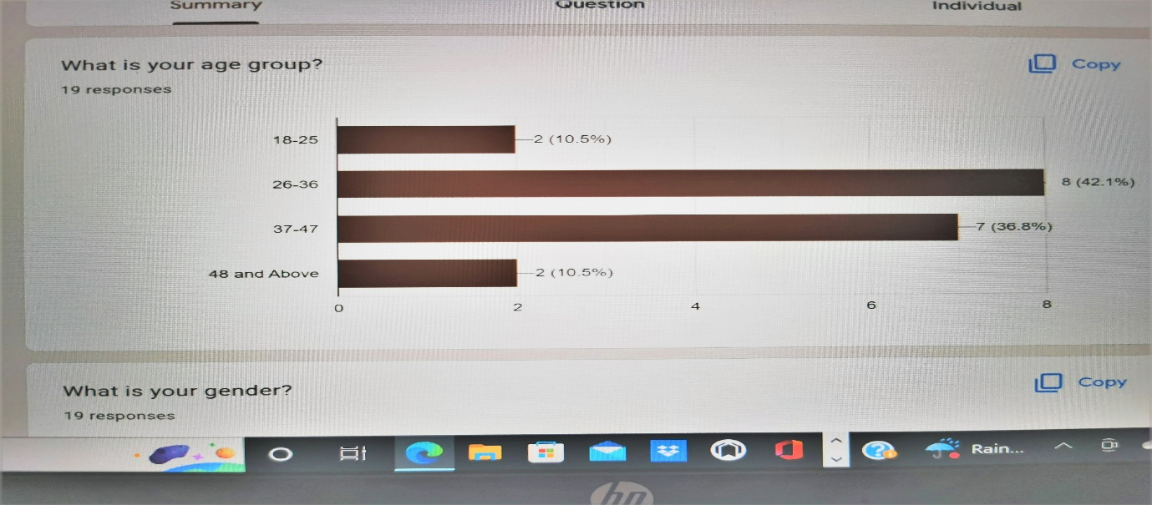
What is your age group?

As it can be seen in this photo the majority of people that completed the questionnaire are aged 26-36, followed by a second category aged 37-47. These two categories would classify as my main target for honey consumption. It’s also noticeable that there is a wide range of people, from different age groups, interested in honey products and shows that the potential of honey could be better advertised and better approached in order to boost our honey consumption on a wider range of age groups.

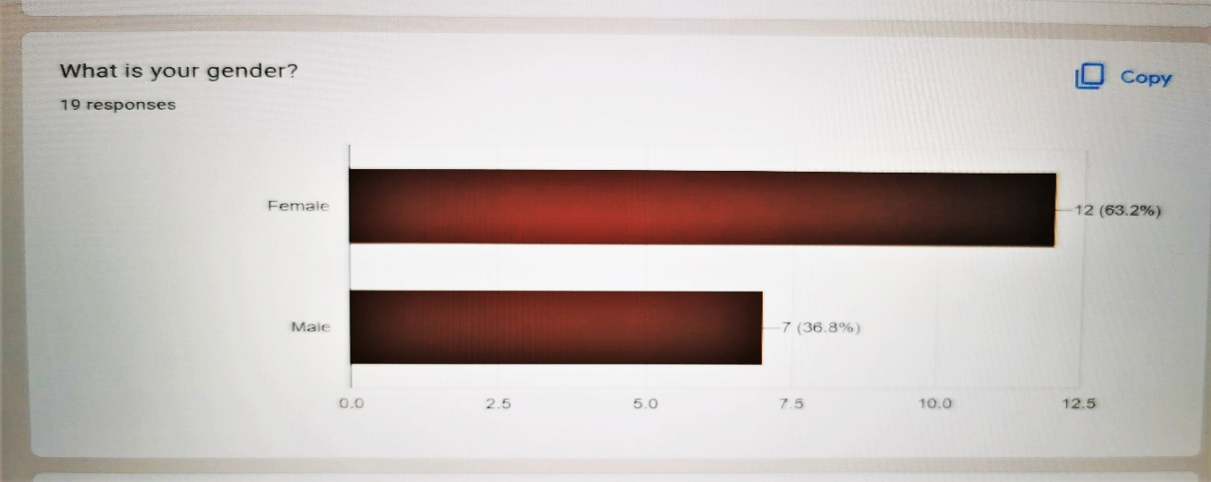
What is your gender?

By asking this question allowed me to have a better understanding of the gender customer when comes to honey consumption. When analysing the answers for this question I have noticed that the majority of the target market is female, fact that can be explained by (Wardle et al., 2004) in a study on adults from 23 different countries ,study based on their food choices. The results showed that women’s food choices are more healthier than male food choices.

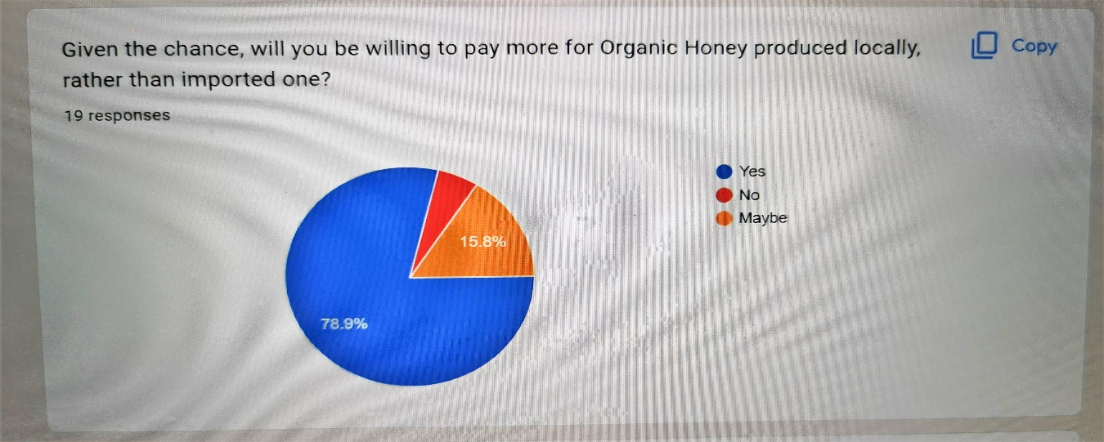
Given the chance, will you be willing to pay more for Organic Honey produced locally, rather than imported one?

The question listed above shows that the majority of people are willing to pay more money for honey produced locally, possibly due to having a positive impact on the environment, such as less pollution on transport and possibly due to enhancing the local economy. The 15.8% of people that selected ,,maybe ‘’ prove that there are opportunities to take and to work on a better strategy market to be able to re-direct people into buying our local products.
Would you be interested to buy other products based on honey, such as Creams, Candles or drinks?
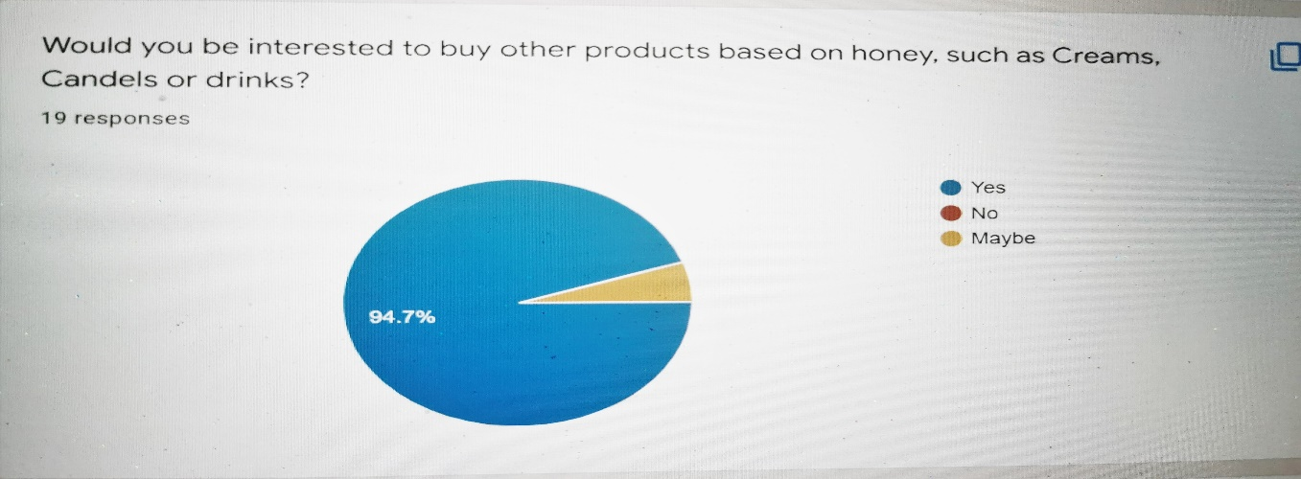

Honey is known for its many health proprieties and benefits , therefore people are slowly becoming more interested in a wider range of honey products. According to Samarghandian et al. (2017) some of the health proprieties of honey are : antioxidant, anti-inflamator and antimicrobial proprieties, used in cardiovascular and neurological diseases, wound healing and skin conditions , as well as being used in astma and throat infections.

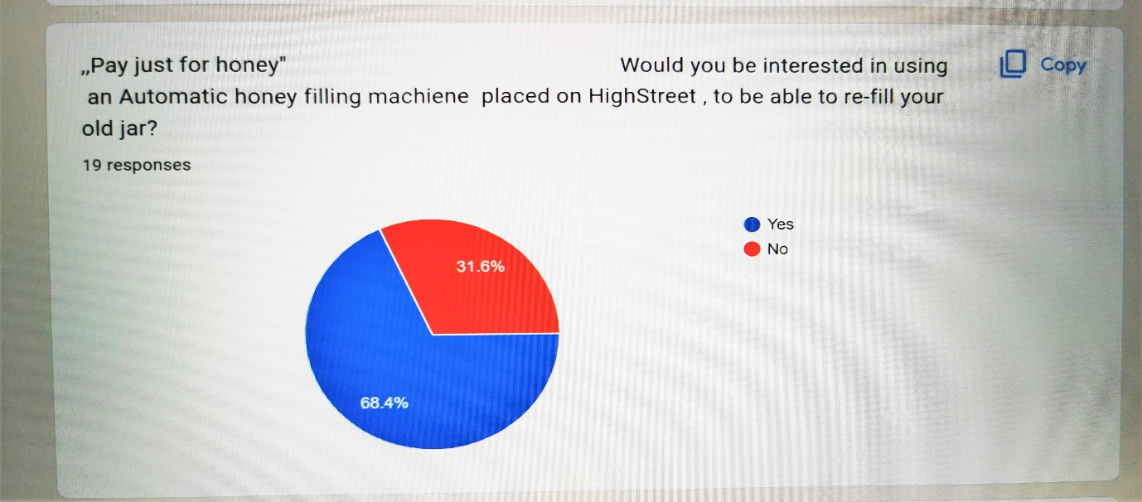
Would you be interested in using an Automatic honey filling machine placed on Highstreet , to be able to re-fill your old jar?

Following this question we can notice that 68.4% of people who answered the questionnaire are willing to go beyond the normal recycling system already in place, for the good of the environment as well as for the economy. By re-using the old jars we are not only helping the environment by decreasing the CO2 emissions but we are also saving money that could be used for something else, instead of purchasing more jars that will be turned into waste short after emptying its content.
According to Arokiaraj et al. (2019) by reducing our honey containers we are reducing the use of all other resources required in producing honey containers and labels, and on order to help the environment, we should invest in waste prevention products such as Commercial Auto-filling honey machines.

4. I Bee - Webpage
I Bee will be focusing on making its website user-friendly for both computers and smartphones. People are living busier lives nowadays , therefore due to being on the run most of the time people tend to use their smartphones more , either to shop or to research for businesses and products.
According to (KIJO, 2019) the best way to treat our website is to treat it as our castle, a castle where we promote our believes as an easy way of convincing everyone that the products we sell are as good as we know they are, this way gaining the customers thrust as well.
I Bee has created a logo to accompany it’s name and products , adding an unique note for the website and for the business in general.
Through it’s website I Bee is looking to promote it’s products and to gain brand awareness on social media platforms. For the website I Bee has used numerous photographs, in order to attract the customers, making it more realistic and closer to everyone’s heart. Most of the photographs used in I Bee website contain honey and they are meant to make the customers crave the golden products, as well as with honeybees and their beehive, surrounded by green areas meant to help in the realisation of how much the environment and us need these little pollinators not only to survive but to thrive.
One of the best features for this business that will benefit for having a website is Adopt a hive scheme, our website along with the social media platforms being almost the only way to advertise it.
In it’s journal (Ashraf et al., 2019) mentioned that a very important part of the website is the design and it’s aesthetics , as a website well designed will increase not only sales but brand awareness as well. I Bee website’s colours are mainly gold and green, to emphasise the beautiful colours of honey and the importance of the environment. In the same journal (Ashraf et al., 2019) discussed about how yellow and green, accompanied by low brightness are a successful recipe for customer memorisation and therefore will aim increase our sales.
Another way for people to remember our website is through the font styles used, meaning that learning more about it, can make the difference, whether it’s a good design or not. Applying a good font style to our website can secure a constant flow of customers and avoid customer churn. I Bee has used a few different styles in its website, such as Slab Serif (BOLD) to I Bee name, followed by Sans Serif for our Mission statement and Seriff ( little feet/ROMAN) mostly used to describe our products (Toptal Design Blog, n.d.).By writing the name of the business in a different way , gave the design a unique touch that customers will remember and it will differentiate it from our competitors.
I Bee website has been created mostly for it’s online services and deliveries, but due to the increasing usage of digital platforms, I Bee has also been able to better interact with the customers and to build a better relationship with them.

5. SEO importance
SEO refers to Search Engine Optimisation, a very important part for our business, process meant to attract and increase the customers views on the business webpage across the internet.
According to (Digital Marketing Institute, 2019) SEO could bring traffic with paid research or free, organic search results in search engines, by improving the websites position using keywords and quality content.
Due to the multitude of websites on honey, I Bee will have to be very active with it’s SEO in order to be in the first websites in search engines, by updating the website regularly and be on top of the keywords and it’s content.
For the I Bee’s website further development will implement multilingual SEO and website translation investments in order to increase the search engines across other countries, to avoid language barriers and to boost the business growth as well as increasing brand awareness ( ValueWalk, 2022).

6 References
Arokiaraj David et al., A.D. et al. (2019). Recover, Recycle and Reuse, An Efficient Way to Reduce the Waste. International Journal of Mechanical and Production Engineering Research and Development, 9(3), pp.31–42. doi:10.24247/ijmperdjun20194.
Ashraf, N., Faisal, M.N., Jabbar, S. and Habib, M.A. (2019). The Role of Website Design Artifacts on Consumer Attitude and Behavioral Intentions in Online Shopping. Technical Journal, [online] 24(02). Available at: https://tj.uettaxila.edu.pk/index.php/technical-journal/article/view/926/82.
Dawson, C. (2009) Introduction to Research Methods A Practical Guide for Anyone Undertaking a Research Project. 4th ed. New York: Constable & Robinson.
Birn, R. (2004) The effective use of market research how to drive and focus better business decisions. 4th ed. London ;: Kogan Page.
Enge, E. and Enge, E. (2012) The art of SEO. 2nd ed. Beijing: O’Reilly.
Digital Marketing Institute (2019). What is SEO and how does it work? | DMI. [online] Digital Marketing Institute. Available at: https://digitalmarketinginstitute.com/blog/what-is-seo [Accessed 30 Jun. 2022].
KIJO. (2019). Website vs Social Media, Do You Need a Website in 2019? [online] Available at: https://kijo.co.uk/blog/why-have-a-website-and-not-just-rely-on-social-media/.
ValueWalk: Website translation and the importance of SEO (2022) Newstex Global Business Blogs. Chatham: Newstex. [Accessed 30 Jun. 2022].
The 60 Second Marketer: The Importance of SEO in Online Marketing (2019) Newstex Global Business Blogs. Chatham: Newstex. [Accessed 30 Jun. 2022].
Wardle, J., Haase, A.M., Steptoe, A., Nillapun, M., Jonwutiwes, K. and Bellisie, F. (2004). Gender differences in food choice: The contribution of health beliefs and dieting. Annals of Behavioral Medicine, [online] 27(2), pp.107–116. doi:10.1207/s15324796abm2702_5.
Toptal Design Blog. (n.d.). Understanding the Nuances of Typeface Classification. [online] Available at: https://www.toptal.com/designers/typography/typeface-classification#:~:text=There%20are%20five%20basic%20classifications.
Thiele, J. (2022). Benefits of Honey: Potency against Micro-organisms and Its Use in Skin Care. Journal of Apitherapy, [online] 9(5). Available at: https://www.japitherapy.com/japitherapy-articles/benefits-of-honey-potency-against-microorganisms-and-its-use-in-skin-care-88691.html [Accessed 30 Jun. 2022].
Samarghandian, S., Farkhondeh, T. and Samini, F. (2017). Honey and Health: A Review of Recent Clinical Research. Pharmacognosy research, [online] 9(2), pp.121–127. doi:10.4103/0974-8490.204647.

