

School of Tourism & Hospitality Management
BA International Hotel Management
BMIH6008
Hotel Placement Research Project
LEVEL6
BMIH6008
Module Lead: Maggie-Lan Zhang
l.zhang@uwtsd.ac.uk
Student:Carmen Dragu
2117510

“Role of Resilience and Communication in Leadership on Employee Relation and Customer Satisfaction: A Study on Marriott Cardiff”
Table of Contents
Introduction 5
Research Aim 5
Research Objectives 5
Research Background 5
Research Questions 6
Literature Review 7
Significance of resilience and communication in leadership practices 7
Benefits of communication and resilience in leadership on customer satisfaction and employee relations 8
The challenges imposed on communication and resilience in leadership measures against customer satisfaction and employee relations 9
Suggestions 9
Literature Gap 10
Methods 11
Case Study Methodology 11
Research Philosophy 11
Research Design 11
Research Approach 12
Data Collection and Analysis 12
Research Strategy 12
Ethical Considerations 12
Limitations 12
Case Study Discussion 14
SWOT Analysis 14
PEST Analysis 18
Competitor Analysis 24
Netnography 26
Theme Exploration 29
Thematic Table 29
Analysis 36
Conclusion and Recommendations 41
Conclusion 41
Linking with Objectives 41
Recommendations 42
Future Implications 43
Limitations 43
Reflective Account 44
Reference List 48

Executive Summary
Leadership resilience and communication are two key factors driving commitment among employees and guiding them to navigate through difficult situations. The importance, benefits and challenges of resilience and communication for customer satisfaction and employee relations have been discussed. After analysing the challenges there are also some solutions mentioned. In this regard, the research study has conducted a PESTLE analysis, a SWOT analysis, a competitive analysis and netnography in terms of evaluating the essence of communication and leadership in the field of leadership. Leaders at work must possess strong communication and resilience skills to effectively motivate teams, navigate challenges, and inspire confidence.

Introduction

Research Aim
The research aims to explore the importance of communication and resilience in leadership to maintain customer satisfaction and employee relations at Marriott Cardiff.

Research Objectives
- To explore the importance of communication and resilience in leadership practices
- To investigate the benefits of communication and resilience in leadership on customer satisfaction and employee relations of Marriott Cardiff
- To determine the challenges imposed on communication and resilience in leadership measures against customer satisfaction and employee relations in Marriott Cardiff
- To devise strategic solutions to enhance leadership at Marriott

Research Background
Marriott offers the most powerful portfolio within the hotel industry with 30 leading brands and around 8,900 properties in over 141 nations ensuring the provision of experiences, expansion and connections (Marriott 2024). This research will address the roles of leadership within Marriott Cardiff based on enhancing customer satisfaction and employee relations through communication and resilience. Herein, the key themes to be explored in this study revolve around communication and resilience as aspects of leadership based on their impact on employee relations and customer satisfaction. However, there have been a wide range of issues that Marriott Cardiff may come across in its leadership practices. For instance, although hotels have been rebounding from the adversities of the global pandemic, workers are now concerned about labour cuts, costing tens of thousands of job opportunities along with increased workloads for those who remain (Sainato, 2021). Herein, the hotel brand has widespread awareness, and secondary research is being conducted in the United Kingdom.

Research Questions
Q1. What is the importance of leadership in hospitality?
Q2. How do leaders’ communication and resilience impact employee relations and customer satisfaction at Marriott Cardiff?
Q3. What challenges that Marriott Cardiff can face in maintaining leadership resilience and communication for customer satisfaction and employee relations?
Q4. How can Marriott Cardiff improve leadership measures and associated aspects?

Literature Review

Significance of resilience and communication in leadership practices
Resilience and communication both are crucial in leadership practices because they help leaders create collaboration, and trust and build a culture of resilience within their organisations and teams. Recognising personal stressors, and triggers and understanding the weaknesses as well as strengths is fundamental to creating resilience. According to Hartung (2020), a leader who has self-awareness can enhance the coping strategies to fulfil their desired goals. It can help them to adapt to new things, make adjustments, and guide their team as per the situation. Adaptability not only helps the business to survive it also helps them to thrive in the continuously changing market. It allows the business to make changes and create new market opportunities. If the leader cannot adapt to new situations quickly, it can be challenging for the business.
An emotionally intelligent leader solves interpersonal challenges more effectively. Dasborough et al. (2022) implied that the cognitive ability of a leader can positively influence their subordinates. With higher emotional intelligence, they build great relationships with their teammates and can support them more effectively during their hard times. Not only with teammates, a higher emotionally intelligent individual also builds a strong relationship with the guests and customers. It helps the leader to make a productive and friendly workplace. On the other hand, as argued by Mysirlaki and Paraskeva (2020) if a team leader is lacking in emotional intelligence, then it can be challenging for them to create strong relationships with their team members, management and Customers. Leaders need to make decisions under pressure. Resilience leaders can make more effective choices, they can think logically. As stated by Hallo et al. (2021), reliance can enhance the decision-making skills of the leader who can lead a productive team. It enables the organisation to succeed by making great decisions by the leaders. A leader who is bad at making decisions can face big challenges such as loss, decreased demand in the market and many more. It can enhance the services of the hospitality industry by understanding the taking action on tourist behaviour.

Benefits of communication and resilience in leadership on customer satisfaction and employee relations
Communication and resilience are crucial to achieving customer satisfaction and employee relations. In the opinion of Vera et al. (2020), positive communication between leaders and their subordinates can open diverse perspectives and possibilities. It can help leaders guide their team members through adversities and communicate with customers efficiently. As stated by Kamaraj (2023), effective and clear communication is crucial for resilience in employee relations and customer service. It can help the company to set logical expectations and solve problems promptly. Good communication skills of a leader help to train the team more effectively. This transparent communication can reduce frustration and build trust which leads to higher customer satisfaction. Resilient communication can address the concerns of the customers. Without transparent communication, the business will fail to build a strong employee relationship.
Resilience builds empathy with the customers. From the viewpoint of Nadeem et al. (2020), by sharing and understanding the feelings of the customers the business can create a strong connection which goes beyond transactions. Lombardi, e Cunha and Giustiniano (2021) have further emphasised that resilience is an important characteristic for leaders considering that they are required to guide their teams toward a purpose and encourage their development while instilling a sense of commitment and engagement among employees. A good leader can understand the needs and concerns of the customers through their good communication skills. This tactic not only solves the issues but also can turn a negative situation into a positive situation. By understanding the feelings of the customers, the business can improve their services as per customers' needs. From the viewpoint of Zhang et al. (2021), resilience is solving problems to satisfy customers. It instils a problem-solving mindset in the team members and encourages the team-mates to face challenges with a can-do attitude. With the authority and necessary tools, it can resolve issues more efficiently. A team with high confidence in problem-solving attitude is more productive.

The challenges imposed on communication and resilience in leadership measures against customer satisfaction and employee relations
According to Khan et al. (2022), good leadership is vital for employee relations and customer satisfaction. Communication gaps can create misunderstandings between customers and employees. Additionally, this misunderstanding can create difficulties in understanding customers' needs and preferences. A feedback channel is crucial for a leader to make the team more productive and effective. However, a lack of feedback indicates poor communication by a leader. To grow professionally it is vital to receive and give feedback which supports encouraging supports to the organisations. Communication gaps can create conflicts, a leader needs to understand the issues of the customers and try to solve them. However, failing to understand the perspectives of employees as well as the needs of customers can affect leaders’ decision-making resulting in failure in attaining organisational goals. Guzmán et al. (2020) implied that leadership is quintessential for supporting an agile environment and driving innovations which is the basis of creating higher customer satisfaction. Not only customer satisfaction, but employee relations are also important to create a better workplace. However, good communication can build good employee relations which leads to customer satisfaction.

Suggestions
To fill the communication gap leader should practice enhancing their communication skills. They should be confident and clear while communicating with their team. According to Kluger and Itzchakov (2020), demonstration of empathy and understanding and giving full attention to the speakers can improve communication skills. Another important thing to build good employee relations and customer satisfaction is receiving and giving feedback. To receive and give feedback organisations should create a feedback channel where they can speak about their needs and concerns.
As per Stewart (2021), Behaviorism Theory is a set of psychology that helps to learn people from their interactions and behaviour. It can be used in any field such as business, education, therapy and many more. However, it is criticised for its simplicity. This theory can help the leader to understand the needs and concerns of the teammates and customers through their interaction and behaviour.
According to Mbindyo et al. (2021) and Tănase (2020), Transformational theory is a leadership tactic that motivates and encourages employees to innovate and develop new ways to improve and grow with idealised influences. This theory inspires the employees to make decisions on their own which builds trust within the team. It is only possible with good and clear communication by the team leader.

Literature Gap
Although there is a multitude of literature focusing on the impact of leadership on customer satisfaction and employee relations, the impacts have been discussed separately. In this study, two specific aspects such as communication and resilience of leadership have been focused on and the way these aspects impact both employee relations and customer satisfaction altogether has been analysed.

Methods

Case Study Methodology
Conducting case study research helps to ensure the provision of a practical resource for beginner researchers requiring a specific step-by-step guide. Case study research revolves around an intensive and detailed analysis of particular events, organisations, social units or situations (Schoch, 2020). This is a significant approach for this research study since it will conduct a secondary qualitative thematic analysis. The key benefit of the case study research method is that case study research involves qualitative research (Eisenhardt, 2021). However, there are a few limitations that may be imposed on this research study regarding the case study approach to research. For instance, there may exist boundaries between a phenomenon and its associated context leading to the lack of clarity in this research while relying on multiple data sources to collect evidence (Schoch, 2020). In addition to such limitations, the scope of the case study method embeds its technique in terms of investing in a bounded concept while investigating real-life contexts within contemporary phenomena. Other than this, netnography, PESTLE analysis, SWOT analysis, competitive analysis, thematic analysis and a reflective account has also been carried out.

Research Philosophy
An interpretivism philosophy has been performed to determine how communication and resilience in leadership affect customer satisfaction and employee relations at Marriott Cardiff. An interpretivism philosophy emphasises qualitative analysis focusing on meanings while grouping the diverse approaches (BRM, 2024).

Research Design
Exploratory research has been chosen to analyse the role of leadership on customers and employees at Marriott Cardiff. An exploratory design generally includes the use of interpretive methods in research that help in answering questions such as how, what, and why (BRM, 2024). It also offers a detailed overview of the issue helping to change the direction of the researcher.

Research Approach
The deductive research approach can make use of pre-ordinate themes and subsequently apply explicit theoretical frameworks (BRM, 2024).

Data Collection and Analysis
In this research, the most appropriate selected method is secondary data collection, adhering to qualitative thematic analysis. Secondary data are generally collected through technical publications such as articles, journals, handbooks, datasheets or manuals (Pandey and Pandey, 2021). Qualitative analysis helps to gather useful insights and figure rich context by finding subtle patterns and themes.

Research Strategy
A qualitative research strategy has been applied to this study, based on the research for Marriott Cardiff. As per Islam and Aldaihani (2022) qualitative research helps to search for viable solutions to an issue and also know something new.

Ethical Considerations
While performing secondary research, plagiarism has been avoided along with adherence to academic integrity. The gathered data have been kept secure in the online library with strict passwords. The Data Protection Act 2018 refers to the rights and also controls what and how the organisations and the government store about an individual (GOV.UK, 2024).

Limitations
The research study has been limited to a thematic analysis wherein conducting a quantitative survey in the form of primary research and a qualitative interview with managers might have been beneficial. Herein, the interview might have helped the researcher understand the opinions and perspectives of managers at Marriott Cardiff, UK. The absence of adequate resources, subscription to paid sources, time, and budget are some other limitations.

Case Study Discussion

SWOT Analysis
Strengths
- Gallo (2020) implied that Marriott International employs an authentic leadership approach where its CEO maintains direct communication with its stakeholders, customers, and employees. The leader directly addressed the adverse situation during the pandemic which builds trust and respect among employees.
- Marriott generated around $23.71 billion in revenue in the year 2023, an increase from 20.77 billion from the prior year (Statista, 2024). This showcases the efficiency of Marriott’s leaders in maintaining profitability which can be useful in implementing measures to improve customer satisfaction.
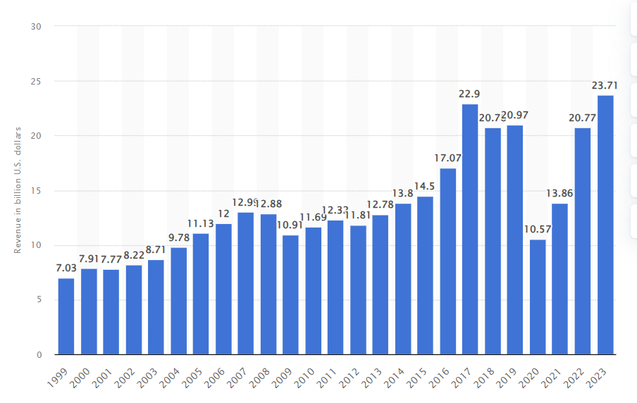
Figure 2: Revenue Generated by Marriott
(Source: Statista, 2024)
- The brand awareness rate of Marriott in the UK is 82%, aided by the recognition of the brand name and its logo in a survey carried out within the nation (Statista, 2024).
- Marriott offers franchises, operations, licenses hotels, timeshare properties and residential activities in around 3,900 properties with a vast majority of profit gained through luxury packages (Crunchbase, 2024).
- In addition to such branches of Marriott, and with 148,000 staff, the operations of the organisation span across Europe, the Middle East, the Caribbean, Latin America, North America, Africa and the Asia-Pacific (Global Data, 2024).
Weaknesses
- The absence of proper training to build resilience has also been highlighted by the workers serving Marriott as found from the review (Indeed, 2024). This can have a significant impact on employee relationships as a lack of growth opportunities can contribute to their growing job dissatisfaction.
- Hotel chains in the UK hospitality industry have been rebounding from the adversities of the pandemic although employees now fear planned labour cuts costing tens and thousands of job opportunities while increasing workloads for the ones who remain (Sainato, 2021).
- Around 13,500 hotel workers at Marriott engaged in a strike to push for essential wage increases while demanding protection against unprecedented job cuts aimed at being able to overcome the adversities of the outbreak of the global pandemic (Sainato, 2024).
- In the year 2020, a consecutive decline of 30.46% in the number of employees was observed in Marriott (Macrotrends, 2024). Considering the occurrence of the global pandemic in the same year, it can be stated that Marriott’s leadership has not been resilient enough to address the situation.
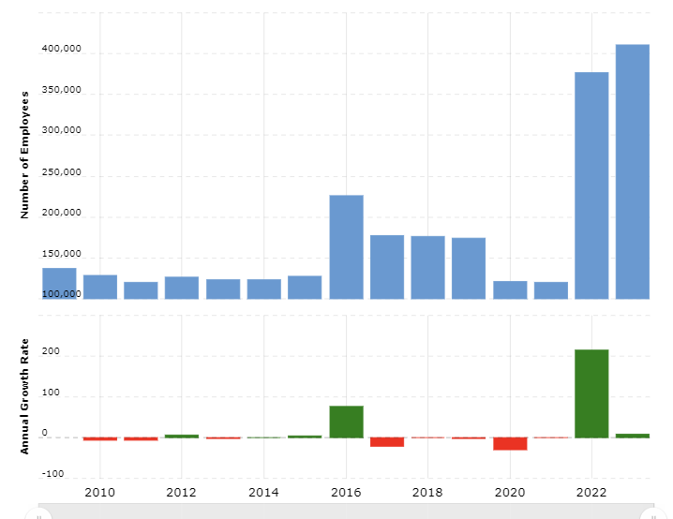
Figure 2: Employee Turnover Rate of Marriott C14
(Source: Macrotrends, 2024)
Opportunities
- Marriott in the UK has been engaged in the implementation of hotel technology in the form of its Marriott Bonvoy App, ensuring the provision of access to seamless travelling and personalised experiences for customers, aimed at fusing virtual solutions and customer-centricity (Marriott, 2024).
- The revenue generation of the “hotel” sector of the UK had been estimated to grow at a constant pace between the years 2024 and 2029 by more than 13.62%, reaching $2.7 billion (Statista, 2024).
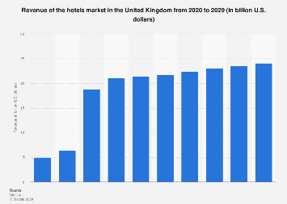
Figure 3: Revenue Forecast of the UK Hotels Market
(Source: Statista, 2024)
- Marriott Hotels has revealed a strong interest in operating or expanding its hotel chain to Wolverhampton, a city in the UK which has the capacity to hold thousands of visitors (Sweeney, 2024).
Threats
- Marriott Hotels was fined around £18.4 million for a data breach that had hit millions with their names, passport details, and contact information being compromised due to the cyberattack (BBC, 2020).
- Marriott Hotels confirmed that a cyberattack took place affecting around 500,000 customers whose data had been stolen including private and sensitive information such as names, date of birth, passport numbers and addresses with the share prices of Marriott dropping by 5% (Strategic Risk, 2019).
- In the year 2018, Marriott came across a major cyberattack where the private data and information of millions of guests had been exposed (LinkedIn, 2024).

PEST Analysis
Political Factors
The corruption perception index of the UK recorded around 71 points in 2023, implying a positive scale in this field (The Global Economy, 2024). Herein, Marriott Cardiff is likely to be able to avoid fraudulent activities such as bribery or discrimination in the long run.
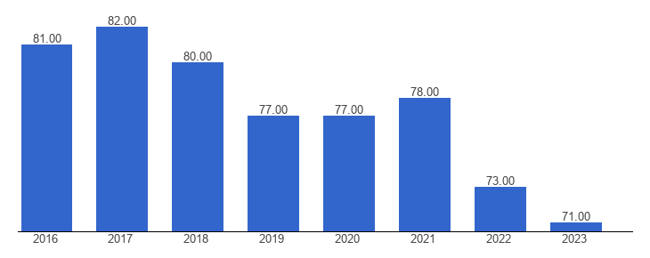
Figure 4: Corruption Perceptions Index
(Source: The Global Economy, 2024)
The political stability index identified in the UK recorded a score of 0.50 in 2022, establishing a negative scale of events (The Global Economy, 2024). Herein, Marriott Cardiff may be subject to uncertainties, complexities, volatilities and ambiguities in the long run which can impact the leadership activities and decisions regarding employee relations and customer satisfaction.
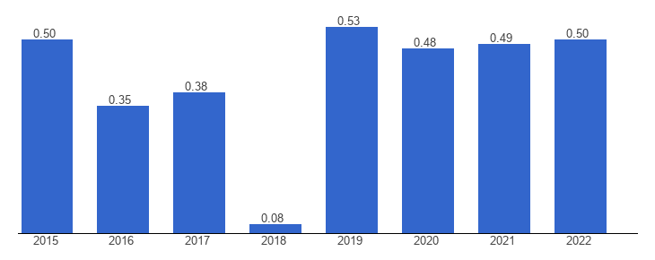
Figure 5: Political Stability Index
(Source: The Global Economy, 2024)
Economic Factors
The economic growth rate of the UK declined by 1.67% in 2021 reaching $3,089.07 billion in 2022 (Macrotrends, 2024). This implies that Marriott Cardiff may experience recessions or financial crises, resulting in economic problems.
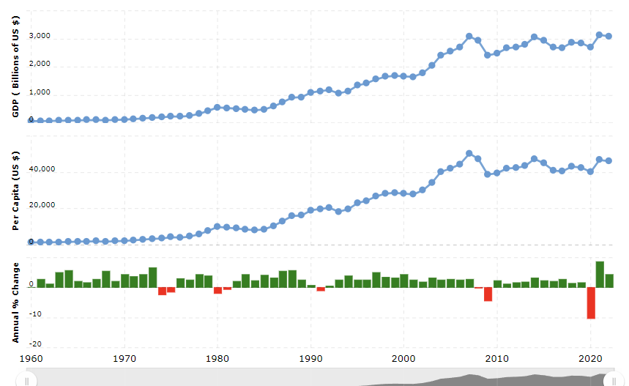
Figure 6: Economic Growth Rates
(Source: Macrotrends, 2024)
Inflation rates in the UK reached 2.2% in 2024, declining to its lowest rate from 2023 (Statista, 2024). Marriott Cardiff may be able to prevent supply chain bottlenecks and keep production costs lower while ensuring that employment rates are stable at the hotel.
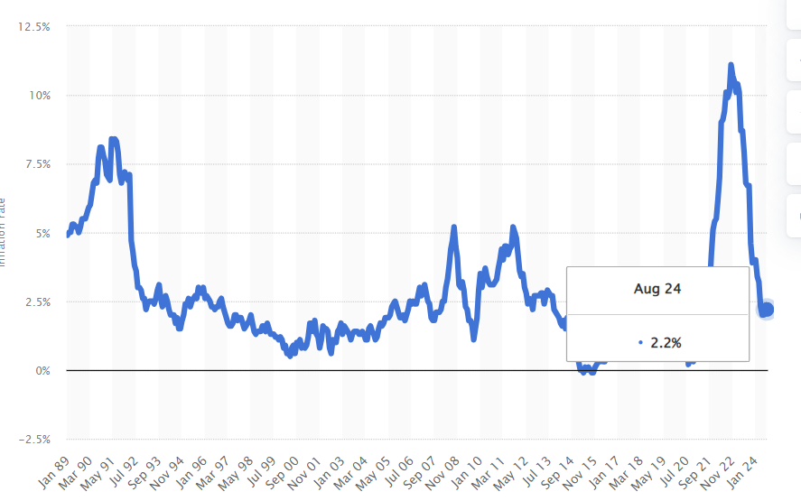
Figure 7: Inflation Rates
(Source: Statista, 2024)
Social Factors
The populace of the UK in 2023 was 67,736,802, an increase of 0.34% from 2022, indicating positive changes (Macrotrends, 2024). Herein, Marriott Cardiff may come across an increase in the count of its employees and customers.
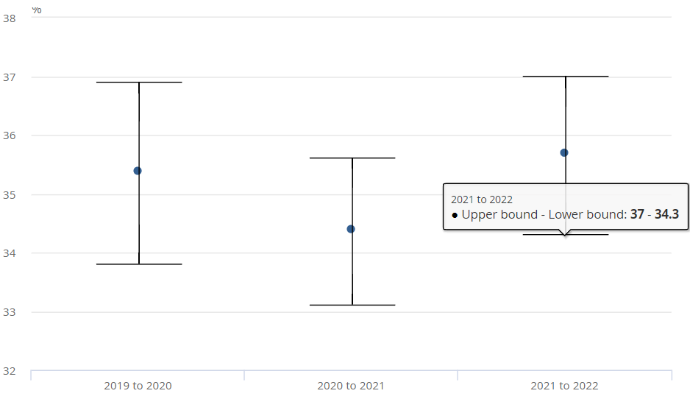
Figure 8: Income Inequality Rates
(Source: O’Neill and Croal, 2023)
Income inequality rates in the UK increased by 1.3% from 35.5% in 2021 to 34.4% in 2021 (O’Neill and Croal, 2023). Herein, Marriott Cardiff has been expected to experience a lack of customer satisfaction and high staff turnover rates resulting from prevalent income inequalities within the economy.
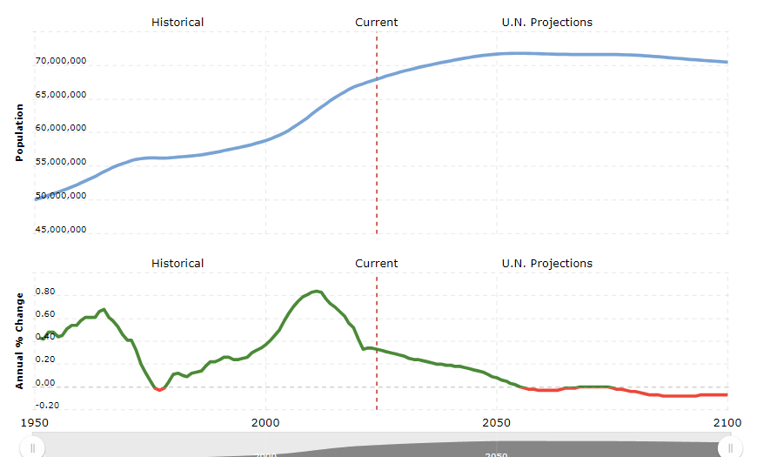
Figure 9: Population Growth Rates
(Source: Macrotrends, 2024)
Technological Factors
The count of social media users in the UK reached 52.7 million in 2024, with an estimate reaching 65 million by 2027 (Statista, 2024). Herein, Marriott Cardiff may be able to engage in social media promotions and contribute to search engine optimisations. Additionally, the leaders of Marriott Cardiff can also leverage these platforms to maintain transparent communication with their customers and collect their feedback to enhance their satisfaction level.
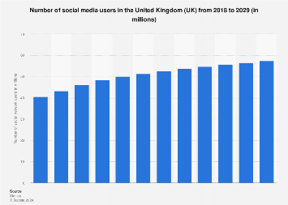
Figure 10: Count of Social Media Users
(Source: Statista, 2024)
The internet penetration rate accounted for 66 million users with 97.8% individuals in 2023 (Statista, 2024). Marriott Cardiff can utilise digital tools like Artificial intelligence and other forms of technological advancements requiring the assistance of the Internet to operate to enhance the resilience of the organisation and maintain effective communication among employees and customers.
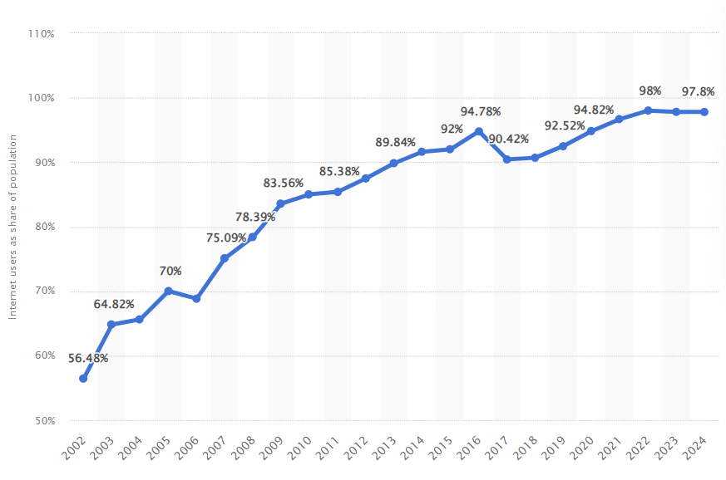
Figure 11: Internet Penetration Rates
(Source: Statista, 2024)

Competitor Analysis
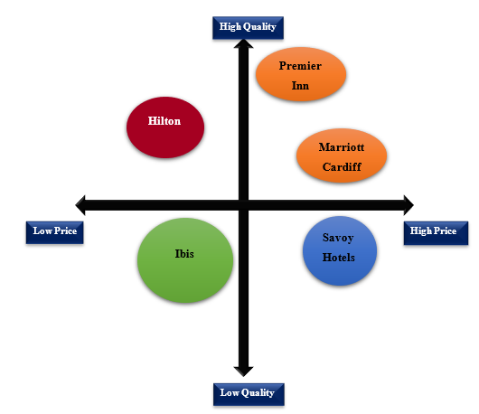
Figure 12: Competitor Analysis
(Source: Created by the learner)
Premier Inn, Hilton, and Savoy Hotels are some of the leading hotel brands in the UK as evaluated from the reports of the second quarter of 2024 (Statista, 2024). They might also act as direct competitors for Marriott Cardiff thus influencing its operations in the location. Premier Inn tops the list with 78% popularity followed by Hilton with 53%, and Savoy Hotel and Ibis rated at 42% and 34% respectively (Statista, 2024). On the contrary, Marriott is rated at 50% which means that it operates with a lower quality compared to that of Premier Inn and Hilton in the country.
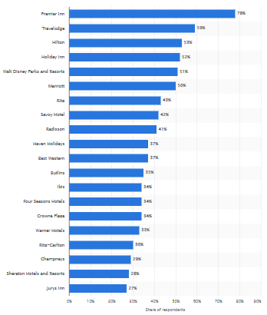
Figure 13: Most popular hotels in the UK
(Source: Statista, 2024)
Hence, Marriott Cardiff has been positioned in the first quadrant as it also offers premium quality products maintaining a high price range. Based on the customer reviews, the hotel has been rated 4.0 on average referring to its high-quality service offered to customers (TripAdvisor, 2024). Marriott Cardiff has been positioned as a high-price and high-quality hotel followed by the Hilton Hotels at a comparatively lower price than Marriott but high quality. On the other hand, compared to them, Premier Inn has been positioned to maintain a high price and high quality followed by Ibis at a low price and low quality.
Ibis Hotels are known to offer affordable comfort and are considered to be sociable havens for budget-conscious travellers (Ibis, 2024). On the contrary, the Savoy Hotels based on the customer reviews have been rebuked for the unexpected quality standards wherein some of the travellers also find the hotels to be overpriced irrespective of its offerings (TripAdvisor, 2024). Hilton Hotels is known to abide by a dynamic pricing strategy with a range of package deals (Qubein, 2024). The hotel is well-known for its exemplary services and seamless check-in processes for guests. Hilton Hotels is also known to curate exceptional experiences, memories, and extraordinary stays thus helping it to emerge as one of the largest hotel brands in an international context. On the other hand, the pricing strategy of Premier Inn also depends on the stay dates and hotel demands (Premier Inn, 2024). The prices of the rooms are most likely to be higher if the room is in high demand whereas, booking well in advance helps to opt for the lowest-priced rooms. Furthermore, the hotel is also known for its outstanding quality followed by exceptional guest service and comfort in its rooms.

Netnography
With a 4.0-star rating and 77% of employees recommending Marriott to their friends, the hotel has gained wide exposure (Glassdoor, 2024). Herein, the hotel has also been able to establish a successful brand name and create awareness among customers, especially in the United Kingdom. For instance, in the year 2023, the brand awareness rate of Marriott in the UK reached 81%, higher than its potential competitors (Statista, 2024). This implies that the hotel has been exclusively managing its practices while forming enticing practices against distinct trends that have been evolving within the UK hospitality industry. Most employees strongly agree that Marriott has been successful in introducing resilience and communication within the workplace. Herein, the hotel has been engaged in developing its brand awareness rates over the years with an emphasis on exclusive leadership practices that have been taking place throughout. For instance, the cultural grounds of Marriott have been evolving as a major structure for the establishment of inclusion and diversity. Marriott has been committed to engaging socially driven and diverse consumers over shared values while reinforcing inclusion, diversity and equality (Marriott, 2024). Herein, the hotel has also been capable of serving customers and employees with an emphasis on leadership measures in the form of inclusion, diversity and equality.
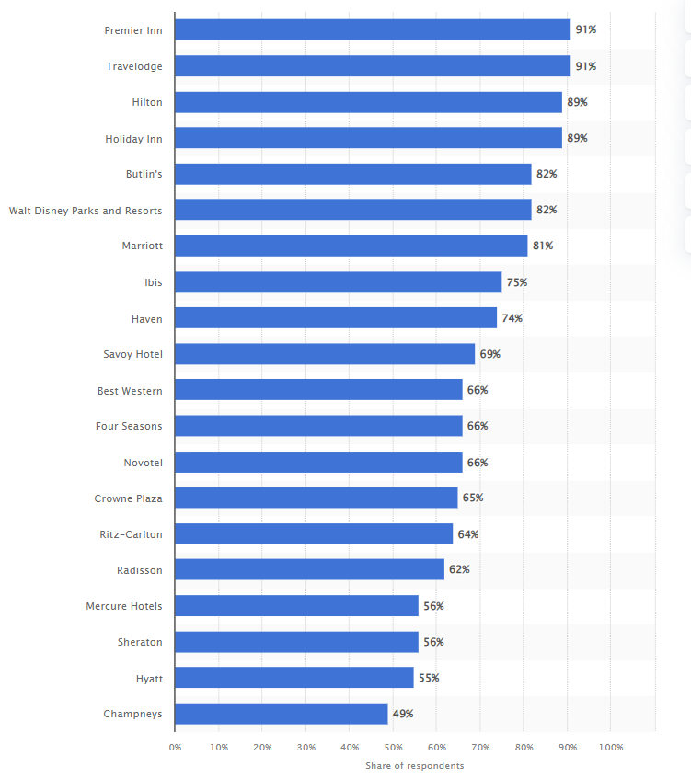
Figure 14: Brand Awareness Rate
(Source: Statista, 2024)
However, Marriott has also been subject to adverse approaches and threats to its reputation concerning dissatisfaction from customers and negative employee reviews. For instance, more than 10,000 workers caused a strike to improve pay structures and working conditions (Tait, 2024). Herein, employee satisfaction has not been taken into account by Marriott leading to demotivation and increasing rates of turnover. From another perspective, employees have also been subject to shifting from Marriott to other affordable hotel brands. The lack of confidence in employees due to this shift held them back from creating an interactive environment. More than workplace satisfaction at Marriott Cardiff, many employees are concerned with building healthy organisational relationships. This is because it can keep them motivated, and, in turn, contribute to customer expansion.
This may have been due to the lack of a customer-centric approach and the absence of effective corporate social responsibilities, especially in the form of community engagement programmes. For instance, one customer has put in a negative review for Marriott rating it with a single star and revealing that the hotel has horrible services (Trust Pilot, 2024). One of the major issues was that the staff members of the hotel kept losing private information, revealing a cybersecurity threat. Cyberattacks nowadays have been increasing at a rapid pace and it is the responsibility of leaders to look after the private information and data of customers. However, the leaders of Marriott have failed to do so, implying that customer satisfaction has taken a step back. In this regard, the establishment of efficient training practices may be able to enhance employee satisfaction and build resilience. This can also help managers communicate the need for changes to workers.

Theme Exploration

Thematic Table
Themes | Title | Author | Year | Findings
Theme 1: Necessity of leadership communication and resilient in leadership practices | Improvising resilience: The unfolding of resilient leadership in COVID-19 times | Lombardi, e Cunha and Giustiniano | 2021 | The study aimed to analyse the necessity of leadership resilience in organisations and the factors which influence the resilience of leaders. The authors of the study have implied that in times of unprecedented situations, leaders need to be able to cultivate resilience as this helps organisations to return back from unfavourable situations and become prepared to tackle future situations more effectively. As the business world is changing constantly and facing unprecedented challenges continually, resilient leadership prepares employees and organisations for unpredictable situations in the future.
 | The effects of organizational communication, leadership, and employee commitment in organizational change in the hospitality sector | Ramos-Maçães, M.A. and Román-Portas | 2022 | The study has highlighted the efficiency of organisational communication in enhancing the commitment of both leaders and employees in an organisation. It has highlighted leadership and employee commitment as the most important variables for the success of an organisation and communication is the key to enhancing this. Communication with employees helps leaders increase awareness of possible changes and reduce resistance and a sense of uncertainty. This further helps enhance the level of attachment among employees and leaders allowing them to be committed to attaining the shared goals of the organisation.
Theme 2: Benefits of communication and resilience on employee relations and customer service | “The transformational leadership role in achieving organizational resilience through adaptive cultures: the case of Dubai service sector.” | Madi Odeh et al. | 2023 | The research proposes that resilience is in increasing demand as it helps organisations survive, where leaders perform a pivotal role. Resilient leaders are known to demonstrate a higher level of emotional intelligence which helps them to communicate effectively to foster better relations with employees. It also encourages them to clearly define the organisational goals to empower and inspire employees so that they strive towards maximising efforts and performance. It also helps foster stronger relations at work thus helping to create positive outcomes through better employee experiences. Leaders are also known to perform a critical role in maintaining and managing employee well-being directly related to their productivity.
 | “Resilience as thriving: The role of positive leadership practices.” | Vera et al. | 2020 | The journal explains resilience as an idea for thriving. In such an instance, positive leadership is defined as an aspect which is related to the process of fostering positive relations through positive communication. Resilient leaders also perform a vital role that helps to shape employees by motivating and inspiring them to adapt to changing situations. It also encourages them to prioritise customer satisfaction thus facilitating a culture of continuous improvement, accountability, and empathy. Effective communication and resilience also help them to direct their teams towards the maximisation of organisational efforts as a whole to enhance customer satisfaction through high-quality service.
Theme 3: Challenges imposed on communication and resilience in leadership measures against customer satisfaction and employee relations | “Developing leadership communication in theory and practice.” | Salonen | 2024 | The journal proposes that cultural differences at work are known to foster a fertile ground facilitating misunderstanding. On the other hand, information overload is considered to be another major challenge of leadership communication at work. Leaders often face an overwhelming amount of information in today's fast-paced business environment, making it difficult to effectively communicate key messages to employees and customers. Poor communication at work is considered to be detrimental to the firm as it makes it hard for employees to achieve goals and align their strategies with customer demands thus impeding personal and business success along with the level of customer service.
 | “Stress resilience: researching a key competence for professionals in communication management.” | Ziegele and Zerfass | 2021 | The journal mentions stress as a combination of a feeling of being tense and also the absence of resources to manage the same. Leaders who are constantly under pressure can experience stress and burnout, which can negatively impact their decision-making abilities and communication skills. On the other hand, the growing stress levels at work also reveal a higher level of pressure and frustration causing employees to feel exhausted and tired thus decreasing the level of customer satisfaction due to reduced service value. This prevents the leaders at work from supporting or guiding others towards the attainment of success thus declining customer satisfaction.
Theme 4: Strategies to enhance leadership practices | ““Vision, passion, and care:” The impact of charismatic executive leadership communication on employee trust and support for organizational change.” | Men, Yue and Liu | 2020 | According to the journal, leadership communication is known to positively impact employee reaction to change and trust. It also encourages leaders to communicate in a manner that is easily understood by others at work. This, in turn, encourages the leaders to get everyone to work so that they can strive towards a common goal. Communication is also considered to be a core element of leadership thus helping to strengthen relations with both the external and the internal stakeholders.
Theme 4: Strategies to enhance leadership practices | “The role of emotional intelligence in organizational performance.” | Krén and Séllei | 2021 | The article proposes that emotional intelligence is known to influence social and emotional problem-solving. Developing emotional intelligence is considered to be a major aspect as it helps leaders to be empathetic, enhance self-awareness, and also manage emotions effectively. In the case of leaders, emotional influence is considered to be an essential part as it helps them to manage the emotions and moods of others. In such an instance, leaders are expected to foster an emotionally resonant ambience where employees can successfully and securely use their skills for higher performance.
Table 2: Thematic Analysis
(Source: Created by the learner)

Analysis
Theme 1: Necessity of leadership communication and resilient in leadership practices
The frequently changing business environment along with distinguished social, political, and economic scenarios have made it necessary for businesses to stay resilient in this world. Lombardi, e Cunha and Giustiniano (2021) illustrated resilience as an ability to imbibe adversities, external shocks and even sources of stress and respond to these changes by learning from adversities. This ability enables individuals to learn from events and get prepared to combat unexpected situations more efficiently. This is even more necessary for leaders as they are in charge of guiding employees in times of uncertainty. Resilience places a great emphasis on positive adaptation which is useful in navigating through difficult situations. Resilient leaders are able to adapt themselves and their approaches to suit changing situations more efficiently while also motivating their subordinates to overcome obstacles and persevere through difficult events. By becoming resilient themselves, leaders can foster a culture of resilience in their organisations which nurtures high-goal achievement, adaptation and self-actualisation (Madi Odeh et al., 2023: FERRAZZI, 2020). Moreover, resilient leaders are more stable in managing their emotions under pressure making them equipped to make sound decisions for their subordinates and organisations.
According to Ramos-Maçães and Román-Portas (2022), organisational communication is a process of change which helps in the interchange of various ideas, messages and such within an organisation. The role of leadership in influencing the understanding of employees in regard to change as well as enhancing their commitment towards organisational goals is huge. Effective communication allows leaders to not only convey the vision and mission of the organisation but also help motivate employees to participate in the attainment of organisational goals. Communication is further essential for leaders, especially in the hospitality sector, to communicate expectations from employees clearly and provide necessary resources to meet these expectations, leading to higher productivity of employees (Rabiul et al., 2023: Ghani et al., 2022). Additionally, leaders can also create an awareness of employees regarding changes and such, thus, making employees more committed towards their work.
Theme 2: Benefits of communication and resilience on employee relations and customer service
As discussed by Madi Odeh et al. (2023) effective leadership is considered to be a critical aspect of a business model as it helps in driving excellence and quality. Resilience is referred to as the ability that helps to adapt efficiently and effectively to apply the change processes and ultimately thrive for the future to success. Leaders who are most likely to demonstrate resilience help them to communicate effectively ensuring that employees are highly motivated at work and are also willing to participate effectively. On the other hand, a resilient organisation also requires the presence of resilient individuals who are empowered with the necessary support, and resources and are also inspired to make good decisions. For example, the employees have rated the hotel as 4 (Indeed, 2024). Effective leaders at Marriott Cardiff demonstrating high resilience and communication will be capable of maintaining better employee relations for higher productivity. They will be able to greatly impact the self-efficacy and well-being of employees thus helping them to cope with the external environmental dynamics and inspire a change vision.
As mentioned by Vera et al. (2020) resilience is considered to be a major characteristic of collectives and individuals. Organisational resilience indicates the ability of a firm to maintain its functioning or absorb strain in some adverse situations. Clear and transparent communication is considered to be at the core of resilience. Mastering the same helps the leaders to better understand customer concerns which helps to excel in customer service roles for better rapport. Resilient leaders are known to communicate effectively and also lead with resilience in customer service by fostering teamwork towards better operations. Such leaders prioritise their employees which helps motivate them towards excellent customer service thus ensuring the long-term sustainability of the business. For example, the customers of the Marriott Cardiff have rated the hotel at 4 acknowledging their stay to be very good (TripAdvisor, 2024). Hence, maintaining resilient leaders who are capable of communicating effectively will be vital for the hotel to further strengthen its customer satisfaction through exquisite service.
Theme 3: Challenges imposed on communication and resilience in leadership measures against customer satisfaction and employee relations
According to Salonen (2024), poor leadership communication often hinders the process of transferring information, especially in a crisis situation. Information overload is one of the major challenges wherein individuals struggle to disseminate and filter the most accurate and relevant information. On the other hand, Aririguzoh (2022) states that miscommunication is triggered by intense cultural differences which often leads to conflict. This, in turn, offends others causing absenteeism and decreased productivity. Hence, it is important for leaders to communicate their actions effectively and handle crisis situations easily. In the case of employees, poor communication leads to incorrect assumptions and misunderstanding thus hindering their effectiveness and leading to ineffective customer service and declining customer satisfaction rates. For example, in the case of Cardiff Marriott poor communication might led to a loss of loyal customers persuading them to go elsewhere thus declining the brand loyalty of the hotel in the industry.
As per Ziegele and Zerfass (2021), stress or the associated problems arising from the same are declining the functioning of professionals at work. Leaders lacking resilience are more likely to demonstrate higher levels of stress as they fail to cope with the dynamic business environment thus reducing the level of communication between colleagues. This is known to adversely impact the overall staff productivity. As per Luu (2021), resilience also prevents the leaders from preaching the importance of effective communication in teams thus preventing employees from interacting clearly with customers for better clarity on their requirements to enhance service. For example, in the case of Cardiff Marriott, leaders lacking resilience and the ability to manage stress leading to burnout might hinder overall organisational function thus declining employee morale and their intention to drive higher customer satisfaction through better customer service.
Theme 4: Strategies to enhance leadership practices
As elucidated by Men, Yue and Liu (2020) leadership communication is referred to as the process that helps them to better connect and directly influence their stakeholders. On the other hand, it is also inferred as an integral part of an organisation’s internal communication process. Positive leadership communication directly helps in influencing how the stakeholders perceive the reputation and image of the company based on employee productivity and customer service. According to Santoso, Sulistyaningtyas and Pratama (2023), effective communication is perceived to be an opportunity that helps to bolster employee outcomes by building higher trust, being empathetic, boosting engagement, keeping them informed, and resolving conflicts effectively. It also helps in driving excellent customer service by setting overall expectations and cultivating a culture of continuous improvement and accountability. For example, for Marriott Cardiff, effective communication will help the leaders to encourage employees based on the organisational mission and vision to handle customer service with efficiency and care.
As stated by Krén and Séllei (2021) in organisations, emotional intelligence is considered to be a major aspect helping to retain a better competitive position. Leaders demonstrating high emotional intelligence are capable of building a comfortable business environment and reciprocal trust. They are also known to involve employees in various decision-making processes, strengthen engagement, share knowledge, and encourage teamwork for higher organisational performance. Moreover, Xianjun (2022) states that an emotionally intelligent leader is also known to demonstrate higher levels of empathy and self-awareness contributing to organisational success. It also helps them to be resilient to work under pressure and manage difficult situations easily. For example, leaders at Marriott Cardiff might exemplify higher emotional intelligence to develop a strong bond with the team and be empathetic towards their concerns for better outcomes.

Conclusion and Recommendations

Conclusion
In conclusion, it can be derived that the current scope of Marriott Cardiff in the United Kingdom has been inclined on a positive scale, revealing the essence of resilience and communication in the field of leadership. This implies that the introduction of organisational resilience and the establishment of an interactive workplace environment may be challenging but can be effective in the long run. Employees are likely to be satisfied and motivated with their job opportunities while contributing to healthy customer relationships. Herein, the key points that can be extracted reveal both opportunities and challenges at Marriott Cardiff concerning leadership.
- Marriott Cardiff may be adversely impacted by the atrocities of the external environment in the form of high inflation rates or lower economic growth rates.
- On the other hand, Marriott may be able to make use of social media technologies and the internet in terms of reaching more target audiences.
- Personalisation and discounts can attract more consumers in the long run while training employees can build organisational resilience through leadership, contributing to customer satisfaction rates.
- Keeping the workforce motivated needs to be prioritised by Marriott Cardiff and this can be made possible by communicating the need for changes to them.

Linking with Objectives
Objective 1: This objective has been met in the first theme of the literature review with an emphasis on the evolution of leadership practices. It has been further emphasised in the first theme of the thematic analysis, embossing emotional intelligence and adaptability at the core of leadership.
Objective 2: This objective has been met in the survey with employees of Marriott Cardiff responding to communication and resilience being the key factors to enhance employee satisfaction and customer relationships. Moreover, the thematic analysis has also shed light on the current perceptions of both employees and customers of hotels.
Objective 3: This objective has been met in the survey, the third theme of the literature review and the thematic analysis. The PESTLE analysis has included the external environment while the opportunities and threats have been sorted in the SWOT analysis with an emphasis on the collection of online data.
Objective 4: This objective has been initially highlighted in the survey and taken into account through netnography based on the collection of customer feedback and employee reviews concerning Marriott. With the help of secondary research, recommendations such as training facilities for employees regarding the acceptance of changes.

Recommendations
- One of the most essential aspects of organisational communication revolves around the potential for this interactive environment to act as a major tool designed by the management department to achieve objectives set by firms (Syakur et al., 2020). Marriott may be able to relate to maintaining healthy customer relationships.
- Being resilient denotes the idea that one may be knocked down and then have the power to counter again, learn from events, work under pressure, and be ready to experience challenges while accepting changes (Lombardi, e Cunha and Giustiniano, 2021). Herein, Marriott Cardiff can nurture resilient leaders through active listening.
- Unlike earlier when individuals took in the roles and responsibilities of leaders, nowadays an evolving work culture celebrates and embraces the distribution of functional leadership roles based on requisite talent (Gichuhi, 2021). Herein, Marriott Cardiff can distribute leadership responsibilities among team members in terms of being able to motivate workers.
- In this diversified 21st century, leaders have been responsible for minimising discrimination and establishing inclusion in the workforce (Adams, Meyers and Sekaja, 2020). Marriott can focus on inclusion, equality and diversity in the workforce as well as for customers with the help of effective communication and change-resilient behaviour for growth.

Future Implications
The findings from this research study can be generalised since the resources that have been taken into account are valid and credible. Herein, the generalised research outcomes can be applied to similar fields in terms of understanding other aspects of leadership such as conflict resolution or decision-making abilities.

Limitations
This study has been limited to secondary qualitative thematic analysis. However, conducting a primary qualitative interview and quantitative survey may have shed light on the opinions and perspectives of managers serving Marriott in the UK. Subsequently, a competitive analysis based on Porter’s Five Forces may have been effective.

Reflective Account
Description
My placement at Marriott Cardiff provided me with invaluable insights into the intricate relationship between leadership, employee relations, and customer satisfaction within the hospitality industry. Initially, I was assigned to a group of five members where we had to collaboratively analyse how leadership affects customer satisfaction at Marriott Cardiff. Being assigned the topic, I was immensely thrilled to analyse the intricate relationship between customer service and employee morale. On the other hand, the teamwork experience has also excited me immensely as I have not performed previously in a group. The placement has helped to foster a sense of shared purpose and camaraderie while I intended to explore the impact of transformational leaders who strived to motivate and inspire their teams. Other than these, I was also expected to critically analyse the hotel’s operations based on SWOT, PEST, competitor analysis, and netnography. We were also expected to perform secondary research in the form of online surveys and thematic analysis for which we had to divide the tasks. Such an instance, created a bit of conflict among the members while aiming to analyse the direct correlation between employee satisfaction and customer satisfaction.
Feelings
My experiences at Marriott Cardiff evoked a range of emotions. While exploring the benefits of leadership on employee relations and customer satisfaction, I felt quite inspired as I understood the role of good leaders on employee empowerment, clear communication, positive brand image, increased employee morale and improved engagement. On the contrary, examining the atrocities of poor or ineffective leadership and its detrimental effect on employees and customers often frustrated me. The main role of leaders is to connect with employees to motivate and excite them to outperform tasks rather than just improving processes (Russell, 2023). Although I was thrilled to work in the team, the conflict at the start also frustrated me as I was anxious and stressed about how to complete the entire project. I was particularly drawn to exploring the potential solutions to address workplace issues by understanding the correlation between customer satisfaction and employee morale along with how they are affected by leadership. Researching the communication and resilience aspects of the leadership functions at Marriott Cardiff, I have realised that leadership performs a critical role. Resilience is considered to be the process of overcoming obstacles and being adaptable in some adverse situations (Kelly, 2024). Other than these exploring the internal and the external business environment also thrilled me immensely as I was able to navigate through the complex business environment of a renowned organisation. Hence, my observations while researching the prestigious establishment were a mix of apprehension and excitement.
Evaluation
Reflecting on my observations, I gained a deeper understanding of the importance of leadership in fostering positive employee relations and driving customer satisfaction. The research helped me to realise the strengths of the company concerning its financial background and properties as a whole. However, it also helped me to explore the weaknesses and threats of the company relating to increased turnover rate, chances of cyberattack, uncertainties, intense competition, and others. Further, the survey results also enlightened the complicated leadership role. Alsaleh (2020) and Ghanizadeh, Al-Hoorie and Jahedizadeh (2020) proposed critical thinking refers to the use of cognitive strategies or skills while skillfully conceptualising to enhance the desirable outcomes. In my opinion, performing in the team and exploring long-term employee engagement and customer loyalty driven by effective leadership helped me to brainstorm critical concepts and bolster my research ability for outlining the most effective solutions. It also helped me to realise the importance of critical thinking and problem-solving to ensure the best possible results.
Analysis
My experiences at Marriott Cardiff align with the concept of effective communication and resilience at work. Sumaiya et al. (2022) and Doyle (2023) said good communication helps to transfer feelings while facilitating interactions with others. In my opinion, the placement also helped me realise the necessity of transformational leaders for higher employee engagement and customer satisfaction. Although the conflict at the start caused a bit of reluctance as I hesitated to perform with my colleagues, however, later I realised personal drawbacks in communication. I could then sense the essence of communication ability for better collaboration. Further, it also helped me realise how good communication acts as a cornerstone in teamwork helping every member to collaborate for unified outcomes. Teamwork is known to offer a collective advantage compared to an individual performer thus enhancing productivity (Akinpelu, 2024 and Tannenbaum and Salas, 2020). Later, we were able to sort out our differences as we came forward to help each other and research the topic as we started structuring and writing our research on Marriott Cardiff and its leadership roles.
Conclusion
On a concluding note, based on my experience I would like to mention that my placement at Marriott Cardiff has provided me with valuable insights into the critical role of leadership. The placement has been of immense help as it helped me to understand the role of leaders in shaping employee relations and customer satisfaction to make a positive impact in the sector. Performing surveys and thematic analysis have helped me to realise the challenges to be mitigated to offer exceptional customer service upon retaining a diverse and highly motivated or high-performing talent pool. Lastly, the group work experience has also been an indispensable experience in helping to strengthen the basic skills at work for professional development.
Action Plan
In the future placement, if I am assigned to group work, I will ensure to adhere to my past experiences as it will help me to avoid such atrocities in the future. On the other hand, I will also be able to guide others on the same so that they are capable of participating effectively in a group. On the other hand, this particular experience will also help me to be resilient and bolster my personal communication ability which is a cornerstone for success. Further, in case of any doubt, I will take help from my mentors, seniors, or friends to help me in the same and also set apart a time for self-studying.

Reference List
Adams, B.G., Meyers, M.C. and Sekaja, L. (2020) Positive leadership: Relationships with employee inclusion, discrimination, and well‐being. Applied Psychology, 69(4), pp.1145-1173.
Akinpelu, A. (2024) Harnessing Teamwork For Greater Productivity. Available at: https://www.forbes.com/councils/forbescoachescouncil/2024/02/06/harnessing-teamwork-for-greater-productivity/#:~:text=A%20team%20is%20made%20of,a%20collective%20advantage%20over%20an (Accessed: 14 October 2024).
Alsaleh, N.J. (2020) Teaching Critical Thinking Skills: Literature Review. Turkish Online Journal of Educational Technology-TOJET, 19(1), pp.21-39.
Aririguzoh, S. (2022) Communication competencies, culture and SDGs: effective processes to cross-cultural communication. Humanities and Social Sciences Communications, 9(1), pp.1-11.
BBC (2020) Marriott Hotels fined £18.4m for data breach that hit millions. Available at: https://www.bbc.com/news/technology-54748843 (Accessed: 2 October 2024).
BRM (2024) Deductive Approach (Deductive Reasoning). Available at: https://research-methodology.net/research-methodology/research-approach/deductive-approach-2/ (Accessed: 16 December 2024).
BRM (2024) Exploratory Research. Available at: https://research-methodology.net/research-methodology/research-design/exploratory-research/ (Accessed: 16 December 2024).
BRM (2024) Interpretivism (interpretivist) Research Philosophy. Available at: https://research-methodology.net/research-philosophy/interpretivism/ (Accessed: 16 December 2024).
Crunchbase (2024) Marriott International. Available at: https://www.crunchbase.com/organization/marriott-international (Accessed: 1 October 2024).
Dasborough, M.T., Ashkanasy, N.M., Humphrey, R.H., Harms, P.D., Credé, M. and Wood, D. (2022) Does leadership still not need emotional intelligence? Continuing “The Great EI Debate”. The Leadership Quarterly, 33(6), p.101539.
Doyle, T. (2023) Helping students learn in a learner-centred environment: A guide to facilitating learning in higher education. Taylor & Francis.
Eisenhardt, K.M. (2021) What is the Eisenhardt Method, really?. Strategic organization, 19(1), pp.147-160.
FERRAZZI, M. (2020) Objectives and key results as a tool for organizational agility: the case of digital start-ups.
Gallo, C. (2020) Marriott’s CEO Demonstrates Truly Authentic Leadership In A Remarkably Emotional Video. Available at: https://www.forbes.com/sites/carminegallo/2020/03/21/marriotts-ceo-demonstrates-truly-authentic-leadership-in-a-remarkably-emotional-video/ (Accessed: 16 December 2024).
Ghani, B., Zada, M., Memon, K.R., Ullah, R., Khattak, A., Han, H., Ariza-Montes, A. and Araya-Castillo, L. (2022) Challenges and strategies for employee retention in the hospitality industry: A review. Sustainability, 14(5), p.2885.
Ghanizadeh, A., Al-Hoorie, A.H. and Jahedizadeh, S. (2020) Higher order thinking skills in the language classroom: A concise guide. Springer International Publishing.
Gichuhi, J.M. (2021) Shared leadership and organizational resilience: a systematic literature review. International Journal of Organizational Leadership, 10(1), pp.67-88.
Glassdoor (2024) Marriott International. Available at: https://www.glassdoor.co.in/Reviews/Marriott-International-Reviews-E7790.htm (Accessed: 2 October 2024).
Global Data (2024) Marriott International Inc: Overview. Available at: https://www.globaldata.com/company-profile/marriott-international-inc/ (Accessed: 1 October 2024).
GOV.UK (2024) Data protection. Available at: https://www.gov.uk/data-protection#:~:text=The%20Data%20Protection%20Act%202018,Data%20Protection%20Regulation%20(GDPR). (Accessed: 16 December 2024).
Guzmán, V.E., Muschard, B., Gerolamo, M., Kohl, H. and Rozenfeld, H. (2020) Characteristics and Skills of Leadership in the Context of Industry 4.0. Procedia Manufacturing, 43, pp.543-550.
Hallo, L., Nguyen, T., Gorod, A. and Tran, P. (2020) Effectiveness of leadership decision-making in complex systems. Systems, 8(1), p.5.
Hartung, P. (2020) The impact of self-awareness on leadership behaviour. Journal of Applied Leadership and Management, 8, pp.1-21.
Ibis (2024) ibis. Available at: https://ibis.accor.com/en/ibis.html (Accessed: 16 December 2024).
Indeed (2020) Marriott International Employee Reviews. Available at: https://uk.indeed.com/cmp/Marriott-International/reviews (Accessed: 16 December 2024).
Indeed (2024) Marriott International. Available at: https://uk.indeed.com/cmp/Marriott-International/reviews?fcountry=GB&floc=Cardiff (Accessed: 15 October 2024).
Islam, M.A. and Aldaihani, F.M.F. (2022) Justification for adopting qualitative research method, research approaches, sampling strategy, sample size, interview method, saturation, and data analysis. Journal of International Business and Management, 5(1), pp.01-11.
Kamaraj, J.A. (2023) EMPLOYEE RESILIENCE AND EMPLOYEE RELATIONSHIP MANAGEMENT TOWARDS SUSTAINABLE BUSINESS DEVELOPMENT. HUMANITIES AND SOCIAL SCIENCE STUDIES Peer-Reviewed, Bi-annual, Interdisciplinary UGC CARE List Journal.
Kelly, J. (2024) How To Be Resilient Amid Failure And Uncertain Times. Available at: https://www.forbes.com/sites/jackkelly/2024/01/24/how-to-be-resilient-amid-failure-and-uncertain-times/ (Accessed: 14 October 2024).
Khan, R.U., Salamzadeh, Y., Iqbal, Q. and Yang, S. (2022) The impact of customer relationship management and company reputation on customer loyalty: The mediating role of customer satisfaction. Journal of Relationship Marketing, 21(1), pp.1-26.
Kluger, A.N. and Itzchakov, G. (2022) The power of listening at work. Annual Review of Organizational Psychology and Organizational Behavior, 9(1), pp.121-146
Krén, H. and Séllei, B. (2021) The role of emotional intelligence in organizational performance. Periodica Polytechnica Social and Management Sciences, 29(1), pp.1-9.
LinkedIn (2024) Cyberattack History: Marriott International. Available at: https://www.linkedin.com/pulse/cyber-attack-history-marriott-international-mark-pinchen-2zzfe (Accessed: 2 October 2024).
Lombardi, S., e Cunha, M.P. and Giustiniano, L. (2021) Improvising resilience: The unfolding of resilient leadership in COVID-19 times. International Journal of Hospitality Management, 95, p.102904.
Lombardi, S., e Cunha, M.P. and Giustiniano, L. (2021) Improvising resilience: The unfolding of resilient leadership in COVID-19 times. International Journal of Hospitality Management, 95.
Lombardi, S., e Cunha, M.P. and Giustiniano, L. (2021) Improvising resilience: The unfolding of resilient leadership in COVID-19 times. International Journal of Hospitality Management, 95, p.102904.
Luu, T.T. (2021) Activating salesperson resilience during the COVID-19 crisis: The roles of employer event communication and customer demandingness. Industrial Marketing Management, 96, pp.18-34.
Macrotrends (2024) Marriott: Number of Employees 2010-2024 | MAR. Available at: https://www.macrotrends.net/stocks/charts/MAR/marriott/number-of-employees (Accessed: 1 October 2024).
Macrotrends (2024) U.K. GDP 1960-2024. Available at: https://www.macrotrends.net/global-metrics/countries/GBR/united-kingdom/gdp-gross-domestic-product#:~:text=U.K.%20gdp%20for%202022%20was,a%2016.45%25%20increase%20from%202020. (Accessed: 15 October 2024).
Macrotrends (2024) U.K. Population Growth Rate. Available at: https://www.macrotrends.net/countries/GBR/united-kingdom/population-growth-rate (Accessed: 15 October 2024).
Madi Odeh, R.B., Obeidat, B.Y., Jaradat, M.O., Masa'deh, R.E. and Alshurideh, M.T. (2023) The transformational leadership role in achieving organizational resilience through adaptive cultures: the case of Dubai service sector. International Journal of Productivity and Performance Management, 72(2), pp.440-468.
Madi Odeh, R.B., Obeidat, B.Y., Jaradat, M.O., Masa'deh, R.E. and Alshurideh, M.T. (2023) The transformational leadership role in achieving organizational resilience through adaptive cultures: the case of Dubai service sector. International Journal of Productivity and Performance Management, 72(2), pp.440-468.
Marriott (2024) A Brand Leader. Available at: https://www.marriott.com/marriott/aboutmarriott.mi (Accessed: 2 October 2024).
Marriott (2024) Diversity, Equity + Inclusion. Available at: https://www.marriott.com/en-gb/diversity/diversity-and-inclusion.mi (Accessed: 2 October 2024).
Marriott (2024) Hotel Technology. Available at: https://www.marriott.com/en-gb/meeting-event-hotels/meetings/mobility-and-tech.mi (Accessed: 1 October 2024).
Mbindyo, M., O’Connor, R.J. and Nandedkar, A. (2021) Linking transformational leadership theory to the practice of academic advising-A conceptual paper. Journal of Higher Education Theory and Practice, 21 (12).
Men, L.R., Yue, C.A. and Liu, Y. (2020) “Vision, passion, and care:” The impact of charismatic executive leadership communication on employee trust and support for organizational change. Public Relations Review, 46(3), p.101927.
Mysirlaki, S. and Paraskeva, F. (2020) Emotional intelligence and transformational leadership in virtual teams: Lessons from MMOGs. Leadership & Organization Development Journal, 41(4), pp.551-566.
Nadeem, W., Juntunen, M., Shirazi, F. and Hajli, N. (2020) Consumers’ value co-creation in sharing economy: The role of social support, consumers’ ethical perceptions and relationship quality. Technological Forecasting and Social Change, 151, p.119786.
O’Neill, J. and Croal, P. (2023) Household income inequality, UK: financial year ending 2022. Available at: https://www.ons.gov.uk/peoplepopulationandcommunity/personalandhouseholdfinances/incomeandwealth/bulletins/householdincomeinequalityfinancial/financialyearending2022#:~:text=Disposable%20income%20inequality%20increased%20to,(COVID%2D19)%20pandemic. (Accessed: 15 October 2024).
Pandey, P. and Pandey, M.M. (2021) Research methodology tools and techniques. Bridge Center.
Premier Inn (2024) FAQs | Room rates. Available at: https://www.premierinn.com/gb/en/faq/room-rates.html#:~:text=Our%20room%20prices%20are%20set,close%20to%20your%20stay%20date. (Accessed: 15 October 2024).
Qubein, R. (2024) Hilton Honors vs. Marriott Bonvoy: Which Loyalty Program Is Best? Available at: https://www.nerdwallet.com/article/travel/hilton-honors-vs-marriott-bonvoy-2#:~:text=To%20redeem%20points%2C%20Hilton%20uses,need%20for%20a%20specific%20trip. (Accessed: 15 October 2024).
Rabiul, M.K., Shamsudin, F.M., Yean, T.F. and Patwary, A.K. (2023) Linking leadership styles to communication competency and work engagement: evidence from the hotel industry. Journal of Hospitality and Tourism Insights, 6(2), pp.425-446.
Ramos-Maçães, M.A. and Román-Portas, M. (2022) The effects of organizational communication, leadership, and employee commitment in organizational change in the hospitality sector.
Russell, J.E.A. (2023) Leadership Is More Than Just Efficiency And Processes. Available at: https://www.forbes.com/sites/joyceearussell/2023/04/10/leadership-is-more-than-just-efficiency-and-processes/ (Accessed: 14 October 2024).
Sainato, M. (2021) Overworked, underpaid: workers rail against hotel chains’ cost-cutting. Available at: https://www.theguardian.com/us-news/2021/jul/05/overworked-underpaid-hotel-workers-employees (Accessed: 1 October 2024).
Sainato, M. (2021) Overworked, underpaid: workers rail against hotel chains’ cost-cutting. Available at: https://www.theguardian.com/us-news/2021/jul/05/overworked-underpaid-hotel-workers-employees (Accessed: 14 October 2024).
Sainato, M. (2024) 13,500 US hotel workers hold strike votes over pay and conditions. Available at: https://www.theguardian.com/business/article/2024/aug/06/hotel-workers-strike-vote (Accessed: 1 October 2024).
Salonen, A. (2024) Developing leadership communication in theory and practice.
Santoso, N.R., Sulistyaningtyas, I.D. and Pratama, B.P. (2023) Employee engagement and trust relationships during COVID-19 pandemic: the expanded role of internal communication. Communication & Society, pp.187-204.
Schoch, K. (2020) Case study research. Research design and methods: An applied guide for the scholar-practitioner, 31(1), pp.245-258.
Statista (2024) How high is the brand awareness of Marriott in the UK? Available at: https://www.statista.com/forecasts/1335619/marriott-hotels-brand-profile-in-the-uk (Accessed: 1 October 2024).
Statista (2024) Inflation rate in the UK 1989-2024. Available at: https://www.statista.com/statistics/306648/inflation-rate-consumer-price-index-cpi-united-kingdom-uk/#:~:text=The%20UK%20inflation%20rate%20was,11.1%20percent%20in%20October%202022. (Accessed: 15 October 2024).
Statista (2024) Internet penetration in the United Kingdom (UK) 2002-2024. Available at: https://www.statista.com/statistics/1124328/internet-penetration-uk/ (Accessed: 15 October 2024).
Statista (2024) Most popular hotel brands in the United Kingdom in 2nd quarter of 2024. Available at: https://www.statista.com/statistics/951262/most-popular-hotel-brands-uk/ (Accessed: 16 December 2024).
Statista (2024) Most well-known hotel brands in the UK 2023. Available at: https://www.statista.com/statistics/1343521/most-well-known-hotel-brands-in-the-uk/ (Accessed: 2 October 2024).
Statista (2024) Most well-known hotel brands in the UK 2023. Available at: https://www.statista.com/statistics/1343521/most-well-known-hotel-brands-in-the-uk/ (Accessed: 2 October 2024).
Statista (2024) Number of social media users in the United Kingdom (UK) from 2018 to 2029. Available at: https://www.statista.com/statistics/553530/predicted-number-of-social-network-users-in-the-united-kingdom-uk/ (Accessed: 15 October 2024).
Statista (2024) Revenue of Marriott International worldwide 1999-2023. Available at: https://www.statista.com/statistics/266279/revenue-of-the-marriott-international-inc-hotel-chain/#:~:text=Global%20hotel%20giant%20Marriott%20International,(COVID%2D19)%20pandemic. (Accessed: 1 October 2024).
Statista (2024) Revenue of the hotels industry in the UK 2020-2029. Available at: https://www.statista.com/forecasts/515548/revenue-in-the-hotels-market-in-the-united-kingdom (Accessed: 1 October 2024).
Stewart, M. (2021) Understanding learning:: Theories and critique. In University teaching in focus (pp. 3-28). Routledge.
Strategic Risk (2024) Marriott cyberattack: could it have been prevented? Available at: https://www.strategic-risk-global.com/operational-risk/marriott-cyber-attack-could-it-have-been-prevented-/1429767.article#:~:text=The%20chain%20confirmed%20that%20a,of%20birth%20and%20passport%20numbers. (Accessed: 2 October 2024).
Sumaiya, B., Srivastava, S., Jain, V. and Prakash, V. (2022) The role of effective communication skills in professional life. World Journal of English Language, 12(3), pp.134-140.
Sweeney, J. (2024) Hopes to attract international hotel chain to city. Available at: https://www.bbc.com/news/articles/c131xp5n035o (Accessed: 2 October 2024).
Syakur, A., Susilo, T.A.B., Wike, W. and Ahmadi, R. (2020) Sustainability of communication, organizational culture, cooperation, trust and leadership style for lecturer commitments in higher education. Budapest International Research and Critics Institute (BIRCI-Journal): Humanities and Social Sciences, 3(2), pp.1325-1335.
Tait, R. (2024) More than 10,000 US hotel workers strike on Labor Day weekend. Available at: https://www.theguardian.com/us-news/article/2024/sep/01/hotel-workers-strike-labor-day-weekend (Accessed: 2 October 2024).
Tănase, M. (2020) Influence of transformational leadership on innovation in organizations. Network Intelligence Studies, 8(15), pp.81-89.
Tannenbaum, S. and Salas, E. (2020) Teams that work: the seven drivers of team effectiveness. Oxford University Press.
The Global Economy (2024) United Kingdom: Corruption perceptions. Available at: https://www.theglobaleconomy.com/United-Kingdom/transparency_corruption/ (Accessed: 15 October 2024).
The Global Economy (2024) United Kingdom: Political stability. Available at: https://www.theglobaleconomy.com/United-Kingdom/wb_political_stability/ (Accessed: 15 October 2024).
TripAdvisor (2024) Cardiff Marriott Hotel. Available at: https://www.tripadvisor.co.uk/Hotel_Review-g186460-d192339-Reviews-Cardiff_Marriott_Hotel-Cardiff_South_Wales_Wales.html (Accessed: 15 October 2024).
TripAdvisor (2024) The Savoy. Available at: https://www.tripadvisor.com/Hotel_Review-g186338-d187686-Reviews-The_Savoy-London_England.html#REVIEWS (Accessed: 16 December 2024).
Trust Pilot (2024) Marriottbonvoy.com. Available at: https://www.trustpilot.com/review/marriottbonvoy.com (Accessed: 2 October 2024).
Vera, D., Samba, C., Kong, D.T. and Maldonado, T. (2020) Resilience as thriving: The role of positive leadership practices. Organizational dynamics.
Vera, D., Samba, C., Kong, D.T. and Maldonado, T. (2020) Resilience as thriving: The role of positive leadership practices. Organizational dynamics.
Xianjun, T. (2022) An Exploratory Study of Emotional Intelligence towards Leadership Effectiveness. Journal of Digitainability, Realism & Mastery (DREAM), 1(04), pp.112-122.
Zhang, J., Raza, M., Khalid, R., Parveen, R. and Ramírez-Asís, E.H. (2021) Impact of team knowledge management, problem-solving competence, interpersonal conflicts, organizational trust on project performance, a mediating role of psychological capital. Annals of Operations Research, pp.1-21.
Ziegele, D. and Zerfass, A. (2021) Stress resilience: researching a key competence for professionals in communication management. Journal of Communication Management, 25(4), pp.335-352.

