HTML & CSS Web Development
Student Name: Timothy Edwards, Student number: 2004445, Course name: Computing (Software Engineering), Module name: Introduction to Web and Database Concepts (ACCA4023), Submission Date: 26/04/2021

Contents
Introduction 2
Requirements 3
Implementation 4
Evaluation 7
References 9
Appendices 10

Introduction
In this report, we will be examining a website made with a criteria set, an interest or a hobby, to that end the report will be looking at a basic website that is focused around programming in the language C.
This report will be broken down into sections as seen in the table of contents, requirements, implementation, and evaluation. Some o the sections will be broken up even further.

Requirements
The website itself is a means to introduce the main concepts behind programming, the three subject areas covered on the website can be transferred to nearly every language, the code used for the examples was C, the same language as is used in the Software Development unit. The language to make the website is HTML, code listings will be available in the appendices.
As stated already the main idea for the website was to introduce someone who has never coded before into the world of coding. To do this the website has five pages in total, two pages dedicated as the landing page and about page. And three pages dedicated to variables, if statements and two versions of loops.
The target audience is anyone who has a wish to learn coding. The age range for that is therefore any age, as coding can be learned to any age, though an actual number is more likely to be 10+. The relevance of the website is that the knowledge shown on the website would be common knowledge, thus there are many sites available which has the same information, presumably tidier, as such the information is relevant.

Implementation
For this section of the report, it will feature screenshots for each page, and validation for both the HTML home page and the CSS.
Screenshots
Home Page
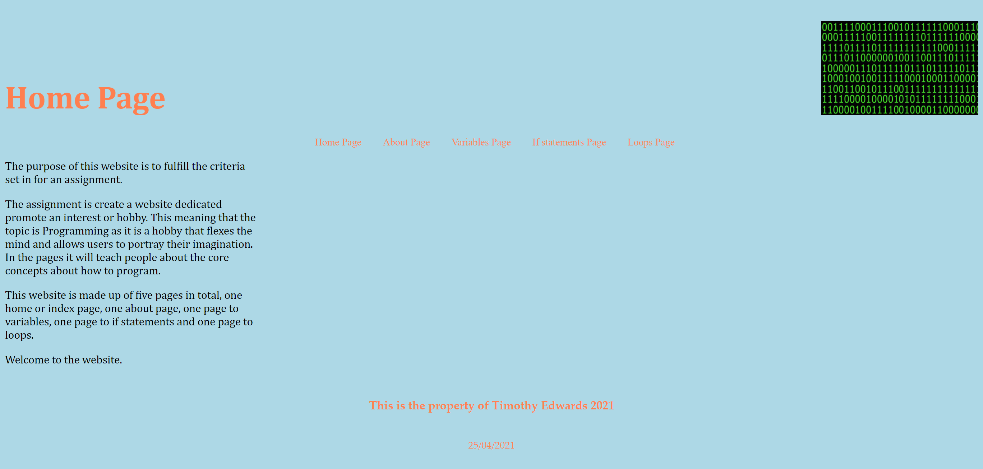
About Page
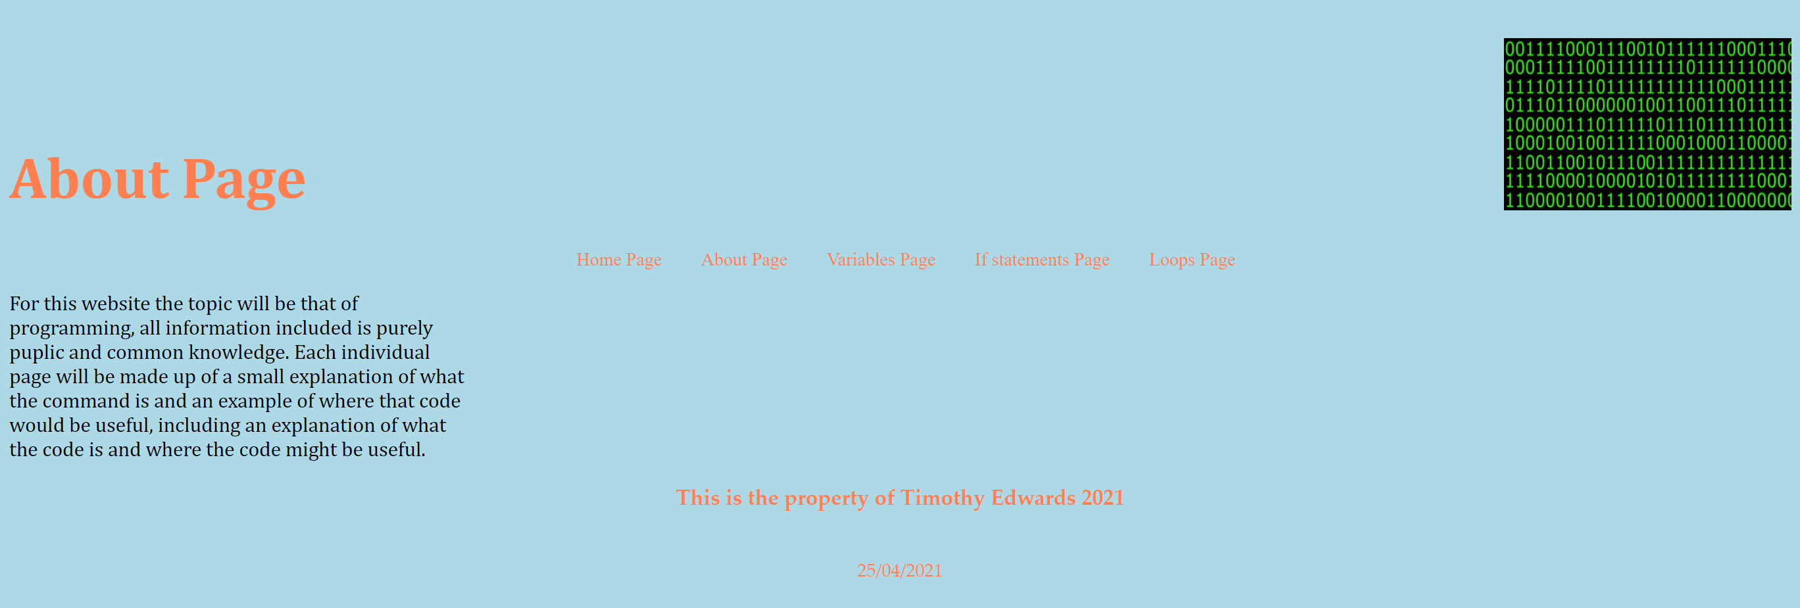
Variables Page
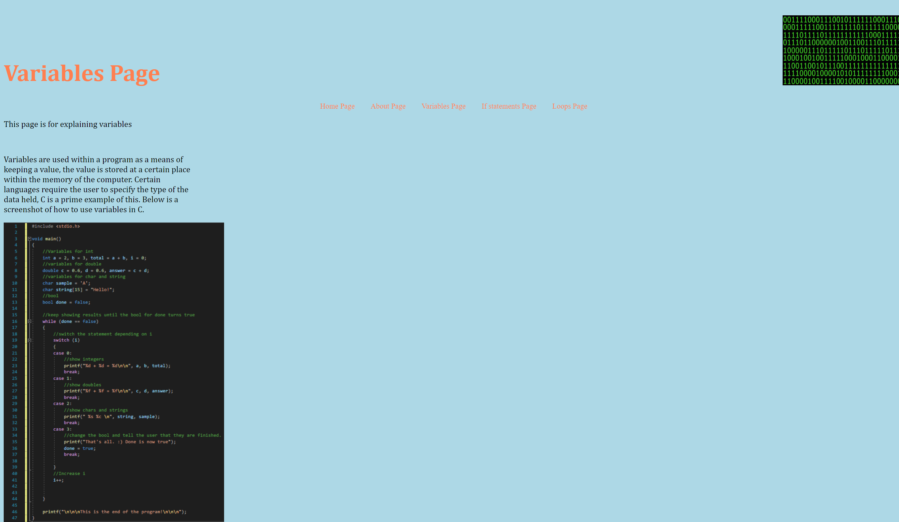
If Statement Page
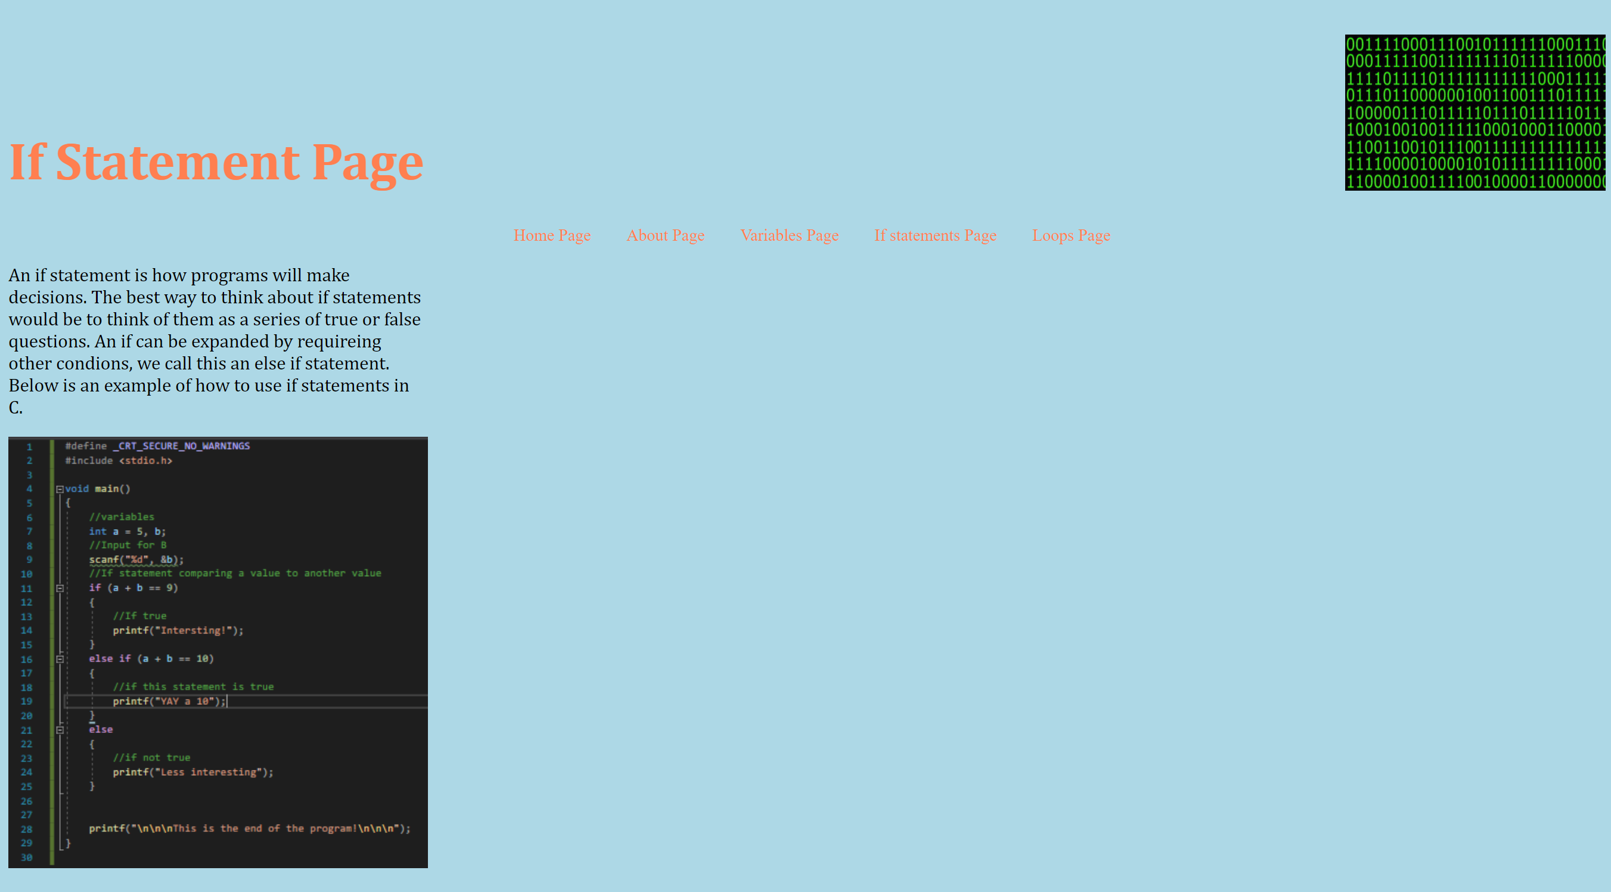
Loops Page
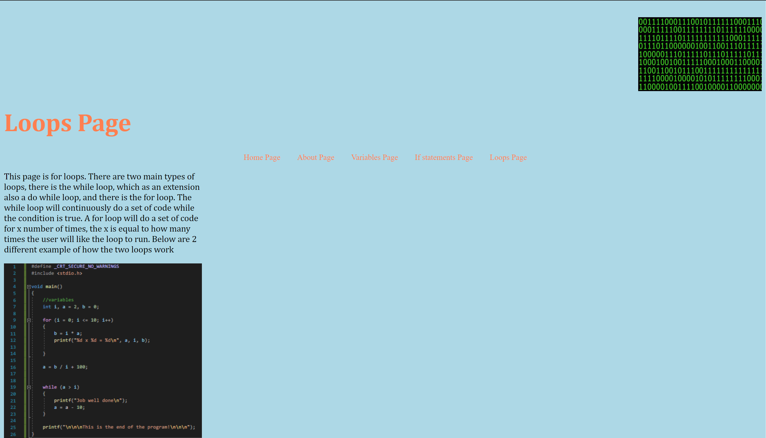
The picture labelled “Logo”, in the top right of every screen belongs to [1].
Validation
Home Page
The validator that was used had flagged four issues in total, the first two are warnings, one explaining that where the language of the document was defined could have a Language tag on it. And the other was a lack of headings used (h2-h6).
The other two issues were both errors, both of them sharing the same issue and that is the lack of CSS, in both cases claiming that <center> is obsolete. However, the <center> tag is used her as a means of putting the necessary text centre of the webpage, or at least centre of the line on the webpage.

CSS
The validation for the CSS showed 4 errors too. The first error is in the header tag, where there is a value error, the value of float: up does not exist. The next error was in the tag for a:link, the error here was “taxt-decoration” the correct one is “text-decoration”. Further, in the article the term “centre” is not a valid value for float. Finally, the error is in the footer, the property “fon-size” does not exist. The correct term is “font-size”.

Evaluation
For this section of the report, we will be looking at the term’s usefulness, accessibility and search engine optimisation. After looking at the terms we will apply it by looking at the programming website made for this report.

Usability
The usability of a website can be defined as extensive research that a website designer does to see if the website will appeal to the visiting user [2][3]. What is meant by this? This means that the user may stay to read about the topic more if they were captivated by the website. As a means of measurement, Usability evaluation is how it has done [2]. What does this entail this evaluation evaluates the effectiveness, users’ satisfaction, and efficiency throughout the use of the website. The website then gets a certain level of usability. The way that we can learn these attributes level can through many different means, including a survey we can ask any visitors of the website to fill out [2]. This will allow us to gauge where abouts the usability level is. A survey would also allow for us to see where the improvement for the website is. As an example, the user could state that the colour of the background is too bright with a little too bright of text. This will not only mean that the websites usability is low, but also it will mean that the text clashes with the background requiring a change of either the background or the text, probably the text. Usability can have a positive effect on people’s views of a website and even a positive effect on how people perceive organisations [3].

Accessibility
Web accessibility is a term used for people with disabilities to navigate or to use the website [4]. People who have changing needs will also have a use for Web accessibility. We use this for many different reasons, including failing eyesight, maybe in the event of a video, failing hearing, and many more reasons. Someone with difficulty reading may need narrative, this would also come under this topic. The guideline has a name of WCAG or the Web Content Accessibility Guidelines [4]. This guideline has 3 varying levels, Level A, Level AA and Level AAA. Each of these levels features different levels of accessibility, such as Level AA having the ability to dismiss any additional content on the page without moving the pointer or changing the keyboards focus.

Search Engine Optimisation
The aim of Search Engine Optimization, or SEO, is to increase the likelihood of a website turning up in the results page of a search engine [5]. By today’s standards, Search Engine Optimisation is closer to being an online marketing channel. At the moment, the top three search engines around are Google, Bing and Yahoo!, although Google is at the top of these. Result pages are generally made up of 2 sections, organic, which is the main body of the results and the pay per click, otherwise known as adverts [5]. Typically, the pay per click pages appear on the right hand side of the search page or at the top of the search page [5].

Now we will look at the programming website made for this report and see how it compares to the three sub-headings above.
Usability
Overall, the website is a rather basic site, the colour of the website remains the same throughout, Blue background, orange text for the header, footer and navigation, and black for the main body’s content. Thus, the text is consistent. The problem begins to stem when there are no page regions or containers. So as far as future improvements are concerned the first thing would be to have page regions, then as a lesser priority, though still a priority, add containers to the page. Maybe expand on the information in the main content too, the information may be relevant but more words explaining the content would be preferable, maybe even to the point of explaining step for step what is going on in the code. On the subject of, changing how the code is presented on the website is also a strong idea, as it will allow for the user to copy and paste the code into their projects instead of typing out the content from a screenshot.

Search Engine Optimisation
For the search engine optimisation, there is not any in the main body of the page, however, as a means to appear on the search results we are using meta tags. All pages share 2/3 of the keywords, the keywords shared is “Code, Learn”. Each page then has a unique keyword to go alongside it, as seen below.
“Assignment” – Home Page
“About” – About Page
“Variables” – Variables Page
“Ifs” – If Statement page
“Loops” – Loops page

Accessibility
Accessibility for the website has one error according to the app WAVE, and that error belongs to a photo which has missing alternative text. However, from examining the website’s code the error could not be found. The next thing would be the colour of the font and background to see if they comply with the WCAG standards. The main text font’s colour with the background as it is does in fact meet the standard, however, the colour of the font for the Page title, navigation bar, however, does not meet the standard of either AA or AAA, future improvements for this would therefore be exactly that, the changing the font colours so that they do in fact comply with the guideline.

References
[1] N. Russo, “To 1 or To 0: Translating Binary in Fiction”, Erindor Press, [Online], https://www.erindorpress.com/2019/06/to-1-or-to-0-translating-binary-in-fiction/, [21/04/2021]
[2] Qu, Qing-Xing, Guo, Fu, and Duffy, Vincent G, “Effective use of human physiological metrics to evaluate website usability,” Aslib journal of information management, vol. 69, no. 4, pp. 370–388, 17/07/2017., [22/04/2021]
[3] Braddy, Phillip W, Meade, Adam W, and Kroustalis, Christina M, “Online recruiting: The effects of organizational familiarity, website usability, and website attractiveness on viewers’ impressions of organizations,” Computers in human behavior, vol. 24, no. 6, pp. 2992–3001, 2008, [22/04/2021]
[4] Conway, Vivienne, Brown, Justin, Hollier, Scott, and Nicholl, Cam, “Website Accessibility: a Comparative Analysis of Australian National and State/Territory Library Websites,” The Australian library journal, vol. 61, no. 3, pp. 170–188, 08/2012, [22/04/2021]
[5] Visser, Eugene B and Weideman, Melius, “Fusing website usability and search engine optimisation,” South African journal of information management, vol. 16, no. 1, pp. 1–e9, 01/01/2014, [22/04.2021]

Appendices

Code listing: Home Page

<!doctype html>
<html>

<head>

<meta charset="utf-8">
<meta name="Keywords" Content="Code, Learn, Assignment">
<link href="Style_Sheet.css" rel="stylesheet"/>

<title>Index</title>
<script src="Scripts/swfobject_modified.js"></script>
</head>

<body>

<header>

<div id="logo">

<img src="Images/Logo.jpg" width = "250" height="150" alt="There are a series of 1s and 0s."/>

</div>

<h1>&nbsp; </h1>
<h1>Home Page</h1>

</header>

<nav>
<ul>
<li><a href="index.html"> Home Page</a></li>
<li><a href="about.html"> About Page</a></li>
<li><a href="variables.html"> Variables Page</a></li>
<li><a href="ifs.html"> If statements Page</a></li>
<li><a href="loops.html"> Loops Page</a></li>
</ul>
</nav>
<article>

<p>The purpose of this website is to fulfil the criteria set in for an assignment.</p>
<p>The assignment is create a website dedicated promote an interest or hobby. This meaning that the topic is Programming as it is a hobby that flexes the mind and allows users to portray their imagination. In the pages it will teach people about the core concepts about how to program.</p>
<p>This website is made up of five pages in total, one home or index page, one about page, one page to variables, one page to if statements and one page to loops.</p>
<p>Welcome to the website.</p>

</article>

<figure>

</figure>

<footer>
<center><h3> This is the property of Timothy Edwards 2021</h3></center><br>
<center>
<!-- #BeginDate format:Am3 -->25/04/2021
</center>
</footer>
</body>
</html>

Code Listing: About Page

<!doctype html>
<html>

<head>

<meta charset="utf-8">
<meta name="Keywords" Content="Code, Learn, About">
<link href="Style_Sheet.css" rel="stylesheet"/>

<title>About</title>
</head>

<body>

<header>

<div id="logo">

<img src="Images/Logo.jpg" width = "250" height="150" alt="There are a series of 1s and 0s."/>

</div>
<h1>&nbsp; </h1>
<h1>About Page</h1>

</header>

<nav>
<ul>
<li><a href="index.html"> Home Page</a></li>
<li><a href="about.html"> About Page</a></li>
<li><a href="variables.html"> Variables Page</a></li>
<li><a href="ifs.html"> If statements Page</a></li>
<li><a href="loops.html"> Loops Page</a></li>
</ul>
</nav>
<article>
<p>
For this website the topic will be that of programming, all information included is purely public and common knowledge. Each individual page will be made up of a small explanation of what the command is and an example of where that code would be useful.
</p>

</article>

<footer>
<center><h3> This is the property of Timothy Edwards 2021</h3></center><br>
<center>
<!-- #BeginDate format:Am3 -->25/04/2021
</center>
</footer>

</body>
</html>

Code Listing: Variables Page
<!doctype html>
<html>

<head>

<meta charset="utf-8">
<meta name="Keywords" Content="Code, Learn, Variables">
<link href="Style_Sheet.css" rel="stylesheet"/>

<title>Variables</title>
</head>

<body>

<header>

<div id="logo">

<img src="Images/Logo.jpg" width = "250" height="150" alt="There are a series of 1s and 0s."/>

</div>
<h1>&nbsp; </h1>
<h1>Variables Page</h1>

</header>

<nav>
<ul>
<li><a href="index.html"> Home Page</a></li>
<li><a href="about.html"> About Page</a></li>
<li><a href="variables.html"> Variables Page</a></li>
<li><a href="ifs.html"> If statements Page</a></li>
<li><a href="loops.html"> Loops Page</a></li>
</ul>
</nav>
<article>
<p> This page is for explaining variables</p>
<br>
<p>Variables are used within a program as a means of keeping a value, the value is stored at a certain place within the memory of the computer. Certain languages require the user to specify the type of the data held, C is a prime example of this. Below is a screenshot of how to use variables in C.</p>

<img src="Images/Variable_Example.PNG" alt="This is example of the code used to show how variables are used. It begins by setting the variables, it then progresses to a while loop to show the variables"/>

<br>
<br>
<br>

</article>

<footer>
<center><h3> This is the property of Timothy Edwards 2021</h3></center><br>
<center>
<!-- #BeginDate format:Am3 -->25/04/2021
</center>
</footer>

</body>
</html>

Code listing: If Statement Page

<!doctype html>
<html>

<head>

<meta charset="utf-8">
<meta name="Keywords" Content="Code, Learn, Ifs">
<link href="Style_Sheet.css" rel="stylesheet"/>

<title>If Statement</title>

</head>

<body>
<header>

<div id="logo">

<img src="Images/Logo.jpg" width = "250" height="150" alt="There are a series of 1s and 0s."/>

</div>
<h1>&nbsp; </h1>
<h1>If Statement Page</h1>

</header>

<nav>
<ul>
<li><a href="index.html"> Home Page</a></li>
<li><a href="about.html"> About Page</a></li>
<li><a href="variables.html"> Variables Page</a></li>
<li><a href="ifs.html"> If statements Page</a></li>
<li><a href="loops.html"> Loops Page</a></li>
</ul>
</nav>
<article>
<p>An if statement is how programs will make decisions. The best way to think about if statements would be to think of them as a series of true or false questions. An if can be expanded by requiring other conditions, we call this an else if statement. Below is an example of how to use if statements in C.</p>

<img src="Images/If_Example.PNG" alt="This is example of the code used to show how if statements are used. It begins by setting the variables, then asks the user for input and checks the total of the two variables and shows a different message if one is true.">

</article>

<footer>
<center><h3> This is the property of Timothy Edwards 2021</h3></center><br>
<center>
<!-- #BeginDate format:Am3 -->25/04/2021
</center>
</footer>

</body>
</html>

Code Listing: Loops Page

<!doctype html>
<html>

<head>

<meta charset="utf-8">
<meta name="Keywords" Content="Code, Learn, Loops">
<link href="Style_Sheet.css" rel="stylesheet"/>

<title>Loops</title>
</head>

<body>

<header>

<div id="logo">

<img src="Images/Logo.jpg" width = "250" height="150" alt="There are a series of 1s and 0s."/>

</div>

<h1>&nbsp; </h1>
<h1>&nbsp;</h1>
<h1>Loops Page</h1>
</header>

<nav>
<ul>
<li><a href="index.html"> Home Page</a></li>
<li><a href="about.html"> About Page</a></li>
<li><a href="variables.html"> Variables Page</a></li>
<li><a href="ifs.html"> If statements Page</a></li>
<li><a href="loops.html"> Loops Page</a></li>
</ul>
</nav>
<article>

<p>This page is for loops. There are two main types of loops, there is the while loop, which as an extension also a do while loop, and there is the for loop. The while loop will continuously do a set of code while the condition is true. A for loop will do a set of code for x number of times, the x is equal to how many times the user will like the loop to run. Below are 2 different example of how the two loops work</p>

<img src="Images/Loop_Example.PNG" alt="This is example of the code used to show how Loops are used. It begins by setting the variables, it will then loop and set a value to what ever value one thing is multiplied with another. It will then begin another loop to print a message and reduce a value.">

</article>

<footer>
<center><h3> This is the property of Timothy Edwards 2021</h3></center><br>
<center>
<!-- #BeginDate format:Am3 -->25/04/2021
</center>
</footer>

</body>
</html>

Code Listing: Style Sheet

@charset "utf-8";
/* CSS Document */

body
{
background-color:lightblue
}
h1
{
font-family: Cambria, "Hoefler Text", "Liberation Serif", Times, "Times New Roman", "serif";
font-size:50px;
color:coral;
}
p
{
font-family:Cambria, "Hoefler Text", "Liberation Serif", Times, "Times New Roman", "serif";
font-size:18px;
}
header
{
float:none;
}

#img
{
width: 100%;
height: auto;
}
#logo
{
float:right;
}
nav
{
padding-left:10px;
margin-top:10px;
}
nav ul
{
padding-left:0px;
text-align:center;
}
nav ul li
{
display:inline;
list-style-type:none;
}
nav ul li a
{
padding:15px;
text-decoration:none;
color:aqua
}
a:link
{
color:coral;
background-color:transparent;
text-decoration:none;
}
a:visited
{
color:lightcoral;
background-color:transparent;
text-decoration:none;
}
a:hover
{
color:beige;
background-color:transparent;
text-decoration:underline;
}
a:active
{
color:lime;
background-color:transparent;
text-decoration:underline;
}
article
{
float:none;
width:400px;
}
figure
{
float:right;
}
footer
{
font-family:Baskerville, "Palatino Linotype", Palatino, "Century Schoolbook L", "Times New Roman", "serif";
font-size:12px;
color:coral;
clear:both;
}
#main
{
clear:both;
}

