
31/07/2026

Assessment 1
Innovation & Research

Module NaMe: Changemakers, Creativity and Value creation
Module Code: ACCA 5033
Student NAME: Ma. crystal pearl grajewski
Student ID: 2442405
Lecturer: dr. fahad ahmed

UNIVERSITY OF WALES TRINITY SAINT DAVID
LONDON CAMPUS
Table of Contents

Introduction 2
Task 1 Ideation and Mind Map 3
1.1 Mind Map 3
Different Social Media Platform and its Features 4
Feature Drawbacks of Social Media 6
1.2 Ideation 10
Task 2 Project Scope 11
2.1 Project Proposal Aim and Objectives 11
2.2 Research Philosophy 12
2.3 Search Tools/Strategies 13
Task 3 Research Strategies 14
3.1 Validity, Reliability, Generalisability and Ethical Considerations 14
3.2 Research Strategies 15
3.3 Quantitative and Qualitative Analysis 15
Conclusion 16
Appendices 17
a. Primary Data 17
b. Secondary Data 21
References 23

Introduction

The rapid growth of digital technology has transformed the way people communicate, learn, work and generate income. Social media platforms such as Facebook, Instagram and Tiktok and other social media platforms enable users to connect and share content, while digital marketplaces such as Etsy and Fiverr etc. allow individuals to sell products and services. Although these platforms provide valuable opportunities, they each serve different purposes, requiring users to navigate multiple applications to establish an online presence, promote their work, communicate with customers and manage business.

At the same time, many single mothers continue to experience barriers to stable employment due to childcare responsibilities, limited flexible working opportunities, and financial pressures. While others possess valuable skills, knowledge, or entrepreneurial potential, existing digital platforms are not specifically designed to support their unique circumstances through an integrated and accessible solution.

Task 1 Ideation and Mind Map

1.1 Mind Map

Innovation is not only inventing technology but about to solve problem creating value for people. Innovation happens when creative ideas developed into practical solutions that help to improve lives or solve any problem.
Highlighting the Unit 1 Topic 1, my project proposal is based on the innovation of technology. In connection to the topic, EVALUENT is innovative because it brings several services in one platform focusing on single mother’s target user. Instead using separate apps for social networking, selling products, learning, advertise business, and finding support, EVALUENT combines these features into one community.

Mind Map Links:
https://mm.tt/map/4035849992?t=vjYfjb2euG

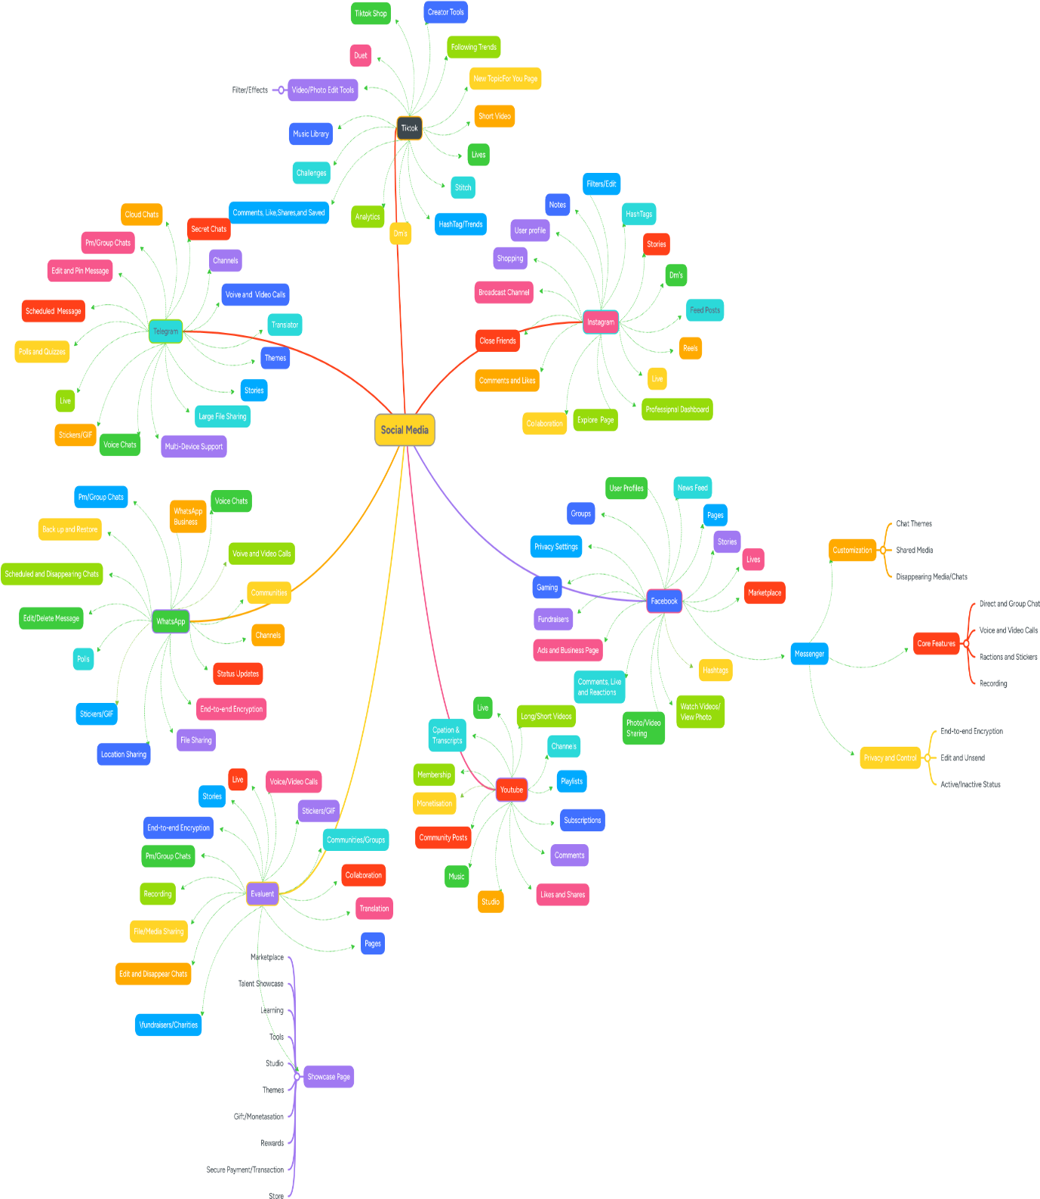

Different Social Media Platform and its Features
Figure 1
My Mind Map explores the theme of social media and how different platforms such as TikTok, Facebook, Instagram, WhatsApp, Telegram, and YouTube provide opportunities for communication, marketing, networking, and entrepreneurship. These platforms demonstrate how digital innovation has transformed society by creating new ways for individuals to connect, learn, and generate income. The mind map links to Unit 1 Topic 1 because it shows how creativity and innovation shape the world through technology. Social media platforms are examples of innovative digital solutions that have changed how businesses operate and how individuals create value. Features such as content creation, live streaming, digital marketing, online communities, and e-commerce enable users to develop creative ideas and turn them into economic opportunities. Creativity is used to produce engaging content and identify market opportunities, while innovation provides the digital tools that make these activities possible. Below is my mind in relation to my project proposal.

Existing social media platform provides communication, entertainment and content-sharing features, the study suggests that while social media has transformed communication, its popularity-driven design can encourage unhealthy online behaviours and reduce meaningful engagement. These limitations indicate a need for platforms that prioritise users' personal development and wellbeing rather than social validation.but they often lack dedicated support for vulnerable groups such as single mothers who want to develop sustainable income opportunities. Here are some drawbacks of social media features that greatly effect the well being of mostly people.

Mind Map Links:

https://mm.tt/map/4055602576?t=jHFBIXndpZ

Feature Drawbacks of Social Media

Drawback Features of
Social Media
WhatsApp
Primarily for communication
Less customer discovery
Less business tools functionality
Telegram
Less suitable in products/services
visibility
Limited functionality
Lack of business features
Youtube
Build up time
Monetisation threshold
Expense over productivity
Visibility
Facebook
Overload advertisement
Marketplace verification
Visibility competition
Paid promotion
Health Impact
More on social side
Privacy concern
Environmental Impact
Instagram
Paid promotion
Popularity based
Competition
TikTok
Algorithm reliance
Trends shortspan
Infinite scrolling

Figure 2
General Negative Impact of Traditional Social Media:

- Addiction and excessive screen time
- Cyberbullying
- Fake news and misinformation
- Privacy concerns
- Unrealistic lifestyle comparisons
- Popularity based on likes and followers
- Mental health issues
- Time wasting
- Limited focus on real economic opportunities
These issues create a gap between social interaction and meaningful personal or financial growth.
In response to these challenges, Evaluent is proposed as a purpose-driven social platform that shifts the focus from popularity and entertainment to entrepreneurship, skills development, learning, and professional networking. By providing online business opportunities, educational resources, and a supportive community, Evaluent aims to create a more productive digital environment that empowers users, particularly single mothers, to achieve financial independence and personal growth.
Evaluent combines the strengths of these platforms while addressing their limitations by creating a trusted, community-driven environment where users can showcase skills, promote businesses, access learning resources and build financial independence.

Social media has become an essential part of modern communication, providing users with opportunities for interaction, information sharing, and community engagement. However, H. Pang (2022) highlights that social media can also create several negative impacts on individuals and society. The study discusses issues such as social media addiction, excessive usage, social comparison, emotional stress, online violence, and reduced quality of real-life interactions. These negative consequences suggest that although social media platforms provide valuable communication benefits, their current designs may encourage unhealthy patterns of engagement, where users focus more on attention, popularity, and continuous consumption rather than meaningful personal development [1].

Further research, The Relationship Between Social Media Use and Mental Health: The Role of Motivations to Use Social Media, Mindfulness, and Self-Compassion, provides a more balanced perspective by examining both the positive and negative aspects of social media usage. (See Appendices for secondary data references)
Based on these limitations, Evaluent is proposed as an alternative social platform designed to transform online interaction into a more purposeful and empowering experience. Unlike traditional social media platforms that often measure success through popularity, likes, and followers, Evaluent focuses on users’ skills, talents, learning, and economic opportunities. The platform aims to support single mothers and aspiring entrepreneurs by combining social networking with online stores, business opportunities, educational resources, and professional connections. By shifting the focus from attention-based engagement to value creation, Evaluent seeks to create a digital environment where users can develop their abilities, build confidence, connect with supportive communities, and generate sustainable income.

How Evaluent is Different

Traditional Social Media | Evaluent
Focuses on entertainment | Focuses on income generation
Success measured by  likes and followers | Success measured by business growth and skills
 | Success measured by business growth and skills
Endless scrolling | Productive activities and learning
Influencer culture | Entrepreneur and talent development
Social popularity | Economic empowerment
General networking | Business networking and mentorship
Sharing personal life | Showcasing products, services, and talents
Content consumption | Skill development and entrepreneurship
Marketplace is secondary | Marketplace is a core feature
Anyone can post anything | Encourages meaningful, value-driven content

Recent research indicates that many low-income single mothers continue to experience financial insecurity, relying on multiple income sources and support networks to meet their families' needs. These findings demonstrate the need for digital platforms that not only facilitate social interaction but also provide opportunities for entrepreneurship, learning, networking, and income generation. Evaluent addresses this gap by integrating business tools, online marketplaces, educational resources, and professional networking into a single platform [2].

1.2 Ideation

The idea of a proposal project Evaluent as an integrated digital entrepreneurship platform specifically targeting single mothers base on today’s social and economic conditions because they often experience barrier to achieve financial stability while balancing childcare responsibilities.
From this ideation process, I selected my project proposal, Evaluent, an app designed to support single mothers in earning income through social media. The app will bring together learning resources, social media guidance, business support, networking opportunities, and income-generation tools. This project creates value for both individuals and society by helping single mothers improve their financial independence, develop digital skills, and access flexible employment opportunities. The idea demonstrates how innovation can address real social challenges while creating positive social and economic impact.

Research has shown that many low-income single mothers face financial hardship, social stigma, and limited opportunities for economic independence. However, access to education and supportive environments can strengthen their resilience, improve their self-efficacy, and motivate them to pursue better opportunities for themselves and their children. These findings suggest that digital platforms combining learning resources, supportive communities, and income-generating opportunities may contribute to empowering single mothers. Evaluent is designed with this objective by integrating business networking, online commerce, and educational resources into one platform [3]

Task 2 Project Scope

2.1 Project Proposal Aim and Objectives
The idea of a proposal project Evaluent as an integrated digital entrepreneurship platform specifically targeting single mothers base on today’s social and economic conditions because they often experience barrier to achieve financial stability while balancing childcare responsibilities [4]

Project title: EVALUENT: An Integrated Digital Entrepreneurship Platform (for single mothers)

Evaluent is a proposed platform idea project to empower single mothers by providing all in one digital space where they can create personalized business profile , showcase their skills, services or products, connect with customers/friends, access learning resources, and engage in a supportive community.
Aim: The platform aims to reduce barriers to entrepreneurship by combining multiple digital services into single, user-friendly application.
Objectives:
- Investigate financial and employment challenges faced by single mothers through current academic and industry report/research.
2. Analyse existing platform (eg. Facebook, Tiktok, Instagram, Telegram, WhatsApp, Youtube, and maybe in e-commerce platform such as Etsy, Fiverr etc) to compare and identify their strength, limitations, gaps to enhance or support the making of Evaluent.
- Review existing social media and digital business platforms to identify useful features and gaps.
- Design a user-friendly interface and user experience in a way that the user find it easy to use without requiring advanced technical skills.
- To propose an integrated platform (Evaluent) that could support entrepreneurship, learning, networking, and income generation for single mothers.
- Demonstrates how the platform support entrepreneurship and income generation/profit making possibly with real currency or as a form of a gift.
- Evaluate the potential social and economic value of the proposed platform.

2.2 Research Philosophy

In my perspective, pragmatism is the most suitable research philosophy because it focuses on solving practical problems and producing useful outcomes rather than relying on a single method of research. According to Unit 1 Topic 2, research philosophy guides how researchers understand knowledge and choose the most appropriate methods to answer their research questions. Pragmatism supports the idea that the research approach should be based on what works best to achieve the project's objectives, allowing researchers to combine both qualitative and quantitative methods when necessary.
This philosophy aligns well with the proposed Evaluent application, which aims to help single mothers improve their financial independence by providing a platform where they can showcase their skills, services, and small businesses. The project is not only interested in understanding the challenges faced by single mothers but also in developing a practical solution that can create social and economic value.
A pragmatic approach allows the research to collect qualitative data through interviews or questionnaires to understand user’s experiences while also gathering quantitative data, such as survey results and user feedback, to evaluate the effectiveness of the application.
Furthermore, pragmatism supports innovation, creativity, and problem-solving, which are key principles of the Changemaker, Creativity and Value Creation module. Rather than focusing solely on theories, the philosophy encourages developing solutions that can be implemented in real-life situations [5].
Since Evaluent is designed to address a genuine social issue by creating opportunities for single mothers to earn income and build supportive communities, pragmatism provides the flexibility needed to design, test, and improve the application based on users' needs. Therefore, this philosophy is appropriate because it connects research with practical action and supports the project's goal of creating meaningful social impact.

2.3 Search Tools/Strategies
Search Tools/  Database | Strategy Tools | Links
Google Scholar | “Negative Impact of  Social Media”  AND all aspects of life | The Negative Impact of Social  Media on People’s Lives |  Atlantis Press
Google Scholar | ("single mothers" OR  "single-parent  families") AND  ("low income" OR  "financial hardship")  2026 | Making Ends Meet Thirty Years  Later: How Single Mothers  Survive on Low Incomes |  RSF: The Russell Sage  Foundation Journal of the  Social Sciences
University Library/  UWTSD/  Wiley Library | “single mothers” AND  financial  independence | Resilient self‐efficacy and  transformative growth of poor  single mothers and their  children: Higher education -  Geiger - 2023 - Family Relations -  Wiley Online Library
Springer Nature Link/  Google Scholar | "parenting student"  AND "financial  stability" AND  "single parents" | Parenting Students and  Indicators of Financial Stability,  Health, and Academic Success:  Findings from a Population-  Based Sample of Public Urban  University Students | Journal of Urban  Health | Springer Nature Link
University Library/  UWTSD | "research methods"  AND philosophy | UWTSD Library Catalogue -  "research methods" AND  philosophy
Google Books | "research" AND  quantitative and  qualitative method  AND creswell | Research Design - Google Books
Springer | “social media use”  AND “mindfulness” | The Relationship Between Social  Media Use and Mental Health:  The Role of Motivations to Use  Social Media, Mindfulness, and  Self-Compassion | Journal of  Technology in Behavioral  Science | Springer Nature Link
ProQuest | ("single-parent mothers")  AND  ("employment barriers"  OR job opportunities)  AND  "challenges and needs" | Exploring the Challenges and  Needs of Single Parents:  A Qualitative Case Study -  ProQuest
Google Scholar | "financial hardships of  single mothers"  review | The_financial_hardships_of_single_mothers_  A_review-libre.pdf
Office for National  Statistics (ONS) | “employment status of  single parents” | Employment rates of people by parental  status: Table P - Office for National Statistics

Task 3 Research Strategies

3.1 Validity, Reliability, Generalisability and Ethical Considerations

Following the principles of Unit 2 Topic 2: Finding a Needle in a Haystack, the research will use appropriate sampling, data collection, and ethical practices to ensure that the information collected is relevant, trustworthy and
Validity
Improved by collecting information from trusted and credible academic journals, books, reports and government publications.
Reliability
Using consistent data collection methods, clear and easy question for surveys will enhance reliability and can be use in future for re study and compare results.
Generalisability
Though the target user for this proposal is single mothers, this is mostly a general approach for some individuals seeking flexible work/income opportunities.
Ethics
Obtaining information from participants (survey) with their consent before collecting data. Participants are well informed what and how the data is collected and explained that the personal information would remain anonymous and confidential and the data collected was use for academic purposes only.

3.2 Research Strategies
The research will adopt a pragmatic research strategy because the project aims to develop a practical solution for single mothers. Pragmatism allows the use of both qualitative and quantitative research methods to gain a better understanding of users' needs and evaluate whether the proposed features of Evaluent are suitable. This approach provides flexibility and enables the researcher to collect different types of data that can improve the application's design.
Primary data is collected using online questionnaire sent to different people, mostly target user which is single mothers, but to obtain more participants, I sent to women, single, mother, widow status and in different countries/ethnic group, I also include 2 men to ask with the app general purpose. The questionnaire and result will be seen in appendix section/page.
The secondary data is collected through references such as academic journal, books, government publications. These resources will provide evidence to support the research and identify existing gaps that Evaluent aims to address.

3.3 Quantitative and Qualitative Analysis

The Evaluent project use both quantitative and qualitative analysis to understand the needs and preferences of single mothers. This mixed approach supports the pragmatic research philosophy by combining numerical data with participants' experiences. It also reflects the learning outcomes of Unit 4 Topic 1: It's All in the Numbers and Unit 4 Topic 2: There's a Theme Here, where numerical analysis and thematic analysis are used together to produce meaningful research findings.
Creswell and Creswell (2017) state that mixed methods research combines qualitative and quantitative approaches to provide a more comprehensive understanding of a research problem by integrating numerical findings with participants experiences [6].

Conclusion

This project proposal has demonstrated the potential of Evaluent as a digital platform designed to support single mothers by providing opportunities for entrepreneurship, skill development, business promotion and community support. The proposal was developed using a pragmatic research philosophy supported by both quantitative and qualitative research methods. Primary data were collected through an online questionnaire, while secondary data from academic books, peer-reviewed journals, government publications and reports highlighted the financial, social and employment challenges experienced by many single mothers. The research also considered validity, reliability, generalisability and ethical principles to ensure the quality and credibility of the findings. Overall, the evidence gathered supports the need for Evaluent as a practical solution that could help empower single mothers and improve their access to income-generating opportunities.
From completing this proposal, I have gained a deeper understanding of the research process and the importance of making evidence-based decisions when developing a project. I learned how to identify reliable academic sources, select appropriate research methods, design a questionnaire, conduct a pilot study and interpret both quantitative and qualitative data. This experience has improved my research and critical thinking skills and has shown me that successful digital solutions should be based on the real needs of users rather than assumptions. I believe the knowledge and skills I have developed throughout this project will help me continue improving Evaluent into a meaningful and valuable platform for its intended users.

Appendices

a. Primary Data
Primary data for the Evaluent project was collected using a self-administered online questionnaire developed in Google Forms. The questionnaire contained both closed-ended and open-ended questions to gather quantitative and qualitative data from participants about their use of social media platforms, business interests and opinions on the proposed features of Evaluent.

Survey
https://docs.google.com/spreadsheets/d/1x9P0qoGACha39iXC_79wbgHkMwPWRwnLCLHg8asKqgE/edit?usp=sharing

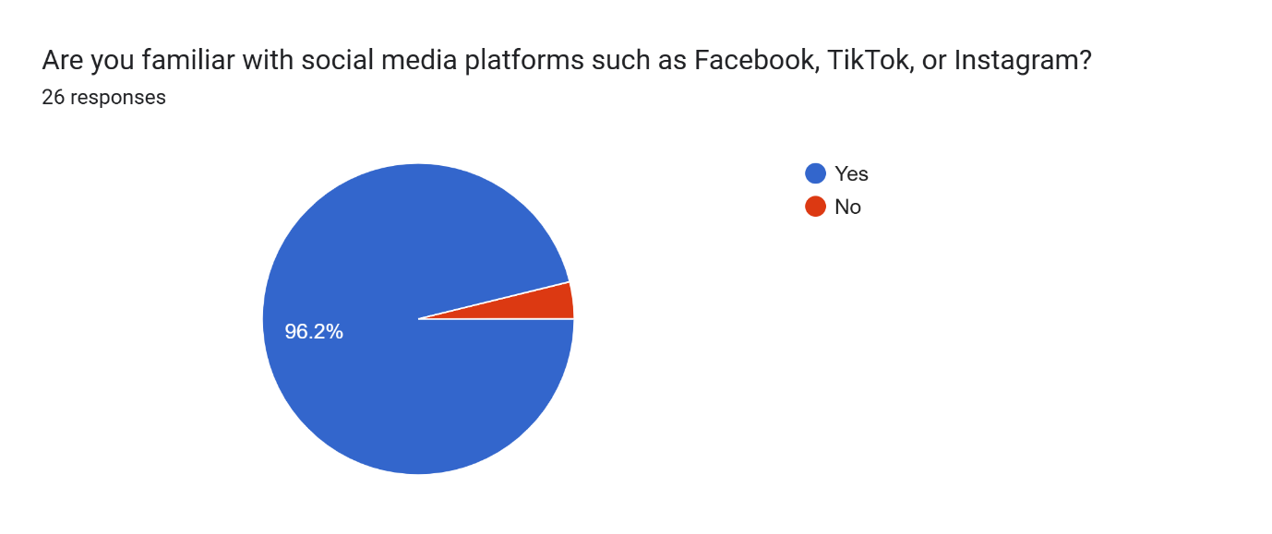

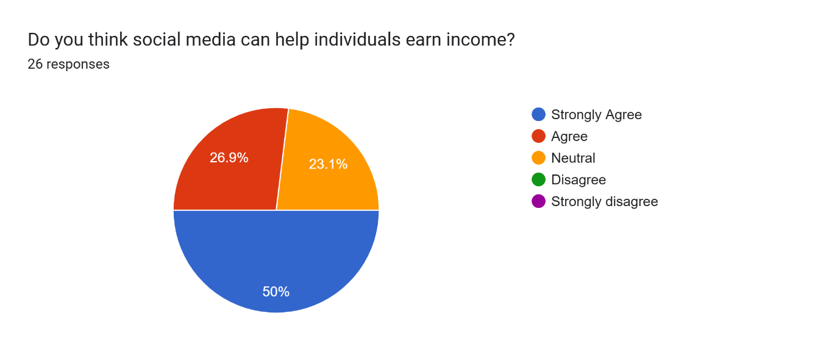

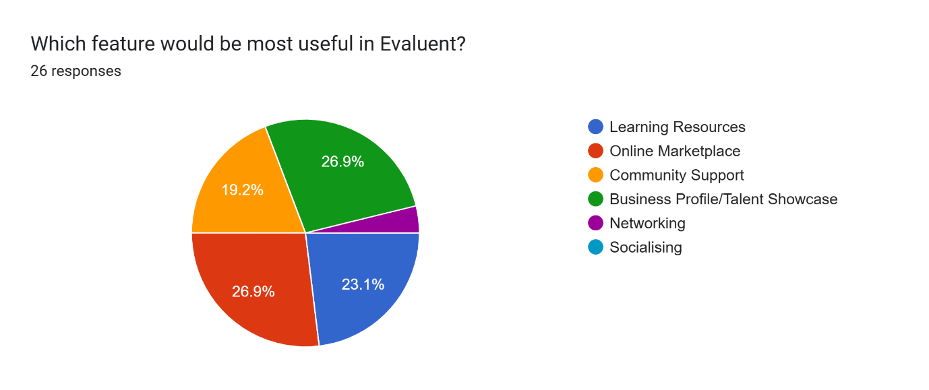

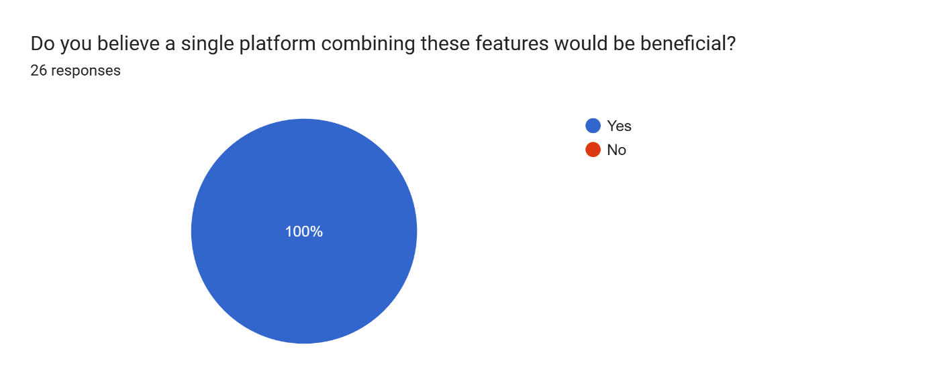

(Open-ended question)

Any suggestions for improving the proposed platform?
(26 responses)

*None
*No
*Add affordable and easy to use business tools to help single mothers promote and grow their businesses without paying expensive fee
*I would recommend expanding Evaluent App beyond a traditional social networking platform by integrating features that directly support entrepreneurship and professional development for single mothers in Italy. The application could include a business marketplace, networking opportunities, mentoring programmes, and access to educational resources and job opportunities. Integrating AI-powered tools for business planning, marketing, grant discovery, and career guidance would significantly increase the platform's value. It would also be beneficial to develop local community groups and partnerships with public institutions, NGOs, and organisations supporting women entrepreneurs. Future versions of the app could include childcare support services and funding opportunities to address the practical challenges faced by single mothers. A freemium business model with optional premium services could help ensure both accessibility and long-term financial sustainability. Overall, these additions could transform Evaluent App into a comprehensive digital ecosystem that empowers single mothers to achieve greater financial independence and professional success. If you are looking for development company I would recommend: www.evolutionofdreams.com/en. A few years ago we created 2 apps about improving children's sleep - Unicorn baby and Omm Parenting. The consultation is free.
*Create more informative and useful content.
*none
*Credo che nella terza domanda, sarebbe buono avere la possibilità di due funzionalità, io ad esempio avrei aggiunto le reti, o il socializzare ( che per una mamma single può essere utile avere supporto da altre mamme)
*No
*No good
*-
*im not frequently using social media but if this app help to have income then im willing to try
*I would like to suggest that it will be open or offered throughout the whole world so that all single mothers will enjoy and benefit this platform.
*Easy akces
*Use platform that are more user-friendly,engaging,and useful for learning business, networking and community interaction
*Local. Put a maximum request for each user
*I suggest including practical support that single mothers truly need, such as affordable online job opportunities, financial literacy lessons, mental health support, childcare resources, and a community where we can connect with other single mothers. The platform should also be easy to use, mobile-friendly, and provide trusted mentors who can guide us in building a better future for ourselves and our children.
*Advertising at the start, good design, and ease of use
*Add tools to help users promote their products and services on social media and reach more customers.And access free business training.
*For single mother doing online business, this platform can use to help her business grow, a big help also if there's platform or tools that offer free ads making for business, boost page, and etc.
*Easy to access for monetization
*Provide free learning resources, a safe marketplace, verified profiles, job opportunities, easy payment options, and strong privacy and security. Keep the platform simple, user-friendly, and mobile-friendly.
*Increase in information useful for daily life.
*I'm not sure; I'd like some advice on parenting.
*I believe a crucial point is that not just anyone should be able to comment on whether someone is talented or not. If people want to post videos or photos showcasing their talent—even if they aren't exceptionally skilled—they should be able to show what they can do without facing judgment from others, especially haters.

b. Secondary Data
Secondary data for this study were obtained from either academic books, peer-reviewed journal articles, government publications and research reports. These sources consistently show that many single mothers experience financial hardship, employment barriers and the challenge of balancing work responsibilities with childcare and household duties. The literature also highlights that access to flexible employment, digital opportunities and supportive communities can improve their economic and social outcomes. This evidence provides the rationale for proposing Evaluent, a digital platform designed to help single mothers showcase their skills, promote businesses, access learning opportunities and build supportive networks that may strengthen their financial independence and personal development.

Supporting references:

Further research, The Relationship Between Social Media Use and Mental Health: The Role of Motivations to Use Social Media, Mindfulness, and Self-Compassion, provides a more balanced perspective by examining both the positive and negative aspects of social media usage. The study suggests that the impact of social media is not determined only by the platform itself, but also by users’ motivations and behaviours. While social media can support connection, communication, and self-expression, certain motivations such as habitual checking, boredom, or emotional dependence may be associated with negative mental health outcomes, including increased depressive symptoms. This indicates that the purpose and design of a social media platform can influence whether users experience positive growth or harmful effects [7].

The study explores the lived experiences of single parents to better understand the challenges they face and the types of support they need. Using a qualitative case study approach, it examines participants' personal experiences, allowing them to describe their financial, emotional, social, and practical difficulties in depth. The findings highlight that single parents often face multiple responsibilities simultaneously, including earning an income, raising children, managing household responsibilities, and coping with limited support networks. The study also emphasises the importance of accessible support systems, education, community resources, and opportunities that help single parents become more independent and improve their quality of life [8].

Dharani and Balamurugan (2024) reviewed two decades of research and found that single mothers experience persistent financial hardship, higher risks of poverty, psychological stress, and limited access to support systems. The review emphasises the importance of social support, community resources, and policies that promote financial stability and resilience. These findings support the need for Evaluent, which aims to empower single mothers by providing online business opportunities, learning resources, professional networking, and a supportive digital community [9]

The Office for National Statistics (ONS) reports that employment rates differ according to parental status, with lone parents generally experiencing lower employment levels than parents living with a partner. These figures highlight the employment inequalities and financial challenges that many single parents continue to face while balancing childcare and work responsibilities [10].

References
[1] H. Pang, "The negative impact of social media on people’s lives", in 2021 International Conference on Social Development and Media Communication (SDMC 2021), pp. 554–557.
[2] N. V. Pilkauskas and K. Bruey, "Making Ends Meet Thirty Years Later: How Single Mothers Survive on Low Incomes," vol. 12, no. 2, pp.57–82, 2026,
[3] B. Geiger, "Resilient self‐efficacy and transformative growth of poor single mothers and their children: Higher education," vol. 72, no. 5, pp.2410–2428, 2023, doi: 10.1111/fare.12872.
[4] J. Sanborn, M. Manze and D. Watnick, "Parenting students and indicators of financial stability, health, and academic success: Findings from a population-based sample of public urban university students," vol. 101, no. 2, pp.371–382, 2024,
[5] M. N. K. Saunders, P. Lewis and A. Thornhill,Research methods for business students, New York: Pearson, 2019.
[6] J. W. Creswell and J. D. Creswell,Research design: Qualitative, quantitative, and mixed methods approaches, Sage publications, 2017.
[7] A. G. Harvey and S. N. Aikman, "The relationship between social media use and mental health: The role of motivations to use social media, mindfulness, and self-compassion," pp.1–14, 2025,
[8] K. Shy, "Exploring the Challenges and Needs of Single Parents: A Qualitative Case Study," Amridge University, United States -- Alabama, 2025. [Online]. Available:
[9] M. K. Dharani and J. Balamurugan, "The financial hardships of single mothers: A review of two decades," vol. 7, no. 8, pp.2024179, 2024,
[10] Office for National Statistics. "Employment rates of people by parental status: Table P." https://www.ons.gov.uk/.

