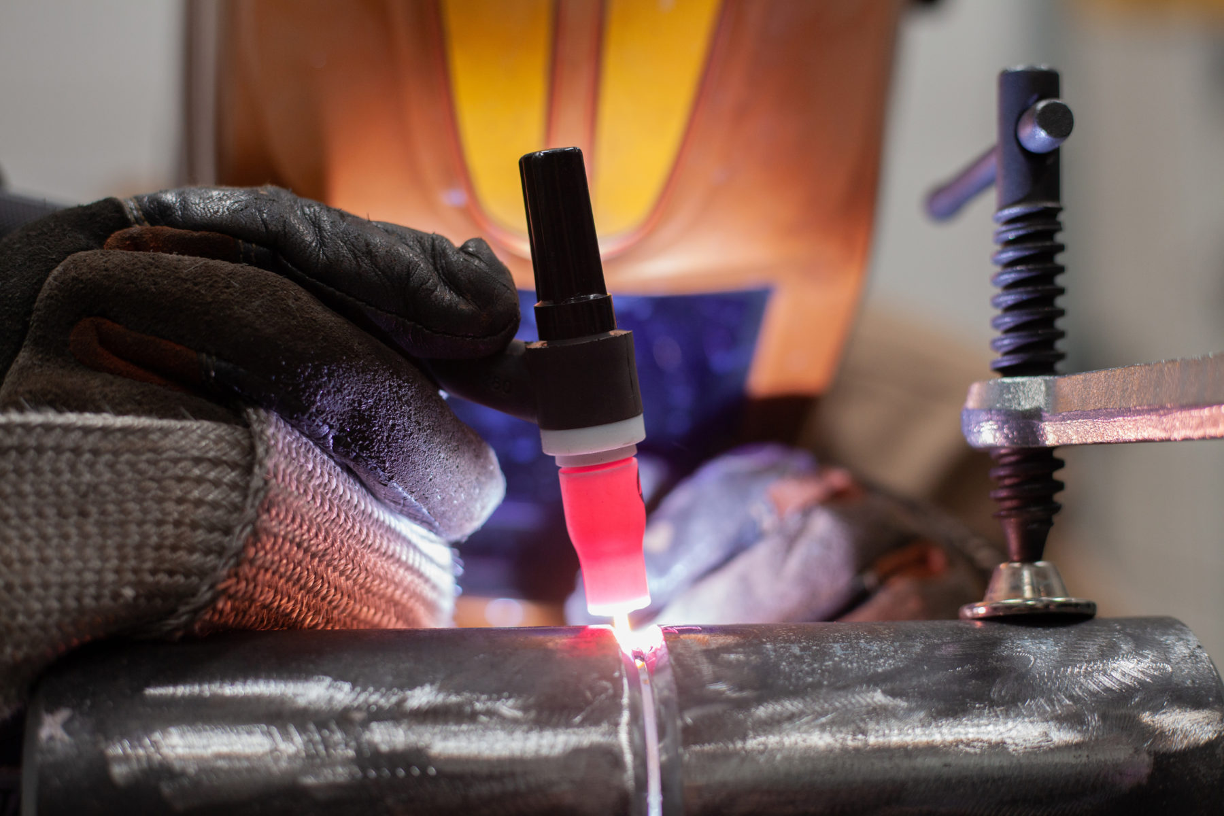  Control of Distortion and Dilution in Critical Pressure Vessel Welds Using Gas Tungsten Arc Welding (GTAW)  Mechanisms of Material Failure | Anthony Walker 2519861  Meng Msc ACHA 7019

Table of Contents
Abstract 2
1. Introduction 2
2. Welding Process and Application 3
2.1 Gas Tungsten Arc Welding (GTAW) 3
2.2 Application: Pressure Vessel Plate Butt Welds 3
2.3 Materials Used (Base and Filler Materials) 4
3. Control of Distortion and Dilution in GTAW 4
3.1 Heat Input and Distortion Control 4
3.2 Dilution Control 5
4. Welding Preparations 5
4.1 Joint Design and Preparation 5
4.2 Fit-Up, Restraint, and Jigging 6
5. Welding Procedure 6
5.1 Root Pass 6
5.2 Fill and Cap Passes 6
5.3 Preheat and Post-Weld Heat Treatment 7
6. Degree of Internal and External Stress Applied 7
6.1 Internal Residual Stresses Generated During GTAW 7
6.2 External Stresses Introduced During Fabrication 8
6.3 Interaction Between Residual and Service Stresses 8
6.4 Code-Based Requirements for Stress Control 8
6.5 Comparative Perspective: GTAW versus GMAW 8
6.6 Integrated Stress Mitigation Strategy in GTAW 9
6.7 Hydrogen Embrittlement and Hydrogen-Assisted Cracking 9
7. Metallurgical Factors Affecting Distortion and Dilution 9
7.1 Thermal Contraction and Residual Stress 9
7.2 Phase Transformations 10
7.3 Microstructure and Grain Size 10
7.4 Intermetallic Formation and Dilution 11
8. Conclusion 11
References 12

Abstract
Welding-induced distortion and metallurgical dilution present major challenges in the fabrication of critical load-bearing structures. In industries such as petrochemical processing, power generation and aerospace, welded joints must satisfy stringent requirements related to dimensional accuracy, mechanical integrity, and long-term reliability. This paper examines Gas Tungsten Arc Welding (GTAW) applied to butt welding of pressure vessel steel plates, with particular emphasis on the mechanisms of distortion and dilution and the methods used to control them. Process parameters, joint preparation, welding procedures and metallurgical phenomena are analysed to demonstrate how GTAW can produce high-integrity welds suitable for safety-critical applications.

1. Introduction
Welding and fabrication by fusion and solid-state processes are essential manufacturing methods in modern engineering. Whilst welding distortion may be acceptable in non-critical structures, it becomes a critical concern in load-bearing applications where dimensional inaccuracies can lead to residual stresses, reduced fatigue life, or catastrophic failure. Distortion arises primarily from non-uniform heating and cooling during welding, resulting in differential thermal expansion and contraction (Kou, 2003).
Dilution, defined as the proportion of base metal mixed with the filler metal in the weld pool, is another key consideration, particularly in critical welds and cladding operations. Excessive dilution can adversely affect corrosion resistance, mechanical properties, and compliance with design specifications (Lancaster, 1999).
Critical welds are commonly encountered in pressure vessels, pipelines, aerospace structures, and transport systems, where failure can have severe safety and economic consequences. For these applications, precise control of heat input, metallurgical transformations, and weld geometry is essential.
This assignment focuses on Gas Tungsten Arc Welding (GTAW), a fusion welding process renowned for its high-quality welds and precise thermal control. The selected application is the butt welding of carbon-manganese steel plates used in pressure vessels. The discussion addresses welding process characteristics, joint preparation, welding procedures, and metallurgical factors influencing distortion and dilution.

2. Welding Process and Application

2.1 Gas Tungsten Arc Welding (GTAW)
Gas Tungsten Arc Welding is a fusion welding process in which an electric arc is formed between a non-consumable tungsten electrode and the workpiece. The weld pool is shielded from atmospheric contamination by an inert gas, typically argon or argon–helium mixtures. Filler metal is added separately, allowing independent control of heat input and weld metal composition.
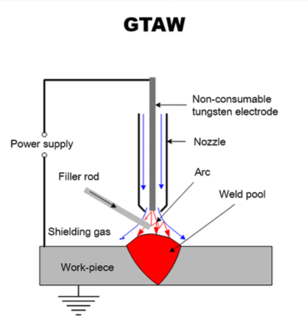
Figure 1. Schematic of the GTAW Process

Key advantages of GTAW for critical welding include:
- Precise control of heat input
- Excellent weld pool visibility
- Low hydrogen weld metal
- Superior control of dilution
- High-quality, defect-free welds
These characteristics make GTAW particularly suitable for applications requiring stringent quality assurance and metallurgical control.

2.2 Application: Pressure Vessel Plate Butt Welds
The selected application involves butt welding of carbon-manganese or low-alloy steel plates with thicknesses typically ranging from 8 to 20 mm. Such plates are widely used in pressure vessels operating under elevated pressures and temperatures in petrochemical and power generation industries.
Pressure vessel welds are classified as critical due to:
- High internal pressure loading
- Exposure to corrosive and high-temperature environments
- Strict regulatory requirements under codes such as ASME Section VIII and IX
Any distortion leading to misalignment or excessive residual stress can compromise the structural integrity and service life of the vessel.

2.3 Materials Used (Base and Filler Materials)
The materials selected for critical pressure vessel welding have a significant influence on distortion, residual stress development and dilution behaviour. The base material considered in this application is a carbon-manganese pressure vessel steel, representative of grades such as ASME SA-516 Grade 70 or EN P355 steels, widely used in unfired pressure vessel construction. Filler materials are selected to closely match the chemical composition and mechanical properties of the base material, typically ER70S-2 or ER70S-6.
Property | Base Material (SA-516 Gr.70 / EN P355) | Filler Material (ER70S-2 / ER70S-6)
Carbon content (wt%) | 0.18–0.22 | 0.08–0.12
Yield strength (MPa) | 260–355 | 420
Tensile strength (MPa) | 485–620 | 540–670
Elongation (%) | 21–27 | 22–28
Hardness (HB) | 120–180 | 140–180
Carbon equivalent (CE) | 0.45 max | 0.35 max
Thermal conductivity (W/m·K) | 46 | 45
Coefficient of thermal expansion (10^-6 /°C) | 12 | 13

This table highlights the close match between base and filler materials in terms of mechanical and thermal properties, ensuring minimal metallurgical incompatibility, controlled dilution and reduced residual stress accumulation. Material selection, combined with the precise heat input control of GTAW this underpins the success of critical pressure vessel welds.
From a distortion perspective, the thermal conductivity, coefficient of thermal expansion and phase transformation behaviour directly influence heat flow and contraction behaviour during welding. The precise heat and filler control offered by GTAW makes it particularly suitable for such applications.

3. Control of Distortion and Dilution in GTAW

3.1 Heat Input and Distortion Control
Heat input is one of the primary factors influencing welding distortion and is expressed as:
$$Q=\frac{VI }{S}$$
where V is arc voltage, I is welding current, and S is travel speed. GTAW allows fine adjustment of each parameter, enabling the welder to minimise overall heat input while maintaining adequate penetration.
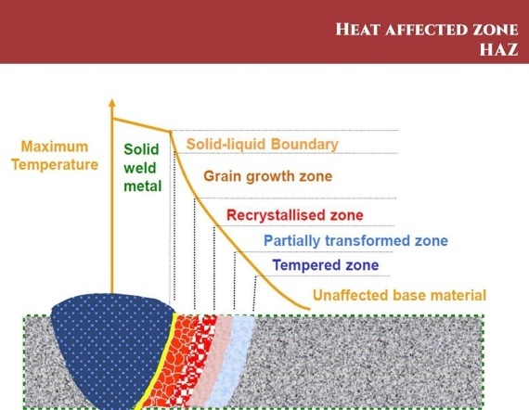
Figure 2. Thermal Gradient and Heat Affected Zone in GTAW

The concentrated arc and relatively low heat input of GTAW produce a narrow heat affected zone (HAZ), reducing thermal gradients and limiting angular and longitudinal distortion. The use of pulsed GTAW further enhances control by alternating between high peak current and low background current, allowing partial solidification between pulses and reducing cumulative heat input (Messler, 2004).

3.2 Dilution Control
Dilution is influenced by weld pool size, penetration depth and base metal melting rate. In GTAW, filler metal addition is independent of the arc, enabling precise control over weld metal composition. This is particularly important in applications requiring corrosion-resistant overlays or strict chemical composition limits.
Lower arc forces and reduced weld pool turbulence in GTAW result in controlled mixing between filler and base metal, thereby minimising dilution compared to consumable electrode processes such as Gas Metal Arc Welding (GMAW).

4. Welding Preparations

4.1 Joint Design and Preparation
Proper joint preparation is essential for controlling distortion and ensuring adequate penetration. For pressure vessel butt welds, single-V or double-V groove preparations are commonly used.
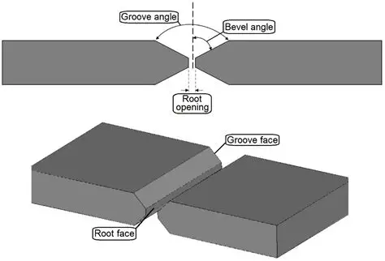
Figure 3. Double-V Butt Joint Preparation

Double-V preparations reduce weld metal volume and total heat input compared to single-V joints, significantly lowering the risk of distortion, particularly in thicker plates.

4.2 Fit-Up, Restraint, and Jigging
Accurate fit-up minimises residual stresses and ensures uniform weld geometry. Controlled restraint using fixtures, strongbacks and tack welds helps maintain alignment during welding. However, excessive restraint can increase residual stress levels, making a balanced approach essential.
Backing bars made from copper or ceramic materials are often used to support the root pass, promote consistent penetration and extract heat from the weld zone.

5. Welding Procedure

5.1 Root Pass
The root pass is critical in pressure vessel welding as it establishes penetration and joint integrity. GTAW root passes are typically deposited using low current and precise torch control, often with argon back purging to prevent oxidation on the root surface.

5.2 Fill and Cap Passes
Subsequent fill and cap passes are deposited using controlled stringer beads rather than wide weave beads, minimising heat input and distortion.
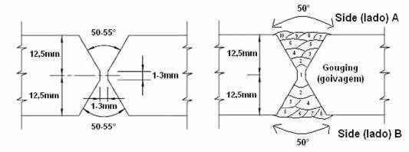
Figure 4. Balanced Weld Bead Sequence

Alternating bead placement balances thermal contraction forces and reduces angular distortion.

5.3 Preheat and Post-Weld Heat Treatment
Preheating, typically between 50 and 150°C for carbon-manganese steels, reduces cooling rates and the risk of hydrogen-induced cracking. Post-weld heat treatment (PWHT), commonly performed at 550–650°C, relieves residual stresses, stabilises microstructure and further reduces distortion.

6. Degree of Internal and External Stress Applied

6.1 Internal Residual Stresses Generated During GTAW
Residual stresses are an intrinsic consequence of fusion welding and constitute a primary factor governing both distortion and in-service structural performance. In GTAW, the highly localised arc produces steep thermal gradients between the molten weld pool, the heat affected zone (HAZ), and the surrounding parent material. During heating, thermal expansion of the weld metal is mechanically constrained by the cooler base material. On cooling, contraction is similarly restrained, resulting in tensile residual stresses within the weld metal and HAZ, balanced by compressive stresses in the adjacent parent plate (Kou, 2003).
From a critical standpoint, distortion should be regarded not merely as a dimensional imperfection but as a manifestation of an underlying residual stress field. Even where visible distortion is minimised through restraint or corrective techniques, significant tensile stresses may remain locked into the joint. In pressure vessel applications, these stresses are of particular concern as they may locally approach the yield strength of the material, thereby reducing fatigue life and increasing susceptibility to brittle fracture and stress corrosion cracking under service conditions.
The comparatively low heat input and narrow HAZ associated with GTAW limit the spatial extent of residual stress fields relative to higher heat input processes. Nevertheless, in thick-section, multi-pass welds, residual stress accumulation remains significant, necessitating careful control through procedure qualification and post-weld heat treatment.

6.2 External Stresses Introduced During Fabrication
External stresses are imposed during fabrication through the use of fixtures, jigs, strongbacks and tack welds intended to control alignment and dimensional accuracy. While such restraint is essential for limiting gross distortion, it simultaneously inhibits free thermal contraction during cooling, thereby elevating residual stress levels within the welded joint.
Critically, restraint represents a compromise rather than a universally beneficial control measure. Excessive restraint may successfully suppress visible distortion while substantially increasing residual stress magnitudes, potentially compromising long-term structural integrity. Conversely, insufficient restraint may lead to unacceptable geometric distortion requiring costly rectification. Effective fabrication practice therefore requires controlled restraint, complemented by balanced welding sequences and joint designs that distribute shrinkage strains more uniformly.

6.3 Interaction Between Residual and Service Stresses
Residual stresses do not exist independently but are superimposed on externally applied service stresses arising from internal pressure, thermal cycling and mechanical loading. In pressure vessels, this interaction is explicitly recognised within design and fabrication codes, as the alignment of tensile residual stresses with principal service stress directions can significantly accelerate fatigue crack initiation and environmentally assisted cracking mechanisms.
This interaction provides the technical justification for post-weld heat treatment (PWHT) in many critical applications. PWHT facilitates stress relaxation through creep mechanisms at elevated temperature, reducing peak residual stresses and redistributing stress fields without inducing further distortion when properly controlled.

6.4 Code-Based Requirements for Stress Control
International standards provide explicit requirements for the control of internal and external stresses in pressure vessel fabrication:
- ASME Section VIII, Division 1 mandates PWHT for carbon and low-alloy steel vessels above specified thickness thresholds to mitigate residual stresses and enhance fracture resistance.
- ASME Section IX requires qualification of welding procedures, ensuring that heat input, joint configuration and welding sequence are demonstrably capable of controlling residual stress development.
- EN 13445 emphasises fabrication practices and heat treatment procedures aimed at limiting residual stress and distortion in unfired pressure vessels.
- ISO 15614 requires welding procedure qualification to demonstrate acceptable control of distortion and residual stress as part of overall weld integrity.
Compliance with these standards ensures that stress levels are maintained within limits compatible with safe service performance.

6.5 Comparative Perspective: GTAW versus GMAW
When compared with Gas Metal Arc Welding (GMAW), GTAW offers superior control of residual stress development in critical applications. GMAW typically operates at higher deposition rates and heat inputs, producing wider HAZs and larger molten weld pools. While this increases productivity, it also elevates thermal gradients and residual stress magnitudes, particularly in restrained joints.
In contrast, GTAW’s lower heat input, precise arc control, and independent filler metal addition result in narrower HAZs and reduced weld pool volumes, thereby limiting residual stress development. Although GTAW is less productive than GMAW, its enhanced control of distortion and residual stress makes it more suitable for safety-critical pressure vessel welds where structural integrity takes precedence over deposition rate.

6.6 Integrated Stress Mitigation Strategy in GTAW
This strategy consolidates the process controls described in Section 3, the fabrication practices outlined in Sections 4 and 5, and the metallurgical considerations discussed in Section 7 into a coherent approach for minimising distortion and residual stress.
Effective control of internal and external stresses in GTAW pressure vessel fabrication is achieved through an integrated approach combining: - Low heat input and, where appropriate, pulsed welding parameters - Symmetrical joint preparations, such as double-V grooves, to balance shrinkage - Controlled welding sequences that distribute thermal strains evenly - Optimised restraint that limits distortion without over-constraining the joint - Application of preheat and post-weld heat treatment in accordance with applicable codes
This integrated strategy reflects the interdependence of distortion control and residual stress management and is essential to achieving regulatory compliance and long-term structural reliability in critical welded components.

6.7 Hydrogen Embrittlement and Hydrogen-Assisted Cracking
Hydrogen embrittlement represents a critical failure mechanism in welded pressure vessel steels, arising from the combined presence of diffusible hydrogen tensile stress and a susceptible microstructure. In GTAW hydrogen-assisted cracking is most likely to occur in the heat affected zone where the residual tensile stresses are generated during cooling and approach the yield strength of the material.
While GTAW is inherently a low-hydrogen process due to the use of inert shielding gas and non-consumable electrodes, hydrogen may still be introduced through surface contamination, moisture or inadequate gas purity. The risk is further influenced by cooling rate and microstructural hardening, particularly in restrained joints. Effective mitigation therefore requires an integrated approach combining low-hydrogen welding practice, controlled heat input, appropriate preheating and post-weld heat treatment to reduce residual stress and promote hydrogen diffusion away from critical regions.

7. Metallurgical Factors Affecting Distortion and Dilution

7.1 Thermal Contraction and Residual Stress
During welding, localised heating causes expansion of the weld zone, while surrounding cooler material restrains this expansion. Upon cooling, contraction is similarly restrained, resulting in tensile residual stresses in the weld and HAZ, which contribute to distortion (Kou, 2003).

7.2 Phase Transformations
Steel undergoes phase transformations during welding, with ferrite transforming to austenite on heating and reverting to ferrite, pearlite or martensite during cooling. These transformations involve volume changes that influence residual stress development and distortion (Bhadeshia and Honeycombe, 2017).

7.3 Microstructure and Grain Size
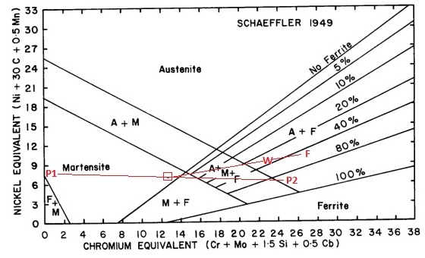Figure 5. Schaeffler diagram (including common Schaeffler formulas)

The Schaeffler diagram is a widely used in welding metallurgy, particularly for stainless steels. It predicts the solidified weld metal microstructure based on chemical composition by combining alloying elements into chromium and nickel equivalents which respectively promote ferrite and austenite formation.
The diagram allows estimation of austenite, ferrite, and martensite proportions in the weld. This predictive capability assists in filler metal selection and procedure design helping to minimise defects such as hot cracking, excessive brittleness and reduced corrosion resistance. Although its accuracy is limited by assumptions such as the exclusion of nitrogen effects, the Schaeffler diagram remains a practical and effective method for anticipating weld metallurgical behaviour without extensive experimental testing.
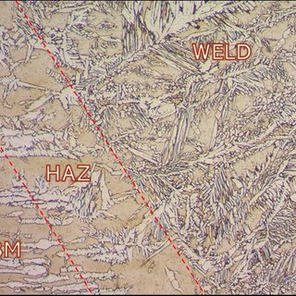
Figure 6. Microstructural Zones in a Welded Joint

Lower heat input in GTAW results in finer grain structures in the HAZ, improving toughness and reducing susceptibility to cracking. Pulsed GTAW further refines microstructure by controlling solidification rates.

7.4 Intermetallic Formation and Dilution
In dissimilar metal welding or cladding applications, excessive dilution can promote the formation of brittle intermetallic compounds. GTAW minimises this risk through controlled penetration and precise filler metal addition, ensuring weld metal chemistry remains within acceptable limits.

8. Conclusion
- Offers exceptional control over distortion and dilution in critical pressure vessel welds.
- Provides precise heat input regulation, reducing thermal stresses.
- Allows independent control of filler metal, improving weld composition accuracy.
- Produces superior weld quality.
- Suitable for safety-critical applications.
- Enables distortion minimisation through appropriate joint preparation.
- Relies on controlled welding procedures for consistent results.
- Can be combined with suitable heat treatment to achieve favourable metallurgical properties.
- Remains a preferred welding process for high-integrity structures.
- Ensures high reliability and safety in demanding applications.

References
ASM International (1993) ASM Handbook, Volume 6: Welding, Brazing, and Soldering. Materials Park, OH: ASM International.
Bhadeshia, H.K.D.H. and Honeycombe, R. (2017) Steels: Microstructure and Properties. 4th edn. Oxford: Butterworth-Heinemann.
Kou, S. (2003) Welding Metallurgy. 2nd edn. Hoboken: John Wiley & Sons.
Lancaster, J.F. (1999) Metallurgy of Welding. 6th edn. Cambridge: Woodhead Publishing.
Messler, R.W. (2004) Principles of Welding. Hoboken: John Wiley & Sons.

