Student Name: Sonia Davie Bijmohun

Student Number: 1905918

Lecturer Name: Anita Nan

Module Name: Academic and Employability Skills

Module code: BMSW4001

Contents
Introduction 3
SWOT Analysis 3
Employability Skills 5
Academic Skills 6
Personal Development 7
Conclusion 8
Appendix 9
10
11
12
List of References 13

Introduction
The purpose of this report is to analyse my own academic and employability skills. Academic skills are demonstrated throughout the process of school, college and university courses whereas employability skills are developed as you progress through life, although people do choose to spend more of their life academia.

People in employment may tackle through different career paths in order to upskill themselves through practical and hands on work while others in education decide between a variety of courses as skills are gained through more theoretical experiences, however skills gained through both work and education are valuable in this society. The skills which are analysed below include communication, team-working, leadership, time-management, paraphrasing, summarising and critical thinking.

SWOT Analysis
In order to identify my strengths and weaknesses, a SWOT analysis will be conducted.

Strengths: -
Communication skills
How my communication sets me apart is that I have a friendly approach on the job and at university and find it easy to establish a relationship with colleagues and peers as I always listen to everyone’s opinion and make sure they always try to find answers to people’s questions. At work I deliver exceptional customer service by engaging with customers and trying to find the best options suited for them.
Daily Situations challenges my communication and I can address issues that happen in the workplace, I am able to explain the problem to the customer and help them to understand. I also communicate well with the back office so there are no mistakes in transactions.

Digital Skills
My accounting qualifications and advanced digital skills sets me apart from colleagues. Managers can refer that I have quickly leant how to use operating systems in the bank, I am very confident in moving ahead to operating of machinery and more in detailed inspection of accounts in the back office.

Interview skills
I am on the right course at university to working the development of my communication, academic and employability skills. Before I was offered a job at Barclays, I already had confidence with interview preparation and after joining my university course I am one step closer because I have more experiences to share in an interview.

Teamworking: -
I can work well in a team as I possess good personal qualities, I share my ideas and opinions for all to see. Working in collaboration suits me as I extract information and use it to better myself. I see myself as assertive and follow guidance and instructions. My strong communication and target orientated mind-set help me to work well with colleagues.

Paraphrasing: -
I am good at paraphrasing as I have a wide vocabulary and I know synonyms for many different words. I have been given good feedback on pieces of writing and I always thoroughly read and double check my work before submission.

Summarising: -
In a classroom environment, I acknowledge what is being taught by asking summarising what has been taught and I ask clarifying questions to make sure the I have not misunderstood information.

Weaknesses: -
Time Management
My punctuality and time keeping lets me down as I must balance my family life with work and education. I tend to leave my assignments until last minute and in the morning, spend on unnecessary tasks or doing things that can wait till later, this usually makes me late for work or university.

Leadership
I do not possess all the skills required to be a leader, I find it difficult to set tasks or assign roles for others. I do not have confidence in being in control and power, the centre of attention in a lead role. I have a problem delivering in terms of a speech or presentation, I worry that I will being judged on my work or my opinions, I also worry that I could be be the reason for a failure.

Opportunities: -
Career Progression
I learn from others and use research methods to improve my product knowledge and keep up to date in order to successfully qualify in training for the next level from a community banker a personal banker.

Better Job
Having worked at Barclays and completing an apprenticeship programme as well as now continuing into higher education and having the interview skills needed, I can successfully apply for a more challenging and rewarding job. As well as working part time,

Threats: -
Academic skills
The obstacles I face in my career is the level of education I have restricts me in terms of the type of jobs I can apply for.

Presentation skills
A work and education environment require the confidence that I do not possess. Although I am quite knowledgeable, I am not able to deliver information to my full potential as I struggle to emphasise to the maximum on specific topic.

Employability Skills
Communication: -
Communication is a personal understanding between two people, the process which is spoken by one and received by another who then interprets the information in exchange for more interaction. Communication can be exchanged through symbols, signs or behaviour and a way people can express how they are feeling. Not only are new ideas conveyed through communicating, people can connect and share through different language.

Everyone in the workplace will be satisfied when the work environment becomes friendly and everyone can communicate openly thus forming good professional relationships. When staff have thought carefully over feedback given by a manager regarding work-related issues, staff will be satisfied and feel cared for and valued by the company and it will give them motivation to do continue with their hard work and they are more likely to stay with the company and stay loyal. Miscommunication can cause the company to face problems and
conflicts such as customer complaints and low productivity, this can be avoided and solved when discussions are more concise. Workplace productivity can be increased if aims and targets have been clearly communicated, workers will be able to work to a high standard to ensure delivery of services at work (Adu-Oppong, and Emmanuel, 2015, p. 209).

Leadership: -
A leader controls and gives direction by a process when predictions are made, and targets are set to benefit the company through their ideas and perception. Expressing and Inspiring through speech and communication together with active listening and positive discussions simplifies for team members to bring forward their opinions and reliance and moves them past uncertainty to a clear understanding which result in commitment to help the company achieve. Leaders can be a group of people with authority that focus and guides team members with various skills set towards the mission and objectives of the company (Winston and Patterson, 2006, p. 7).

Leaders who have broad knowledge of their industry are competent in managing groups and contribution to tasks help to support the group. Followers look for specific qualities in leaders which has an impact on their overall performance in the workplace (Guirdham 2001, cited in Morgan, 2017 p. 226)
Leadership skills help to develop personal growth and in and others emotionally and intellectually and for that reason you will gain their upmost respect, it will show through interpersonal and transferable skills. It is essential when dealing with customer facing problems.

Teamworking: -
Teams are of more significance and importance as they all work collaboratively and are dedicated to achieving specific desired results in comparison to groups which get together to simply share what is in common (Katzenbach and Smith, 1993, cited in Morgan, 2017, p. 204).

In an organisation, teams must have authenticity and prove their identity, trust and efficacy in order to perform to the maximum (Druskat and Wollf, 2001, cited in A. Maund Et Al. pp. 8).
Teamwork is important as teams can split their workload and complete a task more quickly and efficiently in accordance with developing specific skills, therefore decided which task is best suited for which person and the productivity of individuals can become more profitable.
As everyone is working towards the same goal, members can to encourage each other to work at a faster pace, by helping them to understand from their own knowledge and give them the support motivation for improvement. Good teams can monitor themselves without having the need for a manager to intervene. Performance can improve by learn from each other as you can someone can be taught when they’re doing something wrong as people have their own weaknesses and can acquire strengths from somebody else. Approaching problems with everyone’s perspective, skills and experiences can have better outcomes and overall giving working relationships more security (BrightHR, 2019)

Time Management: -
There are many aspects of managing time effectively such as organisation, planning, and prioritising responsibilities. It is about scheduling tasks and making good use of the time available to you which means It’s important in your day to day life as you must consider work life balance and personal family life.

In the workplace, planning is vital for example, if you were running late for a client meeting and did not let anyone know about it, you could lose out on a sale which causes a bad reputation for the business. People’s perception of you needs to be a relying and representing. In order to be a colleague who contributes to success, you need to be a leading example for progression to leadership roles

Academic Skills
Paraphrasing: -
This is the act of taking someone else’s work, whether it is from a book, journal or a website article and keeping the same meaning of the writing or speech but changing the nouns or adjectives and using synonyms to change the structure of sentences and put them into your own words.

Paraphrasing is important when studying i.e. when doing an assignment because if your work is copied word for word from another author it could lead to plagiarism and you could get referred for unfair practice. You should not directly copy any quotes without stating where you got the information from. Paraphrasing is a key academic skill as you use it in everything you write, this makes your work unique.

Summarising: -
When summarising a piece of writing, you are shortening the text by keeping the main ideas and changing it into your own words. Summarising can also be done verbally where you are giving the main idea of what you understood.

Summarising is important in education as it shows the lecturer that you understood the key concepts. It is also important to have this skill so you can rephrase what has been said in your perception

Critical Thinking: -
Defining of critical thinking is broad. All lecturers have their own way of defining critical thinking and even they find it difficult. A lecturer will be able to tell when a student demonstrates critical thinking in 3 stages. Gaps, mistakes assumptions and weakness can be easily identified in a student’s work, by providing strong arguments for views and taking certain courses of action and if a clear and detailed interpretation of situation and occurrences have been given. (Morgan, 2017)

It is necessary to use critical thinking skills when studying to show the lecturer that you have a broad understand the topic, you can give your and opinions, take the necessary steps to justify your actions.

Personal Development
To improve on managing my time effectively, I will follow the RAC method. I need to keep
record of my daily activities, at the end of the day analyse the unproductive time and
change the time-wasting habits and prioritise using a to-to-list. I will schedule my five
most important tasks of the day and give them numbers according to the importance
(How to manage your time better, 2019).
I can also use the ‘Time Management Matrix’ and learn to eliminate unnecessary tasks and put things in order according to important, I also need to challenge myself on how long I spend on each daily task (Morgan, 2017).

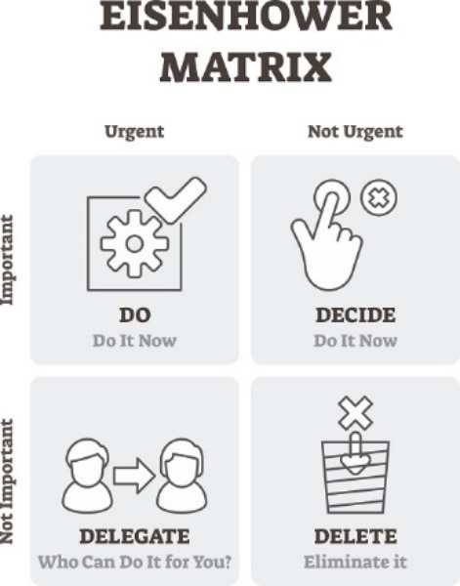
To improve my time management skills, I can also use the Eisenhower Method which consists of 4 quadrants.
1st Priority – Do the most urgent and important task now.
2nd Priority – Decide which of your tasks is as urgent but still important and do it now.
3rd Priority – Delegate responsibilities of urgent routine tasks but not so important tasks to others.
No priority – Eliminate tasks of no urgency and no importance and delete it from my to-do-list (Training Industry, 2019).

I need to develop my confidence by working closely with a team and doing more group presentations. When I have an idea, I need to build on it to make it more thorough and when delivering, I need to learn to emphasise to get people to ask more questions

Conclusion
To summarise, several key skills have been focused on in this report. Each skill has been defined and the reason it is essential in a workplace or an academic environment has been stated. Throughout my SWOT analysis I was able to evaluate the skills I possess and picked out some weak areas I can improve, and I have come up with different methods to help me such as the RAC method to organise daily tasks, Eisenhower Matrix to prioritise tasks and more group presentations to develop my confidence in speaking.

Appendix
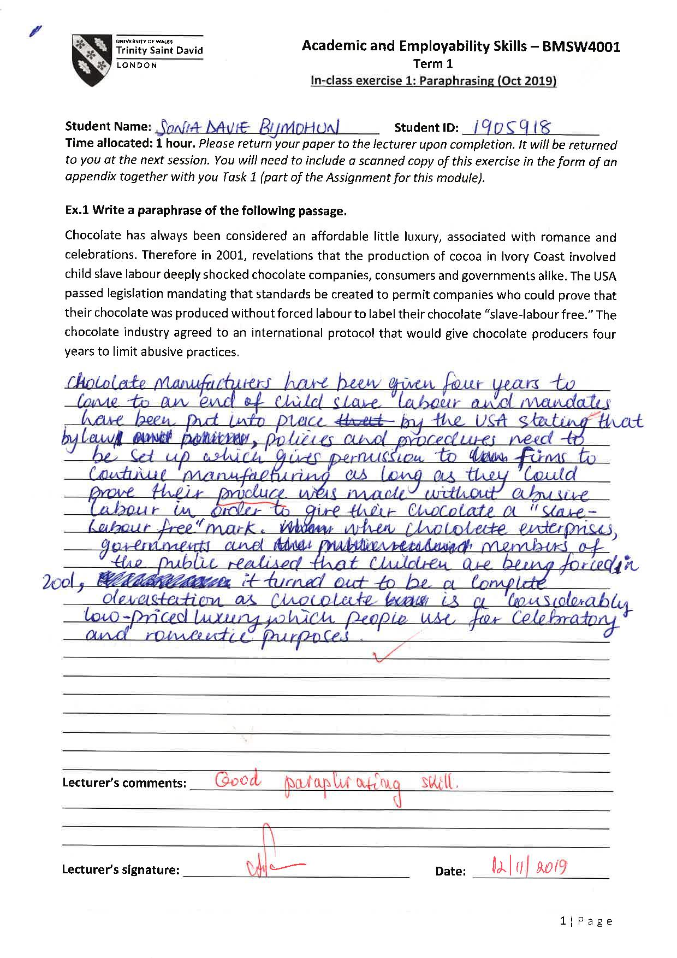
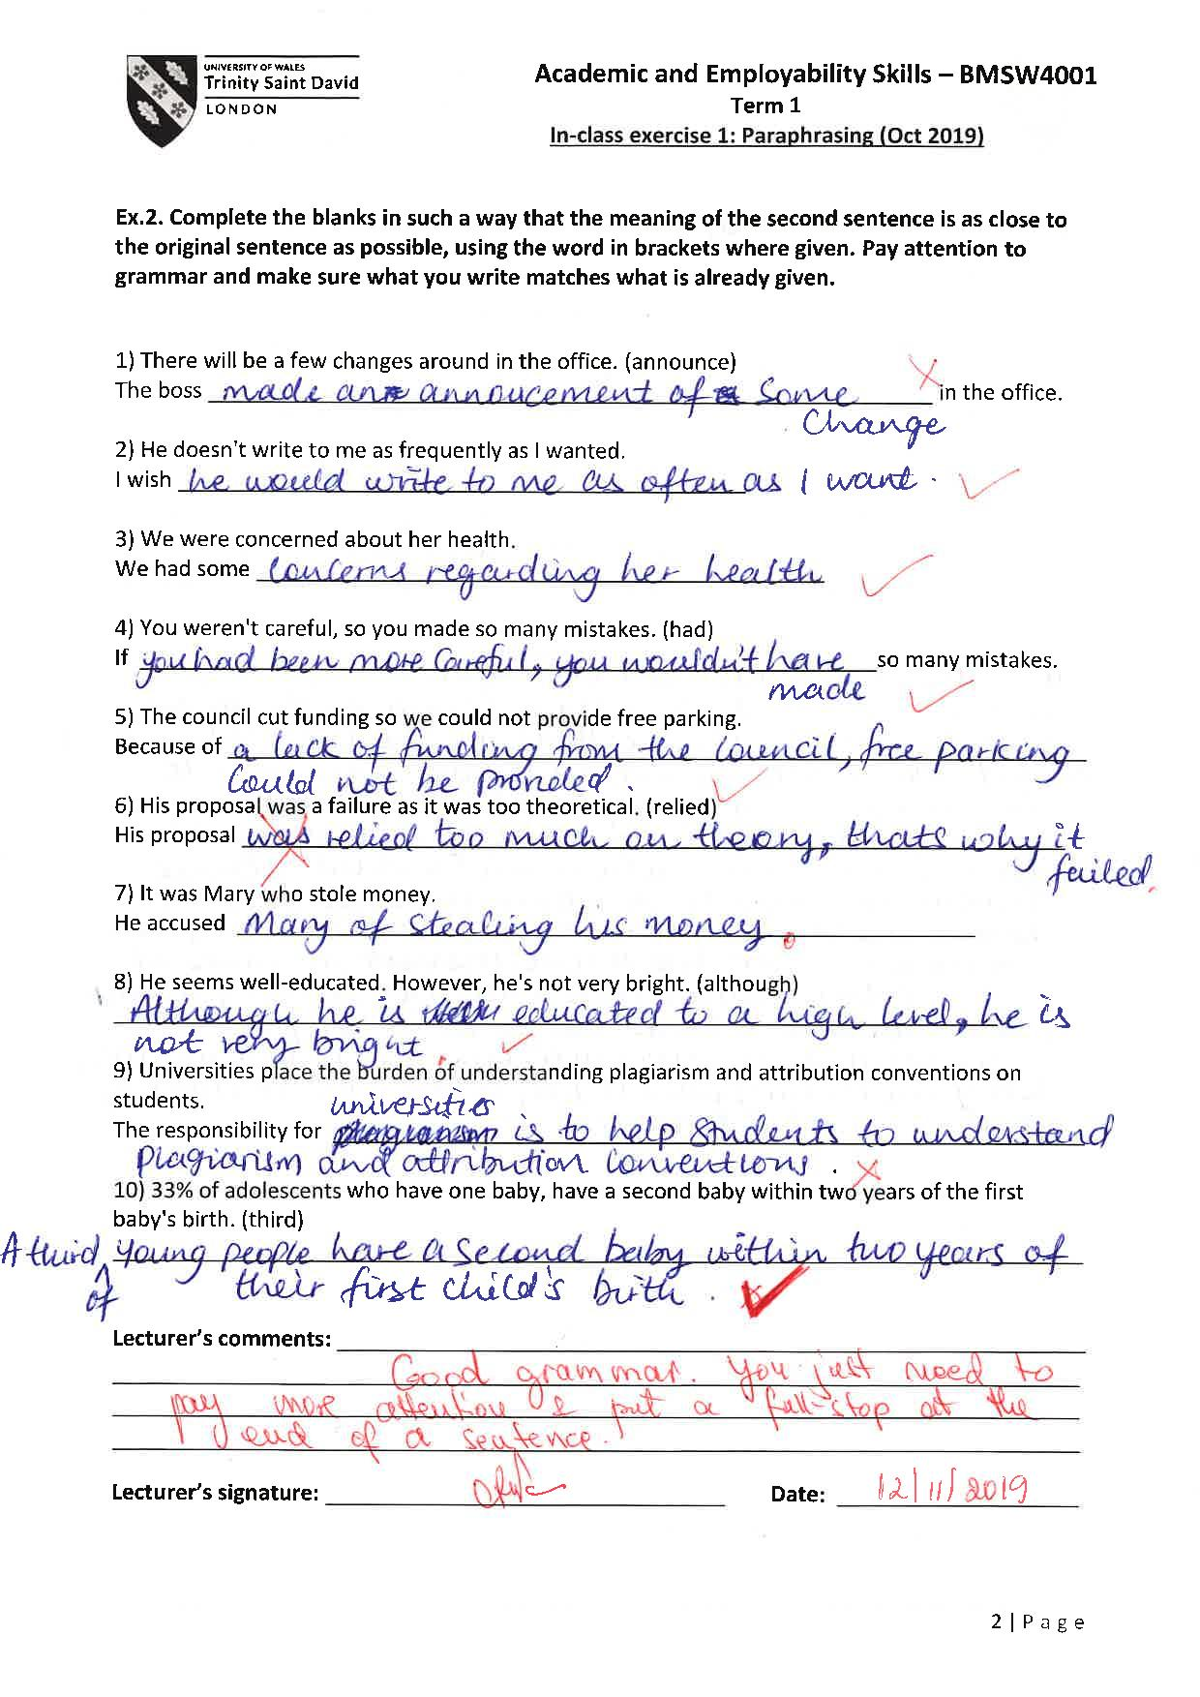
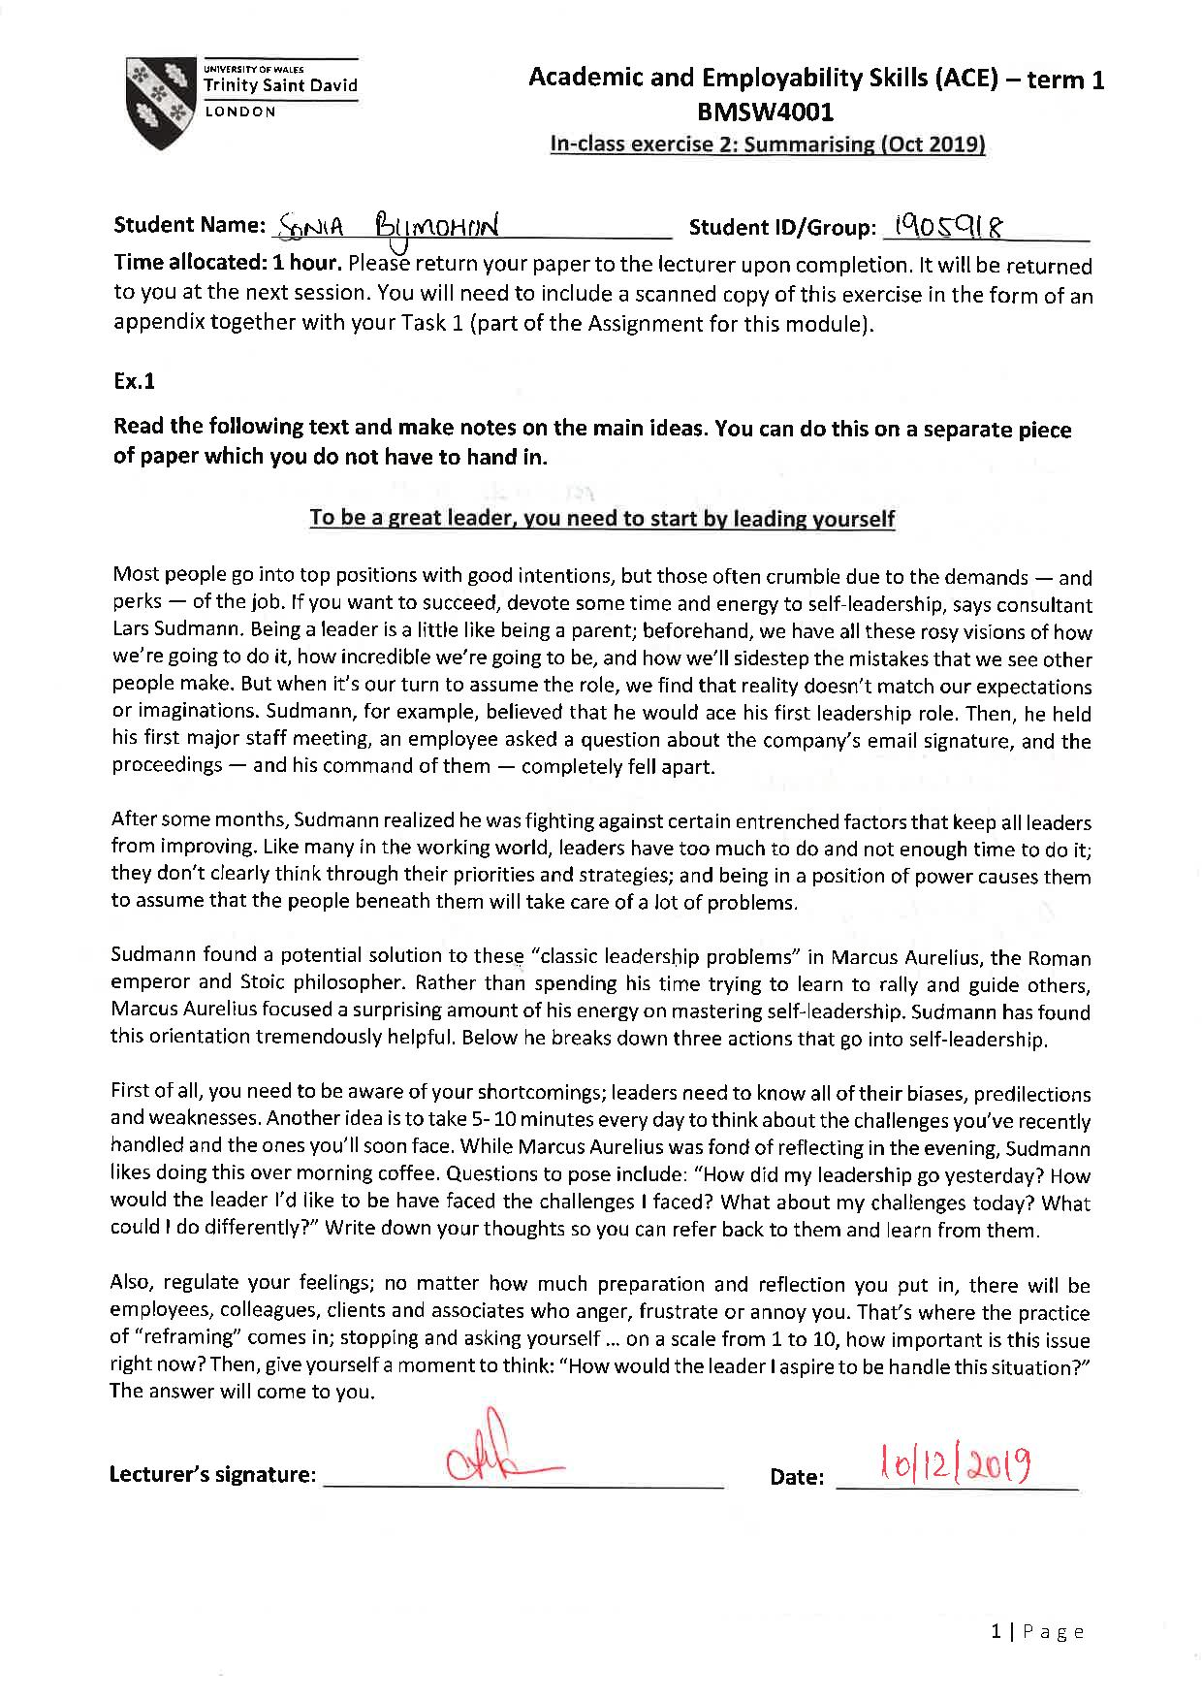

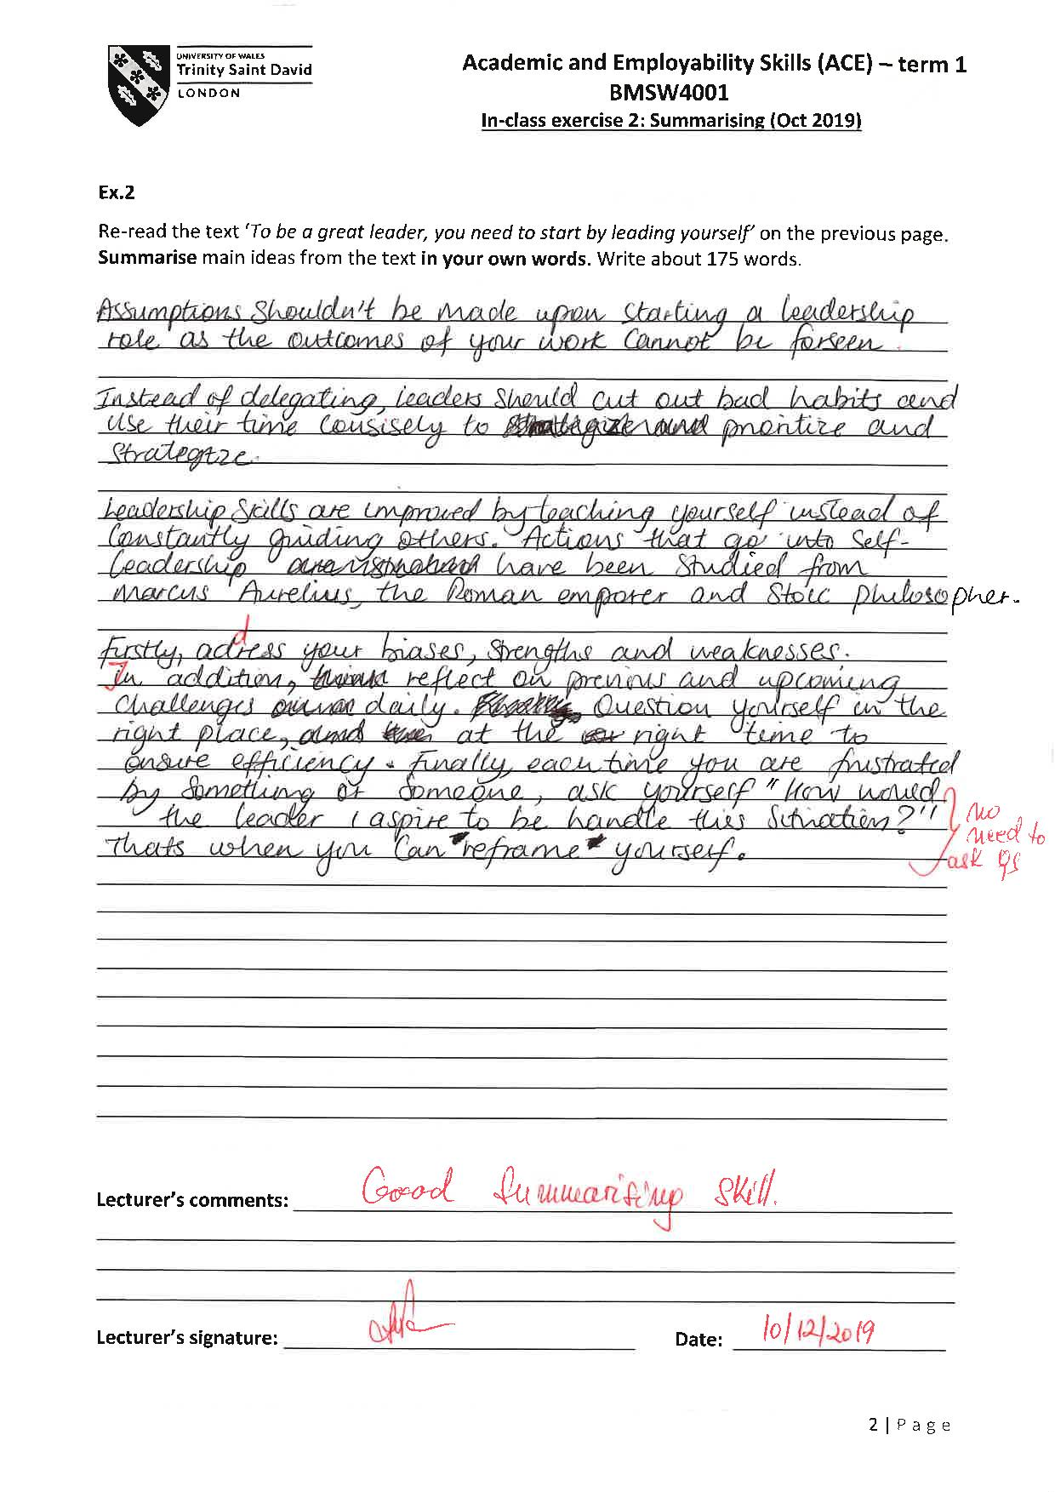

References

Adu-Oppong. A. A and Agyin-Birikorang. E (2014) ‘Communication in the workplace: Guidelines for improving effectiveness’, Global Journal of Commerce and Management Perspective, 3(5), pp.208-213, [Online]. Available at: https://www.researchgate.net/publication/304782482_COMMUNICATION_IN_THE_WORKPLACE_GUIDELINES_FOR_IMPROVING_EFFECTIVENESS (Accessed:30 November 2019).

Druskat and Wollf (2001) ‘Conditions for Team Success’ cited in Maund. A, Schriek M & Tinkler K. P (2015) Certificate in higher education: skills for the workplace student yearbook. London: SAGE, p. 8.

Guirdham (2001) ‘The skills of Leadership’ cited in Morgan. P (2017). The business students guide to study and employability. London: SAGE, p. 226.

Katzenbach and Smith (1993) ‘Definitions: Groups and Teams’ cited in Morgan. P (2017). The Business Guide to Study and Employability. London: SAGE, p. 204.

Morgan. P (2017) The importance of time management: The business guide to study and employability. London: SAGE.

Morgan. P (2017) Understanding and defining critical thinking: The business guide to study and employability. London: SAGE.

Training Industry (2019) [Online]. Available at: https://trainingindustry.com/articles/strategy-alignment-and-planning/what-is-the-eisenhower-matrix-and-how-can-it-help-with-time-management/ (Accessed: 30 November 2019).

Watchwellcast (2019) How to manage your time better: YouTube Video [Online]. Available at: https://www.youtube.com/watch?v=VUk6LXRZMMk (Accessed: 30 November 2019).

Winston. B. E and Patterson. K (2006) ‘An integrative definition of leadership’, International Journal of Leadership Studies, 1(2), pp.6-66, [Online]. Available at https://www.regent.edu/acad/global/publications/ijls/new/vol1iss2/winston_patterson.doc/winston_patterson.pdf (Accessed: 1 December 2019).

