  References
  Dictionary.com. Amphitheatre. [online] Available at: <https://www.dictionary.com/browse/amphitheatre> [Accessed 16 February 2020]
  Google maps. Caerleon Amphitheatre. [online] Available at: <https://www.google.com/maps/place/Caerleon+Amphitheatre/@51.6 080529,-2.9590761,450m/data=!3m2!1e3!4b1!4m5!3m4!1s0x4871e7aa1 7536349:0xebbd5a4886c59ab4!8m2!3d51.6080496!4d-2.9568874> [Accessed 15 February 2020]
  Stokes. L. 2020. Caerleon Amphitheatre. [photograph] (Own collection)
  Nash-Williams, V.E, 2011. The Roman Legionary Fortress at Caerleon, Monmouthshire. Redditch: Read Books ltd
  Welch, K.E, 2007. The Roman Amphitheatre: From Its Origins to the Colosseum. Cambridge: Cambridge University Press
  Caerleon Amphitheatre
  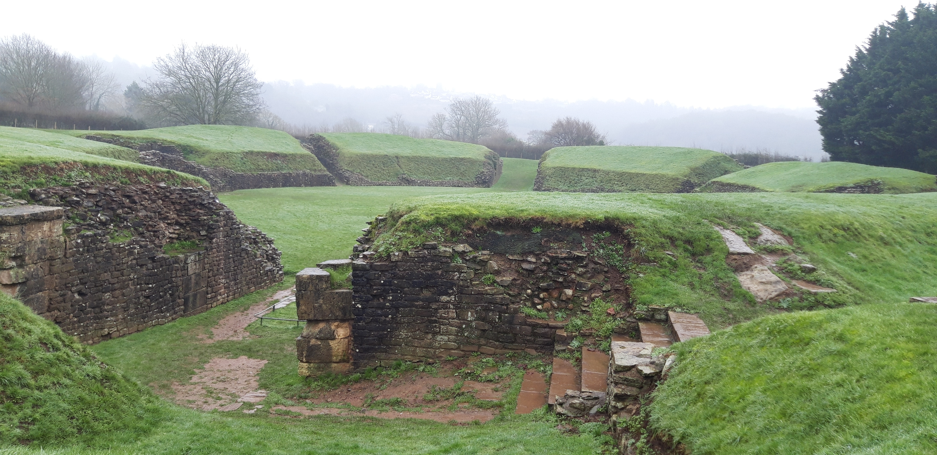
    - Figure 1: Caerleon Amphitheatre (Own photo)

This booklet contains:  Background information to Caerleon 1  What was the Amphitheatre used for? 2  The settlement 3  Amphitheatre’s and Roman life 4  Contact information 5  References 6 |  |  | Contact information  Address  Figure 2: Amphitheatre site (Google maps)
  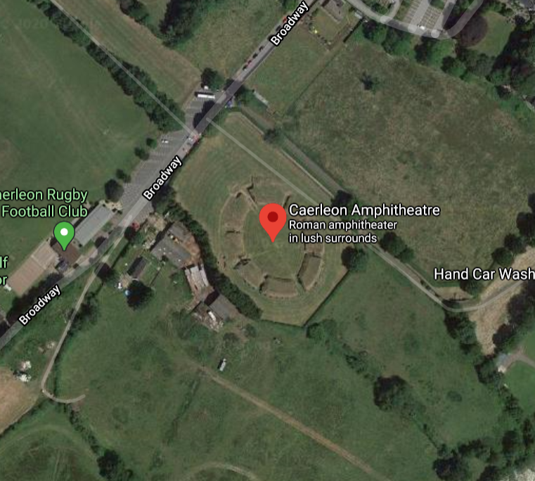 |  | High St  Broadway  Caerleon  N P18
 |  |  | 5

Amphitheatre’s and Roman life  The Roman’s conquered Wales in 78 AD and settled alongside the native Celts in relative peace. The local people, at least in Caerleon, developed a relationship with the Romans and reaped the rewards of working alongside the Romans in the form of gaining access to the baths and the Amphitheatre.  ‘We have seen that the Amphitheatre originated as a temporary wooden structure in the Forum Romanum during the republican period and was initially disseminated as a permanent stone building in Italy during the first century BC by Roman colonists.’ (Welch, 2007).  The two cultures began to merge as everyday life became a mix of the Celtic and Roman ways of life’s and religious views. The views of the Romans were not heavily forced but the colonies still adapted to include Roman aspects. |  |  | Background information
  Caerleon was known as Cair Legeion in the Roman period and the Legionary fortress was called Isca Augusta.
  An Amphitheatre is ‘an oval or round building with tiers of seats around a central open area, as those used in ancient Rome for gladiatorial contests.’ (Dictionary.com).
  The Amphitheatre found in Caerleon was built in 80 AD for the entertainment of the Roman legions based there.
  Many soldiers took wives whilst living in the Roman colonies and did not return home meaning Caerleon would have become a permanent settlement for many of the legionaries.
4 |  |  | 1

What was the Amphitheatre used for?  The Amphitheatre would have been host to training exercises but was able to be used for entertainment as it could hold approximately 6 thousand spectators. It would have been used by the soldiers and the families they took whilst based in Caerleon.  It is unlikely the Amphitheatre would have seen wild animal fights as the extent of animals possible for Wales would have been wolves. The Amphitheatre also does not have any space to house the wild animals before putting them into the arena.  There would have been nearly no gladiatorial fights in Caerleon as they were more commonly found in bigger Roman cities and Amphitheaters. |  |  | 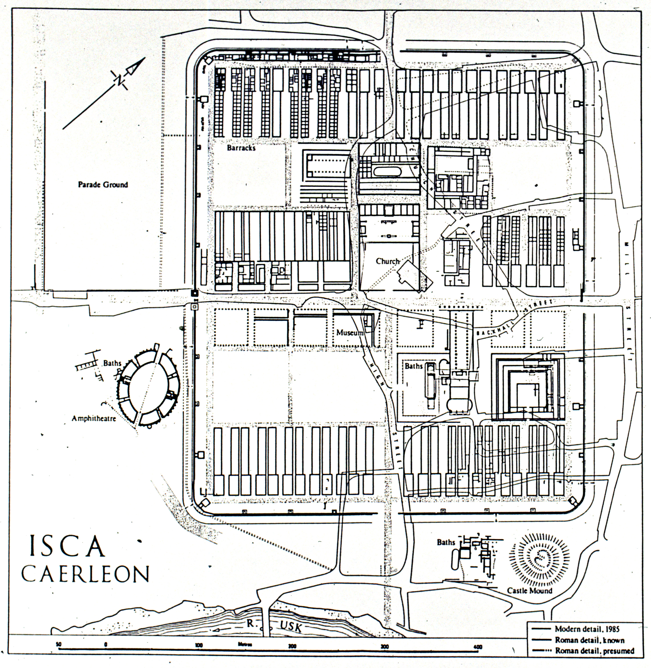  The settlement
  Legionary fortress, Caerleon
  The Amphitheatre was based to the left of the
  Roman barracks which housed the legions.
  Caerleon was a Roman settlement which centered around the barracks but expanded out to
  encompass the local community who also had
  access to the Amphitheatre entertainment and
  baths.
  The legion that settled in Caerleon was the ‘IInd Augustan Legion…moved to Britain from its station…to form part of the army of invasion dispatched to these shores by the Emperor Claudius in AD 43.’ (Nash-Williams, 2011).
2 |  |  | 3

