

A Study of the 3g, 4g and 5g Mobile Networks Speed and Coverage
by
Lloyd Johnson
Supervisor: Nitheesh Kaliyamurthy
Second Marker: Carlene Campbell

Project submitted as part of the requirements for the award of BSc (Hons) Computing (Computer Networks and Cybersecurity)
April 23, 2021

Declaration
I, Lloyd Johnson declare that I am the sole author of this Project; that all references cited have been consulted; that I have conducted all work of which this is a record, and that the finished work lies within the prescribed word limits.
This work has not previously been accepted as part of any other degree submission.
Signed : Lloyd Johnson
Date : 23/4/2021

Form of Consent
I, Lloyd Johnson hereby consent that my Project, submitted in candidature for the BSc (Hons) Computing (Computer Networks and Cybersecurity), if successful, may be made available for inter-library loan or photocopying (subject to the law of copyright), and that the title and abstract may be made available to outside organisations.
Signed : Lloyd Johnson
Date : 23/4/2021

Abstract

Objective
The first objective of the Individual Project is to provide background information on 3g, 4g and 5g mobile networks. The background information on the mobile will include the history of the mobile networks, the features and functions of the mobile networks and a brief explanation on why the older mobile networks were updated to the newer versions.
The second objective will be an investigation, the coverage speed and distance of each of the mobile networks will be tested in different areas of Wales which include, a city, town, and rural village. The test will take place in January 2021.
The third objective is to test the 3g, 4g and 5g mobile networks using a mobile phone in a real-life scenario. The test will include testing download speed, upload speed, jitter, and latency on each network when used in a real-life scenario.
The fourth objective of the Individual Project is to outline which mobile network performed the best in the location where it was tested. Figures generated from the experiment will be shown to determine the differences in the speed and coverage. This will be done by using the figures generated in the third objective testing phase.

Methods
The Project will use Secondary Research, meaning information gathering will be an integral part of the project. The first method of information gathering is using online resources. Much of the online research will include online case studies, the studies will be examined to ensure the information is relevant to the Project. Academic Case Studies will be a trusting source as it is less likely for any errors in figures or statements to be included in the case studies. As the case studies are secondary resources then the writer must find other studies that back up the information before it can be used in the project.
For the investigation section of the Project, it will rely on the researcher to use correct procedures to obtain then document the findings. A mobile app will be used to collect the data speeds, and coverage in the different locations. To document the findings from the mobile app, the data will first be recorded in excel then created into tables to help display the findings.

Summary of Findings
The question of the difference of speed and coverage of the three different network technologies is the 5g network had average totals of download and upload speed that were much greater than the average totals of the 4g network and 3g network. Also, the 4g has higher average totals for the download and upload speed compared to the 3g network.
The question of the difference in coverage between the three network technologies is answered using the figures from the jitter and latency parameters. The jitter and latency averages are lower on the more updated networks 5g and 4g compared to 3g meaning the delay is lower on the networks allowing more traffic to be shared over the network, with the 5g having the lowest delay.

Conclusions and Recommendations
In conclusion it is clear from the experiment that the 5g network is better than the older networks in terms of speed and coverage. The 4g is also better than the 3g network technology in terms of speed and coverage. The recommendations that can be made from this is if the user has the technology in their mobile phones to utilise the 5g technology, and the area they are in allows the use of the 5g technology then it should be used as it will provide faster access to online services such as video streaming and social media surfing compared to the older technologies.

Contents
Declaration 2
Form of Consent 2
Abstract 3
Objective 3
Methods 3
Summary of Findings 4
Conclusions and Recommendations 4
Introduction 7
Aims 7
Objectives 8
Flow of the Report 8
Literature Review 9
First Source 9
Second Source 12
Third Source 15
Research Method 17
Design 19
Contingency Plan 26
Experiment 28
Location 1 28
Location 2 31
Location 3 34
Analysis 37
Location 1 37
Location 2 39
Location 3 41
Evaluation 42
Conclusion and Recommendations 43
Reflection 44
Bibliography 45
Appendix 47

Introduction
The Individual Project will be a project paper into discussing and testing mobile networks, the aim of the project is to research 3g, 4g and 5g mobile networks to show how the networks operate in ranging environments along with the highlighting the features of the networks. The Project will examine each mobile network, an experiment will be completed to generate figures that will show to the reader the differences between the three network technologies, these technologies will then be compared against each other in these parameters download speed, upload speed, jitter, and latency.

Aims
The first aim of the project is to provide the reader with an understanding of the background and history of 3g, 4g and 5g mobile networks. The history section will include information on the creators of the mobile networks, the first countries to use the updated mobile networks along with when the U.K changed to using the networks. This will utilise the literature review to provide an understanding of the background of the networks.
After the history has been explained, the next aim is to into the operation of the mobile networks will take place to give the reader an explanation into how the different mobile networks work. This will be an overall summary of how the networks function, later in the project the functions will be further explained.
The next aim is to test the different mobile networks, using a mobile app as the tool to test download speed, upload speed, jitter, and latency on the mobile networks. A real-life scenario will be created first to test the 3g, 4g and 5g mobile networks to ensure that the reader is able to fully view and understand how the networks operate in real-life.
Then the final aim of the project is to compare the figures that have been generated through the test that have been carried out to then determine the percent increase the newer networks have over the older network technologies to outline the differences between the download speed, upload speed, jitter, and latency.

Objectives
To provide the reader with the background and history of the mobile networks, online sources such as online case studies and online websites providing, they are from reliable sources will be used. Multiple sources will be used to ensure the information from the sources are accurate.
The next objective is to research the operations of the mobile networks, like the steps taken to provide the reader with background information of the networks, online sources will be referenced throughout the operations section of the project. Online Books will be a good source to use given the current situation. This can be done using the literature collected from online sources.
To provide the reader with knowledge of the selected aspects of the mobile networks speed, and coverage online case studies will be referenced, case studies that include tests on speed and coverage will be analysed to provide support to the investigation that will be discussed later in the project.
To complete the investigation for the project the writer will travel to three different geographical areas and obtain speed and coverage readings using a mobile app. The readings from the app will then be used to create table, the table will help to show the difference in speeds and coverage from each of the mobile networks. Each table will be analysed to provide the reader with information on the tests that have taken place. The figures will also be compared between each other to help to outline the differences between the network technologies in terms of upload speed, download speed, jitter, and latency.

Flow of the Report
In the first section of the project a review of relevant literature will be included. All the literature included in this section of the project will be relevant to this individual project, the first section of each review will include an introduction, in this introduction the writers will be introduced along with the date and the location that the investigation took place. The contents of the source will be critiqued and an overall summary of the source containing the most important points will be written at the end of the literature review.
The next section of the project is an explanation into the research methods that have been used in the project. The next section included in this section is a further explanation into the main research method used in the project including advantages and disadvantages of the research method chosen.
After this section, the design of the experiment will be discussed in the report to show the reader the foundation of the tests, then once the design has been set in place the implementation section will be discussed where the results from the designed experiment will be displayed then further discussed in the evaluation section the figures will be compared between each other.
The final section of this project will include a conclusion to the experiment and the project along with a review of the entire project detailing if the objectives have been met and any further recommendations that can be made to further improve on the experiment that had been carried out.

Literature Review
In this section of the project case studies relevant to the aim of this Individual Project will be analysed. The analysis will include a summary of the piece of literature along with the study’s findings that are relevant to this project.

First Source
The first piece of literature that will be reviewed is “A Review on mobile technologies: 3G, 4G and 5G”, the authors of this source are E. Ezhilarasan and M.Dinakaran. The source discusses the mobile network 3g, 4g and 5g. Each network is split into sections where they are discussed fully, working chronologically starting with 3g then 4g and finally 5g networks. For each of the networks it first discusses the background of the network then leads into discussing the key features of the mobile network. This leads on to discussing the applications that become available when using the relevant mobile network and finally discusses challenges that occur when using the mobile network. The final part of the source is a comparison between the three mobile networks.
In the first section the background of the 3g network is explained, this portion is much smaller compared to 4g and 5g background sections used in the same piece of literature. In the section the date is included as it is in the other background sections however there is only a small sentence used to explain the overall differences in the newer 3g network compared to previous versions, whereas in the 4g background section the differences are explained in more detail including mentioning new standards that the new network uses to improve on the previous network version.
The next part of the source briefly discusses 3g key features, the 3g key features section is significantly smaller than the 4g and 5g sections, in the 4g section the standards 4g uses are listed then explain what new features these standards bring to the network, there is little mention of the 3g network standards in the 3g key features section. The 5g section does the same as the 4g section however the standards are not separated into paragraphs making it more difficult to read and understand. The key features section in this source should be uniform throughout the report, as there is a comparison included at the end of the report having each section using the same structure will make it easier to compare the features of each network.
The following section in the report lists the applications that the newer network standard allows, as mentioned in the key features section there is a lack of standardization in this area of the report, in the 3g and 5g applications paragraphs the significant applications are split into paragraphs each explaining the function of the application, whereas in the 4g applications section the new applications the 4g network offers is briefly explained. The 4g applications paragraphs should follow the same structure as the 3g and 5g sections to allow an easier comparison in the later section of the report.
Included in the 5g section of the report is an explanation into the architecture of the 5g network just after the background is explained, there is no mention of the architecture for 3g and 4g networks. As a comparison between the different networks is the key point of this report, not including the architecture in the 3g and 4g sections, later in the report the architectures are compared however, due to the lack of explanation of the architecture for the 3g and 4g networks it is harder for the reader to understand the comparison made.
In the section where the different networks are compared, the report offers some numbers on the data rates of each of the networks.
 | 3G | 4G | 5G
Data Rate | 2 Mbps | 2 Mbps – 1 Gbps | 1 Gbps & Higher
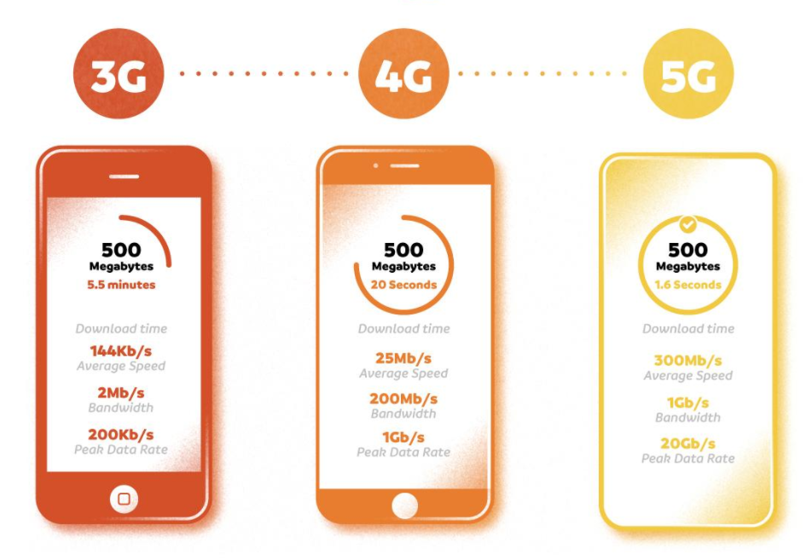
Another source collected supports these Data Rate Numbers [1], the data rate is described as bandwidth in this next source, however the numbers remain the same as the numbers in the table above.

There are further sources that support the numbers given in the report. [2] [3].
A source that does not support the figures given in this report is from “A Comprehensive Survey of TDD-Based Mobile Communication Systems from TD-SCDMA 3G to TDLTE(A) 4G and 5G directions”. This Source has a different data rate speed for 4g networks, 30 Mbps however the 3g and 5g data rates are the same. This change in the data rate for 4g networks does fall in the range of the figures given in the table above and may have been an average number given to demonstrate the data rate however this is not stated in the source so it must be taken as a direct figure which does not agree with the report.
When investigating the validity of the figures given in the report there are more sources that confirm the figures given in the report than sources that contradict the figures (only some sources were chosen). This provides more support for the numbers given in the report than sources that contradict the numbers making it more likely the figures in the report are true figures.
In conclusion the report gives the reader useful information about the mobile networks in a well organised format, however in the format there is a lack of standardisation in the sections, as the sections do not follow the same structure in providing the reader the information. As an example, explaining the network standards in the 4g features section and not doing this for the 3g features section, this makes it harder for the reader to follow the report as the structures changes throughout. The figures given in the comparison section of the report have supporting sources that back up the numbers showing there is validity in the numbers the report.

Second Source
The second piece of literature that will be reviewed is “A Comprehensive Guide to 5G Security”. The authors of this book are, Madhusanka Liyanage, Ijaz Ahmad, Ahmed Bux Abro, Andrei Gurtov, Mika Ylianttila. This book includes sections that discuss the security aspects of the three mobile technologies. The book begins by discussing the beginning of mobile technologies, then leads to examining the different technologies. In these sections the architecture of the mobile technologies is described along with standards that the technologies use, then finally discussing the security aspects such as features and threats of the mobile technology. The books next section explains the security threats and protection that each mobile technology uses, this is followed by further explanations into the 5g security structure including, 5g security design, 5g network security, 5g device and user security and 5g cloud security. There are more aspects of the 5g mobile technology that are discussed in the book however they are less relevant to the topic of this report.
In the section discussing the Security of the mobile technologies the book is structured well to include an introduction into the security standards that each of the mobile technologies use, from 2g to 5g. In the 3g section there is a discussion into CDMA2000 standards, in this it discusses the AKA protocol, the information giving in this section is backed up by this source “New Privacy Threat on 3G, 4G, and Upcoming 5G AKA Protocols” [4]. In the source that supports the information in the book a diagram is used to illustrate the function of the AKA protocol this is something the book could have used as it is a straightforward way of explaining the function of the protocol rather than a large paragraph.
Further along in the 3g section there is a diagram used to show the architecture of UMTS (Universal Mobile Telecommunications System). The writer then researched other UMTS architecture diagrams that would either support or contradict the diagram shown in the book. The below source is a diagram for the UMTS architecture the first thing that is noticed is the different names for each component in the architecture. In the book the components that connect to the external nodes are labelled RNC (radio network controller) whereas in another source the components are labelled RNS (Radio Network Subsystem) [5]. A brief explanation is the RNS component houses the RNC as shown in the source below. [6]
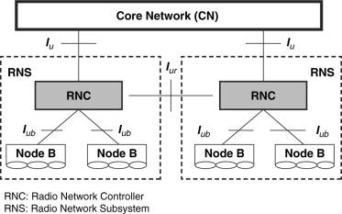
The RNS is not mentioned in the book, including a brief explanation into the RNS in the book would ensure that all elements of the UMTS Architecture are included.
The next point to be analysed in the book is a section that explains network slicing in the 5g mobile technology. This section describes the further uses that the 5g mobile technology will use in devices such as mobile, autonomous cars and Internet of Things. Network slicing is the procedure that will allow the mobile technology to support the diverse devices. Below is the diagram used in the book.
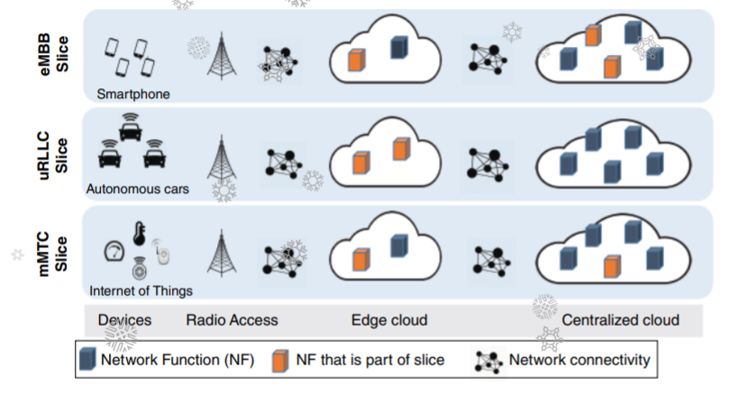
A source found that backs up this diagram shows a similar diagram is below. [7]
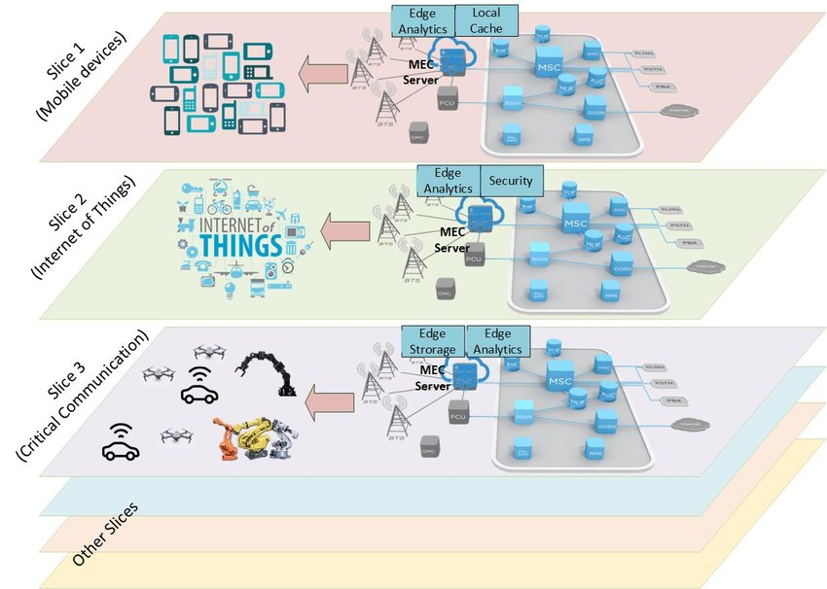
This source follows the same structure as shown in the diagram included in the book with the split of the mobile devices, critical communications and IOT(Internet of Things). The supporting sources shows more detail than the diagram shown in the book, however the split in the clouds remain the same with the MSC cloud or Centralised cloud connecting to the edge cloud called the Edge analytics in the supporting source then the edge clouds connect to the end devices. This adds validation to the book as there are supporting sources. However, the supporting source does show more detail in the diagram which the book diagram could have used to further the knowledge of the reader.
In conclusion the book included in depth detail into most aspects of different mobile technologies, the information giving in the book such as the diagrams described in the sections above have supporting sources that validate what is said in the book, the only problem in these sections is the lack of explanation giving in some of the diagrams that are used in the book such as not mentioning Radio Network Subsystem in the UMTS architecture however it still gives the reader a thorough explanation into the characteristics of each mobile technology.

Third Source
The third piece of literature that will be reviewed is “Comparison of Algorithms and Technologies 2G, 3G, 4G and 5G.” The Authors of this source are Ramije Zeqiri, Florim Idrizi and Halim Halimi. This report begins by presenting the reader with an overall summary of each network explaining the background of the network along with some key features. The source follows this section with an analysis and comparison of each of the technologies highlighting the key differences between each of the technologies. The next section starts an investigation into the differences of using an Android or an iPhone on these technologies. The investigation measures the download speed of the two mobile systems using 3 different mobile phones for each system. After the investigation of the download speeds, the figures are presenting using graphs then compared briefly.
The first critique of this report is the sections that first explain the different technologies and then compare the technologies both have the same heading for each section, this can confuse the reader as they may expect a comparison in the summary section and vice versa. The information is well structured, providing the reader a chronological explanation into the technologies then comparing the previous technology to the technology that follows.
The next part is the investigation into the download speeds of the separate mobile phone systems. The investigation starts by explaining the two systems, more explanation into the operations of these two systems would improve this section, including summarising advantages and disadvantages users have found in these systems this would help to illustrate using the outcome of the investigation by highlighting the pros or cons using the figures in the investigation. The investigation uses three different mobile phones to help show a wider range of results in the test, a brief description of each mobile phone is missing from this section as it would help the reader to understand aspects of the phone such as the date of the technology, if the phones are new or used models and cost of the mobile phones. The interior elements of the phones are listed in a table which will affect the download speeds of the phones, this is an important factor to include in the test.
The report separates the Android and IOS systems into tables, these tables include the download speeds of each mobile phone for each network technology. A conclusion to the findings is that the 4g is a faster network particularly when downloading music or videos.
One source that agrees with these results showing the real-world download speeds of 2g, 3g and 4g. The source does not mention what technology or formula was used to gather the real-world figures which can affect the validity of the results. The source does not show exact time in seconds of a download but rather the real-world speeds of the results in Mbit/s. [8]
Another source that agrees with the results shown in the report “To be precise 4G offers typical download speeds of around 14Mbps and typical upload speeds of around 8Mbps”… “To be precise 4G offers typical download speeds of around 14Mbps and typical upload speeds of around 8Mbps” [9]. Having these two supporting sources that verify the figures given in the report improves the validity of the report.
There were no suitable sources that contradicted the figures in the report, most sources that showed figures disagreeing with the report mentioned reasons such as congestion on the 4g network which leads to higher speeds at 3g compared to 4g. This is not the goal of this report.
In conclusion the report provides the reader with a structured description of every mobile technology from the start to the most recent mobile network technology. The report does well to define each of the networks by explaining key features of the technology following it with an explanation into the changes that the updated technology uses. The only problem in this section was the headings caused confusing as they did not always relate to the following paragraphs. The final section of the report was a carefully planned investigation into download speeds only missing some extra descriptions of the mobile phones used in the investigation. The outcome of the investigation had numerous sources validating the figures making the report legitimate.

Research Method
This section explains the research methodology chosen to help complete this project. In the explanation it includes why the methods of research were as chosen. This section of the report will explain the experiments hypothesis, further discussing what the methods that are used to test the hypothesis. These methods will include outlining the hardware and software used in the experiment along with explaining how and why the experiment chosen to test the hypothesis is suitable., the benefits and drawbacks of the research method and what steps are being taken to help combat the drawbacks of the research method.
The hypothesis is to test the mobile network technologies 3g, 4g and 5g in a real-life scenario. The test will include testing the technologies upload speed, download speed, jitter, and latency using a mobile app to gather data to then analyse the differences between the three mobile technologies using these parameters.
The hardware that the writer will use to conduct this experiment is a Samsung Galaxy a51 mobile phone. These phones will smoothly run the applications chosen to collect the data from the testing, The Samsung will collect data from 3 mobile service provider. The software that will be used in the experiment is OpenSignal and Speed Test, OpenSignal will collect the download, upload speed and latency of the mobile network, then Speed Test will collect the data for Jitter and Packet loss.
The research into the upload speed, download speed, jitter, and latency for each of the mobile technologies in a real-life scenario is done using two mobile apps that will capture the data needed. Each network technology will be tested in a chosen location using the software, the following inputs will be incorporated into the design, network distance and network size. This will show how each of the network technologies upload speed, download speed, jitter, and latency change when the network sizes differ and the distance between the network connections change. At the end of the experiment the way each of the network’s cope with these changes will be analysed.
The experiment is valid as the software used to provides readings that can accurately show how each of the mobile networks operate in real-life. Due to the current situation, travel is restricted this means that the readings will be collected in the South Wales area. The parameters chosen to be analysed in the simulated network are valid as they help to show the way the network technologies would function in a real-life scenario which is the aim of the experiment. Multiple readings in each location will be generated to increase the validity of the experiment along with using two separate mobile phone systems which will provide the reader with a larger sample size to understand how each mobile network differs with upload speed, download speed, jitter, and latency.
This research methodology has been chosen as it allows more control into the experimentation. The difference between 3g, 4g and 5g networks have been researched in case studies before however creating an experiment to test these networks allows the writer to have full control over the parameters to develop an analysis that suits the project rather than collecting information from case studies to analyse the network technologies. The case studies can be used to validate the data collected from the research however using them as the main source of material to research the mobile technologies would not create an in-depth report.
The advantage of the method chosen is the ease of the experiment being repeated by the writer or other personnel. Being able to repeat the experiment proves the validity of the data collected and used to compare the network technologies this increases the strength of the report. As the experiment will be carried out using a phone app, it gives an accurate representation of a real-life scenario than using a software application to simulate, locations where the data will be collected will include changing the size and connection distances to give the reader a full overview of how each network technology functions in these types of locations. Another advantage from this method of research is if it were a simulated the writer would have full control over every aspect of the design the outcome could include artificial results.
The disadvantages of using this method of data collection are that the only areas that will be able to be used to collect the data will all be in the South Wales area of Swansea which does not provide a broad spectrum of how the mobile technologies will operate all over the country. To counter this disadvantage once the travel restrictions have been lifted the experiment can be copied in all areas of the U.K to gather readings for each county. Another disadvantage of this method is the writer will not have fully accurate numbers of how many users are on the mobile technology, the writer will have a rough estimate on the numbers of users depending on the location of the experiment however no accurate numbers which will make the experiment difficult to duplicate fully.
The data from the experiment will be collected into an excel spreadsheet table, with each of the network technologies having separate tables. These tables will be used for analysis to make comparisons between the network technologies, further analysis will be completed by creating diagrams to make visual representations of the way the network technologies function in the real-life simulation.

Design
The following section will outline the design of the experiment that will be carried out. In the outline the area the writer conducted the experiment on the mobile networks will be defined following this the reasons why this area was chosen as a point to conduct the experiment will be detailed. Next the parameters that will be analysed in the experiment will be detailed, this will lead into how the chosen parameters were tested then the data was gathered from the testing. The next part of the design will display a map from the Speed Test application used to collect the data this will help to show the reasons for the choice of the locations.
The chosen network technologies that have been chosen to be analysed are 3g, 4g and 5g mobile networks. The experiment involves the writer travelling to specific locations in the South Wales area and testing the networks. The parameters of the network that are tested include Upload Speed, Download Speed, Jitter and Latency. As mentioned in the research method section of the report these parameters will be tested by the two applications OpenSignal and Speed Test.
There are multiple areas that were chosen for the experiment to be conducted each area had a specific purpose for the reason it was chosen. The first area where the experiment was chosen is the IQ building in SA1. Below is the Map for the SA1 area.
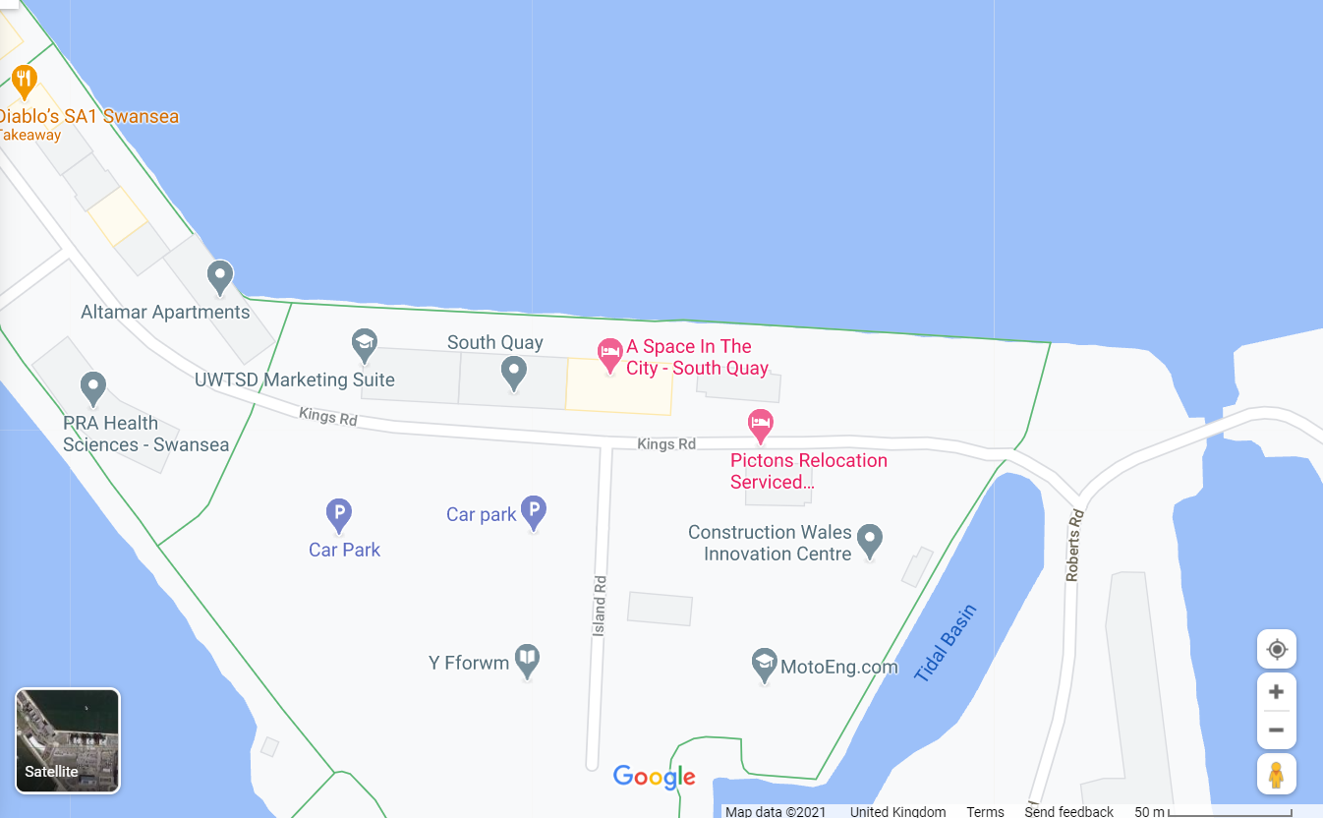
The specific point where the first readings will be collected is the Car Park for the IQ building. The reason this area is used in the experiment is because the area chosen is amongst a high number of office buildings and a university, this will mean that the number of people operating on the network technologies will be high. This will then give a good indication of how the network technologies operate in a large network. Another reason this location has been chosen is because it is a one of a small number of areas that has access to a 5g network, there is a small number of areas in the South Wales area that allow users to access a 5g network: Below is a map showing the availability of the networks in the area selected.
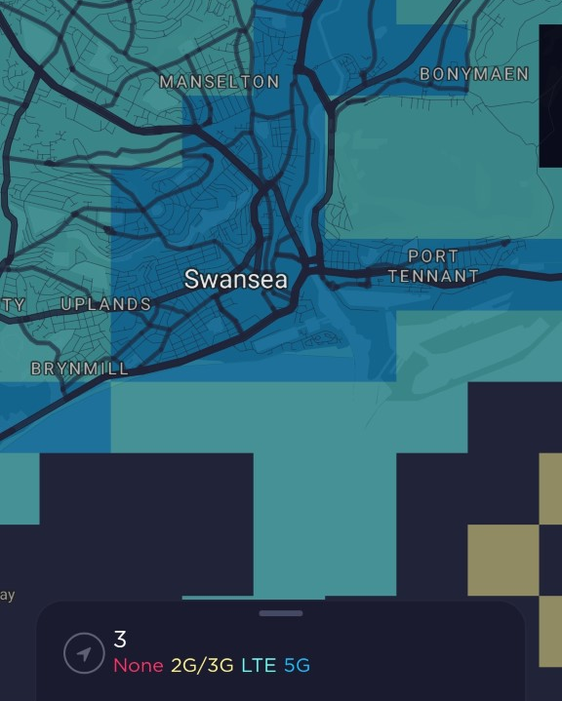
As the map shows the Swansea area has the 5g access and the area chosen for the first location is in the middle of the 5g availability allowing for the best network access. On the 3 mobile network website it also offers a Post Code check to see if it has availability for 5g which the University Post code does have that availability. Below is the link for the 3 mobile service provider website that shows the coverage of each of the network technologies. http://www.three.co.uk/Discover/Network/Coverage

The next location where the experiment will take place is Swansea Uplands SA2 0PG. Below is a map of the area where the experiment will be carried out.
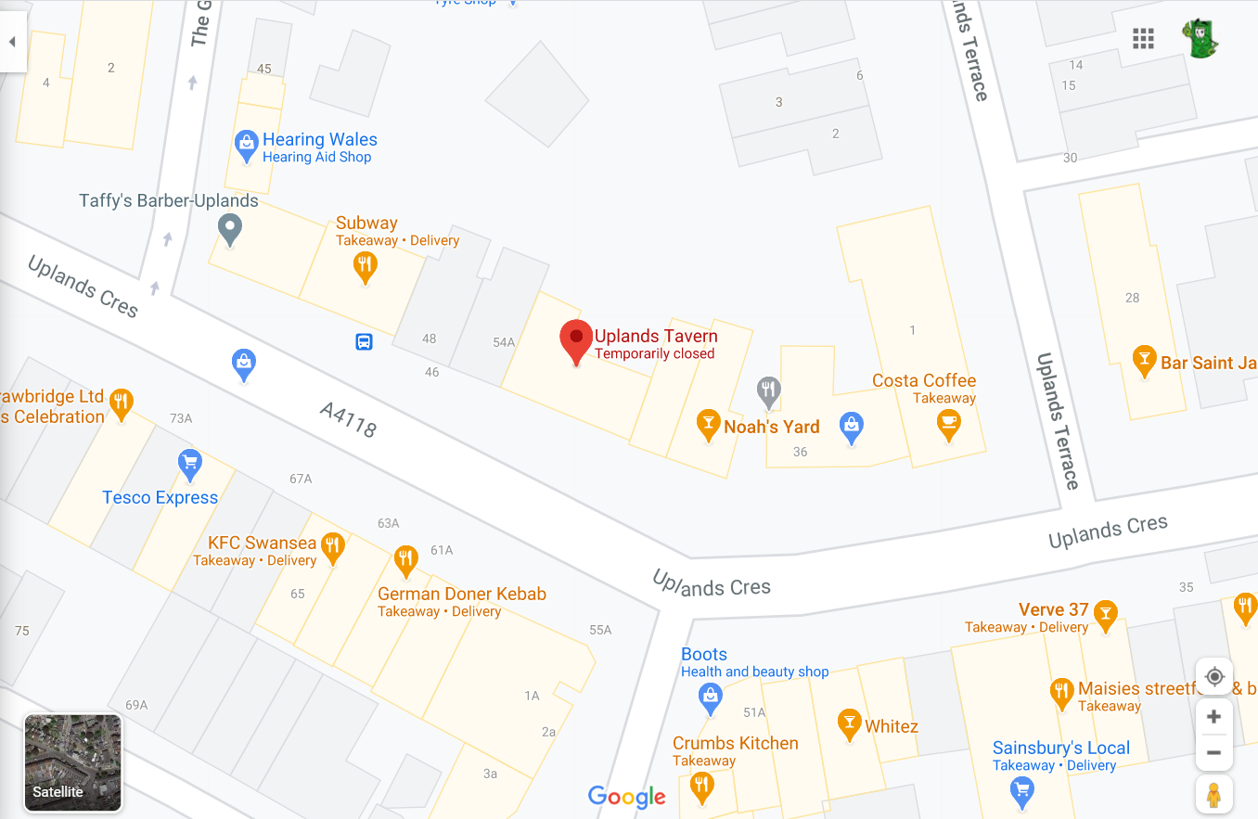
The Specific point where the data will be collected is outside the Uplands Tavern. The reason this area has been chosen to conduct the experiment is because it is a different setting compared to the university car park. The readings will take place amongst houses and shops that are spread out, which will mean for a smaller number of users on the network that will be tested. The next reason this location was chosen is, if the reader observes the coverage map above the uplands area is on the edge of the 5g availability meaning that the data collected from the readings could show that the 4g Network has better upload/download speeds than the 5g network during the comparison in the analysis. The network coverage for the 4g is better in this area so this could mean the 4g network shows a better average for the parameters.

The final location where the experiment will be conducted is the Morfa Retail Park SA1 7DS. Below is a map of the area where the experiment will take place.
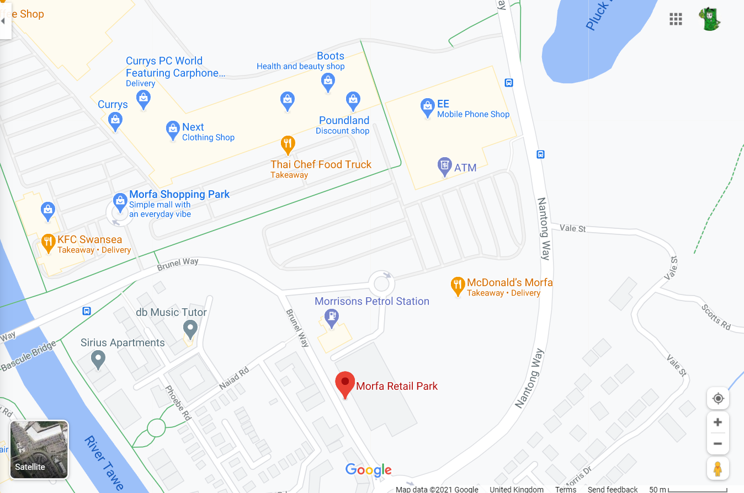
The specific point where the data will be collected from the experiment is the near the Thai Chef food truck. The reason that this area has been chosen to conduct the experiment is because like the previous two locations it is one of the few areas in the South Wales area that has access for a 5g Network on the service providers chosen to be tested. Another reason for this location to be tested is the number of users on the networks will be very low, due to the current world situation the shops located at this area will be shut lowering the number of users on the networks.
These three locations chosen to be tested on the network technologies will show the reader how each technology operates in a different network setting. The first location shows how the technologies will operate in a large network that is close to the source tower. This location will represent how the technologies work in a city area with large office buildings and high number of users. The second location will show how the technology operates in a smaller network size, this location is further from the source tower and located close to a residential area showing how the networks operate in suburbs. The final location shows how the network technologies operate in small networks further away from the 5g source tower. This will represent how the networks operate in more rural areas that have access to the 5g network.
The parameters that will be measured in the experiment are upload speed, download speed, jitter, and latency. The first parameter upload speed, this parameter measures how quickly the user of the network can upload data for example, how quickly the user can upload a photo to social media. The next parameter download speed, this parameter measures the speed that a user can download data from the network such as how efficiently streaming videos online will be on the network. Following this the next parameter that will be measured is the Jitter in the network. Jitter is a measurement for the delay within the network, the jitter measurement will help to determine the network congestion. If the jitter is high in the network, it will affect the download and upload speed and quality within the network. The final parameter that will be measured in the experiment is the latency in the network. Latency is also a measure of the delay within a network however it measures the time it takes for a packet to travel from the sender to the receiver. The readings within the latency test will determine if the network is slow or fast within the limits of the network technology. The jitter and latency help to show the coverage of the network for multiple users. For each location and network, the experiment will be carried out 3 times with a 5-minute space between each test, this is to determine an average of each parameter and remove any anomalous results.

The parameters will be tested using two mobile applications OpenSignal and Speed Test. The first application OpenSignal is a free mobile network tester, this application will measure the download, upload speed and latency within the network technology. The application offers the user to test how efficiently the network can run video to a mobile phone however the experiment will focus on the Network speed test. Below is a screenshot of the application that is being used.
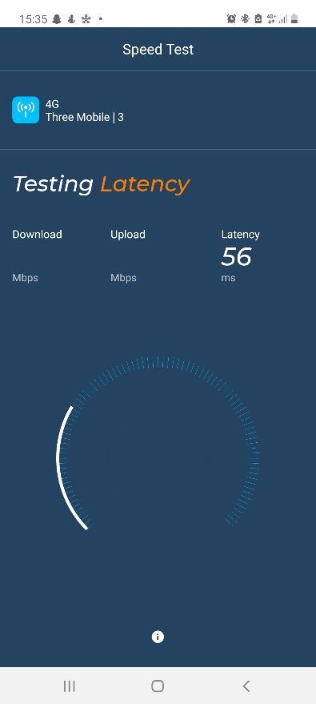

The next application is Speed Test this application will also measure the download and upload speed of the network, in addition to this, Speed Test will measure the Jitter within the network technology. Once the measurements have been collected from the experiment the readings will be displayed in table form using the excel application. Below is a screenshot of the Speed Test application.
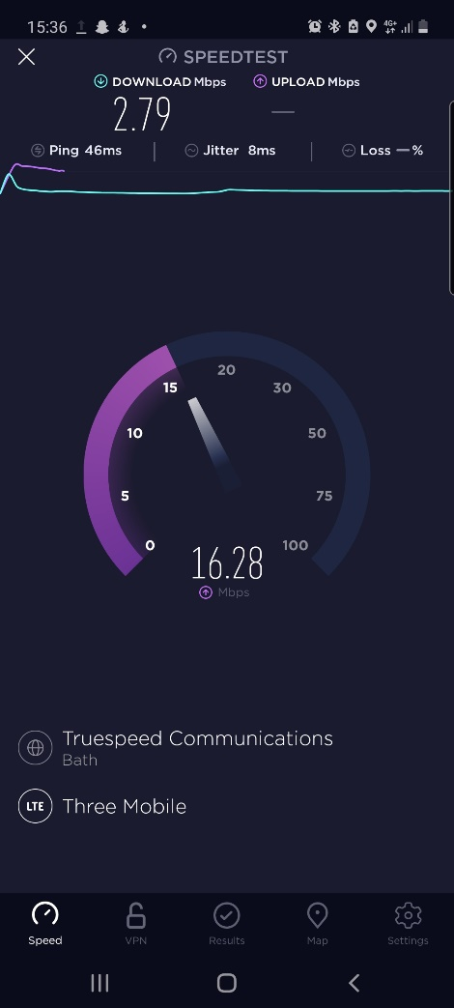

Contingency Plan
Below is the contingency plan for the experiment carried out. The plan lists all the risks that the person conducting the experiment will face when completing the experiment for each of the mobile networks.
The first risk that the researcher will come across when completing the experiment is the restriction on travel due to the current climate. The current restrictions on travel that are in place as of the writing of this contingency report are slim, the only restriction that is in place is the researcher must stay in the South Wales area. This allows the researcher to conduct the experiment that is in place, however there is an uncertainty that the travel restrictions can change from week to week. The action that needs to take place is the experiment should be conducted within a week to ensure that the travel restrictions do not affect the outcome of the experiment. Another combat method to this risk is to complete the experiment using a simulated network this would avoid the need to travel, however while travel is allowed it is advantageous to gather real world data.
The next risk that the researcher will encounter is maintenance times. Mobile network providers carry out maintenance on the networks on given dates to remove any faults that are in the system, the researcher should check on each of the network provider websites to verify when the maintenance is being carried out on the network to avoid planning the experiment on the day when the maintenance is taking place.
The final risk that risk that the researcher will face is weather changes. The weather can affect the strength and distance of a mobile network technology from the source tower, if the weather changes when the experiment is underway then it will not clearly show the true differences in the network parameters that are being tested. The locations where the experiments are taking place are all within a 5-mile radius meaning that the weather should stay the same when the experiment is being carried out, however, to get the best chance of completing the experiment in the same conditions the researcher should plan a day to complete the experiment when the weather is stable.

Experiment

Location 1
The experiment was carried out on the 5th of April. The first experiment was carried out at 14:45 at the first location the university, the first network technology that was tested was 5g. Below is a table showing the outcome of the first test. Mbps in the table stands for megabytes per second and Ms stands for milliseconds.
Test 1 – 5G
Download | Upload | Latency | Jitter | Ping
203 Mbps | 56 Mbps | 28ms | 5ms | 58ms
After the first test was completed in location 1 the figures were inserted into a notepad app on the phone then the researcher waited 5 minutes to run the test again. Below are the figures for the second test.
Test 2 – 5G
Download | Upload | Latency | Jitter | Ping
207 Mbps | 53 Mbps | 27ms | 5ms | 58ms
The final test was then completed 15 minutes after the second test.
Test 3 – 5G
Download | Upload | Latency | Jitter | Ping
236 Mbps | 62 Mbps | 30ms | 5ms | 58ms
After the 5g experiment had been completed the next technology that was tested in location 1 was the 4g network technology. Below are the findings from the first test completed for this technology. The first test was completed at 15:05.
Test 1 – 4G
Download | Upload | Latency | Jitter | Ping
80 Mbps | 12 Mbps | 35ms | 14ms | 66ms
Following the same structure of the 5g test the researcher waited 5 minutes after each test to continue with the next test.
Test 2 – 4G
Download | Upload | Latency | Jitter | Ping
91 Mbps | 22 Mbps | 41ms | 14ms | 66ms
Again, another test was completed to help create a mean average further in the analysis.
Test 3 – 4G
Download | Upload | Latency | Jitter | Ping
75 Mbps | 17 Mbps | 39ms | 14ms | 66ms

After the 4g network had been tested the final network technology 3g was tested. The first test was completed at 15:30.
Test 1 – 3G
Download | Upload | Latency | Jitter | Ping
9 Mbps | 2 Mbps | 60ms | 7ms | 50ms
Below are the figures for the second test.
Test 2 – 3G
Download | Upload | Latency | Jitter | Ping
10 Mbps | 2 Mbps | 41ms | 7ms | 50ms
Here are the final figures from the last test carried out in location 1.
Test 3 – 3G
Download | Upload | Latency | Jitter | Ping
11 Mbps | 3 Mbps | 53ms | 14ms | 50ms

Location 2
After all the tests had been completed in location 1 the researcher moved to location 2 to carry out the next set of tests. The Location of this test was at the uplands tavern in Swansea Uplands this is further from the source tower than the university car park. The first test was completed at 16:00 also on April 5th.
Test 1 – 5G
Download | Upload | Latency | Jitter | Ping
61 Mbps | 3 Mbps | 60ms | 13ms | 59ms
As was done in completing the tests at location 1, there is a 5-minute gap between each test.
Test 2 – 5G
Download | Upload | Latency | Jitter | Ping
67 Mbps | 3 Mbps | 64ms | 13ms | 59ms
Below are the final figures from the 5g test.
Test 3 – 5G
Download | Upload | Latency | Jitter | Ping
75 Mbps | 3 Mbps | 59ms | 14ms | 50ms

After the 5g technology had been tested in an urban environment the 4g network technology was then tested.
Test 1 – 4G
Download | Upload | Latency | Jitter | Ping
2 Mbps | 1 Mbps | 61ms | 10ms | 59ms
Below are the figures for the second test of 4g at the second location.
Test 2 – 4G
Download | Upload | Latency | Jitter | Ping
2 Mbps | 3 Mbps | 62ms | 10ms | 59ms
Here are the final figures from the last test for the 4g technology at the second location.
Test 3 – 4G
Download | Upload | Latency | Jitter | Ping
3 Mbps | 2 Mbps | 57ms | 10ms | 59ms

Then the final technology was tested at the second location. Kbps stands for Kilobits Per Second.
Test 1 – 3G
Download | Upload | Latency | Jitter | Ping
3 Mbps | 667 Kbps | 59ms | 15ms | 108ms
Below are the figures for the 3g technology second test.
Test 2 – 3G
Download | Upload | Latency | Jitter | Ping
4 Mbps | 497 Kbps | 60ms | 15ms | 108ms
Here are the final findings from the last test on 3g and the last test at the second location.
Test 3 – 3G
Download | Upload | Latency | Jitter | Ping
5 Mbps | 308 Mbps | 62ms | 15ms | 108ms

Location 3
The final set of tests were carried out on the 5th of April at 16:30. Below are the findings from the first set of tests which is the 5g technology.
Test 1 – 5G
Download | Upload | Latency | Jitter | Ping
59 Mbps | 10 Mbps | 58 Mbps | 17 Mbps | 60 Mbps
Below are the findings from the second test on the 5g network in the final location.
Test 2 – 5G
Download | Upload | Latency | Jitter | Ping
55 Mbps | 11 Mbps | 60 Mbps | 17 Mbps | 60 Mbps
The following figures are from the final test carried out on 5g in the final location.
Test 3 – 5G
Download | Upload | Latency | Jitter | Ping
77 Mbps | 6 Mbps | 59 Mbps | 17 Mbps | 60 Mbps

The next step was completing the test for the 4g network below are the set of tests for these tests.
Test 1 – 4G
Download | Upload | Latency | Jitter | Ping
10 Mbps | 3 Mbps | 56 Mbps | 16 Mbps | 59 Mbps
Below are the figures from the second test carried out on the 4g network.
Test 2 – 4G
Download | Upload | Latency | Jitter | Ping
12 Mbps | 3 Mbps | 60 Mbps | 16 Mbps | 59 Mbps
This next table shows the findings from the final test on the 4g network.
Test 3 – 4G
Download | Upload | Latency | Jitter | Ping
15 Mbps | 4 Mbps | 59 Mbps | 16 Mbps | 59 Mbps

The final set of tests that were carried out in the experiment were completed on the 3g network in the last location. Below shows the final set of tests.
Test 1 – 3G
Download | Upload | Latency | Jitter | Ping
6 Mbps | 1 Mbps | 60 Mbps | 17 Mbps | 59 Mbps
Below is the second test completed on the 3g network in the final location.
Test 2 – 3G
Download | Upload | Latency | Jitter | Ping
4 Mbps | 886 Kbps | 64 Mbps | 17 Mbps | 59 Mbps
Here are the final figures from the experiment on the 3g network technology.
Test 3 – 3G
Download | Upload | Latency | Jitter | Ping
4 Mbps | 768 Kbps | 60 Mbps | 17 Mbps | 59 Mbps
From the tests completed in the experiment, the data included in the tests will be analysed further to show the differences in the parameters tested for the different network technologies.

Analysis

Location 1
Once the experiment was completed the figures collected were inserted into an excel spreadsheet. The figures were separated into the locations the tests were carried out to then provide a comparison later between the network parameters in each location to show the differences in the technologies.
In the excel spreadsheet the averages from each test were calculated for each parameter in each network technology. Below is a table showing the average for each parameter in the first location over the three tests.
Location 1 - University Car Park 5G
Parameter | Average
Download | 215.33
Upload | 57.00
Latency | 28.33
Jitter | 5.00
Ping | 58.00

Location 1 - University Car Park 4G
Parameter | Average
Download | 81.67
Upload | 17.00
Latency | 38.33
Jitter | 14.00
Ping | 66.00

Location 1 - University Car Park 3G
Parameter | Average
Download | 10.00
Upload | 2.33
Latency | 51.33
Jitter | 7.00
Ping | 50.00
From the test averages at the first location, the 5g mobile network technology is significantly faster than the older network technologies. From the mean average of the download speed for each of the technologies the 5g network percent increase from the 4g network is 163.67% this means that the 5g network when rounded up is 1.64 times faster at downloading than the 4g network. Then comparing the 5g and 3g network technologies download speed the percent increase from 3g to 5g is 2053.33% meaning that the 5g network is 20.5 times faster than 3g. Next when comparing the percent increase of the 4g and 3g network the increase from 3g to 4g is 716.67% indicating that the 4g network download speed is 7.17 times faster than the 3g download speed. This was an expected outcome from the experiment as shown in this source the maximum download speed for 3g is 42mbps, for 4g the maximum is 150mbps and for 5g the maximum is 1000 Mbps. All the download speeds fall into their bracket showing the download speeds in a real-life scenario.
The next averages to be compared from location 1 are the upload speed averages. From the tables 5g is significantly faster than either 4g or 3g. Firstly, calculating the percent increase between the 5g upload speed to the 4g upload speed, the percent increase is 235.29% showing that the upload speed of the 5g network is 2.35 times faster than the upload speed of the 4g network. Now comparing the upload speed of the 5g network to the 3g network, the percent increase from the 3g network to the 5g network is 2342.86% meaning that the upload speed of the 5g network is 23.43 times faster than the 3g network. Finally comparing the 4g upload speed to the 3g upload speed the percent increase is 628.57%. This means that the upload speed of the 4g network is 6.29 times faster than the 3g network upload speed. Like the download speed this was an expected outcome from the tests, there is a correlation between the upload and download speed with similar percent increases between the networks in both upload and download speed.
Finally comparing the jitter and latency between each the network technologies. Firstly, looking at the latency in each network which is a term for measuring the delay or time it takes for one packet to travel to the destination then back, we can see that the average latency for the 5g network is lower than the latency for the 4g and 3g network technologies and 4g has less latency than the 3g network. This was an expected outcome from the experiment as the updated mobile technologies have more bandwidth than the previous versions, this means that the network can carry more devices sending data on the network meaning there will be less chance for delay on the network lowering the latency average. Then comparing the jitter in the network devices, jitter is also a measure of delay of sending packets and helps to detect congestion in the network. From the averages the 5g and 3g networks have the lowest jitter compared to the 4g network this would not be expected as 4g should have a higher bandwidth to allow for more traffic along the network. An explanation for this could be as the university car park is surrounded by office buildings many employees would be using their phones on the mobile network and as 4g is still currently then most used network as 5g is still a new technology, the 4g network will have much more devices using the network causing congestion in the network which causes the jitter to be higher than the 3g network.

Location 2
Moving to the averages for the second location the average of each parameter is listed in the tables below.
Location 2 - Swansea Uplands 5G
Parameter | Average
Download | 67.67
Upload | 3.00
Latency | 61.00
Jitter | 14.00
Ping | 50.00

Location 2 - Swansea Uplands 4G
Parameter | Average
Download | 2.33
Upload | 2.00
Latency | 60.00
Jitter | 10.00
Ping | 59.00

Location 2 - Swansea Uplands 3G
Parameter | Average
Download | 4.00
Upload | 0.49
Latency | 60.33
Jitter | 15.00
Ping | 62.00

The first parameter that will be compared is the download speed for each of the networks. Firstly, from the tables the 5g network is much faster than the other networks. Looking at the percent increase between the newer networks to the older networks the 5g network has a 2800% percent increase compared to the 4g network this is a much larger percent increase than it was in location 1, an explanation to this massive difference is network is the distance between the end device and the 4g cell tower which is larger than the distance between the 5g cell tower also the amount of end users on the 4g network could be slowing the downloading connectivity. The percent increase between the 5g network and 3g network is 1591% this is an expected outcome from the test as mentioned in this source. Another anomaly in the test is the percent difference between the 4g network and the 4g network which is -41.67% meaning the 4g download speed is slower than the 3g download speed. Another factor that could be affecting the 4g download speed is the surroundings, there a numerous large buildings packed together in this location which could be affecting the 4g connectivity.
The next parameter to be compared is the upload speed between the networks. The percent increase from the 5g network to the 4g network is 50% this is a much smaller percent increase compared to the download speed. The percent increase from the 5g network to the 3g network upload speed is 511.41% again this is a smaller increase however it still is a larger than the 3g network meaning it is an expected outcome from the test. The percent increase from the 4g network to the 3g network upload speed is 307.61% this is an expected outcome from the test and is what would have been expected from the download speed test.
The final parameters to be compared are Jitter and Latency. The first Parameter to be compared is the latency, from the tables all the network technologies have similar latency this means that the time it takes for the packets to travel from the sender to the recipient is similar, this helps to show the speed of the 5g network compared to the older networks as the download speed is much quicker meaning that is affected much less than the other networks however it can explain why the upload speed is much smaller than in the first location. The next parameter is Jitter, this parameter provides another anomalous figure as the jitter is lower on the 4g network compared to the 5g and 3g networks. This means there should be less interference on the 4g network however the download and upload speed averages do not show this. There isn’t an explanation that can be given as to why this is, another test should be carried out to determine if the download and upload speeds gave a untrustworthy figure.

Location 3
The final location averages are the last to be compared. Below are the tables for the averages form the final tests done in the last location.
Location 3 - Morfa Shopping Center 5G
Parameter | Average
Download | 63.67
Upload | 9.00
Latency | 59.00
Jitter | 17.00
Ping | 60.00

Location 3 - Morfa Shopping Center 4G
Parameter | Average
Download | 12.33
Upload | 3.33
Latency | 58.33
Jitter | 16.00
Ping | 59.00

Location 3 - Morfa Shopping Center 3G
Parameter | Average
Download | 4.67
Upload | 0.88
Latency | 61.33
Jitter | 17.00
Ping | 59.00

The final tests for the download speed averages are as follows. The percent increase from the 5g network to the 4g network is 416.22% this is as expected. The next percent increase is from 5g to 3g which is 1264.29% again this is expected from the test and follows the other two previous locations. The percent increase from the 4g network to the 3g network is 164.29% this is expected and helps to show that the figures from the second location averages are likely to be anomalous results.
The next parameter is upload speed averages. The upload speed average percent increase from the 4g to the 5g network is 170% and the percent increase from the 3g network is 917.33% this follows the test from the other locations and is also backed by this source.
The final parameters to be compared are latency and Jitter. As in the averages for latency in location 2 the latency averages are similar helping to show the key differences between the download and upload speed differences between the three network technologies. The final comparison is between the Jitter in the networks as with the latency the averages are like one another again showing how the 5g network is much faster than the 4g and 3g networks. This is an expected outcome from the tests.

Evaluation
In this evaluation the total averages for each network will be calculated to show if the outcome from the experiment is as expected and then these averages will be compared to other sources that carried out similar experiments.
Firstly, looking at the total averages from the experiment the first conclusion that can be determined is that the 5g network is much faster compared to the older network technologies in both upload and download speed. This conclusion follows the research that was completed in the literature review whereby the first and third research sources both provide figures that validate the experiment conclusion. Also, it can be determined that the 5g network is better at handling travelling data within the network as the 5g network has smaller averages for jitter and latency meaning there is less delay for a user when operating on the 5g network. Another source that supports these average totals. [10]
By generating the total averages for the parameters in the experiment it completes the objective to show the differences for the network speeds the download and upload speeds help to show the speed differences and the delay parameters jitter and latency help to display the differences between the coverage ability between the network technologies.
The total averages of the experiment help to complete the aim of the project by generating figures using tests to show how the network technologies operate in real-life situations, the literature review sources help to complete the aim of providing the reader with an understanding of the background and operation of 3g, 4g and 5g mobile networks along with the small description paragraph at the beginning of the report.
Finally, looking at the results from the experiment the figures generated were in line with expected outcome. The expected outcome was created when studying similar experiments that had been carried out in case studies. The lone section that does not agree with the expected outcome is the averages from the 4g network test in location 2. These figures were counted as anomalies as the other tests completed on the 4g network in the other two locations do not support the figures given in the second location. Leading onto the next point if this experiment was to be completed again to help and combat these anomalous results generated in this experiment, further locations can be added to the experiment to help outline the anomalous results so then these figures can not be included in calculating the averages to provide the reader with a more accurate representation of the differences between the networks.

Conclusion and Recommendations
This section of the report will summarise the key points made in this report. In summary the literature review helped to achieve the objective of explaining the differences between the three networks in both in terms of using figures to show the different speeds and coverage capabilities which the experiment completed in this report also achieves as well as describing the function of the networks.
The next point to summarise is the design element of the project. The design section of the report creates the structure for the experiment that is to be carried out. The importance of the design is to make sure that the experiment that is being designed allows the objectives of the report to be completed, the design that was created in this project achieved this goal. The experiment design helped to complete the objective of explaining to the user the key differences in the parameters download speed, upload speed, jitter, and latency. It done this by designing an experiment using multiple locations in an area to generate figures for the chosen parameters in a real-life scenario to help showcase the differences between the networks.
In summary the implementation of the design was an overall success as the experiment helped to showcase the difference in the parameters using the figures that had been generated from the experiment. By showcasing the differences in the parameters, the implementation section helped to complete the objective of explaining to the reader the differences in speed and coverage between the three network technologies.
In summary the evaluation section helps to complete the objective of showcasing the differences between the networks in terms of speed and coverage, by calculating the overall totals from the experiment it gives an overall average for each of the network’s averages which helps to show the differences of speed and coverage capabilities.
There are some recommendations that can be made to help and further achieve the objectives given in this report. The first recommendation that can be made to help improve the report is to include different areas in the experiment such as travelling to other countries to gather real-life data from these different areas to help and further show the difference in the network technologies. The researcher was unable to do this as there were travel restrictions in place due to the coronavirus. Another recommendation that can be made is to use other mobile service providers as these service providers may have better coverage in these areas and using other service providers will help to give a better overall display of the differences in speed and coverage in the network technologies.

Reflection
This section of the report will reflect on what the writer has learnt when completing this report. The first subject that will be reflected is the importance of planning. The writer has learnt that without proper planning in place when completing an experiment, it becomes hard to ensure the completion of the objectives that have been set in place.
Another aspect that the writer has learnt is the significance of gathering developed research completed by other people, having informative research to refer to when completing the project and experiment can help to give an outline to the writer when completing the project. The writer can go back to the piece of literature to gather ideas to help in completing the aims and objectives that the writer has set in place.
The next aspect that the writer has learnt is the importance of creating aims and objectives for a project before starting the project. This is because if no objectives are set and only the aim of the project is determined then it can lead the writer to diverge and start to implement sections in a report that do not firmly complete the aim of the project. Using objectives to help and split the aim down into sections makes sure that the writer stays on track to complete the aim of the project.
The final point that the writer has learnt from this project is the management of time. Certain sections that must be completed for the overall project take more time to complete than others this is like the importance of planning. To understand which sections should be given the most time to complete the marking scheme is crucial. The writer did not fully utilise marking schemes in other projects however this project the writer relied heavily on the marking scheme to help to plan and ensure that more effort is given in these high mark sections.

Bibliography

[1] | A. Weissberger, “Visual Comparison of 3G, 4G, and 5G,” IEEE Comsoc, 2 November 2019. [Online]. Available: https://techblog.comsoc.org/2019/11/02/visual-comparison-of-3g-4g-and-5g/. [Accessed 20 December 2020].
[2] | “What is the difference between 3G, 4G and 5G?,” Verizon, 18 November 2019. [Online]. Available: https://www.verizon.com/about/our-company/5g/difference-between-3g-4g-5g. [Accessed 20 December 2020].
[3] | “What are the differences between 2G, 3G, 4G LTE, and 5G networks?,” Rantcell, 2019. [Online]. Available: https://www.rantcell.com/comparison-of-2g-3g-4g-5g.html. [Accessed 2020 December 2020].
[4] | R. Borgaonkar, L. Hirschi, S. Park and A. Shaik, “New Privacy Threat on 3G, 4G, and Upcoming,” Proceedings on Privacy Enhancing Technologies, vol. 3, no. 1, pp. 108-127, 2019.
[5] | “3G UMTS Network Architecture,” electronicsnotes, [Online]. Available: https://www.electronics-notes.com/articles/connectivity/3g-umts/network-architecture.php. [Accessed 30 December 2020].
[6] | V. K. Garg, “Wide-Area Wireless Networks (WANs) — GSM Evolution,” 2007. [Online]. Available: https://www.sciencedirect.com/topics/computer-science/network-controller. [Accessed 28 December 2020].
[7] | M. Liyanage, P. Porambage and A. Y. Ding, “Five Driving Forces of Multi-Access Edge Computing,” October 2018. [Online]. Available: https://www.researchgate.net/publication/328039848_Five_Driving_Forces_of_Multi-Access_Edge_Computing. [Accessed 2 January 2021].
[8] | B. Ackroyd, “A Guide to Mobile Download Speeds: 2G, 3G, 4G and 5G. What Do They Actually Mean?,” tigermobiles.com, 23 January 2019. [Online]. Available: https://www.tigermobiles.com/faq/mobile-download-speed-guide/. [Accessed 27 December 2020].
[9] | “What is the difference between 3G and 4G?,” 4g.co.uk, 29 September 2014. [Online]. Available: https://www.4g.co.uk/news/difference-3g-4g/#:~:text=In%20practical%20terms%204G%20tends,take%20minutes%20rather%20than%20hours.. [Accessed 27 December 2020].
[10] | “Download Speeds: What Do 2G, 3G, 4G & 5G Actually Mean?,” Ken's Tech Tips, 23 November 2018. [Online]. Available: https://kenstechtips.com/index.php/download-speeds-2g-3g-and-4g-actual-meaning. [Accessed 10 April 2021].

Appendix
This section includes any extra documents from the project.
The only extra file included in the report is the experiment excel spreadsheet with 3 sheets for each of the locations the experiment was carried out is shown below.

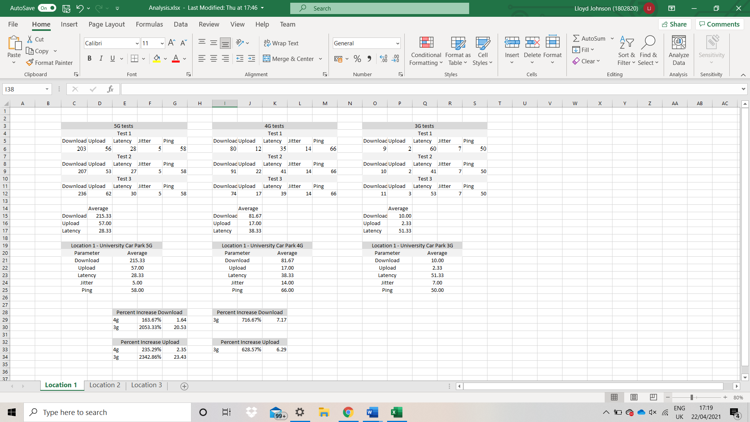

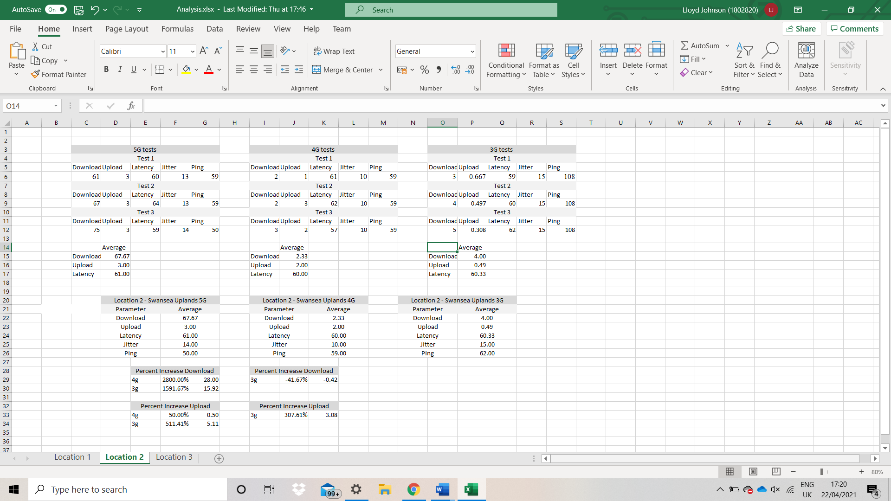

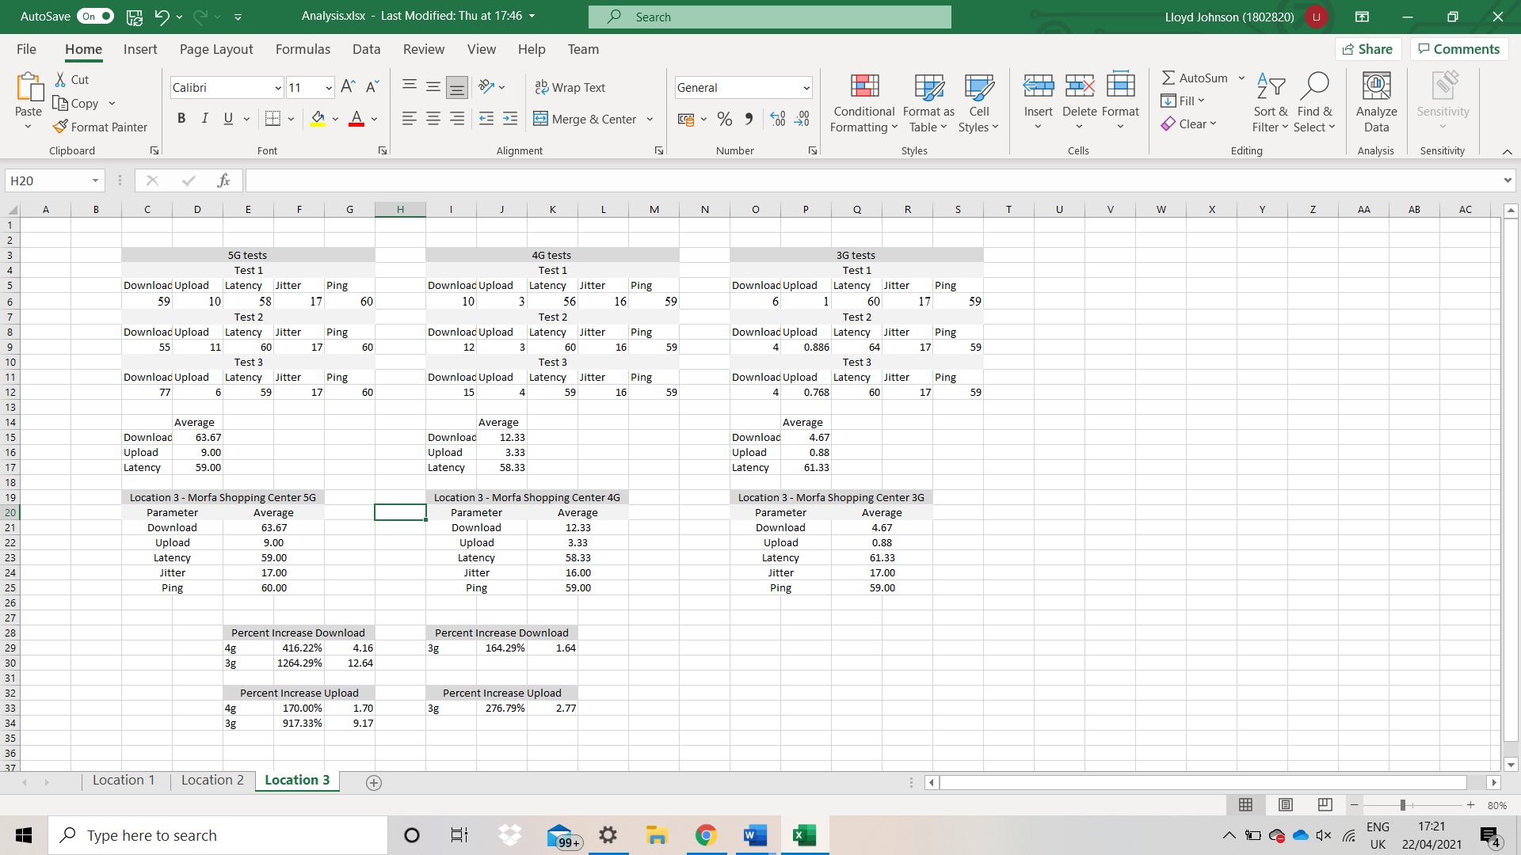

Below is an Action Plan that was used to help and plan the document.
Chapter 1 - Introduction
Description of Project | 100% | November 27, 2020 | November 28, 2020
Aims | 100% | November 28, 2020 | November 30, 2020
Objectives | 100% | November 30, 2020 | Dec 2, 2020
Intro to Project | 100% | Dec 2, 2020 | Dec 2, 2020
Proofread | 100% | Dec 2, 2020 | Dec 2, 2020
Chapter 2 - Lit Review
Case Study Collection | 100% | Dec 15,2020 | Dec 18,2020
Introduction | 100% | Dec 19, 2020 | Dec 20, 2020
Source 1 - Read through | 100% | Dec 21, 2020 | Dec 21, 2020
Source 1 - Analysis and Review | 100% | Dec 27, 2020 | Dec 29, 2020
Source 2 - Read through | 100% | Dec 29, 2020 | Dec 29, 2020
Source 2 - Analysis and Review | 100% | Dec 30. 2020 | Jan 1, 2021
Source 3 - Read Through | 100% | Jan 1, 2021 | Jan 1, 2021
Source 3 - Analysis and Review | 100% | Jan 2, 2021 | Jan 3, 2021
Conclusion | 100% | Jan 4, 2021 | Jan 4, 2021
Proof Read | 100% | Jan 4, 2021 | Jan 4, 2021
Chapter 3 - Research Methods
Introduction | 100% | Jan 5, 2021 | Jan 5, 2021
Discussion of Research method used | 100% | Jan 6, 2021 | Jan 6, 2021
Advantages of method | 80% | Jan 6, 2021 | Jan 16, 2021
Disadvantages of method | 0% | Jan 20, 2021 | Jan 21, 2021
Conclusion | 0% | Jan 21, 2021 | Jan 21, 2021
Testing Speeds and Coverage
Rural Testing | 0% | Mar 21, 2021 | Mar 21, 2021
Suburban Testing | 0% | Mar 21, 2022 | Mar 21, 2022
City Testing | 0% | Mar 21, 2023 | Mar 21, 2023
Comparison | 0% | Mar 21, 2024 | Mar 21, 2024
Proofread | 0% | Mar 21, 2025 | Mar 21, 2025
Comparison of Networks
Introduction | 0% | April 5, 2021 | April 5, 2021
Comparison of speed Average totals for 5g, 4g and 3g | 0% | April 6, 2021 | March 7, 2021
Comparison of coverage average totals for 5g, 4g and 3g | 0% | April 8, 2021 | April 9, 2021
Proof Read | 0% | April 12, 2021 | April 13, 2021
Conclusion | 0% | April 14, 2021 | April 15, 2021
Recommendations | 0% | April 16, 2021 | April 17, 2021
Reflections | 0% | April 18, 2021 | April 19, 2021
Bibliography | 0% | April 20, 2021 | April 20, 2021
Appendices | 0% | April 20, 2021 | April 20, 2021

