[Date]
Lihadi Ahmed Deen-Alhadi (2519142)
[company name]
Software Solutions for Business

Module Name: Software Solutions for Business
Module Code: ACCA4026

Student Name: Lihadi Deen-Alhadi
Student ID: 2511942
Group: 1

Lecturer’s Name: Fahad AHMED

Table of Contents
Introduction 1
Task 1. e-Commerce Website builders or software solutions 1
1.1 WooCommerce 1
1.2 Wix 1
Task 2. Mind-map of contemporary software applications 1
a. Mind mapping and explain the benefits of using mind mapping in business operations 1
b. Create a mind map of contemporary software applications 1
Task 3. Office Applications 1
a. Four office software solutions for business operations 1
MS Word 1
MS PowerPoint 1
MS Excel 1
MS Access 2
b. Practical demonstration of Two Office Features 2
Mail Merge 2
If Statement 2
Task 4. Communication and Collaboration applications 2
a. One contemporary Communication and one Online Collaboration applications/tools 2
MS Outlook 2
MS Teams 2
b. One feature of a freely available Communication (1) and one feature of a Collaboration (1) application 2
MS Outlook 2
Ms Teams 2
Conclusion 2
References 3

Task 1. e-Commerce Website builders or software solutions

WooCommerce
WooCommerce is a well-known e-commerce plugin for WordPress that makes it simple for people and companies to set up and run online stores. Since its 2011 launch, WooCommerce has been one of the most popular e-commerce platforms due to its scalability, versatility, and easy connection with WordPress websites. Because it is an open-source platform, users have complete control over their online store and can modify it to suit certain business requirements.

WooCommerce's usability is one of its key benefits. Without requiring sophisticated technical knowledge, users may rapidly put up products, manage inventory, and process payments. It facilitates transactions for both the store owner and customers by supporting a variety of payment channels, such as PayPal, Stripe, and credit card alternatives. Additionally, WooCommerce enables customized shipping.
Flexibility and scalability are two more important aspects of WooCommerce. The functionality of the store can be improved with thousands of free and paid plugins. For instance, companies can increase consumer engagement and sales by adding marketing tools, advanced analytics, booking systems, or subscription alternatives. Additionally, WooCommerce works nicely with third-party technologies like Mailchimp, Google Analytics, and social media sites, which enables companies to monitor performance and expand their consumer base.
Additionally, WooCommerce is SEO-friendly, enabling customers to improve product pages for search engines to boost visibility. It also facilitates mobile-responsive designs, guaranteeing a seamless purchasing experience for users across all platforms.

In conclusion, WooCommerce is a robust, adaptable, and user-friendly e-commerce system that enables companies of all sizes to build polished online storefronts, successfully manage operations, and expand their online presence.

1.2 Wix
Wix is a cloud-based website builder that enables people and companies to design expert websites without the need for sophisticated technical knowledge. Since its founding in 2006, Wix has grown in popularity as a platform for entrepreneurs, small enterprises, and creatives looking to swiftly and simply establish an online presence. Because of its drag-and-drop interface, users can easily build pages, add media, and alter layouts on websites.

Wix's user-friendliness is one of its key benefits. Hundreds of pre-made themes for various industries, including e-commerce, portfolios, blogs, and business websites, are available for users to select from. Users have complete control over how the website looks thanks to the platform's features for altering fonts, colors, backgrounds, and menus.[1].
Wix provides an all-inclusive online store solution for e-commerce. Product additions, inventory management, numerous payment choices, tax calculation, and discount campaign creation are all available to users. Additionally, it facilitates mobile-responsive designs, guaranteeing that consumers can easily buy on smartphones and tablets.

Wix's integrated SEO and marketing tools are another important aspect. Users may launch email campaigns, integrate social media platforms, monitor visitor metrics, and optimize their website for search engines. Wix is a trusted choice for companies wishing to expand online since it offers SSL certificates, secure hosting, and dependable customer service[2].
In conclusion, Wix is an adaptable, user-friendly website builder that lets both people and companies create eye-catching, useful, and polished websites. It is an efficient way to create and expand an online presence because of its simplicity of use, e-commerce features, and marketing tools.

Task 2. Mind-map of contemporary software applications

Mind mapping and explain the benefits of using mind mapping in business operations
Mind mapping is a potent, adaptable, and visually appealing method of improving corporate processes that helps teams make decisions more quickly, organize information more efficiently, and stimulate creativity. Mind maps make difficult activities easier to break down and manage by presenting concepts in a non-linear, interconnected structure that helps employees grasp the overall picture while still grasping the minor elements of a process or project [1]. Because mind maps organize data in an understandable and user-friendly manner, they help alleviate cognitive overload.
This visual clarity is particularly useful in fast-paced business contexts where teams must swiftly digest enormous amounts of information. Mind maps encourage creativity and reveal opportunities that can be overlooked with more conventional planning techniques by allowing teams to come up with ideas during brainstorming sessions without being constrained by strict outlines Their framework encourages participants to make connections between concepts, which frequently results in more thorough approaches and efficient problem-solving. This enhances project management efficiency and ensures that each team member comprehends their part in fulfilling corporate objectives [2]. Mind maps function as efficient communication instruments, providing a collective visual reference that maintains team alignment and minimizes the likelihood of misinterpretations.
Mind maps serve as effective communication tools, offering a shared visual reference that ensures team coherence and reduces the risk of misunderstandings. ￼
All things considering, mind mapping not only increases output and operational effectiveness but also cultivates a culture of clarity, innovation, and ongoing development inside an organization [3].

Create a mind map of contemporary software applications
<Insert diagram using mind Meister app>

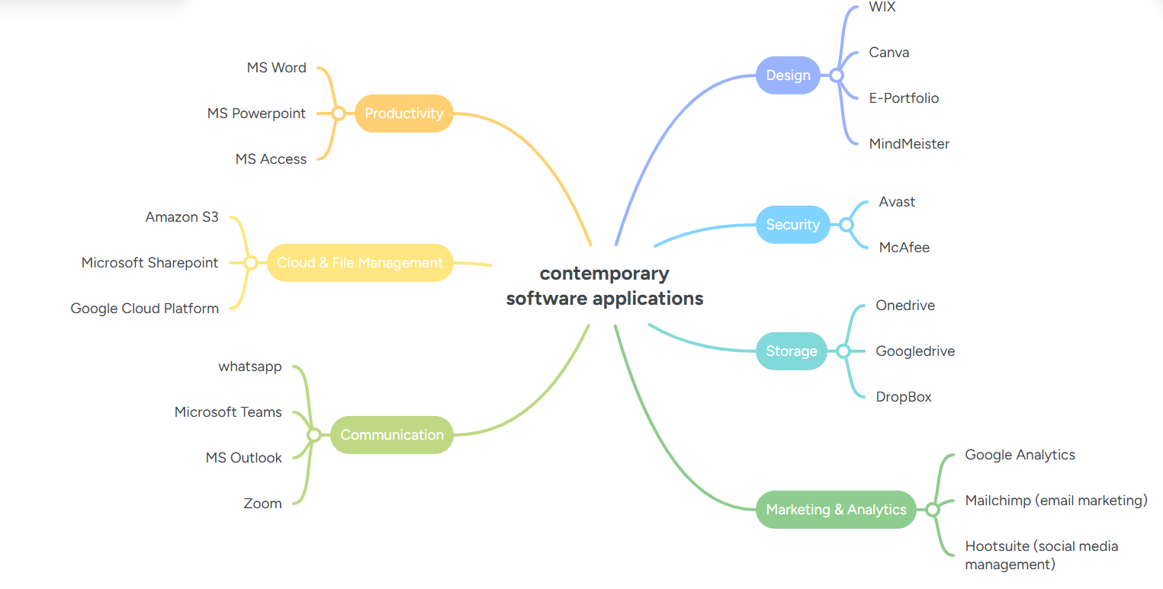How to Make a Mind Map Using Mind Meister
1. Create an Account or Log In
Go to Mind Meister's website or open the app.
Sign up or log into your existing account.

2. Start a New Mind Map
Click “New Mind Map” on your dashboard.
Choose a blank template or select from pre-designed templates (e.g., project planning, brainstorming, SWOT, tasks).

3. Add Your Central Topic
A central bubble appears automatically.
Type your main idea (e.g., “Marketing Plan” or “Study Notes”).

4. Create Branches (Primary Topics)
Press Tab (or click “+ Topic”) to create your first level of branches.
These represent major categories or sub-ideas related to the main topic.

5. Add Subtopics
Click a branch and press Enter or Tab to add sub-nodes.
Continue breaking ideas down into smaller concepts.

6. Customize the Mind Map
Mind Meister includes flexible design features:
Change colours, fonts, and shapes.
Add icons, emojis, images, or attachments.
Rearrange nodes by drag-and-drop.

7. Use Collaboration Tools (Optional)
Invite teammates to view or edit the mind map.
Use comments or built-in voting for brainstorming sessions.

8. Export or Present
Export as PDF, PNG, Word, PowerPoint, or MindManager file (depending on your plan).

Benefits of Using Mind Meister
1. Intuitive and Easy to Use
Clean interface, drag-and-drop actions, and keyboard shortcuts make mapping fast.

2. Enhances Creativity and Clarity
Provides a visual structure that helps generate ideas and reveal connections.

3. Great for Collaboration
Real-time editing and commenting make it ideal for teams, classrooms, and workshops.

4. Cloud-Based and Accessible Anywhere
Your mind maps sync across devices (web, tablet, phone).

5. Integrates with Productivity Tools
Works with Meister Task, Google Workspace, Microsoft Teams, and others.

6. Versatile Use Cases
Brainstorming
Project management
Note-taking
Teaching and studying
Strategic planning

7. Built-In Presentation Mode
Automatically converts your mind map into a clean slide deck—no extra software needed.

8. Supports Visual Memory
Colours, icons, and spatial layout help reinforce memory and understanding.

Task 3. Office Applications

Four office software solutions for business operations

MS Word

Microsoft Word is a popular word processing program that the company created. It is intended to make it simple for users to create, edit, format, and distribute documents. It is a component of the Microsoft Office and Microsoft 365 suites. For tasks including composing letters, reports, resumes, essays, and manuals, Microsoft Word is frequently used in homes, workplaces, and educational institutions.[4]

Microsoft Word's ease of use is one of its primary advantages. Because of the interface's ease of use, novices can begin typing and structuring texts with little assistance. Spell check, grammar check, and autocorrect are examples of tools that assist users in improving the caliber and precision of their writing. Additionally, Word provides a large selection of fonts, styles, and formatting choices that help documents appear polished and well-structured.
Productivity is another significant advantage. When writing documents, Microsoft Word offers time-saving features including tables, bullet lists, headers and footers, and templates. While capabilities like word count and page layout assist effectively control document length and structure, the search and replace function enables users to swiftly locate and update text.[5]

Microsoft Word facilitates teamwork as well. It is simple for numerous individuals to work on the same document because users can track changes, add comments, and share documents online. This is particularly helpful for teamwork in the workplace and group tasks. Word also works nicely with other Microsoft programs, including Outlook, Excel, and PowerPoint. Another important benefit is productivity. Tables, bullet lists, headings and footers, and templates are just a few of the time-saving features that Microsoft Word provides when creating documents. The search and replace feature allow users to quickly find and alter content, while features like word count and page layout help efficiently control document length and structure.

Additionally, Microsoft Word makes collaborating easier. Because users can track changes, provide comments, and share documents online, it is easy for multiple people to work on the same document. This is especially useful for group projects and collaboration at work. Additionally, Word integrates well with Outlook, Excel, and PowerPoint, among other Microsoft applications.
Microsoft Word is a robust word processing program that is used all over the world to create, edit, format, and manage text-based documents. It is a fundamental part of the Microsoft Office and Microsoft 365 suites and is extensively utilized in corporate, government, education, and private contexts. Letters, reports, resumes, research[6] papers, newsletters, and books are just a few of the document formats that Microsoft Word can handle.

Microsoft Word's extensive collection of formatting and design capabilities is one of its main advantages. To satisfy particular needs, users can alter the fonts, colours, spacing, margins, and page layouts. Advanced features like styles, themes, columns, and section breaks aid in producing documents that are both aesthetically pleasing and well-organized. Microsoft Word also improves writing quality and accuracy. Built-in tools like spell check, grammar suggestions, thesaurus, and readability statistics help users refine their writing. The Editor feature provides advanced language suggestions, including clarity, conciseness, and tone. For academic and professional writing, Word offers citation and bibliography tools that support multiple referencing styles, such as APA and MLA.[6]

Another major benefit of Microsoft Word is efficiency and automation. Features such as templates, macros, mail merge, and quick parts save time and reduce repetitive work. Mail merge, for example, allows users to create personalized letters, labels, and emails for large groups. AutoSave and version history help prevent data loss and allow users to recover previous versions of a document.

MS PowerPoint
A presenting tool created by Microsoft, Microsoft PowerPoint is a component of the Microsoft Office suite. It is commonly used in organizations, enterprises, and educational institutions to provide visual presentations that facilitate learning and communication. By combining text, graphics, charts, videos, animations, and audio on slides, PowerPoint users may make content more comprehensible and captivating for viewers. Microsoft PowerPoint's ease of use is one of its key advantages. With the program's user-friendly interface and pre-made templates and design tools, users of various skill levels can quickly produce presentations that appear professional. This saves time and effort, particularly for novices[7].
Its capacity to improve communication is another significant advantage. Graphs, diagrams, and pictures are examples of visual components that make difficult concepts easier to understand than text alone. This increases the effectiveness of presentations and improves audience retention. Additionally, PowerPoint is adaptable and versatile. It can be used for training sessions, project reports, business meetings, and classroom instruction, among other things. Presentations can be tailored to fit various subjects and audiences.

Another benefit of Microsoft PowerPoint is collaboration. Multiple users can work on the same presentation simultaneously, share feedback, and make revisions with ease thanks to cloud integration via Microsoft OneDrive. Lastly, interactivity and multimedia are supported by PowerPoint. Presentations become more dynamic and captivating with features like animations, transitions, and linked movies, which keeps viewers interested. To sum up, Microsoft PowerPoint is a strong and useful presenting tool. It is a useful tool for professionally and clearly presenting ideas because of its visual appeal, ease of use, flexibility, collaborative features, and support for multimedia. Microsoft created PowerPoint, a potent presentation tool that is part of the Microsoft Office suite. It is used all over the world in corporate, professional, and educational settings to produce and give presentations in an understandable, well-structured, and eye-catching manner. Slides that contain text, pictures, tables, charts, shapes, audio, video, and animations make up PowerPoint presentations[8].

Microsoft PowerPoint's extensive collection of formatting and design capabilities is one of its main advantages. To produce visually coherent and polished presentations, users can select from a variety of pre-built templates, themes, fonts, and color schemes. Users can manage the presentation's overall layout with the Slide Master function, which guarantees consistent formatting on every slide. Compatibility and accessibility are two more significant advantages. Computers, tablets, and smartphones are just a few of the devices that can open PowerPoint files. Presentations are simple to share with others because they may be exported as PDFs or videos. Additionally, PowerPoint has accessibility features that help make presentations inclusive for individuals with impairments, such as screen reader support, subtitles, and alt text for images.[9]

Microsoft PowerPoint facilitates remote work and teamwork. Multiple users can update a presentation at once, add comments, and monitor changes in real time with cloud services like Microsoft Teams and OneDrive. This is particularly helpful for teamwork in the workplace and group tasks.

MS Excel
A spreadsheet program created by Microsoft, Microsoft Excel is a component of the Microsoft Office suite. It is widely used for data storage, organizing, analysis, and presentation in organizations, corporations, and educational institutions. Excel allows users to enter data, do computations, and generate visual representations like charts and graphs using rows and columns organized into spreadsheets.
The speed and accuracy with which Microsoft Excel can do computations is one of its key characteristics. Numerous built-in formulae and functions are available in Excel, including addition, subtraction, averages, percentages, logical functions, and financial computations. When dealing with a lot of numerical data, these technologies assist users save time and make fewer mistakes. Excel is highly effective for data analysis since it can automatically recalculate results as data is updated[10].
Excel's ability to organize and handle data is another significant advantage. Users can quickly locate specific information by sorting and filtering data. Data is kept readable and organized with the use of tables, rows, and columns. Data validation is another feature of Excel that helps guarantee accurate and consistent data entry. This is particularly helpful for things like inventory management, budgeting, and record keeping.

Data analysis is another area in which Microsoft Excel excels. Large datasets can be swiftly summarized and analyzed because to features like PivotTables and PivotCharts. Excel is helpful for business and research decision-making because of these tools, which assist in identifying trends, patterns, and comparisons. Additionally, Excel offers conditional formatting, which makes information easier to interpret at a glance by highlighting significant data with colors, icons, or data bars.
Excel's ability to make graphs and charts is another significant benefit. Data can be transformed by users into visual representations including column charts, pie charts, bar charts, and line graphs. These graphics aid in the straightforward presentation of information and enhance the readability and engagement of reports[11].

Excel facilitates sharing and teamwork. Multiple users can work on the same spreadsheet simultaneously, post comments, and monitor changes thanks to cloud connection via OneDrive and Microsoft 365. Excel is useful for reporting and teamwork since files can be shared in several formats, including PDFs.

Microsoft Excel is used in the classroom to educate students problem-solving techniques, data processing, and fundamental programming ideas. It is frequently utilized in business for payroll, forecasting, accounting, budgeting, and performance monitoring.
To sum up, Microsoft Excel is a flexible and effective spreadsheet program. It is a crucial tool for professionals, organizations, and students in a variety of sectors because of its capacity to conduct computations, arrange and analyze data, construct charts, and facilitate teamwork[12].

MS Access
The Microsoft Office suite includes Microsoft Access, a database management system (DBMS) created by Microsoft. It is intended to assist users in effectively managing, storing, and analyzing vast amounts of data. Small firms, students, and organizations that need to manage data without utilizing sophisticated database systems frequently utilize Microsoft Access[12].

Easy database creation and management is one of Microsoft Access's key advantages. Tables that hold data in rows and columns make up an Access database. Large volumes of connected data, such inventory lists, personnel information, and customer records, can be stored in each table. Access enables users to specify data types, primary keys, and table associations, all of which contribute to the accuracy and well-being of data organise.
Additionally, Microsoft Access offers tools for effective data entry and editing. Data entry can be made easy and user-friendly by using forms. Users can use forms with buttons, drop-down lists, and text boxes in place of directly entering data into tables. As a result, even those with little technical expertise may utilize the database more easily and with fewer errors[13].

Microsoft Access's strong querying capabilities are another significant advantage. Users can search, filter, sort, and compute data according to predetermined criteria using queries. For instance, a user can easily determine the overall sales for a given time period or locate every consumer from a particular place. Queries facilitate better decision-making by assisting users in extracting pertinent information from huge datasets.
Reports can also be made with Microsoft Access. Reports enable users to display data in an understandable, polished style that can be shared online or printed. Reports that summarize data, show computations, and have headings or charts can be created by users. This is particularly useful for summary, invoicing, and company reports.

Another benefit of Access is its integration with other Microsoft Office programs. It is compatible with Microsoft Word, Excel, and Outlook. Excel allows for the input and export of data, which facilitates information sharing and analysis. Additionally, Access has the ability to link to external data sources, including web data and SQL databases.
Visual Basic for Applications (VBA) and macros in Microsoft Access facilitate automation. These features enable users to construct custom functions, automate repetitive operations, and develop basic applications. This boosts productivity and enables more sophisticated database usage[14].

Microsoft Access is used in both business and education for operations like project tracking, inventory control, customer databases, and student record management. Small to medium-sized database applications are particularly well suited for it.
In summary, Microsoft Access is an effective database management solution that is also easy to use. It is a useful tool for efficiently managing information because of its capacity to store and arrange data, generate forms and reports, run queries, and interface with other Microsoft Office applications.

Practical demonstration of Two Office Features

Mail Merge
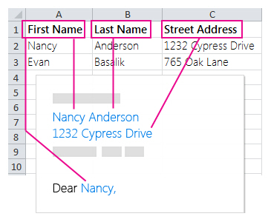
This picture shows an example of a spreadsheet mail merging. It displays columns named "First Name," "Last Name," and "Street Address," with sample data entered. The illustration shows how information from the spreadsheet can be automatically entered into a letter format, such as "Dear Nancy," with the full name and street address in the letter body. This illustrates the use of spreadsheet data for individualized bulk communication.

If Statement
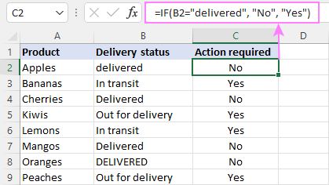
This is a if statement for example if you select no it will slect it and if you select yes it will also select it

Task 4. Communication and Collaboration applications

One contemporary Communication and one Online Collaboration applications/tools

MS Outlook
Microsoft created Outlook, an email program and personal information manager. Businesses, organizations, and individuals use it extensively to manage email correspondence, scheduling, contacts, and projects. It is a component of the Microsoft Office suite. Outlook is a potent tool for both personal and business use because it integrates several features into a single interface.

Microsoft Outlook's email management system is one of its key features. Emails can be sent, received, and arranged effectively by users. To assist with sorting and prioritizing messages, Outlook offers folders, categories, and flags. Additionally, the program has capabilities like search, filters, and rules that automatically arrange incoming emails according to predetermined standards. This makes it possible for users to handle high email quantities without feeling overburdened[15].
Outlook's calendar and scheduling features are yet another important advantage. Users can share their calendar with coworkers, set reminders, and schedule events, meetings, and appointments. Outlook facilitates meeting scheduling by automatically sending out meeting invitations and verifying participant availability. Particularly in work environments, this function guarantees improved coordination and time management.

Additionally, Microsoft Outlook facilitates efficient contact management. Email addresses, phone numbers, locations, and notes are just a few of the comprehensive details about people and organizations that users can keep. Users may converse straight from the contact list thanks to email connectivity, and contacts can be grouped and categorized for easier access. Because of this, Outlook is a handy tool for keeping up personal and business networks.
Another important Outlook feature is ask management. To-do lists, deadlines, task delegation, and progress monitoring are all available to users. By keeping users focused and structured on crucial tasks, this boosts productivity. Nothing is missed thanks to the integration of tasks with emails and calendar events[16].

Additionally, Outlook facilitates interaction and teamwork with other Microsoft Office programs. Users may share documents, set up meetings, and work together on projects since it integrates easily with Word, Excel, and Teams. Users may access their contacts, calendars, and emails from a variety of devices, including PCs, tablets, and smartphones, thanks to cloud connection via Microsoft 365.
Outlook's dependability and security are other crucial features. To protect sensitive data, the application has encryption settings, phishing prevention, and spam filters. It's easy to stay organized because users can manage several email accounts from a single interface, including Outlook.com, Exchange, Gmail, and other email providers.

Microsoft Outlook is frequently used in business and education to organize activities and projects, manage communication, and set up appointments. It increases overall productivity, keeps users organized, and lowers the possibility of missing crucial communications or deadlines.
To sum up, Microsoft Outlook is an all-inclusive utility for handling tasks, contacts, schedules, and emails. Students, professionals, and companies looking for effective communication and productivity will find it indispensable due to its email organization, calendar scheduling, contact management, task tracking, interaction with other Microsoft products, and security features[17].

MS Teams
As a component of the Microsoft 365 package, Microsoft Teams provides a platform for collaboration and communication. Teams facilitates effective communication, collaboration, and information sharing among corporations, schools, and groups by bringing individuals together in a virtual workspace. It is a crucial tool for contemporary remote and hybrid work situations since it integrates chat, video meetings, file storage, and program integration into a single interface[18].

Microsoft Teams' chat and messaging system is one of its primary features. Through group conversations or individual messaging, users can interact in real time. Threaded conversations are supported by Teams, making it simple to follow topics, respond to particular messages, and maintain organization. Additionally, users can communicate by sharing files, pictures, links, and emojis in conversations.
The video conferencing and meeting features of Microsoft Teams are well-known. Users can use screen sharing, audio, and video in virtual meetings. Teams works with Outlook to handle invitations and reminders, and it enables meeting scheduling straight from the calendar. It is appropriate for both small team conversations and big webinars since features like recording, live subtitles, and background effects increase the accessibility and efficacy of meetings[19].
File sharing and teamwork are two other significant advantages of Teams. Files are automatically saved in OneDrive or SharePoint, and users can store them in specific chats or channels. Office programs like Word, Excel, and PowerPoint allow several users to work on the same document at once. By enabling smooth teamwork, this real-time collaboration removes version control problems and boosts productivity.

Additionally, teams facilitate task and project management. To effectively arrange work, users can build channels for various teams, projects, or subjects. Task assignment, progress monitoring, and deadline management are made possible by integration with Microsoft Planner and To Do. Teams channels eliminate the need for frequent emails or dispersed information by offering a single location for all relevant discussions, files, and resources.
Microsoft Teams is highly flexible and customizable. It supports integration with hundreds of third-party apps such as Trello, Zoom, Salesforce, and GitHub. Users can add tabs, bots, and connectors to tailor the platform to their workflow. This makes Teams not just a communication tool but a comprehensive workspace for diverse business needs.These features guarantee the security of files, communications, and sensitive information.

Security and compliance are other significant advantages of Teams. Microsoft provides enterprise-grade security, including data encryption, multi-factor authentication, and compliance with standards such as GDPR and HIPAA. These features ensure that conversations, files, and sensitive data remain protected[20].

One feature of a freely available Communication (1) and one feature of a Collaboration (1) application

MS Outlook
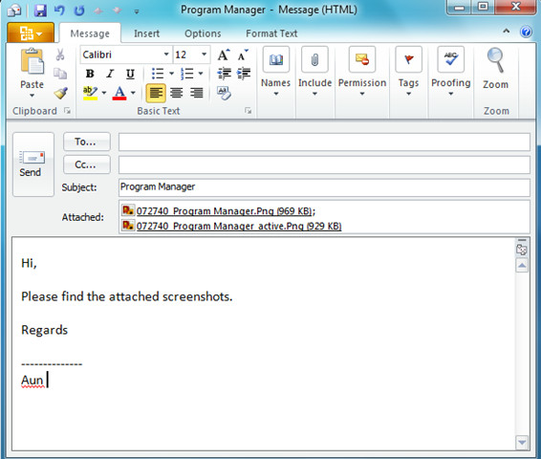
This picture displays a draft of an email from Microsoft Outlook. Two screenshots titled "Program Manager" are included, along with a brief message alerting the recipient to the attachments. With a brief salutation, a description of the attachments, and the sender's name, "Aun," at the end, the email is plain and kind. Standard email formatting tools are displayed on the screen.

Ms Teams
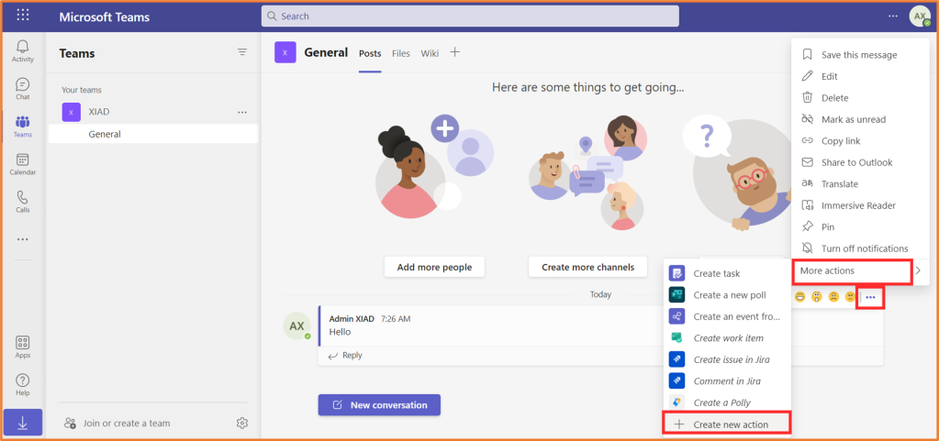
This picture displays a message from "Admin XIAD" in the "General" channel of Microsoft Teams. After opening the message options menu and selecting "More actions," the user was presented with choices to create tasks, surveys, and events. You can also see the sidebar with navigation buttons. Here's a brief overview of how Teams makes task management and message interaction simple.

Conclusion
For this assignment, I examined various software solutions that improve business operations, such as creating online storefronts, managing projects, and interacting with teams. These programs can significantly increase output, maintain organization, and facilitate teamwork. The practical sections demonstrated these tools' usefulness by demonstrating how they function in real-world scenarios. All things considered, every organization that wishes to function effectively and stay up with the fast-paced world of today must understand how to use these software solutions.

References
Woo-Commerce

Wix
References
[1] J. Holland, "Learn how to create a wix website: Current best practices," vol. 8, no. 2, pp.50–58, 2020,
[2] H. Li, "Developing a Website for Nordic Inn Travel Oy by Wix," 2020,

Mind Map
References

[1] P. Farrand, F. Hussain and E. Hennessy, "The efficacy of the mind map 'study technique," Med.Educ. vol. 36, no. 5, pp.426–431, 2002,
[2] E. N. Biktimirov and L. B. Nilson, "Show them the money: Using mind mapping in the introductory finance course," pp.72–86, 2006,
[3] T. Buzan and B. Buzan, The mind map book, Pearson Education, 2006.

MS Word
References
[1] G. B. Shelly and M. E. Vermaat,Microsoft Office 2010: Introductory, Course Technology Press, 2012.
[2] S. Greenstein and M. Devereux, "The Crisis at Encyclopædia Britannica," pp.1–18, 2017,
[3] B. Camarda, Special Edition Using Microsoft Office Word 2003, Que Publishing, 2004.

MS Powerpoint
References
[1] D. M. Marcovitz, Powerful PowerPoint for educators: using Visual Basic for applications to make PowerPoint interactive, Bloomsbury Publishing USA, 2012.
[2] J. S. Artal-Sevil, E. Romero and J. M. Artacho, "Using new multimedia learning technologies: presentations design tools, dynamic animations, interactive maps, visual content and multimedia resources", EDULEARN18 Proceedings, pp. 9617–9627.
[3] C. F. De Wet, "Beyond presentations: Using PowerPoint as an effective instructional tool," vol. 29, no. 4, pp.29–39, 2006,
MS Excel
References
[1] S. Brown, et al., "A Microsoft-Excel-based tool for running and critically appraising network meta-analyses—an overview and application of NetMetaXL," vol. 3, no. 1, pp.110, 2014,
[2] S. Bullen, R. Bovey and J. Green,Professional Excel development: the definitive guide to developing applications using Microsoft Excel and VBA, Addison-Wesley Professional, 2005.
[3] B. Liengme, A guide to Microsoft Excel 2013 for scientists and engineers, Academic Press, 2015.

MS Access
References
[1] L. R. Zuniga, Evaluating the effectiveness of an Excel logical functions tutorial on beginning Excel college students, California State University, Dominguez Hills, 2007.
[2] В Д Михеева, Microsoft Access 2003 ( CD), БХВ-Петербург, 2006.
[3] F. Rios and D. Fearon, "Microsoft Access Data Curation Primer," 2019,

MS Outlook
References
[1] S. Mosher, Microsoft Outlook 2000 E-mail and Fax Guide, Elsevier, 2000.
[2] A. Basu, "AI tools for everyone: Your guide to artificial intelligence," 2025,
[3] P. Ayers, C. Matthews and B. Yates,How Wikipedia works: And how you can be a part of it, No Starch Press, 2008.

MS Teams
References
[1] H. Gruenwald, "COVID-19 and Microsoft Teams," 2021,
[2] A. Basu, "AI tools for everyone: Your guide to artificial intelligence," 2025,
[3] B. N. Ilag and A. M. Sabale, "Microsoft teams overview," in Troubleshooting Microsoft Teams: Enlisting the Right Approach and Tools in Teams for Mapping and Troubleshooting Issues, Springer, 2022, pp. 17–74.

