
• Student Name: Denis Tejada
• Student ID: 2616458
• Module: LCLM4001 – Academic Skills.
• Assessment: AS1 – Reading and Notes.

Assessment 1 – Reading Task Template
PART 1: Upload your photo of your A3 in-class notes here:
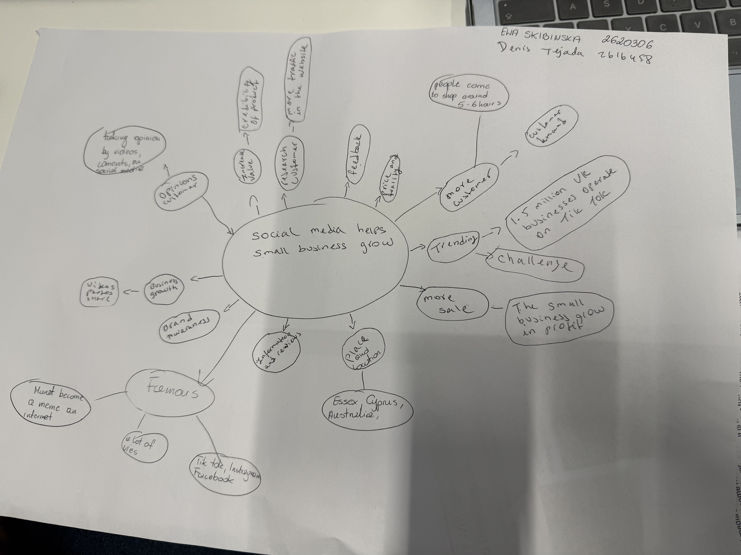

PART 2:
- Answer every question below in 1-3 full sentences.
- Use your own words. Do not use generative AI to answer these questions.
- Include a specific detail from the text when asked.
REMINDER
- The main idea is the overall message of the whole text.
- A key point helps to explain the main idea.
- A specific detail or example from the text shows that the key point is true.

- What is the main idea of the whole text?

The main idea is that a small businesses can bring more people from around the country through social media.

- What is one key point that supports the main idea, and which specific example from the text shows this?

Honywood Sandwich Shop, many people shared the location and gave positive feedback and it went viral.

- What is a different key point that supports the main idea, and which specific example from the text shows this?

Lindy Loo's Boutique after Covid-19, started selling more online than in a physical store .
The business gained 320,000 followers.
- Which part of the text do you think is most important, and why?

I think both stories are important because many people travel from so far away and the other business gains more followers. I'm surprised by how social media has a big impact on small businesses.
Reflection:
- What did you find difficult in this task (including in-class components), and why was it difficult?

I found it difficult to organise my ideas and to understand the article and how a business works.

- What helped you with this difficulty, and how did it help you?

The teacher's explanation and reading the article several times helped me understand better how social media helps small businesses.

