

Managing Enterprise in the 21st Century

Executive summary
The present business world is becoming more competitive since new business ventures are entering in the market. This report is about the establishment of a new business venture. There are opportunities for innovative and inventive ideas for establishing a new business venture. To plan for a new business establishment the market should be analyzed first. Nowadays the technology firms are growing faster and the marketplace is becoming broaden. So the plan is to serve for technical service in London. The report has been formulated with the details of the plan for the technical organization and its establishment in the market.
Table of Contents
Executive summary 2
Introduction 4
Task 1 5
Overview of the new business plan 5
Product and services for new business 5
Market Audit 6
Target market 6
Marketing plan 6
Management Team 7
Financial plan 7
SWOT analysis for the new business venture 9
Employability skills for establishing a new venture 10
Conclusion 11
Task 2 12
References 25

Introduction
The business world is getting competitive since more business organizations are coming with innovative products and services in the market. The emergence of new businesses is rising the competition (Bound, 2017). This report is about the management of new enterprise and setting an enterprise in the market. In this report, the aspects of setting a new business organization and performing it in the market will be discussed. The whole report has been decorated with two parts. Part one is decorated with a business plan with proper components and their explanation for the plan. The second part is a PowerPoint presentation in which consists of a summary of the business plan and the recommendation for the business plan.

Task 1
In this part of the report, the new business plan has been explained. The explanation includes a marketing plan, product or service, target consumers and customers, management process, and financial plan for new business ventures. Some required skills for the entrepreneur for launching a new business organization in the market have also been discussed in this part.

Overview of the new business plan
A new business venture is about planning for organizing different requirements to serve with products or services. The plan is to serve with the security software for different business organizations. The name of the new business venture is SoSo which stands for Software Solution.
The planned organization will work for the protection of business information to keep them confidential and ensure their privacy. Different organizations are providing security software online and offline. But with the increasing number of business firms and clients for this software, the demand in marketing is rising for which service with such business has more potential to grow and expand in the market. The service will be provided online and offline.

Product and services for new business
The service for which the new company will work for is security software. Nowadays most of the business organizations handle their operations online. There are different risks related to the information that is recorded and maintained in a computer system. Confidential data for any company might be hacked, viruses might cause some data erased, and so on. To avoid risk for the confidential data and information for any business, organizations take security software for maintaining their privacy and security system for making them secured (Janseen, 2018). The new organization will meet the demand of such firms with proper security software and its service. The service will be provided offline and online. In the case of online service, the websites and online profiles of the clients will be protected by the company. In offline servicing, the technician from this organization will visit the client and make their database system with proper security. To serve different companies this new venture will appoint a specialist for software security.
The product and service will be provided with different packages. Since there are different companies with different sizes of servers to maintain security. The packages are priced differently with different types of service.

Market Audit
The new business venture is about the service with technology. In the field of technologies serving with information security is one of the important jobs for any organization. The selection of such service has been decided because there is a potential market gap in which the new organization will serve the clients. From the research in the market, it is found that there are about 1 million companies and 2.5 million SME organization in London. Most of the firm handles its operations with a computerized system. The organization which records their information in the computer system needs physical service with a database system and its security (Agrawal, 2017). On the other hand, the firms which operate online need online security service for ensuring the security of transaction and confidentiality. To serve this large portion of companies and organization there are not enough service providers in the market. The number of new business organizations is also rising which makes it more competitive for technological companies. The motive of the new business venture is to capture the clients and different business organizations to purchase the security service online and offline.

Target market
The target market for the new venture is huge under which the organization maintains a computerized information system. The physical service by visiting the organization has an area limitation of London. The company will provide direct service to the client’s organization which is located within London. With the expansion of business organizations, the market will broaden according to capability and capacity. For serving online there is no limit to customers. All the organizations around the world can opt for the service from this organization. There are proper options for taking service with different packages that are available on an online platform.

Marketing plan
The marketing plan is about the setting of the process including the introduction of new products or services in the market, the promotion of product and service, distribution of product, and service (De Pelsmacker, 2017). The marketing plan for the new business venture is mostly concerned with the online market area. Among the target customer for the new business venture, customers in the online market are more potential. The organization needs to maintain an office in the Commercial Area of London where different client organizations can contact easily. For physical marketing, there will be billboards, leaflets about the organization, and direct visiting the client and confessing about the service with different promotional activities. The online marketing plan includes online advertisement, social media interaction, and email marketing. Moreover, the new organization will act for the marketing plan according to the service which indicates the physical marketing for direct service and online marketing online service.

Management Team
The management of an organization is the driver of the operations and functions of the organization. The new planned organization will be led by a proper management team. The organization will be led with the office building where the following criteria of managerial personnel will be present.
CEO: The CEO of the organization is the higher level of the executive to control the management of the organization. Here in the beginning the Owner himself will act as the CEO of the company.
General Manager: The general manager allocates different departments with the activities of the task with two assistants under him to comply with the tasks and duties allocation plan.
Operational manager: For different teams of organizations there will be a leader known as an operational manager who will control the activities of the employees within the team.
Operation executives: These are the employees who will provide the service directly to the client. There are two types of operational executives. The experts who direct visit the client office and ensure data security. Other executives are expert who serves online security. To plan for the operational and security service for the clients there will be head of the team who will decide about the process of service.

Financial plan
The financial activities for an organization while setting a new organization is most important depending on which the activities, functions, and area of organizations are decided. The financial resources decide how the business will run and operate. The size of the business organization also depends on financial resources.
The financial resources for the target business plan are as follows:
Tangible resources
The tangible resources are those which are fixed for an organization and those which are financed with the motive of long term investment and profit (Bystryakov, 2013). The Tangible resources for this business organization are as follows:
Office: For this business organization the office is the place where the clients and the agents from clients communicate about their service. The employees for serving online also maintain their team of service in the office building.
Capital: The capital is required for meeting operating expenses, administrative expenses, training, software, technological tools, and different equipment for service (Bystryakov, 2013). The salary for the employees at the office is another major cost since the expert in technologies requires more payment than other operations.
Employees and staff: The staff and employees are recruited who are efficient in serving online and physically are also deemed as an asset for the organization. The management is always active to form a team for different operations with different employees depending on their skills and abilities.
Equipment: For providing proper security to the client organization and their computer system proper software, software engineer, computerized tools for developing new software are required. The interaction of online security malware program is also required.
Intangible resources
The intangible assets for the organization are the permission, goodwill about the organization, trademark, and the skills of the security providers (Bonomo and Pasternak, 2012). By maintaining proper intangible assets for the organization the new venture can develop its quality.
Budget for the new business organization
The following requirements are to be filled for complying with the business requirements and starting the new venture.
Particulars | Amount
Operating capital | £25000
Office rent and decoration: | £20000
IT equipment procurement: | £40000
Staff salary: | £60000
Promotion and advertising: | £20000
Miscellanies: | £5000
Total: | £170000
Forecast of financial plan and revenue goal for the first year:
Months | Cash Inflows in £ | Cash outflows In £ | Profit In £
1 | 60000 | 25000 | 35000
2 | 65000 | 30000 | 35000
3 | 70000 | 30000 | 40000
4 | 72000 | 30000 | 42000
5 | 75000 | 32000 | 43000
6 | 75000 | 35000 | 40000
7 | 78000 | 35000 | 43000
8 | 80000 | 35000 | 45000
9 | 82000 | 35000 | 47000
10 | 85000 | 35000 | 50000
11 | 88000 | 35000 | 53000
12 | 90000 | 35000 | 55000

SWOT analysis for the new business venture
Strength
- More companies are involving in computerized information systems which are potential clients for the company.
- The online marketing area provides more opportunity for the organization to grow in a multinational extent.
- The security measures in an online and offline computer system are required for all the organization which is involved in technological service.
Weakness
- It is tough for a new business organization to raise trust among the customers and clients.
- The lack of experience for the organization might cause mistakes in operations.
Opportunities
- More business organizations are coming in the online market which requires proper security.
- Online marketing for the company is easier since the employees of the organization are selected from the technological background.
Threats
- The market for security service is more competitive in the online marketing area and the new organization has to compete with larger firms.
- The new business venture has to lack in resources for complying with proper security services.

Employability skills for establishing a new venture
For a new organization to establish in the market, an entrepreneur has to comply with the requirements of the organization and make it happen actually. To comply with the required factors an entrepreneur should have the following skills and qualities.
Organizing and leading: Different factors are required for establishing an organization. To gather them and lead the organization the entrepreneur should have the quality to organize the required element of organization and lead them to accomplish the organizational goal (Faxheden, 2015).
Planning: Planning is an important quality which an entrepreneur should have. The entrepreneur in the new business organization has to plan for the goals, operations of the organization, and marketing of the organization with proper planning.
Managing: For a new organization the owner or entrepreneur plays the most efficient role in managing all the requirements. For an organization, there is a management team that is involved in operations, but managing the management team is the duty of an entrepreneur.
Collaboration and communication: To comply with the tasks and operations, gather the requirements for an organization, and maintaining an organization there are several people with whom the entrepreneur needs to communicate (Harris et al., 2009). The communication with the internal employees, workers and external personnel are required for which the entrepreneur should have proper communication and collaboration skills
Decision making: The decision regarding the newly established organization is taken by the entrepreneur for which an entrepreneur should have the skills to take an efficient decision. The entrepreneur in this new venture should have the ability to decide on the solution in different issues while serving the clients.
Problem-solving skills: While running an organization there might be different problems and issues that the entrepreneur has to solve (Karlsson and Moberg, 2013). The entrepreneur of the new organization should have technical skills since this organization is a technological organization.

Conclusion
Forming a new business organization in the market is a challenging thing. There are different requirements for an organization to establish in the market. The people who have proper skills and abilities for establishing a new venture should take initiatives for establishing a new venture. In this part of the report, the new business venture and its planning have been provided.

Task 2
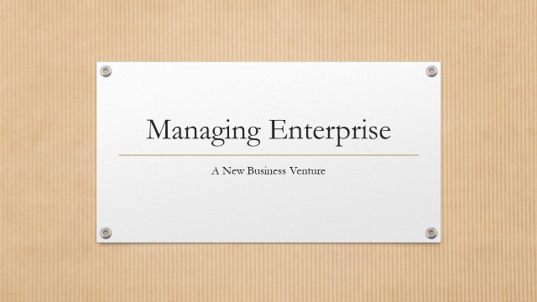
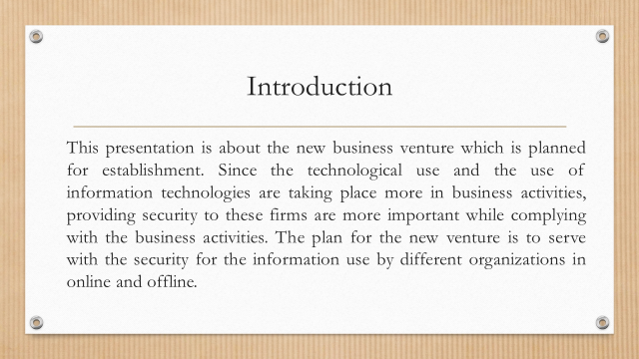
Speaker Note
This presentation is about the new business venture which is planned for establishment. Since technological use and the use of information technologies are taking place more in business activities, providing security to these firms is more important while complying with business activities. The plan for the new venture is to serve with the security for the information used by different organizations in online and offline.
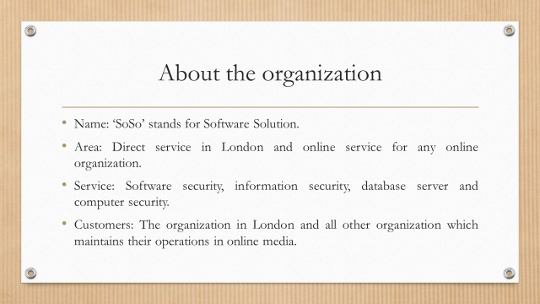
Speaker note
- Name: ‘SoSo’ stands for Software Solution.
- Area: Direct service in London and online service for any online organization.
- Service: Software security, information security, database server, and computer security.
- Customers: The organization in London and all other organization which maintains its operations in online media.
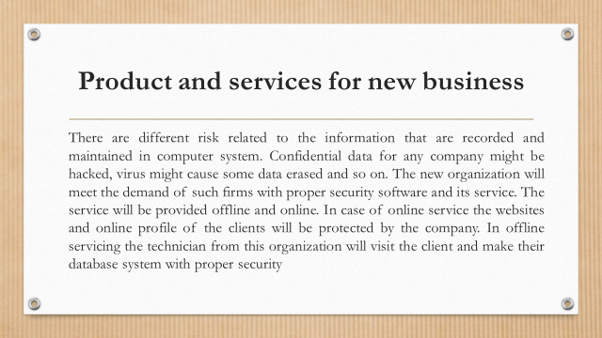 Speaker note
There are different risks related to the information that is recorded and maintained in a computer system. Confidential data for any company might be hacked, viruses might cause some data erased, and so on. The new organization will meet the demand of such firms with proper security software and its service. The service will be provided offline and online. In the case of online service, the websites and online profiles of the clients will be protected by the company. In offline servicing, the technician from this organization will visit the client and make their database system with proper security
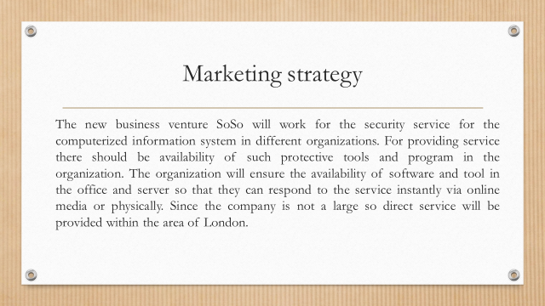
Speaker note
The new business venture Sozo will work for the security service for the computerized information system in different organizations. For providing service there should be the availability of such protective tools and programs in the organization. The organization will ensure the availability of software and tool in the office and server so that they can respond to the service instantly via online media or physically. Since the company is not large so direct service will be provided within the area of London.

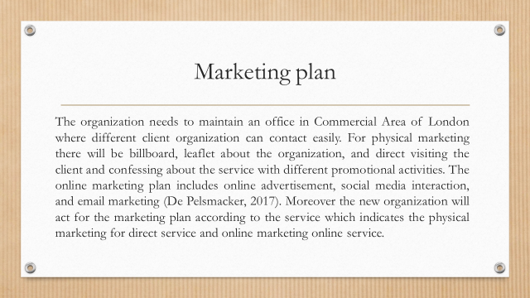 Speaker note
The organization needs to maintain an office in the Commercial Area of London where different client organizations can contact easily. For physical marketing, there will be billboards, leaflets about the organization, and direct visiting the client and confessing about the service with different promotional activities. The online marketing plan includes online advertisement, social media interaction, and email marketing (De Pelsmacker, 2017). Moreover, the new organization will act for the marketing plan according to the service which indicates the physical marketing for direct service and online marketing online service.

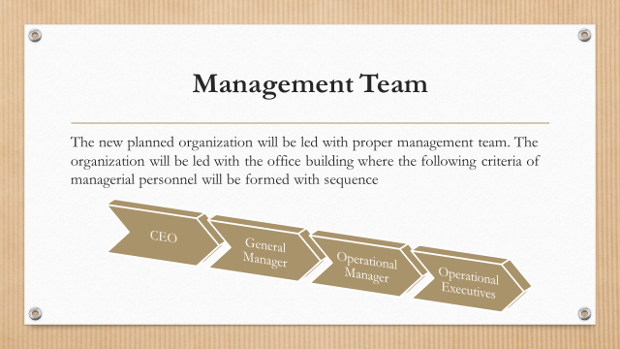
Speaker note
The new planned organization will be led with a proper management team. The organization will be led with the office building where the following criteria of managerial personnel will be formed with sequence

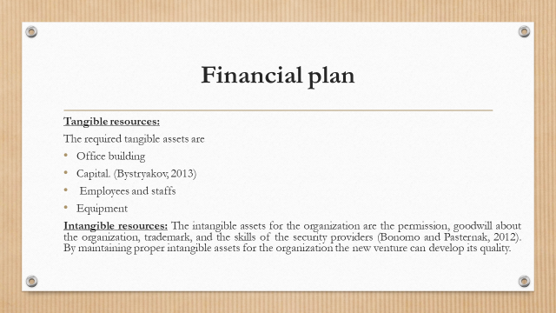
Speaker note
Tangible resources:
The required tangible assets are
- Office building
- Capital. (Bystryakov, 2013)
- Employees and staffs
- Equipment
Intangible resources: The intangible assets for the organization are the permission, goodwill about the organization, trademark, and the skills of the security providers (Bonomo and Pasternak, 2012). By maintaining proper intangible assets for the organization the new venture can develop its quality.
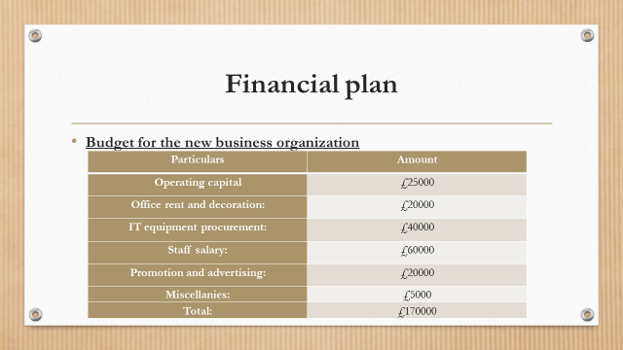
Speaker note
Budget for the new business organization
Particulars | Amount
Operating capital | £25000
Office rent and decoration: | £20000
IT equipment procurement: | £40000
Staff salary: | £60000
Promotion and advertising: | £20000
Miscellanies: | £5000
Total: | £170000

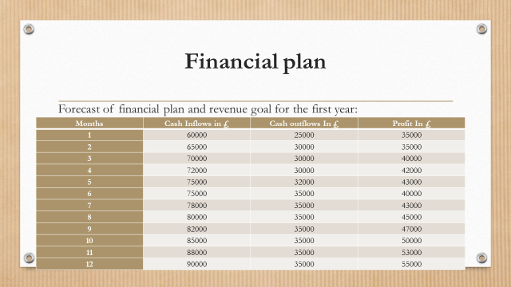
Speaker note
Forecast of financial plan and revenue goal for the first year:
Months | Cash Inflows in £ | Cash outflows In £ | Profit In £
1 | 60000 | 25000 | 35000
2 | 65000 | 30000 | 35000
3 | 70000 | 30000 | 40000
4 | 72000 | 30000 | 42000
5 | 75000 | 32000 | 43000
6 | 75000 | 35000 | 40000
7 | 78000 | 35000 | 43000
8 | 80000 | 35000 | 45000
9 | 82000 | 35000 | 47000
10 | 85000 | 35000 | 50000
11 | 88000 | 35000 | 53000
12 | 90000 | 35000 | 55000
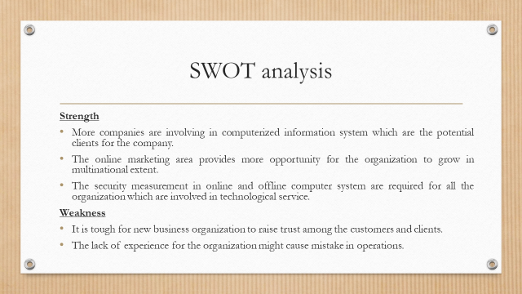
Speaker note
Strength
- More companies are involving in computerized information systems which are potential clients for the company.
- The online marketing area provides more opportunity for the organization to grow in a multinational extent.
- The security measures in an online and offline computer system are required for all the organization which is involved in technological service.
Weakness
- It is tough for a new business organization to raise trust among the customers and clients.
- The lack of experience for the organization might cause mistakes in operations.
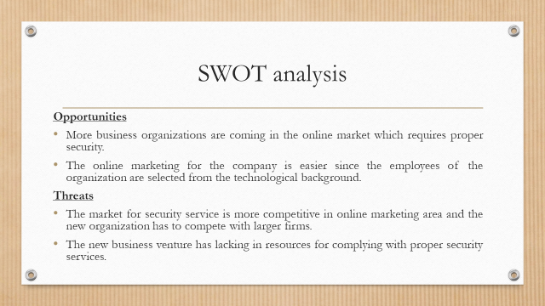
Speaker note
Opportunities
- More business organizations are coming in the online market which requires proper security.
- Online marketing for the company is easier since the employees of the organization are selected from the technological background.
Threats
- The market for security service is more competitive in the online marketing area and the new organization has to compete with larger firms.
- The new business venture has to lack in resources for complying with proper security services.
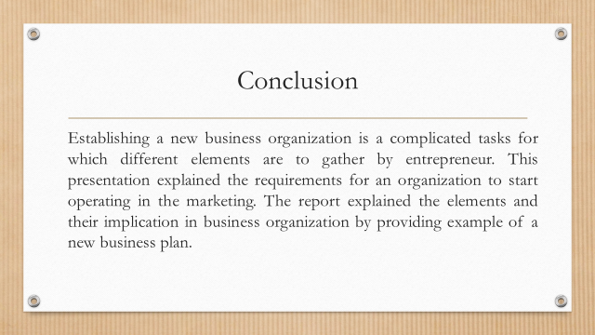
Speaker note
Establishing a new business organization is a complicated task for which different elements are to gather by an entrepreneur. This presentation explained the requirements for an organization to start operating in the marketing. The report explained the elements and their implication in business organizations by providing an example of a new business plan.
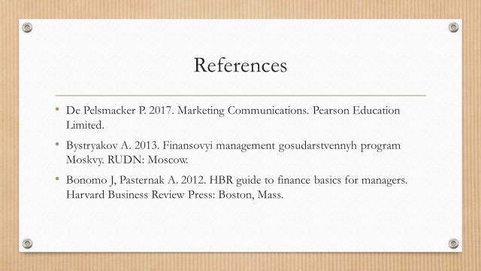

References
Bound A. 2017. Number of UK start-ups rises to new record | Financial Times. Ft.com.
Janseen D. 2018. What is Information Security (IS)? - Definition from Techopedia. Techopedia.com.
Agrawal A. 2017. 13 Ways To De-Risk Your Startup Failing. Startupgrind.com.
De Pelsmacker P. 2017. Marketing Communications. Pearson Education Limited.
Bystryakov A. 2013. Finansovyi management gosudarstvennyh program Moskvy. RUDN: Moscow.
Bonomo J, Pasternak A. 2012. HBR guide to finance basics for managers. Harvard Business Review Press: Boston, Mass.
Faxheden T. 2015. Course PM 2015 CIP017 Technology-based Entrepreneurship.
Harris J, Sapienza H, Bowie N. 2009. Ethics and entrepreneurship. Journal of Business Venturing 24: 407-418.
Karlsson T, Moberg K. 2013. Improving perceived entrepreneurial abilities through education: Exploratory testing of an entrepreneurial self-efficacy scale in a pre-post setting. The International Journal of Management Education 11: 1-11.

