Guy Debord contends that the ‘reality’ of our perceived negotiation with the mediated world has been replaced by ‘The Spectacle’ – image has replaced substance. To what extent do you believe this to be true and how have visual artists used the medium to comment on and critique this reality?

Student Number: 1901275
BA Course Title: Photography in the Arts
Word Count:2242
Lecturer: Paul Duerinck

In this essay I will discuss the use of ‘The Spectacle’ in our modern era and how it influences us on a day-to-day basis. First, I will explore the meaning and how it’s been used, I will then use this knowledge to analyse an image from two different artists and compare how they are similar but also different and explain how these images helped me to make my final decision if I agree with the statement.

‘In societies dominated by modern conditions of production, life is presented as an immense accumulation of spectacles. Everything that was directly lived has receded into a representation’ – Guy Debord

We live in an age of ‘The Spectacle’ where we crave more material possessions because media is telling us we’ll look and feel more successful in life, for example, we always look to have the newest phone or laptop, not only for their efficiency but to be able to show off that we have the money to get such luxuries, this is all down to “consumer culture” telling us that we will look and feel better if we splash out on the more expensive items in life rather than going for the cheaper and not so pretty option that will do the exact same job. Guy Debord summarised the spectacle as “autocratic reign of the market economy” and is a tool used to distract the public. The spectacle is everywhere and is used in different scenarios for different meanings, for example, new products have adverts that show how that product will transform our lives and media reduces the world into a simpler narrative easy for everyone to understand.
“A lively new polemic about the concepts ‘one divides into two’ and ‘two fuse into one’ is unfolding on the philosophical front in this country. This debate is a struggle between those who are for and those who are against the materialist dialectic, a struggle between two conceptions of the world: the proletarian conception and the bourgeois conception. Those who maintain that ‘one divides into two’ is the fundamental law of things are on the side of the materialist dialectic; those who maintain that the fundamental law of things is that ‘two fuse into one’ are against the materialistic dialectic. The two sides have drawn a clear line of demarcation between them, and their arguments are diametrically opposed.” – Guy Debord

Gargantua, 1831, Honoré Daumier
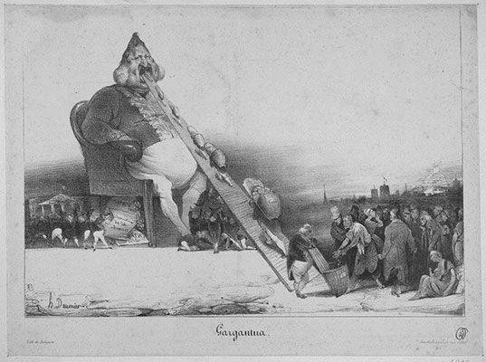

In 1831 Daumier created a lithograph that soon became a topic of controversy as it depicts a wealthy public figure sat on a throne eating bags of money from the poor. The figure is King Louis-Philippe of France who reigned from 1830-1848. Louise-Philippe was at first a well-liked king and was known as “Citizen King” but it soon changed when the economy fell, this ultimately led to his retirement in 1848. This caricature was published in La Caricature, a French comic journal. This was initially inspired by the 5-part novel “The Life of Gargantua and of Pantagruel” written by François Rabelais. The second story in this novel focuses on Gargantua’s son Pantagruel who befriends a noble man who is a con-artist and a womaniser who is forever spending his money and as a result is always devising new plans to gain money. I think Daumier took inspiration from that character and used it to shape the idea of his caricature of Louis-Philippe, as at the time Louis-Philippe was his modern-day pilfering nobleman.
Even though this lithograph was created over 100 years before Debord’s ‘Society of the spectacle’ this is still a good representation of consumerism and how it’s continued to affect us for centuries, the poor or working class working for companies to produce products that seemingly make out day to day life easier while only getting paid a small sum of money an hour while the company director takes home almost 10 times as much. This image shows lower class citizens paying all their hard-earned money to King Louis-Philippe and being left in misery and poverty while he sits on his throne happily taking the money he so clearly doesn’t need. This reflects onto todays society where majority of working class people work minimum wage jobs to only spend that money to keep a roof over their heads, put food on their tables and have clothes on their back and to pay tax on top of that all while feeding the big guys at the top of the food chain, people who don’t need the money and buy massive houses and fast cars as they watch poverty struck countries in dire need of help.
“Actually, referring to the incredible amounts of money the French government spent on itself. Louis-Philippe allowed himself a ‘salary’ of more than 18 million francs, which was 37 times more than Napoleon Bonaparte or almost 150 times the amount the American President received” – Brandeis University.

You are not yourself, 1981, Barbara Kruger
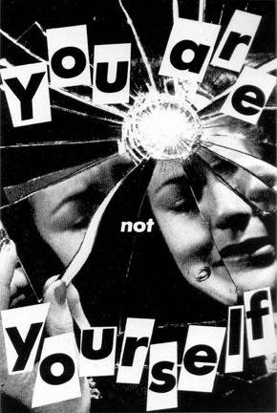
This black and white collage by Barbara Kruger is another negative representation of the spectacle and consumerism as it takes a more feminine approach to the topic. Simply looking at it you can see it’s a shattered mirror with the fragmented reflection of the woman and around her are the words “You are not yourself”. The mirror in this image is a powerful element to me as I feel the many shards of mirror could represent the many different personalities and aesthetics women have to be beautiful. Every woman wants to be beautiful and with the ever changing beauty standards and trends means women need to take on endless facades in order to meet these standards. This is a strong image which to look at these days makes you think of the beauty standards of women and how much pressure young girls are putting themselves under to be like the models they see on magazines and Instagram with their flat stomach large breasts and thigh gaps, which we all know are photoshopped, but that doesn’t stop us from looking at said models and proceeding to look in our mirrors and question “why can’t I look like her” and make us hate the features that make us unique. Since this collage was made in 1981, I looked at the 1980’s beauty standard and this is what I found:
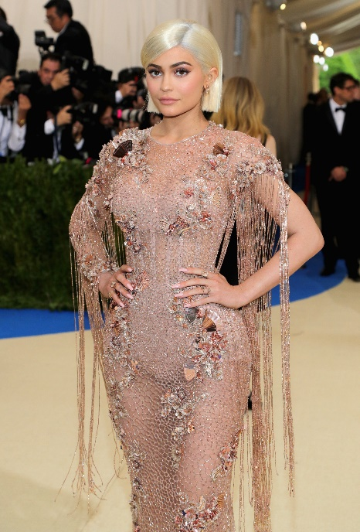

Taking the late Whitney Houston as an example, she was a massive icon during the 80’s not only in music but as a style icon too. The typical beauty standards of the 80’s consisted of being tall, athletic looking and toned; which suited the fitness craze aesthetic perfectly. Fitness videos were all the rage during the 80’s and all the models and trainers had the same sort of body type. As shown in the photo Whitney Houston also had the same body type and she was well loved and praised for her music and looks. Many other female celebrities came to mind with this body type such as Madonna, Olivia Newton-John and even Princess Diana.
Beauty standards change through the years and sometimes they become more and more difficult to obtain. Our current beauty standards are a prime example of this as girls these days seem to worship women like Kylie Jenner and Beyonce. Using Kylie Jenner as an example, she’s got what girls think these days as “The perfect figure” she’s got the small waist with a large chest and large bum. Her face is also a source of envy amongst young girls, however, the truth behind Jenner’s face is she’s gone through numerous sessions of plastic surgery to get the look she has now and seeing this as a beauty standard I feel is dangerous as it seems to be encouraging youth to go under the knife to be like the girls they see online.
The cosmetic industry is the largest growing industry and this is all due to consumerism as the beauty industry is expected to reach “$15.98 billion” in 2020 and as stated by Dusan Goljic, Pharm.D. “With the approximate annual growth rate of 6–8%, they are predicted to increase their revenue to $54 billion by 2027.” Goljic also stated a rather unnerving statistic about the “peer pressure” that comes with beauty and influencers on Instagram and YouTube, “In teenagers, social media has increased peer pressure to look good. A staggering 90% of girls and 70% of boys actively seek beauty advice.” These impressionable teens are the majority of the audience for the beauty industry as they are more likely to fall to peer pressure. Kylie Jenner seems to know this as she promotes her own makeup and skincare line constantly on her YouTube and Instagram stating these are the only products she uses on a day to day basis and being the beauty icon she is and looking the way she does this pressures people into buying her products by making them think you’ll have the same skin as her if you use her products. Dr Esho told Harpers Bazaar Magazine, “Over 30 per cent of my clients come with visual references of social media influencers to demonstrate the look they’d like… We have a large group of patients between the ages of 25 and 35 who are most connected to social media trends.”
Looking at these images I can see strong differences and similarities. To start with the differences, the more prominent difference is the type of consumerism presented in the images, the lithograph by Daumier shows how the poor feed the rich with what little money they have all because they need what the rich is providing such as houses, food and clothing all because it just makes their lives that little bit easier, it also highlights the possible high cost of these products at the time as the lower class citizens are clearly miserable and can hardly afford to pay what they’re paying for their necessities. The caricature of Louis-Philippe has a comedic element as Daumier intentionally designed him to be huge and fat to show the growing greed of the rich and how as they grow larger and fatter, they need more food (money in this instance) to keep them going. In contrast, Barbara Kruger’s collage takes a more feminist approach to consumerism as it seems to touch on beauty and idealism in media and how women think they should look in order to be thought of as attractive. This piece is probably the closest to our current issues which I highlighted in my last paragraph. This piece told me that beauty standards and the struggles and pressures women go through to feel better about their appearances is not a new issue at all and that it’s been around for decades.
However, the two images are also rather similar as they both show a negative side to consumerism and how it negatively effects working class people and feeds the rich industries that supply these products that supposedly make our lives easier. Daumier’s piece indicates the poverty people suffer all because they need to pay for a roof over their heads, food for the table and somewhat decent clothing or fabric to be able to wear with what little money they are able to earn due to low pay rates, all while the rich who make 100 times more money a day is happy to take their pennies. Kruger’s piece shows me the broken reality of the beauty industry and how everyday a woman’s world shatters because they feel they aren’t good enough or their not pretty enough all because they don’t meet the current beauty standard that will inevitably within a few years, and because these women feel this way they purchase an abundance of makeup, skincare and other beauty products to make them feel better about their appearance, some even go to the extreme and pay thousands to have plastic surgery for a permanent fix and thus, like in Daumier’s piece, the already rich will continue to profit off their misery and take advantage of the constant changes in beauty standards and come out with new and improved products to help these women become what everyone else is saying is beautiful all while women continue to suffer with their inner demons and societies ever changing standards.
In conclusion, I agree with Debord’s statement that “image has replaced substance” these two images have helped me realise that consumerism has been around for centuries and will continue long after we’re gone and although we try to avoid it, it’s impossible. Artists create work protesting this issue but also continue to make money from said pieces therefore being a part of the problem. We are all part of it if we like it or not but at the end of the day consumerism is how we all make a living, farmers earn their money due to the consumers demand for milk, eggs, meat, ect. People in the beauty industry make their money off people who buy beauty products to feel better about themselves and for those who work in the entertainment industry. Our obsession with how we look and how we present ourselves to others have replaced who we really are, we are too obsessed with getting rich and having an abundance of luxury items, we are too obsessed with being the most beautiful or the most intelligent person in the world, we are too busy trying to be people we are not rather than embracing our individuality and what makes us naturally different from everyone else and beautiful in our own ways.

Bibliography
Barbara Kruger’s you are not yourself, What/Why/Woman, 2012, https://whatwhywoman.wordpress.com/2012/12/11/barbara-krugers-you-are-not-yourself/#:~:text=Kruger's%20You%20Are%20Not,a%20non%2Dessential%20social%20construct.&text=Kruger%20uses%20bold%20graphic%20techniques,the%20messages%20delivered%20by%20society.
Coverley. M, Psychogeography, Oldcastle books, 2018
Daumier. H, Gargantua, WikiArt, 2020, https://www.wikiart.org/en/honore-daumier/gargantua-1831.
Debourd. G, Society of the spectacle, Rebel press London, 1991.
Goljic. D, 38 Awe-Inspiring beauty industry statistics for 2020, HealthCareers, 2020, https://healthcareers.co/beauty-industry-statistics/#:~:text=The%20global%20organic%20beauty%20market,reach%20%2415.98%20billion%20in%202020.&text=The%20natural%20cosmetics%20market%20is,to%20%2454%20billion%20by%202027.
Kuspit. D, Secrets of success: Paradoxes and problems of the reproduction and commodification of art in the age of the capitalist spectacle, Artnet, 2010, http://www.artnet.com/magazineus/features/kuspit/art-and-capitalist-spectacle2-8-11.asp.
March. B, Under the influence: The effects of social media accentuating unrealistic expectations of beauty, Harpers Bazaar Magazine, 2019, https://www.harpersbazaar.com/uk/beauty/a27451385/social-media-beauty-mental-health/.
Venkatesh. A (1992) ,"Postmodernism, Consumer Culture and the Society of the Spectacle", in NA - Advances in Consumer Research Volume 19, eds. John F. Sherry, Jr. and Brian Sternthal, Provo, UT : Association for Consumer Research, Pages: 199-202.

