katrina sheppeard
BMPF7013 | 25th June 2021
VOcal Exercises
Exploring Soprano Resonance Strategies

TABLE OF CONTENTS
Portfolio |  | 2
 | Introduction | 2
 | Planned Programme of Study | 3
 | Method | 3
 | Gantt Timeline | 6
 | Literature Review | 7
 | fR1:fo | 7
 | Low/mid voice fR2:4fo/3fo | 8
 | Passagio shift fR2 to fR1 | 10
 | Detuning fR2 above the stave | 10
 | Critical Reflection | 13
Assignment |  | 16
 | fR1:fo exercises | 17
 | Low/mid voice fR2:3fo exercises | 19
 | Passaggio fR2 to fR1 shift exercises | 20
 | Detuning fR2 above the stave exercises | 22
 | Combining fR2:3fo/2fo tuning exercises with detuning fR2 above stave | 23
 | Whole range exercises: integrating soprano resonance strategies | 24
 | Discussion | 27
 | Conclusion | 29
 | Bibliography | 28
 | Appendices | 32
 | Appendix 1. Time stamps with link for vocal exercises recordings | 32
 | Appendix 2. All vocal exercises collated for the project | 33
List of Figures
 | Figure 1. (Henrich et al, 2011) | 9
 | Figure 2, 3, 4, 5 (Sheppeard, 2021) | 10
 | Figure 6. (Henrich et al, 2011) | 11
 | Figure 8. Chart summarising soprano resonance strategies | 13
 | Figure 9. Gibb’s Reflective Cycle | 13
 | Figure 10. Exercise 1 | 17
 | Figure 11 and 12. Spectrograph of Exercise 1 | 18
 | Figure 13. Exercise 2 | 18
 | Figure 14 and 15. Spectrograph of Exercise 2 | 18
 | Figure 16 and 17. Spectrograph of Exercise 2 | 19
 | Figure 18. Exercise 3 | 19
 | Figure 19 and 20. Spectrograph of Exercise 3 | 20
 | Figure 21. Exercise 4 | 20
 | Figure 22 and 23. Spectrograph of Exercise 4 | 21
 | Figure 24. Exercise 5 | 21
 | Figure 25. Spectrograph of Exercise 5 | 22
 | Figure 26. Exercise 6 | 22
 | Figure 27. Spectrograph of Exercise 6 | 22
 | Figure 28. Exercise 7 | 23
 | Figure 29, 30, 31 and 32. Spectrograph of Exercise 7 | 23
 | Figure 33. Exercise 8 | 24
 | Figure 34 and 35. Spectrograph of Exercise 8 | 24
 | Figure 36, 37 and 38. Spectrograph of Exercise 8 | 25
 | Figure 39. Exercise 9 | 25
 | Figure 40, 41, 42, 43, 44, 45 and 46. Spectrograph of Exercise 9 | 26
 | Figure 47, 48 and 49. Spectrograph of Exercise 9 | 27

PORTFOLIO

INTRODUCTION

Classically trained sopranos rely on resonance tuning to boost their sound in order to be heard over an orchestra in a large theatre without electronic amplification (Sundberg, 1987). Henrich, Smith and Wolfe (2011) define resonance tuning as the adjustment of a resonance frequency to match a harmonic enabling the singer to increase sound pressure with little extra vocal effort, with Sundberg (1987) stating that a soprano tuning the sung pitch to a resonance can increase sound pressure by up to 30 dB for little extra effort. The authors recent study (Sheppeard, 2021) revealed two important soprano resonance strategies; fR1:fo tracking (first resonance coupled with the first harmonic) once the fo reaches the fR1 frequency of the vowel (Henrich, Smith and Wolfe, 2011; Sundberg and Skoog, 1997, Titze, 2008; Bresch and Narayanan, 2010), and an uncoupling of the fR2 (second resonance) from 2fo (second harmonic) above the stave (Hijleh, 2021; Sheppeard, 2021). There are however two more strategies which are used by classically trained sopranos for the low (A3-E4) and mid/upper (F4-C5) voice, as well as the upper passaggio (C5-G5). The vowels with a low fR1, /i/ and /u/, will couple with and track the pitch from the low range of the soprano voice – but what of the vowels with higher first formant frequencies? What resonance strategies might be used with the higher fR1 vowels in the low, mid and passaggio ranges of the soprano voice? How can a voice pedagogue facilitate the experience of these resonance strategies for young sopranos through appropriate choice of vocal exercises and repertoire?

It is important for a practitioner to understand the theory of resonance strategies of soprano voices but also to be able to apply this theory to the training of the soprano voice. Vocal exercises have been the backbone of vocal technique training throughout the history of bel canto training (Stark, 1999) and many pedagogue practitioners including Marchesi, Martienssen-Lohmann, Chapman, R. Miller, and Coffin have published their technical theories alongside practical vocal exercises, or vocalises, developed over years of teaching. A vocalise is defined by the Oxford Learner’s Dictionaries (2021) as ‘an exercise for practising singing in which syllables or vowel sounds are repeated’. These vocal exercises are repeated patterns of notes sung on Italian vowels used in bel canto voice training and passed on from teacher to student aurally over generations of teaching.

This project consists of two parts, the Portfolio, where current acoustic theories of soprano resonance strategies for the whole range of the soprano voice will be reviewed, and the Assignment, in which vocal exercises will be critically evaluated using the theoretical understanding developed in the Portfolio.

PLANNED PROGRAMME OF STUDY
The two parts of this project will be used to investigate soprano resonance theory; as a literature review in the Portfolio, and then present and analyse vocal exercises in the Assignment in light of theory outlined in the literature review. The specific learning and development aims and learning outcomes of this planned programme of study are:

- for the author to build upon her current knowledge of acoustics
- to relate theory to practice by reviewing the vocal exercises currently used by the author in her voice teaching through the lens of soprano resonance strategy theory
- to transcribe and collate vocal exercises that can be used for different soprano resonant strategies
- to show the vocal exercises spectrographically, highlighting the targeted resonance strategy
- to develop a visual aid that summarises soprano resonance strategies that can be referred to in the teaching studio to evaluate exercises and repertoire in practice

METHOD
Leavy and Harris (2019) describe feminism as creating more nuance within research ontology ‘beyond the postmodern binary of social constructivism and objective knowledge’ (p. 28). Winter (2021) agrees that these traditional dualisms are not helpful within voice pedagogy research and that moving toward a research methodology where the relevance of embodied knowledge and practice has as much weight academically as the rigor of a traditional positivist paradigm. Bell (2018), too, calls for the legitimisation of knowledge produced out of the lived experiences of professionals. This call for a new methodology within voice pedagogy research aligns with Oram’s (2015) PaR (Practice as Research) methodology. Piccini (2004) recognises the difficulty of defining PaR and its ‘…radical approach to questions of knowledge production in the universities…' (p. 16) but uses Kershaw’s (2002, p.138) definition, ‘…practice as research [refers to] research into performance practice, to determine how that practice may be developing new insights into or knowledge about the forms, genres, uses, etc. of performance' (p. 3). Training soprano voices in the bel canto tradition for the performance of operatic repertoire brings together many aspects of the practitioners experience as a both a singer and a pedagogue.

Oram (2015) advocates for the bringing together of previously academically disregarded knowledges including “how-to” voice manuals as well as the ‘embodied knowledge inherent in artistic practice itself’ (p.7). Oram’s (2015) PaR model ‘…recognises that some knowledge lives in the body experientially in a way that defies linguistic definition and explanation' (p.7) promoting the physical experience of the practitioner to become part of the research process, described by Nelson (2013, in Oram, 2015) as “know-how”. Nelson (2013, in Oram, 2015) also recognises the use of reflective practice as a component of PaR describing it as the “know-what” component of the model and the “know-that” which is the theoretical knowledge from outside the pedagogues realm feeding into their practice. Oram (2015, p.9) defends the question of rigour in PaR by describing '… how the particular strands of thought, practice and reflection are brought together' with Nelson’s (2013) use of the Deluziun "rhizome model" to describe these multiple strands of knowledge. Winter, (2021) cites Bolton (2005a) advocating for the interweaving of different knowledges to ‘deepen practice understanding’ (p. 10). These strands of knowledge come together and are embodied within a practitioner, particularly one with many years of voice training and stage experience reinforced with theoretical voice science, and can be taken out and examined and then rewoven into the fabric of the practitioner pedagogue as an ongoing cycle of research in action.

The author’s current research exemplifies this PaR model with her embodied experience as a professional singer and pedagogue, or ‘know-that’, underpinned with the theories of voice acoustics, the ‘know-how’, using the reflective practice, or ‘know-what’ to guide and develop knowledge creation. Advocating for the elevation of a practitioners embodied knowledge, the author looks to Moya (2014) citing (Gallagher and Zahavi, 2008, cited in Leder 1990) ‘a skill is finally and fully learned when something that once was extrinsic, grasped only through explicit rules or examples, now comes to pervade my own corporeality. My arms know how to swim, my mouth can at last speak the language’. In this statement, ‘corporeality’, a term coined by Merleau-Ponty (2012, cited in Moya, 2014), refers to the knowledge of the body. Taking this idea further, defining epistemology as the theory of knowledge (Leavy and Harris, 2019), an elite singers embodiment of physical knowledge can be considered their epistemology, or 'corporealization', with every new learning incorporated into understanding through the experience of the body. The author’s physical understanding is now scaffolded with a growing theoretical understanding of soprano resonance strategies. Piccini (2004) agrees that practitioners describe the epistemological contribution of PaR as the creation of embodied knowledges and traces this epistemological historiography back to Helmholz's acoustics theory (Reber, 1995, p.15) and includes Schoen's (1993) reflective practitioner work. Bringing together strands of embodiment as an epistemology, and the pedagogical dissemination of this knowledge as an ontology, the author wishes to sit this engagement with PaR as a methodology within the discussion and sharing of knowledge considered within Barad’s (2012, in Leavy and Harris, 2019) mutually informing and co-constructive feminist onto-epistemology. As a voice pedagogue practitioner defining ontology as ‘describing what is known’ (Leavy and Harris, 2019, p. 18), finding ways to translate the ‘corporealization’ by facilitating the bodily experience of the creation of the desired sound within the student can be exemplified in practice through vocal exercises.

For this investigation, the author will be considering vocal exercises as ‘grey literature’ documents. Vocal exercises are used in classical voice training to develop various aspects voice and are passed on verbally with instructions from teacher to student. Some vocal exercises have been collected and written down in instructional publications (Marchesi, 1970; Chapman, 2006; Coffin, 2002; R. Miller, 1986) and some can be found online (Nix, 2018; Bozeman, 2019); these are the pedagogically focused, ‘how-to’ publications described by Oram (2015) and conform to the definition of grey literature '…knowledge artefacts that are not the product of peer-review processes characterizing publication in scientific journals’ (Lawrence et al. 2014 in Adams, Smart and Huff, 2017, p. 433). Vocal exercises have come from the pedagogue practitioner experiences becoming embodied knowledge, honed over many years of teaching. This can be illustrated in a personal communication from the authors singing teacher, Janice Alder, answering the question of where her vocal exercises came from;

‘So my exercise sheets and motivation came from the truly wonderful singers I had the great good fortune to work with some only briefly and on courses eg. Simionata... & even with Mario del Monaco... but had a major influence! The exercises developed over the years of teaching from the basic exercises they gave me and my instinctive ideas of helping technical development’ (Alder, 2021)

Bowan (2009) suggests systematic procedure for reviewing or evaluating both printed and electronic documents. Using the Adams, Smart and Huff (2017) model of evaluating grey matter, the author engages with the Why and What questions of inclusion; the advantages and benefits of including the chosen grey literature. Within the body of the assignment, the reason for the choice of each exercise is clearly described, reflecting on its use in the authors pedagogic practice, its history and development and its usefulness as a facilitator of the soprano resonance strategy to which it is applied. This conforms to the PaR assessment criterion as described by Winter (2021, citing Nelson 2015) which requires critical appraisal of the research process alongside documentation. To this end, the author has devised four categories of soprano resonant strategy and chosen vocal exercises that will facilitate each of these. The exercises critically evaluated in the Assignment have been chosen from the authors more than 20 years of voice training with various voice teachers as well as new, acoustically informed pedagogical approaches found in the process of researching. The author has also developed exercises informed by acoustic theory and practitioners that work within this knowledge.

Reflection on practice is an important tool for a practitioner and part of the PaR methodology framework described by Oram (2015), with Winter (2021) describing both Griffiths and Tann (1992) as well as Schoen (1983) advocating the importance of rapid reflection on practice through journaling. Within voice teaching, application of new theoretical learning can occur within the voice lesson with the teacher applying knew knowledge by trying a new concept with their own voice, and then demonstrating this within a lesson and for the student to then emulate. This new concept may or may not give advantageous results with the practitioner either leaning into or adjusting away from the new concept to find a successful outcome for the exercise given; this requires self-awareness and reflexivity as a practitioner (Trahar, 2009) and is an immediate and creative process helping the teacher discover new themes and ‘create theoretical constructs’ (Winter, 2021). The choice of vocal exercises for this study has therefore been an act of reflection within the authors teaching practice and how ‘favourite’ or ‘go-to’ exercises act as a practical application of newly acquired theoretical knowledge by exploring historically used exercises, the development of these, and the devising of new exercises to improve pedagogical practice.

All of the four categories of soprano resonance strategies can be displayed using Voce Vista Pro software developed by Miller (2008), and used by acoustically informed pedagogic practitioners Hijleh (2021), Mitton (2020), Lissemore (2020), Moss (2020), Bozeman (2017) and Nix (2018). The author will therefore use this technology to show the resonance strategies utilised for the chosen exercises, presenting screenshot’s the chosen exercise and describing the soprano resonance strategy it is facilitating. This method of spectrographic representation is utilised by Miller (2005, 2008) as well as the aforementioned practitioners. The author will use a simple method; recording her own voice performing the chosen vocal exercise on Voce Vista Pro software, keeping a distance of 30cm from the microphone and using the power spectrum and LTAS function within the software to analyse the specific resonance strategy; an audio/visual link to the recorded exercises can be found at the link https://youtu.be/ASBB9d2W8SA with timestamp links added to each exercise within the main assignment.

While researching this assignment, the author created a chart (Figure 8) consolidating information into a graphic that can be used practically. The creation of the chart developed over the course of the research period and reflects the development of the authors knowledge. The chart emerged from a need for a visual aid that can be referred to when teaching.

Table 1. GANTT TIMELINE
ACTIVITY/  DATE | 1st Mar | 8th Mar | 15th Mar | 22th Mar | 29th  Mar | 5th Apr | 12th  Apr | 19th  Apr | 26th  Apr | 3rd  May | 10th  May | 17th  May | 24th May | 31st May | 7th Jun | 14th Jun | 21st Jun
Literature review
Design Chart
Discuss project with tutor
Choose and use vocal exercises
Discuss exercises with tutor
Write Portfolio
Record and Analyse exercises
Write Assignment
Submit Draft
Edit Draft
Final Submission

LITERATURE REVIEW
This literature review is of the current research available of resonance strategies that a soprano might use throughout her range. The method used to review the literature was not a systematic review as dictated by Cooper (1988) as decisions of inclusion and exclusion developed with the progression of the project. The categories of soprano resonance strategy emerged through greater understanding of acoustic theory and the author reflecting on vocal exercises and repertoire in practice; the categories then informing the choice of vocal exercise. The authors previous project (Sheppeard, 2021) was used as a start point to review soprano resonance strategies but greater engagement with grey literature was required as the acoustic theories reviewed are emerging knowledges, although established amongst acoustically informed pedagogues, their research is not as yet peer reviewed. A literature matrix was created by the author with topics of interest, first sources and second sources included; sources were then excluded on the criteria of being beyond the scope of this project.
In a previous study by the author (Sheppeard, 2021), two important soprano resonance strategies were noted; fR1:fo (the first formant coupled with the first harmonic or pitch) once the fo reaches the first formant of the vowel (Henrich, Smith and Wolfe, 2011; Sundberg and Skoog, 1997, Titze, 2008; Bresch and Narayanan, 2010), and the detuning of the second resonance (fR2) from the second harmonic (2fo) for pitches above the stave (Hijleh, 2021; Sheppeard, 2021). There are two other resonance strategies that need to be considered for a soprano voice to be well balanced throughout the range: the low and mid voice (A3 to C5), and the second or upper passagio (C5 to G5). This literature review will discuss the current available acoustic research of these two areas of the soprano voice as well and briefly review the first two strategies elucidated in the authors previous study. This literature review, and a chart (Figure 8) summarising all of the available soprano resonance strategy theory for the range of the soprano voice, will be used to examine the practical vocal exercises presented in the second part of the assignment.

The four soprano resonance strategies have been designated by the author as;
- fR1:fo
- fR2:4fo/3fo (low/mid voice)
- passaggio fR2 to fR1 shift
- detuning fR2 above the stave.

fR1:fo
Several peer reviewed studies have shown this important soprano resonance strategy (Henrich, Smith and Wolfe, 2011; Sundberg and Skoog, 1997, Titze, 2008; Bresch and Narayanan, 2010) as well as the author’s own case study (Sheppeard, 2021); when pitch is higher than fR1 for speech, sopranos tune fR1 to match fo (Smith and Wolfe, 2009) which enables vocal fold vibration to be more efficient and stable (Titze, 2008). Further, Sundberg (1987) states there is a 30dB increase in sound pressure when fR1:fo. Smith and Wolfe (2009) describe keeping the fR1 above the fo throughout the range to increase loudness, uniformity of tone and ease of singing, and used this phenomena to evaluate soprano opera repertoire finding that Wagner utilised the fR1:fo soprano resonance much more than other composers. Smith and Wolfe (2009) cite Carlsson-Berndtsson and Sundberg (1991) stating 'if a composer took advantage of vowel-pitch matching...the singer would no longer need to 'tune' the resonance significantly, the libretto would partially do it for her, making it easier to sing with a high ratio of power to input effort' (p.3), further stating that 'resonance tuning would be assisted if the pitch of the note written for a vowel corresponded with its usual range of fR1' (p.1) finding that Wagner did this when setting his text to music. Breach and Narayan (2010) found that the vowels /i/ and /u/ for all trained soprano subjects studied showed a consistent positive correlation of fR1 to fo coupling. These studies findings could be extrapolated to vocal exercises with a view to training this resonance strategy; choosing vowels to pitch match their fR1 could facilitate the efficiency and stability described by Titze (2008) and encourage the uniformity of tone and ease of singing described by Smith and Wolfe (2009). Using the concept of these studies, a young soprano could be taught to 'hook into' the /i/ and /u/ in the low and mid voice to train the feeling of maintaining efficiency and stability which could help with developing confidence of sound production for a young classical singer. Pitch matching to the higher fR1 vowels when moving up through the range could then be utilised as confidence and ability increase. To that end, a pedagogues awareness of the fR1 values of vowels and their movement when tuning to the pitch through the range would be a valuable tool when choosing vocal exercises to facilitate this resonance strategy.

fR2:4fo/3fo (low/mid voice)
Miller and Schutte (2005) showed a preferred fR2:3fo strategy for professional tenor voices in their passaggio and upper range, a strategy shared by sopranos at the same frequency, being the mid-range of the soprano voice E4-C5 (Miller, 2008), with the low range of the soprano voice correlating to the frequency of the passaggio of the male voice. The soprano classical voice however uses the M2 mode of registration, also known as ‘head’ voice, which according to Miller (2008), has an affinity for a fR1 acoustic strategy. In the low/mid part of the soprano voice, this affinity can be taken advantage of by the low fR1 vowels (/i/ and /u/) but the vowels with higher fR1 values will require a different strategy to be both intelligible and boosted enough for the requirements of unamplified classical singing. Smith and Wolfe (2009) agree with Miller (2008) that for notes low in the soprano range the fR1 of higher fR1 vowels may boost the second or even third harmonic.

Miller (2008) makes a strong case for the utilisation of fR2:3fo in the male upper voice as opposed to reliance on the Singers Formant Cluster (SFC) strategy stating ‘the ability to track H3 with the second formant all the way to C5 - is also unusual, and the result of disciplined practice. Perhaps the singers formant strategy for high notes is a reflection of a failure to learn (or to be taught) F2 tuning' (Miller, 2008, p.82). This area of the male voice that correlates to the mid voice of the soprano show similarities of resonance strategy with Miller (2008) stating that ‘…skilful singers use F2 on the second harmonic to bolster their sound. A similar strategy is available in the lower middle, using F2 on the third or fourth harmonic' (p.90). Miller (2008) gives an example of this strategy from Maria Callas showing the fR2 of the vowel /a/ tuned to 2fo on the note D5 which would also resonate the 3fo of G4. This would require maintaining the vocal tract shaping that facilitates the fR2 tuning of the /a/ vowel for both of these notes. Regine Crespin also uses a fR2:3fo strategy in her middle register (Miller, 2008).

Voice pedagogue Hijleh (2021) cites Miller and Schutte (2005) stating fR2 tuning is utilised for a well-executed mid soprano voice. Henrich, Smith and Wolfe (2011) show soprano fR1:2fo tuning between the notes C4 to C5 but only results for the first two harmonics reacting with the vowel formants were described in this study. Some further information can however be gleaned from the presentation of results, and in the graph below (Figure 1.) of the /heard/ vowel from the Henrich (2011) study it can be seen that the upper harmonics are utilised by fR2 until the pitch reaches the fR1 of that vowel with a clear fR2:3fo tuning at 350Hz or the note F4.
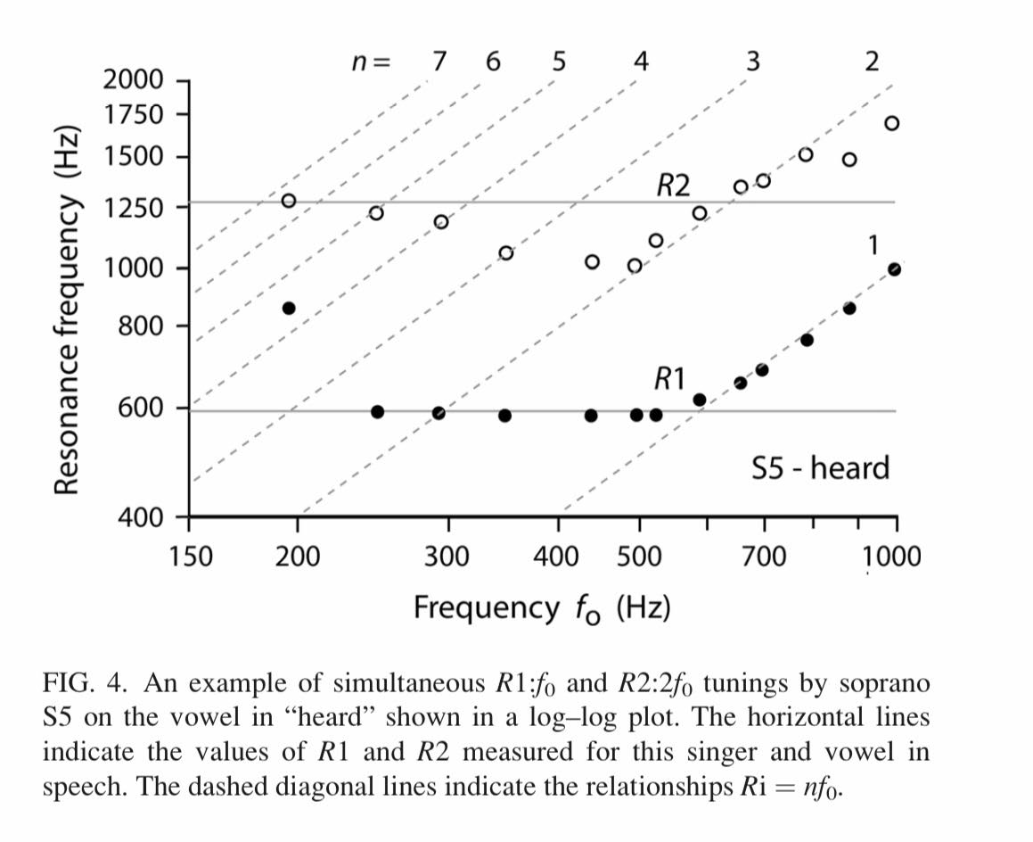
Figure 1. (Henrich et al, 2011)
The authors own study (Sheppeard, 2021) shows utilisation of upper harmonics by vowels with higher fR1 formants before the sung pitch reaches the frequency of the first formant as can be seen in the graphs below (Figures 2 to 5) of the vowels /a/, /ɔ/, /o/ and /ɛ/. (The /i/ and /u vowels will of course track the first harmonic much lower in the range). These examples show interaction of fR2 with 3fo in the low/mid voice for the back vowels and 4fo for the high fR1 front vowel (/ɛ/).
Figure 3. (Sheppeard, 2021)
Figure 2. (Sheppeard, 2021)

Figure 5. (Sheppeard, 2021)
Figure 3. (Sheppeard, 2021)

Finding exercises to facilitate this resonance strategy can be challenging, particularly in the mid voice for vowels with the higher fR1; in this area of F4-B4 there can be an acoustic ‘no-man’s land’ if a coupling strategy is not found naturally with the voice sounding weak or breathy particularly when moving from a low fR1 front vowel to an open vowel, for example /i/ to /a/ on G4. Hijleh (2021) cites Miller (2008) demonstrating that coupling the fR2 of the /a/ vowel to the second harmonic of D5 and then third harmonic of G4 to find this fR2:f3o strategy; in the main body of the assignment an exercise utilising this strategy will be examined.

Passaggio shift fR2 to fR1
The second passaggio of the soprano voice occurs between the notes C5 and G5 and, in the author’s experience, can be a notoriously difficult area to train. In the author’s previous study, a convergence of all vowels fR1 frequencies (except /a/) was found from the note E5 (Joliveau, 2014; Sheppeard, 2021). Smith and Wolfe (2009) discuss this effective absence of fR1 above this pitch means that vowels with a similar value of fR2 become indistinguishable, with Miller (2008) describing a generalised front and back vowel occurring approximately at pitch F5. Miller (2008) suggests using this phenomena to create a more ‘rounded’ front vowel by matching it with its fR1 vowel equivalent that has a lower fR2; on F5 he suggests toggling between /ɔ/ and /ɛ/ which will lower (or detune) the fR2 of the /ɛ/ toward that of the /ɔ/. Hijleh (2021) also demonstrates this strategy on a D5 between the vowels /e/ and /o/ to match the sound and ease of the two vowels.

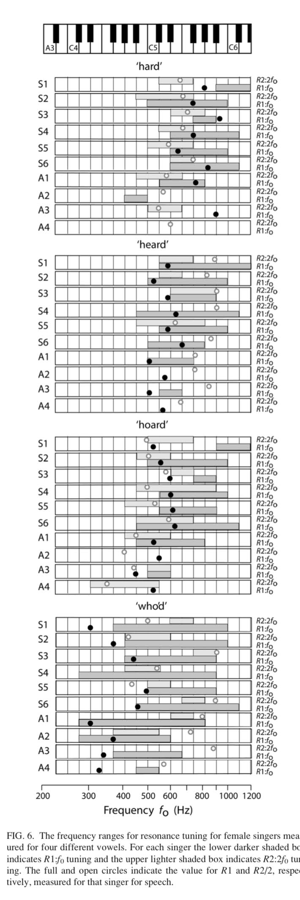
The Henrich et al. (2011) study shows the upper passagio area of the soprano voice to use both fR1:fo and fR2:2fo tuning simultaneously, this can be seen for the soprano subjects in Figure 3. where soprano subjects 2 through 6 (S2 – S6) all show a cross-over of at least one note where both fR1:fo and fR2:2fo are used. The figure also shows that these sopranos are lowering their fR1 to below their speech fR1 value to accommodate the resonance shift at a lower pitch.

Lissemore (2020) describes the soprano upper passaggio area in terms of an acoustic transition occurring between the pitches D5 and F5 requiring a change in articulation to change the resonance frequencies in favour of the fR1:fo strategy. For an /a/ vowel, the change will be from fR2 tracking of 2fo in the mid-range to fR1 tracking of fo through and above the passagio (Miller, 2008). Thus the uncoupling of fR2 begins in the second passagio region to negotiate an elegant transition into the top of the voice. Lissemore’s (2020) study shows that the most ‘techniqued’ sopranos achieved this transition lower in the range at around D5 with less techniqued sopranos not shifting strategies until G5; his ultrasound investigation showing this transition was facilitated by a larger anterior oral cavity to accommodate a lower resonance frequency to match the sung pitch and thus less articulatory change between C5 to G5 as the shift had already been facilitated and the articulatory position required for G5 had been created.
Figure 6. (Henrich et al, 2011)

When using this information to choose vocal exercises that will facilitate a successful transition through the soprano second passaggio a pedagogue must therefore be aware of several factors; is the target vowel intelligible at that pitch? If it is a front vowel, can its ‘partner’ fR1 back vowel be utilised to round (detune fR2) for a more elegant sound? If ascending through the passaggio on an /a/ vowel, can the fR1 be lowered being mindful of articulation that will accommodate notes above the stave? These questions were reflected upon during the consideration of vocal exercises within the Assignment part of this project.

Detuning fR2 above the stave
Soprano resonance strategies for the upper part of the soprano range have been investigated (Joliveau, 2004a, 2004b; Deme, 2014; Henrich, 2011; Garnier, 2010) showing double coupling of the first two harmonics to the two vowel formants. This strategy however is not agreed upon by practitioners Hijleh (2021) and Sheppeard (2021) both finding an uncoupling of fR2 for elite sopranos above the stave. These observations by practitioners have not been peer reviewed but can be demonstrated practically using Voce Vista Pro software. Hijleh (2021) states that fo is at least 10bB greater than 2fo above the stave in elite sopranos describing the facilitation of this in two ways; the choice of vowel, or a diminuendo into the top. Both of these strategies will detune the fR2 from 2fo with vowel choice lowering fR2 away from the harmonic, and/or a diminuendo depriving the upper harmonics of energy and thus they will not be available to be resonated by the fR2. Sheppeard (2021) found in her recent case study that her ‘preferred’ vowels above the stave, sung at a normal volume, all showed detuning of fR2 disagreeing with the findings of the aforementioned research studies showing double coupling; the reasons for this discrepancy could be to do with methodology as the Joliveau (2004a, 2004b), Henrich (2011) and Garnier (2010) studies all used acoustic broadband technology which required the soprano subjects to sing softly and without vibrato above the stave (Deme, 2014) whereas the author sang at a ‘normal’ operatic volume with vibrato for her own project, as does Hijleh (2021) in her live lecture demonstration.

The following chart shows the interaction of the first two formants with the harmonics of the pitches for a two octave range as well as the ranges of the categorised soprano resonance strategies. The data used for this chart was from the author’s previous study (Sheppeard, 2021) combined with information from this projects literature review. The chart is a consolidation of knowledge discussed in the literature review and used to reflect upon vocal exercise choices for the main assignment. The chart was created on an excel spreadsheet displaying a music stave, two octave scale and its harmonics interacting with the vowel formants of the seven studied vowels. The left columns displays pitch names as the harmonics and second formant frequencies are far above the range of what is usually read by a soprano. The top rows of the chart show the ranges of the four described soprano resonance strategies.

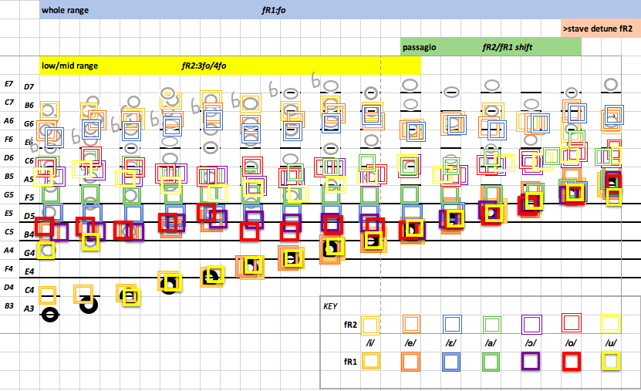
Figure 8. Chart of authors speech formant interactions with harmonics through a two octave scale with soprano resonance strategy categories.

CRITICAL REFLECTION
The six steps of the Gibbs (1988) Reflective Cycle provide a framework within which the author can critically reflect upon the learning experience of the assignment. Gibbs (1988) advocates for reflection on experience to enable the fulfilment of potential of learning, stating ‘…it is from the feelings and thoughts emerging from this reflection that generalisations or concepts can be generated and it is generalisations that allow new situations to be tackled effectively.’ (Gibbs 1988, p. 52). The author will use this model (Figure 9.) to reflect on the learning experience of this project.
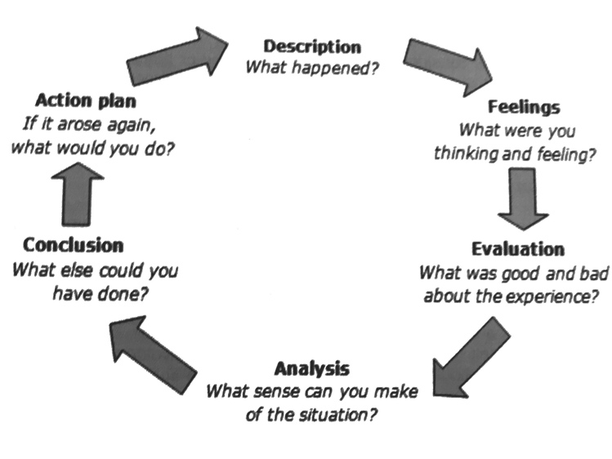
Figure 9. Reflective Cycle (Gibbs, 1988, p. 39)
Description: The author began engaging with acoustic theory two years prior to the commencement of this project and was eager to relate this theoretical knowledge to practical examples in her teaching practice. To this end, the author reviewed her habitually used vocal exercises and questioned their facilitation of the soprano resonance strategies described in an earlier study (Sheppeard, 2021). In addition, the author was aware that a fR2 resonance strategy was perhaps used in the mid voice, and that a second passaggio resonance shift occurred but had not reviewed the research prior to this investigation. The subsequent literature review led the author to categorise four possible resonance strategies that could be facilitated with vocal exercises. In an attempt to assimilate the knowledge gained form the literature review, the author devised a chart as learning evolved over the course of the project to show the resonance strategies, along with the formant and harmonic interactions over the soprano range.

The author used the theory discussed in the literature review to review the exercises from her experience as a singer and teacher and also to develop exercises that might assist in the production of these strategies in students. The author recorded her own voice singing the chosen exercises using Voce Vista Pro spectrographic software and analysed the files with a view to highlighting the resonance strategies described in the literature review. Some of the examples showed expected results, but others did not, prompting the author to try variations of exercises and also led to questions of aesthetic and vocal fach.

The learning experience of the author had several aspects. The relationship between the desired aesthetic of the bel canto technique and its spectrographic representation revealed differences in expected outcome with the mid voice being more complex than the author had estimated, and revealed that the limited theory available does not fit with the practical experience of the author in all cases. The author reviewed habitually used vocal exercises through the lens of developing acoustic knowledge and deepened her understanding of soprano resonance strategies through practical application. The author devised a visual aid to consolidate knowledge in a tangible and practical application of knowledge.

Feelings: The choice of vocal exercises was initially overwhelming as so many pedagogues have published vocal exercises in ‘how-to’ books of singing instruction. The author was unsure whether to write her own exercises or to use those familiar and habitually used in her teaching. The author was also unsure how many exercises to choose for each category to exemplify each resonance strategy. With so little peer reviewed research available on all but one (fR1:fo) of the chosen soprano resonance strategies, the author also questioned the validity of undertaking the project. Understanding and choice of exercise for the well-established resonance strategy was not difficult, but for the other three resonance strategies as defined by the author the choice was more complex. Moving through the initial feelings of overwhelm, anxiety and self-doubt, the author embraced the project, recognising its learning potential and application for her teaching as positive. The creation of the chart began as a assimilation of knowledge for the authors benefit but progressed to a piece of work in its own right and has developed into a surprisingly useful visual representation.

An unexpected outcome of the learning experience has been from the further exploration of the authors own singing voice with Voce Vista Pro giving a feeling of empowerment and autonomy to the author for her own singing. Through the author’s own singing practice, embodiment of new acoustic concepts merged with her traditional technique knowledge and she was able to review vocal exercises and repertoire in situ through this knew lens. Over the course of the authors career she has had to rely on others ears to help shape and correct her own singing; learning the theory and then applying it to her own voice through the evaluation of much used vocal exercises has given the author a deeper understanding of her own resonance strategies which will in turn help her to teach these more effectively to her students.

Evaluation: The learning project had many positives as the author was able to build upon acoustic theory knowledge and also apply it in a very practical way, helping to weave together strands of knowledge of theory and practice. Evaluating traditional vocal exercises through an acoustic lens, as well as creating new exercises, was very useful and this knowledge can be further applied to vocal repertoire. The production of a chart was a positive outcome, the creation of which not only facilitated learning but it is a useful stand-alone tool for the voice studio.

Negatives of the experience have been the tying of the practical to ‘grey-literature’ as research is as yet not available, or under researched, or the research available does not correspond to the practical experience of a soprano. This is very frustrating as there is so much that could be gained by being able to ground traditional teaching methods in acoustic theory.

Analysis: Voice science, and in particular relating acoustic theory to traditional classical training for sopranos, is a very new area. The author’s previous study (Sheppeard, 2021) highlighted the need for greater accessibility for soprano pedagogues to acoustic theory as she found speech acoustic theory difficult to relate to her own vocal experience. This is reflected in the lack of research pertinent to soprano resonance strategies as there are so few classically trained sopranos investigating their own voices. The author finds the intersection of the empowerment that the knowledge of one’s own voice can give a soprano an interesting and important emergence from her investigation that can guide further research. The training of sopranos in acoustics can help give them some autonomy in their own training, informing the perceived subjectivity involved in vocal training and casting.

Professional sopranos are often away from teachers and need trusted ‘ears’ when faced with directors, conductors or the requirements of the score; technology such as Voce Vista could give sopranos autonomy and the ability to correlate resonance strategies with the demands required in professional settings. Technology and acoustic theory offers a demystifying and democratisation of traditional voice training by empowering sopranos with knowledge and understanding of their own voices. Embodied practitioner knowledge, too, can be aided by technology to inform and improve on traditional practice and choice of vocal exercises and repertoire.

Conclusion: Further enhancement of learning could have been gained by exploration of other elite soprano voices to quantify their resonance strategies and either give further credence to the research available or the discovery of new theories. Evaluating commonly used soprano repertoire – particularly pieces used in early training – would have been of additional interest. The lack of theory available on all of the soprano resonance strategies the author wished to investigate has not diminished the learning that has been acquired during this project but the author acknowledges the many gaps in knowledge that require further study.

Action Plan: If undertaking this project again, the author would make several changes to add to the learning experience. Firstly, the author would ask a panel of expert listeners to decide on preferred strategies, particularly the middle voice fR2:3fo coupling and the amount of detuning of fR2 into the top of the voice; this would validate the authors choice of preferred strategy for teaching. Secondly, the author would investigate several other elite soprano voices using the chosen exercises to further examine the pattern of reliable resonance strategies put forward by the author’s investigation. Thirdly, the author would include excerpts of widely used arias or songs to show how different acoustic strategies could be applied to improve the approach to notoriously problematic intervals or passages.

THE ASSIGNMENT

The Assignment addresses the practical implications of soprano resonances strategies using both traditional and acoustically informed vocal exercises from various pedagogical sources. Classical vocal exercises are passed down from teacher to student; as the student becomes teacher and embodies her own technique, exercises can change over time into a new exercises or acquire new uses. These exercises have been chosen from several sources representing the authors historical practical experience with exercises from past voice teachers, as well as exercises created specifically for this project with acoustic theory underpinnings. Several of the exercises used in this study come from the author’s singing teacher, Janice Alder, who is based in Berlin and trained within the Franziska Martienssen-Lohmann tradition. Martienssen-Lohmann was a German pedagogue who published eight books of singing pedagogy, only one of which has been translated into English (as a PhD thesis) but her teaching is known as ‘the bible’ in Germany, its lineage traced back to Manuel Garcia (Reuter, 2001). Alder (2004) transcribed and privately printed the vocal exercises that she had collected and developed over many years of teaching.

The author has used the four soprano resonance strategies categorised in the literature review; fR1:fo, low/mid voice fR2:3fo/4fo, passaggio fR2/fR1 shift, and detuning fR2 above the stave. All exercises will be evaluated using acoustic theory as discussed in the literature review with examples shown using Voce Vista software; the evaluation includes a brief description of the exercise, the resonance strategy it is facilitating, and the resonance strategy shown on the Voce Vista screenshot. The author follows the exploration of vocal exercises with a discussion. All exercises have been scored and are available in the appendices as well as a link to the audio/visual examples of the authors demonstration (timestamp links are also embedded below each exercise score excerpt to hear and see the example).

fR1:fo exercises
Tracking of the pitch of the sung note with the first resonance has been well established by researchers (Henrich, Smith and Wolfe, 2011; Sundberg and Skoog, 1997, Titze, 2008; Bresch and Narayanan, 2010) as well as the authors recent case study (Sheppeard, 2021). A vocal exercise to facilitate this resonance strategy could be chosen in a comfortable range for a novice soprano to develop a proprioceptive and aural awareness of this tuning (Jeanneteau et al, 2020) with the head voice more naturally coupling with a fR1:fo strategy (Miller, 2008). The author therefore suggests exercises utilising the lower fR1 vowels where the fR1:fo coupling will be felt low in the voice and can be utilised throughout the range. Both exercises below utilise the low fR1 vowels /i/ and /u/.

The first exercise examined is an adaptation from Chapman’s (2008) published instructional book “Singing and Teaching Singing” which includes exercises in its appendices. Chapman (2008) writes the exercise with instructions to relate all Italinate vowels through the /i/ vowel tongue position with the hump of the tongue up against the back molars. The author has adapted the exercise to be over a 5th (rather than a 9th as published by Chapman) to be suitable for novice sopranos, and to use just the /i/ vowel when first approaching the exercise.
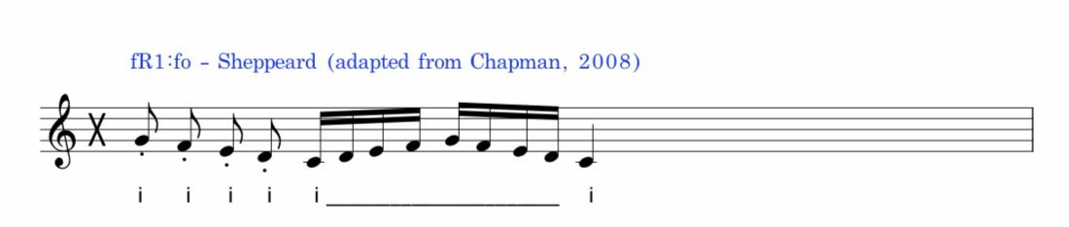
Figure 10. Exercise 1 adapted from Chapman's (2008) 'dial a vowel' 0:00

Figures 11 and 12 show screen shots of the exercise being performed by the author and captured using Voce Vista Pro software. Figure 11 shows the exercise beginning on the note G4 which is highlighted with the curser. The right hand side panel of Figure 11 shows an LTAS (long term average spectra) of the first staccato note with the cursor showing the first harmonic carrying the bulk of the sound. The left hand panel of the spectrograph shows the ‘tracking’ of this harmonic by following the red line (outlined) of the pitch over the descending 5th staccato and then the ascending and descending legato scale.

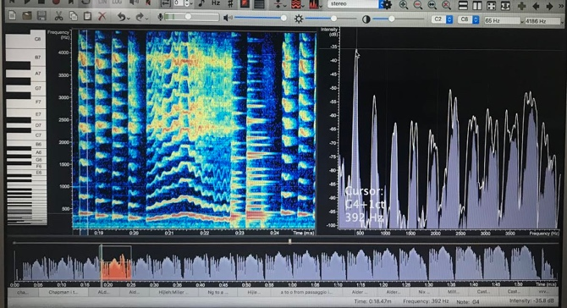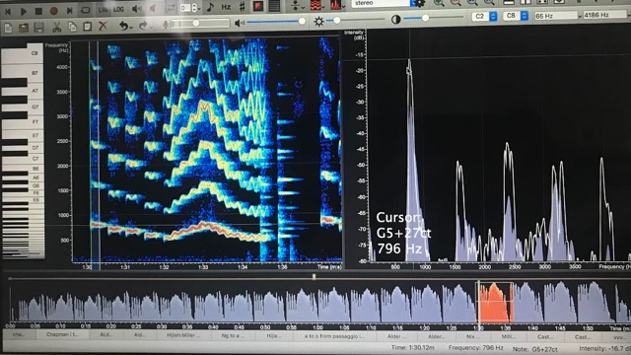
Figure 11. Spectrograph of Exercise 1 G4 to C4 Figure 12. Spectrograph Exercise 1 G5 to C5

Figure 12 is the same exercise an octave higher and shows the same strategy. The right hand panel is again showing the LTAS across the initial staccato note which is G5 as shown by the curser, and in the left hand panel the spectrograph shows the first harmonic, again the reddest, indicating it is carrying the bulk of the sound thus tracking the first formant.

The next exercise also uses the fR1:fo strategy but with the /u/ vowel and is for more advanced students; the author uses a shortened version with an /u/ staccato arpeggio over a 5th for more novice sopranos.
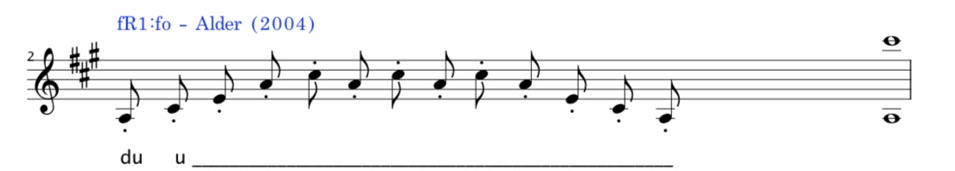
Figure 13. Exercise 2 /u/ staccato arpeggio over 10th (Alder, 2004) 0:08

Figures 14 and 15 show a spectrograph of the above exercise with the lowest and highest note highlighted to show the utilisation of the fR1:fo resonance strategy (indicated with an arrow) throughout the range. The author begins this exercise on the pitch A3 to establish a ‘head voice’ registration low in the voice which favours the fR1:fo coupling (Miller, 2008).

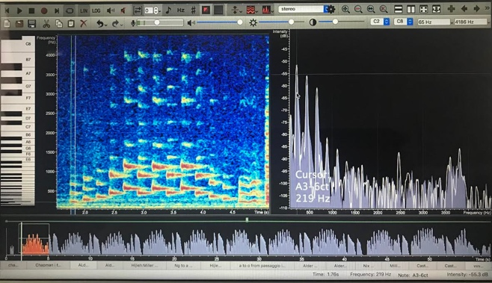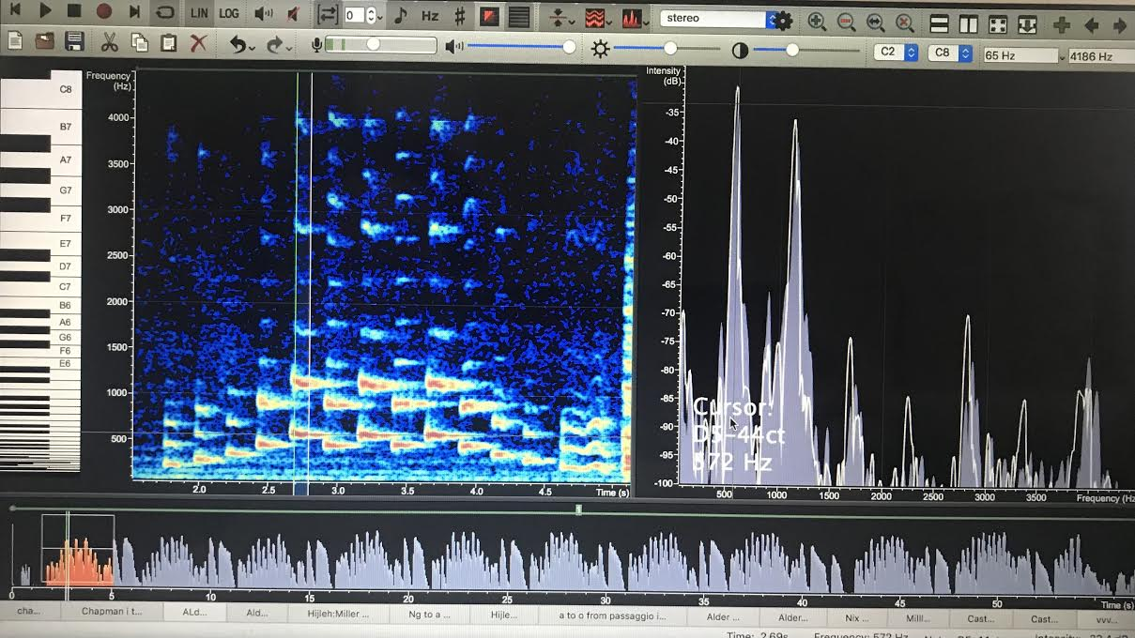
Figures 14 and 15. Spectrograph of Exercise 2 range A3 to E5 showing fR1:fo coupling

Figures 16 and 17 show the same exercise performed higher in the range with the starting note F#4 and the top note A#5. The right hand panel of both figures is an LTAS of both the lowest and highest note showing the fR1:fo strategy with the first harmonic carrying the bulk of the sound throughout the range (indicated with an arrow). The tracking of the first formant with the pitch can also be seen in the left panel spectrograph as the pitch remains the reddest of the harmonics throughout the exercise (outlined).

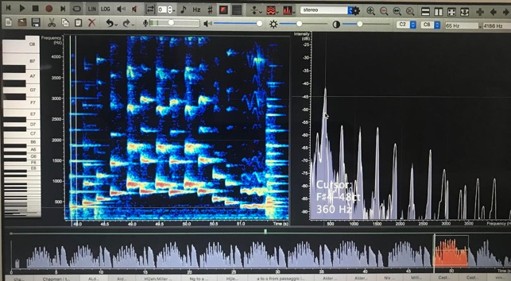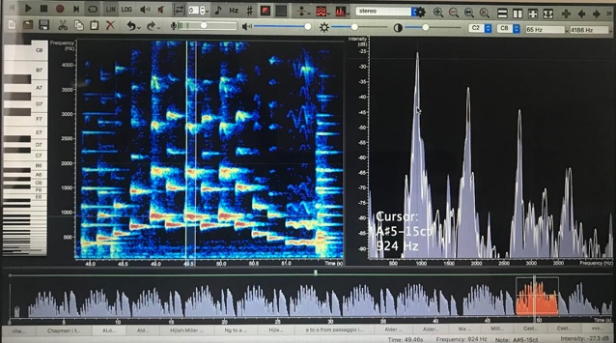
Figure 16 and 17. Spectrograph of Exercise 2 showing fR1:fo coupling

When teaching these exercises, the author listens for a balance of sound and ease of voice production which will indicate that the student has ‘hooked’ the pitch into the resonance and is able to track it throughout their range. This aural observation can be clearly seen in the Voce Vista Pro examples given above.

Low/mid voice fR2:3fo strategies
As discussed in the literature review, the fR1:fo strategy is not available to sopranos in the low and mid voice for Italianate vowels other than /i/ or /u/. The other five vowels that are primarily used for classical voice training exercises have higher fR1 speech frequencies; /e/ and /o/ being approximately C5 in the authors voice, the fR1 of the /ɛ/ and /ɔ/ approximately E5, and the fR1 of /a/ being G5. Therefore, between the notes A3 to C5 the first resonance of the vowels /e/, /ɛ/, /a/, /ɔ/ and /o/ is not available, unless lowered, for coupling to the sung pitch for a classically trained soprano aesthetic so either another harmonic must be utilised by the first resonance, or the second resonance is utilised by a higher harmonic in the soprano voice in this range (Miller, 2008).

To facilitate this strategy, the author devised Exercise 3 utilising the ‘harmonic jumping’ exercise D5 to G4 on /a/ ‘harmonic jumping’ 2fo to 3fo as described by Miller (2008) and Hijleh (2021), with the addition of a three note scale.

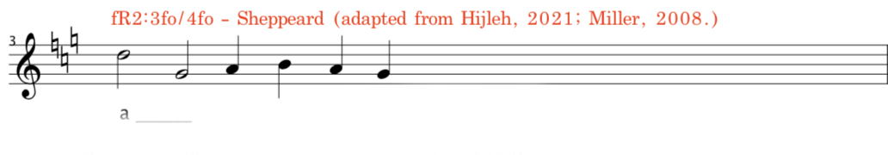
Figure 18. Exercise 3 'harmonic jumping' from D5 to G4 0:16

Miller (2008) describes this manoeuvre as ‘leaping an interval while maintaining a tuned formant’ (p.102) and can be used to find an optimal resonance in the mid-range of the soprano voice for vowels where the sung pitch is below the fR1 of speech and there is not an available harmonic to resonate; in the authors experience, an open /a/ vowel in this area of the voice can be particularly difficult for some sopranos.
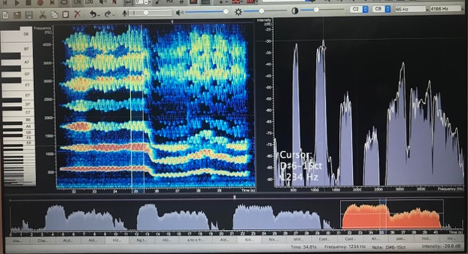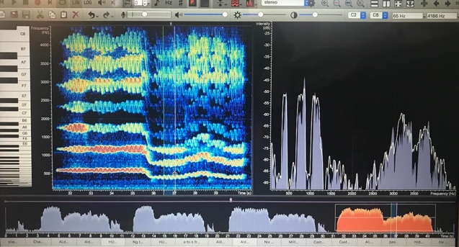
Figure 19 and 20. Spectrograph of Exercise 3 showing maintenance of fR2 on the pitch G4
When recording this exercise, it can be observed on Voce Vista examples (Figures 19 and 20) that the author did not maintain the fR2:3fo coupling as robustly as expected, with the formant resonating the lower part of the third harmonic when the G4 pitch is sung. This is investigated further in Exercise 7 where the author modified the exercise to consciously utilise the ‘harmonic leaping’ strategy by keeping the /a/ vowel very ‘bright’, producing a very different aesthetic than that trained and practiced by the author. However this aesthetic may be called upon for certain repertoire or language and so a flexibility of options should always be explored, noting it was useful for the author to try an option that might be useful for a soprano with a lighter voice and not easily able to find a resonant sound in the mid-range on an /a/ vowel. The Miller (2008) ‘harmonic jumping’ theory as a useful resonance strategy warrants further investigation.

Passagio fR2/fR1 shift
The upper passaggio of the soprano voice can be a difficult area of the to train, the author has historically used an ‘ng’ exercise (Figure. 21) with students to help facilitate its training as taught by two teachers of the author, Janice Alder and Elizabeth Connell.

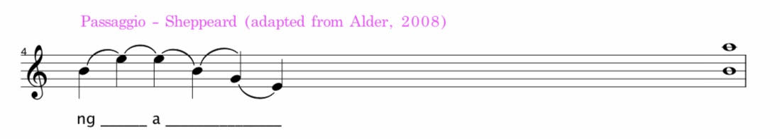
Figure 21. Exercise 4 Passaggio shift from fR2 to fR1 using 'ng' 0:25

The ‘ng’ spectrographically (Figure 22) shows a strong fR1:fo coupling correlating with a strongly felt vibration in the forehead sinus which is used as a ‘guide’ proprioceptively with students by the author. The author theorised that the fR1:fo coupling of the ‘ng’ might facilitate a fR1:fo coupling when releasing into the /a/ vowel on sung passaggio note E4. The author however found it difficult to achieve the theorised maintaining of fR1 resonance dominance as indicated in Figure 22, with the arrow showing more fR2 tuning than expected.
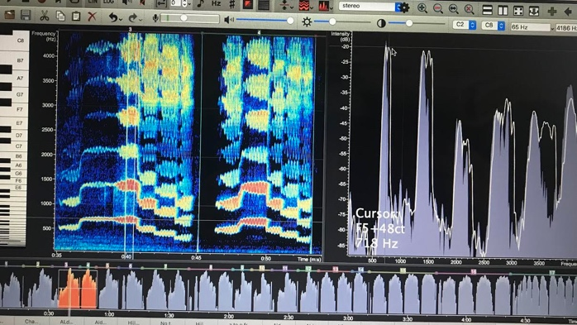
Figure 22. Spectrograph of Exercise 4 (Left spectrograph) showing unsuccessful shift to fR1 (Right LTAS panel)
Incorporating newly acquired knowledge from the literature review research conducted for this project of resonance strategy through the passaggio described by Hijleh (2021) and Lissemore (2020), a different approach was attempted. Lissemore (2020) described the shift of fR2 to fR1 lower in the passaggio for ‘techniqued’ sopranos with ultrasound observations of tongue position noted; with this research in mind, the author performed the same exercise pattern without the ‘ng’, instead using vowel modification and being mindful of the tongue position. This showed a better acoustic execution of the desired resonance strategy (Figure 23). Being aware and able to produce both strategies for different repertoire could be a useful utilisation of both of these methods of resonance production in the passaggio.

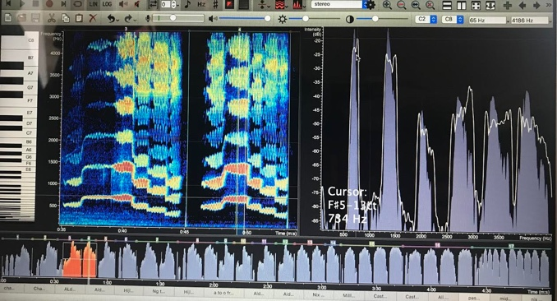
Figure 23. Modified Exercise 4 (Right spectrograph) showing more successful fR2 to fR1 shift (Right panel LTAS)

Additionally, within the soprano second passaggio, Miller (2008) and Hijleh (2021) both advocate for the use of fR1 paired vowels for finding a more ‘rounded’ front vowel which is a preferred aesthetic for classical singing. Miller (2008) describes the vowels on the pitch F5 becoming ‘generic’ front and back vowels as vowel intelligibility is limited at this pitch, and Hijleh (2021) demonstrates /o/ to /e/ on D5. The exercise below (Figure 24) occurs within the passaggio range and can be used to facilitate the experience of de-tuning of fR2 needed for a rounder sound for front vowels in this area of the voice and help soprano students learn detuning fR2 for approaching the top and above stave.

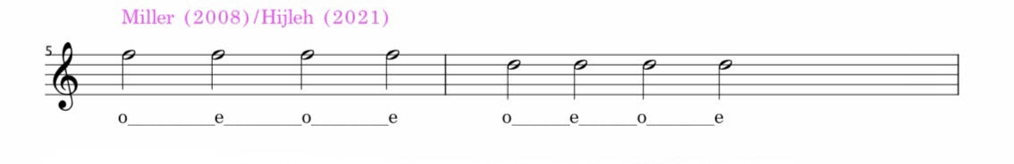
Figure 24. Exercise 5 0:34

The right hand panel of Figure 25 below shows the second resonance has remained detuned (indicated by the arrow) for the /e/ vowel with a dominant first resonance to first harmonic coupling.

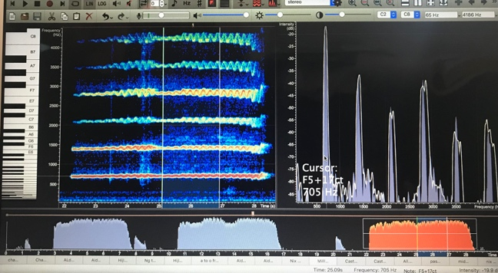
Figure 25. Spectrograph of Exercise 5 'rounding' front vowels

Detuning fR2 above stave
Hijleh (2021) describes Lissemore’s (2020) research as showing a clear decoupling of the second resonance above the stave, demonstrating this is achieved by both reduced sound pressure and/or vowel modification to a lower fR2 of the vowel. To achieve this, the author has written a simple arpeggio exercise (Figure 26) using an /o/ vowel on D5, where the fR1:fo should be established as it is above this vowels speech fR1, with a decrescendo up to the G5 encouraging a detuning of fR2.

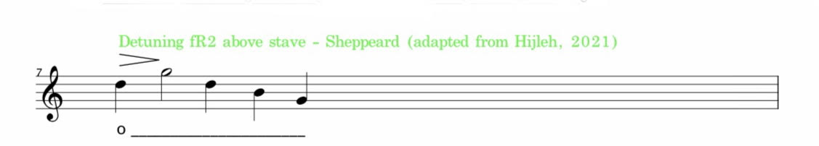
Figure 26. Exercise 6 0:39
The spectrograph of this exercise below (Figure 27) shows a clear detuning of the second harmonic from the second resonance with the first harmonic carrying the bulk of the sound.
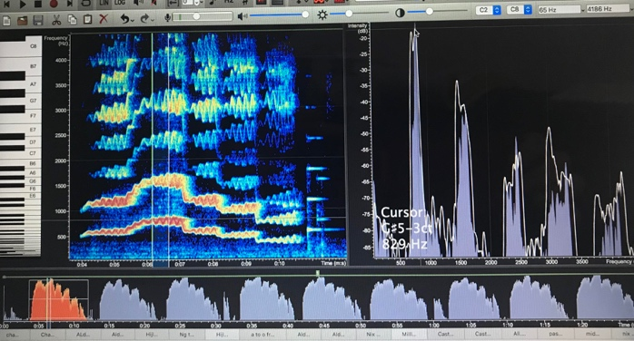
Figure 27. Spectrograph of Exercise 6 showing successful detuning of fR2 above stave

Combining fR2:3fo/2fo tuning with detuning of fR2 above stave
Further exploring the tuning and detuning of fR2, the author devised the following exercise (Figure 28) which combines the ‘harmonic jumping’ from 2fo to 3fo explored in Exercise 3 and then detuning fR2 to above the stave.
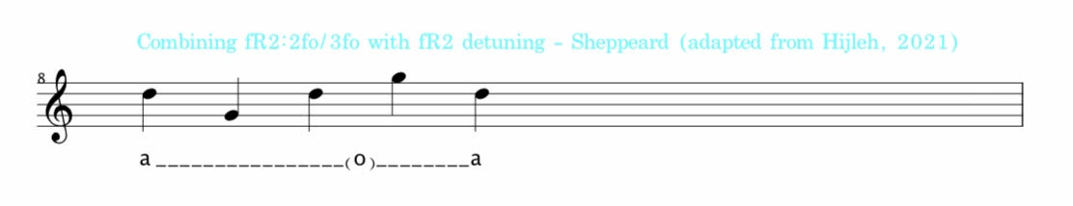
Figure 28. Exercise 7 – combining exercises to explore two strategies 0:46

Figure 29 shows this exercise firstly performed without any vowel modification; maintenance of the fR2 tuning can be seen on the pitch G4 and then above the stave there is no detuning of fR2 (indicated by the arrow in Figure 30). The author would describe this as a very strident sound production and not desirable for the majority of classical repertoire.
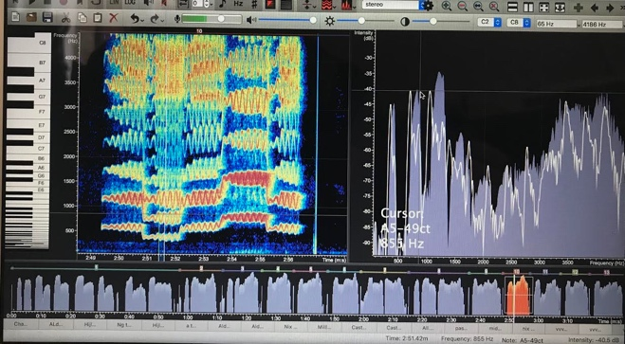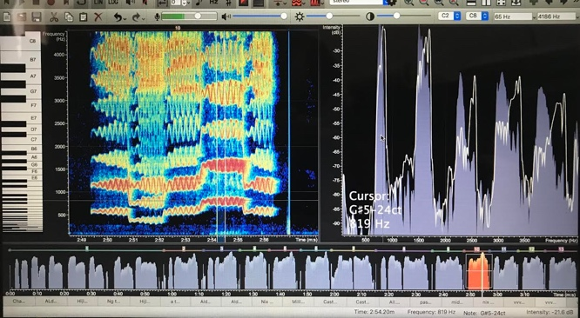
Figure 29 and 30. Spectrograph of Exercise 7 maintaining fR2 tuning for all three pitches

This can be contrasted to Figure 31 showing some vowel modification from D5 to G4 and then a more modified vowel above the stave producing a pronounced detuning of fR2 (Figure 32) and the desired difference between fo and 2fo described by Hijleh (2021). In the authors opinion, this strategy gives a more elegant sound much more in keeping with the bel canto aesthetic used in her own training. Exploring these modifications with students and finding the best strategy and sound could make this exercise a useful tool within lessons.

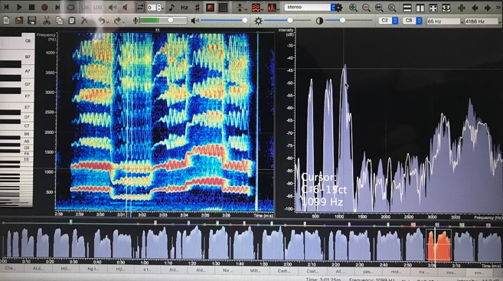
Figure 31. Spectrograph of Exercise 7 showing less robust maintenance of fR2:3fo on G4
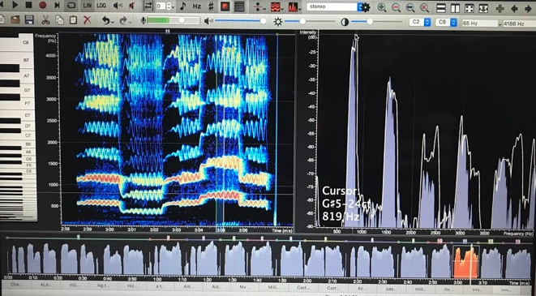
Figure 32. Spectrograph of Exercise 7 showing detuning of fR2 above stave

Whole range exercises: integrating soprano resonance strategies
Exercises the author uses with students that utilise all of the above strategies can help to facilitate the learning and practice of an even resonance production throughout the soprano range. Figure 33 below is a coloratura exercise from Alder (2004) and utilises fR1:fo, fR2:2fo in the mid voice, passaggio shift fR2 to fR1, and detuning fR2 above the stave.

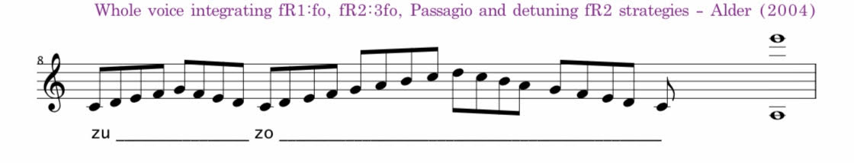
Figure 33. Exercise 8 1:03

Figures 34 and 35 of the spectrograph showing the use the fR1:fo strategy in the ‘zu’ part of the exercise:

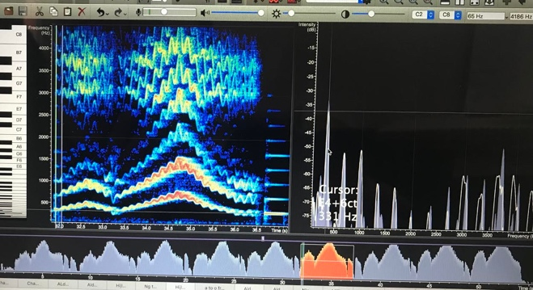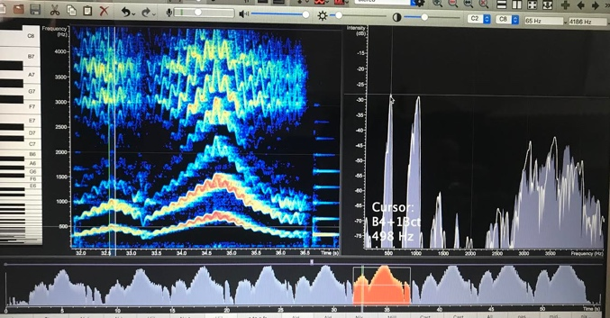
Figure 34 and 35. Spectrograph of exercise 8

Within the ‘zo’ part of the exercise, the different strategies can be seen as the pitch moves up through the range (indicated by the arrows). Figure 36 shows fR2 resonating the second harmonic with a gradual detuning of fR2 as seen in Figure 37, with the top note in Figure 38 showing a pronounced detuning of fR2.
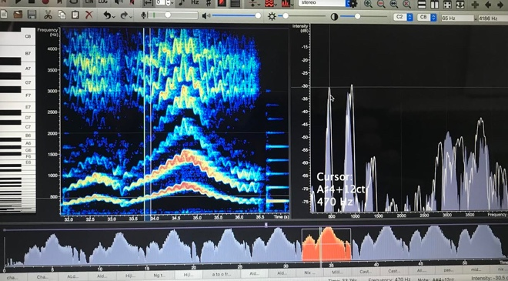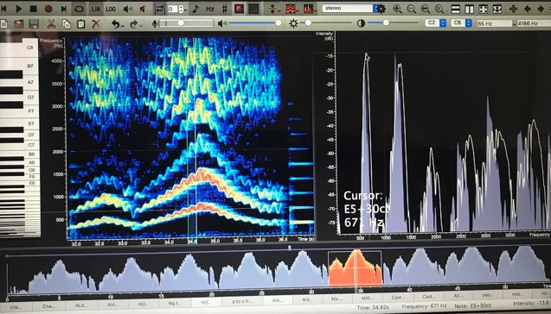
Figure 36 and 37. Spectrograph of Exercise 8

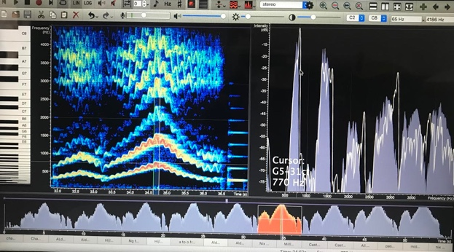
Figure 38. Spectrograph of Exercise 8

The final exercise (Figure 39) investigated is a favourite exercise of the author, and also popular with more advanced students; an extended arpeggio from Alder (2004). This exercise does not use the fR1:fo strategy but can be used to explore low, mid, passaggio and above stave resonance strategies.
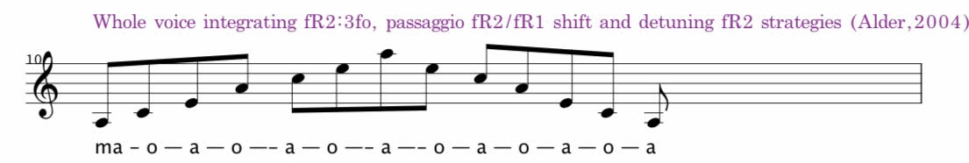
Figure 39. Exercise 9 1:13
The author begins this exercise at the lowest note the student can comfortably sing in a chest (or M1) registration. Moving through the range, legato and evenness of tone between vowel changes are the goal. Figures 40 to 46 show the spectrographs of this exercise for the range E3 to E5 sung by the author. Chest registration resonance strategies are beyond the scope of this paper but it is interesting to note (indicated by arrows) the lowest note is utilising the second resonance on the 6th harmonic with a fR1 and second harmonic coupling on the second note (G#3). Utilisation of the fR2 can then be seen throughout the middle range with the fR2 to fR1 shift beginning at the top note of the exercise.

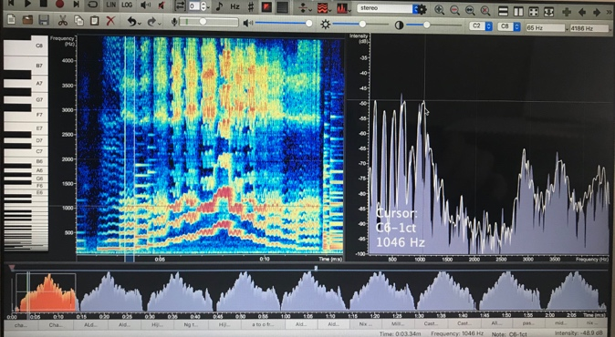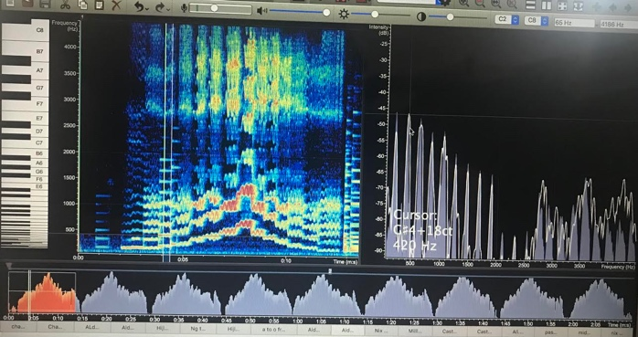
Figure 40. Exercise 9 E3-E5 /a/ highlighted Figure 41. Exercise 9 E3-E5 /o/ highlighted

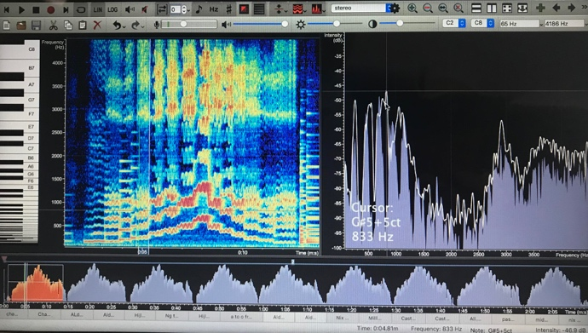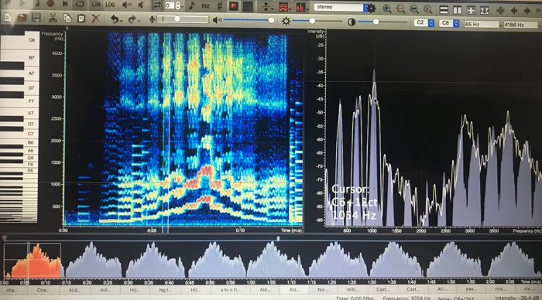
Figure 42. Exercise 9 E3-E5 /a/ highlighted Figure 43. Exercise 9 E3-E5 /o/ highlighted

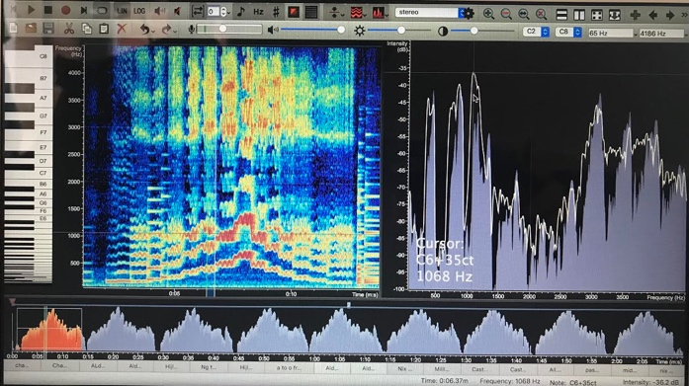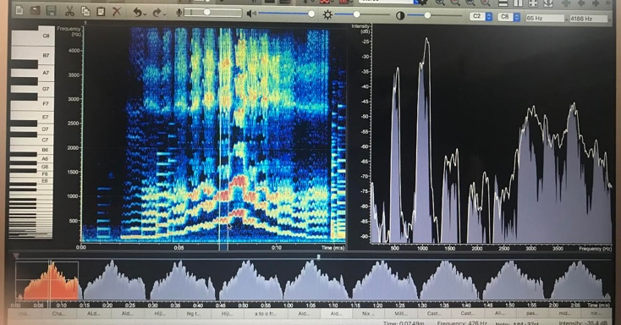
Figure 44. Exercise 9 E3-E5 /a/ highlighted Figure 45. Exercise E3-E5 9 /o/ highlighted

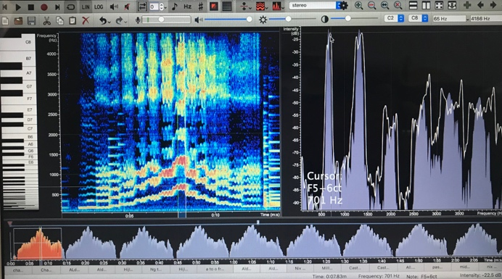
Figure 46. Exercise 9 E3-E5 /a/ highlighted

Figures 47 to 49 show the same exercise performed over the range A3 to A5 with the spectrographic screenshots taken to illustrate a fR1:3fo coupling on the lowest note (A3) and the fR2/fR1 shift occurring earlier than in the previous scale as a fR1:fo coupling can be seen at E5 in Figure 48 as compare to Figure 46 (indicated by the arrows) where the fR2 is more present. The final spectrograph shows detuning on fR2 for the top note of A5 (as indicated by the arrow).

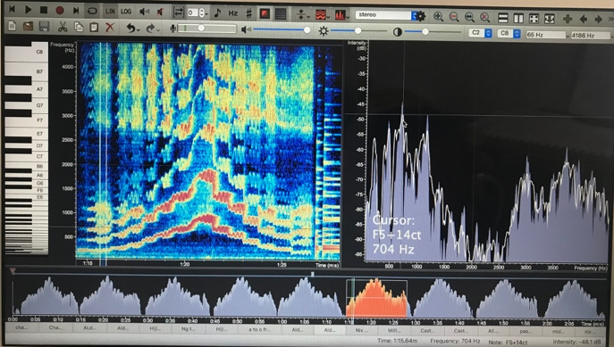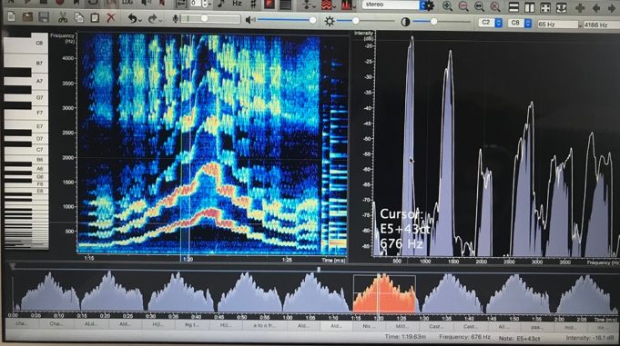
Figure 47. Exercise 9 A3-A5 /a/ highlighted Figure 48. Exercise 9 A3-A5 /o/ highlighted
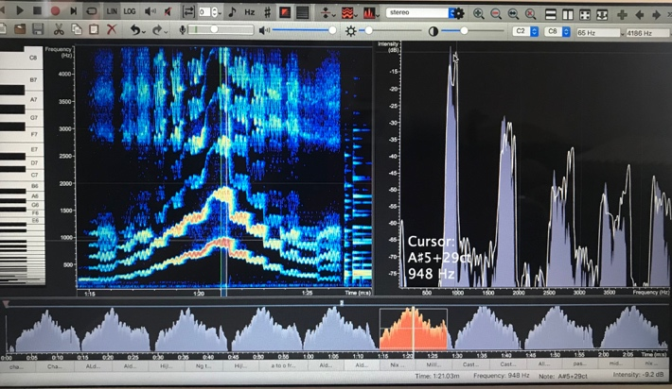
Figure 49. Exercise 9 A3-A5 /a/ highlighted

DISCUSSION
The choice of the above exercises were selected from the many vocal exercises in use by the author from several of her voice teachers, but primarily from Janice Alder whose exercises have become a mainstay of the authors own teaching practice. An instinctual and aural understanding of their usefulness in the author’s own training and use with students has been examined through the lens of newly acquired acoustic knowledge and its development and application of these concepts by the author to her traditional classical soprano training knowledge. Reflecting on the exercises used by the author in her practice, justification of vocal exercise choice can be found when examining habitually used vocal exercises as well as experimentation using acoustic concepts and the applying of new acoustically informed ideas within the authors own singing practice and subsequent application to teaching.

Several observations can be made from the vocal exercise examination. The note E5 in the second passaggio of authors voice showed different amounts of fR1/fR2 shift depending on the approach to that note within the exercise. Within Exercise 9 (Figures 39 to 49), when E5 is a top note of the exercise, less decoupling of fR2 is seen than if connected to a higher note, as seen in Figure 49; this has pedagogic implications for training intervals through the passaggio to above the stave. Not detuning fR2 above the stave was examined (Figure 28 to 32) and is traditionally described as ‘carrying too much weight into the top of the voice’. This may be a question of aesthetic and/or voice fach; pedagogue and author Bozeman (2017) asserts passive vowel migration across the range but the author demonstrating this strategy by maintaining the vocal tract shape across the range (Figure 28 to 32) does not herself train within this strategy. The Martienssen-Lohmann training of the author has a much finer (in the German language ‘shlank’) aesthetic which can be seen to correlate well with the detuning of fR2 research of Lissemore (2020) and Hijleh (2021). This question is worthy of investigation and important to be aware of when preparing students for auditioning at a high level; a flexibility of resonance strategy can be required for different repertoires and perhaps different countries. Healthy and consistent voice production must always be the goal and within that an awareness of the limits of what is possible vocally for the student balanced with what is required. Investigating ‘preferred’ aesthetics by heads of casting in opera houses would be a useful study that could then be implemented practically when training sopranos. Sopranos and their teachers could explore the different aesthetics aurally, as well as visually using Voce Vista Pro.

Several questions have emerged during the research period and subsequent examination of the chosen vocal exercises with Voce Vista Pro. The authors dramatic soprano voice may not reflect the soprano resonance strategies of many of her students who possess much lighter voices; quantifying the difference in expected resonance strategies for a dramatic soprano as compared to a light lyric soprano is beyond the scope of this paper but does prompt the author to reflect on whether the desired resonance strategy theories highlighted might be better demonstrated in a more common voice type. This warrants further study and a pedagogically led investigation of other soprano voices. The author reflects on her own interest in dramatic soprano voices and their acoustic structure, balanced with the need to teach sopranos that are largely not of her vocal fach.

There is a paucity of pedagogically led research of soprano resonance strategies. Several classically trained pedagogue practitioners do engage with acoustic concepts and use spectrographic software within their practice but there are very few sopranos investigating their own voices with the available software. Lissemore’s (2020) as yet unpublished research will be a welcome and important contribution to the collective knowledge and its application by Hijleh (2021) in her own work is very instructive. This paper has relied upon resonance strategy concepts from practitioners (Lissemore, 2020; Hijleh, 2021) that rejects the findings of more formal laboratory investigations (Joliveau,2004a, 2004b; Henrich, 2011; and Garnier, 2010) but supports the authors own findings (Sheppeard, 2021) from her recent case study, and investigations within this study. The author acknowledges this contradiction, its probable methodological source discussed earlier, and is aware of the gap between peer reviewed research and practitioner knowledge and the need to strengthen its validity. The author again notes the need for accessible acoustic education for soprano pedagogues in the UK to develop collective research in this area.

The chart developed by the author came from a need to consolidate soprano resonance strategy information that is available but not readily accessible while teaching; the program Voce Vista itself does not reflect the movement of formants within the soprano range in its vowel chart function and so is not as useful as it could be for sopranos. A software program or visual aid that does show the important soprano resonance strategies would be a valuable addition to the pedagogues toolbox. Expanding the chart developed by the author with data collected from a number of sopranos would generalise findings and develop a useful teaching aid that can be used by other pedagogues.

CONCLUSION

The specific learning and development aims and learning outcomes of this project have been largely met by the author. Acoustic knowledge, and in particular soprano resonance strategies defined acoustically, has been built upon across successive research projects. In this project, the author has combined acoustic theory to practical experience by examining and creating vocal exercises to help facilitate soprano resonance strategies. The author has been able to collate vocal exercises used within her teaching practice and transcribe them with thought and care to their use with different students based on their examination for this project. Using Voce Vista Pro to examine the vocal exercises has further enabled the authors familiarity with the technology and increased confidence of usage. The practical use of this software, along with the development of the chart showing formant and harmonic interactions across the soprano range with the soprano resonance strategies will enable integration of acoustic theory within voice lessons that can help the author evaluate other vocal exercises and repertoire in her practice.

BIBLIOGRAPHY

2020. VoceVista Video pro (version 5.4.04861). [Sygyt software]. accessed 24th June 2021
Adams, R. J., Smart, P. & Sigismung Huff, A., 2017. Shades of Grey: Guidelines for Working with the Grey Literature in Systematic Reviews for Management and Organizational Studies. International Journal of Management Reviews, Vol 9. p. 432-454
Alder, J., 2004. Vocal Exercises. Unpublished
Bozeman, K., 2017. Kinesthetic voice pedagogy: Motivating acoustic efficiency. Inside View Press.
Bresch, E. and Narayanan, S., 2010. Real-time magnetic resonance imaging investigation of resonance tuning in soprano singing. The Journal of the Acoustical Society of America, 128(5), pp.EL335-EL341.
Chapman, J.L., 2016. Singing and teaching singing: A holistic approach to classical voice. Plural Publishing.
Coffin, B., 1974. On hearing, feeling and using the instrumental resonance of the singing voice. NATS Bulletin, 31, pp.26-30.
Cooper, H.M., 1988. Organizing knowledge syntheses: A taxonomy of literature reviews. Knowledge in society, 1(1), pp.104-126.

Duke, E., Plexico, L.W., Sandage, M.J. and Hoch, M., 2015. The effect of traditional singing warm-up versus semi occluded vocal tract exercises on the acoustic parameters of singing voice. Journal of Voice, 29(6), pp.727-732.
Erickson, H.M., 2021. Mobile Apps and Biofeedback in Voice Pedagogy. Journal of Singing, 77(4), pp.485-500.
Gibbs, G., 1988. Learning by doing: A guide to teaching and learning methods. Oxford: Oxford Further Education Unit
Gibson, I.W., 2001. At the intersection of technology and pedagogy: Considering styles of learning and teaching. Journal of Information Technology for Teacher Education, 10(1-2), pp.37-61.
Groth, S.M., 2020. Using Bel Canto Pedagogical Principles to Inform Vocal Exercises: Repertoire Choices for Beginning University Singers (Doctoral dissertation, University of Colorado).
Haraway, D. 2003. Situated Knowledges: The science question in feminism and the privelege of partial perspective. In Y.S Lincoln and N. K. Denzin (Eds.) Turning points in qualitative research: tying knots in a handkerchief (p. 21-46) Lanham, MD: Rowman and Littlefield.
Henrich, N., Smith, J. and Wolfe, J., 2011. Vocal tract resonances in singing: Strategies used by sopranos, altos, tenors, and baritones. The Journal of the Acoustical Society of America, 129(2), pp.1024-1035.
Hijleh, K. 2021. Acoustic 'Tips and Tricks' for the Classical Treble Voice, Online Zoom Lecture, Voice Workshop, East Bergholt; UK.
Hillenbrand, J., Getty, L.A., Clark, M.J. and Wheeler, K., 1995. Acoustic characteristics of American English vowels. The Journal of the Acoustical society of America, 97(5), pp.3099-3111.
Hoch, M., 2019. Historical Landmarks in Singing Voice Pedagogy. Voice and Speech Review, 13(1), pp.43-60.
Iwane, N., Gao, C. and Yoshida, M., 2016, February. Building an experimental system to examine a method for supporting verbal explanation. In 2016 13th International Conference on Remote Engineering and Virtual Instrumentation (REV) (pp. 347-349). IEEE.
Jeanneteau, M., Hanna, N., Almeida, A., Smith, J. and Wolfe, J., 2020. Using visual feedback to tune the second vocal tract resonance for singing in the high soprano range. Logopedics Phoniatrics Vocology, pp.1-10.
Joliveau, E., Smith, J. and Wolfe, J., 2004. Vocal tract resonances in singing: The soprano voice. The Journal of the Acoustical Society of America, 116(4), pp.2434-2439.
Leavy, P., Harris, A., 2019, Contemporary Feminist Research from Theory to Practice. Guilford Press: London
Lindblom, B.E. and Sundberg, J.E., 1971. Acoustical consequences of lip, tongue, jaw, and larynx movement. The Journal of the Acoustical Society of America, 50(4B), pp.1166-1179.
Lissemore, R.C., Roon, K., Shadle, C.H. and Whalen, D.H., 2018. Articulatory correlates of the acoustic transition during the second passaggio of sopranos. The Journal of the Acoustical Society of America, 143(3), pp.1907-1907.
Lissemore, R.C., Shadle, C.H., Roon, K. and Whalen, D.H., 2017. Use of H1-H2 to quantify formant tuning for notes and portions of the vibrato cycle in the second passaggio of a professional female singer. The Journal of the Acoustical Society of America, 141(5), pp.3724-3724.
Lissemore, R.C., Shadle, C.H., Roon, K.D. and Whalen, D.H., 2020. Articulatory activity of the tongue, jaw, and lips during the second passaggio acoustic transition of female singers. The Journal of the Acoustical Society of America, 148(4), pp.2700-2700.
Lissemore, R.C., Shadle, C.H., Roon, K.D. and Whalen, D.H., Head-Corrected Ultrasound During the Second Passaggio Acoustic Transition of Sopranos. UltraFest IX Ultrasound Imaging for Speech and Language Virtual Conference October 21-24, 2020
McCann, M., 2018. Vowel-Pitch Matching, from Senta to Kundry.
McCoy, S., 2013. Formantology. Journal of Singing, 70(1), p.43.
Mendes, A.P., Rothman, H.B., Sapienza, C. and Brown Jr, W.S., 2003. Effects of vocal training on the acoustic parameters of the singing voice. Journal of voice, 17(4), pp.529-543.
Miller, D., 2008. Resonance in Singing, Inside Press View, Princetown; NJ
Miller, D.G., Svec, J. G., Schutte, H.K. 2002. Measurement of characteristic leap interval between chest and falsetto registers, Journal of Voice, 16:8-19.
Miller, R. and Schutte, H.K., 2019. The effect of tongue position on spectra in singing. Journal of Singing, 76(1), pp.25-29.
Mitton, D.A., 2020. Sung Russian for the Low Male Voice Classical Singer: The Latent Pedagogical Value of Sung Russian (Doctoral dissertation).
Moya, P., 2014. Habit and embodiment in Merleau-Ponty. Frontiers in Human Neuroscience, 8, p.542.
Nix, J., 2018. John Nix: Varying Vowels and SOVTs: Does it make a difference? [online video] Available at: https://www.youtube.com/watch?v=ZFrGdNAU2T8 [Accessed 25/5/2021]
Oram, D., 2015. Research and Practice in Voice Studies: Searching for a Methodology. Voice and Speech Review, 9 (1), p. 15-27
Anon, (2021). In: Oxford Learner’s Dictionaries. [online] Available at: https://www.oxfordlearnersdictionaries.com/definition/english/vocalise [Accessed 3 Jun. 2021].
Piccini, A., 2003. An Historiographic Perspective on Practice as Research. Studies in Theatre & Performance, 23(3).
Pitts-Taylor, V. ed., 2020. Mattering: Feminism, science, and materialism. New York University Press.
Reuter, J.F., 2001. The development of the singing voice by Franziska Martienßen-Lohmann: A critical translation. University of Washington.
Schutte, H. K., Miller, D. G., Duijnstee, M., 2005. Resonance Strategies Revealed in Recorded Tenor High Notes, Folia Phoniatrica et Logopaedica, 57:292-307
Sheppeard, K., 2021. Soprano Resonance Strategies. Unpublished.
Smith, J. and Wolfe, J., 2009. Vowel-pitch matching in Wagner’s operas: Implications for intelligibility and ease of singing. The Journal of the Acoustical Society of America, 125(5), pp.EL196-EL201.
Stark, J., 1999. Bel Canto: A History of Vocal Pedagogy. University of Toronto Press.
Stevens, K.N., 2000. Diverse acoustic cues at consonantal landmarks. Phonetica, 57(2-4), pp.139-151.
Sundberg, J., 1987. The Science of the Singing Voice p. 123. Dekalb: Northern Illinois University Press
Sundberg, J. and Skoog, J., 1997. Dependence of jaw opening on pitch and vowel in singers. Journal of Voice, 11(3), pp.301-306.
Sundberg, J., 2009. Articulatory configuration and pitch in a classically trained soprano singer. Journal of Voice, 23(5), pp.546-551.
Titze, I.R., 2001. Acoustic interpretation of resonant voice. Journal of voice, 15(4), pp.519-528.
Titze, I.R., 2008. Nonlinear source–filter coupling in phonation: Theory. The Journal of the Acoustical Society of America, 123(4), pp.1902-1915.
Vos, R., 2018. Resonance Tuning in Professional Operatic Sopranos. PhD thesis, University of York.
Winter, D., 2020. Voicing a Practitioner Research Methodology: Further Framing the Conversation. Voice and Speech Review

APPENDIX 1. TIME STAMPS WITH LINK FOR VOCAL EXERCISE RECORDING ON YOUTUBE https://youtu.be/ASBB9d2W8SA (also embedded with each exercise in the main body of the Assignment).

0:00 Exercise 1 (Chapman 'dial a vowel' on /i/)

0:04 Exercise 1

0:08 Exercise 2 (Alder staccato on /u/)

0:11 Exercise 2

0:16 Exercise 3 (Miller 'harmonic jumping' D5 to G4)

0:25 Exercise 4 (Alder 'ng' to /a/)

0:34 Exercise 5 (Miller/Hijleh /o/ to /e/)

0:39 Exercise 6 (Hijleh /o/ detune fR2 D5 to G5)

0:46 Exercise 7 (/a/ detuned to /o/ 'experiment' - tuned)

0:56 Exercise 7 (detuned)

1:03 Exercise 8 (Alder 'zu-zo')

1:08 Exercise 8

1:13 Exercise 9 (Alder 'ma-o-a')

1:24 Exercise 9

APPENDIX 2. ALL VOCAL EXERCISES COLLATED FOR THE PROJECT

