Rahela Begum
1809413
Workplace Culture and its impact on Organisational Efficiency
BMSW5105
Rexon Nting

Table of Contents
Abstract: 3
1.0 Introduction: 3
1.1 The profile of Tesco company: 4
2.0 Organizational culture definition: 5
2.1 Features of organizational culture: 5
2.2 Types of organizatinal culture: 7
2.3 Organizational culture, ethos and values: 7
2.4 Communication tools of Tesco for building strong relationship: 8
2.5 The ways of establishing and maintaining sustainable culture in the organization: 9
3.0 SWOT Analysis of Tesco: 11
Tesco’s strengths: 12
Tesco’s Weaknesses: 12
Tesco’s Opportunities: 13
Tesco’s Threats: 13
4.0 PESTEL analysis of Tesco: 14
5.0 Assessment of workplace culture of Tesco: 16
5.1 Environmental and corporate social responsibility of Tesco: 16
5.2 Obsacles to effective functioning in Tesco: 18
5.3 The ways to overcome the obstacles of effective functioning in Tesco: 18
6.0 Recommendations to Tesco: 20
Conclusion: 20
References: 21

Abstract:
This study says about the workplace culture and portrays the picture of its necessity or importance for any organization. Here I have taken the Tesco public limited company to understand about the organizational workplace culture and its importance on that organization. This study is divided into five parts to show the whole picture of it. The first part of this study has the introductory description of workplace culture and about the profile of Tesco company. Second part covers the definition, features and types of different culture theories, and implication of those theories in the company. It narrates the organizational culture, values, ethos and channels that are used to seccessful communicaton. This study also focuses on a discussion about the role of a good leader to create a positive and productive culture within the organization. In third part, I have tried to find out Tesco’s strengths, weaknesses, opportunities and threats through the basis on my experience when I visited this company to collect data for this study. Here I have also tried to understand the external factors that have a vital impact on the company to gain its goal and objectives.

The last part of this study claims some recommendations to Tesco for overcoming the challenges they facing and to increase the ability for adapting with new world. These will also help to achieve the sustainable goals through developing positive and productive culture within the organization.

1.0 Introduction:
It is very difficult to give a universal definition of culture because it varies from place to place and organization to organization. Normally culture accumulates the traditions, norms, values, beliefs and assumptions used and exercised by the members of an organization. According to Richard Perrin, “organizational culture is the sum of values and rituals which serve as a glue to integrate the members of the organization.” Culture plays a vital role to achieve the organization’s desired goals and objectives. Without creating a positive and productive culture, it is totally impossible for an organization to run a long race because every member works as a part of the whole organization. A positive culture increases the spontaneous participation of the members forwarding the organization. It also attracts the meritorious freshers for working with this organization. A sound culture creates a sound environment that helps and motivates the members to work enthusiastically. A good leader is very important for creating this enviroment. There are several theories of culture for creating and maintaining this environment within the organization.

1.1 The profile of the Tesco company:
Tesco plc is a British multinational groceries and general merchandise retailer which is established in 1919 by Jack Cohen. The headquarter of this company is in Welwyn Garden City, Hertfordshire, England. Tesco is regarded as the 3rd and 9th largest retailer on the basis of gross revenues and revenues in the world. It has the leading positon in the grocery market of UK and also shops in seven counries in Europe and Asia.
Jack Cohen founded it as a group of market stalls and the first Tesco shop was established in 1931 in Burnt Oak, Barnet. Cohen’s business spreaded quickly and he established about 100 shops across the country by 1939. Now Tesco has the supermarket, hypermarket, superstore and convenience shop facilities and 440,000 active workers. In 2018, its revenue was £57,491 million, operating income was £2,206 million and net income was £1,208 million. The following picture includes the basic information about Tesco.

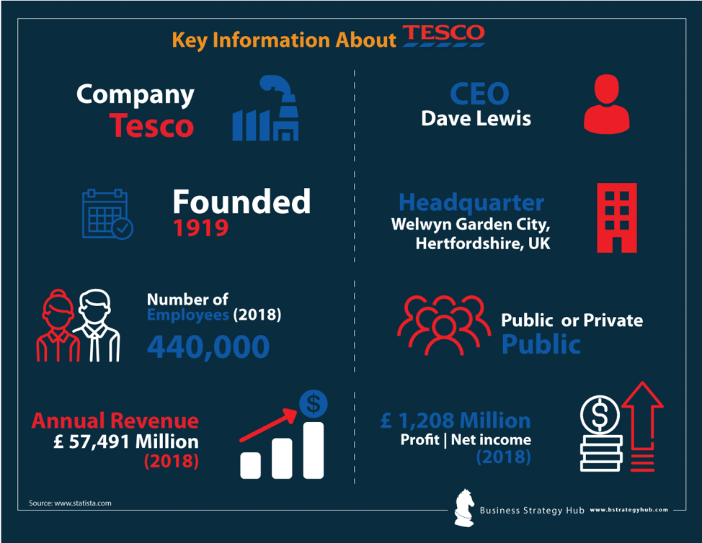
Figure 1: Key facts about Tesco
Source: Business Strategy Hub

2.0 Organizational culture definition:
We have already mentioned that culture noramlly accumulates the traditions, norms, values, beliefs and assumptions used and exercised by the members of an organization (Safeer and Allen, 2019). The main elements of an organizational culture are the employees of that organization. They crate the culture, they changes the culture and they give the new shape of culture within the organization. Culture represents the behavior of the membes of the organization. In the broad sense, culture also includes the thoughts and responses of the members and it helps the management to give the environment that suits for them. Each organization has its own and distinct culture based on its field and place (Baicker et al., 2010). Robbie Katanga says that “organizational culture is how organizations do things.” So, if we want to presisely say that what actually organizational culture is then we get the followings :

- Culture is the ways through which an organization runs its business, hehaves with its members and develops its new ideas.
- Culture limits the extent of freedom which the membes can exercise and participate in the decision making process.
- It has direct impacts on the organization for achieving its goals and objectives.

2.1 Features of organizational culture:
The followings are the very important characteristics that an organization mainly holds to achieve its goal and objectives.
Innovation: every company gives focus on innovation encouraging their employees taking risk because every new innovation makes the company different from others (Safeer and Allen, 2019).
Detailed attention: Company needs accuracy in their works. So it gives focuses on employees for performing their jobs accurately.
Outcome oriented: Outcomes or results are the ultimate desired goals of any company. So it gives extra focus on results rather other tools (Catling and Rossiter, 2019).
People oriented: People or employees are the main elements of the company and so it indicates how extent space is given for the people.

Management support: Manager is the prime leader who actively works with the subordinates and so he/she should clear every thing like company’s visions, targets, norms etc to the other employees (Baicker et al., 2010).
Teamwork: Teamwork is the most important for any company because without working jointly no company will able to achieve its goals.
Stability: Company’s culture helps to make a stable situation within the organization and it hels to gain desired goals.
Agressiveness: Agressiveness refers to the ability of the company to compete with other companies in the market. The company which has taken agressiveness as the important characteristic will perform well in the long term basis (Catling and Rossiter, 2019).
Integrity: Integrity is one of the important feature of corporate culture as it makes same sense among the employees. Integrity makes employees more liable and commited to the organization. So each organization should give focus on making integrity among the employees.
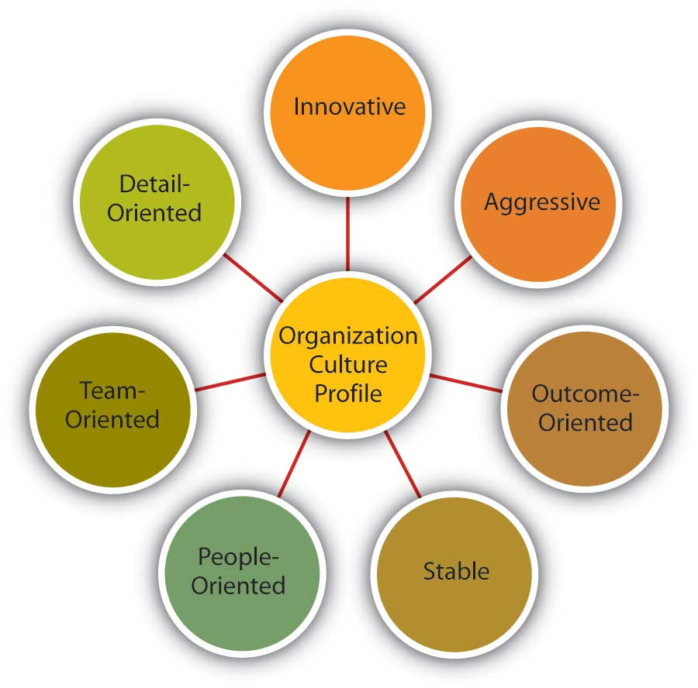
Figure 2: Characteristics of organizational culture (Safeer and Allen, 2019)

2.2 Types of organizatinal culture:
There are different types of organizational culture. It varies from organization to organization and sector to sector. Here we will discuss some dominant types of culture which are normally exercised by the organizations. These are given as follows:

Normative culture: Normative culture is mainly considered as hard culture of an organization. This type of culture frames its norms and procedures as the pre-determined basis and the rules and regulations are made following the existing guidelines. Here the employees are bound to hehave in given freedom (Baicker et al., 2010).
Pragmatic culture: Pracmatic culture is formed based on the customer’s satisfaction. Here customers are considered as the God and every thing is done for satisfying them. Employees are always busy to work for the external parties and their clients not for them (Catling and Rossiter, 2019).
Academy culture: Academy culture is mainly formed based on knowledge. This type of culture always tries to hire skilled and meritorious employees. After hiring them, they also arrange frequent training courses for developing further skill and adapting with new challenges to achieve their goals. Educational institutions like schools, colleges, universities and hospitals practise this culture within their organization (Epstein, 2018).
Baseball team culture: Baseball team culture is very popular and most practised culture in the recent world era. It focuses on their own employees and considered them as the most importan tools for gaining their goals (Safeer and Allen, 2019). In this culture, emoloyees do not feel bother or stress about their organization and this helps the organization to run smoothly.

2.3 Organizational culture, ethos and values:
Organizational culture: Organizational culture refers the all kinds of sharings like beliefs, norms, traditions, goals, assumptions etc among the members of the organization. Culture has a great impact on the organization’s performance. When the employees get a environment that serves all the necesseries, they cann’t feel any bother to the organization and works spontaneously for betterment of the organizataion (Epstein, 2018). A employee friendly culture makes employees more enthusiastic and it pleasurely guides them to do work for their organization.
Organizational ethos: Organizational ethos is mainly related with ethics of the organization. Ethos claims generosity, honesty, transparency, commitment and sharings of the members. These are the soul of the organization for attaining and maintaining a effective and active culture within the organization. Ethos makes an organization unique from other organizations. Every customer searches this unique feature in the organization to contract with them and it creats a trust to the organization. Without creating trust and psychological attachment among the clients, no company will sustain in the market (Catling and Rossiter, 2019).
Organizational values: Organizational ethos is the inherent things of the members but values are very important as these make strong relationship among the members (Safeer and Allen, 2019). Every organization maintains some values like respect and love to all, assistance in any situation, integrity among the members and appreciation for outstanding performance. These values give dignity and recognition of their excellence jobs which they do for their organization.

2.4 Communication tools of Tesco for building strong relationship:
Not only Tesco but also every company has some own distinct communication tools that they use for building a strong relationship with their internal and external bodies. Communication and creating new networks are the prime task of every company to attain their desired goals (Baicker et al., 2010). Tesco, as a groceries retailer, has always to inform their clients about their collections, qualities and stocks of their goods. Besides informing external parties, maintaining internal communication is very important for sharing information about all branches of the company. Tesco is a vast groceries company in the world and so it has to face many challenges to maintain communication among themselves along with external parties (Safeer and Allen, 2019). Tesco developed some strong online communication tools for getting extra facilities in communication and reaching to the large numbers of employees and clients across the world. These are discussed as follows:

Social intranet software: Social intranet softwares are the best solution for interacting with both internal and external bodies. As Tesco is one of the largest groceries in the world, it has to communicate with a vast number of employees as well as clients (Catling and Rossiter, 2019). Social intranet softwares make both the internal and external parties up to date about the latest changes and upgradation of the company. As most the clients of the world use social networking sites so they can easily reach to them about their products’ advertisement.

Private, group messaging and chat tools: Private, group messaging and chat tools are very effective communicative tools of the present world. Tesco uses these tools for better communication among their employees. There are many employees who don’t feel very comfortable to talk directly (Epstein, 2018). These tools create the environment for gathering of those employees’ ideas that hepl the management to collect something new. Tesco is getting the advantages for using these tools that are helping for increasing the productivity of the company.
Internal blogs and videos: It is said that “people eat with their eyes”. It is scientifically proved that visulization is more effective than contextual reading (Safeer and Allen, 2019). Tesco has a strong department to research the market mechanism and it takes this tool for effective communication (Catling and Rossiter, 2019). Reaching to the all employees is impossible for a manager to give a new message but a video will reach to all the members easily. And it obviously lessens the time cost of the company.
Mailes: Sending mails is very popular mechanism of communication among the members and the clients. Tesco sends mails to every member to update them about the current changes and upgradation (Baicker et al., 2010). Clients are also informed concerning their requirements. Mail is important as it gives the protection of the secret and close information that is sent to the members. A 24 hours help line is also open for giving services like answers of any quiery and requirements of the external parties.

2.5 The ways of establishing and maintaining sustainable culture in the organization:
Every company follows some ways to establish and maintain sustainable culture within its organization (Epstein, 2018). Though the primary elements for creating a culture come from the founders’ vision and view but many other things help to make a sustaniable culture in the organization. These are given as follows:
Founder’s values and preferences: A company which is installing itself as a fresher in the market will obviously be guided and motivated through the values prefering by the founder. It is also important as the founder must have positive and visionary goals hehinds the establishment of the company (Catling and Rossiter, 2019).
Company’s demand: Defining and framing a culture within the organization is very difficult as various types of people work in together but company’s demands to the the employees create the enviroment to make a same sense to work jointly for achieving the desired goals. So it plays an vital role to maintain a sustainable culture in the organization (Epstein, 2018).
Attraction Selection Attrition: Attraction selection attrition process helps to maintain a sustainable culture in the organization. This mechanism works for the perfect selection for the perfect job (Safeer and Allen, 2019). Some employees like to work in the competetive environment rather working jointly. Attraction selection attrition process solves this problem and varities recruiting them in the suitable field.
New employee onboarding: It works like a socialization process of the society. Here every employee is given the chances to know about the company’s values, norms, traditions, assumptions and desired goals. To do this job, every company arranges many orientation programmes.
Leadership: Leadership plays the vital role to establish and maintain a sustainable culture within the organization. If managers coorperate and listen the employees’ demand then they feel more goal oriented and be more active. Sometimes a leader may be a role model for the company’s culture (Baicker et al., 2010).
Reward system: When an employee gets the recognition of his/her excelency, he/she feel more honor and dignity and becomes more committed to work for the company’s betterment. Otherwise punishment for any corruption will given alarm to the employees for the future cautiousness (Catling and Rossiter, 2019).
The following figure shows the requirements for establishing and maintaining a sustainable culture in the organization.

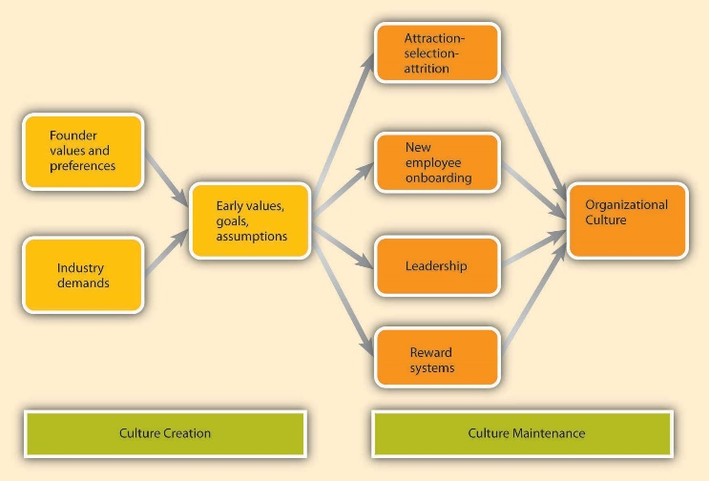
Figure 3: The ways of establishing and maintaining sustainable culture in the organization (Safeer and Allen, 2019)

3.0 SWOT Analysis of Tesco:
SWOT analysis is an essential tool for each company to develop its business strategies. SWOT refers the strengths, weaknesses, opportunies and threats of the company. Strengths and weaknesses are considered as the internal issues of the company whether opportunities and threats are treated as the external issues that company cannot change rather can take advantages of these opportunities (Epstein, 2018). Tesco also has these four issues in its organization that are discussed below:

Tesco’s strengths:
Largest grocery retailer in the UK: Tesco developed itself as a largest grocery retailer and number 1 supermarket in UK. No company is able to compete with Tesco in the supermarket sector in UK and its annual operating profits increased 28% in 2018.
Leading market share: Tesco has 27% market share among the big four supermarkets in the Britain. It has become the most accepted and popular supermarket in Ireland now.

Geographically diversified: Tesco is not only a domestic company of UK rather it expanded its business in 14 countries of the world. Besides Europe and America, it invested huge amount in Asia. Tesco has more than 6800 stores in the 14 countries (Hardiman and Dewing, 2019).
Diversified stores: Tesco is always trying to increase their business establishhing new stores. It is not only increasing their stores but also focusing on the diversification of the products and departments establilshing new branches like Tesco Metro, Tesco express, Tesco Homeplus etc.
Superior technology usage: Tesco always tries to use new and advance technologies to increase efficiency and reduce cost of the maintenance. RFID, M-commerce and mobile payment app have made easier the business of Tesco (Epstein, 2018).
Efficient supply chain network: As Tesco is a very old and experienced company, it has been able to make a efficient supply chain network within the organization. It has grown the simple business model and effective management polycies for their organization.

Tesco’s Weaknesses:
Failed operations in USA and Japan: The exit of 2012 from Japan and USA is a great failure of Tesco that had a great negative impact on it. It was only active nine years in Japan and five years in USA.
Fraud Trial and Accounting Scandal: 2017 was the very bad time for Tesco as it was condemned for giving false information about their accounting and profits and it has to give big amount of fine and face to bad scandal for it (Hardiman and Dewing, 2019).
Decrease in operating profits: Brexit issue has hampered its business which affects in the share prices of Tesco decreasing 9%. It has to face new challenges for Brexit problem.
Financial errors: In recent years Tesco has to face the problems of financial errors. It has huge debts and credit card liability that’s why financial profits are being affected (Epstein, 2018).
Low-cost strategy: Tesco has the advantage of price leader in UK but it may be affected for their extreme low cost strategy in the long run business.
Poor operational performance in specific markets: Though Tesco is the giant of groceries retailer but it is not doing well in all sectores in which they are entering with their business.

Tesco’s Opportunities:
Expanding Jacks’ business: Tesco has recently launched Jack’s business which already indicates the large growth of their business and it may give more opportunities for competing with Aldi and Lidi.
Strategic alliances with other brands: Tesco has a tendency of building partnership with the reputed companies for growing further profits and it is giving extra opportunities for expanding their business.
Joint ventures: As Tesco is a big company and has a positive repution, it gets the joint venture facilities for expanding their business in the remote area where they are not suiting well (Epstein, 2018).
Online shopping: Online shopping has become a very popular and wide used platform for shopping and Tesco is getting this facilities as it has developeda big online site named tesco.com.
Emerging markets: Tesco is expanding its business in emerging countries like South Korea, Turkey and Indonesia and it may create more opportunities for Tesco to grow further profits (Baicker et al., 2010).

Tesco’s Threats:
Christmas ad controversy: In 2017, Tesco made an ad on christmas and published. After publishing this ad Tesco faced social media trauma condemning a disrespectful act on christmas faith and they boycotted their products (Epstein, 2018).
Fake Farm legal threat: Tesco was condemned for exposing fake farm brand for increasing their products’ sale. But it had to face many legal procedures for this incident in 2017 that had huge negative impact on it (Hardiman and Dewing, 2019).
Brexit Referendum: Tesco, like other organizations, is in great difficulties for the uncertainty of Brexit issues. It cannot doing any clear deals with their external parties for the uncertainty of the exit of Britain from European Union (Safeer and Allen, 2019).
Competition with supermarket giants: Tesco is not a single giant in UK’s supermarket now. WalMart, Carrefour and Aldi are big competitors of Tesco in the market. These may fall Tesco in the great challenge in future (Epstein, 2018).
Economic crisis and credit crunches: Tesco has to face many difficulties in the backward regions for imposing many barrier like hard regulations, legal and tax matters, credit crunches and economic unheavals.

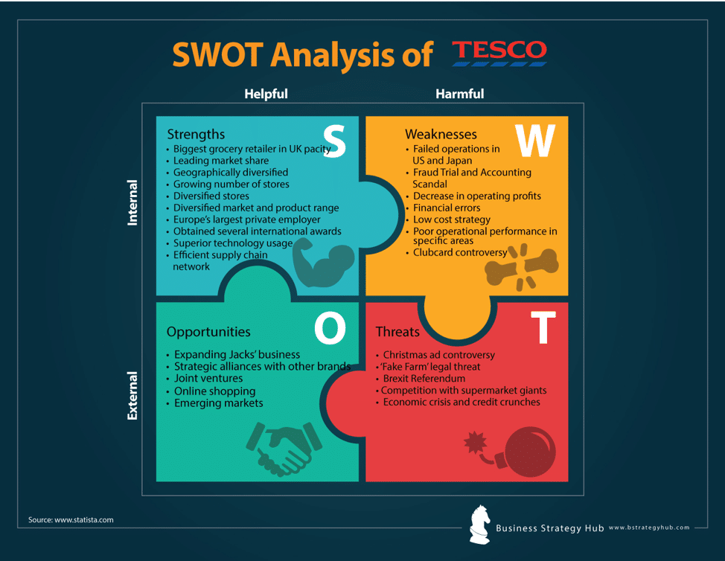

Figure 4: SWOT analysis of Tesco
Source: Business Strategy Hub (Baicker et al., 2010)

4.0 PESTEL analysis of Tesco:
PESTEL analysis is a business tool which gives the idea about the operating environment of a company. PESTEL means the politilcal, economic, social, technological, environmental and legal factors that have huge impact on the company. There are discussed the Tesco’s PESTEL analysis report in the below:
Political factors of Tesco: Tesco has to face many political factors as a multinational organization (Epstein, 2018). As it has to work in abroad, it does not get same facilities in all countries. Many government does not cooperate to work without facing any barrier rather imposes taxes and duties to the products which hamper the business. Political factores also include fiscal policies, trade tariffs, political instability etc.
Economic factors of Tesco: Economic factors have direct impact on the organization. While inflation rate rises in a country Tesco has to face the difficulties that happens for inflation (Hardiman and Dewing, 2019). The rise of inflation rate lessens the people’s purchasing power that falls down the company’s sale. The other economic factors include interest rate, foreign exchange rates, economic wrowth patterns changes etc.
Social factors of Tesco: As a big company Tesco has always to study the social factors of the countries in which it conducts their business. Because without discovering the tastes, habbits, demands and season of the products no company will run their business smoothly. So Tesco has to work for the adaptation with the cultural trends and demographics of the society (Baicker et al., 2010).
Technological factors of Tesco: The world is becoming more advance for the day by day new innovations. Every company gives more focus on discovering new technologies for reducing their cost and developing their efficiency. Tesco has also these challenges and is trying to discover and use them in their factories (Epstein, 2018).
Environmental factors of Tesco: Environmental factors are the most conserning issue in the world now. Each environmental issue has direct or indirect impact on the company’s business. Tesco has to work in many countries and these countries have its own natural and environmental factors like flood, drought, high and low temperature etc that affect Tesco’s business. Besides that Teaco has to play some roles on these.

Legal factors of Tesco: Legal factors are very concerning issues not only for the Tesco but also for the other companies. Many legal laws hamper the businesses (Hardiman and Dewing, 2019). Tesco has to face many legal factors like consumer laws, safety standards, labor laws, intellectual property laws, patents and copyrights laws for entering in any region as a fresher.

5.0 Assessment of workplace culture of Tesco:
We have already discussed aboout the culture, ethos and values that each company holds as the essential parts of the company’s vision. Here we will see the performance of culture, ethos and values that Tesco exercises in their organization structure (Hardiman and Dewing, 2019).

Culture’s of the Tesco: Tesco, like other organization, has also established a distinct culture based on its goals and objectives. It has also some unique personalities like traditions, norms, beliefs and assumptions (Epstein, 2018). Tesco’s employees work based on the culture that it developed.
Ethos’ of the Tesco: Tesco company gives extra focus on ethical values for building a strong culture in the organization. It has clear and open code of conduct on the ethical values that must be obeyed by the members. Tesco focuses on the generosity, honesty, commitment and transparency (Baicker et al., 2010).
Values’ of the Tesco: Values are the internal affairs of the organization. In the Tesco company, all the employees are treated respectively and given assistance in any emergency situation. Here integrity is the most powerfull weapon for achieving their goals and objectives. Tesco developed itself as giant groceries retailer for the ability of gathering ideas from the employees. Employees can give the more effective information to solve any issue as they have the praactical knowledge in this field (Catling and Rossiter, 2019).

5.1 Environmental and corporate social responsibility of Tesco:
Environmental and corporate social responsibility plays a crucial role to increase the image of the company and it has a positive impact to expand its business. In the very beginning of this century, all the multinational companies has being started to invest on the environmental and corporate social responsibilities specially after exposing many positive surveys on CSRs. The companies have also been encouraged for the pressure of the government, consumers, investors and stakeholders. As a result of these, environmental and CSR programmes of the companies have dramatically increased in the recent years (Safeer and Allen, 2019).
Like other companies, Tesco has also developed some CSR programmes for playing voluntaries role in the society (Catling and Rossiter, 2019). In 2001, Tesco has made a Corporate Social Resoinsibility Committee to do this job perfectly. This committee sits meeting several times in a year and reports on the performance of the CSRs. CSRs have become the part and parcel of everyday performance of Tesco in the recent era. The CSR programmes which have been taken by the Tesco are discussed below as follows:

Environmental resoponsibility: Tesco is always aware about the protection of the healthy environment. It knows that any task that harms the environment will damage its reputation and create bad image to the clients (Hardiman and Dewing, 2019). A polluted and unhealthy environment has also negative impact on the company and so they always try to play dynamic role to protect the environment. Advanced technologies and intruments are used in the industry for reducing pollution.
Energy, Water and Fuel: The major initative has been taken for reducing energy consumption in 1996. There is a clear instruction to all the employees to play dynamic role for that. Here the managers always monitor the usage of energy, water and fuel and take steps for reducing any waste of these (Epstein, 2018). Tesco had reduced these consumption at least 35% within 1997 to 2005.
Societal Responsibility: Tesco is one of the largest company in the world and so it has many chances to do something for the society. It always ecourages their employees and clients to perform resposibility for the society (Catling and Rossiter, 2019). Tesco has taken some programmes for doing their social responsibilities sush as fund raising, charity and educational programmes for the orphan and poor children. Tesco also takes supplying healthy food as key responsibility to the society with reasonable price.

Communities: Tesco also works for the communities donating minimum one percent of their profits before paying tax on it. It has being played important role to the vulnerable communities in the world. The total amount of donations of charity project was 21,762,931 in the year 2004 to 2005 and the amount of this in Britain was 878,556. Tesco has increased this amouont double in the recent year (Epstein, 2018).
Economic Responsibility: Tesco is playing vital role for increasing economic growth and development across the world. It has also created many job opportunities for the unemployed. Supplying foods at reasonable prices is an another role of Tesco to the society and it is also giving the assurance of the quality of the foods that is very important for health security.

5.2 Obsacles to effective functioning in Tesco:
Each organization has to face some obstacles for effective functioning within the organization. The everyday’s functioning of any organization depends on the clear and effective functioning among the employees. Managers have to maintain non stop communication with their employees for effective functioning. Tesco is large company and it has some obstacles to communicate with their employees. These are discussed below as follows:
Leadership problem: The managers have to busy with many official tasks and so they cann’t maintain direct communication with their employees that’s why employees do not understand the latest instructions to them. It affects the employees’ ability to do more for their company (Catling and Rossiter, 2019).
Poor communication: Internal bodies are important for running their service but external bodies are the main part as they buy their service or products. Maintaining communication with external bodies is a great challenge for the Tesco. Sometimes it fails to reach their clients about their products’ advertisement (Hardiman and Dewing, 2019).
Goals ambiguity: Clear goals and objectives help the employees about what they have to do for their company (Epstein, 2018). Tesco, as a big company, cann’t always clear about their goals and objectives to their employees. Goals ambiguity directly hampers the efficiency of the employees.
Lower paticipation of the subordinates: We have to again say that Tesco is a giant in its own field and so it has to face many challenges to collect or accumulate the ideas and thoughts of the subordinates. It has a negative impact on the company because employees do not work hard if they do not feel emotional attachment with their company.

5.3 The ways to overcome the obstacles of effective functioning in Tesco:
Though Tesco is one of the largest groceries retailer in the world and it has about 440,000 active workers and vast number of customers across the world, it must have to maintain strong communication in both internal and external bodies (Epstein, 2018). Without building this communication, it may be difficult to attain its goals in a long run. So Tesco has to overcome the following recommendations for their better communication.

- Tesco must have to increase their communication in both external and internal bodies.
- Tesco’s leaders have to more innovative to increase and manitain communication with their employees.
- It has to create friendly environment in their organization to collect more information and ideas from subordinates (Hardiman and Dewing, 2019).
- Has to give more focus on the organizational’s values and ethos for reducing egos among the employees.
- Leadership has to clear their goals and objectives to the employees.
- Leadership has to create “we feeling” concept increasing the integrety among the
employees.

6.0 Recommendations to Tesco:
Though Tesco has developed itself as one of the most dominant groceries retailer in the world, it has to follow some further initiatives for their future betterment. It has more potentialities in the grocery industry with increasing their strategic and effective marketing tools. The recommendations to Tesco are given as folows:

- It has to explore the emerging markets in the Asia and African countries.
- It has to discover the challenges and problems before entering in a new market.
- Has to increase and upgrade the online market platform.
- Has to build strong networking sites both in internal and external bodies.
- Has to establish a friendly culture in the organization.
- Has to give more focus on organizational ethos and values.
- Has to invent advanced technologies and use these in the industry.
- Leadership has to play vital role to motivate the employees.
- Has to include the employees in decision making process.

Conclusion:
Tesco is a giant in its own field and conducting their business with good profit in UK along with other 14 countries. To conduct this business they have already established a unique culture in its organization that differentiates it from other organization. It has own organizational culture, ethos and values. Organizational culture is very important for any company to run its business efficiently as it has great impact on the organizational performance. So Tesco has to develop its culture as the international standard corporate culture. It has to upgrade their online site, blogs and other platforms in a regular basis. More space should have to give to the employees to share their ideas and views about the organization. Tesco’s leaders have to more frank and friendly to communicate with their employees that will help to increase their employees’ efficiency.

References:
Amin, Razmi, and Zhang, (2011). Supplier selection and order allocation based on fuzzy SWOT analysis and fuzzy linear programming.

Arundell, F., Mannix, J., Sheehan, A. and Peters, K., 2018. Workplace culture and the practice experience of midwifery students: A meta‐synthesis. Journal of nursing management, 26(3), pp.302-313.
Baicker, Cutler, and Song, (2010). Workplace wellness programs can generate savings.

Brown, N., 2016. The Role of Leadership in Building a Workplace Culture of Health. The Role of American Heart Association (AHA) in Advancing Workplace Health Promotion, 30(7), p.564.
Cameron, and Quinn, (2011). Diagnosing and changing organizational culture: Based on the competing values framework.

Catling, C. and Rossiter, C., 2019. Midwifery workplace culture in Australia: A national survey of midwives. Women and Birth.
Cravens, K.S., Oliver, E.G., Oishi, S. and Stewart, J.S., 2015. Workplace culture mediates performance appraisal effectiveness and employee outcomes: A study in a retail setting. Journal of Management Accounting Research, 27(2), pp.1-34.
Davis, K., White, S. and Stephenson, M., 2016. The influence of workplace culture on nurses’ learning experiences: a systematic review of qualitative evidence. JBI database of systematic reviews and implementation reports, 14(6), pp.274-346.
Epstein, (2018). Making sustainability work: Best practices in managing and measuring corporate social, environmental and economic impacts.
Fan, C.J., Pawlik, T.M., Daniels, T., Vernon, N., Banks, K., Westby, P., Wick, E.C., Sexton, J.B. and Makary, M.A., 2016. Association of safety culture with surgical site infection outcomes. Journal of the American College of Surgeons, 222(2), pp.122-128.
Hardiman, M. and Dewing, J., 2019. Using two models of workplace facilitation to create conditions for development of a person‐centred culture: A participatory action research study. Journal of clinical nursing.
Isfandyari-Moghaddam, A., 2015. Workplace Culture in Academic Libraries: The Early 21st Century. The Electronic Library.
Korczynski, M., 2016. From Workplace Culture to Collective Resistance: An Ethnography☆', A Gedenkschrift to Randy Hodson: Working with Dignity (Research in the Sociology of Work, Volume 28).
Nash, Bethany (2006). Fair-Trade and the growth of ethical consumerism within the mainstream: an investigation into the Tesco consumer. Leeds: University of Leeds.
O'Leary, K., 2019. The Breakthrough Artist: BBVA's Rosilyn Houston on Her Path from Frontline Teller to Workplace Culture Visionary. ABA Banking Journal, 111(4), p.52.
Rankin, Jennifer (1 September 2014). "New Tesco boss Dave Lewis starts work as share price falls". The Guardian. London. Retrieved 22 January 2015.
Redmond, S.A., Wilcox, S.L., Campbell, S., Kim, A., Finney, K., Barr, K. and Hassan, A.M., 2015. A brief introduction to the military workplace culture. Work, 50(1), pp.9-20.
Safeer, R. and Allen, J., 2019. Defining a Culture of Health in the Workplace. Journal of occupational and environmental medicine, 61(11), pp.863-867.
Schein, (2010). Organizational culture and leadership(Vol. 2).

