DS 1 Assessment

My Screenshots/Photos
- Please add 4–6 screenshots or photos of your digital life.
- You can use your phone or laptop.
- For each screenshot, write one or two sentences explaining what it shows.

Screenshot/Photo 1
[YOUTUBE]
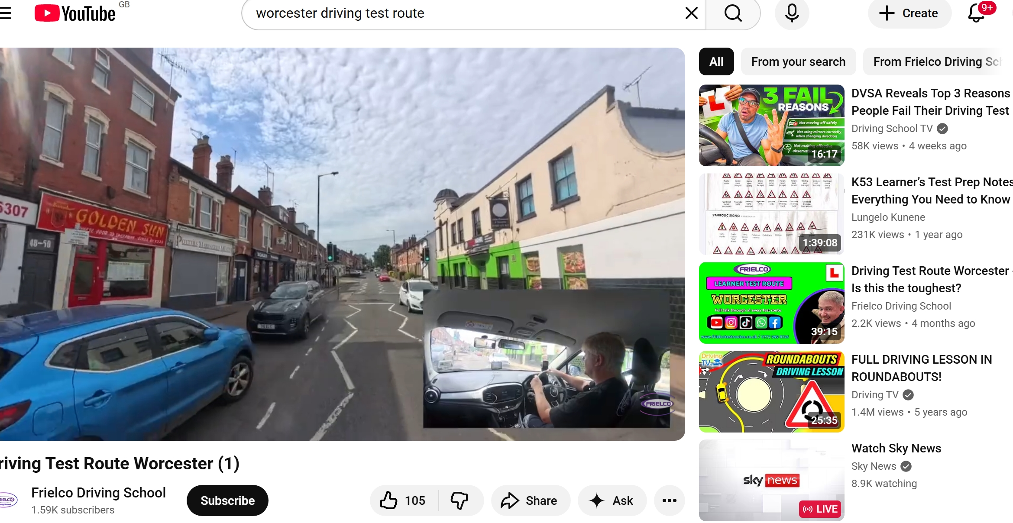
[I’m using youtube as a learning tool, not only just for entertainment.]

Screenshot/Photo 2
[Insstagram]
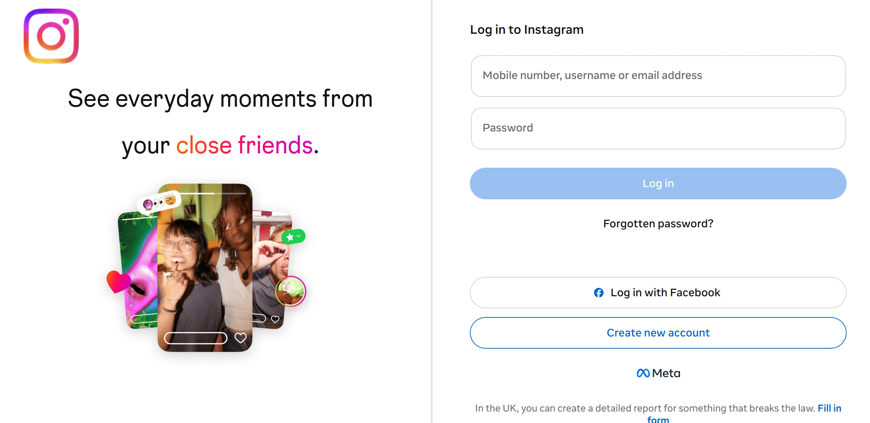
[I’m using Instagram to communicate with my friends and share the pictures on the story]

Screenshot/Photo 3
[Gmail]
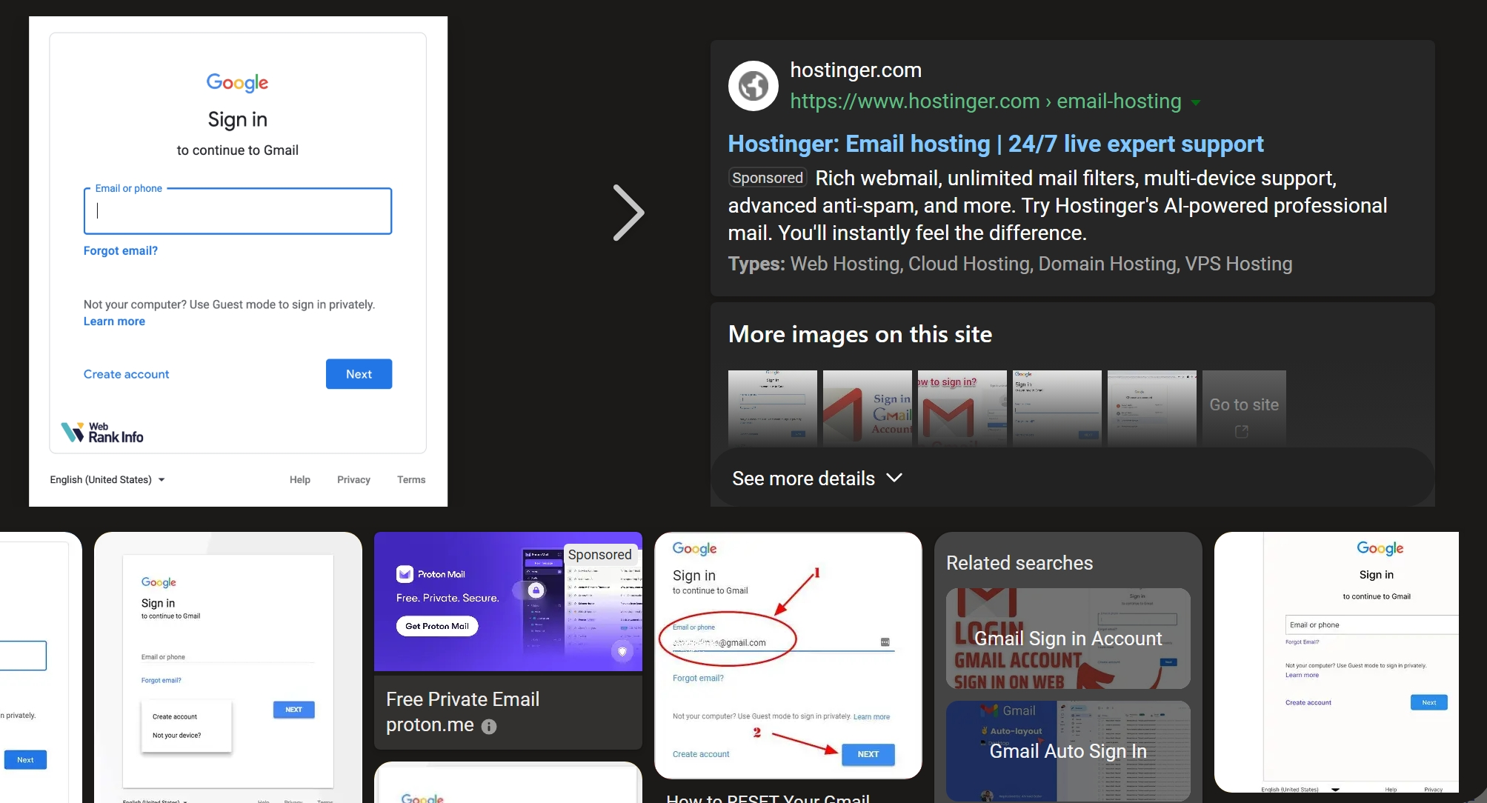
[I’m using the #Gmail almost each and everyday because now a day everything is through email , applying a job or appointments etc…]

Screenshot/Photo 4
[CALCULETER ]
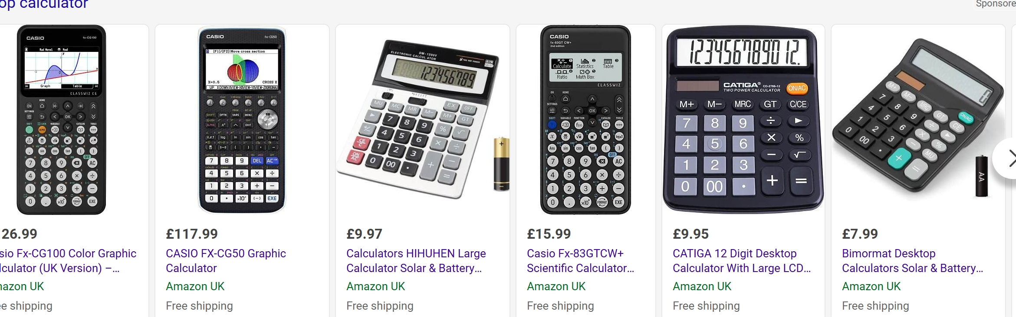
[I’M using a calculator for managing my income and expense through all of my days activity]

Screenshot/Photo 5
[Amazon]
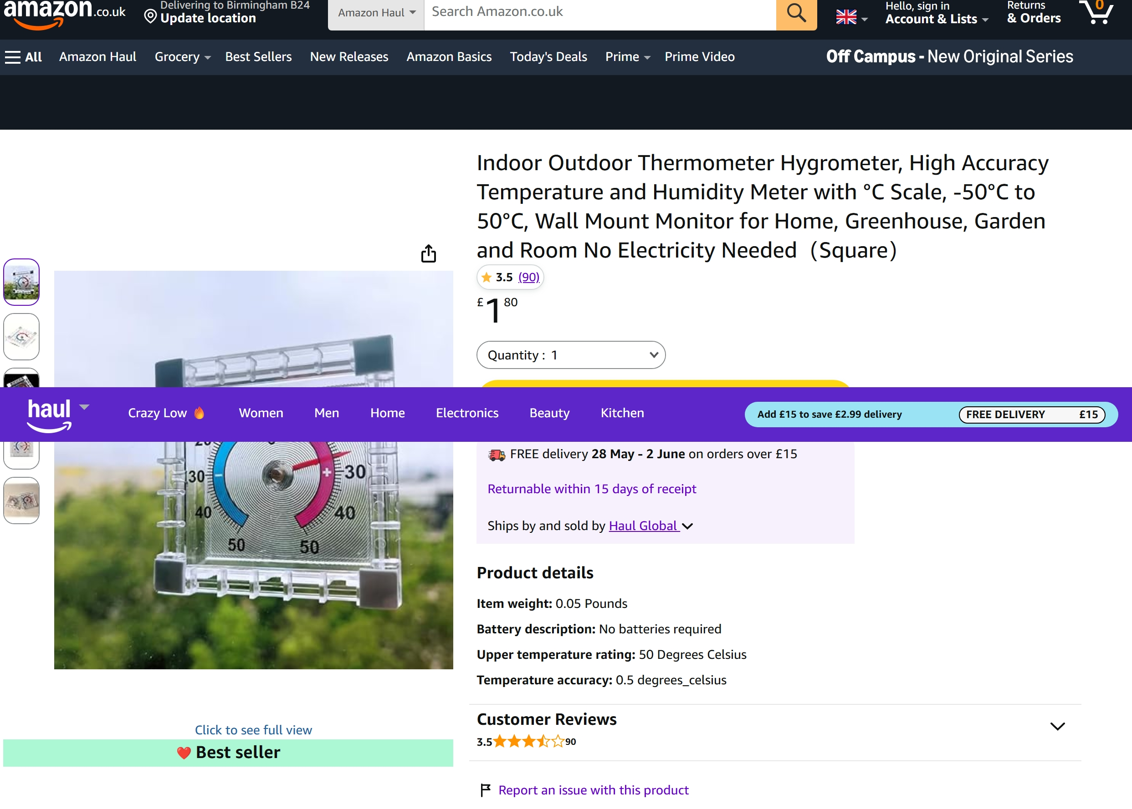
[now a days I don’t go often to buy some products I buy from amazon or online market.]

Screenshot/Photo 6
[Google map]
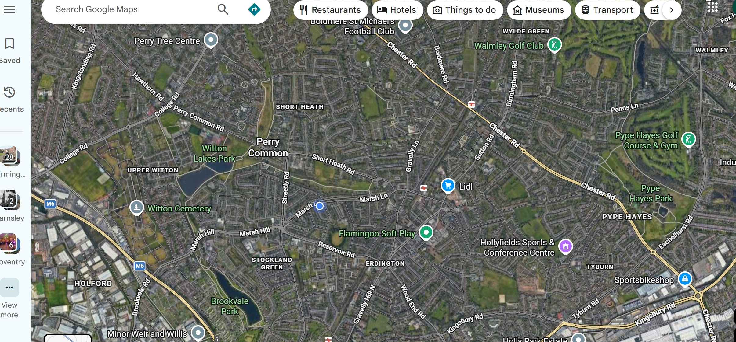
[I used every day to go somewhere from my home to the school or shopping centre etc……]

My Short Reflection
- Write 5–8 simple sentences about your digital life.
- You can use the sentence starters below if helpful.
I use digital tools in my everyday life starting from google map. Digital tools make life easy. I’m very happy to live my life in this century, because our grand father and mother they didn’t use this kind of tools for there life. I feel very confident when I use Instagram, google map, booking.com, online marketing etc…..
I still want to improve a lot of things like to start my own online business, video editing , coding. And I have to mange how to use social media.
I’m sure digital skills goanna help me a lot. Ill learn a lot of new things from this module.

Sentence starters
- I use digital tools to …
- I feel confident when I …
- I want to improve …
- I often use these tools: …
- I sometimes feel nervous about …
- I hope this module will help me …
- Digital skills are important for me because …
You can write more if you want.

Submission Checklist
Before you submit, please check:
​​​ ☒ I added 4–6 screenshots
☒ I wrote short sentences for each screenshot
☒ I wrote my short reflection
☒ My work is my own
☒ My file opens correctly
​​☒ My file opens correctly

