“Re-thinking Tradition”
How contemporary artists are reasserting the importance of historical textiles.

Megan Rhianna Thomas
P146669
Surface Pattern Design: For Fashion

Word Count: 5,326
Supervisor: Ainsley Hillard
Contents

- List of illustrations Page 3
- Introduction Page 4-5
- Chapter 1 Page 6-10
- Chapter 2 Page 11-19
- Conclusion Page 20-21
- Bibliography Page 22-23

List of Illustrations

- Figure 1: ‘Liquid’. Faig Ahmed. 2014. Page 13

- Figure 2: ‘Glasgow Toile’. Timorous Beasties. 2004. Page 15

- Figure 3: ‘Shooting Wallpaper’. Brigette Zeiger. 2012. Page 18

Introduction

The aim of this dissertation is to examine the idea of ‘Re-thinking Tradition’ to depict the importance that traditional textile processes of weaving and printing have among artists and designers. Considering the role textiles accepts within the everyday life of human existence, within social, economical and political surroundings. Looking at how contemporary artists use their traditional culture as a focus in their practise unpicking their heritage and re-thinking traditional textiles, placing them in a contemporary surrounding, to highlight its value and worth within a prevailing society.

Chapter one will look at the importance of cloth and textiles within the historical context and the influence it has had socially, politically, and economically. Theorists Annette B. Weiner and Jane Schneider highlight the importance of cloth and textiles throughout history and the role cloth has had within many aspects of society in ‘Cloth and Human Experience’. I will further look at the work of theorist Susan S. Bean and her knowledge of the importance of traditional textiles within the economy of India and Ghandi’s political stance towards the British Industrial Revolution. I will explore Jessica Hemmings theories in ‘Cultural Threads’ toward the idea of textiles giving people a universal language and voice, as an individual and as a collective group.

Chapter two will explore the way contemporary artists are using the idea of ‘Re-thinking Tradition’ in their own practice to highlight their cultural heritage and the importance of traditional textile methods within their culture. I will examine the work of Faig Ahmed’s ‘Liquid Series’ and his notion to re-create his cultural views in a contemporary setting to highlight the loss of an important traditional craft that is significant to his cultural heritage.

Chapter three will examine the way in which contemporary designers use traditional pattern as a way to alert their audience to social and economic problems in todays society. Looking specifically how Timorous Beasties and Brigette Zeiger use traditional French Toile de Jouy patterns to shock and alert their audience about the problems in their own societies. Timorous Beasties highlight the difficulties in the battle with drugs, alcoholism and homelessness in Glasgow particularly. I will examine how traditional textiles and pattern informs their practice and gives them their own voice as designers, to express their views and apprehensions of their own culture. Theorist Jana Schiowitz reflects upon the idea of how Timorous Beasties combine their knowledge of traditional textiles and own experiences of Glasgow and how they impact their practice, highlighting the importance of traditional methods and how it relates to the idea of loss within a culture. I will further look at the work of contemporary artist Brigette Zeiger’s animated wallpaper ‘Shooting Wallpaper’ and how she uses the traditional wallpaper pattern with modern technology to create a shock impact on her audience to question the role of women in relation to violence.

Chapter 1

Textiles is “a type of cloth or woven fabric” (https://en.oxforddictionaries.com/definition, 2017) threads entwined closely together creating a structured bond, creating many different surfaces beautifully handcrafted from skilful individuals, each telling its own story and carrying a sense of cultural heritage. Textiles has been an important craft in humans lives for centuries.

The tradition of textiles connects us all in many different ways, within families, cultures and as countries, and in many different situations such as social, economical and political. It allows us to relate to each other and provides everyday uses but also gives us a sense of comfort and unity. “In the form of clothing and adornment, or rolled or piled high for ex-change and heirloom conversation, cloth helps social groups to reproduce themselves and to achieve autonomy or advantage in interactions with others.” (Schneider, Weiner, 1988, 1). This places emphasise on the idea that textiles come in many forms, creating the sense of a cultural heritage, suggesting “The attitudes and behavior characteristic of a particular social group.” (https://en.oxforddictionaries.com/definition, 2017) highlighting the idea that the traditional textile patterns and structure are used to distinguish a collective group of people and speaks of the collective identity of a place or society. Cygan suggests “Textile art exists on the edge. That is what gives it its character as an art medium. It lives on the fringes of so many everyday human activities. It is adjacent to so much” (in Rowley, 1999, 91). Cygan highlights the importance of traditional textiles is that its ability to be treated in various ways lends itself to becoming entwined within every aspect of our lives, which gives textiles its rich and stimulating character. In spite of its character it is an increasing worry to many artists and skilled craftsmen that ancient traditions like weaving and handmade textiles are becoming lost in an ever growing technological world to mass produce textiles. Losing the sense of bringing people together and losing the beauty of the detail and journey in the craft telling a story and a memory of the past, Conroy highlights

Such social forms were traditional relationships and obligations embedded in craft skills, forming a mesh of associations within the community quite apart from the monetary value of crafts, and these relationships and obligations are no longer seen as significant in large-scale capitalist societies. (in Rowley, 1999, 111).

The importance of handmade traditional textiles resonates more with some cultures, North India in particularly still practice a traditional way of creating textiles and fabric, “Passionate about all Indian crafts, particularly textiles, and dedicated to the notion of excellence in contemporary craft production, each sari had been hand picked, a fine blend of the historical and the contemporary, eloquently expressing, regional variety and richness.” (in Rowley, 2015, 47). Poovaya-Smith expresses the importance of the precise detail to every hand picked choice is what gives traditional textiles the benefit over industrialised ways of bulk producing textiles. After the Industrial Revolution relations between North India and Britain became tense as Britain began to create cheaper alternatives of Indian fabrics, Poovaya-Smith,

From critical admiration of the wondrous textiles to decrying them because they did not employ the superior technology of the Industrial Revolution, to banning and suppressing them in favour of the much cruder British imports, Indian textiles have played a dominant role in the power struggles between two countries. (in Rowley, 1999, p45).

The relationship between North India and the intricate process of skilfully hand weaving fabric highlights the strong connection to the process of the craft as well as the links it has with their heritage which resonates with their way of living and how they believed it was important to continue the craft, “… economical, political and psychological act, made Khadi, or homespun cloth, the symbol of Indian resistance to British imperialism.” (in Rowley, 2015, 45). The use of the word ‘resistance’ strengthens the notion of how much India were committed to using traditional textile methods, whilst highlighting the importance of the knowledge of the foundations of textiles as a craft. Ghandi, the leader of the Indian independence movement, “…had achieved an understanding of the role of cloth in Indian life, the culmination of decades of experimentation with cloth as a medium of communication and means of livelihood.” (Bean, 1988, 355). Ghandi suggests that the role of cloth and the traditional way of creating textiles within Indian life is crucial for the livelihood of the country. Ghandi was very skilled at being able to communicate his beliefs through politics, highlighting his opposed views of the mechanized industry. However, it can be said that Ghandi’s views favourable towards traditional methods of creating textiles were recognised as of higher quality and were more desirable “…the demand for Indian painted cottons had become so great that France banned chintz imports to protect its own silk industry…So popular were these fabrics that the prohibitions were ignored.” (Bean, 1988, 361). Highlighting that the quality of textiles, dyed and woven by traditional Indian craftsmen was recognised within the textiles industry that Indian hand made textiles were more desirable than industrialised batch produced textiles. The fact that ‘prohibitions were ignored’ reinforces the idea that a large amount of the industry was prepared to go against regulations to receive quality textiles which had been created with knowledge and skill.

Traditional pattern goes hand in hand with the importance of traditional textiles reinforcing the symbolism of a culture and helps to create an identity, Dhamiji conveys the idea that “our culture heritage consists mostly of folk and tribal art forms. This creativity reflects not only the psyche of the people but the social, economical and political situations as well.” (in Rowley, 1999, 33). As Dhamija indicates the pattern of a textiles is essential in creating an identity for a culture, traditional printing methods like wax resist are model of this idea, as Hemmings indicates; “The transnational identity of wax resist textiles emerges from the numerous cultures that have in the past, and continue today, to identify with wax- resist cloth.” (Hemmings, 2015, 66), suggesting that people often associate particular textiles with certain printing techniques with a culture.

Another trait that the craft of textiles lends itself to is the idea that it can be conveyed as a universal language connecting different cultures and giving people a voice, “In the ancient Andes people did not write; they wove meaning onto textiles and knotted cords five thousand years they created the quipe (knot), a poem, in space, a tactile, spiritual metaphor for the union and interdependence of all.” (Hemmings, 2015, 45). Highlighting that textiles is not only used as a practical function but also as a way of communicating to make a statement and make people aware of a situation using textiles as a universal language to give people a voice. Mellor, “One of the most dynamic textile statements to hit the interface between settler and indigenous cultures here, was the Aboriginal flag…and taken up as a powerful symbol for Aboriginal people, of their human rights, and of strong spirit which sustained the culture.” (in Rowley, 1999, p21). Suggesting that without the traditional skills and knowledge being passed down Aboriginal people wouldn’t have had the knowledge to voice what they believed to be their own human rights. The word ‘powerful’ highlights the impact of the textile was and how the closely woven structure brought the country together to unite and allowed them to voice their own opinions, “Textiles, in the form of a cloth flag, played a key role in this issue. Despite a profile which is usually low key and inconspicuous, the presence of textiles is universal (perhaps mandatory!). What can happen without them?” (in Rowley, 1999, 22). The use of Mellor’s rhetorical question at the end of this statement reinforces the influence textiles has on many different levels.

Textiles is important in a closer knit environment such as in the everyday lives of families, it connects them by the teaching of a skill Conroy highlights that “The importance of place, of families passing down knowledge” (in Rowley, 1999, 111) it creates bonds between relations and remembering family who taught them giving a sense of belonging and heritage through the skill and craft of textiles. “Craft traditions and skills passed on from mother to daughter, from father to son, from hand to hand, in ‘immemorial usage, having almost the force of law’…” (in Rowley, 1999, 111). Conroy describing textiles as something that is almost a ‘force of law’ suggesting it’s significance is so important it is recognised as regulating actions (https://en.oxforddictionaries.com/definition, 2017). “For us it was a way of ‘passing’ and connecting to a desirable past.” (Hemmings, 2015, 51). Hemmings highlights that it is also a way of reaching to the past as well as connecting the present.
Artists and designers are investigating the idea of ‘re-thinking tradition’ incorporating traditional methods to construct and print their new innovative artwork to highlight the importance of the knowledge of the skill as a key to the foundation of their work to which they can built upon. Cygan suggests that

Despite the fact that for centuries our human language has remained reasonably consistent, we nonetheless endeavour repeatedly to create an individual and unique from for our verbal messages. And so it is with our fibre art: I continue to harbour the illusion that nobody has ever woven quite the way I do. (in Rowley, 1999, 91).

This emphasises the idea that by using a machine to weave and create the fabric it often takes away part of the story and journey of the artwork, it becomes identical to so many more pieces of textiles, highlighting that the act itself of weaving and creating by hand gives the artwork more of a personal connection with the artist and that part of their story becomes entwined and embedded within the foundations of the structure. “We are immigrant artists, finding ourselves ‘neither here nor there’, grappling with personal identity construction puzzling over genealogical fuzziness, navigating political shifts and revising culture and culture production.” (Hemmings, 2015, 59). Proposing that the whole process of traditional methods is part of a discovery for the artist to creating their identity and as a way of innovating their ideas, the act of traditional textiles allows the space for discovery, rather the idea of traditional textiles being repeats of their heritage. As Cygan highlights “For an artist, an ongoing process of deeper penetration or examination involves a renewed willingness to discover and trace numerous possibilities, thus establishing new qualities or links in the creative process.” (in Rowley, 1999, 92). The exploration of traditional textiles can be an interesting source of research to begin to create and innovate new ideas and ways of communicating for many artists, Faig Ahmed is an artist who finds inspiration from traditional textiles and subverts the meaning to inform the audience of a new journey.

Chapter 2

“Craft was assumed to be dependent on tradition, and modern art was deeply concerned to break away from the shackles of tradition.” (Rowley, 1999, 2). Faig Ahmed is a contemporary artist who “…sees tradition as a rich starting point for his artistic practise. In contemporary art, it is hard to find a topic that has not been touched. Azerbaijani village crafts offer something new” (Hemmings, 2015, 38-39). Emphasizing that Faig Ahmed views tradition as a focal point to create something more up-to-date and relevant.

Faig Ahmed artwork is closely related to textiles.

…works re-imagine ancient crafts and creates new visual boundaries by deconstructing traditions and stereotypes”. Ahmed’s work uses traditional textiles to subvert the meaning and make the viewer aware of his heritage and how it has continued to change and the concern of the ancient act of weaving becoming lost in his culture. He is “not interested in merging the past and present, but is interested in the past because it’s the most stable conception of our lives. (http://www.faigahmed.com/#origin, 2017)

An idea which is present in his “Liquid Series” of handmade woollen carpet, which were designed as part of his exhibition in 2014. “Carpets are a strong visual symbol of the region” (Hemmings, 2015). Faig Ahmed distorts a religious symbolic carpet to tell a story of growing up in Azerbaijan in the 90’s, though out political unrest. When the USSR broke up into 15 Union Republics as a result of the Cold War. Faig Ahmed uses the juxtaposition of the uncertainty of growing up after the cold war and traditions becoming lost in the unrest and uncertainty, with the stability of the traditional act of woven carpets to create rich pieces of artwork filled with heritage and journey,

…while its oil-rich Absheron Peninsula fell victim to some of the Soviet Union's most devastating acts of environmental destruction; in the intervening years, this easternmost Caucasus nation has been captured, conquered, and occupied by such formidable empires, kingdoms, … and Soviets. The narrative of Azerbaijani art, in turn, is no less layered. (Busta, 2013).

The ‘devastating acts of environmental destruction’ is echoed in Ahmed’s deconstructed and re-woven carpets, signifying how Azerbaijani had to rebuild as a country after the cold war.

It is evident that Faig Ahmed finds comfort in the ancient tradition of weaving, as part of his ‘Intangible heritage’ (Jessica Hemmings, 2015, 39). “something very stable. Carpet is the result of ages. Even 2,500 years ago there were similar patterns, similar techniques to today. The center and the borders are like a social structure, giving the idea of everything we know.” (The Guardian, 2016). The importance that the carpets were handmade by traditional techniques reinforces the idea of Ahmed using the past as something stable in his mind, he is using an ancient tradition something which is familiar to him and gives him a sense of stability to express his new stories; “the potential of traditional carpets to carry new stories has stayed with him” (Hemmings, 2015, 38).

His heritage being “Valued objects and qualities such as historic buildings and cultural traditions that have passed down from previous generations” (https://en.oxforddictionaries.com/definition, 2017). The idea that his heritage is ‘intangible’ suggests that its of a high importance to his beliefs and something that cannot be touched, which is also reflected in the exhibition of the rugs, titled “Liquid Series”.

Liquid suggesting the idea that “A substance that flows freely but is of constant volume, having a consistency like that of water or oil” (https://en.oxforddictionaries.com/definition, 2017). However, it is interesting that Faig Ahmed uses the act of weaving to portray awareness of the loss of this ancient tradition in his culture, as the act of weaving is intertwining of several threads to create a solid constructed fabric which is tightly woven, which juxtaposes the idea of ‘a substance that flows freely’. It suggests that Ahmed is trying to convey the idea of this ancient tradition of weaving is being lost through technology.

Faig Ahmed subverts the meaning of the traditional carpet by distorting it, making the viewer look at the art work in a new light. Highlighting the change in the normality of living as a united Soviet Union to becoming an independent Republic and how the structured way of life became unfamiliar and deconstructed. Faig Ahmed is re-thinking the symbolic everyday textile to make the viewer aware of his “intangible heritage” (Hemmings, 2015, 39).

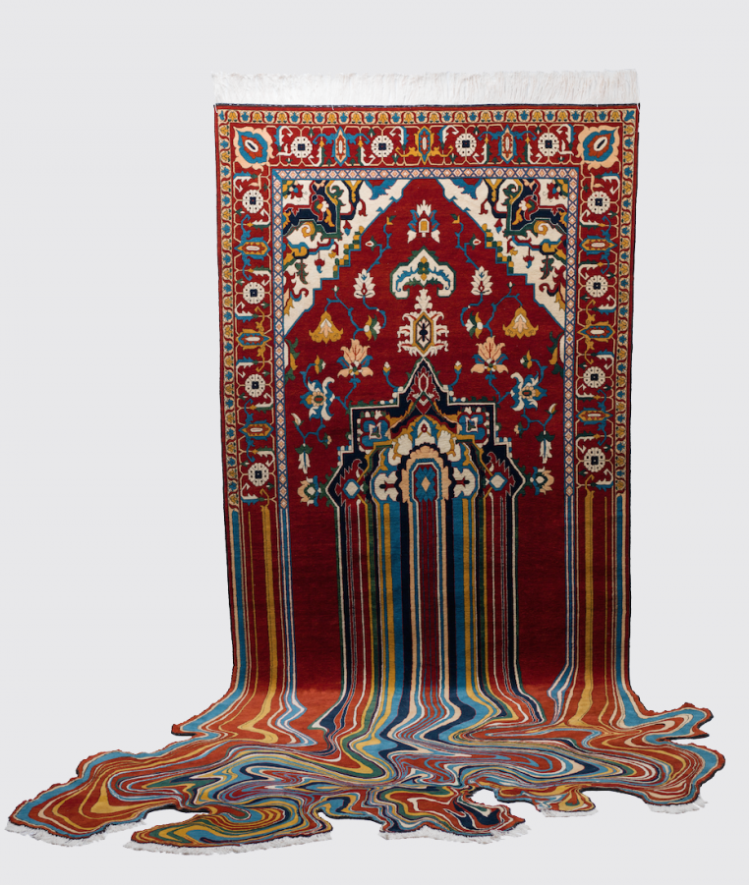
Figure 1
Faig Ahmed. 2014. ‘Liquid’. Accessed on (4th November 2017) (http://www.faigahmed.com/index.php?lang=en&page=8&projID=13)

The carpet in image 1 as seen above, starts with a very structured and detailed traditional pattern, which then starts to become distorted as though its running off the surface as though something is being lost, highlighted in the title “Liquid Series”. It has a very fluid movement “Everything is flowing, displaying ever present change and becoming transformed in his innovative art works.” (Tahir Bayramov, 2015). Faig Ahmed could be suggesting the idea of the fluid movement of the design representing the uncertainty of his childhood, growing up in Azerbaijani as well as the ancient tradition becoming lost. The structure of the artwork being skillfully woven in a traditional art form could also subvert the idea of its uncertainty becoming something rigid, as it is now in the past and is part of “his most stable conception of his life” (http://www.faigahmed.com/#origin, 2017).

The set up of the exhibition continues to strengthen the idea that Faig Ahmed is trying to make the audience aware of his heritage and the importance of the ancient weaving technique to his culture. The “Liquid Series” is hung in exhibition, conveying the idea that this ‘domestic rug’ is of more importance as an artwork rather than an everyday textile which is walked over, emphasizing the importance of his intangible heritage and further the importance of this ancient tradition. The large scale artwork is hung vertically which ‘extend their boundaries’ reaching and spreading across the floor, the scale engages the audience to look directly at the piece hung in front of them and question what is happening and what it could signify.

The traditional Azerbaijani carpets that have inspired Ahmed’s Masterpiece of Intangible Heritage in 2010 by UNESCO. Unlike buildings or architectural ruins, UNESCO’s definition of intangible heritage focuses on types of knowledge that are key to cultural diversity and creative expression (Hemmings, 2014)

Hemmings highlights that Faig Ahmed realises that an important part of understanding his work is to widen the viewer’s knowledge about his heritage, to consider the cultural diversity and how it affects Ahmed’s way of thinking and perceiving his experiences. “First you have to understand and study the tradition and this is the respect – detailed and objective research gives you a chance to see the sacred elements of the tradition, it reveals its secrets to an objective investigator.” (http://www.textilecurator.com, 2017).

Faig Ahmeds “Liquid Series” challenges the idea of re-thinking tradition and sparks controversy about whether or not he should be deconstructing symbolic carpets that mean a lot to his community of Azerbaijani, many of the traditional weavers were against helping Ahmed create his contemporary artwork.

His first attempt to persuade village weavers to help him with his intellectual art project almost ended in blows. One man, who Ahmed describes in “natural terminology” as the “alpha,” told him that he had done “something very wrong,” and that, if he were to take his request elsewhere, he’d get less lucky. “They will kill you,” the man said. (Carmichael, 2016)

Nevertheless, Faig Ahmed continued to push boundaries and create artwork which he connected with. His purpose to make the audience aware of how the rug was symbolic of how the people of Azerbaijani had evolved from the effects of the Cold War, not just to be seen as a domestic carpet which was part of their heritage. In spite of the controversy Faig Ahmed’s re-worked traditional carpets captured the audience’s attention receiving a positive attitude, “his reworking of Azerbaijani carpets enjoys a far more positive- and increasingly international reception.” (Hemmings, 2014). By raising awareness of specific cultures and different heritages.

Likewise, many other artists are exploring the idea of ‘re-thinking tradition’ as a way to respond to social, economic and political issues, exploring traditional ways of weaving fabric alongside traditional ways of printing onto fabric. Timorous Beasties, a Scottish design company, explore traditional patterns to shock and capture the audience’s attention, investigating traditional methods to print their designs. Timorous Beasties designed a collection of wallpapers based on traditional French Toile de Jouy to highlight social problems in Glasgow, “…it’s recent Glasgow Toile reinterprets traditional 19th Century French Toile de Jouy, giving it a radically Glaswegian slant.” (Design Week London, 2005).
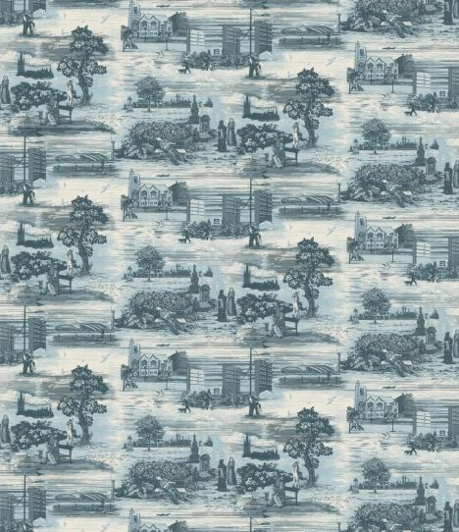
Figure 2.
Timorous Beasties. 2004. ‘Glasgow Toile’. Accessed on (10th November 2017) (http://www.timorousbeasties.com/shop/wallcoverings/86/glasgow-toile/ )

As seen in image 2, they explore the harsh reality of social problems of drugs, alcoholism and homelessness in Glasgow, “A wino boozes on a bench, a scamp pees in some bushes, a junkie shoots up, while behind loom the council blocks of Firhill, the working-class area Simmons lived in for seven years. 'We wanted to portray the Glasgow the tourist board never tells you about,' he says.” (Design week, 2005).

The original Toile de Jouy fabrics were often depictions of life at the time of their creation or images of political and social events, such as Napoleon's trip to Egypt or the first Montgolfier hot air balloon launch, colonial wars, etc. Our take on the late 18th century Toile de Jouy fabrica was actually quite literal; it's just that it has been updated. (Schiowitz, 2010, 49-50).

Timorous Beasties study the idea of using the Toile de Jouy fabrics to depict political and social events at the time, which were usually positive events but subvert the idea by taking its literal meaning but interpreting a negative social problem which often society and government will try to ignore by focusing on positive occasions happening at the same time.

As designers Timorous Beastie is aspiring to shock and capture the audience’s attention by subverting the politeness of a traditional wallpaper (Design Week, 2005) they replace the positive images with negative scenes which a large number of people would try to avoid when walking down the street in their day to day lives. “…scenic patterns filled with drug addicts, cities in turmoil, and violence that both offend and capture audiences at the same time.” (Schiowitz, 2010, 49-50). At a first glance the audience may not even pay attention to what is really going on in the design as from afar the wallpaper looks like a traditional scenic wallpaper which has an eccentric British feel, “The fabric world is very strange,' says Simmons. 'You only have to have a print with a slightly evil-looking bird in it and everyone freaks out.” (Design Week, 2005). Timorous Beasties are contemporary designers and don’t design with the intention to appeal to a wide range consumer market, they use their designs as starting points to move away from the expected and create a disruption to what is seen as the ‘norm’ in the pattern world, “It's a matter of taste. Who do you prefer? Hogarth or Boucher? Punk or Cliff Richard? Vibrant color or shades of beige? I just prefer for things to be a bit more interesting.” (Schiowitz, 2010, 49-50). Although Timorous Beasties use their wallpaper to shock its audience and to generate conversation, it is interesting that ‘Glasgow Toile’ wallpaper is still a product for consumers. This reinforces the idea that this is the social reality for many of the population and that it is their everyday lives, the fact that Timorous Beasties choose to print this statement onto an everyday interior textile reinforces the everyday reality for these people.

Although the design of the wallpapers is used to highlight problems which are present in Glasgow, the way that the wallpaper is printed emphasizes the importance which traditional printing techniques still has to designers, Timorous Beasties take time to develop their own creative learning to invest in traditional methods. “The group’s labor intensive, mostly hand-printed work is based on an appreciation of history. ‘We have taken a lot of time researching old methods, experimenting with complex repeats’ says Simmons.” (Design week, 2005). They show the importance of learning traditional methods of printing,

We are very hands on in terms of production and process…Anything that is liquid and can be pushed through the mesh of a, screen. We have printed onto stone and wood. We also work with many manufacturers, first to understand the process, then to find out how we can push the boundaries. (Schiowitz, 2010, 49-50).

This emphasize the importance of the relationship between the designer and the traditional printing techniques which allows them to form a relationship with their work, to explore and innovate new processes and designs.

Similarly, contemporary artist Brigitte Zeiger also uses traditional French Toile de Jouy wallpaper in her work, ‘Shooting Wallpaper’ to shock and engage her audience, she juxtaposed the seemingly peaceful French scenes to raise question about the role of women in relation to violence. “They are part of our visual everyday life so it’s more something I need to talk about, it means to me that we are in a growing violent society…” (https://www.youtube.com/results?search_query=interview+with+artist+brigette+zieger, 2017) Zieger expresses her views on the growing violent society she is surrounded by which is unspoken of, referring to guns and weaponry and her need to unfold this taboo subject. Zeiger is another artist who uses the idea of re-thinking tradition to create conversation about the social and economic disputes going on in todays society.

“The work is often related to different materials; the material has its own role in my work…the material itself gives information a context to the work.” (https://www.youtube.com/results?search_query=interview+with+artist+brigette+zieger, 2017) Zeiger expresses that the material itself is important in her work, she combines traditionally printed wallpapers which features an animation. This highlights the importance of traditional printing methods in Zeiger’s work however she combines traditional methods with new technology to create new and innovative artwork which captures the audience’s attention. Perhaps to suggest the idea that the problems society is facing currently could be as a result of the past, by bringing these two traditional and modern art forms together allude this idea. “…maybe its like a nostalgia sometimes and its also a question of failure of this period that didn’t succeed to transform the society…” (https://www.youtube.com/results?search_query=interview+with+artist+brigette+zieger, 2017).
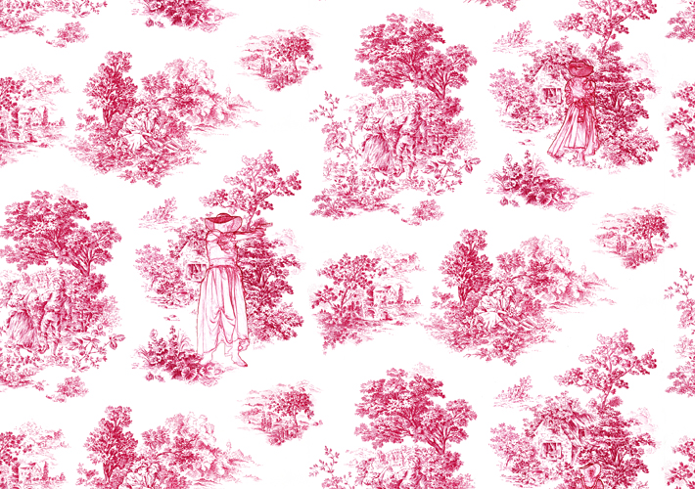

Figure 3.
Brigitte Zeiger. 2012. ‘Shooting Wallpaper’. Accessed on (4th November 2017) (http://www.brigittezieger.com/pages/Shooting_Wallpaper.html ).

The title ‘Shooting Wallpaper’ immediately creates the sense of juxtaposition within the artwork as its creating an image of violence, however when you first look at the wallpaper itself it appears like a traditional style Toile de Jouy giving the impression of a scenic, positive environment, as seen in image 3. Brigitte Zeiger uses animation to create a gun shot sound in the exhibition, this immediately engages the audience as they automatically are alerted by the gun shot and look at where the noise came from. This forces the audience to look at the detail of the ‘Shooting Wallpaper’ to see a depiction of a shepherdess confidently shooting a gun and walking away. This is a powerful statement and one that generates discussion among the audience, the confidence and control the woman has in the animation suggests that Zieger is indicating that women do have an active role in relation with violence in todays society. The exhibition of the ‘Shooting Wallpaper’ is set up with the whole room covered in the wallpaper, this could further suggest that the role of women in relation to violence is all around us, whether we choose to acknowledge their involvement in a growing violent society.

Conclusion

In conclusion the traditional methods of textiles and printing are of value to many cultures, artists and individuals. It is a way of creating an identity for many people and cultures, which provides comfort and a sense of unity and belonging. Overall traditional methods provide many individuals a voice to make people aware of the social, economical and political backgrounds they come from and what they have faced as a community, it is a way of telling a story and highlighting the importance of what they stand for.

Faig Ahmed particularly felt a personal connection with the act of weaving within his culture and felt its importance was being lost within his community. Ahmed describes his heritage as an “intangible heritage” (Hemmings, 2015, 39) his work is allowing the audience be aware of a more tangible culture, reversing the sense of his culture being lost within his community.

Although the symbolic rugs were just a starting point for Ahmed’s work, it is evident that his work wouldn’t have been able to be produced without his own knowledge of the traditional art of weaving and it was in fact his knowledge which allowed him to create new innovative ways to express his cultures story.

Likewise, Timorous Beasties and Brigitte Zeiger also highlight the importance of traditional methods in their own practice as their knowledge allows them to know how much they can afford to push the boundaries within their designs. “The work is often related to different materials; the material has its own role in my work…the material itself gives information a context to the work.” (https://www.youtube.com/results?search_query=interview+with+artist+brigette+zieger, 2017) Which goes hand in hand with the knowledge of traditional patterns and the established views that surround them which then allows them as artists to subvert the meaning to and shock the audience engaging their attention.

Therefore, it can be said that the importance of traditional methods of textiles and printing gives artists and designers the foundations for their work, which then allows them to build upon their knowledge to continue to be experimental and innovative in their own practice, allowing them to create new engaging artwork to express their own story and views within society. The audience and subjective are reliant on their own individual experience, social history which forms our collective culture, the audience becomes aware of their own preconceived ideas making them to consider the issue and how it affects the reading, understanding and meaning of the work.

Bibliography

Books

- Buszer, M. (2011) Extra/Ordinary Craft and Contemporary Art. Duke University Press Books.

- Colchester, C. (2007) Textiles today. Thames and Hudson.

- Collette, A and P.Sharrad. (2004) Reinventing Textiles Volume 3 – Postcolonialism and Creativity. Clifton: Telos Art Publishing.

- Constance, M and Reuter, L. (1997) Whole Cloth. New York. The Monacelli Press, Inc.

- Hemmings, J. (2012) The Textile Reader. (1st edn) UK: Berg.

- Hemmings, J. (2015) Cultural Threads. Bloomsbury Publishing.

- Rowley, S. (1999) Reinventing Textiles Volume 1; Tradition and Innovation. Clifton: Telos Art Publishing.

- Stevenson, A. (2010) Oxford Dictionary of English. (3ed) Oxford University Press.

- Weiner, A and Schneider, J. (1989) Cloth and Human Experience. Wenner-Gren Foundation for Anthropological Research.

Article

- Busta, Caroline. Artforum international; New York Vol. 52, Iss. 2, (Oct 2013): 297.

- Design Week; London Vol. 20, Iss. 4, (Jan 27, 2005): 13.

- Gray, Lesley Ann. Art and AsiaPacific; New York Iss. 102, (Mar/Apr 2017): 157.

- Hemmings, J. Textile Writer. Surface Design Journal, (2014).

- Hemmings, J. Rethinking Tradition. Surface Design Journal, (Spring2015): 38-39.

- Schiowitz, Jana. Hospitality Design: HD; New York Vol. 32, Iss. 9, (Nov/Dec 2010): 49-50.

Photos

- Brigette Zeiger. 2012. ‘Shooting Wallpaper’. Accessed on (4th November 2017) (http://www.brigittezieger.com/pages/Shooting_Wallpaper.html).
- Faig Ahmed. 2014. ‘Liquid’. Accessed on (4th November 2017) (http://www.faigahmed.com/index.php?lang=en&page=8&projID=13).

- Timorous Beasties. 2004. ‘Glasgow Toile’. Accessed on (10th November 2017) (http://www.timorousbeasties.com/shop/wallcoverings/86/glasgow-toile/)

Websites

- Ahmed, F. Faig Ahmed Biography [Online]. [Accessed; 31st October 2017]. Available from: http://www.faigahmed.com/#origin

- Carmichael, J. (1st December 2016). Please Allow Faig Ahmed’s psychedelic Carpets to Mutate Your Mind [Online] Inverse Culture [Accessed; 14th November 2017]. Available from: https://www.inverse.com/article/24372-faig-ahmed-carpets-sapar-exhibition

- Cocozza, P. (13th November 2016) Magic carpets: the art of Faig Ahmed’s melted and pixilated rugs [Online]. The Guardian. [Accessed; 5thNovember 2017]. Available from: https://www.theguardian.com/artanddesign/2016/nov/13/magic-carpet-art-faig-ahmed-rugs-azerbaijan

- English Oxford Living Dictionaries. [Accessed on 6th November 2017]. Available from: https://en.oxforddictionaries.com

- Allartinitiatives. Interview with artist Brigette Zieger. (20th February 2012) [Accessed on 31st October 2017]. Available from:https://www.youtube.com/results?search_query=interview+with+artist+brigette+zieger

- Textile Curator. [Accessed; 5th November 2017]. Available from: http://www.textilecurator.com/home-default/home-2-2/faig-ahmed/

