

Postgraduate/Distance Learning
Assignment coversheet & feedback form

THIS SHEET MUST BE THE FIRST PAGE OF THE ASSIGNMENT YOU ARE SUBMITTING (DO NOT SEND AS A SEPARATE FILE)

For completion by the student:
Student Name: Karen Hanson

Student University Email: 2113844@student.uwtsd.ac.uk
Module code: HPCA7028  Module title: Sacred Skies | Student ID number:  2113844 |  |  | Educational support needs:  No
Assignment title: A Critical Examination of the Sky in Relation to Material Culture

Assignment due date: 4th May 2023
This assignment is for the 4th module of the degree
I confirm that this is my original work and that I have adhered to the University policy on plagiarism.
Signed ……Karen Hanson………………………………………………………
Email submission: if you are submitting this form via email, please tick this box □
(as a substitute for your signature) to confirm that you agree to the above declaration.
Assignment Mark
1st Marker’s Provisional mark
2nd Marker’s/Moderator’s provisional mark
External Examiner’s mark (if relevant)
Final Mark

NB. All marks are provisional until confirmed by the Final Examination Board.

For completion by Marker 1 :
Comments:

Marker’s signature: |  |  | Date:
For completion by Marker 2/Moderator:

Comments:

Marker’s Signature: |  | Date:
External Examiner’s comments (if relevant)

External Examiner’s Signature: |  | Date:

A Critical Examination of the Sky in Relation to Material Culture
An Investigation of the possible celestial orientation of the three henges at Thornborough

Introduction
The aim of this research is to critically examine the triple arrangement of henges at Thornborough monument complex as a cultural response to the sky and consider the various academic arguments concerning the orientation of the earthworks in respect of celestial alignments. As Sinclair asserts, archeoastronomy is the investigation of the ways that ancient cultures, 'have understood the phenomena in the sky, how they used phenomena in the sky and what role the sky played in their cultures.'
After a brief history of Thornborough Henges has been considered, the current understanding regarding the original purpose of the monuments in reference to the sky will be explored. A section on methodology details the hardware and software used, prior to onsite fieldwork as well as within the field. Consequently, these findings will be discussed and interpreted to explore any celestial significance within a historical and ethnographical context of the prehistoric culture at Thornborough.
Academic Rationale
Archaeoastronimcal assessment regarding the northern and southern entrances of the henges have been focused on in past studies and findings have proposed alignments indicating potential intentionality However, it can be considered, that it is not only the physical astronomical measurements that align Thornborough with the sky. The concentric design of the earthworks allows the observer, as Sims suggests, to use their body as an 'astronomical focusing device', to perceive the alignment and be fully engaged with the sky. The sky subsequently becoming, the cynosure of the observer within the henge.
All structures are celestially aligned to some degree but as Prendergast suggests, it is the directed focus within the henge monuments that brings to attention, not only the orientation but moreover, the ability to perceive and interpret this intended alignment. The alignments only work if the material culture was designed and orientated in such a manner as to perceive them.
A Brief History of Thornborough Henges
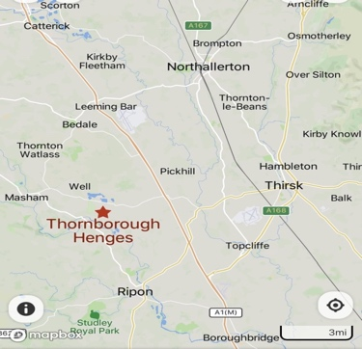
Thornborough lies between the Vale of Mowbray, within the Hambleton district of North Yorkshire (Figure 1). The landscape in Yorkshire is particularly rich in Neolithic archaeology with many ancient settlements found on the dale's, valleys, and open moors. Though there are at least six giant henges identical in size and shape and within six miles of one along the River Ure, Thornborough is unique as the only triple alignment found in the same landscape and on the same SE/NW axis.

Figure 1: Mapcarta map depicting the district of Hambleton in North Yorkshire.

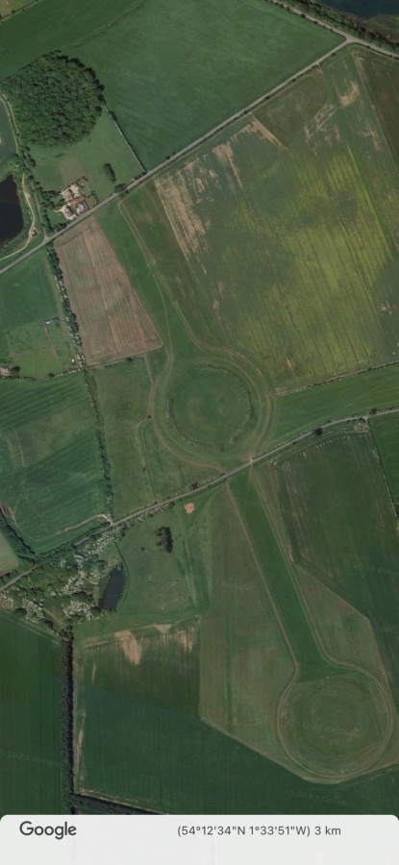
The henges, date back to the late Neolithic while the cursus, orientated SW/NE is thought to date back to the early Neolithic. While each henge has two opposite entrances (northern and southern) and measures fifteen metres wide, they do not perfectly align due to an off-centre alignment (Figure 2). Though quarrying and ploughing has eroded much of the central and southern henges, the northern henge has been protected by dense tree coverage, yet the inner ditches, banks and entrances of all henges are still visible, especially in an aerial view (Figure 2). As the cursus running through the central henge was damaged irreversibly in the 1950's, it is visible only as a crop anomaly from the vantage point of aerial photography.

Figure 2: Google Earth aerial image of Thornborough Henges.

Literature Review
Harding proposed that the henges at Thornborough were a mirror image of Orion's Belt in its highest position, with the entrances aligned with the belt stars and the rising and setting of Sirius on the Midwinter Solstice. According to Harding, the henges provided meaningful, intentional, and physical embodiments of the celestial sky suggesting that the sky was fundamental to the Neolithic way of life and the monuments constructed to interact with the celestial bodies.
Heath confirmed 'the parallels to Orion's Belt (as) an acceptable interpretation', though suggested a better alignment with the northerly moonset, while Grigsby noted that nearby prehistoric monuments often shared alignments with the same celestial phenomena as with each other. This could indicate a degree of intentionality within the orientation of Thornborough Henges, not only to celestial bodies but to local structures within the area.
Conversely, Bradley favoured a solar rather than stellar significance to the earthworks suggesting that the henges at Thornborough are aligned at sunrise only on the midwinter solstice and in accordance with Harding's assertion, a more controversial view from Knight and Butler agreed that the henges at Thornborough were constructed as a 'faithful reproduction of Orion's Belt', and by pointing directly to Sirius, this enabled calculation of a sidereal day. The calendrical, sidereal days would have been of enormous benefit to the Neolithic farmers when anticipating the coming seasons. Pavlovic proposed that the henges served a practical purpose such as farming and astronomical timekeeping and this suggests that celestial solar and stellar alignments along the entrances of the henges may have been intentionally orientated according to farming, calendrical and ritual purposes.
Henty contested Harding's understanding that the henges at Thornborough mirrored Orion's Belt, suggesting that it was Orion's appearance coinciding with seasonal changes such as harvest that ensured the culture's ritual connection and harmony with the sky. Comparatively, in response to assertions that many earthworks have intentional alignments with the sky, Ruggles proposed the need to consider the 'broader archaeological context in order to interpret cultural significance'. Both Henty and Ruggles believed that an understanding of the archaeology and ethnographic culture would also be required to understand the intentionality of the Neolithic monuments at Thornborough.
Considering celestial alignments to prehistoric sites, Sims found that the illiterate, farming community at Thornborough would not possess the understanding of sophisticated celestial movements, the complex lunar standstills being beyond the understanding of a hunter-gatherer culture. In addition, Polcaro & Polcaro argued that celestial alignments do not necessarily prove the builder's original intent, presenting a challenge in validating the original intention when claiming a structure to have astronomical orientation. Mulligan found that fluidity in movement along the landscape ensured survival of the Neolithic people and their livestock and that structures such as henges were used more in the winter months, implying that the celestial alignments over the winter months were more relevant to the culture.
Regarding the cursus monument at Neolithic sites, Tilley suggested a possible lunar and solar connection', though Brophy opined that the linear disposition of cursus monuments suggest that they would always point to something significant, with lunar and solar alignments frequently uncovered at prehistoric sites. Concentrating on the physical structure of the cursus, Pearson and Field proposed that the prehistoric monument appears as a form of observatory and it seems feasible that the high banks of the cursus would direct the observer's sightline upwards.
In closing this section, regarding the concentric construction of the henge, Bradley found that they 'reflect(ed) a perception of space that extends outwards from the individual and upwards into the sky', while Gianotti et al found that the spatial circular design of the henge segregated areas within, and Pendergast, in addition, understood these controlled spaces within the earthworks as a means of directing attention to the central, focal point. With the observing eye directed upwards, the proposition being, that the circular henge was originally designed to act as an ancient observatory.
Ingold's assertion of how actively participating within the interior of a concentric dwelling can shift the perspective, suggests that once inside, the experience differs compared to viewing externally while Hunt suggests that the concentric henge represents the border separating 'their "holy" spiritual places from the day-to-day places'. The concentrical henge being the boundary between the sacred and the profane.
Methodology
Turning now to the methodological approaches used within this research. As the aim of the research is to critically examine the sky in terms of material culture, the intention of the fieldwork was to determine any celestial orientation at Thornborough Henges.
Establishing initial measurements regarding the henges was a primary focus prior to fieldwork and examination of celestial alignments at Thornborough were tested and recorded using virtual measurements with software such as Google Earth, Heywhatsthat and Stellarium. In addition to physical fieldwork, I was therefore able to work remotely using Stellarium to create a virtual celestial profile within the Neolithic period.
Fieldwork involved several on-site visits during the day and after sunset, approaching the henges from the SE and NW entrances, taking measurements, examining the physical structures, and becoming fully immersed within the landscape. As the northern henge is under private ownership, the southern and central henges were surveyed for alignment using hardware including compass with built in clinometer and a ‘Theodolite’ app used on a smartphone. Field work notes include detailed subjective inspection and physical interaction with the locality as well as taking photographs and recording measurements on field note templates.
Nearby Neolithic monuments of interest were additionally surveyed for orientation to the horizon and connection to Thornborough Henges though the primary site was Thornborough and the fieldwork calculations, recording of physical attributes and phenomenological notes are concentrated on this site.
Reflexivity
I come to this research as a white, British woman of 47 with no prior experience of Neolithic culture nor the discipline of archeoastronomy.
Findings
From virtual measurements taken prior to fieldwork using Google Earth, the southern henge is orientated to a true azimuth of around 326°, the central henge orientated to 325° (Figure 5), and the northern henge orientated to around 324°. The azimuth representing the compass bearing when measured from 0° due north. The altitude of the henges ranged from 0.5°-0.6° using heywhatsthat and this was confirmed on-site using theodolite readings (Figures 3,4 and 6).
Using a 'Theodolite' app on a smartphone, I was able to confirm the latitude, longitude, and altitude of the central henge from within a centre position and facing the SE entrance (Figure 3) and the NW entrances (Figure 4). This confirmed earlier readings from Google Earth and Heywhatsthat and consequently, from an azimuth reading of 325.53° NW using google earth (Figure 5), my reading onsite appears at 307° though this could possibly be a discrepancy in angle through trying to hold a smartphone still on a cold and windy day (Figure 4). Though the reading appears to be several degrees different to the virtual azimuth reading on Google Earth, there does appear to be a certain cardinality between the axis NW and the azimuth reading from due north.

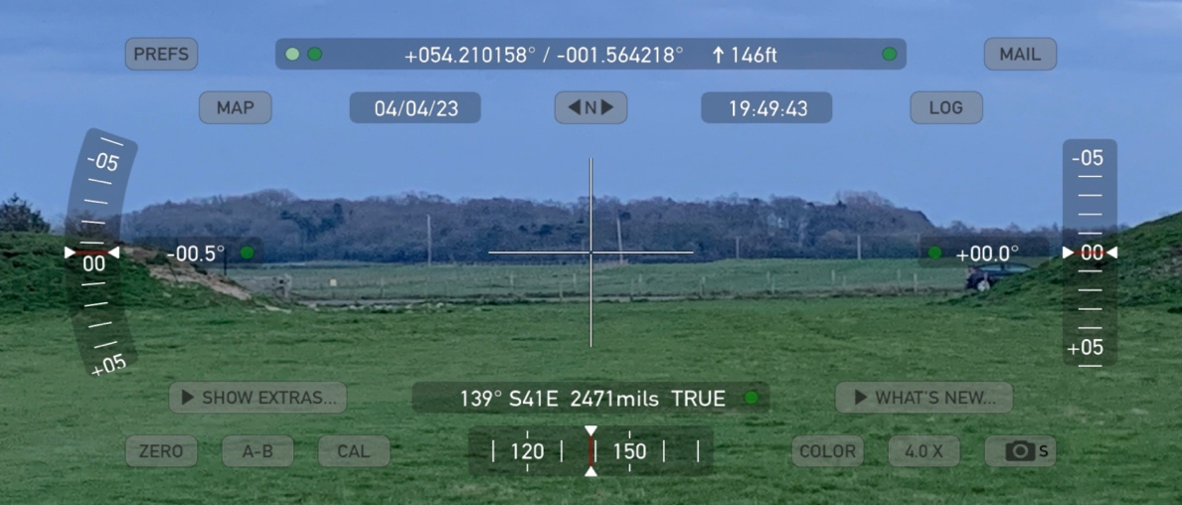
Figure 3: Theodolite reading facing the SE entrance of the Central henge.

I measured an altitude of 0.61° (Figure 6) in heywhatsthat and this was confirmed onsite (Figure 4) giving a declination of 29.18° within the centre of the central henge and facing NW. This fits in with Heath's findings of a full moon standstill at a declination of 29.228° around 3800BC through the entrance of the central henge.

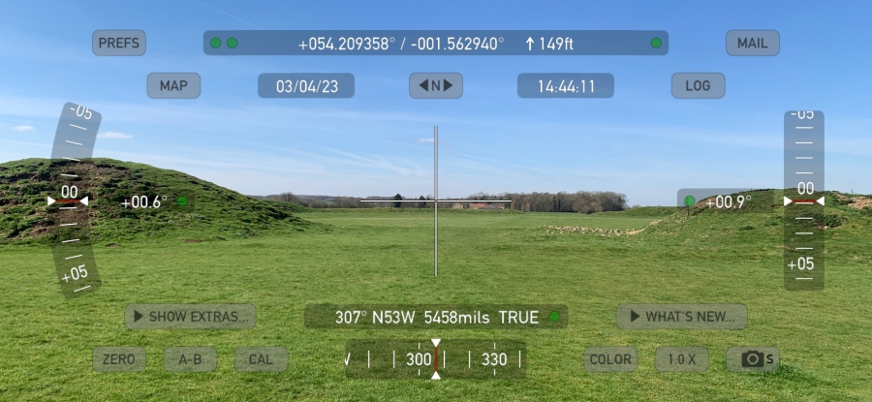
Figure 4: Theodolite reading facing the NW entrance of the centre henge.
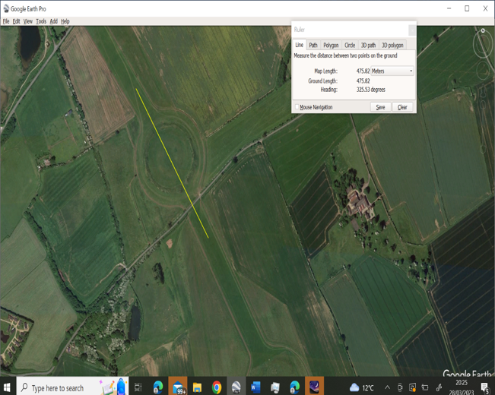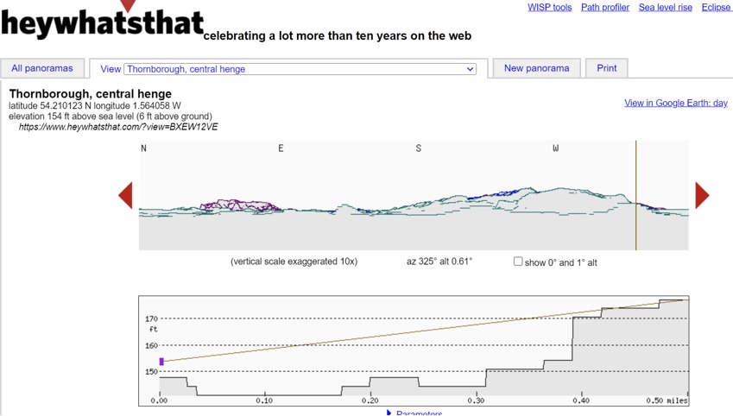
Figure 5: Azimuth reading of the central henge. Figure 6: Heywhatsthat altitude reading/central henge.
Comparably with Heath, I measured an azimuth of around 326° SE for the southern henge using Google Earth and this was confirmed by the theodolite application giving an altitude of 0.6° (Figure 7). This gives a declination of 29.94° and suggests that this henge 'is aligned to the standstill moonset as a last flash.' Again, this supports Heath's supposition that the henges demonstrate the lunar extremes from east to west on the horizon and therefore represents the sun at the winter and summer solstice.
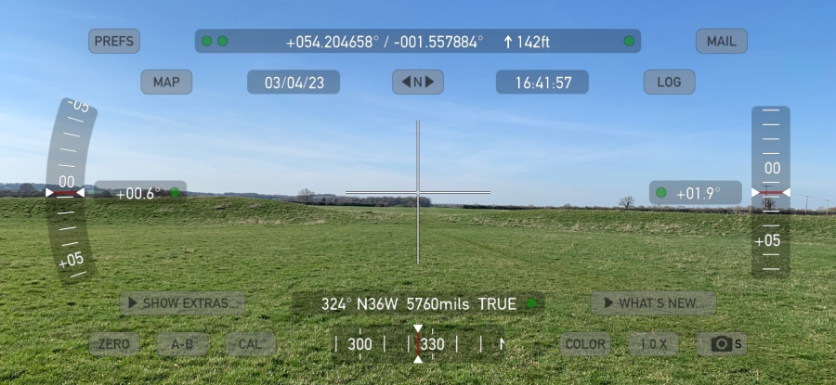
Figure 7: Theodolite reading facing the NW entrance of the southern henge.
A Stellarium landscape was then created through Heywhatsthat depicting the central henge at Thornborough looking out through the SE entrance (Figure 8). The year and date have been adjusted to 3000BCE and 12th of January by adding 22 days to the Julian Calander to roughly reflect the Neolithic Winter Solstice. At the latitude given, the Moon, Sirius and Orion are seen rising to the east until they frame the SE entrance later that night (Figure 8).
Orion's belt first appears above the eastern horizon and is visible through the SE entrance followed by Sirius not immediately after sunset on the winter solstice but several hours later (Figure 8), which supports Harding's assertion that the southern entrances were intentionally orientated to frame Sirius and Orion. An azimuth grid system within Stellarium shows the constellation of Orion rising at an azimuth of 120° before the sunset (Figure 9) and would therefore only become visible upon rising to an azimuth of roughly 130° onwards which is similar to the theodolite reading facing the SE entrance of the central henge (Figure 3).

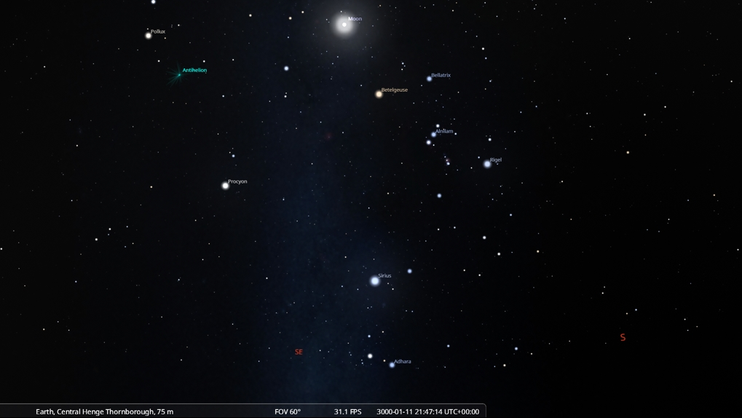
Figure 8: Stellarium landscape showing the Moon, Sirius ad Orion's Belt framing the SE entrance of the central henge.

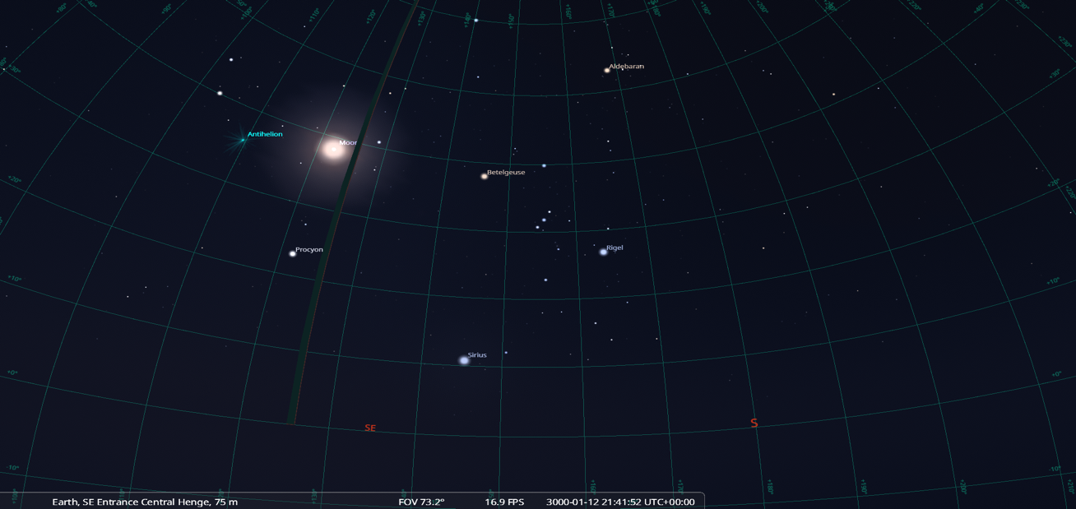
Figure 9: Stellarium azimuth grid for the SE entrance of the central henge.

Concerning the sunrise and sunset at the vernal equinox, from the azimuth due north (Figure 5), it would appear that in agreement with Bradley, the sunrise at the equinox does not appear to frame the SE entrance of the Henges, with the sun would only appearing within the entrance at around 10am that morning. The spring equinox has been adjusted to 14th April 3000 on Stellarium in accordance with the Neolithic dates.
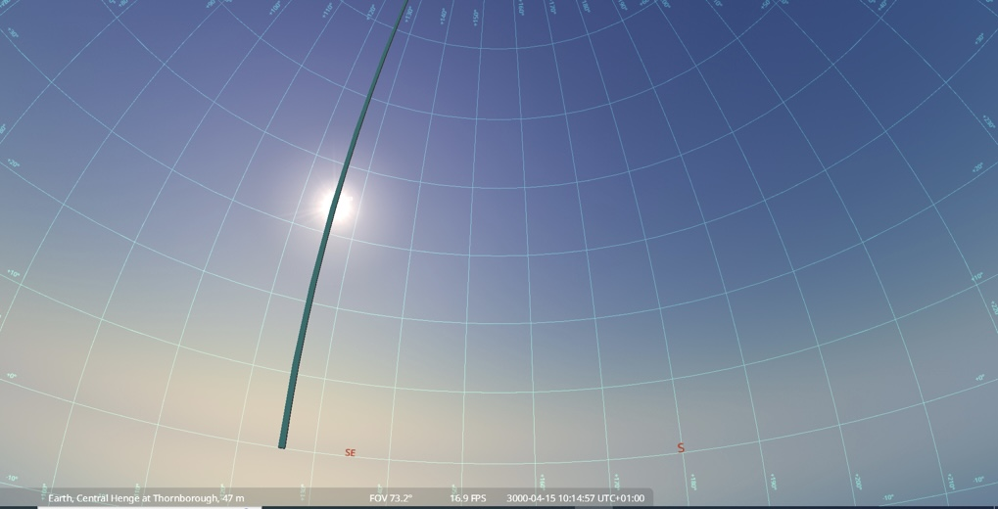
Figure 9: Stellarium with azimuth grid showing the Neolithic Spring Vernal Equinox sunrise.
Looking at winter solstice at Thornborough Henges, using planetarium software and with the date reflecting the neolithic period, the sun does rise adjacent to the SE entrance of the central henge (Figure 10). This supports Bradley's supposition that Winter Solstice sunrise is the only alignment at Thornborough Henges. This was confirmed by on site readings using a theodolite and a mobile version of Stellarium on a smartphone (Figure 3).
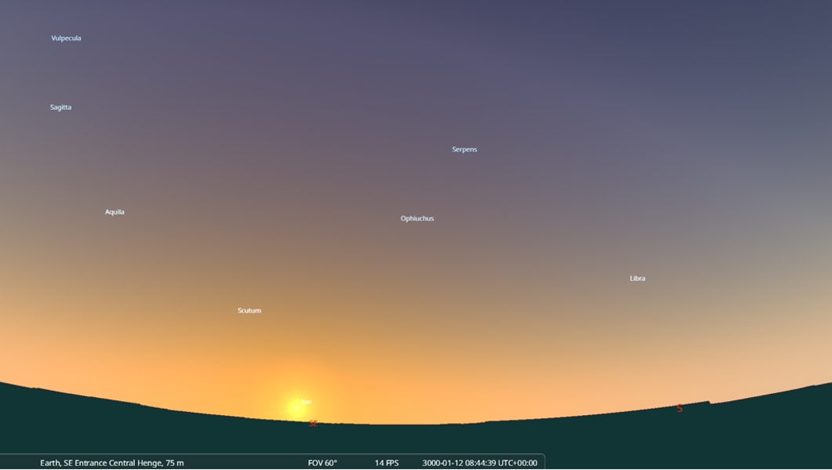Figure 10: Winter Solstice sunrise as seen from the SE entrance of the central henge.
I did, however, find that the original cursus monument at Thornborough, having a SW/NE alignment, appeared to be a better viewing area for the Winter Solstice. Observing along the cursus to the east would frame the rising of the Moon and the Belt of Orion, while viewing down the cursus to the west would frame the setting of Orion, Sirius, and the Moon. Using Stellarium with the Winter Solstice date of 12th January 3000BCE (Figures 11 and 12), demonstrates a considerable accuracy to the rising and setting of Orion and the Moon at the eastern and western ends of the cursus compared to the SE/NW axis of the entrances to the henges. By the time that Sirius rises in the same alignment, Orion's Belt would be rising to the east (Figure 11), becoming visible to the observer within the centre of the henges looking through the southern entrances.

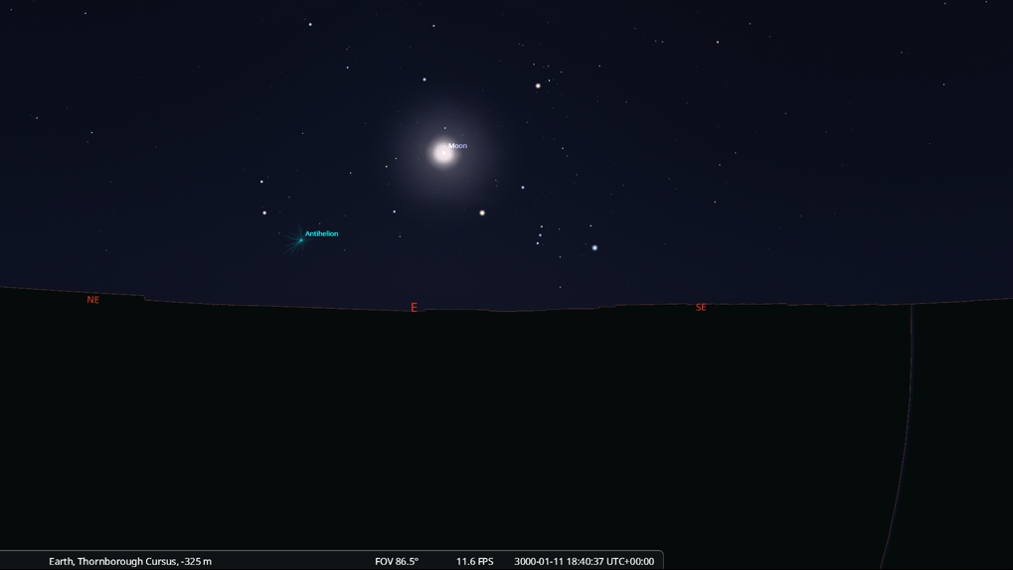
Figure 11: Orion and the Moon rising over the eastern viewing point of the Thornborough cursus.

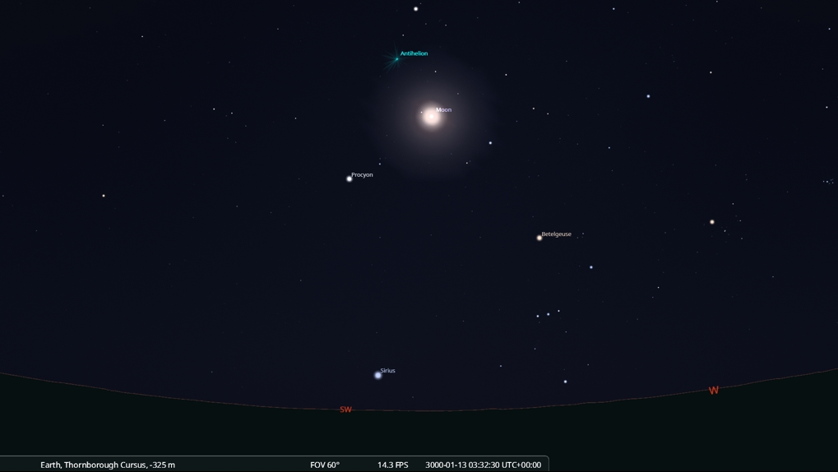
Figure 12: Orion and the Moon setting over the western viewing point of the Thornborough cursus.
Viewing over the SW Bank of the central henge (Figure 13) with an azimuth of 240°, and an altitude of 1.5 gives a declination of -16° which suggests a good viewing area for the setting of Sirius in the Southwestern sky. Though the theodolite reading is slightly west to the SW orientation of the cursus running at a right angle to the SE/NW alignment of the henges (Figure 13), a general impression can be seen regarding the setting of the Orion, Sirius, and the Moon on the Winter Solstice at the rounded SW end of the ceremonial avenue (Figure 12).
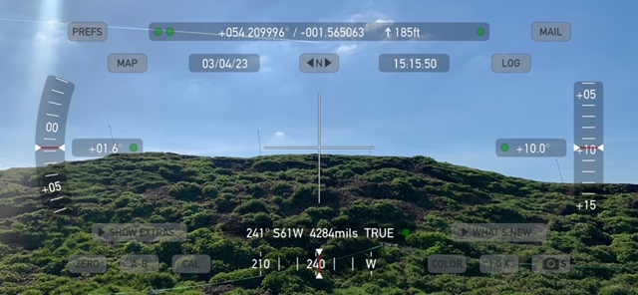
Figure 13: Theodolite reading of the SW banks of the centre henge demonstrating the SW axis of the underlying cursus.
With reference to Harding's postulation regarding the correlation between the Belt of Orion and the henges at Thornborough, I found that using an overlay in Google Earth did not provide an exact match and I had to reverse Orion as well as scale the constellation to create the best fit (Figure 13) however it must be noted that Harding used more detailed software. The overlay used in Google Earth was a Stellarium image indicating the constellation of Orion around 3000BCE (Figure 14), and this was a closer match to a previous overlay from the present day. I further noted that additional stars of Orion such as Betelgeuse did not overlay any neolithic monuments and points of interest though I did consider how the star Alnilam appears to overlay the earlier cursus monument rather than the later centre henge (Figure 13).
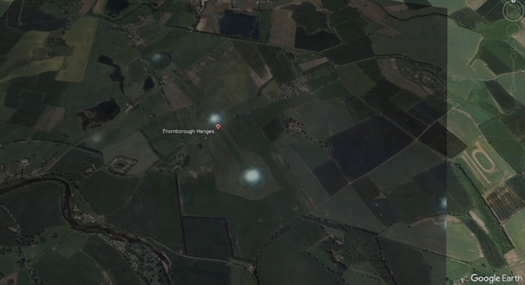
Figure 13: Overlay of Orion's belt onto a Google Earth image of Thornborough Henges.

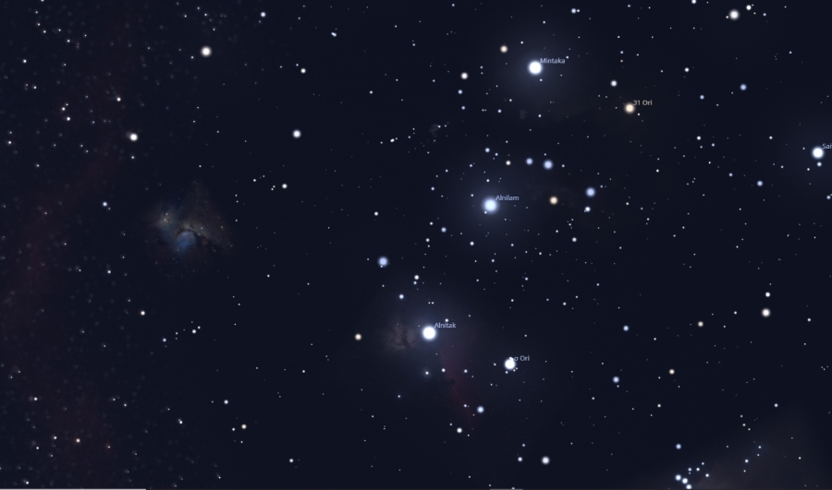
Figure 14: Stellarium image of Orion's Belt rising SE in 3000BCE.
Considering Grigsby's assertion that nearby prehistoric monuments often shared alignments with the same celestial phenomena as well as with each other, I examined the orientation of nearby structures to Thornborough Henges that follow the undulating River Ure and Swale and shared an azimuth 325° (Figure 15).
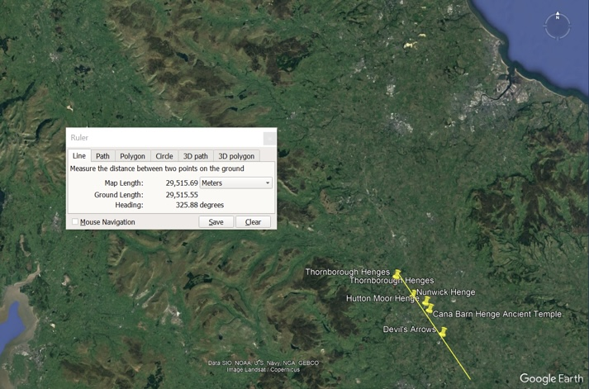
Figure 15: Google Earth image representing Neolithic monuments near Thornborough Henges.
The Devil's Arrows shares the SE/NW alignment of the Thornborough Henges, and on-site measurements follow roughly the same altitude of 0.8 and an azimuth of 333° due north (Figures 16, 17 and 18). A Stellarium image of Winter Solstice on roughly the same axis as the SE entrances of the three henges at Thornborough, depicts the Moon, Sirius and Orion rising in the eastern sky after sunset (Figure 19) suggesting a similar alignment to sunset on the shortest day.
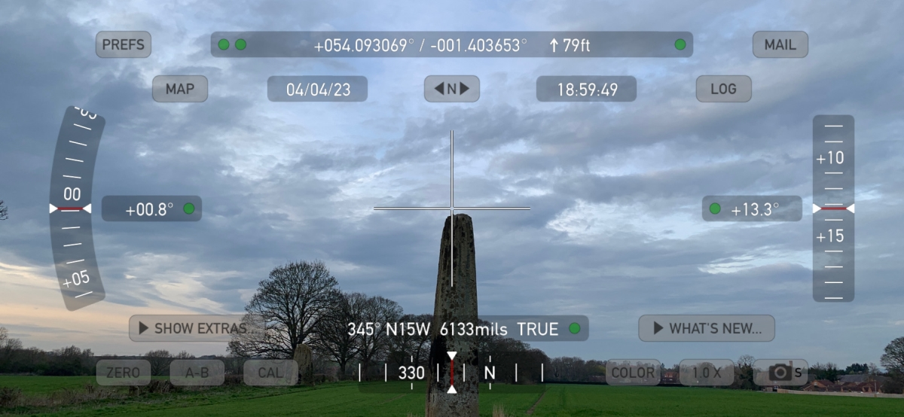
Figure 16: Theodolite image of centre stone.
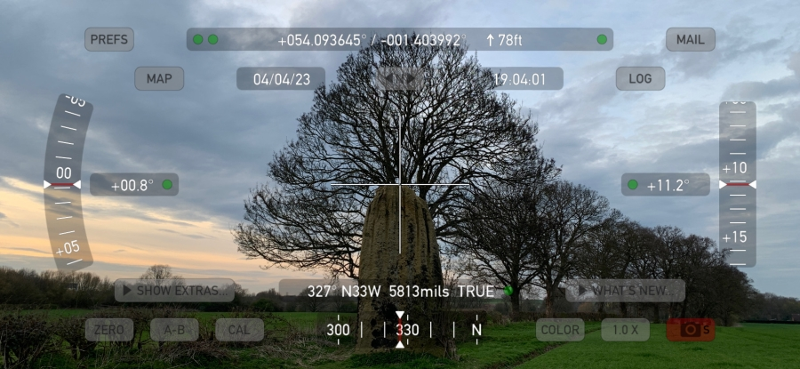
Figure 17: Theodolite image of northern stone
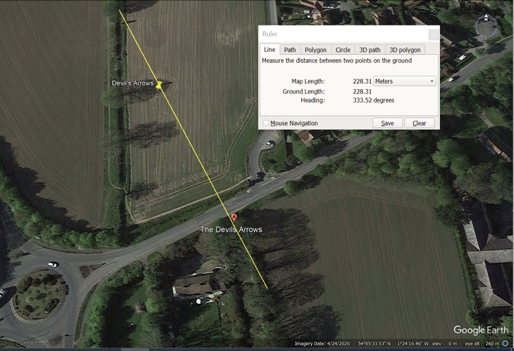
Figure 18: Azimuth of The Devil's Arrows

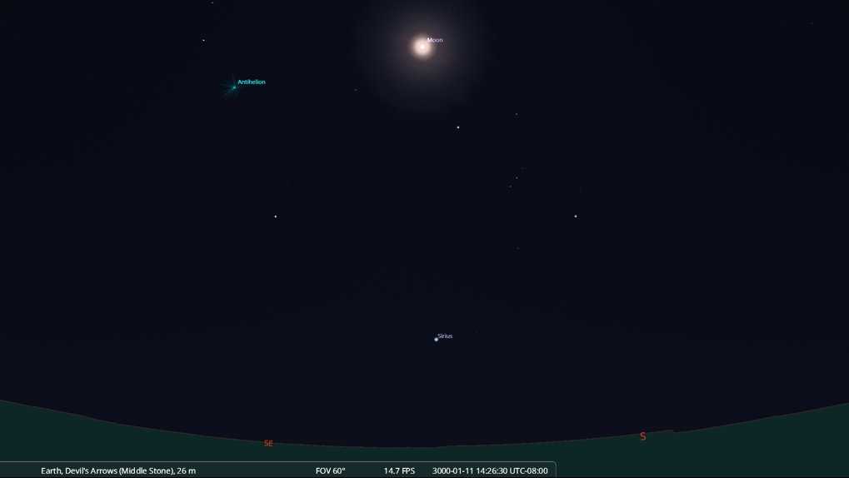
Figure 19: Winter Solstice sunset due NW at The Devil's Arrows.
After observing on-site, the sun setting WNW two weeks after the vernal equinox (3rd April 2023), between the centre and northern stones (Figure 20), I used the date of April 15th in the year 3000BCE for the spring equinox in Stellarium (Figure 21), and this aligned with the sun setting between the central and northern stones.
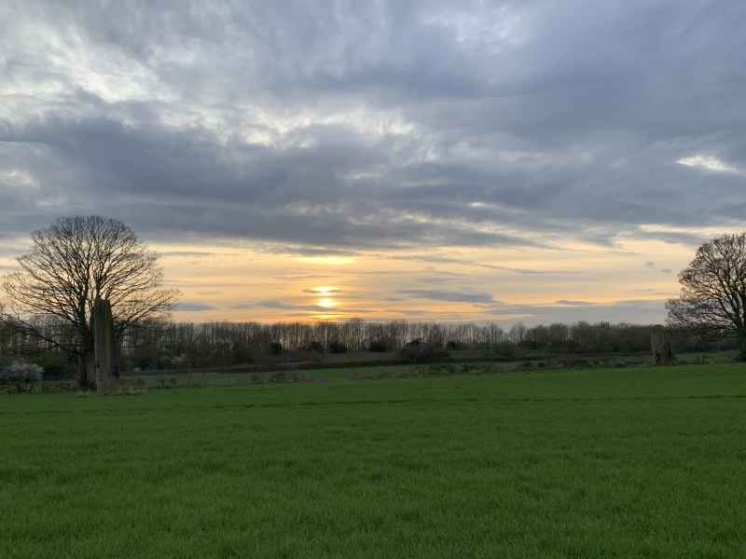
Figure 20: Sun setting NW between the Devil's Stones two weeks after the spring equinox 2023. The sun will rise from this point on the autumn equinox.
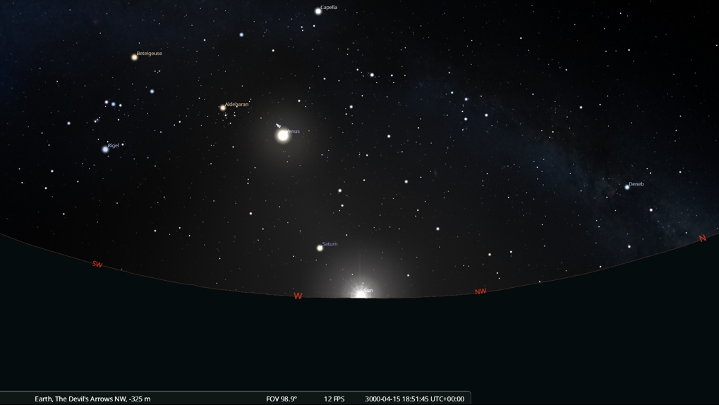
Figure 21: Sun setting NW between the central and northern Devil's Stones on the Neolithic Vernal Equinox.
Another local monument, Hutton Moor Henge, is visible using aerial photography and Google Earth and shares similar orientation to other neolithic sites in the area – SE/NW and north/south entrances (Figure 22). Excavation has shown that the henge is a comparable size and layout to Thornborough though agriculture and quarrying has diminished the earthwork considerably. An Azimuth of 325° and declination of 29.17° is in keeping with Harding's supposition regarding the alignments of nearby neolithic monuments along the river Ure.
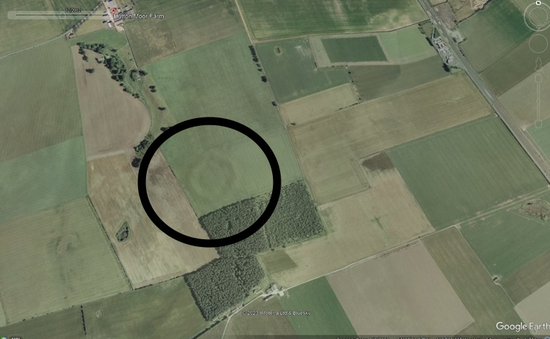
Figure 22: Google Earth aerial view of Hutton Moor henge.

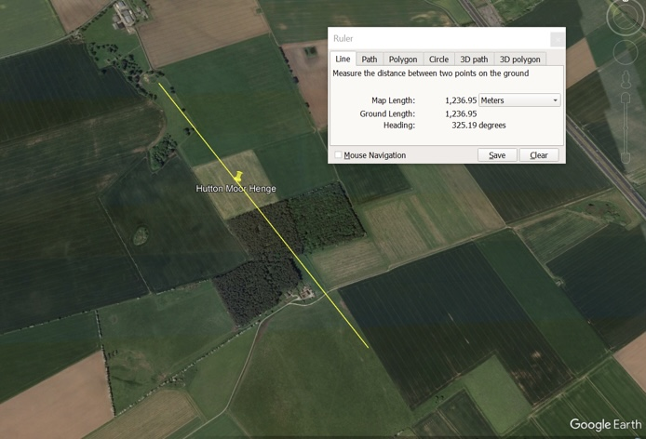
Figure 23: Hutton Moor azimuth, identical to the central henge at Thornborough.

Cana Barn henge also follows this orientation. The earthwork is undecipherable from the ground, but an aerial view shows the same concentric banks and ditches (Figure 24), as well as a similar azimuth of 323° running through the NW entrance (Figure 25). Cana Barn henge at a declination of 29.36 also corresponds to the lunar declination that Heath gave in relation to Thornborough Henges.
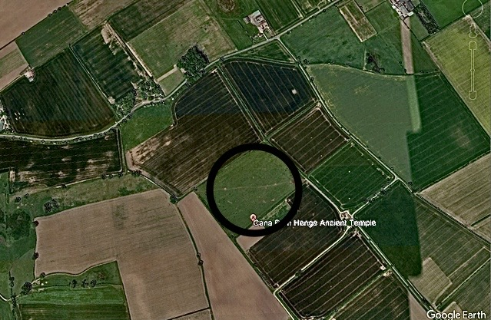
Figure 24: Google Earth aerial view of Cana Barn henge.
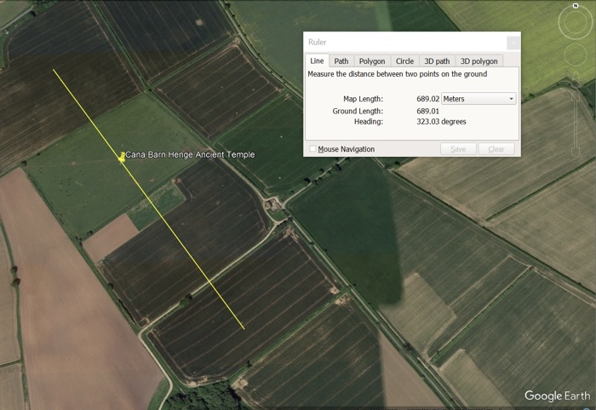
Figure 25: Azimuth of Cana Barn henge.

Discussion
A Celestial Union
Previous studies have proposed alignments within the northern and southern entrances of the henges and by using an amended date in planetarium software to reflect the neolithic winter solstice in 3000BCE, the azimuth and astronomical declination regarding the SE/NW axis has demonstrated significant solar and lunar events. In agreement with Bradley's assertion, I found that the entrances only aligned at Winter Solstice sunrise. This would also support Henty's argument regarding an alignment at the entrance of the henges that marked the changing of the seasons, notably the ritual significance of the shortest day portending the end of a fearful cycle of shorter days, bleaker climates, and barren land.
As Sims attests, 'the standard Neolithic model predicts the rapid adaption to sedentary farming'. and if this newly emerging culture had moved away from its foraging past to become proficient in agriculture and animal husbandry, then it can inform an understanding of how monuments displayed lunar and solar cycles to assist with land management. This prehistoric culture may have tracked the seasons by aligning monuments with the solstices, and designed as observatories or celestial calendars, these structures could also have assisted the task of agriculture.
Further evidence from Mulligan concerning excavated temporary encampment sites in the late Neolithic culture, questioned whether the culture remained nomadic in the lighter and warmer summer months but returned to pre-built structures to process food and care for livestock in the winter months. This understanding of landscape mobility evidencing short term use of the landscape, might suggest that astronomical alignments within the harsher winter months at Thornborough held more prestige that those of the spring and summer months when crops were plentiful, and the weather was warm.
In addressing the question of why the Belt of Orion was singled out at Thornborough, Harding postulated a ritualistic connection to Orion, evidenced from the use of gypsum to coat the henges that were used as pilgrim centres to connect Neolithic man to the celestial bodies/gods. A further consideration could be, that without the glare of the daytime sun, Orion can shine in its resplendent glory within the winter months. Much like a planet at opposition to the sun, once the sun departs from Orion's nearest constellations, Taurus and Gemini, Orion begins its visibility once again at dawn in August, signalling the new seasonal change and forthcoming harvest.
As the neolithic farmers at Thornborough would have observed the sky through ancient lens, Orion would then be seen to climb higher and higher into the heavens until its visibility is fully pronounced after sunset during the cooler, harsher months. Orion's lower culmination is only visible at night during the winter months, and this is the recurrent pattern today.
Therefore, observing Orion climbing higher in the night sky until out of mortal vision may have given hope of lighter, warmer, and more fruitful days ahead. Orion, acting as a god in the autumn sky, may potentially have guided the Neolithic people through the dark, barren, and cold nights that stretched endlessly into eternity. The sight of Orion, the bringer of fortuitous or nefarious weather, framing the entrance of the henges (Figures 8 and 9), could therefore suggest that these earthworks were set apart as special places for calendrical and ritual purposes.
As the centre henge at Thornborough was built over an existing cursus, Bradley proposed that the cursus was intentionally designed as a monument of symbolic significance. Facing the setting sun at the equinox suggests a processional use for the cursus, allowing the sun to set west along the banks and mark the turning point of another year. The sun experienced a 'death' at Winter Solstice, only to be reborn when the sun no longer stands still in its declinations but reverses and moves towards the promise of longer days and the cursus could have been constructed to ensure that the sun returned, persuaded through worship and a guiding passage.
The orientation of nearby monuments denotes a regularity of SE/NW alignments, and this suggests that the material culture was orientated purposefully to the sky and the rising and setting of celestial bodies. Sims, argues against the Neolithic culture having ''sophisticated engagement with the moon such as alignments and standstills' while Polcaro & Polcaro suggest that alignments may be the result of chance or coincided with events such as solstices that are celebrated due to agriculture and survival. Undoubtedly, humans look for patterns, yet the evidence presents a prehistoric culture who have invested considerable skill and effort into building and orientating the axis of these monuments within the Hambleton district of North Yorkshire.
In summing up this section, the evidence suggests that the Neolithic culture at Thornborough was governed by the rhythms and cycles of the sky, and this aided the conversion from hunter-gatherer to farming and animal husbandry. The star-watching community, able to construct a seasonal calendar within the henge monuments, could have foreseen the seasonal changes, knowing when to plant and harvest and this may have engendered by necessity, a deep and long-standing interest not only in the daily lunar and solar cycles but moreover, the elusive stellar movements.

Observatory to the heavens
When the expanse of the sky is bigger than the landscape visible, then this presents a different milieu to the observing group. When the sky remains constant until the seasonal changes bring about the appearance and disappearance of celestial bodies, this also impacts upon the society especially in winter when the darkness of the night hours is greater than the day. Through observing the active stage of diurnal movement above and watching from a period of minutes to hours then days to months, the Neolithic people could note the seasonal and annual changes and when applied to the earth-based practices of agriculture and calendars, could then record festivals, markets, and rituals.

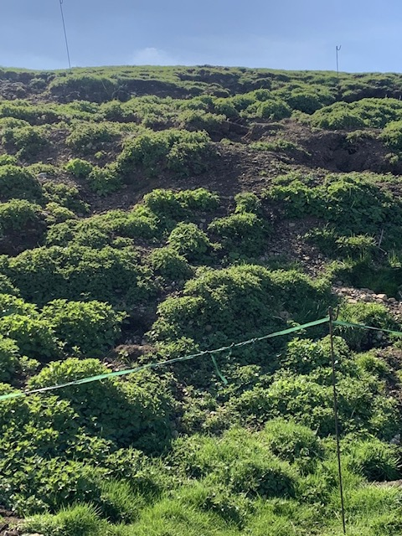
The artificial banks of the central henge are still an imposing sight (Figure 26) and when inside, the experience is comparable to a 'fisheye' view in which full attention is given to the heavens and not the immediate landscape. All attention, as Knight and Butler posit, is focused upwards in the peripheral vision and 'the scene is set for the most perfect form of naked eye astronomical observatory possible.'
Figure 26: The preserved tall banks of the central henge.
For Tilley, the human body is fundamental in the triangulation of experiencing unity between the sky and landscape (Figure 27) and the Neolithic lived experience within the henges would appear to suggest a dwelling place to observe and unite the essential facets of earth and sky. Human bodies, being implicit therefore in connecting the henge and the sky are continually engaging, as Ingold suggests, in material and energetic exchanges with components of their environment. For the Neolithic people, moving around the enclosed space of the henge, their bodies would become, as Sims suggests, an 'astronomical focusing device', the observing eye lifted upwards to the celestial ceiling above. This in turn ensured, that the sky was the cynosure of the observer.
This bodily experience within material culture could therefore be seen as fundamental in the transmission of cultural knowledge within a non-written people. The embodied experience of focusing on and moreover, interpreting celestial alignments within these mnemonic structures, providing the driving force for their construction as a way of collecting and disseminating this knowledge.
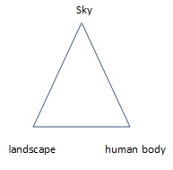
Figure 27: Triangulation of body, landscape, and sky, (Tilley 2004).

The high banks of the henges, coated with brilliant white gypsum, imparts upon the observer the experience of being inside an observatory in which all planets and stars, as Knight and Butler assert, appear at the same altitude. The banks effectively block any view of the landscape due east and west and the sightline is guided upwards, especially after dusk, to the celestial ceiling above.
Using Stellarium to recreate a fieldwork image over the central henge, with the pink moon shining through the turbid clouds (Figure 27), the appearance of white gypsum on the high banks provided a theatrical backdrop in the dark. The unilluminated henges would have eventually fused with the inky black of the sky as the night progressed. Experiencing the dark night sky in this way could demonstrate how sites such as Thornborough were used and perceived by the culture, especially within the winter months when the nights unfolded endlessly with the intermittence of shortened daylight hours.
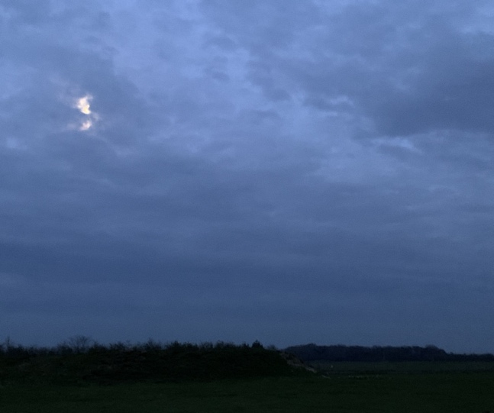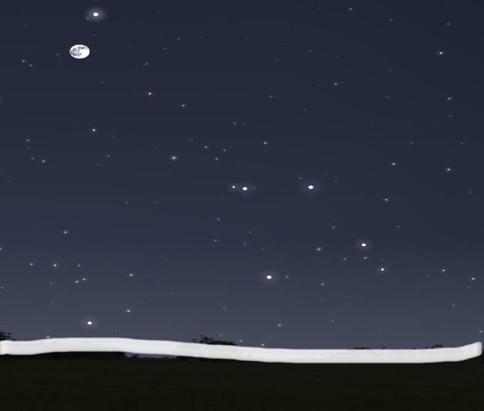
Figure 27: The pink moon rising over the central henge (06/04/23). Figure 28: Stellarium image of the pink moon rising (06/04/23)
To summarise this section, it can be suggested that the moving heavens played a part in the worldview of the neolithic people. The sky was as much a part of the culture as the earthly landscape and the Neolithic archaeology provided the ideal observatories to mark the coming seasons. The Neolithic dark night sky belongs to a culture whose true meaning may never be known yet from the evidence stated, it would appear that the celestial sphere, draping endlessly around the corners of the globe, was observed through the symbolic environment below.
Liminal Gateway to the Heavens
Tilley found that entering a neolithic chamber purposefully orientated to the sky, was to enter a sacred, ritual space whilst leaving the chamber was to return to the mundane domain of everyday life with its undulating landscape. Within the henge, the Neolithic culture might have sought a transitional space or what Hunt describes as 'the border between light and dark, the liminal space between life and death'.
Ruggles suggests from archaeological evidence that the Neolithic people did not live at the henges, attending only for ritual, pilgrimage, and ceremonial purposes. Gypsum did not occur naturally at the henges and would have been transported at considerable effort to the earthworks. Once painted in this illuminating substance, the raised banks might have appeared as a refulgent entrance into the netherworld and this sense of enclosed sacred space could have effectively created a temple to the neolithic sky gods aligned to this earthly place.
Considering Tilley's assertion that a structure appears to alter as we change our relationship with it , being within the henge or looking at the henge from the outside, I found, influenced the perception of the sky. Ingold's model of two ways of perceiving the environment (Figure 29), demonstrates how entering the liminal world of the henge differs considerably from the exterior worldview.
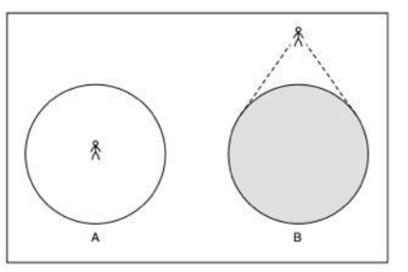
The experience of dwelling within a circular monument, Ingold opines, allows for a local interpretation and engagement of a world as experienced from within, much like the feeling of being at the centre of a world in which the horizon comprises of the external sky that stretches endlessly around. A world within a world is experienced when entering through the tall banks of the henge and the Neolithic culture may have intended this altered perception as once within the henge, the experience of a sacred union with the sky appears as ontologically real as the physical matter of the earthen enclosure.

Figure 29: Two views of perceiving the environment A: as a lifeworld and B: as a globe, (Ingold, 2000, p. 209).

Within the late Neolithic period, the standard sacred unit of space developed into an open-air, enclosed circle and according to Gianotti et al, this demonstration of material culture organised the space within to segregate areas leading up to a pre-eminent centre. Pendergrast in addition, found that the 'axis, path (aisle) and centre are inextricably linked' and convey a directed physical movement towards the focal target, which is what I found within the centre of the henges, being situated along the SE/NW axis that perfectly captures the rising and setting of the prominent celestial bodies within the opposing entrances.
When standing within the henges, I found that the high outer banks obscured the view of the distant horizon suggesting that the henges were closed off places, secluded from the outside world. The interior ditch could have been constructed to separate the observers from the sacred ground, the raised bank in the centre allowing for a more sacred space to commune with the sky. I found within my visual observations on-site that visitors naturally proceed to the centre of the henge, and only then look up.
In reviewing this section, the fundamental question becomes; within the transitional space of a henge, how do you express this unity of landscape and sky in a non-verbal society? The very act of coming together to construct this monument as well as the rituals that took place here are important cultural factors in uniting the sacred space below with the sacred space above, the henge representing the liminal threshold between the people and the sky.
Conclusion
To conclude, the research question asked if there was a possible celestial orientation at Thornborough Henges. As the neolithic earthworks remain today, it has been possible to examine onsite and consider possible celestial alignments and the cultural significance thereof. Though fieldwork measurements proved certain alignments feasible and should not be discarded, the original intention of Thornborough Henges may never be fully understood, belonging to a time before written record. The sky and culture do not always disclose their mysteries nor comply with archeoastronomical presumptions.
Looking through cultural and historical lens may present correlations and indicate many insights into the Neolithic way of life and even though we have lost the people and their narrative that constructed this ancient monument, the structure's relationship to the sky is ever present and this allows a present understanding of the culture's intentionality. Yet irrespective of whether material culture does align with celestial objects or events, the actual material phenomena of Thornborough Henges does exist and was therefore built with an original intentionality. These monuments appear to embody a multi-faceted engagement with the sky beyond the measured celestial alignments; their orientated and intentional design allowing for a better understanding and engagement with the sky.
In a nonwritten culture, Thornborough Henges become a physical form of verbal expression, a metaphorical living book that testifies to its enduring relationship with the sky. Whilst it is debatable whether archeoastronomy can provide conclusive evidence regarding orientation at Thornborough Henges, the evidence derived from astronomical monuments can certainly contribute and supplement existing archaeological evidence. It would, however, be a mistake to believe that the alignments at Thornborough Henges are connected to their original cultural function as a church aligned to the compass can also be used for book clubs.

Bibliography
Barrett, John C., Bradley, Richard, and Green, Martin, Landscape, Monuments and Society: The Prehistory of Cranborne Close, (Cambridge University Press, 1991)
Bradley, Richard, The Significance of Monuments: On the shaping of human experience in Neolithic and Bronze Age Europe, (Routledge: London and New York, 1998)
Brophy, K., Reading Between the Lines: The Neolithic Cursus Monuments of Scotland, (Routledge: London, 2016)
Dowd, Marion and Hensey, Robert, The Archaeology of Darkness, (Oxford Books, 2016)
English Heritage, History of Thornborough Henges: Circular Worlds, <History of Thornborough Henges | English Heritage (english-heritage.org.uk)>
FORUM: The Journal of Council for British Archaeology YORKSHIRE, (Council for British Archaeology, The Archaeological Forum Journal, Volume 9, 2020/2021)
Galicia (Northwest Iberia), (Cambridge Archaeological Journal 21:3, 2010)
Grigsby, John, Skyscapes, Landscapes, and the Drama of Proto-Indo-European Myth, (Unpublished [Doctoral Thesis], Bournemouth University, 2018)
Harding, Jan, Johnston, Ben and Goodrick, Glyn, Neolithic Cosmology, and the Monument Complex of Thornborough, North Yorkshire, (University of Texas Press: Austin, 2006)
Harding, Jan, Cult, Religion and Pilgrimage: Archaeological Investigations at the Neolithic and Bronze Age Monument Complex of Thornborough, North Yorkshire, (Council for British Archaeology, 174, 2013)
Heath, Richard, Thornborough Henge as the Moon’s Maximum Standstill, (MegalithicScience, 2015)
Henty, Liz, Book Review, (Review of ‘Cult, Religion and Pilgrimage: Archaeological Investigations of the Neolithic and Bronze Age Monument Complex of Thornborough, North Yorkshire’ by Jan Harding), Equinox Online, JSA 1.1. (2015)
Heritage Gateway, Historic England Research Records: Hutton Moor Henge, 2005, <Heritage Gateway - Results >
Ingold, Tim, Hunting and Gathering as Ways of Perceiving the Environment in Redefining Nature, 1st Edition, (Routledge, 1996)
Ingold, Tim, The Perception of the Environment: Essays on Livelihood, Dwelling and Skill, (Routledge: New York and London, 2000)
Knight, Christopher, and Butler, Alan, Before the Pyramids: Cracking Archaeology's Greatest Mystery, (Watkins Publishing: London, 2011)
Muir, Richard, The Yorkshire Countryside: A Landscape History, (Edinburgh University Press, 1997)
Mulligan, Gerard, Settling Down or Moving On? The Settlement of the Irish Neolithic Landscape, (New Hibernia Review 16, no. 1, 2012)
Oakey, Matthew Daniel van den Toom and Alison Deegan, Thornborough Henges Air Photo Mapping Project, (English Heritage, Swinton, 2005)
Pavlovic, Goran, Henges-Rondel enclosures, Old European Culture Blog, <Old European culture>,
Pearson, T. and Field, D., Stonehenge Cursus: Investigation of Earthworks, (Research Department Report Series 103, Swindon: English Heritage, 2011)
Polcaro, Andrea, and Polcaro, Vito, Man and Sky: Problems and Methods of Archeoastronomy, (Archeologia e Calcolatori, 2009)
Silva, Fabio and Campion, Nicholas, Skyscapes: The Role and Importance of the Sky in Archaeology, (Oxbow Books: Oxford & Philadelphia, 2015)

Ruggles, Clive L. N., Heritage Sites of Astronomy and Archeoastronomy in the Context of the UNESCO World Heritage Convention: A Thematic Study, (ICOMOS, 2010)
Ruggles, Clive, Handbook of Archeoastronomy and Ethnoastronomy, (Springer Science and Business Media: New York, 2015)
Sims, Lionel, Entering and Returning from, the Underworld: Reconstituting Silbury Hill by Combining a Quantified Landscape Phenomenology with Archeoastronomy, (The Journal of the Royal Anthropological Institute, vol. 15, no. 2, 2009)
Sinclair, R. M., The Nature of Archeoastronomy in Oxford VII International Conference on Archeoastronomy: Viewing the Sky Through Past and Present Culture, Eds. Todd W. Bostwick and Bryan Bates, (Pueblo Grande Musuem Anthropological Paper, no. 15, Phoenix, 2006)
Tilley, Christopher, A Phenomenology of Landscape, (BERG: Oxford, 1994)
Tilley, Christopher, The Materiality of Stone: Explorations in Landscape Phenomenology, 1st Edition, (Routledge: London and New York, 2004)
Williamson, Mitch, The Sacred Prehistoric Complex of the Thornborough Henges, in Broch, Crannog and Hillfort Blog, (Monday January 25, 2016)

R. M. Sinclair, The Nature of Archeoastronomy in Oxford VII International Conference on Archeoastronomy: Viewing the Sky Through Past and Present Culture, Eds. Todd W. Bostwick and Bryan Bates, (Pueblo Grande Musuem Anthropological Paper, no. 15, Phoenix, 2006), pp. 13-26.
Lionel Sims, Entering and Returning from, the Underworld: Reconstituting Silbury Hill by Combining a Quantified Landscape Phenomenology with Archeoastronomy, (The Journal of the Royal Anthropological Institute, vol. 15, no. 2, 2009), p. 389.
Frank Prendergast, An Architectural Perspective on Structured Sacred Space – Recent Evidence From Iron Age Ireland in Skyscapes: The Role and Importance of the Sky in Archaeology, eds. Fabio Silva and Nicholas Campion, (Oxbow Books: Oxford & Philadelphia, 2015), p. 94.
Matthew Oakey, Daniel van den Toom and Alison Deegan, Thornborough Henges Air Photo Mapping Project, (English Heritage, Swinton, 2005), p. 2.
Richard Muir, Farming and Territory: The Neolithic in The Yorkshire Countryside: A Landscape History, ed. Richard Muir, (Edinburgh University Press, 1997), pp. 30-45.
Mitch Williamson, The Sacred Prehistoric Complex of the Thornborough Henges, in Broch, Crannog and Hillfort Blog, (Monday January 25, 2016).
English Heritage, History of Thornborough Henges: Circular Worlds, <History of Thornborough Henges | English Heritage (english-heritage.org.uk)> [Accessed 18 March 2023].
Jan Harding, The Neolithic and Bronze Age Monument Complex of Thornborough, North Yorkshire UK, in Handbook of Archeoastronomy and Ethnoastronomy, ed. Clive Ruggles, (Springer Science and Business Media: New York, 2015), pp. 1239-1247.
Jan Harding, Ben Johnston and Glyn Goodrick, Neolithic Cosmology, and the Monument Complex of Thornborough, North Yorkshire, (University of Texas Press: Austin, 2006) , pp. 47-48.
Richard Heath, Thornborough Henge as the Moon’s Maximum Standstill, (MegalithicScience, 2015), pp. 1-6.
John Grigsby, Skyscapes, Landscapes, and the Drama of Proto-Indo-European Myth, (Unpublished [Doctoral Thesis], Bournemouth University, 2018), pp. 168-170.
Richard Bradley, The Dark Side of the Sky: The Orientations of Earlier Prehistoric Monuments in Ireland and Britain, in The Archaeology of Darkness, eds. Marion Dowd and Robert Hensey, (Oxford Books, 2016), pp. 51-62.
Christopher Knight and Alan Butler, Before the Pyramids: Cracking Archaeology's Greatest Mystery, (Watkins Publishing: London, 2011), pp. 59-60, 70-73.
Goran Pavlovic, Henges-Rondel enclosures, Old European Culture Blog, <Old European culture>, [Accessed 13th March 2023], pp. 1-10.
Liz Henty, Book Review, (Review of ‘Cult, Religion and Pilgrimage: Archaeological Investigations of the Neolithic and Bronze Age Monument Complex of Thornborough, North Yorkshire’ by Jan Harding), Equinox Online, JSA 1.1. (2015), 150-154, (pp. 153-4).
Clive L. N. Ruggles, Heritage Sites of Astronomy and Archeoastronomy in the Context of the UNESCO World Heritage Convention: A Thematic Study, (ICOMOS, 2010), p.28.
Lionel Sims, 30b – the West Kennet Avenue Stone that Never Was: Interpretation by Multidisciplinary Triangulation and Emergence through Four Field Anthropology in Skyscapes: The Role and Importance of the Sky in Archaeology, eds. Fabio Silva and Nicholas Campion, (Oxbow Books: Oxford & Philadelphia, 2015), pp. 47-48.
Andrea Polcaro and Vito Polcaro, Man and Sky: Problems and Methods of Archeoastronomy, (Archeologia e Calcolatori, 2009), p. 232.
Gerard Mulligan, Settling Down or Moving On? The Settlement of the Irish Neolithic Landscape, (New Hibernia Review 16, no. 1, 2012), pp. 94-112.
Christopher Tilley, A Phenomenology of Landscape, (BERG: Oxford, 1994), p. 179.
K. Brophy, Reading Between the Lines: The Neolithic Cursus Monuments of Scotland, (Routledge: London, 2016), p. 33.
T. Pearson and D. Field, Stonehenge Cursus: Investigation of Earthworks, (Research Department Report Series 103, Swindon: English Heritage, 2011), pp. 35-36.
Richard Bradley, The Significance of Monuments: On the shaping of human experience in Neolithic and Bronze Age Europe, (Routledge: London and New York, 1998), p. 109.
Camila Gianotti, Borrazas, Criado-Boado and Lopez-Romero, Deconstructing Neolithic Monumental Space: Montenegro Enclosure in Galicia (Northwest Iberia), (Cambridge Archaeological Journal 21:3, 2010), pp. 391-406.
Frank Prendergast, An Architectural Perspective on Structured Sacred Space – Recent Evidence From Iron Age Ireland in Skyscapes: The Role and Importance of the Sky in Archaeology, eds. Fabio Silva and Nicholas Campion, (Oxbow Books: Oxford & Philadelphia, 2015), p. 94.
Tim Ingold, The Perception of the Environment: Essays on Livelihood, Dwelling and Skill, (Routledge: New York and London, 2000), pp. 209-217.
Tony Hunt, Life, Death, and the Shadow World in Neolithic Spirituality in FORUM: The Journal of Council for British Archaeology YORKSHIRE, (Council for British Archaeology, The Archaeological Forum Journal, Volume 9, 2020/2021), p. 72. Forum 2021 complete.pdf
Richard Heath, Thornborough Henge as the Moon’s Maximum Standstill, (MegalithicScience, 2015), pp. 1-6.
Heath, Thornborough Henge, p. 3.
Heath, Thornborough Henge, p. 6.
Jan Harding, Cult, Religion and Pilgrimage: Archaeological Investigations at the Neolithic and Bronze Age Monument Complex of Thornborough, North Yorkshire, (Council for British Archaeology, 174, 2013), 1-231, p. 210.
Richard Bradley, The Dark Side of the Sky: The Orientations of Earlier Prehistoric Monuments in Ireland and Britain, in The Archaeology of Darkness, eds. Marion Dowd and Robert Hensey, (Oxford Books, 2016), pp. 51-62.
Richard Bradley, The Dark Side of the Sky: The Orientations of Earlier Prehistoric Monuments in Ireland and Britain, in The Archaeology of Darkness, eds. Marion Dowd and Robert Hensey, (Oxford Books, 2016), p. 52.
Jan Harding, The Neolithic and Bronze Age Monument Complex of Thornborough, North Yorkshire UK, in Handbook of Archeoastronomy and Ethnoastronomy, ed. Clive Ruggles, (Springer Science and Business Media: New York, 2015), pp. 1239-1247.
Harding, The Neolithic and Bronze Age Monument, pp. 1239-1247.
John Grigsby, Skyscapes, Landscapes, and the Drama of Proto-Indo-European Myth, (Unpublished [Doctoral Thesis], Bournemouth University, 2018), pp. 168-170.
Heritage Gateway, Historic England Research Records: Hutton Moor Henge, 2005, <Heritage Gateway - Results > [Accessed 9th April 2023].
Jan Harding, Thornborough, North Yorkshire: Neolithic and Bronze-Age Monument Complex, Archaeology Data Service: York, 2008), <Thornborough, North Yorkshire: Neolithic and Bronze-Age monument complex: Overview (archaeologydataservice.ac.uk)>
Richard Heath, Thornborough Henge as the Moon’s Maximum Standstill, (MegalithicScience, 2015), pp. 1-6.
Richard Bradley, The Dark Side of the Sky: The Orientations of Earlier Prehistoric Monuments in Ireland and Britain, in The Archaeology of Darkness, eds. Marion Dowd and Robert Hensey, (Oxford Books, 2016), p. 62.
Liz Henty, Book Review, (Review of ‘Cult, Religion and Pilgrimage: Archaeological Investigations of the Neolithic and Bronze Age Monument Complex of Thornborough, North Yorkshire’ by Jan Harding), Equinox Online, JSA 1.1. (2015), 150-154, (pp. 153-4).
Lionel Sims, 30b – the West Kennet Avenue Stone that Never Was: Interpretation by Multidisciplinary Triangulation and Emergence through Four Field Anthropology in Skyscapes: The Role and Importance of the Sky in Archaeology, eds. Fabio Silva and Nicholas Campion, (Oxbow Books: Oxford & Philadelphia, 2015), pp. 47-50.
Gerard Mulligan, Settling Down or Moving On? The Settlement of the Irish Neolithic Landscape, (New Hibernia Review 16, no. 1, 2012), pp. 94-112.
Jan Harding, Ben Johnston and Glyn Goodrick, Neolithic Cosmology, and the Monument Complex of Thornborough, North Yorkshire, (University of Texas Press: Austin, 2006), pp. 45-48.
Richard Bradley, The Character of the Dorset Cursus Complex in Landscape, Monuments and Society: The Prehistory of Cranborne Close, eds. John C. Barrett, Richard Bradley, and Martin Green, (Cambridge University Press, 1991), p. 47.
Lionel Sims, 30b – the West Kennet Avenue Stone that Never Was: Interpretation by Multidisciplinary Triangulation and Emergence through Four Field Anthropology in Skyscapes: The Role and Importance of the Sky in Archaeology, eds. Fabio Silva and Nicholas Campion, (Oxbow Books: Oxford & Philadelphia, 2015), pp. 47-48.
Andrea Polcaro and Vito Polcaro, Man and Sky: Problems and Methods of Archeoastronomy, (Archeologia e Calcolatori, 2009), p. 232.
Christopher Knight and Alan Butler, Before the Pyramids: Cracking Archaeology's Greatest Mystery, (Watkins Publishing: London, 2011) p.66.
Christopher Tilley, The Materiality of Stone: Explorations in Landscape Phenomenology, 1st Edition, (Routledge: London and New York, 2004), pp. 6-9.
Tim Ingold, Hunting and Gathering as Ways of Perceiving the Environment in Redefining Nature, 1st Edition, (Routledge, 1996), p. 41.
Lionel Sims, Entering and Returning from, the Underworld: Reconstituting Silbury Hill by Combining a Quantified Landscape Phenomenology with Archeoastronomy, (The Journal of the Royal Anthropological Institute, vol. 15, no. 2, 2009), p. 389.
Christopher Knight and Alan Butler, Before the Pyramids: Cracking Archaeology's Greatest Mystery, (Watkins Publishing: London, 2011), pp. 62-66.
Christopher Tilley, A Phenomenology of Landscape, (BERG: Oxford, 1994), p. 140.
Tony Hunt, Life, Death, and the Shadow World in Neolithic Spirituality in FORUM: The Journal of Council for British Archaeology YORKSHIRE, (Council for British Archaeology, The Archaeological Forum Journal, Volume 9, 2020/2021), p. 79.
Clive L. N. Ruggles, Heritage Sites of Astronomy and Archeoastronomy in the Context of the UNESCO World Heritage Convention: A Thematic Study, (ICOMOS, 2010), p.33.
Christopher Tilley, The Materiality of Stone: Explorations in Landscape Phenomenology, 1st Edition, (Routledge: London and New York, 2004), p. 11.
Tim Ingold, The Perception of the Environment: Essays on Livelihood, Dwelling and Skill, (Routledge: New York and London, 2000), p. 209.
Tim Ingold, The Perception of the Environment: Essays on Livelihood, Dwelling and Skill, (Routledge: New York and London, 2000), pp. 209-217.
Camila Gianotti, Borrazas, Criado-Boado and Lopez-Romero, Deconstructing Neolithic Monumental Space: Montenegro Enclosure in Galicia (Northwest Iberia), (Cambridge Archaeological Journal 21:3, 2010), pp. 391-406.
Frank Prendergast, An Architectural Perspective on Structured Sacred Space – Recent Evidence From Iron Age Ireland in Skyscapes: The Role and Importance of the Sky in Archaeology, eds. Fabio Silva and Nicholas Campion, (Oxbow Books: Oxford & Philadelphia, 2015), p. 94.

