Assignment Title: Programme improvement project
Programme Name: MSc Digital Skills for the Health and Care Professions
Academic Year: 2022/2023
Module Name: Digital Technology in Health and Social Care
Module Code: BMDS 7006
Student ID: 2212124
Total word count: 1950
Date of Submission: Formative – 2nd February 2023

Table of Contents

 | Title | Page
1 | Introduction | 4
2 | Methods | 7
3 | Results
4 | Discussion
 | Resources

List of Abbreviations

BJC  CAC | Business Justification Case  Clinical Audit Co-ordinator
CIAT | Clinical Intelligence and Assurance Team
ePCR | electronic patient clinical record
FHIR  FITT  FBC | fast healthcare interoperability resources  fit between individuals, task and technology  Full Business Case
NHS  PCR | National Health Service  Patient Clinical Record
UK | United Kingdom
WAST | Welsh Ambulance Services NHS Trust

Introduction

Organisation Overview
As an important part of the National Health Service (NHS), set up in 1998, the Welsh Ambulance Services NHS Trust (WAST) is an emergency service that covers the whole of Wales. A patient with a life-threatening injury or condition telephones 999. The telephone call is answered by a Call Handler and assessed for urgency, then, depending upon the patient’s needs, the nearest available emergency ambulance or Paramedic in a car is dispatched.
Patient Clinical Record History
It is a legal requirement that all Paramedics complete a patient clinical record (PCR) for each patient to record the demographics, clinical observations, and treatment provided to all patients. This must be an accurate account of all care provided (Health and Care Professions Council, 2023, record keeping).
Historically, WAST Paramedics used a paper PCR. Whilst this was a way to capture all the required information, this had various limitations. There are approximately 250,000 calls to the emergency number each year (Welsh Ambulance Service NHS Trust, 2022). Due to the large size of the paper PCR and the number of fields that would need to be uploaded onto an electronic system for each, it would take an excessive amount of time to scan every PCR. Therefore, although an image was uploaded, only the data from eight fields could be saved (date, incident number, PCR number, call code, patient surname, patient first name, date of birth, and postcode).
If any meaningful full data was required for auditing purposes, this could not be gained from the system electronically. For example, if the auditor needed to look at all stroke incidents from October 2012, they would need to manually search all records for that month, and extract the ones with a condition code of 172. This was very time-consuming, and there was a risk of auditor error.
Digital Patient Clinical Record
In October 2015 the paper PCR was replaced by a digital version where a digital pen was used to complete a special version of the PCR. All the information that was written on the PCR was held on a microchip within the pen. Once the pen was docked (into a docking station), the information was then transferred to a database held within WAST headquarters. This digital PCR would enable the WAST Health Informatics Team or Clinical Intelligence and Assurance Team (CIAT) to collect data from the PCR. This could then be used to audit the level of patient care in addition to providing vital information to help inform service improvement and update the Welsh Government on care compliance. This could then provide evidence to improve patient care. This digital version was an interim measure that was merely intended to be a bridge between a simple paper PCR and an electronic PCR (Winspear, 2018).
Once the digital pen became embedded, the issues surrounding it became apparent. Paramedics were not docking their pens, resulting in incomplete or missing data at the time of reporting. The handwriting was not always easy to read. Pen cameras were being distorted so the data was not showing on the PCR. Pens were being lost or damaged and needed to be replaced regularly. Faults with the cameras were being recorded so the data was either not showing up or appeared to have scribbles over it. This resulted in less data being available than had originally been anticipated (Welsh Ambulance Services NSH Trust, 2020a). Also, the data was not always accurate e.g., the patient’s pulse was electronically saved as twelve instead of seventy-two as the top of the seven had not been clearly visible.
Electronic Patient Clinical Record
Once the digital pen system was embedded, work started on sourcing an appropriate electronic version of the PCR as, at that time, WAST was the only ambulance service in the UK that had not yet migrated to the use of an electronic patient clinical record (ePCR).
In February 2018, a task and finish group was set up to develop a Full Business Case (FBC) or Business Justification Case (BJC). A sub-group was set up which consisted of relevant senior personnel, each with a responsibility based on their area of expertise (Table 1).
Table 1: Key Personnel and Area of Expertise:
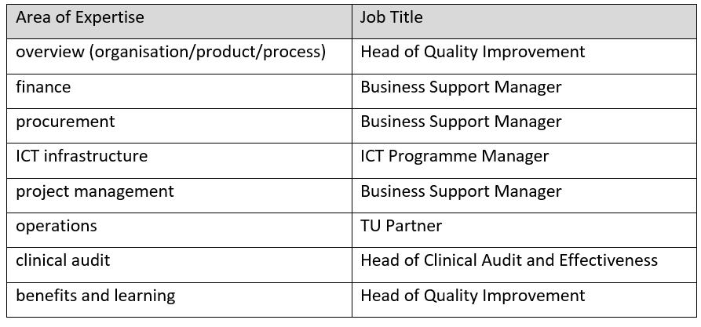
Throughout 2018 the sub-group visited four ambulance sites in England where versions of the ePCR were already in use (one system had been designed in-house). The visits aimed to enable WAST staff to gain information about the ePCR from staff who were using the devices. Also, this allowed WAST staff to ask questions regarding the individual user’s experience. A questionnaire was then completed by WAST staff to provide the perceived benefits, concerns etc.
Following these questionnaires, user feedback was presented in a document. In order for WAST staff to decide which system should be used, the identities of all four ambulance services and software providers was anonymised to avoid bias (Welsh Ambulance Services NHS Trust, 2018a). A supplier event was then held on the 28th and 29th November 2018.
As additional funding was required, a five case model capital business case with three stages was submitted (Welsh Ambulance Services NHS Trust, 2020b).
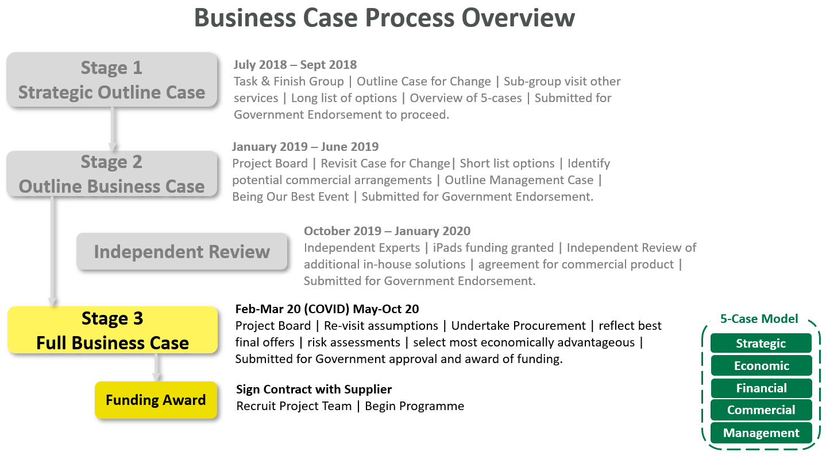

In February 2021, the WAST signed a contract with Terrafix Ltd for the provision of the TerraPACE ePCR solution. Terrafix Ltd was established in the United Kingdom (UK) in 1983 and the company describes themselves as being “the leading supplier of ICT and Mobile Data systems to the UK Ambulance Service, Security's Services, Police and other emergency-based organisations” (Terrafix Limited, 2019). Terrafix Limited is also a large supplier of multiple systems and products which relate to navigation, mapping, and security which are known by names including TerraTRACK, TerraMED, TerraSECURE, TerraMOD, TerraWORLD etc. Terrafix were also responsible for the electronic patient clinical record that is currently utilised in other Ambulance Trusts throughout the UK.
The rollout of the new electronic patient clinical record (ePCR) commenced in November 2022. This was an action that was specified in the WAST Integrated Medium Term-Plan (IMTP) 2021/22 – 2023/24. Welsh Ambulance Services NHS Trust, 2021). This replaced the digital PCR, however, a paper version was retained which was to be used in case of technical failure.
All operational Paramedics were provided with an Apple iPad, and training was provided around the use of the new ePCR. There were also notices displayed on the WAST intranet.
Role Outline
The author of this document is currently employed as a Clinical Audit Co-ordinator (CAC) working for WAST. As part of the role (Welsh Ambulance Services NHS Trust, 2020c), she needs to download information from the ePCR using Microsoft SQL. Once downloaded, the data is uploaded onto a Microsoft Excel spreadsheet. This information is then used to carry out clinical audits by assessing the data by inserting formulas onto excel. E.g. All patients with a blood sugar level less than four should have been given Glucose.
Due to her role commitments and the fact that she is not clinically trained, the author of this document has a particular interest in the data that can be downloaded from the ePCR, rather than the clinical elements and functionality.

Methods

FITT Framework
A FITT framework (Ammenwerth et al., 2006), is so-called as it has been designed to look at the fit between individuals, task, and technology. It was designed to look at information technology (IT) systems that were implemented in a clinical setting.
It was designed following a literature study and a case study, as the implementation of new IT systems in healthcare Often systems would often fail as they were not specifically designed to consider that the needs of the user, who may often be a clinician or doctor. (Beynon-Davies, Lloyd-Williams, 1999). What may seem to be the perfect system to an IT technician may not be practical in a clinical setting. A multi-disciplinary approach which includes clinicians must always be used to ensure that the system is suitable for everyone. An example of this is a clinician using a cyber transcriber to dictate a letter, (which automatically types it) rather than dictate it and a medical secretary typing it. Whilst, to an IT person it would seem like a time-saving system, in reality, it took a mean of 41.5 minutes per letter, compared to 25.9 minutes per letter. (Sandilyan, Darley, 2013).
As suggested, the framework would align the characteristics of the person using the system and the characteristics of the technology. To ensure the system was fit for purpose, Ammenwerth looked at three other models which were previously used, and noted which elements were successful:
The first model was the Information Success Model, developed by William H. DeLone and Ephraim R. McLean, (DeLone, McLean, 2003). This system looks at six elements as shown in Image 1 below.
Image 1: D & M IS Success Model:
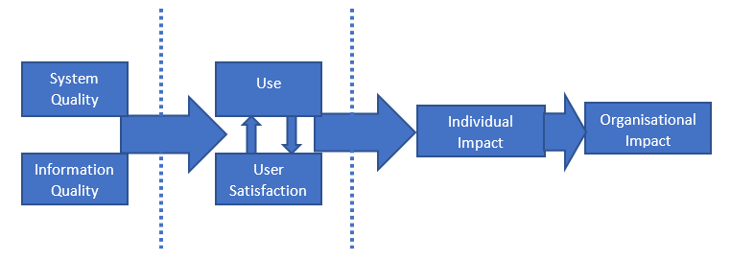

The second model was the Technology Acceptance Model by Davis (Davis, 1993) which looks at why users chose to accept or discard a system. It examines how easy and useful the systems are.
Image 2: The technology acceptance model (TAM) by Davis:
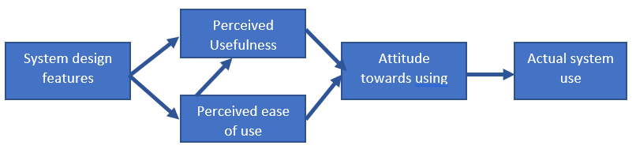

The third model was the Task Technology – Fit model (TTF) (Goodhue, Thompson, 1995) which looks at the ability of the individual, the characteristics of the technology and the requirements of the task.
Image 3: The Task-Technology – Fit (TTF) Model:
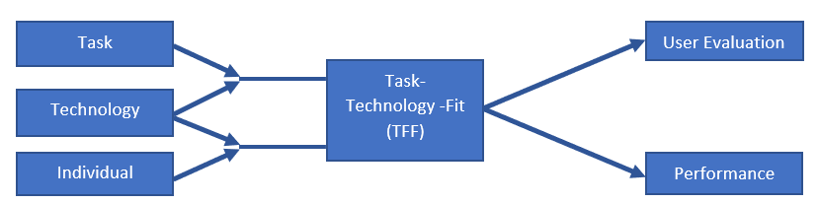

From this, Ammenworth could then formulate a suitable system which took into account the most successful elements of each. The FITT therefore looked at the attributes of the user, technology and clinical tasks. This could take into account issues such as individual enthusiasm or apprehension, the system usability and intricacy of the task.
Image 4: The (Fit between Individuals, Task and Technology) FITT framework (Ammenwerth et al., 2006):

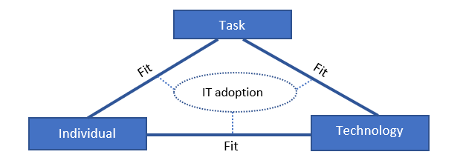
FITT Utilisation
The author of this document used her own experiences gained whilst carrying out her role within the CIAT to examine the system, with particular emphasis on the functionality of the ePCR from a data extract and usage perspective. To ensure she had the correct aims and objectives of the project to cross-match against, the author of this document liaised with the TerraPACE Project Team to obtain the relevant documents. Some of these included (Harris, 2020), (Harris, 2021), and (Terrafix ,2019). Although the author of this document was able to obtain a large variety of supporting documentation, due to not being a part of the project team, and additional matters of confidentiality within WAST, some information was limited. Therefore the author of this document could only provide evidence from a limited amount of unpublished resources. An example of this is the “WAST Electronic Patient Clinical Records – Statement of Need” (Welsh Ambulance Service NHS Trust, 2019), whereby the author of this document could see what WAST requirements were, but not what TerraPACE had replied, stating that they could deliver, thus rendering the document unusable.
Using the available documents, the author of this document compared the objectives set out by both WAST and the supplier and cross-referenced them for accuracy during for initial year following implementation, providing both personal experience and relevant evidence where available.
Due to a lack of expertise in the field of finance, the author of this document is not assessing cost or value for money.
The author of this document used the FITT framework in full:
The ‘IT adoption’ was the implementation of the ‘TerraPACE’ electronic patient clinical record (ePCR)
The ‘task’ was for the author of this document in conjunction with other members of the CIAT to gain and distribute accurate information from the ePCR.
The ‘individual’ was the CAC who, as the author of this document has a working knowledge of various computer packages including Microsoft SQL, Microsoft Excel, and Microsoft Word.
The ‘technology’ is the ‘TerraPACE’ system which Paramedics complete via a portable iPad, in addition to various computer hardware and software that WAST staff use on a daily basis. Examples of this are the Lenovo ThinkPad, the WAST network, and Microsoft computer packages.

References

Ammenwerth, E., Iller, C. and Mahler, C., 2006. IT-adoption and the interaction of task, technology and individuals: a fit framework and a case study. BMC medical informatics and decision making, 6(1), pp.1-13. Available at:https://bmcmedinformdecismak.biomedcentral.com/articles/10.1186/1472-6947-6-3) (Accessed: 21 January 2023).

Beynon-Davies P, Lloyd-Williams M. When health information systems fail. Topics in Health Information Management. (1999) (1):66-79. PMID: 10539424.

Davis, F. D. (1993). User acceptance of information technology: system characteristics, user perceptions and behavioral impacts. International journal of man-machine studies, 38(3), 475-487.

DeLone, W.H. and McLean, E.R., (2003). The DeLone and McLean model of information systems success: a ten-year update. Journal of management information systems, 19(4), pp.9-30.

Goodhue, D.L. and Thompson, R.L., (1995). Task-technology fit and individual performance. MIS quarterly, pp.213-236.

Harris, S, (2020) “Full Business Case, Electronic Patient Clinical Records (ePCR), Emergency Care Services” Unpublished.

Harris, S., (2021) “TerraPACE Project, Project Initiation Document” Welsh Ambulance Services NHS Trust. Unpublished.

Health and Care Professions Council, (2023). Record Keeping. Available at: Record keeping | (hcpc-uk.org) (Accessed: 14 January 2023).

Sandilyan, M., & Darley, J. (2013). Voice recognition software: Psychiatrist as a transcriber. The Psychiatrist, 37(4), 130-134. doi:10.1192/pb.bp.112.038950.

Terrafix, (2019), Electronic Patient Report Forms. TerraPACE 100028/ 05.03.2019 Iss:3. Terrafix. Unpublished.

Terrafix Limited, (2019). Available at: About| Terrafix Limited| Mobile Data Systems. (Accessed: 29 January 2023).

Welsh Ambulance Services NHS Trust, (2018a). Exploring ePCR Solutions utilised by other NHS Ambulance Services, The ePCT Sub-Group’s Feedback.

Welsh Ambulance Services NHS Trust, (2019) WAST Statement of Need, Electronic Patient Clinical Records (ePCR), Emergency Care Services, June 2019, V0.1. Unpublished.

Welsh Ambulance Services NHS Trust, (2020a). Medical Directorate Clinical Notice Ref 06/2020. Unpublished.

Welsh Ambulance Services NHS Trust, (2020b). Electronic Patient Clinical Records (ePRC) Programme Update for #TeamWAST. Unpublished.

Welsh Ambulance Services NHS Trust, (2020c) “Clinical Audit Coordinator Job Description”, Welsh Ambulance Services NHS Trust. Unpublished.

Welsh Ambulance Services NHS Trust, (2021). Integrated Medium-Term Plan, 2021/2022 – 2023/2024.

Welsh Ambulance Service NHS Trust - About Us (wales.nhs.uk) (Accessed: 6 October 2022).

Winspear, J. (2018). SBAR EPCR Proposal v0.1.

