CertHE computing skills for the workplace
Assignment Module Code: ACCA4026_BIRM
25/03/2026

Module Name: Software Solutions for Business

Lecturer’s Name: Osman Elgawi

Name of the University: University Of Wales Trinity Saint David

Campus Name: Birmingham

Student full name:

HASNAIN AKHTAR

Student ID:

2512913

Table of Contents
INTRODUCTION 2
Section 1: e-Commerce Website builders/software solutions 3
Website Builder 1: 4
5
Website Builder 2: 5
Section 2: Mind-map of contemporary software applications 6
Section 2a 6
Section 2b 7
Section 3 - Office Applications for creating, storing, presenting, & analysing information/data 8
Section 3a 8
MS PowerPoint 8
Microsoft Word 10
MS Excel 13
MS Access 15
Section 3b 16
IF Function 16
VLOOKUP 19
Section 4 Communication and Collaboration applications 21
Section 4a 21
Communication tool 21
Collaboration tool 22
Section 4b 23
Communication tool - Feature 1. 24
Collaboration tool – Feature 1. 28
CONCLUSION 31
References: 32

INTRODUCTION

Welcome to my portfolio, here I will be demonstrating my understanding of multiple technical platforms, software applications/ tools and websites. I will be taking you through several different applications, highlighting their purposes and demonstrating my knowledge of how to operate individual apps with screenshots along the way to bring to life my explanations.
I will also be highlighting the structure behind my future career as a cyber security engineer pin pointing some of the software applications used within that role and building a mind map of it to help visualise my research and further explain why each branch requires certain software/ Applications. Just an overview of the tasks which I will be covering are as follows, Section one highlights commerce website builders, Section 2 explains the benefits of mind map, Section 3 addresses four Ms office applications and finally Section 4 outlines one communication and one collaboration tools.

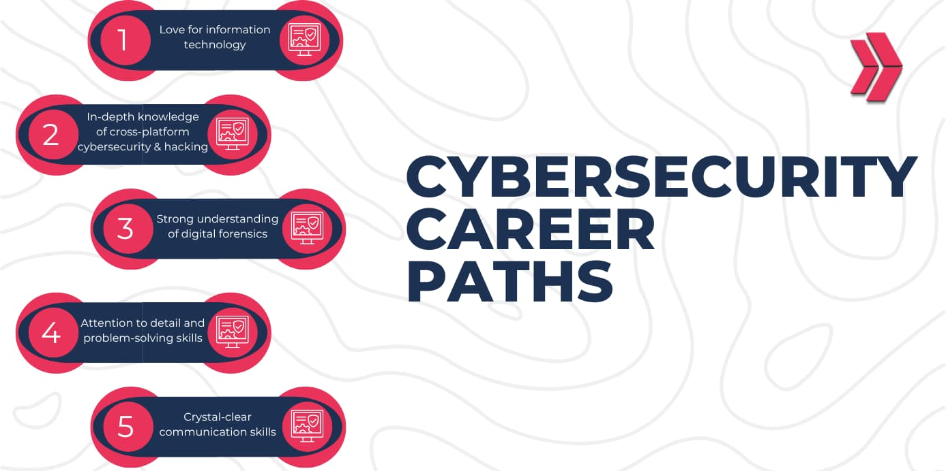



Section 1: e-Commerce Website builders/software solutions

For task one I will be talking about two very common and widely used website builders and describing their advantages and disadvantages. I have chosen for this task to discuss Wix and Shopify as they are both voted within the top 10 website builders taking into account their simplicity, variety of tools within the building frame and the fact they’re budget friendly [1].

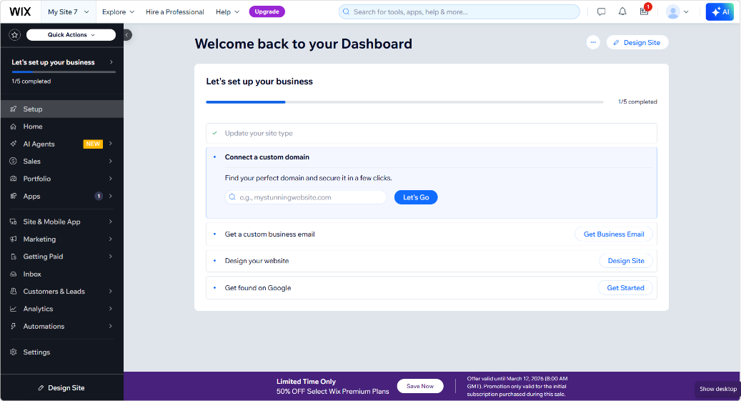
Website Builder 1:
Figure 1, WIX website building dashboard
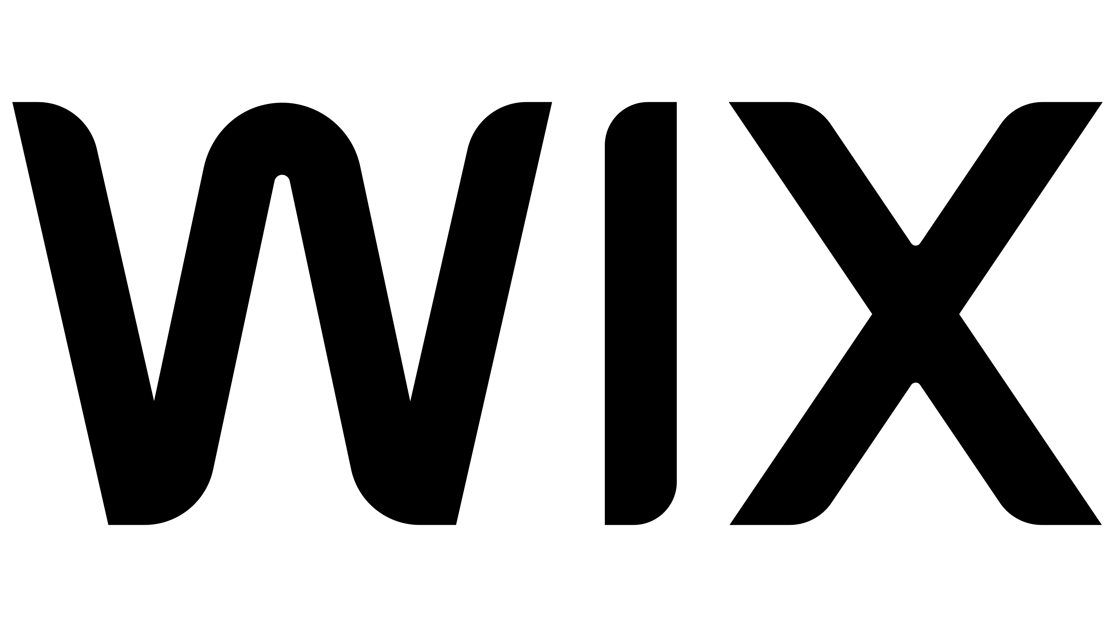

WIX is a great website builder, brilliant for beginners and it’s quite straight forward to start using it to create and edit as you go along and easy to publish. WIX has many advantages to its platform, however with everything it also comes with its disadvantages to which I’ve listed a few below [2].

ADVANTAGES:
- Time efficient simple creative options.
- There are a huge variety of templates available to choose from.
- They are efficient in updating and improving their site tools.

DISADVANTAGES:
- The more you add to gain a bigger audience the cost can increase.
- Very difficult to switch from one template to another whilst carrying over your designs.
- The further you go within your website and the more advanced you want your website to be it becomes very limited to the tools available.
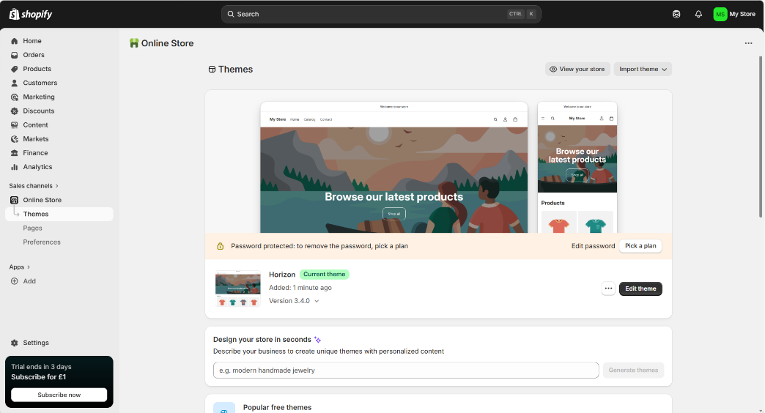

Website Builder 2:
Figure 2, SHOPIFY website building dashboard


The reason behind choosing SHOPIFY is due to having many advantages which are user friendly and simple to use. Whether your business is small or large Shopify will accommodate you. It also allows you to integrate with some other platforms which is very convenient and the site itself is very reliable in doing so, nevertheless as with everything it also carries several disadvantages, and I will now take you through some common pros and cons [3].

ADVATAGES:
- Beginner friendly with its simplicity in using the site and features.
- Very cheap and sustainable trial offer to help you get started and create your site/sites.
- It has a huge variety of what you can sell.
- If you grow so can your account with the ability to trade across multiple stores.

DISADVANTAGES:
- Fees can quite quickly mount up and be overwhelming when you start to sell your products.
- If you like to engage with your clientele and prefer to express, it in writing you will be very limited by the lack of tools available.
- If you grow and want to connect via another app integrated with Shopify it can get quite costly.

Section 2: Mind-map of contemporary software applications

Section 2a

Mind mapping is a desirable way of collating, visualising and presenting a particular topic and adding branches to describe or provide further information related to the original core topic and to elaborate on it. The advantage of this is that you can visually brainstorm what you are thinking and bring it to life [4]. Rather than just using the old fashioned note taking system and pen and paper, mind mapping allows you to picture what you’re explaining with the ability to add different colour themes, shapes and designs which not only makes it more attractive aesthetically but also can potentially play a vital role in the long run to aid you to recollect what you have previously brainstormed and use it in your future career [5].

When you think about it, Mind mapping when it comes to business operations would in my opinion be a very crucial part when it comes to several factors such as Team building/ bonding sessions, planning detailed and structured tasks and making vital and pivotal decisions. In terms of team building, it would enhance the opportunity for everyone to collaborate and get involved with sharing their ideas as it can be broken down into individuals adding a branch and dwell into it further and once done bring it together and add their parts to the main topic. This idea would also be crucial taking into consideration time management and productivity. When it comes to planning detailed and structured tasks everyone has their own initiative, ideas and ways of working as many come from different backgrounds and possess their own unique skills. Soo furthermore this would be a great way for every individual to be a part of new ideas and plans which will also motivate them to do well knowing they contributed to the overall mind map and now they would want to put their expertise to the test and show how committed they are to making a difference and being a part of the new plans knowing they contributed to a successful future/ Completion of certain tasks [6].

Section 2b

If I was to elaborate on mind mapping when it comes to my future career as a cyber security engineer it would include multiple software applications I would use daily, while highlighting the different types of software companies available for every particular task I would need them for as I will demonstrate in the next section with my very own mind map using some examples of software’s that are available on the market.

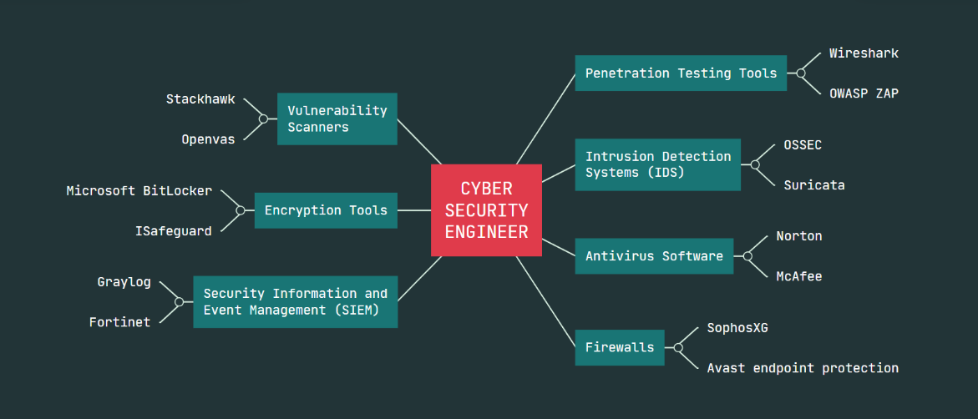
My cyber security engineer mind map LINK: https://mm.tt/map/3959351024?t=uXl6obJxw5
Figure 3, Consisting of relevant software applications used within the CYBER SECURITY industry.

Section 3 - Office Applications for creating, storing, presenting, & analysing information/data

Section 3a


MS PowerPoint

Here I will go through some of MS PowerPoints features, some advantages of MS PowerPoint as well as some disadvantages of MS PowerPoint. I will also highlight one feature I believe will benefit myself in my future career as a Cyber security engineer linking it with presentations. The feature I have chosen to highlight here is the basic, simplistic and easily adaptable options available when it comes to decorating, selecting, editing and colour co-ordinating your background or slides for a presentation also known as a ‘slide show’. I have chosen to stick to a particular colour theme so it is more colour co-ordinated however with MS PowerPoint you are free to choose and edit from a huge variety of different options which I will mention below [7].
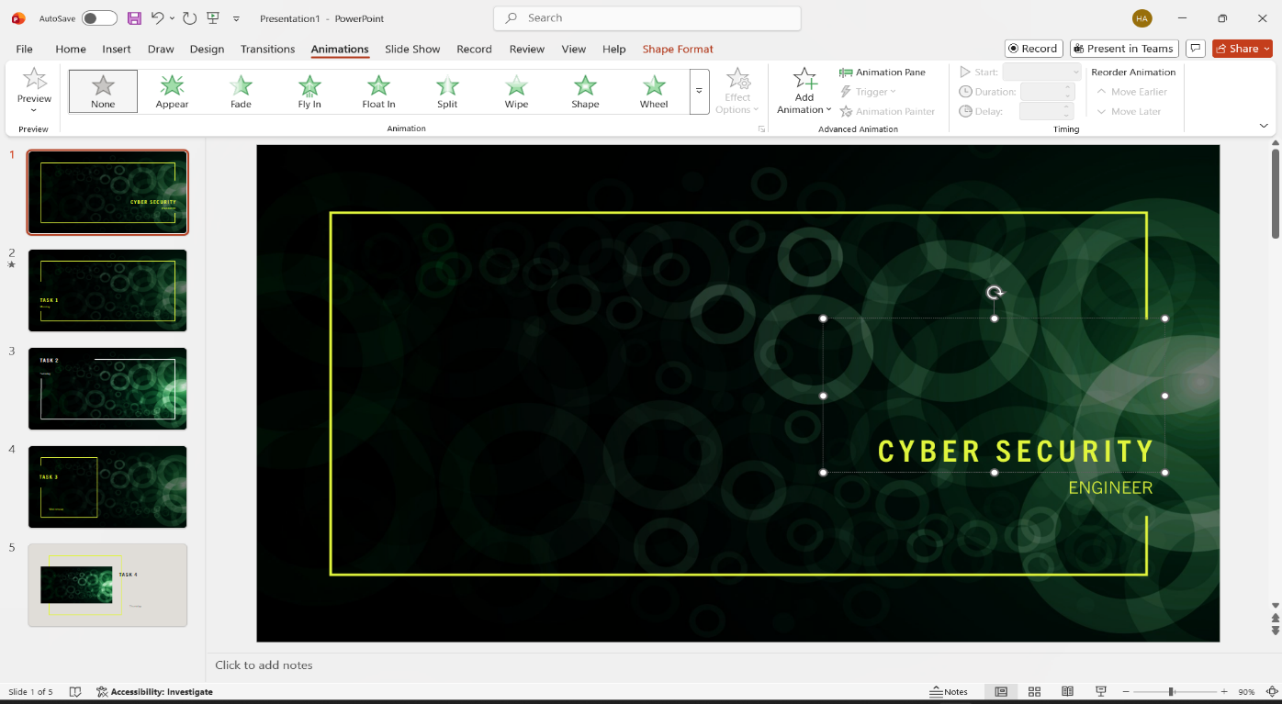
Figure 4, MS PowerPoint background and multi slide layouts.

Benefits of MS PowerPoint:
- Easy to use, very user friendly.
- Huge variety of layouts and templates for professional presentation looks.
- An array of different background options to colour co-ordinate or choose different ones to match a set topic or match the intensity of the subject itself.
- Ability to change various Colours, text locations, animations all to bring your presentation to life.
- These add ons not only showcase your skills but assist you to engage your audience in more than one way [8].

Limitations of MS PowerPoint:
- So many options, animations and edits available you may get too drawn into overpowering a presentation with animations and not be so engaging to your audiences [9].
- Desktop or mobile versions of MS PowerPoint costs.
- Once you have edited and fully constructed your presentation, then proceed to the slide show you are then limited to adjustments and updates you may then need [10].


Microsoft Word

Here I will take you through MS Word’s features, some benefits of MS Word and also some limitations of MS Word. I will also highlight one feature I believe will benefit myself in my future career as a Cyber security engineer. The feature I have chosen to highlight here is the signature line which allows me to pre-fill my role, name, date and signature and make it fast and easy to add signatures to any work document I need to label/ account for. I can write my signature by freehand and then scan it in, save as an image and then use the insert feature to insert the signature pic wherever you want it and adjust accordingly and you are ready to go. This is extremely beneficial when it comes to adding your signature to items such as invoicing someone or any contractual documentation [11]. I have added a few screenshots showing the guide to setting up the signature line.
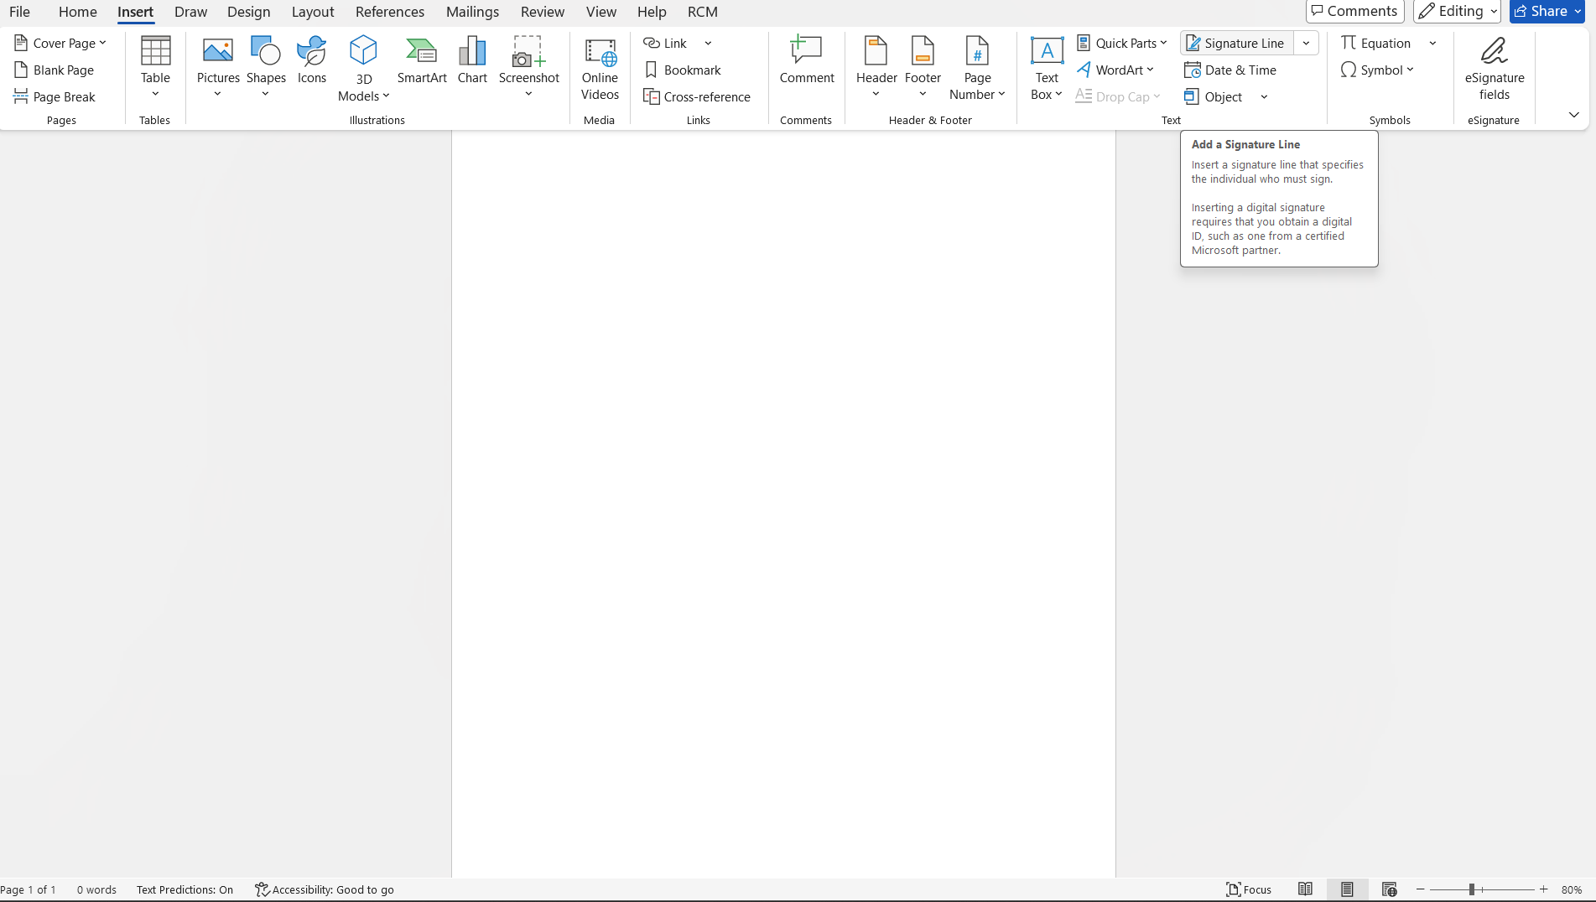
Figure 5, location of signature line option.
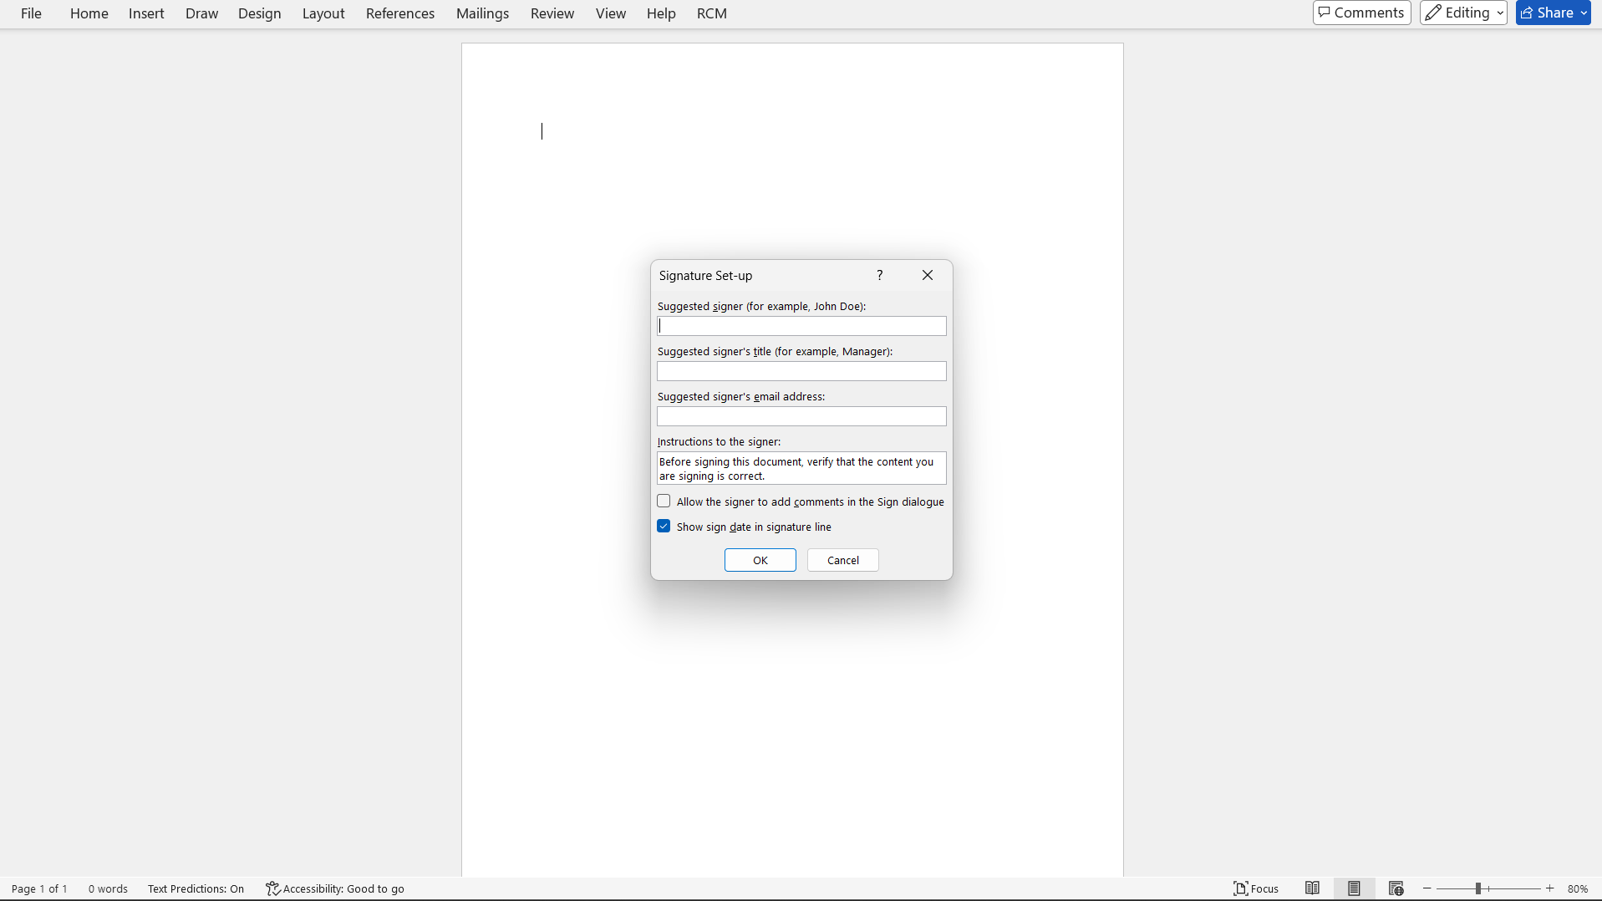
Figure 6, Options once 'signature line' clicked.

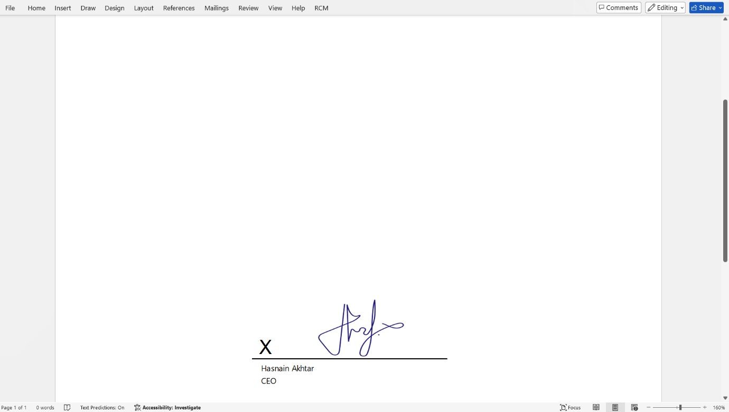
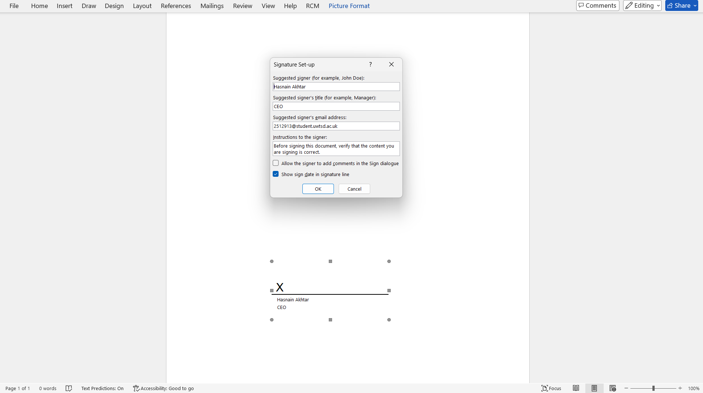
Figure 8, Completed signature line (pre saved signature added).
Figure 7, inputting my personal information.

Benefits of MS Word:
- Very user friendly, easy to use and very versatile even with the most basic of MS Word knowledge [12].
- Simple and convenient variety of templates and layouts for basic tasks suitable for almost anything such as curriculum vitae’s, reports, posters, letters making it easier and quicker to dwell into the required task rather than starting right from the beginning and so much more [13].
Limitations of MS Word:
- MS Word is a flatform that does not come free, you can either pay a one off fee or join a subscription.
- The overall recorded written information is limited to 32 MB.
- Technical limitations even though there is a variety of templates for basic tasks, the more complex tasks that require a more diverse variety of templates will be limited as well as fonts also being limited to set templates which may impact prevent individuals from editing to their direct preferences [14].

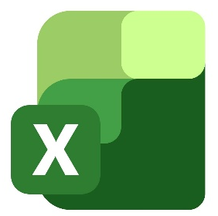
MS Excel

Here I will go through some of MS Excels features, some advantages of MS Excel as well as some disadvantages of MS Excel. I will also highlight one feature I believe will benefit myself in my future career as a Cyber security engineer linking it with Spreadsheets and formulas. MS Excel is a very versatile platform and with that being said I will highlight one of the most reliable and adaptable features being the ‘PIVOT TABLE’. The pivot table would be a great benefit to me within the cyber security world as it gives me the ability to collate large amounts of data which can then be analytically simplified, filtered and easily categorised making it very crucial for time management, breaking down challenging amounts of data as well as keeping everything very well organised [15].
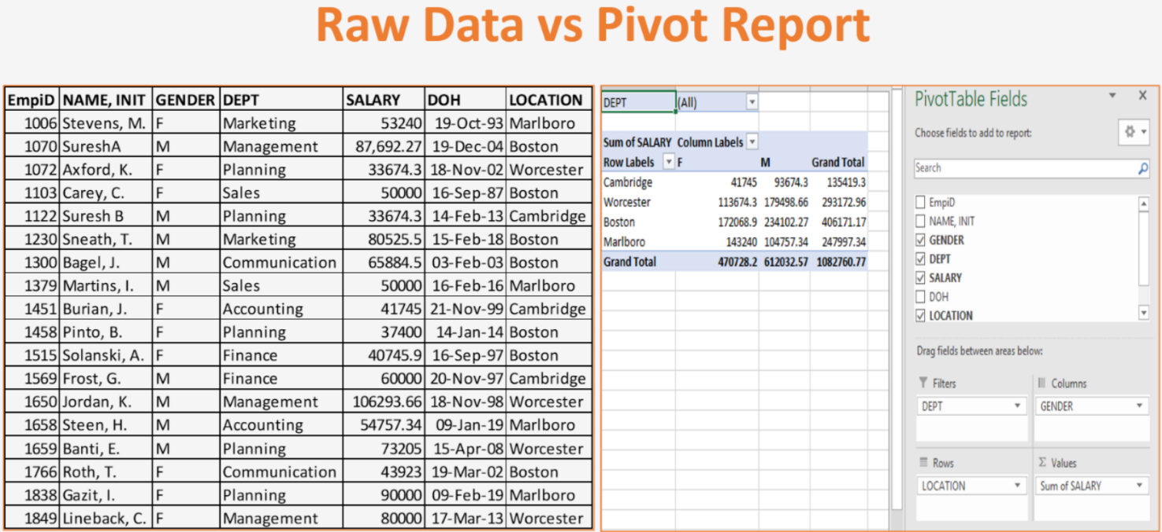
Figure 9, PIVOT TABLE e.g (raw data (left) converted into pivot table (right)).
Benefits of MS Excel:
- Versatile and organised data management.
- You can help your audience/ colleague understand the data patterns better by creating different types of graphs and charts [16].
- Excel allows you to collaborate with others and utilise the table, spreadsheets or whatever date you are working with all at the same time.
Limitations of MS Excel:
- Excel spreadsheets are amazing with limited data to analyse and store however on a larger scale excel may start to slow down and compromise accuracy of data by either rounding off the figures which not only effects time management by having to manually edit or correct data but if not spotted may lead to errors in your stored data [17].
- Excel can be detrimental on large scales if human error gets in the way as all it takes is some incorrect figures and/ or functions and formulas and the whole spreadsheet can be out of sync.

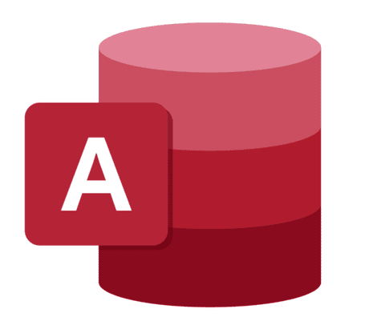
MS Access

Here I will go through some of MS Access’s features, some advantages of MS Access as well as some disadvantages of MS Access. I will also highlight one feature I believe will benefit myself in my future career as a Cyber security engineer. MS Access is great, very common platform that’s used all around the globe and an amazing platform for collating data, creating an easy to manage and easily updatable database [18]. I will show you below an example of information collated (Fictitious data) for clients and arranged in order of their account they hold with the (Fictitious) company.

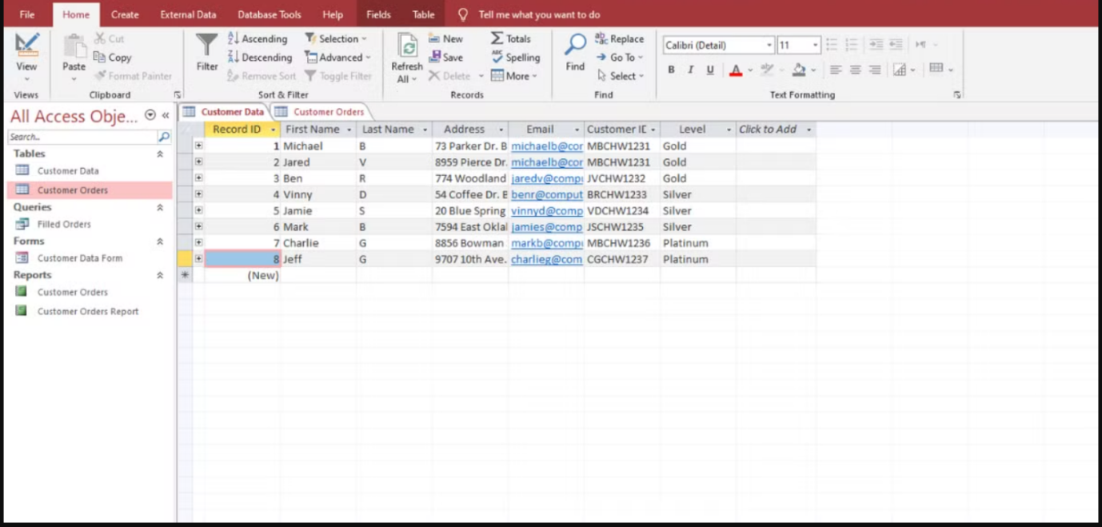
Figure 10, MS Access database table for clients account and personal info (Fictitious)

Benefits of MS Access:
- Versatile platform and once you get used to how to use MS Access it becomes a quick and effective way to collect and store data.
- You can generate reports and use charts to analyse date.
- You can use it in combination with other MS Office tools and platforms as well as being cost effective [19].

Limitations of MS Access:
- Ms Access starts to slow down when to many users are added to manage a database and/ or the amount of data stored starts to creep up towards it’s date size limit [20].
- Limited functionality available for mobile devices so to take advantage of Access you will have to utilise a desktop device.

Section 3b

IF Function

The IF Function is a very commonly used function within MS Excel with options like true or false and high or low results. I will now take you through an example of the IF Function to demonstrate how it actually works and how easy it is to set up and gather the relevant information into the tables. I will be using a random selection of (fictitious) data samples and using the relevant function for each. I will show a screenshot of the sample WITHOUT any functions attached to it and then with my functions attached. For this particular function I will be using a formula to identify total revenue within the sample table below if above or equal to £1000 it will state “HIGH” and if it is below £1000 it will state "LOW” and I will show screenshots below after each step and highlight the relevant information.

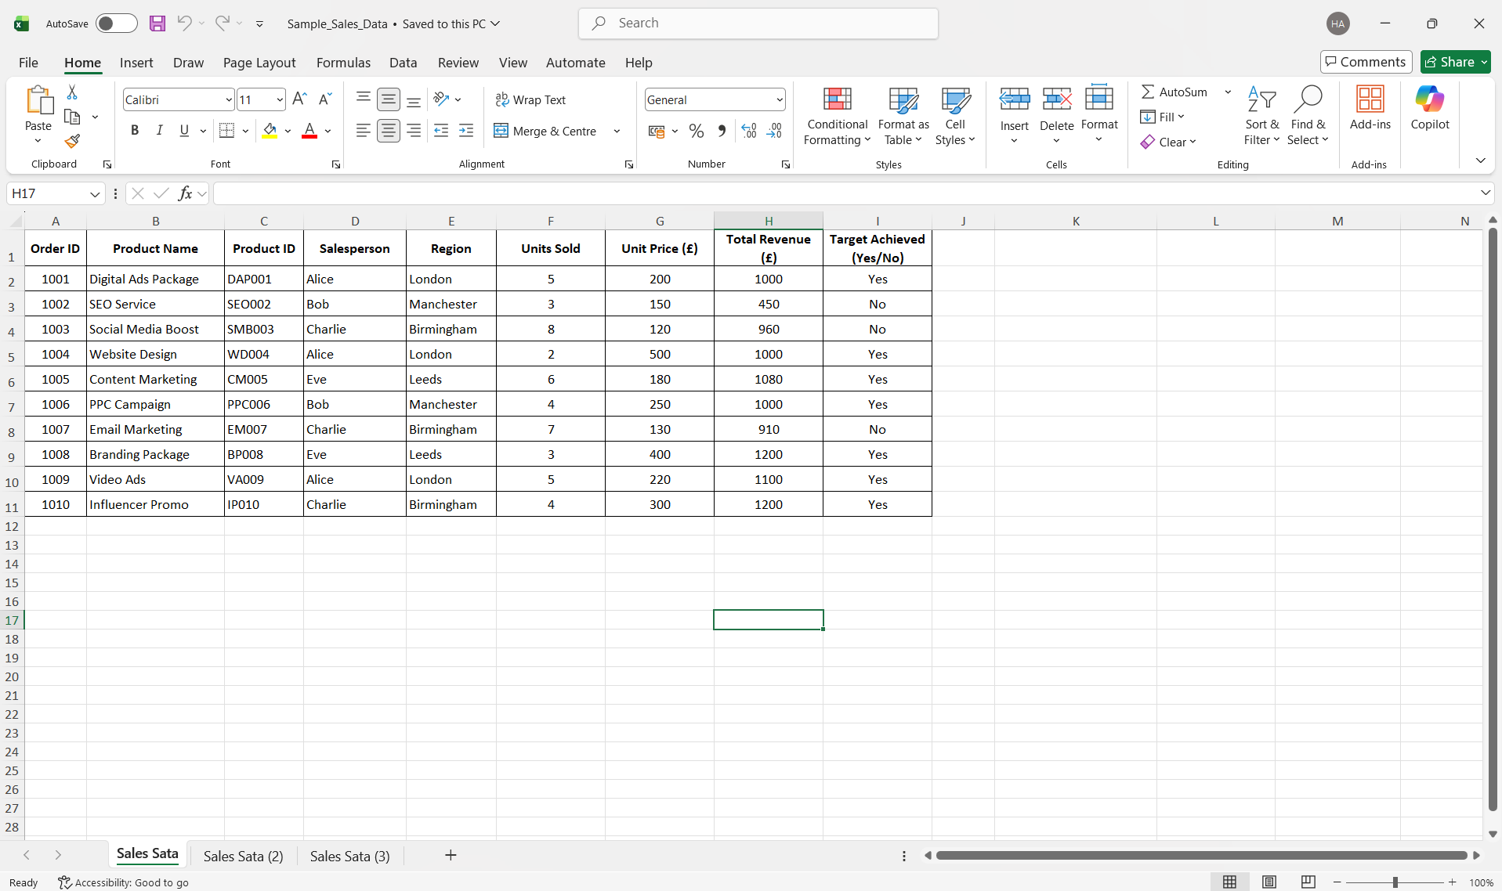
Figure 11, MS Excel sample data table (With NO functions)

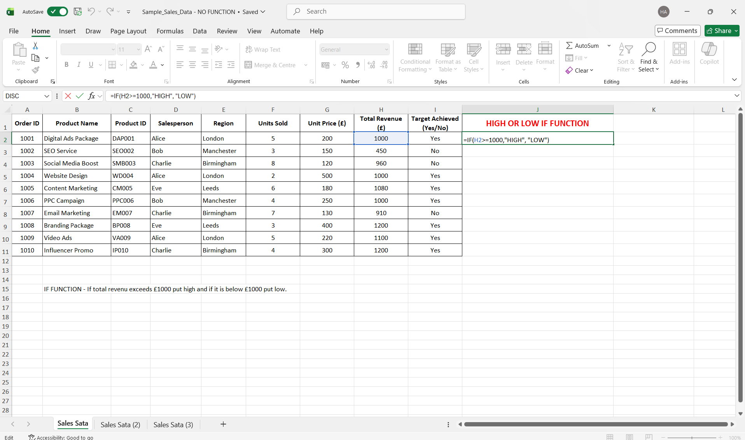
Figure 12, MS Excel - IF FUNCTION added (=IF(H2>=1000,"HIGH", "LOW")

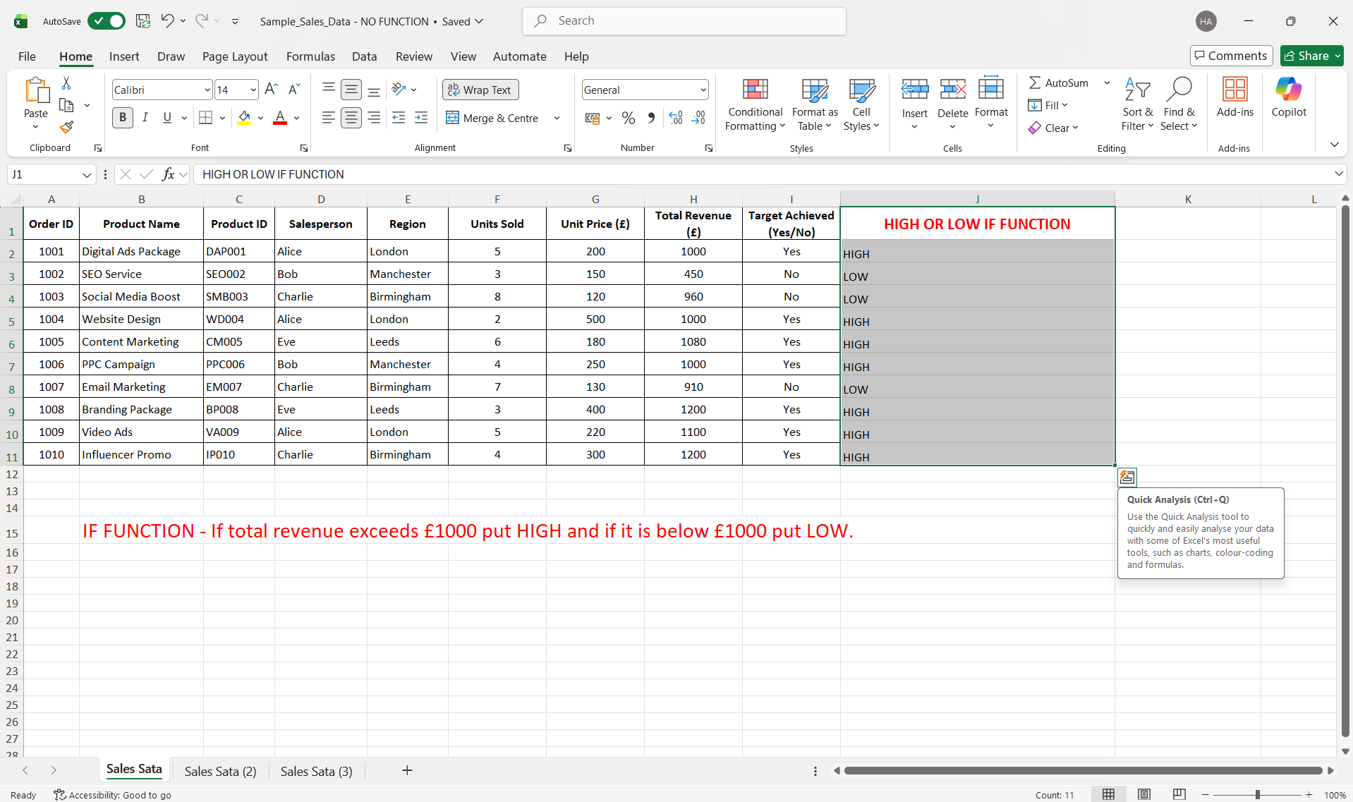
Figure 13, MS Excel - IF FUNCTION results (HIGH/LOW)

VLOOKUP
VLOOKUP is another commonly used function within MS Excel which allows you to search and retrieve relevant types of data and information held within that spreadsheet/ database in an efficient and timely manner. This function not only aids time management which is very crucial when it comes to deadlines and productivity it also benefits the analysts who need to search and retrieve a numerous amount of data and multiple times also. In this VLOOKUP example I will show a screenshot of the sample WITHOUT any functions attached to it below and then with my functions attached and the results to follow. VLOOKUP function - I want to know the "UNIT PRICE" of a particular "PRODUCT ID" (3 examples searched below).
Figure14, MS Excel sample data table (With NO functions)

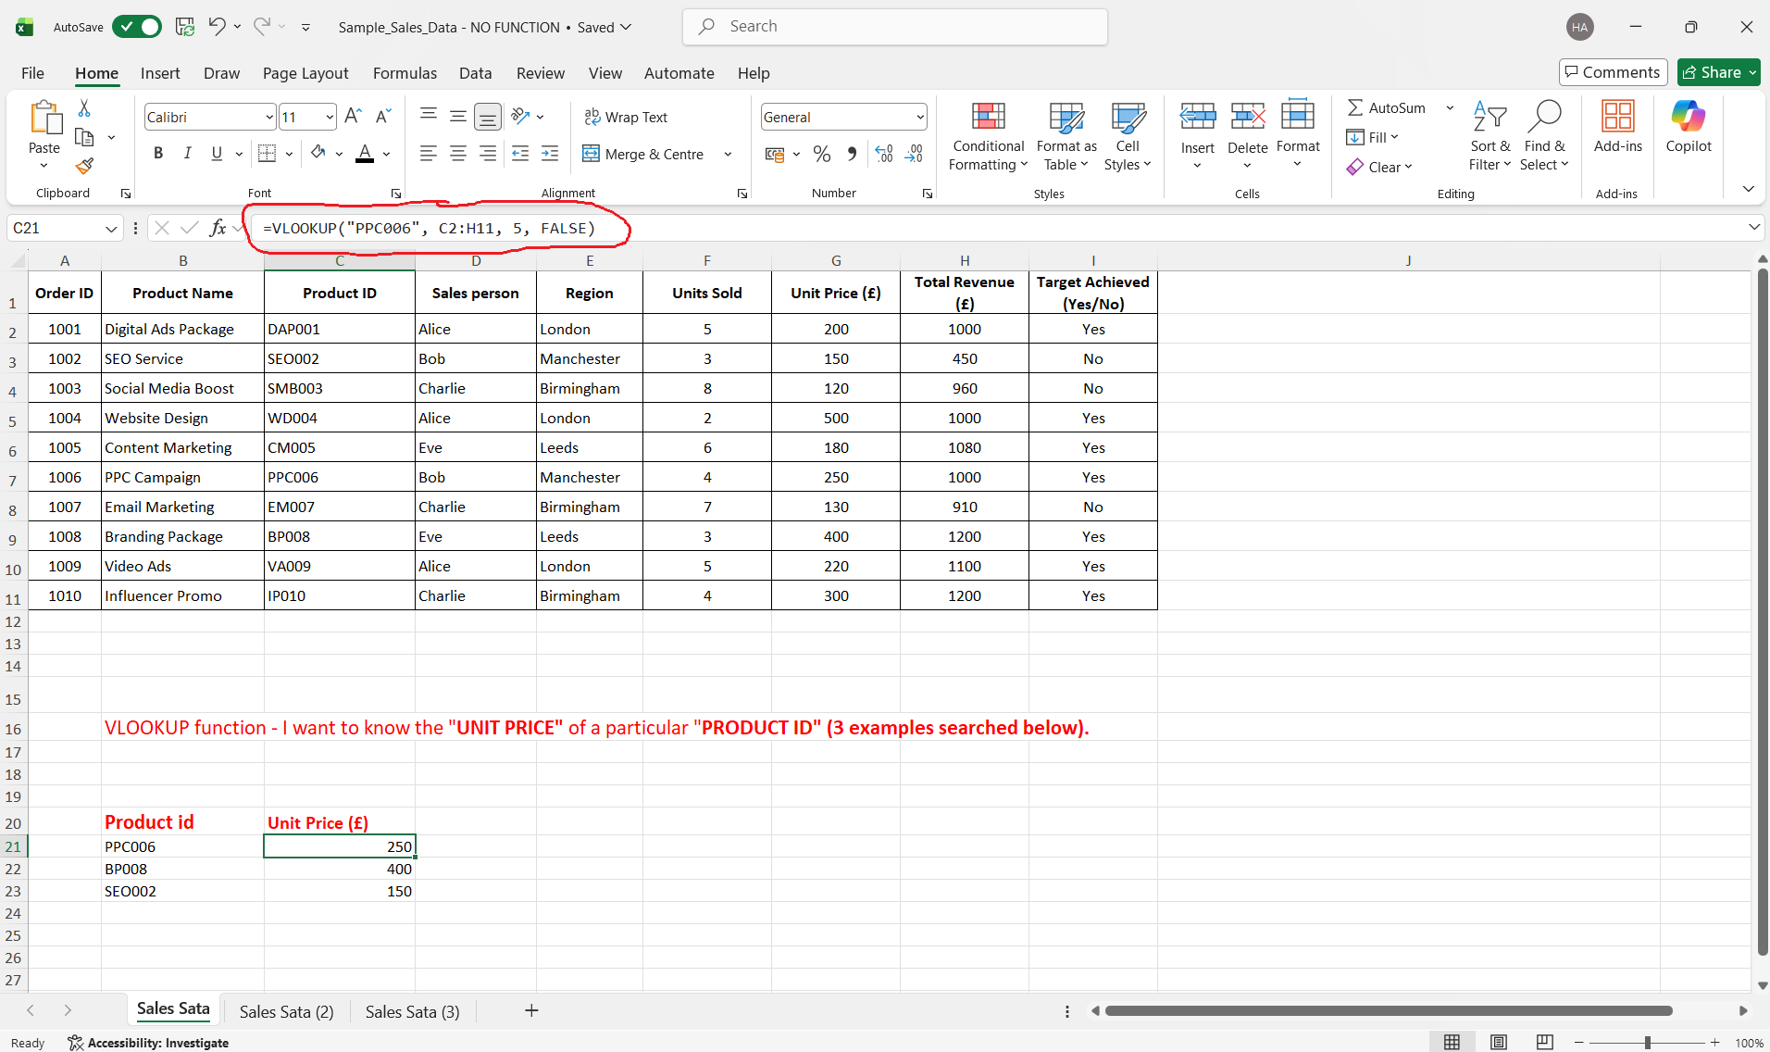
Figure 15, MS Excel - VLOOKUP FUNCTION- UNIT PRICE for Product ID - PPC006

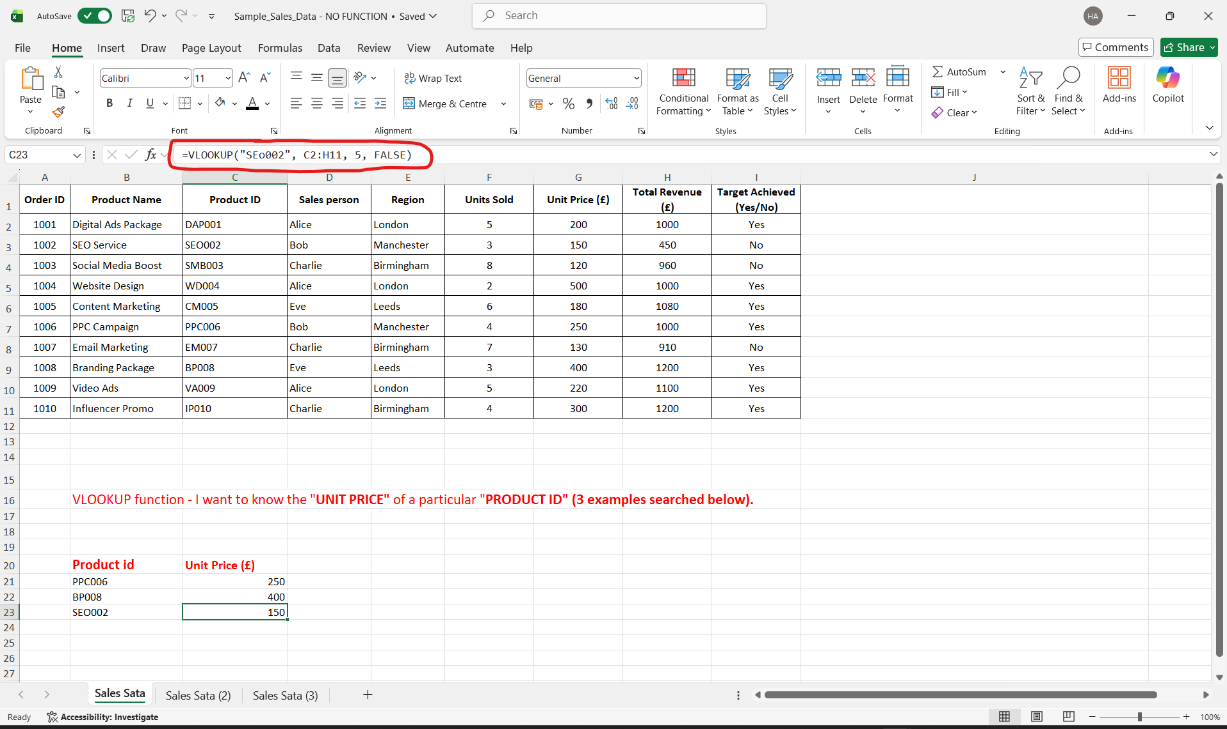
Figure 16, MS Excel - VLOOKUP FUNCTION- UNIT PRICE for Product ID - SEO002

Section 4 Communication and Collaboration applications

Section 4a

These days everything is ONLINE, social media, communication and collaboration. In today’s modern world within a business platform everything is moving to a more faster paced, faster communication, faster collaboration aspect. We want something done or a message to go out whether it be to clients or colleagues we look for the fastest most convenient way possible. This is what brings me to a communication tool I want to discuss known as MS OUTLOOK and a collaboration tool knowns as MS TEAMS [21].
As I take you through this task, I will be dwelling into some of the key features for both MS OUTLOOK and MS TEAMS. I will also highlight how and why most organisations if not all use the platforms on a daily basis.

Communication tool


OUTLOOK EMAIL

To start with I will be talking you through a reputable, widely used contemporary communication platform called OUTLOOK. This platform is now a familiar zone for more or less all of us, daily used by the majority be it for personal or business use [22]. This platform has become so popular due to it’s versatile and user friendly interface. I will list several key features for this platform which will help you understand why it is so popular and convenient for us all to use.
- Management of your emails is so convenient as you are able to organise them into individual folders, categories them accordingly and flag them to mark their importance.
- Your are able to manage and use multiple email addresses/ accounts all under one umbrella.
- As a business the option of integrating your calendar intwined within outlook not only allows you to stay on top on events and task but also allows you to set reminders as well as being able to schedule those very important meetings.
- With time everything advances and unfortunately so does cyber crime and that’s where outlooks advanced security and encryption comes into play especially with it’s 2 factor authentication.
- This platform is available to use no matter what device you are using whether is be a desktop or mobile device regardless of what software/ firmware your device uses (e.g IOS/ ANDROID).

Collaboration tool


MS TEAMS

I will now take you through another reputable, globally used contemporary collaboration platform called MS TEAMS. This platform is an amazing bit of technology as it allows you to communicate with multiple people and invite them into a group session and collaborate together. For many businesses this platform is a vital collaboration tool, this has become a global go to and ever more since covid 19 in 2020 where majority businesses decided to take advantage of the forever evolving online contemporary platforms and started working hybrid [23]. I will now list several key features for this platform which make a lot more sense as to why it is so popular and convenient for us all to use whether in the office or working hybrid.
- Ability to have shorter but more proactive meetings.
- Group work made easy regardless of location, as long as you have a device with MS Teams and an internet connection you are on.
- Collaboration with colleagues is all done in real time, so no more awaiting for someone to reply to yourself or get back to you at a later time unless you do not have a choice depending on the subject.
- Agile and integrated with other MS 365 applications.
- This in fact reduces the need for emailing rather speak in real time and get the information needed there and then.
- You can always go back and look at chats and information shared as that is available even once you have logged off.
- Ability to send attachments all in one place so you can all view them together.

Section 4b
Communication and collaboration platforms are all utilized globally for both personal and business conveniences. These are the most common ways to interact with one another and I will demonstrate with a few screenshots of both communication and collaboration applications to show how easy and quick the process is for each.

Communication tool - Feature 1.

OUTLOOK EMAIL

The feature I will be demonstrating for MS OUTLOOK is sending an email with an attachment.
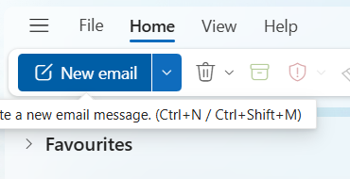

Figure17, Once you have opened Outlook, on the main dashboard, towards the top left click on "NEW EMAIL"
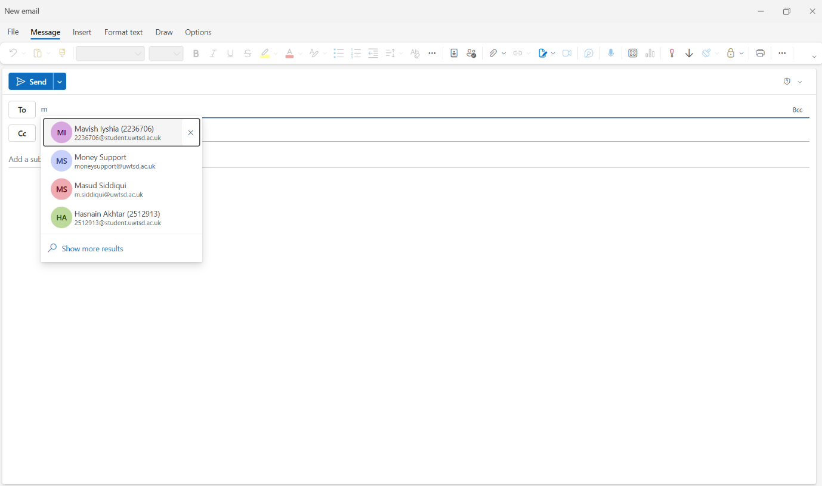
Figure 18, This tab will then open where you can select a recipient (TO)

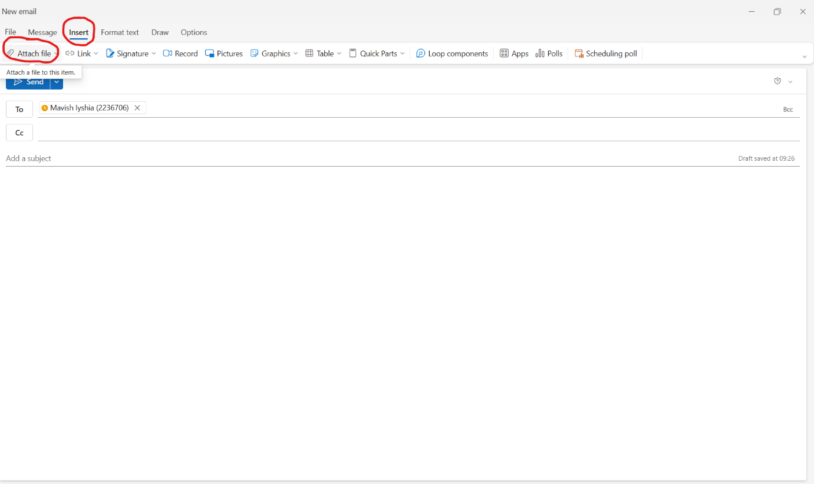
Figure19, You then click "INSERT" and then "ATTACH FILE"

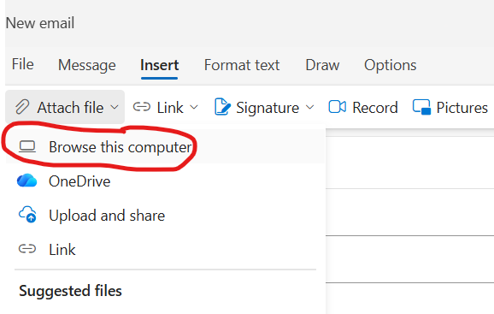

Figure 20, This tab will then appear and you click on "BROWSE THIS COMPUTER" as I have the attachment I want to send saved on this computer

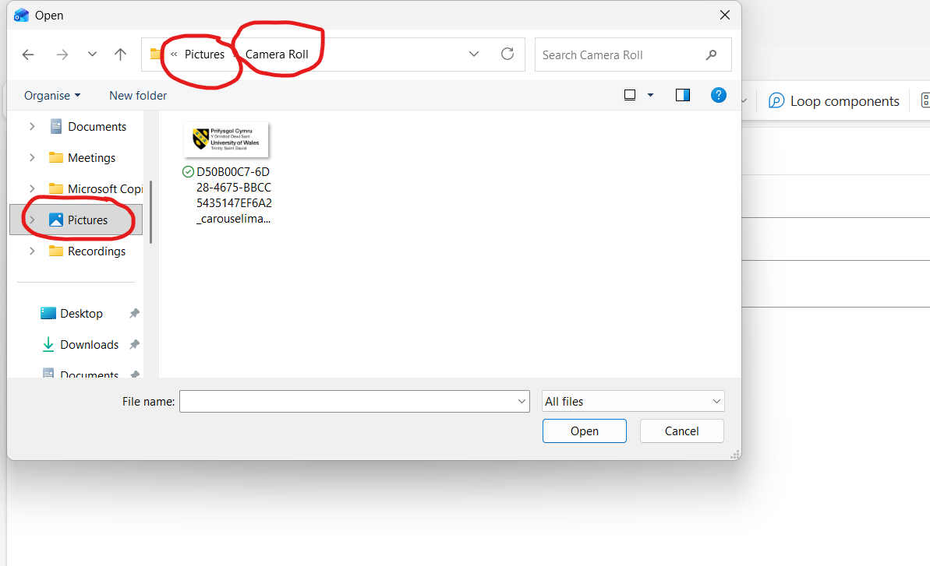
Figure 21, This will then bring up my documents, I click on "PICTURES", then "CAMERA ROLL" and then select that picture to attach to my email

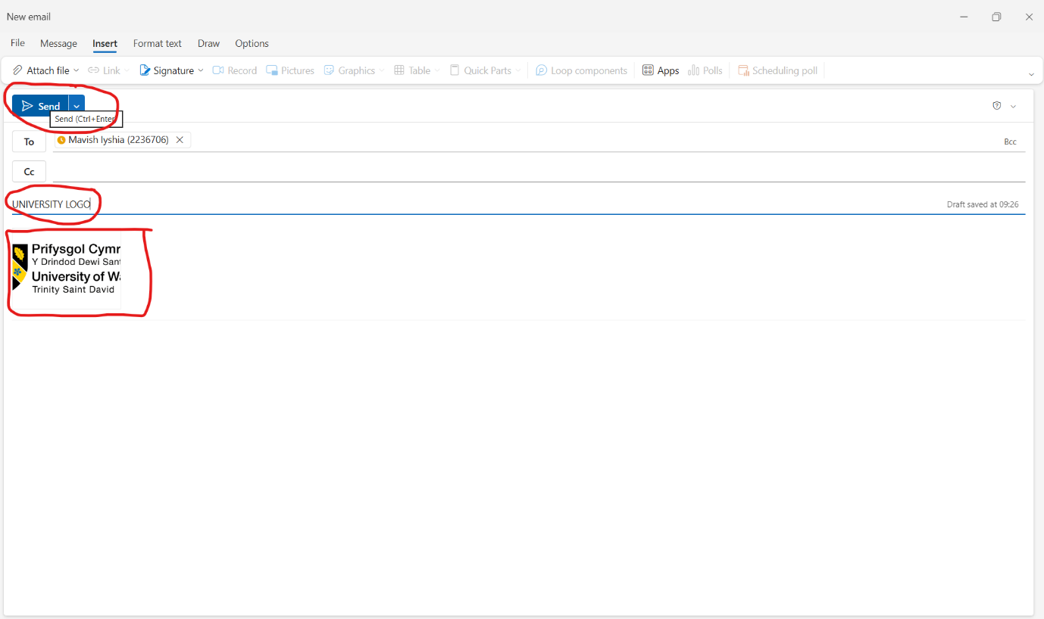

Figure 22, Finally once you have the picture attached, you can then add a subject and finally click "SEND" as circled in red

Collaboration tool – Feature 1.

MS TEAMS

The feature I will be demonstrating here for MS TEAMS is making a call.

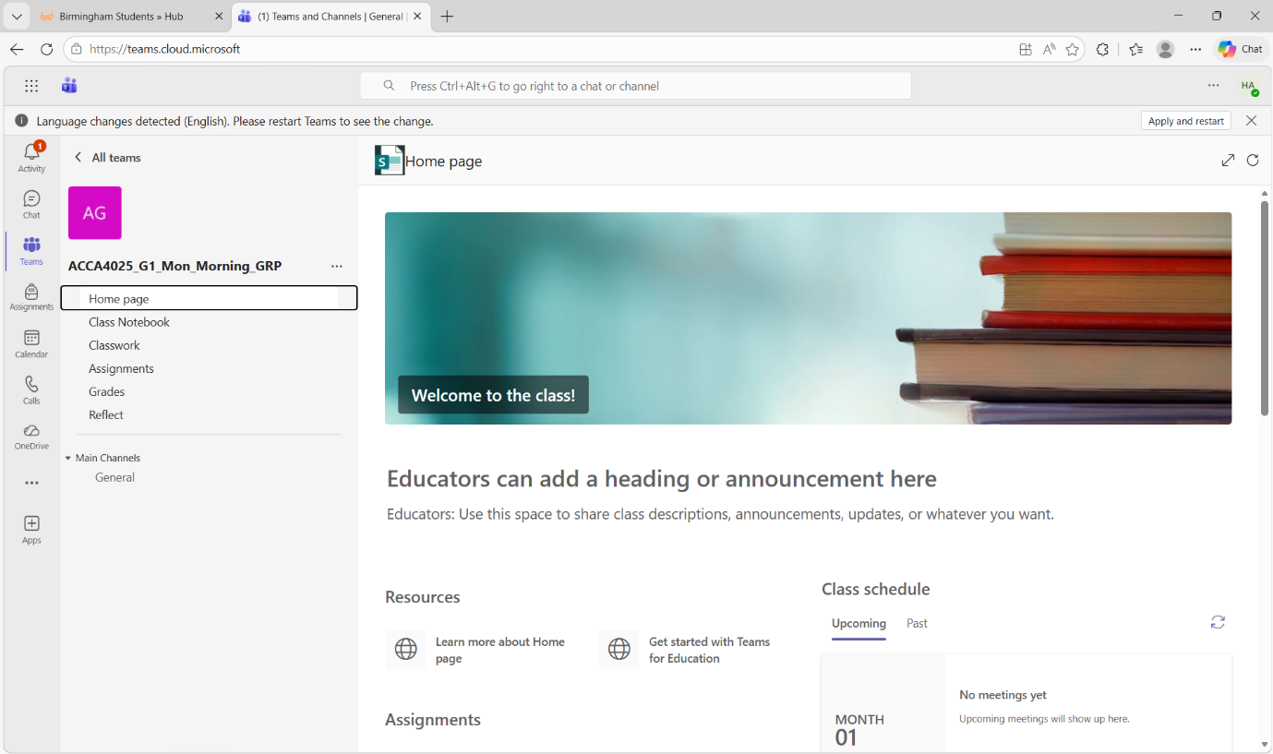
Figure 23, First we open MS TEAMS which takes us to the home page

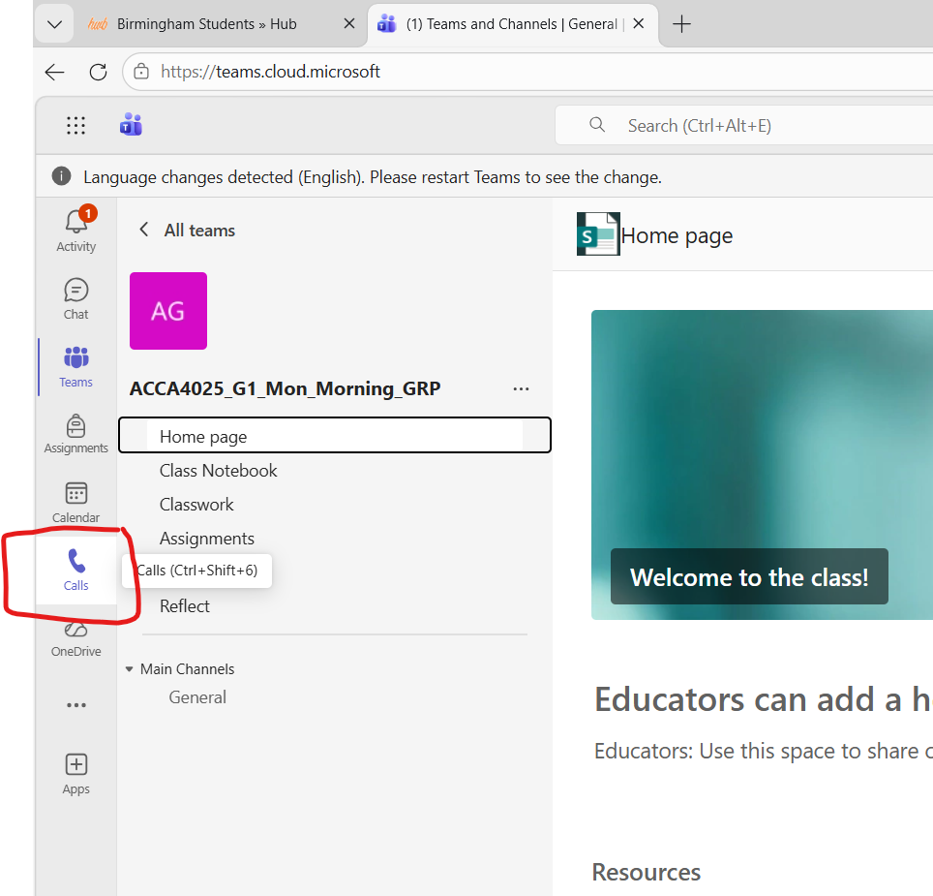
Figure 24, On the left I have drawn a square around the "CALL" tab which we now click

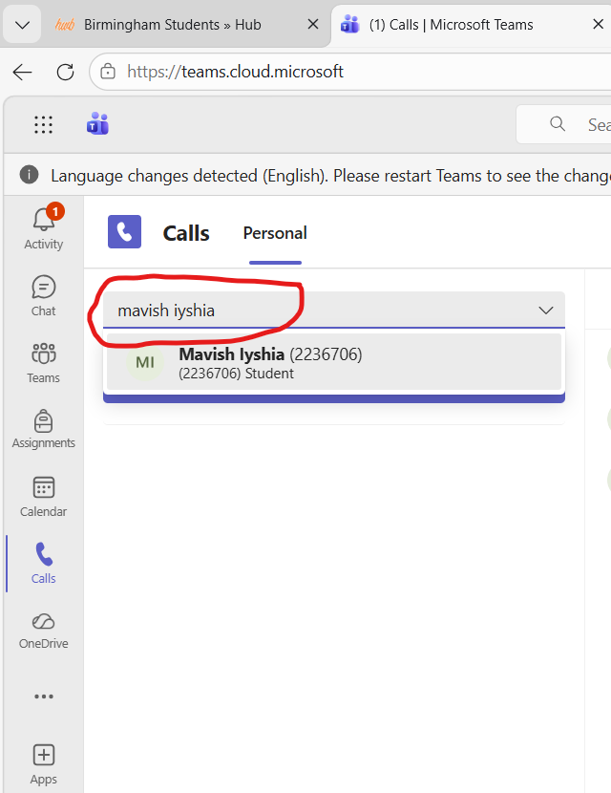

Figure 25, You then select or type the name of whom you wish to call in the box which I have circled

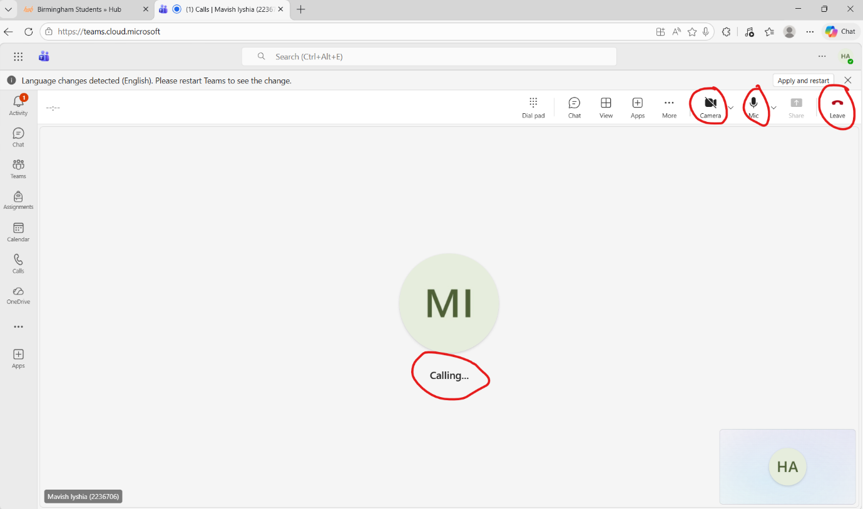
Figure 26, Finally the call is now in progress, you can choose to control your mic and camera as you wish (circled) and once finished you can end the call (also circled)

CONCLUSION

To conclude, all in all we have learned that majority of businesses in the modern world now not only use digital communication and collaboration platforms, as well as E-Commerce websites such as the ones I have discussed above and others, but they actually rely on them. We use the platforms that regularly and for so much of our daily tasks this day and age, without these platforms we would be truly lost and time management, well… we will leave that for another day.
Moreover everything we have discussed from online platforms to mind maps, they all have their importance and play their own crucial roles within our business day-to-day needs. In this fast paced and ever-growing digital era, the more we familiarize ourselves with technology and build confidence in using the vast majority of the platforms and tools out there, the better it will be for us all as we progress up our career ladders.

References:

[1] “Website Builders Comparison: Find the Best Site Builder,” www.top10.com, Nov. 25, 2021. https://www.top10.com/website-builders/comparison
[2] RSA Creative Studio, “Is Wix Worth It in 2026? 13 Real Pros and Cons,” Rsacreativestudio.com, Mar. 10, 2026. https://www.rsacreativestudio.com/blog/is-wix-worth-it-in-2026-13-real-pros-and-cons
[3] https://dodropshipping.com/author/wachira, “17 Shopify Pros and Cons (Is It Still Worth It in 2026?),” Do Dropshipping, Apr. 03, 2023. https://dodropshipping.com/shopify-pros-and-cons/
[4] J. Haines, “The Power of Mind Mapping for Business Success,” ABC Money, Dec. 23, 2024. https://www.abcmoney.co.uk/2024/12/the-power-of-mind-mapping-for-business-success/
[5] S. Peek, “How Mind Mapping Can Help Entrepreneurs,” business.com, Apr. 03, 2023. https://www.business.com/articles/benefits-of-mind-mapping-for-professionals/
[6] The and G. Low, “8 Benefits Of Mind Mapping & The Data That Proves It,” The Digital Project Manager, Oct. 18, 2022. https://thedigitalprojectmanager.com/project-management/benefits-of-mind-mapping/
[7] TheKnowledgeAcademy, “What is PowerPoint?: Introduction, Features, Uses & Benefits,” www.theknowledgeacademy.com, Aug. 16, 2023. https://www.theknowledgeacademy.com/blog/what-is-powerpoint/
[8] “Top 15 Excellent Advantages Of Ms PowerPoint,” May 10, 2022. https://advantageslist.com/top-15-excellent-advantages-of-ms-powerpoint/‌
[9] J. Scott, “17 Advantages And Disadvantages Of Powerpoint,” PresentationSkills.me, Nov. 13, 2022. https://www.presentationskills.me/advantages-and-disadvantages-of-powerpoint/
[10] “Advantages and Disadvantages of Using PowerPoint for Presentations,” SlideUpLift, May 10, 2023. https://slideuplift.com/blog/advantages-and-disadvantages-of-using-powerpoint-for-presentations/
‌[11] J. Valiente, “How to Add a Signature Line in Word: Our Step-by-Step Guide- SignWell,” SignWell, Oct. 08, 2025. https://www.signwell.com/resources/how-to-add-signature-line-in-word/
[12] “List of Top 10 Advantages of Ms word - Advantageslist,” Apr. 30, 2022. https://advantageslist.com/list-of-top-10-advantages-of-ms-word/
[13] TechBloat, “What Are The Advantages Of Using Microsoft Word - TechBloat,” TechBloat, Jan. 19, 2025. https://www.techbloat.com/what-are-the-advantages-of-using-microsoft-word.html#gsc.tab=0
‌[14] “15 Advantages and Disadvantages of Microsoft Word,” Oct. 06, 2023. https://barrazacarlos.com/advantages-and-disadvantages-of-microsoft-word/
[15] L. Education, “The 6 Benefits of Using a Pivot Table in Excel | Lorman Education Services,” www.lorman.com, Apr. 06, 2022. https://www.lorman.com/resources/the-6-benefits-of-using-a-pivot-table-in-excel-17423
[16] Puneet, “Top 10 Benefits of Microsoft Excel – Why YOU Should Learn it in 2020,” Excel Champs, 2023. https://excelchamps.com/benefits-of-microsoft-excel/
[17] IOA, “Excel’s Limitations in Modern Business and Real-World Implications,” IoA - Institute of Analytics. https://ioaglobal.org/blog/excels-limitations-in-modern-business-and-real-world-implications/
[18] “9 Benefits of using Microsoft Access,” Popular Tech World, Feb. 28, 2025. https://populartechworld.com/9-benefits-of-using-microsoft-access/
[19] T. Singh, “Advantages & Disadvantages of MS Access,” ScaleupAlly, Dec. 21, 2020. https://scaleupally.io/blog/advantages-disadvantages-of-ms-access/
[20] J. Fisher, “What Is Microsoft Access? A Beginner’s Guide,” AddictiveTips, Oct. 29, 2025. https://www.addictivetips.com/microsoft-office/what-is-microsoft-access/
[21] Chiara Alzati, “The New Era Of Corporate Communication: From Informing To Connecting,” Forbes, Dec. 03, 2024. Available: https://www.forbes.com/councils/forbescoachescouncil/2024/12/03/the-new-era-of-corporate-communication-from-informing-to-connecting/
[22] G. Mileva, “Outlook User Statistics: Fresh Insights For 2025,” Clean.email, Jan. 23, 2025. https://clean.email/blog/email-providers/outlook-statistics
[23] “Microsoft Teams’ Role in the Post-Pandemic Workplace,” nexacu.com. https://nexacu.com/insights-blog/microsoft-teams-role-in-the-post-pandemic-workplace/

