Certificate of Higher Education in Business Skills for the Workplace
Academic Skills
Task 3- Reflective Report
LCLM 4001
Student Name:
Student ID:

Table of Contents
Introduction 3
Main Discussion 3
Conclusion 7
References 8

Task 3

Introduction
Reflective practice is the approach of self-evaluation based on a set of specific experiences that allows an individual to establish strategies on behalf of self-development aspects (Akpur, 2020). This particular report produces my initial thoughts and understandings regarding the Academic Skills Module. I have specifically used Gibb’s reflective cycle as the formation of this reflective discussion and induced the stages allocated in the model as part of the discussion. The academic skills that I will indulge in in this reflective report will include academic writing, research skills, and summarising skills. I think these three skills are necessary for any academic like me to enhance the attributes of academic performance.

Main Discussion
Gibb’s Reflective Model
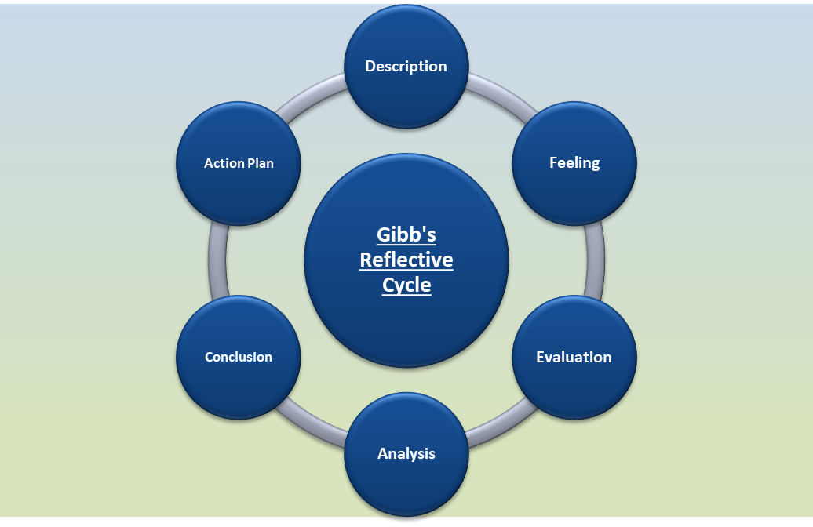
Figure 1: Gibb’s Reflective Cycle
As opined by Adeani et al., (2020, p.141), Gibb’s reflective model is a comprehensive reflective model that produces effective actions necessary in the personal and professional development process based on a self-evaluation process. The six stages of Gibb’s reflection model include description, feeling, evaluation, analysis, conclusion and action plan (Hashim et al., 2023). In the following discussion, I have utilised these six stages as individual yet correlative aspects of the discussion regarding the way this module has influenced my academic skill development.
Description
The description stage of Gibb’s reflective cycle enables the individual to describe the executed activities and their experience (Markkanen et al., 2020, p.51). As per my understanding, the current module of Academic Skills focused on delivering fundamental to advanced skills development prospects. The module content had fundamental and logical explanations about the different skills and their application in academic aspects. The three tasks curated in this module needed different actions based on their characteristics. All the tasks included in this module required individual levels of activities. The first task of this module included a quiz contest based on the academic skills and practices that were directly related to developing my time management, taking and referencing skills. The second task of the module included a tools exercise based on the three academic skills such as note-taking, paraphrasing and academic writing skills. I found both tasks to be effective in terms of providing me with a stage to perform and utilise my existing knowledge as well as gaining knowledge based on activities such as quiz contests and tools exercises. I believe that the individual tasks allowed me to be a part of the learning environment which is necessary for any student to be a part of inclusive and active learning.
Feeling
The feeling stage of Gibb’s reflective model enables a learner to describe the inner thoughts about the learning experience described in the previous stage (Bassot, 2024). Personally, I feel that both the tasks included in the module were necessary and I thank my module leader for inducing innovative methods in academic practices. The quiz contest delivered a professional stage of the competition which influenced my performance levels. Task one required me to practice the integral knowledge of the key evidence based on the relative skills. I needed to be efficient and accurate at the same time which required an extended level of research and knowledge acquisition at the time. As per the views of Lee et al., (2020, p.1471), research skills are necessary for any learner to enhance the capability of knowledge gathering and utilisation as per necessity. Based on this viewpoint, I believe that research skills are the foremost criterion that is going to influence my further academic activities. On the other hand, the second task was most influential in terms of realising where I stand regarding academic skills and summarization. The second task was crucial to identify the efficient level of performance as per the regulations established by the module leader. Therefore, it is certain that irrespective of the drawbacks that I have encountered during these tasks, they were necessary to enhance my performance based on academic writing and summarization skills.
Evaluation
The evaluation stage of Gibb’s reflective model creates a position of assessing the need for change based on previous experience (Ningrum and Ariani, 2020, p.311). I believe that both summarization skills a necessary attributes that influence the overall development of academic writing. As depicted by Scruggs and Mastropieri, (2021, p.231), summarization skills are constructive standards of academic writing that enable any writer to create a smaller version of large content. The research activities I have gone through via books, websites and journals produced a significant amount of necessary information regarding the academic practices. Each module and task always produced a fixed number of words to perform and I think that my summarization skills need improvement as I want to produce more efficiency in my work. The particular characteristics of summarization require the right choice of words and a calculative approach to which information is necessary for the particular academic activity (Zou et al., 2020). As per my understanding, this will directly influence my academic writing as summarisation is a major part of academic writing. In consideration of academic writing, the key aspects that I have found to be challenging are the formation and use of additional skills like formatting the content and choosing the writing style and tone. The tasks allocated in this module have provided me with the knowledge that academic writing is not just using words to describe inner thoughts as it needs correct formation, method of delivery and utilisation of key resources.
Analysis
The analysis part of Gibb’s reflective model allows a learner to identify the key points of change and reconsideration in terms of personal development (Pieper et al., 2021, p.113). The consideration regarding research skills that I have made in this context is factually correct as I need to do my research properly in every section of academic practice beyond this module. Therefore, I believe research skill is the activity that I have to learn throughout my academic career not just this particular module as research topics and areas of research ought to change as per the area I have chosen for my academic journey. On the other hand, summarization and academic writing skills are particular attributes that I need to work on in this module. As opined by Li and Mak, (2022), academic writing skills are the overall eligibility of creating new and original ideas that maintain academic integrity. As I have described academic writing requires a certain amount of consideration other than writing such as grammatical correctness, sentence structure, format of the content and tone of writing. I believe that practising more academic writing is the key under the supervision of my module leader so that I can be ready to face greater challenges in the future of academic activities. Summarization skills are one of the necessary attributes that I have to adopt that can be effectively used in both my academic writing and other academic practices. I believe that summarization skills are necessary for me to note down a certain point or my understanding of a lecture that I might forget shortly.
Conclusion
The conclusive evidence as per the depicted experience in this module suggests that I have a proper understanding of my current situation regarding research skills, academic writing skills and summarization skills. The detailed description of the stages of Gibb’s reflective model develops a suitable understanding of the experience and realisation I have made in the Academic Skills module. The description of the evaluation and analysis stage suggests that I want to work on my summarisation and academic writing skills as a necessary step to develop myself at this point. I will introduce a detailed action plan about both the skills that I have understood need development in the following stage.
Action plan
Objectives | Actions to be taken | Projected Time Frame
To develop my summarisation skills through practising more in the context of different areas of study that I have selected in my career. | The practice would involve writing down specific summaries about topics discussed in the class and evidence that I would gather through research. I want to take effective suggestions from my seniors and module leaders about the way they consider summarising any topic in academic practices. The distinguished viewpoint ought to enrich my thought process which will reflect on my performance in academic writing. The enhanced skill would reflect the quality of my writing in the future. | I believe that enhancing my summarisation skills would take at least two months to complete.
To develop my academic writing skills by participating in an additional session of academic writing. | I want to understand the specific format of a written presentation that is necessary for academic performance such as academic report writing, essay, dissertation and portfolio. I would take part in the dedicated sessions for each aspect of academic writing. This experience is going to enhance my academic performance which will be visible in the assessment outcome in the future. | I believe this practice would take at least three months to complete.

Conclusion
The current reflective report produces a detailed description of the author’s experience in the Academic writing module. The key skills that are discussed in this report include academic writing, research and summarization skills. Each stage of Gibbs's reflective model was elemental in describing different aspects of the modules and key activities that the author wants to take part in as part of the future development process related to this module.

References
Adeani, I.S., Febriani, R.B. and Syafryadin, S., 2020. Using GIBBS’reflective cycle in making reflections of literary analysis. Indonesian EFL Journal, 6(2), pp.139-148. https://journal.uniku.ac.id/index.php/IEFLJ/article/view/3382
Akpur, U., 2020. Critical, reflective, creative thinking and their reflections on academic achievement. Thinking Skills and Creativity, 37. https://www.sciencedirect.com/science/article/pii/S1871187120301577
Bassot, B., 2024. The reflective journal. Bloomsbury Publishing.
Hashim, S.N.A., Yaacob, A., Suryani, I., Asraf, R.M., Bahador, Z. and Supian, N., 2023. Exploring the Use of Gibbs' Reflective Model in Enhancing In-Service ESL Teachers' Reflective Writing. Arab World English Journal, 14(2). https://www.researchgate.net/profile/Ina-Suryani/publication/371830975_Exploring_the_Use_of_Gibbs'_Reflective_Model_in_Enhancing_In-Service_ESL_Teachers'_Reflective_Writing/links/64d4ddd51290c33cce866847/Exploring-the-Use-of-Gibbs-Reflective-Model-in-Enhancing-In-Service-ESL-Teachers-Reflective-Writing.pdf
Lee, M.G., Hu, W.C. and Bilszta, J.L., 2020. Determining expected research skills of medical students on graduation: a systematic review. Medical Science Educator, 30, pp.1465-1479. https://link.springer.com/article/10.1007/s40670-020-01059-z
Li, J. and Mak, L., 2022. The effects of using an online collaboration tool on college students’ learning of academic writing skills. System, 105. https://www.sciencedirect.com/science/article/pii/S0346251X21002669
Markkanen, P., Välimäki, M., Anttila, M. and Kuuskorpi, M., 2020. A reflective cycle: Understanding challenging situations in a school setting. Educational Research, 62(1), pp.46-62. https://www.tandfonline.com/doi/abs/10.1080/00131881.2020.1711790
Ningrum, Y. and Ariani, N., 2020. Reflective journal writing: A review of the literature. In NEELS (National English Education, Language and Literature Seminar) Proceedings (pp. 305-313). http://inggris.sastra.um.ac.id/wp-content/uploads/2021/05/Copy-of-043-P313-Yuniatri-Nova..pdf
Pieper, M., Roelle, J., vom Hofe, R., Salle, A. and Berthold, K., 2021. Feedback in reflective journals fosters reflection skills of student teachers. Psychology Learning & Teaching, 20(1), pp.107-127. https://journals.sagepub.com/doi/abs/10.1177/1475725720966190
Scruggs, T.E. and Mastropieri, M.A., 2021. How to summarize single-participant research: Ideas and applications. In The meta-analysis research in special education (pp. 227-244). Routledge. https://www.taylorfrancis.com/chapters/edit/10.4324/9781410608260-5/summarize-single-participant-research-ideas-applications-thomas-scruggs-margo-mastropieri
Zou, Y., Zhang, X., Lu, W., Wei, F. and Zhou, M., 2020. Pre-training for abstractive document summarization by reinstating source text. arXiv preprint arXiv:2004.01853. https://arxiv.org/abs/2004.01853

