Exploring Behaviour and Interventions in the Learning Environment
SJTA5007
This assignment will be discussing internal and external factors that can encourage behaviour within the learning environment, and briefly mentioning behaviours that can be displayed. The author will discuss theories from Jean Piaget and Abraham Maslow, and their link to these factors.
There are many factors that can affect childhood behaviour in the learning environment, and it is very important never to assume the reasons behind it. Society are very quick to judge and assume, without thinking there could be reasons behind the behaviour.
The factors are categorised into three headings pervasive development, disruptive behaviour and behaviour problems.
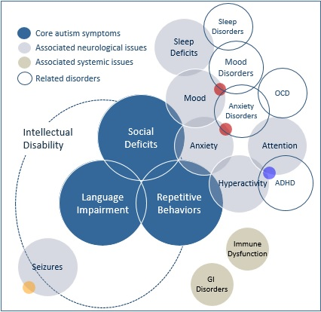
Pervasive developmental disorders, which are internal factors, are those that effect the individual’s development, so diagnosis of Autism, Attention Deficit Hyperactivity Disorder (ADHD), Tourette’s, Dyslexia, Gifted Children and Global Developmental Delay. All these diagnosis’ will bring different behaviours with the child’s development and understanding of the world. For example; Autism generally relates to difficulties in social-interaction, difficulties in communicating, and showing repetitive behaviours.
This diagram shows the basic symptoms of autism. It also shows the issues and related disorders that often accompany Autism. As you can see from the diagram that ADHD is a related disorder, in the sense that an individual with ADHD experiences the same behaviours and associated neurological issues but do not experience seizures.
(Autism Speaks, 2018)

Autistic children have difficulty controlling their emotions, unfortunately for those who assume in society, this behaviour can come across as ‘babyish’ behaviour, behaviours such as crying and temper tantrums in untimely situations. Autistic children can become physically aggressive and troublesome, in ‘unfamiliar, overwhelming or frustrating situations.’ This built up frustration can also lead to more severe behaviours such as biting, grabbing, hair pulling, punching and head banging, among many more.

Psychologist Jean Piaget, was the first to make a logical study of cognitive development. Cognitive development refers to pretty much everything we do, it is perception, memory, reasoning, problem solving and judgment.
Jean Piaget married Valentine Catenay in 1923, who was also a psychologist. She became his research associate and so their research began, studying and observing the behaviour or their own three children. They recorded their children’s developing knowledge from early stages through to their childhood years. They observed them playing, they engaged in playing with them admiring their cognitive development and how it differed from an adult. They recorded milestones, speech, words and actions, they noted the children’s thought processes and basic logic. He continued to observe, research and record his findings on various age groups of children through to adolescent, throughout his career.
Piaget researched cognitive development for his sixty-year career, which he named Genetic Epistemology, the theory of knowledge, its methods, legitimacy, and the distinction between validated belief and opinion. To this day his research has an influence on epistemology, developmental psychology, child psychology and education.
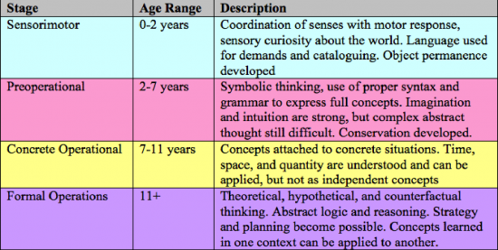
Piaget developed four stages of cognitive development, he believed that a child’s progression from one stage to the next is achieved after a vast exposure to relevant experiences and motivations.

(HQ, n.d.)

The author criticises Piaget’s stages of cognitive development, because I think it depends whether the child has any disorders such as Autism, ADHD, Tourette’s etc. Children with special needs do tend to develop at a slower pace, whilst parental involvement can have a positive impact on their child’s development, the child will still develop at a slower pace than a child without special educational needs.
Also, on the other end of the scale, gifted children are particularly advanced and intellectual for their age and may need a more enriched learning environment, so again this group wouldn’t necessarily fit into Piaget’s stages of cognitive development. Piaget does not appear to have made allowances for special needs, he studied not only his own three children, but the children he studied later all came from well educated families, implying that their children also were of a higher social intelligence, so his research is difficult to associate with other cultures and populations (Verywell, n.d.).
However, the author does feel that Piaget’s research can be used to set targets and milestones for individuals of different status’. The stages of cognitive development can be used a guideline to work toward. For example, behaviour plans and Individual Education Plans (IEP).
Disruptive Behaviour disorders are both internal and external factors, for example, genetic disorders such as ADHD or brain functions cause enhanced reactions to day to day problems. These disorders include Oppositional Defiant Disorder (ODD) and Conduct Disorder (CD), which HealthyChildren.org, 2018, states “often first attract notice when they interfere with school performance or family and peer relationships, and frequently intensify over time.” The individuals may experience a ‘normal’ problem, for example their routine may have changed, for unforeseen circumstances such as the minibus had broken down. Due to the child’s developmental disorder, i.e. ADHD, adding to their behaviour disorder, the reaction to this could be extreme anxiety, and could result in lashing out, kicking, and screaming.
The characteristics of ADHD have three titles, Inattention; which is poor concentration, easily distracted, no focus, not listening or completing tasks. Impulsivity; inappropriate behaviours, impatience and acting before thinking. Hyperactivity; Inability to act quietly and calmly, restless and fidgety behaviour. Statistics say that more boys than girls and the disorder at a ratio of 4:1.
The author supports professionals saying that interventions for ADHD should be ‘skills not pills’. There are stimulant medications available, which can help the condition, but cannot provide skills and strategies that would be beneficial to thrive in life. Skills such as personal values, courage, honesty, integrity, responsibility and self-discipline. These skills need to be demonstrated and taught by parents, educational staff and other professionals. These skills build character.

There are many interventions that can be used when working with a child or young person with ADHD, ignoring inappropriate behaviours usually displayed to gain attention, removing items from the classroom which may distract, offering sensory items to assist in calming, provide an area for them to calm and self-regulate, this could be in the form of a soft play room or sensory room.
It is important to give praise immediately, regarding appropriate behaviour, the more likely the child will repeat it, but its important to change verbal and physical praise acknowledgment, this is because if they are praised in the same way each time the praise loses its significance, resulting in inappropriate behaviour being displayed.
Children and young people with ADHD are individual, they are all different, some interventions may work with some but not others. There is no cure, and no medication, no one way of teaching skills, that will work the same for all, so it is important to address the behaviour not the symptoms.
There are many theories on ADHD, and it can be split into two groups these being ADHD is a disorder, and ADHD is a naturally occurring phenomenon in humans. However, there is unfortunately a third group, the conspiracy that ADHD was invented by the pharmaceutical industry “disorder to medicate” (Adhd-health.com, n.d.).
The final factor is Behaviour Problems which is an External Factor, environmental factors, which could include things like observations and experiences with family members who initiate alcohol abuse, drug abuse, violence, bullying and general criminal activity. These behaviour problems could be a result of family breakdown, poverty, a bereavement, moving school, home or city, these experiences can have a serious affect on how an individual behaves, the stress, anxiety, grief, upset, and anger can trigger any number of behaviours.
A child needs to feel secure, to feel safe in their own home and in the care of their parents and family. This sense of security is extremely important for a child to achieve, research from Feinstein and Symons (1999) found that “very high parental interest is associated with better exam results, than those children whose parents show no interest.” Children who receive their parents support and motivation find it easier to learn, they have the confidence to turn to their parents and request help, or report any concerns. Parental involvement in their child’s education has a positive affect on their child’s mental health and wellbeing.
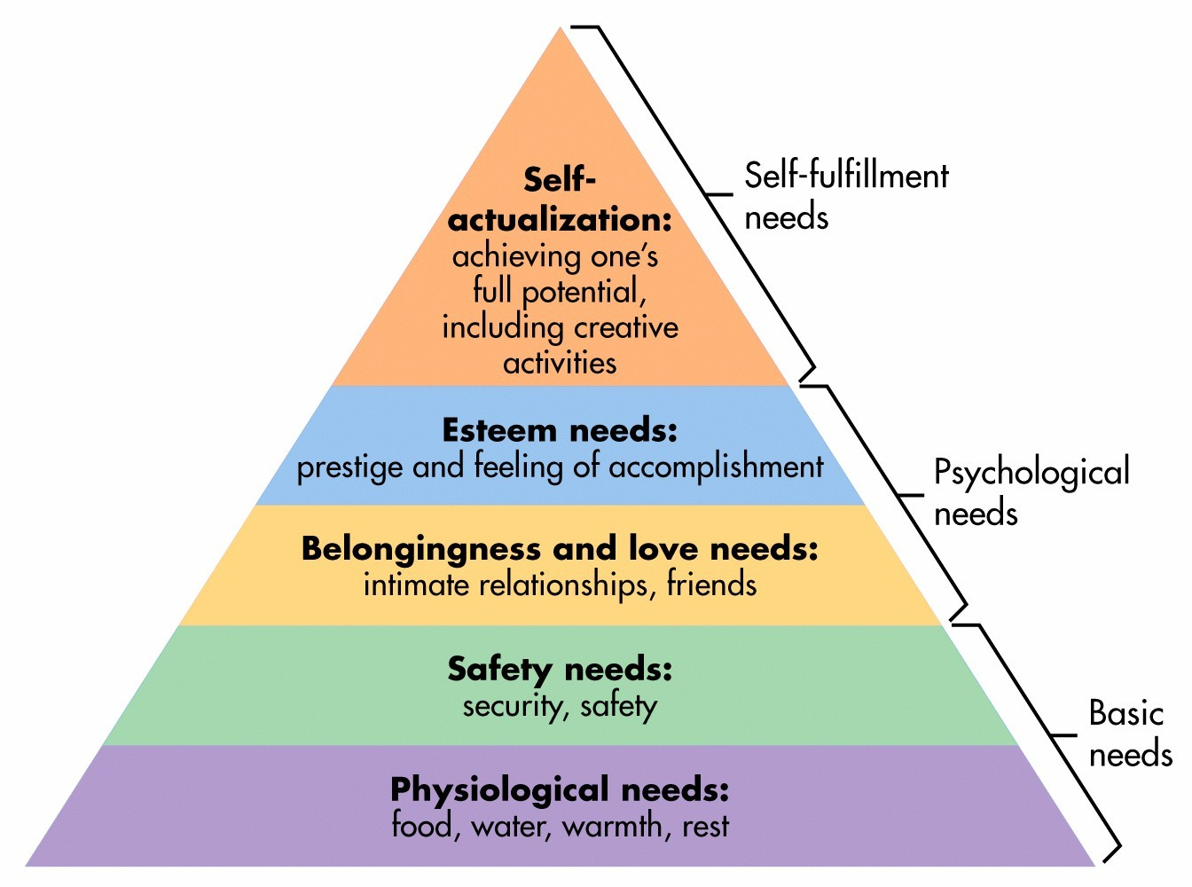
Abraham Maslow studied humanistic psychology, and developed a hierarchy of needs, he believed that humans basic need for physical survival, is the first thing that motivates our behaviour. Once that level is achieved then the next level up is what motivates us to move further up the pyramid towards the ongoing process of self-actualisation.

Maslow classes the first four stages of his theory as deficiency needs, the top of his pyramid is known as the growth or being needs.

(Simply Psychology, n.d.)
Maslow believed that everyone is striving to reach their full potential, the author agrees with this thought, however, there are factors that may interrupt his theory.
The stages of Maslow’s pyramid identify external factors, that can have an effect not only on development and achievement but also on an individual’s behaviour.
Families living poverty may not even reach the first two stages, physiological needs and safety needs. A family may not have an income, maybe a single parent family with young children, so unable to go out to work due to the lack of childcare available, or a more severe situation could be that there has been a bereavement in the family, and a family member may turn to alcohol or drug abuse, which can be expensive as well as dangerous. It is heart-breaking to think that there are families out there that prioritise their addiction over their needs, or their children’s needs, then children can become neglected.
Some families may be just getting by living on benefits, some may have the motivation to eventually get back to work, in Maslow’s theory they then would move up the pyramid towards self-actualisation and further improve themselves. Unfortunately, there are also families who have no desire to go back to work, no future aspirations. These behaviours can be model behaviours for children and young people, it is unfortunate that some children will grow up the same way as their parents, living off benefits with not future hopes or dreams, just treading water for most of their lives not amounting to anything, possibly turning to alcohol, drugs or criminal activities.

Of course, there is always that possibility of them changing their lives around with the correct help support and guidance. We hear of stories of people who turn their lives around, and become very successful, Maslow mentions this within his report. The stages of the pyramid do not consistently move upwards, people lives change all the time, lots of circumstances can have a positive or negative impact on life. Maslow discusses the possibility that an individual will achieve different stages but could always move back down a stage as a result of a negative impact such as a move of house, or school/college, they may not experience belongingness at first, making them depressed and anxious, they will lack motivation to achieve or attend school they would need to achieve psychological needs, with the pressure and anxieties of a new home or school they may need to rebuild that sense of belonging, to then build on their own self esteem.
As mentioned earlier, children need to have security, and to feel safe in any situation, school or home. If a child is being neglected, going to school in dirty clothes, looking unclean, not having lunch, this can be a clear indicator that there may be problems at home. If children are not getting the very basic needs, food water, shelter, warmth and rest, this will have a negative affect on their development. It could be that the child may display concerning behaviours, or that they maybe be disengaged, isolated, or bullied by peers.
Bullying can have a serious impact on a child, their self-esteem is damaged, it is like an invisible scar on the mind, the memories will never disappear, but it is possible to build upon it, building on their confidence with the potential to achieve.
As far as children with Special Needs are concerned parental involvement should be paramount, however, schools and other professionals work closely with these children, usually on a one to one basis.
The author feels passionate about ensuring that children with special needs have an enriched curriculum, adapted to their individual needs. The author works within a Special school where the pupils needs vary from Autistic Spectrum Disorder through to Downs Syndrome and Cerebral Palsy. The school provide various interventions, sensory therapies, enriched activities and topic related trips to suit the child and encourage development in their education as well as their mental health, wellbeing and social skills.
However, the author does have concern for those children who are placed in pupil referral units (PRU) and special teaching facilities (STF). Generally, these establishments have small classes, within a small building separate from mainstream school. While the children are receiving supportive provision within the unit, they are still excluded from ‘normal’ school experience. The social aspect of school is limited, they tend to have separate break and lunch times, and may not have the same equal opportunities and experiences as children within a main stream school.
In conclusion to this assignment, it is evident that there are many different behaviours that are influenced by many different factors, it is a question of nature versus nurture, are the factors neurological, genetic or environmental.
Theorists Abraham Maslow and Jean Piaget, both psychologist’s, have researched stages in development and achievement and have given us a detailed information which although maybe dated, can still have a positive impact on the development and achievement for young minds regardless of their abilities and competency. Their theories can be adjusted to suit the individual, and used as a guideline to assist in diagnosis, understanding and interventions to assist the individual in reaching their full potential, as Maslow says ‘self-actualisation’ the continuation of development.
Unfortunately, there are some individuals who are in a situation where they are unwilling to change for the better, they are happy to live the lives role modelled to them by their parents or carers. This is known as the ‘domino effect’ and can continue from generation to generation. They are not a lost cause though, they are given opportunities to change for the better if they have the motivation and support to assist them, becoming valued members of society.
The author criticises the benefit system, there is not much of any kind of incentive for able people to come off benefits and enter employment or training. Is it any wonder why we have so many youngsters with poor work ethic and being label as NEET (Not in Employment, Education, or Training)?
Behaviour is influenced by various factors, it is how we choose to manage these behaviours, and what interventions and support is accessible, which will motivate us and shape our futures and futures for future generations.

References
ADHD Information Library. (2012). C is for Character : Skills Not Pills. [online] Available at: http://newideas.net/character [Accessed 13 Jan. 2018].
Adhd-health.com. (n.d.). ADHD Theories. [online] Available at: http://www.adhd-health.com/philosophy/adhd-theories.php [Accessed 13 Jan. 2018].
Autism Speaks. (2018). Symptoms. [online] Available at: https://www.autismspeaks.org/what-autism/symptoms [Accessed 12 Jan. 2018].
Behaviour in Wales. (2006). [ebook] Estyn. Available at: https://files.eric.ed.gov/fulltext/ED496346.pdf [Accessed 10 Jan. 2018].
Dictionary.com. (n.d.). the definition of cognitive. [online] Available at: http://www.dictionary.com/browse/cognitive [Accessed 12 Jan. 2018].
Educationworld.com. (2018). Teaching Children With ADHD Part 9: Behavioral Intervention Techniques for Children With ADHD | Education World. [online] Available at: http://www.educationworld.com/a_curr/doe/adhd_page9.shtml [Accessed 13 Jan. 2018].
HealthyChildren.org. (n.d.). Disruptive Behavior Disorders. [online] Available at: https://healthychildren.org/English/health-issues/conditions/emotional-problems/Pages/Disruptive-Behavior-Disorders.aspx [Accessed 10 Jan. 2018].
HQ, P. (n.d.). Piaget's Stages of Cognitive Development: A Closer Look. [online] Psychologynoteshq.com. Available at: https://www.psychologynoteshq.com/piaget-stages/ [Accessed 12 Jan. 2018].
Krapp, K. (2005). Psychologists and their theories for students. Detroit: Thomson Gale.
Nagc.org. (2018). What is Giftedness? | National Association for Gifted Children. [online] Available at: https://www.nagc.org/resources-publications/resources/what-giftedness [Accessed 11 Jan. 2018].
Simply Psychology. (n.d.). Maslow's Hierarchy of Needs. [online] Available at: https://simplypsychology.org/maslow.html [Accessed 11 Jan. 2018].
Simplypsychology.org. (n.d.). Jean Piaget | Cognitive Theory | Simply Psychology. [online] Available at: https://www.simplypsychology.org/piaget.html [Accessed 12 Jan. 2018].
StopBullying.gov. (2018). What Is Bullying. [online] Available at: https://www.stopbullying.gov/what-is-bullying/index.html [Accessed 11 Jan. 2018].
Verywell. (n.d.). Abraham Maslow Is the Founder of Humanistic Psychology. [online] Available at: https://www.verywell.com/biography-of-abraham-maslow-1908-1970-2795524 [Accessed 13 Jan. 2018].
Verywell. (n.d.). Support and Criticism of Piaget's Stage Theory. [online] Available at: https://www.verywell.com/support-and-criticism-of-piagets-stage-theory-2795460 [Accessed 13 Jan. 2018].
Verywell. (n.d.). What Are the Traits and Characteristics That Make Gifted Kids Unique?. [online] Available at: https://www.verywell.com/characteristics-of-gifted-children-1449114 [Accessed 11 Jan. 2018].

