Sean Perks 1704066
Transmission matching – M4X02196
19/04/2020

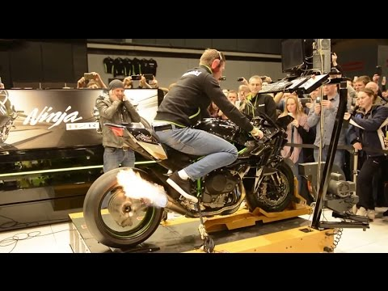

Contents
Introduction 2
What is a chassis dyno? 2
How a chassis dyno works 2
Experimental procedure 2
Results 3
Conclusion 6
References 6

Introduction
In this report I will be outlining the process for running a vehicle on a chassis dyno and I will be analysing the results that were produced and comparing the data collected. I will also be explaining how a chassis dynamometer works and the process of how the data was collected.

What is a chassis dyno?
In simple terms a chassis dyno is essentially a rolling road that allows a vehicle to be run as it would be on the road or racetrack. This allows the power and torque to be calculated at the driven wheel/s. When the vehicle is being run on a chassis dyno, a gear that is as close to 1:1 as possible is selected. This is to get the most accurate results as is possible. Not all vehicles have a gear that is actually 1:1 hence why the gear that is as close as possible is selected.

How a chassis dyno works
A chassis dyno works by applying a load to a roller to simulate real road conditions and load on the vehicle that is being tested. As mentioned, it provides a more realistic look on how the engine and transmission are performing together. It also allows us to see how efficient the transmission is.

Experimental procedure
For our experiment, a 2018 BMW S1000RR was used. The BMW S1000RR is a superbike with great racing pedigree.
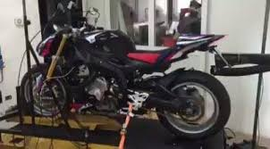
The first step is to secure the bike on the dyno. This is achieved through a wheel chock at the front and some ratchet straps holding the bike down.
Once the operator is satisfied that the bike is secured sufficiently onto the chassis dyno, the exhaust extractor is placed behind the exhaust to ensure that the exhaust fumes are extracted safely. Next the bike was plugged into the dyno to get data directly from the bikes ecu, this tells the computer what RPM the bike is at and other important information. The software is loaded onto the computer and is checked to make sure the settings are correct. Next the bike is started to warm it up. This is to ensure the bike was at its normal operating temperature before the run was started. Once the bike has been warmed up by running it through the gears, the gear that is closest to 1:1 is then selected and the bikes RPM is dropped as low as is possible before the power run is started. The power run is then started, and the bike is run through the entire rev range until it hits the limiter. Once the bike hits the limiter, the clutch is pulled in and the bike can coast back down to a stop. This is so that the dyno can calculate the efficiency of the drivetrain to get an accurate figure of the power and torque of the bike.

Results
Figure 1
Above is a graph showing the wheel torque produced by the bike against the engine speed of the bike. As the engine increases in RPM so does the wheel torque. This is because as the engine increases in RPM it produces more power and torque. There is a slight dip around 6500 RPM lasting until around 8000RPM. I believe this to be because of a fault with the bike on the day or this could be because of emission control. As the bike reaches it maximum RPM the graph declines rapidly, this is because the bike hit the limiter and does not produce much wheel torque when hitting the limiter. At the start of the run, the engine wheel torque increases at a fats rate when compared to the rest of the run. The peak wheel torque is produced around 10000RPM and after this point the graph begins to drop off. This is because the engine has already made its maximum wheel torque and as the RPM increases beyond this point the engine is producing less wheel torque. The highest torque figure tends to be recorded at a lower RPM than the maximum power figure.
Figure 2
Above is showing the tractive effort of the bike against its engine speed. Tractive effort is the amount of force produced by a vehicle at the wheel. The reason the tractive effort increases in a very similar manor to the wheel torque is because the amount of force needed to overcome the frictional resistance increases also. This tells us how much force is being applied the wheel of the vehicle in question which in this case is a motorcycle. The graph trend is very similar of that to the graph showing wheel torque against engine speed, the only visible difference is that the tractive effort is much higher than that of the wheel torque.
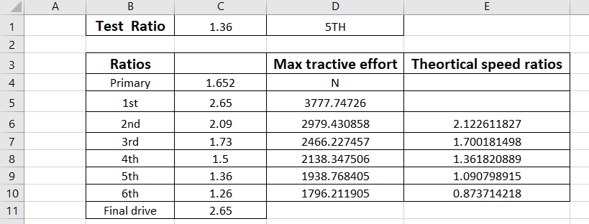
Figure 3
Above is the table showing the bikes gear ratios, the maximum tractive effort and its theoretical speed ratios.
With regards to the maximum tractive effort, as the bike goes up the gears, the maximum tractive effort produced by each gear decreases. This is because the pulling gears as it were are the lower gears. For example, when going up steep inclines. The difference between the values also gets closer as the gears increase also.
With regards to the theoretical speed ratios, both second and third gear are very close to that of the bikes actual gear ratios, however 4th is only slightly different but the big difference comes at 5th and 6th. As I mentioned in the experimental procedure, the gear ratio that is closest to 1:1 is selected. In theory on this bike it is 5th however the actual ratio is not 1:1. 6th gear is not very close at all. The actual gear ratio between 5th and 6th is very close, this could be for many reasons, but personally I believe it to be the fact that 6th gear is only used when at very high speeds and when moving very fast, the drag of the bike is increased, therefore the bike needs to be kept in its optimum power range to keep increasing its speed.
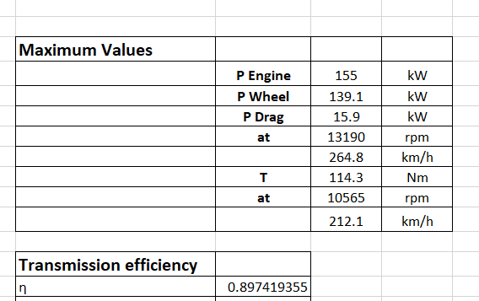 Figure 4
Above is the table that shows all the maximum values produced by the bike and it shows the efficiency of the drivetrain. As is clearly visible the bike produced 155kw at the engine and 139.1kw at the wheels. With the transmission efficiency being at 89%. A bikes transmission is generally more efficient than that in cars, this is down to shorter distance and smaller gears generally than those found in cars.
The maximum torque produced was 114.3Nm at 10565RPM. That is a very high RPM for the engine to be producing its maximum torque. This is because bikes rev a lot higher than cars tend to, of course there are some car engines that rev very high, but it is far less common. For example, the limiter on the BMW S100RR is 13920 RPM. The bike produces its maximum power at 13120. This is very close to its limiter. This tells me that BMW when tuning the engine did not see any point in allowing the engine to rev any higher as it has already produced its maximum power and would drop off after that.
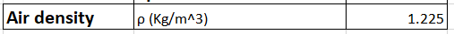 Figure 5
After doing some research on air density, I chose the air density to be the value shown above as the test we carried out was done at sea level. While the temperature was not totally accurate the difference in air density against temperature was not that great. The reason why air density is important when using data from a dyno run is that as the altitude increases the air density decreases. This effects the power and torque of the vehicle.

Conclusion
In conclusion, having carried out the dyno session and analysed the data I have not only learnt a lot about how power and torque varies from the engine to the wheel, I have also learnt how the gear ratios themselves work and effect the data. The data has told me that as the engine speed increases, so does the wheel torque. This is much the same for the tractive effort produced by the bike. This means that both the tractive effort and torque at the wheel both act in a very similar way. Another conclusion I can make from the data is that as the bike increases in engine speed the drag power also increases along with it.

References

N/a, N./.A. Unknown. Tractive effort. [Online]. [21 April 2020]. Available from: https://www.merriam-webster.com/dictionary/tractive%20effort
Anne Marie Helmenstine, PhD, A.M.H. 2020. What Is the Density of Air at STP?. [Online]. [21 April 2020]. Available from: https://www.thoughtco.com/density-of-air-at-stp-607546

