

NAME : GAUTAM MALVIYA
COURSE : MSC CYBER SECURITY
SUBJECT : CLOUD ENGINEERING PRINCIPLE AND PRACTICE
STUDENT ID : 2504384

Contents
1. Introduction 1
2. Principles of Virtualisation 1
3. The Principles and Advantages of Containerisation. 1
4. Publication of Pictures and Production of Pictures. 4
5. Container Volumes 5
6. Container Networking 6
7. Complete Practical Example : 7
8. Cloud Computing Concepts 8
8.1 Load Balancing 8
8.2 Scalability 9
8.3 Application Gateway 9
8.4 The reason why Load Balancing and Scaling are Complementary. 9
9. Serverless Functions vsContainerisation. 9
9.1 Serverless Functions 10
9.2 Containerisation 10
9.3 Serverless vs Containerisation. 10
9.4 Evaluation 10
10. Clouds of Driving Forces. 10
10.1 Cost Efficiency 11
10.2 Flexibility 11
10.3 Scalability 11
10.4 Serverless Computing (FaaS) 11
10.5 Comparison with Containerisation 11
10.6 Evaluation 11
11. Conclusion 12
12. References 12

1.Introduction
This report describes Docker as it relates to cloud computing and containerisation. The knowledge on how to create Docker images, launching containers and deploying a simple web application was developed through practical exercises. This gave an insight into the development and the implementation of applications effectively in the cloud. Cloud computing is an important aspect of contemporary computing as it allows a connection to applications, storage and services via the internet. It enables organisations and individuals to save money on infrastructure, and enhance flexibility and scalability. Amid these strengths, a significant issue is to make sure that applications can be relied upon to work across various systems and environments. Variations in the operating systems, software versions and configuration may cause compatibility problems frequently. Containerisation is a solution to this problem that packages an application, along with all its dependencies (including libraries and configuration files) into a unit called a container. This means that the application can be deployed anywhere (local machine, server or on the cloud) and act in the same manner. One of the most popular containerisation platforms is Docker which offers the tools to create, control and deploy containers effectively. An analysis of the virtual machines and containers reveals some significant differences in resource consumption and performance. Virtual machines are based on a hypervisor and have a complete operating system per instance, which consumes more resources and time to start up. By comparison, Docker containers use the same host operating system kernel and are much faster to start and are much lighterweight. This performance renders containers especially handy in the context of clo ud environments where the performance and scalability are of utmost importance. In addition, containerisation encourages current cloud computing trends, like continuous integration and continuous deployment (CI/CD), which enables applications to be created, tested and deployed faster. It is also more scalable with several containers being able to be deployed and managed easily to cope with the high demand.

2. Principles of Virtualisation
Virtualisation is a technology that is central to contemporary computing, whereby one physical machine can support many virtual machines (VMs) at a time. Each virtual machine is a computing environment that is independent and has its own operating system, applications and virtualised hardware resources. It is an abstraction layer that enables effective utilisation of physical infrastructure and ensures good isolation of workloads [1]. Virtualisation is realized by the use of a software layer called a hypervisor or a virtual machine monitor (VMM). The hypervisor will create, manage and assign hardware resources like CPU, memory and disk to various virtual machines. Hypervisors can be broadly categorized into two: Type 1 (bare-metal) and Type 2 (hosted) [2]. In data centres, as well as in cloud computing, virtualisation has a great impact on resource utilisation. Rather than having a single physical server dedicated to a single application, multiple virtual machines can be used on the same infrastructure which saves on hardware costs, energy usage and physical space. It is also more efficient in its operations as it allows centralisation of computing resources [3]. Virtualisation is also very important in cloud computing environments as it facilitates scalability and flexibility. Virtualisation is a way of dynamically assigning resources to users through the cloud providers. This enables the sharing of physical infrastructure by several tenants in a secure manner and logical separation of workloads. Consequently, the cloud services may be also scaled up or down according to the usage needs [4]. Reliability and availability of systems is also improved by virtualisation. There is the ability to migrate virtual machines among physical hosts, clone or save them with a minimum downtime. This helps in recovery plans in case of any disaster and also continuity of services in case of hardware failure. Virtual machines however are resource-heavy in that each instance will need a complete operating system and this will consume more memory, storage, and CPU resources. Also, virtual machines generally can be started more slowly than a container-based solution, because the operating system needs to boot completely before the execution can start [1].

3. The Principles and Advantages of Containerisation.
Containerisation is a new software deployment method, where applications are run in isolated user-space environments called containers. In contrast to the traditional virtual machines, containers bundle the application and all the dependencies needed, such as libraries, binaries, and configuration files. This guarantees that applications will be reliable when used in various environments irrespective of the underlying infrastructure [8]. Containerisation is very different concerning the architecture of virtualisation. Virtual machines need a complete guiding operating system per occurrence, whereas containers share the host operating system kernel. This architectural difference is able to save a lot of overhead and enhance efficiency. Consequently, there is the ability to operate several containers on a host without new operating systems hence enhanced resource utilisation [4]. Practically, Docker is a popular containerisation system to develop, distribute, and execute containers. With the help of practical exercises, images were created and containers were deployed using Docker in order to create a simple web application. This was found to be because container startup times are much lower than virtual machine startup times because there is no operating system boot process. This predisposes containers to be very appropriate in environments where rapid scaling and deployment is essential [1]. The other outstanding benefit of containerisation is that it is lightweight. Containers use much less CPU and memory resources than virtual machines since they share system resources like the operating system kernel. This helps cloud providers to operate many more applications in the same physical equipment, which enhances the overall efficiency of the infrastructure as well as lowers the cost of operation [4]. One of the most popular advantages of containerisation is its portability. After creating a Docker image, a consistent deployment across various environments, such as development machine, testing system, and cloud platforms can be realized. This removes any issues that are environment specific and makes sure that the applications are consistent all through the software lifecycle [8]. Another important benefit of container-based systems as far as cloud computing is concerned is scalability. Containers are created and destroyed in a short period of time and thus systems can dynamically respond to evolving workloads.

my practical work
https://youtu.be/YxCrYELnoyI
Dockerfile to build a simple web application:
Index.html
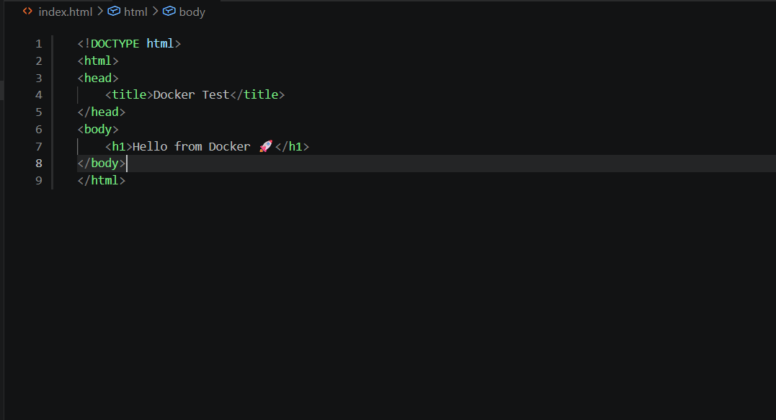

Dockerfile.
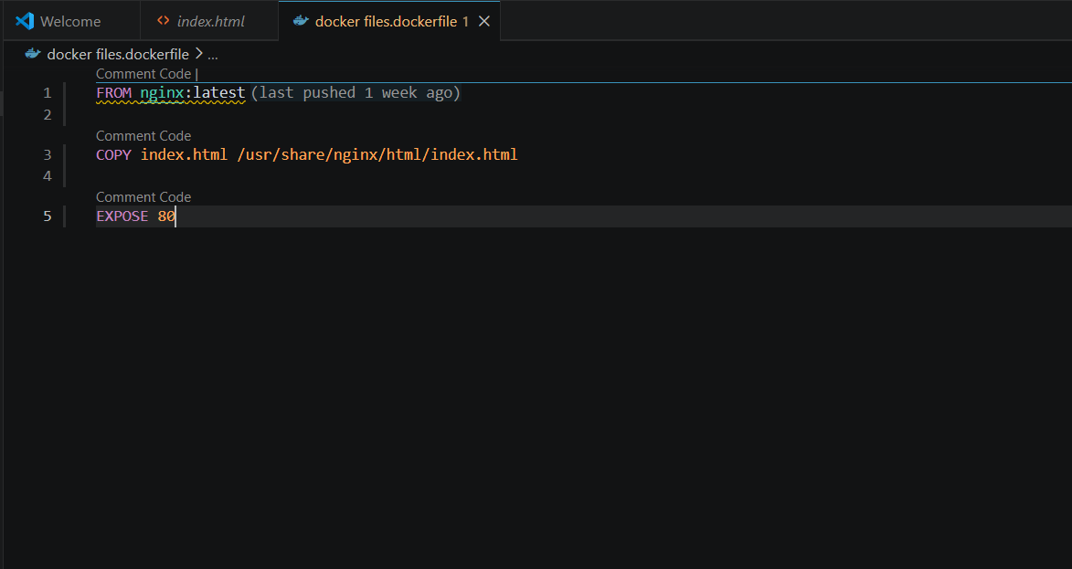

Build image: docker build -t my-image .

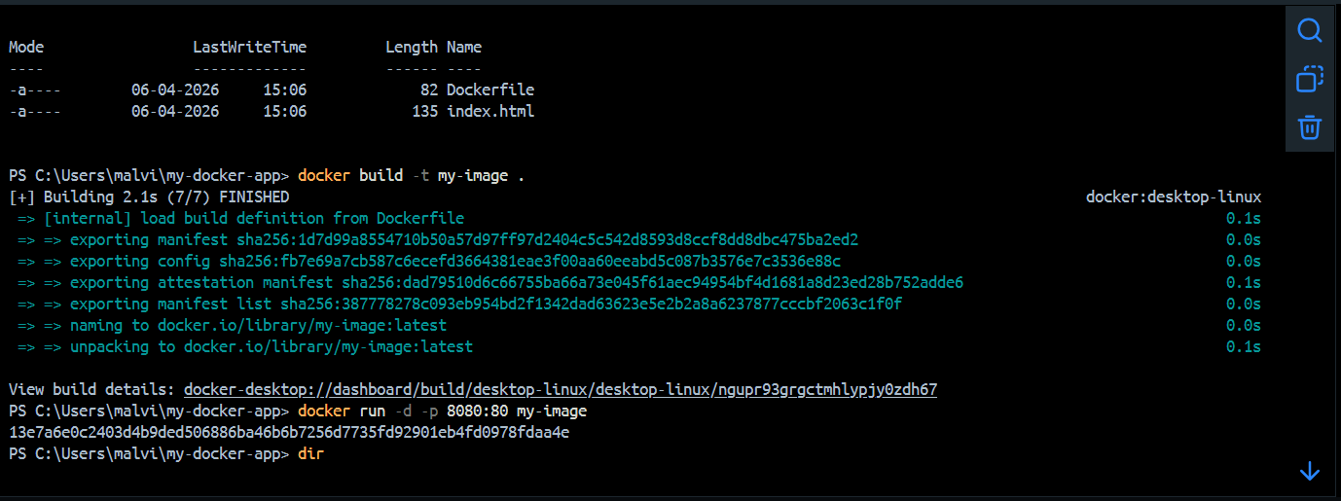

Run container: docker run -d -p 8080:80 my-image
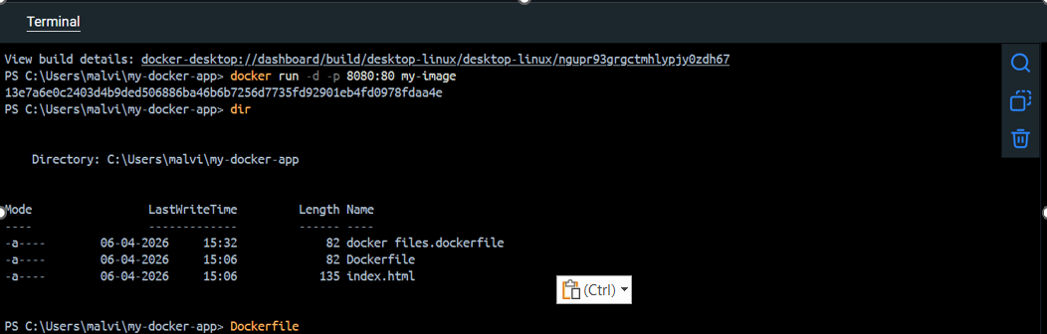

4. Publication of Pictures and Production of Pictures.
Containers are created based on the templates that are available as Docker images. A Docker image is a lightweight, immutable package that consists of the code of the application, its runtime environment, system libraries, configuration files and instructions needed to run an application. This method of packaging also guarantees that software will act the same way in any computing environment, thus avoiding compatibility problems due to differences in operating systems or dependencies installed [8]. Docker images are built in layers with each command in a Dockerfile forming a layer. These layers are reused and cached where feasible, and enhances the build efficiency, as well as storage needs. This is one of the most important design aspects of Docker images, enabling them to be efficient and scalable in cloud environments [3]. One of the most important benefits of Docker images is that it is reusable and scalable. One image may be deployed into several containers which may serve as isolated instances of the application. This enables the ability to scale horizontally, with more containers being implemented to manage more workloads. This is necessary in cloud computing systems to ensure that they maintain performance in times of peak demand [16]. Container registries like DockerHub can be used to distribute docker images. DockerHub is a cloud-based repository whereby the users can save, administrate and share Docker images. It is a significant part of the contemporary DevOps processes since it allows collaboration between software developers and streamlines the procedures of deployment. Users are able to draw a ready-made image and run it in different systems without having to manually configure the applications, which ensures consistency of the applications in the development, testing and production environments [4]

Demonstrated below are the process of building and publishing a Docker image:
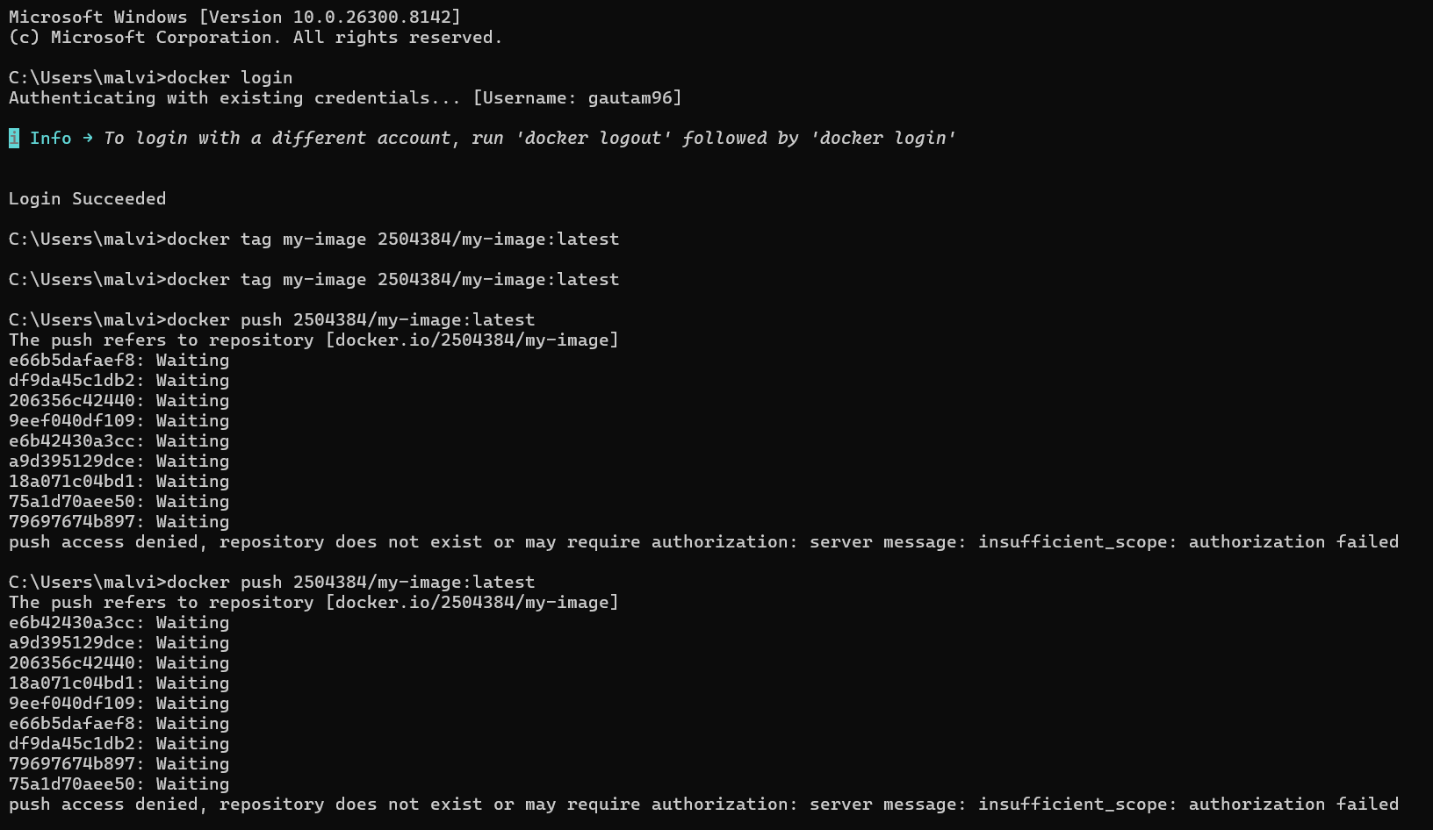

After creating my image my-image, I wanted to upload it to DockerHub so I could use it anywhere. I did this using the following commands:

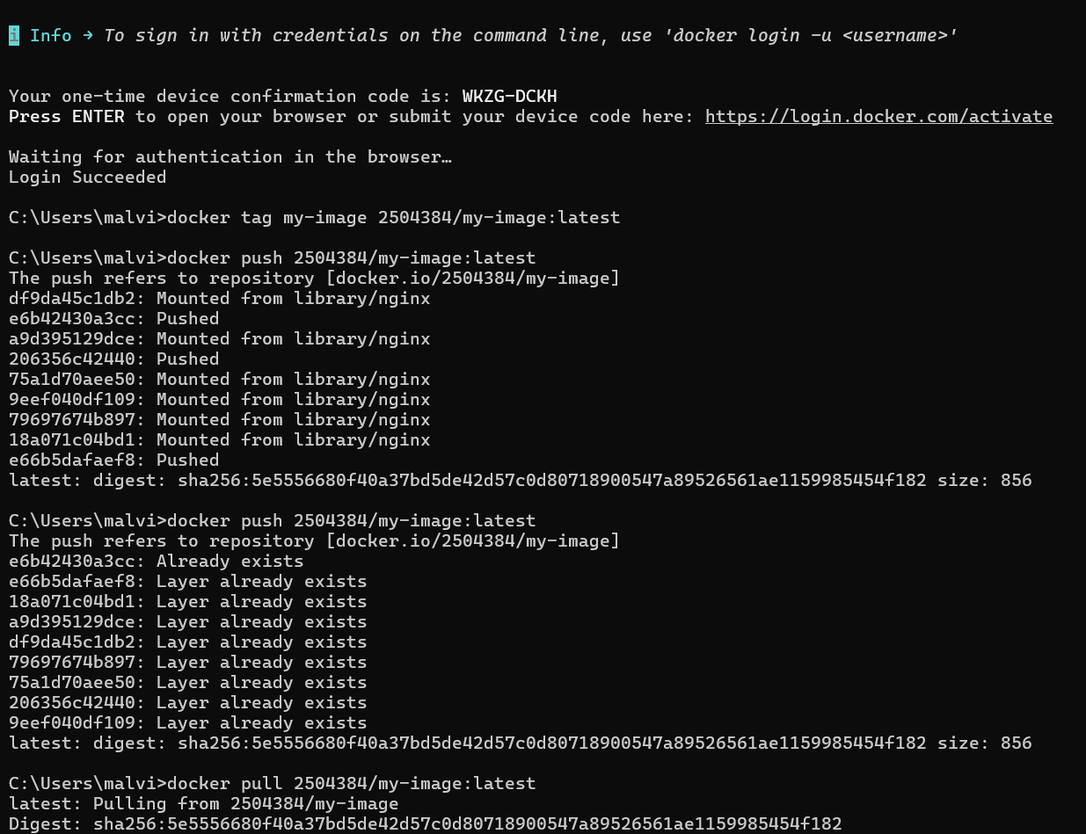

5. Container Volumes
Containers are volatile, i.e. any changes introduced during runtime including file creation, changes in configuration or changes in the application state are lost when the container is stopped or deleted. This behaviour is due to the design principle of containers, which are meant to be lightweight, stateless and easily replaceable execution units [8].To address this restriction, Docker offers a service called volumes that has the option of storing data persistently regardless of the container life cycle. A Docker volume is a storage system administered by Docker which is external to the writable layer of the container. This guarantees that information that is stored in a volume is not lost in case the container that contains it is removed, recreated, or substituted [9]. Docker volumes are typically utilized in those applications that need the consistent storage of data, like databases, logging applications, and user generated content. Volumes enhance the reliability of the execution of applications by decoupling them with data storage and maintain scalable cloud-native architectures. Considering the cloud computing, volumes will enhance resilience and fault tolerance of systems by making sure that important data is not lost when a container is restarted, updated or failed. This is one of the pillars of the modern distributed systems and cloud environments where the separation of compute and storage is a cornerstone [7].
I created a volume using this command: docker volume create my-volume

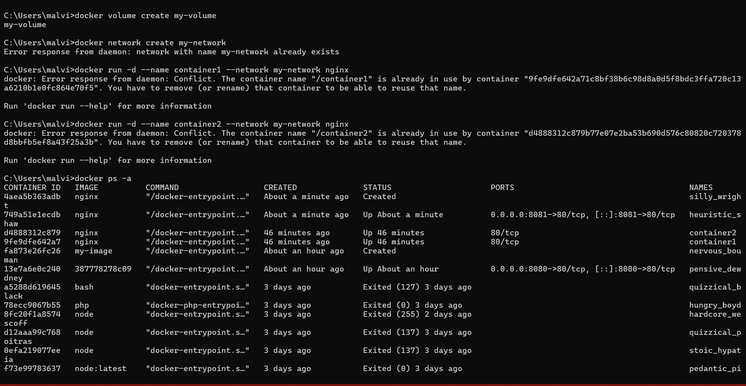

Then, I attached it to a container: docker run -d -v my-volume:/usr/share/nginx/html nginx
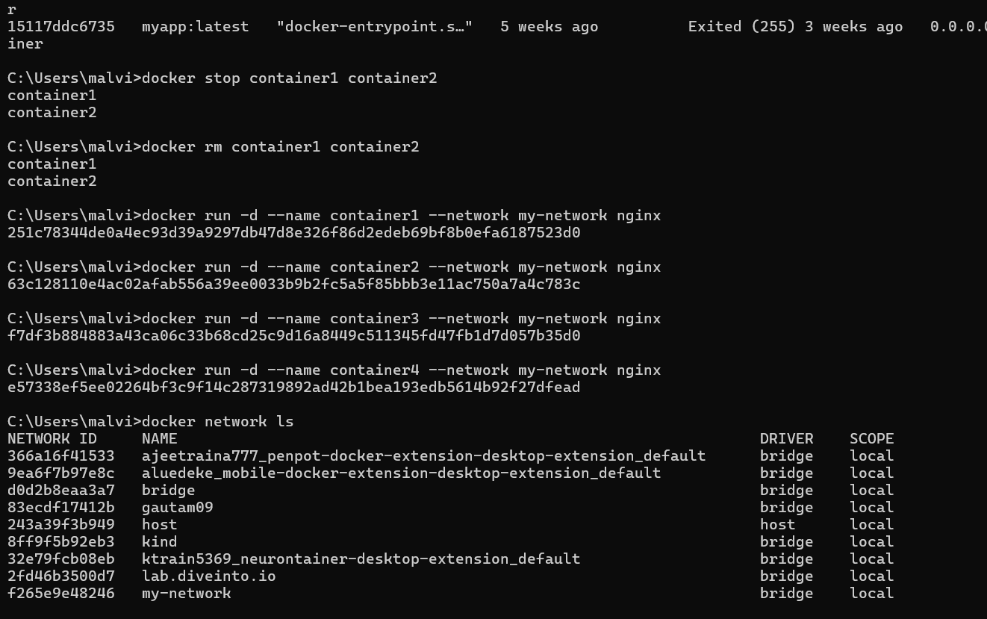
Once this was done, any files that were added or modified within the directory of /usr/share/nginx/html within the container were stored in the volume. I could still see the files in the volume, even after I deleted the container. In my experience, I found volumes useful when using the applications that require data storage such as databases or websites. It makes sure that the vital information is not lost in case of updating or removing containers.

6. Container Networking
In practice, it is observed that container networking allows several containers to interact with each other in a Docker environment. Containers are by default designed to run in isolation, but in practice applications may need inter-container communication, like a web application communicating to a database service. The Docker networking offers a secure and structured way of facilitating this communication. Containers can be assigned hostnames as container names, rather than using static IP addresses, when they are all connected to the same Docker network. This enhances flexibility since IP addresses can vary when containers are re-started or re-created [1]. Docker has various drivers of networks, e.g., bridge networks (default), host networks, and overlay networks. Single-host container communication is typically implemented over the bridge network where containers on the same host can communicate effectively and remain insulated to outside traffic unless directly exposed [5]. In cloud computing, container networking is very vital in facilitating microservices-based systems. Applications are frequently divided into several services, each of which is a containerized application [3].
Docker network using: docker network create my-network
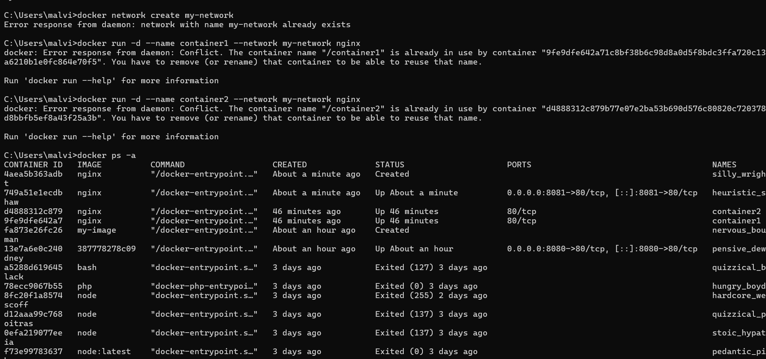
Then ran two containers and connected them to the network:
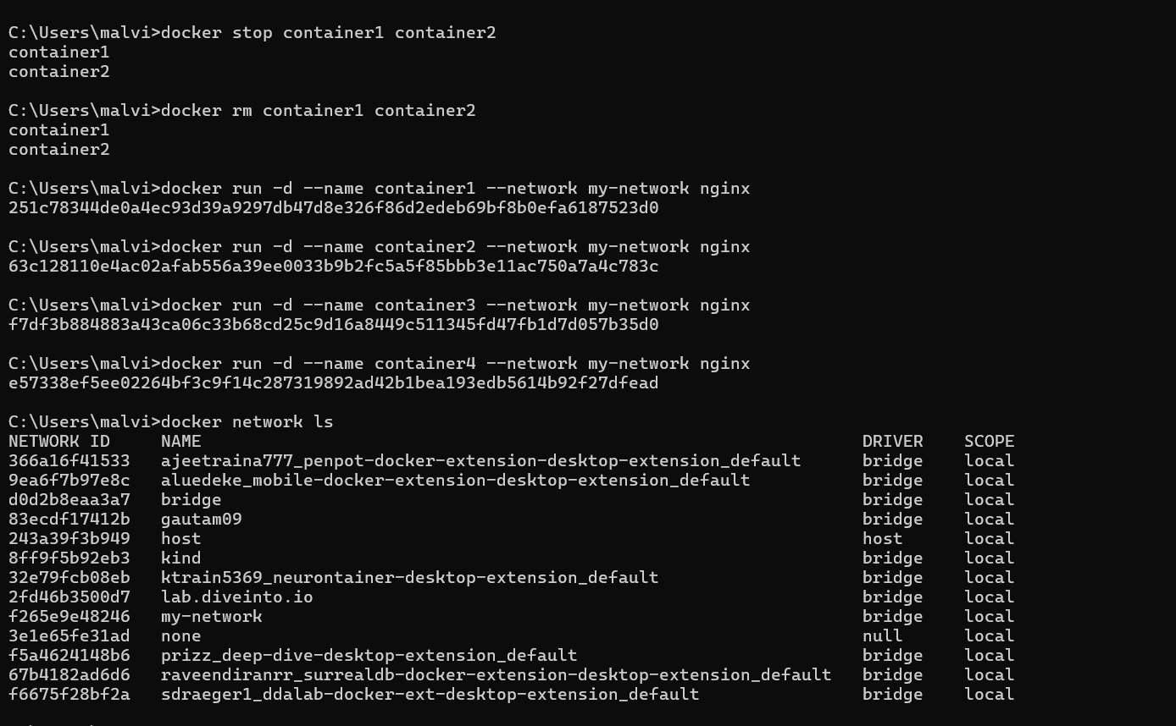
Having done so, both the containers could communicate with one another within the same network. In my knowledge, this comes in handy when developing applications that consist of different components, like frontend and backend services. Networking assists them in collaborating with each other. Overall, container networking makes it easier to manage communication between different services and is very important in cloud-based applications.

7. Complete Practical Example :
In practical work to have an insight into the entire process of containerisation, a basic web server application was created using Docker. This example illustrated the main processes of creating a Docker image, spawning a container and deploying a functional web page. To start with, a simple index.html was developed with a code editor like Visual Studio Code. This file was a simple HTML file that was an image of the web page that would be shown. This step was done to determine the static material that would be served by the web server. After that, a Dockerfile was created that outlines the steps to be taken to construct the container image. The Dockerfile based on the official Nginx base image, which offers a lightweight and efficient web server setup. The HTML file was then used to copy to the relevant directory, which was in the Nginx container in order to be served as the default web page [8]. This operation illustrates the basic concept of containerisation where an application along with the necessary files are put into one image. After construction, the image can be utilized in creating a series of containers that can always deliver the same web content in various settings
Then, I built the Docker image using:
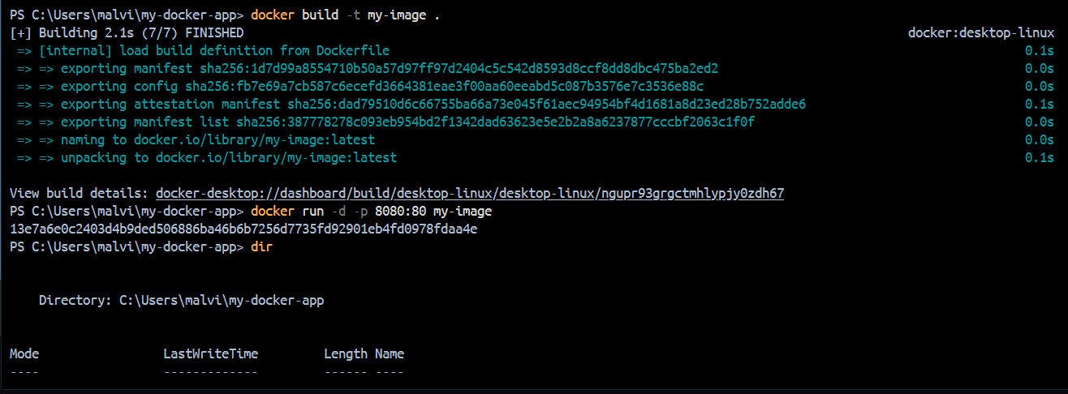
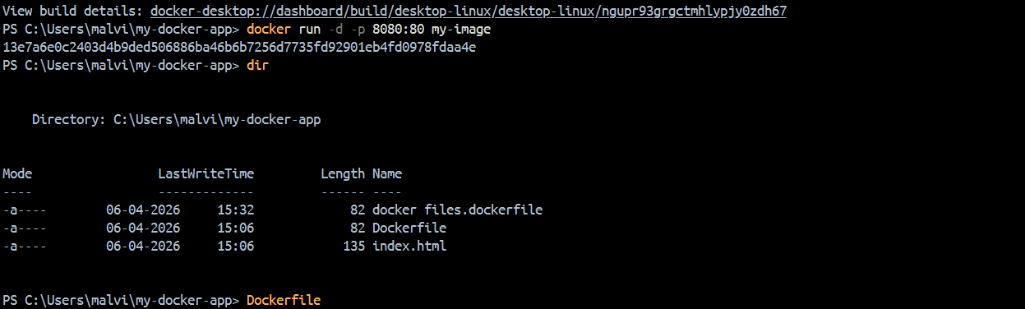
After the container had started, I opened my browser and accessed: http://localhost:8080. I could see my HTML page and this indicated that the container was functioning properly. Lastly, I published my picture on DockerHub to allow its usage in other systems. This entire procedure made me comprehend how Docker functions in an actual setting. I was able to create, run, and share an application using containers.
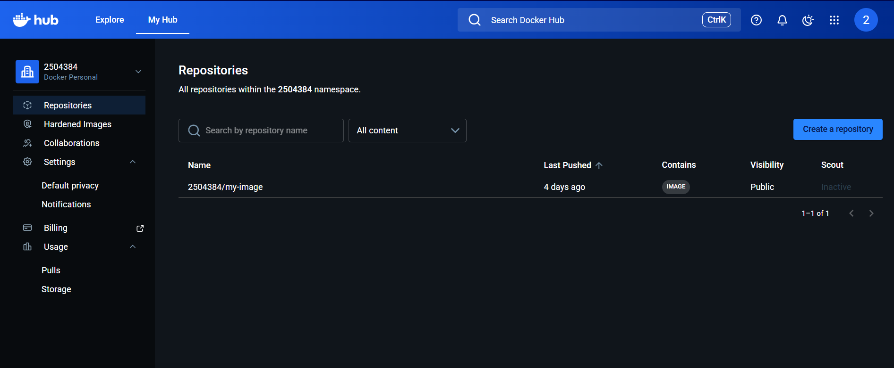

8. Cloud Computing Concepts
This part will talk about three major concepts of cloud computing which include: load balancing, scaling and application gateways. The theories and practical experience have demonstrated that these technologies are necessary in designing stable, efficient and high-performance cloud-based applications. Load balancing It is a network traffic method which spreads the traffic entering the network over several network servers or instances. This will make sure that none of the servers are overloaded, thereby enhancing response time and system availability. Load balancers in clouds automatically redirect user requests to the most appropriate available resource, improving the performance and reliability [6]. Scalability is the capacity of a system to manage workloads, as they grow or diminish by dynamically reconfiguring resources. Scalability is not a new concept to cloud computing: it is often done by means of horizontal scaling, i.e., more instances of the application are created to support increased demand. This will make sure that there will be no performance when it is at its peak usage [2]. Application gateways are an intermediate that can manage and control incoming application traffic. They offer routing, security and load distribution capabilities, where requests can be sent to relevant backend services. Microservices architectures are often supported by application gateways which route traffic depending on URL path or type of request [3]. The three concepts are interrelated and collaborate to make sure that the cloud applications are responsive, reliable, and scalable to different workloads.

8.1 Load Balancing
Load balancing is a process that is applied to distribute the incoming requests by the users in many servers or containers. This makes sure that a single resource is not overloaded, otherwise, it may reduce the performance or even cause a system crash. Load balancing ensures that response times are better and the general reliability of applications are enhanced by evenly distributing traffic [11]. Managed services are used by the cloud service providers to do load balancing. As an illustration, Amazon Web Services (AWS) offers Elastic Load Balancing (ELB), which automatically allocates traffic entering the system according to the existing demand and health of the systems. The balancing load balancer continuo. usly checks the health of backend instances and routes requests to instances which are healthy and operating correctly [1]. Load balancing is an important aspect in ensuring high availability in the cloud environment. The load balancer reroutes the incoming requests to the other healthy instances in case either of the servers or containers fails. This will guarantee continuous service delivery and will reduce downtime, which is critical to the current cloud-based application. Besides, load balancing helps to scale by dynamically adding and removing new instances without disrupting user experience.

8.2 Scalability
Scalability is the capability of a system to withstand the growing or diminishing workload by dynamically utilizing its resources. It is an inherent feature of cloud computing, which allows applications to perform and be reliable across the different degrees of demand [1]. Two main scales of cloud platforms are horizontal scaling and vertical scaling. Vertical scaling is an expansion of the capabilities of a single server by adding additional CPU, memory or storage. Conversely, horizontal scaling is when one adds or removes several servers or containers to distribute the workload more effectively. Horizontal scaling has been widely used in cloud computing because it is flexible and can be used to achieve high availability [6]. Cloud providers provide automated scaling capabilities to efficiently handle such processes. As an illustration, Amazon Web Services (AWS) has Auto Scaling, which automatically balances the number of running instances according to the demand of traffic and performance goals set. This is to make sure that the resources are sufficient when used most and less when there is low demand [5]. One of the most important benefits of cloud computing is scalability, where systems can be dynamically scaled without having to manually upgrade hardware or have to physically upgrade them. This results in increased utilisation of resources and optimisation of costs since the users only consume and pay the resources that they require [9].

8.3 Application Gateway
Application gateway is a sophisticated network element which serves as a point of contact between the users and the back-end application services. It takes care of incoming requests, traffic routing to relevant backend resources, and offers other security and performance capabilities. Application gateways work on application layer (Layer 7) and therefore can control traffic in a more intelligent way than the traditional load balancers [12]. Cloud providers provide application gateway services to ease the management of traffic and increase security. As an illustration, Microsoft Azure offers the Azure Application Gateway, which can accommodate URL-based routing, Secure Socket Layer (SSL) termination, and safeguard of typical web-based attacks using an inbuilt Web Application Firewall (WAF). These features enable the analysis of incoming requests and sending them to particular services on the backend depending on the properties of the request [2]. Application gateways are an important part of contemporary cloud architectures, especially when they adhere to a microservices-based design. In these environments, applications are broken down into several autonomous services, with each service having a certain functionality. The application gateway makes sure that requests made by the users are directed properly to the right service enhancing organisation and efficiency of the system. Moreover, application gateways are more secure because they can block malicious traffic and use of secure communication protocols. [3].

8.4 The reason why Load Balancing and Scaling are Complementary.
Load balancing and scalability are similar terms in cloud computing and are best utilized jointly to ensure that the systems perform and remain dependable. Scalability adds or removes resources to the available ones according to the demand of the workload whereas load balancing is used to distribute the incoming traffic effectively among the available resources [1]. In the absence of load balancing, the new resources introduced might not be fully utilised and vice versa, as load balancing cannot deal with the increased demand unless adequate resources are provided. As such, the two mechanisms have to work in unison so as to optimize performance during different workloads [2]. Moreover, these technologies, together with application gateways, provide a very efficient and safe cloud environment. Application gateways are used to enhance this architecture by handling request routing at the application level and offering security measures like traffic filtering and web-based attacks protection [3]..

9. Serverless Functions vsContainerisation.
The current cloud computing technologies that have been employed to efficiently deploy applications are serverless computing and containerisation. They both seek to enhance scalability, performance and cost-efficiency, but differs in their implementation. Serverless computing eliminates the overhead of managing servers and containerisation offers packaged environments in which applications can be run more easily and with increased control and portability.

9.1 Serverless Functions
Function as a Service (FaaS) or serverless computing is a type of cloud computing where developers run code in the cloud without having to control the underlying server architecture. The typical ones are AWS Lambda and Microsoft Azure Functions [1], [2]. The cloud provider takes care of all infrastructure management, provisioning, scaling and execution in this model. Code is run when a particular event occurs, like a request by a user or system action. One of the main benefits of serverless computing is that it is cost efficient as the billing is made depending on the real time of execution and not on the available resources. This causes it to be appropriate to workloads that are event based and whose traffic is variable or unpredictable. Moreover, serverless computing makes development and deployment easier, as there is no longer a need to directly manage servers, instead the developers can just concentrate on application code.

9.2 Containerisation
Containerisation is made possible by the use of tools like Docker, which enables applications to be run in isolated containers. Every container contains all the components needed to be executed in the application, such as libraries, dependencies, and configuration files, which can be reliably used in various environments [1]. Containerisation offers more control over the runtime environment in the real world. It is possible to create a Docker image and deploy containers using it to deploy applications. The process eases the process of application packaging and deployment, enabling software to be executed in a reliable manner without compatibility problems across systems. Containerisation can be applied especially where the operation is to be continuously executed like web servers and backend services [2].

9.3 Serverless vs Containerisation.
The major difference between serverless computing and containerisation is the number of controls and management needed. Serverless computing puts the cloud provider in full control over the infrastructure, such as provisioning, scaling, and execution, and developers only write application logic (without maintaining servers) [1]. Containerisation on the other hand needs some amount of infrastructure and deployment management, but it offers more flexibility and control of the runtime environment. Serverless computing typically is cheaper with short-lived or intermittent workloads, since only execution time is billed. Containers, however, can be more appropriate in applications that last longer based on the fact that they are capable of offering consistent performance and persistence in execution environments [14]. The two methods assist in the scaling but in different ways. Serverless systems are self-scaling based on events and need, and container systems are self-scaling by launching numerous copies of containers to achieve load balancing. Consequently, the two technologies can help in effective resource utilisation in a cloud computing environment.

9.4 Evaluation
The main aims of cloud computing, such as scalability, flexibility, and cost efficiency, can be attained both with the help of serverless computing and containerisation [1]. They are however used differently with regard to system requirements and characteristics of workloads. Containerisation allows more control over the application environment and is then more appropriate to the complex, long-running application, which needs to be performed with consistency and tailored settings. Conversely, serverless is less complicated to operate and is based on an event-driven model, so it is best suited to short, stateless tasks which are performed in response to a particular event. Both methods can be integrated in practice in cloud architecture in order to enhance the overall system efficiency. As an example, a core application may be deployed with the help of containers to achieve stability and control and serverless functions may be deployed to process background tasks, e.g., notifications, data processing, or events. Such a hybrid solution allows improved resource utilisation and improves system performance and scalability in a realistic cloud setting.

10. Clouds of Driving Forces.
The main factors that have contributed to the rapid adoption of cloud computing are cost efficiency, flexibility and scalability. These reasons render the cloud-based solutions to be more efficient and viable as opposed to the conventional on-premises IT infrastructure [15]. Cloud computing saves money spent on capital expenditure as organisations do not have to spend a lot on physical hardware since facilities are availed on pay-as-you-use basis. The capability to quickly provision and configure computing resources on demand brings about flexibility. Scalability is another feature that improves this model since the systems are able to dynamically scale up/down resources to meet the varying workloads effectively to maintain consistency in performance and availability.

10.1 Cost Efficiency
One of the most common factors that have led to the use of cloud computing is cost reduction. Traditional IT infrastructures also demand the organisations to invest in physical servers, networking gadgets and constant upkeep which may prove costly and in most cases generate underutilisation of the resources [5]. Cloud computing on the other hand is based on a pay-as-you-use service model where users pay only the resources used. This will remove any unnecessary capital investment and will result in better cost management as organisations can scale resources to demand.This model is especially useful in the case of small business and startups because it will not require huge investments in IT infrastructure upfront. Consequently, cloud computing offers cost effective and convenient solution to both large and small organisations and enhances the overall efficiency of resources.

10.2 Flexibility
Flexibility is another important driving force in the development and adoption of cloud computing. It enables applications to be built, tested, and deployed across different environments without requiring significant modifications. This reduces compatibility issues and improves the overall efficiency of software development and deployment processes [5]. In practical experience with Docker, a container image was successfully built and executed across the local system without configuration issues. This demonstrates the role of containerisation in ensuring portability and environmental consistency. As a result, applications can run reliably across development, testing, and production environments, regardless of underlying infrastructure differences.

10.3 Scalability
One of the main advantages of cloud computing is scalability where systems provide automatic adjustment of resources as per user demand. The more users one has, the more computing resources will be dynamically provisioned to ensure performance and service availability [5]. On the other hand, any unused resources can also be cut or reallocated when the demand is low to eliminate any unnecessary expenditures and enhance resource efficiency. This dynamic assignment guarantees the applications their optimum performance and eliminates wastages of resources. Scalability is thus a key trait of cloud computing, which aids in effective resource use as well as makes the systems responsive with fluctuating workloads..

10.4 Serverless Computing (FaaS)
The development of serverless computing or Function as a Service (FaaS) is one of the driving factors in the expansion of cloud computing. Such solutions are AWS Lambda and Microsoft Azure Functions [8], [5]. Serverless computing permits code to be run without worrying about server infrastructure management or maintenance. The cloud provider in this model manages the process of infrastructure, scaling and execution. The code will only be executed upon occurrence of certain events and is turned off otherwise, which increases efficiency. This execution model is event based and only uses resources on requirement making serverless computing cost-effective and resource-efficient. Consequently, serverless computing eases the development of applications and enables scalability and minimizes the operational load, making it an important innovation in the current cloud computing.

10.5 Comparison with Containerisation
Both containerisation and serverless computing promote the key goals of cloud computing, such as scalability, flexibility, and cost-effectiveness but are implemented in various settings depending on the needs of the application []. Containerisation offers more control over the application environment, and it is most appropriate in implementing entire long-term applications that are in need of consistent performance and customised settings. Serverless computing, in its turn, is better suited to the short-lived and event-driven tasks, in which the code is only executed when needed. This allows it to be very effective in managing background processes, intermittent workloads and on command operations. As such, long-term services tend to scale better to container deployment whereas short-lived and event-driven activities are better handled through serverless computing. This difference emphasizes the possibility to use the two approaches as complements to each other in contemporary cloud systems.

10.6 Evaluation
Some of the main reasons why cloud computing is being adopted include cost efficiency, flexibility and scalability. The technologies of containerisation with Docker and serverless computer are direct contributors to these goals as they enhance the efficiency of resource utilisation and make the deployment process easier, as well as allow scaling dynamically [8], [2]. In cloud architectures today, a combination approach is frequently the best way to go. Containers can be used to deploy core applications to provide stability, control, and perpetual performance, and smaller, event-driven applications can be effectively managed using serverless functions. This hybrid model enables systems to reach the best performance, cost-efficiency, and scalability, which makes it very appropriate in the actual cloud based applications.

11. Conclusion
In this report, there is an insight into important concepts of cloud computing taking a specific interest in containerisation using Docker. Its practical implementation has shown the process of creating Docker images and executing containers and deploying a simple web application, which is the practical implementation of containerisation. Virtualisation concept has also been discussed where it is possible to operate several systems using a common hardware but it was found to be less efficient because of its light weight and high performance compared to virtual machines [5]. 36The hands-on example also demonstrated the entire process of containerisation, which includes authoring a Dockerfile, creating an image, executing a container and pushing the image to DockerHub. This showed how one can easily deploy, share and execute applications across various environments. Moreover, the important concepts of cloud computing like the load balancing, scalability as well as application gateways have been examined, and it has been seen how they integrate to enhance the system performance, reliability, and user experience. It was also in the report that the key forces behind cloud computing such as cost effectiveness, flexibility and scalability were also examined. Moreover, a comparison of serverless computing and containerisation revealed that both methods possess their own merits basing on the needs of applications. All in all, the combination of containerisation and current cloud technologies is both a highly effective and efficient way of developing and implementing applications in cloud systems.

12. References
- P. Mell and T. Grance, “The NIST Definition of Cloud Computing,” National Institute of Standards and Technology (NIST), 2011.
Available: https://nvlpubs.nist.gov/nistpubs/Legacy/SP/nistspecialpublication800-145.pdf
- M. Armbrust et al., “A View of Cloud Computing,” Communications of the ACM, vol. 53, no. 4, pp. 50–58, 2010.
Available: https://dl.acm.org/doi/10.1145/1721654.1721672
- D. Merkel, “Docker: Lightweight Linux Containers for Consistent Development and Deployment,” Linux Journal, 2014.
Available: https://www.linuxjournal.com/content/docker-lightweight-linux-containers-consistent-development-and-deployment
- J. Pahl, “Containerization and the PaaS Cloud,” IEEE Cloud Computing, 2015.
Available: https://ieeexplore.ieee.org/document/7169085
- E. Jonas et al., “Cloud Programming Simplified: A Berkeley View on Serverless Computing,” 2019.
Available: https://arxiv.org/abs/1902.03383
- Amazon Web Services, “AWS Lambda Developer Guide,” 2023.
Available: https://docs.aws.amazon.com/lambda/
- Microsoft, “Azure Functions Documentation,” 2023.
Available: https://learn.microsoft.com/en-us/azure/azure-functions/
- Docker Inc., “Docker Documentation,” 2024.
Available: https://docs.docker.com/
- R. Buyya et al., “Market-Oriented Cloud Computing: Vision, Hype, and Reality,” Future Generation Computer Systems, 2009.
Available: https://www.sciencedirect.com/science/article/pii/S0167739X08001957
- N. Dragoni et al., “Microservices: Yesterday, Today, and Tomorrow,” 2017.
Available: https://link.springer.com/chapter/10.1007/978-3-319-67425-4_12
- B. Burns et al., “Borg, Omega, and Kubernetes,” Communications of the ACM, 2016.
Available: https://dl.acm.org/doi/10.1145/2890784
- K. Hightower et al., Kubernetes: Up and Running, O’Reilly Media, 2017.
Available: https://www.oreilly.com/library/view/kubernetes-up-and/9781491935668/
- G. Toffetti et al., “Self-Managing Cloud-Native Applications,” 2017.
Available: https://www.sciencedirect.com/science/article/pii/S0167739X17302325
- A. Balalaie et al., “Microservices Architecture Enables DevOps,” IEEE Software, 2016.
Available: https://ieeexplore.ieee.org/document/7435910
- VMware Inc., “Understanding Virtualization,” 2018.
Available: https://www.vmware.com/topics/glossary/content/virtualization
- NIST, “The NIST definition of cloud computing,” Special Publication 800-145, 2011.

