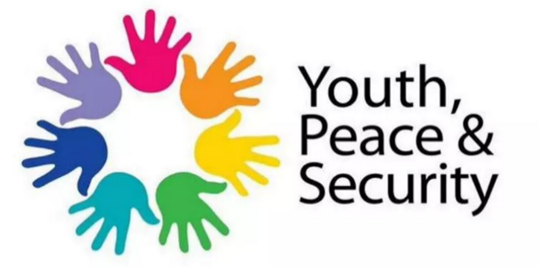
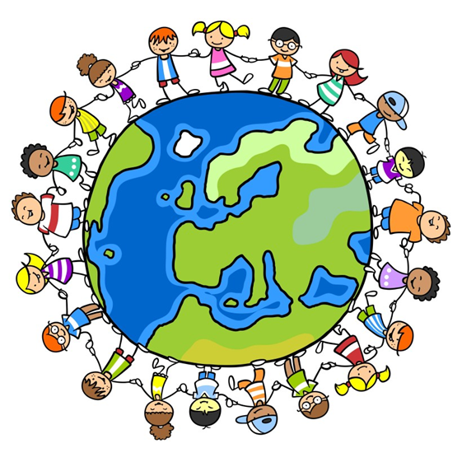
From Poster Contest for Youth, Peace and Security Consultation and Dialogue (United Nations, 2017).
Advocacy
Never be afraid to speak up for those who are unable to. There is no such thing as a quiet voice when that voice speaks up for a thousand others around the world. A powerful advocate is someone who is prepared with the correct information and questions for the rights of a child (Goodreads, 2021).

Important UNCRC Rights
- Article 2 - The right to protection against discrimination.
- Article 5 - The right to be given guidance by your parents and family.
- Article 8 - The right to an identity
- Article 12 - The right to an opinion, to be listened to and taken seriously
- Article 23 – Disabled children have the right to special care and education
- Article 27 - The right to a good enough standard of living.
- Article 29 - The right to education which tries to develop your personality.
- Article 31 - You have the right to play and relax by doing things you like
(Save the Children, 2018).
Above photo from Same human rights to children campaign (UNICEF for every Child, 2020)
.
080880 81001 legal@nyas.net
legal@nyas.net.

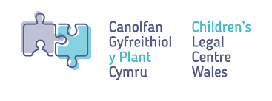

01792 678458
childrenslegalcentre@swansea.ac.uk

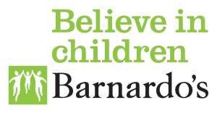
01639 620771
Help@barnardos.org.uk.

03003230965
admin@advocacyfocus.org.uk
Empowerment
To guide children in the correct way that would also involve encouragement and self-belief in their own capabilities for positive growth in the future. To help children believe in their inner strength and confidence during their school years and adult life, ensuring they have the freedom and power to be successful (Mathpal, 2019).

Participation
Participation is the act of engaging in a particular activity, group, or decision. Activity participations allows young people to have a say in their own development as well their communities. Participating in tasks and activities also enables young people to learn life-skills and promotes positive civic action (UNDESA, 2019).

Let’s give young people a vocie

