Assignment 2: Project Management & Innovation
Module Code: ACCA5033
BSc Data and Information Systems
Tyler Williamson (2237644)
Date: Tuesday 12th August 2025

Table of Contents
Table of Contents 1
Introduction 2
Task 1: Project Management 2
Q1. Project Management and Planning 2
Gantt Chart 3
Q2. Project Design 3
Task 2: Innovation 1
Q1. PEST & SWOT Analysis 1
PEST Analysis 1
SWOT Analysis 2
Q2. Development and Implementation 3
Task 3: Project Reflection 3
Opportunity to develop new skills 3
The Positive Impact on and Contribution to Society 4
The Risks and Challenges 4
Conclusion 5
References 6

Figure 1 – Gantt Chart 3
Figure 2 – ERD 4
Figure 3 – DFD 4

Introduction
This report outlines a project focused on Optimising Neurodivergent Student Support and Retention through Data-Driven Insights in UK Higher Education. The project aims to leverage existing; internal university data and external organisation’s data (ONS etc.) to proactively enhance support and improve retention for neurodivergent students. Its development involves key stakeholders including neurodivergent students (whose experiences drive the project, informed by my own lived journey), university management (seeking actionable insights for strategic planning), and MIS Data Department staff (providing the technical expertise). This data-driven framework will create significant value by enabling personalised, evidence-based interventions, improving operational efficiency for support services, and contributing to better-informed national policies for greater inclusivity in UK Higher Education.

Task 1: Project Management

Q1. Project Management and Planning
The project’s scope is to create a data-driven framework that uses institutional and external data to proactively support neurodivergent students. This process innovation is aimed at improving the student experience and increasing retention. The primary deliverable is an analytics dashboard and a data pipeline that pulls data from university systems and open-source sources, transforming it into actionable insights for staff. This ensures the project's findings are grounded in wider national trends, providing a robust foundation for institutional strategy[1].
Required technologies and resources include a data warehousing solution to securely store the data, ETL (Extract, Transform and Load) tools for automated data pipelines, and a data visualisation platform. Key resources also include access to institutional data and active collaboration with the university’s IT and Student Support departments. This collaboration is crucial given the sensitive nature of the project and the need for domain expertise, ensuring the framework is both technically sound and ethically responsible[2].
The project timeline is structured into three distinct phases:
- Phase 1: Discovery and Design (Months 1-2)
- Phase 2: Development and Integration (Months 2-5)
- Phase 3: Pilot and Evaluation (Months 5-6).
This phased approach allows for clear milestones and performance tracking, essential for keeping the project on schedule. The schedule, as documented in the Gantt chart, will be managed to track all tasks and dependencies, which is a key component of effective project management.
The most suitable development method is an Agile approach. This is ideal for a data-driven project because it allows for flexibility and iterative development. Working in short "sprints" (For example in two weekly cycles) enables the team to quickly build and test a data model, get feedback on the dashboard prototype, and make adjustments. Agile's emphasis on continuous improvement and stakeholder collaboration ensures the final solution is robust and truly meets the needs of its users[3].
Key constraints that will be carefully managed include the availability of data from legacy systems, strict adherence to UK GDPR and institutional data governance policies, and the project's six-month timeline[4]. Mitigating these constraints will involve early engagement with IT to assess data accessibility and thorough documentation of ethical protocols from the start of the project.

Gantt Chart
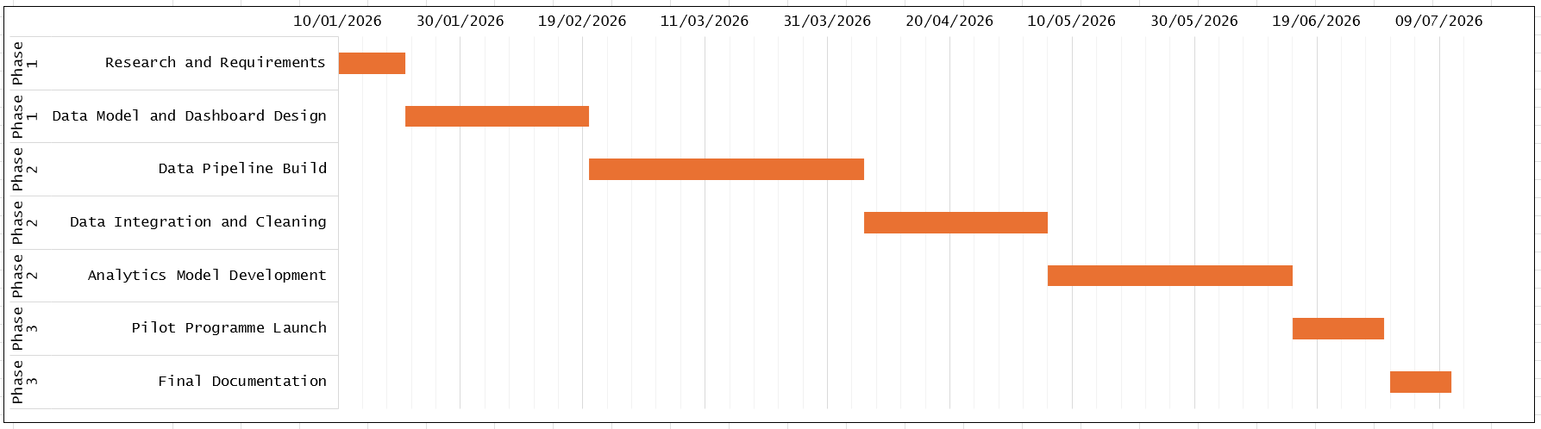
Figure 1 – Gantt Chart
The Gantt chart provides a visual roadmap for the project's six-month timeline. It details three phases: Discovery and Design, Development and Integration, and Pilot and Evaluation. The chart clearly illustrates how each task, from “Research and Requirements” to “Final documentation”, builds sequentially upon the last, ensuring a logical progression.

Q2. Project Design
For a data-driven project, two pieces of project design work are essential to illustrate the project's technical foundation.
- Entity-Relationship Diagram (ERD): An ERD visually represents the relationships between different data entities as shown below in Figure 2. My ERD will show the connections between key entities like 'Student,' 'Course,' 'Disability Disclosure,' 'Support Service Usage,' and 'Retention Status'. This diagram will be crucial for designing a coherent and scalable database schema that can support the project's analytical needs.
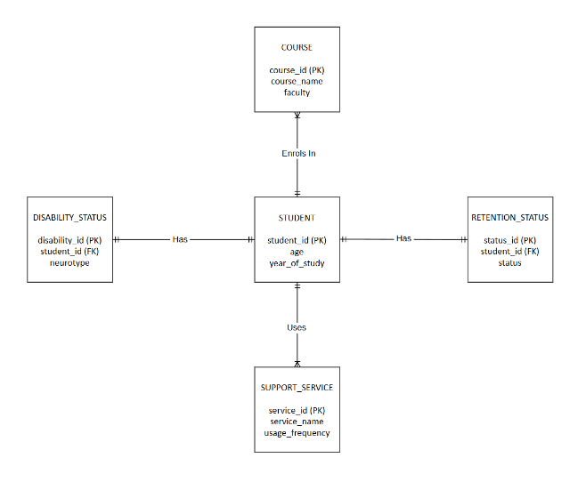
Figure 2 – ERD

- Data Flow Diagram (DFD): A DFD, as illustrated in Figure 3, demonstrates the flow of data from its source to its destination. My DFD will map how data moves from various university systems and external sources into a central data warehouse, through the data pipeline (which includes data cleaning and transformation), and finally to the analytics dashboard. This diagram will help in visualising the project's technical architecture and ensuring data integrity.
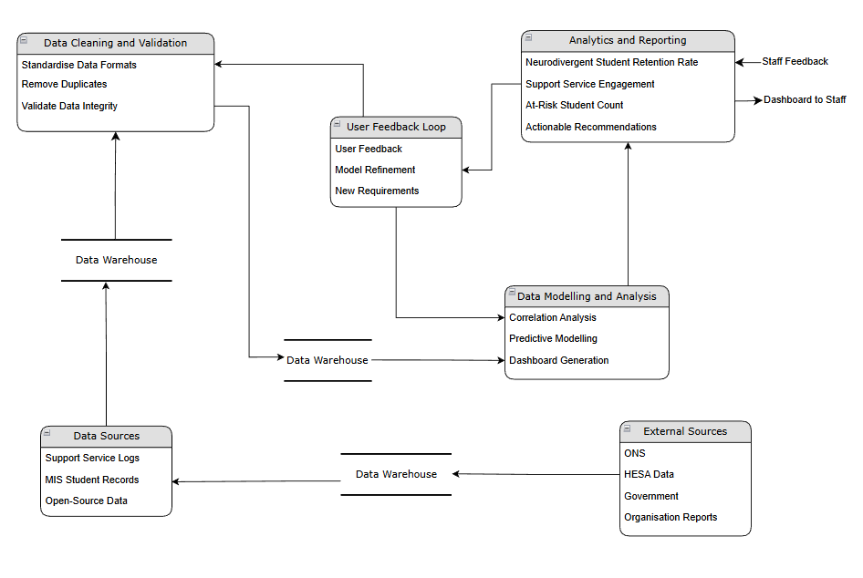
Figure 3 – DFD

Task 2: Innovation

Q1. PEST & SWOT Analysis

PEST Analysis
This PEST analysis examines the external environment affecting a tech company that operates in the UK higher education sector.
- P - Political:
  - Legal: Data protection laws (UK GDPR) and the Equality Act 2010 are critical[5]. The company must ensure its systems are compliant and do not enable discrimination.
  - Policy: Government policies on widening participation and student retention directly influence the market for student analytics solutions[6].
- E - Economic:
  - Funding: Changes in university funding models and student fee caps affect a university's budget for new technology, making cost-effectiveness a key selling point.
  - Market: The competitive landscape includes other Education Technology providers, but also the in-house IT and data teams at universities.
- S - Social:
  - Student Well-being: There is a growing social demand for universities to address student mental health and well-being, creating a strong market need for solutions that help identify at-risk students[7].
  - Neurodiversity Awareness: The increasing number of neurodivergent students and growing awareness of their needs create a significant demand for specialised, inclusive support systems[8 - 9].
- T - Technological:
  - AI and Machine Learning: Rapid advancements in AI offer powerful new tools for predictive analytics and personalised support, creating a constant need for the company to innovate.
  - Data Infrastructure: The shift to cloud computing and the maturity of data warehousing technologies makes large-scale data analytics feasible and more affordable for universities.

SWOT Analysis
This SWOT analysis identifies the internal strengths and weaknesses, and the external opportunities and threats.
- S - Strengths:
  - Expertise: Deep understanding of the UK higher education sector, its data, and its unique reporting requirements.
  - Existing Relationships: A company like Jisc already has established relationships with most UK universities, making it easier to sell and implement new products[10].
  - Data Access: Direct access to a wide range of institutional and sector-level data, which is a major competitive advantage.
- W - Weaknesses:
  - Legacy Systems: Internal reliance on older systems can make it difficult to innovate quickly or integrate with new technologies.
  - Perception: May be perceived as a slow-moving, public sector-focused organisation, rather than a fast, agile innovator.
- O - Opportunities:
  - New Legislation: Changes in government policy around student well-being and diversity create a strong market for specialised data solutions.
  - Growth in Student Data: The increasing volume and types of data being generated by online learning platforms create new opportunities for advanced analytics.
  - Ethical Leadership: The company can position itself as a leader in ethical data governance, which is a growing concern for universities and students.
- T - Threats:
  - GDPR/Privacy Concerns: Public backlash or new privacy regulations could limit data access, making the core business model more difficult[11 - 12].
  - Competition: New, agile Education Technology startups could enter the market with more modern, user-friendly solutions.
  - Internal Development: Universities could choose to develop their own data solutions in-house, bypassing external providers entirely.

Q2. Development and Implementation
The framework for optimising neurodivergent student support would be developed using an Agile methodology. This would involve working in short sprints to develop data pipelines and analytics models, with continuous feedback from stakeholders like Student Support Services.
The project would be deployed in a phased approach. A pilot program would be launched with a small group of staff to test the dashboard's usability and the value of its insights. This would allow for a proof of concept before a broader institutional rollout.
Maintenance of the framework is critical. My team in the MIS department would be responsible for monitoring the data pipelines, ensuring data quality, and updating the analytical models to reflect new university policies or changes in student behaviour. The project would evolve using CI/CD (Continuous Integration/Continuous Delivery) pipelines for models and dashboards, allowing for quick, automated updates to keep the framework current.
The tools used would include ETL tools, a data warehouse, and a data visualisation platform to present the insights to staff.

Task 3: Project Reflection

Opportunity to develop new skills
Undertaking this project, is a significant opportunity for my professional development. As a Data Science apprentice working in this field, this project will allow me to transition from simply handling data to strategically applying it to solve a complex, human-centric problem.
A key area of skill development will be in ethical data governance and UK GDPR compliance. My work with this project will provide practical experience in navigating these challenges. This will involve developing and documenting protocols for anonymisation and data minimisation, skills that are highly sought after and critical for any data professional[11 - 12].
I will also develop my technical skills in data quality management. This project will challenge me to build robust data pipelines and validation rules, moving beyond theoretical knowledge to practical application. Furthermore, I will gain experience in stakeholder communication, learning to effectively translate complex data insights into clear, actionable recommendations for non-technical audiences.
This project is not just a theoretical exercise; it is an opportunity to bridge my technical expertise with my personal lived experience, turning a passion for social good into a professional competency.

The Positive Impact on and Contribution to Society
This project has the potential to create a profound positive impact on society by contributing to a more inclusive and equitable higher education system. By providing university staff with a tool for proactive and personalised support, the project can help close the persistent retention gap for neurodivergent students[8 - 9]. This ensures that a diverse and valuable talent pool is not lost from our future workforce due to a system that doesn't meet their needs.
The project's societal contribution extends beyond individual student success. It promotes a fundamental cultural shift within universities, moving them towards a more data-informed and empathetic approach to student support[13]. By highlighting the importance of ethical data practices, the project will contribute to a more trustworthy and transparent use of student data across the sector[5]. This, in turn, can influence national policies on student well-being and diversity, ensuring that universities are held accountable for creating truly inclusive environments[14]. Ultimately, by empowering neurodivergent students to thrive, the project helps build a more diverse and innovative society.

The Risks and Challenges
Every project faces challenges and anticipating them is key to success. Several risks for this project have been identified and a mitigation plan is developed for each:
- Data Quality Issues: A primary risk is that data from existing university systems may be inconsistent, incomplete, or difficult to access.
  - I will address this by conducting a thorough data discovery and designing phase at the start of the project. My role in the MIS Data Department gives me an advantage here, as I can better identify and document data limitations. The data pipeline will be built with a robust data validation and cleansing module to handle inconsistencies.
- Stakeholder Resistance: Departments and staff may be resistant to adopting a new data-driven system due to concerns about surveillance, workload, or a lack of understanding.
  - This will be addressed through a proactive communication plan. I will hold workshops with Student Support and academic staff to demonstrate the dashboard's value and ethical design. The focus will be on showcasing how the tool is a safety net for students and how it will reduce their administrative burden.
- Algorithmic Bias. A significant ethical challenge is the risk of a predictive model inadvertently creating bias. A model could unfairly flag students from certain backgrounds as "at-risk."
  - I will mitigate this by continuously auditing the data and the model. The model's development will be transparent, and I will perform regular checks to ensure its fairness and accuracy across different demographics[11 - 12].
By anticipating these risks and planning for their mitigation, the project is positioned for a higher chance of success.

Conclusion
This report has outlined a project focused on Optimising Neurodivergent Student Support and Retention through Data-Driven Insights in UK Higher Education. The project is a process innovation designed to address the persistent retention gap faced by neurodivergent students by moving from reactive to proactive support.
A clear plan was outlined in Task 1 which defined the project's scope, deliverables (a data pipeline and analytics dashboard), and the chosen Agile development method. The project's design was demonstrated through an ERD and a DFD, showing the logical structure and data flow of the solution. Following on from this, Task 2 then explored the strategic context with a PEST and SWOT analysis and detailed the project's iterative development and implementation plan within a large organisation. Finally Task 3 provided a critical perspective on the project, highlighting the skills developed, its positive societal impact, and key challenges with the mitigation strategies.
In summary, this report demonstrates that this data-driven framework is not only a viable technical project but a fundamental social innovation with the potential to create lasting, positive change in UK higher education.

References
[1] J. Cray, L. Hull and F. Sedgewick, "What's out there? A scoping review of autism-related policies and research interests at U.K. higher education institutions," Neurodiversity, vol. 2, Mar 2024. doi: 10.1177/27546330241237882. Available: https://journals.sagepub.com/doi/full/10.1177/27546330241237882
[2] W. Wang, et al., "An empirical study on the evaluation system of innovation and entrepreneurship education in applied universities," Computer applications in engineering education, vol. 31, no. 1, pp.100–116, Jan 2023. doi: 10.1002/cae.22573. Available: https://onlinelibrary.wiley.com/doi/abs/10.1002%2Fcae.22573
[3] J. S. Saltz and I. Krasteva, "Current approaches for executing big data science projects—a systematic literature review," PeerJ. Computer science, vol. 8, pp.e862, Feb 21 2022. doi: 10.7717/peerj-cs.862. Available: https://www.ncbi.nlm.nih.gov/pubmed/35494858
[4] C. Robson, Real world research, Fifth edition Ed. 2024.
[5] P. Prinsloo, S. Slade and M. Khalil, "The answer is (not only) technological: Considering student data privacy in learning analytics," British journal of educational technology, vol. 53, no. 4, pp.876–893, Jul 2022. doi: 10.1111/bjet.13216. Available: https://onlinelibrary.wiley.com/doi/abs/10.1111%2Fbjet.13216
[6] A. Le Cunff, et al., "Key Research Questions to Support Neurodiversity in Higher Education: A Participatory Priority Setting Exercise," Education sciences, vol. 15, no. 7, pp.839, Jul 1 2025. doi: 10.3390/educsci15070839. Available: https://www.proquest.com/docview/3233140728
[7] N. ScotSMART, et al., "What Do We Know About Student Mental Health in UK Higher Education?: A Scoping Review of Trends, Gaps, and Research Directions (Preprint)," JMIR research protocols, Aug 25 2024. doi: 10.2196/65594. Available: https://doi.org/10.2196/65594
[8] G. Aguilera Rodríguez, et al., "University experiences of students and graduates with neurodiversity: tools for creating a specialized mentoring program related to working life," Frontiers in education (Lausanne), vol. 9, Aug 12 2024. doi: 10.3389/feduc.2024.1432930. Available: https://doi.org/10.3389/feduc.2024.1432930
[9] L. Butcher and S. Lane, "Neurodivergent (Autism and ADHD) student experiences of access and inclusion in higher education: an ecological systems theory perspective," High Educ, vol. 90, no. 1, pp.243–263, Jul 2025. doi: 10.1007/s10734-024-01319-6. Available: https://link.springer.com/article/10.1007/s10734-024-01319-6
[10] N. Dixon, R. Howe and U. M. Richter, "Exploring learning analytics practices and their benefits through the lens of three case studies in UK higher education," Research in learning technology, vol. 33, pp.1–14, Feb 10 2025. doi: 10.25304/rlt.v33.3127. Available: https://doaj.org/article/dbacdafe448741788a8c6c8ba432e27b
[11] M. Korir, et al., "Investigating the dimensions of students’ privacy concern in the collection, use and sharing of data for learning analytics," Computers in human behavior reports, vol. 9, pp.100262, Mar 2023. doi: 10.1016/j.chbr.2022.100262. Available: https://dx.doi.org/10.1016/j.chbr.2022.100262
[12] F. Siddiq and D. Murchan, "Towards a code of ethics for using technology-enabled data and related analytic approaches in educational assessment," Assessment in education : principles, policy & practice, vol. 31, no. 5-6, pp.376–400, Nov 1 2024. doi: 10.1080/0969594X.2025.2453138. Available: https://www.tandfonline.com/doi/abs/10.1080/0969594X.2025.2453138
[13] N. von Jacobi, et al., "Creating social value by empowering people: a social innovation perspective," Annals of public and cooperative economics, vol. 95, no. 2, pp.413–439, Jun 2024. doi: 10.1111/apce.12447. Available: https://onlinelibrary.wiley.com/doi/abs/10.1111%2Fapce.12447
[14] G. Goodall, et al., "Barriers and Facilitators in the Transition From Higher Education to Employment for Students With Disabilities: A Rapid Systematic Review," Frontiers in education (Lausanne), vol. 7, Apr 25 2022. doi: 10.3389/feduc.2022.882066. Available: https://www.frontiersin.org/articles/10.3389/feduc.2022.882066/pdf

