Coursework: Reflective Essay
Critically reflect on your own values and beliefs and consider how these align with a professional code of Counselling practice (such as the BACP Ethical Framework, 2018)

Module: Reflective Practice in Counselling Skills
Module Code: ECCS6004

Student name: Hannah Owen
Student Number: 1001210
Where does the desire to ‘help people’, so often given as the reason for wishing to train as a counsellor, originate? What are the unconscious motivations and gratifications for the would-be therapist? (Barnett, 2007). As a prospective student counsellor, one of the questions I have asked myself or have been asked is why do you want to be a counsellor? The first answer that comes to mind is because I want to help others, but I ask myself why do I want to help others? Reflecting on my past, I have always wanted to help others. The purpose of this essay is: to critically reflect on my values and beliefs, with particular focus on the value of altruism and what it means to me, considering how this aligns with the British Association for Counselling and Psychotherapy (BACP, 2018) Ethical Framework. I will first outline what reflective practice is, then explain Mark Wareing’s (2017) ‘Me, My, More, Must’ values-based reflective practice model, which I will use to guide my exploration of self-identity and how my values and beliefs, particularly altruism resonate with me most; aligning with the BACP (2018) Ethical Framework. I will also evaluate the benefits and or impediments of my journey into the counselling profession, considering alternative models that may have been more useful.

The emergence of reflective practice can be traced back for centuries. The ancient Greek philosopher Socrates famously stated ‘The unexamined life is not worth living’, emphasising the importance of self-awareness and questioning one's beliefs, actions, and purpose in life (The Socratic Method, 2024). Reflective practice promotes us to re-visit our experiences, noticing our emotional responses and questioning our known or unknown assumptions that may arise during the reflective process; assumptions often being based on our values and beliefs about the world (Bassot, 2020, pp.ix, 83). Donald Schön’s (1983, p68) highly regarded writings on reflective practice describe the reflective practitioner as one who ‘reflects on the phenomena before him, and on the prior understandings which have been implicit in his behaviour’.

The importance of reflective practice in the counselling profession is discussed throughout literature. Wong-Wylie (2007) emphasises the importance of self-awareness; ‘counsellor, know thyself’, noting that a deep connecting to one’s values, beliefs and experiences is crucial for ethical practice and personal development. In summary, reflective practice fosters a deeper understanding of one’s self, increasing awareness of our subconscious thoughts including, but not limited to, assumptions, beliefs and biases, enabling more informed and ethical decision making.

To gain a deeper understanding of our values and beliefs, I will use Mark Wareing’s (2017) ‘Me, My, More, Must’ values-based reflective practice model. Initially designed for health and social care practitioners, the model was developed in response to failures in patient care within UK hospitals. The model encourages practitioners, throughout their training and professional practice, to place values at the centre of their medical practice, by promoting use of values-based reflection, factual and ethical decision-making, effective communication skills and consideration of differing perspectives. More specifically the ‘Me, My, More, Must’ model intends to promote users to reflect by considering who they are and what impact their values might have before they proceed with reflecting on a particular experience, in order to enable practitioners to process their experiences, underpinning their core values throughout their work.

The first stage of the model, ‘Me’, poses questions to draw the practitioner to examine one’s self, their personal values and their origins, to consider what we are ‘capable of doing, thinking and sensing’. Secondly, the ‘My’ stage, aims to support the learner to distinguish between ‘who they are from what they do’, understanding the connection between their personal identity and professional role, to understand our experiences, whilst observing the significance of our emotions. The ‘More’ stage of the model requires you to identify experiences that you have been left bewildered by, to ‘consider what ‘more’ needs to be learnt’ to forge new awareness and consider a way forward. Lastly, the ‘Must’ stage of the model, guides the learner to create an action plan for personal and professional growth and developmental needs identified in the prior stage.

I chose this model as I felt it was best aligned to the assignment’s focus on value. Unlike experiential-based models, Wareing’s model is specifically designed as a values-based model, that prioritises self-awareness by promoting us to consider the impact of our values by identifying our subconscious thoughts and behaviours before reflecting on an experience. As I have chosen to reflect on my core value of altruism, it is difficult to pinpoint a specific experience for this purpose. Therefore, I will use the model as a flexible guide, rather than a definitive framework (see Table 1). (Wareing, 2017)

To start with the first stage of the model, reflecting on:
- Who am I?
- What values are important to me personally and professionally?
My name is Hannah. I am currently studying counselling skills whilst working for my Local Authority as a coordinator for Looked After Children with Additional Learning Needs. I am a white female in my mid thirties, raised in a semi-rural area near a small city with a strong, primarily public sector presence. My parents eventually separated when I was 12, I chose to live with my father, while maintaining regular contact with my mother and bother. Neither of my parents completed formal qualifications; my mother had various part-time jobs whilst parenting us, now working as an administrative assistant for the government. My father is a retired police officer and now enjoys living part-time in Spain. My younger brother completed a Masters in photography and lives away from home.
When thinking about what values are important to me, I reflect on my childhood and consider what was important to me growing up, which brings me back to the question why do I want to help others? As a child, I took such pleasure in being useful and helping others. My parents have always worked in roles that involved service to others; my father’s work as a police officer became a way of life for us, spending the first 6 years of my life living in a rural police station, which significantly influenced my aspirations to help and support others. In adulthood, I have followed a career path centred on helping professions, in my personal life I have always had a natural desire to help others, problem solve and fix issues, particularly those in distress. I have the innate ability to go into the mode of helper and throw myself into action. However, I still find myself feeling curious as to why. Owen’s (1993) question ‘why altruistic persons should take a job in caring for strangers, when the rest of the 'non-caring' world goes about it’s business’ makes an interesting point. Research considers the nature and nurture of values, suggesting that altruistic tendencies and behaviours may be influenced by both genetic predisposition and early childhood experiences, forming the foundation of our subconscious ethical attitudes expressed in our behaviours throughout life (Vyskocilova and Prasko, 2013, p.102). I now understand that my childhood experiences of parental separation may have had an impact on my altruistic values, particularly my desire to fix, problem solve, and manage situations around me as I grew up, as that was an aspect of my life that I had no control over. Wheeler (2002) notes that people may pursue a career in counselling inspired by their life experiences, as ‘wounded healers’ they can harness that to be beneficial to the client. However, the effectiveness of such depends on how the healer has processed their past, without allowing it to become a barrier to their professional role.

The second stage of the model leads me to consider:
- What are my thoughts and feelings on my work experiences?
- What are my thoughts about myself and others with regards to my work experiences? Are there any concerns?
- Who can support me to understand this?
When I think about my work experiences, I have always aimed to apply key qualities such as benevolence, empathy and courage, while striving to achieve the best possible outcomes within the best interests of the service user. In my previous role as a Child Protection Officer, the outcomes would not always align with the child’s hopes; however, they would fall within the realms of my capacity to ensure further harm was avoided, whilst promoting the child’s wellbeing and ensuring their voice was heard. I was always conscious of the sensitive nature and significance of their disclosures and how these could often damage the trusting relationship established between us. I tried to employ empathy, respect and integrity, throughout to maintain trust.
When evaluating my ways of working, I value collaborative working and feedback. Some feedback I received indicated that I often seek reassurance, which reflects my lack of confidence in my decisions, despite being competent in my work. However, when responsible for making life-changing decisions that can profoundly impact people’s lives, I believe working collaboratively with professionals, peers and supervisors is vital to ensure fairness, justice and continuity of service; as well as gaining differing perspectives, which are crucial for ongoing professional development. Reeves and Bond (2021, p.73) highlight the importance of discussing issues as an additional safeguard for the clients, while also acknowledging that the ‘ethics significance of avoiding psychological harm to a client is barely matched by the corresponding legal obligation’.

The next stage of the model asks:
- What lessons can I take from this?
- What has surprised or puzzled me?
- What questions do I have or what information would I like more of?
This experience has made me consider more deeply why I want to be a counsellor. I had never before considered how my childhood experiences, along with my biology, have influenced my desire to help and problem solve.
While I am proud of the work I have done with young people and remain passionate about helping with others, I now see how my altruistic values can be both beneficial and detrimental, not just to the client but also to myself. I am aware that my desire to help has, at times, taken precedence over my work-life balance, impacting my wellbeing. This reflection has made me realise the importance of reflective practice and the use of supervision to support both my professional development and personal growth. Flynn and Black (2011) recognise that while there are many benefits of the profession, counsellors who are naturally more altruistic could be at risk of burnout, and highlighted the importance of implementing professional boundaries and other forms of self-interest. Limberg et al. (2018) note that altruism can include wellness and self-care, highlighting their importance in being an effective counsellor, as they allow counsellors to be more present with their clients. This leads me to contemplate how to best maintain my altruistic values without detriment to my professional competency, my clients or myself.

And lastly, the model asks:
- What are my learning needs?
- What are my personal and professional aspirations?
- What values do I wish to explore further to assist in reaching my aspirations?
I have experienced the benefits of reflective practice and believe it will remain a continuous learning need throughout my training and career as a counsellor, or in any helping role I may pursue. I had not previously taken the time to consider in such depth why I like helping people and how that has led me to this point in my development. I would like to continue to develop my reflective practice skills so that it becomes a habit, rather than something I assign. By incorporating reflection into my everyday life, I hope to establish a solid foundation for implementing boundaries and being more disciplined with my work-life balance, while maintaining benevolence, empathy and sincerity. This will increase my resilience and competency as a professional. I am motivated to find a balance between my desire to care and upholding non-maleficence and client autonomy in the counselling role, which differs from the parameters I have been governed by in my other professions.
Reflective practice cannot be achieved by following a set procedure. While there are numerous reflective models available that offer a step-by-step process, Thompson and Thompson (2023, p. 73) explain that it is a much more convoluted and creative process, where various strategies and techniques can be employed to support critically reflective practice, both independently and with others (e.g. in supervision, mentoring and training). It will be beneficial to experience supervision with others, whether one-to-one or in a group, as well as continued individual practice, as regular ongoing supervision is considered an essential ethical condition by most professional bodies for counselling, such as the BACP (Reeves and Bond, 2021, p.73).

Such ethical standards are highly regarded in the counselling field. Holmes and Adshead (2009, quoted in Vyskocilova and Prasko, 2013, p. 103) accentuate the natural connection between psychotherapy and ethics, asserting that psychotherapy without an ethical component would no longer be psychotherapy. For the purpose of this essay, I have chosen to consider the BACP Ethical Framework (2018). The framework outlines the commitment to clients, ethical standards, and good practice in action, emphasising values, principles and personal moral qualities that members are encouraged to aspire to.

The BACP highlights six core principles that underpin their ethical framework, advising that well-founded ethical decisions should be strongly supported by one of more of these principles without any contradiction:
- Being trustworthy: honouring the trust placed in the practitioner.
- Autonomy: respect for the clients right to be self-governing.
- Beneficence: a commitment to promoting the clients wellbeing.
- Non-maleficence: a commitment to avoiding harm to the client.
- Justice: fair and impartial treatment of all clients and the provision of adequate services.
- Self-respect: fostering the practitioner’s self-knowledge, integrity and care for self.
(BACP, 2018)

My value of altruism, along with other values such as trust, justice, fairness and promoting client wellbeing whilst avoiding harm to others, closely aligns with the BACP Ethical Framework, with examples discussed in the reflective practice above. Although there are no irreparable conflicts, I am aware that my natural tendency to help and assist people with their difficulties could potentially clash with the BACP framework if I do not maintain a healthy level of self-awareness, reflection, and boundaries, particularly concerning client autonomy and learning new ways of working in line with the core principles.
Respect for client autonomy is a highly regarded goal of psychotherapy. Counsellors should strive to promote, rather than induce, clients to make independent choices (Stirmann et al., 2010). While clients often seek advice and guidance on situations, the therapist must balance developing a trusting relationship and rapport with creating a safe space that facilitates the client’s right to self-governance (Vyskocilova and Prasko, 2013). However, such distinctions can be made, and the ethics of the framework adhered to, by ensuring effective communication with the client regarding their expectations and engaging in supervision to monitor and reflect potential conflicts, ensuring that personal values do not impact on professional practice. A counsellor’s ethical responsibility is both personal and professional. Counsellors should aspire to distinguish between their personal and professional ethics, integrating both within a deeper sense of self to enhance the ethical dimensions of counselling (Reeves and Bond, 2021, p.41-42). I had wrongly assumed that my skills would be transferable and that I had less to learn than fellow prospective counsellors due to my professional experience. However, upon reviewing the BACP framework, I can see that adhering to the principles of the framework as an independent counsellor could be very different to applying those responsibilities to a dual role. Upon reflection of their own values, learners may discover conflicting values imposed by their organisations, creating an ethical dilemma (Siebert & Costley, 2012).

I chose Wareing’s model as I felt it was best suited to the objectives of this assignment. As a values-based model, it seemed to have some of the desired elements of double-loop learning, where we consider our underlying values, beliefs, and assumptions, compared to single-loop learning, such as Kolb’s experiential-based model, which focuses primarily on the action (Bentall, 2021). However, Wareing notes that whilst the model supports ethical reasoning, it does not follow a consequentialist approach that examines ethical principles to predict outcomes, thus not being a fully double-loop model (1969, 1994, cited Wareing, 2017, p.11-12). Still, there seemed to be little choice in models specifically based on values, leaving limited opportunities for comparison. The few other models I found that applied more closely to value-based reflection, such as John or Smyth’s frameworks (1995, 1989, cited Greenwood, 1998, p.1051), were also related to health care professions and started with evaluating an experience before considering values. I could have attempted to use one of these models; however, the majority are single-loop experiential based, focusing on a specific experience rather than the underlying meaning or, as Wareing (2016) states, the important process of considering who you are and developing self-awareness. Although Wareing’s aim is to facilitate the development of professional identity before making sense of the experience, emphasising the importance of exploring the origins and impacts of your values and beliefs, I found this element limited to the first stage only, with the next three stages relating specifically to the experience (Wareing, 2016).

Overall, I found this a useful tool to explore my values, although a model more primarily based on values, without the need to discuss specific experiences, would have been more useful since I was not reflecting on a particular experience, but instead using it as a mode of deeper reflection on my values. It was difficult to find literature on the Wareing’s model outside of his own work, which made critical evaluation more challenging.
However, Wareing (2016) highlights that this is a ‘sufficiently flexible’ model that can be used by practitioners and learners in clinical and therapeutic settings, as well as formal learning situations, giving the model an element of longevity, that is helpful in promoting growth as a student in training and progressing into practice.

In conclusion, reflecting on the desire to help others and the motivations behind wanting to become a counsellor has allowed me to better understand my core value of altruism and its significance within my identity. By using Wareing’s (2017) ‘Me, My, More, Must’ model, I have gained deeper insights into how my values, beliefs and past experiences shape my actions and motivations. This reflection has revealed that while altruism is a strength, it also presents potential challenges, particularly when it comes to maintaining professional boundaries and person wellbeing. Aligning my values with the ethical standards of the BACP (2018) Ethical Framework, I am now more aware of the importance of continuous self-awareness, reflective practice, and supervision in supporting my development as a counsellor. Moving forward, I am to foster a balance between my altruistic tendencies and the core principles of counselling, ensuring that my desire to help others does not undermine my own wellbeing or professional competency. Ultimately, reflective practice will remain an essential tool in my journey to becoming an ethical, effective and resilient counsellor.

Bibliography:
Barnett, M. (2007) ‘What brings you here? An exploration of the unconscious motivations of those who choose to train and work as psychotherapists and counsellors’, Psychodynamic practice, 13(3), pp. 257–274. Available at: https://doi.org/10.1080/14753630701455796

Bassot, B. (2020) The reflective journal. London: Red Globe Press An Imprint Of Macmillan Education, pp.ix, 83

Bentall, C. (2021) Models of Reflection and Reflective Practice. Available at: https://london.hee.nhs.uk/reflective-writing-models-reflection-and-reflective-practice (Accessed: 10 February 2025)

British Association for Counselling and Psychotherapy [BACP] (2018) Ethical Framework for the Counselling Professions. Available at: https://www.bacp.co.uk/events-and-resources/ethics-and-standards/ethical-framework-for-the-counselling-professions/ (Accessed: 1 February 2025)

Flynn, S.V. and Black, L.L. (2011) ‘An Emergent Theory of Altruism and Self-Interest’, Journal of Counseling and Development, 89(4), pp.459–69. Available at: https://doi.org/10.1002/j.1556-6676.2011.tb02843.x

Greenwood, J. (1998) ‘The Role of Reflection in Single and Double Loop Learning’, Journal of Advanced Nursing, 27(5), pp. 1048–53. Available at: https://doi.org/10.1046/j.1365-2648.1998.t01-1-00579

Limberg, D., Schuermann, H., Fox, J. and Robinson, E.H.M. (2018) ‘A Phenomenological Investigation of Altruism from the Perspective of Counsellors in Scotland’, Counselling and Psychotherapy Research, 18(1), pp.49–58. Available at: https://doi.org/10.1002/capr.12150

Owen, I. (1993) ‘On “The private life of the psychotherapist” and the psychology of caring’, Counselling psychology quarterly, 6(3), pp. 251–264. Available at: https://doi.org/10.1080/09515079308254120

Reeves, A. And Bond, T. (2021) Standards and Ethics for Counselling in Action. 5th edition. London : SAGE

Schön, D.A. (1983) The Reflective Practitioner: How Professionals Think in Action. United States of America: Perseus Books Group, p.68

Siebert, S. and Costley, C. (2013) ‘Conflicting Values in Reflection on Professional Practice’, Higher Education, Skills and Work-Based Learning, 3(3), pp.156–67. Available at: https://doi.org/10.1108/HESWBL-07-2011-0032

Stirman, S.W., Toder, K. and Crits-Christoph, P. (2010) ‘New Psychotherapies for Mood and Anxiety Disorders’, Canadian Journal of Psychiatry, 55(4), pp.193–201. Available at: https://doi.org/10.1177/070674371005500402

The Socratic Method (2024) The Socratic Method Available at: https://www.socratic-method.com/philosophy-quote-meanings/socrates-the-unexamined-life-is-not-worth-living (Accessed: 2 February 2025)

Thompson, S. and Thompson, N. (2023) The Critically Reflective Practitioner, 3rd edition. London: Bloomsbury Academic

Vyskocilova, J. and Prasko, J. (2013) ‘Ethical reflection and psychotherapy’, Neuroendocrinology Letters, 34(7), pp.590-600. Available at: https://www.nel.edu/userfiles/articlesnew/NEL340713R02.pdf (Accessed 9 February 2025)

Wareing, M. (2016) ‘Using the ‘me, my, more, must’, British Journal of Healthcare Assistants, 10(9), pp.446-452. Available at: https://doi.org/10.12968/bjha.2016.10.9.446

Wareing, M. (2017) ‘Me, my, more, must: a values-based model of reflection’, Reflective practice, 18(2), pp. 268–279. Available at: https://doi.org/10.1080/14623943.2016.1269002

Wheeler, S. (2002) ‘Nature or Nurture: Are Therapists Born or Trained?’, Psychodynamic Practice, 8(4), pp.427–41. Available at: https://doi.org/10.1080/1353333021000038809

Wong-Wylie, G. (2007) ‘Barriers and Facilitators of Reflective Practice in Counsellor Education: Critical Incidents from Doctoral Graduates’, Canadian journal of counselling, 41(2), pp. 59-76. Available at: https://research-ebsco-com.ezproxy.uwtsd.ac.uk/c/onvpsy/viewer/pdf/ase4qrunz5?route=details (Accessed 8 February 2025)

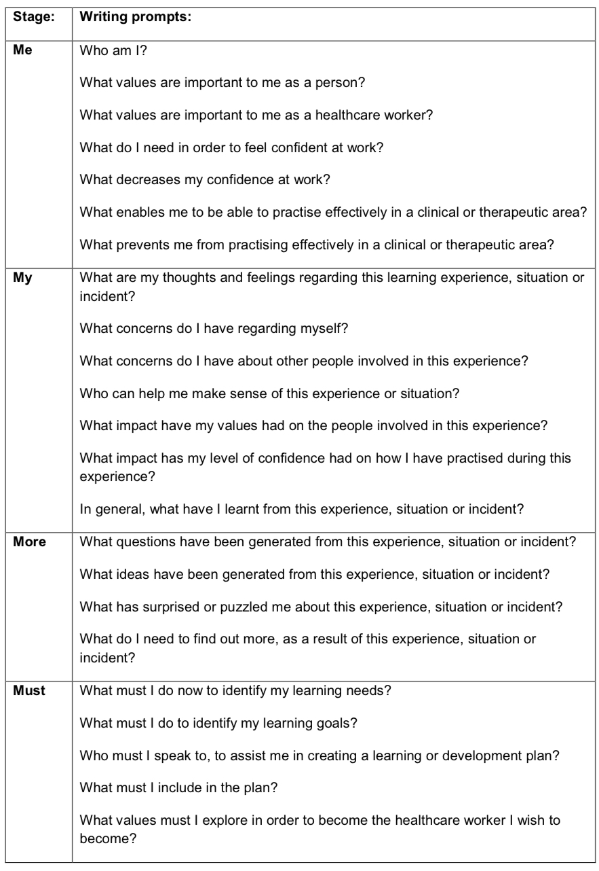
Appendix:
Table 1: Me, My, More, Must model of values-based reflection (Wareing, 2017, p.19)

