ECAD7003 Assignment: Part 2
How a School Develops One Aspect of its School Improvement Plan: A Report that Critically Reflects on the Actions, Impact and Evidence Base

Introduction
Throughout this assignment, the School Improvement Plan (SIP) for a primary school (School X) within the Neath Port Talbot County Borough Council area will be analysed and the priority of improving pupil attendance, with additional focus on eFSM (eligible Free School Meals) and ALN (Additional Learning Needs) pupils. The SIP was obtained with adherence to the British Educational Research Association (BERA, 2018) ethical guidelines for Educational Research along with compliance with child protection and safeguarding policies of the school. Therefore, for confidentiality purposes, the school will be identified as School X and referred to as ‘the school’ throughout this assignment.
School X is an English medium school with 389 pupils on roll. The school has 34.7% of eligible Free School Meals (eFSM) children, and 27.7% of children with Additional Learning Needs (ALN); both of which are higher than the national average percentages (Estyn, 2023, p2).
Under the Curriculum for Wales (Gov.uk, 2022a), schools need to ensure that learners are working towards the four purposes:
- ambitious, capable learners, ready to learn throughout their lives
- enterprising, creative contributors, ready to play a full part in life and work
- ethical, informed citizens of Wales and the world
- healthy, confident individuals, ready to lead fulfilling lives as valued members of society (Gov.uk, 2023a).

The Welsh Government provide further guidance as to how to achieve these aims through the use of School Improvement/ Development Plans, highlighting that the “overarching aim” is one of schools providing the best learning experiences to its learners, despite their backgrounds or circumstances with “high aspirations” for all (Gov.uk, 2022b). However, as can be seen through the responses from Rowlands (Estyn, 2021), it is important to ensure that school improvement plans are inclusive and support those learners who may be disadvantaged, such as those who are identified as eFSM or ALN. Brighouse and Woods (2013) concur that school improvement plans are an important aspect in developing and progressing learning for the outcomes of the learner as well as future improvements for the school.

Literature Review
School Improvement Plans – Positives and Negatives
In order for Welsh schools to meet their aims of becoming learning organisations and to provide all Welsh learners with high-quality education that is ever evolving and adaptive (OECD, 2018), school improvement plans are necessary to ensure that both quantitative and qualitative data is being collected and a strategic plan designed. School improvement plans help identify ways in which the school can improve, identify key issues and recognise ways of addressing them (Dodds and King, 1996; Gov.uk, 2022b). These SIPs take a holistic approach to encapsulate all types of information surrounding key issues for the school. The school takes the feedback from all of its stakeholders and the school community (Nahar et al, 2022; Gov.uk, 2022b), self-evaluates and conducts data analysis and, out of the results, identifies a number of short and long-term priorities, typically within a timescale of 1-3 years, and ways to address them (Knowlton & Phillips, 2012; Gov.uk, 2014). The layout of how a school improvement plan links to the overall vision of the school can be seen in Figure 1 below.
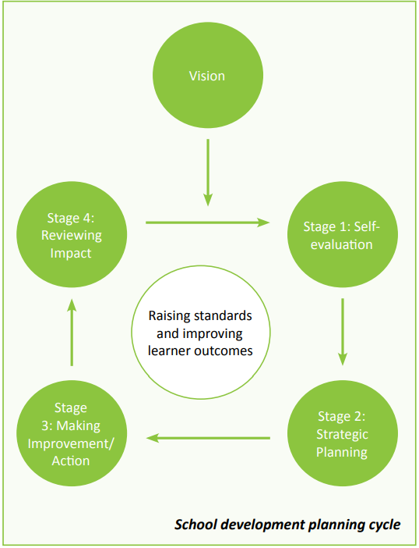
Figure 1 – (Central South Consortium, 2017)

Whilst fundamentally a School Improvement Plan is a positive, there can be some negatives. One such negative is that by focusing on the points raised within the SIP, the school can risk inadvertently misdirecting, or even ignoring, other fundamental points which need attention within the school (NAHT, 2020).
Another such negative to School Improvement Plans is that of rigidity (ASCD, 2022). Whilst it is helpful to have guidance surrounding how and why to create a School Improvement Plan (Gov.uk, 2022b), the need for fluidity throughout an SIP is important. Schools need to be reactive to issues and policies may need to change in response to issues raised during a school’s self-evaluation. However, this means that priorities for the school and Local Authority/ Government do not always align (Vangronigen et al, 2023). The policies and guidelines from Local Authority and Government may be too prescriptive and rigid.

Social Justice
In order address social justice, a definition is required; Oxford (2024) define it as an “objective of creating a fair and equal society”. Smith (2018) highlighted that whilst there are many naysayers surrounding children and their upbringing and circumstances, there are many who support that schools can provide an escape of specific group confines, such as that of Brint (2017, cited in Smith, 2018). Smith (2018) explores how school, and the education system can afford opportunities for all children, provide them with the prospects of social mobility and works with, or despite, the support of the children’s parents/carers. The Welsh Government support this through their implementation of a holistic approach under the Curriculum for Wales (Gov.uk, 2022a; Donaldson, 2015). However, as Smith’s book was written prior to the Covid-19 pandemic, it is interesting to note how work on reducing social justice inequalities/ inequities has been affected. Lanker and Parolin (2020) highlighted that many ways in which Covid-19 impacted on education and social justice for children, describing how there is a near social crisis since the pandemic. Prescott (Big Issue, 2023) also explores how since the pandemic, more children are absent from school than ever before, thus resulting in a greater gap in the achievement of social justice within education.

Attendance
Attendance is a key pillar in the school education journey; for if there is poor attendance, then poor, unstructured learning and/ or insufficient opportunities for learning has taken place (please see figure 2).
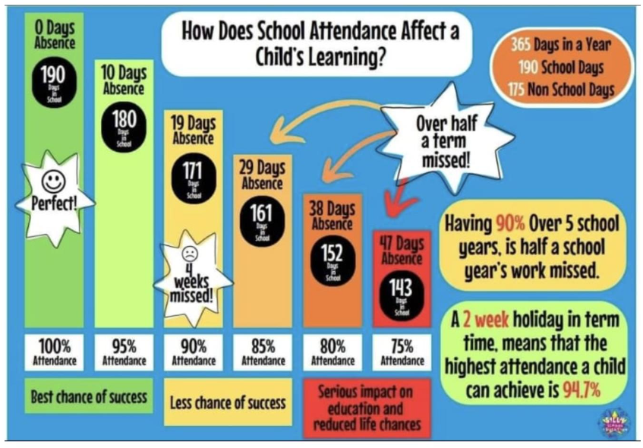
Figure 2 - (School X, NPTCBC 2023a)

Aucejo and Romano (2016) concur that chronic non-attendance can lead to earlier school drop out predictions, something which also aligns with an increased gap in social justice, as explored above.
The Welsh Government has also issued a report (Gov.uk, 2024) highlighting the concerns that the increase in absenteeism in Primary schools has for them. Figure 3 shows an increase in absences, however, does note that there is no data for the years surrounding the Covid-19 pandemic. Whilst this highlights the growing apprehension surrounding attendance, the lack of three previous years (school years 2019/20, 2020/21 and 2021/22) does raise questions surrounding the accuracy of its data.
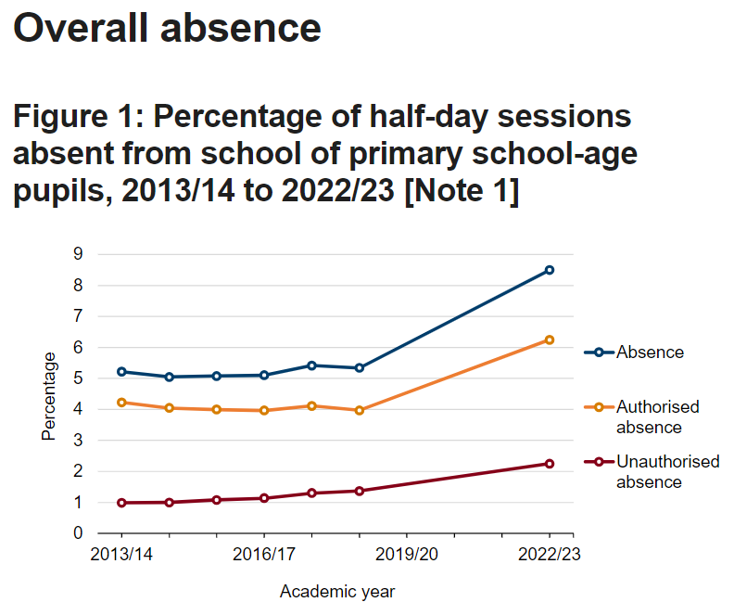
Figure 3 - (Gov.uk, 2024)

As can be seen throughout this section, attendance is a universal issue and has in the past acknowledged that children from poorer backgrounds and those with Additional Learning Needs are more at risk of missing school (Schoolsweek, 2023; UK Parliament, 2023; Contact, 2022). However, as further explored throughout Hill’s article (Schoolsweek, 2023) the reasons for these absences are an increase in illness and increased relaxed attitudes amongst parents to allow their children to stay home under the recognition that schools readily provide alternative provision for learning (Gov.uk, 2023).

Developing an Action Point
Self- Evaluation
The Welsh Government identifies that there are three main objectives to arise from completion of an SIP; namely those being:
- information and evidence,
- evaluation and improvement, and
- accountability (Gov.uk, 2022b).

With these objectives identified, along with the guidance in figure 4 (below), School X conducted a self-evaluation of the current practices and data stored to create a plan on how to improve attendance. School X analysed the data from Welsh Government (Gov.uk, 2024) and conducted a more detailed analysis of their own data. This highlighted those learners of eFSM and ALN status had a higher percentage of absence. This information, coupled with discussions and reflections of staff and pupils have enabled School X to identify ways in which to move forward. One area within the self-evaluation at School X that could have benefitted the school improvement plan was that of comparison of attendance data over previous years. As schools are still coming to terms with the impact of Covid-19, data held regarding attendance is unreliable. Therefore, the comparison of data over a 5-year period, would mean taking into account pre and post pandemic and may have contributed to a more reliable dataset. Also, another area to consider when recording and analysing data is that of the current cost-of-living crisis which has impacted poverty levels greatly since the pandemic (The Conversation, 2023; House of Commons, 2023). This may be a causative factor in the reasons absences are higher however, it is appreciated that this is a speculative theory.
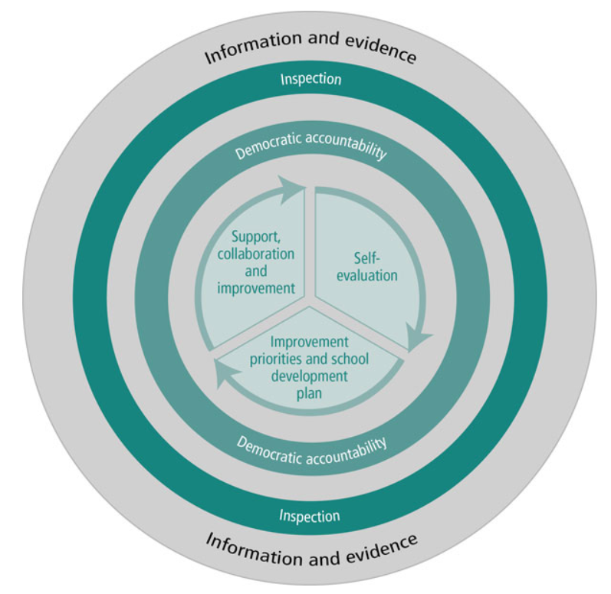
Figure 4 - (Gov.uk, 2022b)

Impact from Stakeholders
Whilst School X’s improvement plan was underpinned by the school’s aims and values and was developed by staff and pupils, the input from other stakeholders would have been beneficial. Mitra and Serrier (2012) and Bell and Aldridge (2014) both concur with the power of pupil voice in the development of a school’s practice, and this aligns itself with the Welsh Government’s aim of breaking down barriers to learning (Gov.uk, 2023c) as well as the United Nations Convention on the Rights of the Child (Unicef, 2024). However, it cannot be overviewed, the impact of input from parents/ carers, the community, the Governing Body, Social Services/ Team Around the Child and the Local Authority (Fullan, 2015; Brighouse and Woods, 2013). Harris, Chapman and Muijs’ (2006) report explores this in further detail and agrees that the external environment can impact greatly on a school’s ability to improve. Conversely, however, the input of external stakeholders can also impede a school improvement plan due to the stakeholders’ own biases, political agendas or personal viewpoints. Similarly, the phrase ‘too many cooks in the kitchen’ also holds some relevance here as whilst it is important to consider other viewpoints, too many at one time, over an emotive issue such as children’s education and attainment, can lead to misalignments and disagreements, hampering progress. Mugenyi (2015) explored this by acknowledging that whilst external stakeholders can impact positively to an SIP, there can also be limitations due to lack of training, ignorance and attitudes of both individual and community.

Strategic Planning
Following reflections, self-evaluation and discussion, School X ascertained that Attendance, with a special focus on eFSM and ALN learners, is a top priority for them. It devised a strategic plan moving forward to assist with the own school, underpinning Local Authority and National Government’s aim of improving attendance (NPTCBC, 2023b; Gov.uk, 2023d; Gov.uk, 2012; Senedd, 2022). School X acknowledged that during the last two years, since the pandemic, there has been conflicting messages about attendance at school; with the Public Health message sent home that if a child is symptomatic, to keep the child home from school (PHW, 2023). Therefore, the school planned to meet with the Education Welfare Officer (EWO), clarify the All Wales Attendance Framework and follow through with the correct procedures regarding letters home and meetings with parents. The school also highlighted how they would be liaising more with the EWO for guidance on how to address attendance with at-risk learners and their parents/carers. The school highlighted ways to improve coherent communication and emphasised the importance of class teachers discussing attendance with parents/carers as they have more face-to-face contact (at school drop offs/ pick ups/ via dojo). Regular meetings amongst staff and Local Authority/ EWO to analyse data as well as the sharing of ‘good practice’ from schools identified as being in a similar situation were scheduled to take place at least once every half term. Guidance from Jeremy Miles, Minister for Education’s report on breaking down barriers to learning was also sought as specific advice surrounding eFSM and ALN learners was provided (Gov.uk, 2023c).

Measuring Impact
An important aspect of a successful school improvement plan is that of measuring the impact changes have had to the issues concerned (Brighouse and Woods, 2013). The school highlighted ways to work alongside the Pupil Attendance Team within the Local Authority and Attendance Link Governor to undertake data analysis and evaluation of the progress towards the SIP target. Key questions were highlighted – please see figure 5.
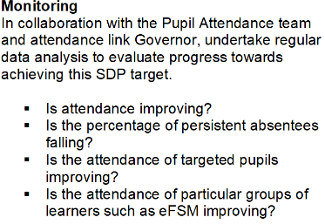
Figure 5 - (School X SIP, 2023)
Regular review and constant monitoring of the interventions brought in have already shown an increase in attendance rates (School X, 2023). These figures are being provided to parents/carers, discussed during Pupil Voice meetings and assemblies by the Head Teacher and Deputy Head Teacher, as well as printed and placed around the school building. This, added to the consistent approach (Brighouse and Woods, 2013) across all staff regarding rewards and information, all adds to the ripple effect of learners going home.
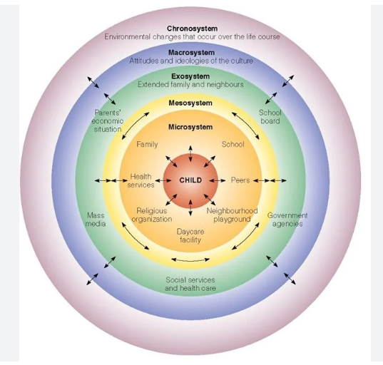
Bronfenbrenner (1977) discusses this impact and how different systems have an effect on a child. For example, if Public Health Wales (Exosystem) send out messages to families to keep children who are symptomatic from school (Mesosystem), then this affects the school’s attendance rates (Microsystem) which impacts on the child. Conversely, if the child is receiving information within school (Mesosystem) assemblies and posters (re: attendance rates), they can go home and discuss this with their parents/carers (Mesosystem), which impacts on the school’s attendance rates and improve figures sent to Local Authority/ Government Authorities (Exosystem).

Figure 6 - (Simply Psychology, 2024)

Reflection and Evaluation
As explored by Doss, Akinniranye and Tosh (2020), the impact of the changes required following feedback of a School Improvement Plan need to be shared throughout the school’s staff to ensure that the main priorities identified within the plan are realized and improved. As Headteachers are more likely to believe that SIPs can change teaching practices (Doss, Akiniranye and Tosh, 2020), it is important for this message to be conveyed to teaching staff to ensure that the teacher do not perceive their efforts as discounted and to ensure they are all ‘singing from the same sheet’ (Brighouse and Woods, 2013).
Schools need to ensure that they cultivate a learning environment which encourages attendance (OECD, 2012). School X have identified a reward system that provides learners with a raffle ticket system and gift card prize for those learners with 100% attendance per term. Whilst this is a positive step toward improving attendance, the risk of not receiving a prize due to the chance aspect of the raffle ticket, coupled with the waiting time for a prize, may not be enough to entice learners. Therefore, the suggestion of a monthly winner of the highest attendance with the promise of pizza for the class, as well as a trophy for the winning class (which moved to each class as per attendance rates), could be a more appealing reward.
Similarly, as School X had written into their SIP steps to meet more regularly with the EWO and Local Authority Attendance Team, this approach was aimed at increasing the knowledge of the school staff. Although this knowledge for staff is appropriate, and the sending home of figures to parents/ carers via dojo messages and face to face contact is helpful; meetings between the EWO and parents/carers of at-risk learners would be beneficial. Easy to understand infographics, akin to figure 2 (above) may also help convey the message to parents/ carers who may struggle with literacy skills. By explaining the impact absence from school has on a learner to themselves as well as their parents/ carers, can help reduce the perceived divide of ‘School’ and ‘Home’ and affords a closer relationship between both parties.

Conclusion
Throughout this assignment the importance of attendance to learner’s attainment levels, social justice and wellbeing has been explored. Bronfenbrenner’s Ecological Systems Theory (1979, 1996) emphasises the impact a SIP can have on the individual and the wider systems, and vice-versa, positing that an impact can be made, whether positive or negative to a child regarding their attendance and attitudes towards absence. The significance of listening to all stakeholders’ viewpoints has been highlighted in order to provide strategic planning for a school. This assignment has highlighted the need for an educational setting to be engaging and exciting and has inspired planning for future classrooms with the aim of school to be so unmissable that learners will not want to have any absence. It has also highlighted the need for open, coherent and forthcoming communication to ensure all people involved receive the same information. Through this approach, it is anticipated that there will be greater opportunities for learners of all backgrounds to access equitable learning, centred around the learner and their needs, and improved outcomes affording learners to meet the four purposes of the Curriculum for Wales (Gov.uk, 2022a). This is something I will take with me in my future career.
Total Word Count (inc headings) - 2703

Targets from Previous Assignment

 | Targed/Target | Yr hyn yr wyf wedi’i wneud yn yr aseiniad hwn….  What I have done in this assignment….
Targed/Target 1 | Widen your literature sources to gain a more in depth perspective of the topic with a deeper critical view. Using synthesis is better than long direct quotes. | Attempted to synthesise any quotes in my assignment to ensure I meet this target.
Targed/Target 2 | Your PETs are quite brief in the what next sections. These should be the most detailed with reference to literature. Please see the guidance on SWAY for PETs for advice. | Revisited PETs already created to try and link in literature and references where appropriate. Also, referred to the SWAY guidance for PETs and printed this off so I can highlight as I go through.

Reference list

ASCD (2022), Jackson, R., The Problem with Annual Improvement Planning. Available at: https://www.ascd.org/el/articles/the-problem-with-annual-improvement-planning (Accessed on: 24.02.24).

Aucejo, E.M., and Romano, T.F. (2016) “Assessing the Effect of School Days and Absences on Test Score Performance,” Economics of education review, 55, pp. 70–87. Available at: https://doi.org/10.1016/j.econedurev.2016.08.007.

Bell, L.M. and Aldridge, J.M. (2014) Student Voice, Teacher Action Research and Classroom Improvement. 1st ed. 2014. Rotterdam, Netherlands: Sense Publishers. Available at: https://doi.org/10.1007/978-94-6209-776-6.

Big Issue (2023), Prescott, B., Why are so many children vanishing from school?, Available at: https://www.bigissue.com/opinion/why-are-so-many-children-vanishing-from-school/ (Accessed on: 24.02.24).

Brighouse, T. and Woods, D. (2013) The A-Z of School Improvement : Principles and Practice. London: Bloomsbury.

British Educational Research Association (BERA) (2018), Ethical guidelines for Educational Research, London, Available at: https://www.bera.ac.uk/publication/ethical-guidelines-for-educational-research-2018 (Accessed on: 17.02.24).

Bronfenbrenner, U. (1996) The Ecology of Human Development Experiments by Nature and Design. Cambridge, Massachusetts ; Harvard University Press.

Central South Consortium (CSC) (2017), Guidance to Support School Improvement Planning. Available at: https://www.cscjes.org.uk/api/storage/2f1b1673-dc31-4fe3-98b8-bbf11ac2b25f?preview=true (Accessed on: 24.02.24).

Contact (2022) Children with SEND have Higher Rates of Severe Absence from School. Available at: https://contact.org.uk/about-contact/news-and-views/children-with-send-have-higher-rates-of-severe-absence-from-school/ (Accessed on: 24.02.24).

Conversation, The (2023) Its Not a Cost of Living Crisis, It’s a Poverty Pandemic. Available at: https://theconversation.com/its-not-a-cost-of-living-crisis-its-a-poverty-pandemic-218474 (Accessed on: 26.02.24).

Dodds, N., and King, G. (1996) The School Development Plan and Action Planning : The Essential Guide for Headteachers, Governors and Teachers : How to Involve your Governors, Teachers and Parents in Developing the School’s Plan for Improvement. New ed. Wolverhampton: Governor Teacher Presentations.

Donaldson. G. (2015) Successful Futures Independent Review of Curriculum and Assessment Arrangements in Wales. Available at: https://www.gov.wales/sites/default/files/publications/2018-03/successful-futures.pdf (Accessed on: 24.02.24).

Doss, C.J., Akinniranye, G., and Tosh, K., School Improvement Plans: Is There Room for Improvement? Santa Monica, CA: RAND Corporation, 2020. Available at: https://www.rand.org/pubs/research_reports/RR2575z4-1.html. (Accessed on: 24.02.24).

Estyn (2021) Rowlands, M., Consultation Response. Available at: https://www.estyn.gov.wales/system/files/2021-12/School%20improvement%20guidance.pdf (Accessed on: 17.02.24).

Estyn (2023) ------ [deleted for confidentiality purposes] Primary School Report. Available at: https://www.estyn.gov.wales/provider/6712236 (Accessed on: 17.02.24).

Fullan, M., (2005) Leadership & Sustainability : System Thinkers in Action. Thousand Oaks, Calif: Corwin.

Gov.uk (2012) All Wales Attendance Framework. Available at: https://www.gov.wales/all-wales-attendance-framework. (Accessed on: 26.02.24).

Gov.uk (2014) School Development Plans. Available at: https://www.gov.wales/sites/default/files/publications/2018-03/school-development-plans.pdf (Accessed on: 24.02.24).

Gov.uk (2022a) Developing a Vision for Curriculum Design. Available at: https://hwb.gov.wales/curriculum-for-wales/designing-your-curriculum/developing-a-vision-for-curriculum-design/#curriculum-design-and-the-four-purposes (Accessed on: 17.02.24).

Gov.uk (2022b) School Improvement Guidance: Framework for Evaluation, Improvement and Accountability. Available at: https://hwb.gov.wales/evaluation-improvement-and-accountability/school-improvement-guidance-framework-for-evaluation-improvement-and-accountability (Accessed on: 17.02.24).

Gov.uk (2023a) The Four Purposes for the Curriculum for Wales. Available at: https://www.gov.wales/sites/default/files/publications/2018-03/the-four-purposes-of-the-curriculum-for-wales.pdf (Accessed on: 17.02.24).

Gov.uk (2023b) Arranging Education for Children Who Cannot Attend School because of Health Needs. Available at: https://assets.publishing.service.gov.uk/media/657995f0254aaa000d050bff/Arranging_education_for_children_who_cannot_attend_school_because_of_health_needs.pdf (Accessed on: 24.02.24).

Gov.uk (2023c) Our National Mission: High Standards and Aspirations For All. Available at: https://www.gov.wales/our-national-mission-high-standards-and-aspirations-all-html (Accessed on: 24.02.24)

Gov.uk (2023d) Improving School Attendance. Available at: https://www.gov.wales/improving-school-attendance. (Accessed on: 26.02.24).

Gov.uk (2024) Absenteeism from Primary Schools: September 2022 to August 2023. Available at: https://www.gov.wales/absenteeism-primary-schools-september-2022-august-2023-html (Accessed on: 24.02.24).

Harris, A., Chapman, C. and Muijs, D. (2006) “Improving Schools in Challenging Contexts: Exploring the Possible,” School effectiveness and school improvement, 17(4), pp. 409–424. Available at: https://doi.org/10.1080/09243450600743483.

House of Commons (2023) Poverty in the UK: Statistics. Available at: https://commonslibrary.parliament.uk/research-briefings/sn07096/ (Accessed on: 26.02.24).
Knowlton, L. W., & Phillips, C. C. (2012). The Logic Model Guidebook: Better Strategies for Great Results. Sage.

Mugenyi, C., (2015) An Examination of Teachers Perceptions of Stakeholders Involvement in
School Improvement Planning: The Case of Uganda. International Journal for Cross-Disciplinary Subjects in Education (IJCDSE), Volume 6, Issue 3, September 2015. Available at: https://infonomics-society.org/wp-content/uploads/ijcdse/published-papers/volume-6-2015/An-Examination-of-Teachers-Perceptions-of-Stakeholders-Involvement-in-School-Improvement-Planning.pdf (Accessed on: 25.02.24).

Mitra, D.L. and Serriere, S.C. (2012) “Student Voice in Elementary School Reform: Examining Youth Development in Fifth Graders,” American educational research journal, 49(4), pp. 743–774. Available at: https://doi.org/10.3102/0002831212443079.

Nahar, G., Urick, A., Wescoup, S. M., Jang, C. S., Cascio, C. J., Unsicker-Durham, S. K., (2022) “A Framework for Cohesive School Improvement: Integrating School Improvement Plans, Evidence Use, and Resources,” AASA journal of scholarship & practice, 19(3), pp. 32-.

NAHT (2020), Improving Schools. Available at: https://www.naht.org.uk/Portals/0/PDF's/NAHT%20Improving%20schools%20final.pdf?ver=2021-05-31-090628-853/ (Accessed on: 24.02.24).

NPTCBC (2023a), Team Around the Family, Infographic provided by School X

NPTCBC (2023b) School Attendance. Available at: https://beta.npt.gov.uk/schools-and-learning/school-attendance-and-welfare/school-attendance/ (Accessed on: 26.02.24).

OECD (2012), Equity and Quality in Education: Supporting Disadvantaged Students and Schools, OECD Publishing. http://dx.doi.org/10.1787/9789264130852-en (Accessed on: 24.02.24).

OECD (2018) Developing Schools as Learning Organisations in Wales, Implementing Education Policies, OECD Publishing, Paris. Available at: https://doi.org/10.1787/9789264307193-en. (Accessed on: 24.02.24).

Oxford (2024) ‘Social Justice’. Reference. Retrieved 24 Feb. 2024, Available from: https://www.oxfordreference.com/view/10.1093/oi/authority.20110803100515279. (Accessed on: 24.02.24).

Public Health Wales (2023) Exclusion Period for Common Infections (May 2023) Including A-Z of Common Infections and Next Steps. Available at: https://phw.nhs.wales/services-and-teams/aware-health-protection-team/documents/exclusion-period-for-common-infections-may-2023-including-a-z-of-common-infections-and-next-steps/ (Accessed on: 26.02.24).

School X (2023) School Improvement Plan 2023-2024 ------ [deleted for confidentiality purposes] Primary School. Available: via email. (Accessed on: 15.01.24).

Senedd (2022) Pupil Attendance. Available at: https://senedd.wales/media/jcvef0z5/cr-ld15456-e.pdf (Accessed on: 26.06.24).

Simply Psychology (2024) Bronfenbrenner. Available at: https://www.simplypsychology.org/bronfenbrenner.html (Accessed on: 26.02.24)

Smith, E. (2018) Key Issues in Education and Social Justice. 2nd edition. London ; SAGE.

VanGronigen, B.A., Meyers, C. V., Adjei, R. A., Marianno, L., Charris, L. (2023) “The Design and Characteristics of School Improvement Plan Templates,” AERA open, 9, pp. 233285842311683-. Available at: https://doi.org/10.1177/23328584231168378. (Accessed on: 24.02.24).

Van Lancker, W. and Parolin, Z. (2020) “COVID-19, School Closures, and Child Poverty: A Social Crisis in the Making,” The Lancet. Public health, 5(5), pp. e243–e244. Available at: https://doi.org/10.1016/S2468-2667(20)30084-0. (Accessed on: 24.02.24).

UK Parliament (2023) Tackle School Absence Crisis with Better Mental Health and SEND Support and Urgent Legislation, says Education Committee Available at: https://committees.parliament.uk/committee/203/education-committee/news/197667/tackle-school-absence-crisis-with-better-mental-health-and-send-support-and-urgent-legislation-says-education-committee/ (Accessed on: 24.02.24).

Unicef (2024) How we Protect Children’s Rights with the UN Convention on the Rights of the Child. Available at: https://www.unicef.org.uk/what-we-do/un-convention-child-rights/ (Accessed on: 24.02.24)

