A Geotechnical Lab Report Focussing On:

The Mechanics of Engineering Soils

Module Code – ACBA5004

Word Count Required – 3500 (+/- 10%
Word Count: 3800

Prepared for:
- Nantel

Created By:
E. Evans (2211009)

Submission Deadline – 23rd April 2024

Table of Contents
1. Sieve Analysis Test 3
1.1 Introduction 3
1.2 Methodology 4
1.3 Results and Analysis 7
1.4 Conclusion 9
2. Atterberg Limit Test 10
2.1 Methodology for Liquid Limit 11
2.2 Methodology for Plastic Limit 13
2.3 Results and Analysis 14
2.4 Conclusion 16
3. Constant Head Permeability Test 18
3.1 Introduction 18
3.2 Methodology 19
3.3 Results and Analysis 21
3.4 Conclusion 29
4. References 31

Table of Figures
Figure 1. Soil sample 1000.02g with metal pan weighing 276.62g 4
Figure 2. British Standard sieves. 5
Figure 3. Pouring the sample into the British Standard sieves. 5
Figure 4. Brushing the aggregate from the sieve onto the collection sheet ready for weighing. 6
Figure 5. Aggregate being transferred into weighing pan. 6
Figure 6. Particle Size Distribution Chart marked with soil curve moving from fine sand to fine gravels. 8
Figure 7. Triangular graph of Soil Texture, classified within sands. 8
Figure 8. Apparatus for Atterberg Test 11
Figure 9. Soil specimen when water has been added. 12
Figure 10. Cassagrande Apparatus with split soil sample. 12
Figure 11. Liquid Limit Results plotted on scatter graph. 15
Figure 12. Plasticity Chart with marked ‘X’ to classify the sample as a Low Plasticity Clay. 16
Figure 13. Constant Head Apparatus equipment and soil samples set up. 18
Figure 14. Permeability cell with gravel like soil sample completely saturated. 19
Figure 15. Soil sample 1 sand like soil. 21
Figure 16. Permeability table for Darcys Law and classifying soil. 23
Figure 14. Permeability cell with gravel like soil sample completely saturated. 23

1. Sieve Analysis Test

1.1 Introduction
Soil Sieve Analysis plays a vital role in the Civil Engineering tests carried out when initially surveying a site to be built on, this test involves several key steps to accurately assess the particle size distribution of soil samples which influences its engineering behaviour such as its permeability, compaction, shear strength, bearing capacity and compressibility. By identifying the distribution of particle sizes within a soil sample, engineers on a construction project can make informed decisions in regard to the selection of construction materials, the choice of foundations and the mitigation of geological hazards. Soil sieve analysis can be utilised in various Civil Engineering disciplines such as geotechnical engineering, pavement design, slope stability analysis and environmental engineering. In geotechnical engineering, sieve analysis is utilised to classify soils according to their grain size distribution which aids in design stages for foundations, earthworks and retaining structures and can be directly fed into the construction report for any other works that may occur. In pavement design, identifying soil particle sizes helps engineers select suitable aggregate materials for base and sub layers to fully utilise the pavement performance and longevity. In slope stability analysis it is important to understand soil particle sizes to accurately assess erosion, landslides and other geotechnical hazards.
Soils are usually categorised by;
Clay = Less than 0.002mm
Silt = 0.002mm – 0.063mm
Sand = 0.063 -2mm
Gravel = 2mm – 20mm

1.2 Methodology
This test requires a certain procedure and equipment to be used according to the British Standards BS410-1:2000.
Equipment
BS2410-1:2000 standard sieves ranging from 2mm – 0.045 Micron plus the pan
Soil Specimen
Sieve Vibration Machine with timer
Weighing Scales
Plastic Catchment Sheet
Scale Pan
Cleaning Brush

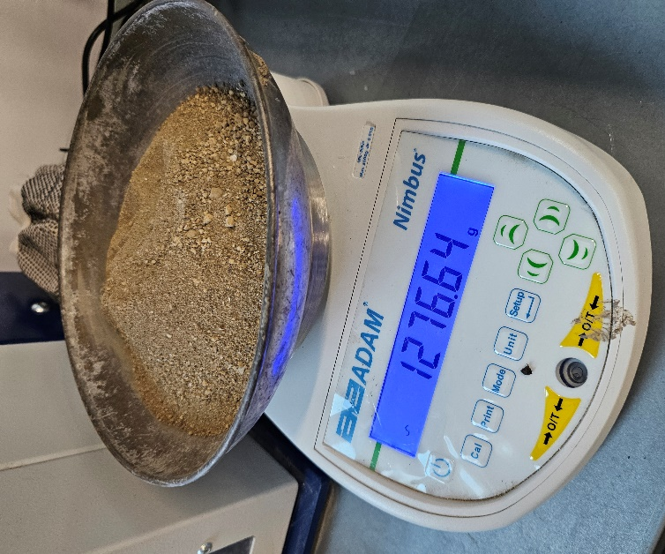
Before the test, the soil sample was dried at 120 degrees Celsius to take the moisture out. Working in a group of three technicians, the workstation was set out with all the equipment tested to make sure it works and tools laid out for seamless approach to the test. The sieves were checked to be in the correct order in particle size as well as ensuring the sieves were clean from debris and the weighing scale was set to zero ready to be weighed. The technicians then individually marked on a record sheet the sieve particle sizes that they were recording in the test. Once this was completed the scale pan was weighed and recorded, then a sample of the soil specimen was taken by quartering the soil into four parts and extracting around 1kg of the soil then recorded.
Figure 1. Soil sample 1000.02g with metal pan weighing 276.62g
(Evans, 2024)

To start the test the technician placed the clean sieves onto the stack in the correct order of particle size once more and continued to pour the soil sample onto the top sieve and then secured the stack onto the sieve vibration machine by means of screwing down the brace. Once the sieves were secure in place the sieve machine was set on a timer for two minutes and once this cycle was completed it was wise to unsecure the brace and let it settle for a few seconds to prevent any dust escaping. The technicians then removed the sieves carefully and individually transferring the material from the sieve onto the plastic catchment sheet and then brushing the particles and any excess (using the brush) into the clean scale pan and then weighing the aggregate that has been collected in the first sieve of 2mm and made a record of the mass in grams on the record sheet to the nearest 0.1g.
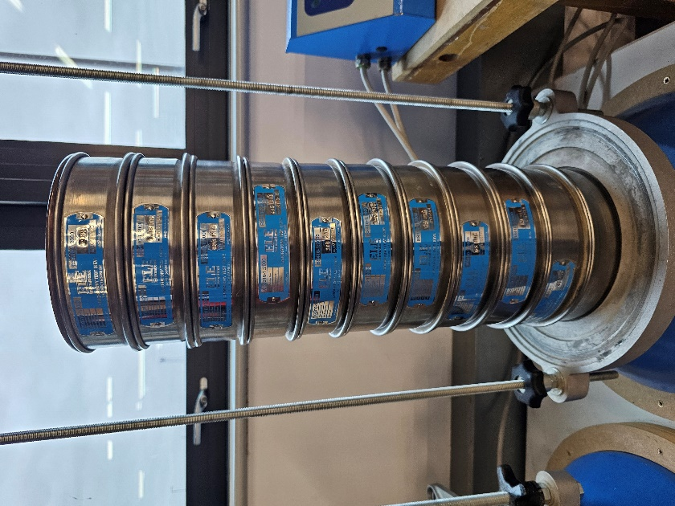
Figure 2. British Standard sieves.
(Evans, 2024)

Figure 3. Transferring aggregate from the sieve onto the collection sheet for weighing.
(Evans, 2024)

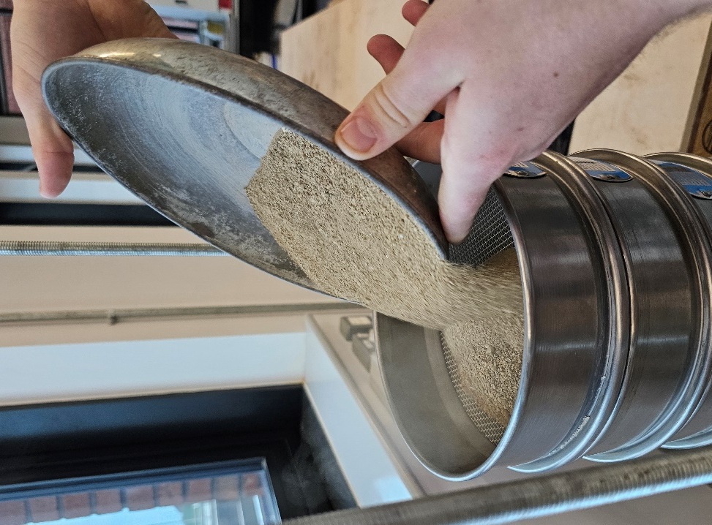

Figure 3. Pouring the sample into the British Standard sieves.
(Evans, 2024)

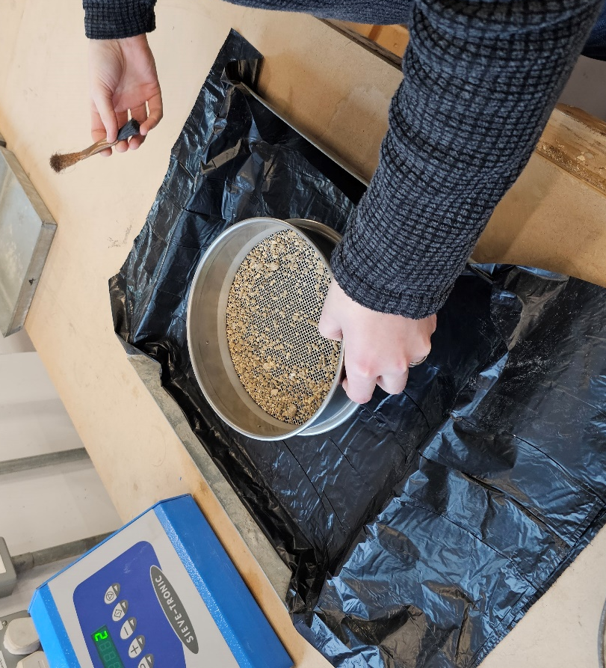
This process was then repeated for each of the sieve sizes ensuring the equipment used was cleaned after every use to prevent any transfer of sample or any loss, weights recorded on the record sheet by the technicians individually and also recording the end pan weight at the bottom. Once this had been done for all the sieve sizes it was then time for the technicians to calculate the percentage of soil passing throughout the sieves by using the weights recorded, and then this can be plotted on the particle size distribution chart and then classified on the triangular graph of texture.
Figure 4. Brushing the aggregate from the sieve onto the collection sheet ready for weighing.
(Evans, 2024)

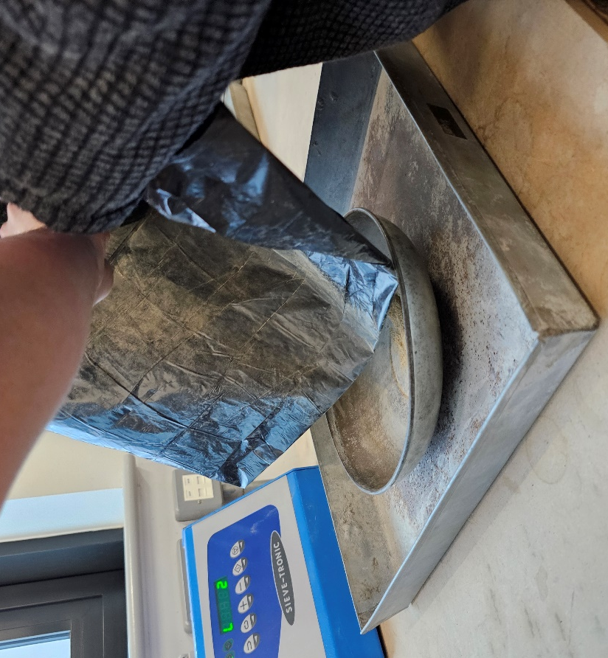
Figure 5. Aggregate being transferred into weighing pan.
(Evans, 2024)

1.3 Results and Analysis
The results of the test are highlighted in the below table from the test carried out above.
Particle Size Distribution Test
Results Table
Sample Size = 1000.02g
Pan Weight = 276.62g
Sieve Size (mm) | Mass (g) | % on Sieve | % Passing | Weight of Pan & Sample (g)
2 | 31.55 | 3.15 | 96.85 | 308.17
1.18 | 61.86 | 6.19 | 90.66 | 338.48 |  | Key;
0.6 | 129.64 | 12.96 | 77.7 | 406.26 |  | Sand
0.425 | 269.54 | 26.95 | 50.75 | 546.16 |  | Silt
0.3 | 240.09 | 24.01 | 26.74 | 516.71
0.15 | 168.71 | 16.87 | 9.87 | 445.33
0.075 | 72.2 | 7.22 | 2.65 | 348.82
0.063 | 6.23 | 0.63 | 2.02 | 282.85
0.053 | 10.94 | 1.09 | 0.93 | 287.56
0.045 | 1.17 | 0.12 | 0.81 | 277.79
Pan | 5.16 | 0.52 | 0.29 | 281.78
Total | 997.09 | 99.71
Including Pan | 1273.71

Classification
From these results the technician is able to identify and classify the soil texture using the Particle Size Distribution which follows;
Sand distribution from 2mm sieve size to 0.075mm totals to 973.59g with a percentage passing total of 97.36% by mass.
Silt distribution from 0.063mm sieve size to 0.045 and including the pan totals 23.5g with a percentage passing total of 2.35% by mass.
There were no clay deposits found in the soil specimen.

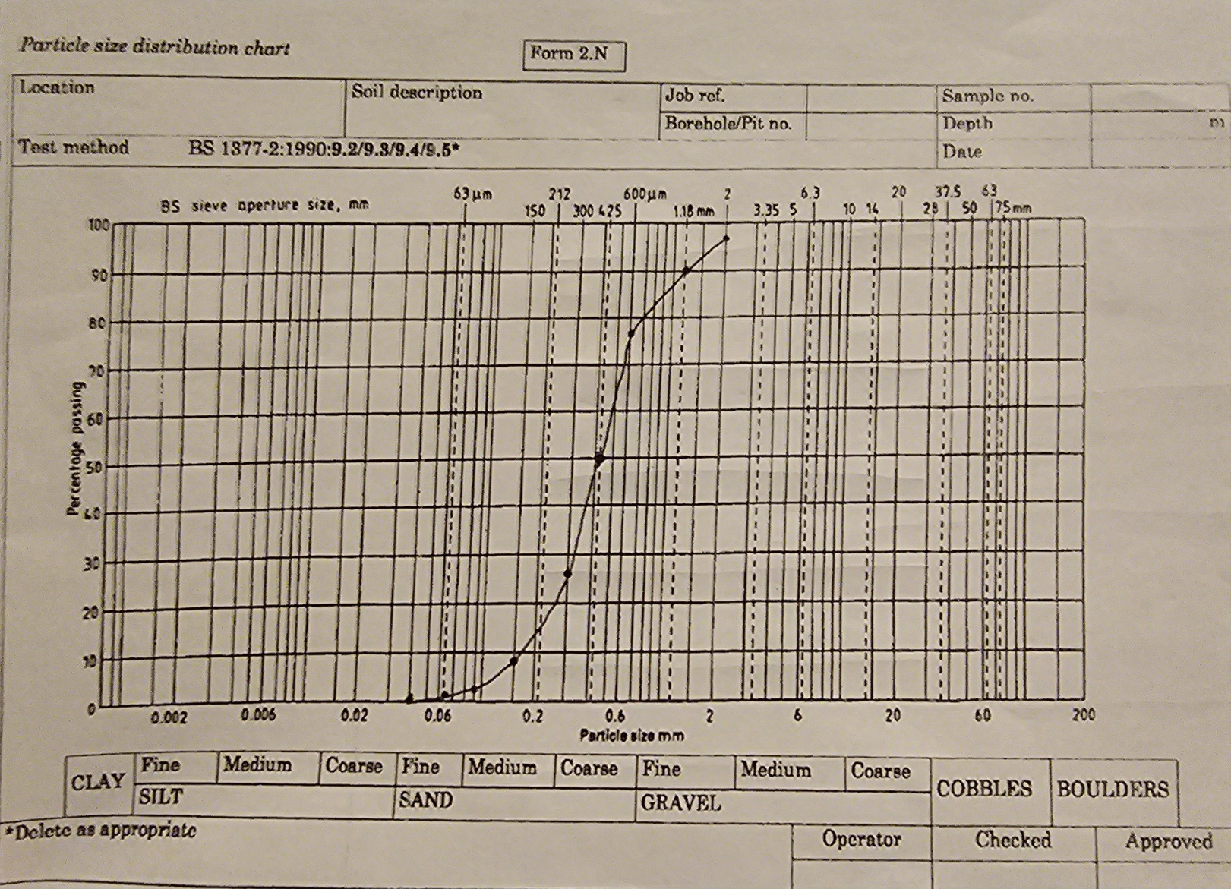
Figure 6. Particle Size Distribution Chart marked with soil curve moving from fine sand to fine gravels.
(Evans, 2024)

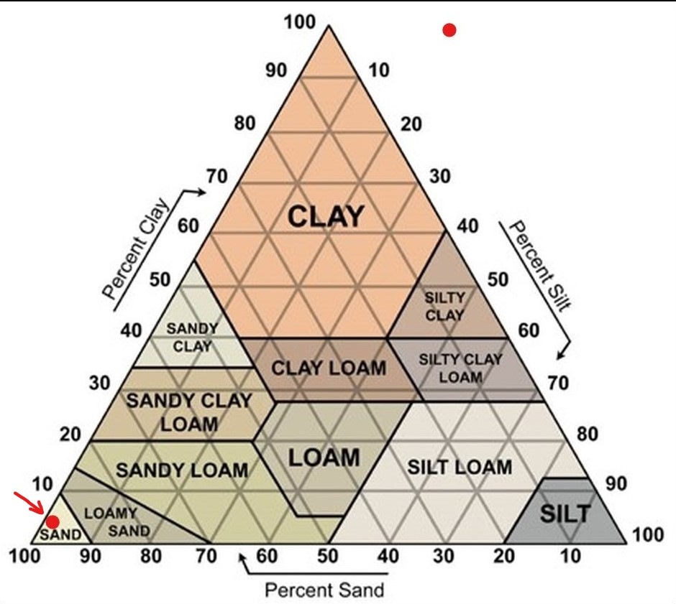
Red dot specifying classification.

Figure 7. Triangular graph of Soil Texture, classified within sands.
(Evans, 2024)

1.4 Conclusion
To conclude the sieve analysis of the soil specimen, the results show that the sample is a coarsely grained sand that is uniform in nature as shown on the particle distribution chart with evidence of fines and gravels. Coarsely grained sand soil comprises of mainly larger particles with minimal fines content which aids in higher permeability and making it suitable for drainage and various engineering applications due to its granular nature. Sand soil features high porosity and significant void ratio which is useful in water drainage further reducing the risk of water retention and preventing structural issues. Coarse grained soil offers very good load bearing capacity and shear strength when properly compacted which makes It a good choice for supporting heavy structures, another characteristic of this type of soil is the minimal settlement over time which provides stability and longevity to the engineered structures it is supporting.
While the Sieve Analysis test is very useful for providing essential information in regard to the particle size distribution of soil samples found at an engineering project site, the test also comes with a few limitations such as the loss of part of the soil sample due to particles being stuck in the gauze of the sieve and not being able to free the grains which in turn does not aid the accuracy of the results, due to the time scale and limitations on lab availability the technicians were not able to rerun the test so had to proceed with a loss. The technicians also noted that the plastic sheet that was used to capture the soil from the sieve would retain parts of the soil as well as the weighing pan which both would need extensive brushing after every use. Another limitation of this test is the ineffectiveness of dry sieving at a certain particle size where ensuring particles pass through an opening becomes more difficult.

2. Atterberg Limit Test
The Atterberg limits are used to measure the critical water contents of fine grained soils such as silt and clay as they change in behaviour. The Atterberg Limits test consists of three key indices, these are the Liquid Limit (LL), Plastic Limit (PL) and Shrinkage Limit (SL) but this test will require determining the Liquid Limit and Plastic Limit. The Atterberg Limits involves several standardised procedures to ensure accurate results and below contains a brief outline of the procedure carried out within a laboratory environment overseen by the lab technician.
The most important part of the laboratory test is acquiring a suitable sample from the site and ensuring that the sample is undisturbed, free from contamination while also ensuring that the sample is free from debris, rocks or organic matter. It is very important that there is a high level of quality control and assurance present while in the lab and the lab technicians must ensure that all testing equipment is properly calibrated and maintained. There are standardised testing procedures that need to be adhered to such as the British Standard BS 1377-2:1990 and testing must be documented including the procedures, observations and results. By following the standardised procedures, engineers and geotechnical professionals can accurately determine the Atterberg Limits of fine grained soils and provide essential information for engineering design and construction projects.
Liquid Limit (LL) is the lowest water content to which a soil behaves like a liquid and begins to flow, usually below 100.
Plastic Limit (PL) is the lowest water content at which a soil starts to behaves like a plastic material, usually below 40.
Plastic Index (PI) is the range between the Liquid Limit (LL) and the Plastic Limit (PL).
Equipment
Weighing Scales
The Cassagrande Apparatus
Soil specimen
Metal mixing bowl
Water bottle
Moisture cans
Grooving tool
Spatula

2.1 Methodology for Liquid Limit
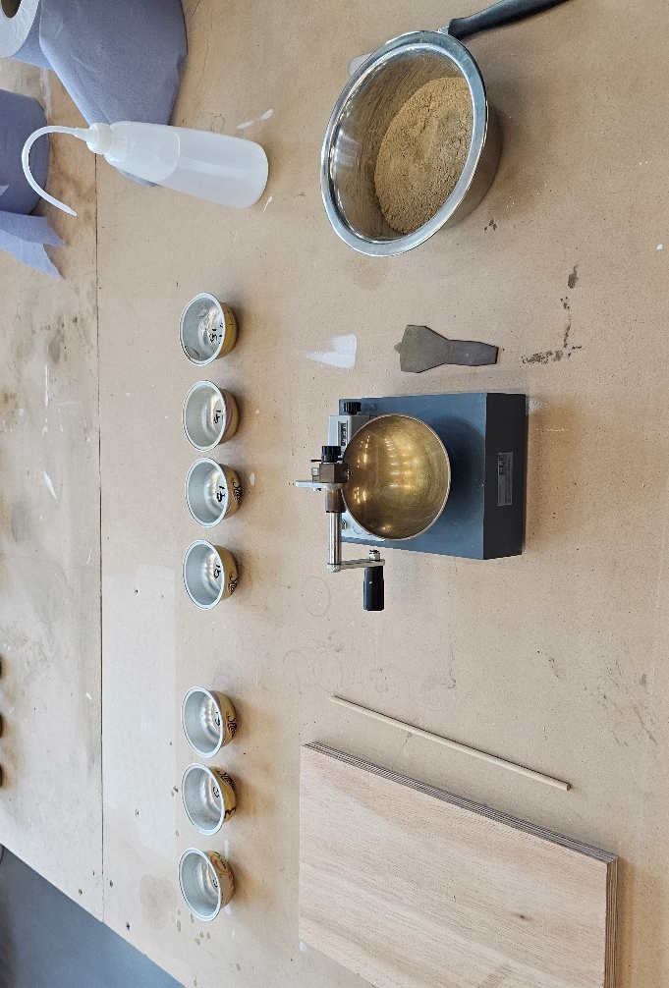
Working in a group of two, the technicians laid out the apparatus and then proceeded to mark and weigh four metal containers while recording each container weight onto a record sheet. Upon retrieving the soil specimen, 250g of the sample was added to a metal mixing bowl and then proceeded to mix thoroughly by one technician while the other is adding small (1-2ml) amounts of water to the sample while stirring consistently with the spatula to produce a clay that will require 30-35 drops of the Cassagrande apparatus to create a groove gap closure of 12mm, this was repeated until the correct consistency of clay was achieved.
Figure 8. Apparatus for Atterberg Test
(Evans, 2024)

When the correct consistency of clay was achieved, a sample of the mixture was placed into the bowl of the Cassagrande apparatus and spread as flat as possible across the base of the bowl to an approximate depth of around 10mm with caution to avoid any air bubbles in the sample, returning an excess or spillage into the mixing bowl. Using the grooving tool, a groove was cut from the front to the back of the bowl in a maximum two swipes to avoid any side tear.
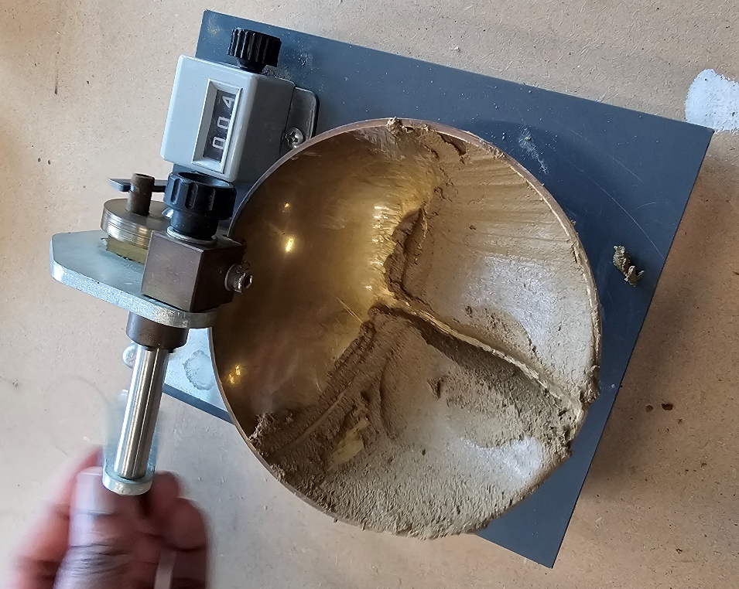
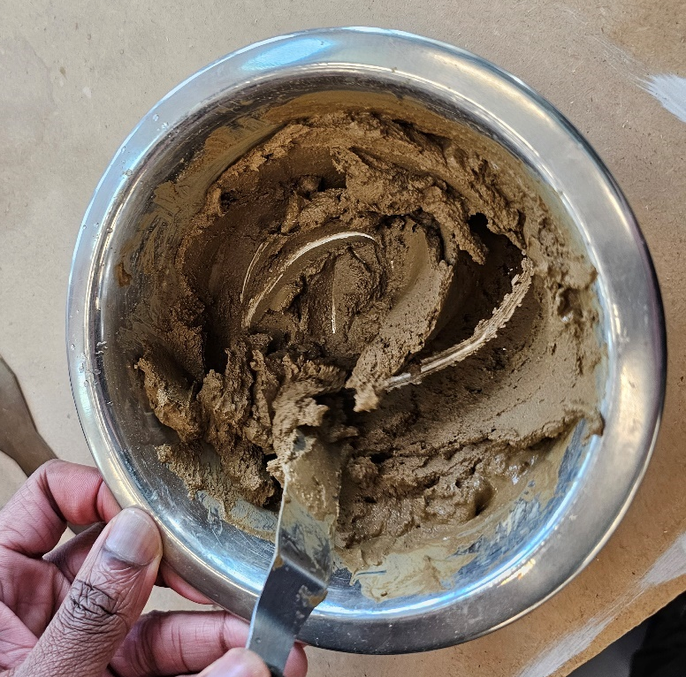
The technicians then zero the drop counter on the apparatus and proceeded to turn the crank handle of the apparatus at a rate of 2 turns per second until the two halves of the separated soil sample close over a distance of 12mm across the groove that was made with the grooving tool. Once the gap has been closed the technicians make a record of how many drops were required to close the 12mm gap on their record sheets and then continue to remove a slice of the soil the width of the spatula from edge to edge across the groove that was made, this was then placed into the marked container LL1 and weighed containing the wet soil and the container together. This process was repeated for in total four samples while gradually increasing the moisture content to reduce the number of blows required to close the gap, the objective was to obtain samples that required above and below 25 drops to close the gap and range between 35 and 15 drops. Once the technicians have made a record of their results it was then time to carry out the Plastic limit test before drying the samples in the oven.
Figure 9. Soil specimen when water has been added.
(Evans, 2024)

Figure 10. Cassagrande Apparatus with split soil sample.
(Evans, 2024)

Equipment for Plastic Limit test
Weighing scale
Soil specimen
Moisture Cans
Metal mixing bowl
Water bottle
Wooden plate
Wooden rod
Spatula

2.2 Methodology for Plastic Limit
The technicians retrieved the extra equipment required to carry out the Plastic Limit test, then proceeded to mark and weigh three containers labelled PL and recorded each container weight on the record sheet. To begin the test the technician then thoroughly knead the clay within the metal mixing bowl while adding more dried soil to adjust the moisture content to the required limits, if the sample is too dry the technicians could have added more water to return to clay. Once the sample has been mixed and knead thoroughly the technician then started to mould a ball of clay with their hands and continued to roll between the palms of their hands to create warmth and so that the sample dries slowly.
Using the wooden plate the technician continues to roll the sample until slight cracks began to form on the surface, the sample was then divided into three equal parts of around 10g each and then measured against the wooden rod and rolled into a thread at around 6mm in diameter making sure the thread is intact and continued until the thread is around 3mm in diameter. This was repeated until the thread started to crumble around the 3mm diameter mark while maintaining consistent rolling pressure throughout until shearing occurred both longitudinally and transversally as it is being rolled. The crumbling point of the thread is the Plastic Limit moisture content and when this was reached the technicians gathered any crumbs and placed in the previously marked containers and then were weighed with the wet soil and container together, then made a record of their weight on the record sheet. This was then repeated for the other two samples and then all three samples were dried in the oven with the Liquid Limit test containers at 120 degrees Celsius for 24 hours.

When both Liquid Limit and Plastic Limit samples had finished drying, the technicians then weighed each sample again to achieve a record of the dry weight and container together and then recorded their individual weights. Once this was completed for all samples, the technicians then individually calculated the Liquid Limit, Plastic Limit, Plasticity Index and the soil classification.

2.3 Results and Analysis
Liquid Limit and Plastic Limit Record Sheet
 | 1 | 2 | 3 | 4 | 5 | 6 | 7
Type of Test | LL | LL | LL | LL | PL | PL | PL
Container Number | 1 | 2 | 3 | 4 | 1 | 2 | 3
Weight of WET soil + Cont (g) | 14.56 | 12.63 | 15.6 | 14.54 | 7.96 | 7.97 | 8.55
Weight of DRY soil + Cont (g) | 12.49 | 10.99 | 13.3 | 12.47 | 7.43 | 7.48 | 7.95
Weight of Container (g) | 4.71 | 4.74 | 4.72 | 4.72 | 4.66 | 4.76 | 4.76
Weight of Moisture (g) | 2.07 | 1.64 | 2.3 | 2.07 | 0.53 | 0.49 | 0.6
Weight of DRY soil (g) | 7.78 | 6.25 | 8.58 | 7.75 | 2.77 | 2.72 | 3.19
Moisture Content | 26.61 | 26.24 | 26.81 | 26.71 | 19.13 | 18.01 | 18.81
Number of Blows | 31 | 26 | 22 | 19

Calculations
To achieve the ‘Weight of Moisture’ value it is Weight of wet Soil + Container – Dry soil + container.
For example; LL1 – $14.56g-7.78g=2.07$
To achieve the ‘Weight of Dry Soil’ value it is Dry soil + container – container weight.
For example; LL1 – $12.49-4.71=7.78$
Moisture content for the sample is taken at the 25 blow mark.
Moisture content = $\frac{Weight of Moisture}{Weight of Dry soil}×100$
For example; LL1 - $\frac{2.07}{7.78}×100=26.61\%$
These calculations were repeated for each of the samples.

Using the results from the table the technicians can now plot these results on a graph to determine the Liquid Limit by plotting the Moisture Content (%) on the y-axis against the number of blows on the x-axis, once this has been plotted it is then time to draw a ‘best’ line through the values and then an intersected line from the 25 blow mark across to the moisture content to get the Liquid Limit value.
Figure 11. Liquid Limit Results plotted on scatter graph.
(Evans, 2024)
Liquid Limit = 26.6%
To achieve the Plastic Limit (PL) value it is the average of the Plastic Limit moisture content values such as;
$$\frac{19.13+18.01+18.81}{3}=18.65$$
Plastic Limit = 18.65%
To achieve the Plasticity Index value it is Liquid Limit value – Plastic Limit value.
(LL) 26.6 – (PL) 18.65 = 7.95%
Plasticity Index = 7.95%
These values are then plotted on the Plasticity chart for Classification of Fine Soils using the Liquid Limit (%) on the x-axis against the Plasticity Index (%) on the y-axis.

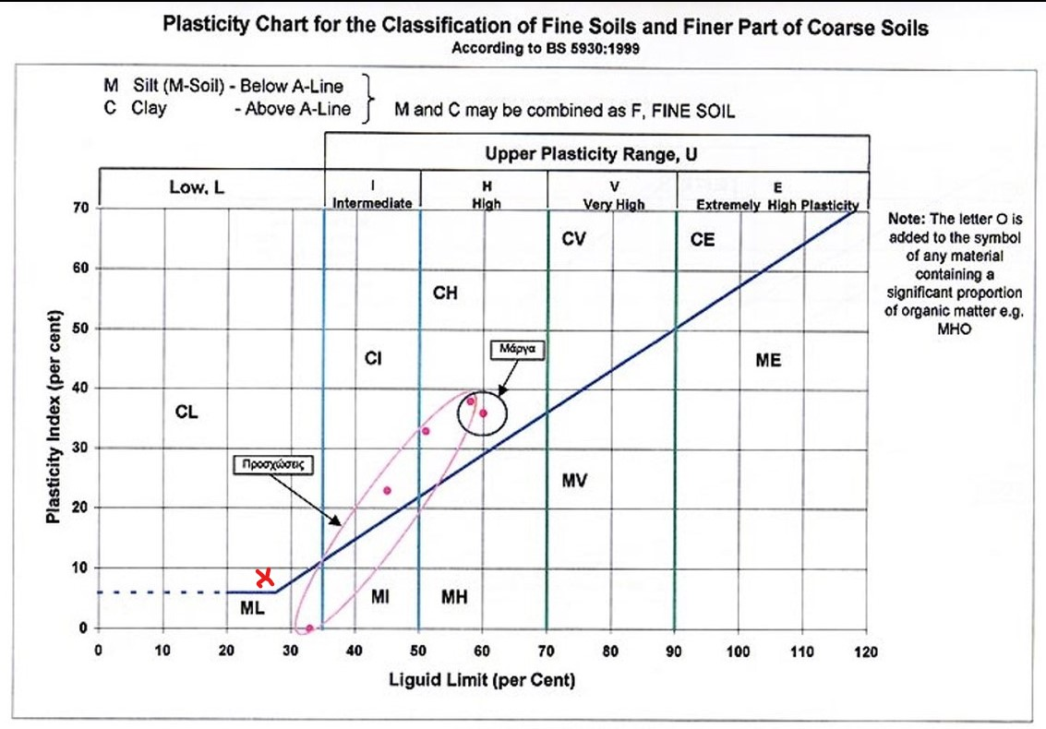
Figure 12. Plasticity Chart with marked ‘X’ to classify the sample as a Low Plasticity Clay.
(Evans, 2024)

2.4 Conclusion
To conclude the results of the Atterberg Tests on the soil specimen, the results show by means of calculations and plotting on standardised graphs that the classification of the sample is a low plasticity Clay soil which lies just above the ‘A-Line’ on the plasticity classification chart. A classification of low plasticity clay has characteristics such as the minimal ability to undergo significant deformation without cracking or failing which influences the soils behaviour when under load and its suitability for construction purposes such as foundations. Compared to other soils a low plasticity clay generally has a lower shrink-swell potential which therefore makes it less susceptible to volume changes due to moisture variations, although moisture control is still necessary to prevent undesirable soil movement. Dependant on its composition, this soil class can have moderate to high permeability, allowing water to flow more readily through the soil which gives it advantageous properties for drainage, seepage and slope stability. The technicians observed a few limitations of the test which included things such as the inaccuracy of adding water to the sample and had to be repeated multiple times to get the desired amount as well as the possible human error when using the Cassagrande apparatus such as too fast or too slow. The technicians also noted the environmental effects of the soil such as the room temperature and moisture content as well as how the sample was prepared.
There are a few tests carried out to determine slope stability and the results that are found from the Atterberg Limits can give an crucial information of the potential risks and hazards as well as the properties of the soil so that engineers can determine what procedures and processes they can use when designing the project. With a low plasticity clay soil determined by the results there are multiple factors that need to be considered.
The Shear Strength of this soil is impacted significantly by the moisture content present, low moisture content typically shows higher shear strength due to increased cohesion between the particles which helps resist the forces can cause slope failure. In the case study of the retaining wall collapse on a site in India, there was a significant rainfall event that caused water seepage into excavated material on the slope of the retaining wall that directly relates to the poor permeability of a low plasticity clay soil that often has a reduced ability to allow water to flow through them which causes excess water pressure within the soil and therefore reducing effective stress and potentially causing a slope failure.
Low plasticity clay soil is also prone to shrink-swell behaviour in response to the changes in moisture content, when the soil is dried I can shrink and lead to cracks, but when exposed to moisture they will swell and cause pressure on structures. When the soil is exposed to this cycle of shrink-swell it can compromise the stability of soil slopes. With the shear strength and deformation characteristics of low plasticity clay soils will influence the safe angle of slope inclination. The higher the shear strength will typically support steeper slopes and using the Atterberg Limits results, engineers are able to determine the appropriate slope angle for the given soil type on site. The case study features similar results to those that are achieved in the test carried out by the technicians and when documented on the case study it is shown that the failure was due to excessive rainfall causing the shear strength and permeability values to increase and therefore the forces acting upon it were too much leading to the collapse. It was documented that with proper water drainage systems in place this even would be prevented when another occurrence such as heavy rainfall occurred.
(Missouri University of Science and Technology, 1984)

3. Constant Head Permeability Test

3.1 Introduction
There are two types of permeability test methods that are used and are routinely performed in the laboratory, this being the Constant Head test and the falling head test. The constant Head test is utilised and best suited to test the flow of water through higher permeability granular soils such as clean gravels and vary from ‘K’ value of 1m/s to a small value of 10⁻¹⁰ m/s for very fine soil such as silt/clay. The Falling Head test is best suited for testing the water flow for lower permeability soil mixtures of sands, silts and clays with K values of between 10‾⁴ and 10‾⁹. Permeability is a fundamental property of soils and plays a crucial role in various engineering and environmental applications such as structural foundations, embankments, dams and flood management. The constant head permeameter test is a method used for determining the hydraulic conductivity of soils in laboratory conditions and provides valuable data for engineers and researchers to properly assess the behaviour of soils and therefore be able to make informed decisions in geotechnical and environmental engineering projects. Hydraulic conductivity is the rate at which water flows through soil materials and The Constant Head Permeameter test finds itself in multiple fields of engineering including Geotechnical engineering where the test is utilised for the design of drainage systems, estimating seepage through dams and also predicting settlement behaviour. The Constant Head test was to be carried out according to the British Standards BS EN ISO 17892-11:2019.
Equipment
Constant Head Permeability cell
Soil specimen
Constant level tank
Manometer tubes and measurement rulers
Measuring Cylinder
Stopwatch
Constant water supply

3.2 Methodology
Before beginning the test the lab technicians set the apparatus up and made sure all connections were secure and tight so that no leaks occurred and the permeable cell was air tight. Measurements of the apparatus were taken such as the height from the bottom connection to the top connection of the permeability cell in millimetres, then the difference between the measurements were recorded in metres as the length of the flow line (L). Then a measurement of the diameter of the permeability cell was taken and recorded and converted into metres for the Area of flow (A). All of these measurements were recorded In their respective letters ready for the calculation of Co-efficient of Permeability.
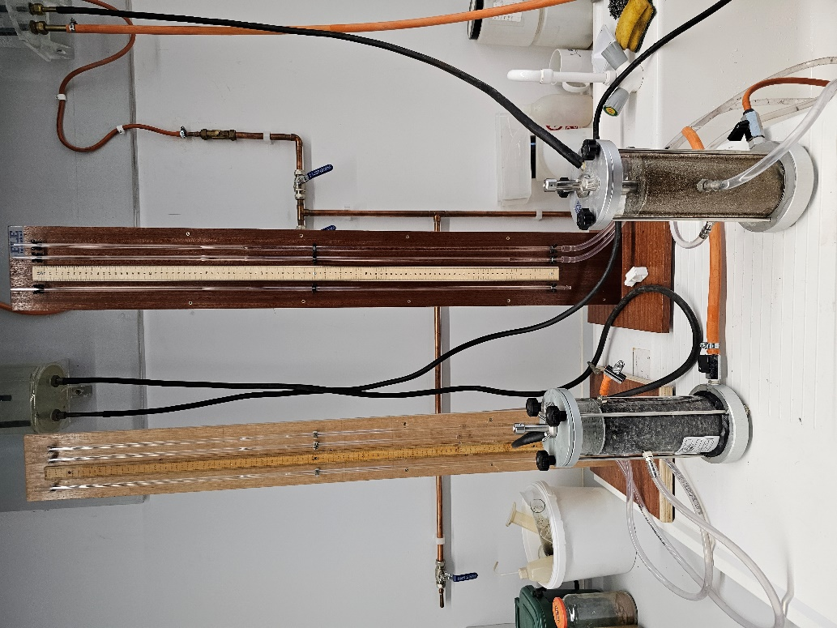
The soil sample was compacted into the cell to make sure it was uniform to achieve the best results free of air and voids. Before beginning the test, both soil samples were fully saturated by allowing water to flow through it under a low hydraulic gradient until no air bubbles are observed escaping from the sample. This was done to further ensure the soil pores are filled with water and there are no voids that could affect the permeability measurements. The cell is fully saturated with water and the reservoir tank is at a constant head so the technicians can now take a measurement for the hydraulic head difference (h) which was observed on the monometer tubes and taken the difference between top and bottom measurements and converted into metres.
Figure 13. Constant Head Apparatus equipment and soil samples set up.
(Evans, 2024)
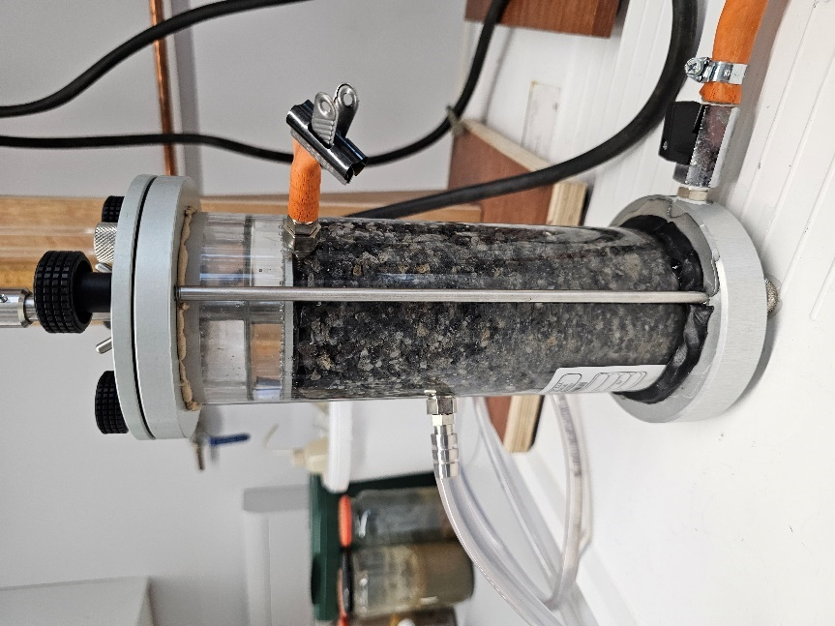
When starting the next and most important measurement the technicians decided to test the flow rate of the two different soil samples in three different times, the flow rate was going to be recorded at a time duration of 20s, 40s and 60s via stopwatch. One technician set the measurement cylinder up while another held and monitored the stopwatch for all three times each time recording the measurement of water collected in the tube in millilitres and marked as the flow over time (t) in m³/s for each of the durations.
Figure 14. Permeability cell with gravel like soil sample completely saturated.
(Evans, 2024)

Once the measurements were taken the technicians ran through the Co-efficient of Permeability equations for the three durations and achieved answers for each and confirmed with each other, the average was taken of all of the individuals answers to give a final result that would clarify and categorise the range of values for K (m/s) using Darcys Law which relates the flow rate, hydraulic gradient and samples dimensions, this was then classified within the soil classification table. This test was repeated in the exact same way for the other soil sample that had been prepared but repeated twice to ensure accuracy and then classified using Darcys Law.

3.3 Results and Analysis
Calculations
To determine the Co-efficient of Permeability of both soil samples the technician followed Darys Law and is documented below.
Equation for the Co-efficient of Permeability is;
$$K= \frac{Q×L}{A×h×t}$$
Where:
Q = Flow over time ‘t’ in m³/s
A = Area of Flow
K = Co-efficient of Permeability
L = Length of Flow Line
h = Hydraulic Head Difference
t = Time in Seconds
Note: This calculation was repeated for each of the three times.
Measurements and constants:
Diameter of permeability cell = 78.52mm > converted into metres = 0.078m > r² = 0.039²
Height to connections of permeability cell = 154mm – 84mm = 70mm > converted into metres = 0.07m
A = 0.039²
L = 0.07m
t = 20s / 40s / 60s

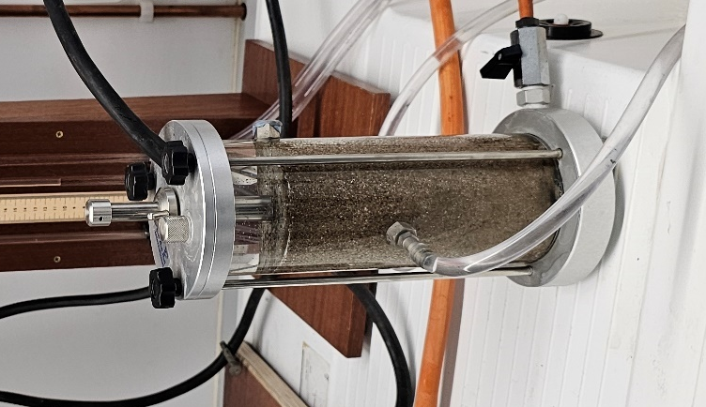
Soil Sample test 1
Figure 15. Soil sample 1 sand like soil.
(Evans, 2024)

Measurement on monometer tubes:
Hydraulic Head Difference: Difference between 63.3cm (top) & 10.6cm (bottom) = 52.7cm > converted into metres = 0.0527m
Q = $1.18×10‾^{4}+1.18×10‾^{4}+1.16×10‾^{4}$
A = 0.039²
K = 1.17 x 10‾⁴
L = 0.07m
h = 0.527m
t = 20s / 40s / 60s
Below is a table for the volume of water collected over the three time periods.
Time (s) | Volume of Water Collected (ml)
20 | 85
40 | 170
60 | 250
In the first test of the soil sample 85ml of water was collected within 20 seconds which can be calculated to gain our Q value. 85 x 10‾⁶ = 0.00085 m³.

The calculation for permeability was then completed;
Test with 85ml water collected at 20s
$$K= \frac{Q×L}{A×h×t}$$
$$K= \frac{\left(85×10‾^{6}\right)×0.07}{\left(π×0.039^{2}\right)×0.527×20}=1.18×10‾⁴$$

Test with 170ml water collected at 40s
$$K= \frac{Q×L}{A×h×t}$$
$$K= \frac{\left(170×10‾^{6}\right)×0.07}{\left(π×0.039^{2}\right)×0.527×40}=1.18×10‾⁴$$

Test with 250ml water collected at 60s
$$K= \frac{Q×L}{A×h×t}$$
$$K= \frac{\left(250×10‾^{6}\right)×0.07}{\left(π×0.039^{2}\right)×0.527×60}=1.16×10‾⁴$$
Now that the three calculations have been completed it is then time to average the values to determine the Co-efficient of Permeability.
$$\frac{1.18×10‾^{4}+1.18×10‾^{4}+1.16×10‾^{4}}{3} K=1.17 ×10‾⁴$$
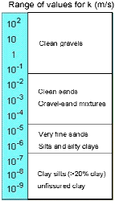
The value for the above soil sample being K=1.17 ×10‾⁴ which classifies in the Permeability table for Darcys Law as a ‘Clean sands/ Gravel-Sand mixtures’ soil.
Figure 16. Permeability table for Darcys Law and classifying soil.
(Nantel, A., 2024)

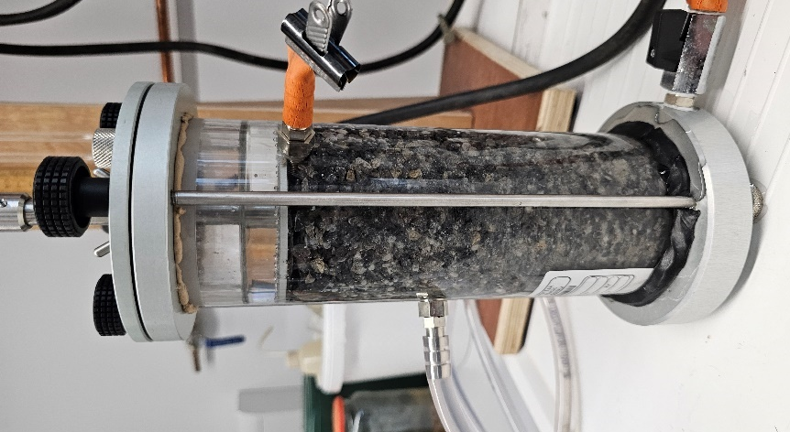
Soil Sampe test 2
Figure 14. Permeability cell with gravel like soil sample completely saturated.
(Evans, 2024)

Measurement on monometer tubes:
Hydraulic Head Difference: Difference between 7cm (top) & 12cm (bottom) = 5cm > converted into metres = 0.05m
Q = $1.099×10‾^{3}+1.047×10‾^{3}+1.026×10‾^{3}$
A = 0.039²
K = 1.057 x 10‾³
L = 0.07m
h = 0.05m
t = 20s / 40s / 60s
Below is a table for the volume of water collected over the three time periods.
Time (s) | Volume of Water Collected (ml)
20 | 75
40 | 143
60 | 210
In the first test of the soil sample 75ml of water was collected within 20 seconds which can be calculated to gain our Q value. 75 x 10‾⁶ = 0.00075 m³.
The calculation for permeability was then completed:
Test with 75ml water collected at 20s
$$K= \frac{Q×L}{A×h×t}$$
$$K= \frac{\left(75×10‾^{6}\right)×0.07}{\left(π×0.039^{2}\right)×0.05×20}=1.099×10‾³$$

Test with 143ml water collected at 40s
$$K= \frac{Q×L}{A×h×t}$$
$$K= \frac{\left(143×10‾^{6}\right)×0.07}{\left(π×0.039^{2}\right)×0.05×40}=1.047×10‾³$$

Test with 210ml water collected at 60s
$$K= \frac{Q×L}{A×h×t}$$
$$K= \frac{\left(210×10‾^{6}\right)×0.07}{\left(π×0.039^{2}\right)×0.05×60}=1.026×10‾³$$
Now that the three calculations have been completed it is then time to average the values to determine the Co-efficient of Permeability.
$$\frac{1.099×10‾^{3}+1.047×10‾^{3}+1.026×10‾^{3}}{3} K=1.057 ×10‾³$$
The value for the above soil sample being K=1.057 ×10‾³ which classifies in the Permeability table for Darcys Law as a ‘Clean sands/ Gravel-Sand mixtures’ soil.
Figure 16. Permeability table for Darcys Law and classifying soil.
(Nantel, A., 2024)

REPEAT of Soil Sampe test 2
Figure 14. Permeability cell with gravel like soil sample completely saturated.
(Evans, 2024)
Measurement on monometer tubes:
Hydraulic Head Difference: Difference between 52cm (top) & 41.6cm (bottom) = 10.4cm > converted into metres = 0.104m
Q = $9.72×10‾⁴+9.86×10‾⁴+9.86×10‾⁴$
A = 0.039²
K = $9.81×10‾^{4}$
L = 0.07m
h = 0.104m
t = 20s / 40s / 60s
Below is a table for the volume of water collected over the three time periods.
Time (s) | Volume of Water Collected (ml)
20 | 138
40 | 280
60 | 420
In the first test of the soil sample 138ml of water was collected within 20 seconds which can be calculated to gain our Q value. 138 x 10‾⁶ = 0.00013 m³.

The calculation for permeability was then completed:
Test with 138ml water collected at 20s
$$K= \frac{Q×L}{A×h×t}$$
$$K= \frac{\left(138×10‾^{6}\right)×0.07}{\left(π×0.039^{2}\right)×0.104×20}=9.72×10‾⁴$$

Test with 280ml water collected at 40s
$$K= \frac{Q×L}{A×h×t}$$
$$K= \frac{\left(280×10‾^{6}\right)×0.07}{\left(π×0.039^{2}\right)×0.104×40}=9.86×10‾⁴$$

Test with 420ml water collected at 60s
$$K= \frac{Q×L}{A×h×t}$$
$$K= \frac{\left(420×10‾^{6}\right)×0.07}{\left(π×0.039^{2}\right)×0.104×60}=9.86×10‾⁴$$

Now that the three calculations have been completed it is then time to average the values to determine the Co-efficient of Permeability.
$$\frac{9.72×10‾⁴+9.86×10‾⁴+9.86×10‾⁴}{3} K=9.81×10‾⁴$$
The value for the above soil sample being K= $9.81×10‾^{4}$which classifies in the Permeability table for Darcys Law as a ‘Clean sands/ Gravel-Sand mixtures’ soil.
Figure 16. Permeability table for Darcys Law and classifying soil.
(Nantel, A., 2024)

3.4 Conclusion
To conclude the Constant Head Permeameter analysis, multiple tests were carried out on two different soil specimens at different interval times to achieve the most useful data and a further test was carried out on soil sample two to further check the results that had been achieved as the technicians noticed from a visual inspection of the soil specimen that it should have possibly been identified higher up in the classification table which means their may be some errors in the tests or faulty equipment present. Before carrying out the final test the apparatus was checked and the result classification was still the same, which gave a verdict that there may be some limitations of the apparatus such as the cell not working correctly and possibly losing pressure due to air escaping the cell. By applying the Co-efficient of Permeability equations and using Darcys Law, the two soil specimens were classified as being in the 10‾⁴ class which is the ‘Clean Sands and Gravel-Sand mixtures’ and with this result it can give the engineers on the project an accurate idea to determine the rate of water flow and hydraulic conductivity throughout the proposed site, which is crucial for the implementation of drainage and predicting groundwater movement as a very important factor of the possibility of ‘under washing’ can occur to a site when water percolates through the soil and can potentially wash out and prove detrimental to the structural stability of a site.
While this analysis is very useful to predict soil behaviour and aid engineers and designers with an idea of what they can achieve with the underlying soil strata, there is also limitations to the test and the apparatus. The test relies on human input for the timing of the water flow via stopwatch and the human input of removing the flow tube from the collection cylinder, this means water may flow for more or less depending on two errors that may occur. While this can be a small limitation there is a major factor to take into consideration in regards to the stability and effectiveness of the apparatus, such as air escaping from the permeability cell and creating errors in the results for the classification.

4. References
ABG Geosynthetics , 2021. Soil Properties / Atterberg Limits. [Online]
Available at: https://abg-geosynthetics.com/technical/soil-properties/atterberg-limits/#:~:text=In%20the%20UK%20this%20is,are%20used%20throughout%20the%20world.&text=The%20Plastic%20Limit%20Test%20is,into%20a%20ball%20and%20repeating.
[Accessed 08 03 2024].
BASIC CIVIL ENGINEERING, 2017. Sieve Analysis – Particle size analysis procedure. [Online]
Available at: https://basiccivilengineering.com/2017/06/sieve-analysis-test.html#:~:text=British%20Standard%20Sieving%20Test%20Procedure,are%20struck%20in%20the%20openings.
[Accessed 08 03 2024].
Carleton University, 2011. Lab 4: Hydraulic Conductivity. [Online]
Available at: https://www.youtube.com/watch?v=BqJqcTdf4FY&ab_channel=CarletonUniversity
[Accessed 13 03 2024].
Evans, E., 2024. s.l.:s.n.
geotechdata, n.d. Constant head permeability test. [Online]
Available at: https://www.geotechdata.info/geotest/constant-head-permeability-test#:~:text=Concept,or%20disturbed%20granular%20soil%20samples.
[Accessed 07 03 2024].
Hossain, M. P. P. e. a., 2021. PROPERTIES AND BEHAVIOR OF SOIL. [Online]
Available at: https://uta.pressbooks.pub/soilmechanics/chapter/sieve-analysis/
[Accessed 07 03 2024].
Jeevagan, P., 2023. Introduction to permeability testin. [Online]
Available at: https://www.vjtech.co.uk/introduction-to-permeability-testing/
[Accessed 13 03 2024].
LinkedIn, 2023. How do you perform the main types of soil tests?. [Online]
Available at: https://www.linkedin.com/advice/0/how-do-you-perform-main-types-soil-tests-skills-civil-engineering
[Accessed 06 03 2024].
M.J.Smith, 1975. Soil Mechanics 2nd edition. 2nd ed. Norwich: Macdonald & Evans Ltd.
Mettler-Toledo International Inc, 2023. Sieve analysis. [Online]
Available at: https://www.mt.com/gb/en/home/applications/Laboratory_weighing/sieve-analysis.html
[Accessed 08 03 2024].
Missouri University of Science and Technology, 1984. Stability of Slopes - A Case History, Missouri: Missouri University of Science and Te.
Nantel, A., 2024. Lecture Slides. s.l.:s.n.
Soil Lab Modules, n.d. ATTERBERG LIMITS. [Online]
Available at: https://labmodules.soilweb.ca/soil-compaction-atterberg-limits/#:~:text=The%20method%20is%20based%20on,are%20the%20most%20commonly%20used.
[Accessed 08 03 2024].
Southern Testing, 2023. Geotechnical soil & rock testing. [Online]
Available at: https://www.southerntesting.co.uk/services/laboratory-testing/geotechnical-soil-testing/
[Accessed 05 03 2024].
The Editors of Encyclopaedia Britannica, 1998. Soil mechanics | Compaction, Shear Strength & Consolidation. [Online]
Available at: https://www.britannica.com/science/soil-mechanics
[Accessed 06 03 2024].

