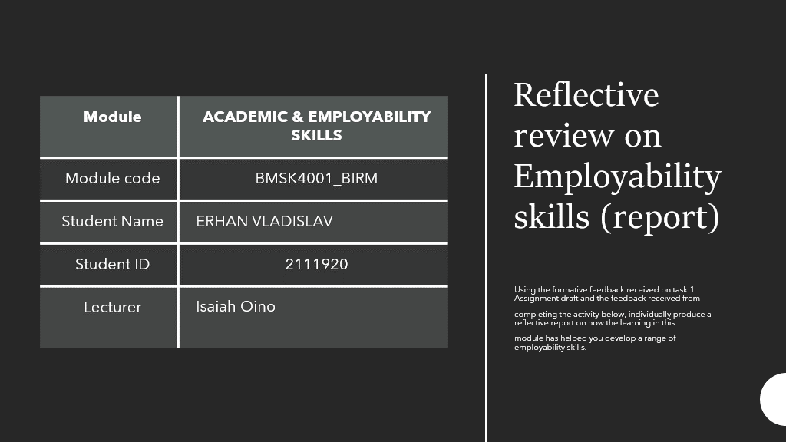





In second my part of the assignment I will demonstrate how the skill I gain from first of my assignment help me to plan ahead of my task and organization skills to achieve the best result and develop good time keeping also in this report will describe five Employability skills:

- Time Management skill​
- Type of Time Management skills​
- Note Taking​
- Written Communication skill​
- Critical thinking skill​
- Digital skill



Time management is the process of setting objectives and determining over the amount of time management is the process, with the goal of increasing efﬁcacy, efficiency, and efficiency. It entails mixing up a person's varied needs work - related, social life, family, hobbies, personal interests, and commitments with limited availability. Managing time essentially gives a person "choice" in terms of spending or managing activities through their own pace and convenience. [1] A range of skills, tools, and techniques used it to manage time when achieving particular things, projects, and objectives by a deadline can assist the person. At first, time management referred only to business or collaborate activities, however the term was later expanded to include personal activities as well. A moment management solution is a carefully planned series of procedures, tools, techniques, and methodologies. Time management is generally required in managing projects since it determines the project completion and scope. It is equally essential to consider that cultural differences in time management cause both technical and institutional disparities in time management. The following are the major ideas that have emerged from the literature on time management:
• Creating an environment favourable to effectiveness (in terms of price analysis, quality of results, and time to finish tasks or projects)
• The process of reducing time costly and non.
• Goals execution



- Task checklists are frequently diaryized and tierred. The most fundamental ranking system includes a general to-do list (or mission folder) to store all things that must be completed, as well as a week to-do list that is produced every day by transferring items from the basic must list. You can build a "not-to-do list" to prevent doing things which aren't necessary. [26].The following are common methods for prioritising task lists. The most beneficial advise obtained by Charles M. Schwab (1862–1939), president of the Bethlehem Steel Corporation, was a daily list of tasks to do, ranked in order of priority and done in that order one at a time as daily time allowed, ascribed to consultant Ivy Lee (1877–1934). [27] [28] [29]
- Alan Lakein was an early proponent of "ABC" prioritising in 1973. In his system, "A" things were the most significant ("A-1" was the most important within that category), "B" items were the next most essential, and "C" items were the least important. [8]
- • One approach of using the ABC technique[30] allocates "A" to projects that must be completed within a day, "B" to tasks that must be completed within a week, and "C" to tasks that must be completed within a month.• To prioritise a daily task, record the tasks in the order of priority highest priority, or assigns them a number after they are listed ("1" for highest priority, "2" for second highest priority, etc.) which indicates in which order to execute the tasks. The latter method is generally faster, allowing the tasks to be recorded more quickly.^{[26]}
- • One method for prioritising mandatory chores (group A) is to start with the most unpleasant one.When it's done, the rest of the list feels easier. Groups B and C can benefit from the same idea, but instead of doing the first task (which is the most unpleasant) right away, it gives motivation to do other tasks from the list to avoid the first one.

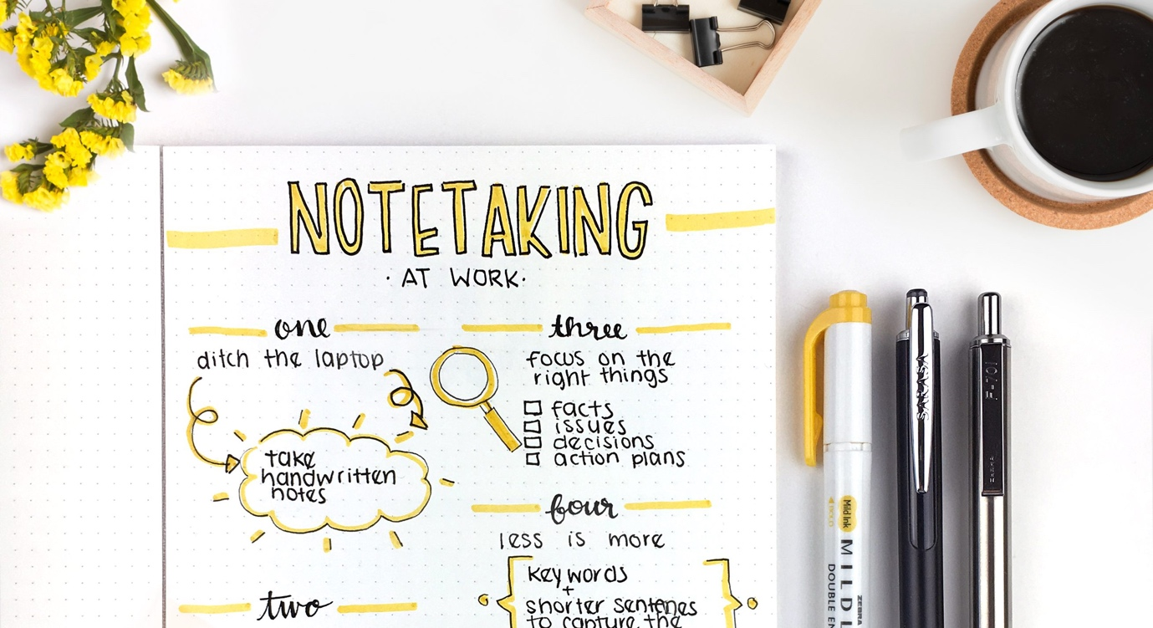

The practise of capturing information from numerous sources and platforms is known as note-taking (sometimes spelled note-taking or note-taking). The writers catches the substance of the material by note taking, alleviating their mind of the pressure of memorising everything. Notes were commonly taken from the a temporary source, such as an informal conversation at a meeting or even a lecture (minutes of a meeting), in which instance the notes is the sole record of a event, however electronic notetaking is now feasible owing to notetaking technology.
The increasing use of laptops in colleges and universities has led to a increase in digital note-taking. Many students to prepare digital hand-written notes that used a visuals tablet or tablet computer, styli or digital pencils, and note-taking software by composing their notes in word processing software or preparing digital hand-written notes using a visuals tablet or tablet computer, styli and digital pens, and also note-taking software. Students who can provide remarks through email or even other means are more interested in digital application.

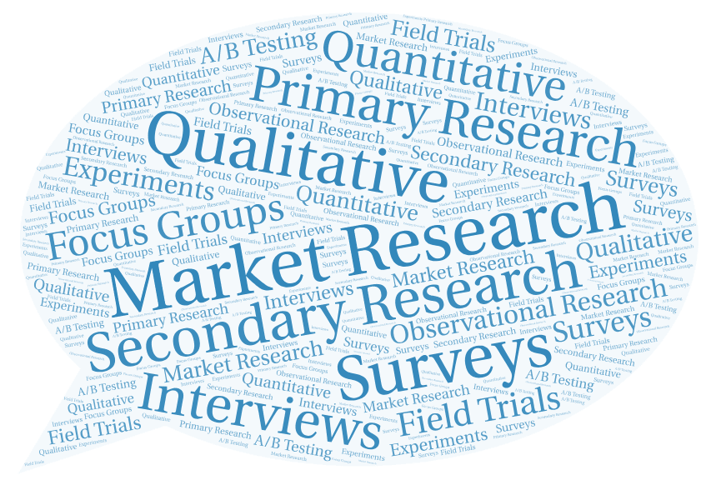

We're all academics! Buying a train or trip, choosing a university course, or looking again for ideal breakfast and ice cream scoop are all instances of everyday research.
Research skills refer to the ability that search for, locate, extract, organise, assess, and utilise or present information pertinent to a specific topic. Academic research is a subset of research that entails a thorough and systematic inquiry of a particular field of study. It comprises conducting a thorough search, inquiry, and serious thought in answer to a specific research question or idea. It also usually necessitates a substantial amount of reading.
Here are a few examples of research questions:

• And what were the advantages and disadvantages of water bills?

• Do gender stereotypes emerge as a result of nature and nurture?

• Will humans ever be able to grow new tissues thanks to genetically engineered?

The purpose of any academic study is to be able to make credible statement concerning the issue at hand. The vast majority all your instructors also are researchers having expertise in specific fields. Advanced academic research strives to contribute anything new to the field, but at the undergrad level, you are normally required to start by researching other people's ideas and accomplishments, primarily through reading.

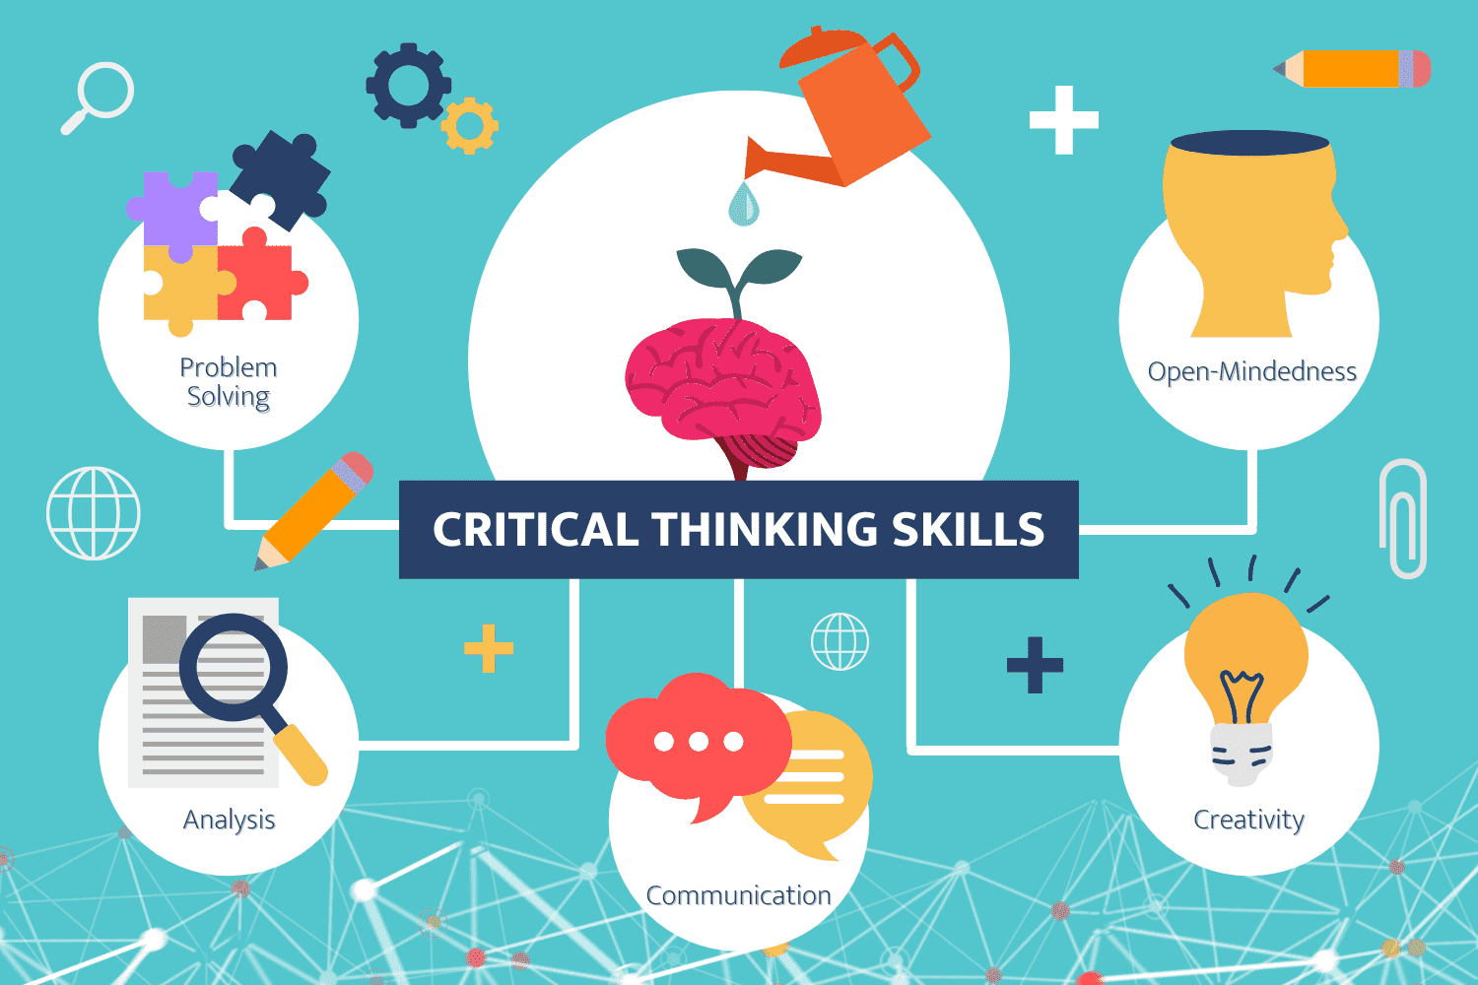

The ability to think in an organised and logical manner in order to find connections between concepts and/or facts is referred to as critical thinking. It assists you in deciding what else to believe in. In other words, it entails "thinking about thinking"—identifying, analysing, and then correcting errors in our thought habits.

I utilised in my report. The following critical thinking step is:
1. Identify a problem or question.

Keep the issue as explicit as potential: the much more specific your issue, the simpler it will be to find solutions and responses.

2. Collect facts, views, and justifications.
Seek for sources that present a variety of ideas and viewpoints.

3. Examine and assess the data.
Are indeed the sources reliable? Are their views data-driven or just argumentative? Is there enough information or data to back up the hypotheses?

4. Decide on your beliefs.
Were we sure the resources you've chosen are objective? How can you be certain that your search for solutions was not biassed?

5. Determine the significance.
What the most crucial piece of data? Is the sample sufficient? Is it even possible that all opinions and explanations are relevant to the problem at hand?

6. Make a decision/come to a decision.
Determine the various potential inferences and decide what (if any) are adequately supported. Weigh the benefits and drawbacks of all possible options.



Believe it or not, digital skills have been essential in the workplace for decades. There has always been a demand for digitally savvy professionals such as IT specialists and staff who really can securely eject a floppy diskette.
Digital skills are indeed the capacity to locate, analyse, use, share, and create material using electronic devices like computers or phones.

Digital skills are getting increasingly advanced in the workplace, and employers expect the broad majority of their workers, not just a chosen handful, to have them. Our lives are increasingly dependent upon technology, and as our dependence on the internet and electronic communications grows, our workforce must adapt to meet changing skill demand.

Why Should You Improve Your Digital Skills?
Every sector is being affected by the rise of digital transformation. Farmers are automating, monitoring, and regulating their operations with sensors and information technology in order to be more lucrative, efficient, and sustainable. Food delivery applications help eateries provide menu alternatives to hungry consumers who don't want to leave their homes.

Here are some statistics that demonstrate the increasing demand for technologically skilled professionals: By 2022, 54 percent of all workers will need significant reskilling. This is especially true for technology abilities such as computing and application provided. Over the next five years, the global labour market will be able to accommodate around 149 million technology-related jobs. Seventy percent of People think that digital skills are vital for corporate success in modern environment. According to a recent study on digital skills for job progression, "the number of professions requiring digital abilities is predicted to increase by 12% by 2024."

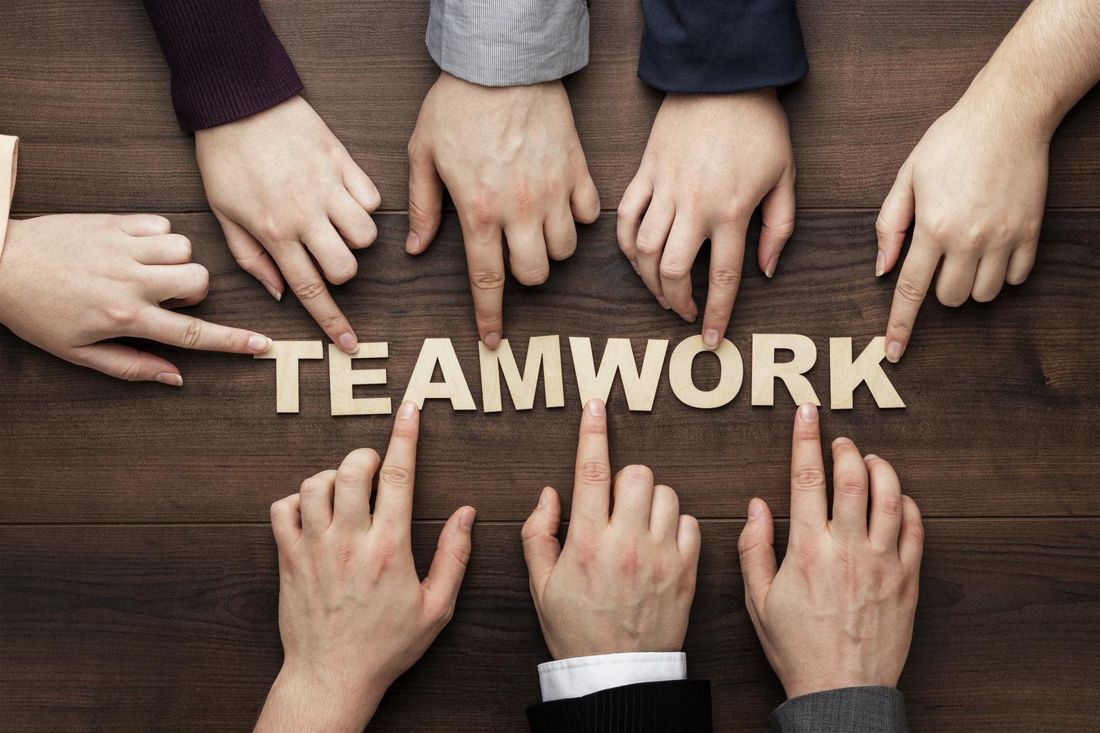

Teamwork abilities are essential for professional success in any business or job title. Working well with clients, colleagues, bosses, and others at work may help your complete things more quickly while also creating a pleasurable environment for yourself and others. A company that values teamwork is typically a happy, well-functioning one.

Teamwork abilities are composed of a variety of soft skills that you may focus on developing over time. Here are some instances of characteristics that might help you build your collaboration abilities:

Communication
Cooperation necessitates the capacity to communicate effectively and efficiently. When collaborating with others, it is critical to provide relevant perspectives, ideas, and facts. There are several forms of communication talents, such as verbal and nonverbal communication.

Responsibility
It really is vital that all individuals participating in the collaboration dynamic understand the work for which they are accountable and make every effort to perform these duties on time and to the expected standard. They may collaborate to achieve a common goal if the entire team is functioning correctly and taking full responsibility for their own task.

Conclusion:
In my report, I understand how important it is to manage your time well and to have good teamwork skills, but it is also important to follow the critical thinking that'll be a good support to you.

Reference:
Stella Cottrell (2013). The Study Skills Handbook. Palgrave Macmillan. pp. 123+.
Morgenstern, Julie (2004). Time Management from the Inside Out: The Foolproof System for Taking Control of Your Schedule—and Your Life (2nd ed.). New York: Henry Holt/Owl Books. p. 285. ISBN 0-8050-7590-9.
Mackenzie, Alec (1972). The Time Trap (3rd ed.). AMACOM - A Division of American Management Association. pp. 41–42. ISBN 081447926X.
LeBoeuf, Michael (1979). Working Smart. Warner Books. pp. 52–54. ISBN 0446952737.
Nightingale, Earl (1960). "Session 11. Today's Greatest Adventure". Lead the Field (unabridged audio program). Nightingale-Conant. Archived from the original on 2013-01-08{{inconsistent citations}}
"Time Scheduling and Time Management for dyslexic students". Dyslexia at College. Archived from the original on 2005-10-26. Retrieved October 31, 2005. — ABC lists and tips for dyslexic students on how to manage to-do lists
Forster, Mark (2006-07-20). Do It Tomorrow and Other Secrets of Time Management. Hodder & Stoughton Religious. p. 224. ISBN 0-340-90912-9.
Horton, Thomas. New York The CEO Paradox (1992)
Tyranny of the Urgent" essay by Charles Hummel 1967

Apendix:


