
learning in digital era assignment 2
Name: Abdifitah Ahmed Muhidin()

[Date]
[Company name]
[Company address]
Module code: ACCA4025
Assignment Title: Assignment 2: professional Development Plan (PDP)
Table of content
Task 1 – Self evaluation
Task 2 – PDP
Task 3 – unit 4 topic summary
Conclusion/ References
Task 4 - video presentation

Link to presentation

https://uowtsd-my.sharepoint.com/:p:/g/personal/2519518_student_uwtsd_ac_uk/IQCsxtV1C_tkSa8Tx92QjSRCAW88fIZ1_ppYmxGegjFbC3w?e=tfH75q

Task 1
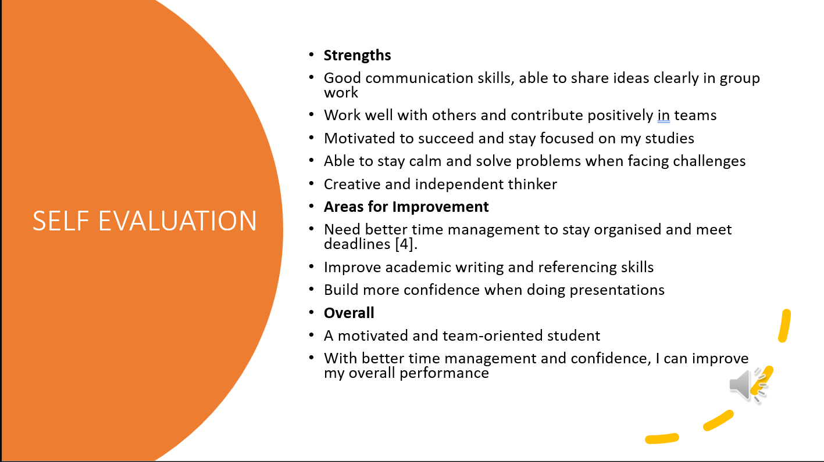

Task 2
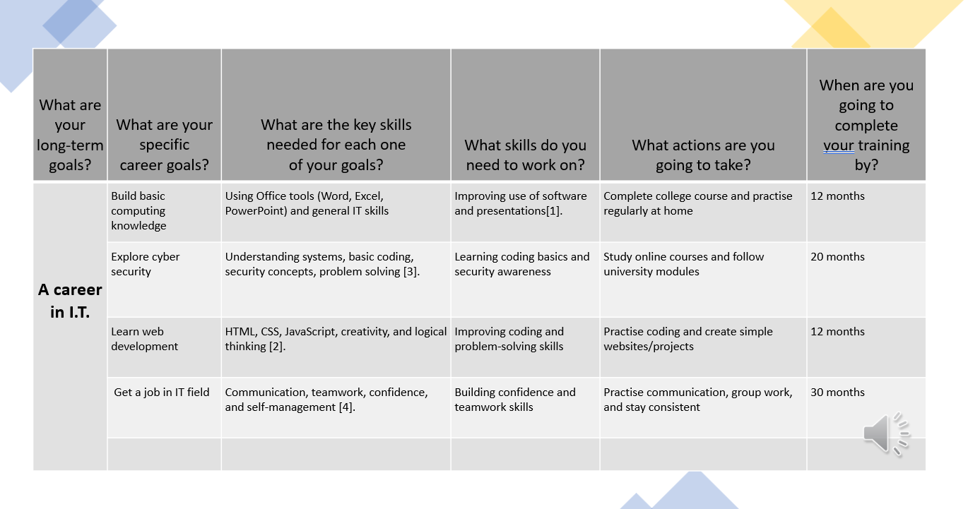

Task 3

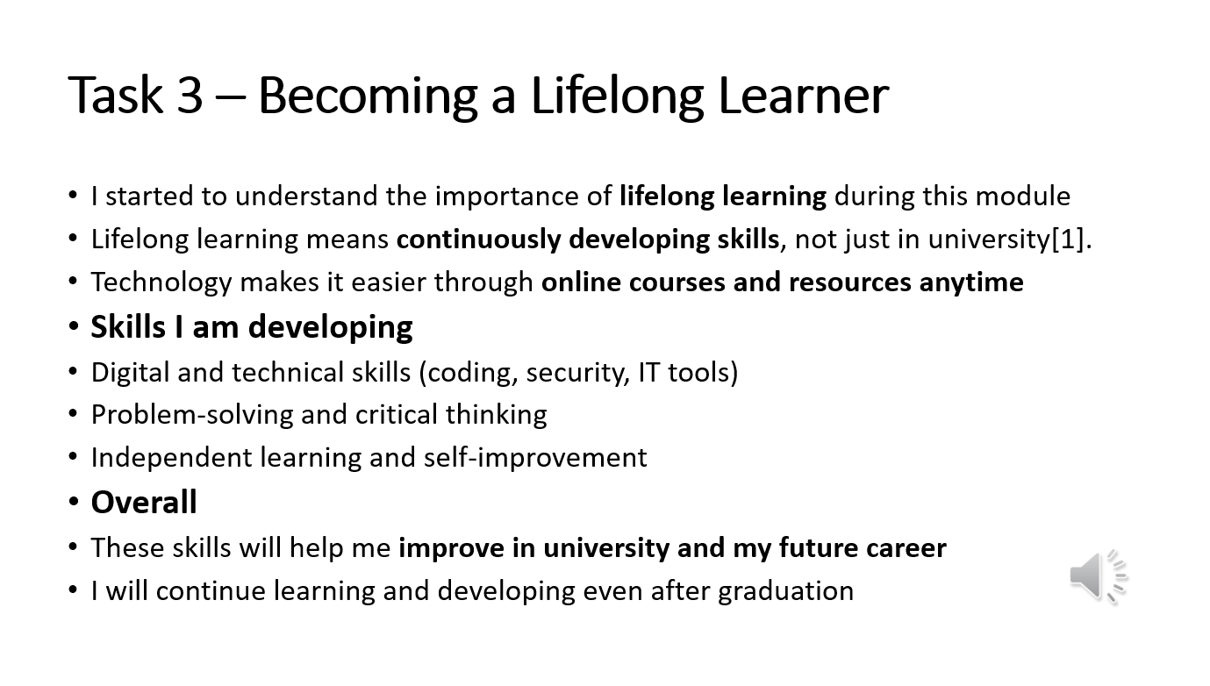

Rest
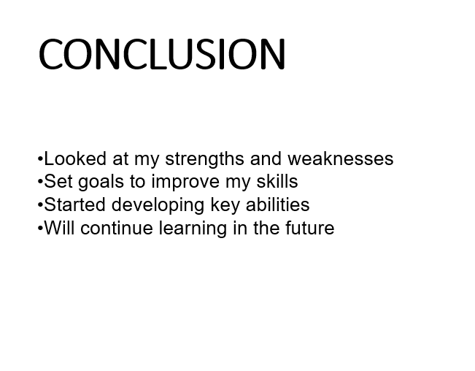

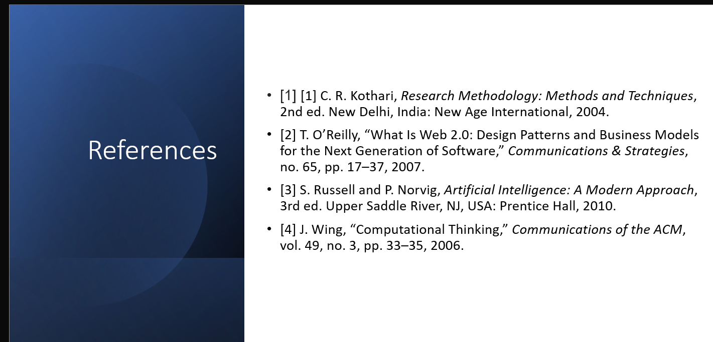

Task 4
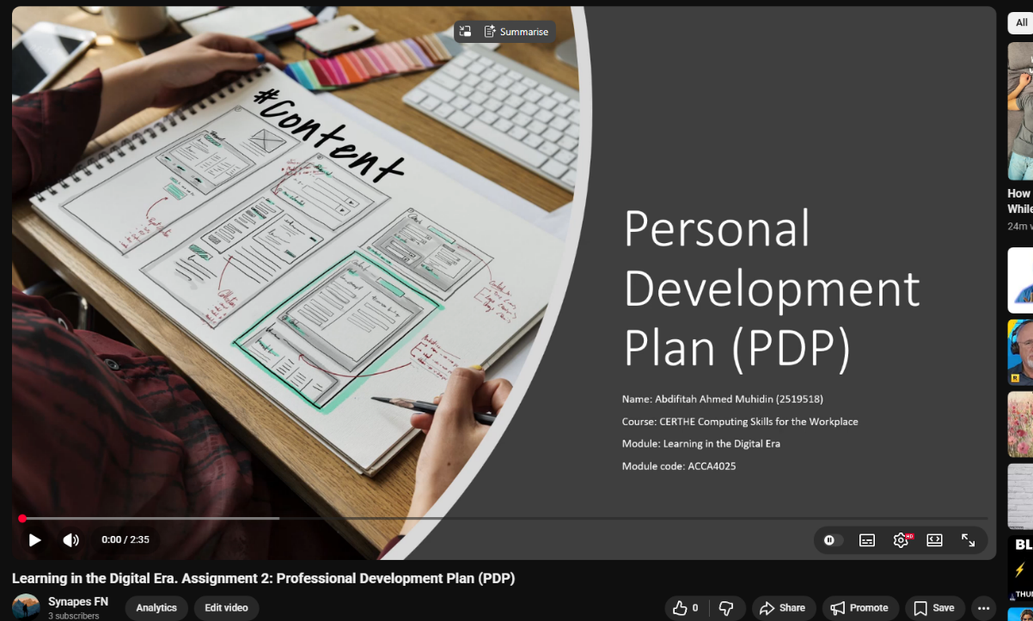

https://youtu.be/dpekx6dsjO4

https://uowtsd-my.sharepoint.com/:p:/g/personal/2519518_student_uwtsd_ac_uk/IQCsxtV1C_tkSa8Tx92QjSRCAW88fIZ1_ppYmxGegjFbC3w?e=tfH75q

