SCRIPT WORKBOOK

PRE-MODULE:
Before the module began, I found that I was looking forward to being able to perform a larger scene rather than smaller monologues or duologues, and I was eager to work with a bigger cast as we haven’t had many opportunities to do so. However, I was somewhat worried about line-learning multiple texts in a short amount of time and returning back to old habits of generalising my performance, but I was determined to tackle these issues head-on this module.

BEGINNING THE MODULE:
As we started, we were presented with our two texts and were asked to read them with the intention of gauging a first impression. With ‘The Last of the Pelican Daughters’, I was very interested in the realism- I felt that there were certain interactions that I could see myself having with my own family, which I knew would help me to create a more authentic emotional connection with others in the play. I was somewhat sad that there wasn’t a happy ending for them within the boundaries of the text, but often when portraying reality and situations that could realistically happen, that is often the outcome.

When I read the second text- ‘Mythfits: Tales of the Unaccepted’- and discovered that it reimagined aspects of Greek mythology, I was very excited to read it, as I have had a long-time interest in it and its retellings. My first impression was positive, but I was curious about how certain myths had been changed and rewritten. Medea, as a myth, is surprisingly feminist for the era it was written in. Although Medea commits murders, she is presented as more justified in the eyes of the gods- Jason abandoned his marriage with her for the princess of Corinth, but instead Medusa received this retelling.

Beginning our rehearsals and our research on ‘The Last of the Pelican Daughters’, we explored Katie Mitchell’s ‘facts and questions’ to the Pelican Daughters script. In this exercise, we organised a list of facts (non-negotiable things that are explicitly stated within the text, that help build an impression of the character’s pasts and can lead onto further research) and questions (things that aren’t concrete in the text, which can be used as a way of notating things we’re not sure about). These help us to build both backstory and a character’s opinions on others, as well as allowing us to logically build character timelines of events that influence their behaviours. Because of this, every fact matters- no matter how small it is.

In our first few rehearsals of Mythfits, when working with the prologue, we began with the foundations of Tina Landau and Anne Bogart’s viewpoints to help us. The key steps in viewpoints are, as – says:
- “Spatial relationship: how far apart bodies, props, and other objects are
- Kinesthetic response: the ways in which performers respond to forms of movement
- Shape: the way that a body appears in space
- Gesture: a movement or expression that has a beginning, middle, and end
- Repetition: when a performer recreates or mimics another
- Architecture: the physical environment surrounding a performer
- Tempo: the speed at which movements unfold
- Duration: the length of a movement
- Topography: the ways in which movements create patterns or designs”
It allowed us to begin interpreting the words of the text in a more abstract way, and it would help to create imagery through movement- which the audience can interpret a meaning of. Viewpoints also helped with learning to become a company chorus which, as Bogart and Landau state: “... relieves the pressure to have to invent by yourself, to generate all alone, to be interesting and force creativity. View points allows us to surrender, fall back into empty creative space and trust that there is something there, other than our own ego or imagination, to catch us. Viewpoints helps us trust in letting something occur onstage, rather than making it occur. The source for action and invention comes to us from others and from the physical world around us.”

When doing character-work for ‘The Last of the Pelican Daughters’, we applied Katie Mitchell’s ‘I am’ exercise to our characters. It puts you into their headspace, and allows you to explore how they feel from the inside, how they see the world, their thought process- which informs the way they act and behave. When doing this for Sage I found her to be very close emotionally to her mum, both before and after her death, and trying to continue the traditions and values she held. This helped me to realise that she’s a perfectionist in this particular regard- best shown in scene 5, when she discovers that nobody wanted to celebrate mum’s birthday with the tradition of eating cake on mum’s bed. She insists that they’re going to celebrate, and begins to lose control of her temper.

We also created ‘Scenes we’d like to see’ in smaller groups- using this technique helps to fill gaps in the text and missing scenes or context- which can also lead to further research. It gives more insight on a character’s emotions and relations with others, and provides context for their behaviour in the text. When using this for Pelican Daughters, we were focusing on the relationships between the family members, and I found out that Sage’s relationship with her mum took priority, especially when in regard to other members of the family- this can be seen in scene 5 of “The Last of the Pelican Daughters”, when Storm- speaking as mum- states: “And don’t tell Sage, she’s busy. I don’t want to worry her.”

CHOOSING MONOLOGUES AND REHEARSING:
In my search for monologues, I settled on two- one that I felt was relevant to very current societal issues, and one that I found funny while being different to my usual characters. I thought the second seemed quite similar to how I speak in day-to-day, and it felt much more comfortable to do- as opposed to performing something like Shakespeare. As we we were making out decisions, I was given a suggestion that the first monologue might be too similar to what my character, Sage, in ‘The Last of the Pelican Daughters’ believed. This worked in my favour as I had much more fun with the second monologue and, although I had trouble deciding at first, I was leaning towards the second.

When we began to solidify our ideas for Mythfits, we explored viewpoints further- approaching the ‘Odysseus’ section with this was very useful, as working with the angular shapes and full embodiment that viewpoints offers us helped to make everything sharper and more jagged to get a more expressive feel of a slaughter. We also had to solve the issue of the staging- as we were working with a thrust configuration, and we had set our scene with end-on in mind. To solve it, we moved the action further back so that each moment was visible to the audience, and made sure to create eye contact when delivering out lines.

Revisiting the Pelican Daughters, we applied the technique of eventing to help with character reaction and emotions regarding changes in the scene- of which there are many in the script. During this process, we separated the script into events, which are classified as changes that affect everyone. Katie Mitchell mentions that: “Events can be very useful when you are devising a piece of theatre. Instead of thinking in terms of plotting a story, focus on planning the changes that will occur.”

She also states that events can be major or minor and she states that: “Events have a whole variety of different forms: they can be sudden (such as if someone threw a stone through a window during a family meal) or gradual (as when a group of people in a remote building slowly realise there is a stalker outside)”. Events also change the tempo of the scene in some way, and everyone has to relate to the title given to the event in order to play or react to it. She mentions that: “Organising information in this way encourages you to hold an objective relationship to the material and inhibits premature attempts to interpret the play.”

When rehearsing my monologue in our one-to-one session, I brought up that I was unsure about movement, and that I didn’t have enough variation in the delivery of the lines. In response, I was given the note that in the monologue, my character- Cynthia- is terrified of letting herself be vulnerable; the ‘bitch’ persona is a mask to hide behind. Playing this would give me more to work with in terms of emotion and ‘colour’ in the lines. The monologue also brings up an idea of conflict between the walls she puts up and her love for her might-be fiancé, as well as perhaps a change in her identity, as becoming a wife means losing status and independence. Since Cynthia is losing this ‘bitch’ persona, I was given feedback to play her vulnerability on stage- I could lower her status at points, finding where those moments were in the script. I was also told to work on fresh-minting the ‘future’ scenarios, and figure out thought lines. Both of these would help me with channelling her desperation and the identity crisis she is going through.

FINAL REHEARSALS:
In our final week of rehearsals, there were problems that arose when working with the set and having to move it for each piece. We found a solution for this by keeping select parts of set on stage- specifically the living room for Pelican Daughters- so that it was ready, but nothing obstructed the main space. We also smoothed out the transitions between each performance by designating cue lines for others to remove or move set, or stand to begin the next piece. This helped to create a relatively seamless flow, and meant that there was no awkward lingering or delay between performances.

PERFORMANCE:
After finishing the assessment, I felt it went well, and I felt more confident with the audience there. I aimed to prioritise my monologue- working on the authenticity of what she is feeling, and capturing the conflict she was going through, as I felt those were the most important parts of feedback I was given. I felt I managed this, but not as well as I wanted to; I didn’t feel satisfied, as I found myself speaking my lines without purpose or intention. I also believe I missed a line or two in my monologue, due to being nervous, which I am frustrated at. If I was able to do it again, I would attempt to become more in-tune with what my characters are feeling emotionally, and work on finding more variation in my performance.

REFERENCES:

Bustance, J. (2023). ‘Viewpoints Acting Training: A Guide’. [online] Backstage.com. Available at: https://www.backstage.com/magazine/article/viewpoints-acting-training-guide-76450/.

Bogart, A. and Landau, T. (2005). ‘THE VIEWPOINTS BOOK A Practical Guide to Viewpoints and Composition’. [online] Available at: Bogart, A. and Landau, T. (2005). THE VIEWPOINTS BOOK A Practical Guide to Viewpoints . and Composition. [online] Available at: https://stilluntitledproject.wordpress.com/wp-content/uploads/2014/11/anne-bogart-and-tina-landau-the-viewpoints-book.pdf
Mitchell, K. (2009). ‘A Director's Craft’. Oxford: Routledge.
The Wardrobe Ensemble (2019). ‘The Last of the Pelican Daughters’. London: Nick Hern Books

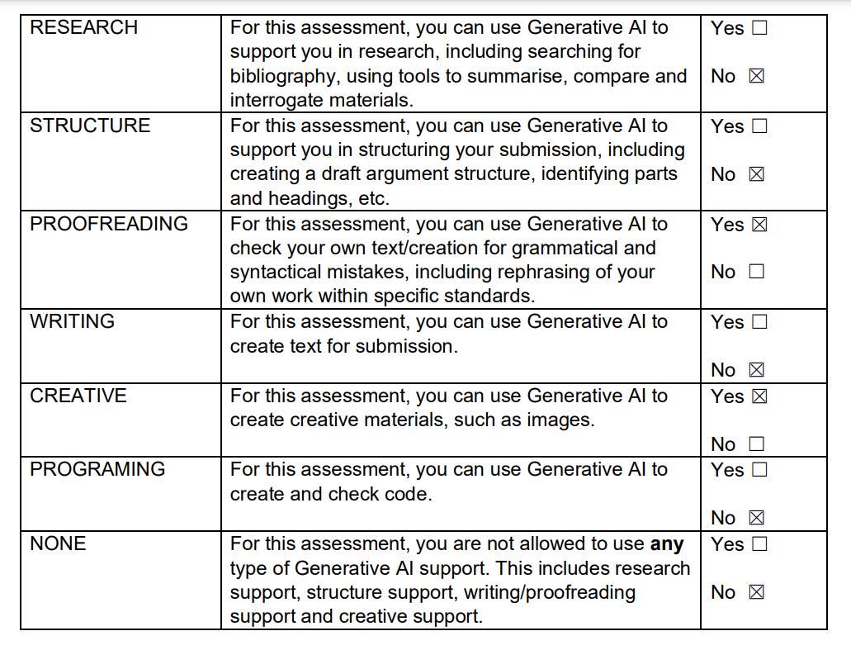
I confirm that I have not presented any Al generated text as my own work. I confirm I have copies of my drafts, notes, and other resources I used before, and after the use of
Al tools which I may be asked to provide in evidence.

