Report on
Developing Relationships and Workplace Achievement


By
Laura Morgan – 1811899

Findings –

What is Employee Engagement?
Employee engagement is a workplace approach resulting in the right conditions for all members of an organisation to give of their best each day, committed to their organisation’s goals and values, motivated to contribute to organisational success, with an enhanced sense of their own well-being.
(Engage for Success 2019)

Employees can be engaged with different aspects of their work:
- The job itself
- A particular task
- Relationships with colleagues
- The organisation
- People outside the organisation e.g. customers

Employee engagement is about being part of the team,
having regular feedback, being trusted and knowing the
company is completing its goals. It’s a feeling of being
happy to go to work rather than feeling like you don’t
want to go every day. When an employee feels valued,
they are more likely to complete work to a higher
standard.

Employee engagement is about positive attitudes and behaviours leading to improved business outcomes, in a way that they trigger and reinforce one another. It’s also about our employees feeling pride and loyalty working for an organisation, being a great advocate of the organisation to clients, users and customers, going the extra mile to finish a piece of work. Employee engagement is about drawing on employees’ knowledge and ideas to improve products and services and be innovative about how work is performed. It’s about drawing out a deeper commitment from employees so fewer leave, sick absence reduces, accident rates decline, conflicts and grievances go down, productivity increases. Employee engagement is about organisation actions that are consistent with the organisation’s values. It is about kept promises, or an explanation why they cannot be kept.
(Engage for Success 2019)

What employee engagement is not!
Employee engagement cannot be achieved by a mechanistic approach which tries to extract discretionary effort by manipulating employees’ commitment and emotions. Employees see through such attempts very quickly and can become cynical and disillusioned.

(Engage for Success 2019)

An employer can not fake employee engagement. An employee would know and sense if he or she wasn’t part of the team of felt trusted. No employer could keep this pretence up every day. And it wouldn’t benefit neither the employee nor employer.

This is the psychological contract –
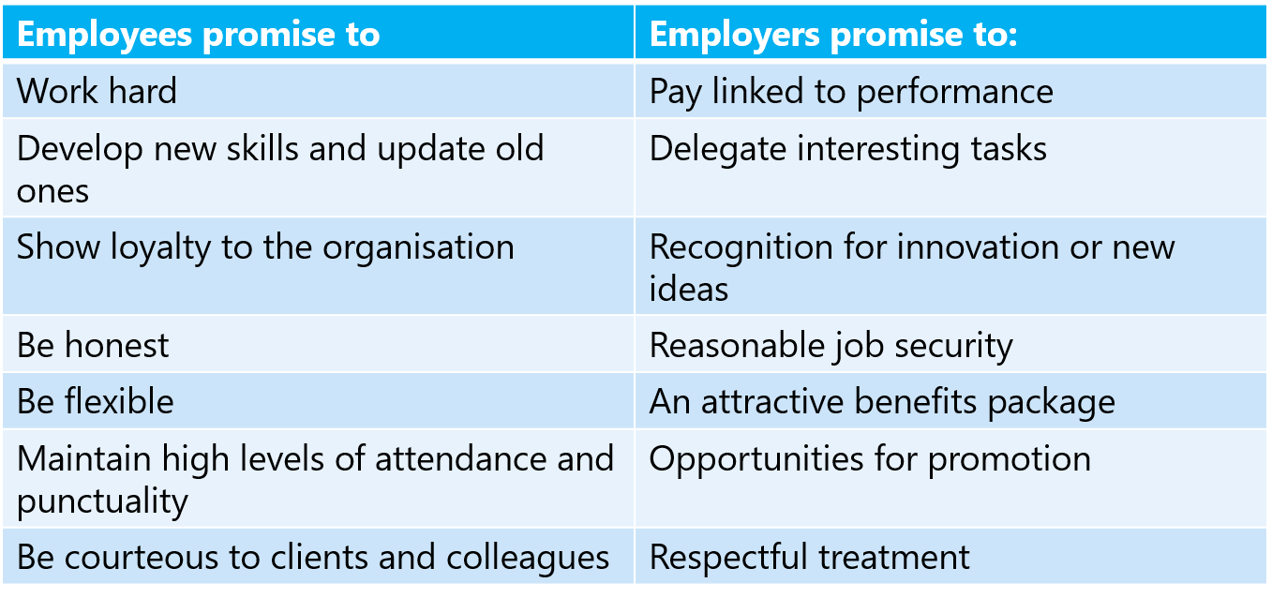
This is an unwritten contract between the employer and employee. If these were not followed it would cause a negative impact on job satisfaction and a negative impact on the commitment of the employee. It’s the managers job to take responsibility to maintain the contract, keeping this contract in focus is better than trying to repair the damage afterwards.
This would make the employee want to work to the best of their ability, which in the long term the employee will be committed and want to stay in the job, which benefits both the employee and saves the employer time and money by not having to hire new staff on a regular basis because the employees keep leaving due to not having this unwritten contract.

One of the best ways to engage employees is to show value their opinion, by asking for their feedback. Gathering meaningful feedback on everything from training, to the staff social helps to ensure and understand the employees’ needs. Employers must remember to act on the feedback to maintain employee engagement. Taking action matters, with 70% of engaged staff saying they feel their feedback is acted on, compared with just 2% of disengaged staff.
Online solutions and mobile apps mean staff surveys no longer have to be as long, probing and off-putting as a dreaded finals exam! You can avoid low response rates by making the survey anonymous and as simple as possible. Instead of a long-winded ‘21 Questions, employers could ask employees to simply vote anonymously online.
(Growth Engineering 2020)

Maslow’s Hierarchy of needs theory
Maslow's Theory is a general theory on motivation which states that the urge to satisfy needs is the most important factor in motivation.
(Key Differences 2020)

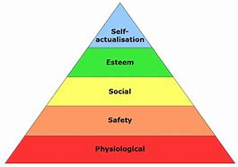

Physiological needs are having enough wages to cover your bills every week, to have food and shelter. And to rest.
Safety needs are having job security. Protection against danger in the workplace and to be fairly treated.
Social needs are having work colleagues that support you in the workplace and having friendships in the workplace as well as feeling part of the team.
Esteem needs are having recognition for a job that’s been well done or achievement in the workplace. Having independence builds a person’s esteem.
Self-actualisation needs are having a promotion or given more responsibilities at work after working so hard to get there.

It infers that higher-level needs cannot evolve until the lower level needs are satisfied. As the needs of human beings are unlimited, whenever one need is satisfied, another need takes its place. Moreover, an unsatisfied need is the motivator which governs the behaviour of the individual.
(Key Differences 2020)

In most jobs, people go in, do their work then leave. This can be very monotonous. A lot of people continue to do this without a prospect of climbing the ladder and becoming more qualified.
Some people believe that you learn on the job without any other training.

Here are 6 ways that training can benefit the employee and the company.

1. Fight off Stagnation
People are creatures of habit, and they tend to follow their familiar patterns as much as possible, whether they’re good or bad. Offering training in new skills can shake things up, causing employees to consider new perspectives or find a new interest.
Fighting off stagnation in your employees can also fight off stagnation in your company, as your team brings new ideas to the table. In order to compete, companies need to continue innovating and learning on a continuing basis.

2. Discover New Talents (and Weaknesses)
When employers hire someone, they won’t always discover all their talents and weaknesses. Sometimes, they bring on someone who is very good at the job they hired them for but has other qualities that could be even more valuable to the team.
Therefore, one of the most beneficial things that a manager can do is to periodically spend time working closely with their employees. This helps employees develop new skills, but also allows managers to get a better sense of each employee’s talents and weaknesses.
Having such a strong understanding of your team is especially important when working in a growing business or industry. Take nursing, for example, where there is expected to be a need to fill over 260,000 positions by 2025. While this may sound like a daunting task, many of these positions can be easily filled in-house if managers have a solid sense of their teams’ talents.

3. Maintain Engagement
Only about 33% of the US workforce reports being engaged with their work, representing a big challenge for employers. Engaged employees do better work and can help a company reach its goals faster. One-way employers can help boost engagement is by offering professional development. Employees who are learning together feel like they are advancing in their career and can gain a sense of camaraderie from working with their peers. This is one great way to boost engagement while teaching useful skills.

4. Gain a Competitive Edge
Keeping up with the trends in the industry and keeping tabs on competitors is an essential part of doing business. But how can employers keep up if employees aren’t knowledgeable about what’s happening in their industry? Offering ongoing training and development ensures that everyone is on the same level when it comes to the latest in their industry, giving the organization a competitive edge.

5. Increase Productivity and Satisfaction
If employees feel supported and inspired at work, they will naturally become more productive and satisfied with their work. By offering ongoing training that increases employee confidence and skill, employers can support their team while simultaneously seeing increased productivity and satisfaction. Who knows – this increased satisfaction might even be enough to spark some employees interest in gaining some key leadership traits like self-awareness, process management and a desire to keep learning? In turn, this development will prove beneficial for both the individual, their team and the company. If they’re not actively looking to support the team and improve satisfaction, employers may consider making a switch.

6. Attract and Retain Talent
There are a lot of jobseekers, but attracting the best candidates isn’t easy. Employers need to show top talent that your company invests in its workforce. One way to do that is providing ongoing training. Potential employees will feel like they’re getting more than just a pay check, and existing employees will be more likely to stay so they can learn and grow.
(Innovation Management 2020)

Personal Development Plan
A Personal Development Plan is used for self-development. Setting goals to be achieved and by what date. Training that an individual wants to complete. Its a going process that can always be added to every month or every few months.
A personal development plan is “a combination of approaches, ideas and techniques that will help you manage your own learning and growth”
(Bridgwater 2016)
A Personal Development Plan is for one person, its not shared and or team plan, its individual. Its also to help improve areas of weakness that need improving or for strengths. It’s a lifelong process. It can also be changed, if something didn’t work out as planned or it no longer suits the needs of the individual then these goals or targets can be changed.
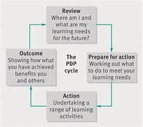

This is an example of to start the process of a Personal Development Plan Cycle.
Review – thinking process, where does the individual want to be in 5 years’ time.
Prepare for action – working out what goals, training or tasks that needs to be completed or set.
Action – putting these activities into action and setting dates when these need to be achieved.
Outcome – when the goal, task or training has been completed.

This is an example of a personal development plan.

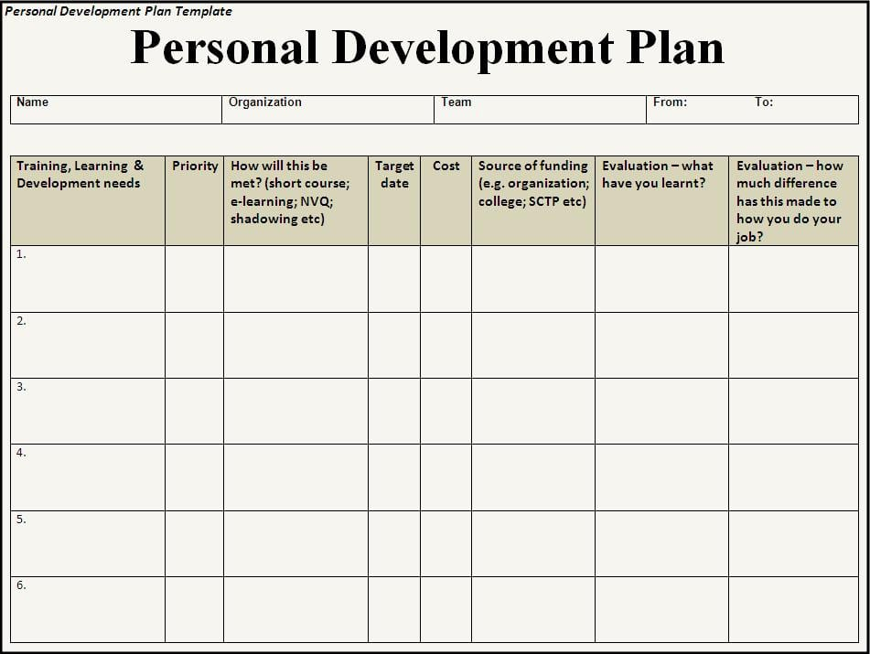
The first column is the development or training needs required. The next is the length of time each will take and in which order/priority and a date for each task to be completed. There is also a column for the course of the training and who will be funding it. Then the last two columns are the evaluation. Did they benefit the job, what has the person learnt?
Although this is a personal development plan it would be good for a manager to keep record of as it would help for future training for other employees.

7 reasons why personal development is important.
Confidence and credibility: The phrase, ‘knowledge is power’ rings true. The act of learning provides new perspective and increased expertise in your field.
Ability to influence and lead: By using the knowledge learned with the confidence and credibility gained, the ability to influence and lead becomes less subjective and more about the facts and figures brought to the table. These opportunities provide a tool for more meaningful contributions to the team.
Network: Professional development opportunities conducted in group settings provide an added benefit of building your network.
Keep current: It is easy to become complacent and simply maintain the status quo. Employee development opportunities can shed light on new approaches and how to navigate through them.
Achieve career goals: For many individuals, professional development is just a part of moving up the career ladder. Whether necessary for advancement or not, encourage it as a motivator for your team.
Become a better employee: Enlighten staff that development opportunities are about getting more out of the work experience. Being the best, they can be for the operation hopefully is reciprocated in things like better compensation, flexibility, perks, advancement and more!
(Farm Journals Pork 2020)
Maslow’s Hierarchy of needs
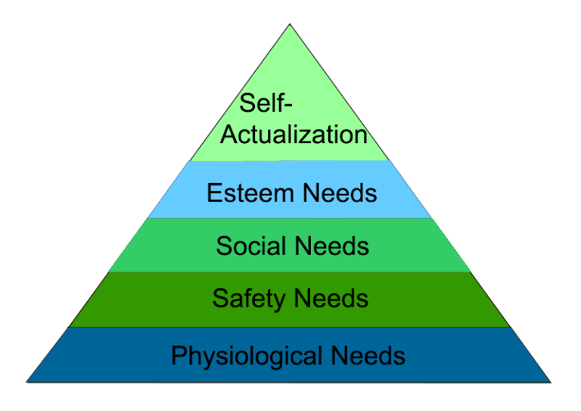

According to the hierarchy of needs:
- People are motivated to fulfil certain needs
- Some needs take precedence over others
- Basic needs need to be fulfilled first
- Lower level needs arise from deprivation
- Needs become increasingly complex as you move up the hierarchy
- Higher level needs arise from a need to grow as a person

(Explore Psychology 2011)

In order to better understand what motivates human beings, Maslow proposed that human needs can be organized into a hierarchy. This hierarchy ranges from more concrete needs such as food and water to abstract concepts such as self-fulfilment. According to Maslow, when a lower need is met, the next need on the hierarchy becomes our focus of attention.
(Thought co. 2020)

Maslow believed that you can’t move onto the next need until the first one is fulfilled.
However, this theory has been criticized.

The basic issue is what he calls the physiological, in which one's needs for survival must be met.
The second issue is safety needs. These can take the form of an infant's healthy attachment to the mother, having enough money in the bank to be secure, and having a degree of physical health.
Social belonging is next, characterized by a need for harmony in one's family, friendships, and community relationships. Peace in one's environment is the key.
The fourth point on the pyramid is the need to be esteemed, to be recognized by others, and have one's ego is not threatened by disrespect or an unjust lack of recognition.
The top of the hierarchy, only made possible if the other motivational issues are met and mastered, is self-actualization. This includes the need to be creative, spontaneous, and to try to be one's best self. A person now is free to achieve one's own stated desires. An athlete is free to be the best on the team, a parent is free to become the very best parent to the children, the business-minded person is free to build the company based on the vision of what this company should be.
Later in his career, Maslow discussed a sixth point in the hierarchy: transcendence, in which self-giving is paramount. This includes the quest to know the spiritual dimension of life on earth and beyond.
(Psychology Today 2020)

References –
Bridgewater (2016) https://www.bridgewateruk.com/2016/09/personal-development-plan/ accessed on 01/04/2020

Engage for Success (2019) https://engageforsuccess.org/what-is-employee-engagement accessed on 29/03/2020

Explore Psychology (2011) https://www.explorepsychology.com/maslows-hierarchy-of-needs/ accessed 29/04/2020

Farm Journals Pork (2020) https://www.porkbusiness.com/article/7-reasons-why-professional-development-important accessed 03/04/2020

Growth Engineering (2020) https://www.growthengineering.co.uk/how-to-engage-employees/ accessed on 30/03/2020

Innovations Management (2020) https://innovationmanagement.se/2017/11/17/6-benefits-of-ongoing-employee-development/ accessed on 30/03/2020

Key Differences (2020) https://keydifferences.com/difference-between-maslow-and-herzberg-theories-of-motivation.html accessed on 30/03/2020

Psychology Today (2020) https://www.psychologytoday.com/gb/blog/the-forgiving-life/201805/why-maslows-self-actualization-theory-is-not-quite-right accessed on 02/04/2020

Though Co. (2020) https://www.thoughtco.com/maslows-hierarchy-of-needs-4582571 accessed on 30/03/2020

