How the use of UI design has impacted on our interaction with the world wide web
Gemma Conboy
P149522
Graphic Design

Topic Summary

The world wide web is essential in the everyday life. Whether it be used on a mobile, devices or computers. It’s all around us. It’s a necessity for us to interact and connect to the world. Web design plays a vital key. What makes a web page have beneficial user interface? What draws us in, to make us spend hours scanning the web? This dissertation deconstructs what enables good user interface and why is it so influential?

List of figures

Fig 1: Author not known, (2018) Behance [ONLINE]. Available at: https://99designs.co.uk/blog/freelancing/find-design-work-online/ [Accessed 2018].

Fig 2: Screenshot of website, (2018) Airbnb [ONLINE]. Available at: https://www.airbnb.co.uk [Accessed 2018].

Fig 3: Louisa LaughtonScott (2018), Example of Advertising on Facebook [ONLINE]. Available at: https://medium.com/@LLaughtonScott/dreaming-of-building-an-app-how-to-validate-your-million-dollar-idea-with-no-budget-f1056c0b38ff [Accessed 2018]

Fig 4: Brandon Jones, (2010), Understanding the Z-layout in Web Design [ONLINE]. Available at: https://webdesign.tutsplus.com/articles/understanding-the-z-layout-in-web-design--webdesign-28 [Accessed 2018].

Fig 5: Armin, (2016), A New Look For Instagram [ONLINE]. Available at: https://www.underconsideration.com/brandnew/archives/new_icon_for_instagram_done_in_house.php [Accessed 2018].

Fig 6: Vikas Shukla, (2015), Google – New Logo vs. Old Logo [ONLINE]. Available at: https://www.valuewalk.com/2015/09/google-new-logo-vs-old-logo/ [Assessed 2018].

Fig 7: studiogstock, (2018), Play Button [ONLINE]. Available at: https://www.vectorstock.com/royalty-free-vector/play-button-symbol-vector-10903012 [Accessed 2018].

Fig 8: mrpickens, (2012), On Button [ONLINE]. Available at: http://www.clker.com/clipart-on-button-small.html [Accessed 2018].

Content page

Introduction
Chapter 1 How UI design has changed over the past ten years.
Point 1 The introduction of responsive websites to accommodate smart phone and tablet devices.
Point 2 The increase in apps available that make your consumer life easier.
Point 3 Examples of good and bad UI design.
Chapter 2 Growth of Social media
Point 1 What is it and why is it now so important?
Point 2 Different social media platforms. Facebook, Twitter etc.
Point 3 Design examples on how people interact with social apps from a UI perspective.
Chapter 3 The Visual Communication and social conditioning aspects of apps and websites.
Point 1 Graphic elements and use of icons to help with communication.
Point 2 Are Emoticons important methods of communication?
Point 3 Semiotics relating to UI design considerations.
Conclusion
Bibliography

Introduction

We perceive the world through how it’s pictured. We’re attracted to beauty. We appreciate things that just make our life easier. It is in our human nature. We are crossed between business and pleasure. Which is why web design plays on similar features. We live such crazy, busy lives that we have generated a way to make living much easier. We view our digital life, similar to our everyday life. Which is why I am so fascinated to explore what makes web design so essential in our everyday lives. Why is the world wide web, the life support to our digital age? It has been around since the 90’s, constantly updating and developing into an addiction that none of us can overcome, because we don’t want to. Why would we want to? Why would we want to leave behind such a beneficial thing to the world? Are we going to keep developing in this digital age and can we live without it?
It has become such a vital key in our lives that we can’t never draw away from.
In this dissertation, I will be researching the creation of web design and how it influences user experience and user interface. What makes a good web page and what draws people to it? This dissertation breaks down key factors in why it is so addictive, including design, content and access. Also, how web design has adapted to different devices, such as mobile phones, tablets etc, instead of just computers. Why are we so reliant, can we cope without it? It brings distant families closer, connecting us to the world and benefitting our everyday lives.
But what makes a good web design? What are many designers missing in the success to the best web design? Well, breaking down key factors and many subtle differences that have such a significant importance, can create the most successful outcome for many designers. What exactly are designers missing?

Chapter one will discuss how user interface design has changed over the last ten years. The development of web pages and easier access and loading speeds. Different features and responsive web design can really change a web site and its users.
Chapter two will then go on to discuss how Social media has impacted user interface. How it has impacted the world wide web and what developments have come from it, such as apps and different examples.
Chapter three will discuss more broadly into apps, how emoticons have become an important feature in communication and how semiotics has been created to enable us to recognise certain symbols for their function.

Chapter 1 - How UI design has changed over the past ten years.

The introduction of responsive websites to accommodate smart phone and tablet devices.
During the mid-1990’s, web pages were first built. During those times content was more essential than the display of a web pages, which is why creators of these web pages were not referred to as designers.
As CSS wasn’t invented, designers had to find alternate ways of displaying content, often using the ‘single-pixel GIF trick’, as a method of spacing content as it isn’t visible on a webpage. ‘Single-pixel GIF trick’ creates an image that is transparent and is 1px by 1px.
Designing appropriate layouts has to be essential in order for a successful website. Whether it being a wide-screen laptop, or a small screen mobile phone.
Adapting layouts didn’t really come into effect until 2009, when designers realised they didn’t have to create different websites and pages to suit different browsers. Instead, designers found alternate ways to overcome this. This is where responsive web designs come into action.
In order for a web design to be responsive, designers must ensure the website is compatible with the device the user is browsing on. Thus, being responsive web design.
In order for web design to be effective, responsive web design must take in place. Compatibility is essential, as it promotes easy navigation through the website. Also, ensuring that users can return with no problem.
(Jennifer Kyrnin, 2015).
Nowadays web pages are designed to be accessible. A web site with a lot of information, does not attract a viewer. This is because we scan through web pages, we don’t spend our day to day life reading every bit of information that is thrown at us. This is where effective web design comes in. Web sites that are designed for the busy life, are often the most successful ones. Easy to navigate, less text and interesting information attracts the viewer a lot more. No one wants to access a complicated web site, it just uses more time, and data. We don’t analyse a web page, we scan it. We pick out key information for what we are looking for, our interests and ignore the rest. We are used to scanning magazines, newspapers, articles, what makes web pages any different?
Successful web pages often include a strong header and footer, images and just enough text. If a user is getting annoyed trying to find what they want on a web page, then it’s not a successful web page. A user is not likely to stay long on the web site, if they’re having a hard time accessing it. It is what people are used to in their lives. They don’t analyse shops, or bus timetables or even menus, they scan.
“Making pages self-evident is like having good lighting in a store: it just makes everything seem better”. (Steve Krug)

The increase in apps available that make your consumer life easier.
With mobile technology advancing and on the rise since 2010. Although, smart phones were created in the 2000’s. They didn’t really become popular until 10 years later. Smart phones became mini, transportable computers. Due to the decrease in screen size and storage, creators had to think of a way to receive information, the same as a computer, but at a smaller scale.
Then came the invention of mobile device apps. Mobile phone apps are a software application designed for a mobile phone. It was designed in order to create an easier and faster way of accessing information and social media.
‘consumers spend 90% of their time on mobile apps compared to mobile websites’ (Chaffey, 2018)
But what makes mobile phone apps the preferred choice, rather than accessing on a computer? Well, mobile phone apps contain a lot less data than web sites via a computer. Mobile phone apps do this on purpose, in order to have faster download speed, because who wants to wait around for an app to load?
Examples of good and bad UI design.
With User Interface being a key factor to a successful web page or app. But what is UI (User interface) when it comes to the world wide web? User interface is the how web pages, apps etc. interact with the viewer. The way it is displayed, accessed and information it contains that shows whether it is good use interface or not. Most apps and web designs place user experience as their main priority, with easy to navigate systems. But, not all web pages have good user interface. A website containing good User interface, must ensure it has learnability and efficiency, meaning that users can complete tasks fast without little effort. Also, the user should be able to remember how to navigate through the website again, with little to no errors and be happy with the outcome. (Beaubien, 2018)

According to Mockplus.com, Behance was rated the best website for UI.
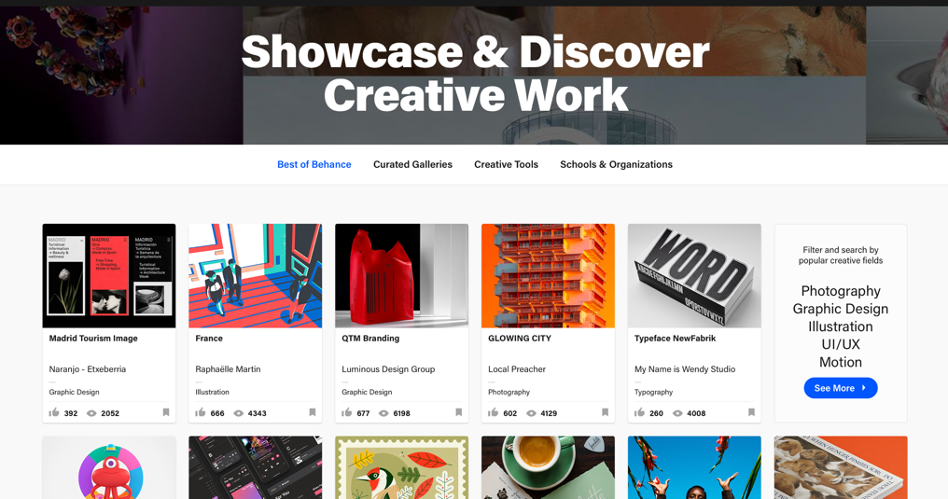
Figure 1: Behance (Author not known, 2018)
“Behance is one of the best inspirational design websites for UI designers. You can see a lot of stunning creations by different designers from around the world. Behance's management team carefully selects new creative works from a variety of fields every day. They include design, fashion, illustration, industrial design, architecture, photography, fine arts, advertising, typography, animation, sound effects, and more.” (mockplus, 2018)

The way it is also structured, with it’s very simplistic layout, containing very little text, but also straight to the point information. With a lot of click options to navigate to different page. It doesn’t overcomplicate the design, which can cause bad user interface and frustration to the user. Its simplicity can also help with loading of a web page, which is a significant factor in creating good user interface. Users would be uninterested in a web page that takes too long to load due to its bad structure and mass amount of data which causes the web page to loading speed.

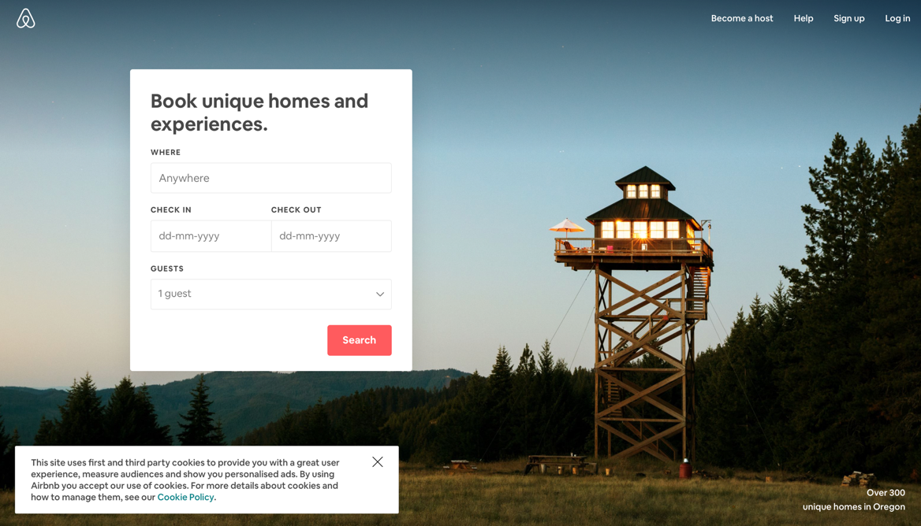
Figure 2: Airb&b (Screenshot of website, 2018)

Airbnb is also another great website for UI. It has an easy to navigate system, which ensures users know what they are looking for. With a box that allows them to type in the information required to find what they are looking for, users are more inclined to visit the website again. It has a clean look to the page, it doesn’t have any unnecessary information that can distract a user from what their initial purpose to the website is and it is easy and very presentable.
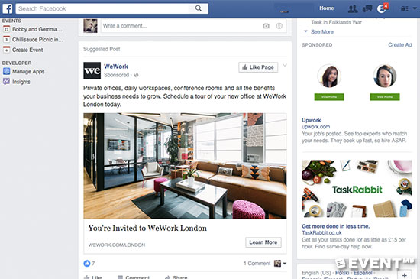
Figure 3 Example of Advertising on Facebook (Louisa LaughtonScott, 2018
Facebook is a very good example of bad User interface, as well as user experience.
Facebook was originally designed to allow users to communicate to each other, as well as post and share content they like. But as Facebook is more involved with advertisement, it has simply become a market place. This can cause but user interface as videos watched by users now contain adverts in between that users cannot opt out of. As well as adverts along the sides of every pages and sponsored apps included in their news feed.
Chapter 2 - Growth of Social media
What is it and why is it now so important?

Social media is the online version of the real world. It is where we communicate, interact, share content and much more. It reconnects lost families, helps raise awareness of issues around the world. Helps us contact each other instantly, rather than writing a letter and hoping for the best.
Social media is also a major benefit ton companies in the market place. Whereas before, companies had to pay excess amounts to promote their business through radio and television advertising. Now they can simply do it for free through Social media platforms, or promote their businesses more for a fraction of the cost.
It has become such a great benefit for our everyday lives.
Social media first came about in the early 2000’s, and is designed to contact individuals by limiting one to one contact. It has changed dramatically over the last decade, with websites constantly increasing in popularity, then fading when new websites offer better features. It is a constant battle on what website is better. With technology advancing, many websites cannot adapt to the change and ends up decreasing in popularity. Updating the website constantly to ensure it is up to date with the advancing technology is a key factor to having a successful social media platform.
Social media is a massive benefit for connecting the world. Being able to contact different people in different areas without even meeting.
‘The biggest benefit is that by removing geography from the networking equation you can connect with people all over the world. In fact, one of the greatest fears is that you can extend your network to places you will never visit and connect with people you would never otherwise encounter.” (Ashton and Juby, 2013)
A lot of social media specifically focus on certain things. For example, some are used for posting and sharing pictures, whereas others are created to socialise.

Different social media platforms.

There are millions of different social media platforms out there. The biggest social media platform is Facebook. Facebook is a social media platform designed to connect people together originally, but as it’s advancing more, Facebook is a big opportunity for businesses. With its main source of profit coming from advertisement, Facebook has become a huge market place for many businesses. It uses its cookies to enable ads are connected to users search engines, meaning that ads are more relevant to the users, therefore being more successful.
Facebook has 2.23 billion monthly users all over the world, those of which 1.47 billion are active daily users (CNN, 2018). With such a massive following, there comes a lot of data. Facebook processes 2.5 billion pieces of content daily, including 300 million photos. Which means that they can process data quickly, revealing new products (Constine, 2012). Big data, means large amounts of users. This is essential for user interface, because if a website cannot contain the amount of data it is storing, or simply isn’t storing enough data, then a lot of problems can occur. Such as the website not functioning how it’s supposed to, which loses a significant number of users.
Myspace first started in 2003. It feels like forever since Myspace was once the biggest social media platform, nothing but a distant memory now. It peaked 2005-2008. Myspace was considered the new way of social networking and was also the most visited social network in the world. Although, the reasoning behind Myspace decreasing in popularity is simply because Myspace couldn’t handle the quantity of users. Finding different ways to fund the Social Network, Myspace started increasing the number of ads used in their platform. This was a massive inconvenience to users. There wasn’t much change to the Myspace, which also affected its popularity. People wanted change and Myspace just couldn’t provide updates and much difference to its website. Not ideal for User experience. As well as Facebook become increasingly more popular, users just weren’t interested anymore. Ironically, now Facebook is increasing the number of ads shown to users. Are they going to go down the same route Myspace did? Which Social media platform will take over?
Facebook has turned into an older generation network. Many young users are more interested in Instagram and Snapchat, but why is that?
Snapchat and Instagram are different in a way in which the main source of communication us through pictures. It’s gaining popularity through its simplicity. Users can optionally see ads (unless sponsored ads). Young users aren’t interested in long posts, they are more visually interested.

Design examples on how people interact with social apps from a user interface perspective.

Social apps are designed to make lives easier for the viewer. With most apps suitable for Android and iPhone, apps are taking over most websites. For example, Instagram is still accessible as a website, but is featured more UI through the app. As well as Snapchat, which is mainly an app.
Facebook has designed a messenger app that enables users to reply to messages without having to open Facebook first. This app is separate to the Facebook app, ensuring that the data from the messages are stored through Messenger, rather than Facebook. Which is beneficial to UI as it isn’t all stored onto one app, therefore, less problems and bugs can occur.
Another great feature to Apps, is that users can now view and reply to notifications through the lock screen, ensuring that they don’t even have to access the app in order to reply to messages.
Another example of good UI is creation of The Apple Watch. The Apple Watch first launched on September 9th, 2014. The Apple device allows users to reply to text messages, through voice as a keypad, which means users can reply on the go quickly and efficiently. As well as accessing apps, such as Snapchat, Facebook, etc, without having the phone present.
Apps also are suited to hand of the user. Most apps having ‘scrolling’ which supplies users with data that can be on a constant loop to draw the user to the app. It can lead to the user ‘scrolling’ endlessly, which is a common occurrence to many that use mobile devices. This prolongs usage on the app.
A good example of different design examples is the Z format for web design. The Z Format is a layout in which is a great starting point for designers. It contains branding, hierarchy, structure and call in action.
The Z format works in a way in which we automatically view a web page. For example, in many web pages, we tend to see the logo tends to always be on the left-hand side of a web page. This is the basic structure of a Z format. The format works in a similar way in which we read text. It starts from the left and works to the right. This benefits user interface as it is structures to how we read text in an everyday basis.
This is the most popular format in web design as it is the easiest to navigate and the most beneficial in terms of basic formatting.

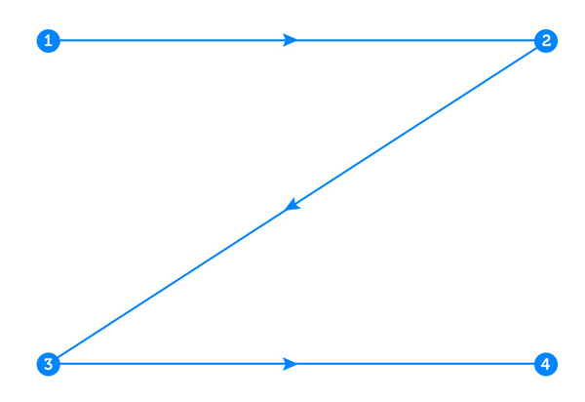
Figure 4: Understanding the Z-layout in Web Design (Brandon Jones, 2010).

This is an example of how Z format is structured. For example, the logo will at staring point one. Then at point two will follow with links to separate web pages within the web site. For example, “Home, Contact Us” etc. Then in between the 2nd & 3rd point normally has imagery about the website, this will enable users to view what the web site is all about. Then down to the 3rd point tends to be the contents of the web page and general information about the website to give a general background to what the user is experiencing when they view this webpage. Then finally at the 4th point will tend to be information regarding either a “Sign up” option, or normally a button to press in order to access more information from the webpage.
Another example is the F format. The F format was first brought into the web design in 2006. It is a structure that isn’t found by users and businesses due to the user experience, as the Z format was developed for an easier scan through a web page. Although, not as commonly used as the Z format, the F format plays a significant role in web design.
The F format was created for web pages that had most of their content towards the left of their web page. The F format is placed when a web page has a strong header. A header in which the logo and links to various other web pages inside that website occur.
Then to follow on the web design is the contents of the website. This structure the ‘F’ format, users pay more attention to the header, rather than the contents, which they scan.
One major design factor that is commonly used to create better user interface is the actual web features. For example, we automatically know that clicking on the logo on a web page will redirect us back to the home page. If this feature isn’t place on a web design, then we assume it doesn’t have good user interface and that they have not thought of the design process. It is such a massive design in most websites that we just assume it will be a reoccurring process for every web page.

Chapter 3 The Visual Communication and social conditioning aspects of apps and websites.

Graphic elements and use of icons to help with communication.

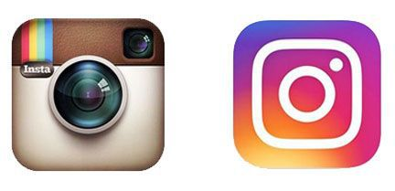
Figure 5: A New Look For Instagram (Armin, 2016).

Many apps are often recognised by their famous icons. Instagram went through a massive redesign where they changed their famous icon, into a simplistic version. In 2012, Facebook bought the app for $1 billion. The reason behind the change was for a more modern approach. As the icon became dated when technology was advancing, it simply looked too complex for the design industry. Achieving this, they managed to create an app design that can with stand any device. Its usage of bright colours creates great user interface as it is easier to find and users are more likely to click on the app. Attracting more viewers creates more business. Making it one of the more successful apps.
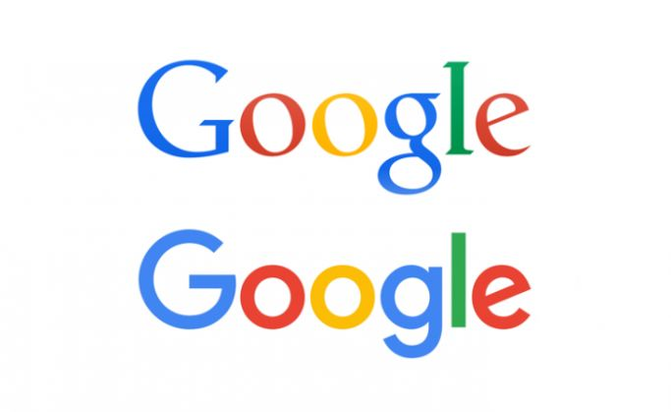
Figure 6: Google – New Logo vs. Old Logo (Vikas Shukla 2015).

Another major re-design was the change of the google logo. Google has been majorly influential when it comes to web design. Google is the most popular search engine on the internet. Networking a billion searches through its search engine daily. Google is well known for its fast pace at finding useful resources. Having less ads get in the way, unlike other search engines.
But what made Google change the layout to their logo? What made them change from a serif to a sans serif and what impact can it make through these simple changes?
The design aspect behind Google was initially created to have a simplistic yet friendly design. Something that attracts users, but doesn’t overcomplicate the page.
If you look on Google, you will see that the design is very basic. With a white screen and a colourful logo. This was the outcome Google wanted. A straight to the point layout design that can be used by anyone. Making it the most successful search engine.
But what does this have to do with the logo? Well, having a logo that matches the structure of the web page is essential in good user interface. If the logo was distracting, it would defeat the purpose of the web design. Creating a simplified version of the logo gave the search engine character, and with technology advancing it achieves a modern approach to development in the digital world. Also, as mobile devices and screens are made smaller, Google’s new logo can still be viewed clear on any device size. Making this a vital key for user interface.

Are Emoticons important methods of communication?

Emoticons are digital images implanted in the keypad for Mobile devices. Although these used to be an optional keypad that would have to be adjusted through settings, nowadays mobile devices automatically contain the keypad in their feature. Emoticons have become increasingly popular for substituting words in text. Communication is often formed simply through emoticons and users are able to deduct what other users are responding to them, through a simple emoticon. They are essential when it comes to messaging, as users often signify the mood of the individual. The nickname term ‘emoji’s’. These emoji’s were first created in 1999, but became increasingly popular since the iPhone created their own set of emoji’s. Emoji’s used to be the basic symbols, such as the typical emotions e.g, Smiley face, sad face, angry face. To signify people’s emotions through their text. But as emoji’s have evolved, there is now an emoji relevant to every day text. It has become essential, for example, if users do not contain emoji’s in their text, they can often come across blunt or arrogant, which can usually have a significant mood change in text. We have become so reliant on these little emoticons. They have become essential in everyday text. Emojis are a type of Semiotics which we use in everyday life.

Semiotics relating to UI design considerations.

Semiotics trick our mind. They play a key role in design elements. Semiotics are how a meaning is created and communicated, for example how symbols represent meanings without having to add text. (SignSalad, 2018)
Semiotics is how our mind perceives the meaning to symbols and signs.
Semiotics are structured into three key elements: Semantics, Syntactic and Pragmatics.
Semantics is the signification of representation between a sign and its meaning. The properties of language and systems is then dealt by Syntactic and Pragmatics casually focuses on the relationship between symbols and their users. (Infragistics Community, 2013)

Semiotics are an essential key to User Interface design considerations. For example, certain icons are recognised as actual features, without having to write the name.
Semiotics play a big role in User Interface when it comes to web design. The design aspect of a web page changes constantly. With such minimal outlooks to nowadays web design. Semiotics help which creating such a minimal look to a web page. The use of symbols instead of words can achieve that desired effect, which creates a more range of user interface. Ensuring that users can get the information they need, in such limited space. Semiotics also play a key role in faster loading time for web pages. With such little data to obtain within the web design, comes more beneficial designs.


Figure 7: Play Button (studiogstock, 2018).

Take for example this play button. It is a feature on all media devices. No words are there to specify what it is at all, but we automatically know it is the play button. It has been around for decades and plays a significant role when listening to audio on a device. It is simply a triangle, yet in our minds, it is the play button. This is a very simple design symbol. But it helps with shorten keyboards on a device. Users don’t even realise the significance of semiotics in the design world. It helps a great deal with shortening words and simplifying design features.

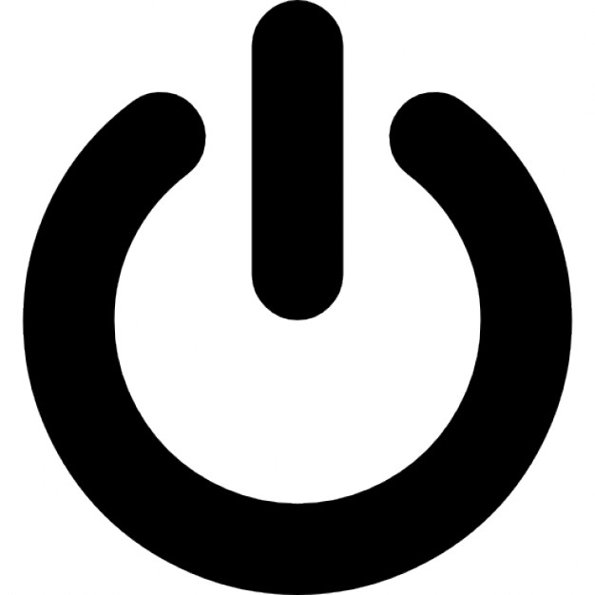
Figure 8: On Button (mrpickens, 2012).

Another key example is the power button. What is this symbol and how does it replicate that something is on? This symbol is literally made up from a circle split at the top with a line running down until half way. Now, if someone viewed this power button for the first time, they would have no idea what it means. But this is where we have interpreted this symbol to resemble the power button. This is a vital semiotic that occurs in every device. This symbol represents the power to the device. But how do we recognize this? Why do we automatically know that this symbol represents the power button? Well this is where semiotics plays a big factor. We have developed so much in technology that we do not need long words to explain the definition. This semiotic is essential with many devices. These symbols were designed for better user interface. They structure correctly on a keyboard, they are literally designed in order for us to have better user interface.
Semiotics were designed to make our lives easier. They are essential in the digital world. They are in our day to day lives.

Conclusion

This dissertation has broken down key aspects in what makes good user interface and what role it plays in creating a good website. What keeps users coming back?
Through this dissertation, I have learned that it takes a whole lot of thinking behind a web site. That it’s not just all about what attracts the eye and what doesn’t. It’s more than just easy navigating and good logo. It’s all about how the user feels.
A good web site is all based on the users it attracts, so if the users aren’t engaged, what’s the point in designing a web site? Success is all down to how well you engage with your audience. Success isn’t about who has the best design skills, or who can create a better logo. Even though these are beneficial features, they do need to be balanced out. You can’t just lean into one side more than the other.
With the digital world expanding, many key features play a great role in what makes good user interface. For example, the design aspect. This dissertation analysed what design aspects and features create the most beneficial User Interface. Then comes the actual navigation of the page. Simplistic design features create the better web designs.
Breaking down key aspects such as breaking down why social media is expanding, what consumers want out of a website? How development of different technology has impacted the way user’s interface with the web site.
Pin pointing these different aspects in this dissertation has found the different outcomes that have enabled me to find a variety of answers to what makes the best user experience and what is good user interface.
Through my findings, I have realized that the most success in web design is all based down to the little key factors. For example, who knew semiotics can play such a massive role to creating good user interface? This wouldn’t have even crossed many minds when designing a web site. But the realization is what could be missing from many web pages to this date.
Could this be the future to web design? Who knows, but knowing this information can be the make or break of designers. The tiny detail that is often overlooked by many designers is what they really need in order to create good user interface and an overall better user experience. Even with all key factors of a website, without good user interface and user experience interpreted into the thought of the web page. The web page will not be successful. Web design all falls down to the user interface and experience. Regardless of how it looks like, or how it functions.

Bibliography

Chaffey, D. (2018). Mobile marketing statistics 2018. [online] Smart Insights. Available at: https://www.smartinsights.com/mobile-marketing/mobile-marketing-analytics/mobile-marketing-statistics/. [Accessed 2018]
Dave Chaffey. (11/07/18). Mobile Marketting Statistics 2018 . Available: https://www.smartinsights.com/mobile-marketing/mobile-marketing-analytics/mobile-marketing-statistics/. Last accessed unknown.
unknown, u. (2018). 25 Best UX/UI Design Inspiration Sites in 2018. [online] Mockplus.com. Available at: https://www.mockplus.com/blog/post/design-inspiration-sites [Accessed 2018].
Ashton, R. and Juby, J. (2013). Writing for the web. 1st ed. Great Britain: Hodder & Stoughton, pp.79-81.

CNN. (2018). Facebook Fast Facts. [online] Available at: https://edition.cnn.com/2014/02/11/world/facebook-fast-facts/index.html [Accessed 2018].

Constine, J. (2012). How Big Is Facebook’s Data? 2.5 Billion Pieces Of Content And 500+ Terabytes Ingested Every Day. [online] TechCrunch. Available at: https://techcrunch.com/2012/08/22/how-big-is-facebooks-data-2-5-billion-pieces-of-content-and-500-terabytes-ingested-every-day/?guccounter=1 [Accessed 2018].

SignSalad. (2018). Semiotics Explained | Sign Salad. [online] Available at: https://signsalad.com/our-thoughts/what-is-semiotics/ [Accessed 2018].
Infragistics Community. (2013). Benefits of Semiotics in User Interface Design | Infragistics Blog. [online] Available at: https://www.infragistics.com/community/blogs/b/ux/posts/benefits-of-semiotics-in-user-interface-design [Accessed 2018].

