
LCMB7024 Marketing Management
Assessment Component 2: Marketing Portfolio

Student Name: Jamila Begum
Student ID: 2503076

Lecturer Name: Dr Laila Maazouz (London)

Words Count: 2542

Table of Contents
Introduction 3
Element 1: Segmentation, Targeting, Differentiation and Positioning (STDP) Analysis for BMW’s New Brand Concept 4
Introduction to BMW and New Brand Concept 4
Why this brand would appeal to the current market? 5
Segmentation Analysis 5
Targeting Strategy 7
Differentiation Strategy 7
Positioning Strategy 8
Element 2: Marketing Mix (4Ps) for BMW’s New Brand NexRide 8
1. Product Strategy 9
2. Price Strategy 10
3. Place (Distribution) Strategy 10
4. Promotion Strategy 11
Element 3: Marketing Strategy Pitch 12
Element 4: Reflection 13
Conclusion 16
References 17

Introduction
Marketing management is defined as the act of planning, organising, and executing strategies to meet the customer requirements and also realise the organisational objectives (Aghazadeh, 2022). With contemporary trends of mobility moving towards smart technology and sustainability, firms need to change their marketing strategies to remain competitive. The following report constitutes the robust marketing plan of the new high-end e-bike brand, NexRide, which is the creation of BMW. This report consists of an STDP analysis to determine target customers, a 4Ps marketing mix to sustain the brand at a competitive position, and a pitching strategy that suits the changing consumer and market expectations.

Element 1: Segmentation, Targeting, Differentiation and Positioning (STDP) Analysis for BMW’s New Brand Concept

Introduction to BMW and New Brand Concept
Company Overview: BMW has a presence more than 140 countries and has a global automotive market share of over 3% indicating its premium mobility leadership strength and established in 1916 (BMW Group, 2025). In 2024, the company delivered more than 2400 thousand units cars and it has a worldwide staff of approximately 159,000 workers.
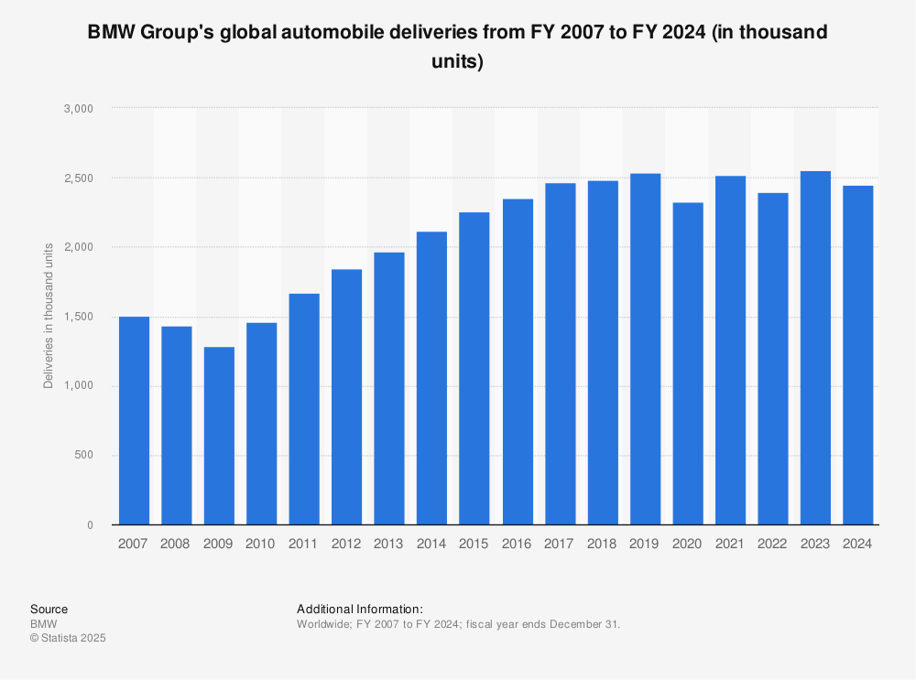
Figure 1: GMW Group's Global Automobile Deliveries
Source: (Statista, 2024)
Concept of the New Brand: NexRide will launch AI-driven e-bikes that will be located in a market worth over $45+ billion worldwide. The NexRide Pro flagship can satisfy the needs of 72% of commuters who choose environmentally-friendly modes of transit. As road traffic jam is rising 20 percent every year, the product helps in faster commuting within urban areas.
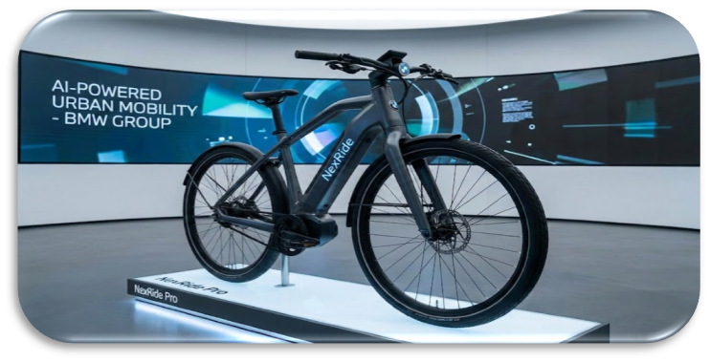
Figure 2: New Brand (NexRide)
Source: (Self-Made)

Why this brand would appeal to the current market?
The demand of e-bikes is increasing by 40 percent every year because of the high fuel prices and awareness about sustainability. More than half of young professionals prefer electric micromobility in the undercommute. Smart performance features are beneficial to global commuters who spend 30-40 minutes in a day. The rising popularity of e-bikes as hybrid fitness-mobility products globally by 35 per cent is because of health-oriented behaviour (BMW Group, 2025).

Segmentation Analysis
Market segmentation refers to the act of sub-division of a wide market into smaller sections of the consumers sharing common needs, attributes, or behaviour. The next section will include market segmentation of the new brand:
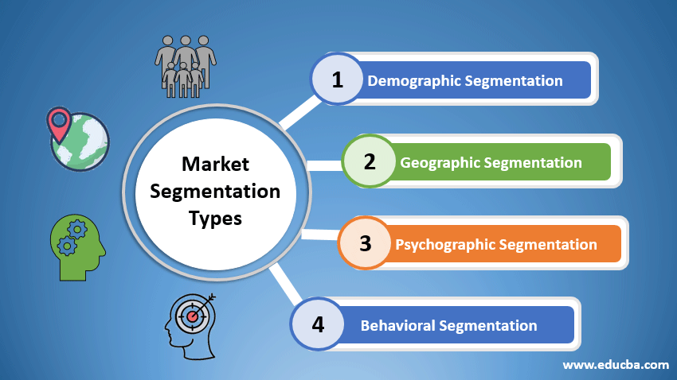
Figure 3: Types of Market Segmentation
Source: (EDUCBA, 2020)
- Demographic Segmentation: The micromobility users are 50% of urban professionals who are aged 2040, and this is the largest group of users. High digital adoption provides 60 percent of the interest of e-bikes by the Millennials and Gen Z (Vávrová, 2025). The young employees and students make up 45 percent of the premium e-bikes sales because they have middle-high purchasing power.
- Geographic Segmentation: Cities with a population above 1 million generate 70% of the world demand of e-bikes because of congestion. Europe and Asia are some regions with usage rates of over 35 percent and they are facilitated by cycling infrastructure (Schepers and Aldred, 2021). The increasing environmental regulations by 10 per cent annually drive low-emission transport adoption.
- Psychographic Segmentation: The sustainability-seeking consumers constitute 65 per cent of the e-bike customers due to the trends of climate-conscious behaviour. Technical people who handle AI on a daily basis are half as likely to buy intelligent cars (Tong and Maharjan, 2022). Segments of the lifestyle which emphasise work-life balance have a 40 per cent preference for stress-reducing mobility.
- Behavioural Segmentation: Commuters who travel 5-15 km per day constitute half of the e-bike frequent users, which are suitable to NexRide Pro. The premium segment constitutes 48 per cent of people who value components of high performance and are ready to spend money on them (Nwokah, 2024). There is a rising number of safety-oriented users who want smart features by 25 percent a year, further boosting the demand of integrated systems.

Targeting Strategy
- Primary Target Market: The main customer segment involves tech-savvy workers between 22-40 years, and they constitute half of the micromobility demand (Hauslbauer and Schade, 2022). This category describes a preference of 60% to AI-assisted commuting. Their purchasing power has increased by 15 percent over the last three years allowing them to buy premiums. The sustainability affects 70 percent of their transport choices.
- Secondary Target Market: The secondary market includes students and environmentally conscious customers age 18-30, who contribute 35 percent of the e-bike sales. This population is increasing 12 percent each year because of university commuting. More than 65 per cent are choosing a sustainable and convenience-oriented mobility (Nielsen, 2022). Online recommendations make 80% of the purchases socially influenced.

Differentiation Strategy
- Technological Differentiation: NexRide Pro is an AI-based route optimisation that saves 20% of the commute time with real-time information. The biometric security is superior to standard locks by 30 per cent. Regenerative braking enhances the battery efficiency by 15 per cent, and this enhances performance (BMW Group, 2025). The smart sensors will have a 25% improved performance in preventing accidents with predictive alerts.
- Brand-Based Differentiation: The engineering reputation of BMW translates into 40% trust on high mobility markets (BMW, 2024). Its record of innovation lends some credibility in a segment that is expanding at double-digit rates every year. Premium design adds 35 points to the perceived value as tested by consumer survey.

Positioning Strategy
- Positioning Statement: NexRide will position itself as a luxurious AI-based e-bike to provide sustainable, efficient commuting wherein 55 percent of the consumers require eco-solution and 45 percent value high-tech features (BMW Group, 2025). Engineering improvement offers 30% improvement in performance over normal models.

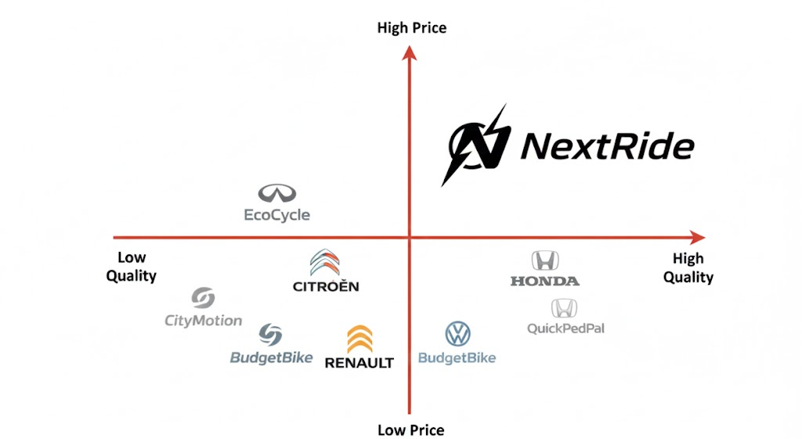
Figure 4: Positioning Strategy of NexRide
Source: (Self-Made)
- Desired Market Position: The brand will capture the top of the luxury smart e bike market that will have a projected growth of $100 billion in one decade. NexRide is aimed at the 5 -percent urban e-bikes market share within the first stage. Its technology that is oriented to sustainability is in line with the trends of doubling-digit adoption of green mobility (Schepers and Aldred, 2021).

Element 2: Marketing Mix (4Ps) for BMW’s New Brand NexRide
The 4Ps of marketing (Product, Price, Place, and Promotion) is a marketing strategy tool employed by high-premium mobility brands to position offerings successfully (Mishra, 2020). This section will demonstrate how the 4Ps will be utilised to support the NexRide brand strategy by balancing high-growth trends, competition expectations, and consumer demand patterns.
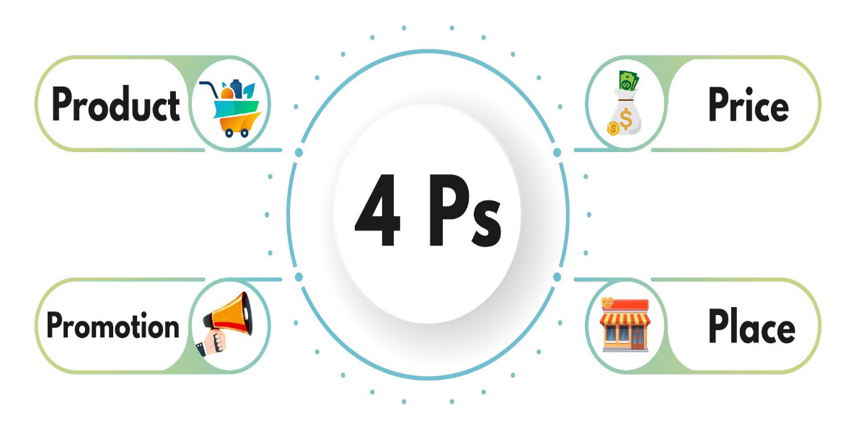
Figure 5: 4Ps of Marketing Mix
Source: (Mishra, 2020)

1. Product Strategy
The NexRide Pro product approach is based on three levels of interdependence in providing the full value to the high-end e-bike market.
- Core Product Value: The Core Product is the ultimate advantage over the rider: the high performance, safety and efficiency. The main value proposition is the AI-based optimization of routes which reduces the commute time significantly, which directly targets urban commuters. Increased safety is handled with the help of smart safety sensors with increased hazard detection.
- Actual Product: The core value is converted into features in the Actual Product. NexRide Pro will be constructed based on a low-weight, aerospace-quality frame, and aimed at health-aware consumers who want a hybrid mobility-fitness product. It has a large 120km battery range, 4 times the average daily rider demand, and serves users with a moderate daily commute (BMW Group, 2025).
- Augmented Product: The Augmented Product refers to the intangible benefits and services which make the offering special. It also has a generous warranty of 100% battery performance in 3 years to accommodate the demand of a long-term warranty (BMW, 2024). Moreover, a free yearly artificial intelligence-based diagnostic and maintenance service is provided, which saves time in maintenance and appeals to the convenience-seeking market.

2. Price Strategy
- Premium Pricing: NexRide Pro will apply the premium pricing strategy with brand equity that 40 percent of mobility customers worldwide place their trust in BMW (Pantelous and Passalidou, 2022). The projected price level of 20-25 above the standard smart e-bikes is appropriate due to the 48% of customer need to afford higher performance parts. The price premium is justified by the AI capabilities rated 30 per cent higher by consumers.
- Flexible Financing: Available flexible financing plans such as 12-24 months instalments cater to increased demand by 35% of young professionals who wish to pay monthly. Subscriptions with an annual growth in 22% are to be implemented on riders who would like to use but not to own. Corporate leasing (with 30% of workplace commuters in Europe) facilitates B2B growth and empowers the BMW ecosystem of partners (BMW Group, 2025).

3. Place (Distribution) Strategy
- Showroom and Dealer Network: The sales will be performed by 4,000+ dealerships of BMW across the world, making NexRide Pro available to 60 more than to newcomers that have no networks established (BMW, 2024). Distributing e-bikes through high-end showrooms will appeal to the 48 percent premium consumers that enjoy testing the product in-store.
- E-Commerce Distribution: Online sales will reach the 80 percent of customers who are impacted by online recommendations and also the 65 percent who want to purchase tech products online. The urban customers who require fast service will be accommodated by fast delivery networks that will enhance the speed of the logistics by 25 per cent.
- Urban Micro-Hubs: NexRide charging and servicing facilities will be located in densely populated regions where micromobility coverage is increasing 12 per cent annually. Collaborations with smart-city initiatives - growing 18% worldwide - increase access and will guarantee consumer engagement at all times (Viale Pereira and Cunha, 2023).

4. Promotion Strategy
- Digital Campaigns: NexRide will leverage AI-based targeted advertisements to tap the 60% of tech-savvy Millennials and Gen Z that make up the micromobility demand. Influencer collaboration on platforms that have 2 billion monthly active users makes a brand more visible by up to 35 per cent (Aghazadeh, 2022). AR demos (interactive) are provided to 50 per cent of auto shoppers and increase product knowledge and interaction.
- Sustainability Branding: Eco-friendly mobility is appreciated by 70% of urban riders, therefore, the zero-emission experience of riding will be promoted via campaigns. The partnership with environmental organisations that increase 15% per year enhances the credibility of customers concerned with climate (Nielsen, 2022).
- Corporate Partnerships: B2B adoption will be targeted by offering 30% European commuters programmes on mobility in workplaces (Clark and Gifford, 2024). Secondary market penetration is facilitated by partnerships with universities whose commuter numbers of students grow 12% a year. Brand relevance is promoted through health and wellness campaigns that are attractive to the 35% fitness-conscious riders.

Element 3: Marketing Strategy Pitch
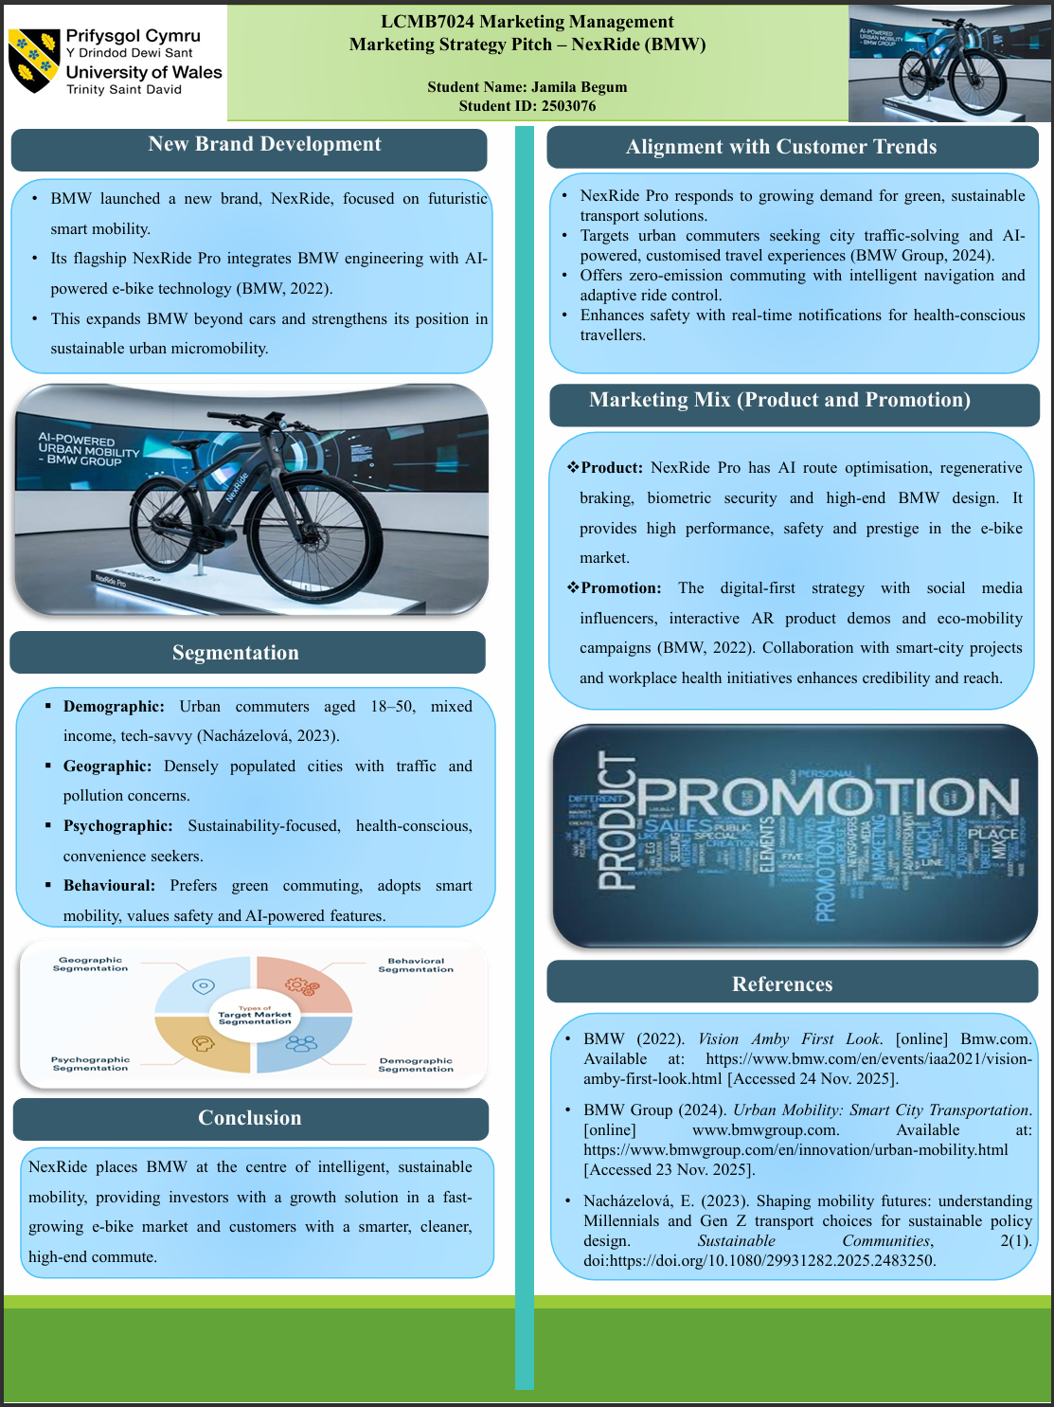

Element 4: Reflection
The Reflective tool by Gibbs contains description, feelings, evaluation, analysis, conclusion and action plan (McLeod, 2025). NexRide and the design of the entire marketing strategy with this model in BMW will be described in the following section:
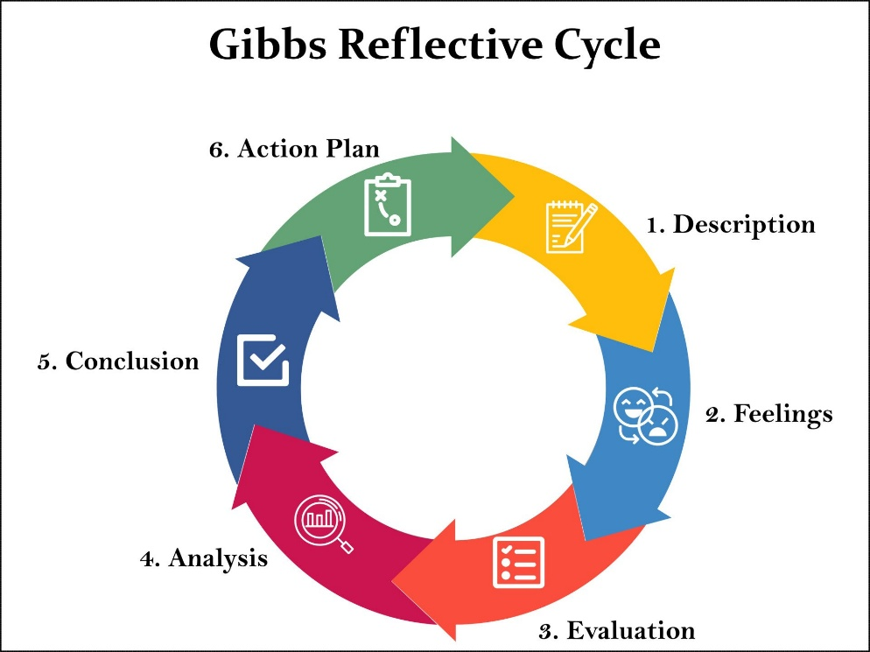
Figure 6: Gibbs Reflective Cycle
Source: (McLeod, 2025)
- Description
This was a project that entailed the creation of a new brand under the BMW brand, called NexRide, and an entire marketing strategy and strategic selling pitch (Element 3) of their flagship under the NexRide brand, NexRide Pro e-bike, which was powered by AI. It involved thorough research on the market trends, customer segmentation, positioning tactics and marketing mix which was then considered to prepare a pitch of a marketing strategy pitch to an investor.
- Feelings
At the initial level, I was scared by the magnitude of the task, especially by its difficulty to develop an entirely new brand concept that would be in line with the premium identity of BMW. Nevertheless, my confidence grew when I learned more about BMW innovation approaches and the development of micromobility market. I also liked the artistic side of the future-driven, AI-controlled product development, but I was under pressure to make sure that the idea was realistic and compatible with brand values of BMW. In the process of working on the marketing strategy pitch, I felt anxious about the delivery of the strategy in a clear and convincing manner but I also felt that I was driven to make an effective presentation of my work.
- Evaluation
All in all, it was a very valuable experience. I also enhanced my skills to associate the market trends, including employing sustainability and AI integration, with a consistent brand strategy. The marketing strategy pitch (Element 3) has greatly enhanced my communication and presentation skills, especially the ability to organize the information in a logical way in order to convey the value of NexRide to a potential investor audience. Nevertheless, I found that there was a flaw at the level of competitor analysis and financial forecasting that could have been improved to bolster the strategic argument. Another form of difficulty in the preparation phase was time management because it was difficult to balance the depth of research and the pitch clarity in research.
- Analysis
This project brought to the fore the fact that innovative brand ideas need to be backed up with high market evidence. Learning how customers can be motivated, such as being more sustainable, in the urban congestion, and health conscious enabled me to create a product concept that was not based on pure imagination. The pitch helped to emphasize the need to do proper segmentation and positioning when launching a new brand in a competitive market. Also, the experience has proven the importance of brief storytelling and visualization in keeping the audience on the gas. One of the weaknesses that were noted was that I would tend to be too premature about a particular idea and would not explore the other strategic choices as well as this restricted the scope of my analysis.
- Conclusion
To sum up, the project allowed my growth in marketing, research, and presentation competencies. I became confident in the ability to apply the theory of marketing to a real-life branding situation and became more proficient in the ability to sell strategic concepts through a structured pitch. Simultaneously, the experience showed the aspects to improve, especially in critical assessment, scope of thinking, and time management.
6. Action Plan
Based on my self-assessment, and aligning with the strategic development framework proposed by (Broman and Robèrt, 2024), my action plan in the near future will be on improving the depth of research, presentation, generation of ideas, and time management to develop stronger, evidence-based brand strategies.
Development Area | Identified Weakness / Challenge | Planned Action | Expected Improvement
Strategic research depth | Limited competitor and financial analysis | Conduct detailed competitor benchmarking and basic financial forecasting | Stronger evidence-based strategies
Pitch delivery skills | Anxiety and clarity issues during presentation | Practise pitch delivery and rehearsal before final presentation | Improved confidence and clarity
Idea generation | Early fixation on one concept | Explore multiple brand concepts before final selection | Broader strategic thinking
Time management | Pressure during preparation phase | Create a structured project timeline with milestones | More efficient and organised workflow

Conclusion
This report presented the new brand of BMW, NexRide which is aligned with the increased attention to sustainable and high-performance mobility. The strategy makes NexRide Pro a high-end AI-enabled e-bike among urban, technology-oriented, and environmental-aware consumers through an elaborate analysis of the STDP and a specific marketing mix. Market success is facilitated by strong brand equity, innovation capacity and worldwide network of BMW. On the whole, NexRide makes BMW even more intelligent in micromobility and helps to make the urban transportation future cleaner.

References
Aghazadeh, H. (2022). Strategic Marketing Management: Achieving Superior Business Performance through Intelligent Marketing Strategy. Procedia - Social and Behavioral Sciences, [online] 207(3), pp.125–134. doi: https://doi.org/10.1016/j.sbspro.2015.10.161.
Awolusi, I. and Nnaji, C. (2023). Overcoming barriers to smart safety management system implementation in the construction industry. Results in Engineering, [online] 20(5), p.101503. doi: https://doi.org/10.1016/j.rineng.2023.101503.
BMW (2022). Vision Amby First Look. [online] Bmw.com. Available at: https://www.bmw.com/en/events/iaa2021/vision-amby-first-look.html [Accessed 24 Nov. 2025].
BMW Group (2024). Urban Mobility: Smart City Transportation. [online] www.bmwgroup.com. Available at: https://www.bmwgroup.com/en/innovation/urban-mobility.html [Accessed 23 Nov. 2025].
BMW Group (2025). BMW Group History. [online] BMW Group. Available at: https://www.bmwgroup.com/en/company/history.html [Accessed 8 Dec. 2025].
Broman, G.I. and Robèrt, K.-H. (2024). A framework for strategic sustainable development. Journal of Cleaner Production, 140(1), pp.17–31. doi:https://doi.org/10.1016/j.jclepro.2015.10.121.
Clark, M. and Gifford, K. (2024). Business-to-business carsharing: evidence from Britain of factors associated with employer-based carsharing membership and its impacts. Transportation, 42(3), pp.471–495. doi: https://doi.org/10.1007/s11116-015-9609-y.
EDUCBA (2020). Market Segmentation Types | Top 4 Key Types of Market Segmentation. [online] EDUCBA. Available at: https://www.educba.com/market-segmentation-types/ [Accessed 8 Dec. 2025].
Hauslbauer, A.L. and Schade, J. (2022). The identification of mobility types on a national level. Transport Policy, 125(3), pp.289–298. doi: https://doi.org/10.1016/j.tranpol.2022.06.013.
McLeod, S. (2025). Gibbs Reflective Cycle. [online] Simply Psychology. Available at: https://www.simplypsychology.org/gibbs-reflective-cycle.html [Accessed 8 Dec. 2025].
Mishra, A. (2020). 4 Ps of the marketing mix: a beginner’s guide! [online] Management Weekly. Available at: https://managementweekly.org/4-ps-of-the-marketing-mix/ [Accessed 6 Dec. 2025].
Nacházelová, E. (2023). Shaping mobility futures: understanding Millennials and Gen Z transport choices for sustainable policy design. Sustainable Communities, 2(1). doi: https://doi.org/10.1080/29931282.2025.2483250.
Nielsen (2022). 66% of Consumers Willing to Pay More for Sustainable goods, Nielsen Report Reveals | Ashton Manufacturing. [online] Ashtonmanufacturing.com.au. Available at: https://ashtonmanufacturing.com.au/66-of-consumers-willing-to-pay-more-for-sustainable-goods-nielsen-report-reveals/ [Accessed 8 Dec. 2025].
Nwokah, N.G. (2024). Premium customers’ perception of firms’ customer relationship management segmentation, identity strategies and their satisfaction. International Journal of Markets and Business Systems, 2(4), p.291. doi: https://doi.org/10.1504/ijmabs.2016.084754.
Pantelous, A.A. and Passalidou, E. (2022). Optimal premium pricing strategies for competitive general insurance markets. Applied Mathematics and Computation, 259(3), pp.858–874. doi: https://doi.org/10.1016/j.amc.2015.03.027.
Schepers, P. and Aldred, R. (2021). The development of cycling in European countries since 1990. European Journal of Transport and Infrastructure Research, [online] 21(2), pp.41–70. doi: https://doi.org/10.18757/ejtir.2021.21.2.5411.
Statista (2024). BMW Group: car shipments 2024| Statista. [online] Statista. Available at: https://www.statista.com/statistics/264342/global-sales-volume-of-automobiles-of-bmw-group/?srsltid=AfmBOoqdvgeiM8rQ0efNL-1y7nu5n6w9Ure_T8vJdB9Q4FC21pDmD_QQ [Accessed 8 Dec. 2025].
Tong, W. and Maharjan, S. (2022). Artificial Intelligence for Vehicle-to-Everything: A Survey. IEEE Access, [online] 7(4), pp.10823–10843. doi: https://doi.org/10.1109/ACCESS.2019.2891073.
Vávrová, L. (2025). Shaping mobility futures: understanding Millennials and Gen Z transport choices for sustainable policy design. Sustainable Communities, 2(1). doi: https://doi.org/10.1080/29931282.2025.2483250.
Viale Pereira, G. and Cunha, M.A. (2023). Increasing collaboration and participation in smart city governance: a cross-case analysis of smart city initiatives. Information Technology for Development, 23(3), pp.526–553. doi: https://doi.org/10.1080/02681102.2017.1353946.

