[Name:_________________________________]
[Student Number: _________________________]
[WORKSHEET 2 -- TESTING (Parking Fee Calculator)]
[Copy and paste your original code from Moodle into this box. Do not change it.]
Car = 2.5
MtBike = 1.0
Van = 4.0
extended_stay = False
while True:
Hours = float(input("How Many hours are you staying?\n"))
if Hours > 1 or Hours < 48:
Duration = input("are you sure staying?")
if Duration == "Yes".lower():
extended_stay=True
break
Weekend = input("Is it a weekend?")
Vehicle_type = input("Car, MotorBike or Van\n")
if Weekend == "yes".lower():
if Vehicle_type == "Car".lower():
Amount = float(3 * Hours)
if Amount > (30.00) and extended_stay == False:
print("Cannot exceed £25 per Day")
else:
print(f"That will be £{Amount}")
if Vehicle_type == "MotorBike".lower():
Amount = float(1.20 * Hours)
if Amount > 12.00 and extended_stay == False:
print("Cannot exceed £10 per Day")
else:
print(f"That will be £{Amount}")
if Vehicle_type == "Van".lower():
Amount = float(4.8 * Hours)
if Amount > 48.00 and extended_stay == False:
print("Cannot exceed £40 per Day")
else:
print(f"That will be £{Amount}")
else:
if Vehicle_type == "Car".lower():
Amount = float(2.5 * Hours)
if Amount > 25.00 and extended_stay == False:
print("Cannot exceed £25 per Day")
else:
print(f"That will be £{Amount}")
if Vehicle_type == "MotorBike".lower():
Amount = float(1 * Hours)
if Amount > 10.00 and extended_stay == False:
print("Cannot exceed £10 per Day")
else:
print(f"That will be £{Amount}")
if Vehicle_type == "Van".lower():
Amount = float(4 * Hours)
if Amount > 40.00 and extended_stay == False:
print("Cannot exceed £40 per Day")
else:
print(f"That will be £{Amount}")

[Code Testing]
For each test below, run your code and enter the values provided. Provide a screenshot of what happened when the programme ran. Did the programme behave correctly or did it do something unexpected? Fill in a box for each test below. You should present 12 separate boxes, 1 for each test. (Note: the first box is provided as a template)
Test the following values for your calculator:
- 2 hours parking with a car on weekday
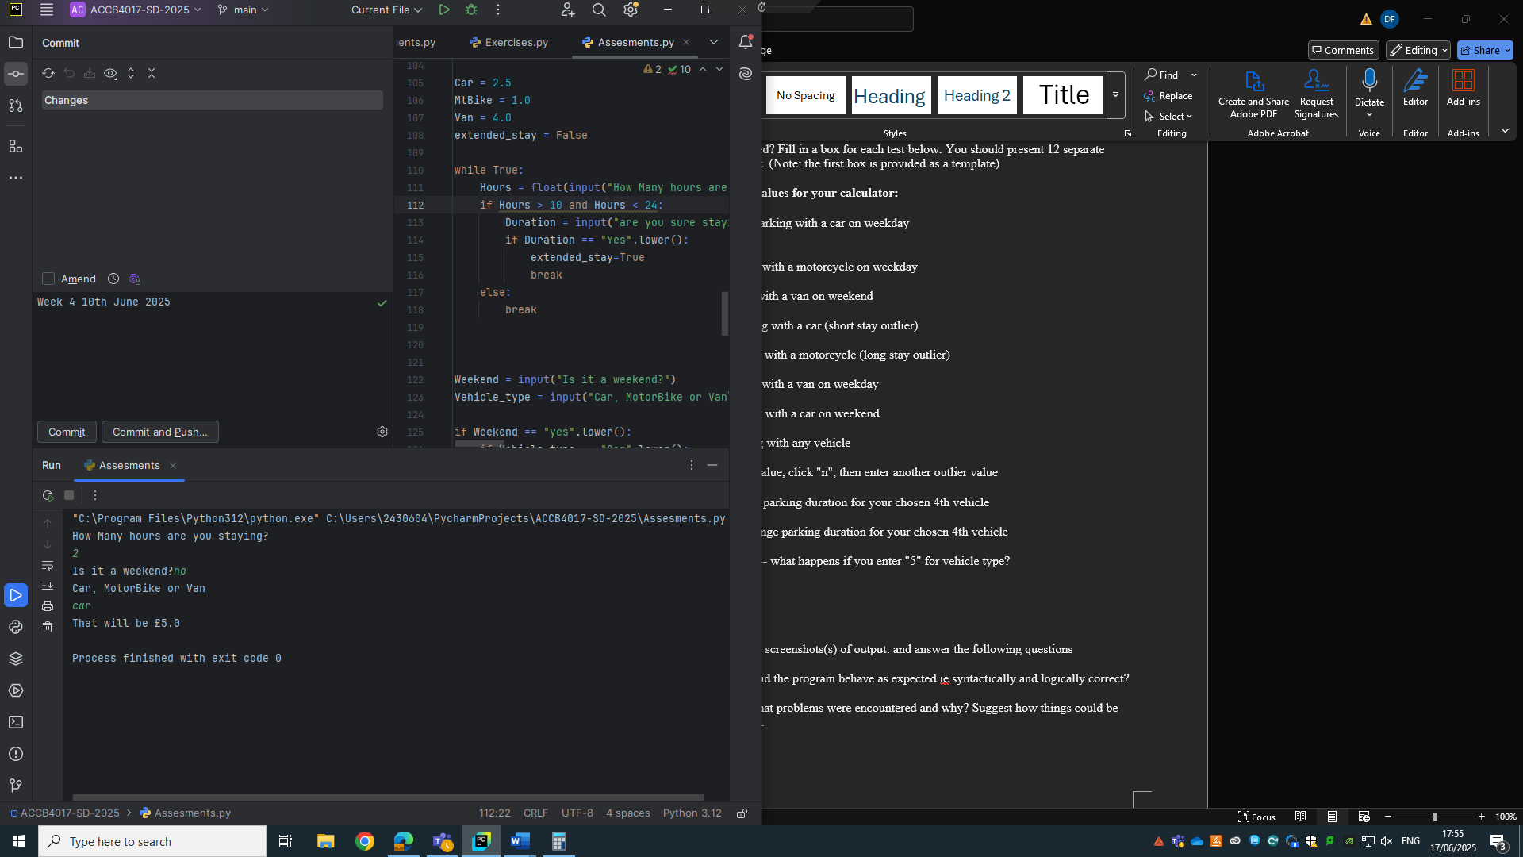
- 0.5 hours parking with a motorcycle on weekday

- 8 hours parking with a van on weekend

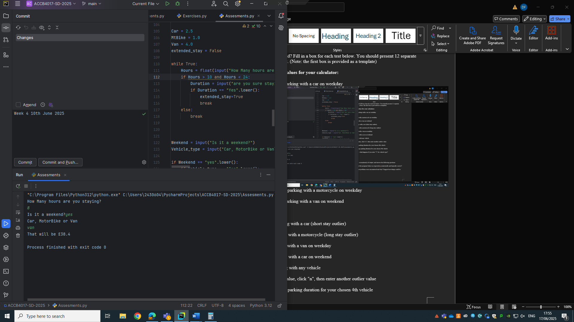
iv) 0.25 hours parking with a car (short stay outlier)
- 100 hours parking with a motorcycle (long stay outlier)

vi) 24 hours parking with a van on weekday
vii) 72 hours parking with a car on weekend
viii) -2 hours parking with any vehicle
ix) Enter an outlier value, click "n", then enter another outlier value
x) Suitable "normal" parking duration for your chosen 4th vehicle
xi) Suitable out of range parking duration for your chosen 4th vehicle
xii) Test your menu -- what happens if you enter "5" for vehicle type?

For each test provide screenshots(s) of output: and answer the following questions
- Result: Did the program behave as expected ie syntactically and logically correct? YES/NO
If NO, what problems were encountered and why? Suggest how things could be improved.

