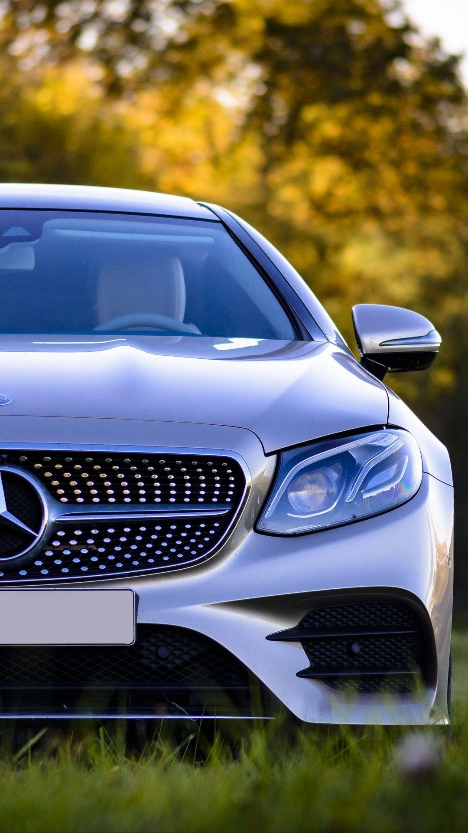
Module name: Marketing Fundamentals
Module code: LCBB4004
Lecturers name: Tushara Balendran
Student name: Paul-Silvian Vornicescu
Student ID No: 2246785
Assignment 1
by Paul Vornicescu

Mercedes-Benz
Contents
History

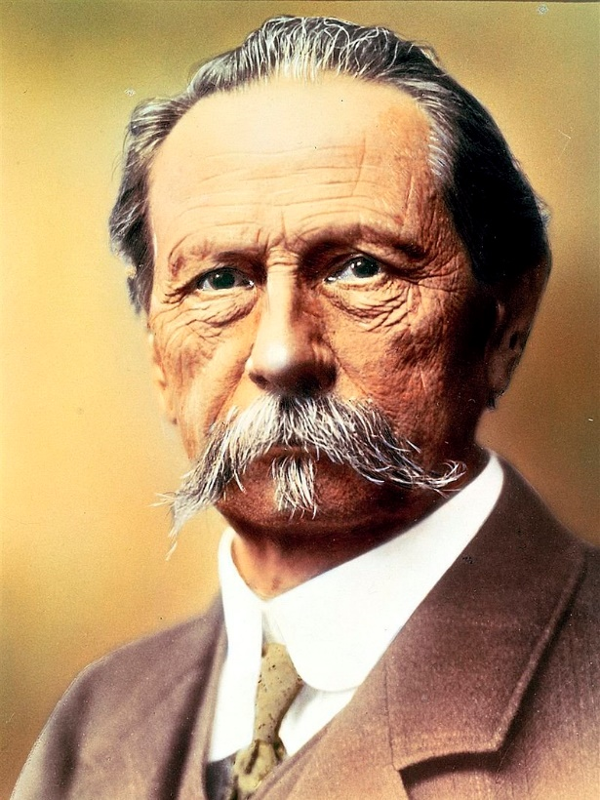
Mercedes-Benz, an iconic German automobile manufacturer, has an illustrious history that extends over a century, with its origins rooted in the broader history of the automobile itself. Established in 1926, Mercedes-Benz can trace its lineage back to two significant individuals in automotive history, Gottlieb Daimler and Karl Benz, who, operating independently, crafted the world's first internal combustion engine-powered automobiles in 1886 (Nieuwenhuis & Wells, 2007).
Karl Benz engineered the "Benz Patent-Motorwagen", which is recognised as the world's first practical automobile, while Gottlieb Daimler and his associate Wilhelm Maybach developed a motorised carriage around the same time (Nieuwenhuis & Wells, 2007). The companies established by these pioneers—Benz & Cie. and the Daimler Motoren Gesellschaft (DMG) continued to function independently until they merged in 1926, forming Daimler-Benz, and introducing the Mercedes-Benz brand (Eckermann, 2001).
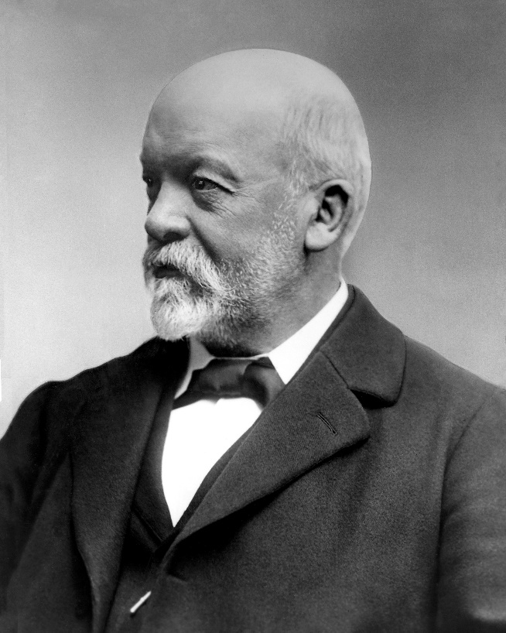
The brand name Mercedes was inspired by Mercedes Jellinek, the daughter of Emil Jellinek, a prominent Austrian automobile entrepreneur and member of DMG's board of directors. The Mercedes 35 HP model, which debuted in 1901, was an innovative design that cemented the reputation of the Mercedes brand within the burgeoning automotive industry.
Throughout the 20th century, Mercedes-Benz has maintained its reputation for quality and durability. The brand played a pioneering role in many technological and safety innovations that later became common in other vehicles. For instance, Mercedes-Benz developed the first diesel-powered passenger car, the 260D, in 1936 and introduced the pioneering safety system, the Anti-lock Braking System (ABS), in 1978.

In the 21st century, Mercedes-Benz has made significant strides in electric vehicle production, forming the EQ sub-brand, and continues to be a significant player in the luxury automobile market. With a focus on sustainable mobility and digitisation, Mercedes-Benz is poised to continue its storied legacy in the automotive industry.

The logo

Designed with precision, the logo comprises three intersecting arrows of equal length, pointing in three distinct directions: top left, top right, and bottom right. The star-shaped formation created by these arrows is enclosed within a circular frame, which often adopts a silver or chrome finish, exuding an air of sophistication and refinement.
Symbolically, the Mercedes-Benz logo holds great meaning, signifying the brand's commitment to excellence across various modes of transportation. Each of the star's three points represents the brand's aspiration to establish supremacy in the realms of land, sea, and air, showcasing its dedication to mastering diverse forms of mobility.

Mission and vision

Mission:
Mercedes-Benz strives to deliver unrivalled luxury, performance, and innovation through exceptional vehicles that embody superior engineering, advanced technology, and exquisite craftsmanship. The company is committed to enhancing the driving experience, prioritizing safety, and offering sustainable mobility solutions.

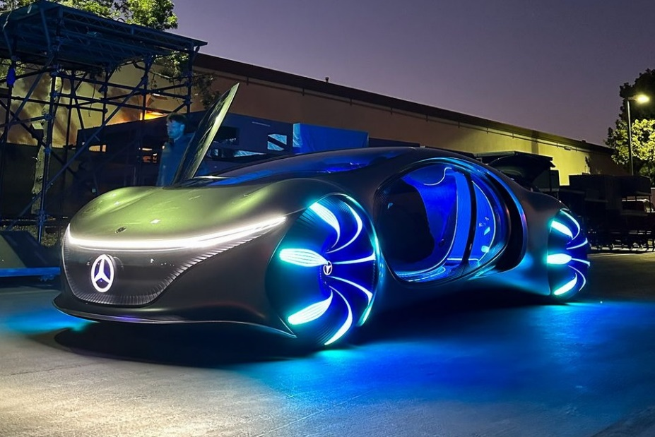
Vision:
Mercedes-Benz aims to be the leading global luxury automotive brand, renowned for its commitment to excellence, innovation, and captivating design. The company envisions shaping the future of mobility through continuous advancements, pioneering technologies, and personalized experiences that harmoniously integrate luxury and sustainability.
Segmentation

A demographic factor for Mercedes-Benz is income, as its products fall within the premium automobile category, and therefore, are usually affordable only to consumers in the high-income segment. Moreover, the brand tends to appeal more to middle-aged and older consumers, as well as professionals and executives who possess the financial capacity to acquire a luxury vehicle.
Mercedes-Benz operates globally, but distinct regional preferences and purchasing patterns result in market segmentation by regions, including North America, Europe, Asia, and the Middle East. This geographical segmentation enables the company to implement region-specific strategies (Kotler, et al., 2018).
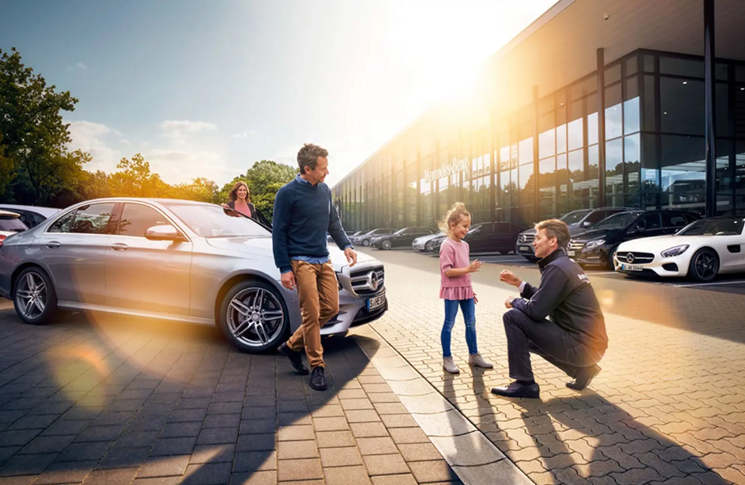
Many Mercedes-Benz consumers exhibit a psychographic profile characterized by a preference for prestige, superior quality, and performance. The brand is often seen as a representation of a luxurious lifestyle, appealing to individuals who take pride in the societal status associated with Mercedes-Benz ownership.
Behavioural segmentation is based on specific consumer behaviour towards the brand. For instance, there are consumers who have demonstrated brand loyalty by consistently purchasing or showing a preference for Mercedes-Benz when considering vehicle upgrades or newer models (Hollensen, 2015).
Advantages: Segmentation helps to identify profitable segments that the company can pursue, for instance these are high income people that are willing to pay for luxury and quality. By segmenting the market, Mercedes creates targeted and effective marketing campaigns (Dibb and Simkin, 1991).
Disadvantages: Segmentation requires significant research and data analysis. Moreover, producing and marketing products for different segments may increase costs (Weinstein, 1987).

Targeting

Upon conducting market segmentation, Mercedes-Benz proceeds to target its identified market segments through a differentiated strategy, tailoring different models to cater to various customer needs:

- Luxury Segment: Models such as the S-Class and E-Class are primarily targeted at high-income individuals and corporate executives seeking luxury and comfort (Kotler, et al., 2018).

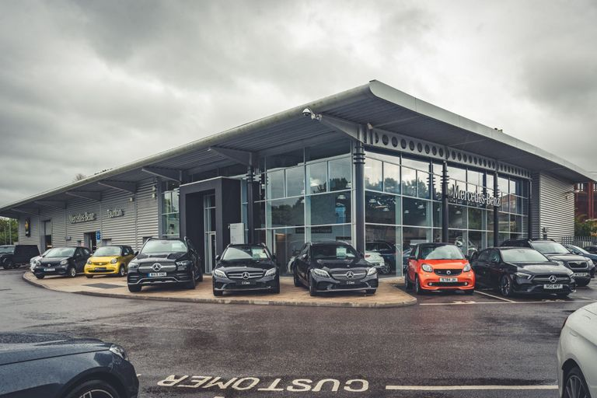
- Performance Segment: For the performance-seeking consumers, Mercedes offers the AMG line, including models like the AMG GT and the C63 AMG (Mercedes-Benz, 2021).

- Younger and Environmentally Conscious Segment: In recent years, Mercedes-Benz has begun targeting younger and more environmentally conscious consumers by introducing the EQ series, its line of electric vehicles, and compact vehicles like the A-Class and CLA (Daimler, 2021).

- Businesses: Vans, trucks and buses are targeted for people that need to carry large packages, to deliver parcels or to carry passengers.

Advantages: Targeting allows Mercedes-Benz to focus its resources on the most promising market segments, leading to higher returns on investment (Hollensen, 2015).
Disadvantages: An excessive focus on a particular market segment may culminate in market saturation, restricting growth opportunities (Kotler et al., 2018). The company must invest in having up to date information about where the future of the automobile industry is heading and plan accordingly.

Positioning

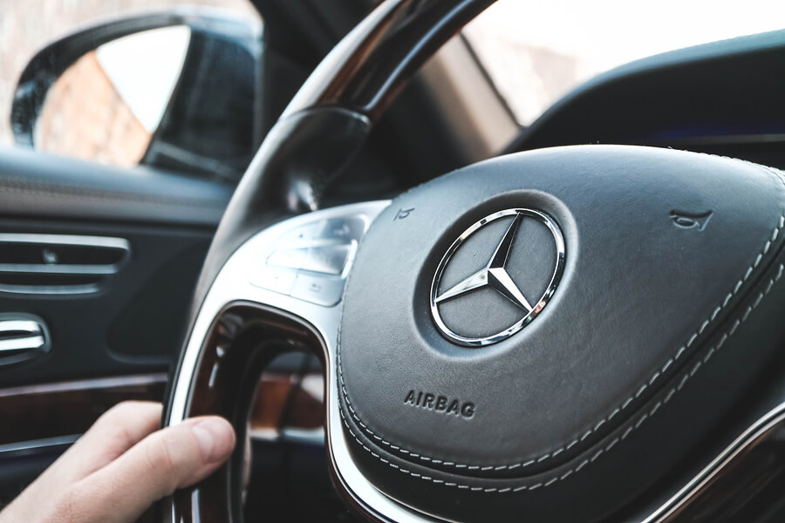
Mercedes-Benz strategically positions itself within the automobile market based on a few pillars: luxury and status, quality and reliability, innovation and technology.
The company capitalizes on its reputation as a luxury brand, reinforcing the idea of vehicle ownership as a status symbol in their marketing communications (Hollensen, 2015).
Mercedes-Benz is renowned for its superior build quality, smooth drive, and durability, which are integral to the brand's positioning strategy (Kotler, et al., 2018).
Mercedes-Benz is recognized for its innovative edge, regularly incorporating advanced features for safety, comfort, and performance into its vehicles. Their introduction of the EQ series further positions them as a forward-thinking, environmentally conscious brand (Daimler, 2021).
Advantages: Positioning aids in distinguishing a brand from its competitors, often serving as a crucial determinant in a customer's purchase decision (Porter, 1985). Mercedes Benz effective positioning is shaping customers perceptions, leading to greater brand equity. For the company, their positioning as a luxury and high-quality brand has contributed to their strong brand image.
Disadvantage: Once a brand's position has been cemented in the minds of consumers, repositioning becomes a challenging endeavour. For instance, should Mercedes-Benz attempt to appeal to a lower-income segment, altering customer perceptions would prove difficult (Aaker, 1991).

Our products

Mercedes-Benz offers a diverse array of products spanning luxury vehicles, buses, coaches, and trucks. The company's product portfolio encompasses several categories:
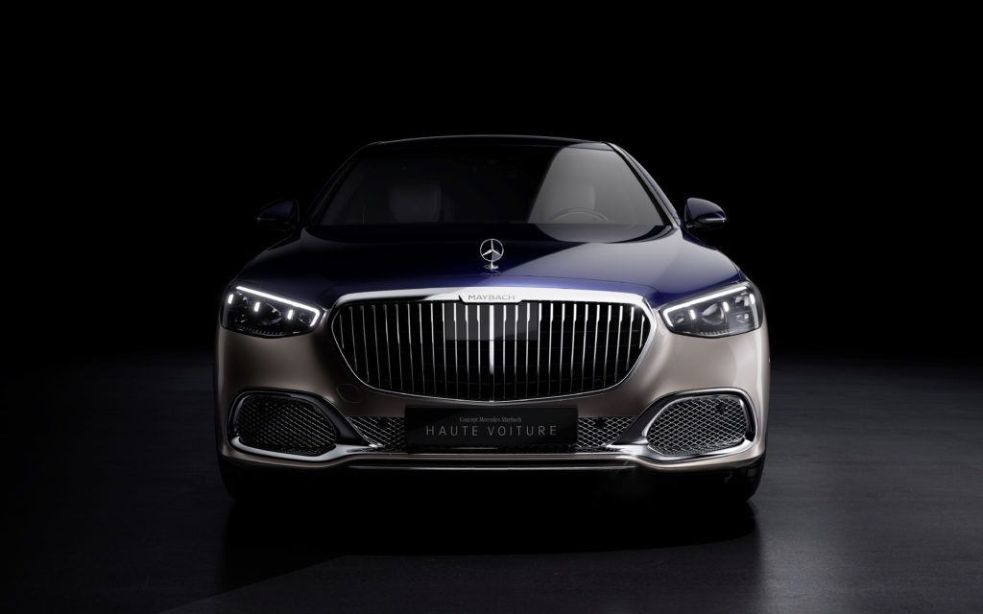
Passenger Cars:
Mercedes-Benz's passenger car offerings encompass a broad spectrum, including sedans, coupes, convertibles, and SUVs. These vehicles embody elegance, advanced technological features, and exceptional performance, epitomizing a luxurious driving experience.

Electric and Hybrid Vehicles:
Mercedes-Benz has made significant strides in the field of electric and hybrid vehicles. The company's EQ line emphasizes sustainable mobility, encompassing models like the EQC all-electric SUV and the EQS electric luxury sedan.
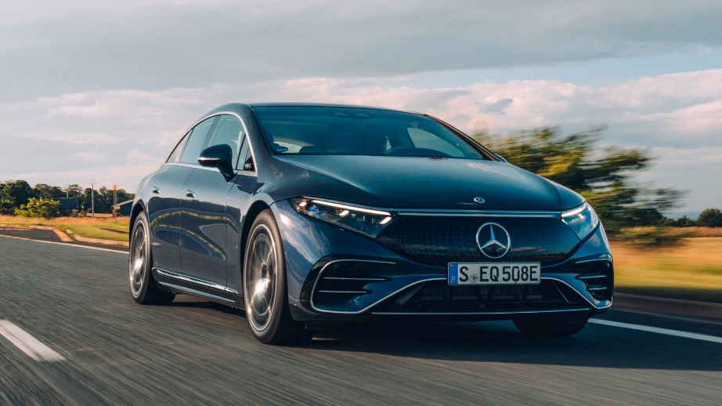
AMG Performance Vehicles:
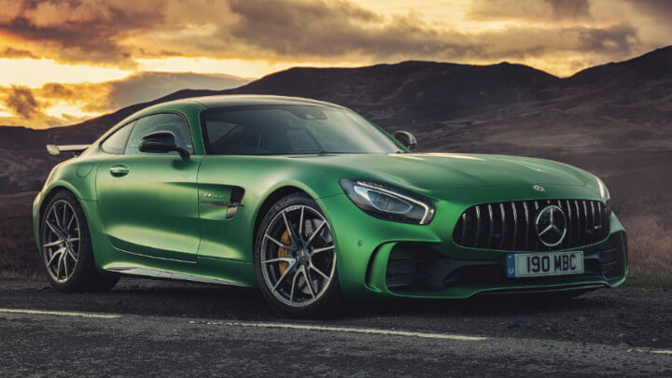
Mercedes-AMG, the high-performance division of Mercedes-Benz, specializes in producing a range of sporty and powerful vehicles under the AMG badge. These models undergo rigorous performance enhancements, featuring upgraded engines, sport-tuned suspensions, aerodynamic styling, and refined interiors.

Vans:
Mercedes-Benz boasts a lineup of vans catering to both commercial and private use. The range encompasses the Sprinter, a versatile large van suitable for diverse applications, and the Metris (also known as Vito in select markets), a mid-size van aimed at businesses with specific operational requirements. These vans are characterized by their robust build quality, spacious interiors, and advanced safety features.

Buses and Coaches:
Mercedes-Benz extends its product offerings to the realm of public transportation and tourism with its range of buses and coaches. The lineup includes city buses, intercity buses, and premium touring coaches. These vehicles prioritize passenger comfort, safety, and operational efficiency, integrating advanced technologies and environmentally conscious features.
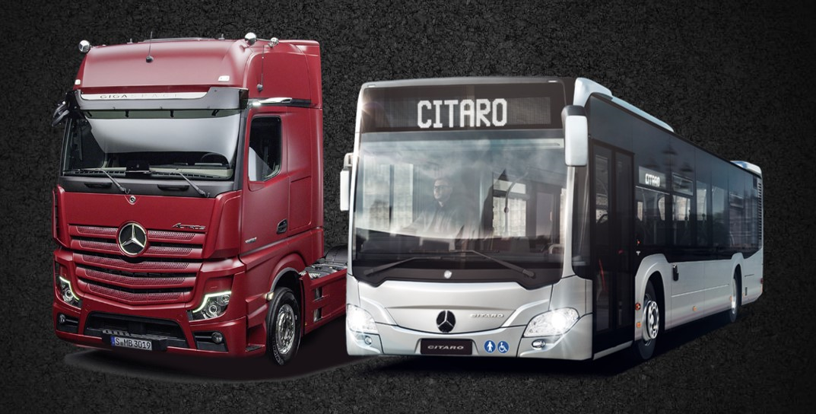
Trucks:
Mercedes-Benz is actively involved in the production of commercial trucks, catering to various sectors such as long-haul transportation, construction, and distribution. The company's truck lineup encompasses models such as the Actros, Arocs, and Econic, delivering reliable performance, innovative functionalities, and driver-centric designs.

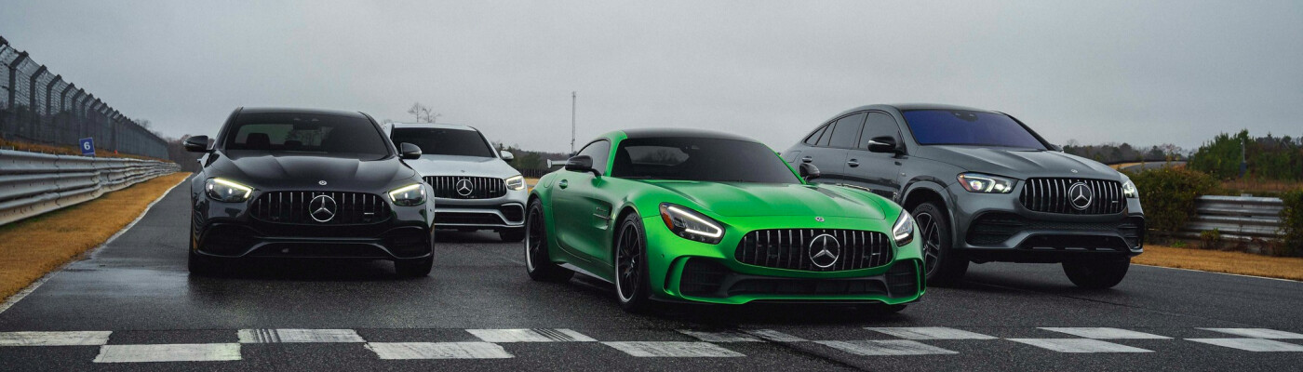
Pricing strategy

Mercedes-Benz is using a premium pricing strategy, projecting its product offerings as status symbol luxury vehicles. This elevated pricing approach serves two purposes: communicating the brand's positioning to potential consumers and justifying the incorporation of high-quality materials, exceptional engineering, state-of-the-art technology, and comprehensive safety features in their vehicles.
Within its premium pricing strategy, Mercedes-Benz also employs product line pricing. This means that there is a price range within its various model line-ups, starting from the entry-level luxury vehicles such as the A-Class(starting from £31,905), going up to the top-tier luxury models like the S-Class(starting from £103,880), and the high-performance AMG GT models(starting from £120,000)(Mercedes-Benz, 2023).
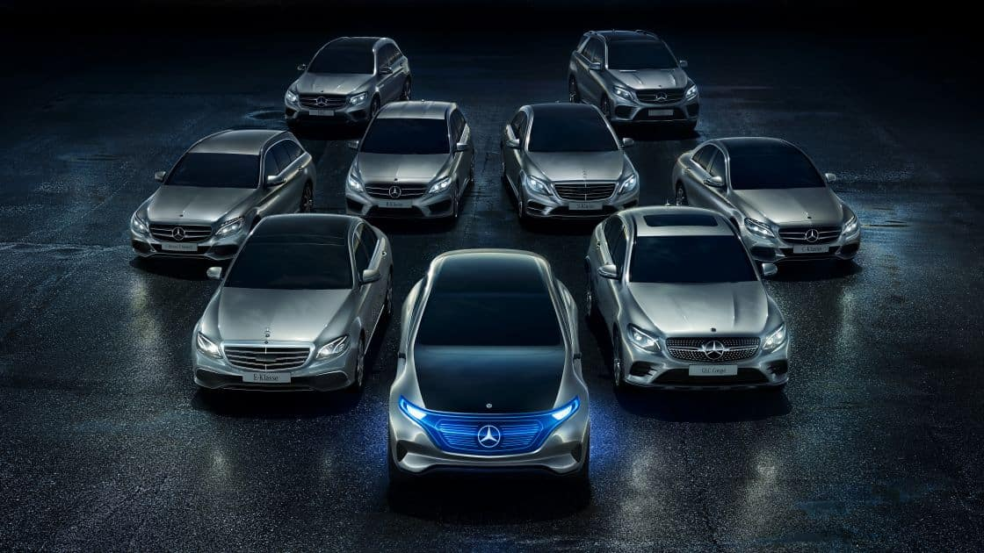
Mercedes-Benz also follows an optional product pricing strategy. This means customers can add optional features and services to their vehicle for an additional cost. These options can include various upgrades such as premium audio systems, advanced safety features, performance enhancements, and extended warranties or service packages.

Distribution

Mercedes-Benz's distribution strategy can be described as both direct and indirect, depending on the specific context:

Indirect Distribution: The majority of Mercedes-Benz sales occur through an indirect distribution channel, utilizing a network of independent franchised dealerships. These dealerships sell the vehicles to the final consumer. They also provide services such as maintenance and repair, parts sales, and customer service. Although the dealerships are closely affiliated with Mercedes-Benz and must meet the brand's rigorous standards, they are separate businesses.
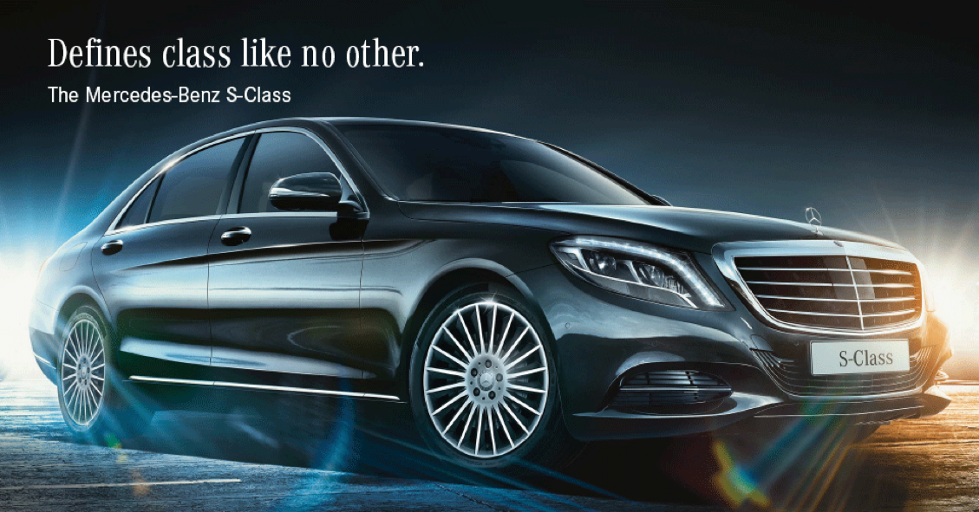
Direct Distribution: On the other hand, Mercedes-Benz does also employ some direct distribution methods. For example, their online sales platforms allow customers to order vehicles directly from the company. Similarly, the company sells to fleet customers, such as rental car companies or corporations, using direct sales. Also, some Mercedes-Benz owned retail outlets sell vehicles directly to consumers. However, these are less common than the indirect distribution through independent dealerships.

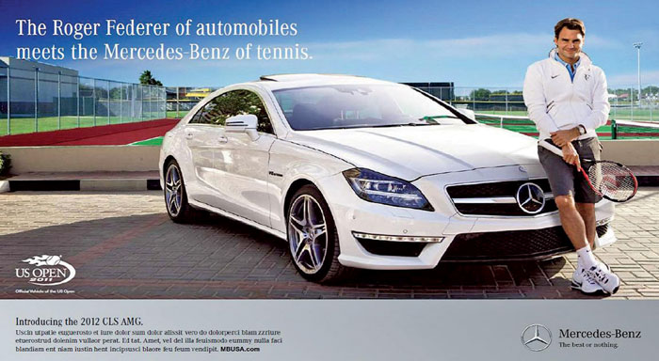
Promotion

The company employs a mix of traditional and digital marketing channels, with a strong emphasis on storytelling and emotional appeal. Here are some of the key elements of its promotional and advertising strategy:
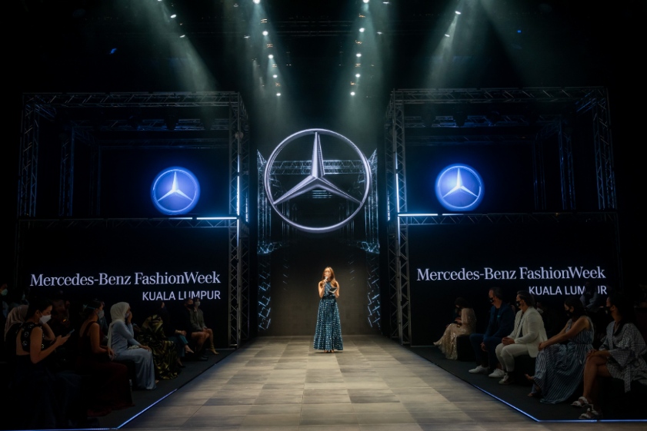
Television and Print Advertising: Mercedes-Benz has traditionally used television and print advertising to reach a broad audience. The company creates high-quality, emotionally driven advertisements that showcase the luxury, craftsmanship, and technological innovation of its vehicles. These ads often feature in premium magazines, newspapers, and during high-profile television events.
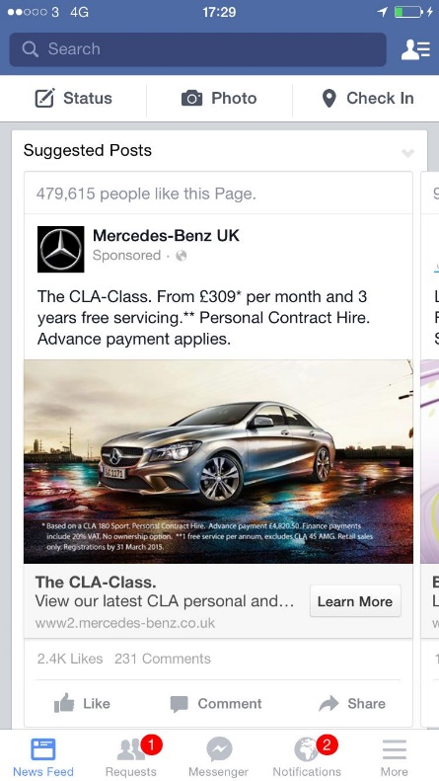
Digital Marketing: Mercedes-Benz has embraced digital marketing and social media to reach younger audiences and digitally savvy consumers. The company maintains a strong presence on platforms such as Instagram, Facebook, Twitter, and YouTube, where it shares product information, promotional content, brand stories, and interacts with its audience.
Sponsorship and Events: Mercedes-Benz sponsors a range of sports and cultural events that align with its brand image. This includes high-profile events such as Mercedes-Benz Fashion Week and various golf, tennis, and motorsport events. The company also holds its own events, such as new vehicle launches and customer experience events.
Sales Promotions: Mercedes-Benz uses sales promotions, such as special leasing or financing deals, to incentivize purchases. However, these promotions are typically more subtle and less frequent than in lower-end markets, in order to maintain the brand's premium image.
Public Relations: Mercedes-Benz uses public relations to manage its brand image and communicate with its stakeholders. This includes press releases, media events, and corporate social responsibility initiatives.

Contact us:

Facebook: https://www.facebook.com/MercedesBenz/
Instagram: https://instagram.com/mercedesbenz/
Twitter: https://twitter.com/mercedesbenz
LinkedIn: https://www.linkedin.com/company/mercedes-benz_ag
Youtube: https://www.youtube.com/user/MercedesBenzTV
TikTok: https://www.tiktok.com/@mercedesbenz

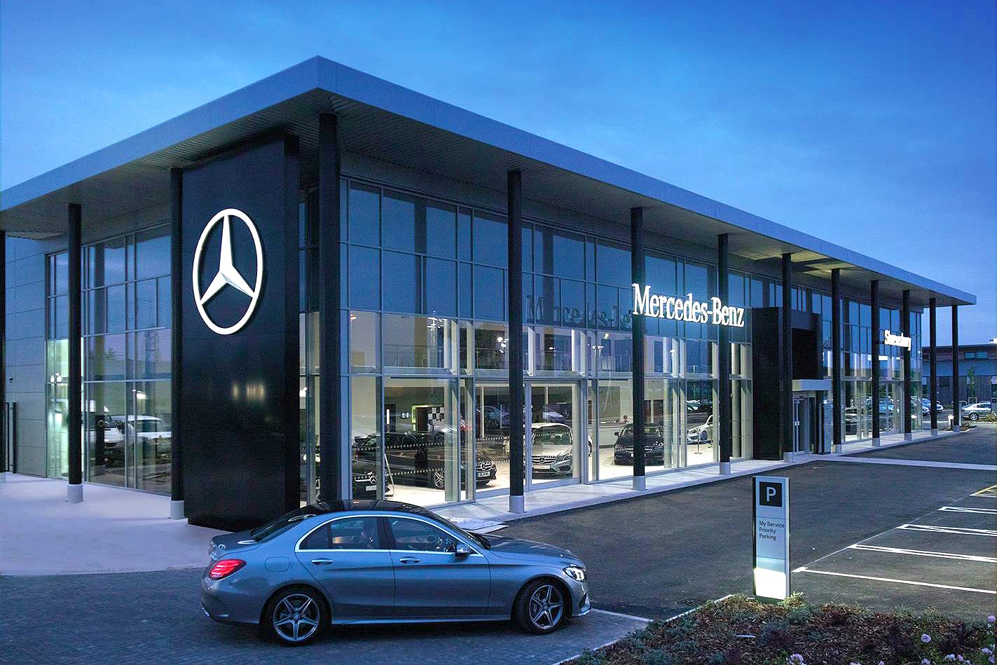

References

Aaker, D. (1991). Managing brand equity: capitalizing on the value of a brand name. New York: Free Press.

Daimler AG (2021). 'Mercedes-Benz Strategy Update'. Available at: https://www.daimler.com/ (Accessed: July 2023).

Dibb, S. and Simkin, L. (1991). Targeting, segments and positioning. International Journal of Retail & Distribution Management.

Eckermann, E., (2001). World History of the Automobile. SAE International.

Hollensen, S. (2015). Marketing Management: A Relationship Approach. 3rd edn. Harlow: Pearson Education.

Kotler, et. al. (2019). Marketing Management. 4th European edn. Harlow: Pearson Education.

Mercedes-Benz (2021). 'Mercedes-AMG: About Us'. Available at: https://www.mercedes-amg.com/en/world-of-amg/about-us.html (Accessed: July 2023).

Mercedes-Benz, (2023). Mercedes-Benz Passenger Cars. Mercedes-Benz UK. Available at: https://www.mercedes-benz.co.uk/passengercars/models.html?group=all&subgroup=see-all&view=BODYTYPE (Accessed: July 2023).

Mercedes-Benz Group AG (2020). Mercedes-Benz Strategy Update 2020 Presentation. Mercedes-Benz Group. Available at: https://group.mercedes-benz.com/dokumente/investoren/praesentationen/daimler-ir-mercedes-benz-strategy-update-2020-presentation.pdf (Accessed: July 2023).

Nieuwenhuis, P., and Wells, P., (2007). The Automotive Industry and the Environment: A Technical, Business and Social Future. Woodhead Publishing.

Porter, M. (1985). Competitive advantage: creating and sustaining superior performance. New York: Free Press.

Weinstein, A. (1987). Market segmentation: using demographics, psychographics and other niche marketing techniques to predict and model customer behavior. Chicago: Probus Pub Co.

