UWTSD
Designing and Building a Portable Pelicase Game
Group Project: ACDA5017
Authors  Louise Caygill (2110765)  Rhys Higgins (2110763) | Sam Lloyd (2110666)  Freya Vafadari (2112275)
10/07/2023
Word count:
Report: 5043
Presentation: 457
Total: 5500

Contents
Table of Figures 3
Introduction 4
Background Research 4
Research and Development Methodology 6
Microprocessor and Peripherals 6
Evaluating success 8
Design 9
Hardware and Enclosure 9
Modules 9
Implementation 12
Gantt chart 12
Hardware and Software 12
Simulating and Coding 12
Fabrication 12
Prototyping 14
Programming 16
Creating I2C Communication 17
Creating the GUI 19
Code Flowcharts 20
PCB Design and Creation 25
Difficulties 28
Results and Analysis 29
Testing: Project Team 29
Testing: Other Members of Staff 29
Evaluation 30
Conclusion and Recommendations 30
Reflections 30
Louise Caygill 30
Samuel Lloyd 31
Rhys Higgins 31
Freya Vafadari 31
References 32
Appendix A 34
Appendix B 35
Appendix C 36

Table of Figures
Figure 1: Example of Bomb in "Keep Talking and Nobody Explodes" [1] 3
Figure 2: Escape Room in a Box by Cameron Coward [23] 4
Figure 3: Penny Arcade Bomb Defusal Game [24] 4
Figure 4: PIC16F877A Pinout [6] 5
Figure 5: PIC16F84A Pinout [7] 6
Figure 6: I2C Bus configuration [25] 6
Figure 7: SPI Bus Config [25] 7
Figure 8: Proteus Simulation Layout for Binary Game 8
Figure 9: Proteus Simulation of Morse Code Module 9
Figure 10: Simulation of Safe Cracker Module 9
Figure 11: Proteus Simulation for Needy Button Game 10
Figure 12: Proteus Simulation for Wire Jumper Game 10
Figure 13: Gantt Chart for Project Management 11
Figure 14: Baseplate Design with Floating Faceplates 12
Figure 15: Rendering of Fully Assembled Baseplate 12
Figure 16: Breadboard Prototyping 13
Figure 17: Prototyping of Wire Jumper Game 13
Figure 18: State One of Decimal to Binary Game 14
Figure 19: Testing Incorrect Input for Decimal to Binary Game 14
Figure 20: Completed State of Decimal to Binary Module 15
Figure 21: Programming the Morse Code Module 15
Figure 22: I2C code for Main.c 16
Figure 23: I2C code for Main.h 16
Figure 24: RPi Running “i2cdetect -y 1” Command 17
Figure 25: Working Connection Between Boards and RPi 17
Figure 26: Image of Code to Send Data to PIC 18
Figure 27: Decimal to Binary Code Flowchart 19
Figure 28: Morse Code Software Flowchart 20
Figure 29: Safe Cracker Code Flowchart 21
Figure 30: Wire Jumper Code Flowchart 22
Figure 31: Needy Button Code Flowchart 23
Figure 32: KiCad Schematic for Wire Jumper Module 24
Figure 33: Image Showing the DRC Tool on the Wire Jumper Game 25
Figure 34: Populating the Wire Jumper PCB 26
Figure 35: Populating the Safe Cracker PCB 26
Figure 36: Populating the Decimal to Binary PCB 27
Figure 37: Questionnaire Handout 28

Introduction
This report details the design, creation and build of a modular “Disarm the Bomb” type game, by students Louise Caygill, Rhys Higgins, Sam Lloyd, and Freya Vafadari. The intention was to produce an attractive, engaging, and transportable system that can be taken to STEM (Science, Technology, Engineering, and Maths) events. Both to aid recruitment for DSTL and raise awareness and interest for the STEM industry.
The objectives are to achieve a base game unit, with swappable modular minigames, that once completed will output a digit of a pin number sequence linked to the base unit. Entering this pin number will then “disarm the bomb”, completing the game. These objectives will be achieved by proper planning, research, and design, leading to a finished product.
This report includes the initial research for the project, with included literature review, the design and later implementation, testing and results, with a final evaluation, conclusion, and future recommendations. Also included is a personal reflection from each team member on how they found the project.

Background Research
For this project, the customer (DSTL STEM co-ordinator) stated the requirement for something portable, engaging, and useful for different age groups. To start the project, research into STEM events was conducted and it was noted that having something interactive, and noticeable from a distance was the most engaging.
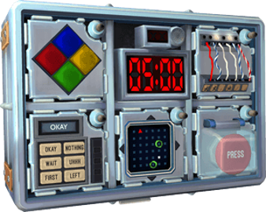
A concept that fitted the requirements from the customer was a ’disarm the bomb’ game. The assembly would fit inside a Peli case and would consist of minigames to disarm the bomb. However, this initial idea would mean that the games would be the same for all age ranges, making it unsuitable for some. It was decided that the minigames would need to be modular, with one central unit that would remain the same and which the modular minigames would connect to. Meaning they may be removed and swapped out for different minigames, the difficulty dependant on the makeup of the event audience. This would be simple to setup and close-down prior to and following the event, with only the Peli case game itself, and a peripheral smaller case for cabling.
Figure 1: Example of Bomb in "Keep Talking and Nobody Explodes" [1]
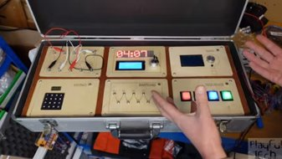
Variants of this game already exist, the most notable being “Keep Talking and Nobody Explodes”, released in 2015 for VR. The premise of this game is the player is talked through completing several minigames that will result in the disarming of the bomb [1].
Figure 2: Escape Room in a Box by Cameron Coward [23]

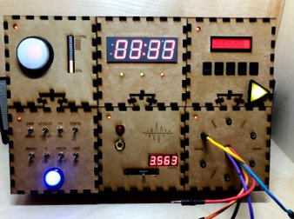
Another two examples are the “escape room in a box” by Cameron Coward seen below in Figure 2 and the “Bomb Defusal Penny Arcade Game” found on “loganrsweet” shown below in Figure 3, both were good inspiration for modular concepts.
Figure 3: Penny Arcade Bomb Defusal Game [24]
When presenting this concept to the customer, it was stated that they were interested, but raised that there should be some kind of draw to engage the audience from a distance. With this in mind, it was suggested that a large screen is connected to the box via HDMI. This screen would then display the status of the game and create interest from further afield. It would also be useful to connect to the RPi without having to remove the baseplate or modules to set up the game.
It was also stated that completion of the game may influence how an interview at DSTL is conducted. For example, if a player states that they played the game and then applied, the interviewer may decide to talk about their problem-solving skills and which module they enjoyed the most or found the most challenging. If they state that they found the binary module easiest, and struggled with the morse code module, then they may be more suited to a position in software or mathematics over dataset-based roles.

Research and Development Methodology
The project made use of the prototype methodology [2] [3]. The advantage of this methodology is the ability to create small module prototypes, which are assessed in simulations using Proteus. These simulations then inform component choice and the complexity of making each module. Additionally, by creating simulated prototypes, changes can be quickly implemented without having to manually remove hardware or components. The components selected through the simulations are trialled using breadboard, and, if successful, implemented into the final unit.
However, this methodology may increase the cost of the overall project, due to the purchase of materials for additional prototypes, if, for example, the breadboard prototype doesn’t behave in the same manner as the Proteus simulation. It also may increase the time spent on each module. In Proteus, the components are “ideal”. This means they are not subject to any degradation, manufacturer error, or outside interference. To work around this, multiple modules will be constructed at the same time, to allow ordering to be done in blocks, rather than many small purchases.

Microprocessor and Peripherals
It was decided to use the C programming language [4] for the embedded software as there was existing familiarity among the group, which would create consistency, and work within the short timescale.
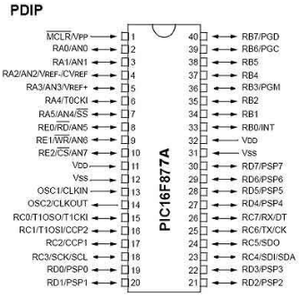
The PIC16F877A [5] was chosen as the microcontroller in each of the game modules over other PICs like the PIC16F84A, for various reasons. The PIC16F877A PDIP-type has a total of 40 pins including 33 pins for I/O (input and output) peripherals with the remaining pins utilised for MCLR (Master Clear Pin of the IC), two VDD pins (primary power pins), two VCC pins (GROUND pins), CLKIN (external clock interface input) and CLKOUT (external clock interface output). The PIC16F877A has a maximum operating voltage of 5V, a maximum operating clock input speed of 20MHz, and an instruction cycle of 200ns [6].
Figure 4: PIC16F877A Pinout [6]
Additionally, it has 7 analogue pins that function as analogue inputs on PORTA, the remaining 33 I/O pins are bidirectional. One disadvantage of the PIC16F877A is that it has no internal oscillator, requiring an external oscillator [6]. Figure 4 above shows the PIC16F877A pinout.
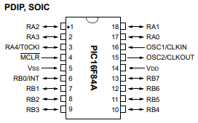
In comparison the PIC16F84A PDIP type has a total of 18 pins, including 13 pins for I/O peripherals with the remaining pins utilised for MCLR, 1 VDD pin, 1 VSS pin, CLKIN and CLKOUT [7]. Figure 5 below shows the PIC16F84A pin out diagram.
Figure 5: PIC16F84A Pinout [7]
One advantage of the PIC16F84A is that it has a USART module which consists of a TX pin for transmitting serial data and an RX receive pin for receiving serial data. The PIC16F84A has 1 8-bit timer that can function as a timer or a counter and has internal and external clock select capability. One disadvantage of the PIC16F84A is that it only has USART and no I2C or SPI [7].
The PIC16F877A has 368 bytes of RAM compared to the 68 of the PIC16F84A. This greater RAM means the processing speed of the PIC is faster and memory transfers information between data and memory data registers at a greater speed. One advantage the PIC16F877A has over the PIC16F84A is that it supports several communication protocols including synchronous serial port (SSP) with SPI (Master mode) and I2C (Master/Slave) and Universal Synchronous Asynchronous Receiver Transmitter (USART/SCI) with 9-bit addressing. Whilst the PIC16F84A only supports USART/SCI communication. The PIC16F84A has one 8-bit timer in comparison to the three timers including two 8-bit and one 16-bit timer of the PIC16F877A [6] [7].
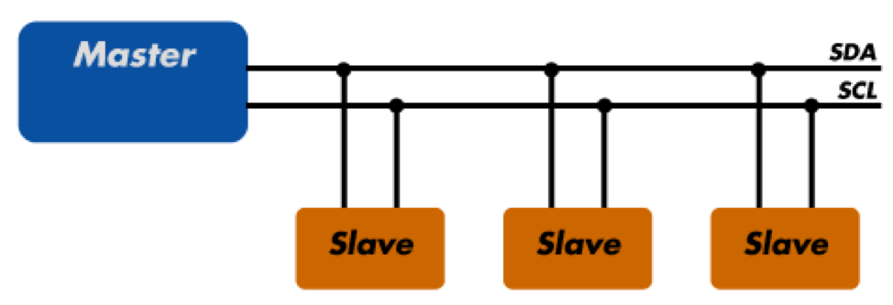
The main control module makes use of a Raspberry Pi 3B+ [8], henceforth referred to as RPi. The decision to use the 3B+, over other alternatives like the Arduino Mega 2560 was informed through the fact that the Raspberry Pi 3B+ has 40 GPIO pins [9]. Additionally, it has an HDMI-out to connect to an external monitor, so the audience can see the players’ progress on screen. Alongside this, RPi’s are well documented and can be programmed from the Linux desktop environment. The group all had previous experience using RPi’s, meaning learning a new system would not have to be factored into the timeline of the project. Finally, RPi’s and PICs both require 5V [6] [7] [9], allowing a single power supply to be used.
Figure 6: I2C Bus configuration [25]
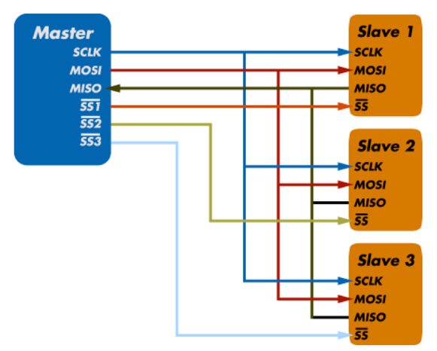
The five PIC modules are controlled by a RPi central module; therefore, a means of master-to-peripheral communication was required. It was decided to use i2c, instead of alternatives (like SPI), due to the simplicity of setup - only requiring two signal lines (as seen in Figure 6) compared 4+ 1 SS, for each slave with SPI (seen in Figure 7). Also, this has the benefit of easier integration of future games into the system, as only a new address is required to add more devices [10].
Figure 7: SPI Bus Config [25]

Evaluating success
Evaluating the success of this project will be outcome based, [3]. Firstly, the system should work as intended, and the customer satisfied. Additionally, it should be able to be taken to a STEM event, meaning it should be easily transportable, and able to be assembled quickly on location. The main purpose of the unit is to attract attention, potentially leading to increased interest in recruitment at DSTL. Were the product to bring in a single new member of staff, it would be considered a remarkable success to the company.

Design
As a group, it was discussed what the modules would do and what the outcome of each game would be. This ensured there was a uniform approach, and that completing each module would work towards a single goal. The workload was then split between team members, each designing at least one module. Once these modules were designed and simulated, a parts list was able to be created. These were then collated into a master parts list to be ordered once funding was acquired.

Hardware and Enclosure
To remain portable, and yet be of a size where each module would have enough space, it was decided to use a Peli case im2300. Chosen due to their ruggedness and tough design, being IP67-rated, and therefore ability to be transported to events with minimal risk of damage during handling [11].
Initially, it was suggested to use project boxes for each of the minigames. However, this would create an incoherent product, and wouldn’t be as aesthetically appealing. Instead, it was decided to create a baseplate for the Peli case and have sections for the modules to slot into and hang beneath.

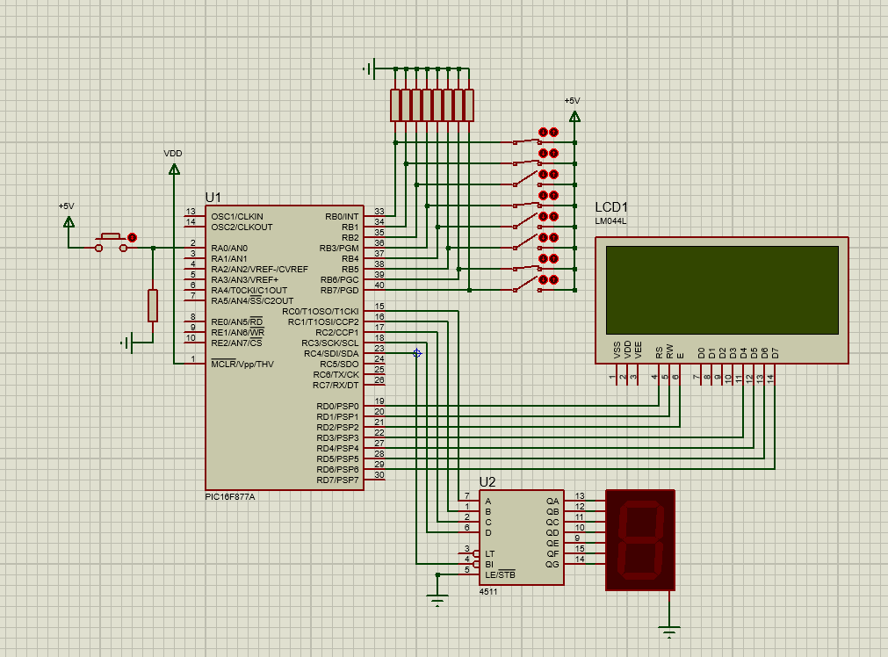
Modules
Figure 8: Proteus Simulation Layout for Binary Game
Each mini game module upon completion produces a digit of a pin number, which when correctly entered on the main module will disarm the bomb.
For module 1, the Decimal to Binary module the aim is to translate a random decimal number into binary using switches. As shown in Figure 8 above.
Module 2 is a Morse Code module where the user translates a generated Morse sequence into a pin number that is entered into the module keypad, shown below in Figure 9. It was decided to use LEDs to flash the morse code as it is likely to be loud at events the unit is taken to, meaning that the user may struggle to hear a small speaker/buzzer.
Module 3, the Safe Cracker, uses a potentiometer to find a randomly generated value, the LEDs indicating if the user is close to the correct value. As shown in Figure 10.

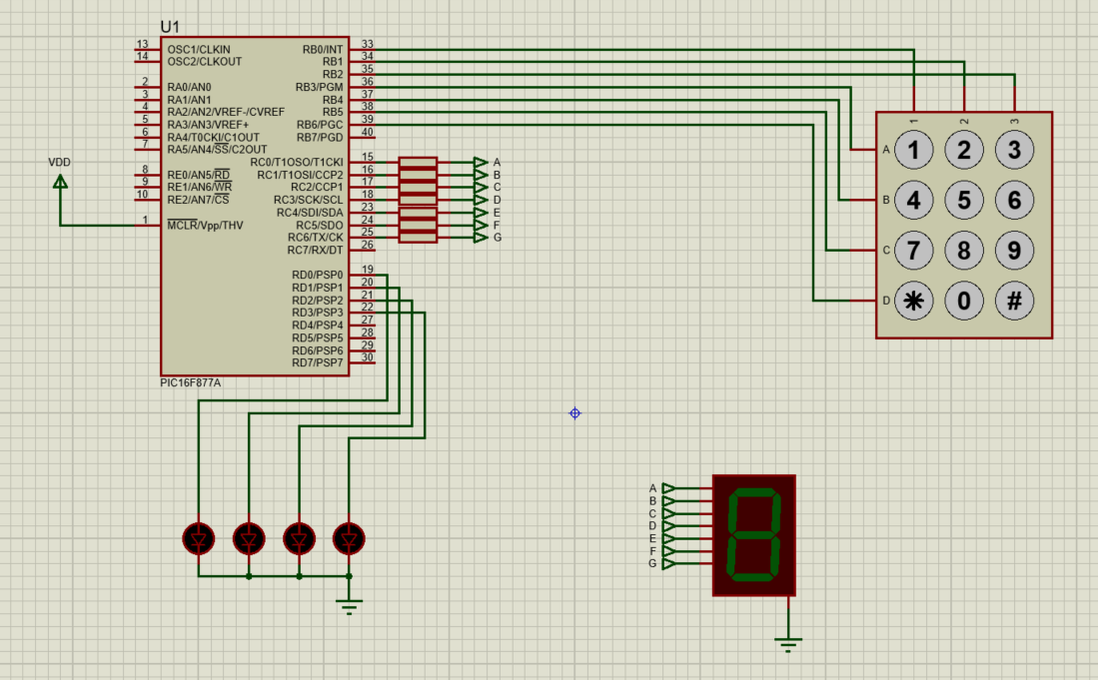
Figure 9: Proteus Simulation of Morse Code Module
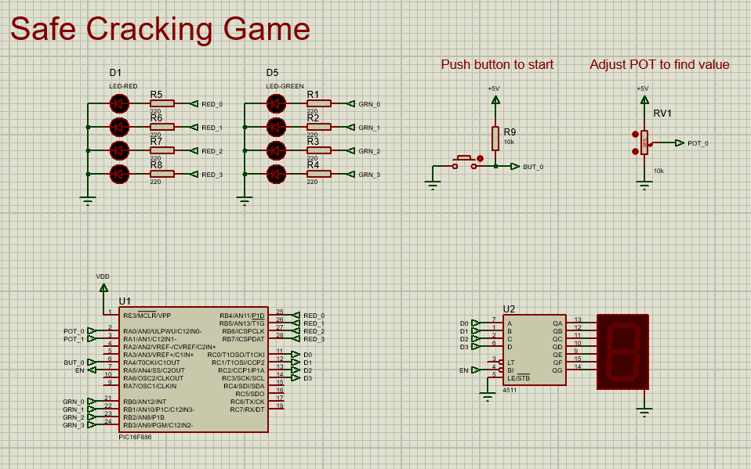
Figure 10: Simulation of Safe Cracker Module
Module 4 is a visual wire connection game where the correct order is given in the manual through a series of sentences where the user must pick the right ones.

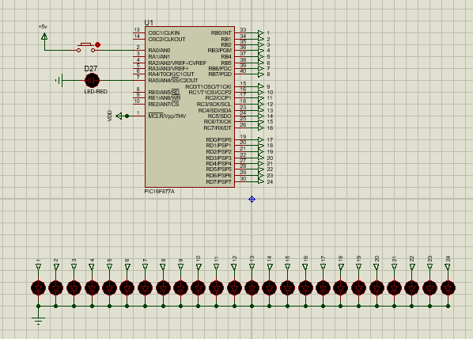
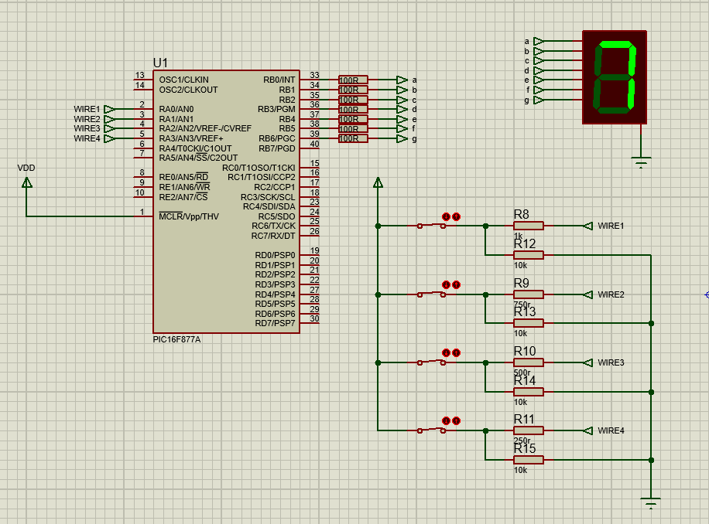
Additional to the mini game modules, the Needy Button is a duty module that needs to be maintained regularly within a defined time period to progress. If it is not reset in time, the entire game is over.
Figure 11: Proteus Simulation for Needy Button Game
Figure 12: Proteus Simulation for Wire Jumper Game

Implementation

Gantt chart
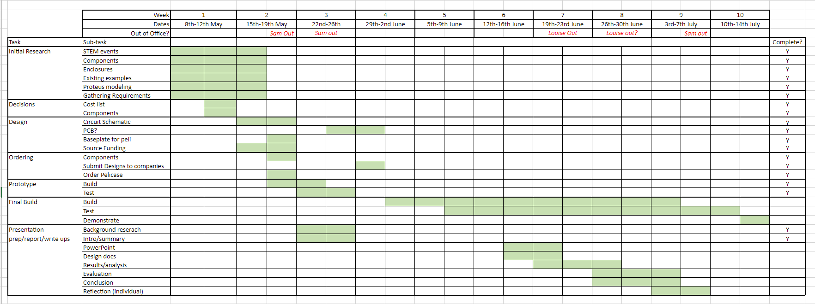
At the start of the project a Gantt chart [12] was created to keep track of the build, and to distribute work evenly throughout the available timescale. Ordinarily there would be contingency days built into the chart. However, due to the short timescale allowed for this project, it wasn’t possible to build in much contingency time. Instead, more time was given to the physical build and implementation, as that would be the most technically difficult and time-consuming.
Figure 13: Gantt Chart for Project Management

Hardware and Software
For this project, work-supplied laptops were used to simulate the circuits and run the required software, plus writing the report at the end. To programme the PICs a PICKit 4 was used [13].
The software, however, is a bit more specialised. To simulate the circuits virtually Proteus 8 will be used; Microsoft Visio [14] to create flowcharts of the code, KiCAD to design the PCBs for manufacture, MPLAB X in conjunction with the PICKit programmer, and SolidWorks to design the Base and Faceplate.

Simulating and Coding
Proteus was used as it was easily accessible by each group member, suitable for purpose, and familiar. Alongside Proteus, the CCS compiler for PIC [15] was used to create the foundation main.c and main.h files, which were imported into Proteus.
Upon receipt of the order, the components were checked for their suitability. Here it was discovered that some components, whilst physically fine and working, were unsuitable for use in their respective module. An example being the potentiometers for the safe cracker module. On the website they met all the criteria needed, but on receipt, it was discovered that they only do one turn, and were therefore unsuitable This meant that a new potentiometer, which had multiple turns, needed to be sourced. Fortunately, a suitable potentiometer was found and upon receipt was suitable for purpose.

Fabrication
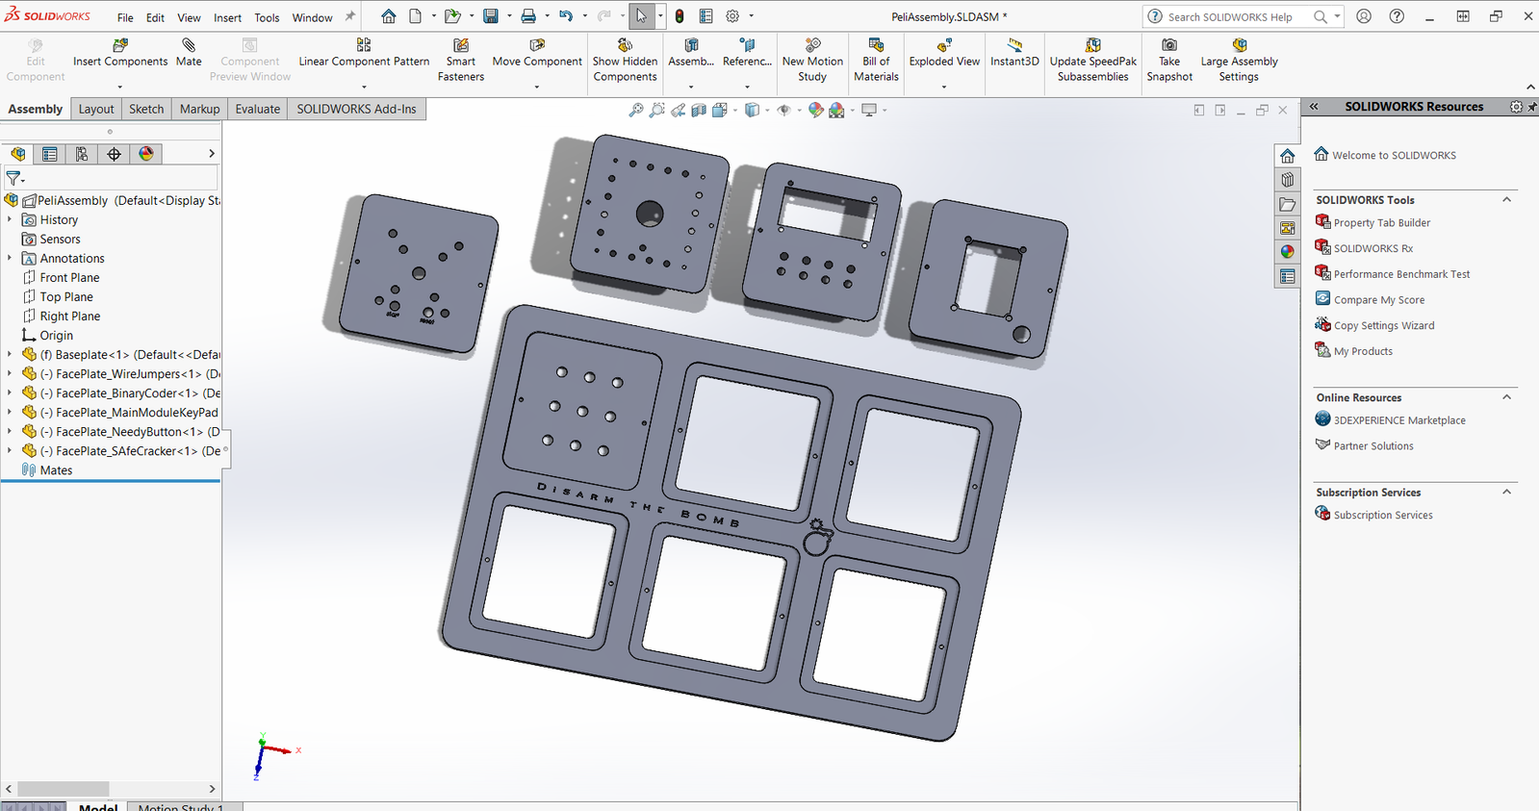
Whilst the components were on order the design for the base and module face plates was made. For this, the design software SolidWorks was used. This software was chosen as it can produce multiple different file type outputs of a design [16]. Additionally, there was a degree of familiarity with SolidWorks which would work with the short timeline.
Figure 14: Baseplate Design with Floating Faceplates

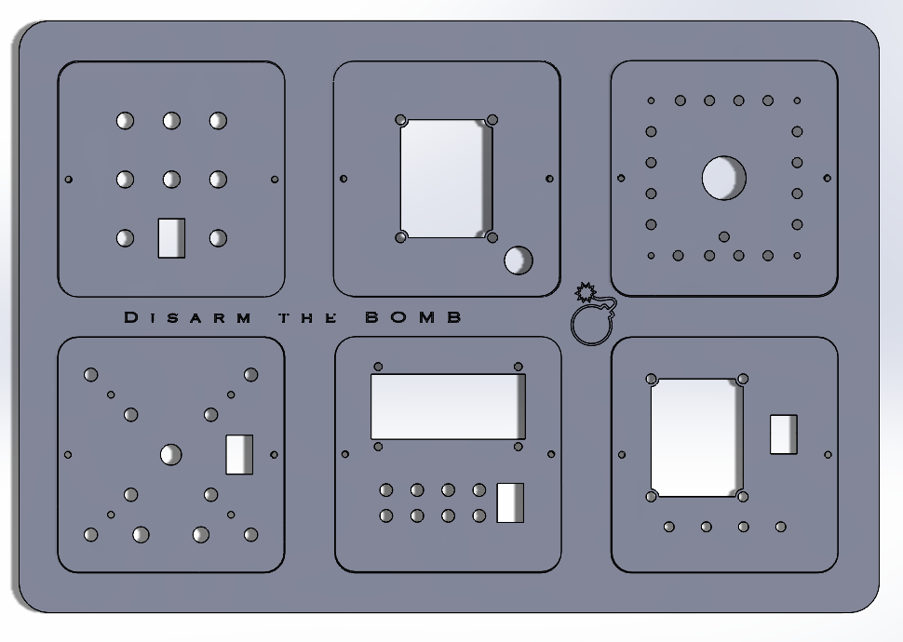
Unfortunately, after having the materials for two weeks, engineering stated that they would be unable to meet the timescale originally agreed upon. At this point it would be difficult to find another manufacturer who would be able to meet the deadline. It was decided instead to use the 3D printer that was available in the lab. The printer had issues with printing the first faceplate, which turned out to be an issue with the bed-levelling of the printer. After levelling the printer again, the issue remained unresolved, so the CAD files were checked, and the settings changed. The faceplates were then able to be printed, with just the baseplate needing to be sent out for manufacture in the future as this could be done in slightly slower time.
Figure 15: Rendering of Fully Assembled Baseplate

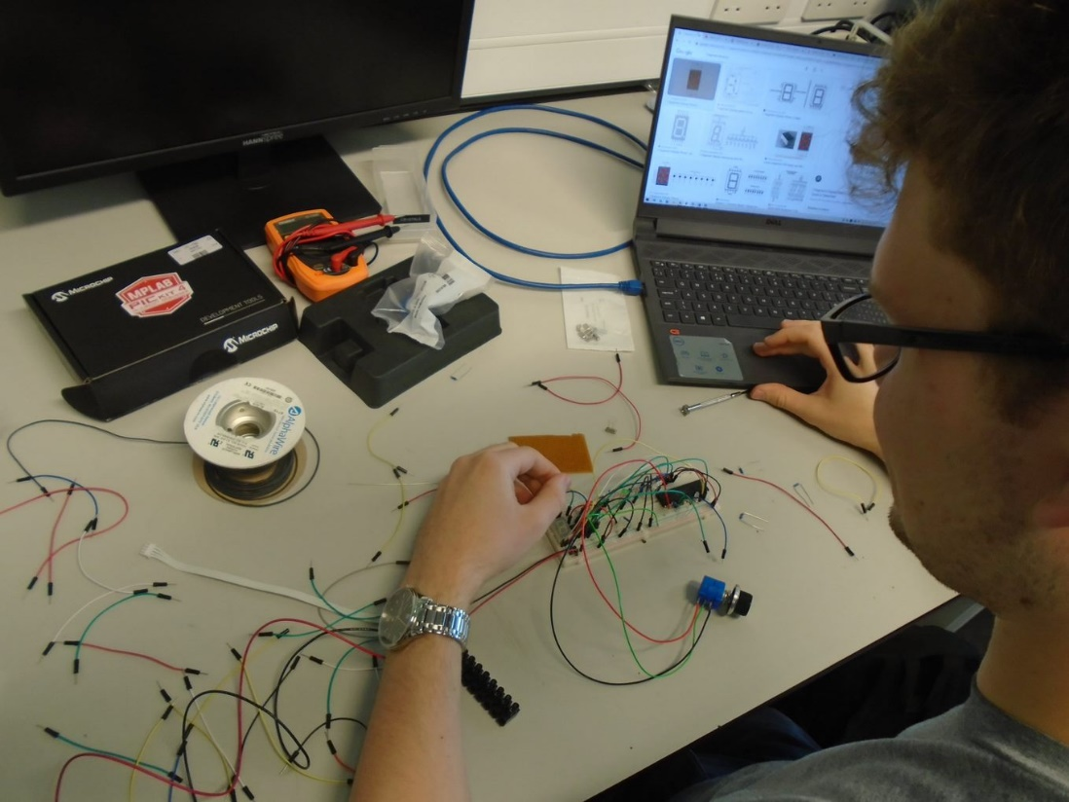
Prototyping
Figure 16: Breadboard Prototyping
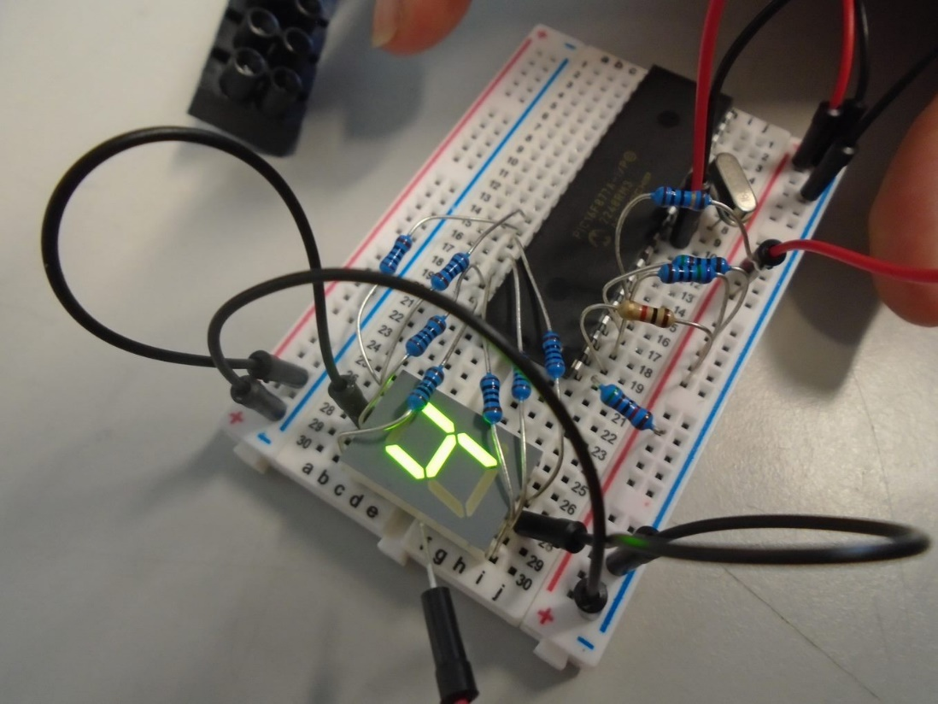
Breadboard prototypes were used to test Proteus circuit with the purchased components, as it was necessary to be able to frequently change connections to programme the PIC and add/remove components, meaning solderable board, like Veroboard, would be unsuitable. An example of prototyping can be seen below in Figure 18, Figure 19, and Figure 20 using the Decimal to Binary Game.
Figure 17: Prototyping of Wire Jumper Game
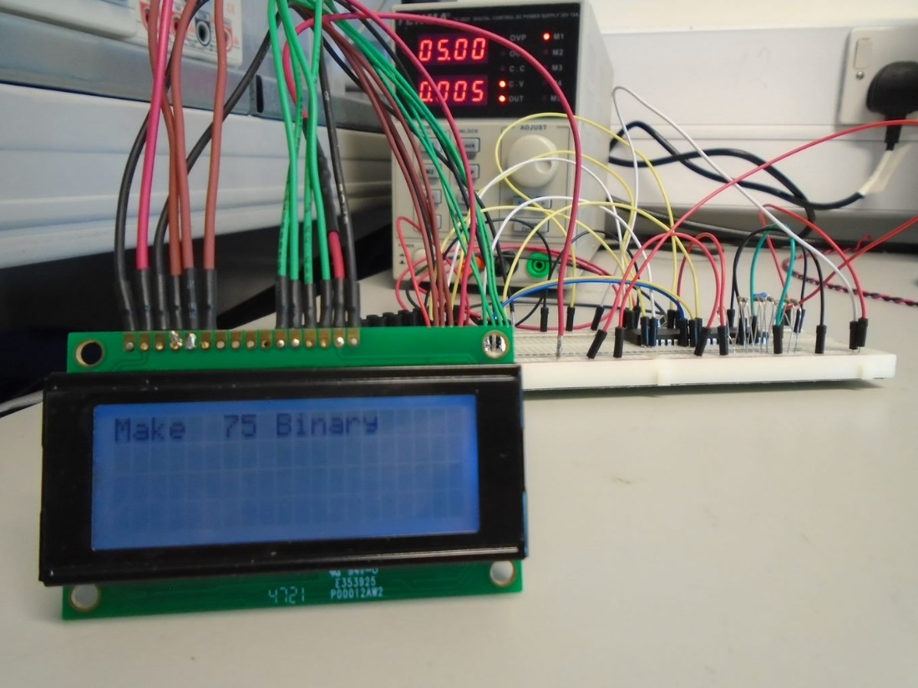
Figure 18: State One of Decimal to Binary Game
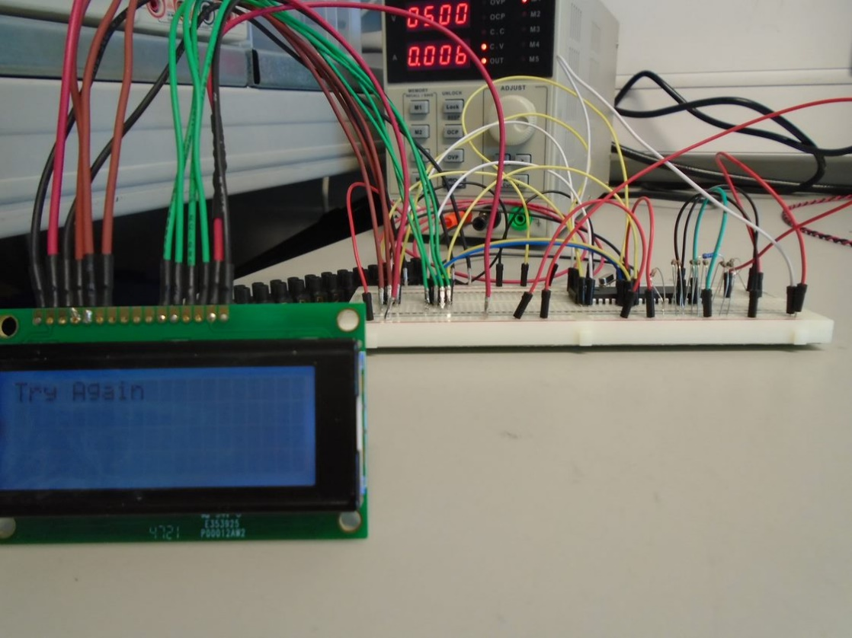
Figure 19: Testing Incorrect Input for Decimal to Binary Game
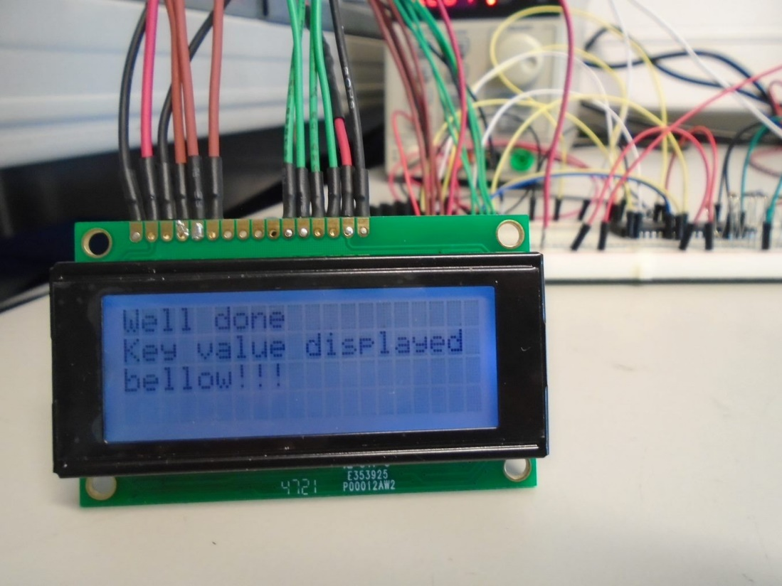
Figure 20: Completed State of Decimal to Binary Module

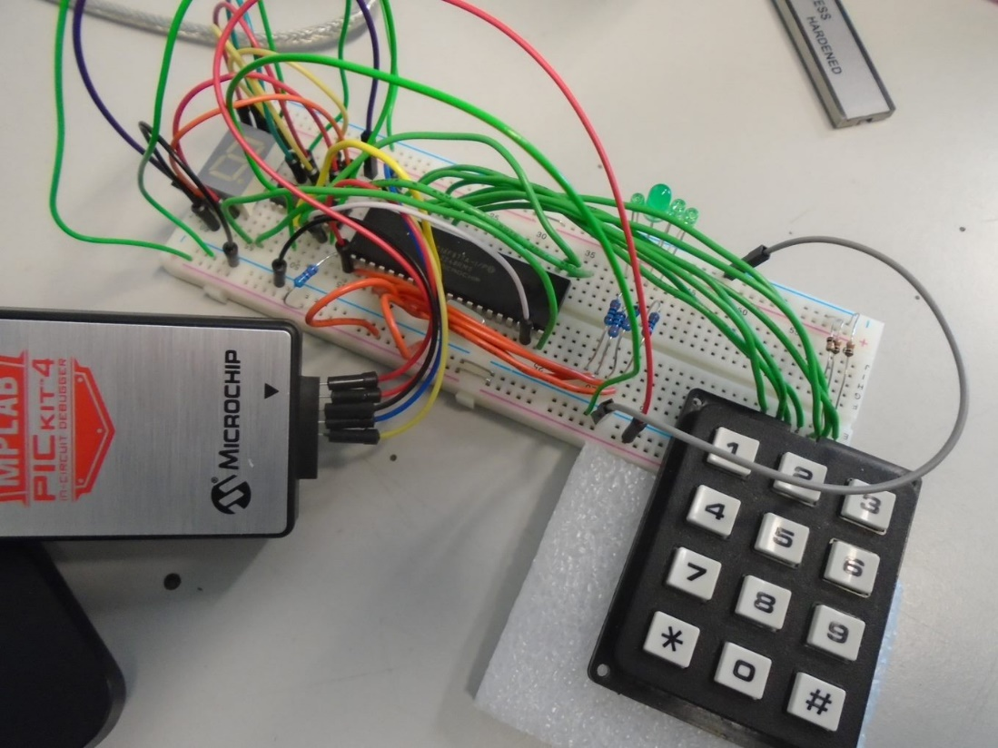
Programming
Figure 21: Programming the Morse Code Module
To program the PICs during prototyping, the toolchain MPLAB X IDE was used, with the CCS C Compiler plugin enabled, in conjunction a PICkit 4 circuit debugger. The biggest factor behind the tool selection was that the PICKit was initially able to be borrowed from another lab user, providing a head-start. Another advantage of the PICKit is that it only has a 5-pin connection to the PIC, allowing easy integration into a breadboard prototype. Finally, the PICKit can supply 50mA of current [13], allowing circuits requiring less than 50mA to be powered during and post-programming, nixing the need for an additional external power source, allowing for rapid debugging and a simpler bench setup.

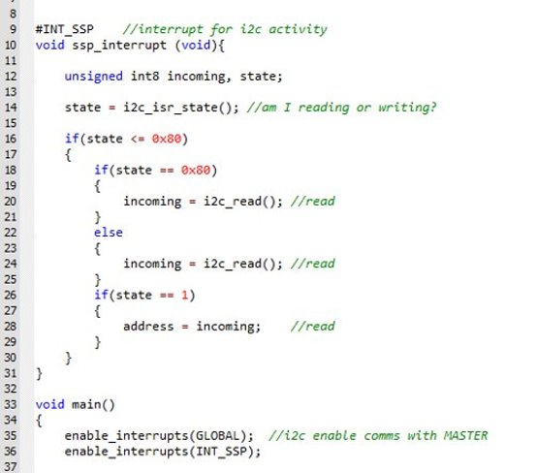
Creating I2C Communication
Figure 22: I2C code for Main.c
Firstly, to use the RPi i2c bus, it had to be enabled using the raspi-config menu. Following this, the “bcm2835” library was installed, enabling use of the i2c bus via C code [17]. In this setup, the Pi would function as i2c master, with the PICs as i2c peripherals. The PICs were re-programmed and assigned the 7-bit hexadecimal addresses 0x20 and 0x40, with an i2c interrupt added to the C source file - seen in Figure 22 and Figure 23.
Next, the command “i2cdetect -y 1”, seen in Figure 24, was issued in the Pi’s terminal, the 1 being the i2c channel of the Pi, it’s purpose being to scan the i2c bus for connected devices [18]. To begin with, it did not work, with the PIC peripheral devices not detected. However, after adding 4K7Ω pull-ups to the SDA and SCL pins of the i2c bus, the circuit worked as expected, as shown in Figure 25.
Figure 23: I2C code for Main.h

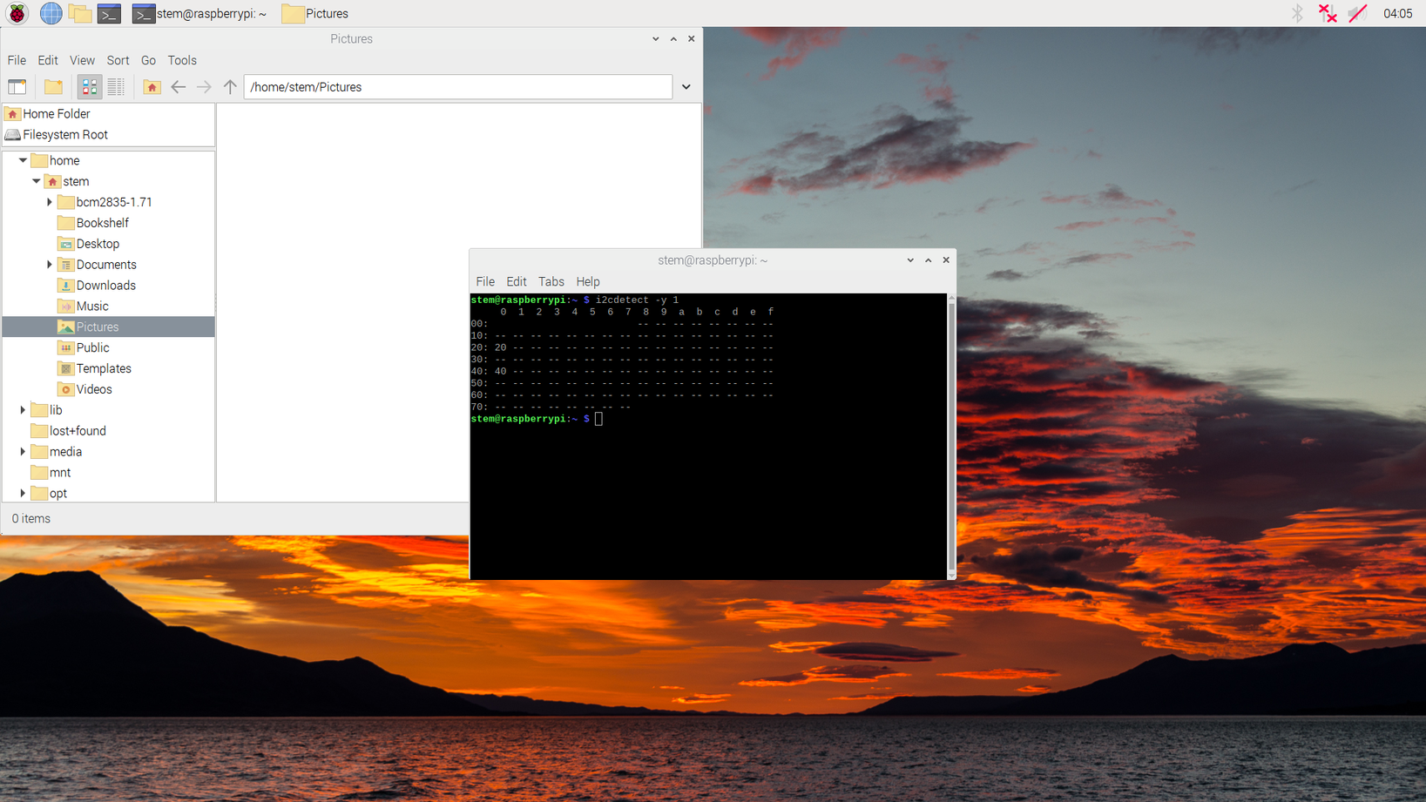
Then a simple program was developed on the Pi, using the BCM2835 library, its purpose to send an integer, via i2c, to the connected PICs.
Figure 24: RPi Running “i2cdetect -y 1” Command
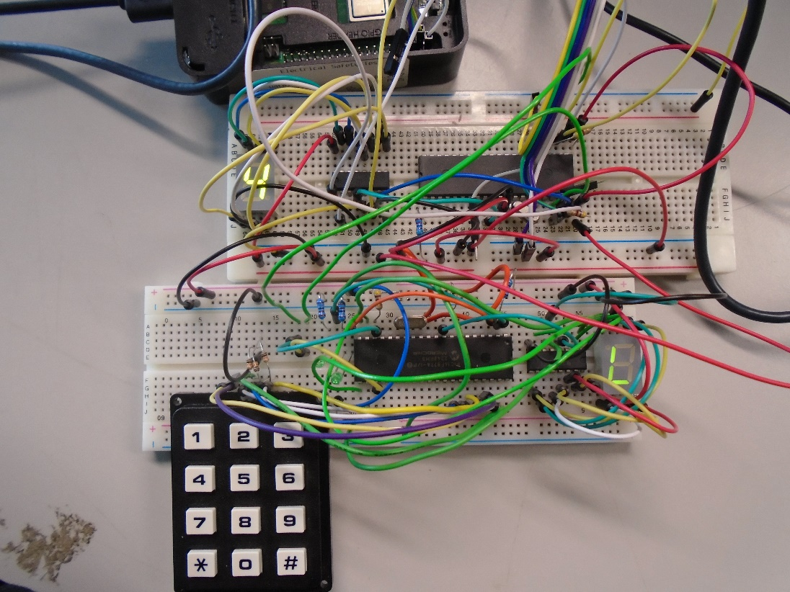
Once the PIC slave circuits were seen to receive the integers from the Pi, seen in Figure 22, it was decided that this could be finalised once all circuits were constructed on PCBs, due to the inherent instability of breadboard [19].
Figure 25: Working Connection Between Boards and RPi

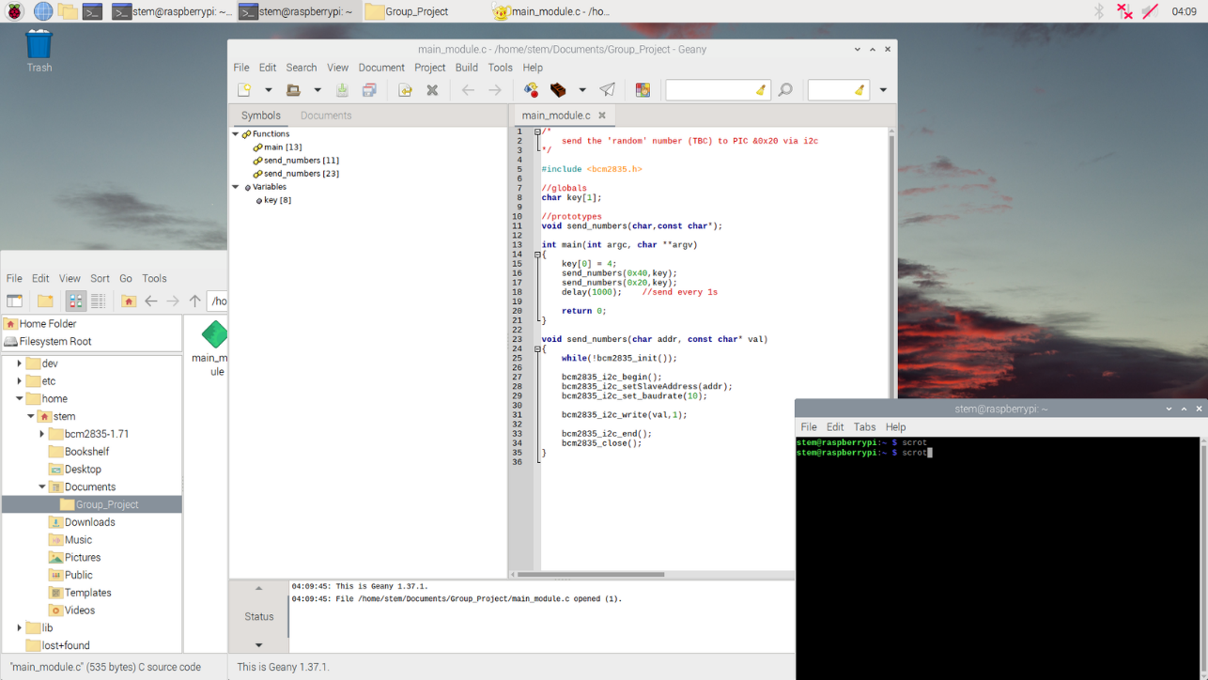
Figure 26: Image of Code to Send Data to PIC

Creating the GUI
Creating the GUI was done using GTK3 (Gnome Tool Kit 3) [20], this was added to the existing code for the I2C connection. The initial purpose was to open a window, with the addition of a GTK widget to the GTK container (window) which displayed a countdown.
Unfortunately, the full GUI implementation of wasn’t possible within the period given. Therefore, it will be completed in the future.

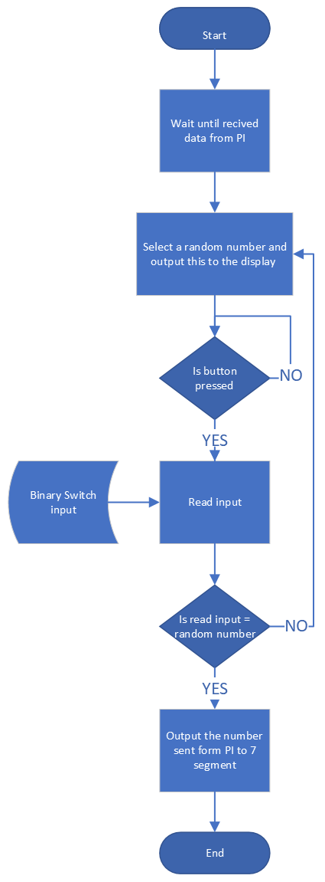
Code Flowcharts
Figure 27: Decimal to Binary Code Flowchart

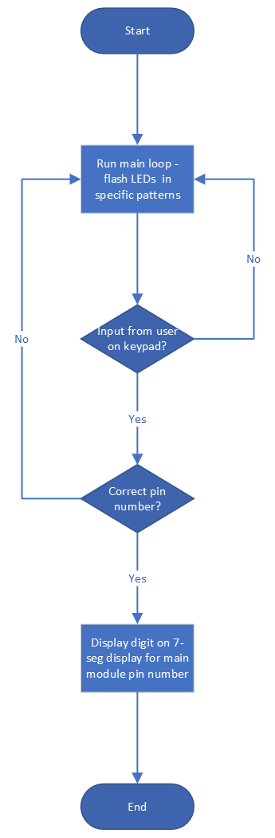
Figure 28: Morse Code Software Flowchart
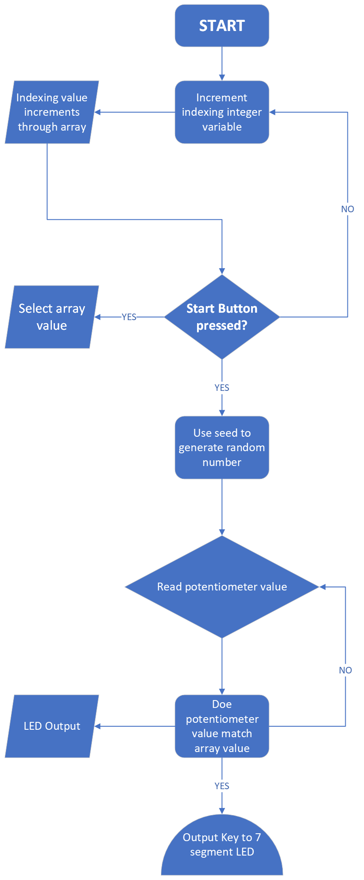
Figure 29: Safe Cracker Code Flowchart
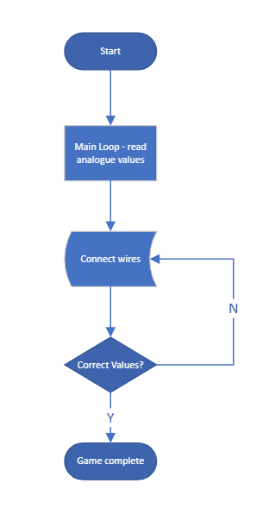
Figure 30: Wire Jumper Code Flowchart
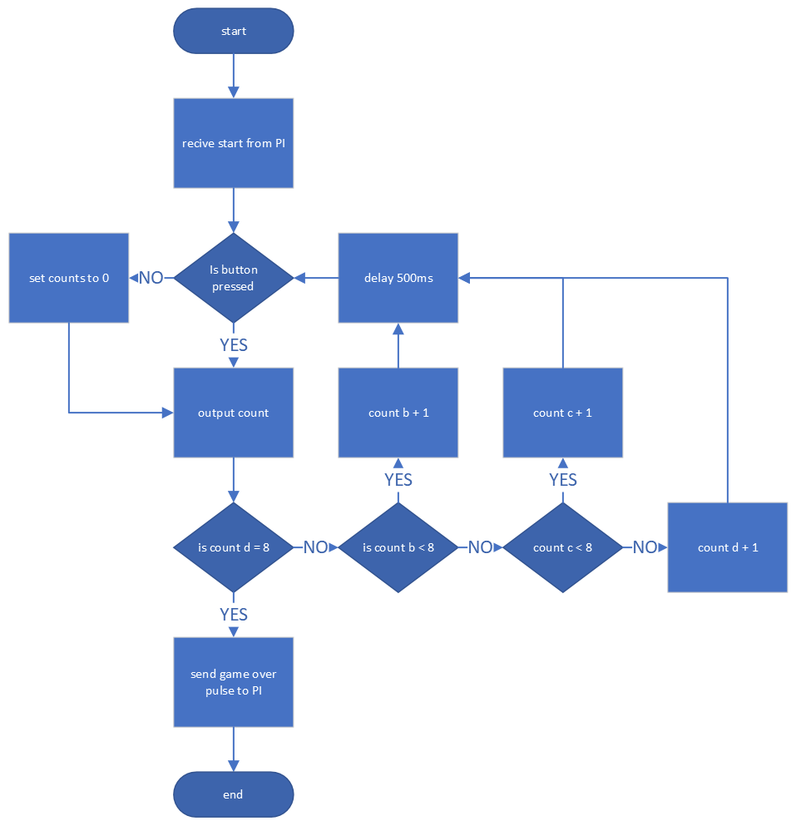
Figure 31: Needy Button Code Flowchart

PCB Design and Creation
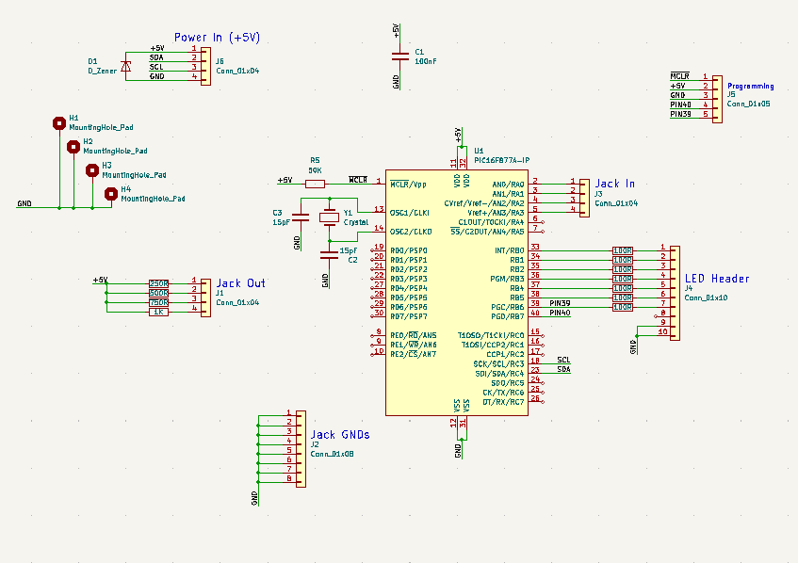
It was decided to use PCBs (Printed Circuit Boards) as it would increase the robustness, reduce the size of the board, plus give a more professional appearance to the final product [21]. These PCBs would use through hole components rather than surface mount to populate the boards. Whilst this would increase the size of the boards, this would allow the boards to be more easily populated and modified, if necessary [22]. Additionally, there was a ready supply of through-hole components that were able to be used for the build.
Figure 32: KiCad Schematic for Wire Jumper Module
To achieve consistency across the boards and to reduce the chance of a cable being connected incorrectly, it was decided to use a four-pin connector for power and I2C. The final layout of these pins was: 1 – +5V, 2 – SDA (Serial Data), 3 – SCL (Serial Clock) and 4 – Ground. This arrangement was printed on the silkscreen, as seen at the base of Figure 33 overleaf.
To design the PCBs the KiCAD software package was used. This is a free to download piece of design software that can create all steps of a PCB [23]. To start with, the circuits simulated in Proteus were drawn in the schematic editor of KiCAD. As the components had already been identified from the Proteus simulations the required footprints were known and were able to be added to the schematic footprints. After this, the PCB editor tool is used and the details from the schematic imported. This imports all footprints from the schematic into the PCB tool so that it can be laid out. The boards needed to be able to fit through the gap in the baseplate, meaning that there was a set amount of space that available for the boards. The final step in designing the PCBs was to run a design rule check (DRC) on the layout. This tool is used to make sure that there are no issues with the design that have been missed, such as unconnected nets, or overlapping components. Due to the simplicity of the boards, the majority passed through the DRC first time.
Once the DRC was complete, the fabrication files were able to be produced for the boards to be made.
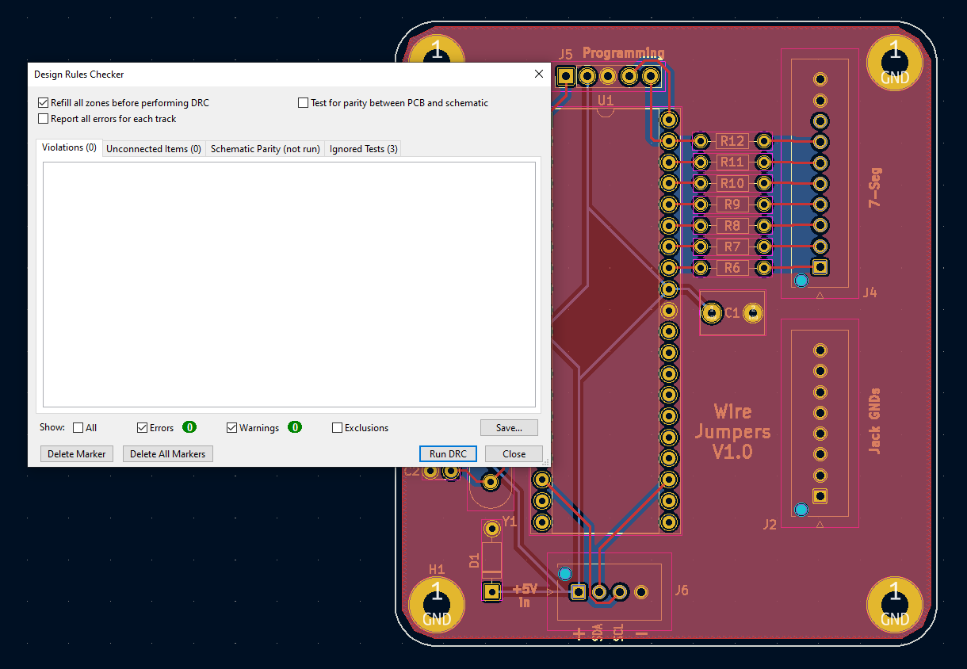
Figure 33: Image Showing the DRC Tool on the Wire Jumper Game

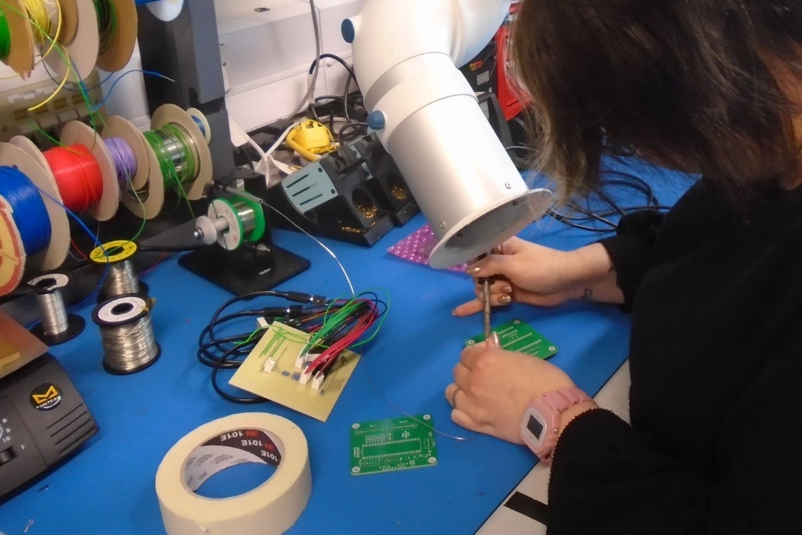
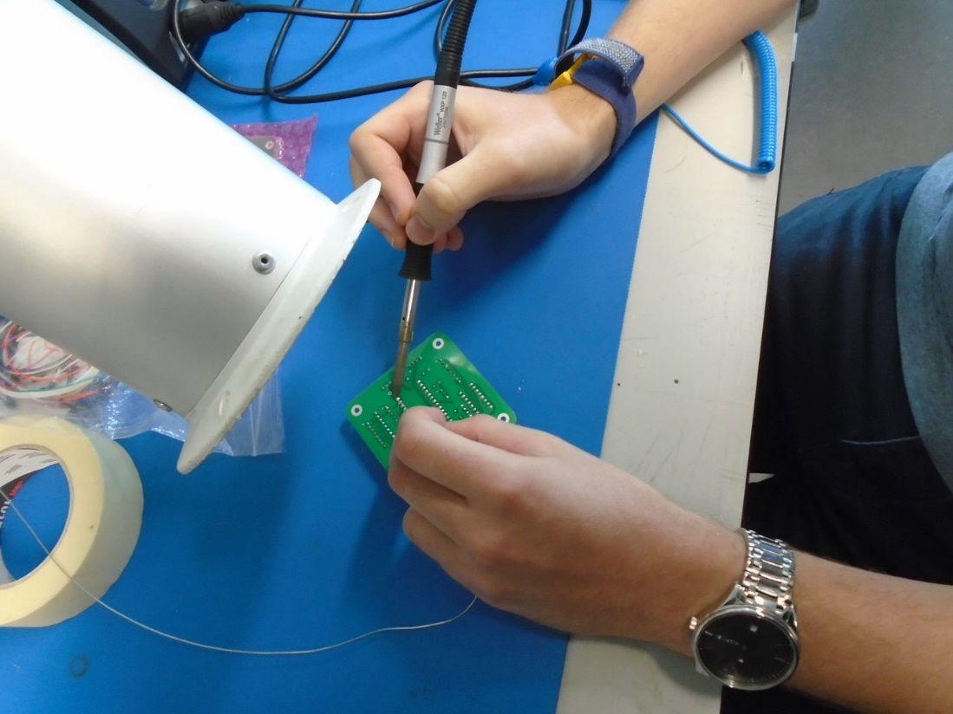
Upon receipt of the PCBs each team member populated the PCB of the module that they had designed and created. During this task the lab risk assessment was adhered to, meaning extraction and safety glasses were employed. This risk assessment has considered various concerns that are present when soldering, for example leaded solder, fumes, and fire/heat [24]. These are mitigated by using non-leaded solder, fume extraction and heatproof mats with stands for the hot irons. Additionally, there is a lab-based phone with the numbers of first aid qualified personnel in the event of an injury.
Figure 34: Populating the Wire Jumper PCB
Figure 35: Populating the Safe Cracker PCB

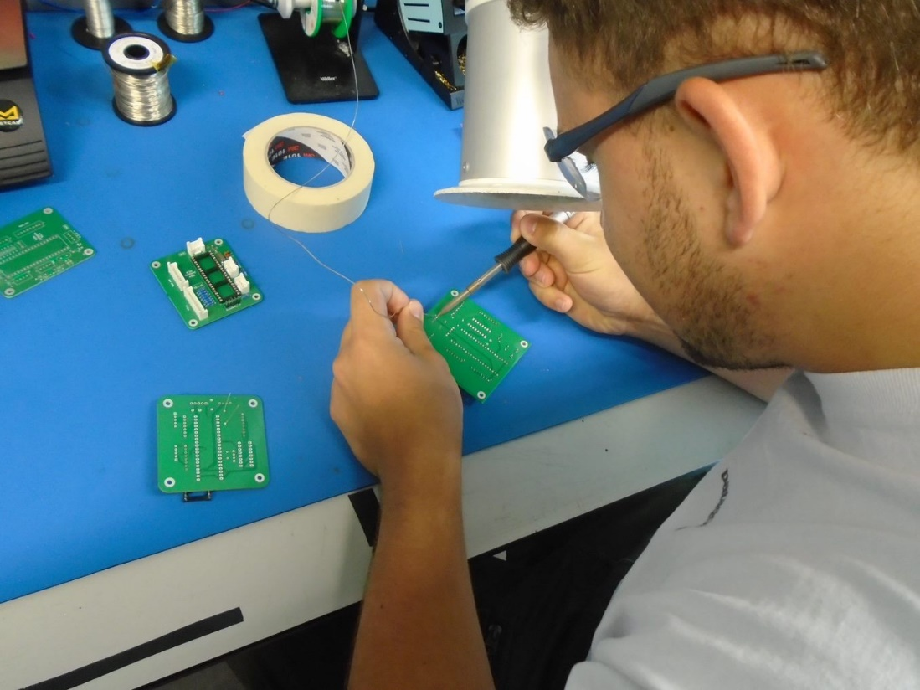
Figure 36: Populating the Decimal to Binary PCB

Difficulties
The main difficulties were found to lie in pieces needing external manufacture. Whilst the PCBs were able to be made quickly, one of the PCB files was missed out, resulting in a later reorder that arrived a week after the rest. Additionally, the onsite engineering team were unable to complete the fabrication of the metalwork within the time originally agreed. This, however, proved to be beneficial, as engineering had quoted ~£1300 for the baseplate and 6 face plates. With the face plates being 3D printed, it was able to be done for the price of a reel of filament (~£40) and an external company was able to laser cut the baseplate for £30 +VAT. Due to the massive difference in price, two baseplates were ordered to have a spare.

Results and Analysis

Testing: Project Team
Initial testing of the modules was conducted during prototyping. Completion of the prototypes meant that each module worked as expected, one module tested with a dummy module to ensure the I2C communication from the RPi would work with more than one board. The circuits were progressed to PCBs to be assembled into the final unit.
The expected outcome for the project was a working game build, this was 90% achieved, with all modules tested and working cohesively, it just needed testing as a fully built unit.
At this point in time, all the objectives specified have been met, apart from having the ability to stand out from a distance using the GUI. Upon completion of the GUI this additional objective will then also be satisfied.

Testing: Other Members of Staff

In the future there is a plan in place that will allow more testing to be completed on the game by giving access to people around the workplace. This will be done by asking them to play the game and then fill out a questionnaire which can be seen below in Figure 37. After collection these will be examined and the unit may be changed accordingly, if a majority of people complete the game quickly, the time may need to be reduced, or if very little are completing the game, time may be added. This method will also highlight any bugs, such as a minigame not working correctly, that will then be able to be fixed.
Figure 37: Questionnaire Handout

Evaluation
Overall, the project has delivered a 90% complete unit, with the majority of the objectives met and running largely as expected. The remaining objective being to create a standout display GUI for use at STEM events.
The build takes cues from existing versions of the game, such as ‘Keep Talking and Nobody Explodes’, and the Escape Room in a Box, and achieves a similar construction, with the inclusion of more organisational themes. Considering the short timescale of the project the outcome achieved is of a high standard, with good potential for future development.
If it were to be done again, the items that need to be externally manufactured would take precedence, and the onsite engineering would be avoided, with metalwork/mechanical construction being sent out to industry immediately. A “stock check” of existing supplies would be conducted to make sure that there were adequate amounts of components to avoid losing time by having to order new components in a rush.

Conclusion and Recommendations
In conclusion, despite setbacks and some mistakes, an outcome of high quality has been achieved. Making use of the existing units and how others have designed them, the project has been able to be almost a complete success. As of this report there are some outstanding tasks as mentioned in the evaluation. However, these tasks do not affect the use of the unit, the unit is able to be “played” and completed.
In summary, successful simulation and testing was able to be carried out, along with eventual success with external fabrication. The objectives specified in the introduction have been met, with the option for future development. During the review of existing literature and systems, the project was able to come up with an overall design, as well as ideas for mini games and what would be too difficult or time consuming to make it not worth it. The design went largely as planned and was able to inform component orders and unit layout, as well as set out an order of how to build the unit. The majority of issues encountered were with the implementation, as discussed in previous sections, however, the objectives were still able to be met.
In the future, the design of modules and mini games will be opened to the CIS division, or DSTL as a whole. The dimensions and source file of the module faceplate will be made available to download, so that the new module is able to fit correctly, along with the connection required for communication with the RPi. This will be done as a Capability Development task in order to provide experience in manufacture and design to newer or existing members of staff to build knowledge and qualifications.

Reflections

Louise Caygill
Overall, I am happy with how the project went. I think we were able to play to each other’s strengths and learn from each other in areas that we weren’t as confident in. Resulting in a build that (at the time of writing this) is ~1 week away from full completion. For myself this was the software for the mini games, in comparison my game module was quite simple, and I was confident I was able to finish it, using the knowledge of the others where I was unsure. In the future I need to make sure that I have all the components needed, and to make sure that more are available for purchase should they run out. There were also small mistakes I made during the design of a faceplate and two of the PCBs, to avoid these mistakes in the future I will take more time to make sure that I get it right the first time, rather than rushing due to time pressures.

Samuel Lloyd
At this stage of the project, I am happy with how everything has gone, we made a few mistakes on the way but recovered well when these came up. I wish we had some more time to have completed the project to its entirety but believe this will be done soon. For myself I found the software and simulations simple as it is something I am very comfortable with, but when it came to the KiCad work this was new for me so found it more difficult but with the help of my team I managed to complete it. If I was to do this project again, I would have attempted to prioritise ordering the PCBs sooner as we did this a bit late which then caused us a problem when an error was made creating larger delays. We also made an error thinking that the GUI would be a simpler job, and this took a lot longer than expected and still isn’t completed at this point.

Rhys Higgins
Altogether, I am satisfied with the outcome of the project. I believe that we managed the tasking of the project well and were able to utilise each other’s capabilities to deliver our respective sections of the project. As of this report, we have some outstanding development work regarding the GUI. However, this is something which should be completed by the date of the presentation. My contribution was predominantly in programming/software, playing to my strengths, however, I also managed the procurement of the PCB’s, dealing with the suppliers. One mistake was not double-checking the ordering of the PCB’s as one had been missed-off the initial order – costing us 5 working days. In the future, I will be more diligent when placing orders to ensure that these mistakes do not cost the group time.

Freya Vafadari
I’ve enjoyed this opportunity as part of the group project to be able to complete the whole engineering process from the start when designing a concept to the finish where we’re able to present an interactive STEM puzzle focussing on cybersecurity and ethical hacking.
One of the main obstacles faced on the project were the short timescales which meant ordering electronic components and getting PCBs manufactured included a risk because they might not arrive in time from the manufacturers. This risk was mitigated by using components already in the lab and using a UK based PCB supplier so shipping times were reduced.
As a further development opportunity in the future I would like to design more PIC puzzles so there’s a greater variety of games and the combination of games can be changed before new STEM events to keep the challenges interesting and exciting.

References

[1] | “Keep Talking and Nobody Explodes,” [Online]. Available: https://keeptalkinggame.com/. [Accessed 5 June 2023].
[2] | S. Lewis, “Tech Target,” June 2023. [Online]. Available: https://www.techtarget.com/searchcio/definition/Prototyping-Model. [Accessed 7 June 2023].
[3] | Funding For Good, What are Evaluation Methods?, https://fundingforgood.org/what-are-evaluation-methods/#:~:text=The%20three%20main%20types%20of,evaluations%20analyze%20strengths%20and%20weaknesses., 2020. [Accessed 7 June 2023].
[4] | “Interview Bit,” 10 April 2023. [Online]. Available: https://www.interviewbit.com/blog/difference-between-c-and-python/. [Accessed 7 June 2023].
[5] | V. Ryan, “Technology Student,” 2017. [Online]. Available: https://technologystudent.com/pics/picgen1.html. [Accessed 22 June 2023].
[6] | “PIC16F87X Data Sheet,” 2003. [Online]. Available: https://ww1.microchip.com/downloads/en/devicedoc/39582b.pdf. [Accessed 1 June 2023].
[7] | “PIC16F84A Data Sheet,” 2001. [Online]. Available: https://ww1.microchip.com/downloads/en/devicedoc/35007b.pdf. [Accessed 1 June 2023].
[8] | “Raspberry Pi,” [Online]. Available: https://www.raspberrypi.org/help/what-%20is-a-raspberry-pi/. [Accessed 9 June 2023]
[9] | “Raspberry Pi 3 Model B+,” Rasbperry Pi, [Online]. Available: https://datasheets.raspberrypi.com/rpi3/raspberry-pi-3-b-plus-product-brief.pdf. [Accessed 6th June 2023].
[10] | “SPI vs I2C Protocols - Pros and Cons,” Arrow Electronics, 4 February 2019. [Online]. Available: https://www.arrow.com/en/research-and-events/articles/spi-vs-i2c-protocols-pros-and-cons. [Accessed 15 June 2023].
[11] | “What are Pelican Cases Made Of?,” Pelican, 11 July 2022. [Online]. Available: https://www.pelican.com/us/en/discover/pelican-flyer/post/what-are-pelican-cases-made-of-/#:~:text=Pelican%20cases%20are%20built%20tough,and%20all%20kinds%20of%20weather.. [Accessed 7 July 2023].
[12] | “Association of Project Management,” [Online]. Available: https://www.apm.org.uk/resources/find-a-resource/gantt-chart/. [Accessed 31 May 2023].
[13] | “MPLAB® PICkit™ 4 In-Circuit Debugger,” Microchip, 2023. [Online]. Available: https://www.microchip.com/en-us/development-tool/PG164140. [Accessed 29 May 2023].
[14] | “Microsoft,” [Online]. Available: https://support.microsoft.com/en-au/office/video-create-a-flowchart-8ff7ba4d-cbfd-4977-95ab-51d9017071b9. [Accessed June 13 2023].
[15] | “CCS Info,” [Online]. Available: https://www.ccsinfo.com/downloads/ccs_c_manual.pdf. [Accessed 9 June 2023].
[16] | R. K. I. M, “What is Solidworks?,” TECHNIA, 2022. [Online]. Available: https://www.technia.co.uk/blog/what-is-solidworks/. [Accessed 7 July 2023].
[17] | M. M., “C library for Broadcom BCM 2835 as used in Raspberry Pi,” bcm2835, 2021. [Online]. Available: https://www.airspayce.com/mikem/bcm2835/. [Accessed 3 July 2023].
[18] | Unknown, “Basics of I2C and checking the I2C devices present on a port,” packt, 2023. [Online]. Available: https://subscription.packtpub.com/book/hardware-&-creative/9781786463852/5/ch05lvl1sec64/basics-of-i2c-and-checking-the-i2c-devices-present-on-a-port. [Accessed 27 June 2023].
[19] | “The Advantages and Disadvantages of Designing with Breadboards,” 30 October 2020. [Online]. Available: https://resources.altium.com/p/advantages-and-disadvantages-designing-breadboards. [Accessed 3 July 2023].
[20] | “GTK3 - Getting Started,” February 2023. [Online]. Available: https://docs.gtk.org/gtk3/getting_started.html. [Accessed 03 07 2023].
[21] | “The Difference Between Breadboard Projects and Prototype Layouts,” Altium, 15 December 2020. [Online]. Available: https://resources.altium.com/p/understanding-nuances-between-breadboard-projects-and-prototype-layouts. [Accessed 4 July 2023].
[22] | L. M., “Through-Hole Versus SMD Components,” 22 August 2017. [Online]. Available: https://www.vishay.com/docs/45242/throughholevssmdcomponents.pdf. [Accessed 26 June 2023].
[23] | “About KiCAD,” KiCAD Project, [Online]. Available: https://www.kicad.org/about/kicad/. [Accessed 1 July 2023].
[24] | University of Cambridge, Soldering Safety, https://safety.eng.cam.ac.uk/safe-working/copy_of_soldering-safety. [Accessed June 15 2023]
[25] | C. Coward, “Hackster,” 2020. [Online]. Available: https://www.hackster.io/news/this-escape-room-in-a-box-is-perfect-for-quarantine-brain-stimulation-0a5c7a446cc3. [Accessed 30 May 2023].
[26] | “LoganRSweet,” 2017. [Online]. Available: http://loganrsweet.com/ProjectBombDefusalGame.html. [Accessed 30 May 2023].
[27] | “Total Phase,” 08 July 2021. [Online]. Available: https://www.totalphase.com/blog/2021/07/i2c-vs-spi-protocol-analyzers-differences-and-similarities/. [Accessed 20 June 2023].

Appendix A
Email from Lesley Bagley - Customer
- Needs to stand out from a distance to attract attention
- Possibility that the challenges can be adapted and are age appropriate for the environment eg harder challenges at University STEM career fairs looking to recruit graduates.
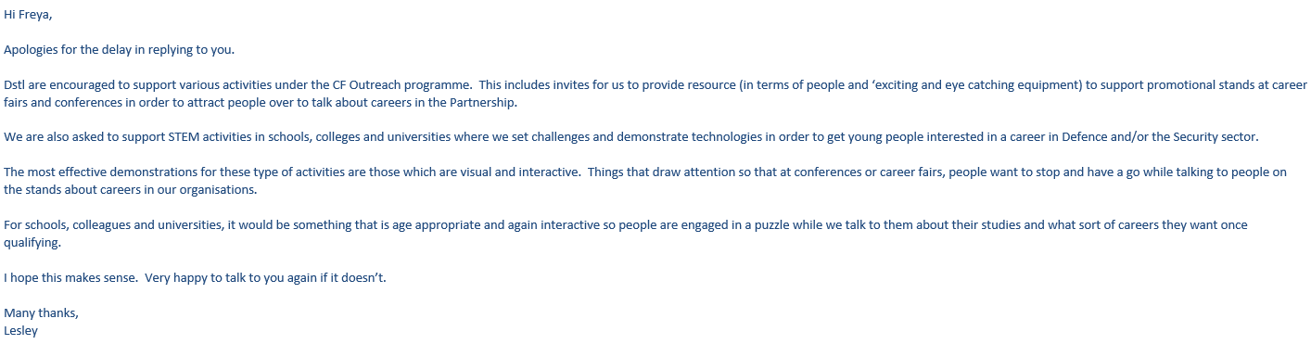

Appendix B
Email from Buster Parr about STEM Fairs.
- Optimal time frame at stands at careers and recruitment fairs is 5 minutes to maintain engagement from the audience
- Additional thinking about how the audience who aren’t playing the games can still view the progress and excitement of the game for example by connecting the main control Raspberry Pi to an external monitor
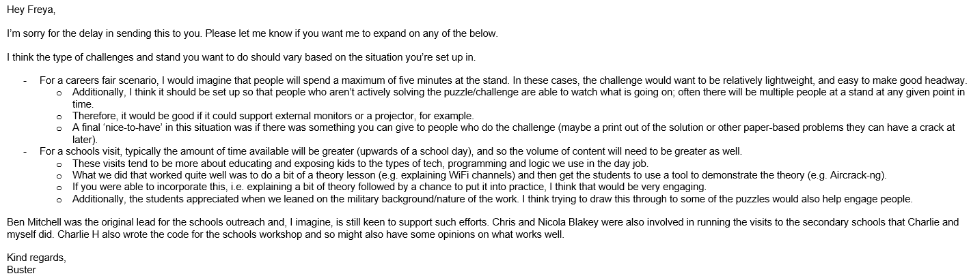

Appendix C
Review of Keep Talking and Nobody Explodes by Andy Godfrey and Danielle Heywood.
Andy:
“Keep talking and nobody explodes, What is it?
Keep talking and nobody explodes is a cooperative computer game where two or more people have to work together in order to defuse a bomb before the timer ends, at which point it explodes and the players lose the game. In order to defuse the bomb, the players have to overcome a series of puzzles. These are not related to an actual bomb, but a series of logic based activities. The biggest complication is that only one of the players can see the bomb, and the other players have a manual that is key to solving the puzzles.
Naturally the gameplay revolves around reciprocal explanations of the material that each player can see so that between them, they can narrow down the answers in time. To avoid players guessing, there is a time penalty applied for answering incorrectly. It’s like an escape room in small form factor.
What the game does well.
• It has an initial ‘wow’ factor.
• The presentation is a 3d image of a bomb on screen, but is essentially just a cube with the puzzles on one face. This bounds the game to five puzzles and a keypad to enter the code to defuse the bomb thus setting the boundaries of the game. The rest of the bomb you can search for clues to the puzzles.
• The instructions are clear. It is clear what the goals of the game are and the roles of each player therefore.
• The balance of the game is really good. It always feels like you are going to lose. There is always a tension and it feels close every time you win or lose. As a new player, the game starts with easier puzzles and fewer of them. The number of puzzles and the difficulty increases naturally as the player progresses.
• You are provided with the bomb defusing manual in pdf format that you can print off if you wish. It is well presented and contains all of the details to carry out the puzzle solving. This means that you can have a manual for every player, meaning that the game is scalable too.
• The puzzles are difficult enough to require some thought so that you don’t just feel like you are going through the motions of a puzzle.
• There is genuine team work.
• Immersion! Especially in VR mode. You feel like you are really a part of the game.
• The tasks are different each time you play and the answers different, even on the same puzzle. No two games are the same.
What it doesn’t do so well.
• The graphics could be better but it does display everything you actually need to play the game in enough detail to not be a hindrance.
• You can’t play it for long periods of time. The tension is exhausting.
• It might be less fun for some people, especially those who can’t cope with tension/anxiety.
There have been a few games that have built off this kind of game since, but never in the same exact style. There are a number of escape room games that have been clearly inspired by this concept. The closest concept I have seen to this is the ‘Exit Room’ board game which provides you with a core piece of equipment and a number of purchasable one play only escape rooms which use the same core mechanism but the presentation and individual puzzles are unique.
The puzzles
There are numerous types of puzzle in the game, far too many to describe and it is unlikely that any casual player has seen them all.
The puzzles are limited in scope as each of the players are only seeing half of the puzzle. Quite often they are pattern recognition and follow quite traditional code breaking ideas. For example, there are instances of Morse code patterns, symbol replacement, Caesar shifts, pattern recognition etc.. The thing to note is that these are not necessarily taking advantage of the computer’s inherent advantages of allowing anything to go, they are staying within a set of unspoken rules or boundaries, i.e. they are puzzles that could equally be written and solved using pen and paper. Each puzzle’s instructions are all on one page, although you might need to access more than one page to solve a puzzle.”
Danielle:
“Keep talking and nobody explodes is a cooperative puzzle solving game for two or more players. One person alone is to play the role of the ‘bomb defuser’, who is the only person who can see the bomb. The other players are ‘the experts’ who have access to ‘the manual’ which contains instructions on how to solve the puzzles. Each bomb is procedurally generated to include a random selection of the puzzles, with a varying time limit and number of allowed errors. The individual puzzles in the game are very achievable and complexity is built by increasing the number of puzzles to solve within the time limit.
A key part of this game is communication between the players. As only one player can see the bomb, they need good communication and descriptive skills to be able to convey to the other players what the puzzles they are faced with look like. The other players then need to find the right puzzle in the manual and convey the instructions for solving the puzzle to the defuser. This communication between players who are unable to see the same information is the most challenging part of the game. Short time limits mean that fast thinking is required and later levels of the game throw in distractions, such as an alarm going off, which adds to the pressuring atmosphere of the game.
From coping with the pressured environment the game creates, and communicating effectively with fellow players to the detailed oriented observation and problem solving skills, this game exercises and demonstrates many of the skills that are useful across CF roles.”

