Sam Lamprey (2203378)
2203378@student.uwtsd.ac.uk
PLCs assignment
Factory control
Beng electrical and electronic engineering
Applied programmable logic controllers
ACDA6000
PLCs assignment
Introduction

This report covers the topic of programable logic controllers more commonly known as PLCs. The main use case of programmable logic controllers is to [1] “automate and monitor manufacturing processes in industrial settings.” [2] “This works by connecting different inputs and outputs to the PLC” which can then be used in the program as desired. The number of inputs and outputs that a PLC can have depends on the specific PLC that is used, and some are modular meaning that as many devices as necessary can be connected. Some common input devices that connect to PLCs include [3]” buttons and diffuse sensors” and common outputs could be [4]” lights, alarms or valves.”
Another device type that is commonly connected to PLCs are human machine interfaces also referred to as HMIs. [5]” An HMI is a device that allows a person to interact with the system using a controller. Which is usually a physical control panel with buttons and switches or a device such as a computer which using a screen allows the operator to interact with the HMI and PLC software.”

For this assignment it was required to design a factory system that was capable of sorting 4 different types of boxes depending on their weight and size. This was achieved using the TIA portal software from Siemens to design the program for the system and factory IO to design a simulation of the system. The system also needed to include an alarm and warning strategy so that if any faults with the system occurred, they would be easily identified.
The system was also required to include an HMI so that an operator would be able to interact with the system. The HMI was used to display information about the system such as the number of each type of box that was sorted and the weight of the boxes that were being sorted. The screen of the HMI also included warning lights which would be switched on if any of the alarms caused by faults were set off.

PLCS literature review

PLCs or programable logic controllers are used all throughout different industries such as [6] “the automotive industry and energy industry” and their main use inside industry is to automate processes. They also allow operators to interact with these processes to ensure that they are working correctly. The main function of PLCs is too [7] “control all of the functions of a system using the logic program stored onto it.” The PLC also processes all signals from any connected inputs so that they can be used to control the outputs of system which can change depending on the program. There are lots of different manufacturers of PLCs but the two most popular are [8] “Siemens and Rockwell” who both produce multiple different models which have different specifications from one another. Below is a table that compares different models of PLCs and lists pros and cons of each one.

Table of existing PLCs
PLC name | Siemens LOGO! 230 RCE - 6ED1052-1FB08-0BA2 | Siemens SIMATIC S7-1200 series PLC CPU | RS PRO Logic Module | Siemens CPU 1214C - 6ES7214-1AG40-0XB0
Inputs | 8 digital | 6 digital | 8 | 14 digital
Outputs | 4 digital | 4 digital | 4 | 10 digital
Memory | 400 blocks | 1MB | 250 lines | 4mB
Pros | 1.Modular  2.Sd card  3.Cloud interface  4.MQTT  5.Integrated web server | 1.Ethernet/profinet  2.Mounts using DIN rail  3.Supports FAD,LAD,SCL for programming | 1.ModBus network type  2.Mounts using DIN rail  3.Ladder logic programming | 1.DIN rail support  2.FBC,LAD,SCL programming languages  3.Profinet programming interface
Cons | 1.Low number of outputs  2.Small amount of memory | 1.Only 4 outputs  2.No analogue outputs | 1. Only 4 outputs  2.Low memory capacity | 1.Isnt cheap  2.Not as much memory as other PLCs
Price(£) | £137.70 | £252 | £129.71 | £413.10
Image | 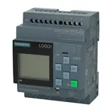 | 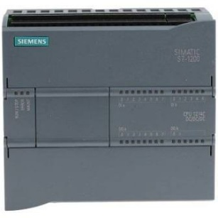 | 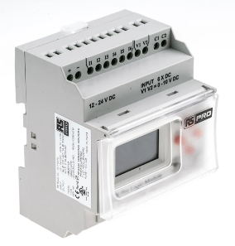 | 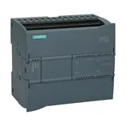
Product page | https://www.automation24.co.uk/siemens-logo-230-rce-6ed1052-1fb08-0ba2?previewPriceListId=1 | https://uk.rs-online.com/web/p/plcs-programmable-logic-controllers/8624459 | https://uk.rs-online.com/web/p/plcs-programmable-logic-controllers/9176370?gb=s | https://www.automation24.co.uk/siemens-cpu-1214c-6es7214-1ag40-0xb0

PLC name | Allen Bradley Micro810 Series PLC CPU | 1763-L16BWA Allen Bradley 1763 MicroLogix 1100 System | Mitsubishi Electric FX3S Series PLC CPU | Allen Bradley 1766 Series PLC I/O Module
Inputs | 8 | 12 | 6 | 20
Outputs | 4 | 6 | 4 | 12
Memory | 4kB | 8kB | 4000 steps | 10kB
Pros | 1.Ladder logic  2.Functions as back up memory module  3.Wide operating temp | 1.Supports ladder logic  2.Variety of I/O types  3.Mounts using DIN rail  4.Supports 4 expansion modules  5.Embedded LCD screen | 1.USB port for programming  2.program with GX works2  3.integrated real time clock  4.integrated power supply | 1.Built in lcd  2.Large memory capacity  3.Program with RSlogix 500  4.Supports up to 7 expansion I/O modules  5.Mounts using DIN rail
Cons | 1.Only 4 outputs  2.Small amount of memory | 1.Expensive | 1.Low number of outputs  2.small amount of memory | 1.Expensive
Price(£) | £143.21 | £1844.52 | £175.80 | £1453.31
Image | 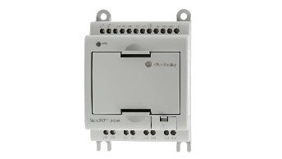 | 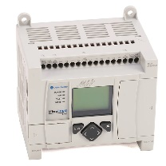 | 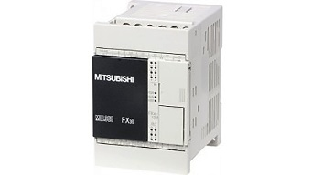 | 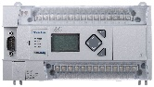
Product page | https://uk.rs-online.com/web/p/plcs-programmable-logic-controllers/7508602 | https://ddpartssolution.com/products/1763-l16bwa-micrologix-1100-16-point-controller?variant=46774255124758&utm_medium=product_sync&utm_source=google&utm_content=sag_organic&utm_campaign=sag_organic | https://uk.rs-online.com/web/p/plcs-programmable-logic-controllers/1235959?gb=s | https://uk.rs-online.com/web/p/plc-accessories/7140105?gb=s

In real world system HMIs or human machine interfaces are commonly used with PLCs [9] “as they work with one another to create an interface for people to interact and access the PLC”. HMIs usually contain a screen which allows an operator to visualize what is happening inside the system and they sometimes also allow the PLC program to be edited directly on the screen. But more modern PLCs can also be connected directly to a computer which then acts as the HMI.

When creating a PLC program there are many different languages and software's that can be used. However [10], “the most common language that is used is ladder logic because it is versatile and is easy to understand.” Ladder logic programs work by operating commands in rungs sometimes also referred to as networks. These are the individual lines of the program, and each one usually contains a different function of the system. The program will run through the rungs in a loop starting from the top and ending in the bottom. However, it will only execute a rung if the first condition inside it is met. Once the condition is met the program will move from left to right across the rung until it has reached the end of the line. It will then move down to the next rung and will start back on the left side.

The program used to write the ladder logic can vary depending on the brand or model of the PLC that is being programmed. Some common programs that are used are TIA portal from Siemens and RSlogix by Rockwell automation. Both pieces of software can be used to write ladder logic programs, but they are for the most part only compatible with PLCs from the same brand which means that depending on what brand of PLC is being programmed certain software won’t be available. There are pieces of software that will be compatible with the majority of PLCs such as codesys and twincat but they lack features that work with certain PLCs and these features are only available through the manufacture of PLCs software.

Alongside writing the program for a PLC it is important to test it to ensure that it is functioning as intended. [11] “The most common way of doing this is to simulate the whole system using simulation software which will allow the user to see a full visual representation of the system.” Depending on what simulator is used a 3d model can be created which helps give an even more detailed view of the system which can help with troubleshooting and fixing any issues. Simulating the system also makes it easy to quickly and easily test different scenarios which difficult to replicate on a physical system. This can also help the engineer test any fail safes that may have been included in the program or the system if something was to go wrong.

System design

Simulation design
Throughout the completion of this assignment multiple different tasks needed to be completed for the system to fully function as specified.
The first task that needed to be done was to create a simulation of the system. This was achieved using factory IO which helped visualize how the system was going to sort the different box types. In factory IO all the inputs and outputs of the system were connected to the PLC before creating the program which made it easier to assign the correct tag values in the program. The simulation included multiple conveyors as well as pushers and diffuse sensors. There was also a weight scale and pop-up sorter which was used at the start to divide the heavy and light boxes from each other. A siren, warning light and stack lights were also added to display the state of the system and to show is there was a system error. Two buttons and an emergency stop were also placed next to the lights and siren so that the system could be started and stopped physically without the need to use the HMI.

Program design

To create the program Siemens TIA portal was used as it interfaced directly with factory IO and the PLC chosen for the system was from Siemens. Inside the software all of the inputs and outputs on factory IO were given tags with the same value as in the simulation so that they would linked together in order to get them to work. Other tags were also created to help the program function and to be able to connect the system with the HMI that was used. Once the tags had been added all of the inputs and outputs were connected in different networks to make sure that the program was linked to factory io and that all of the components were working as intended.

After it was confirmed that factory IO and TIA portal were connected to each other the tasks required for the assignment were completed. The first of which was to start each conveyor up in intervals to limit the current draw when the system starts up. This was achieved by using timer operations to individually start each conveyor in 500ms intervals. After the conveyors the necessary networks to sort 4 different types of boxes were completed. These used the weight of the boxes to then move the direction of the pop-up sorter so that the two smallest boxes went to the right and the two largest to the left. Then taller box on both the left and right side would be pushed onto a different conveyor which then meant that all four types of boxes were all separated from each other.

HMI screen

The HMI that was connected to the PLC had three different screens which were the root screen, warning screen and the engineer's screen. In a real system both the root and warning screen wouldn't require a special key to access, but the engineers screen would as it would contain extra features that only someone with training should be able to access. However, for simulation purposes the engineers screen didn’t require a key is it would need to be easy to access because it would be needed to be used frequently during the testing process. The screens were used to display Information about the system such as the weight of the boxes and how many of each type had been counted. On the root screen there was also button for starting and stopping the system as well as an emergency stop. The counters could also be reset using the HMI screen and preset values could be inputted using the engineers screen. Each of the three HMI screens contained warning indicators which would switch on if an error was detected. There were also buttons on each screen which would allow a user to navigate to the other screens. On the engineers screen there was also a master alarm reset button which was the only way that the system could be restarted once either the emergency stop had been pressed or and major error was detected.

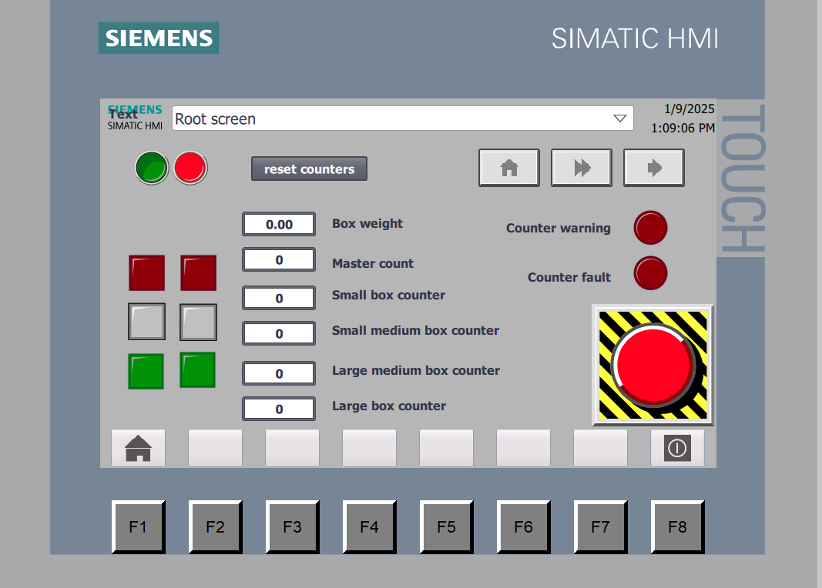
Figure 1
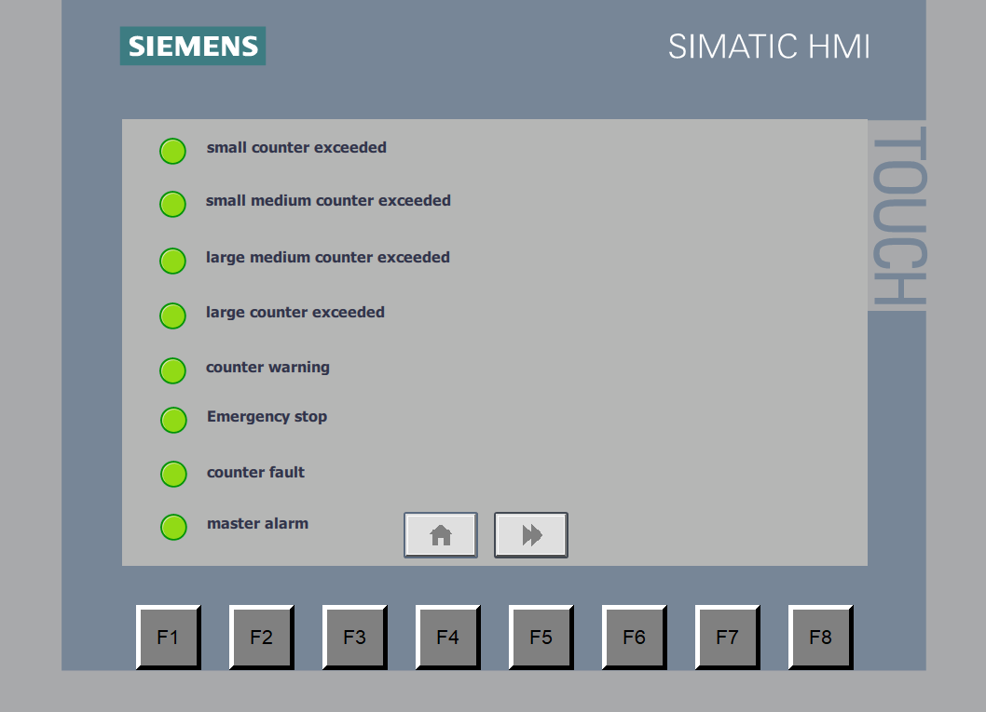
Figure 2
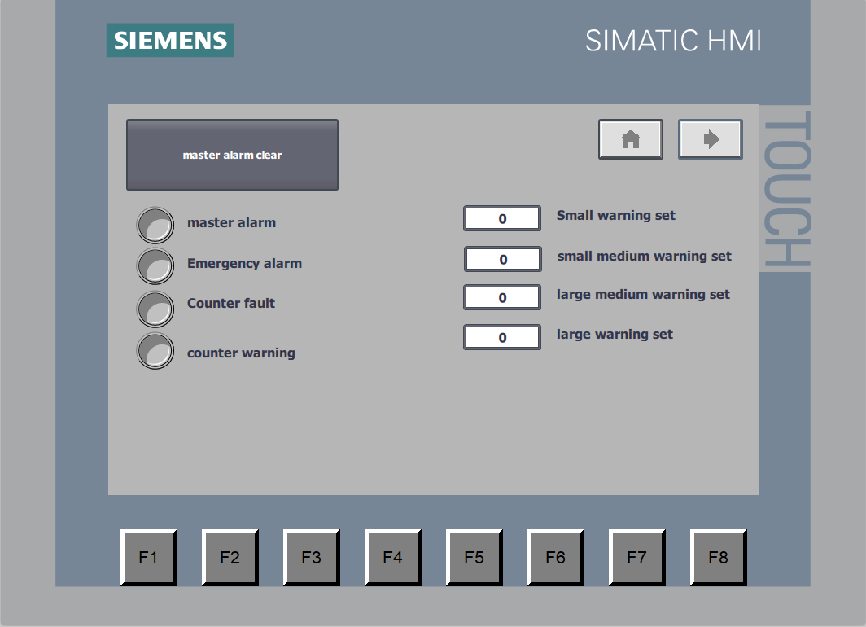
Figure 3

Alarm strategy

In the system an alarm and warning strategy was used to make sure that if there were any faults in the system that no further issues would be caused. In the design the strategy was split into two main methods which were warnings and alarms. The warning were used for smaller problems with the system which included when the value of the counters for each type of box being sorted was too high and when there was a small difference in the number of boxes at the start of the system and the end. The way that the problems were addressed was to switch on a warning light for each problem which could be seen on the warning screen on the HMI. The yellow light on the stack lights would also be switched on when the warnings were set off. For the counter warnings for each different type of box a predetermined value could be set using the engineers screen on the HMI which would change the preset value on the counters. Once the set value was reached the program would then send a signal to the warning lights on the warning screen and the stack lights which would then be turned on. If there was an error with the total count of the boxes the same would happen but instead of using a predetermined value on the counter a calculation would be done to work out the difference in the number of boxes at the start and end of the system. If this number was >=5 the warning would be triggered.

For the second part of the strategy in the system alarms were used, which were for more serious errors. This worked by setting off the master alarm which would stop the system and wouldn't allow it to be restarted unless all of the alarms were cleared on the engineer's screen on the HMI. The specific ways to set off the master alarm were if the emergency stop button was pressed both the one on the simulation and the HMI as well as if the error count for the boxes was over 7.
The way that the alarm strategy was implemented into the program was by assigning a tag for each potential error inside the same byte as well as a tag for the master alarm. In the program there was a specific network for the alarms which would only be used if any of the tags inside the alarms byte was set. This would then set the master alarm which meant that then the only way to restart the system was to switch off the master alarm which was included inside the network that was responsible for starting and stopping the system and if the master alarm tag was set wouldn't allow the running tag which was used to tell the system that it should start running. This meant that unless the master alarm was turned off the system wouldn't be able to start back up once an error had occurred.

The reason for stopping the system if an alarm was set off was to improve the safety of the system and if a major flaw in the system caused the alarm to be set off a trained engineer would be required to reset the alarm due to the engineers screen requiring a key or code to access and before the alarm would be reset the cause of the fault would be fixed.

System flow chart

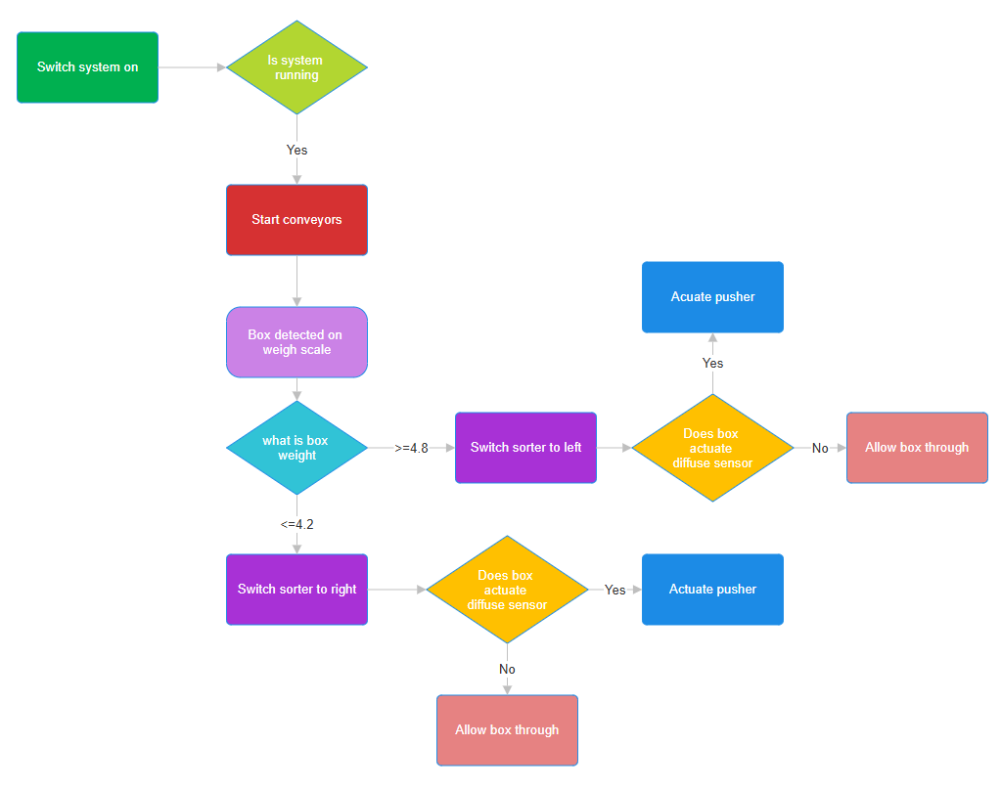
Figure 4

Ladder logic program

Network 1:
Figure 5

Network 2: system start/stop
This network connects the start and stop buttons for the system and sets the variable running which is then used in other networks. Also, if the master alarm is set the network will not allow the running variable to work which stops the system from being switched back on unless the alarm is cleared using the engineers screen.

Figure 6

Network 3: Emergency stop
This network is used to set the master alarm on once the emergency stop button is pressed. This only works if the running variable is set which is only on when the system is running.
Figure 7
Network 4: counter faults
The purpose of this network is to set the master alarm if the counter fault variable is set which occurs when there is an error with the number of boxes that have been sorted.
Figure 8
Network 5: system start up
This network switches on a warning light and all of the conveyors in the system in 500ms intervals to limit the current draw when the system starts up. This was done using TON timers which after the timer has finished keeps the output on until the system is switched off. A siren is also switched on for the first 3 seconds using a Pulse timer.
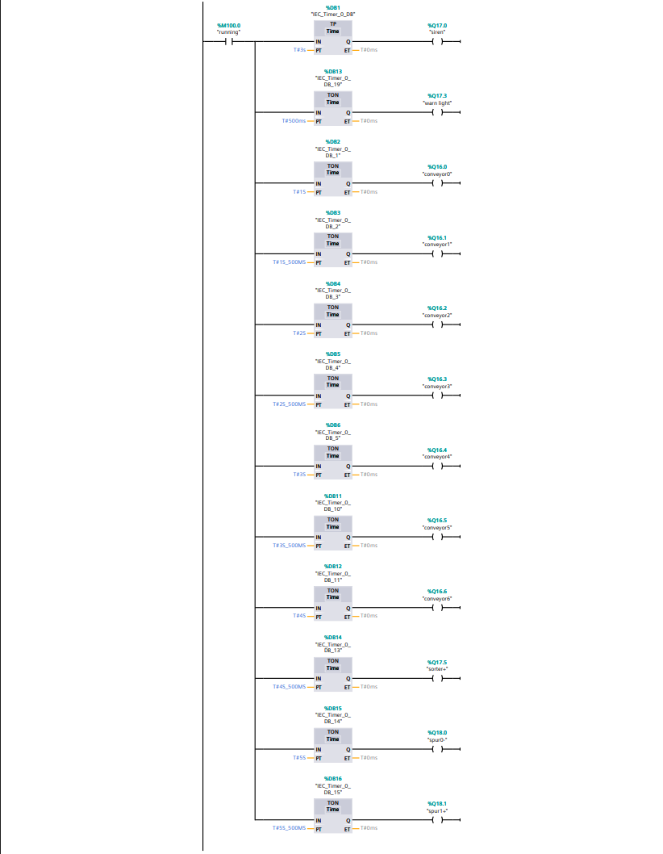
Figure 9

Network 6: stack lights
All this network is used for is to turn the stack lights on and off depending on the state of the system. If the system running variable is set, then the green lights will switch on and if the opposite is true and the running variable isn’t set then the red lights switch on. For orange lights the counter warning needs to be set which occurs when there is a difference between the number of boxes before and after the sorter. 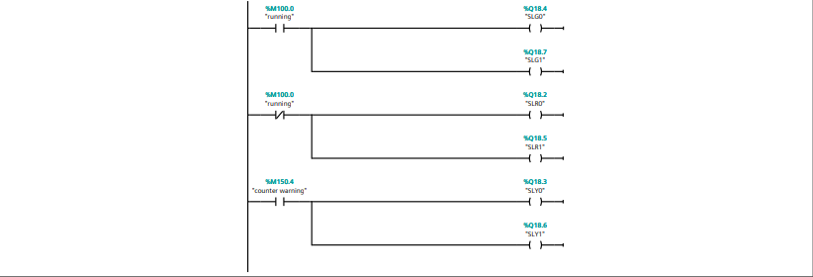
Figure 10

Network 7: Large box pusher
When diffuse sensor 3 detects a box a timer of 1900ms is started which once finished activates pusher 0 which pushes a large box onto a different conveyor.

Figure 11

Network 8: small medium pusher
If diffuse sensor 4 is set off a 1350ms timer starts and then pusher 1 will push a small medium box off the conveyor so all boxes of the same size are moved to the same location.

Figure 12

Network 9: alarms
The alarms byte is used to store all of the alarms so that if one is set off it will trigger the master alarm which stops the system until the alarm has been cleared using the engineers screen.

Figure 13

Network 10: Total count
This network uses diffuse sensor 0 to count how many boxes have passed through the system. This value is then used in other networks to calculate if there have been any errors with the boxes in the system. The counter can be reset when the reset counters variable is set using the button on the root screen on the HMI.

Figure 14

Network 11: weight scale loaded
The purpose of this network is to set the variable named scale loaded when a box moves onto the weight scale. This works by using the input from diffuse sensor 0 which occurs when a box moves in front of it. This then sets the scale loaded tag for 1 second before resetting the tag. This is done so that boxes can be moves along quickly after being weighed but not so quickly that it could cause the measurement of the weight to be inaccurate.

Figure 15

Network 12: weigh scale control
The network is used to inform the rest of the system when the box on the scale is ready to be weighed. This only works when the scale loaded variable has been assigned. Then a variable called scale control is set and a 700ms timer is started which sets a ready variable once the timer has finished. Next another timer is started for 700ms which then resets the ready and scale control variables.

Figure 16

Network 13: weigh scale conveyor
This network is used to control the conveyor on the weigh scale. This is can only be done if the running variable is set, meaning that the system is on. The network then checks if the scale on variable isn’t set which if it isn’t the conveyor turns on until the variable is set.
Figure 17

Network 14: pop up control
The network waits for the ready variable to be set and then sends a 10MS pulse which gives the weigh scale time to get ready to weigh a box. Then the box is weighed, and the value is moved from the weight tag to the final weight tag using the move operation. After that the system checks the weight so that the box can sorted in the correct place depending on the value stored in the final weight tag. The network reads the weight of the box and used a comparator function to calculate which way the sorter should be moved. The comparator operations were set to real due to the values from the weigh scale not always being whole integers. If the weight of the box is <=4.2 the box sorter right is set and sorted left is reset which switches the pop-up sorter to the right. When the box is heavier and has a weight >=4.8 the right sorter is reset, and the left sorted is set meaning the sorter switches left meaning heavier boxes are sent to the left side of the system.
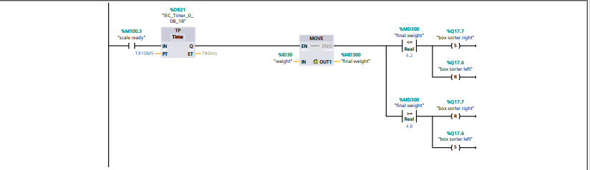
Figure 18

Network 15: display weight
The function of this network is to output the weight of the boxes to a small lcd placed on the side of the system as well as the HMI screen. This is done using a move operation which takes the value of the final weight variable and moves it directly to the lcd.
Figure 19

Network 16: box counters
This network contains the program that counts each individual type of box being sorted by the system. If the running variable is set, then the network will wait for either a pusher or diffuse sensor to set off which then starts a count. The count operation used in a CTU or count up which is then set to UInt so that the tags used in the counter will be recognized. All four of the counters are reset using the same tag which is connected to a button on the HMI screen which when pressed will reset all of the counters. Each counter is assigned its own variable to count up which all are named in relation to the type of box that is sorted at the point where the input of the counter is. To set the pre-set value of the counter the HMI screen must be used which on the engineer’s screen had four different input fields where a value can the selected. Once the counter reaches this value the output on Q is performed. For these counters the output set variables that are then used to switch on warning lights on the warning screen on the HMI.

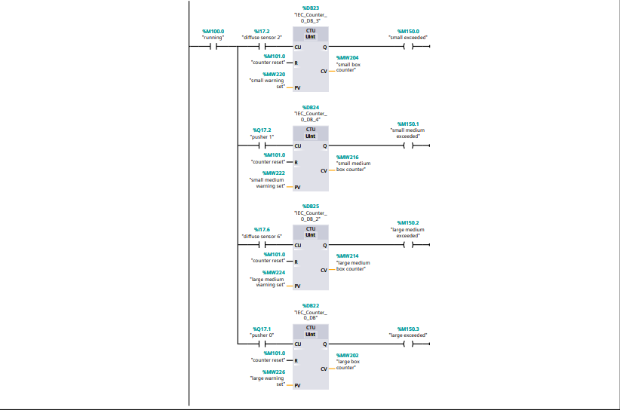
Figure 20

Network 17: error count calculation
The purpose of this network is to calculate if there have been any errors with the number of boxes sorted by the system. The first step to achieve this was to add up all of the counts for each different box type using the ADD maths function. The math functions were all set to UInt because this is the variable type for the counters which are used as the inputs for the math functions. Each side of the system was first added up individually and then added together into the total boxes out variable. Then a subtract function was used to calculate the difference between total counter which is total number of boxes that entered the system and total boxes out which was the total counter of the boxes that had been sorted. The value outputted into the box count errors variable would then be used to set off a warning and alarm depending on the value.
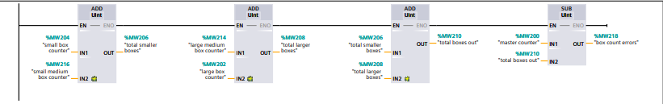
Figure 21

Network 18: errors
The function of this network is to output a warning and alarm if there has been an error with the value of the counters. The first step for this network is to use a comparator function to check the value of the box count errors tag. Two different comparators are used which are both set as UInts due to the counter value always being an integer. If the number of errors is >=5 then a variable called counter warning is set which is used to switch on a light on the warning screen on the HMI. If the number of errors is >=7 then the counter fault alarm is set which then sets of the master alarm causing the system to stop so that the problem can be resolved.

Figure 22

Conclusion
Overall, for this assignment the factory system and program that were created matches the specification given. The system included all of the features necessary to ensure that it would work as intended. It was able to sort four different types of boxes using a weigh scale as well as pushers which sorted the boxes so that only the same type were together. The system also had an alarm system so that if any problems did come up, they could easily be identified. All of the information about the system was displayed using an HMI screen which also contained an engineers screen which is where the master alarm of the system had to be reset.

Reference list
[1] RS uk “PLCs – a complete guide” found at:https://uk.rs-online.com/web/content/discovery/ideas-and-advice/plcs-programmable-logic-controllers-guide
[2] inductive automation “PLC basics, operation, programming and the future of PLCs” found at:https://inductiveautomation.com/resources/article/what-is-a-PLC#:~:text=PLCs%20act%20as%20the%20physical,and%20many%20other%20industrial%20machines.
[3] automation.com “a beginners PLC overview found at:https://www.automation.com/en-us/articles/2018/a-beginners-plc-overview-part-3-of-4-plc-inputs-an#:~:text=The%20most%20common%20type%20of,push%2Dbuttons%20and%20proximity%20switches.
[4] pdfsupply.com “PLC inputs and outputs overiew” found at:https://www.pdfsupply.com/blog/index.php/2022/05/23/examples-of-plc-inputs-and-outputs/
[5] NIST “human-machine interface” found at: https://csrc.nist.gov/glossary/term/human_machine_interface
[6] mobileautomation.com “PLC: Industrial applications of programmable logic controller” found at: https://www.mobileautomation.com.au/plc-industrial-application/#:~:text=PLCs%20are%20used%20in%20various,technologies%20where%20it%20is%20applied.
[7] polycase.com” What is a programable logic controller(PLC)?” found at: https://www.polycase.com/techtalk/electronics-tips/what-is-a-programmable-logic-controller.html#:~:text=A%20programmable%20logic%20controller%20is,internal%20logic%20programmed%20into%20it.
[8] medium.com” An overview of the global PLC industry and its dynamics” found at: https://medium.com/world-of-iot/95-an-overview-of-the-global-plc-industry-and-its-dynamics-102ae2cfc0b4#:~:text=Summary%20of%20the%20PLC%20market&text=Siemens%20have%20the%20largest%20share,Automation%20that%20have%2021.6%25%20shares.
[9] rteng.com “What is HMI in PLC” found at: https://www.rteng.com/blog/what-is-hmi-in-plc#:~:text=PLC%20(Programmable%20Logic%20Controller)%20and,interface%20between%20humans%20and%20machines.
[10] solisplc “Top 5 most popular types of PLC programming languages” found at: https://www.solisplc.com/blog/plc-programming-languages#:~:text=The%20consensus%20is%20that%20the,that%20model%20the%20same%20architecture.
[11] Constantine Vassilev on linkedin.com” How can you test and validate a plc system architecture before deployment?” found at: https://www.linkedin.com/advice/0/how-can-you-test-validate-plc-system-architecture#:~:text=One%20of%20the%20most%20common,%2C%20network%2C%20and%20external%20devices.

[12] https://www.automation24.co.uk/siemens-logo-230-rce-6ed1052-1fb08-0ba2?previewPriceListId=1
[13] https://uk.rs-online.com/web/p/plcs-programmable-logic-controllers/8624459
[14] https://uk.rs-online.com/web/p/plcs-programmable-logic-controllers/9176370?gb=s
[15] https://www.automation24.co.uk/siemens-cpu-1214c-6es7214-1ag40-0xb0
[16] https://uk.rs-online.com/web/p/plcs-programmable-logic-controllers/7508602

[17] https://ddpartssolution.com/products/1763-l16bwa-micrologix-1100-16-point-controller?variant=46774255124758&utm_medium=product_sync&utm_source=google&utm_content=sag_organic&utm_campaign=sag_organic

[18] https://uk.rs-online.com/web/p/plcs-programmable-logic-controllers/1235959?gb=s
[19] https://uk.rs-online.com/web/p/plc-accessories/7140105?gb=s

