Morgan Jenkins (2528481)
[Email address]
Assignment 2- Design and implementation of a Relational Database system
(ACCA4023) Introduction to Web and Database Concepts

Contents
1. Introduction 1
2. Database Design and Implementation 2
2.1 Scenario Analysis 2
2.1.1 Identification of Entities 2
2.1.2 Attributes for Each Entity 2
2.1.3 Relationship Summary 4
2.2 Entity-Relationship Diagram (ERD) 4
2.2.1 ERD Diagram 4
2.2.2 ERD Explanation 4
2.3 Data Structure Development 5
2.3.1 Table Definitions 5
2.3.2 Relationships 5
2.4 Validation Rules 5
2.4.1 Field Level Validation 5
2.4.2 Rationale 6
2.5 Normalisation 6
2.5.1 1NF 7
2.5.2 2NF 7
2.5.3 3NF 7
2.6 Sample Data Population 7
2.6.1 Rider Table: 5 Rows 7
2.6.2 Bike Table: 5 Rows 7
2.6.3 Rental Table: 5 Rows 7
2.6.4 Maintenance Table: 5 Rows 8
2.6.5 Staff Table: 5 Rows 8
2.7 Query Development 8
2.8 Testing of Database 9
3. Review and Reflection 9
4. References 10
5. Appendices 11

Introduction
Eco Ride is a fictional organisation that provides a green alternative to public transport in the local authority. It allows electric bikes to be rented by the public in various locations with the aim of making commuting healthier and greener. The service has grown in popularity but is facing challenges owing to their reliance on paper forms and archaic record handling not suited for a large-scale operation such as this. It relies on manual updates for the availability of bikes, tracking rental invoices and scheduling maintenance. The aim of this report is to design a relational database that can handle this interconnected data, controlling entries through appropriate validation and generate appropriate reports using database queries.

Database Design and Implementation

Scenario Analysis
It was determined that for appropriate record keeping five tables would be created to cover the necessary information for running this service.

Identification of Entities
Entity | Description
Rider | Users of the service
Bike | Electric Bikes in the scheme
Rental | Records of Bikes that have been hired and returned
Maintenance | Service logs for the Bikes
Staff | Employees performing maintenance
Table 1. This table shows the entities present within the database and a description of those entities.

Attributes for Each Entity
PK= Primary Key
FK= Foreign Key
Rider Attributes | Description
RiderID (PK) | Primary key unique to each rider
FirstName | Riders first name
LastName | Riders last name
ContactNumber | Phone number of the rider
EmailAddress | Email address of the rider
IDNumber | Social Security/ NI number of the rider
Table 2. This table shows the attributes which constitute the Rider entity and a description of those attributes.

Bike Attributes | Description
BikeID (PK) | Primary key unique to each bike
BikeType | One of four bike types
Condition | Condition of the bike
Status | What the status of the bike is
Location | Where the bike is last dropped off
Table 3. This table shows the attributes which constitute the Bike entity and a description of those attributes.

Rental Attributes | Description
RentalID (PK) | Primary key unique to each rental instance
RiderID (FK -> Riders) | Foreign Key linking rental to a rider
BikeID (FK -> Bikes) | Foreign Key linking rental to a bike
RentalDate | Date/Time Field where date of rental is input
ReturnDate | Date/Time Field where return date of rental is input
CostPerDay | Currency Field where the cost of the rental per day is entered
InvoicePaid | True/False field for if the invoice has been paid
Table 4. This table shows the attributes which constitute the Rental entity and a description of those attributes.

Staff Attributes | Description
StaffID (PK) | Primary key unique to each member of staff
FirstName | Riders First Name
LastName | Riders Last Name
Role | Lookup list with specific roles
ContactNumber | Phone number of staff
Table 5. This table shows the attributes which constitute the Staff entity and a description of those attributes.

Maintenance Attributes | Description
MaintenanceID | Primary key unique to each Maintenance session
BikeID (FK -> Bikes) | Foreign Key linking Maintenance to a bike
StaffID (FK -> Staff) | Foreign Key linking Maintenance to a staff member
ServiceDate | Date/Time field where the date of service is entered
Description | Text field where description of service is entered
NextServiceDate | Date/Time field where the date of the next schediuled service is entered
Table 6. This table shows the attributes which constitute the Maintenance entity and a description of those attributes.

Relationship Summary
Within the EcoRide database the way in which the entities interact with each other is defined by their relationships and ensure data is stored consistently across the system. The relationships are derived from an Entity Relationship diagram to assist in the conceptual design and then enforced through primary key and foreign key interactions, which enforce referential integrity[1].
Riders-Rentals have a one-to-many relationship which reflects the chance that a single rider can complete multiple rental transactions over time. Each rental transaction contains a RiderID foreign key which ensures that a rental transaction cannot exist without a corresponding rider.
Bikes-Rentals also have a one-to-many relationship. This is because one bike can be rented repeatedly but each rental can only refer to one bike. By following this structure bike usage and availability can be tracked by the operation through the BikeID foreign key.
Staff-Maintenance is another one-to-many relationship as each staff can perform multiple maintenance tasks and the StaffID foreign key ensures accountability and that maintenance tasks are recorded accurately.
Bikes-Maintenance is the last major relationship and is also a one-to-many. This allows the service to keep a complete maintenance history for each bike.
As a collective these relationships represent a well normalised structure which prevents data redundancy and improves the reliability of the data.

Entity-Relationship Diagram (ERD)

ERD Diagram
The ERD diagram can be found in the appendices section as appendix 1.

ERD Explanation
The entity relationship diagram (ERD) provides a conceptual model for how data will be handled in a system that manages both bike rentals and maintenance records. ER modelling is a well utilised technique to represent real world entities and relationships and allow the users to create their databases in a structured and logical way[2][3][4]. In the context of this project the ERD displays the 5 entities; Staff, Riders, Rentals, Maintenance and Bikes along with the relationships between them and how those relationships are created. For example, the Staff entity is linked to the Maintenance entity through the StaffID and the performs action. Within the Maintenance entity, the StaffID is used as a foreign key and links to the primary key StaffID of the Staff table. This ties a single staff member to each maintenance record as they perform maintenance on the bike as part of a one-to-many relationship because each member can perform multiple maintenance tasks. This aligns with standard relational modelling principles, using foreign keys to maintain referential integrity.[1]
The Bikes entity represents the assets of the EcoRide system. It possesses attributes such as BikeID, Status, Location, Condition and BikeType which allows the organisation to track which bikes are available for rent and what state they are in. Bikes are connected to both the renatls and maintenance tables which reflects their central role to the EcoRide project.
The Rentals entity functions as a transactional table tracking all active and historical rental sessions. It links to the bike and rider entity to use identifies for the records involved and also temporal attributes such as the RentalDate and the ReturnDate of the rental. It also contains a currency attribute for generating invoices and a True/False field to track outstanding invoices. The Maintenance entity behaves in a similar way where it records ServiceDate, NextServiceDate and a description of the work done. These transactional entities support historical monitoring and report building.
The Riders entity stores the information for the customers, it includes the primary key RiderID, personal details of the rider as their FirstName, LastName and IDNumber(which would be a social security or NI number). It also contains contact information for the user as their ContactNumber and their EmailAddress. The Rider Entity is connected to the rentals table by a one-to-many relationship between the pair. This is because one rider can have multiple rental records, but each rental record is only tied to one rider.
As a whole the ERD displays a well-normalised data structure and has clearly defined relationships which are enforced with foreign keys, enabling efficient data retrieval and is designed to support operational reporting whilst being scalable. As such provides a strong foundation for creating a relational database within MS Access for the project aims.

Data Structure Development

Table Definitions
The EcoRide database contains five core tables and each table has been designed using an appropriate data type and both primary and foreign keys. Tables, their entities and their data types can be viewed in appendices 2-6.

Relationships
Many Relationships have been defined in the ERD further relationships as have been defined by MS Access can be viewed in Appendix 7[5]. These primarily displays how the tables are connected through their primary and foreign keys.

Validation Rules
Validation rules ensure that the data entered is in the correct format, is accurate and complete reducing errors and supporting reliable analysis. Data can be validated at both the field level and at the table level[5]. It is usually more appropriate to use field level validation however table level validation may be required when performing checks between two fields in the validation rule.

Field Level Validation
Field Level Validation rules can be partially viewed in Appendices 2-6 but a full list is below:
- ContactNumber (Riders/Staff)
Rule: Like “###########”
Reasoning: Ensures an 11 digit format appropriate for a mobile number.
- EmailAddress (Riders)
Rule: Like "*@*.*"
Reasoning: Ensures an email address contains an @ and a domain name.
- FirstName & LastName (Riders/Staff)
Rule: Not Like “*[0-9]*”
Reasoning: Ensures Names are only made with letters and rules out numerical figures.

- Role (Staff)
Rule: In ("Mechanic","Manager","Assistant","Technician")
Reasoning: Must be one of four approved roles in the above list that covers all staff in the EcoRide Organisation.
- BikeType (Bikes)
Rule: Lookup List with a Combo Box "Electric";"Mountain";"Road";"Hybrid";"Cargo"
Reasoning: Prevents invalid options from being entered
- Condition (Bikes)
Rule: Lookup List with a Combo Box "Excellent";"Good";"Fair";"Poor"Reasoning: Prevents invalid options from being entered
- Status (Bikes)
Rule: Lookup List with a Combo Box "Available";"Rented";"Maintenance";"Reserved"
Reasoning: Prevents invalid options from being entered
- Location (Bikes)
Rule: Lookup List with a Combo Box "Station A";"Station B";"Station C";"Workshop"
Reasoning: Prevents invalid options from being entered
- CostPerDay (Rentals)
Rule: >2 And <5
Reasoning: Sets the bounds for fair pricing preventing it from being too low or too high.
- InvoicePaid (Rentals)
Rule: Not explicitly a rule but set as a yes/no field
Reasoning: By setting a yes/no field there are only two possible options

Rationale
It is essential for a relational database to have an appropriate level of validation rules as this is how data is kept consistent and of a high quality[6]. It also ensures that the data adheres to the logical structure as defined by the ERD[1]. Withing my own database extensive field level validation was used to ensure that data was input in the correct format. I also utilised table level validation in the maintenance table. I had to ensure that the next scheduled service date could not be a date before the last service date or within a week. Therefore, as I was checking a field against another fields value, table level validation was necessary which can be viewed in Appendix 4. Another constraint I included was within the lookup lists, by only allowing Bikes to appear in the list when their status is set to “Available”.

Normalisation
To ensure that the database avoids redundancy and maintains data integrity all tables had normalisation applied. The database had Normalisation applied up to the third form which is the most appropriate level for a transactional system. To ensure consistency with 2NF and 3NF as described in the literature each entity was analysed for functional dependencies and ensured that non-key attributes relied solely on the primary key. By following this approach update anomalies are prevented, and queries can be processed efficiently. [7]

1NF
A table is in first normal form when all fields contain atomic (single) values, there are no groups repeated within the same table, and each record within that table is unique[8]. All tables in this database meet first normal form as each field contains a single value and each record is completely unique.

2NF
A table is in the second normal form if there are no partial dependencies whilst already being in first normal form. All the non-key attributes must depend on a whole primary key[8]. As my database only relies on single primary keys for the tables and no composite keys partial dependencies cannot occur and so they are within second normal form.

3NF
A table is in the third normal form if non-key attributes do not depend on other non-key attributes or “there are no transitive dependencies”[8]. For example, from my Riders table, the columns “FirstName”, “LastName”, “ContactNumber”, “EmailAddress” all rely upon the RiderID and not on each other.

Sample Data Population

Rider Table: 5 Rows
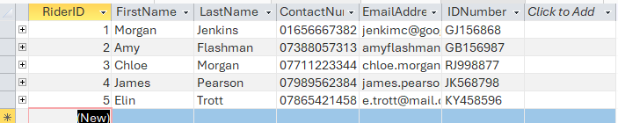

Bike Table: 5 Rows
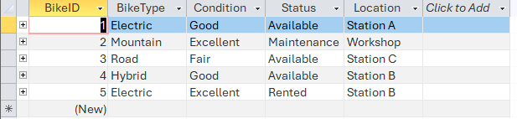

Rental Table: 5 Rows
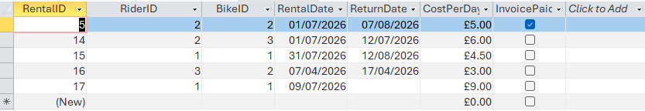

Maintenance Table: 5 Rows
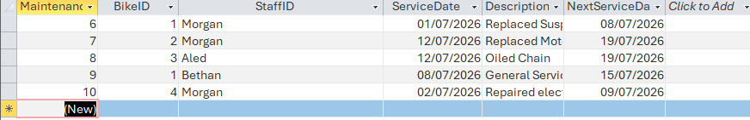

Staff Table: 5 Rows
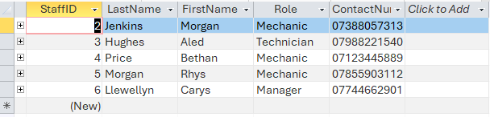

Query Development
Query development in relational databases focuses on the creation of queries which can retrieve, combine, filter and analyse data across many different tables[9]. In the EcoRide Database I focused on the use of SQL as a query language as I felt it gave me more granular control over the development of real-world style reporting[10]. As such I developed 11 queries that can be viewed from appendices (8-18).
An explanation for each is below.
  - Appendix 8
Query designed to display all details of bikes that have their status set to “Available”.
  - Appendix 9
Joins Bikes and Rental Tables to allow a count of the number of times a BikeID has been rented, provides an idea of usage rates for different bikes.
  - Appendix 10
Shows a maintenance history of each bike, as opposed to the maintenance table this orders the table by BikeID and ServiceDate which provides chronological information.
  - Appendix 11
Display Bikes where the next service date is within a week, a useful query for a business in terms of logistical planning.
  - Appendix 12
This query displays all bikes which have been rented over 6 days ago but have not yet been returned. I created this query in mind that this organisation would have a maximum of a week for rentals however this could easily be changed depending on organisational requirements.
  - Appendix 13
By inputting a RiderID this query displays the rental history of that rider.
  - Appendix 14
Displays all rental durations in the system where there is a return date present. This can be used for tracking usage types among the users in the system.
  - Appendix 15
Displays all rentals in the system where there is no ReturnDate set. This allows tracking of all current rentals.
  - Appendix 16
This query uses calculations to calculate the number of days rented and then multiplies that amount by the cost per day, thus giving a total cost for the rental. A useful query for a business to automate invoice creation.
  - Appendix 17
A query that calculates total amount of revenue generated per month, another query that has applications for a real-world organisations.
  - Appendix 18
Similar query to the above but this groups the revenue by RiderID and as such can see who the major users of the system are.

Testing of Database
All queries were tested against manual checks to ensure they performed appropriately and accurately. They were also confirmed to complete within an acceptable time frame to complete performance testing[9]. Incorrect values were also attempted to be entered in fields to confirm that the errors were handled effectively with appropriate error messages.

Review and Reflection
The main purpose of this database was to create a relational database that can effectively track all members of the service, the bikes in the service and the transactions performed. I believe that the database that was designed and created is fit for this purpose. The queries that have been developed are useful for tracking revenues and creating maintenance schedules. They also track specific riders where in the real world you can provide major users with targeted offers and loyalty rewards. For ease of use I developed a form that the database opens on that provides a list of the database features and links to the tables for updating records and buttons that open specific queries. This form can be viewed at Appendix (19).

Reflecting on my experience developing this database the main challenges I faced where in the design of the SQL queries. It took some time to get used to the unique quirks and syntax differences that MS Access SQL requires compared to MSSQL[5]. Another challenge I faced that I could not remedy in time for this report was the generation of forms. I had envisioned a Database dashboard from which any creation, editing or deleting actions could be performed using unique forms. I could not complete this however as I faced difficulties in tying delete record and create record actions between the correct tables and the form.

Further improvements for this database would be to complete the unique forms as that would give a more professional feel to the database rather than editing table records directly.

References

[1] T. Connolly and C. Begg, Database Systems: A Practical Approach to Design Implementation, and Management. (6th ed.) 2015.
[2] E. F. Codd, "A relational model of data for large shared data banks," Acm Cacm, vol. 13, (6), pp. 377–387, 1970. . DOI: 10.1145/362384.362685.
[3] R. Elmasri and S. Navathe, Fundamentals of Database Systems. (5th ed.) 2007.
[4] P. P. Chen, "The Entity-Relationship Model-Toward a Unified View of Data," .
[5] Microsoft. Microsoft Access Documentation: Tables, Relationships, Queries, and Validation Rules. Available: https://support.microsoft.com/en-us/Access.
[6] J. L. Harrington and J. L. Harrington, Relational Database Design and Implementation : Clearly Explained. (3rd ed.) 2009.
[7] S. Mardiah¹, S. Abdy² and Ramadhany³, "Relational Database Design Principles: Normalization, Denormalization, and Query Optimization for Database Management Systems," .
[8] E. F. Codd, "FURTHER NORMALIZATION OF THE DATA BASE RELATIONAL MODEL," 1972. .
[9] Anonymous (-05-10). Query Optimization. Available: https://www.geeksforgeeks.org/dbms/query-optimization-in-relational-algebra/.
[10] Anonymous . SQL Tutorial. Available: https://www.w3schools.com/sql/.

Appendices
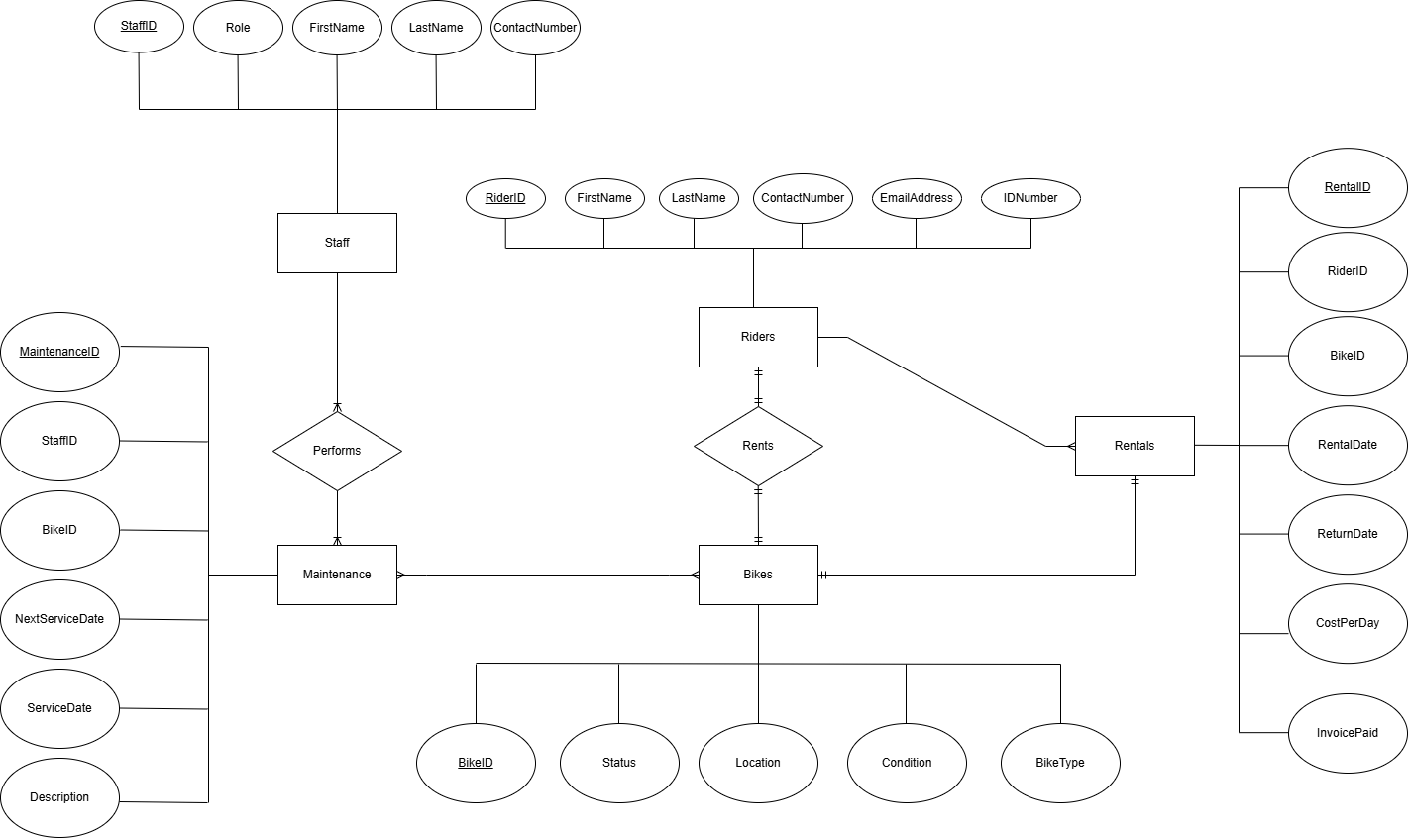
Appendix 1. Entity relationship diagram displaying relationships between the 5 entities of the database.
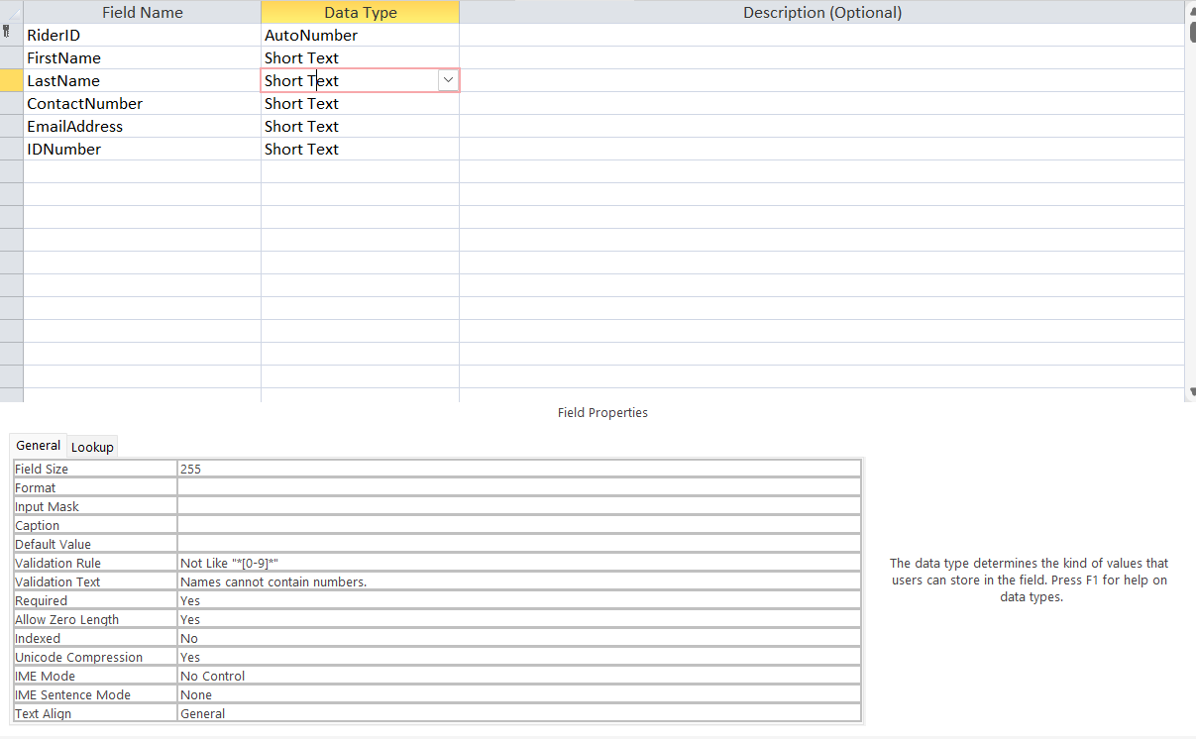
Appendix 2. Table design of the Rider entity
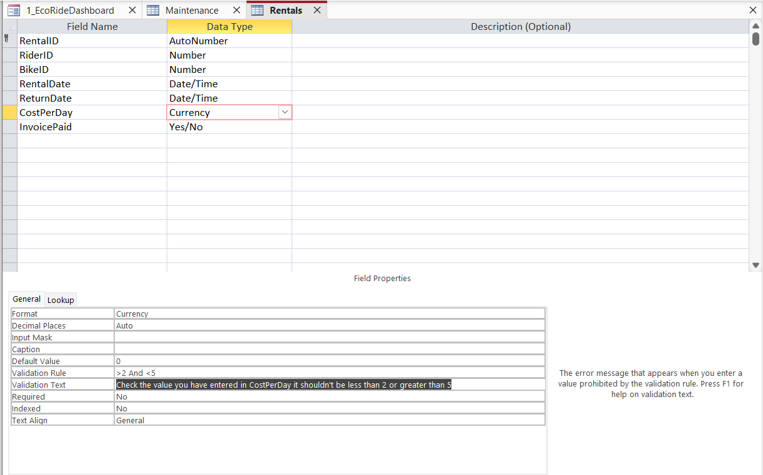
Appendix 3. Table design of the Rental entity
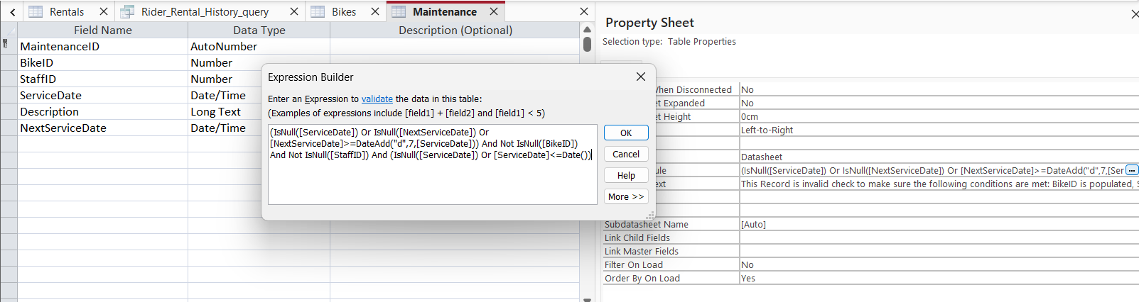
Appendix 4. Table design of the Maintenance entity. Image also displays the table level validation.

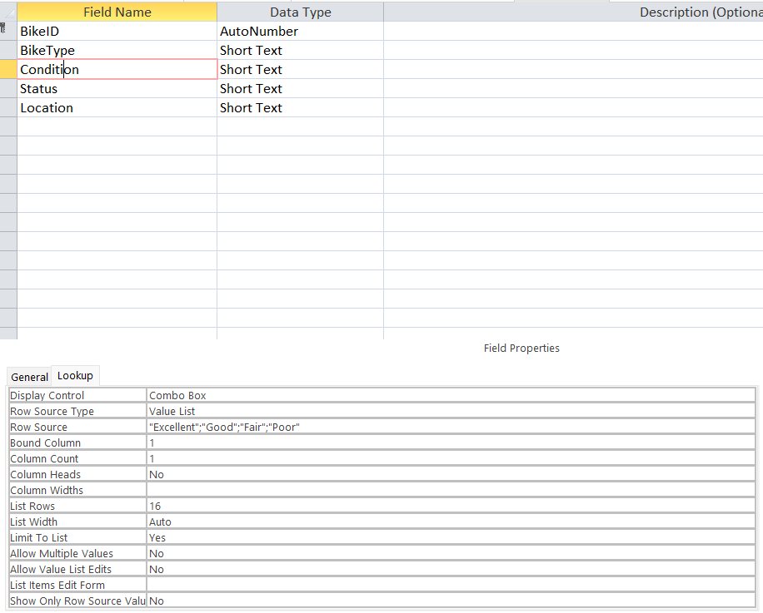
Appendix 5. Table design of the Bike entity

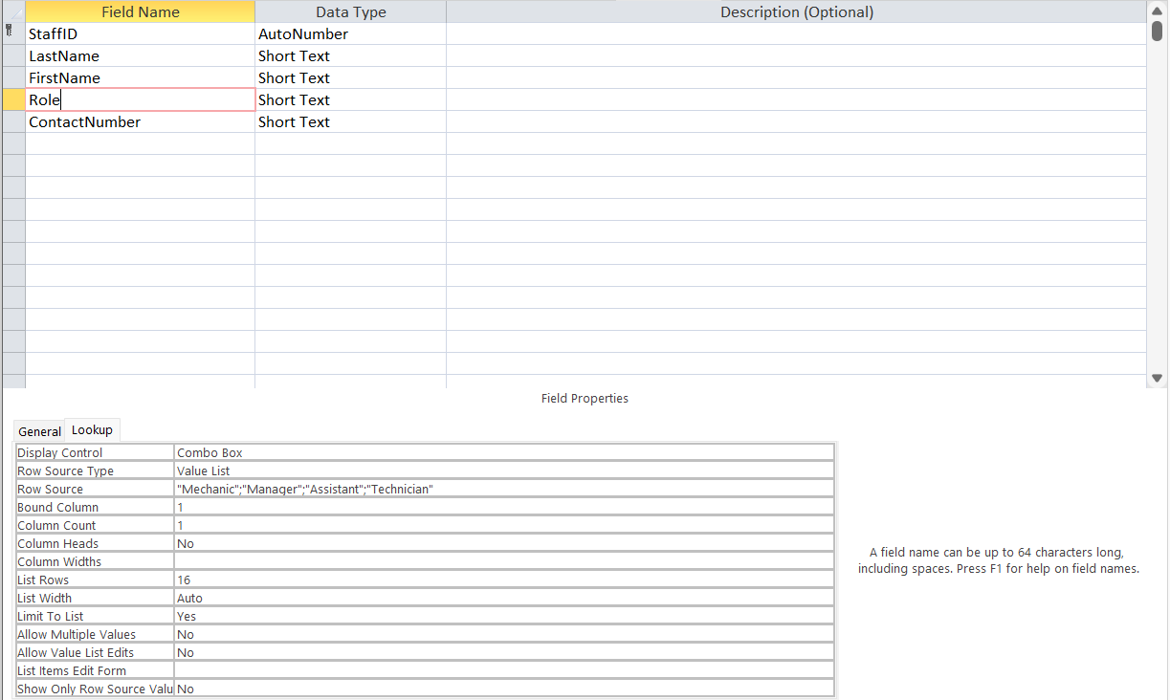
Appendix 6. Table design of the Staff entity
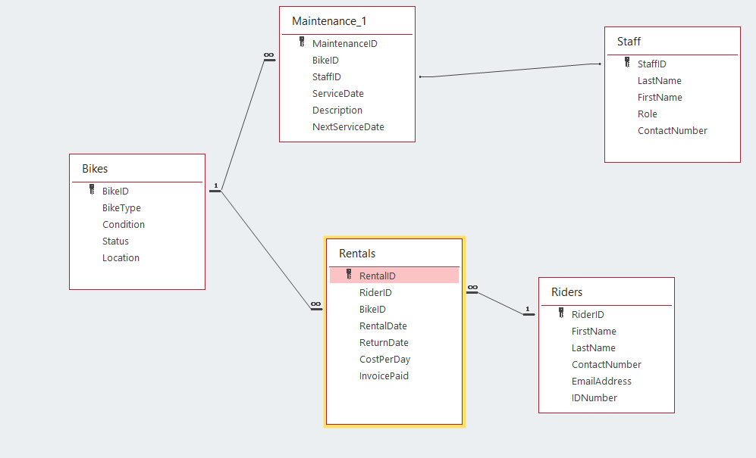
Appendix 7. Relationships as described by MS access

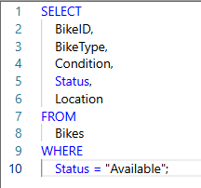
Appendix 8. Bikes_Available SQL query

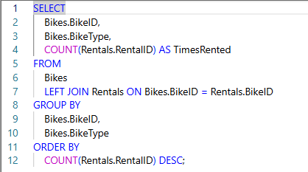
Appendix 9. Bikes_Most_Used SQL query

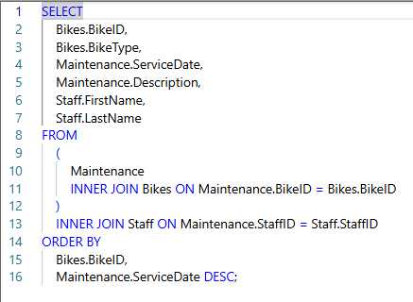
Appendix 10. Maintenance_History SQL query

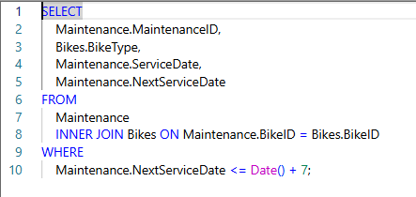
Appendix 11. Maintenance_soon SQL query

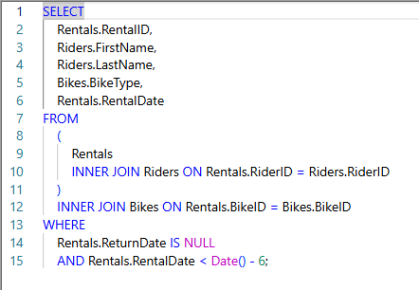
Appendix 12. Overdue_Rentals(7Days) SQL query

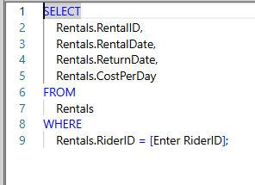
Appendix 13. Rider_Rental_History SQL query

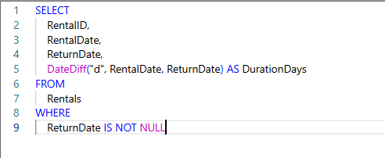
Appendix 14. Reports_Rental_duration SQL query

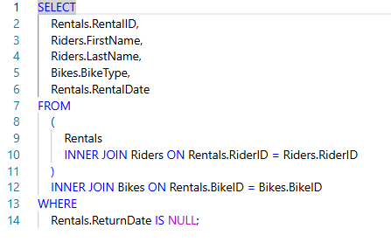
Appendix 15. Rentals_Current SQL query

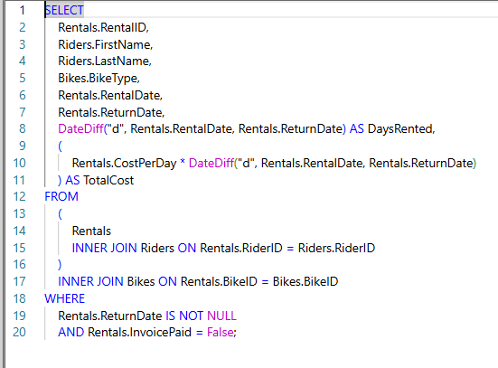
Appendix 16. Reports_Invoice_Cost_Calculator SQL query

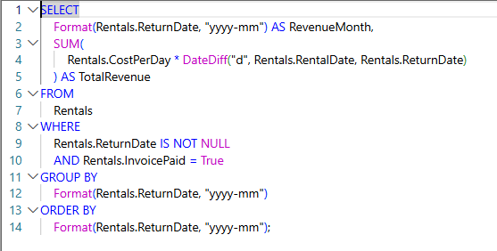
Appendix 17. Reports_Total_revenue_ByMonth SQL query

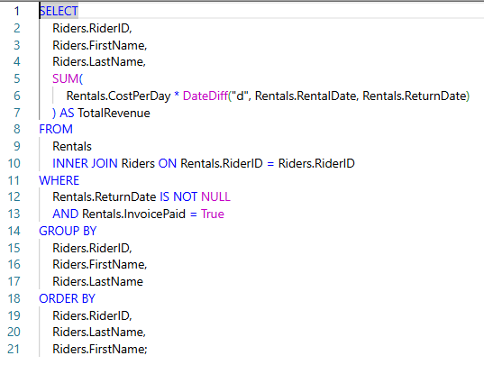
Appendix 18. Reports_TotalRevenue_ByRider SQL query

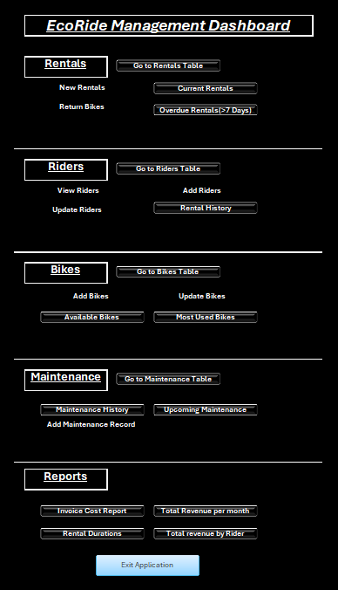
Appendix 19. EcoRideDashboard form. Used as a landing page in the database

